Reactor Energy-Capture and Shutdown Architecture
Non-Operational White Paper for a TPV / GhostCore Reactor Shell Concept
Document Type | High-level non-operational white paper
Scope | Conceptual reactor architecture principles only; excludes construction or operational instructions
Focus | Energy-capture shell geometry, layered shutdown doctrine, shielding, and decay-heat management
Status | Strategic design framing
Abstract
This paper reframes a TPV or GhostCore-style reactor concept into a safe, non-operational architecture discussion. The goal is not to specify how to build or fuel a reactor, but to identify the design principles that separate a visually elegant idea from a credible safety philosophy. The paper focuses on four themes: the role of surrounding shell geometry in shaping energy-capture pathways, the difference between energy recovery and shielding, the need for layered shutdown rather than a single-point safety story, and the continuing importance of heat removal after shutdown. The result is a high-level framework for discussing reactor architecture without operational detail.
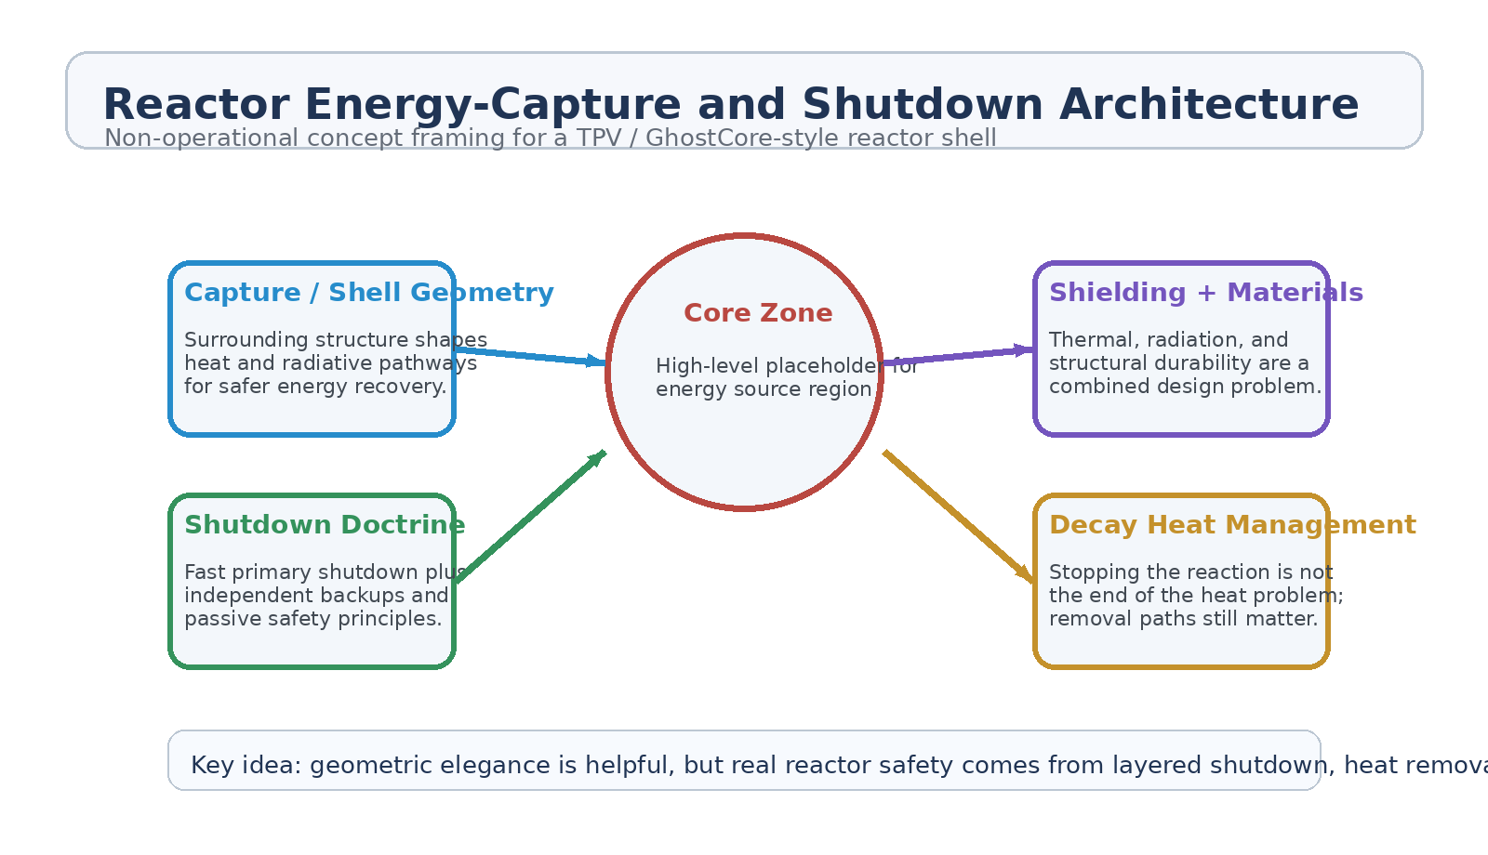
Figure 1. High-level architecture themes: shell geometry, shutdown doctrine, shielding, and post-shutdown heat management.
1. Core Thesis
The motivating intuition is understandable: arrange a central energy source, surround it with a shell or cage-like structure, and use geometry to improve how useful radiative and thermal output is captured. That intuition can be valuable as a conceptual starting point. Where it becomes incomplete is when the same structure is asked to be optical collector, radiation barrier, thermal manager, and safety system at the same time.
A mature reactor discussion therefore needs to split the problem into distinct layers. Energy recovery, shielding, shutdown, and residual heat management are related, but they are not the same engineering job. Conflating them makes the concept sound cleaner than the physics really is.
2. Energy-Capture Shell Geometry
A surrounding shell or semi-cage can be described at a high level as a geometry intended to shape pathways for useful energy capture. In a TPV-framed concept, that means arranging surrounding structures so emitted energy is more recoverable and less chaotic from the perspective of downstream conversion layers.
• The shell can be discussed as a capture geometry, not just a visual dome.
• Its job is to improve coupling between the core region and surrounding recovery systems.
• The same geometry must be evaluated for thermal load, material stress, and radiation exposure.
• A structure that helps one energy pathway may worsen local hot spots or material damage elsewhere.
2.1 What the Shell Is Not
The shell should not be described as a simple light-directing device. In any high-energy core concept, the surrounding structure faces a combined problem set involving heat flux, radiation, material degradation, and long-term integrity. Treating it as a pure optical cage misses the fact that the environment is far harsher and more chemically and structurally demanding than a clean photonics chamber.
3. Shutdown Doctrine
The biggest correction to the original intuition is the role of a 'single control rod' idea. As a high-level thought, one primary shutdown path can sound elegant. As a safety doctrine, it is not enough.
• A credible reactor architecture needs a fast primary shutdown path.
• It also needs one or more independent backup shutdown paths.
• Fail-safe behavior matters more than elegance; the safest action should occur when components lose power or normal control.
• Shutdown is not complete until the remaining heat problem is still survivable.
3.1 Why Single-Point Safety Is Weak
Any single-point safety story is fragile because mechanical failure, misalignment, material damage, control loss, or unexpected state changes can all defeat a lone intervention path. High-level reactor thinking therefore favors layered shutdown doctrine rather than singular hero components. In plain language: a system should not trust one moving piece to save the whole machine.
4. Shielding and Materials
A surrounding shell is also a materials problem. Whatever sits near the core region must tolerate heat, radiation, stress cycling, and structural fatigue while continuing to support whatever capture or moderation role the architecture expects from it.
• Shielding is not only about blocking exposure; it is also about surviving the environment long enough to keep doing useful work.
• Material choice and geometry are inseparable because local shape affects local load.
• Structural longevity matters because degradation changes the behavior of the whole surrounding field of components.
• The distinction between capture layer and protection layer should stay explicit in the architecture.
5. Decay-Heat and Post-Shutdown Reality
One of the most important boundary statements in any safe discussion is this: reducing reactivity does not instantly remove the heat problem. Even after the primary reaction is halted, residual heat remains a critical design consideration. That means shutdown logic without continuing heat-removal pathways is not a complete safety philosophy.
• Emergency shutdown and post-shutdown heat management should be treated as separate but linked problems.
• A design that can stop quickly but cannot reject heat safely is incomplete.
• Thermal pathways must still function under faulted conditions, not only during nominal operation.
• Heat-removal resilience often determines whether an upset becomes survivable or catastrophic.
6. Separation of Functions
The strongest upgrade to the original idea is to explicitly separate functions that are often rhetorically merged:
Function | Primary Question | High-Level Requirement
Energy capture | How is useful output recovered? | Geometry should support conversion without pretending shielding and capture are the same layer.
Shielding | How are people and components protected? | The protection story must address radiation, heat, and long-term material damage.
Shutdown | How is the system driven toward a safer state? | The architecture should rely on layered, independent, and fail-safe paths.
Heat removal | How is remaining heat managed after shutdown? | The system needs durable post-upset cooling or rejection pathways.

7. High-Level Design Principles
• Use shell geometry to improve energy-capture coherence, but do not overclaim what geometry alone can solve.
• Treat every surrounding structure as part optical, part thermal, part radiation, and part durability problem.
• Prefer layered shutdown doctrine over single-point shutdown narratives.
• Assume residual heat remains dangerous after shutdown and architect around that assumption.
• Keep energy-recovery efficiency and safety philosophy in dialogue, but never let one replace the other.
8. Proof-of-Concept Framing
At the white-paper stage, the right goal is not an operational blueprint. It is a concept map. A credible proof-of-concept would therefore ask whether the architecture can be meaningfully decomposed into capture geometry, shielding layers, layered shutdown doctrine, and post-shutdown thermal strategy without contradictions.
Phase | Goal | Concept Activity | Success Signal
P1 | Functional decomposition | Separate capture, shielding, shutdown, and heat-removal roles into distinct concept layers. | No role confusion in the architecture map.
P2 | Safety doctrine review | Test whether the concept still stands when single-point shutdown claims are removed. | A layered safety story still exists.
P3 | Materials framing | Describe the shell as a durability and environment problem, not only a capture shape. | Materials burden is explicit.
P4 | Post-shutdown framing | Check whether the concept acknowledges residual heat after shutdown. | Heat-removal remains part of the design philosophy.

9. Conclusion
The original concept has a useful seed inside it: geometry matters, energy pathways matter, and emergency shutdown should be decisive. What it needs is a stricter safety vocabulary. A surrounding shell should be described as part of an energy-capture and protection architecture, not as a simple dome that solves everything at once. A primary shutdown path can be elegant, but elegance is not the same thing as robustness.
The strongest non-operational version of the idea therefore becomes a layered reactor architecture principle: use surrounding geometry to support energy recovery, keep shielding and materials discipline explicit, reject single-point safety myths, and treat post-shutdown heat removal as part of the design from the beginning.
Working one-line doctrine: Geometric elegance may help energy capture, but real reactor credibility comes from layered shutdown, shielding, materials discipline, and heat-removal resilience.

