Halo Photon Hygiene Chamber
White Paper Proof of Concept for a Space Hygiene Booth with Photon Object Sanitation and Human-Safe Crew Workflow
Document Type | Spacecraft hygiene and sanitation proof-of-concept white paper
Concept Thesis | Use a layered hygiene chamber in which people follow a human-safe cleaning workflow, while objects and the empty chamber can enter stronger photon or chemical decontamination modes.
Primary Use | Crew hygiene, particulate removal, suit/tool sanitation, compartment cleanliness, and post-mission decon support
Status | High-level concept architecture draft
Abstract
Halo Photon Hygiene Chamber is a layered space-hygiene concept designed to separate crew-safe cleaning from stronger unoccupied decontamination cycles. In this architecture, a person entering the chamber first passes through airflow and particulate removal, then a human-safe cleansing stage using wipes, mist, or low-water wash methods. Objects such as tools, suit components, and cargo containers can then enter a photon-based sanitation cycle when no person is inside. A separate sealed deep-decon mode can be reserved for the empty chamber and hard equipment. This makes the system stronger and more honest than the idea of an ‘instant sterilization shower’ for people, because it recognizes that the safest hygiene workflow for humans is not identical to the strongest surface-decon workflow for hardware.
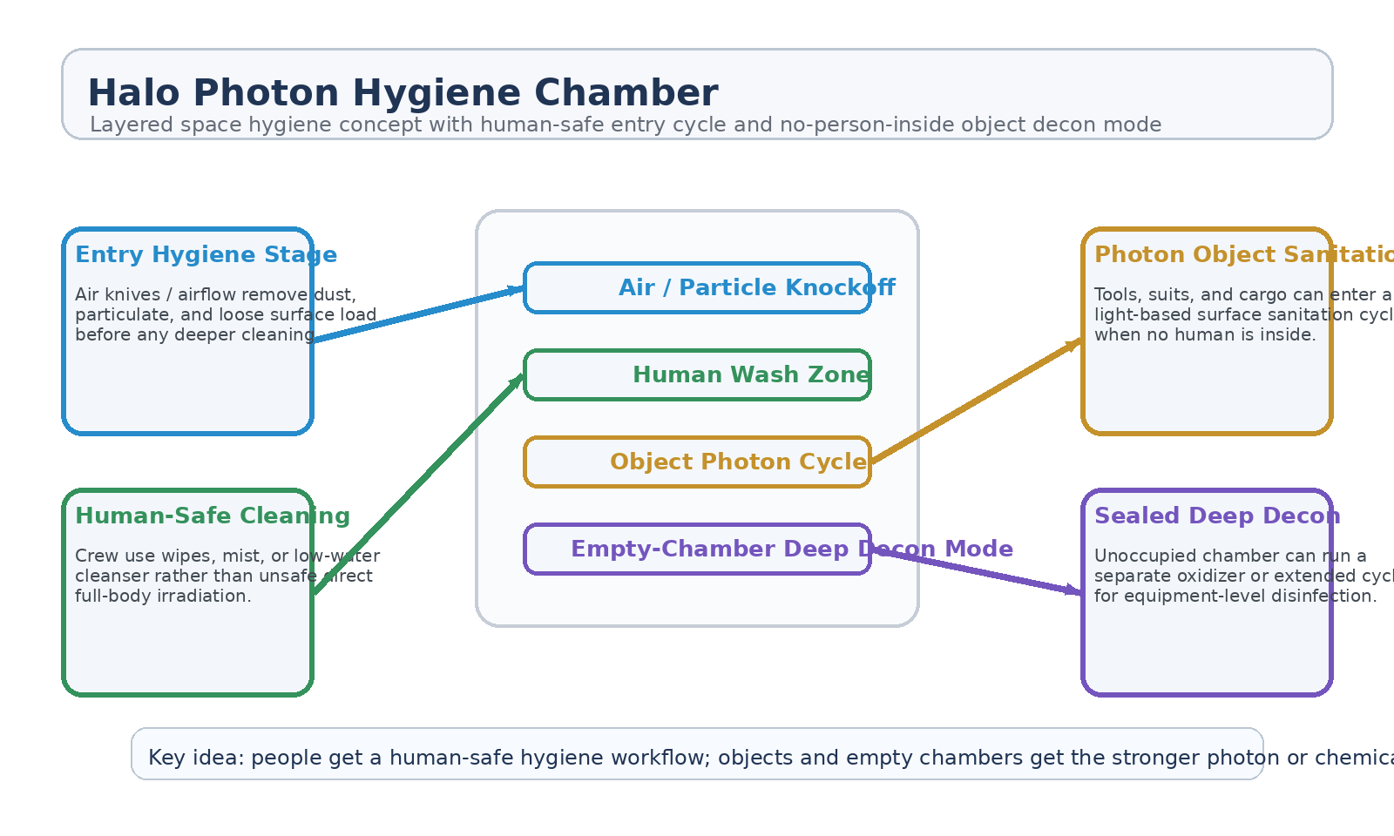
Figure 1. Halo Photon Hygiene Chamber with human-safe cleaning workflow, photon object sanitation, and empty-chamber deep-decon mode.
1. Concept Thesis
The core idea is to stop treating people and objects as the same sanitation problem. A crew member needs a hygiene workflow that is effective, repeatable, and safe for skin, eyes, breathing, and enclosed-ship operations. A tool, suit shell, or cargo tote can tolerate stronger surface-decontamination conditions. The chamber therefore uses one architecture with multiple modes rather than one harsh cycle for everything.
That makes the design feel more like a real spacecraft utility system and less like a medicalized fantasy booth.
2. Why Photons Fit the Object-Sanitation Role
Photon-based sanitation makes the most sense as the chamber's object mode. A light-driven cycle is clean, leaves little residue, and can be applied to suit exteriors, hard tools, exposed surfaces, and sealed equipment when the chamber is unoccupied. This is a strong fit for spacecraft operations because residue management, rinse burden, and chemical storage all matter in a closed environment.
Noble gases can still be useful in the chamber, but most plausibly as purge or support media rather than as the primary sanitation chemistry.
3. Why Noble Gases Are Support Media, Not the Main Sanitizer
• They are chemically inert and therefore useful for purge, controlled atmosphere, or plasma-working support.
• They can help stabilize certain chamber states without reacting aggressively with equipment.
• They are not, by themselves, the strongest broad sanitation chemistry for rapid human/object decon.
• Their best role is support: purge gas, plasma carrier medium, or equipment-safe chamber atmosphere.
4. System Architecture
Layer | Subsystem | Primary Function | Role
L1 | Entry Air / Particle Knockoff | Remove dust, debris, and loose contamination with airflow and collection. | First hygiene gate
L2 | Human-Safe Cleaning Stage | Support wipes, cleanser mist, low-water rinse, or similar crew-safe hygiene. | Crew sanitation mode
L3 | Photon Object Sanitation Stage | Apply light-based decon to tools, suit parts, and hardware when unoccupied. | Object decon mode
L4 | Sealed Deep-Decon Mode | Run stronger empty-chamber disinfection for equipment-level treatment. | No-person-inside mode
L5 | Purge / Vent / Recovery Layer | Clear residues, manage chamber atmosphere, and reset between cycles. | Turnaround control

4.1 Human Workflow
For people, the chamber is best used as a hygiene booth. The person enters, loose particulate is removed, and the remaining cleaning burden is handled with skin-safe approaches such as wipes, wash mist, or low-water cleansing. This is the correct place for everyday spacecraft hygiene, quarantine support, and contamination reduction between ship sectors.
4.2 Object Photon Cycle
For objects, the chamber can switch into a photon-based sanitation mode. This is where the design gets sharper: suit exteriors, tools, handles, storage boxes, and other hard surfaces can be treated without asking the human body to tolerate the same cycle. In mission terms, that means one chamber can serve both habitation and operations.
4.3 Empty-Chamber Deep Decon
A separate sealed cycle should be reserved for the unoccupied chamber. This is where stronger oxidizing or extended treatment modes belong. By separating deep decon from crew occupancy, the system remains practical and safer for repeated use on a closed spacecraft.
5. Candidate Chamber Modes
• Routine crew hygiene mode for normal daily use.
• Dust and regolith knockoff mode after EVA or maintenance work.
• Photon sanitation mode for tools, suit parts, and exposed equipment.
• Quarantine turnover mode between occupants.
• Empty-chamber deep-decon mode for hard-surface reset after contamination events.
6. Why This Is Stronger Than an Instant Chemical Shower
• It separates human-safe cleaning from stronger hardware-only decontamination.
• It reduces residue and rinse burden in a closed spacecraft environment.
• It supports repeated daily use instead of only emergency use.
• It treats particulate removal, hygiene, and disinfection as different jobs instead of one brutal cycle.
• It is easier to integrate into real shipboard life support and waste-management logic.
7. Boundaries and Realism
Halo Photon Hygiene Chamber is strongest as a hygiene-and-decon workflow, not as a promise of perfect instant sterilization for everything in one pass. A person still needs safe cleaning methods. A hard object can tolerate stronger treatment. A chamber can be reset more aggressively when empty. Those boundaries are what make the concept realistic and useful.
• Best framed as a layered hygiene system rather than a single harsh sanitation blast.
• Noble gases are strongest as support media, not the primary sanitation chemistry.
• Photon-based treatment makes more sense for objects and surfaces than for direct whole-body use.
• The chamber's value comes from mode separation and safe repeatability.
8. Proof-of-Concept Build Path
Phase | Goal | Bench / Program Activity | Success Signal
P1 | Particle knockoff demo | Test airflow or low-residue entry-stage particulate removal. | Cleaner pre-wash entry state
P2 | Crew-safe hygiene workflow | Evaluate wipes, mist, or low-water cleaning sequence for repeated use. | Practical daily hygiene routine
P3 | Photon object cycle | Run an unoccupied object-sanitation cycle for tools and hard surfaces. | Reliable object decon mode
P4 | Empty-chamber reset | Demonstrate a sealed deep-decon reset cycle with safe purge and turnaround. | Clean chamber recovery
P5 | Integrated operations review | Assess whether one chamber can support daily hygiene plus operations decon. | Coherent dual-use utility

9. Conclusion
Halo Photon Hygiene Chamber works because it refuses to force one sanitation answer onto every use case. The crew gets a safe hygiene workflow. The hardware gets a stronger photon-sanitation mode. The empty chamber gets the deepest reset cycle. That separation is what makes the design practical for real spacecraft life.
As a white paper PoC, the concept is strongest as a daily-life and contamination-control utility: a chamber that keeps people cleaner, equipment safer, and shipboard hygiene more manageable without pretending that one dramatic instant shower solves everything.
Working one-line doctrine: Give people a human-safe hygiene workflow, give objects a photon sanitation mode, and reserve the strongest decon cycle for the empty chamber.

