Field-Pressurized Reactive Shell
Non-Operational White Paper PoC for PTEC-Regulated Inert Noble-Gas Interlayers in Spacecraft Shell Architecture
Document Type | Non-operational shell-architecture proof-of-concept white paper
Concept Thesis | Use PTECs to regulate a pressurized or energized inert noble-gas interlayer between outer armor and inner pressure hull so the shell gains buffering, shielding, and breach-response capability without replacing the true habitable pressure boundary.
Primary Use | Load management, thermal buffering, reactive shell control, decompression slowing, and emergency damage localization
Status | High-level concept architecture draft
Abstract
Field-Pressurized Reactive Shell is a spacecraft shell concept built around a double-boundary architecture. A real inner hull continues to provide the breathable pressure boundary for the crew. Outside that hull, an interstitial cavity is filled with an inert noble-gas medium such as argon or xenon and regulated by PTEC-assisted field control. The outer shell and its interlayer are then treated as an active buffer zone rather than a passive wall. In this framing, PTECs do not replace the pressure hull. They help energize, stabilize, and regulate the shell cavity so the craft gains thermal buffering, load absorption, reactive shielding behavior, and a more graceful response to puncture or hull stress.
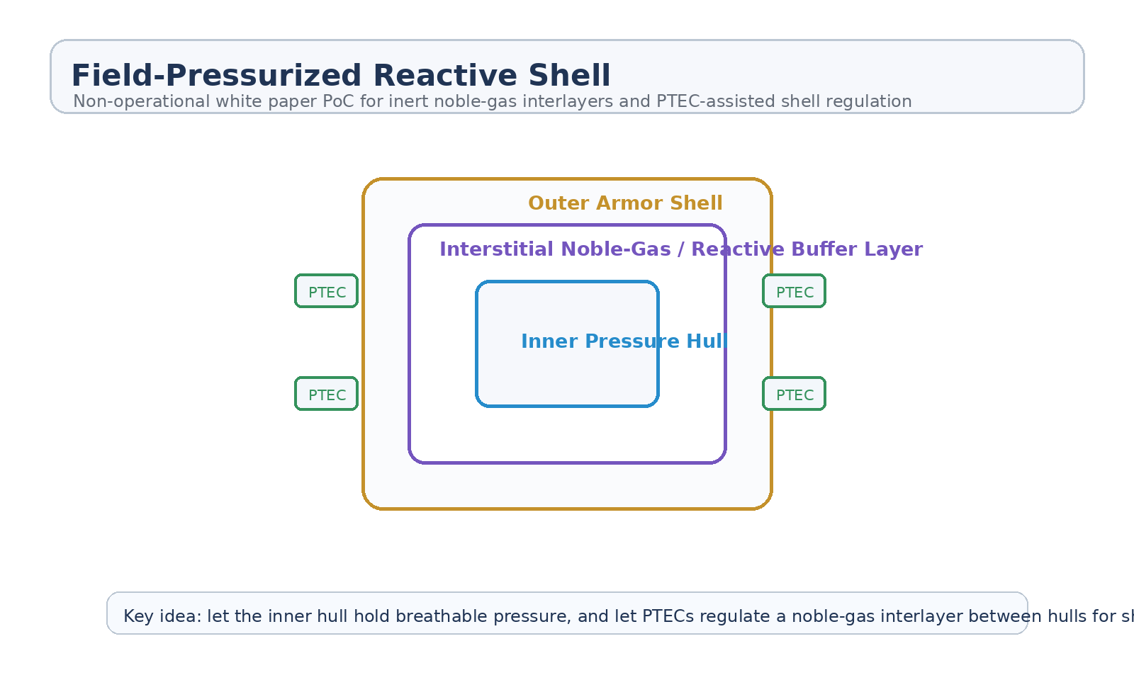
Figure 1. Cross-section of Field-Pressurized Reactive Shell with inner pressure hull, inert noble-gas interlayer, outer shell, and PTEC regulation points.
1. Concept Thesis
The central idea is to make the space between hulls useful. Instead of leaving the shell cavity as dead volume, the ship fills that interstitial layer with an inert noble gas and actively regulates it through PTEC-driven field management. The result is a shell that behaves more like a living buffer zone than a static sandwich of materials.
This is strongest when treated as a support layer around a real pressure hull, not as a force field that replaces one.
2. Why Inert Noble Gas Makes Sense
Inert noble gases such as argon or xenon fit the concept because they are chemically stable, useful in electrically active environments, and compatible with plasma-adjacent or ionized interpretations of shell behavior. In this architecture they would become the controllable medium inside the shell cavity.
• Chemically inert, reducing reactivity risk in the shell space.
• Compatible with ionization and field-managed behavior if the system enters a charged state.
• Can act as a pressure buffer between outer shell and inner hull.
• Useful for thermal, electrical, or damage-response interpretation without being a breathable cabin substitute.
3. System Architecture
Layer | Subsystem | Primary Function | Role
L1 | Inner Pressure Hull | Maintain the true habitable atmosphere boundary for crew and life support. | Actual cabin pressure wall
L2 | Noble-Gas Interlayer | Occupy the shell cavity as a pressure, thermal, and reactive buffer medium. | Interstitial utility zone
L3 | PTEC Regulation Layer | Energize, stabilize, and tune the shell medium under changing conditions. | Field-assist control
L4 | Outer Reactive Shell | Absorb impact, thermal load, and radiation while interfacing with the interlayer. | Primary external armor
L5 | Breach Response Logic | Localize damage and manage shell-state change during puncture or stress. | Graceful failure

3.1 Inner Hull Stays Real
The inner hull remains the true pressure vessel. The crew compartment is still protected by a physical, sealed, structural wall capable of holding breathable atmosphere under normal spacecraft conditions.
3.2 Shell Cavity as Active Medium
The noble-gas interlayer is the architectural upgrade. By occupying the cavity with a controllable medium, the shell gains an adjustable buffer zone that can absorb disturbance, change state under load, and potentially slow the consequences of a puncture or thermal event.
3.3 PTEC Shell Regulation
PTECs are strongest here when treated as the regulation layer rather than the atmosphere source. Their role is to energize, stabilize, and tune the shell cavity so that the interlayer can behave in a managed way during normal operation and abnormal stress.
4. Most Credible Benefits
• Thermal buffering between outer shell heating and inner pressure hull.
• Load and impact smoothing across a double-boundary shell.
• Localized shell-state changes during stress or puncture events.
• Possibility of slower decompression progression if outer-shell damage occurs first.
• A more useful interstitial cavity than simple dead spacing between hulls.
5. Mission Roles
• Deep-space hull protection where radiation and thermal swings are persistent.
• High-risk transit environments where puncture tolerance matters.
• Large spacecraft where a layered shell can justify distributed regulation nodes.
• Emergency shell-state management during damage-control operations.
• Reactive armor frameworks using noble-gas interlayers and field-assisted control.
6. Boundaries and Realism
This concept is strongest as an interstitial shell-management architecture. It should not be oversold as proof that a field alone can replace a pressure hull or that a noble-gas shell cavity automatically behaves like a science-fiction force field. The practical value is more modest and more believable: use the cavity between hulls as an actively managed buffer zone and use PTECs to keep that zone useful under stress.
• The inner hull remains the true habitable pressure boundary.
• PTECs regulate the shell layer; they do not replace the crew compartment wall.
• Noble gas is strongest as a controllable interlayer medium, not a cabin-atmosphere substitute.
• Best understood as a damage-tolerance and shell-utility concept rather than a pressure miracle.

