Magnetic Docking Coupling Spine
White Paper Proof of Concept for Maglev-Derived Capture, Centering, and Soft-Coupling in Spacecraft Docking
Document Type | Docking and capture proof-of-concept white paper
Concept Thesis | Use a maglev-derived stabilization layer as a dynamic capture-and-centering system that aligns, cushions, and holds two spacecraft in docking posture long enough for structural locks and transfer interfaces to engage cleanly.
Primary Use | Ship-to-ship docking, ship-to-station capture, alignment hold, and low-shock soft-coupling
Status | High-level concept architecture draft
Abstract
Magnetic Docking Coupling Spine is a docking architecture that extends the maglev stabilization concept into a capture and soft-coupling role. Instead of treating docking as a purely mechanical impact event, the system uses field-based centering, damping, and alignment control to bring a visiting craft into a stable posture before structural lock engagement. In this framing, maglev is not the only thing holding the ships together under all loads. It is the intelligent alignment layer that turns the final approach into a guided, low-disturbance capture process. Once posture is stable, conventional locks, seals, and transfer hardware take over. The value of the concept is therefore not replacing hard docking hardware, but making hard docking cleaner, safer, and more controlled.
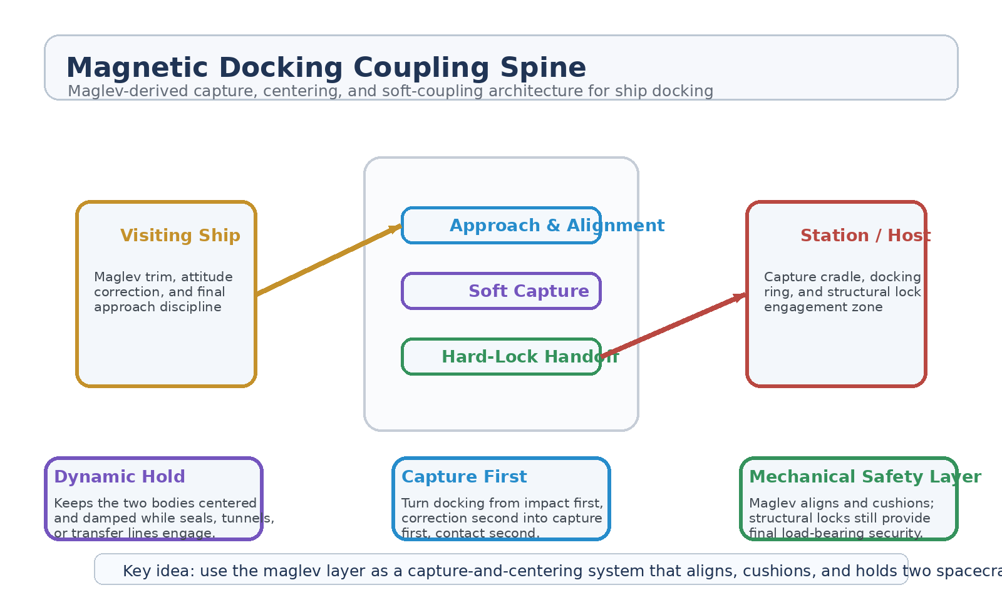
Figure 1. Magnetic Docking Coupling Spine with approach alignment, soft capture, and structural-lock handoff.
1. Concept Thesis
The central claim is straightforward: maglev-style systems are strongest when used for capture, centering, damping, and transition control, not as miracle free-space propulsion. That same logic makes them well suited to the final meters of docking, where the hardest problem is not making thrust, but keeping two large bodies aligned, calm, and structurally disciplined.
This turns docking from impact first and correction second into capture first and contact second.
2. Why the Maglev Layer Fits
The earlier maglev stabilization paper already defines the layer as a trim and damping architecture whose job is to suppress wobble, correct stance, smooth transitions, and keep a larger active system stable enough to use. Those are precisely the conditions that matter during docking approach and soft capture.
• Suppresses lateral drift, yaw, and wobble during final approach.
• Provides centering and stance correction before contact hardware engages.
• Reduces impact shock and bounce-off risk during first capture.
• Holds alignment while seals, tunnels, or transfer lines are brought online.
• Supports cleaner separation after undocking by managing the release posture.
3. System Architecture
Layer | Subsystem | Primary Function | Docking Role
L1 | Approach Alignment Layer | Trim relative position, suppress drift, and guide the visiting craft into lane. | Final approach discipline
L2 | Soft Capture Field | Cushion first capture and prevent shock bounce or misalignment recoil. | Non-contact or low-shock capture
L3 | Dynamic Hold Layer | Keep both bodies centered and damped during docking operations. | Stable posture maintenance
L4 | Structural Lock Interface | Hand off the aligned posture to mechanical locks, seals, and hard interfaces. | Load-bearing engagement
L5 | Undock Release Control | Manage controlled separation and posture reset on departure. | Clean release

3.1 Approach and Lane Capture
During the final approach, the maglev-derived layer should be understood as a dynamic trim field that pulls the visiting craft into the proper docking lane while reducing the small oscillations that make direct contact risky. Its strength lies in guided centering, not brute attraction.
3.2 Soft Capture
Once alignment is close enough, the system can act as a soft-capture cradle. This reduces the need for the docking interface to absorb the full event as a mechanical hit. In practice, the magnetic layer would lower contact shock, prevent rebound, and give the host structure time to engage cleaner locking hardware.
3.3 Dynamic Hold and Handoff
After first capture, the same field layer can remain active as a hold system, compensating for micro-motion and preserving alignment while tunnels, seals, cargo conduits, or transfer lines are brought online. Only then should the system hand off the posture to true structural locks.
4. Mission Roles
• Ship-to-station docking for habitats, depots, and large orbital platforms.
• Ship-to-ship capture and transfer alignment.
• Repair-cradle stabilization for damaged or drifting vessels.
• Cargo module capture where low shock matters more than speed.
• Controlled undocking and safe posture reset after transfer completion.
5. Why This Is Stronger Than Hard Contact Alone
• Spreads docking correction over time instead of concentrating it at impact.
• Reduces shock loading on seals, collars, and structural rings.
• Improves alignment quality before rigid hardware must carry the load.
• Lets the host structure behave more like a capture cradle than a collision target.
• Makes docking a guided transition instead of a mostly mechanical gamble.
6. Boundaries and Realism
Magnetic Docking Coupling Spine is strongest as a capture-and-centering architecture, not as a claim that magnetic fields alone should permanently hold large spacecraft together under every operational load. Structural locks, seals, and transfer hardware still matter. The field layer exists to make those systems engage under better conditions. That is the honest and useful role for the concept.
• Most credible as a docking assist, soft capture, and alignment-hold system.
• Not a full replacement for hard structural lock and seal interfaces.
• Best used in the final meters of docking, not as a stand-alone stationkeeping doctrine.
• Its main contribution is stability, low shock, and cleaner posture control.
7. Proof-of-Concept Build Path
Phase | Goal | Bench / Program Activity | Success Signal
P1 | Approach alignment demo | Use a surrogate host and visiting mass to test centering and drift suppression during final approach. | Improved docking lane capture
P2 | Soft capture test | Evaluate whether magnetic coupling reduces impact shock compared with hard-contact baseline. | Lower first-contact disturbance
P3 | Dynamic hold | Maintain posture while a mock seal or tunnel interface engages. | Stable alignment during handoff
P4 | Mechanical handoff | Transfer load from field-assisted hold to structural lock interface. | Clean lock engagement
P5 | Controlled release | Test undock posture control and separation smoothing. | Safer departure profile

8. Conclusion
Magnetic Docking Coupling Spine takes the most believable role of the maglev layer — centering, damping, and transition control — and applies it to docking, where those same traits are unusually valuable. The result is a cleaner architecture: the field layer handles capture and posture, while the hard interfaces handle load and seal.
As a white paper PoC, the concept is best understood as the layer that makes docking graceful before the metal has to become final.
Working one-line doctrine: Use the maglev layer as a capture-and-centering system that aligns, cushions, and holds two spacecraft long enough for structural locks to engage cleanly.

