Compartmented Friendly Asset Visibility
White Paper Proof of Concept for Role-Based Identity and Telemetry Access Control
Document Type | Safe white paper proof of concept
Concept Thesis | Maintain full safety and deconfliction tracking for friendly assets while restricting identity, route, and mission-detail resolution to authorized nodes.
Primary Use | Role-based visibility control for sensitive aircraft or spacecraft
Status | High-level access-control architecture draft
Abstract
Compartmented Friendly Asset Visibility is a role-based access-control concept for sensitive air or space platforms. The system does not remove friendly assets from internal awareness. Instead, it preserves full safety and deconfliction tracking underneath, while controlling who may resolve exact identity, route, mission state, and high-detail telemetry. This allows critical operations, command, and flight-safety systems to retain precise contact continuity while other viewers receive a protected or redacted representation. The purpose is not to make an asset disappear, but to enforce need-to-know visibility without compromising airspace or orbital safety.
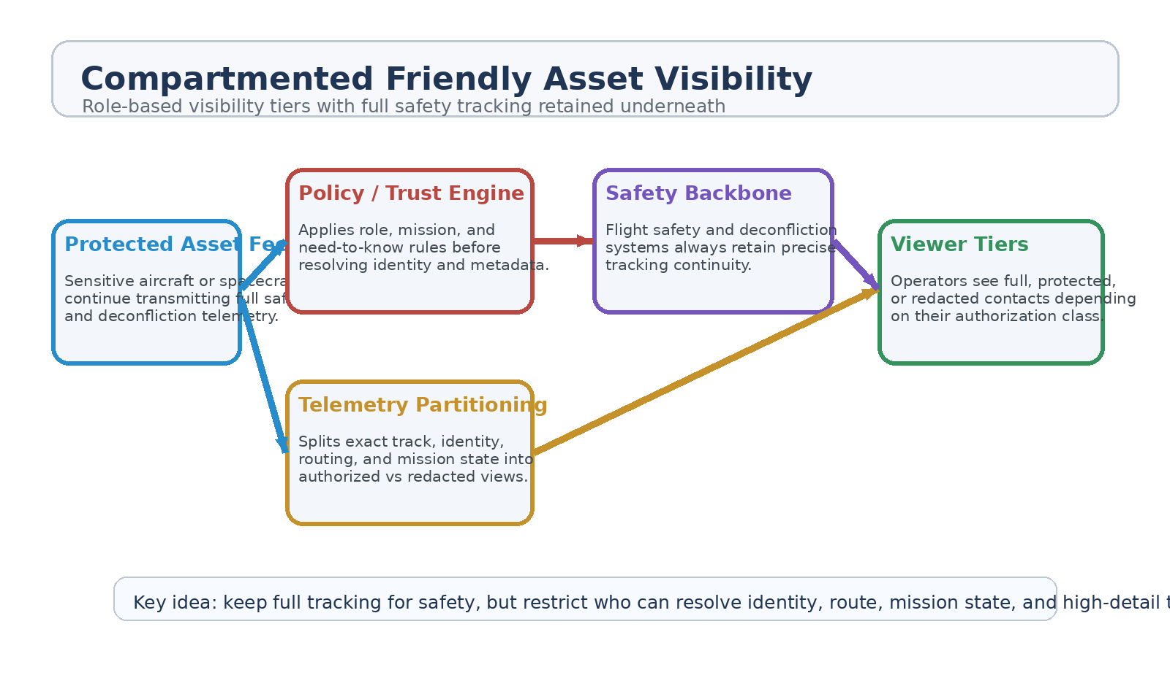
Figure 1. Protected asset feed, policy engine, telemetry partitioning, safety backbone, and role-based viewer tiers.
1. Concept Thesis
The key distinction in this concept is between tracking continuity and information resolution. A sensitive friendly platform should still exist in the system for safety, deconfliction, and command integrity. What changes is who can resolve what level of detail. This makes the architecture one of compartmented visibility rather than concealment.
That separation is the heart of the design: full internal truth for the safety backbone, controlled truth for everyone else.
2. Why This Model Is Safer Than Concealment
• Flight safety systems retain exact track continuity.
• Airspace or orbital deconfliction logic still sees the contact as a real object.
• Operators outside the need-to-know chain can be prevented from seeing mission-sensitive details.
• The architecture reduces unnecessary disclosure without creating blind spots in the safety net.
3. Viewer Tiers
Tier | Who Sees It | Visible Detail | System Purpose
T1 | Command / Flight Safety | Full identity, exact track, telemetry, and mission state. | Safety and control integrity
T2 | Protected Operations | Exact track plus restricted mission metadata. | Operational coordination
T3 | General Monitoring | Protected contact marker with limited detail or coarsened route view. | Situational awareness without disclosure
T4 | Nonessential Viewers | No mission metadata; minimal safety-safe abstraction only. | Need-to-know boundary

3.1 Protected Contact Representation
For lower-access viewers, the asset may appear as a protected friendly contact rather than a fully named platform. The system can preserve collision avoidance and general awareness while withholding exact platform class, mission tasking, or sensitive telemetry fields.
3.2 Telemetry Partitioning
Not all data should be treated the same. Position, heading, fuel state, platform identity, mission payload state, command-channel metadata, and route intent can each be partitioned differently depending on the viewer role. This lets the architecture be precise instead of all-or-nothing.
4. System Architecture
Layer | Subsystem | Primary Function | Output
L1 | Protected Asset Feed | Collect full telemetry from the friendly platform. | Authoritative internal track
L2 | Policy / Trust Engine | Apply role, mission, and authorization rules. | Access decision
L3 | Telemetry Partitioning | Split full data into exact, protected, or redacted views. | Tiered visibility products
L4 | Safety Backbone | Preserve precise tracking for deconfliction and command. | Unbroken safety continuity
L5 | Viewer Endpoints | Render the correct visibility tier to each console or node. | Need-to-know display

5. Safe Use Cases
• Sensitive test flights that require normal safety tracking but restricted public or broad-operator visibility.
• Protected logistics or escort operations where route and mission metadata are compartmented.
• Orbital support craft whose existence must remain fully known to flight safety systems but not fully disclosed to all operator tiers.
• Joint operations where some partners require awareness of the contact but not access to full platform identity or payload state.
6. Proof-of-Concept Build Path
Phase | Goal | Bench / Program Activity | Success Signal
P1 | Authoritative baseline | Demonstrate that full track continuity is preserved for safety and command nodes. | No loss of precise safety tracking
P2 | Tiered redaction | Generate multiple views of the same asset with different identity and telemetry resolution. | Stable role-based outputs
P3 | Policy enforcement | Apply mission-based and user-based trust rules to viewer access. | Correct enforcement across roles
P4 | Deconfliction validation | Verify that redaction does not break collision avoidance or airspace/orbital safety logic. | Safety continuity maintained
P5 | Audit and review | Record who resolved which level of detail and when. | Traceable accountability

7. Governance and Safeguards
• Safety and deconfliction systems must never lose the authoritative track.
• Protected contact rendering should still preserve necessary collision-avoidance behavior.
• Access to full identity and mission state should be logged and reviewable.
• Redaction policy should be role-based, mission-aware, and revocable.
• Compartmenting should reduce disclosure, not create operational blindness.
8. Boundaries and Realism
This architecture is intentionally about information control, not disappearance. Friendly assets remain visible inside the safety backbone. What changes is who gets the exact truth and who receives a limited operational abstraction. That makes the system appropriate for need-to-know management, not for evading detection or corrupting awareness.
9. Conclusion
Compartmented Friendly Asset Visibility provides a safer way to protect sensitive air and space operations: keep the track real, keep the safety net intact, and control who may resolve identity, mission state, and fine-grain telemetry. The architecture preserves operational truth where it is needed most while enforcing disciplined visibility boundaries everywhere else.
That makes it suitable as a policy-and-systems PoC for sensitive-friendly asset management in high-consequence aerospace environments.
Working one-line doctrine: Keep full tracking for safety, but restrict who can resolve identity, route, mission state, and high-detail telemetry.

