Lazarus Pulse Spine
White Paper Proof of Concept for CPSS-Backed Prism Distress Communications
Document Type | Emergency communications proof-of-concept white paper
Concept Thesis | Use CPSS as a burst-energy heart inside a prism relay network so a structured long-range distress pulse can survive after primary communications fail.
Primary Use | SOS beaconing, rescue localization, and low-bandwidth emergency pulse communications
Status | High-level survivable distress-comms architecture draft
Abstract
Lazarus Pulse Spine is a survivable emergency communications concept built around three linked ideas: CPSS as the reserve pulse-energy source, a prism relay shell as the signal-routing lattice, and a balanced dual prismatic corridor as the coherence-preserving SOS lane. The system is not framed as a replacement for normal broadband communications. Instead, it is designed as a last-ditch or degraded-mode beacon architecture that can continue emitting structured distress traffic when primary antennas, network stacks, or relay hardware have failed. The resulting signal path favors persistence, recognizability, and directional reach over bandwidth.
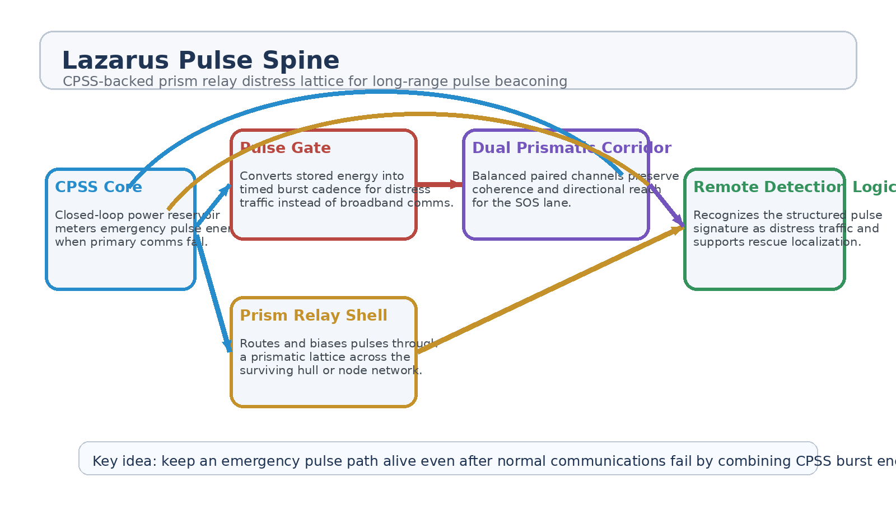
Figure 1. Lazarus Pulse Spine architecture with CPSS core, pulse gate, prism relay shell, dual prismatic corridor, and remote distress recognition.
1. Concept Thesis
The central idea is to treat emergency communications as a survivability problem rather than a throughput problem. When ordinary communications are damaged, overloaded, or power-starved, the system no longer tries to preserve full-spectrum traffic. Instead, it concentrates its remaining energy into recognizable pulse bursts that can be routed through whatever field-aware structure is still viable.
CPSS supplies the stored and metered energy. The prism relay shell provides routing and directional bias. The dual-channel corridor preserves coherence well enough for a distant node or rescue platform to interpret the signal as intentional distress traffic.
2. Why CPSS Fits the Role
• Acts as a reserve power reservoir even after major systems degrade.
• Supports burst-mode output instead of requiring continuous broadband draw.
• Can meter timed pulse cadence rather than uncontrolled discharge.
• Provides continuity when the platform can no longer sustain ordinary comms behavior.
3. System Architecture
Layer | Subsystem | Primary Function | Outcome
L1 | CPSS Core | Stores and meters emergency burst energy. | Beacon heart
L2 | Pulse Gate | Converts reserve energy into timed structured distress bursts. | Recognizable SOS cadence
L3 | Prism Relay Shell | Routes, biases, and concentrates pulses through surviving surfaces or relay nodes. | Directional signal path
L4 | Dual Prismatic Corridor | Stabilizes and reinforces the beacon lane for coherence and reach. | Survivable SOS channel
L5 | Remote Detection Logic | Identifies the pulse signature as distress traffic and supports rescue interpretation. | Recovery and localization value

3.1 Prism Relay Role
The prism relay network is best treated as the shell that turns a local pulse source into a distributed distress surface. Instead of relying on one dedicated emergency antenna, the system uses a field-aware routing layer to bias remaining energy toward the best surviving faces, nodes, or corridors.
3.2 Dual Prismatic Corridor
The dual prismatic lane makes the beacon more survivable. One channel can carry the structured pulse while the second channel balances, reinforces, or preserves coherence. This is especially useful when the platform is damaged, partially shielded, or unable to sustain a cleaner transmission path.
3.3 Why Pulses Instead of Full Comms
Pulse traffic is the most credible degraded-mode behavior because it favors recognizability and persistence over data richness. A rescue platform does not need a full broadband feed first. It needs proof of life, directionality, and timing it can lock onto.
4. Mission Roles
• Emergency SOS beacon after primary communications failure.
• Rescue localization for damaged ships, suits, or modules.
• Low-bandwidth distress traffic in degraded or shielded environments.
• Fallback communications for platforms with intermittent power continuity.
• Beacon handoff to relay meshes or search systems over long distances.
5. Proof-of-Concept Build Path
Phase | Goal | Bench / Program Activity | Success Signal
P1 | Pulse core demo | Drive structured burst output from CPSS reserve power under degraded primary-power assumptions. | Repeatable emergency pulse cadence
P2 | Relay shell routing | Bias pulses through a prism-like routing layer and compare directional output against a simple source baseline. | Improved path control
P3 | Dual-lane coherence | Add a paired channel and test whether the beacon lane remains more stable under simulated degradation. | More survivable signal corridor
P4 | Remote detection test | Verify that a distant receiver can recognize the structured distress pattern as intentional SOS traffic. | Reliable recognition
P5 | Degraded-mode review | Compare normal-comms failure cases with pulse-spine fallback behavior. | Clear emergency value

6. Boundaries and Realism
Lazarus Pulse Spine is strongest as a survivable beacon and low-bandwidth emergency communications architecture. It should not be oversold as a full replacement for normal radio, laser, or networked communications. Its value appears when the mission has gone badly enough that continuity, recognition, and rescue signaling matter more than throughput.
• Most credible for distress bursts and rescue localization, not full-spectrum routine communications.
• Best understood as a fallback layer that activates when ordinary comms degrade or fail.
• Depends on preserving enough energy and enough routing structure to keep a pulse lane alive.
• The architecture favors recognizability and persistence over bandwidth.
7. Conclusion
Lazarus Pulse Spine turns CPSS, prism relays, and dual prismatic channels into a coherent emergency-comms story. CPSS keeps the heart beating, the prism shell gives the pulse a body, and the paired channel keeps the distress lane coherent enough to matter. The result is a white paper PoC for long-range pulse beaconing that fits degraded, damaged, or post-failure mission states better than ordinary communications logic would.
That makes the concept particularly valuable as an SOS system: low-bandwidth, structured, persistent, and survivable.
Working one-line doctrine: When normal communications die, keep the pulse alive long enough for rescue to hear it.

