CALIFORNIA STATE UNIVERSITY, SACRAMENTO

College of Engineering and Computer Science

Department of Electrical & Electronic Engineering

Assignment 4 – Design Idea Contract

DMEA Project: Accelerometer Inclination Test Platform(February 2024)



March 3, 2024

Team Number 2

Mujtaba Khan, Lucas Feil, Warren King, and Xavior Pautin

Neal Levine

TABLE OF CONTENTS

**Introduction**…………………………………………………………………………………………………………...1

**Design Idea**……………………………………………………………………………………………………………………….2

**Funding**…………………………………………………………………………………………………………………………...3

**Work Breakdown Structure……**……………………………………………………………………………………4

**Project Timeline**………………………………………………………………………………………………………6

**Conclusion**…………………………………………………………………………………………………………….7

**References**………………………………………………………………………………………………………………………..8

**Glossary**……………………………………………………………………………………………………………….9

**Appendix.D**…………………………………………………………………………………………………………...10

LIST OF FIGURES

**Fig. 1 Rotating Armature Design 1**

**Fig. 2 GUI Design 1**

LIST OF TABLES

**TABLE 1 Punch List………………………………..……………………………………………………………………………..2**

**TABLE 2 Funding…………………………………………………………………………………………………….…………...4**

**ELEVATOR PITCH**

To develop a test fixture, including the accompanying firmware and software, that would enable the automation of accelerometer testing for the DMEA.

**EXECUTIVE SUMMARY**

1. *DMEA High level functional requirements*

Design requirements for DMEA sponsored accelerometer test fixture project.

1. *Design Idea*

Design proposal for DMEA sponsored accelerometer test fixture project.

1. *Work Breakdown Structure*

A list which tabulates the design features and each task needed to accomplish each feature. Team members are each assigned several tasks

1. *Project Milestones and Timeline*

A visual timeline of the project detailed by task families.

**ABSTRACT**

1. *DMEA High level functional requirements*

This project aims to develop a test fixture as well as accompanying firmware and software to enable the automation of accelerometer testing for the DMEA (Defense Microelectronics Activity) To add, the test fixture shall manipulate the DUT along the x-and y-axis, and firmware/software shall allow the serially connected host to request general data and status information.

1. *Design Idea*

Our proposed design accelerates the DUT by tilting a platform underneath it.

1. *Work Breakdown Structure.*

A detailed list of features needed to satisfy specifications laid out by the project scope. Each feature of the design idea is assigned several tasks and might have several preceding tasks. The WBS works to assign team members to each task and gives an estimated duration for the project.

1. *Project Milestones and Timeline*

A timeline of tasks and features grouped by task families displayed by date. This timeline includes all tasks within a resolution of days. Milestones are defined which underline critical dates for the project. The timeline will be updated when tasks are completed

*Keyword Index*—Accelerometers, Automatic Test Equipment, Fixtures

# **INTRODUCTION**

Accelerometers are a crucial piece of technology, from smartphones to aerial vehicles, by measuring vibration, or acceleration of motion. With this, creating a test fixture for the automation of accelerometers will ensure accuracy and reliability. This paper will detail the development of said test fixture along with the accompanying firmware and software designed with the DMEA’s specifications/requirements.

## DMEA High level functional requirements

### Configurable movement in both x and y axis

1. The firmware and command set shall allow the user to define up to 10 profiles that each define a sequence of up to 10 x-and-y positions with both angel and speed as inputs.
2. The firmware and command set shall allow the user to select and run profiles 1-10.
3. The firmware and command set shall allow the selection of repeating to continuously or a set number of times.

### Fixture movement range of -90° to 90° for each axis.

### Test fixture feedback.

1. The fixture shall provide the user with:
2. Acknowledgement command received.
3. Status if the action was completed.
4. Speed of the movement in each axis

### Support for UART (TTL) communication.

1. The fixture shall use the USB to Serial cable TTL 234x3V3 or similar.

### Fixture maximum dimensions 10 x 8.5 x 15 (HxWxD)

### The fixture logic and control electronics shall be developed using an STM Nucleo board.

## Design Approach

## Our solution to the test fixture consists of a multi jointed gimble arm with a platform mounted to the end as shown in Fig. 1. Testing in every direction will be achieved by tilting the platform on the end of the gimble arm. The fixture will be controlled by a serially connected through an instruction set. The instruction set will allow the user to define, store, and run test profiles.

Fig. 1 Rotating Armature Design

Fig. 2 GUI Design

# **DESIGN IDEA**

## Design Philosophy

Our design philosophy for the test fixture stems from the critical need for accuracy, and reliability when automating accelerometer testing. Per DMEA requirements, the movement of this fixture shall move in the range of -90° to 90° for each axis. The gimble armature satisfies this requirement and allows for speed control as well.

TABLE. 1

Punch List

|  |  |
| --- | --- |
| Feature | Measurable Metric |
| Configurable movement in both x and y axis | Fixture movement range of -90° to 90° for each axis. |
| Firmware Command Set | The firmware and command set shall allow the user to:   1. define up to 10 profiles that each define a sequence of up to 10 x-and-y positions with both angle and speed as inputs. 2. select and run profiles 1-10. 3. Run a profile continuously or a set number of times. |
| Test Fixture Feedback | The fixture shall provide the user with:   1. Acknowledgement of command received. 2. Status if the action was completed.   Speed and angle of the movement in each |
| Support for UART (TTL) communication. | The fixture shall use the USB to Serial cable TTL 234x3V3 or similar for communication. |
| Fixture must fit within a given amount of space on a work bench. | Fixture maximum dimensions: 10 x 8.5 x 15 (HxWxD) |
| The fixture logic and control electronics shall be developed using an STM Nucleo board. | The fixture will be powered and controlled entirely by an STM Nucleo Board |
| Fixture is self-powered | Fixture is powered via wall outlet plug. |
| Fixture is stable | Fixture only moves when it is supposed to. There are no unwanted movements during testing. |

## Specific Design Components

### Gimble Arm

The gimble arm is a servo actuated arm with two joints that allow the platform attached to the end of the arm to tilt 90 degrees in the x and y axis.

### Tilt Platform

The tilt platform is a square plate mounted at the end of the gimble arm which will serve as an attachment point for the DUT. The platform will be made of a rigid, lightweight material that the client can modify with mounting hardware as they require.

### Accelerometer

An accelerometer mounted to the tilt platform provides the fixture with sensor feedback that allows it to confirm that the movement of the tilt platform matches the test profile.

### Enclosure

The enclosure for the gimble arm and the device’s electronics will be made from 3d printed parts.

### Nucleo STM Board

The entire fixture is controlled by a Nucleo STM development board. The Nucleo board receives commands from a serially connected host device. The board controls the gimble arm’s 2 motors to achieve the desired angle and magnitude of acceleration.

### Instruction Set

The user controls the fixture through an instruction set that allows them to define, store, and run test profiles.

# **FUNDING**

TABLE. 2

Funding

|  |  |  |  |
| --- | --- | --- | --- |
|  | Funding | Cost | Remaining Budget |
| DMEA | $2000 |  | $2000 |
| Main Arm Motor |  | $90 | $1910 |
| DUT Vehicle Motor |  | $14 | $1896 |
| Frame Material |  | $47.35 | $1848.65 |
| Nucleo Board |  | $24.47 | $1824.18 |

# **Work Breakdown Structure**

Estimated Hours per Task/Feature

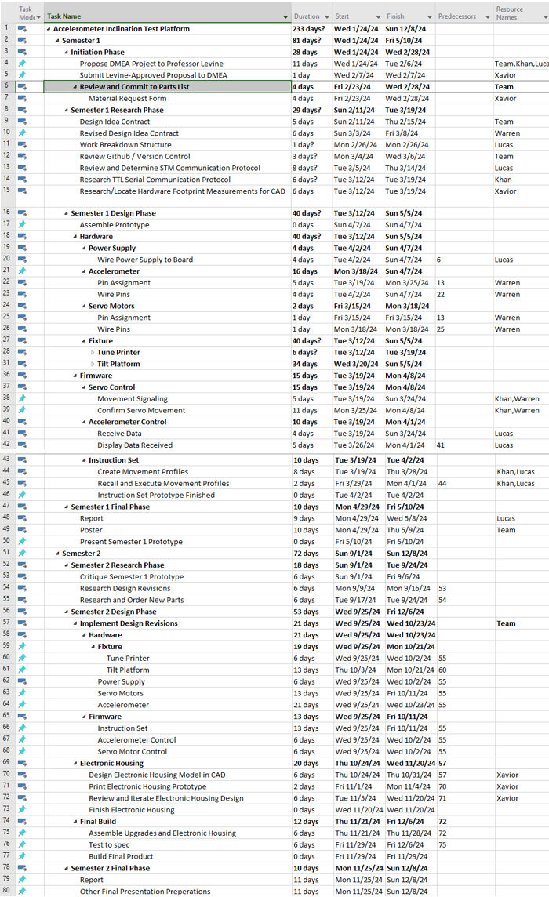

Estimated Hours Per Team Member

# **Project Milestones and Timeline**

Estimated project timeline grouped by task families

# **CONCLUSION**

## DMEA High level functional requirements

## DESIGN IDEA

## Work Breakdown Structure

## Project Milestones and Timeline

# **REFERENCES**

# **GLOSSARY**

**Appendix D.**



**APPENDIX E.**

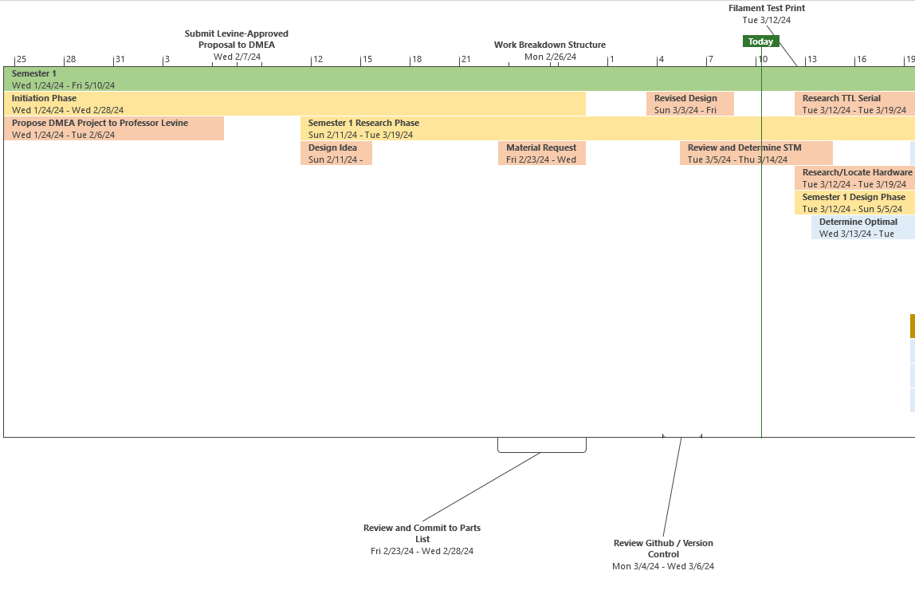

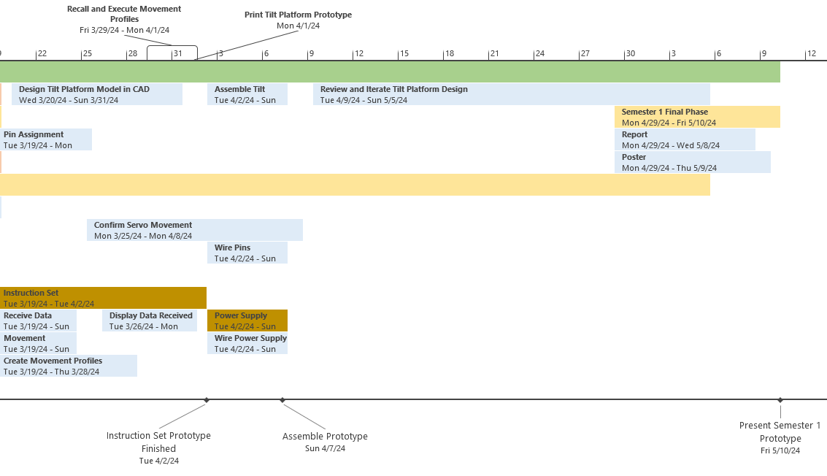

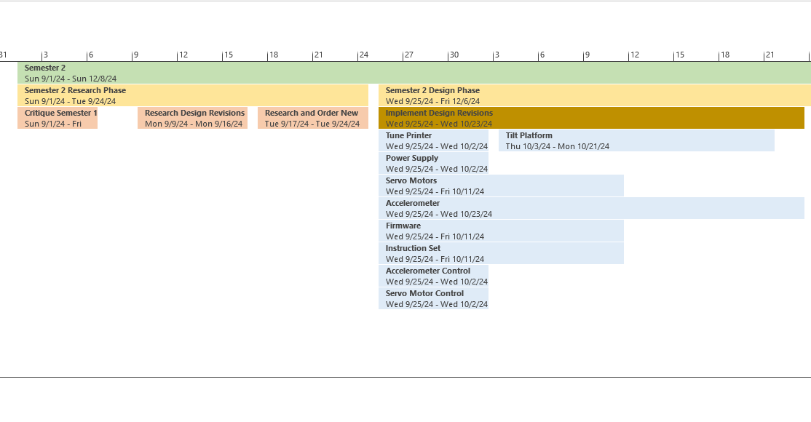

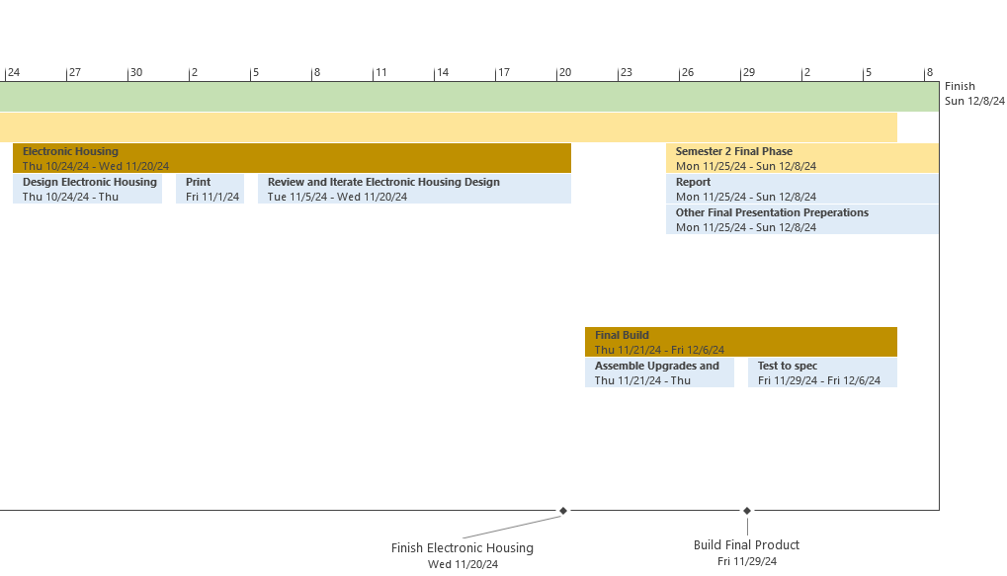

**APPENDIX F. RESUMES**

**MUJTABA KHAN**

**Education**

Bachelor of Science, Computer Engineering

California State University, Sacramento, CA, Expected: December 2024

GPA: 3.44

**Related Course Work:**

Advanced Logic Design Advanced Computer Organization Circuit Analysis

Computer Architecture Design Data Structure & Algorithms Analysis Electronics

Embedded System Design Microcontrollers Signals & Systems

Probability & Random Signals

**Technical Skills**

**Programming Languages:** C, Debugging, Java, MATLAB, MIPS Assembly, Python, Verilog, VHDL

**Hardware:** Analog Discovery 2, PIC24F curiosity Dev. Microcontroller, STM32

**Software:** Eclipse, Linux, ModelSim, PSpice, Quartus Prime, Visual Studio, Xilinx

**Projects**

**Audio Reactive LED**  *Fall 2022*

* Built using STM32 microcontroller, written in C, adapts to room sound: low activates 1-2 LEDs, medium activates 4 LEDs, and high activates all 7 LEDs, provides customizable gain option

**Unix Shell**  *Spring 2021*

* Written in C, supports and accepts same commands as Unix

**Movie Database**  *Fall 2021*

* Written in Java, parses through users' input, user is given 6 options: search by actor, year, runtime, director, or title, adds movies to database that is not already present

**Custom PC Build** *Summer 2019*

* Built PC, purchased all components separately, and assembled accordingly

**Work Experience**

* **Dairy Heaven, Carmichael, CA**  *April 2015 – October 2022   
  Manager/Employee*, created new menu items, designed new logos, developed schedules, received orders from customers, managed inventory, opened/closed restaurant

**Awards**

**Dean’s Honor List** *Spring 2021 – Fall 2022*

* Recognized for Dean's Honor List, spanning Spring 2021 to Fall 2022, awarded to undergraduates achieving a 3.25 GPA or higher

**High School Perfect Attendance** *Spring 2019*

* Consistently maintained perfect attendance through all four years of high school

**LUCAS FEIL**

**WARREN KING**

**Education**

Bachelor of Science, Electrical Engineering

California State University, Sacramento, CA, Expected: December 2024

GPA: 2.78

**Related Course Work:**

Introduction to Logic Design

Network Analysis

Applied Electromagnetics

Signals & Systems

Engineering Economics

Power System Analysis I

Intro to Microprocessors

Introduction to Feedback Systems

Probability and Random Signals

Modern Communication Systems

Electronics II

Intro to Machine Vision

**Technical Skills**

**Programming Languages:** C, Java, MATLAB, Python

**Hardware:** Arduino, RaspberryPi, PIC24F, STM32

**Software:**,Cadence PSpice, OrCAD, SolidWorks

**Projects**

**Smartphone Based Security System** *Spring 2023*

* Built using STM32 microcontroller, programmed in C, uses an infrared proximity sensor to detect intruders and trigger alarm, servos activate camera of mounted smart phone and pan phone back and forth to record video footage of intrusion

**X-Ray Detector Resolution Analysis** *Summer 2021*

* Series of scripts written in python, assess image resolution of in development CMOS x-ray detector, evaluate the resolution of a sample set of x-ray exposure images captured by the sensor at different x-ray dosages, plot results as a performance curve.

**X-Ray Generator Test Fixture** *Spring 2018*

* Built using Arduino microcontroller, programmed in C, emulates output signals from x-ray generator to imaging system, allows testing of imaging systems without needing to connect to an actual x-ray generator

**Work Experience**

**MXImaging, Torrance, CA** *July 2017- –August 2017*

*July 2018-August 2018*

*January 2021-March 2021*

*Intern*, designed and built test fixtures, verified and replicated user reported bugs, assisted with product development and testing

**Awards**

**Dean’s Honor List** *Fall 2022, Fall 2023*

Semester Honors are awarded and the notation "Deans Honors List" is posted to the permanent academic record for freshmen earning a 3.0 GPA and other undergraduates earning a 3.25 GPA.

**XAVIOR PAUTIN**