AD9854-TX SDR

Build an SDR with AD9854 DDS
powered by Pi PICO2 (RP2350)

Table of Contents
Project Goals 2
AD9854 3
10.000 MHz OCXO 4
Kicad files 5
end page – footnote references 7
end page – glossary 9

Text goes here

Project Goals
Build portable TX only SDR with the AD9854 & Pi PICO 2 (RP2350)
- cover 1mhz to 50mhz
- narrow band any-mode (FM, AM, CW, SSB)
- have standard mic or line-in input or optionally USB
Extended wishlist:
- up-converting mixer (something like LT5560) – extend TX into microwave band
- RX Ability : 2nd board to receive, something like 10-bit AD9200 or 14-bit AD9241

How it will be used
- With computer: connect to USB & laptop and use it in GNU Radio
- Without computer: connect 4 pin microphone or line-in audio

Estimated Cost: (may 2026)
TX Only with lucky-find ebay parts : $50
RX & TX combo : $75

- AD9854ASTZ : $35 LCSC , $71 Digikey, $15 ebay
- AD9200 : $10 ebay, $15 digikey
- LT5560 : $5 digikey
- Pi Pico 2 : $6
- PCB fab : $4
- CTI OXCO : $5 (or use txco for $2)
- capacitors, resistors, LDOs : $20
- project box : ??

AD9854
What is AD9854 3
Why AD9854 3
Signal harmonics of AD9854 3

Text goes here

What is AD9854
Datasheet link /

AD9854 is an early-gen 2000s era dual-dac DDS chip, 12 bit amplitude 14 bit frequency & phase. It generates I & Q signals directly as a differential current-source , 4 output pins total for I/Q +/- pins

chipset internal clock is maximum 200mhz , and approximately 500mA 3.3v limit or it can be damaged

generates 0-100mhz output analog signal with phase, frequency and amplitude control
- does not allow for offset or skew inside of AD9854, meaning no built in solution for adjusting gate drive timing for polar or EER type digital amplifiers

AD9854 generates analog waveform out, FM, SSB, AM, CW. Any arbitrary waveform with wide bandwidth.

AD9854 is discontinued and may be difficult to source more

Why AD9854
Sometimes find them on ebay for cheap with luck.
- Ad9854 has parallel interface, easy for hobby programming, doesn’t use complicated serial bus protocol, easy interface to simple device like Pi PICO or FPGA

Signal harmonics of AD9854
Spurs & harmonics calc tool /

different frequencies have harmonics “too close” and must calculate what filtering to use as spurs may be strong or too near for a simple filter, especially beyond 50mhz signal output

10.000 MHz OCXO
CTI SC5A2B02 4
Big Text page2headline2 4
Big Text page2headline3 4

Page2 text

CTI SC5A2B02
ocxo-cti-osc5a2b02-datasheet.pdf /

cti osc5a2b02 is a 5v OXCO.

It consumes 5v 600mA at initial power on and warmup

running consumption is 250mA depending on heat loss

Big Text page2headline2
Example Reference /

Big Text page2headline3
Example Reference /

Kicad files
schematic - transformer 5
pcb 6
Big Text page2headline3 6

Page2 text

schematic - transformer
a “trifilar” transformer on a type-43 torroid or multi-aperture core (Fair-Rite 2843010402) is a possible way (need to verify) to combine the I & Q outputs of the AD9854, to convert “Dual differential” output to something single-ended and GND plane referenced, to put into a filter network & class-A amp as the next stage (RF_OUT’s destination)
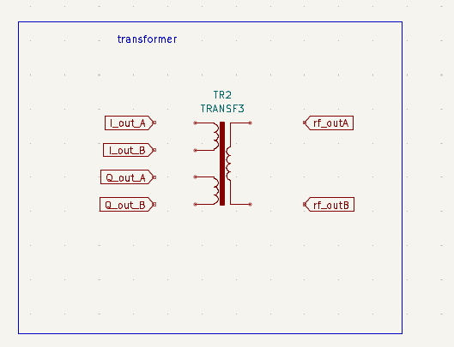

pcb
Basic rough draft idea. There are many things missing but ideally this could fit in a pocket. The OXCO is a hot-part which must be insulated, and the other components must be kept lower temperature stable.
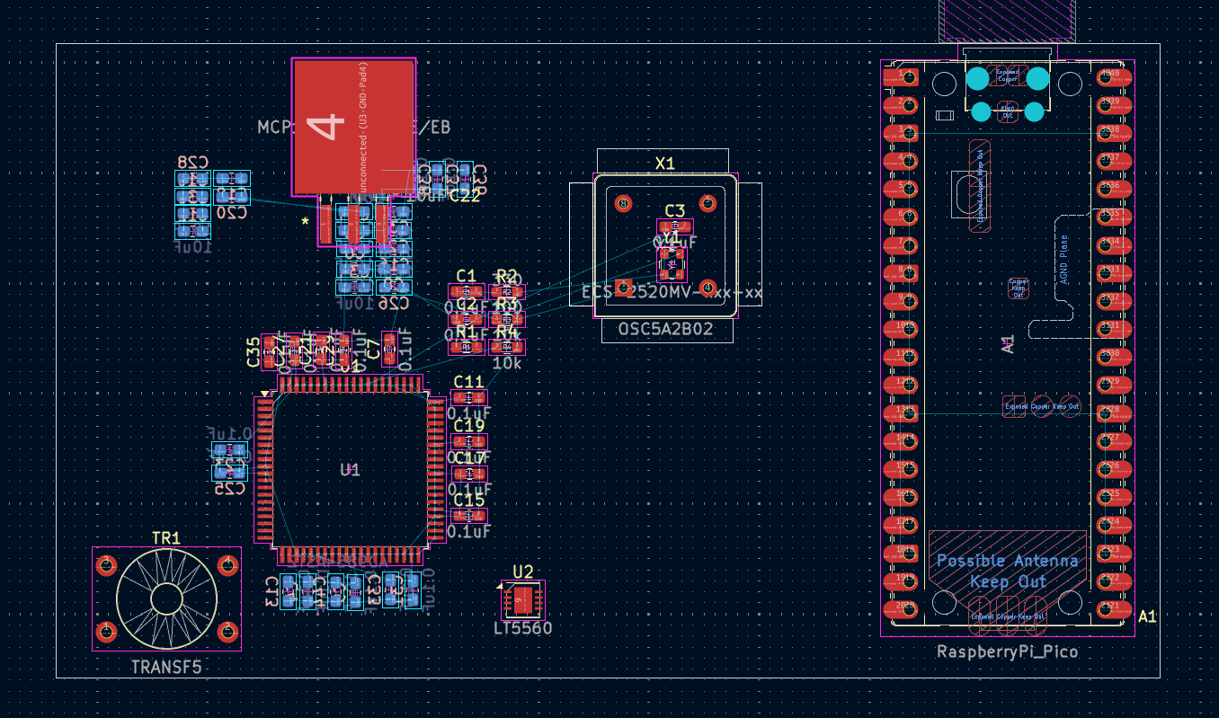

Big Text page2headline3
Example Reference /

end page – footnote references

LIST OF ALL FOOTNOTE REFERENCES
https://www.analog.com/media/en/technical-documentation/data-sheets/ad9854.pdf 3
https://octopart.com/search?currency=USD&specs=0&start=0&q=ADI+AD9854Ast&s=1 3
https://tools.analog.com/en/simdds/?harmonicDB=-50&mult=1&part=AD9854&rso=111111&sclock=300M&tof=114M&useFilters=0 3
This is a footnote and can put a <link> here to click 4
This is a footnote and can put a <link> here to click 4
This is a footnote and can put a <link> here to click 4

end page – footnote references
this page is for listing all of the footnotes. This can be useful if there are links to access, or other resources someone may want to work through

end page – glossary

Glossary of Terms
TechnicalTermA 2
techtermb 2

end page – glossary


dual column glossary. Need to insert “index entry” to expand it

https://www.analog.com/media/en/technical-documentation/data-sheets/ad9854.pdf
https://octopart.com/search?currency=USD&specs=0&start=0&q=ADI+AD9854Ast&s=1
https://tools.analog.com/en/simdds/?harmonicDB=-50&mult=1&part=AD9854&rso=111111&sclock=300M&tof=114M&useFilters=0
This is a footnote and can put a <link> here to click
This is a footnote and can put a <link> here to click
This is a footnote and can put a <link> here to click
This is a footnote and can put a <link> here to click

