Template title

words

Table of Contents
Document Info 2
PAGE1 Example 3
PAGE2 Example 4
end page – footnote references 5
end page – glossary 6

Text goes here

Document Info
This is using heading1 and smaller topics could use heading2 and then chapter specific toc. Under view-styles, right click on heading and then heading1 and set the text flow to have a line break

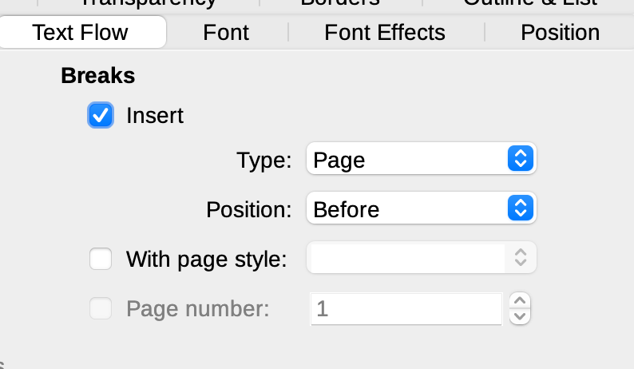

Table Of Contents
toc does not auto update
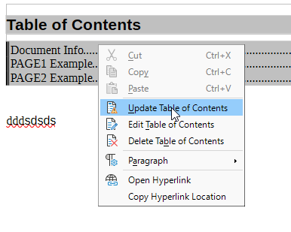Figure 1: TOC must be manually refreshed

chaper1subtopic2
TechnicalTermA

chaper1subtopic3
Words words techtermb words more words

PAGE1 Example
Big Text page1headline1 3
Big Text page1headline2 3
Big Text page1headline3 3

Text goes here

Big Text page1headline1
Example Reference /

Big Text page1headline2
Example Reference /

Big Text page1headline3
Example Reference /

PAGE2 Example
Big Text page2headline1 4
Big Text page2headline2 4
Big Text page2headline3 4

Page2 text

Big Text page2headline1
Example Reference /

Big Text page2headline2
Example Reference /

Big Text page2headline3
Example Reference /

end page – footnote references

LIST OF ALL FOOTNOTE REFERENCES
This is a footnote and can put a <link> here to click 3
This is a footnote and can put a <link> here to click 3
This is a footnote and can put a <link> here to click 3
This is a footnote and can put a <link> here to click 4
This is a footnote and can put a <link> here to click 4
This is a footnote and can put a <link> here to click 4

end page – footnote references
this page is for listing all of the footnotes. This can be useful if there are links to access, or other resources someone may want to work through

end page – glossary

Glossary of Terms
TechnicalTermA 2
techtermb 2

end page – glossary

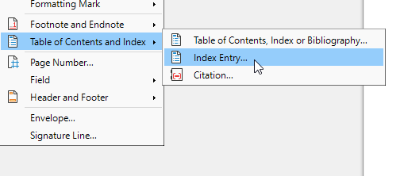
dual column glossary. Need to insert “index entry” to expand it

This is a footnote and can put a <link> here to click
This is a footnote and can put a <link> here to click
This is a footnote and can put a <link> here to click
This is a footnote and can put a <link> here to click
This is a footnote and can put a <link> here to click
This is a footnote and can put a <link> here to click

