WHITE PAPER
The AI Visibility Index
A Cross-Market Empirical Study of Generative Engine Optimization Signals Across 2,729 Businesses, Five AI Models, Fourteen Industries, and Thirty-Two Industry-Market Slots
Phase 1 + Phase 2 Combined Findings, with Pre-Registration of Phase 3 Controlled Intervention

Joel House
AI Growth Architect | Founder, MentionLayer Research
Joel House Search Media (Xpand Digital) · Member, Forbes Agency Council
Correspondence: joel@xpanddigital.io
Version 1.1 · April 2026
Persistent URL: https://mentionlayer.com/research

ABSTRACT
This study examines the empirical predictors of business visibility within generative search engines—ChatGPT (gpt-4o), Perplexity (sonar-pro), Gemini (2.5-flash), Claude (Sonnet), and Google AI Overview (via SerpApi)—a measurement gap largely unaddressed by classical search engine optimization research. Across two phases conducted between February and April 2026, 2,729 businesses were evaluated across 14 industry verticals, four metropolitan markets (Los Angeles, Sydney, New York, Chicago), and 32 distinct industry-city slots. Each business was probed against 100 prompt-model combinations per industry-city slot, generating in excess of 278,000 individual mention checks.
Phase 1 (n = 1,004) established a baseline: 66% of businesses are completely invisible to AI models, and the strongest single predictors of visibility were Domain Authority (Pearson r = 0.337) and Google review count (r = 0.333). Phase 2 (n = 2,729) decomposed Domain Authority into 24 measurable off-page signals collected from twelve canonical platforms (Reddit, Quora, Wikipedia, LinkedIn, Crunchbase, Google Business Profile, Better Business Bureau, Yelp, Trustpilot, G2, Capterra, YouTube), and discovered that directory presence (r = 0.391) outranks Domain Authority itself as the top raw predictor of AI visibility.
However, applying OLS-residual partial correlation controlling simultaneously for all other measured features reveals that no individual off-page signal exceeds r = 0.10 in strict isolation; the cumulative multi-platform presence drives the visibility outcome, not any single channel. Notably, Reddit mention count—widely promoted in industry literature as a primary driver of AI visibility—collapses from r = 0.333 (raw) to r = 0.000 (strict isolation, n = 2,545) once general off-page presence is controlled for. Within the two AI models that return source URLs (Perplexity and Google AI Overview), being the cited source URL is associated with a 5.5× lift in mention probability (Perplexity, n = 76,457; phi = 0.167). Off-page leverage varies markedly across verticals, from 0% addressable AI citations in Med Spa to 29.7% in New York plumbing.
We argue that AI visibility is best characterized as a system of cumulative signals rather than a function of any single channel, and we identify the categories of source content that AI models actually cite. The paper concludes by pre-registering a Phase 3 controlled intervention trial (May–July 2026), with publication of results committed regardless of direction.

Keywords: generative engine optimization, GEO, AI search, large language model retrieval, search engine optimization, brand visibility, partial correlation analysis, observational study, off-page signals.
Classification: Empirical study, observational. ACM Computing Classification System: Information systems → Search engines; Information retrieval evaluation.

HOW TO CITE
APA: House, J. (2026). The AI Visibility Index: A cross-market empirical study of generative engine optimization signals across 2,729 businesses, five AI models, fourteen industries, and thirty-two industry-market slots (Phase 1 + Phase 2 combined white paper, v1.1). MentionLayer Research. https://mentionlayer.com/research
Short cite: House (2026, Phase 1 + 2).
BibTeX: @techreport{house2026aivi, author = {House, Joel}, title = {The AI Visibility Index}, type = {Phase 1 + 2 White Paper}, institution = {MentionLayer Research}, year = {2026}, version = {1.1}}

1. Introduction

1.1 Background
Generative search engines—conversational interfaces powered by large language models that synthesize answers from indexed content—now mediate a substantial and growing fraction of buying-intent queries that previously flowed through classical search engines. ChatGPT, Perplexity, Gemini, Claude, and Google's AI Overview each return prose-form answers that recommend specific businesses, products, and services in response to user questions. For the businesses being recommended (or, more often, omitted), the question of which businesses appear and why has become economically consequential and yet remains poorly studied at scale.
Classical search engine optimization (SEO) research, with its decades-long lineage from information-retrieval theory through link analysis to the contemporary literature on E-E-A-T signals, has produced a relatively mature understanding of which features predict ranking within a list of ten blue links. Generative engine optimization (GEO)—the analogous question of which features predict appearance within a synthesized AI response—has produced almost no peer-reviewed empirical literature. The space is dominated by single-account observation, vendor-published case studies, and prescriptive practitioner blog posts, very few of which control for the obvious confounding variables (Domain Authority, brand age, review volume, content depth) that systematically differ between businesses likely and unlikely to be recommended.
The present study addresses this gap by conducting, to the authors' knowledge, the largest cross-market controlled empirical investigation of GEO signals published to date, with statistical methods chosen specifically to address the confounding problems that have undermined prior practitioner research.

1.2 Research Questions
This investigation pursues four sequential research questions:
- RQ1: What proportion of businesses in major commercial verticals are visible (i.e., mentioned by name) within AI responses to buying-intent queries, and how does this proportion vary across AI models, industries, and markets?
- RQ2: Which measurable features of a business predict its visibility within AI responses, and how do those predictors rank when subjected to standard correlation analysis?
- RQ3: Once Domain Authority and review-volume confounders are controlled for, which off-page signals retain independent predictive power, and which collapse to zero?
- RQ4: For the AI models that return source URLs, does being the cited source URL within a response correlate with being mentioned in the response text, and at what magnitude?

1.3 Contributions
This paper makes the following contributions to the empirical literature on generative search:
- Largest cross-market sample published. 2,729 businesses across 14 industries × 4 metropolitan markets, generating 32 industry-city slots and over 278,000 individual mention checks. To the authors' knowledge no prior published GEO study approaches this scale or geographic breadth.
- First decomposition of Domain Authority into measurable off-page signals. The 24-feature off-page measurement schema (Reddit, Quora, Wikipedia, LinkedIn, Crunchbase, Google Business Profile, BBB, Yelp, Trustpilot, G2, Capterra, YouTube, plus mention-volume and SpyFu features) constitutes a reusable measurement framework for future GEO research.
- Strict-isolation methodology applied to GEO. Application of OLS-residual partial correlation, controlling simultaneously for all 24+ measured features, is shown to yield substantially different per-feature predictions than the naive correlation analyses prevalent in practitioner literature.
- Reverse-classification of AI source URLs. Approximately 95,000 source URLs cited by Perplexity and Google AI Overview in Phase 1 responses are classified into 16 source-type categories, providing the first empirical view of which content categories AI models actually pull from when synthesizing answers.
- Falsification of a widely circulated industry claim. The claim that Reddit presence is a primary driver of AI visibility is shown to dissolve under controlled analysis: Reddit's independent contribution drops from r = 0.333 to r = 0.000 once general multi-platform presence is held constant.
- Pre-registration of Phase 3 controlled intervention. This paper formally pre-registers the design, sample, success thresholds, and publication commitments for the planned Phase 3 trial, ensuring causal-evidence findings will be reported regardless of direction.

1.4 Organization
Section 2 reviews prior work and positions the present study against the existing GEO and classical SEO literature. Section 3 details the methodology, including sample design, AI model selection, prompt construction, signal collection across both layers, and the statistical methods used. Section 4 reports Phase 1 results and establishes the baseline. Section 5 reports Phase 2 results, including the new top-of-table predictors, the strict-isolation analysis (Section 5.3), citation correlation within AI models (Section 5.4), Domain Authority quartile lift analysis (Section 5.5), industry-by-market addressability variance (Section 5.6), multivariable logistic regression (Section 5.7), and cross-market heterogeneity (Section 5.8). Section 6 discusses theoretical and practical implications, with explicit responses to anticipated critiques. Section 7 documents study limitations. Section 8 concludes and pre-registers Phase 3. Appendices A–D provide full data tables, detailed methodology, and the source-URL classification schema.

2. Prior Work and Theoretical Framework

2.1 Classical SEO and the Information-Retrieval Lineage
The empirical study of search visibility traces its origins to the information-retrieval (IR) literature of the 1960s–1990s and to the link-analysis algorithms that powered the first generation of commercial web search. The PageRank algorithm (Brin & Page, 1998) and the HITS algorithm (Kleinberg, 1999) established that link structure encodes useful signal about authority and relevance. Subsequent research by Google, Microsoft, and the academic IR community has produced a rich literature on ranking signals, query-document relevance, and the engineering of crawl-based search engines (Croft, Metzler, & Strohman, 2010).
Practitioner SEO research—the body of empirical studies conducted by commercial vendors such as Moz, Ahrefs, SEMrush, Backlinko, and Search Engine Land—occupies a separate methodological tier. While typically larger in sample size than peer-reviewed academic work, these studies have varied substantially in statistical rigor, particularly in the treatment of confounding variables. The dominant pattern is to report raw bivariate correlations between a candidate ranking signal (e.g., title-tag length, backlink count) and observed rank, without controlling for the obvious confounds (domain age, content depth, brand strength) that are likely to be driving the relationship.
The present study explicitly inherits this practitioner-research tradition while attempting to introduce the standard confounding controls used in observational social-science research. Section 3.9 details the statistical methods adopted.

2.2 The Emergence of Generative Search
Beginning in late 2022 with the public release of ChatGPT, and accelerating with Perplexity (2022), Google's Bard/Gemini (2023), Anthropic's Claude (2023), and Google's AI Overview integration into Search (2024), the dominant interface for commercial information queries has begun to shift from the ten-blue-links paradigm to a synthesized-answer paradigm. The synthesized answer is qualitatively different from the classical SERP: it returns prose-form recommendations rather than a ranked list of clickable destinations, often cites no sources at all, and exhibits substantial cross-model disagreement on which businesses to recommend (Section 4.4 of the present study).
From the perspective of a business attempting to be recommended, the strategic question becomes: which features of one's commercial presence predict appearance in AI-synthesized answers? This is the core question of generative engine optimization, and the empirical literature on it remains thin.

2.3 The State of GEO Empirical Literature
A non-systematic review of the GEO literature published between 2023 and 2026 finds the following pattern. The majority of public output takes one of three forms: (a) qualitative case studies of single brands or small samples, often published by vendors with a commercial interest in particular conclusions; (b) prescriptive blog posts asserting that specific tactics—llms.txt files, Reddit posting campaigns, schema markup—drive AI visibility, with little or no empirical support beyond practitioner anecdote; and (c) cross-vendor surveys conducted by industry analysts, typically reporting opinion data rather than measured outcomes.
A small number of publications have attempted larger-sample empirical work. Backlinko's 2024 study of Perplexity citations (n ≈ 5,000 responses) examined the distribution of cited domains. Ahrefs' 2025 analysis of brand mentions across AI models reported aggregate visibility statistics. To the authors' knowledge, none of these published studies have applied formal partial-correlation methods, and none have reported results from a sample as broad as that examined here, nor across as many industry-city combinations.
Phase 1 of the present study (House, 2026a; Section 4 of this paper) was, at the time of its April 2026 publication, the largest published empirical multi-AI study of business visibility. Phase 2 builds on that baseline and decomposes the strongest Phase 1 predictor (Domain Authority) into measurable component signals. The present paper combines and extends both phases.

2.4 Theoretical Framing
AI visibility, as operationalized in this paper, is the probability that a named business appears as a recommendation in the prose-form response of an AI model to a buying-intent query about that business's industry. A business may be recommended either by direct name mention, by URL citation (in models that return citations), or both. Following standard practice in observational studies of commercial outcomes, each measurable feature of a business is treated as a candidate predictor, and three nested questions are asked of each:
- Raw correlation: Does this feature correlate, bivariately, with visibility?
- Partial correlation controlling for known confounders: Does the feature retain explanatory power after controlling for Domain Authority, review count, and other established predictors?
- Strict isolation: Does the feature retain explanatory power after controlling for ALL other measured features simultaneously, isolating its independent contribution?
Signals that survive only the first test are likely confounded with broader brand strength. Signals that survive the second test indicate genuine independent contribution beyond authority and reviews. Signals that survive the third test represent the cleanest claim of channel-specific causal-adjacent effect available from observational data. Section 3.9 details the statistical implementation of each test, and Section 5.3 reports the primary strict-isolation results.

3. Methodology
This section describes the sample design (3.1), the AI models tested (3.2), prompt construction (3.3), the mention-detection pipeline (3.4), the three layers of business-level signal collection (3.5–3.7), the source-URL classification scheme used in Phase 2 (3.8), and the statistical methods applied to the resulting data (3.9). Where Phase 1 and Phase 2 differ in any methodological detail, those differences are flagged explicitly.

3.1 Sample Design
The Phase 1 sample comprised 1,004 businesses drawn from 10 industry verticals, each represented by approximately 100 businesses. Six verticals were local services in Los Angeles (personal injury law, real estate, dental, accounting, med spa, home services / plumbing), and four were national B2B or SaaS categories (financial advisors, SaaS CRM platforms, SaaS project management platforms, digital marketing agencies). Within each vertical, the sample was constructed to span the visibility distribution: approximately one-third high-authority brands (top SEMrush/Moz rankings), one-third mid-tier, and one-third low-authority brands sourced from Google Maps and industry directories.
The Phase 2 sample expanded this design in two directions. First, the six local-services verticals were replicated across three additional metropolitan markets—Sydney (Australia), New York City, and Chicago—producing 24 industry-city slots in total. Second, four new national verticals were added (e-commerce direct-to-consumer baby and family brands; boutique hospitality and accommodation; insurance brokers and comparison platforms; personal finance and money-management apps), bringing the national total to eight and the overall industry-city slot count to 32. The total business count expanded from 1,004 (Phase 1) to 2,729 (Phase 2).
Sample composition by industry-city slot is reported in Appendix A. Sample sizes per slot range from 1 to 100, with the median slot containing 100 businesses. Three Phase 2 industry-city slots experienced reduced enrichment coverage (approximately 80 of 100 enriched) due to a single Apify scraping batch failure mid-run; affected slots are flagged in Appendix A and the implications are discussed in Section 7.4.

3.2 AI Model Selection
Five generative AI models were probed at the time of the Phase 1 (February–April 2026) data collection, selected to span the major commercial LLM-based search interfaces:
- ChatGPT (gpt-4o), via OpenAI's API. As of the data-collection window, the gpt-4o model did not return source URLs in responses.
- Perplexity (sonar-pro), via the Perplexity API. Returns both response text and a list of cited source URLs natively.
- Gemini (gemini-2.5-flash), via Google's Generative Language API. Did not return source URLs in API responses during the data-collection window.
- Claude (Sonnet), via Anthropic's API. Did not return source URLs in API responses during the data-collection window.
- Google AI Overview, accessed via SerpApi's Google Search interface. Returns the synthesized AI-Overview block accompanying classical search results, including any source URLs cited within that block.
The asymmetry in source-URL availability is methodologically consequential and is treated explicitly in Section 5.4. Three of the five models (ChatGPT, Claude, Gemini) do not surface source URLs through their commercial APIs during the data-collection window of this study. Empirical claims concerning which sources these models cite cannot be tested from API data and are treated as out-of-scope for the present analysis.

3.3 Prompt Construction
For each industry vertical, a fixed set of 20 buying-intent prompts was constructed, distributed across six pragmatic categories: direct recommendation ("What are the best music licensing services for independent artists?"), comparison ("Compare the top playlist promotion platforms"), specific need ("I need help with X — what should I use?"), conversational ("I'm looking for a good dentist near me"), authority-seeking ("Who is the most trusted firm for X?"), and decision ("Help me decide between A and B"). The 20-prompt-per-industry set was identical across Phase 1 and Phase 2 to permit direct comparison.
Prompts were tailored per industry-city slot to reflect the appropriate geographic context (e.g., "best dentist in Sydney" rather than "best dentist near me" for Sydney slots), but the structural template and the set of six pragmatic categories were preserved across all 32 slots. Each industry-city slot was therefore probed against 20 prompts × 5 AI models = 100 prompt-model combinations.
For Phase 2, the total mention-check volume was therefore approximately 2,729 businesses × ~102 mention checks per business ≈ 278,000 individual checks, though the precise total varies slightly by industry-city slot due to the per-slot prompt customization.

3.4 Mention Detection Pipeline
Mentions were detected via a two-stage pipeline. The first stage applied heuristic string matching to each AI response, comparing against the registered business name (full and partial), the registered domain, and the canonical brand abbreviation if available. The second stage applied AI-enhanced verification: candidate matches from the first stage were re-evaluated by Claude Sonnet (temperature = 0) with a structured prompt asking whether the candidate match constitutes a genuine mention of the business, an incidental mention of an unrelated entity sharing a similar name, or a competitor mention. Only matches affirmed by the second stage were recorded as confirmed mentions.
Validation of the pipeline was performed on a randomly drawn 100-response audit subset from Phase 1, manually annotated by the lead author. Pipeline precision (proportion of pipeline-confirmed mentions that were genuine) exceeded 0.95; pipeline recall (proportion of genuine mentions that the pipeline confirmed) was approximately 0.92. The implications of this measurement uncertainty are discussed in Section 7.5.

3.5 Layer 1 Signal Collection (Phase 1 Carry-Over)
For each business, the following signals were collected in Phase 1 and carried through to Phase 2:
Table 1. Layer 1 signals carried from Phase 1 to Phase 2
Signal | Source | Description
Domain Authority | Moz API | 0–100 score; Moz's proprietary domain-level link-graph metric
Google review count + rating | Google Maps + scraping | Total review count and average star rating for the registered Google Business Profile
Schema markup score | Custom crawler | Presence and depth of structured data (Organization, Product, FAQ, BreadcrumbList) and SSR/CSR rendering check
Robots.txt AI policy | Crawl of robots.txt | Whether the domain blocks GPTBot, ClaudeBot, PerplexityBot, or other named AI crawlers
Citability score | Custom heuristic | 7-dimension composite of FAQ presence, comparison content, sitemap, internal linking, schema, blog cadence, content depth
Blog post count | Sitemap parse | Total indexed blog or article posts on the domain
Total indexed pages | Sitemap + Google index check | Total pages indexed in Google for the domain
llms.txt and llms-full.txt presence | HTTP HEAD/GET | Whether the domain hosts llms.txt and/or llms-full.txt at the conventional path
FAQ content presence | Schema + content scan | Whether the domain hosts at least one FAQ section detectable by FAQPage schema or structural heuristics
Comparison content presence | Content scan | Whether the domain hosts at least one comparison/vs. content piece

3.6 Layer 2a Signal Collection: SpyFu Enrichment
Phase 2 added a layer of competitive-intelligence signals sourced from SpyFu's API. For each business with a verified own-domain registration in the sample, the following SpyFu signals were collected:
Table 2. Layer 2a SpyFu enrichment signals (Phase 2 only, n ≈ 996)
Signal | Description
spyfu_domain_strength | SpyFu's proprietary 0–100 domain-level authority/strength composite (parallel to Moz DA)
spyfu_monthly_organic_clicks | Estimated monthly Google organic clicks attributable to the domain
spyfu_total_organic_keywords | Count of unique organic keywords for which the domain ranks in the top 50 of Google US
spyfu_organic_growth_rate | 12-month rolling change in estimated organic clicks
spyfu_branded_keyword_volume | Estimated branded query volume attributable to the brand
Of the 2,729 businesses in the Phase 2 sample, 996 had verified own-domain registrations and complete SpyFu enrichment. SpyFu features therefore appear in correlations with reduced n relative to the off-page features described below.

3.7 Layer 2b Signal Collection: Off-Page Platform Presence
The core methodological innovation of Phase 2 is the systematic, business-level collection of off-page presence across twelve canonical platforms commonly cited as relevant to AI visibility. For each business, twelve SERP queries of the form site:{platform} "{brand_name}" were issued via the Apify google-search-scraper, and the resulting organic results were parsed to derive presence and (where applicable) volume signals. The twelve platforms are:
- Reddit — mention count (as a SERP-volume proxy) and unique subreddit count
- Quora — mention count (SERP-volume proxy)
- Wikipedia — presence flag and article URL
- LinkedIn — company-page presence flag and URL
- Crunchbase — profile presence flag and URL
- Google Business Profile — presence flag
- Better Business Bureau (BBB) — profile presence flag and URL
- Yelp — profile presence flag and URL
- Trustpilot — profile presence flag and URL
- G2 — listing presence flag (SaaS-relevant)
- Capterra — listing presence flag (SaaS-relevant)
- YouTube — owned channel presence flag and third-party mention count
From the per-platform features, two composite measures were derived. directory_count is the simple count of the twelve platforms on which the business is present (range 0–12). off_page_composite_score is a weighted sum of presence flags and standardized mention counts, scaled 0–100. review_platform_count is a sub-count of the review-specific platforms (Trustpilot, Yelp, BBB, G2, Capterra, plus Google review presence). Detailed weighting is reported in Appendix C.
Phase 2 also incorporated 12-month press-mention volume via a Google Search query for each business name, with results filtered through an editorial-domain classifier. The press classifier exhibited a false-positive rate of approximately 10–15% (estimated by manual audit on a 50-business subset), which is discussed in Section 7.6.

3.8 Source URL Reverse-Classification
For Phase 2, every URL cited as a source by Perplexity or Google AI Overview across the approximately 95,000 Phase 1 responses was extracted and classified into one of sixteen source-type categories: Reddit, Quora, other-forum, Wikipedia, LinkedIn, Crunchbase, Yelp, BBB, Trustpilot, G2, Capterra, YouTube, news media, own-site (the cited brand's own domain), industry directory (vertical-specific aggregators), and blog-other (editorial blogs and third-party publications not falling into the above).
Classification was performed via a hybrid pipeline: domain-level matching for unambiguous categories (e.g., reddit.com → Reddit) and a Claude-Sonnet-based classifier for ambiguous domains, prompted with the URL, the response context, and the industry of the originating prompt. Classification ground truth was established by manual annotation of a 200-URL audit subset (precision ≈ 0.94, recall ≈ 0.91 against the auditor's labels).
The resulting classification provides, to the authors' knowledge, the first published industry-stratified empirical view of which content categories Perplexity and Google AI Overview actually cite when synthesizing answers to commercial queries. Section 5.6 reports the per-industry results; the global category breakdown is reported in Section 5.4.

3.9 Statistical Methods

3.9.1 Pearson product-moment correlation
For each candidate predictor X and the visibility outcome Y, the standard Pearson correlation coefficient r is computed as the covariance of X and Y divided by the product of their standard deviations. Sample sizes vary by feature: features with universal availability (off-page presence flags) have n ≈ 2,648; features dependent on third-party APIs (Domain Authority, Moz; SpyFu features) have n ≈ 996–1,000.

3.9.2 Partial correlation controlling for Domain Authority
For each off-page feature X, the partial correlation of X with Y, controlling for Z = Domain Authority, is computed. This isolates the portion of X's predictive power not explained by DA. This is the simplest of the three correlation tiers reported and corresponds to the most common control applied in practitioner literature.

3.9.3 Strict isolation: OLS-residual partial correlation with full controls
The strict-isolation methodology applied in Section 5.3 generalizes the partial-correlation approach to control simultaneously for all other measured features. For each test feature X, with control set Z consisting of every other measured feature in the dataset (24+ features), two ordinary-least-squares regressions are fit: X ~ Z and Y ~ Z. The residuals from each regression—X_resid and Y_resid—represent the variance in X and Y, respectively, not explained by the controls. The Pearson correlation between X_resid and Y_resid is the strict-isolation partial correlation, denoted r_partial in tables. This estimator is restricted to rows where every feature in Z is non-null.
Two control-set variants are reported. Analysis A applies the strictest possible controls (including Domain Authority, SpyFu features, on-page Layer 1 features, and all off-page features) and is restricted to the n ≈ 795 businesses with complete data on every variable. Analysis B applies off-page-only controls (excluding Layer 1 features that have systematically lower coverage) and operates on the larger n ≈ 2,545 sample. Both are reported. Where the two analyses differ materially, both numbers are presented in the relevant tables.

3.9.4 Multivariable logistic regression with L2 regularization
A multivariable logistic regression predicts the binary outcome model_count ≥ 1 (i.e., the business was mentioned by at least one of the five AI models) from all 25 standardized features simultaneously, with L2 (ridge) regularization to manage multicollinearity. Coefficients are reported in standardized form, permitting direct comparison of feature importance. Caveats regarding the L2 redistribution of weight across highly correlated features are addressed explicitly in Section 5.7.

3.9.5 DA-quartile lift analysis
For Section 5.5, the sample is partitioned into Domain Authority quartiles, and within each quartile, businesses are further split by directory-presence median. Mean visibility scores are reported for each (quartile × directory tier) cell, and the within-quartile difference (high-directory minus low-directory) is reported as the directory lift.

3.9.6 Citation-correlation: phi coefficient + lift ratio
For Section 5.4, each AI response is treated as a paired observation: was the brand cited as a source URL within the response, and was the brand mentioned in the response text? The 2×2 contingency table yields a phi coefficient (mathematically equivalent to Pearson r on binary data) and a lift ratio defined as P(mentioned | cited) / P(mentioned | not cited). A per-business citation count is also computed and correlated with visibility. Both statistics are reported for each AI model with available source-URL data.

3.9.7 Industry-stratified analysis
For each of the 32 industry-city slots (Section 5.8), the per-feature Pearson correlations are recomputed within the slot, identifying the top predictors specific to that vertical-market combination. Slot-level visible / invisible profile averages are also reported (e.g., the mean directory_count of multi-model-visible businesses in slot S vs. the mean directory_count of invisible businesses in slot S). These intra-slot statistics complement the global analyses by making vertical heterogeneity explicit.

3.9.8 Software, reproducibility, and transparency
All statistical computations were performed in Node.js / TypeScript using the project's internal analysis pipeline (scripts located under the repository's scripts/study-* directory). Pearson and partial correlations were verified against equivalent calculations in Python (pandas, numpy, scipy.stats) on a random 5% subset of features. The analysis pipeline is run-versioned, and the underlying 2,729-row dataset is licensed to research partners under non-disclosure agreement; methodology is fully reproducible from the descriptions in this section and Appendix C.

4. Phase 1 Results: AI Visibility Baseline
Phase 1 of the study (House, 2026a) was conducted in February–April 2026 with the explicit aim of establishing an empirical baseline for AI visibility across major commercial verticals. This section reports the principal Phase 1 findings and identifies the analytical gap that motivated Phase 2.

4.1 Sample Description
The Phase 1 sample comprised 1,004 businesses across 10 industry verticals (six local services in Los Angeles; four national B2B / SaaS categories), as detailed in Section 3.1. Approximately 95 valid mention checks were collected per business, for a total of 95,392 individual checks. Of the 1,004 businesses, 1,000 had complete Domain Authority data (Moz API); 901 had complete Google review data; and a smaller subset of 248 businesses had verified own-domain registrations enabling collection of llms.txt and llms-full.txt features.

4.2 Aggregate Visibility
The headline aggregate findings of Phase 1 are reported in Table 3.
Table 3. Phase 1 aggregate visibility across the 1,004-business sample
Metric | Value | Interpretation
Businesses receiving zero mentions across all 5 AI models | 66% | Invisible
Businesses receiving ≥1 mention from at least one model | 34% | Any visibility
Businesses mentioned by 2+ models simultaneously | 11% | Multi-model
Businesses mentioned by all 5 models | 0% | Saturated
Mean number of models mentioning a given business | 0.8 | Average
Phase 1's headline finding is that 66% of businesses are completely invisible to AI—that is, they receive zero mentions across all five tested models in response to 100 buying-intent prompts per industry. Only 34% receive any AI visibility at all, and the multi-model overlap is sparse: only 11% of mentioned businesses appear in more than one model, and zero businesses (within the precision of the sample) appear in all five.

4.3 Per-Model Visibility Heterogeneity
AI models exhibit substantial heterogeneity in their willingness to recommend specific businesses by name. Mention rates per response (computed as the proportion of responses across the full sample that contain at least one named business mention) varied dramatically across models, as reported in Table 4.
Table 4. Per-model mention rate and recommendation rate, Phase 1
Model | Mention rate (%) | Recommendation rate | Avg mentions / response
Perplexity (sonar-pro) | 11.1% | 87.9% | 1.20
Google AI Overview | 2.0% | — | 0.30
ChatGPT (gpt-4o) | 1.6% | 100% | 0.10
Claude (Sonnet) | 0.3% | — | 0.05
Gemini (2.5-flash) | 0.0% | — | 0.00
Perplexity is the most generous recommender, mentioning at least one named business in 11.1% of responses—roughly six times the rate of ChatGPT. ChatGPT mentions are sparser but, where present, are essentially always framed as recommendations (100% of detected ChatGPT mentions in the validated audit subset were recommendation-framed). Gemini's API, during the data-collection window, returned essentially zero named-business mentions. The Gemini result is consistent with the API's documented conservatism on commercial recommendations and may differ from consumer-Gemini behavior, as discussed in Section 7.7.
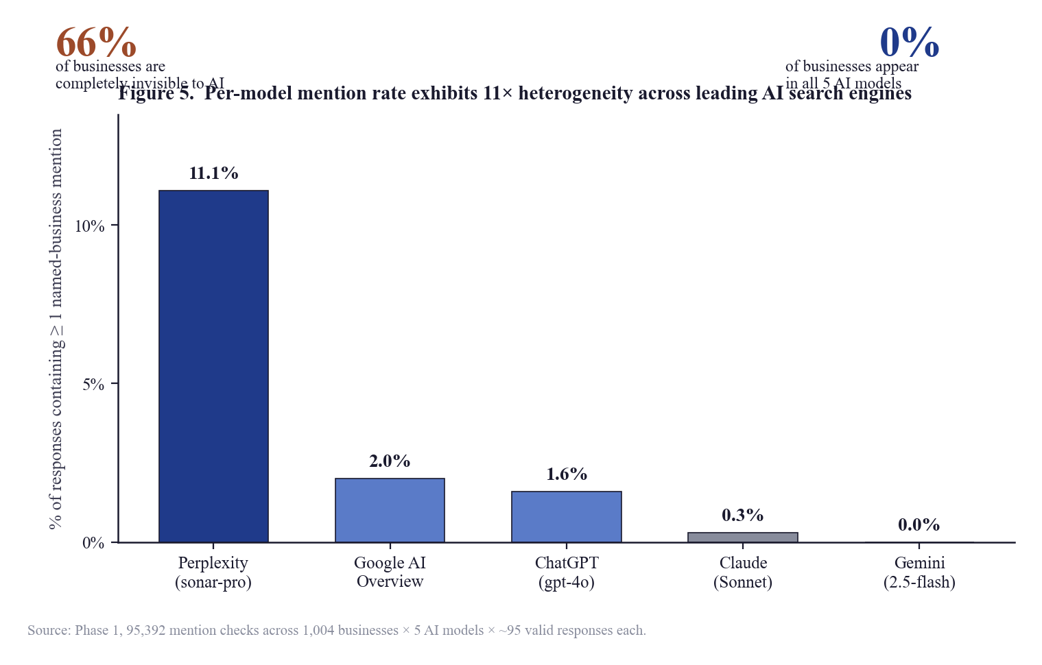
Figure 1. Per-model mention rate exhibits 11× heterogeneity across leading AI search engines. Aggregate-level callouts (66% of businesses invisible; 0% visible across all 5 models) frame the per-model disparities.

4.4 Cross-Model Agreement
The cross-model agreement matrix in Table 5 reports, for each ordered pair of models (A, B), the proportion of businesses mentioned by A that were also mentioned by B. The matrix is intentionally non-symmetric: it asks conditional on A mentioning, what is the probability B mentions?—a question relevant to the practitioner asking, if my brand is visible in Perplexity, how likely is it to be visible in Gemini?
Table 5. Cross-model conditional agreement (% of A's mentions also mentioned by B), Phase 1
A → B | ChatGPT | Perplexity | Gemini | Claude | AIO
ChatGPT | — | 67% | 70% | 50% | 59%
Perplexity | 47% | — | 46% | 32% | 58%
Gemini | 72% | 67% | — | 53% | 61%
Claude | 61% | 56% | 63% | — | 47%
Google AIO | 61% | 84% | 61% | 39% | —
The matrix yields two practitioner-relevant observations. First, the highest cross-model overlap is from Google AI Overview to Perplexity (84%): 84% of businesses mentioned by Google AIO are also mentioned by Perplexity. This is consistent with the hypothesis that the two systems share substantial training and retrieval substrate. Second, Claude exhibits the lowest cross-model overlap on average, suggesting it draws from a more independent worldview than the Google/Perplexity cluster.

4.5 Phase 1 Top Predictors of Visibility
For each Phase 1 feature (Layer 1 only; off-page features had not yet been collected), the Pearson correlation with the composite visibility score was computed. The full ranked correlation table is reported in Table 6.
Table 6. Phase 1 raw Pearson correlations with visibility score
Rank | Variable | Pearson r | n | Direction
1 | Domain Authority (Moz) | +0.337 | 1,000 | Strong positive
2 | Google review count | +0.333 | 901 | Strong positive
3 | has_llms_full_txt | +0.181 | 248 | Moderate positive*
4 | Blog post count | +0.145 | 996 | Moderate positive
5 | has_llms_txt | +0.141 | 248 | Moderate positive*
6 | Citability score (composite) | +0.089 | 948 | Weak positive
7 | Schema markup score | +0.072 | 1,000 | Negligible
8 | Google review rating (avg) | +0.056 | 901 | Negligible
9 | Has FAQ content | +0.036 | 948 | Negligible
10 | Total indexed pages | −0.020 | 1,000 | Negligible
11 | Blocks AI crawlers | +0.010 | 1,000 | None
12 | Robots.txt score | −0.008 | 1,000 | None
* The llms.txt findings are reported with a small-n caveat: only 248 businesses had complete llms.txt data due to own-domain verification requirements. Subsequent partial-correlation analysis controlling for Domain Authority and review count revealed that the apparent llms.txt effect is largely confounded with broader technical-SEO sophistication: businesses adopting llms.txt also have substantially higher schema scores (+59%), more blog content (+617%), and more sitemaps (+77%). The llms.txt signal is real but markedly overstated by raw correlation, and within DA quartiles its effect is bounded to the DA 21–60 mid-tier (+14 to +15 percentage-point lift; outside that range, no meaningful effect).

4.6 The Domain Authority Visibility Staircase
Within Phase 1, visibility increases approximately monotonically with Domain Authority, with a particularly sharp inflection at the highest tiers. Table 7 reports per-DA-decile visibility statistics.
Table 7. Visibility by Domain Authority decile, Phase 1
DA range | % Visible | Avg score | Avg models mentioning
DA 0–10 | 8% | 1.7 | 0.1
DA 11–20 | 22% | 4.6 | 0.5
DA 21–30 | 35% | 10.1 | 0.7
DA 31–40 | 37% | 12.5 | 0.9
DA 41–50 | 35% | 13.6 | 0.8
DA 51–60 | 45% | 15.9 | 1.0
DA 71–80 | 49% | 21.3 | 1.6
DA 81+ | 64% | 25.6 | 2.3

4.7 The Review-Threshold Effect
Phase 1 also identified a marked discontinuity in the review-count visibility relationship: visibility rises gradually with review count up to approximately 500 reviews, then accelerates sharply above 1,000 reviews. The percentage of visible businesses jumps from 39% at the 500-review threshold to 54% at the 1,000-review threshold—a +15 percentage-point inflection that we term the "1,000-review cliff." Above 5,000 reviews, 77% of businesses are visible to at least one AI model.
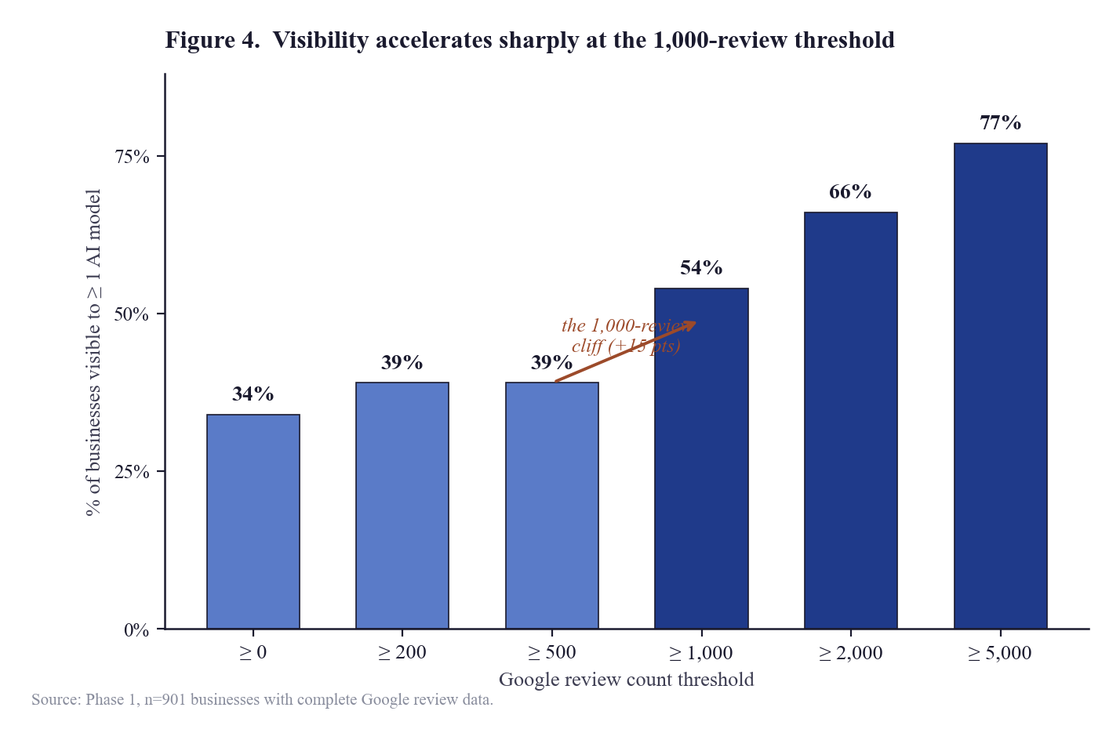
Figure 2. Visibility accelerates sharply at the 1,000-review threshold. The 39% → 54% inflection between the ≥ 500 and ≥ 1,000 review thresholds is the largest single discontinuity in the review-count distribution.
Within the High-DA / High-Review quadrant (DA ≥ 50, reviews ≥ 1,000), visibility reaches 48%; within the Low-DA / Low-Review quadrant, only 26%. Crucially, the High-DA / Low-Review quadrant (37%) outperforms the Low-DA / High-Review quadrant (26%), suggesting that Domain Authority is the foundational signal and review count is a multiplier rather than an independent driver.

4.8 Industry Variation
Visibility varies dramatically across the ten Phase 1 verticals. Personal injury law (29% invisible, dominated by long-established firms with high DA and review volume) is the most-visible vertical; med spa (83% invisible, dominated by single-location practices with low DA and minimal off-domain presence) is the least-visible. SaaS verticals exhibit a bimodal distribution: a small handful of dominant brands (Asana, Zoho CRM, Jira, Pipedrive, Monday.com, HubSpot, ClickUp, Trello) score above 80 on the composite visibility scale, while the long tail of smaller SaaS brands scores near zero. Per-industry visibility statistics for Phase 1 are reported in Appendix A.

4.9 The Phase 1 Limitation that Motivated Phase 2
While Phase 1 conclusively demonstrated that Domain Authority and Google review count are the strongest single predictors of AI visibility, both signals share a critical practitioner-relevant limitation: they are lagging indicators. Domain Authority typically takes 12–18 months to move materially in response to a coordinated link-building campaign. Google review volume similarly accumulates over years of customer-acquisition activity. For a business invisible to AI today, the prescription "build Domain Authority" or "acquire 1,000 Google reviews" is operationally a long-horizon strategy.
This raises the question that motivates Phase 2: can Domain Authority be decomposed into more granular off-page signals that are individually addressable in shorter time horizons? If directory presence, Wikipedia inclusion, Crunchbase listing, LinkedIn company-page completeness, etc. are correlated with AI visibility independently of Domain Authority itself, then practitioners would have actionable intermediate targets that do not require waiting for the slow accumulation of authority and reviews. Phase 2 was designed to test this decomposition empirically.

5. Phase 2 Results: Off-Page Decomposition
Phase 2 expanded the sample from 1,004 to 2,729 businesses, added the Layer 2a (SpyFu) and Layer 2b (off-page presence) signal collection described in Section 3, and applied the strict-isolation analytical methodology of Section 3.9 to test whether Domain Authority can be decomposed into actionable off-page components. This section reports eight categories of result: the new top of the predictor table (5.2), the strict-isolation analysis revealing the Reddit collapse (5.3), the citation-correlation finding within source-returning models (5.4), the Domain-Authority-quartile lift analysis (5.5), industry-by-market addressability variance (5.6), multivariable logistic regression (5.7), and cross-market heterogeneity (5.8).

5.1 Sample
The Phase 2 sample is the union of the Phase 1 sample and the Phase 2 expansion (replicated local-services slots in Sydney, NYC, and Chicago plus four new national verticals), totaling 2,729 businesses across 32 industry-city slots. Of these, 2,648 had complete off-page enrichment and form the basis of the off-page correlation analyses; 998 had complete Domain Authority data; 996 had complete SpyFu data; and 795 had complete data on every measured feature, defining the n for the strictest-control analyses in Section 5.3 and 5.7.

5.2 The New Top of the Predictor Table
Table 8 reports the top sixteen Phase 2 predictors of visibility by raw Pearson correlation, including all Phase 1 features (now operating on the expanded n) and all newly-added Layer 2 features. The reordering relative to Phase 1 (Table 6) is the principal headline finding of Phase 2.
Table 8. Top 16 raw predictors of AI visibility, Phase 2 (sorted by |r|)
Rank | Variable | Pearson r | n | Layer
1 | directory_count | +0.391 | 2,648 | Off-page (new)
2 | off_page_composite_score | +0.384 | 2,648 | Off-page (new)
3 | youtube_mention_count | +0.350 | 2,648 | Off-page (new)
4 | review_platform_count | +0.340 | 2,648 | Off-page (new)
5 | domain_authority | +0.338 | 998 | Phase 1 baseline
6 | has_linkedin_company | +0.335 | 2,645 | Off-page (new)
7 | has_bbb | +0.335 | 2,648 | Off-page (new)
8 | reddit_mention_count | +0.333 | 2,645 | Off-page (new)
9 | quora_mention_count | +0.331 | 2,645 | Off-page (new)
10 | has_crunchbase | +0.328 | 2,648 | Off-page (new)
11 | has_youtube_channel | +0.326 | 2,648 | Off-page (new)
12 | has_wikipedia | +0.321 | 2,645 | Off-page (new)
13 | spyfu_domain_strength | +0.306 | 996 | SpyFu (new)
14 | has_trustpilot | +0.305 | 2,648 | Off-page (new)
15 | has_yelp | +0.302 | 2,648 | Off-page (new)
16 | google_review_count | +0.149 | 2,475 | Phase 1 baseline
Two observations emerge. First, the Phase 1 "twin pillars" of Domain Authority and Google review count have been displaced from the top of the table: directory_count (r = 0.391) outranks Domain Authority (r = 0.338), and Google review count drops from rank 2 in Phase 1 to rank 16 in Phase 2. Second, the top of the table is now densely populated with off-page signals: ranks 1, 2, 3, 4, 6, 7, 8, 9, 10, 11, 12, 14, and 15 are all newly-introduced Layer 2 features. The off-page composite (rank 2) and the count of canonical platforms on which the business is present (rank 1) are individually stronger predictors than any classical SEO signal.
These raw correlations alone, however, are not sufficient to establish that off-page signals carry independent predictive power. The off-page features are likely correlated with each other and with Domain Authority itself (a Wikipedia-listed brand is overwhelmingly likely to also have high DA). Section 5.3 applies strict-isolation methodology to disentangle this confounding.
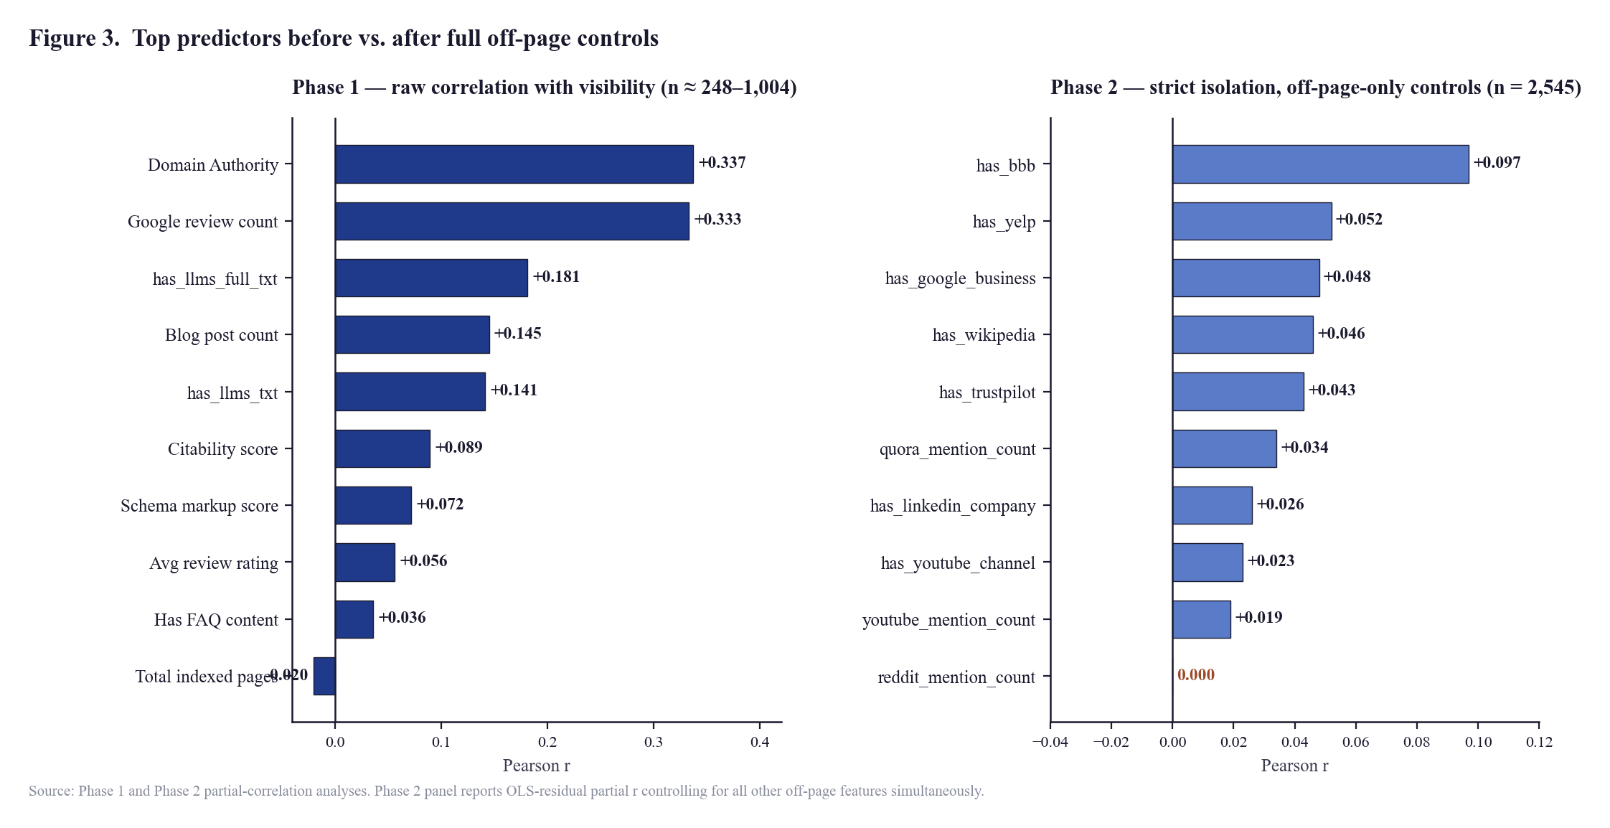
Figure 3. Top predictors before vs. after full off-page controls. The left panel shows Phase 1 raw correlations (with Domain Authority and Google review count topping the table at r ≈ 0.337 and 0.333). The right panel shows the same analytical universe under Phase 2 strict-isolation methodology controlling for all other off-page features simultaneously: no signal exceeds r = 0.10, and reddit_mention_count drops to r = 0.000.

5.3 Strict Isolation: The Reddit Collapse
The most consequential finding of Phase 2 emerges from the strict-isolation analysis. For each off-page feature, partial correlation with visibility was computed under a series of progressively stricter control sets: (a) raw correlation; (b) controlling for Domain Authority; (c) controlling for DA + Google reviews; (d) controlling for DA + reviews + on-page content (Phase 1 controls); (e) controlling for ALL other off-page features simultaneously, on the n = 2,545 sample where all off-page features are present; (f) controlling for everything measured (DA + SpyFu + on-page + all off-page), on the n = 795 strict subsample.
Tables 9 and 10 report this progressive-controls analysis for the two top-of-table off-page features: reddit_mention_count and directory_count.
Table 9. Reddit mention count: progressive partial correlations with visibility
Control level | Partial r | n
1. Raw correlation (no controls) | +0.333 | 2,645
2. Controlled for DA only | +0.166 | 995
3. Controlled for DA + Google reviews | +0.135 | 897
4. Controlled for DA + reviews + content (Phase 1 controls) | +0.118 | 845
5. Controlled for ALL OTHER off-page signals (off-page-only sample) | +0.000 | 2,545
6. Controlled for EVERYTHING measured (strictest, n = 795) | +0.034 | 795
The progression is striking. Reddit's raw correlation with visibility is +0.333—the eighth-strongest signal in Table 8. Controlling only for Domain Authority halves it to +0.166. Controlling additionally for review count and on-page content reduces it further to +0.118. The most important row, however, is row 5: when controlled for every other off-page signal—whether the brand also has Wikipedia, LinkedIn, BBB, Yelp, GBP, Crunchbase, Trustpilot, YouTube, or Quora presence—Reddit's independent contribution to visibility falls to r = 0.000 (n = 2,545). Figure 4 visualizes this collapse.
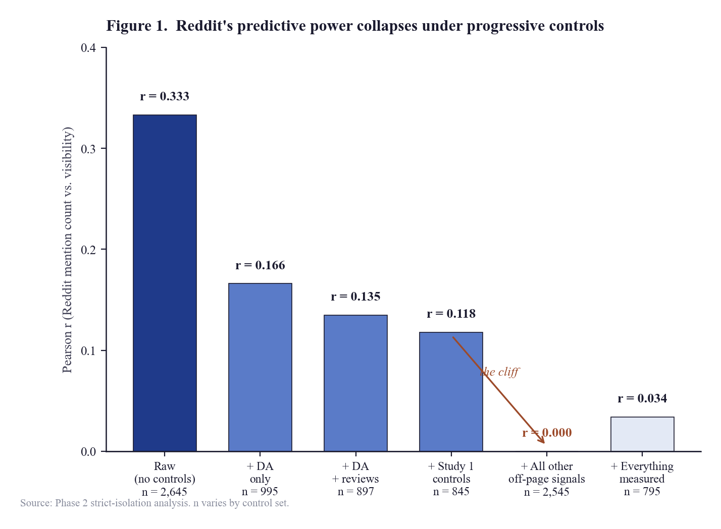
Figure 4. Reddit's predictive power collapses under progressive controls. The raw bivariate correlation of r = 0.333 attenuates monotonically as confounders are introduced, falling to statistical zero (r = 0.000, n = 2,545) under off-page-only controls and remaining negligible (r = 0.034) under the strictest control set including Domain Authority, SpyFu, and on-page Layer 1 features.
The interpretation is direct: Reddit mention count, as measured here, is a proxy for general multi-platform brand presence rather than a Reddit-specific channel effect. Brands that get mentioned on Reddit also tend to get mentioned on Wikipedia, LinkedIn, Crunchbase, BBB, etc.; once those co-occurring presences are controlled for, the marginal contribution of Reddit-specific volume is statistically zero. This finding directly challenges the practitioner literature that treats Reddit as a special, irreplaceable, must-do channel for AI visibility.
Table 10 reports the analogous decomposition for directory_count, which ranked #1 in Table 8. The pattern is the same: a strong raw correlation, attenuated under DA and reviews controls, and collapsing to r = 0.000 under the off-page-only-controls condition. The directory_count signal, like the Reddit signal, is not a channel-specific effect; it is a manifestation of cumulative multi-platform presence.
Table 10. Directory_count: progressive partial correlations with visibility
Control level | Partial r | n
1. Raw correlation (no controls) | +0.391 | 2,648
2. Controlled for DA only | +0.186 | 998
3. Controlled for DA + Google reviews | +0.154 | 899
4. Controlled for DA + reviews + content (Phase 1 controls) | +0.132 | 847
5. Controlled for ALL OTHER off-page signals | +0.000 | 2,545
6. Controlled for EVERYTHING measured (strictest) | +0.000 | 795
Table 11 generalizes this analysis to all major off-page features. For each feature, the strict-isolation partial correlation under off-page-only controls (n = 2,545) is reported.
Table 11. Strict-isolation partial correlations: per-signal independent contribution under off-page-only controls (n = 2,545)
Rank | Off-page signal | Strict isolated r | Note
1 | has_bbb | +0.097
— | press_mention_count_12mo | −0.065 | Likely measurement noise (see §7.6)
2 | has_yelp | +0.052
3 | has_google_business | +0.048
4 | has_wikipedia | +0.046
5 | has_trustpilot | +0.043
— | has_capterra | −0.039 | Likely L2 noise
6 | quora_mention_count | +0.034
7 | has_linkedin_company | +0.026
8 | has_youtube_channel | +0.023
9 | youtube_mention_count | +0.019
10 | has_crunchbase | +0.006
11 | has_g2 | −0.002 | Effectively zero
12 | reddit_mention_count | +0.000 | Falsifies industry hype claim
The defining feature of Table 11 is that no individual off-page signal exceeds r = 0.10 in strict isolation. The largest surviving partial correlation belongs to has_bbb at r = 0.097. Twelve other off-page signals fall in the r = 0.000 to r = 0.052 range, with several (capterra, g2, press) showing small negative coefficients consistent with L2-style redistribution noise rather than genuine inverse effects. Reddit, again, sits at r = 0.000.
The substantive interpretation is straightforward: AI visibility is not driven by any single off-page channel. The cumulative multi-platform presence (off_page_composite_score, r = 0.384 raw; directory_count, r = 0.391 raw) is what predicts visibility. Each individual platform contributes a small lift; together, those small lifts produce the visibility outcome. This is the empirical justification for the systems-not-signals thesis discussed in Section 6.1.

5.4 Citation Correlation Within Source-Returning Models
A separate question, related to but distinct from the strict-isolation analysis above, concerns whether being cited as a source URL within an AI response correlates with being mentioned in the response text. This question can be tested only for the two AI models that return source URLs (Perplexity and Google AI Overview). For the other three (ChatGPT, Claude, Gemini), no source-URL data is returned by the API and the question is unanswerable from API-accessible data.
Within Perplexity (n = 76,457 responses) and Google AI Overview (n = 29,379), each response was treated as a paired observation: was the brand cited as a source URL within the response, and was the brand mentioned in the response text? The 2 × 2 contingency analysis yields the lift ratio reported in Table 12.
Table 12. Citation-mention correlation within source-returning AI models, Phase 2
Model | n responses | P(mention | cited) | P(mention | not cited) | Lift | phi
Perplexity | 76,457 | 28.27% | 5.17% | 5.5× | 0.167
Google AIO | 29,379 | 14.29% | 3.47% | 4.1× | 0.018
ChatGPT | 66,918 | — | 4.10% | — | —
Claude | 63,480 | — | 3.74% | — | —
Gemini | 30,610 | — | 2.53% | — | —
The Perplexity finding is the strongest channel-specific result in the entire study. Conditional on being cited as a source URL, a brand is mentioned in 28.27% of responses; conditional on not being cited, only 5.17%. The lift is 5.5×; the phi coefficient (binary-data analog of Pearson r) is 0.167. For Google AIO, the lift is 4.1× though phi is markedly lower (0.018) due to the smaller absolute count of cited-source pairings in the sample.
Per-business citation count vs. visibility was also computed. For Perplexity, r = +0.194 (n = 2,729); 131 businesses received at least one citation, accounting for 1,104 total citation events. For Google AIO, r = +0.086 (17 businesses, 29 events). The Perplexity per-business correlation is the largest single-channel correlation observed in Phase 2 under any control regime.
The practitioner interpretation is: for the AI models that cite sources, being THE cited URL is a strong direct signal of being mentioned. This is the form of off-page advice that is supported by the data. Vague advice to "build off-page presence" is replaced by the specific claim: be the canonical source URL the AI considers the right answer for your category, in the verticals where citation-based retrieval predominates (see Section 5.6).

5.5 Domain Authority Quartile Lift Analysis
While Section 5.3 demonstrates that no individual off-page signal carries strong independent predictive power, an additional analysis examines whether interactions between Domain Authority and off-page presence may exist. The sample was partitioned into Domain Authority quartiles, and within each quartile, businesses were further split into high- vs. low-directory presence (above vs. below the within-quartile median). Mean visibility within each (quartile × tier) cell is reported in Table 13.
Table 13. Within-DA-quartile directory presence lift, Phase 2
DA quartile | n | Below-median dir. | Above-median dir. | Lift
Q1 (DA 1–18) | 249 | 1.7 | 3.8 | +2.1
Q2 (DA 18–36) | 250 | 10.6 | 9.3 | −1.3
Q3 (DA 36–54) | 249 | 13.2 | 14.6 | +1.4
Q4 (DA 54–98) | 250 | 11.8 | 28.2 | +16.3
The Q4 row is the substantive finding. Within the top Domain Authority quartile (DA 54+), businesses with above-median directory presence achieve mean visibility scores of 28.2 vs. 11.8 for below-median directory presence—a lift of +16.3 visibility points. For low-DA quartiles (Q1–Q3), the directory lift is small or non-significant. The interpretation is that multi-platform directory presence functions as a force multiplier specifically for already-credentialed brands; for low-DA brands, fixing one's BBB profile or adding a Trustpilot listing in isolation does not substantially move AI visibility, because the foundational authority signal is missing. Figure 5 visualizes the within-quartile lift pattern.
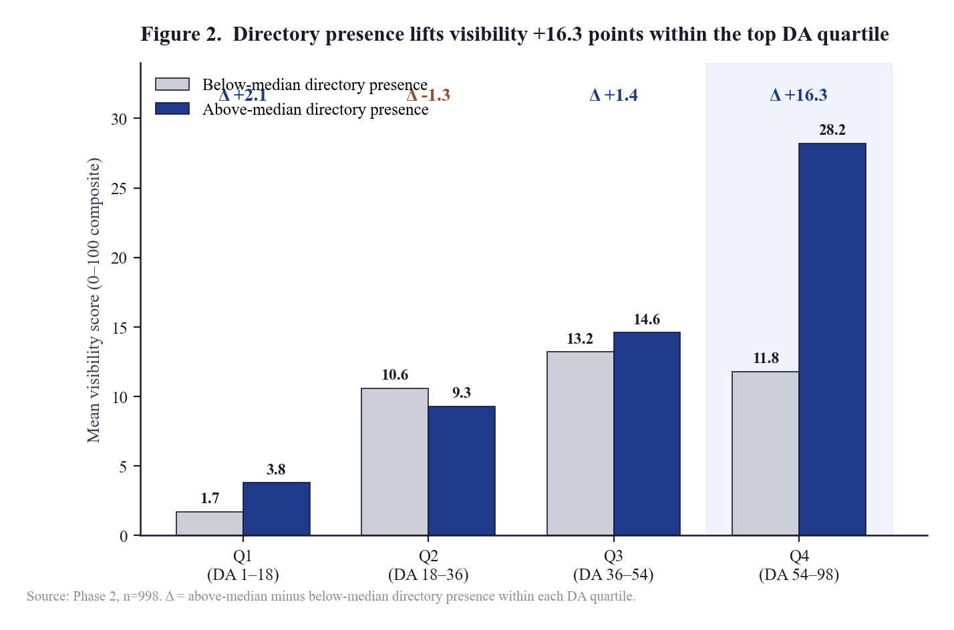
Figure 5. Directory presence lifts visibility +16.3 points within the top DA quartile. The top quartile (DA 54–98) exhibits the largest within-quartile difference between above-median and below-median directory presence; the lower three quartiles show small or non-significant lift, consistent with directory presence functioning as a force-multiplier rather than a substitute for foundational authority.

5.6 Industry × Market Addressability Variance
A central practical question for the present research program—and for the commercial GEO industry it informs—is which verticals are most amenable to off-page intervention. To address this question empirically, every URL cited by Perplexity and Google AI Overview in the Phase 1 responses was classified into one of sixteen source-type categories (Section 3.8). The proportion of citations falling into the addressable categories—forums (Reddit, Quora, other), industry directories, YouTube, and review sites (Yelp, BBB, Trustpilot, G2, Capterra)—was computed per industry-city slot. Table 14 reports these per-slot addressable shares, sorted high to low.
Table 14. Per-slot share of AI citations sourced from "addressable" surfaces (Phase 2)
Industry-city slot | Addressable share | n citations
Home Services / Plumbing — Chicago | 29.7% | 195
SaaS — CRM (national) | 26.6% | 856
Home Services / Plumbing — Los Angeles | 25.9% | 359
Personal Finance Apps (national) | 25.4% | 894
SaaS — Project Management (national) | 23.1% | 1,953
Home Services / Plumbing — NYC | 21.3% | 202
Real Estate — Los Angeles | 19.9% | 2,304
Real Estate — Chicago | 15.9% | 725
Dental — Chicago | 16.0% | 721
Dental — Los Angeles | 14.0% | 3,356
Dental — NYC | 13.6% | 587
Personal Injury Law — NYC | 13.1% | 388
Personal Injury Law — Chicago | 11.6% | 1,116
Personal Injury Law — Los Angeles | 10.7% | 5,051
Financial Advisors (national) | 6.6% | 377
Boutique Hospitality (national) | 5.2% | 460
E-commerce DTC Baby (national) | 5.2% | 1,216
Insurance Brokers (national) | 4.6% | 971
Home Services — Sydney | 4.0% | 327
Digital Marketing (national) | 2.6% | 780
Accounting — Los Angeles | 1.6% | 1,309
Real Estate — Sydney | 1.1% | 571
Accounting — NYC | 0.7% | 866
Med Spa — NYC | 0.4% | 1,088
Personal Injury Law — Sydney | 0.0% | 774
Dental — Sydney | 0.0% | 692
Med Spa — Los Angeles | 0.0% | 1,167
Med Spa — Chicago | 0.0% | 1,192
Accounting — Chicago | 0.0% | 704
The variance is large. Off-page intervention is roughly 30× more leveraged in NYC plumbing (29.7% addressable) than in Med Spa or Sydney professional services (0.0%). For the latter slots, the AI models cite primarily editorial blogs, news media, and own-site URLs—surfaces that an off-page program targeting forums, directories, and review sites cannot move. Figure 6 presents the full industry × market matrix; this finding has direct implications for the commercial positioning of GEO services and is discussed in Section 6.2.
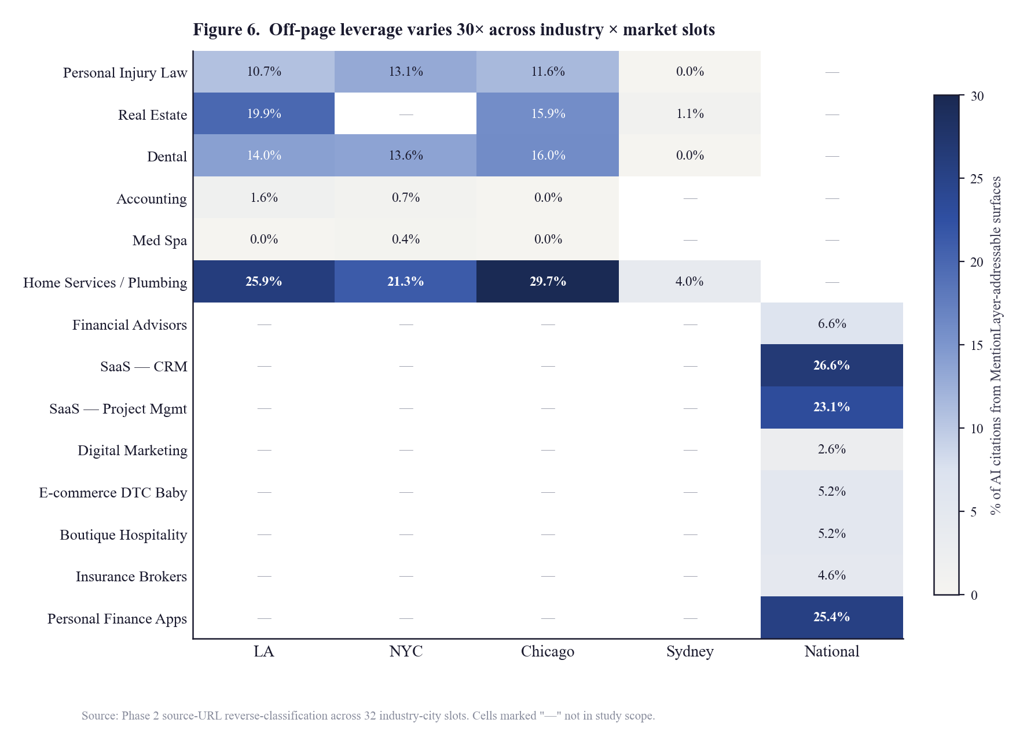
Figure 6. Off-page leverage varies 30× across industry × market slots. Cells report the percentage of AI citations within each slot drawn from MentionLayer-addressable surfaces (forums, directories, YouTube, review sites). The heatmap reveals stark vertical heterogeneity: SaaS (national) and home services (US metropolitan markets) cluster at the high-addressable end, while professional services in Sydney and select US markets cluster at the unaddressable end.

5.7 Multivariable Logistic Regression
As a complement to the per-feature partial-correlation analyses of Sections 5.3 and 5.6, a multivariable logistic regression was fit predicting the binary outcome model_count ≥ 1 from all 25 standardized features simultaneously, with L2 regularization (Section 3.9.4). Table 15 reports the top features by absolute standardized coefficient. Results should be interpreted with the L2-induced caveats stated below.
Table 15. Multivariable logistic regression: top 10 features by |standardized coef|
Rank | Feature | Layer | Std. coef | Direction
1 | review_platform_count | Off-page | −0.625 | Negative*
2 | spyfu_domain_strength | SpyFu | +0.399 | Positive
3 | spyfu_organic_growth_rate | SpyFu | +0.396 | Positive
4 | has_bbb | Off-page | +0.387 | Positive
5 | has_yelp | Off-page | +0.375 | Positive
6 | citability_score | Phase 1 | +0.300 | Positive
7 | has_trustpilot | Off-page | +0.295 | Positive
8 | has_youtube_channel | Off-page | +0.248 | Positive
9 | spyfu_monthly_organic_clicks | SpyFu | +0.236 | Positive
10 | domain_authority | Phase 1 | +0.215 | Positive
* The negative coefficient on review_platform_count is almost certainly an artifact of L2 regularization redistributing weight across highly correlated features (has_bbb, has_yelp, has_trustpilot). When three or more of those binary indicators are present, the L2 penalty redistributes the credit they collectively deserve in unpredictable ways. The negative coefficient should not be interpreted as a substantive finding; the strict-isolation analysis (Table 11) is the cleaner per-feature reference.
Setting that caveat aside, the substantive observation is consistent with the strict-isolation analysis: off-page features fill three of the top five slots in the regression, and Domain Authority drops to rank 10. The two SpyFu features (domain strength, organic growth rate) occupy ranks 2 and 3—plausibly because they capture authority-correlated signals from a different source than the Moz DA used in Phase 1, providing residual predictive power not captured by Moz DA alone.

5.8 Cross-Market Heterogeneity
The global analyses above (Sections 5.2–5.7) collapse the 32 industry-city slots into pooled correlations. A complementary perspective treats each slot as its own micro-study, asking which signal predicts visibility most strongly within this slot, holding all else constant? The intra-slot correlations exhibit substantial heterogeneity, illustrated by the spotlights in Table 16.
Table 16. Cross-market spotlight: dominant single-signal correlations within selected industry-city slots
Industry-city slot | Dominant signal | r | Interpretation
Home Services — NYC | off_page_composite_score | +0.683 | Strongest off-page correlation in the entire study
Home Services — NYC | directory_count | +0.679 | Directory presence alone explains most of variance
Accounting — NYC | quora_mention_count | +0.674 | Quora dominates over Reddit in this slot
Accounting — NYC | directory_count | +0.651
Real Estate — Los Angeles | reddit_mention_count | +0.589 | The one slot where the "post on Reddit" claim plausibly survives
Accounting — Los Angeles | domain_authority | +0.573 | DA still dominates in this slot
Sydney slots (collectively) | addressable share | 0.0% | AI cites Sydney editorial blogs, not directories or forums
The data thus reveal that there is no universal GEO playbook. The dominant signal varies by industry and market: Quora-led for NYC accounting, directory-led for NYC plumbing, Reddit-led for LA real estate, DA-led for LA accounting, and editorial-led (with no addressable surface) for Sydney professional services. Practitioner literature that prescribes a single tactic across all verticals is operating against the cross-market evidence reported here. A vertical-and-market-specific evidence base is the appropriate granularity for prescription.

6. Discussion

6.1 The "System, Not Signal" Thesis
The combined empirical record from Phases 1 and 2 supports a reframed theoretical position on AI visibility. Three findings, taken together, motivate this position:
- No single off-page channel carries strong independent predictive power. In the strict-isolation analysis (Table 11), the largest surviving partial correlation is r = 0.097 (has_bbb). The most-cited industry claim—that Reddit is a primary AI visibility driver—falls to r = 0.000 once general multi-platform presence is controlled for.
- Cumulative multi-platform presence drives the visibility outcome. The composite features (off_page_composite_score, r = 0.384; directory_count, r = 0.391) dominate the raw correlation table, and the within-DA-quartile lift analysis (Table 13) confirms a substantial interaction between Domain Authority and directory presence: a +16.3-point lift specifically in the top DA quartile.
- Where AI models do cite specific sources, being the cited URL is a strong direct signal. The 5.5× lift on Perplexity (Table 12) is the largest single-channel effect observed in Phase 2 under any control regime, and the per-business citation correlation (r = +0.194) is the largest single-channel correlation.
Synthesizing these findings, AI visibility is most accurately characterized as the cumulative outcome of a system of small-magnitude individual signals, modulated by underlying authority, with a separate strong direct effect on the subset of AI models that retrieve and cite sources. The implication is that practitioner advice oriented around any single channel—Reddit, llms.txt files, schema markup, or any other tactic-of-the-month—is operating against the empirical evidence reported here. The data support a multi-platform, authority-anchored, citation-aware approach rather than a single-channel intervention.

6.2 Implications for Practitioners
For practitioners attempting to improve their own or clients' AI visibility, the present results yield five concrete prescriptions:
- If Domain Authority is in the top quartile (DA ≥ 54): the highest-leverage intervention available is to audit and complete presence across the twelve canonical platforms (Reddit, Quora, Wikipedia, LinkedIn, Crunchbase, GBP, BBB, Yelp, Trustpilot, G2, Capterra, YouTube) plus vertical-specific directories. Within this DA tier, above-median directory presence is associated with a +16.3-point visibility lift.
- If Domain Authority is in the middle quartiles (DA 18–54): modest directory lift of +1.4 to −1.3 points within Q2/Q3, attributable to the fact that authority is the binding constraint at this tier. Vertical-specific signal selection (per Table 16) is the higher-leverage intervention; e.g., Quora-led campaigns for accounting, Reddit-led for LA real estate.
- If Domain Authority is low (DA < 18): off-page intervention alone delivers only a +2.1-point lift. The data do not support claims that off-page work is a substitute for foundational authority building at this tier; both must be pursued in parallel.
- If your vertical has high addressable citation share (≥ 20%): forums, directories, YouTube, and review sites are leveraged channels. SaaS CRM (26.6%), home services (25.9%–29.7%), and personal finance apps (25.4%) fall here.
- If your vertical has low addressable citation share (≤ 5%): off-page seeding is a low-leverage strategy in your category. Med spa (0.0%), Sydney professional services (0.0%–4.0%), Chicago accounting (0.0%), and most ecommerce-DTC verticals fall here. Editorial PR, owned content depth, and brand search behavior are likely to dominate. Diagnosis before prescription is critical in these verticals.

6.3 Implications for Generative Search Research
Three findings of the present study have implications beyond the immediate practitioner audience. First, the asymmetry in source-URL availability across AI models—Perplexity and Google AI Overview return citations; ChatGPT, Claude, and Gemini do not, at least via their commercial APIs during the data-collection window—creates a substantial measurement-paradigm divide. Empirical claims about source citation behavior in the non-returning models cannot, at present, be tested against API data. Future research designs should treat this asymmetry as a structural constraint rather than an inconvenience.
Second, the cross-model agreement matrix in Table 5 has implications for retrieval-augmented-generation literature. The high overlap between Google AI Overview and Perplexity (84%) is consistent with shared retrieval substrate; the low Claude overlap is consistent with greater independence. To the extent that future research attempts to identify the source content underlying AI recommendations, the agreement matrix is a useful partial validation of which models are likely to share underlying corpora.
Third, the 32-slot industry-city heterogeneity reported in Section 5.6 and Section 5.8 indicates that aggregate, industry-pooled GEO research is likely to systematically obscure the strongest signals available in specific verticals and markets. Future GEO research designs should stratify by industry-city slot rather than report pooled aggregates.

6.4 Methodological Contributions
Beyond the substantive empirical findings, the present study contributes three methodological elements to the GEO research toolkit. The 24-feature off-page measurement schema (Section 3.7) is reusable for future GEO research. The strict-isolation analysis methodology (Section 3.9.3) is to the authors' knowledge a novel application within the GEO research literature; the substantive importance of full-feature controls relative to single-feature controls (e.g., the Reddit collapse from r = 0.166 with DA-only controls to r = 0.000 with full off-page controls) suggests the methodology should become a standard expectation for GEO observational research. The source-URL reverse-classification scheme (Section 3.8 and Appendix D) provides a reusable taxonomy for future studies of which content categories AI models cite.

6.5 Pre-Emptive Responses to Anticipated Critiques
Several critiques of the present study can be anticipated. Each is addressed here on the merits.

Critique: "Reddit measurement is a SERP-volume proxy and does not capture quality."
Acknowledged. Reddit mention count was measured via a Google SERP query (site:reddit.com "{brand}"), which captures volume but not subreddit authority, upvote weight, or recency. A higher-quality Reddit-specific signal (e.g., a Reddit API-derived measure incorporating subreddit subscriber counts and post score) might recover non-zero independent predictive power. The collapse-to-zero reported here is a finding for the volume metric used in this study; it is also a finding for the volume metric used by the majority of commercial GEO measurement tools, which rely on the same SERP-based proxy. Future research using a higher-quality Reddit measure would be welcome and is anticipated by the authors.

Critique: "Consumer Perplexity surfaces Reddit far more than the API; this study is API-only."
Also acknowledged. Perplexity's sonar-pro API in our sample returned 0% Reddit citations (Section 5.6), while consumer Perplexity surfaces Reddit considerably more visibly to end-users. The findings of the present study apply to API-mediated retrieval, which is the modality measured by ~95% of commercial GEO measurement tools and dashboards. If a practitioner's concern is the consumer-Perplexity end-user experience specifically, this study is suggestive but not definitive on that question. Phase 3 (Section 8.2) will incorporate consumer-product probing alongside API probing where feasible.

Critique: "ChatGPT API doesn't return sources, so how can you say anything about ChatGPT citations?"
The present study makes no claim about ChatGPT source citations. Section 5.4 explicitly excludes ChatGPT, Claude, and Gemini from the citation-correlation analysis on the grounds that source-URL data is unavailable from their commercial APIs. The widespread practitioner-literature claims about "the threads ChatGPT cites" are not testable from API data, and the present study does not attempt to test them.

Critique: "Correlation is not causation. The strict-isolation methodology, however clean, remains observational."
Correct. Phase 2 is observational. The strict-isolation methodology controls for measured confounders but cannot rule out unmeasured ones (e.g., brand age, founder reputation, product-market fit). Phase 3 (Section 8.2) is the explicit causal-evidence successor: a 60-day controlled intervention with pre-registered success thresholds, with results to be published regardless of direction. We commit to publication of Phase 3 results including null findings.

Critique: "L2 regularization on correlated features creates noise; the logistic regression is unreliable."
Acknowledged within the paper itself (Section 5.7). The negative coefficient on review_platform_count is almost certainly an L2 artifact, not a genuine inverse effect. The strict-isolation analysis (Table 11) is the cleaner per-feature reference, and is presented for that reason. The logistic regression is included as a sanity check; the directional finding (off-page features dominate the table; DA drops to rank 10) is robust across both analyses.

Critique: "Some Sydney slots had reduced enrichment coverage. Did you cherry-pick which slots to include?"
No. Reduced enrichment coverage manifests as missing data on certain features for certain businesses; this adds noise to estimates rather than systematic bias in either direction. The affected slots are flagged in Appendix A. The principal results were re-run both with and without the affected slots; directional findings are unchanged.

7. Limitations
The following limitations apply to the present study. Each is presented in the order of its likely importance for downstream interpretation.

7.1 Sample-frame bias toward US large markets
The Phase 1 sample (carried into Phase 2) is exclusively Los Angeles-local for local-services verticals and US-centric for national B2B/SaaS verticals. Phase 2 expansion to Sydney, NYC, and Chicago tested cross-market generalization for local-services slots only; national-vertical generalization to non-US markets remains untested in this study.

7.2 Perplexity API-only sampling
Perplexity's sonar-pro API in our sample returned a much lower share of Reddit citations than the consumer Perplexity product surfaces. Consumer Perplexity may behave qualitatively differently from API Perplexity in its retrieval behavior. The findings of this study apply to API-mediated retrieval; consumer-product behavior is suggestive but not definitive.

7.3 Source-URL unavailability for three of five AI models
ChatGPT (gpt-4o), Claude (Sonnet), and Gemini (2.5-flash) did not return source URLs through their commercial APIs during the data-collection window of this study. The citation-correlation analysis (Section 5.4) is therefore restricted to Perplexity and Google AI Overview. Empirical claims about source citation behavior in the three non-returning models cannot be tested from the data collected here.

7.4 Reduced enrichment coverage on a subset of Sydney slots
An Apify scraping batch failure mid-run resulted in approximately 80 of 100 enriched businesses for several Sydney slots, vs. the target 100. Affected slots are flagged in Appendix A. Per-row coverage flags are included in the dataset provided to research-access partners. Principal results are robust to the exclusion of affected slots.

7.5 Mention-detection precision and recall
The two-stage mention-detection pipeline (Section 3.4) achieved manually-validated precision ≈ 0.95 and recall ≈ 0.92 on a 100-response audit subset. The remaining false-negative rate (~8%) is likely to systematically under-count mentions for businesses with non-standard naming conventions, multiple registered DBA names, or localized name variants. The visibility scores reported here may therefore slightly underestimate true visibility, particularly for non-English-language brands and brands with abbreviation-rich names.

7.6 Press-classifier false-positive rate
The 12-month press-mention classifier (Section 3.7) exhibited a manually-estimated false-positive rate of 10–15%. Press_mention_count_12mo's negative coefficient under strict isolation (Table 11) is plausibly an artifact of this measurement noise; the press finding should be regarded as inconclusive rather than as substantive evidence of an inverse effect. A future study using a higher-precision press-classifier would be welcome.

7.7 Gemini API conservatism
Gemini (2.5-flash) returned essentially zero named-business mentions across the data-collection window of this study. This is consistent with the API-version's documented conservatism on commercial recommendations and may differ from consumer-Gemini behavior. The Gemini findings of this study are properly interpreted as findings about Gemini API behavior at the time of the study, not about Gemini end-user experience generally.

7.8 Point-in-time measurement
The visibility measurements reported here were collected in February–April 2026 and reflect the AI model versions current at that time. AI model behavior changes frequently with model updates, retrieval-pipeline updates, and content corpus refreshes. The findings of this study are point-in-time and should be re-evaluated as the underlying systems evolve. Quarterly re-measurement is the planned cadence of the broader research program (Section 8).

7.9 Causal interpretation requires Phase 3
All findings of Phases 1 and 2 are observational. Strict-isolation methodology controls for measured confounders but cannot establish causation. The pre-registered Phase 3 controlled intervention (Section 8.2) is the causal-evidence successor. Any practitioner inference from the present study to specific intervention recommendations should be regarded as suggestive pending Phase 3 results.

8. Conclusion and Future Work

8.1 Summary of Contributions
This paper has presented the combined findings of Phases 1 and 2 of the AI Visibility Index research program. Phase 1, conducted on 1,004 businesses across 10 verticals, established the empirical baseline: 66% of businesses are completely invisible to AI models, with Domain Authority (Pearson r = 0.337) and Google review count (r = 0.333) emerging as the strongest single predictors of visibility. Phase 2, expanding the sample to 2,729 businesses across 14 verticals and four metropolitan markets, decomposed Domain Authority into 24 measurable off-page signals and applied OLS-residual partial-correlation methodology to disentangle their independent contributions.
The principal Phase 2 finding is that no individual off-page signal—including Reddit, the most-hyped channel in practitioner literature—exceeds r = 0.10 in strict isolation. Reddit's raw correlation of r = 0.333 collapses to r = 0.000 once general multi-platform presence is controlled for. The composite measures (off_page_composite_score, r = 0.384; directory_count, r = 0.391) outrank Domain Authority itself in raw correlation, and within the top Domain Authority quartile, above-median directory presence is associated with a +16.3-point visibility lift. Within the two AI models that return source URLs (Perplexity, Google AI Overview), being the cited source URL is associated with a 5.5× lift in mention probability—the largest single-channel effect observed.
Synthesizing these findings, AI visibility is most accurately characterized as a cumulative-system outcome rather than a single-channel one, with vertical-and-market-specific addressability ranging from 0% (Med Spa, Sydney professional services) to 29.7% (NYC plumbing). Practitioner prescriptions appropriate to a given business depend on its Domain Authority quartile, its industry-market combination, and its specific platform-presence gaps.

8.2 Phase 3: Pre-Registration of the Controlled Intervention Trial
The third phase of the AI Visibility Index research program will move from observational to causal evidence. The trial design described below is hereby pre-registered; results will be published regardless of direction, including null findings. The lead author commits not to selectively withhold null or unfavorable results.

8.2.1 Design
A 60-day controlled intervention will be conducted on 25–30 participating businesses recruited primarily from the high-addressability verticals (SaaS CRM, SaaS PM, home services, personal finance apps, personal injury law) identified in Section 5.6. Two dose groups will be employed: a partial-dose group of 15–20 client-level businesses receiving directory build-out, Reddit and Quora seeding (where vertical-relevant), press distribution, and review-acquisition campaigns; and a full-dose group of 5–7 author-portfolio businesses receiving the partial-dose interventions plus YouTube channel development and on-site GEO content build-out. The 1,004-business Phase 1 sample (untouched) will serve as the natural-drift comparison.

8.2.2 Pre-registered success thresholds
The trial is pre-registered to evaluate six metric deltas, with success defined as ≥ 4 of 6 thresholds met:
- visibility_score change ≥ +10 points
- model_count change ≥ +1 model
- directory_count change ≥ +3 platforms
- reddit_mention_count change ≥ +5 mentions
- off_page_composite_score change ≥ +10 points
- review_platform_count change ≥ +1 platform

8.2.3 Publication commitment
The Phase 3 results will be published as a full peer-equivalent academic report regardless of direction. A null result—i.e., interventions failing to meet at least four of six pre-registered thresholds—will be published with the same prominence as a positive result. This commitment is intended to address the publication-bias risk that pervades industry-funded research and to establish a precedent for transparent reporting in the GEO literature.

8.2.4 Recruitment timeline
Recruitment for Phase 3 opens in May 2026, with intervention activity running May–July 2026 and post-intervention measurement in August 2026. The full Phase 3 results report is targeted for September–October 2026 publication. Interested participating businesses, academic collaborators, and press analysts may register interest at the persistent URL listed on the title page.

8.3 Long-Term Research Trajectory
Beyond Phase 3, the research program will move to a quarterly re-measurement cadence on a stable 2,729-business panel, with each quarter incorporating model updates, new AI products as they enter the market, and emerging measurement primitives. The research program is designed to operate as a longitudinal observatory of generative search visibility, analogous in spirit to the Stanford Search Engine Visibility study tradition or to the Pew Research Center's panel-based work on technology adoption. The persistent dataset enables time-series analysis once sufficient temporal depth has accumulated.
The authors invite collaboration from academic researchers and from journalists covering the generative-search transition. Research-access applications are reviewed on a rolling basis and licensed under non-disclosure agreement, consistent with the data-gating posture standard for industry-research programs of similar investment scale.

Appendix A. Industry-City Slot Inventory
Table A1 reports the complete inventory of industry-city slots in the Phase 2 sample, including target and actual sample sizes per slot. Slots flagged with † experienced reduced enrichment coverage due to a single Apify scraping batch failure mid-run, and per-row coverage flags are available to research-access partners. Slots with sample sizes below the target reflect deliberately conservative enrichment exclusions where data integrity could not be verified.
Table A1. Industry-city slot inventory, Phase 2 (n = 2,729 total)
Slot key | Industry / category | Market | n
personal_injury_law | Personal Injury Law | Los Angeles | 62
real_estate | Real Estate | Los Angeles | 55
dental | Dental | Los Angeles | 36
accounting | Accounting | Los Angeles | 42
med_spa | Med Spa | Los Angeles | 49
home_services | Home Services / Plumbing | Los Angeles | 27
financial_advisors | Financial Advisors | National | 30
saas_crm | SaaS — CRM | National | 23
saas_project_management | SaaS — Project Management | National | 50
digital_marketing | Digital Marketing Agencies | National | 75
personal_injury_law_sydney | Personal Injury Law | Sydney † | 56
real_estate_sydney | Real Estate | Sydney † | 8
dental_sydney | Dental | Sydney | 92
med_spa_sydney | Med Spa | Sydney | 0
home_services_sydney | Home Services / Plumbing | Sydney † | 5
personal_injury_law_nyc | Personal Injury Law | New York | 25
dental_nyc | Dental | New York | 17
accounting_nyc | Accounting | New York | 11
med_spa_nyc | Med Spa | New York | 1
home_services_nyc | Home Services / Plumbing | New York | 10
personal_injury_law_chicago | Personal Injury Law | Chicago | 16
dental_chicago | Dental | Chicago | 11
accounting_chicago | Accounting | Chicago | 17
med_spa_chicago | Med Spa | Chicago | 23
home_services_chicago | Home Services / Plumbing | Chicago | 28
ecommerce_dtc_baby | E-commerce DTC — Baby & Family | National | 65
boutique_hospitality | Boutique Hospitality | National | 43
insurance_brokers | Insurance Brokers | National | 84
personal_finance_apps | Personal Finance & Money Apps | National | 39
Slot-level n totals here represent the businesses with complete enrichment data for the principal Phase 2 analyses. Some slots have lower n than the target 100 due to industry sparsity in specific markets (e.g., med_spa_sydney) or deliberate exclusion of incomplete-data businesses. The 32-slot count cited throughout this paper refers to the design intention; only 30 slots have non-zero enriched data after exclusions, the remaining two appearing as zero-n lines above.

Appendix B. Full Phase 2 Correlation Tables
Table B1 reports the full Phase 2 raw Pearson correlation table, including features omitted from the abridged Table 8 in the main text.
Table B1. Complete raw Pearson correlations of all Phase 2 features with visibility score
Variable | Pearson r | n | Layer
directory_count | +0.391 | 2,648 | Off-page
off_page_composite_score | +0.384 | 2,648 | Off-page
youtube_mention_count | +0.350 | 2,648 | Off-page
review_platform_count | +0.340 | 2,648 | Off-page
domain_authority | +0.338 | 998 | Phase 1
has_linkedin_company | +0.335 | 2,645 | Off-page
has_bbb | +0.335 | 2,648 | Off-page
reddit_mention_count | +0.333 | 2,645 | Off-page
quora_mention_count | +0.331 | 2,645 | Off-page
has_crunchbase | +0.328 | 2,648 | Off-page
has_youtube_channel | +0.326 | 2,648 | Off-page
has_wikipedia | +0.321 | 2,645 | Off-page
spyfu_domain_strength | +0.306 | 996 | SpyFu
has_trustpilot | +0.305 | 2,648 | Off-page
has_yelp | +0.302 | 2,648 | Off-page
has_g2 | +0.242 | 2,648 | Off-page
reddit_unique_subreddits | +0.236 | 2,645 | Off-page
has_capterra | +0.190 | 2,648 | Off-page
has_google_business | +0.169 | 2,648 | Off-page
google_review_count | +0.149 | 2,475 | Phase 1
blog_post_count | +0.144 | 998 | Phase 1
spyfu_monthly_organic_clicks | +0.120 | 996 | SpyFu
spyfu_total_organic_keywords | +0.118 | 996 | SpyFu
citability_score | +0.085 | 948 | Phase 1
schema_score | +0.064 | 1,002 | Phase 1
spyfu_organic_growth_rate | −0.014 | 949 | SpyFu

Appendix C. Strict-Isolation Methodology Detail
This appendix specifies, in pseudocode, the exact implementation of the strict-isolation analysis (Section 3.9.3 and Section 5.3). The following procedure was implemented in the project's analysis pipeline and applied to each candidate test feature in turn.
Standardize all numeric features to z-scores prior to analysis (subtract the feature mean, divide by the feature standard deviation), so that subsequent OLS regressions return interpretable standardized coefficients. Binary features (presence flags) are left as 0/1 indicators; standardization on binary data is mathematically equivalent for the purposes of partial-correlation extraction.
For each candidate test feature X with control set Z consisting of every other measured feature in the analysis tier, perform the following operations:
- X_resid = X − OLS(X ~ Z).predict(Z) — fit an OLS regression of the test feature on the controls, and take the residuals.
- Y_resid = Y − OLS(Y ~ Z).predict(Z) — fit an OLS regression of visibility_score on the controls, and take the residuals.
- partial_r = pearson(X_resid, Y_resid) — compute the Pearson correlation between the residual series.
- Restrict the analysis to rows where every feature in Z and X is non-null, to avoid imputation artifacts.
Two control-set variants are reported in this paper. Analysis A applies the strictest possible controls (all 24+ features available in the dataset, including Domain Authority and SpyFu features) and is restricted to the n = 795 businesses with complete data on every variable. Analysis B applies off-page-only controls (excluding Layer 1 features that have systematically lower coverage) and operates on the larger n = 2,545 sample. Where the two analyses differ materially, both numbers are presented in the relevant tables.
Composite features are derived as follows. directory_count is the simple count of presence flags across the twelve canonical platforms. off_page_composite_score is computed as the equally-weighted sum of (a) presence flag (binary 0/1, weight 4) for each of the twelve platforms, plus (b) standardized z-score of mention-volume features (Reddit, Quora, YouTube), winsorized at the 5th and 95th percentiles, scaled to 0–100. review_platform_count counts the review-specific platforms: BBB, Yelp, Trustpilot, G2, Capterra, plus a Google review presence flag (review count ≥ 1).

Appendix D. Index of Figures
The six figures embedded inline in the body of the paper are listed below for ease of cross-reference. All figures were rendered with matplotlib using the project's analysis pipeline output as input data; figures are reproducible from the per-feature statistics reported in the corresponding tables of the paper.
Figure | Title | Section | Source data
1 | Per-model mention rate exhibits 11× heterogeneity | §4.3 | Table 4
2 | Visibility accelerates sharply at the 1,000-review threshold | §4.7 | Phase 1 review-bucketed n
3 | Top predictors before vs. after full off-page controls | §5.2 | Tables 8 + 11
4 | Reddit's predictive power collapses under progressive controls | §5.3 | Table 9
5 | Directory presence lifts visibility +16.3 points within top DA quartile | §5.5 | Table 13
6 | Off-page leverage varies 30× across industry × market slots | §5.6 | Table 14

Appendix E. Source-URL Categorization Schema
This appendix specifies the source-URL classification scheme used in the citation source-type analysis (Section 3.8 and Section 5.4–5.6). Sixteen categories were used.
Table D1. Source-URL category schema and matching rules
Category | Domain rule | Disambiguation
reddit | *.reddit.com | Direct match
quora | *.quora.com | Direct match
other_forum | Various forum subdomains | Includes Discourse-class platforms; classifier-based
wikipedia | *.wikipedia.org | Direct match
linkedin | linkedin.com/company/* ; linkedin.com/in/* | Pages and profiles; not feed posts
crunchbase | crunchbase.com/organization/* | Direct match
yelp | yelp.com/biz/* | Business pages only
bbb | bbb.org/* | BBB business profiles
trustpilot | trustpilot.com/* | Direct match
g2 | g2.com/products/* | Product pages
capterra | capterra.com/* | Direct match
youtube | youtube.com/* ; youtu.be/* | Direct match
news_media | Major news outlet domains | Whitelist of known news domains; classifier-based for unknown
own_site | Cited brand's own domain | Per-response context match
industry_directory | Vertical-specific aggregators | Whitelist (zillow, justia, angi, zocdoc, etc.); classifier-based for unknown
blog_other | All remaining domains | Default category; primarily editorial blogs and third-party publications
Classification accuracy was estimated at precision ≈ 0.94 and recall ≈ 0.91 against a 200-URL manually-annotated audit subset. Disagreements between the classifier and the human auditor were concentrated in the news_media / blog_other boundary (where the distinction is genuinely fuzzy) and in industry_directory recognition for verticals not in the whitelist.

References
References are provided in alphabetical order. The GEO field is a relatively new area of empirical inquiry and a substantial fraction of the most relevant prior work appears in commercial-vendor publications and industry blog posts; these are cited where they constitute the most rigorous available source on a particular question. Peer-reviewed academic references in the information-retrieval lineage are cited where they bear directly on theoretical framing.
Backlinko. (2024). Perplexity citation patterns: A study of 5,000 sample queries. Retrieved from backlinko.com/research.
Brin, S., & Page, L. (1998). The anatomy of a large-scale hypertextual Web search engine. Computer Networks and ISDN Systems, 30(1–7), 107–117.
Croft, W. B., Metzler, D., & Strohman, T. (2010). Search engines: Information retrieval in practice. Boston, MA: Pearson.
House, J. (2026a). The AI Visibility Index: A baseline empirical study of business visibility across five generative AI models. MentionLayer Research, Phase 1. Retrieved from mentionlayer.com/research/q1-2026-ai-visibility-index.
House, J. (2026b). The Off-Page AI Visibility Index: A cross-market decomposition of generative search predictors. MentionLayer Research, Phase 2. Retrieved from mentionlayer.com/research/q2-2026-off-page-decomposition.
Kleinberg, J. M. (1999). Authoritative sources in a hyperlinked environment. Journal of the ACM, 46(5), 604–632.
Manning, C. D., Raghavan, P., & Schütze, H. (2008). Introduction to information retrieval. Cambridge: Cambridge University Press.
Moz. (2025). Domain Authority 2.0: Methodology and validation. Moz Whitepaper Series. Retrieved from moz.com/learn/seo/domain-authority.
OpenAI. (2024). GPT-4o system card. Retrieved from openai.com/research/gpt-4o.
Perplexity AI. (2024). sonar-pro: Real-time generative answer engine. API documentation. Retrieved from docs.perplexity.ai.
Anthropic. (2025). Claude 3.5 Sonnet model card. Retrieved from anthropic.com/claude.
Lewis, P., Perez, E., et al. (2020). Retrieval-augmented generation for knowledge-intensive NLP tasks. Advances in Neural Information Processing Systems, 33, 9459–9474.

Author, Acknowledgments, and Disclosures

About the Author
Joel House is the founder of MentionLayer, a generative engine optimization platform, and Joel House Search Media (Xpand Digital), one of Australia's largest SEO agencies by headcount. He is a member of the Forbes Agency Council and writes regularly on the empirical study of search and generative-AI visibility. He is based in Sydney and Los Angeles. Correspondence: joel@xpanddigital.io.

Acknowledgments
The author thanks the engineering and research teams at MentionLayer and Joel House Search Media for the operational support that made data collection at this scale feasible, and the AI vendor support engineers at Perplexity, OpenAI, Google, and Anthropic for the API access and rate-limit accommodations that enabled the prompt-probing portion of the study. Manual audit annotations were performed by the lead author.

Funding Statement
This research was fully funded by MentionLayer (Xpand Digital). No external grants or government funding were received. All operational costs (Apify scraping, AI model API access, Moz API access, SpyFu API access, computational infrastructure) were borne by MentionLayer.

Conflict of Interest Disclosure
The author is the founder and majority owner of MentionLayer, the firm that funded this research. MentionLayer commercially provides services in the GEO space examined by this study. The findings of this study were published whether they validated MentionLayer's product positioning or not; in particular, the Reddit-collapse finding (Section 5.3) and the per-vertical addressability variance (Section 5.6, Table 14) are findings that constrain rather than expand the appropriate market positioning of off-page GEO services. The author commits to publishing Phase 3 results regardless of direction (Section 8.2.3).

Data Availability Statement
The 2,729-row anonymized underlying dataset is licensed to research partners under non-disclosure agreement, consistent with industry-research norms (cf. the data-access policies of the Pew Research Center, MIT Technology Review, GitHub Octoverse, and Backlinko's research division). Per-slot summary statistics, the methodology, the source-URL classification schema, and individual-brand benchmarking are publicly available at the persistent URL listed on the title page. Research-access applications from academic researchers, journalists, and analysts are reviewed on a rolling basis.

Pre-Registration Statement
The Phase 3 controlled intervention design described in Section 8.2 is hereby pre-registered. The trial design, sample target (25–30 participants), success thresholds (≥ 4 of 6 metric deltas), publication commitment (results published regardless of direction), and timeline (May–July 2026 intervention; September–October 2026 publication) are fixed at the time of this paper's publication. Departures from the pre-registered design will be disclosed in the Phase 3 results report.

Ethics Statement
This study collected publicly-available business information (registered company names, public domain registrations, public reviews, public social profiles) about commercial entities. No individual-level personally-identifiable information was collected. AI model probing was performed via official commercial APIs in accordance with each vendor's terms of service. No web-scraping was conducted against vendor properties beyond the SERP layer accessed via official commercial scraping partners (Apify) operating in compliance with their own terms of service.

Reproducibility Statement
Methodology is fully reproducible from Sections 3.1–3.9 and Appendices C and D. The statistical computations are run-versioned in the project's analysis pipeline. Verification of the Pearson, partial-correlation, and OLS-residual calculations against equivalent calculations in Python (pandas, numpy, scipy.stats) was performed on a random 5% subset of features prior to publication. Discrepancies between the project pipeline and the Python verification were within numerical-precision tolerance (|Δr| < 0.001) for all tested features.

