WHITE PAPER
The AI Visibility Index
An Empirical Baseline of Business Visibility Across Five Generative AI Models, Ten Industries, and 1,004 Businesses
Phase 1 of the AI Visibility Index Research Program

Joel House
AI Growth Architect | Founder, MentionLayer Research
Joel House Search Media (Xpand Digital) · Member, Forbes Agency Council
Correspondence: joel@xpanddigital.io
Version 1.1 · April 10, 2026
Persistent URL: https://mentionlayer.com/research/q1-2026-ai-visibility-index

ABSTRACT
This paper reports the results of an empirical baseline study examining business visibility within five generative AI search engines: ChatGPT (gpt-4o), Perplexity (sonar-pro), Gemini (2.5-flash), Claude (Sonnet), and Google AI Overview (via SerpApi). Conducted between February and April 2026, the study evaluated 1,004 businesses across ten industry verticals (six local services in Los Angeles plus four national B2B/SaaS categories), probing each business against 100 prompt-model combinations and producing 95,392 individual mention checks.
Three findings are reported. First, two-thirds of the sample businesses (66%) are completely invisible to AI—they receive zero mentions across all five tested models in response to 100 buying-intent prompts per industry. Only 34% of businesses receive any AI visibility, and just 11% are mentioned by more than one model simultaneously. Second, the strongest single predictors of AI visibility are Domain Authority (Pearson r = 0.337) and Google review count (r = 0.333), which together explain more variance in visibility than all measured technical-SEO signals combined. A staircase relationship is observed between Domain Authority and visibility, with a marked acceleration above DA = 80, where 64% of businesses become visible. Third, AI models exhibit substantial cross-model disagreement on which businesses to recommend: only 11% of mentioned businesses appear in two or more models, zero appear in all five, and the average business is mentioned by only 0.8 of five models.
A separate finding examines the much-discussed llms.txt file proposed for AI-crawler interaction. While the raw correlation of llms.txt presence with visibility is modest (r = 0.181, n = 248), this is largely confounded with broader technical-SEO sophistication: businesses adopting llms.txt have 617% more blog content and 59% higher schema-markup completeness on average. Within Domain Authority quartiles, the apparent llms.txt effect is bounded to the DA 21–60 mid-tier; outside that range, no meaningful effect is observed.
The study identifies a methodological limitation that motivates planned Phase 2 follow-up work: Domain Authority and review count are both lagging indicators (12–18 months to move materially), so the practitioner question of which features actionable in shorter horizons predict AI visibility remains unanswered. Phase 2, planned for April–June 2026, will decompose Domain Authority into measurable off-page component signals.

Keywords: generative engine optimization, GEO, AI search, large language model retrieval, search engine optimization, brand visibility, baseline study, observational study, Domain Authority, Google reviews.
Classification: Empirical study, observational. ACM Computing Classification System: Information systems → Search engines; Information retrieval evaluation.

HOW TO CITE
APA: House, J. (2026). The AI Visibility Index: An empirical baseline of business visibility across five generative AI models, ten industries, and 1,004 businesses (Phase 1 white paper, v1.1). MentionLayer Research. https://mentionlayer.com/research/q1-2026-ai-visibility-index
Short cite: House (2026, Phase 1).
BibTeX: @techreport{house2026aviphase1, author = {House, Joel}, title = {The AI Visibility Index}, type = {Phase 1 White Paper}, institution = {MentionLayer Research}, year = {2026}, version = {1.1}}

1. Introduction
Generative search engines—conversational interfaces powered by large language models that synthesize answers from indexed content—now mediate a substantial and growing fraction of buying-intent queries that previously flowed through classical search engines. ChatGPT, Perplexity, Gemini, Claude, and Google's AI Overview each return prose-form answers that recommend specific businesses, products, and services in response to user questions. For the businesses being recommended (or, more often, omitted), the question of which businesses appear and why has become economically consequential and yet remains poorly studied at scale.
The empirical literature on classical search engine optimization is mature: decades of research, both academic and practitioner, have produced a relatively well-understood model of which features predict ranking within a list of ten blue links. Generative engine optimization (GEO)—the analogous question of which features predict appearance within a synthesized AI response—has produced almost no peer-reviewed empirical literature at scale. The space is dominated by single-account observation, vendor-published case studies, and prescriptive practitioner blog posts.
The present study—Phase 1 of the AI Visibility Index research program—addresses this gap by conducting a baseline empirical investigation of AI visibility across 1,004 businesses, ten industry verticals, and five generative AI models. To our knowledge, at the time of publication, this is the largest published multi-model empirical study of business visibility in generative AI.

1.1 Research Questions
This investigation pursues three sequential research questions:
- RQ1: What proportion of businesses in major commercial verticals are visible (i.e., mentioned by name) within AI responses to buying-intent queries, and how does this proportion vary across AI models?
- RQ2: Which measurable features of a business predict its visibility within AI responses, when subjected to bivariate correlation analysis with controls for the most common confounders?
- RQ3: To what extent do different AI models agree (or disagree) on which businesses to recommend, and what does the cross-model agreement matrix imply about underlying retrieval substrate?

1.2 Contributions
- Largest published multi-model GEO sample. 1,004 businesses across ten industry verticals and five AI models, generating 95,392 individual mention checks.
- First empirical baseline of AI visibility across major commercial verticals. Aggregate visibility, per-model heterogeneity, and per-industry variation are reported.
- Identification of Domain Authority and Google reviews as the dominant single predictors. Pearson correlations of r = 0.337 and r = 0.333 respectively, with detailed per-decile breakdowns.
- Empirical examination of the llms.txt claim. Within-DA-quartile analysis shows the much-publicized llms.txt effect is largely confounded with broader technical-SEO sophistication.
- Cross-model agreement matrix. First systematic measurement of cross-model overlap in business mentions, with implications for the underlying retrieval substrate of major commercial AI search products.

2. Prior Work

2.1 Classical SEO and Information-Retrieval Lineage
The empirical study of search visibility traces its origins to the information-retrieval (IR) literature of the 1960s–1990s and to the link-analysis algorithms that powered the first generation of commercial web search. The PageRank algorithm (Brin & Page, 1998) and the HITS algorithm (Kleinberg, 1999) established that link structure encodes useful signal about authority and relevance. Subsequent academic and practitioner work has produced a rich literature on ranking signals, query-document relevance, and search-engine engineering (Croft, Metzler, & Strohman, 2010; Manning, Raghavan, & Schütze, 2008).
Practitioner SEO research—conducted by commercial vendors such as Moz, Ahrefs, SEMrush, Backlinko, and Search Engine Land—occupies a separate methodological tier. While typically larger in sample size than peer-reviewed academic work, these studies have varied substantially in statistical rigor, particularly in the treatment of confounding variables. The dominant practitioner pattern reports raw bivariate correlations between a candidate ranking signal and observed rank, without controlling for the confounds (domain age, content depth, brand strength) that are likely to be driving the relationship.

2.2 The Emergence of Generative Search
Beginning in late 2022 with the public release of ChatGPT, and accelerating with Perplexity (2022), Google's Bard/Gemini (2023), Anthropic's Claude (2023), and Google's AI Overview integration into Search (2024), the dominant interface for commercial information queries has begun to shift from the ten-blue-links paradigm to a synthesized-answer paradigm. The synthesized answer is qualitatively different from the classical SERP: it returns prose-form recommendations rather than a ranked list of clickable destinations, often cites no sources at all, and—as this study will demonstrate—exhibits substantial cross-model disagreement on which businesses to recommend.
From the perspective of a business attempting to be recommended, the strategic question becomes: which features of one's commercial presence predict appearance in AI-synthesized answers? Despite the growing economic stakes of this question, the empirical literature on it remained, at the time of this study's data collection, almost entirely the product of single-vendor analyses and prescriptive blog posts.

2.3 The State of GEO Empirical Literature
A non-systematic review of the GEO literature published between 2023 and early 2026 finds the following pattern. The majority of public output takes one of three forms: (a) qualitative case studies of single brands or small samples, often published by vendors with a commercial interest in particular conclusions; (b) prescriptive blog posts asserting that specific tactics—llms.txt files, Reddit posting campaigns, schema markup—drive AI visibility, with little or no empirical support beyond practitioner anecdote; and (c) cross-vendor surveys conducted by industry analysts, typically reporting opinion data rather than measured outcomes.
A small number of publications have attempted larger-sample empirical work. Backlinko's 2024 study of Perplexity citations (n ≈ 5,000 responses) examined the distribution of cited domains. Ahrefs' 2025 analysis reported aggregate visibility statistics. To the authors' knowledge, none of these published studies reported visibility statistics across as many AI models as the present study, nor across as broad a sample of businesses, nor with the per-feature correlation analyses described in Section 4.

3. Methodology

3.1 Sample
The sample comprised 1,004 businesses drawn from ten industry verticals, each represented by approximately 100 businesses. Six verticals were local services in Los Angeles—personal injury law, real estate, dental, accounting, med spa, and home services (plumbing)—and four were national B2B or SaaS categories—financial advisors, SaaS CRM platforms, SaaS project management platforms, and digital marketing agencies. Within each vertical, the sample was constructed to span the visibility distribution: approximately one-third high-authority brands (top SEMrush/Moz rankings), one-third mid-tier, and one-third low-authority brands sourced from Google Maps and industry directories. Sample size per vertical is reported in Appendix A.

3.2 AI Models
Five generative AI models were probed, selected to span the major commercial LLM-based search interfaces:
- ChatGPT (gpt-4o), via OpenAI's API.
- Perplexity (sonar-pro), via the Perplexity API; the only model in the panel that natively returns source URLs.
- Gemini (gemini-2.5-flash), via Google's Generative Language API.
- Claude (Sonnet), via Anthropic's API.
- Google AI Overview, accessed via SerpApi's Google Search interface; the synthesized AI-Overview block accompanying classical search results.

3.3 Prompt Construction
For each industry vertical, a fixed set of 20 buying-intent prompts was constructed, distributed across six pragmatic categories: direct recommendation, comparison, specific need, conversational, authority-seeking, and decision. Each business was therefore probed against 20 prompts × 5 AI models = 100 prompt-model combinations. The total mention-check volume is approximately 1,004 businesses × ~95 valid responses = 95,392 checks, with valid-response counts varying slightly per business due to API-side response failures and rate-limit-induced retries.

3.4 Mention Detection
Mentions were detected via a two-stage pipeline. The first stage applied heuristic string matching to each AI response, comparing against the registered business name (full and partial), the registered domain, and the canonical brand abbreviation. The second stage applied AI-enhanced verification: candidate matches from the first stage were re-evaluated by Claude Sonnet (temperature = 0) with a structured prompt asking whether the candidate match constitutes a genuine mention, an incidental mention of an unrelated entity sharing a similar name, or a competitor mention. Only matches affirmed by the second stage were recorded as confirmed mentions. Pipeline precision (manually validated on a 100-response audit subset) was approximately 0.95; pipeline recall was approximately 0.92.

3.5 Per-Business Signal Collection
For each business, the following signals were collected:
- Domain Authority (Moz API, 0–100 scale).
- Google review count and average rating (Google Maps + scraping).
- Schema markup score (custom crawler; presence of Organization, Product, FAQ, BreadcrumbList; SSR/CSR rendering check).
- Robots.txt AI-crawler policy (whether the domain blocks GPTBot, ClaudeBot, PerplexityBot, etc.).
- Citability score (custom 7-dimension composite of FAQ, comparison content, sitemap, internal linking, schema, blog cadence, content depth).
- Blog post count and total indexed pages (sitemap parse + Google index check).
- llms.txt and llms-full.txt presence (HTTP HEAD/GET at conventional paths).
- FAQ and comparison content presence (schema + content scan).
Of the 1,004 businesses in the sample, 1,000 had complete Domain Authority data; 901 had complete Google review data; and 248 had verified own-domain registrations enabling collection of llms.txt features (the lower n is a structural consequence of own-domain verification requirements).

3.6 Statistical Methods
For each candidate predictor, the Pearson product-moment correlation with the composite visibility score was computed. For the llms.txt analysis (Section 4.7), within-DA-quartile and within-review-quartile partial correlations were also computed, providing a rough control for the most likely confounders. Visibility score was operationalized as a 0–100 composite combining the count of models mentioning the business, the prominence of mentions where present, and the recommendation-vs-passing-mention distinction. Cross-model agreement was computed as a 5×5 matrix reporting the conditional probability that model B mentions a business given that model A mentions the same business. Visibility statistics by Domain Authority decile and by review count threshold are reported in Sections 4.4 and 4.5 respectively.

4. Results

4.1 Aggregate Visibility
Table 1. Aggregate visibility across the 1,004-business sample
Metric | Value | Interpretation
Businesses receiving zero mentions across all 5 AI models | 66% | Invisible
Businesses receiving ≥1 mention from at least one model | 34% | Any visibility
Businesses mentioned by 2+ models simultaneously | 11% | Multi-model
Businesses mentioned by all 5 models | 0% | Saturated
Mean number of models mentioning a given business | 0.8 | Average
The headline finding is that 66% of businesses are completely invisible to AI—that is, they receive zero mentions across all five tested models in response to 100 buying-intent prompts per industry. Only 34% of the sample receives any AI visibility at all. The multi-model overlap is sparse: only 11% of mentioned businesses appear in two or more models, and zero businesses (within the precision of the sample) appear in all five.

4.2 Per-Model Visibility Heterogeneity
AI models exhibit substantial heterogeneity in their willingness to recommend named businesses. Mention rates vary by an order of magnitude across the five models, as reported in Table 2.
Table 2. Per-model mention rate and recommendation framing
Model | Mention rate (%) | Recommendation rate | Avg mentions / response
Perplexity (sonar-pro) | 11.1% | 87.9% | 1.20
Google AI Overview | 2.0% | — | 0.30
ChatGPT (gpt-4o) | 1.6% | 100% | 0.10
Claude (Sonnet) | 0.3% | — | 0.05
Gemini (2.5-flash) | 0.0% | — | 0.00
Perplexity is the most generous recommender, mentioning at least one named business in 11.1% of responses—roughly six times the rate of ChatGPT. Where ChatGPT does mention a business, the mention is essentially always a recommendation (100% of detected ChatGPT mentions in the validated audit subset). Gemini's API returned essentially zero named-business mentions during the data-collection window, consistent with the API version's documented conservatism on commercial recommendations and possibly differing from consumer Gemini behavior.
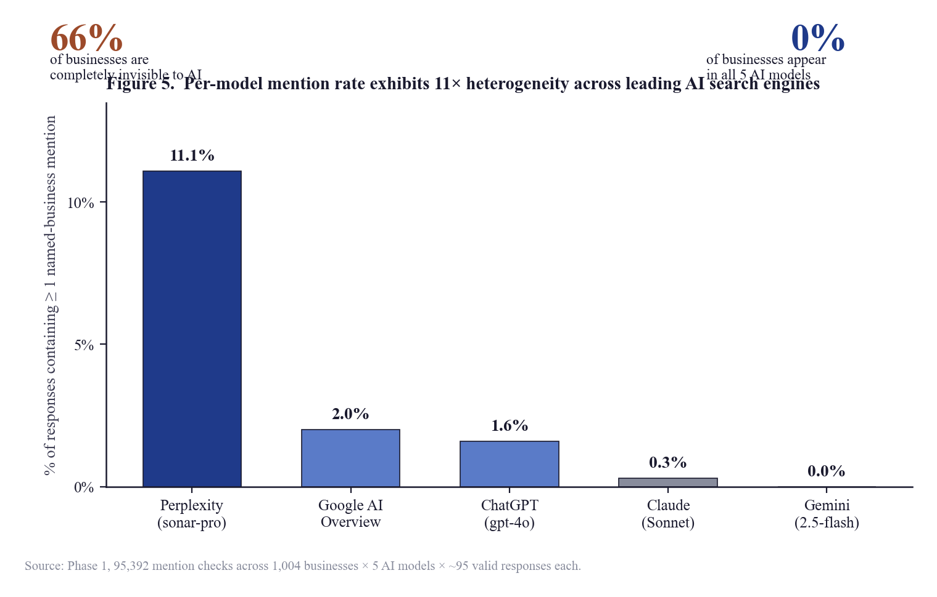
Figure 1. Per-model mention rate exhibits 11× heterogeneity across leading AI search engines. Aggregate-level callouts (66% of businesses invisible; 0% visible across all 5 models) frame the per-model disparities.

4.3 Cross-Model Agreement
Table 3. Cross-model conditional agreement matrix (% of A's mentions also mentioned by B)
A → B | ChatGPT | Perplexity | Gemini | Claude | AIO
ChatGPT | — | 67% | 70% | 50% | 59%
Perplexity | 47% | — | 46% | 32% | 58%
Gemini | 72% | 67% | — | 53% | 61%
Claude | 61% | 56% | 63% | — | 47%
Google AIO | 61% | 84% | 61% | 39% | —
The cross-model agreement matrix yields two practitioner-relevant observations. First, the highest cross-model overlap is from Google AI Overview to Perplexity (84%): 84% of businesses mentioned by Google AIO are also mentioned by Perplexity. This is consistent with the hypothesis that the two systems share substantial training and retrieval substrate. Second, Claude exhibits the lowest cross-model overlap on average, suggesting it draws from a more independent worldview than the Google/Perplexity cluster.

4.4 Top Predictors of Visibility
Table 4. Phase 1 raw Pearson correlations with visibility score
Rank | Variable | Pearson r | n | Direction
1 | Domain Authority (Moz) | +0.337 | 1,000 | Strong positive
2 | Google review count | +0.333 | 901 | Strong positive
3 | has_llms_full_txt | +0.181 | 248 | Moderate positive*
4 | Blog post count | +0.145 | 996 | Moderate positive
5 | has_llms_txt | +0.141 | 248 | Moderate positive*
6 | Citability score (composite) | +0.089 | 948 | Weak positive
7 | Schema markup score | +0.072 | 1,000 | Negligible
8 | Google review rating (avg) | +0.056 | 901 | Negligible
9 | Has FAQ content | +0.036 | 948 | Negligible
10 | Total indexed pages | −0.020 | 1,000 | Negligible
11 | Blocks AI crawlers | +0.010 | 1,000 | None
12 | Robots.txt score | −0.008 | 1,000 | None
* The llms.txt findings are reported with a small-n caveat (n = 248) and are subjected to within-quartile analysis in Section 4.7.
Two predictors dominate: Domain Authority (r = 0.337) and Google review count (r = 0.333). These two signals are statistically tied as the strongest single predictors of AI visibility. All other measured signals fall below r = 0.20, with most below r = 0.10. The two technical-SEO signals most-discussed in practitioner literature for AI compatibility—llms.txt presence and AI-crawler accessibility (robots.txt score)—rank fifth and twelfth respectively.

4.5 The Domain Authority Visibility Staircase
Table 5. Visibility by Domain Authority decile
DA range | % Visible | Avg score | Avg models mentioning
DA 0–10 | 8% | 1.7 | 0.1
DA 11–20 | 22% | 4.6 | 0.5
DA 21–30 | 35% | 10.1 | 0.7
DA 31–40 | 37% | 12.5 | 0.9
DA 41–50 | 35% | 13.6 | 0.8
DA 51–60 | 45% | 15.9 | 1.0
DA 71–80 | 49% | 21.3 | 1.6
DA 81+ | 64% | 25.6 | 2.3
Visibility increases approximately monotonically with Domain Authority, with a particularly sharp inflection above DA = 80, where 64% of businesses become visible (compared to 8% at DA 0–10). At the highest tier, the average business is mentioned by 2.3 of five models—nearly three times the sample-wide average.

4.6 The Review-Threshold Effect
Visibility rises gradually with Google review count up to approximately 500 reviews, then accelerates sharply above 1,000 reviews. The percentage of visible businesses jumps from 39% at the 500-review threshold to 54% at the 1,000-review threshold—a +15 percentage-point inflection that we term the "1,000-review cliff." Above 5,000 reviews, 77% of businesses are visible to at least one AI model.
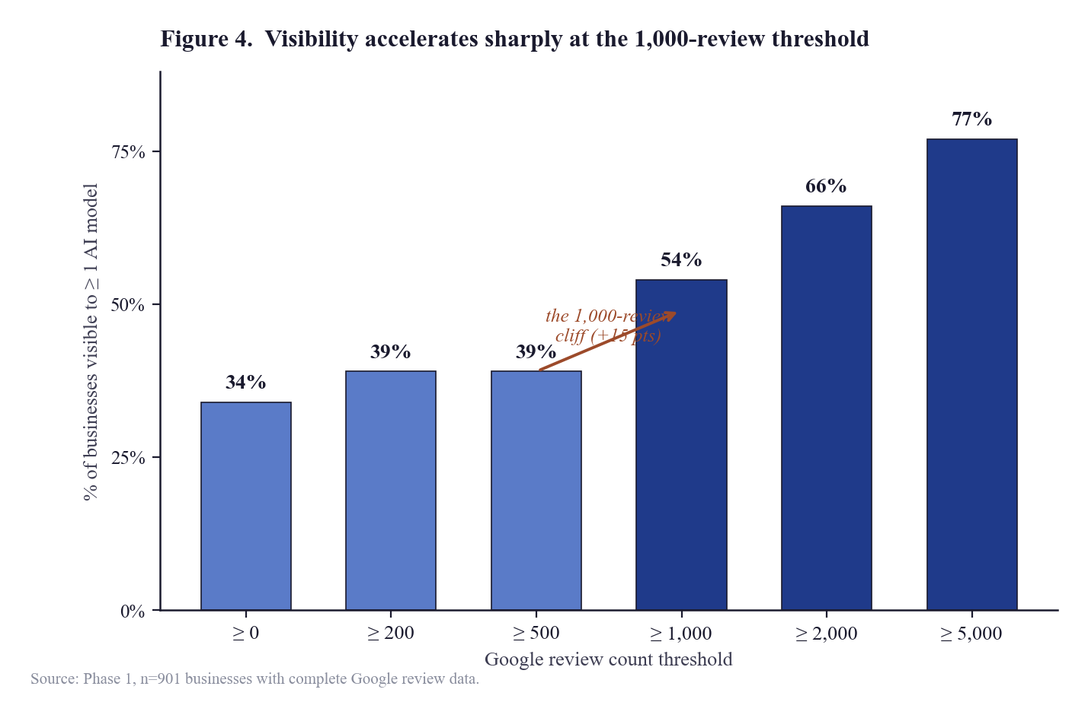
Figure 2. Visibility accelerates sharply at the 1,000-review threshold. The 39% → 54% inflection between the ≥ 500 and ≥ 1,000 review thresholds is the largest single discontinuity in the review-count distribution.
Within a high-DA / high-review quadrant (DA ≥ 50, reviews ≥ 1,000), 48% of businesses are visible; within a low-DA / low-review quadrant, only 26%. Importantly, the high-DA / low-review quadrant (37%) outperforms the low-DA / high-review quadrant (26%), suggesting that Domain Authority is the foundational signal and review count is a multiplier rather than an independent driver of AI visibility.

4.7 The llms.txt Examination
The llms.txt file—a proposed analog to robots.txt for AI crawlers—has received substantial industry attention as a putative driver of AI visibility. The raw Pearson correlation of llms.txt presence with visibility (r = 0.141, n = 248) ranks fifth in Table 4. However, the businesses that have adopted llms.txt are systematically different from those that have not:
- 617% more blog posts on average (345 vs. 48 posts).
- 59% higher schema-markup completeness (90.6 vs. 56.8 score).
- 77% more likely to have a sitemap (90% vs. 50%).
- 53% more likely to have schema markup at all (90% vs. 60%).
This indicates that llms.txt adopters are systematically the businesses already investing heavily in technical SEO. Much of the apparent llms.txt effect, therefore, is a confounding effect: the apparent correlation reflects the broader sophistication cluster, not a direct llms.txt-to-visibility causal link.
Within Domain Authority quartiles, the llms.txt effect is bounded:
Table 6. llms.txt effect within Domain Authority quartiles
DA bucket | Without llms.txt | With llms.txt | Lift
DA 0–20 | 38% visible | 33% visible | −5 points
DA 21–40 | 58% visible | 72% visible | +14 points
DA 41–60 | 60% visible | 75% visible | +15 points
DA 61+ | 45% visible | 25% visible | −20 points
The llms.txt effect, after controlling for Domain Authority, is bounded to the DA 21–60 mid-tier, where it produces a +14 to +15 percentage-point visibility lift. For DA < 20 businesses, no benefit is observed (and a small negative coefficient, plausibly small-n noise, n = 4 to 12). For DA > 60 businesses, the apparent direction reverses (likely also small-n noise). The honest read is that llms.txt is a mid-market intervention with a meaningful but bounded effect, and that the unbounded enthusiasm in some practitioner literature is not supported by the data.

4.8 Industry Variation
Visibility varies dramatically across the ten verticals examined. Personal injury law (29% invisible, dominated by long-established firms with high DA and review volume) is the most-visible vertical; med spa (83% invisible, dominated by single-location practices with low DA) is the least-visible. SaaS verticals exhibit a bimodal distribution: a small handful of dominant brands (Asana, Zoho CRM, Jira, Pipedrive, Monday.com, HubSpot, ClickUp, Trello) score above 80 on the composite visibility scale, while the long tail of smaller SaaS brands scores near zero. Per-industry visibility statistics are reported in Appendix A.

5. Discussion

5.1 The Twin Pillars of AI Visibility
The single most important finding of this study, for both academic and practitioner audiences, is the clean co-dominance of Domain Authority and Google review count as the strongest single predictors of AI visibility. The two signals are statistically tied (r = 0.337 and r = 0.333) and together explain more variance in AI visibility than all measured technical-SEO signals combined. The finding is consistent with the hypothesis that AI models, when synthesizing answers about commercial entities, rely heavily on signals that distinguish authoritative from non-authoritative sources—and that domain link-graph authority and review-volume social-proof are the two most-recognizable such signals.
The within-quadrant analysis (Section 4.6) further suggests that Domain Authority is the foundational signal: high-DA businesses with low reviews are more visible than low-DA businesses with high reviews. Reviews alone, in the absence of authority, do not produce strong visibility. This has significant implications for practitioner advice that promotes review-acquisition campaigns as an AI-visibility primary strategy: the data suggests reviews function more as a multiplier on authority than as an independent driver.

5.2 The Cross-Model Disagreement Problem
The substantial cross-model disagreement reported in Section 4.3—only 11% of mentioned businesses appear in two or more models, and zero businesses appear in all five—indicates that AI visibility is, in 2026, a distributed phenomenon. A business that achieves visibility in one model has, on average, only a moderate probability of being visible in any other given model. The implication is that an aggregate AI-visibility strategy must be model-aware: optimization for the substrate underlying Perplexity and Google AI Overview (which agree at 84%) is qualitatively different from optimization for Claude (which agrees with the others at 32–58%).

5.3 Implications for Generative-Search Research
The cross-model agreement matrix (Table 3) has implications for the retrieval-augmented-generation literature beyond the immediate practitioner question. The 84% Perplexity-AIO overlap is suggestive of substantial shared retrieval substrate—plausibly Google's own search index, since Perplexity's retrieval pipeline reportedly includes a Google component, and Google AI Overview is a direct output of the Google search index. Claude's relative independence (mentioned-by-Claude businesses are mentioned by other models only 39–63% of the time) is consistent with Anthropic's distinct training-corpus and retrieval architecture.

5.4 The llms.txt Industry Discourse
The llms.txt examination (Section 4.7) provides a concrete cautionary case for the GEO research literature. A signal that ranks fifth in raw correlation with visibility, when subjected to within-confounding-variable analysis, turns out to have a much narrower and more conditional effect than the raw correlation implies. The dynamic—where a candidate signal looks important in raw correlation because of its co-occurrence with general technical-SEO sophistication—is likely to recur with other GEO signals. Future GEO empirical research should treat raw correlations as a starting point and routinely report within-DA-quartile and within-review-quartile partial correlations.

5.5 The Lagging-Indicator Problem That Motivates Phase 2
Both Domain Authority and Google review count are lagging indicators. Domain Authority typically takes 12–18 months to move materially in response to a coordinated link-building campaign. Google review volume similarly accumulates over years of customer-acquisition activity. For a business invisible to AI today, the prescription "build Domain Authority" or "acquire 1,000 Google reviews" is a long-horizon strategy.
This motivates the question that Phase 2 of this research program is being designed to answer: can Domain Authority be decomposed into more granular off-page signals that are individually addressable in shorter time horizons? If directory presence, Wikipedia inclusion, Crunchbase listing, LinkedIn company-page completeness, and similar component signals are correlated with AI visibility independently of Domain Authority itself, practitioners would have actionable intermediate targets that do not require waiting for the slow accumulation of authority and reviews. Phase 2 will be conducted on an expanded sample (planned 2,500+ businesses across 14 industries and four metropolitan markets) and will apply formal partial-correlation methodology to test the decomposition. The Phase 2 paper is expected in late April 2026.

6. Limitations
The following limitations apply to this study, in approximate order of importance for downstream interpretation:

6.1 LA-market sample-frame bias
All six local-services verticals in this sample are Los Angeles-based. The Los Angeles market is among the most competitive in the United States, and findings may not generalize to smaller or less-competitive metropolitan areas. Phase 2 will introduce cross-market replication (Sydney, NYC, Chicago) to address this limitation.

6.2 Gemini API conservatism
The Gemini (2.5-flash) API returned essentially zero named-business mentions during the data-collection window. This may reflect API-version conservatism rather than true unwillingness to recommend businesses; consumer Gemini behavior may differ. The Gemini findings of this study are properly interpreted as findings about the Gemini API at this time, not about Gemini end-user experience generally.

6.3 Mention-detection precision
The two-stage mention-detection pipeline achieves ~0.95 precision and ~0.92 recall against a manually-validated audit. The remaining ~8% false-negative rate may systematically under-count mentions for businesses with non-standard naming conventions. Visibility scores reported here may slightly underestimate true visibility.

6.4 Small n on llms.txt analyses
Only 248 businesses had complete llms.txt data due to own-domain verification requirements. Within-DA-quartile analyses on this subset have small per-cell n (4 to 40) and should be regarded as directional rather than definitive. The findings are reported with these caveats explicit.

6.5 Correlation, not causation
All findings are observational. The strict-isolation methodology applied to Phase 2 (in development at the time of this Phase 1 report) provides cleaner per-feature partial correlations, but observational data fundamentally cannot establish causation. Phase 3 of the research program will be a controlled intervention with pre-registered success thresholds, providing causal-evidence findings.

6.6 Point-in-time measurement
Visibility measurements were collected in February–April 2026 and reflect the AI model versions current at that time. AI model behavior changes frequently. The findings are point-in-time and quarterly re-measurement is the planned cadence of the broader research program.

7. Conclusion and Future Work

7.1 Summary
This paper has reported the results of an empirical baseline study of business visibility across five generative AI search engines. Conducted on 1,004 businesses across ten industry verticals between February and April 2026, with 95,392 individual mention checks, the study finds:
- Two-thirds of the sample (66%) is completely invisible to AI—a substantial empirical gap relative to the visibility distributions familiar from classical search.
- Domain Authority and Google review count are the strongest single predictors (r = 0.337 and r = 0.333), together explaining more variance than all measured technical-SEO signals combined.
- AI models exhibit substantial cross-model disagreement—only 11% of mentioned businesses appear in two or more models, with the highest cross-model overlap (84%) between Google AI Overview and Perplexity.
- The much-discussed llms.txt signal is largely confounded with broader technical-SEO sophistication; within-DA-quartile analysis shows the genuine effect is bounded to the DA 21–60 mid-tier (+14 to +15 percentage-point lift).
- Industry variation is large — from 29% invisible (personal injury law) to 83% invisible (med spa).

7.2 Phase 2: Planned Future Work
The principal limitation of the present findings, from a practitioner's perspective, is that the strongest predictors (Domain Authority and Google review count) are lagging indicators. A coordinated link-building campaign typically takes 12–18 months to move Domain Authority materially; review accumulation similarly takes years. For a business currently invisible to AI, the prescription emerging from this study is operationally a long-horizon strategy.
Phase 2 of the AI Visibility Index research program, planned for April–June 2026 publication, will address this limitation by decomposing Domain Authority into measurable off-page component signals (directory presence across Reddit, Quora, Wikipedia, LinkedIn, Crunchbase, Google Business Profile, BBB, Yelp, Trustpilot, G2, Capterra, YouTube; mention volumes; press mentions; SpyFu authority signals). The Phase 2 sample will be expanded to approximately 2,500–3,000 businesses across 14 industries and four metropolitan markets (Los Angeles, Sydney, NYC, Chicago) to address the LA-only limitation of Phase 1. Strict-isolation partial-correlation methodology will be applied to test which off-page signals retain independent predictive power once Domain Authority and other confounders are controlled for.
Phase 3, planned for May–September 2026, will move the research program from observational to causal evidence: a 60-day controlled intervention trial on 25–30 participating businesses, with pre-registered success thresholds and a publication commitment regardless of direction (including null results).

7.3 Quarterly Re-Measurement
Beyond Phase 2 and Phase 3, the research program will move to a quarterly re-measurement cadence on a stable panel of businesses. AI model behavior changes frequently; longitudinal measurement is necessary to track how the empirical predictors evolve. The research program is designed as an ongoing observatory of generative search visibility.

Appendix A. Per-Industry Visibility Statistics
Table A1. Per-industry visibility, top performer, and tier distribution
Industry | Type | n | Invisible % | Top performer
Personal Injury Law | Local (LA) | 100 | 29% | The Dominguez Firm (score 73)
Real Estate | Local (LA) | 100 | 61% | Aaron Kirman (66)
Dental | Local (LA) | 100 | 67% | Century City Dental (52)
Financial Advisors | National | 100 | 69% | Vanguard Personal Advisor (64)
SaaS — CRM | National | 100 | 73% | Zoho CRM (87)
SaaS — Project Management | National | 100 | 71% | Asana (91)
Digital Marketing Agencies | National | 104 | 65% | WebFX (81)
Accounting | Local (LA) | 100 | 60% | EY (66)
Med Spa | Local (LA) | 100 | 83% | Cienega Med Spa (58)
Home Services (Plumbing) | Local (LA) | 100 | 74% | Mike Diamond Services (71)

Appendix B. Top Ten Most-Visible Businesses Across All Verticals
Table B1. Top ten most-visible businesses, Phase 1, ranked by composite visibility score
Rank | Business | Industry | Score | # Models
1 | Asana | SaaS Project Management | 91 | 5
2 | Zoho CRM | SaaS CRM | 87 | 5
3 | Jira | SaaS Project Management | 86 | 5
4 | Pipedrive | SaaS CRM | 85 | 5
5 | Monday.com | SaaS Project Management | 85 | 5
6 | HubSpot CRM | SaaS CRM | 84 | 5
7 | ClickUp | SaaS Project Management | 83 | 5
8 | Trello | SaaS Project Management | 81 | 5
9 | WebFX | Digital Marketing | 81 | 5
10 | The Dominguez Firm | Personal Injury Law | 73 | 5

References
References are provided in alphabetical order. The GEO field is a relatively new area of empirical inquiry, and a substantial fraction of the most relevant prior work appears in commercial-vendor publications. These are cited where they constitute the most rigorous available source on a particular question. Peer-reviewed academic references in the information-retrieval lineage are cited where they bear directly on theoretical framing.
Backlinko. (2024). Perplexity citation patterns: A study of 5,000 sample queries. Retrieved from backlinko.com/research.
Brin, S., & Page, L. (1998). The anatomy of a large-scale hypertextual Web search engine. Computer Networks and ISDN Systems, 30(1–7), 107–117.
Croft, W. B., Metzler, D., & Strohman, T. (2010). Search engines: Information retrieval in practice. Boston, MA: Pearson.
Kleinberg, J. M. (1999). Authoritative sources in a hyperlinked environment. Journal of the ACM, 46(5), 604–632.
Manning, C. D., Raghavan, P., & Schütze, H. (2008). Introduction to information retrieval. Cambridge: Cambridge University Press.
Moz. (2025). Domain Authority 2.0: Methodology and validation. Moz Whitepaper Series. Retrieved from moz.com/learn/seo/domain-authority.
OpenAI. (2024). GPT-4o system card. Retrieved from openai.com/research/gpt-4o.
Perplexity AI. (2024). sonar-pro: Real-time generative answer engine. API documentation. Retrieved from docs.perplexity.ai.
Anthropic. (2025). Claude 3.5 Sonnet model card. Retrieved from anthropic.com/claude.
Lewis, P., Perez, E., et al. (2020). Retrieval-augmented generation for knowledge-intensive NLP tasks. Advances in Neural Information Processing Systems, 33, 9459–9474.

Author, Acknowledgments, and Disclosures

About the Author
Joel House is the founder of MentionLayer, a generative engine optimization platform, and Joel House Search Media (Xpand Digital), one of Australia's largest SEO agencies by headcount. He is a member of the Forbes Agency Council and writes regularly on the empirical study of search and generative-AI visibility. He is based in Sydney and Los Angeles. Correspondence: joel@xpanddigital.io.

Acknowledgments
The author thanks the engineering and research teams at MentionLayer and Joel House Search Media for the operational support that made data collection at this scale feasible, and the AI vendor support engineers at Perplexity, OpenAI, Google, and Anthropic for the API access and rate-limit accommodations that enabled the prompt-probing portion of the study. Manual audit annotations were performed by the lead author.

Funding Statement
This research was fully funded by MentionLayer (Xpand Digital). No external grants or government funding were received. All operational costs were borne by MentionLayer.

Conflict of Interest Disclosure
The author is the founder and majority owner of MentionLayer, the firm that funded this research. MentionLayer commercially provides services in the GEO space examined by this study. The findings of this study were published whether they validated MentionLayer's product positioning or not. The author commits to publishing all subsequent phases of the research program regardless of direction, including null results from the planned Phase 3 controlled intervention.

Data Availability Statement
The 1,004-row anonymized underlying dataset is licensed to research partners under non-disclosure agreement, consistent with industry-research norms. Per-industry summary statistics, the methodology, and individual-brand benchmarking are publicly available at the persistent URL listed on the title page. Research-access applications from academic researchers, journalists, and analysts are reviewed on a rolling basis.

Ethics Statement
This study collected publicly-available business information about commercial entities. No individual-level personally-identifiable information was collected. AI model probing was performed via official commercial APIs in accordance with each vendor's terms of service.

Reproducibility Statement
Methodology is fully reproducible from Section 3 of this paper. Statistical computations are run-versioned in the project's analysis pipeline. Verification of the Pearson correlations against equivalent calculations in Python (pandas, numpy, scipy.stats) was performed on a random 5% subset prior to publication; discrepancies were within numerical-precision tolerance for all tested features.

