**Principles of Software Engineering**

**eMISR**

**Authors:** Erik Roganský, Adam Partl, Juraj Majerník

**IDs:** 120985, 116268, 116241

**Year of study:** Second, Third, Third

**Type of study:** Bachelor

**Programme:** Informatics

**Academic year:** 2023/2024

**Contents**

1. Introduction 3

1.1. Business context 3

1.2. Business goals and success metrics 3

1.3. Solution description 3

2. Business model 4

2.1. Process map 4

2.2. Process diagrams 4

2.2.1. User registration 4

2.2.2. Application creation 5

2.3. Domain model 6

3. Requirements model 6

3.1. Functional requirements 6

3.2. Non-functional requirements 7

4. Use Case Diagrams 7

4.1. User Registration and Authentication 7

4.1.1. Register user 8

4.1.2. Login 8

4.1.3. Two-factor authentication 8

4.1.4. Forgot password 8

4.1.5. Reset password 8

4.1.6. View profile 9

4.1.7. Update profile 9

4.2. Document Application Process 9

4.2.1. Fill out the document form 9

4.2.2. Save draft 10

4.2.3. Upload necessary documents 10

4.2.4. Preview the document 10

4.2.5. Submit the form 10

4.2.6. Track status 10

4.3. Payments and Courier Services 11

4.3.1. Choose delivery and payment method 11

4.3.2. Pay 11

4.3.3. Track delivery information 11

4.3.4. Collect the document 12

4.3.5. Deliver the document 12

5. Sequence diagrams 12

5.1. Applicant registration 12

5.2. Applicant login with two factor authentication 13

5.3. Applicant is filling in the document form 14

5.4. Payment and delivery service 15

6. Class diagram 16

7. State diagram 17

8. Wireframes 18

9. Basic design 19

10. Prototype 21

1. **Introduction**
   1. **Business context**

Our mission is to streamline the process of obtaining various official documents in collaboration with the Ministry of Internal Affairs. We aim to develop a user-friendly web application that drastically reduces waiting times, making it easier and faster for individuals to apply for essential paperwork such as IDs, passports, driving licenses, and weapon licenses.

The current process of obtaining these documents often involves long waiting times at government offices, leading to frustration and inconvenience for citizens. Our goal is to alleviate this burden by providing a digital platform that allows users to complete their applications efficiently from the comfort of their own homes.

* 1. **Business goals and success metrics**
* Saved Time:
  + This application will save you an average of 90% of the time you would typically spend in a government office.
* Simplicity:
  + In contrast to kiosks found in government offices, which often require assistance from workers to navigate and select the correct options, our application prioritizes simplicity. We aim to minimize visual clutter to prevent confusion and provide context clues for easy navigation.
* Mental Health:
  + Dealing with government workers can sometimes be unpleasant, especially when coupled with long wait times. By eliminating the need to wait for personal contact with workers, our application helps to alleviate these stressors.
* Average Amount of Money Saved:
  + Every moment spent outside of your office represents potential lost income. Many individuals are forced to take unpaid leave to attend to personal matters. Our application eliminates the need to physically visit government offices, saving you 100% of the money you would otherwise lose. You can now take care of your personal business outside of working hours, without any need for time off.
  1. **Solution description**

The web application will feature intuitive form layouts for each type of document, such as ID cards, passports, and driving licenses. Users will input their personal information including first and last name, date of birth, place of stay, signature, and photo. The system will then generate a preview of the document in physical form for the user to review.

After filling out the form, users will have the option to edit their information or proceed to payment and courier service. We will discourage personal pick-up at government offices through a prompt highlighting the time, money, and energy saved by opting for courier delivery.

To ensure widespread accessibility, distribution channels will include partnerships with post offices and integration with slovensko.sk, the government's official website, as well as newsletters.

This innovative solution not only saves users valuable time but also reduces the stress and anxiety associated with bureaucratic processes. By simplifying document applications, we aim to enhance efficiency and mental well-being for individuals interacting with government agencies.

1. **Business model**
   1. 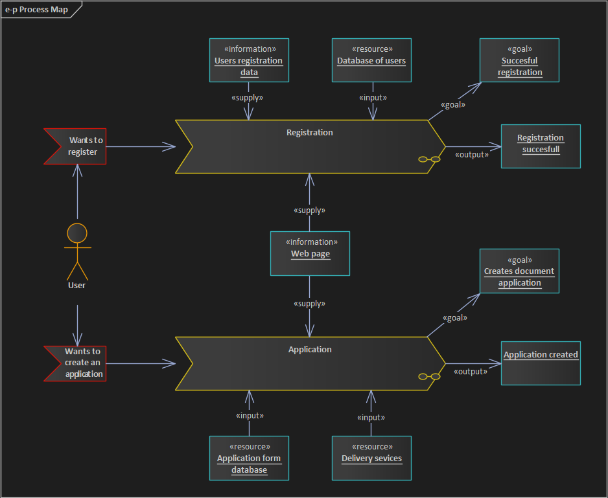**Process map**

Whenever the user wants to register, the first step in the process is for them to provide their registration data. Then, the registration is added to the database of users, and the registration is deemed successful. The goal was to create a successful registration, which has been achieved.

When the user wants to create an application, the initial step is to retrieve the application from the database. Then, the website supplies information about the user. Additionally, the option to add delivery services is available. Subsequently, the application is created. The goal of this process was to successfully create an application, and this goal has been achieved.

* 1. **Process diagrams**
     1. 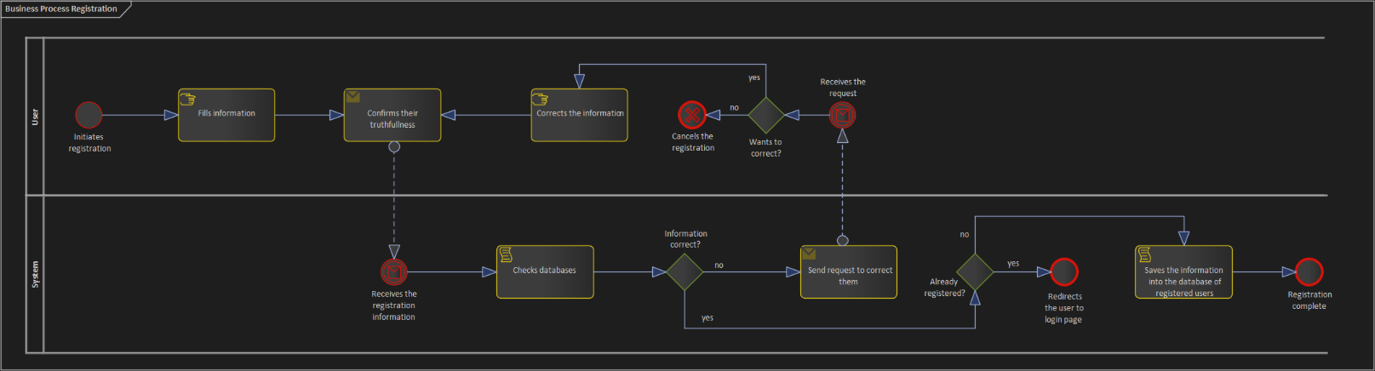User registration

The user registration diagram consists of two parts: the user and the system. The user initiates registration and then fills in the required information. The information is then confirmed. The system receives the registration information and checks the databases to verify its correctness. If the provided information is incorrect, the system sends the user a request to correct it. The user then receives the request and is asked to correct the registration information. If they decide not to correct the registration, it is canceled. However, if they choose to correct the registration, they need to provide the corrected information, and the system receives the corrected registration information. If the provided data is correct, the system checks whether the user is already registered. If yes, the user is redirected to the login page. If not, the information is stored in the registration database, and the registration process is completed.

* + 1. 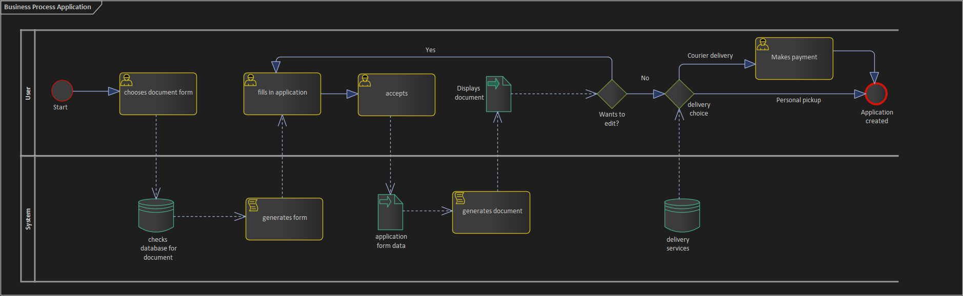Application creation

The application creation diagram is similar to the registration diagram in that it consists of a system and a user part. Firstly, the user chooses a document form they want to apply for. The system then checks the database for the desired document and generates a form for the user. The user then fills in the application, accepts the provided information, and the form is sent to the system to generate a document preview. This preview is then displayed to the user. The user can choose if they want to edit the document or not. In case they want to edit the data inside the document, they are taken back to the point of filling in the application form. If they decide that the provided data is okay and they want to continue the application, they can then choose how they want the document to be delivered from the delivery services provided by the system. In case they choose personal pickup, the application process is finished, and the application is created. If they choose Courier delivery, they need to make a payment, and after that, the application is created.

* 1. **Domain model**

This domain model illustrates the interactions among entities within our application process. The process begins when a user initiates an application by creating a document and submitting payment. Subsequently, the application undergoes review by an administrative worker, who evaluates its accuracy and completeness. Based on this assessment, the administrative worker can either approve or reject the application. Upon successful approval, the application proceeds to the document production department, where the document is generated. Optionally, the document may be sent via a shipping company to the user's designated address, although users also have the choice to collect it in person.

1. **Requirements model**
   1. **Functional requirements**
2. Registration and authentication

* Users can create accounts securely
* Authentication mechanisms ensure that only registered users can access the application

1. Document application process

* User friendly form for each type of document
* The ability to preview documents
* Friendly UI/UX for easier navigation

1. Payments and courier services

* Integrate payment gateways for secure online payments
* Option to choose courier services
* Ability to choose between courier delivery or personal pickup

1. Notification system

* Implement a notification system to update users on the status of their application.
* Notify users when their documents are ready for delivery or pick-up.
  1. **Non-functional requirements**

1. Performance

* Ensure the application can handle concurrent user sessions without significant performance degradation.
* Response times for form submissions and document previews should be minimal.

1. Security

* Strong encryption mechanisms to secure data transmissions
* Protection against cyberattacks

1. Reliability

* Ensure minimal downtime/maintenance
* Have backup and recovery technology to prevent data loss
* Monthly system maintenance

1. Laws and regulations

* Ensure compliance with relevant laws and regulations governing online transactions and personal data protection (GDPR).
* Regularly audit and update the application to maintain compliance with changing regulations.

1. User Satisfaction

* Conduct user testing and gather feedback to continuously improve the application's usability and user experience.

1. Accessibility features

* Provide accessibility features for disabled people (alt text for images, keyboard navigation ...)

1. **Use Case Diagrams** 
   1. **User Registration and Authentication**

* + 1. Register user

1. New applicant opens the app

2. Applicant clicks the register button

3. Applicant fills the information

4. Applicant confirms and submits the information

5. System validates the provided information

Exception: 5a. Provided information are incorrect, user leaves

1. System declines the registration

2. Applicant leaves the app

Alternate: 5b. Provided information are incorrect, user corrects them

1. System declines the registration

2. Applicant corrects the information

3. Applicant returns to step 4

6. System approves the registration

* + 1. Login

Pre-condition: Applicant must be registered

1. Applicant fills the login information

2. Applicant clicks Login button

Alternate: 2a. Applicant has Two-Factor Authentication turned on

1. System approves and redirects applicant to Two-Factor Authentication page

2. Applicant authenticates themselves - Extension Point

3. Applicant continues to step 3

Alternate: 2b. Applicant enters incorrect credentials and uses Forgot Password

1. System declines

2. Applicant uses Forgot Password functionality - Extension Point

3. Applicant successfully resets password

4. Applicant returns to step 1

Alternate: 2c. Applicant enters incorrect credentials and tries to login again

1. System declines

2. Applicant returns to step 1

Exception: 2d. Applicant enters incorrect credentials and leaves

1. System declines

2. Applicant leaves the app

3. System approves and redirects applicant to main page

* + 1. Two-factor authentication

1. Applicant chooses method

2. Applicant authenticates themselves

* + 1. Forgot password

1. Applicant clicks Forgot Password button

2. System redirects applicant to Forgot Password page

3. Applicant enters email of the account to reset password on

4. Applicant continues to reset password - Inclusion Point

* + 1. Reset password

1. Applicant opens reset link in the email

2. Applicant fills the new password

3. System resets the password

4. Applicant is redirected to login

* + 1. View profile

Pre-condition: Applicant must be logged in

1. Applicant clicks profile button

2. System displays everything about the applicant

Extension Point - Update profile

* + 1. Update profile

1. Applicant edits one or more details

2. Applicant confirms them

3. System validates the edited information

Exception: 3a. System declines

1. System declines

4. System approves

* 1. **Document Application Process**

* + 1. Fill out the document form

Pre-condition: Applicant must be logged in

1. Applicant chooses that they want to apply for a document

2. System shows them a list of available forms and saved drafts

Exception: 2a. Wanted option not present

1. Applicant does not find what they need

2. Applicant aborts leaves the app

3. Applicant chooses one

4. System pre-fills it with already known information

5. Applicant opens the form

6. System provides them with comprehensive hints

7. Applicant fills the form cell by cell - Inclusion Point

Extension Point - Saving a draft

* + 1. Save draft

1. Applicant clicks "Save draft"

2. System saves the filled form to applicant's profile

* + 1. Upload necessary documents

1. Applicant uploads necessary documents

2. System checks their integrity

3. System approves or declines the upload

* + 1. Preview the document

Pre-condition: Form is entirely filled

1. Applicant clicks "Preview document"

2. System generates preview

3. Applicant checks the document

Alternate: 3a. Applicant not okay with the preview

1. Applicant declines the document

2. Applicant returns to form editing

4. Applicant approves the document

* + 1. Submit the form

Pre-condition: Form is filled correctly

1. Applicant submits the form

2. System processes the form

3. System assigns the from to administrative worker

* + 1. Track status

Pre-condition: Form was submitted

1. System notifies the applicant about the status

Exception: 1a. Applicant does not want to see status

1. Applicants does not check the notifications

2. Applicants checks the notifications

* 1. **Payments and Courier Services**

* + 1. Choose delivery and payment method

1. Applicant proceeds to fill delivery information

2. Applicant selects the most suitable delivery method

3. Applicant selects payment method

* + 1. Pay

1. System calculates the price

Alternate: 1a. Applicant chose pickup at the office

1. Office worker provides the applicant with the calculated price in person

2. Applicant pays

3. Office worker gives the applicant a receipt

2. System redirects applicant to payment provider

3. Applicant pays the calculated amount

4. System receives the information about the payment

5. System sends an email with receipt to the applicant

* + 1. Track delivery information

1. Applicant opens delivery information section of the app

2. System displays current location/status of the package continuously updated by delivery service

* + 1. Collect the document

1. Applicant is notified by email that the document will be delivered that day

Alternate: 1a. Applicant chose pickup at the office

1. Delivery service delivers the document to user-specified office

2. Office worker takes the document

3. Applicant collects the document at the office

2. Delivery service delivers the document to applicant specified location

3. Applicant takes the document from the delivery service

* + 1. Deliver the document

1. Delivery service receives information about the document from the system

2. Delivery service receives the document

3. Delivery service sends updates about the document to the system

4. Delivery service delivers the document to the specified location

1. **Sequence diagrams**
   1. **Applicant registration**

This sequence diagram shows the process of registration, with the option of applicant providing incorrect information. The applicant submits his information, and the system then checks whether the information is correct or incorrect and based on the decision either approves or declines the registration attempt.

* 1. **Applicant login with two factor authentication**

In this sequence diagram the applicant is trying to log in to the system by filling in and submitting the login form. The login attempt is then redirected to the two-factor authentication site that sends authentication message back to the applicant. The applicant then completes the authentication and 2FA sends a message back to the system, notifying that the authentication was successful, and the system subsequently accepts the login request.

* 1. **Applicant is filling in the document form**

This sequence diagram shows the applicant filling in the document. The applicant first chooses that he wants to apply, the system then provides available forms, and the applicant chooses one. System then pre-fills the document with information it already knows, and applicant fills in the rest. The applicant then saves the draft and system saves it on to his profile. Applicant is then requested to upload necessary documents to complete the application. After the upload, system needs to check the documents, to see if they are correct. System then approves the upload, and the applicant can preview the document. System generates the preview. The applicant can then check the document and submit the form. After submitting the form, the system processes it and assigns it to the office worker. The worker then works on the document and updates the status of the document. The system then notifies the applicant about the status of the document.

* 1. **Payment and delivery service**

In this sequence diagram we can see the process of payment and delivery of the document. The applicant must first fill in the delivery information, specify the delivery method and payment method. The system then calculates the price for the creation and delivery of documents and redirects the applicant to a payment processing site. The site then prompts the applicant to pay the specified amount. The applicant pays and the site sends information about the payment processing to the system. The system then sends and e-mail to the applicant as a confirmation of the payment. Next the system sends a message requesting delivery of the documents to the delivery service. The delivery service then continually updates the delivery status. Meanwhile whenever the applicant opens the delivery information section, the delivery status is displayed from the system (provided to the system by the service). Whenever the delivery is prepared, the delivery service sends a message to the system and the system notifies the applicant by e-mail. The delivery service then delivers the document in the time specified in the e-mail. Upon the completion of the delivery, the applicant confirms the delivery.

1. **Class diagram**

Login class handles user logging into the system or passing user to Registration class where new user is created and inserted into a user database.  When the user passes login, UserManager object takes his data from database and user object is created from which he can create Form object that represents form that the user will fill out. In the Form class he can create a payment object that tracks if the amount was paid, connects to payment gate to make the payment, and sends notification to user about the state if the payment was received. If the payment was received the class DeliveryInfo is created which allows the user to pick what courier service will deliver the package or if he will pick it up himself. After that the information is sent to the MIASR worker.

1. **State diagram**

1. User starts on login page
2. If user is not registered or is on site for the first time he is moved to registration state, otherwise we move to authentication state.
3. In registration sate the user creates his account and is moved to login state
4. In authentication state the user input is checked if they are correct (needs to be protected against injection). If they pass the user moves to main site else, he is moved to login state and insert valid credentials.
5. In Main site he can create new form from list of forms
6. Fills form
7. In Preview form user sees the final state of his form and decide if he’s going to submit it or edit it
8. Lastly, he’s in the submit state where the form is sent to MIASR worker.
9. **Wireframes**

1. **Basic design**

1. **Prototype**

Link:

<https://www.figma.com/proto/pYf8ElSUIL6jKWOmT2AYfG/PSI?type=design&node-id=1-7&t=zLtPLTDrjryeDtMN-0&scaling=scale-down&page-id=0%3A1&starting-point-node-id=1%3A7>