

Name: - Rahul Barnwal



Roll No.: - 2020BEC0003

A four variable Boolean function is given as f(A, B, C, D) = ∑(1, 2, 4, 5, 9, 10, 12, 15) D(8,11,13). Realize a circuit to obtain the function using NAND gates.



**Q1:**

**Ans:**

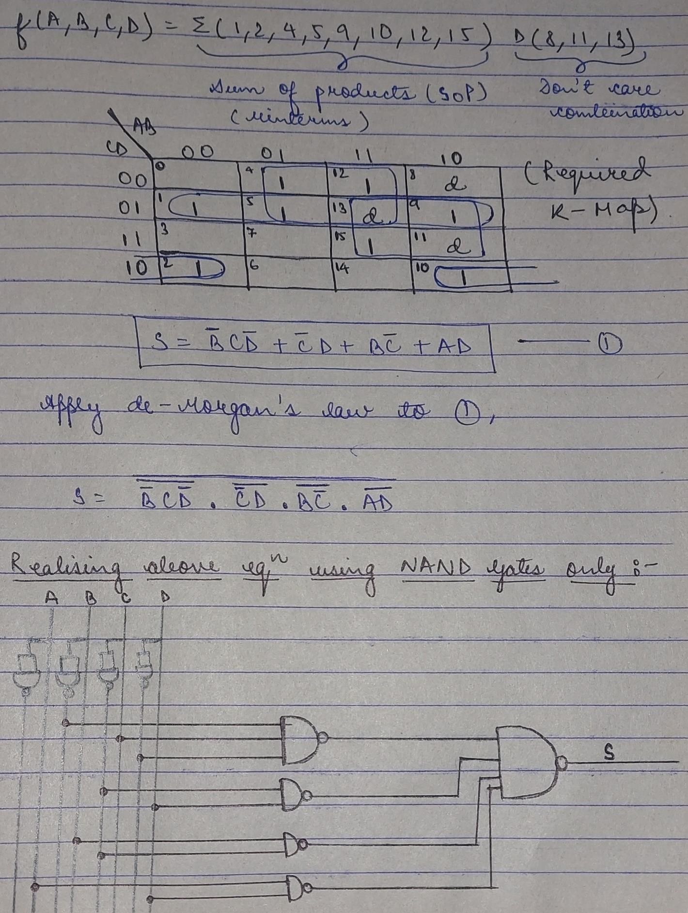



Diagram of Required Circuit:





**Link:**



<https://www.deldsim.com/ugc-c1r10351a/>

Design a combinational circuit whose input is a 3-bit number and output is



**Q2:**

its 2’s complement.

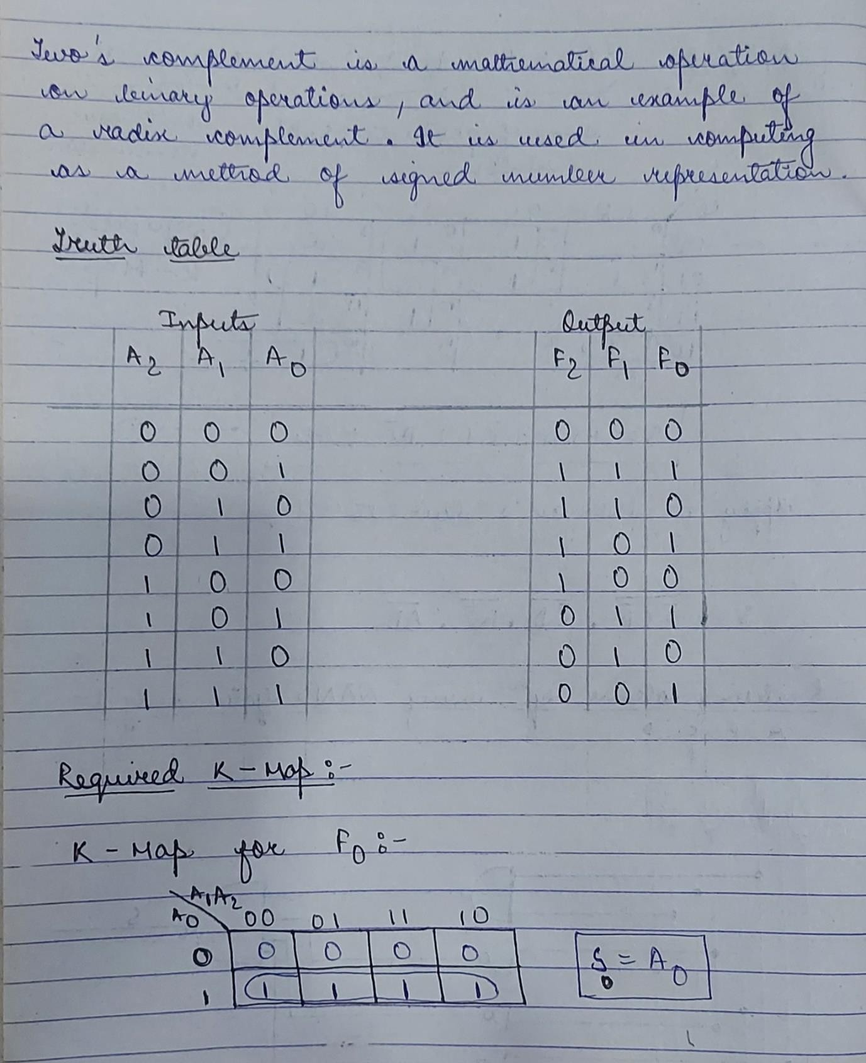



Ans:

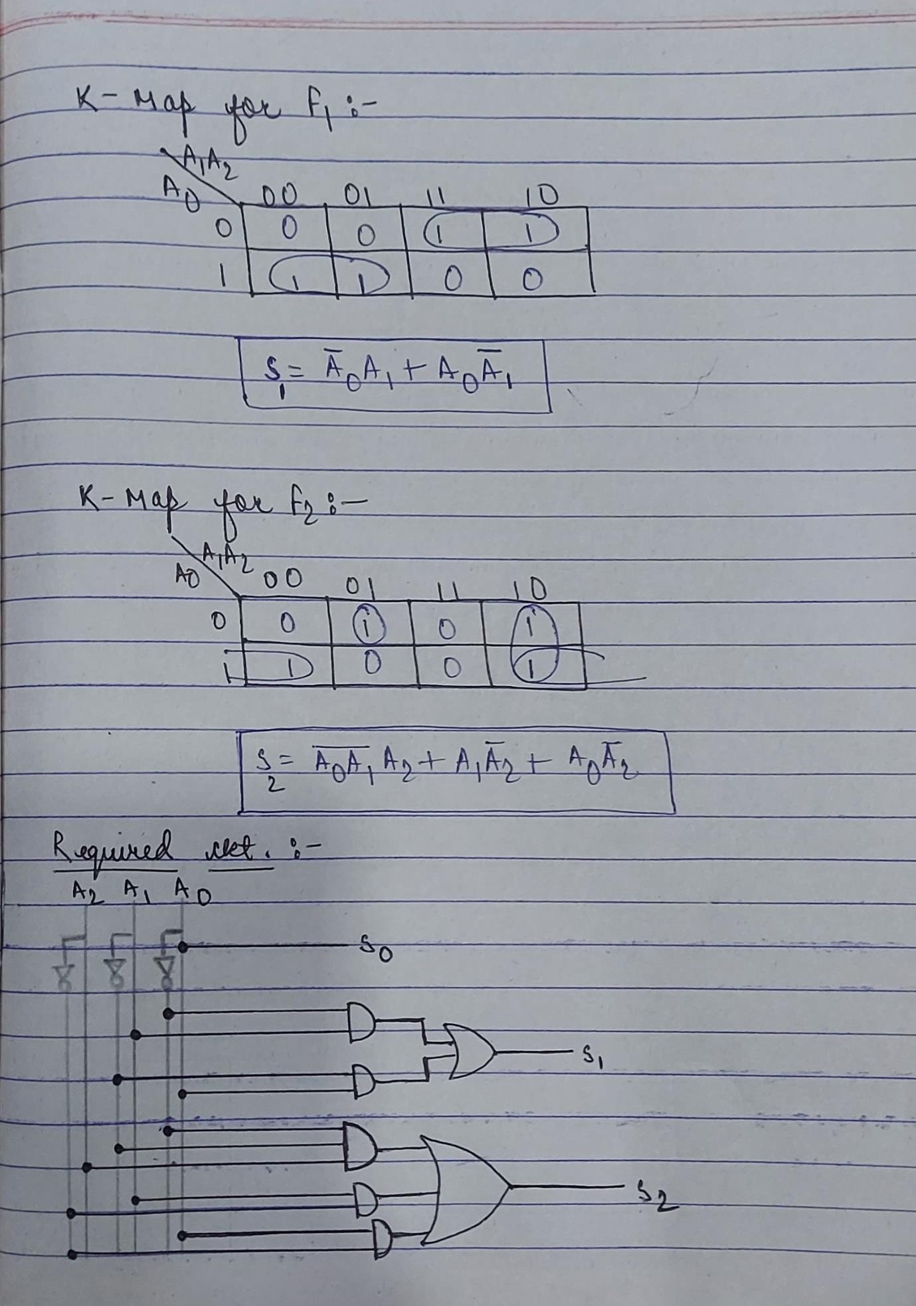



Diagram of Required Circuit:





**Link:**



[**https://www.deldsim.com/ugc-c1y10348v/**](https://www.deldsim.com/ugc-c1y10348v/)