**STEP 1: Create Database and Table**

**1. Create Database**

CREATE DATABASE ecommerce_analysis;



USE ecommerce_analysis;



**2. Create Table (ecommerce_data)**

CREATE TABLE ecommerce_data (

Order_Date DATE,

Time TIME,

Aging INT,

Customer_Id INT,

Gender VARCHAR(10),

Device_Type VARCHAR(20),

Customer_Login_type VARCHAR(20),

Product_Category VARCHAR(100),

Product VARCHAR(100),

Sales FLOAT,

Quantity FLOAT,

Discount FLOAT,

Profit FLOAT,

Shipping_Cost FLOAT,

Order_Priority VARCHAR(20),

Payment_method VARCHAR(20)

);



**3. Import CSV**

Right click on Tables > Table Data import wizard > Choose dataset and click on Next

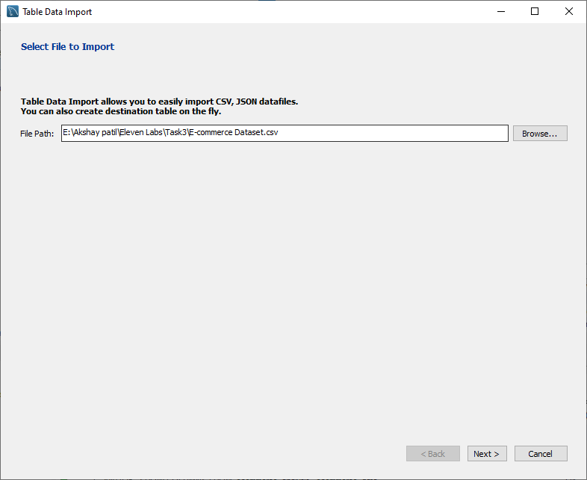

Use existing table

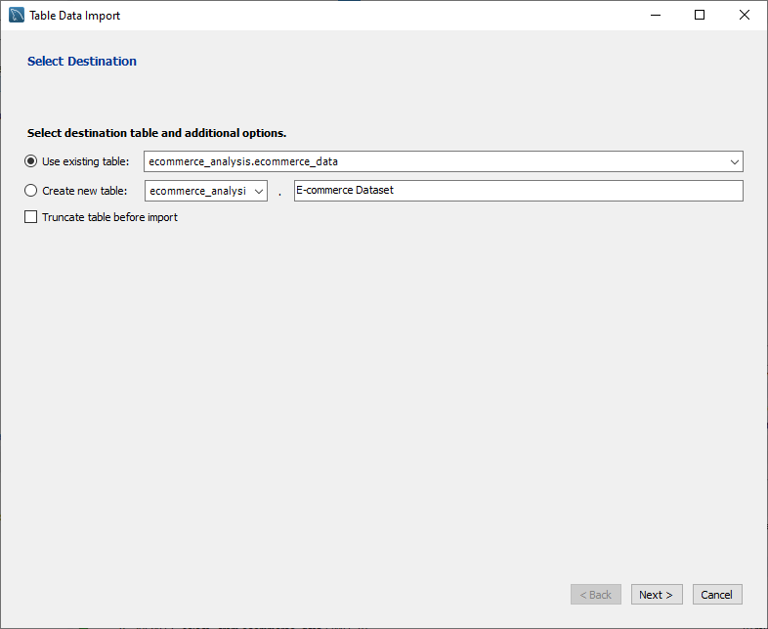

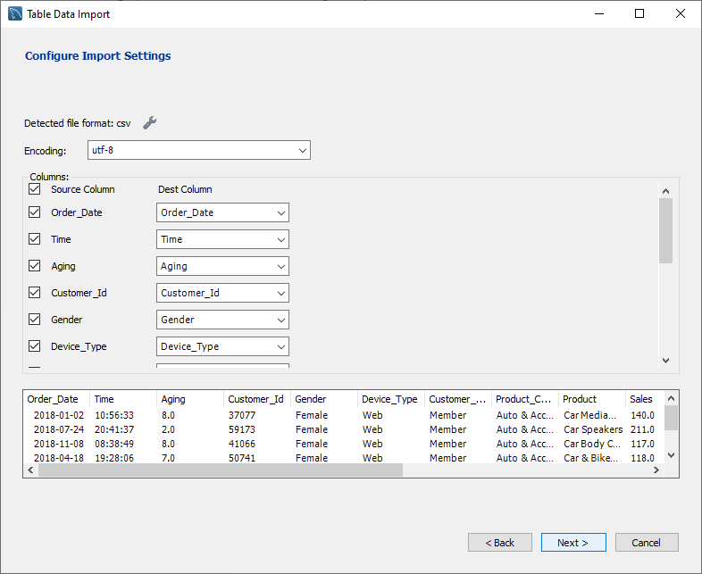

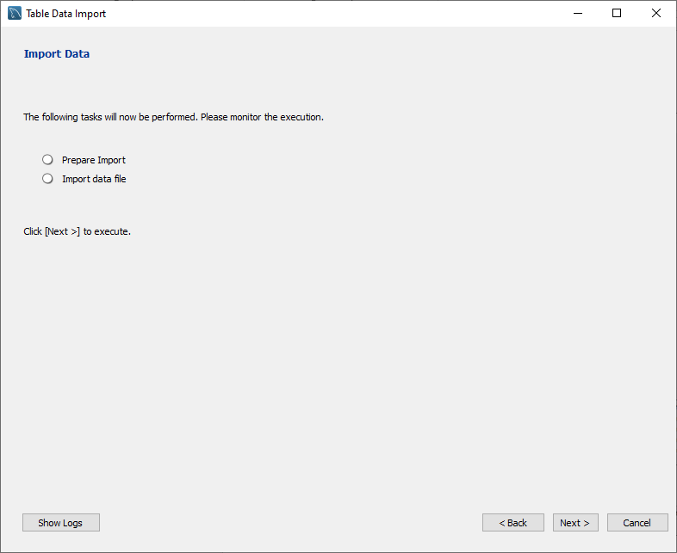

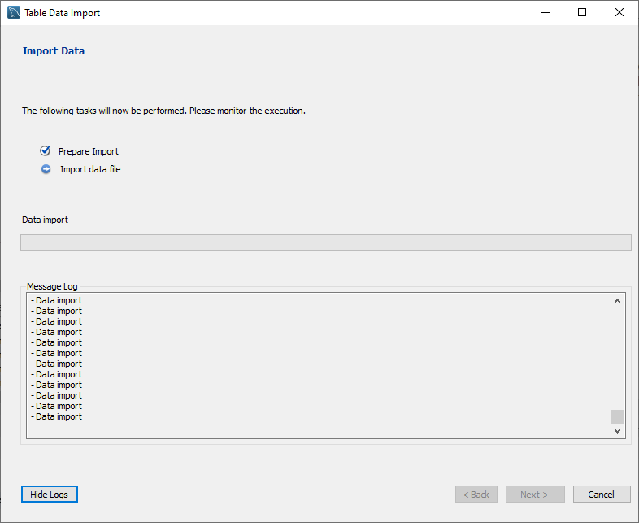

**Basic Queries**

**1. View first 10 rows**

SELECT * FROM ecommerce_data

LIMIT 10;

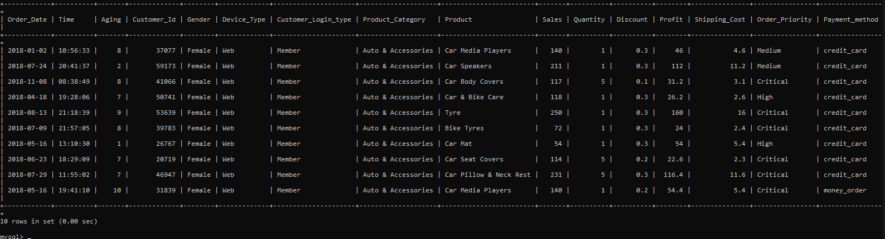

**2. Columns overview: Show distinct product categories**

SELECT DISTINCT Product_Category FROM ecommerce_data;

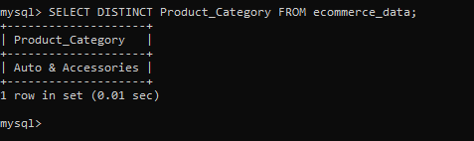

**3. Orders from 'Female' customers using Web**

SELECT * FROM ecommerce_data

WHERE Gender = 'Female' AND Device_Type = 'Web';

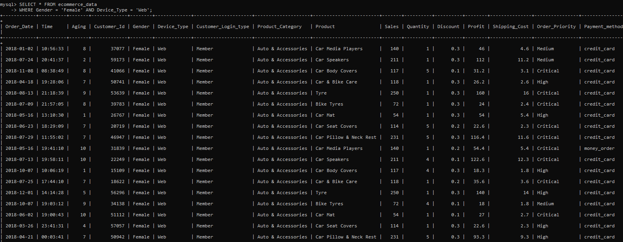

**4. Orders placed in 2018**

SELECT * FROM ecommerce_data

WHERE Order_Date LIKE '2018%';

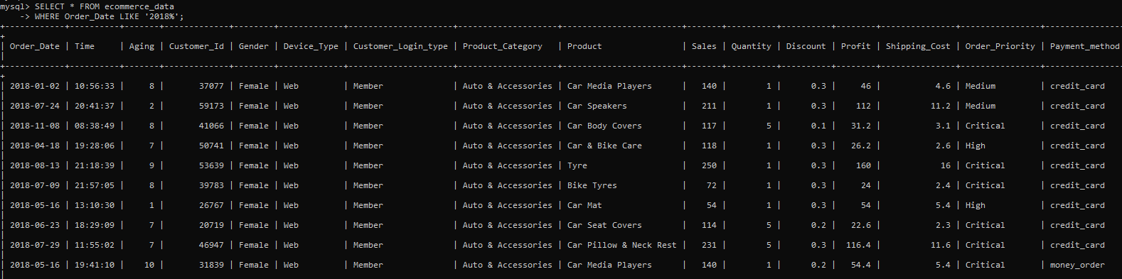

**5. Orders with high priority and profit > 100**

SELECT * FROM ecommerce_data

WHERE Order_Priority = 'High' AND Profit > 100;

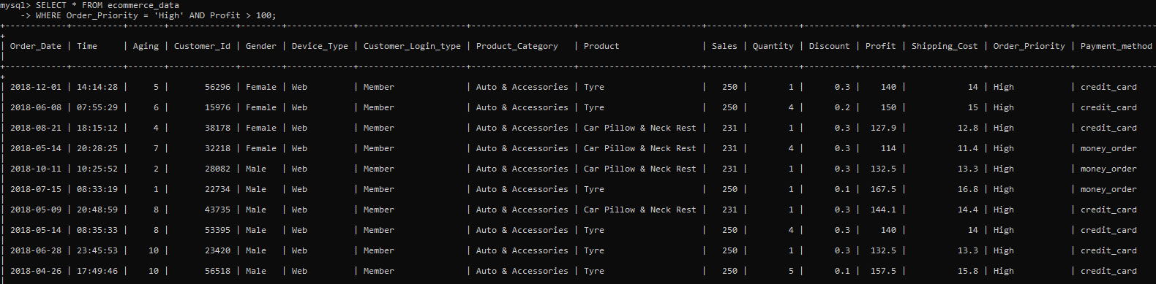

**6. Group sales by payment method**

SELECT Payment_method, SUM(Sales) AS Total_Sales

FROM ecommerce_data

GROUP BY Payment_method;

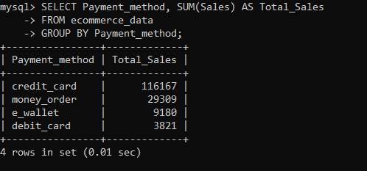

**7. Count orders per login type**

SELECT Customer_Login_type, COUNT(*) AS Order_Count

FROM ecommerce_data

GROUP BY Customer_Login_type;

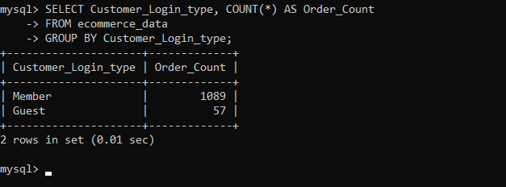

**8. Average discount by product category**

SELECT Product_Category, AVG(Discount) AS Avg_Discount

FROM ecommerce_data

GROUP BY Product_Category;

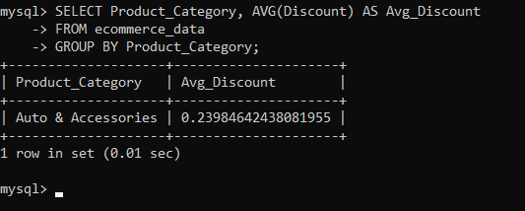

**9. Total and average sales by device**

SELECT Device_Type, SUM(Sales) AS Total_Sales, AVG(Sales) AS Avg_Sales

FROM ecommerce_data

GROUP BY Device_Type;

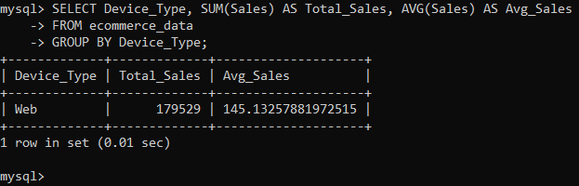

**10. Quantity sold per product (Top 5)**

SELECT Product, SUM(Quantity) AS Total_Quantity

FROM ecommerce_data GROUP BY Product

ORDER BY Total_Quantity DESC LIMIT 5;

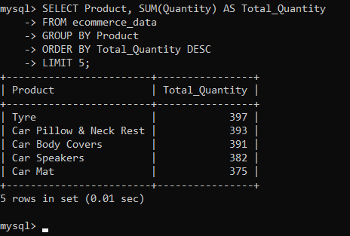

**11. Subquery: Orders where sales > average sales**

SELECT * FROM ecommerce_data

WHERE Sales > (SELECT AVG(Sales) FROM ecommerce_data);

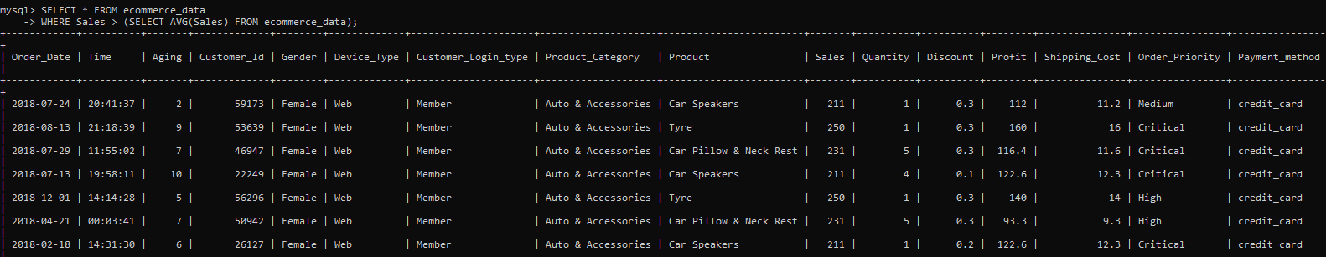

**12. Cumulative sales by date (Window function for PostgreSQL)**

SELECT Order_Date, SUM(Sales) OVER (ORDER BY Order_Date) AS Cumulative_Sales

FROM ecommerce_data;

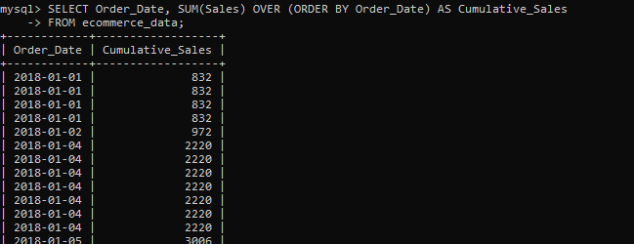

**13. RANK products by profit**

SELECT Product, Profit, RANK() OVER (ORDER BY Profit DESC) AS Rank_By_Profit

FROM ecommerce_data;

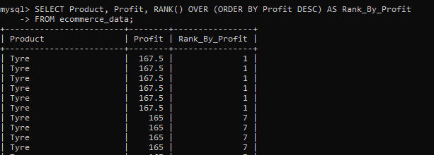

**14. Average Revenue Per User (ARPU)**

SELECT AVG(user_sales) AS ARPU

FROM (

SELECT Customer_Id, SUM(Sales) AS user_sales

FROM ecommerce_data

GROUP BY Customer_Id

) AS customer_sales;

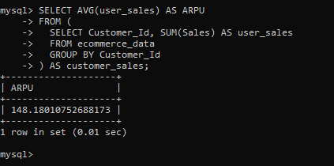

**15. Create a view: Daily profit summary**

CREATE VIEW daily_profit_summary AS

SELECT Order_Date, SUM(Profit) AS Daily_Profit

FROM ecommerce_data

GROUP BY Order_Date;

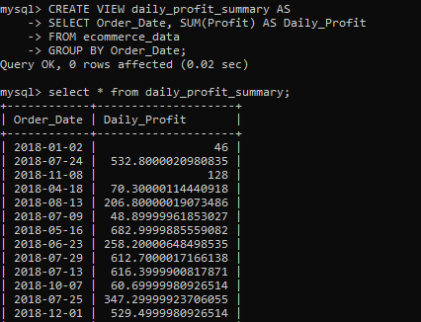

**16. Orders with NULL shipping cost**

SELECT * FROM ecommerce_data

WHERE Shipping_Cost IS NULL;



**17. Replace NULL with default values**

SELECT COALESCE(Quantity, 0) AS Quantity,

COALESCE(Shipping_Cost, 0) AS Shipping_Cost

FROM ecommerce_data;

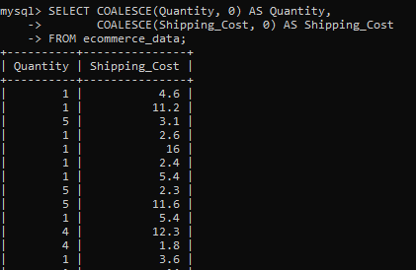

**19. Total profit by gender and device type**

SELECT Gender, Device_Type, SUM(Profit) AS Total_Profit

FROM ecommerce_data

GROUP BY Gender, Device_Type;

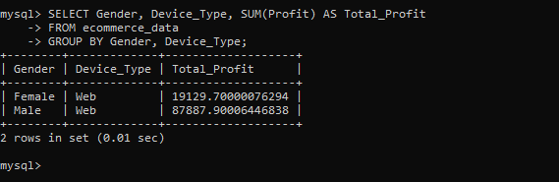

**20. High discount but low sales**

SELECT * FROM ecommerce_data

WHERE Discount > 0.3 AND Sales < 100;

