ANet CUI WCAG Audit

Issue fixing phase 1 ~ 3

11/3/22

## Summary

| Steps | Common Issues | Page issues | Total issues |
| --- | --- | --- | --- |
| Phase 1 | 8 | 53 | 61 |
| Phase 2 | 2 | 27 | 29 |
| Phase 3 |  |  |  |

## Common Issue - [ANE-137868](https://jirafnd.dev.activenetwork.com/browse/ANE-137868)

* Issue

The page titles for all pages fail to adequately describe the page content stating only “Online Services”.

* Recommendation

Ensure that the page title conveys the primary topic of the page as well as the site name (e.g., “Home - Online Services | City of Ottawa”).

// xxxRoute.js  
pageHeaderOptions: {  
 tabName: pageTitle  
},  
// Master.js  
componentDidUpdate(prevProps) {  
 this.syncDocumentTitle();  
}  
syncDocumentTitle = () => {  
 const { configurations } = this.context;  
 const route = this.getCurrentRoute();  
 if (route) {  
 const { pageHeaderOptions = {} } = route;  
 const pageTitle = pageHeaderOptions.tabName || pageHeaderOptions.title;  
 const tabWording = configurations.get('public_url_tab_wording');  
 const finalTabName = combineTabName(pageTitle, tabWording);  
 document.title = finalTabName;  
 }  
}

## Common Issue - [ANE-140296](https://jirafnd.dev.activenetwork.com/browse/ANE-140296)

* Issue

The timeouts fail to offer the extension of time required by this success criterion.

* Recommendation

Provide users with the opportunity to extend the timeout duration by up to ten times the original amount.

### Solution

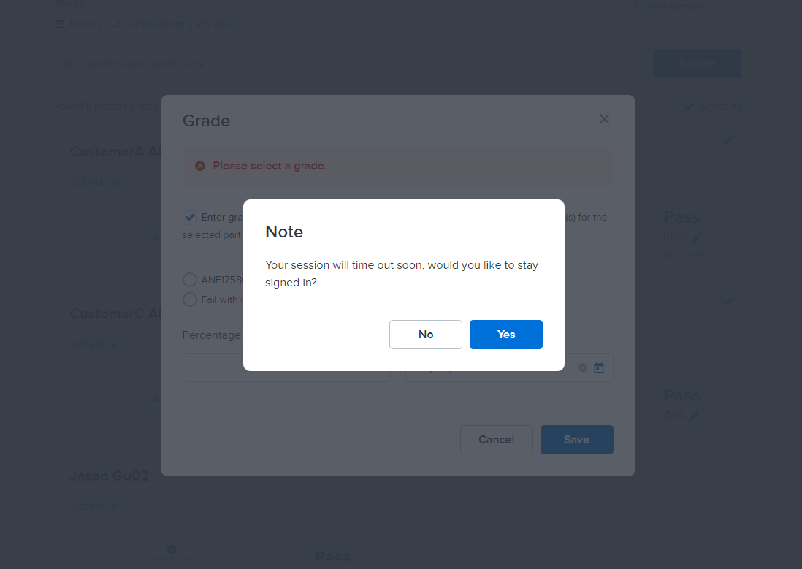

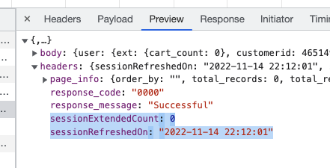

## Common Issue - [ANE-138518](https://jirafnd.dev.activenetwork.com/browse/ANE-138518)

* Issue

Throughout the application, multiple expandable regions are given aria-labels that are too verbose and obscure the description of the actual control with information that is not needed (e.g., “Section Activity selection collapse detail clickable arrow”)

* Recommendation

Change the aria-label wordings to be more precise about the controls they represent and leave out information that is not required to understand the control (e.g., “Activity selection”). Additional attributes already provide many of the queues required for assistive technologies to understand the control such as aria-expanded indicating expanded or collapsed.

 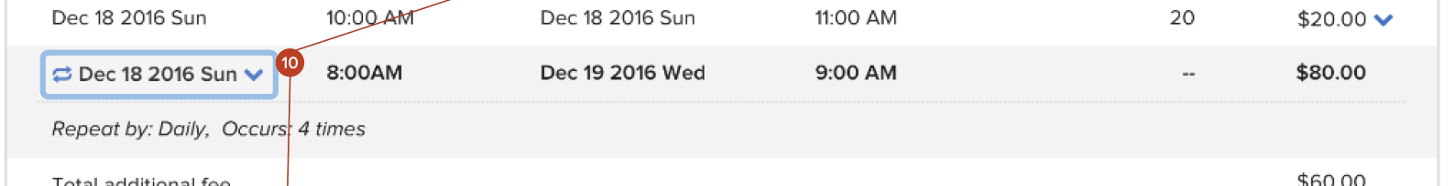 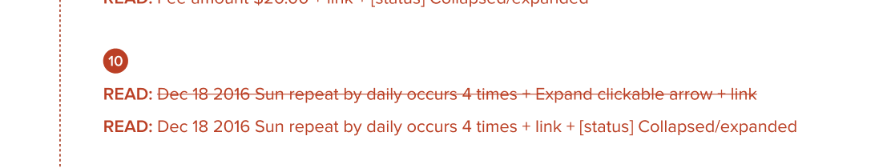

### Solution

* Remove unnecessary words from aria-label.
* Use aria-expanded + aria-own/aria-controls to describe the expand/collapse state and related origin.
* More details please confirm with UX about the special cases.

## Common Issue - [ANE-131139](https://jirafnd.dev.activenetwork.com/browse/ANE-131139)

* Issue

All pages lack a main landmark.

* Recommendation

Wrap the main content of the page in a <main> element …or use a role="main" on the main content parent container.

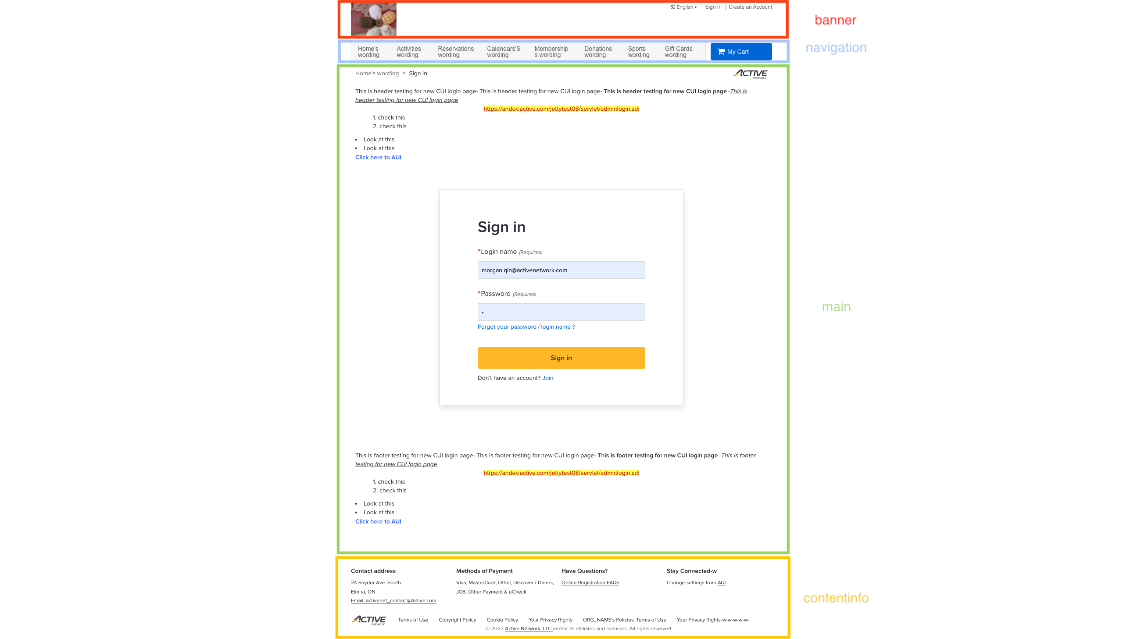

### Solution

Use header tag as a container of the banner region, <main> tag as a container of main region and <footer> tag as a container of the content info region.

You can also use aria roles for each landmark:

* Header landmark: role=“banner”,
* Main landmark: role=“main”,
* Footer landmark: role=“contentinfo”,
* Navigation landmark: role=“navigation”,
* Search: role=“search”

Finally, ensure that <header>, <main>, <footer> should be a direct child of <body> tag. (miss <Nav>)

Refer to:

* <https://www.w3.org/TR/wai-aria-practices/examples/landmarks/index.html>
* <https://www.w3.org/WAI/tutorials/page-structure/regions/>

## Common Issue - [ANE-137830](https://jirafnd.dev.activenetwork.com/browse/ANE-137830)

* Issue

Functional accessibility issue: Many SVG graphics contain a role="presentation" or role="none" attribute. Because these icons are not focusable, they present no real impact on assistive technologies but the implemented role values may flag as invalid in automated testing tools.

* Recommendation

Use aria-hidden="true" in place of role="presentation" or role="none".

### Solution

<Icon  
 symbolPrefix="an-icon"  
 name="location"  
 focusable={false}  
 aria-hidden={false}  
 className="calendar-view__select-icon"  
/>

<svg  
 aria-hidden={false}  
 className="icon-svg icon-svg-ic-problem icon-svg-size-md icon-svg-type-normal"  
 focusable={false}  
>

## Common Issue - [ANE-137668](https://jirafnd.dev.activenetwork.com/browse/ANE-137668)

* Issue

The alternative text on the “Ottawa” wordmark fails to adequately describe the image content, announcing “System - Banner Logo” instead of “City of Ottawa”.

* Recommendation

Change the alternative text to “City of Ottawa” (if “City of Ottawa” appeared in proximity in machine text, we’d recommend “logo of City of Ottawa” instead … either are satisfactory).

### Solution

* Change the alternative text to reflect the image content.

**Dev Notes**

* Currently we use the display name as the alternative text, which were configured in AUI file upload.
* Confirm with UX that we would add additional information to describe the image before the display name.
* For the banner logo image, update alternative text to "Banner logo of {display name}"
* For the logo image of receipt, update alternative text to "Receipt logo of {display name}"

## Common Issue - [ANE-138581](https://jirafnd.dev.activenetwork.com/browse/ANE-138581)

* Issue

The page lacks an <h1> heading. Page lacks any headings.

* Recommendation

Every page must have at least one, and typically only one,<h1>. Add additional headings to the page content (e.g., “Book an event”, “Popular events”).

### Solution

Examples:

Home

* Update module name to h2.

Flexreg

* Update each section header to h2
* Update the “Block booing”, “Selected Summary” to h3

Reservation Detail

* Update “Availability calendar” to h2
* Remove the heading for “Attendee” label, Description of “More Information” item.(See the attachment with red underline)

Note: Anchor should not be whithin the heading

The reasoning is that screen readers will not guarantee to detect the heading level if within an anchor

## Common Issue - [ANE-138601](https://jirafnd.dev.activenetwork.com/browse/ANE-138601)

* Issue

Issue #22: Anchors exist with aria-labels describing the anchors as images, yet the images are background CSS images and do not need to be identified as part of the anchor text. Issue #27: Form errors fail to be announced to screen reader users.Issue #32: The significance of asterisks is not explained.

* Recommendation

Issue #22: Remove the word image from each anchor’s aria-label.Issue #27: [ANE-138601](https://jirafnd.dev.activenetwork.com/browse/ANE-138601) Issue #32: Same with the above issue #27

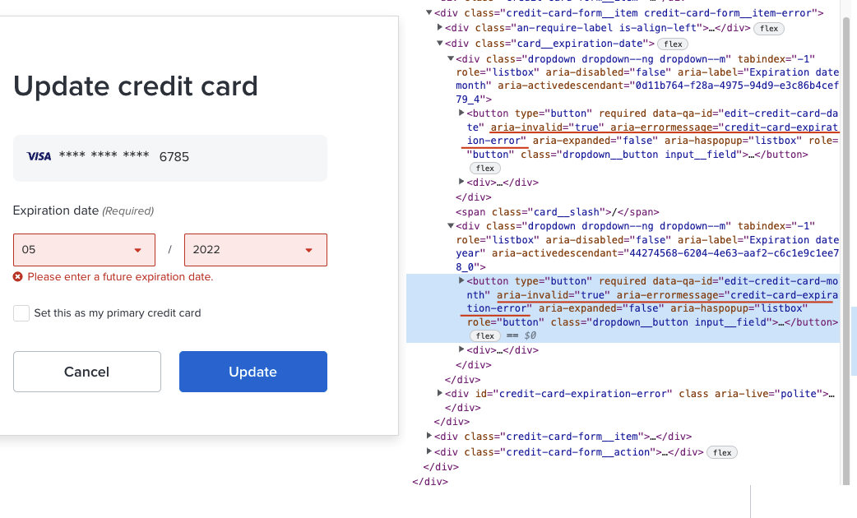

### Solution

Issue #22: Remove the word "image" from aria-label of each link. Issue #27: Add attribute aria-invalid and aria-errormessage.Issue #32: Same with the above issue #27

Refer to:

* <https://developer.mozilla.org/en-US/docs/Web/Accessibility/ARIA/Attributes/aria-errormessage>

## Common Issue - [ANE-138596](https://jirafnd.dev.activenetwork.com/browse/ANE-138596)

* Issue

[WCAG 2.1] Many input fields lack proper input identification (as defined in WCAG 2.1 Success Criterion 1.3.5 Identify Input Purpose).

* Recommendation

Implement the associated input names using the autocomplete attribute.([Input Purpose](https://www.w3.org/TR/WCAG21/#input-purposes))

### Solution

<Input  
 className={classNames('sign-form__field', { error: errors.lastName })}  
 maxLength={40}  
 onValueChange={this.bindOnFieldChange(fields.LAST_NAME)}  
 onBlur={this.bindOnFieldValidate(fields.LAST_NAME)}  
 value={formData.get(fields.LAST_NAME)}  
 ariaLabel={this.getLabelAriaText(lastNameLabel)}  
 autoComplete="family-name"  
/>  
<Input  
 maxLength={phoneMaxlength || 20}  
 formula={/\d/}  
 disabled={disabled}  
 value={phone}  
 onInput={this.handlePhoneNumberChange}  
 onBlur={this.handlePhoneNumberBlur}  
 ariaLabel={phoneAriaLabel}  
 autoComplete="tel-national"  
/>

Refer to:

* <https://html.spec.whatwg.org/multipage/forms.html#attr-form-autocomplete>