总结：

回溯总结笔记

46排列数

backtrack(结果list, 一个符合条件的结果list（路径list）, 原输入数组nums){

}

先判断递归结束条件

if(结果list 的长度和输入数组长度一样){

这个结果有效，把他放入二维结果数组里面

返回

}

遍历输入数组

如果这个数字用过了，就跳过这个循环(不能重复问题)

继续下一个循环，加入别的数字

做回溯递归，改变变量，这是在for循环里面递归

移出最后一个添加的元素；

可以重复利用问题：

backtrack(list, tempList, nums, i + 1);

不可以重复利用问题（题目包含重复元素）：

if(i > start && nums[i] == nums[i-1]) continue; /

Arrays.sort(nums); //Sort the array "int[] nums" to make sure we can skip the same value

if(used[i] || i > 0 && nums[i] == nums[i-1] && !used[i - 1]) continue;

Last Edit: October 27, 2018 5:05 AM

224.5K VIEWS

This structure might apply to many other backtracking questions, but here I am just going to demonstrate Subsets, Permutations, and Combination Sum.

Subsets : <https://leetcode.com/problems/subsets/>

public List<List<Integer>> subsets(int[] nums) {

List<List<Integer>> list = new ArrayList<>();

Arrays.sort(nums);

backtrack(list, new ArrayList<>(), nums, 0);

return list;

}

有一个start 用于判断递归结束

private void backtrack(List<List<Integer>> list , List<Integer> tempList, int [] nums, int start){

if(start > nums.length){

return;

}

list.add(new ArrayList<>(tempList));

for(int i = start; i < nums.length; i++){

tempList.add(nums[i]);

backtrack(list, tempList, nums, i + 1);

tempList.remove(tempList.size() - 1);

}

}

Subsets II (contains duplicates) : <https://leetcode.com/problems/subsets-ii/>

public List<List<Integer>> subsetsWithDup(int[] nums) {

List<List<Integer>> list = new ArrayList<>();

Arrays.sort(nums);

backtrack(list, new ArrayList<>(), nums, 0);

return list;

}

private void backtrack(List<List<Integer>> list, List<Integer> tempList, int [] nums, int start){

if(start > nums.length)return;//可以省略，why

list.add(new ArrayList<>(tempList));

for(int i = start; i < nums.length; i++){

if(i > start && nums[i] == nums[i-1]) continue; // skip duplicates

tempList.add(nums[i]);

backtrack(list, tempList, nums, i + 1);

tempList.remove(tempList.size() - 1);

}

}

Permutations : <https://leetcode.com/problems/permutations/>

public List<List<Integer>> permute(int[] nums) {

List<List<Integer>> list = new ArrayList<>();

// Arrays.sort(nums); // not necessary

backtrack(list, new ArrayList<>(), nums);

return list;

}

## 回溯总结笔记

46排列数

backtrack(结果list, 一个符合条件的结果list, 原输入数组nums){

}

先判断递归结束条件

if(结果list 的长度和输入数组长度一样){

这个结果有效，把他放入二维结果数组里面

返回

}

遍历输入数组

如果这个数字用过了，就跳过这个循环

继续下一个循环，加入别的数字

做回溯递归，这是在for循环里面递归

做出选择，移出元素；

private void backtrack(List<List<Integer>> list, List<Integer> tempList, int [] nums){

if(tempList.size() == nums.length){

list.add(new ArrayList<>(tempList));

} else{

for(int i = 0; i < nums.length; i++){

if(tempList.contains(nums[i])) continue; // element already exists, skip

tempList.add(nums[i]);

backtrack(list, tempList, nums);

tempList.remove(tempList.size() - 1); //tempList.size() – 1 是索引

}

}

}

Permutations II (contains duplicates) : <https://leetcode.com/problems/permutations-ii/>

public List<List<Integer>> permuteUnique(int[] nums) {

List<List<Integer>> list = new ArrayList<>();

Arrays.sort(nums); //Sort the array "int[] nums" to make sure we can skip the same value

backtrack(list, new ArrayList<>(), nums, new boolean[nums.length]);

return list;

}

回溯方法传入：结果二维数组，结果一位数组，原来输入数组，辅助数组used

递归结束条件：有一个结果时候就退出

遍历数组：

判断是否重复

添加元素到一位数组

递归调用；

做删除操作

private void backtrack(List<List<Integer>> list, List<Integer> tempList, int [] nums, boolean [] used){

if(tempList.size() == nums.length){

list.add(new ArrayList<>(tempList));

} else{

for(int i = 0; i < nums.length; i++){

if(used[i] || i > 0 && nums[i] == nums[i-1] && !used[i - 1]) continue;

used[i] = true;

tempList.add(nums[i]);

backtrack(list, tempList, nums, used);

used[i] = false;

tempList.remove(tempList.size() - 1);//相当于移出租后一个元素，//tempList.size() – 1 是索引

}

}

}

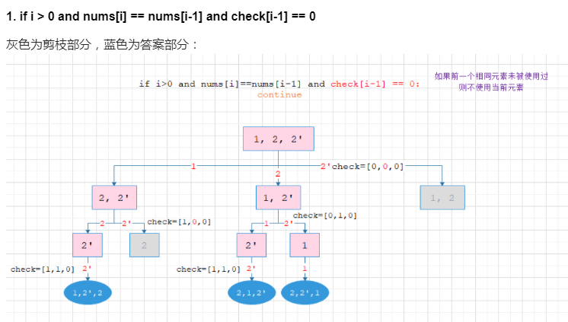

Combination Sum : <https://leetcode.com/problems/combination-sum/>

public List<List<Integer>> combinationSum(int[] nums, int target) {

List<List<Integer>> list = new ArrayList<>();

Arrays.sort(nums);

backtrack(list, new ArrayList<>(), nums, target, 0);

return list;

}

private void backtrack(List<List<Integer>> list, List<Integer> tempList, int [] nums, int remain, int start){

if(remain < 0) return;

else if(remain == 0) list.add(new ArrayList<>(tempList));

else{

for(int i = start; i < nums.length; i++){

tempList.add(nums[i]);

backtrack(list, tempList, nums, remain - nums[i], i); // not i + 1 because we can reuse same elements

//回溯做出改变：：：：templist 就是路径 ，path , p

tempList.remove(tempList.size() - 1);

}

}

}

Combination Sum II (can't reuse same element) : <https://leetcode.com/problems/combination-sum-ii/>

public List<List<Integer>> combinationSum2(int[] nums, int target) {

List<List<Integer>> list = new ArrayList<>();

Arrays.sort(nums);

backtrack(list, new ArrayList<>(), nums, target, 0);

return list;

}

private void backtrack(List<List<Integer>> list, List<Integer> tempList, int [] nums, int remain, int start){

if(remain < 0) return;

else if(remain == 0) list.add(new ArrayList<>(tempList));

else{

for(int i = start; i < nums.length; i++){

if(i > start && nums[i] == nums[i-1]) continue; // skip duplicates

tempList.add(nums[i]);

backtrack(list, tempList, nums, remain - nums[i], i + 1);

tempList.remove(tempList.size() - 1);

}

}

}

Palindrome Partitioning : <https://leetcode.com/problems/palindrome-partitioning/>

public List<List<String>> partition(String s) {

List<List<String>> list = new ArrayList<>();

backtrack(list, new ArrayList<>(), s, 0);

return list;

}

public void backtrack(List<List<String>> list, List<String> tempList, String s, int start){

if(start == s.length())

list.add(new ArrayList<>(tempList));

else{

for(int i = start; i < s.length(); i++){

if(isPalindrome(s, start, i)){

tempList.add(s.substring(start, i + 1));

backtrack(list, tempList, s, i + 1);

tempList.remove(tempList.size() - 1);

}

}

}

}

public boolean isPalindrome(String s, int low, int high){

while(low < high)

if(s.charAt(low++) != s.charAt(high--)) return false;

return true;

}