Signal app - Product search overlay

In the signal app, I’m trying to cover the translations everywhere. There are two places overlay popups which are not yet translated as these pop ups are created using the se-mpa library.

Product search overlay:
In investigation - signal info - Products.
- Users can click on the search button to open a product search screen, which is coming from the se-mpa library.
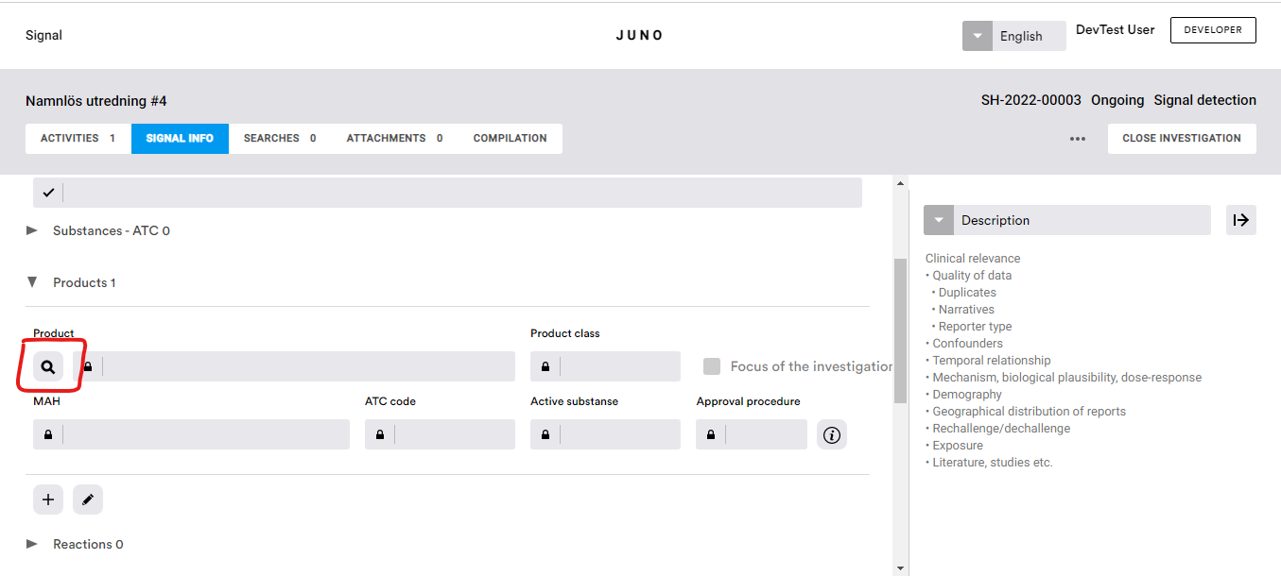

Workflow:
- The signal app calls a function named “setProducsLvisOverlayData” of se-mpa library which opens the related popup.
- For the product search screen, currently it is calling “setProducsLvisOverlayData” with popup name - “ProductLvisOverlayComponent”
- 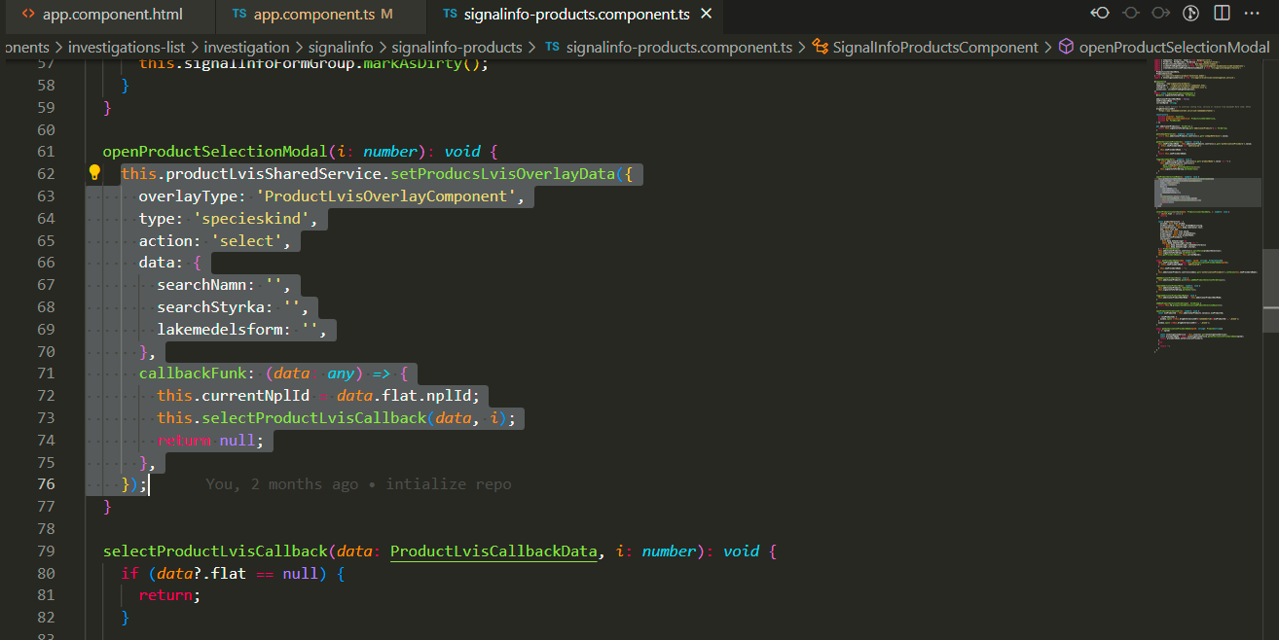
- As per implementation the se-mpa library should open a overlay based on given input:
- 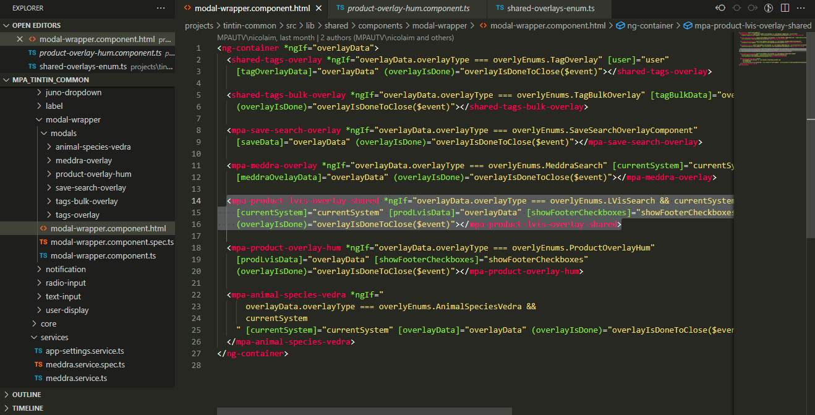
- The library does have a binding for ProductLvisOverlayComponent (as shown in above screenshot), but the related component “mpa-product-lvis-overlay-shared” does not exist in the code.

