**Amélioration de la fiabilité du modèle**

***Cheville du robot NAO, MaxPID, Cordeuse de raquette,***

***Direction Assistée Électrique, COMAX, Control’X***

**TP**

**Cycle 1**

**Modéliser le comportement linéaire et non linéaire des systèmes multiphysiques**

**PSI**

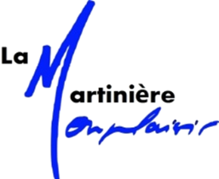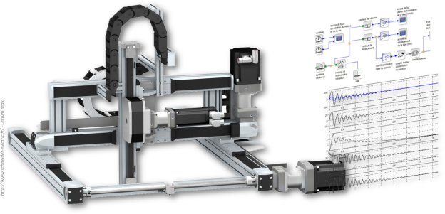

|  |
| --- |
| **Compétences Visées :**   * **Mod2.C1: Chaîne d’énergie et d'information** * **Communiquer**: **Décrire le fonctionnement du système en utilisant un vocabulaire adéquat.** |

# Objectifs

## Contexte pédagogique

|  |  |
| --- | --- |
|  | **Analyser :**   * A3 - Conduire l'analyse   **Modéliser :**   * Mod1 : Justifier ou choisir les grandeurs nécessaires à la modélisation * Mod3 : Valider un modèle   **Expérimenter :**   * Exp1 - Découvrir le fonctionnement d’un système complexe   **Communiquer**   * Com2 - Mettre en œuvre une communication |

## Évaluation des écarts

## Travail à réaliser

aze aze aze aze azeazeazazeza aze ze Zaezae aze aze aze aze aze aze aze azeazeazazeza aze ze Zaezae aze aze aze aze aze aze aze azeazeazazeza aze ze Zaezae aze aze aze aze aze aze aze azeazeazazeza aze ze Zaezae aze aze aze aze aze aze aze azeazeazazeza aze ze Zaezae aze aze aze aze aze aze aze azeazeazazeza aze ze Zaezae aze aze aze aze aze aze aze azeazeazazeza aze ze Zaezae aze aze aze aze aze aze aze azeazeazazeza aze ze Zaezae aze aze aze aze aze aze aze azeazeazazeza aze ze Zaezae aze aze aze aze aze aze aze azeazeazazeza aze ze

Zaezae aze aze aze aze aze aze aze azeazeazazeza aze ze Zaezae aze aze aze aze aze aze aze azeazeazazeza aze ze Zaezae aze aze aze aze aze aze aze azeazeazazeza aze ze Zaezae aze aze aze aze aze aze aze azeazeazazeza aze ze Zaezae aze aze aze aze aze aze aze azeazeazazeza aze ze Zaezae aze aze aze aze aze aze aze azeazeazazeza aze ze Zaezae aze aze aze aze aze aze aze azeazeazazeza aze ze Zaezae aze aze aze aze aze aze aze azeazeazazeza aze ze Zaezae aze aze aze aze aze aze aze azeazeazazeza aze ze Zaezae aze aze aze aze aze aze aze azeazeazazeza aze ze Zaezae aze aze aze aze aze aze aze azeazeazazeza aze ze Zaezae aze aze aze aze aze aze aze azeazeazazeza aze ze Zaezae aze aze aze aze aze aze aze azeazeazazeza aze ze Zaezae aze aze aze aze aze aze aze azeazeazazeza aze ze Zaezae aze aze aze aze aze aze aze azeazeazazeza aze ze Zaezae aze aze aze aze aze aze aze azeazeazazeza aze ze Zaezae aze aze aze aze aze aze aze azeazeazazeza aze ze Zaezae aze aze aze aze aze aze aze azeazeazazeza aze zeZaezae aze aze aze aze aze aze aze azeazeazazeza aze ze Zaezae aze aze aze aze aze aze aze azeazeazazeza aze ze Zaezae aze aze aze aze aze aze aze azeazeazazeza aze ze Zaezae aze aze aze aze aze aze aze azeazeazazeza aze ze Zaezae aze aze aze aze aze aze aze azeazeazazeza aze ze Zaezae aze aze aze aze aze aze aze azeazeazazeza aze ze Zaezae aze aze aze aze aze aze aze azeazeazazeza aze ze Zaezae aze aze aze aze aze aze aze azeazeazazeza aze ze Zaezae aze aze aze aze aze aze aze azeazeazazeza aze ze Zaezae aze aze aze aze aze aze aze azeazeazazeza aze ze Zaezae aze aze aze aze aze aze aze azeazeazazeza aze ze Zaezae aze aze aze aze aze aze aze azeazeazazeza aze ze Zaezae aze aze aze aze aze aze aze azeazeazazeza aze ze Zaezae aze aze aze aze aze aze aze azeazeazazeza aze ze Zaezae aze aze aze aze aze aze aze azeazeazazeza aze ze Zaezae aze aze aze aze aze aze aze azeazeazazeza aze ze Zaezae aze aze aze aze aze aze aze azeazeazazeza aze ze Zaezae aze aze aze aze aze aze aze azeazeazazeza aze ze