**Project 1 Raytracing |UTEID: pnp392**

**Functionality:**

Shading

Reflections

Refraction

Trimesh/Phong interpolation

Shadows

**Shading:**

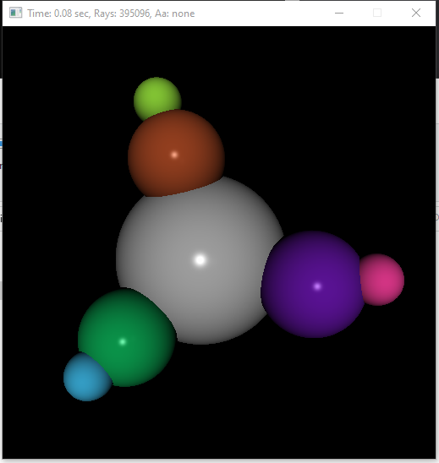

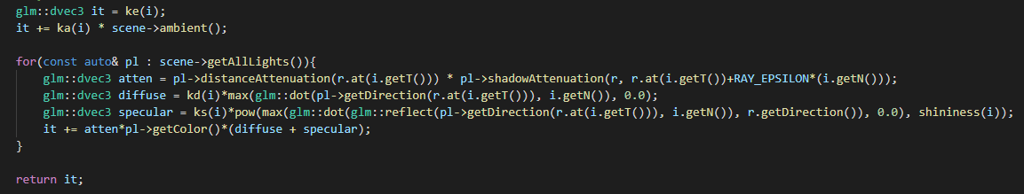

**Reflection/Refraction:**

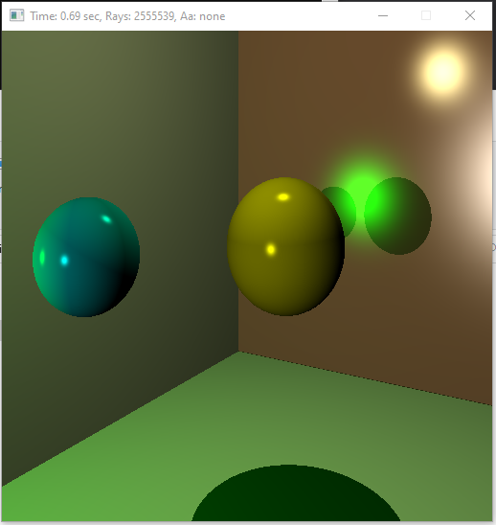

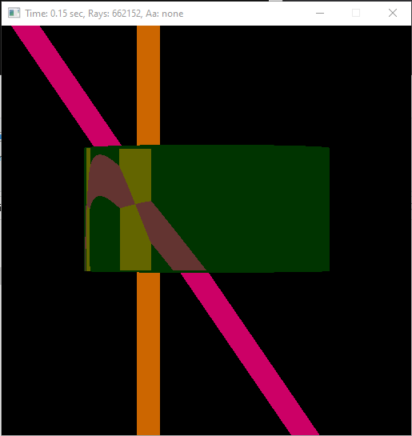

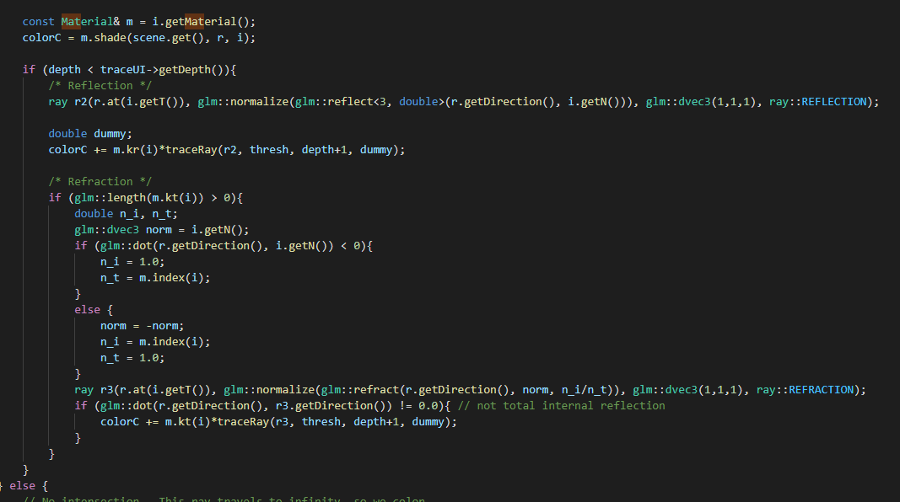

**Shadows:**

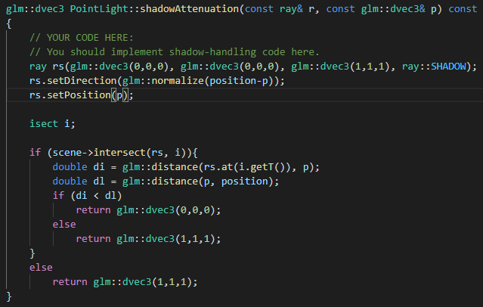

**Trimeshes:**

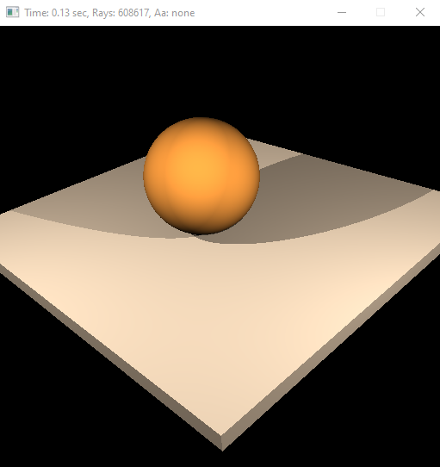

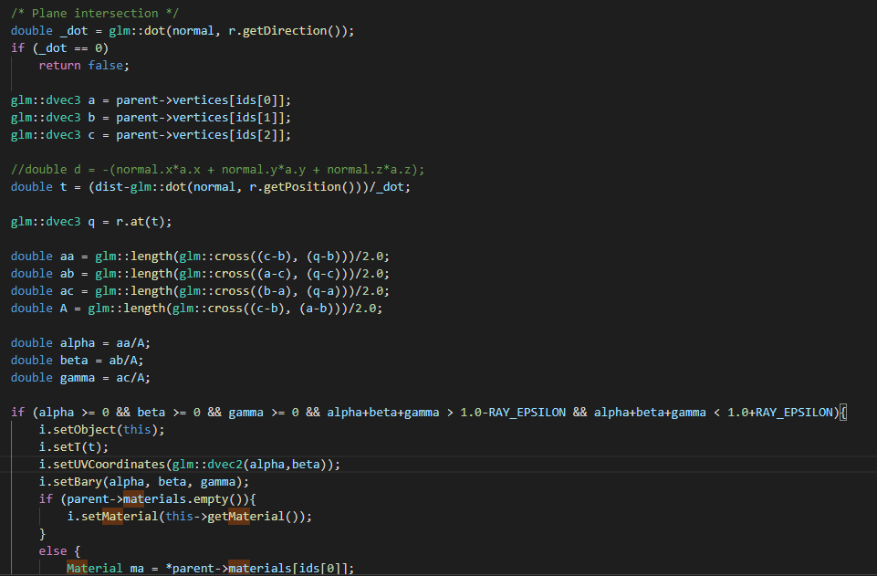

**Phong Interpolation:**

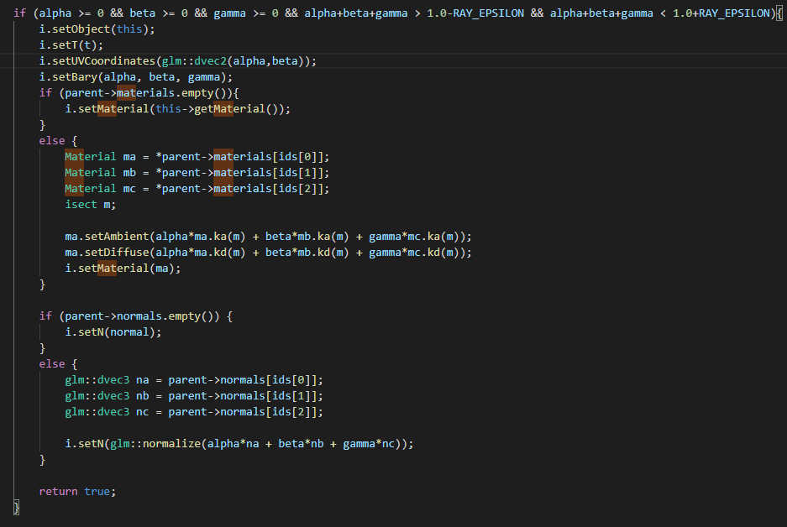

**Issues:**

With trimeshes I had trouble getting some of the materials to render. Some of the textures would appear fully/partially black. I still need to add cubemaps to the project.

