**Covid-19 Related Social Media Analyzer ---**-

Find tweets related to Covid-19 solutions (quarantine, vaccines, treatment and so on) by using Tweeter API. Analyze how people with different social identities (celebrities, politicians, artists and so on) react to different Covid-19 solutions by using sentiment analysis in Google Natural Language API.

For example, here is a tweet by @DrTomFrieden regarding Covid-19 vaccines, which shows his positive attitude towards vaccines.

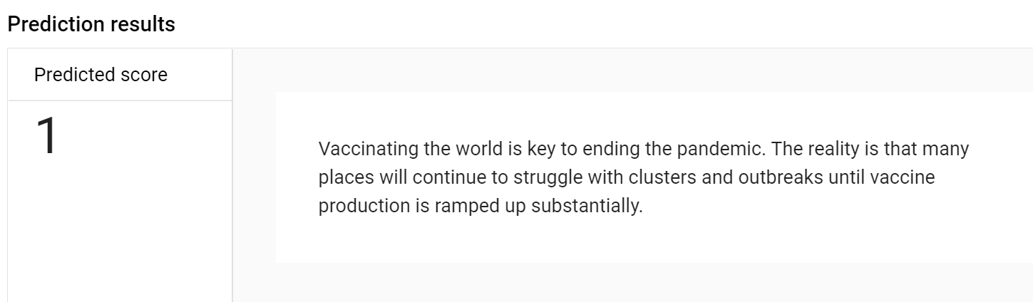

Here is another tweet by @eugyppius1 regarding Covid-19 solutions, which show his negative attitudes towards all solutions to Covid-19.

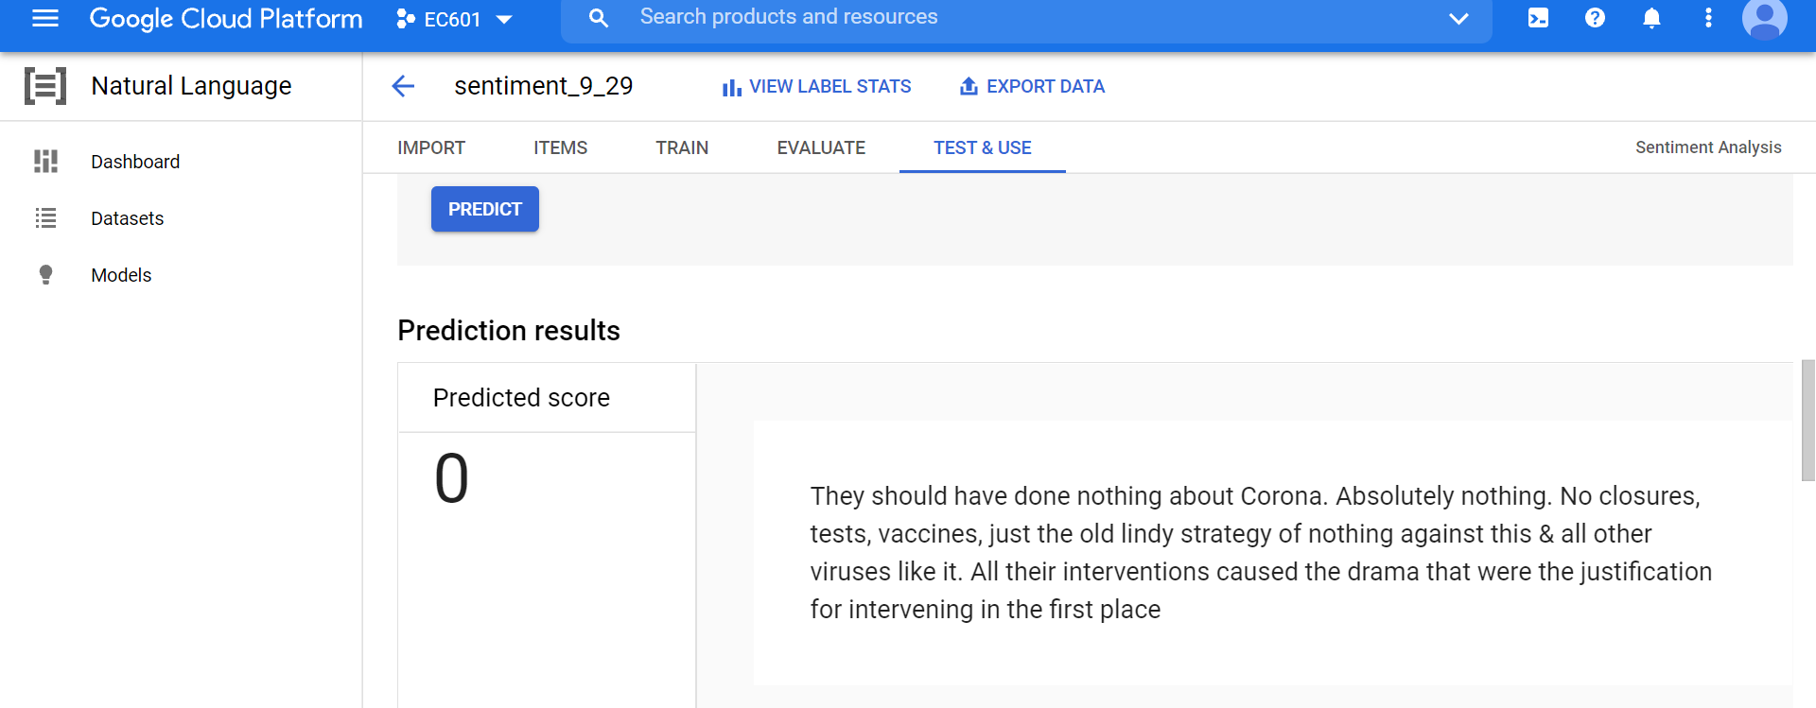

Tweet by @LisaMarieBoothe regarding Covid-19 vaccines.

