1. Introduction

The straw testing is designed to determine the bucking strength of the length of the straw. It is the first step of the Truss Design Project. After the relationship between strength and length of straws is known, it is possible to determine the failure load for the truss.

1. Procedure

• Three different lengths of straws need to be tested: 9cm, 10.5cm and 12cm. First of all, 15 straight straws are picked up and every 5 is cut into 9cm, 10.5cm and 15cm. Then all straws are double-pinned at both ends with the first pin 5 mm from the end and the second 5 mm in from that. All pins are perpendicular to the straw axis and parallel to each other.

•  straw is put into the apparatus vertically and the straw is supported only by the pins sitting squarely in the slots.

•he hinged lever arm is set horizontally, and perpendicular to the straw in all directions when the straw is tested.

• First, an initial mass is placed in the bucket and wait for 30 seconds. Initial masses are obtained from GTF. If no buckling, increase the mass by 20g, record the increment and wait for another 30 seconds. Repeat until the straw is buckling. Finally, record the last mass successfully holds for 30 seconds.

1. Analysis

FBD:

                   F D1=19.7cm G=mg

D2=14~14.4 cm

A

D3 =16.5cm

WA =220~221g

W

W: the load that the straw holds;

WA: apparatus weight;

G: added weight;

D1: distance to straw;

D2: distance to app;

D3: distance to .

According to the FBD, the total moment about point A is zero:

∑MA: D1*W-D2*WA-D3*G =0

For Straw length: 10 cm. Apparatus 4

Average maximum load= 16.76N

M_A = -(0.143m)(0.221kg*9.8N/kg) - (0.165 m)(W) + (0.197 m)(F) = 0

F= (0.42666+0.165W)/0.197

F=16.2N

For Straw length: 12 cm. Apparatus 6

Average maximum load= 11.33N

M_A = -(0.14m)(0.22kg*9.8N/kg) - (0.166 m)(W) + (0.197 m)(F) = 0

F= (0.30184+0.166W)/0.197

F=11.079N

For Straw length: 15 cm. Apparatus 9

Average maximum load= 6.10N

MA = -(0.144m)(0.22kg*9.8N/kg) - (0.165 m)(W) + (0.197 m)(F) = 0

F= (0.310464+0.165W)/0.197

F=6.68N

**Curve Fitting**

Matlab code:

x = [10 12 15];

y = [16.2 11.08 6.68];

E = std(y)*ones(size(x));

errorbar(x,y,E,'k') ;

hold on

p = polyfit(x,y,1);

yfit = polyval(p,x);

plot(x,y,'b*',x,yfit,'r')

title('Length vs. Load')

legend('error bar','Experiment','Linerfit')

xlabel('Length of the straw(cm)')

ylabel('Straw maximum load(N)')

axis([9 16 5 20])

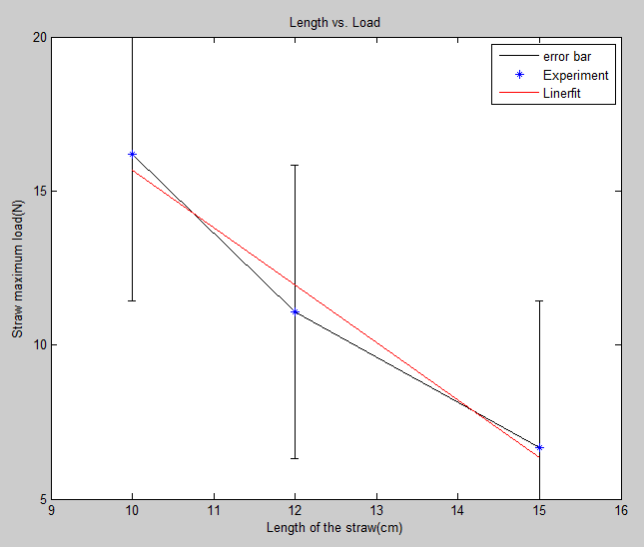

The liner relation between the length and the max load of the straw is:

Load (N) = -1.8695*Length(cm)+34.3768

1. Data

|  |  |  |  |
| --- | --- | --- | --- |
| Straw length: 10 cm Apparatus 4 | | | |
| Trial # | mass load | mass wight | load on straw |
| Trial 1 | 1750g | 17.15N | 16.5N |
| Trial 2 | 1740g | 17.05N | 16.44N |
| Trial 3 | 1600g | 15.68N | 15.29N |
| Trial 4 | 1720g | 16.86N | 16.28N |
| Trial 5 | 1740g | 17.05N | 16.44N |
| Average | 1710g | 16.76N | 16.2N |
| Std.dev. | 48.166g | 0.547N | 0.5097N |
| Mean | 1750g | 17.15N | 16.5N |

|  |  |  |  |
| --- | --- | --- | --- |
| Straw length: 12 cm Apparatus 6 | | | |
| Trial # | mass load | mass wight | load on straw |
| Trial 1 | 1200g | 11.76N | 11.43N |
| Trial 2 | 1150g | 11.27N | 11.02N |
| Trial 3 | 1100g | 10.78N | 10.61N |
| Trial 4 | 1150g | 11.27N | 11.02N |
| Trial 5 | 1180g | 11.56N | 11.26N |
| Average | 1156g | 11.33N | 11.079N |
| Std.dev | 33.823g | 0.331N | 0.31N |
| Mean | 1150g | 11.27N | 11.02N |

|  |  |  |  |
| --- | --- | --- | --- |
| Straw length: 15 cm Apparatus 9 | | | |
| Trial # | mass load | mass wight | load on straw |
| Trial 1 | 590g | 5.78N | 6.41N |
| Trial 2 | 610g | 5.98N | 6.58N |
| Trial 3 | 630g | 6.17N | 6.74N |
| Trial 4 | 680g | 6.66N | 7.15N |
| Trial 5 | 600g | 5.88N | 6.5N |
| Average | 622g | 6.10N | 6.68N |
| Std.dev. | 31.87g | 0.362N | 0.29N |
| Mean | 610g | 5.98N | 6.58N |

1. Result

Please see the plot in the data analysis.

1. Discussion

Possible error :

1. There might be some length loss when the straws are cut.
2. The straws in the tester are not perfectly vertical.
3. The hinged lever arm is not horizontal and perpendicular to the straw.
4. Not all pins are perpendicular to the straw axis and parallel to each other.