# Optimum Location for a New Starbucks Store in California

## Introduction

A Starbucks Reserve Roastery is much more expensive to build and maintain and provides much more luxurious and complementary experience compared to a regular store. Currently, there are only 5 such stores across the U.S.A with the most recent opening in Chicago. Motivated by the success of the previous five stores, it is in our interest to turn an ordinary Starbucks store into a Reserve Roastery in California, where such store is still not available.

## Data

For the success of business, the primary concern is always the location. Ideally, the new store will be located in an area with large population with higher income. In this study, the demographics of Californian counties will be investigated based on several datasets to decide the optimum locations. The first dataset is called “full_starbucks.csv” which contain the location of all Starbucks stores across California; the second dataset called “CA_counties.shp” containing the boundary and shape of each county in the state of California: in addition, the demographics of California will be based on the following three datasets:

* “CA_pop.csv” contains an estimate of the population of each county.
* “CA_high_earners.csv” contains the number of households with an income of at least $150,000 per year.
* “CA_median_age.csv” contains the median age for each county.

The store will be within a county:

* there are at least 100,000 households making $150,000 per year,
* the median age is less than 38.5, and
* the density of inhabitants is at least 285 (per square kilometer).

Additionally, selected counties should satisfy at least one of the following criteria:

* there are at least 500,000 households making $150,000 per year,
* the median age is less than 35.5, or
* the density of inhabitants is at least 1400 (per square kilometer).

The store with the largest population and high incoming people will be chosen as the candidate. Then, we will investigate the nearby coffee stores via Foursqure to determine if the local competitor will be negative factor in this area.

## Methodology

The first step is to import the “full_starbucks.csv” file and check if there is any missing value in this dataset. Other files are imported afterwards. For the convenience of analysis, all the data files were combined in a geodataframe named” CA stats”, where a column” density” was created by column” population” divided by “column “area_sqkm”.

The second step is to define and select the suitable store for our purpose. The promising store will be in a county/location where it should satisfy:

* there are at least 100,000 households making \$150,000 per year,
* the median age is less than 38.5, and
* the density of inhabitants is at least 285 (per square kilometer).

Additionally, selected counties should satisfy at least one of the following criteria:

* there are at least 500,000 households making \$150,000 per year,
* the median age is less than 35.5, or
* the density of inhabitants is at least 1400 (per square kilometer).

After analysis, there are 1043 stores meet our criterion. Further analysis among these counties will be performed based on its high incoming population and population density. Also, a Foursquare requested dataset will be used to investigated nearby coffee shops for competition analysis.

## Results

Figure 1 shows the number and location of the stores.

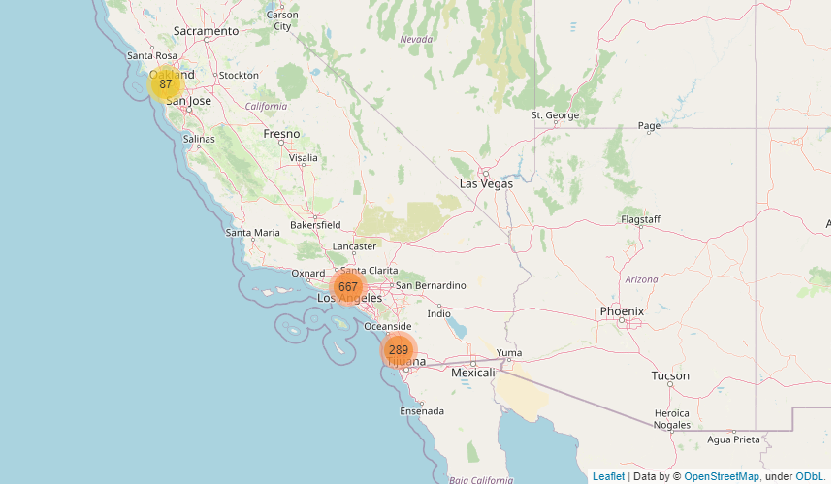

Figure 1. Stores that meet the requirements in California

All the selected stores are in San Francisco (8%), Los Angles (64%) or San Diego (28%). Even though, San Francisco takes up the least percentage, when we sort all the selected stores by their population density and high-income people, the highest ranking is a store in at Stonestown Galleria ,San Francisco, whose location is:'3251 20th Ave, Ste 250F San Francisco CA', whose coordinate is : 37.73 -122.48.

With this information, we will be able to submit a request to Foursquares to see what the local coffee competitors are. With 500m of the Starbucks store, we found other two coffee shops: Peet's Coffee & Tea and Red Whale Coffee. Figure 2 summarizes the returned Foursquare search result.

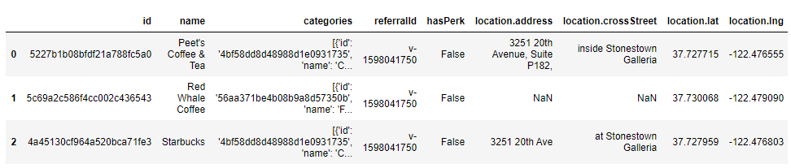

Figure 2. Coffee shops within 500 radius of the selected Starbucks Store

The last step is to see the reviews of each coffee shop. It turned out that all three coffee shops received 7.0 score from their customers, which is decent, acknowledging that most of the coffee shops don’t even have a review score through our study.

## Conclusion

With the help of the data analysis, we decided to turn the Starbuck store at Stonestown Galleria, San Francisco, into the next Reserve Roastery. Because it is in an area with very large population and high-income earners, who will be very likely to be our customers. In addition, the store seems to be well-received already, thus guaranteeing its future success.