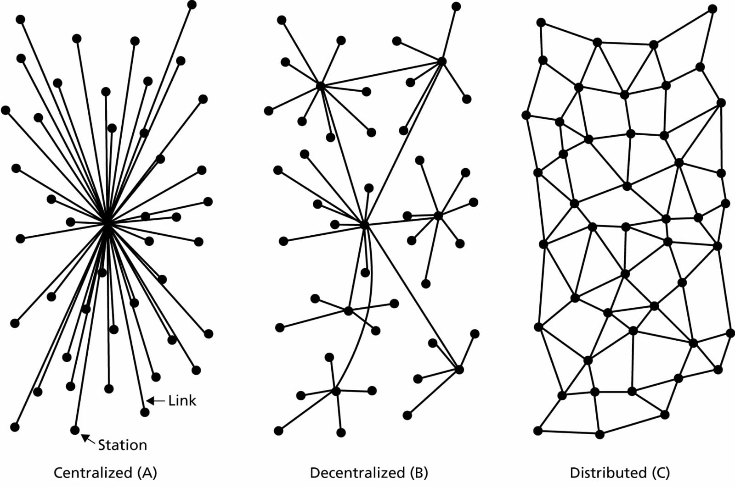
#1

Baran’s concept had the same centrifugal character that defines the Internet today. At its most basic, … the “centrifugal” approach is to flatten established hierarchies and put power and responsibility at the nodal level so that each node is equal. Baran’s network focused on what he called “user to user rather than … centre-to-centre operation”.

— Jonny Ryan
#2
#2
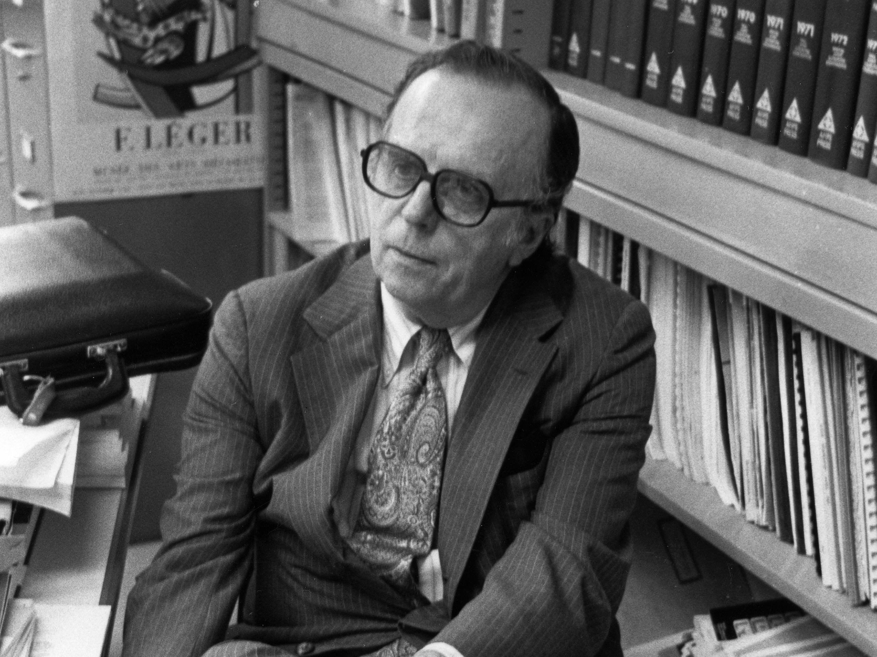
Paul Baran
#3
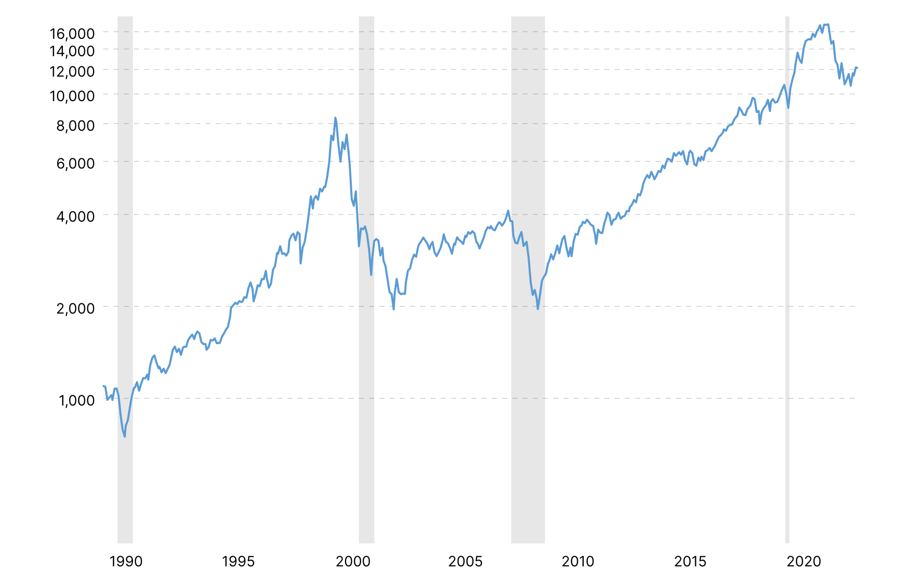
#4

At the core of Licklider’s thinking was an emphasis on collaboration. Licklider posited a future scenario in which a researcher at one research centre could find a useful computer resource over the network from a research centre elsewhere. This, in a world of incompatible machines and jealously guarded computing resources, was far-sighted talk indeed.
#5
— Jonny Ryan

J. C. R. Licklider
#6
#7
Shoshana Zuboff
#8
“Big data” is above all the foundational component in a deeply intentional and highly consequential new logic of accumulation that I call surveillance capitalism. This new form of information capitalism aims to predict and modify human behavior as a means to produce revenue and market control. Surveillance capitalism has gradually constituted itself during the last decade, embodying a new social relations and politics that have not yet been well delineated or theorized.

— Shoshana Zuboff (2015)
#9
The unprecedented nature of surveillance capitalism has enabled it to elude systematic context because it cannot be adequately grasped with our existing concepts. […] the existing categories fall short in in identifying and contesting the most crucial and unprecedented facts of this new regime.

— Shoshana Zuboff (2019)
#10

Aaron Swarz
#11
#12

