International Economics and Development Studies

Chapter 1

Introduction

The World Economy can be analysed through four main ‘windows’; each ‘window’ offers us a view of the world economy that needs to be supplemented by one or more of the other windows. One cannot exist without the others.

1. INTERNATIONAL TRADE

Means:

* The exchange of goods (merchandise) and services among the countries of the world
* Goods: tangible and storable (material)
* Service: intangible and non-storable
* Trade in services accounts for approximately one-quarter of global trade

The growth of export of goods/services and of the GDP can be traced on a graph as a gradual swell for GDP and a sudden upwards-loop for export (peaked in 2008). This is a typical consequence of globalisation. The expansion of exchange of goods/services among the world’s countries is due to:

* Revolution in good global shipping
* Revolution in ICT technology (enhanced the ability to coordinate trade and production at an international level)
* Lowering of tariff barriers

1. INTERNATIONAL PRODUCTION

Refers to the production of a product in multiple countries and can take place through:

* Contracts (low-commitment-low-control option) —> International licensing and franchising
* Foreign direct investment (FDI) —> high-commitment-high-control option)
* Undertaken by multinational enterprises (MNEs) —> involves firms based in one country owning at least a 10% of firms producing in another country

Today, multinational enterprises (MNE’s) account for approximately 1/4 of world gross domestic production (GDP/aggregate output). The sales of foreign affiliates of multinational enterprises now exceed the volume of world trade, and they are involved in 3/4 of all world trade and account for 3/4 of worldwide civilian research and development.

In the 1990’s, foreign direct investment (FDI) experienced a large surge in investments mostly into high-income countries, while middle-income countries continue to host a growing amount of FDI. Inflows into low-income countries, on the other hand, are quite low and stagnant.

This evolution of FDI is the result of:

* Improvements in transportation
* Improvements in ICT
* Increase of global mergers and acquisitions
* Many countries changed their policy by adopting one that was friendlier regarding FDI inflow

1. INTERNATIONAL FINANCE

This refers to the exchange of assets among countries in which individuals and firms around the world conduct international transactions in:

* Currencies
* Equities
* Government bonds
* Corporate bonds (commercial paper)
* Real estate

Today, International finance plays an increasingly important role in the world economy. From 1989 to 2010, we can actually observe a daily foreign exchange market turnover.

1. INTERNATIONAL DEVELOPMENT

International Development is the hope that the processes of International Trade/Production/Finance will contribute to improved levels of welfare and standards of living throughout the world.

The major issues discusses within this field include:

* How we conceptualise levels of welfare or standards of living
* How the processes help to determine international development

The measurement of the differences in living standards within International Development is called the Human Development Index (HDI), which measures:

* Per capita income
* Average life expectancy
* Average levels of education

Given these ‘windows’, the elements we can analyse in order to analyse each asset are:

* Countries
* Sectors
* Tasks
* Firms
* Factors of production
* Currencies
* Financial assets

Chapter 2

Absolute Advantage

What is Absolute Advantage? It’s the concept that is used to refer to a party's superior production capability. Specifically, it refers to the ability to produce a certain good or service at lower cost (i.e., more efficiently) than another party. The analytical elements in Absolute Advantage are:

* Countries
* Sectors
* Factors of production

In order to further understand what this means, we will use the Supply and Demand Diagram. The price and quantity of goods and services in the marketplace are largely determined by consumer **demand** and the amount that suppliers are willing to **supply**. **Demand** and **supply** can be plotted as curves, and the two curves meet at the equilibrium price and quantity.

This diagram helps us in answering these questions:

* Why does a country export a particular good?
* Why does it import a particular good?
* What forces are behind the expansion of world trade that is occurring in the world economy?

In this figure, consider a domestic rice market. We have the traditional market model: the demand curve (downward-sloping; the quantity of rice demanded increases as the price of rice decreases) and the supply curve (upward-sloping; the quantity of rice supplied in the market increases when the price of rice increases).

When the price of the rice changes, we move along a demand and/or a supply curve. The change of price indicates movement along either curve. When the preferences of people or the technology of rice production changes, the supply/demand curve shifts, meaning that they can move either left or right.

Demand and supply have to be in equilibrium. This equilibrium is reached when they interconnec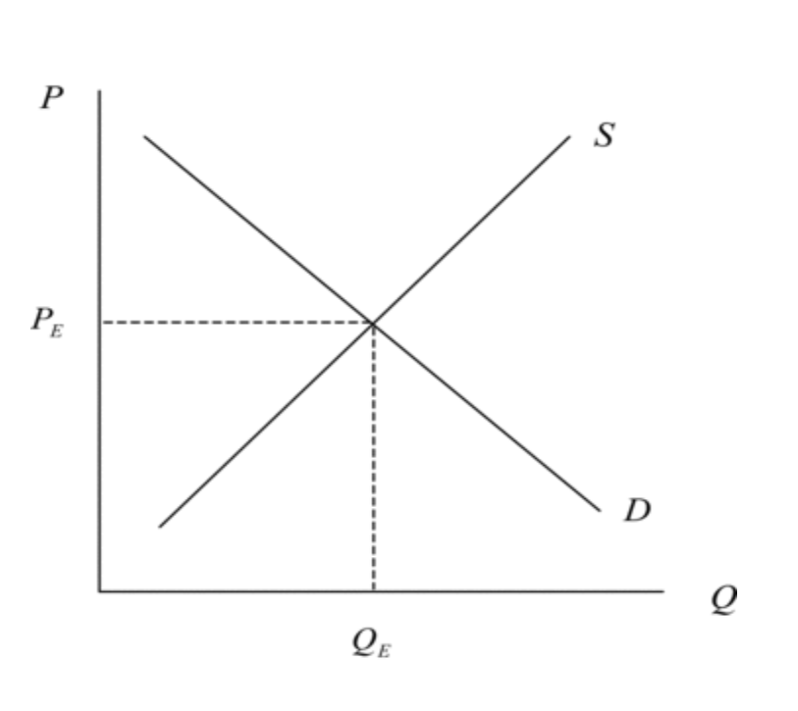t; this interconnection occurs when the quantity of demand is equal to the quantity of supply. In this case, the price of equilibrium (Pe) is the price where demand and supply are equal.

Since rice markets are international, though, we cannot analyse them effectively using this figure.

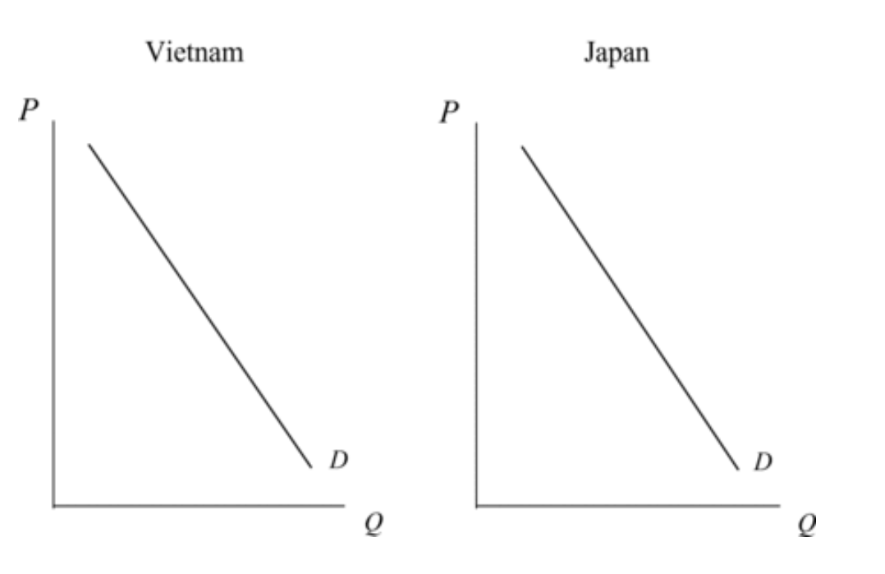

If we want to look at the Absolute Advantage of rice, we should consider that it’s produced in both Vietnam and Japan. Let’s assume that the demand conditions are exactly the same in both countries, which implies demand curves for rice in the two countries that are exactly the same.

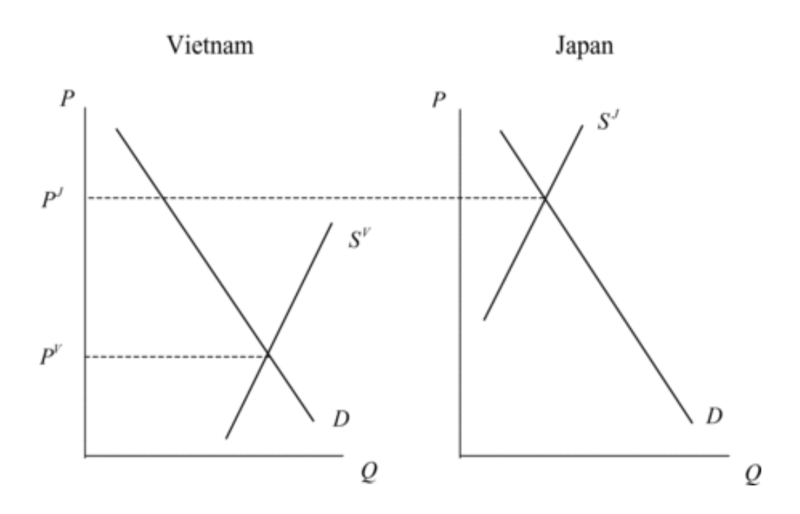

It is when there are differences in supply conditions that trade often arises; assuming Vietnam’s supply curve is farther to the right than Japan’s, we can say that Vietnam supplies more rice than Japan at every imaginable price. This is perhaps because Vietnam uses superior technological means, or because production inputs are lower in Vietnam.

Since no trade is involved between Vietnam and Japan, these prices are known in international economics as Autarky Prices. Autarky is a situation in which a country has no economic relationships with other countries; the above figure depicts a situation in which the Autarky Price of rice is lower in Vietnam than in Japan. Therefore, Vietnam has an Absolute Advantage in the production of rice vis-à-vis Japan.

The presence of an Absolute Advantage implies a potential trade pattern. If the two countries forego Autarky and begin to initiate trade, the world price of rice will lie somewhere between the two Autarky prices (PV < PW < PJ).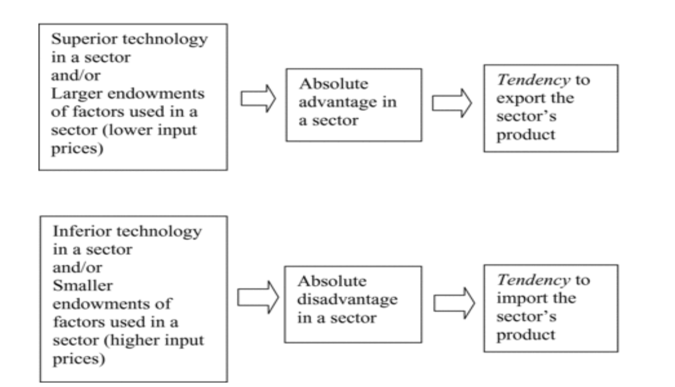

But what ensures that the amount exported by Vietnam is the same as the amount imported by Japan? If EV (Vietnam’s export) were smaller than ZJ (Japan’s import), there would be excess demand or a shortage in the world market for rice. Excess demand in turn causes prices to rice, and as PW (world price of rice) rose, exports of Vietnam would expand and imports of Japan would contract until excess demand in the world market would disappear. Similarly, if EV were larger than ZJ, PW would fall to bring the world market back into equilibrium.

So we said that, given a pattern of Absolute Advantage, it is possible for a country to give up Autarky in favour of importing/exporting. But should a country actually do this?

When Vietnam moved from Autarky to exporting in the rice market, producers experienced both an increase in prices and an increase in quantity supplied along the supply curve. This circumstance would be optimal for producers.

Consumers, however, would be harmed in the process, as they would experience an increase in price and a decrease in quantity demanded along the demand curve.

What do these effects mean for Vietnam? The consequences are a gain for producers, but a loss for consumers. Vietnam, in turn, gains from its entry into the world economy as an exporter, and for the economy as a whole, there is a net welfare increase in the quantity supplied.

When Japan moved from Autarky to importing in the rice market, producers experienced a decrease in price and a decrease in quantity supplied along the supply curve. This harms the producers but is optimal for consumers due to the decrease in price and the increase in the quantity demanded. Japan gains from its entry into the world economy as an importer, and for the economy as a whole, there is a net welfare increase.

Moving from Autarky to importing/exporting involves a net increase in welfare for the country involved (gains from trade). Many popular writings in the world economy suggest trade relationships are a win-lose proposition for the countries involved. The gains from trade idea, however, tells us that trade can be mutually beneficial to the countries involved.

Trade can improve overall welfare for the countries involved, but the concept has its limits. It also suggests the possibility that a country could not have an Absolute Advantage in anything, and would have nothing to export at all (this is unlikely, however).

Chapter 3

Comparative Advantage

The Analytical Elements of Comparative Advantage are:

* Countries
* Sectors
* Factors of production

In business analysis, the production possibility frontier (**PPF**) is a curve that illustrates the variations in the amounts that can be produced of two products if both depend upon the same finite resource for their manufacture.

A PPF can depict, for example, the combinations of output of two goods (rice and motorcycles) that the economy (Vietnam or Japan) can produce given its available resources and technology.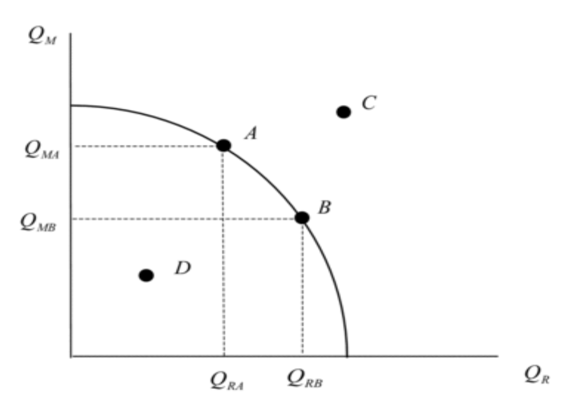

In this diagram we have the following points:

A: full employment on the PPF

B: full employment on the PPF

C: not feasible

D: feasible with unemployed resources

Let’s take Vietnam and Japan as examples when considering Comparative Advantage. Both Vietnam and Japan produce rice and motorcycles; we shall assume that the demand for rice and motorcycles in these two countries is such that these two goods are consumed in the same, fixed proportions (as depicted in the figure below).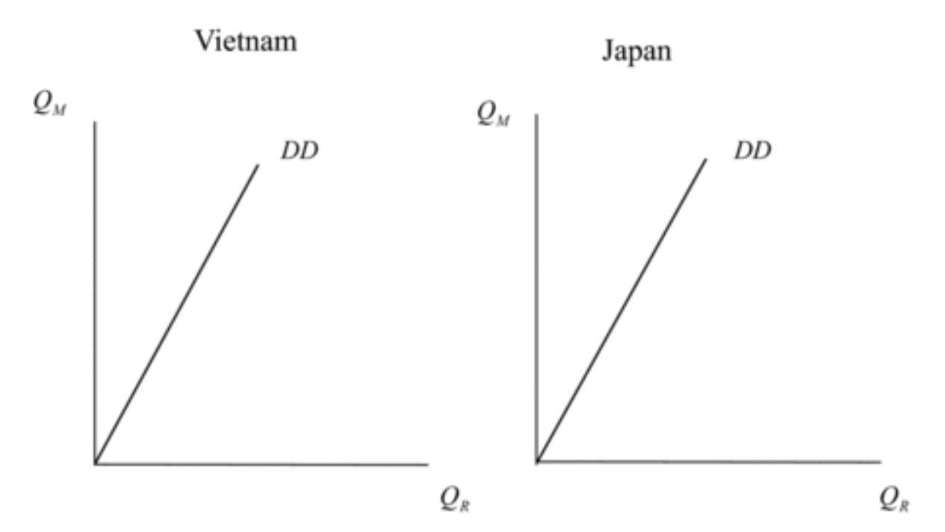

Our assumptions for this PPF example are:

* Resource/technology conditions in Vietnam give it a production possibilities frontier (PPF) that is biased towards rice
* Resource or technology conditions in Japan give it a PPF that is biased towards motorcycles
* Vietnam might have superior technology in rice production, and Japan might have superior technology in motorcycle production or
* Vietnam might be better endowed in rice production factors (land and labor), and Japan might be better endowed in motorcycles production factors (physical capital)

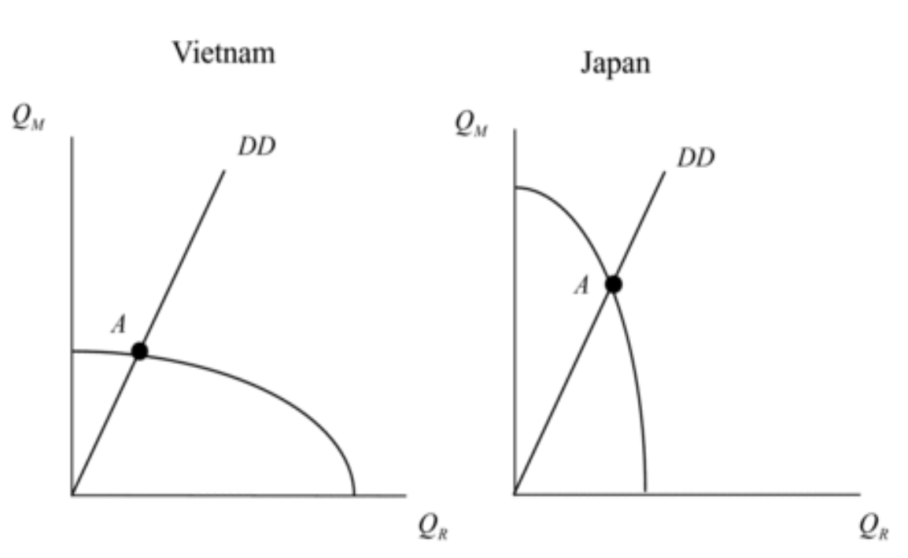

In a system of freely-operating markets and full employment of production factors, opportunity costs are fully reflected in relative prices. The figure above can be broken down into three main points:

* The slope of a PPF where demand diagonal crosses it is the relative price of rice, or PR/PK
* This is shown in the figure below by drawing the tangent lines to the PPFs at the point where the demand lines cross them, points A
* Points A in the two PPFs in the figure below represent two countries under Autarky

The tangency line giving relative prices is flatter in Vietnam than in Japan. This implies that

* The opportunity cost of rice is lower in Vietnam than in Japan (PR/PM)^V < (PR/PM)^J
* The relative price of rice, therefore, is lower in Vietnam than in Japan

What we have here is an expression of the pattern of comparative advantage. Differences in economy-wide supply conditions cause differences in relative Autarky prices and hence a pattern of comparative advantage; it’s important to note that comparative advantage involves four prices rather than two prices as in absolute advantage. Consequently, a country can have comparative advantage in a good in which it has an absolute disadvantage.

If Vietnam and Japan abandon autarky in favour of trade, the world relative price of rice will lie somewhere between the two autarky price ratios. This situation is depicted in the figure below:

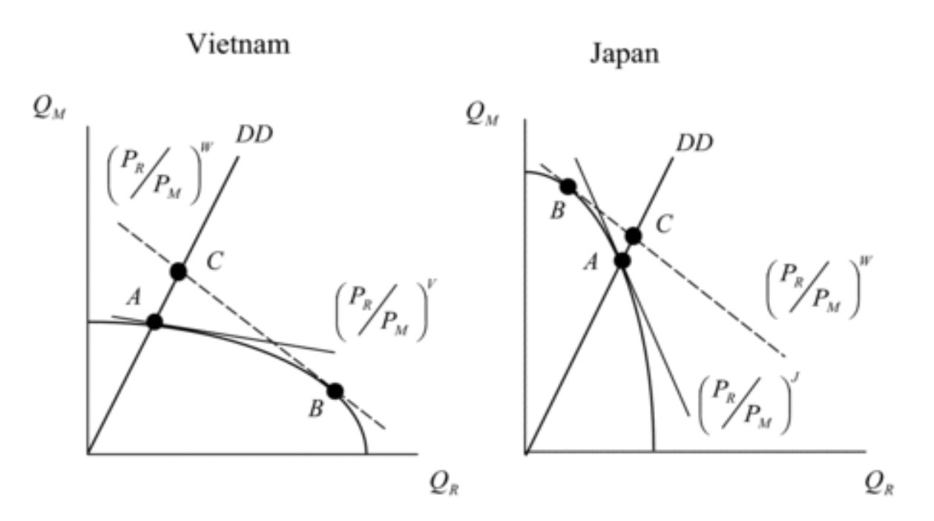

These lines are steeper than the autarky price line in Vietnam and flatter than the autarky price line in Japan. The tangence of these world price lines with the PPFs determine the new production points in Vietnam and Japan; in Vietnam, the movement along the PPF from A to B involves an i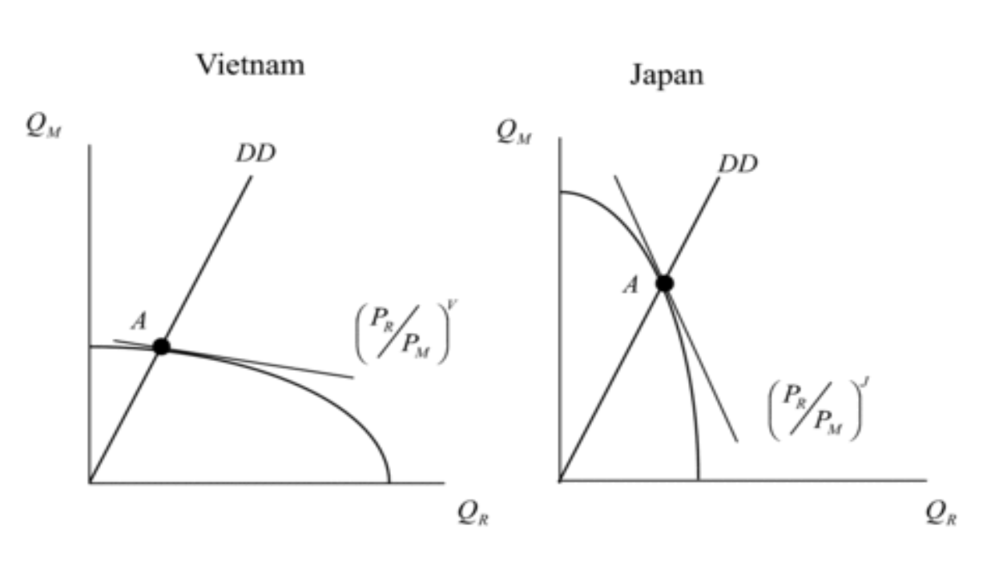ncrease in production of rice, while in Japan, this movement involves an increase in production of motorcycles.

Moving from autarky to trade restructures an economy’s production towards the good in which country has a comparative advantage. Consumption points for Vietnam and Japan must be along our diagonal demand lines—occur where the dashed world price lines intersect demand lines. Furthermore, both consumption and production must respect world prices—both B and C must be on world price lines.

Considering this, the trade between Vietnam and Japan looks something like this:

In Vietnam, the production of rice exceeds the consumption of rice, and the difference is exported. The production of motorcycles, however, falls short of consumption of motorcycles, and this shortfall is imported.

In Japan, the production of motorcycles exceeds consumption of motorcycles, and the difference is exported. The production of rice falls short of production, and this shortfall is imported.

We can see how a pattern of comparative advantage gives rise to a complementary pattern of trade.

Absolute advantage concept can leave the impression that a country could lack an advantage in anything (and thus have nothing to export). An absolute disadvantage in a product does not preclude having a comparative advantage in that product; Vietnam could have an absolute disadvantage in rice, but still export rice because of its comparative advantage.

Comparative advantage is a more powerful concept than absolute advantage and is perhaps the most central concept in international economics.

So should a country actually give up Autarky in favour of importing/exporting? Increased consumption of both goods in Japan and Vietnam, for example, implies that economic welfare has increased. This means that both countries have experienced mutual gains from trade based on Comparative Advantage.

However, gains from trade that occur for the country as a whole does not mean that every individual within the country benefits. We have good reasons to expect that there will be groups that lose from increased trade and that will oppose increased trade despite the overall gains.

Alleged international trade is almost always detrimental to the environment. However, the situation is not always this straightforward; theoretical and empirical results demonstrate that increased trade can be either good or bad for the environment. Thus, there is a need to approach the trade/environment issue on a case-by-case basis. Some goods are traded that do not contrib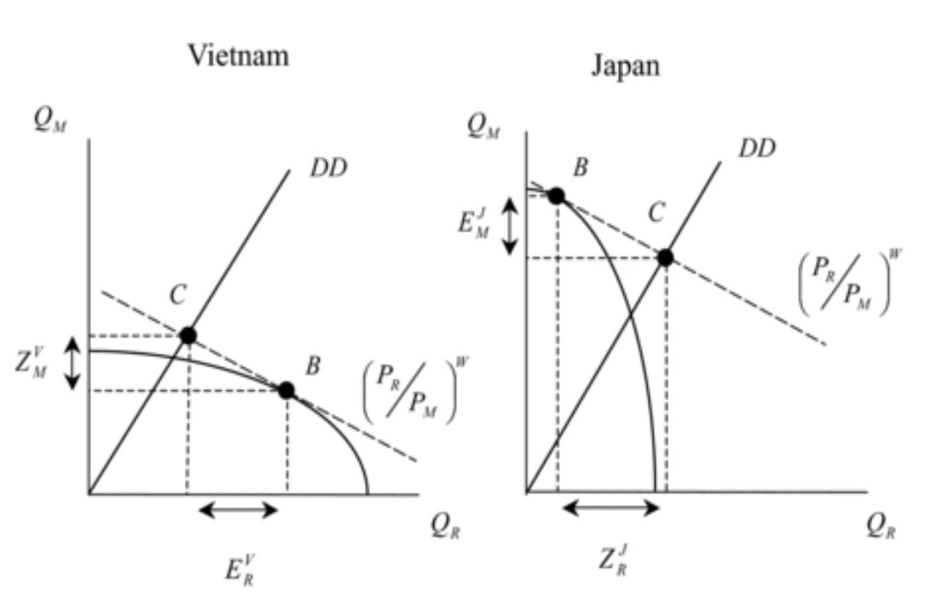ute to increased welfare such as land mines, heroin, and prostitution services.

Chapter 4

Intra-Industry Trade

INTRODUCTION

The Analytical Elements of Intra-Industry trade are:

1. Countries
2. Sectors
3. Tasks
4. Firms
5. Factors

An example of intra-Industry trade could be the fact that the United States both imports and exports cheese. This is different from inter-industry trade, in which a country either imports to exports a given product.

So:

* Inter-industry trade: EITHER imports OR exports
* Intra-industry trade: BOTH imports AND exports

Inter-industry trade has its source in comparative advantage and in the differences in technology and factor endowments of countries. Intra-industry trade and its sources are different, and there are actually two types of Intra-industry trade:

1. Horizontal (both the exported variety and the imported variety are final goods)
2. Vertical (both imports and exports in a given sector of the economy in fragments)

An example of the second type is when China imports computer and assembles them into the final product. The reason vertical Intra-industry trade has occurred is that firms have decided to break up the production process of computers into tasks or fragments and distribute them across national boundaries.

This fragmentation is an example of what we called international production, and vertical intra-industry trade is one area where the windows of international trade and international production interact in an important way. Indeed, another term for fragmentation is international production sharing. This is a relatively new phenomenon and has shown up in the increased volumes of parts and components in international trade flows.

There is another subtle issue associated with vertical intra-industry trade. Some types of fragmentation take place so that final assembly will occur where there is abundant, inexpensive labor. Although comparative advantage is not much help in explaining horizontal intra-industry trade, it is of help in explaining some types of vertical intra-industry trade.

GLOBAL PATTERNS OF INTRA-INDUSTRY TRADE

Approximately one third of world trade takes place as intra-industry trade, and is especially prominent in manufactured goods among the developed or high-income countries of the world (it probably accounts for up to 70% of trade). Globally, intra-industry trade is becoming more important over time, particularly in Asia.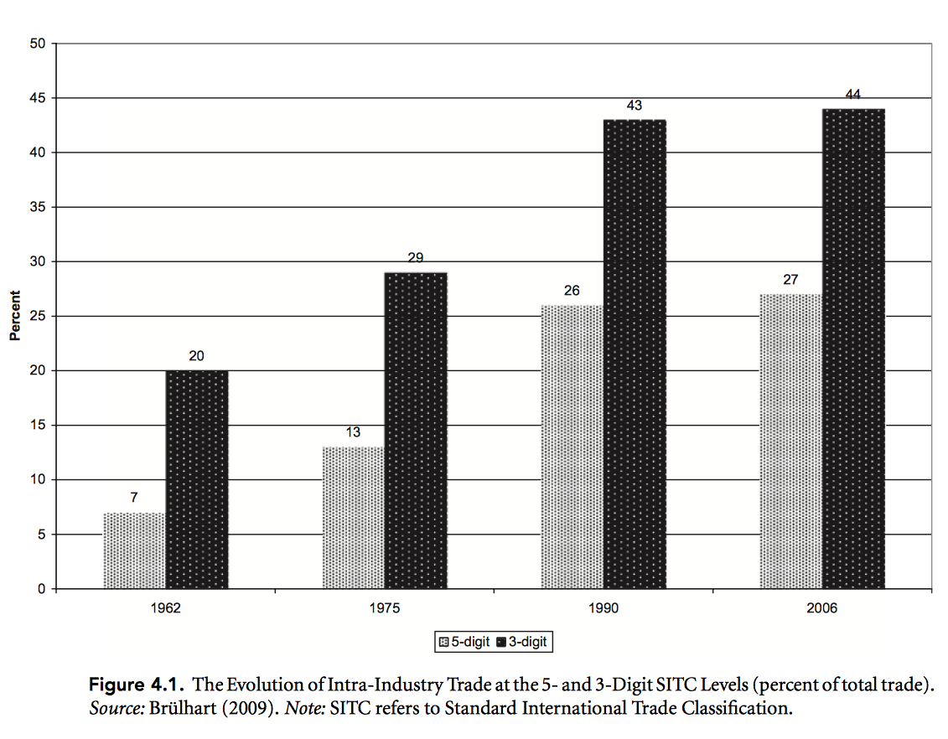

This graph shows that, measured at the five-digit Standard Industrial Trade Classification (SITC) level, intra-industry trade increased from 7 percent of world trade in 1962 to 27 percent of world trade in 2006. Measured at the three-digit SITC level, intra-industry trade increased from 20 percent of world trade in 1962 to 44 percent of world trade in 2006. Based on this evidence, it would be appropriate to state that approximately one-third of world trade is intra-industry trade.

The increasing extent of intra-industry trade in world trading system has some important implications for the *adjustment* of economies to increasing trade. Increases in inter-industry trade based on absolute or comparative advantage involve import sectors contracting and export sectors expanding; this requires that productive resources, most notably workers, shift from contracting to expanding sectors in order to avoid unemployment. It isn’t always an easy process and often gives rise to calls for protection.

The adjustment process in the case of intra-industry trade is very different. A given sector experiences increases in imports and exports simultaneously; workers are less likely to shift between these sectors, and demands for protection from increased imports are also less likely. This is also known as the “smooth adjustment hypothesis”, in which “smoothness” is present in:

* Vertical intra-industry trade (somewhat smooth)
* Horizontal intra-industry trade (smooth)

But is not present whatsoever in Inter-industry trade.

AN EXAMPLE OF INTRA-INDUSTRY TRADE

The US trade in cheese has to allow for product differentiation among types of cheese. For this example, we will restrict ourselves to two types of cheese:

* Blue cheese (denoted by B)
* Food-service cheese (denoted by F)

Let’s represent this situation on a graph:

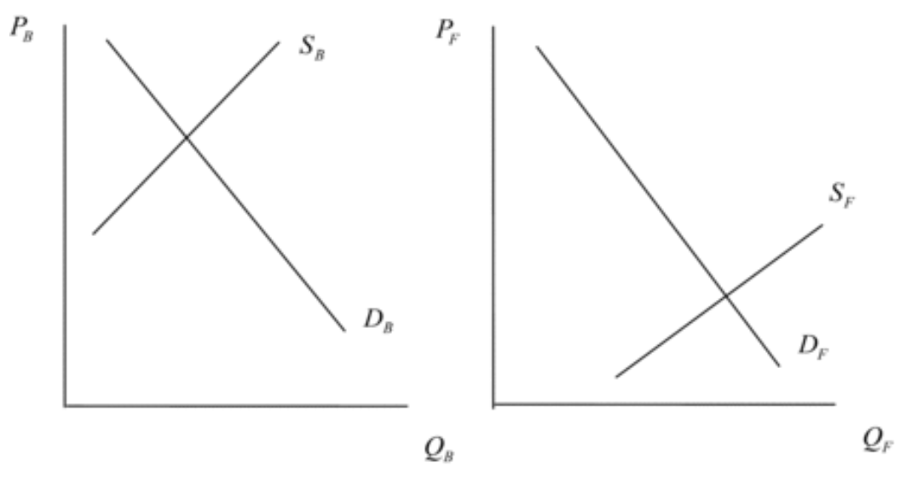

The trade implications of these supply and demand relationships, on the other hand, are illustrated in this figure below:

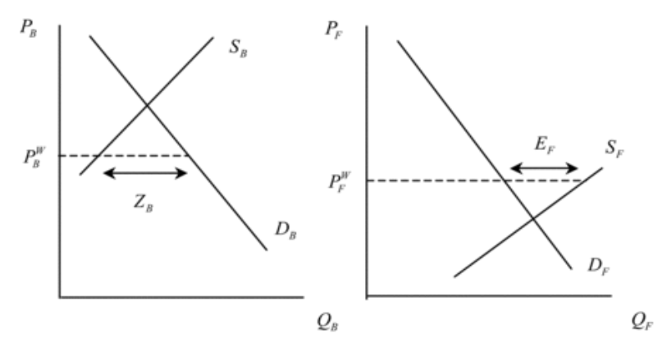

Does intra-industry trade in cheese benefit the United States, or is it unnecessary and wasteful? Let’s take this issue up in the figure below, in which areas B and D represent gains from trade: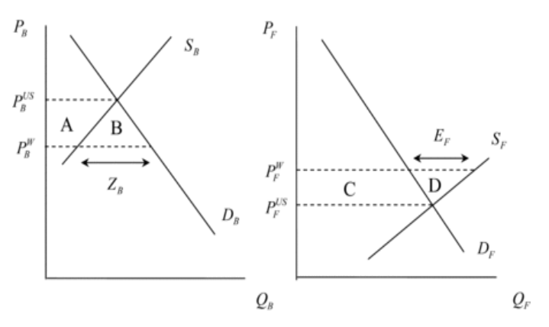

THE GRUBEL-LLOYD INDEX

Grubel and Lloyd (1975) completed the first important study of intra-industry trade; in this study, these authors developed what is now a well-known index for measuring the degree of intra-industry trade, the Grubel-Lloyd index.

The Grubel-Lloyd index looks at a given product category denoted by the letter i. The index of intra-industry trade in this product category is usually denoted by Bi. Bi is calculated based on the level of imports of product i (denoted Zi) and the level of exports of product i (denoted E i ). The Grubel-Lloyd index is calculated as: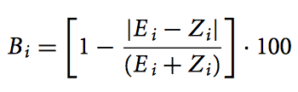

|E i − Z i | refers to the absolute value of the difference between exports and imports of product i. This value is always positive. The best way to make sense of the Grubel-Lloyd index is to consider the case where intra-industry trade is at its maximum. This index is illustrated by: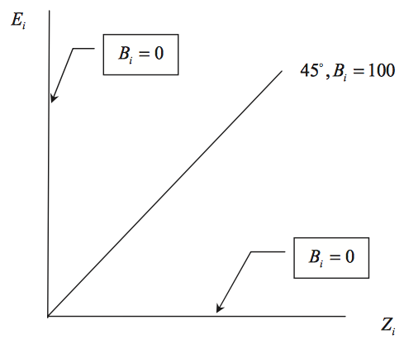

That is where exports and imports of product i are exactly equal to one another. In this case, |E i − Zi| = 0 and Bi = (1 − 0) · 100 = 100. Therefore, the Grubel-Lloyd index ranges from 0 to 100. As the index increases from 0 to 100, the amount of intra-industry trade in product category i increases.

In cases where E i = Z i , a particular trading economy will be on the 45-degree line in this figure and Bi = 100. As the trading economy diverges in either direction from the 45-degree line, B i will decline from 100. If the import and export values are such that one is zero (the pure inter-industry trade case), then the economy will be on one of the two axes and Bi = 0.

Chapter 5

The Political Economy of Trade

INTRODUCTION

It’s possible for countries to move from autarky to inter-industry trading relationships based on patterns of comparative advantage; this movement also involves improvements in welfare for the countries involved.

However, while Japan may experience an economic benefit from importing rice, it has a long history of preventing the importation of rice. This reluctance is mainly due to economic security and cultural reasons. It is also possible (and likely) that certain groups will lose in this change, and Japanese rice producers are one such politically powerful group.

This gives rise to political economy of trade, and the theory of international trade begins to merge into political science.

APPROACHES TO THE POLITICAL ECONOMY OF TRADE

There are several approaches to this topic:

1. Realism (country-based)

There are security externalities associated with international trade.

1. Institutionalism (country-based)

Institutional structures within country governments affect trade policies

1. Heckscher-Ohlin model + Stolper Samuelson theorem (factor-based)

Under factor mobility within a country, different factors can win or lose from trade.

1. Specific factors model (sector-based)

With sector-specific factors, winning/losing depends on export/import factor specificity.

1. Firm-based (firm-based)

Trade exposure of firms can influence their posture to trade liberalisation.

In order to begin talking more specifically about the factor and sector approaches to the political economy of trade, it is useful to revisit the model of comparative advantage we developed in Chapter 3.

Recall that Vietnam has a comparative advantage in the production of rice (denoted R), and Japan has a comparative advantage in the production of motorcycles (denoted M). As these two economies move from autarky to trade, production in each country expands in the direction of the sector in which it has comparative advantage. In the movement from points A to B along the production possibility frontiers in the figure below, rice production expands in Vietnam, and motorcycle production expands in Japan.

But what determines the pattern of comparative advantage illustrated in this figure? Recall from Chapters 2 and 3 that there are two broad determinants: technology and factors of production. A factor-based analysis of the political economy of trade policy takes up the latter determinant and examines the implications of the movement from

points A to B in the figure for factors of production in Vietnam and Japan.

Here is the figure: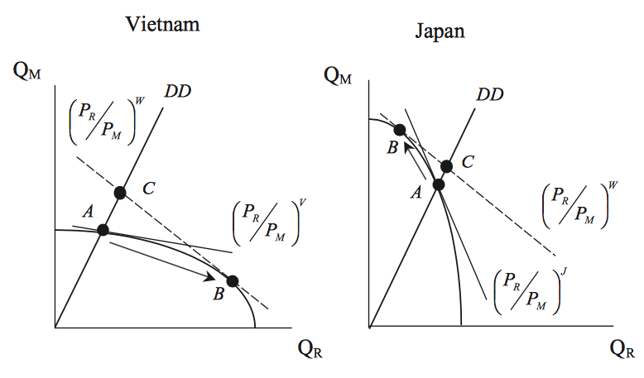

TRADE AND FACTORS OF PRODUCTION

Patterns of comparative advantage may be based on different endowments of factors of production. For instance, Vietnam may have a comparative advantage in rice due to the fact that it has a relatively large endowment of land. The Heckscher-Ohlin model of international trade explains comparative advantage in terms of factor endowments.

The logic of the Heckscher-Ohlin model is illustrated in the top six boxes of the figure below. The top two boxes of this figure concern factor endowments. Vietnam is relatively land abundant, and Japan is relatively capital abundant. The next two boxes concern the pattern of comparative advantage. Vietnam has a comparative advantage in rice (land intensive), and Japan has a comparative advantage in motorcycles (capital intensive). The third level of boxes in the figure concerns trade flows. In accordance with the pattern of comparative advantage, Vietnam exports rice to Japan, and Japan exports motorcycles to Vietnam.

More generally, the Heckscher-Ohlin model of international trade gives the following result with regard to trade:

“A country exports the goods whose production is intensive in its abundant factor. It imports the good whose production is intensive in its scarce factor.”

The implication of the figure above for the political economy of trade policy is addressed in the bottom six boxes. In Vietnam, the comparative advantage in rice causes an increase in the output of rice at the expense of motorcycles. Consequently, there is an increase in demand for land and a decrease in demand for physical capital. These factor demand changes have the result that landowners in Vietnam gain from trade, whereas Vietnamese capital owners (capitalists) lose from trade.

In Japan, the comparative advantage in motorcycles causes an increase in the output of motorcycles at the expense of rice. Consequently, there is an increase in demand for physical capital and a decrease in demand for land. These changes cause Japanese capital owners to gain from trade and Japanese landowners to lose from trade.

Given the results of the figure above, we would expect that landowners in Vietnam and capital owners in Japan would support trade. Political opposition to trade or demand for protection would come from capital owners in Vietnam and landowners in the Japan. Thus we can see why the strong and persistent opposition to rice imports in Japan discussed in the introduction to this chapter arises and persists. It is due, at least in part, to the political clout of Japanese landowners. The reason, however, is not “economic security and culture.” Rather, it is income loss.

Let’s summarise these results in more general terms.

In both Vietnam and Japan, the sector intensive in the country’s abundant factor expands, whereas the sector intensive in the country’s scarce factor contracts. This, in turn, causes an increase in the demand for the abundant factor in each country and a decrease in demand for the scarce factor in each country. These changes in demand, in turn, have implications for the returns to or incomes of the factors in question and hence the demand for protection.

The Heckscher-Ohlin model thus has an important implication for the political economy of trade, and this implication is summarised in a central result of international trade theory, the Stolper-Samuelson theorem.

In general terms, this theorem can be stated as follows:

“As a country moves from autarky to trade, the country’s abundant factor of production (used intensively in the export sector) gains, whereas the country’s scarce factor of production (used intensively in the import sector) loses. Opposition to trade or demand for protection therefore arises from the scarce factor of production.”

The Stolper-Samuelson theorem thus locates the potential opposition to increased trade (and support for protection) in the scarce factor of production in a country. This key insight composes the lens through which many international economists and policymakers view the political economy of trade. The Stolper-Samuelson theorem canno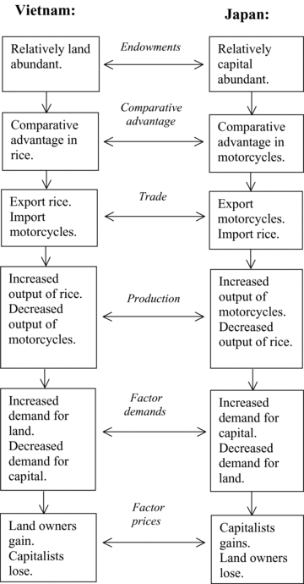t be applied blindly, however. It applies only to inter-industry trade based on different endowments in factors of production. Intra-industry trade and trade based on differences in technology can mitigate the effects described by the theorem.

The Stolper-Samuelson theorem and North-South trade is illustrated below:

These alternative considerations arise in the application of the theorem to the issue of North-South trade and wages.

NORTH-SOUTH TRADE AND WAGES

Concerns have prompted ongoing empirical investigation into effects of trade on Northern wages. Important empirical results state that there are two (not one) main causes for the decline in relative wages of Northern unskilled workers:

1. Trade
2. Technology

Stolper-Samuelson theorem suggests that Northern unskilled workers lose because North has a comparative advantage in skilled-labor-intensive goods. These effects, however, tend to be smaller than Stolper-Samuelson theorem would suggest.

The ongoing process of technological change in the North has increased demand for skilled workers relative to unskilled workers. Trade restrictions in the North on exports from the South is probably not the best approach to the problem, as:

* Technology appears to be at least as important as trade
* Trade restrictions will suppress the overall gains from trade
* Trade restrictions could violate multilateral commitments at the WTO
* Restrictions could harm unskilled workers in the South who are in more dire straits than their Northern counterparts

ENDOGENOUS PROTECTION

The factor-based approach to the political economy of trade as represented by the Heckscher-Ohlin model can be extended to a concept known as endogenous protection. This is a formal explanation of why the demand for and supply of protection interact in such a way to result in positive levels of protection, particularly but not exclusively in the form of tariffs.

Suppose that there are 100 individuals in a country described by the Heckscher-Ohlin model and that each of these individuals has one unit of labor (herself or himself). The other factor of production or resource in the Heckscher-Ohlin economy is physical capital. For each individual, the relative endowment of physical capital is the ratio of the individual’s physical capital to labor. Because the labor endowment is just “1,” the ratio is just the amount of physical capital they own. For example, for individual 10: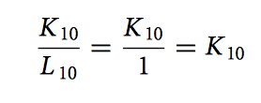

This can be represented as:

We then rank our individuals from the lowest amount of physical capital owned to the highest amount, as follows: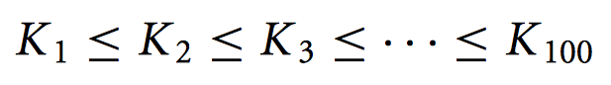

We graph these ownership ratios in the upper graph in the figure above. Note that many individuals own no physical capital at all and are therefore at “0” in this graph.

If we place these 100 individuals in the Heckscher-Ohlin framework developed in thi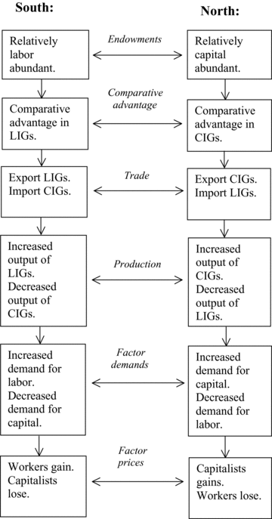s chapter, then a significant result emerges. Suppose that this is a capital-abundant country that will export the capital-intensive good. Then Mayer (1984) showed that losses will occur for those individuals who own less capital and that gains will occur for those individuals who own more capital. We get a gain/loss (G − L ) graph something like that in the lower graph above. All the individuals with “0” capital lose, but so do those with only a little capital, as well as the median individual. Gains are reserved for those with larger amounts of capital.

The presence of losses for the majority of the individuals represents a significant demand for protection due to the Mayer/Stolper/Samuelson effects. But that is not all. There is a basic insight in public choice theory due to Black (1948) that politicians who want to maximise their number of votes will abide by the policy preference of the median voter. This is voter or individual “50” in our model, and this individual suffers losses under free trade in this capital-abundant country. There is thus a bias in this framework toward protectionism. Supply of protection meets demand.

The model considered here combines a factor-based approach to 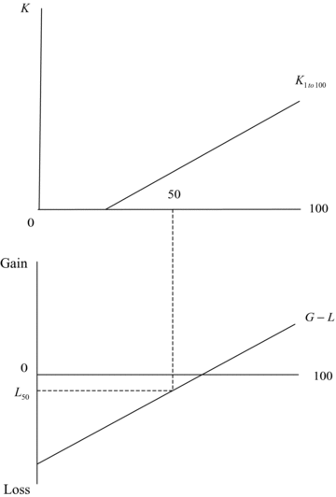the demand for protection with an explanation of the supply of protection that is a very particular and narrow example of institutionalist considerations. The model is not universal. Not all economies are best described by the Hecksher-Ohlin model; as we have seen in this chapter, specific factors matter as well. Also, politics is more complicated than that described by Black (1948). Nevertheless, the model illustrates one possibility that is commonly recognised by many trade policy analysts.

Chapter 6

Trade Policy Analysis

INTRODUCTION

The analytical elements of Trade Policy Analysis are:

1. Countries
2. Sectors
3. Factors of production

Reasons to expect landowners in Japan might oppose the import of rice from another country, and opposition to imports exists despite overall gains to Japan from these imports. Trade policy analysts and international affairs professionals are often called upon to assess impacts of government interventions in international trade. The purpose of this chapter is to understand how these assessments are actually made.

ABSOLUTE ADVANTAGE (REVISITED)

In moving from autarky to trade, there is a reduction in domestic quantity supplied in Japan. Japanese rice-producing firms would lobby Japanese government to oppose decrease in domestic quantity supplied (as a consequence, they demand protection from Vietnamese exports). Protective policies are widespread in world economy.

TRADE POLICY MEASURES

A country can grant import protection to a sector of its economy in form of either:

1. Tariffs: a tax on imports

* Specific tariff is a fixed tax per physical unit of the import
* Ad valorem tariff is a percentage tax applied to the value of the import

1. Non-tariff measures

Governments tend to employ both types of tariffs. When a country seeks to grant import protection to a sector of its economy, it can choose among a number of measures that can be broadly classified as either tariffs or non-tariff measures. A tariff is a tax on imports. It is a very common trade policy used by almost all countries. There are two primary kinds of tariffs:

* A specific tariff is a fixed tax per physical unit of the import
* An ad valorem tariff is a percentage tax applied to the value of the import.

From the point of view of many trade policy analysts and the World Trade Organisation (WTO), the ideal trading system would consist of only tariffs. Tariffs, particularly ad valorem tariffs, are seen as the most transparent kind of trade policy and one that is least susceptible to political manipulation and corruption.

However, tariffs are far from the only type of trade policy. Therefore, the second category of trade policy measures we need to consider is the inclusive and large collection of non-tariff measures (NTMs).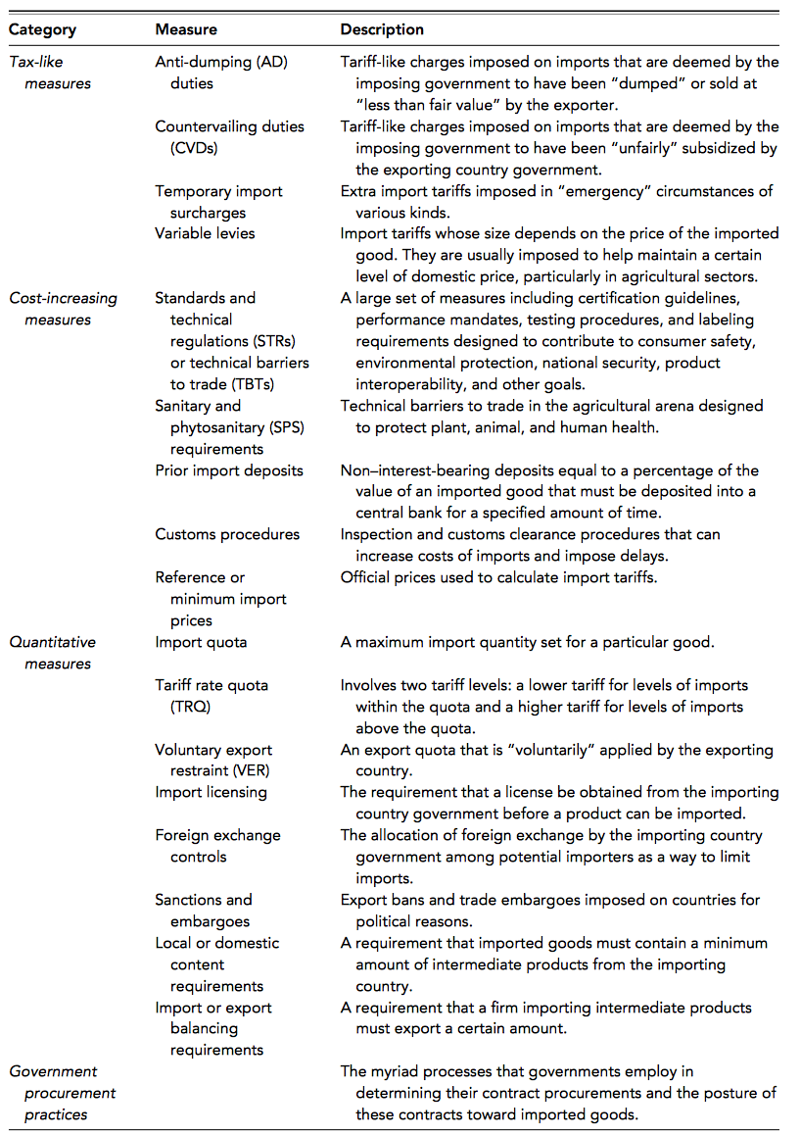

The range of these NTMs is limited only by the imaginations of policymakers.

To get a handle of the numerous kinds of NTMs, we can follow Takacs (2009) and distinguish among four categories: tax-like measures, cost-increasing measures, quantitative trade restrictions, and government procurement policies.

A number of examples of these are presented in the table above. Tax-like measures include anti-dumping (AD) duties, countervailing duties (CVDs), temporary import surcharges, and variable levies. Dumping involves the price of an exported good being lower than the price of the same good in the exporting country, and AD duties can be applied in certain circumstances when dumping takes place.

CVD measures “countervail” subsidies by exporters and again can be applied in certain circumstances. AD and CVD measures are together often referred to as “administrative protection” and form a veritable industry of trade policy analysis spanning national governments and trade policy law firms attempting to assure that trade is “fair.”

Cost-increasing measures include what is known both as standards and technical regulations (STRs) and technical barriers to trade (TBTs), sanitary and phytosanitary (SPS) requirements, prior import deposits, customs procedures, and reference or minimum import prices. STRs and TBTs are a growing area of trade policy activity and analysis.5 It is one area where there are clear cases in which increasing protection can improve welfare in instances such as consumer health and safety.

However, it is also an area where barriers are put in place simply for their protective effect. Customs procedures is another area that has received increased attention. This is for two reasons:

1. There is a concern that slow customs clearance procedures in developing countries can be wasteful
2. Customs clearance, particularly in a “post-9/11” context, can be a real barrier for developing country exporters trying to enter developed country markets.

Consequently, there is a concern with capacity building for developing country exporters in this area.

Quantitative measures is a large group of NTMs including import quotas, tariff rate quotas (TRQs), voluntary export restraints (VERs), import licensing, foreign exchange controls, sanctions and embargoes, local or domestic content requirements, and import or export balancing requirements. As will be discussed later on, for many years, import quotas were the norm in agriculture, textiles, and clothing trade. This is no longer the case among WTO members, but can still exist in nonmember countries.

TRQs, however, are still in use in agricultural sectors, including the Japanese rice sector. These involve two tariff levels: a lower tariff for levels of imports within the quota (the within-quota tariff) and a higher tariff for levels of imports above the quota (the out-of-quota tariff). These complexities make it complicated to administer and analyse. Sanctions and embargoes are a perennial topic with regard to their effectiveness in influencing regimes deemed to be unacceptable (e.g., Apartheid South Africa or present-day Myanmar).

Government procurement practices concern the processes that governments employ in determining their contract procurements and the posture of these contracts toward imported goods. Takacs (2009) reminds us that “In most countries, regardless of the stage of development, government is the single largest purchaser of goods and services”. That makes the government procurement processes and their specific posture toward imports an important matter.

From this discussion and the content of the table above, it is clear that trade policies are numerous. We are going to simplify greatly in this chapter and focus on the basic analysis of a tariff and quota within the absolute advantage framework. We begin with the case of a tariff.

A TARIFF

There are two kinds of tariffs, a specific tariff and an ad valorem tariff. For our graphical analysis in this chapter, it is much simpler to consider a specific tariff, so that is what we will do. The basic results you will learn here, however, will also apply to an ad valorem tariff.

Let’s introduce a specific tariff on Japan’s imports of rice. This policy is depicted above. The world price is PW. At this price, Japanese rice suppliers choose to supply Q S , and Japanese consumers demand Q D . The difference, QD − QS = ZJ , is imported from Vietnam.

Suppose then that the Japanese government imposes a specific tariff of T on its imports of rice from Vietnam. This raises the domestic price of the imported product above the world price to P W + T. In the case of Japanese rice, the domestic price is many times larger than the world price. The increase in the domestic price of rice above the world price has a number of effects. Japan’s production of rice expands from Q S to QStariff. This expansion in output is what the Japanese rice farmers hoped to gain from the tariff. Domestic consumption of rice falls from QD to QDtariff. Imports fall from ZJ to ZJtariff. The tariff has suppressed the importing relationship of Japan with Vietnam.7

In addition to the quantity effects of a tariff, there is also a set of welfare and revenue effe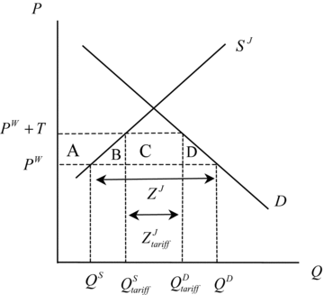cts. These involve Japan’s households, firms, and government.

Examining this diagram carefully, you should be able to see that the tariff has caused consumer surplus to fall by area A+B+C+D. Because Japanese rice consumers are paying more and consuming less, this fall in consumer surplus makes sense. What has happened to the producer surplus of Japanese firms? Again examining the diagram carefully, you should be able to see that producer surplus has increased by area A. Japanese rice producers are better off as a result of the tariff; their welfare has increased. Because Japanese producers are receiving more for their product and producing more as well, this increase in producer surplus makes sense.

What about the Japanese government? It is receiving revenue from the import tax. How much revenue? The tariff is T, and the post-tariff import level is ZJtariff. Therefore, the tariff revenue is T × ZJtariff, or area C in the figure above.

Economists or trade policy analysts are often asked to assess the net welfare effect of a trade policy. This standard measure summaries the welfare impact of the policy for the country as a whole. What would the net welfare effect be? In this case, we take the gains to firms and the government and subtract the losses to households. Doing this, we have:

N = A + C − (A + B + C + D) = − (B + D)

Area A is a transfer from consumers to producers, whereas area C is a transfer from consumers to the government. These areas cancel out with each other in Equation 6.1. That leaves areas B and D. There is a net welfare loss of the tariff equal to areas B+D. From an economic standpoint, the tariff hurts the Japanese society as a whole. Although it benefits producers and government, the losses imposed on consumers outweigh these benefits.

The two triangles B and D are similar to the “deadweight loss” triangle of a monopoly you learned about in introductory microeconomics. They represent economic or allocative inefficiency. In certain situations, tariffs do not necessarily cause a net welfare loss. One such situation, a terms-of-trade gain, is explored in the next section.

Please note one more thing. The figure gives us information on what happens to Japanese rice output as a result of the tariff. As we stated above, Japanese rice output increases from QS to QStariff. Given information on the employment/output ratio in this sector, we could translate the change in output into a change in employment. From the point of view of Japan politicians, this employment effect is important.

Therefore, trade policy analysts often include an estimate of the employment effects of tariffs and other trade policies.

TERMS-OF-TRADE EFFECTS

When Japan imposes a tariff on its imports from Vietnam, amount of these imports decreases. As Japan’s imports of rice decrease, there will be excess supply in the world market for rice will cause the world price to fall (since Japan is importing rice, this is a good thing for the country).

A QUOTA

An import quota is a quantitative restriction on imports, and is a type of non-tariff measure. A quota results in a shortage of a good relative to initial situation without quota, causing price of good to rise. This is known as a quota premium, and consumer surplus falls and producer surplus increases.

A policy is usually administered via a system of import licenses, and quotas have a restricted supply of import licenses. Extra value of the right to import an amount of a good is known as quota rents (area C).

Deciding who receives rents depends on how the quota licenses are allocated. When allocated to domestic importers, quota rents accrue to importers and remain in Japan as a gain. When allocated to foreign exporters, quota rents accrue to exporters and leave Japan as a loss.

COMPARATIVE ADVANTAG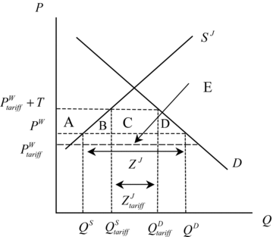E MODELS

In many instances, the effects of trade policies go beyond a single sector. In these cases, trade policy analysts turn to trade policy models based on comparative rather than absolute advantage. The central insight of these models is that a protective measure in one sector acts as an implicit tax on production in other sectors.

THE IMPERFECT SUBSTITUTES MODEL

The standard absolute advantage models assumes that imported goods and domestic competing goods are perfect substitutes. In applied trade policy analysis, this assumption is often relaxed and imported goods and domestic competing goods become imperfect substitutes. This is presented in the figure below:

This figure considers the related markets for a domestic good (D) and an imported good (Z). The shifts in the demand curves in this figure are due to substitution effects, the magnitude of which reflects the cross-price elasticity of substi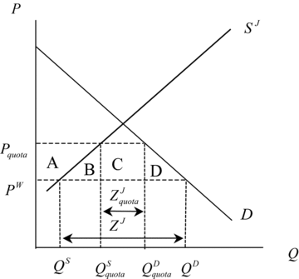tution. This is a more complicated approach to trade policy analysis but one that is widely used, including in anti-dumping analysis.

Chapter 7

World Trade Organisation

THE GENERAL AGREEMENT ON TARIFFS AND TRADE

In 1944, the United States and Britain held a conference (Bretton Woods) that established the International Bank for Reconstruction and Development (World Bank) and the International Monetary Fund.

In 1945, the United States attempted to launch the idea of an International Trade Organisation (ITO). In London, 23 founding members were present and signed the General Agreement on Tariffs and Trade (GATT). In 1948, the ITO charter was agreed to at a United Nations Conference. In 1950, the US announced that it would not seek US Congressional ratific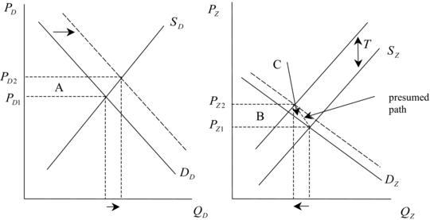ation of the Havana Charter, effectively terminating the ITO plan. The prime vehicle for post-war trade negotiations became GATT.

Between 1946 and 1994, the GATT provided a framework for multilateral trade negotiations that reduced tariffs among member countries in many (but not all) sectors. As a consequence, the weighted average tariff on manufactured products imposed by industrial countries fell from 20% to 5%.

However, GATT suffered from several defects that limited its effectiveness. A number of these defects were addressed in the Marrakesh Agreement at the end of the Uruguay Round of multilateral trade negotiations.

NON-DISCRIMINATION PRINCIPLE

The non-discrimination principle is the most important principle of the GATT. It has two important subprincipals, namely:

1. Most favoured nations (MFN)

Under MFN, each member must grant treatment to all other members as favourable as it extends to any individual member country. If Japan lowers a tariff on Indonesia’s exports of a certain product, it must also lower its tariff on the exports of that product from all other member countries for “like products.” The MFN treatment has special importance for developing countries, because they will bene- fit from tariff reductions negotiated among developed countries. Exceptions to MFN treatment are allowed in the case of certain preferential trade agreements and preferences granted to developing countries.

1. National treatment (NT)

Whereas MFN addresses border measures, NT addresses internal, domestic policies such as taxes. NT specifies that foreign goods within a country should be treated no less favourably than domestic goods with regard to tax policies and other regulations (e.g., technical standards), again for “like products.” Together, MFN and NT compose the nondiscrimination principle.

A second important GATT principle is the general prohibition of quotas or quantitative restrictions on trade. This reflects a longstanding view that price distortions (tariffs) are preferred to quantity distortions in international markets. It also reflects the history of GATT. During its birth, quantitative restrictions were one of the most significant impediments to trade. As always, there are exceptions allowed.

For many years, there were additional, sector-specific exceptions to the general prohibition of quotas in the GATT. The first was the case of agricultural products and applied when certain domestic programs were in place.

Exceptions to the quota prohibitions of the GATT in the areas of agriculture, textiles, and clothing generated negative feelings on the part of developing countries with regard to the world trading system.

Why? Agriculture, textiles, and clothing are three groups of products that countries first turn to in their trade and development process. The fact that these three groups of products were taken out of the GATT framework at the insistence of developed countries (led by the United States and Western Europe) left the developing countries wondering how they could have a fair chance to participate in the trade and development process. These sentiments have not entirely disappeared.

A third important GATT principle is that of binding. GATT- and WTO-sponsored reductions in tariff levels have been based on the practice of binding tariffs at agreed- upon levels, often above applied levels. Once set, tariff bindings may not in general be increased in the future. Applied rates that are below bound rates, however, may be increased.

Although there are provisions made for some re-negotiation of bound tariffs, such re-negotiations must be accompanied by compensation. The general purpose of the binding principle is to introduce a degree of predictability into the world trading system.

A final important GATT principle is that of “fair trade.” In the interest of promoting “fair” competition in the world trading system, the GATT introduced a number of stipulations with regard to subsidies, countervailing duties (CVD), and antidumping duties (AD). The use of subsidies is not supposed to harm the trading interests of other members. When subsidies are shown to cause “material injury” or “threat thereof” to a domestic industry of another country, that other country is authorised to apply countervailing duties or tariffs on its imports of the product from the subsidising country. The GATT leaves room for different interpretations, especially in the case of production as opposed to export subsidies. This, combined with differing national laws, leaves a great deal of room for controversy.

THE WORLD TRADE ORGANISATION

Bretton Woods’ initial vision of an ITO failed to materialise. However, when the Uruguay Round was launched in 1986, there was recognition that the GATT had inherent institutional flaws. Consequently, the Uruguay Round included a negotiating group on the “function of the GATT system,” or FOGS. Then John Jackson (1990), a preeminent trade lawyer, suggested that the Uruguay Round consider establishing a World Trade Organisation, or WTO.

In 1991, the Director General of GATT, Authur Dunkel, released a draft agreement for the Uruguay Round that became known as “the Dunkel text.” The Dunkel text included a draft charter for the WTO. By the end of 1993, the text of the Uruguay Round contained a final charter for a WTO.

The Marrakesh Agreement is actually the “Marrakesh Agreement Establishing the World Trade Organisation.” Therefore, the stipulations of this agreement are formally an element of the WTO, and the new GATT (known as GATT 1994) has been folded into the institutional structure of the WTO. The Marrakesh Agreement and the WTO are sometimes referred to as a “tripod” in that it primarily addressed the following three areas:

1. Trade in Goods
2. Trade in Services
3. Intellectual Property

The Marrakesh Agreement also included a WTO charter. It established the WTO as a legal international organisation and stipulated that “The WTO shall provide the common institutional framework for the conduct of trade relations among its members.”

The administrative aspects can be read about in the following table:

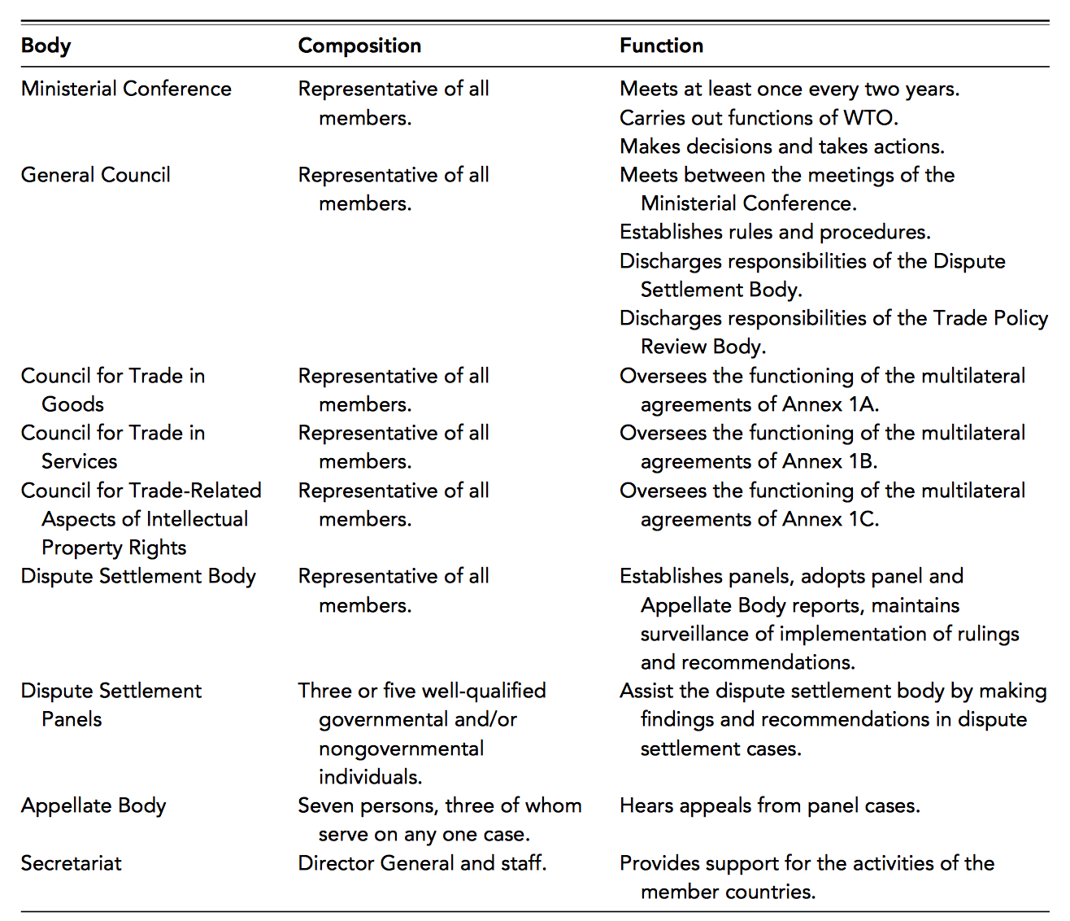

TRADE IN GOODS

The section of the Marrakesh Agreement related to trade in goods contains GATT 1994, an update of the original GATT, as well as an Agreement on Agriculture and an Agreement on Textiles and Clothing.

The Agreement on Agriculture addresses three outstanding issues concerning international trade in agricultural goods: market access, domestic support, and export subsidies. In the case of market access, the Agreement on Agriculture replaced a quota-based system with a system of bound tariffs and tariff-reduction commitments.

The conversion of quotas into equivalent tariffs is a process known as tariffication. In this aspect, the Agreement on Agriculture represents a significant change of regime. Nontariff measures (quotas) are now prohibited. Further, developed country members must have reduced average agricultural tariffs by 36 percent by 2001, and developing country members must have reduced average agricultural tariffs by 24 percent by 2005. Least-developed country members are not required to reduce their tariffs. In practice, the current tariff regime includes tariff rate quotas.

In the case of domestic support, a distinction is made between non–trade-distorting policies, known as “green box” measures, and trade-distorting policies, known as “amber box” measures. Green box measures are exempt from any reduction commitments, while amber box measures are not exempt and are specified in terms of what are known as “total aggregate measures of support” (total AMS). Developed country members must have reduced total AMS by 20 percent by 2001, and developing country members must have reduced total AMS by 13 per- cent by 2005. Least-developed country members are not required to reduce their total AMS.

Finally, in the case of export subsidies, use has not been eliminated. Rather, it has been limited to specified situations. Developed country members must have reduced export subsidies by 36 percent by 2001, and developing country members must have reduced export subsidies by 24 percent by 2005. Least-developed country members are not required to reduce their export subsidies. The persistence of developed-country export subsidies represents a major distortion in global agricultural trade.

Despite these specified reduction commitments, the Agreement on Agriculture is best viewed as a change in rules rather than as a significant program for the liberalisation of trade in agricultural products. The hope is that further liberalisation of the new tariffed quotas will take place in the Doha Round of trade negotiations.

The Agreement on Textiles and Clothing (ATC) required that, in four stages of a 10-year transition period beginning in 1995, countries reintegrate their textile and clothing sectors back into the GATT framework (GATT 1994). At the end of the 10-year period, all quotas on textile and clothing trade were removed. This represented a reintegration of the textile and clothing sector into the GATT-WTO principles from which it had been removed for a half-century.

TRADE IN SERVICES

Trade in services composes more than 20 percent of total world trade and has at times grown faster than trade in goods. The General Agreement on Trade in Services (GATS) represents the first time that services have been brought into a multilateral trade agreement. For these reasons, the GATS was a significant outcome of the Uruguay Round. The negotiations on GATS, however, were difficult. Contributing to this difficulty was the fact that trade in services is less tangible than trade in goods.

Another difficulty in negotiating the GATS was that there was resistance to it on the part of a number of developing countries. The United States and the European Union were in favour of it, however, and prevailed upon developing countries to allow negotiations to move forward. The GATS includes the principle of nondiscrimination previously discussed. Each member was allowed to specify nondiscrimination exemptions on a “negative list” of sectors upon entry into the agreement that lasted for 10 years.

For those sectors a member country specifies on a “positive list,” the GATS prohibits certain market access restrictions. Six types of limitations were prohibited: the number of service suppliers, the total value of service transactions, the total number of operations or quantity of output, number of personnel employed, the type of legal entity in the case of FDI, and the share of foreign ownership in the case of FDI.

To provide a structure to trade in services, GATS defined trade in services as occurring in one of four modes:

Mode 1: cross-border trade

Cross-border trade is a mode of supply that does not require the physical movement of producers or consumers.

Mode 2: movement of consumers

Movement of consumers involves the consumer traveling to the country of the producer and is typical of the consumption of tourism services.

Mode 3: commercial presence or foreign direct investment (FDI)

Commercial presence or FDI is involved for services that require a commercial presence by producers in the country of the consumers and is typical of financial services

Mode 4: movement of natural persons

Finally, the movement of natural persons involves a noncommercial presence by producers to supply consulting, construction, and instructional services.

GATS PROTOCOLS

* Second GATS Protocol: Revised Schedules of Commitments on Financial Services, 1995
* Third GATS Protocol: Schedules of Specific Commitments Relating to Movement of Natural Persons, 1995
* Fourth GATS Protocol: Schedules of Specific Commitments Concerning Basic Telecommunications, 1997
* Fifth GATS Protocol: Schedules of Specific Commitments and Lists of Exemptions from Article II Concerning Financial Services, 1998

INTELLECTUAL PROPERTY

This is an asset in the form of rights conferred upon a product of invention or creation by a country’s legal system regulated by the Agreement on Trade-Related Aspects of Intellectual Property Rights (TRIPS agreement). It is the most contentious aspect of the Marrakesh Agreement, and defined as belonging to one of six categories:

* + - Copyrights
    - Trademarks
    - Geographical indications
    - Industrial designs
    - Patents
    - Layout designs of integrated circuits

Here, we can see how the principle of Nondiscrimination can also be applied to intellectual property. Citizens and firms in developed countries own most of the world’s IP. Developing countries currently often have less IP protection than developed countries, especially in the case of patents. This raises the cost of many goods and services to developing countries and represents a transfer from developing country consumers to developed country producers. Issues have also been raised about the impact of new pharmaceutical patents on access to medicines.

DISPUTE SETTLEMENT

The Marrakesh Agreement also included an Understanding on Rules and Procedures Governing the Settlement of Disputes. The original GATT was unclear about resolution of disputes — Marrakesh Agreement attempted to clarify dispute settlement procedures. The WTO includes councils on trade in goods and services as well as a council on TRIPs, which should help minimise the occurrence of disputes.

If the consultation process fails to settle a dispute within 60 days, the complaining member may request the establishment of a panel composed of three or five “well-qualified governmental or non-governmental individuals”. Their function is to assist DSB in the dispute-settlement process, and they consult the parties involved and provide DSB with a written report of their findings. The DSB then has 60 days to adopt the report by consensus unless a party to dispute decides to appeal. The appeal of a panel report is referred to an appellate body that reviews the appeal and submits its report to the dab. Any DSB member can effectively insist on the adoption of the appellate body report.

The dispute settlement procedure applies to all aspects of the Marrakesh Agreement and improves the procedures of the old GATT. The effectiveness of procedures depends on members’ commitment to it, and a country has the option of ignoring the outcome of the dispute settlement process. The complaining member has the right to impose retaliatory tariffs on a volume of imports from the other country determined by the DSB.

THE ENVIRONMENT

In 1991, the GATT reactivated a long-dormant Working Group on Environmental Measures and International Trade (EMIT). The GATT dispute resolution panel issued its controversial opinion in the now-famous tuna-dolphin case. A rule was imposed against US law banning imports of Mexican tuna that involved dolphin-unsafe fishing practices and argued that the import ban violated general prohibition against quotas and United States had not attempted to negotiate cooperative agreements on dolphin-safe tuna fishing. The US environmental community reacted strongly against the gatt panel ruling, casting the GATT as anti-environmental.

COMMITTEE ON TRADE AND THE ENVIRONMENT

The EMIT was replaced by Committee on Trade and the Environment, but most developing country members of the WTO 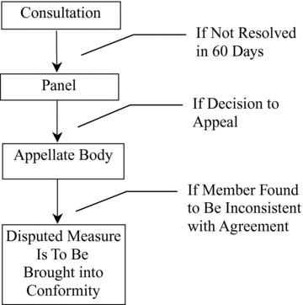have a blurry view of the CTE. They fear the possibility of further protection against their exports in the form of “green protection” and often view environmental matters as having no place in the WTO.

Many trade economists support the developing-country view that environmental issues represent an “intrusion” into WTO trade agenda. They do, however, support the use of multilateral environmental agreements and perhaps even a World Environmental Organisation.

In 1999, the WTO formally took up the “trade and environment issue” and argued that increased trade can have both positive and negative impacts on the environment. It also emphasised that trade-driven growth cannot always be counted upon to deliver improvements in environmental quality through increased incomes. Consequently, these higher incomes must be “translated into higher environmental quality” through mechanism of international cooperation. The WTO also emphasised that government subsidies to polluting and resource-depleting sectors can exacerbate the environmental consequences of trade.

THE DOHA ROUND

The Doha Round was launched in Doha, Qatar, in 2001, and progress has been very uneven, with a noted failure at the 2003 Cancun Ministerial Meeting. July 2004, October 2005 and July 2008 negotiations made some progress on contentious agricultural issues, but a “final countdown” to conclude the Round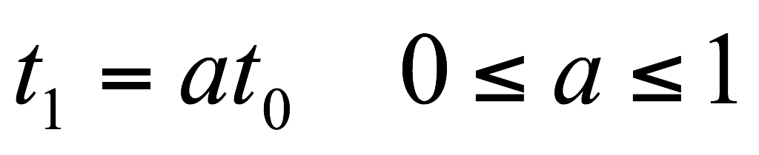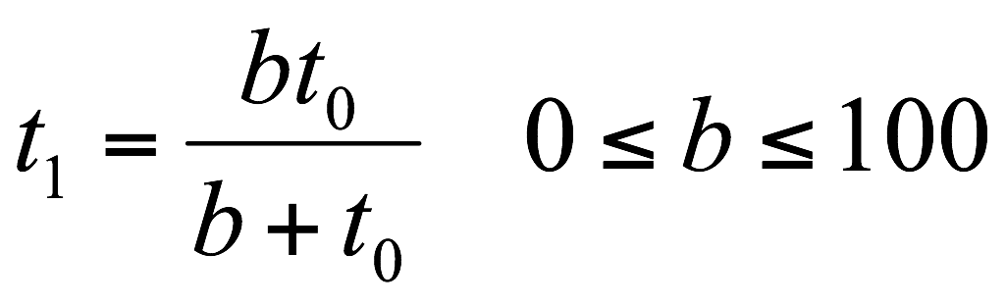 by the end of 2011 was missed. Significant issues remain in agriculture and in “non-agricultural market access” (NAMA).

TARIFF FORMULAS

Tariff formulas can be used to determine tariff reductions in rounds of trade negotiations. The proportional formula is:

The Swiss formula, on the other hand, is:

Chapter 8

Preference Trade Agreements (PTA’s) and their Effects on Welfare

INTRODUCTION

The analytical elements of PTA’s are:

1. Countries
2. Sectors
3. Tasks

The term multilateralism refers to the GATT/WTO system and the trade negotiations that take place within in one of the founding principles of this system is non-discrimination. This involves the most favoured nation (MFN) and national treatment (NT) sub-principles.

“Regionalism” refers to a violation of the nondiscrimination principle in which one member of a regional trade agreement (RTA) discriminates in its trade policies in favour of another member of the RTA and against nonmembers. “Regionalism” has been allowed by the GATT/WTO under certain circumstances:

* Free trade areas (FTA’s)
* Customs unions (CU’s)
* Interim agreements leading to an FTA or CU “within a reasonable length of time”

There are different types of PTA’s: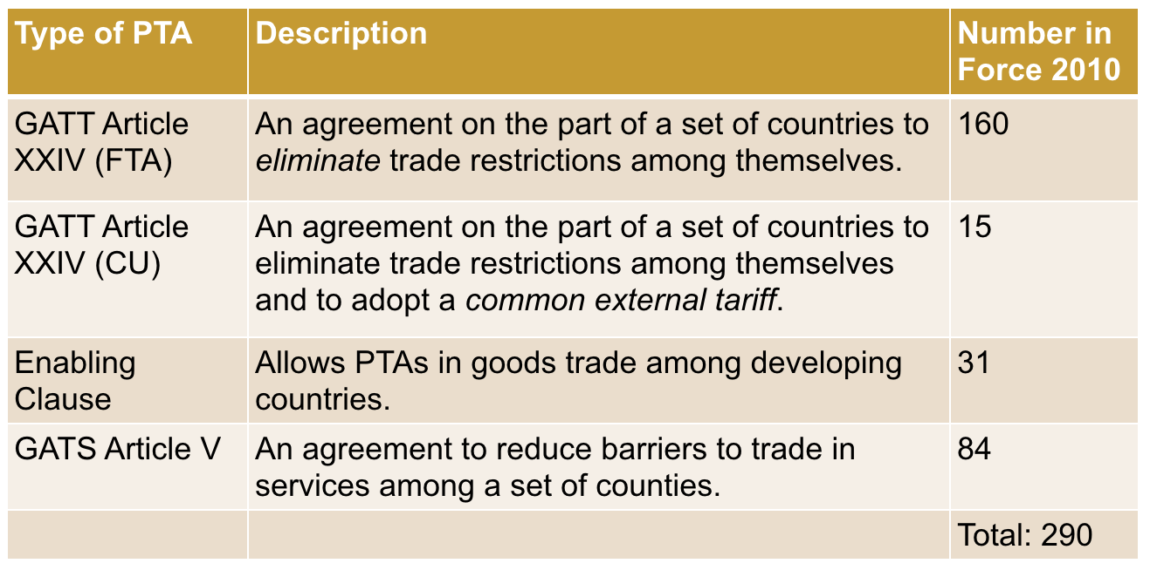

There are several steps to Regional Integration: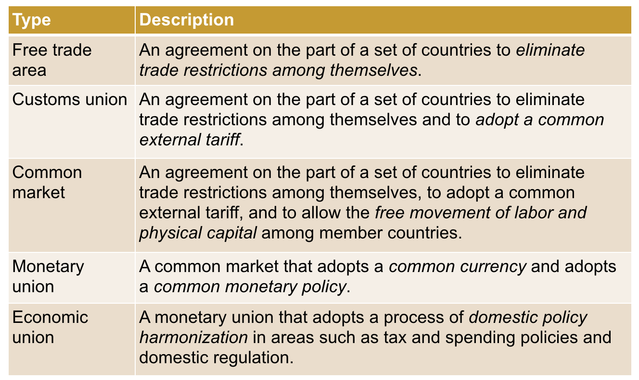

THE WTO AND PTA’s

WTO members who wish to form FTA’s or CU’s may do so. However, there are certain requirements:

1. Trade barriers against non-members cannot be “higher or more restrictive than” those in existence prior to the FTA or CU
2. FTA or CU must be formed “within a reasonable length of time”
3. FTA or CU must eliminate trade barriers on “substantially all the trade” among the members
4. With regard to services, the General Agreement on Trade in Services (GATS) requires that the FTA or CU involve “substantial sectoral coverage”

The WTO has a Committee on Regional Trade Agreements (CRTA). Despite the institutional structure present in the WTO to govern PTA’s, there has never been any serious evaluation or enforcement. Most PTA’s are of dubious WTO consistency. A “cooperative equilibrium” exists where no WTO member contests another’s PTA.

RULES OF ORIGIN

In FTA’s (but not CU’s), a product can be imported into a low-tariff member and then resold in a high-tariff member. This is known as tariff rate arbitrage. Rules of origin (ROOs) protect against this via:

* Domestic content
* Change in tariff heading
* Specific processes
* Substantial transformation

ECONOMIC EFFECTS OF PTA’s

Trade creation occurs when the formation of a FTA or CU leads to a switching of imports from a high-cost source to a low-cost source and tends to improve welfare. Trade diversion, on the other hand, occurs when imports switch from a low-cost source to a high-cost source, and tends to worsen welfare.

TRADE CREATION AND TRADE DIVERSION

Trade creation and trade diversion using the absolute advantage model. Along with Brazil (B) and Argentina (A), we are also going to refer to a third country, El Salvador (S). Brazil and Argentina are members of a PTA, whereas El Salvador is not.

A Trade-Creating PTA looks like this:

Before the PTA, Brazil has in place a specific (per unit) tariff on imports from both Argentina and El Salvador Argentina is the lower-cost producer in comparison to El Salvador, and therefore Brazil imports good from Argentina. Once Brazil joins either a PTA with Argentina, tariff is removed on imports from Argentina.

Goods continue to be imported from Argentina and imports increase because price has fallen due to removal of tariff. Consumer surplus in Brazil increases while producer surplus and government tariff revenue falls. There is a net increase in welfare due to trade creation.

A Trade-Diverting PTA looks like this:

Before the PTA, Brazil had a specific (per unit) tariff on imports in place from both Argentina and El Salvador. El Salvador is the lower-cost producer in comparison to Argentina. Brazil imports the good from El Salvador.

Once Brazil joins a PTA with Argentina, however, Brazil switches to Argentina as an import supplier. Imports expand as the domestic price falls. Consumer surplus in Brazil increases while producer surplus and government revenue fall. Whether net welfare effect is positive or negative is ambiguous.

To summarise: PTA’s can be either welfare-improving or welfare-worsening. Whether an PTA is welfare-improving or welfare-worsening is something that must be assessed on a case-by-case basis, based on evidence on the relative strengths of trade creation and trade diversion.

ECONOMIC ASSESSMENT OF THE EU

Some studies have suggested that trade creation has dominated trade diversion in the EU. Other studies have drawn attention to the role of non-tariff measures, subsidies (especially to agriculture), and trade diversion in the expanding network of PTAs between the EU and other countries.

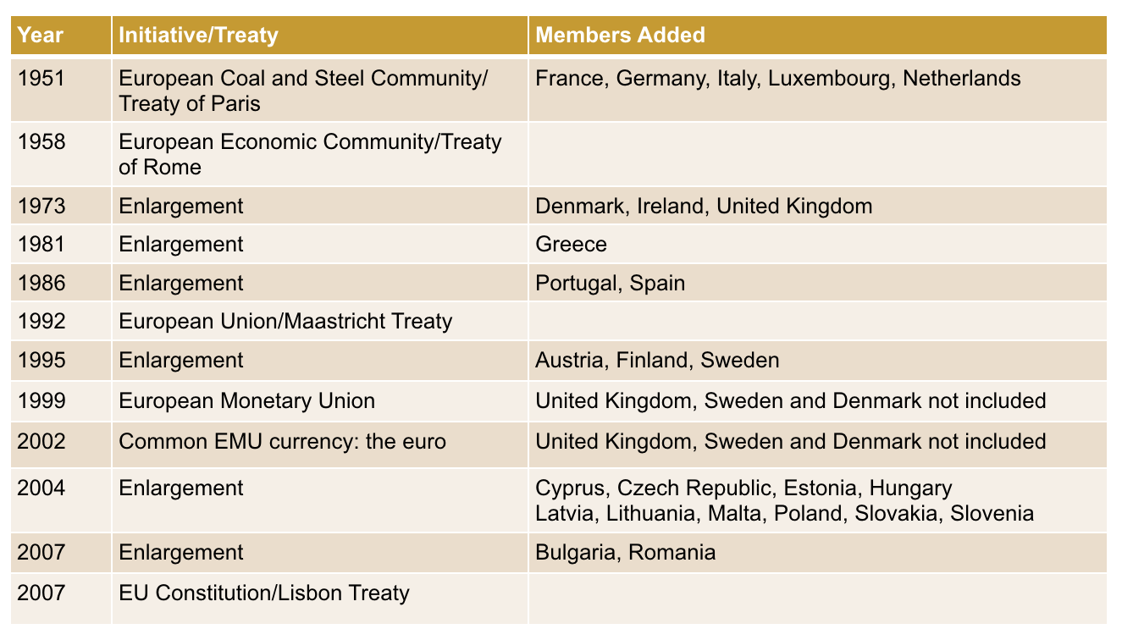

NORTH AMERICAN FREE TRADE AGREEMENT

In January 1994 an FTA between Canada, Mexico and the United States took place (NAFTA). This agreement addressed:

* Trade in goods
* Financial services
* Transportation
* Telecommunications
* Foreign direct investment
* Intellectual property rights
* Government procurement
* Dispute settlement

However, there are some issues with NAFTA. Trade and wages are not as important as often alleged. In fact, **NAFTA** has also contributed to rising income inequality, suppressed real wages for production workers, weakened workers' collective bargaining powers and ability to organise unions, and reduced fringe benefits. What is more, NAFTA Roles of Origin (ROO’s) can be very complex. Migration is also still a continued political issue.

MERCOSUR

Mercosur is a PTA among Argentina, Brazil, Paraguay, and Uruguay that was launched in 1991 with the Treaty of Asunciòn. Mercosur later took on Chile and Bolivia as associate members in 1996 and 1997, respectively. Peru, Colombia and Ecuador became associate members in 2003-2004, and Venezuela signed a partnership agreement in 2006.

Mercosur is not actually a common market, but a CU. Free movement of labor and physical capital is a long way off from being achieved.

FREE TRADE AREA OF THE AMERICAS

In 1994, governments of 34 countries in Western Hemisphere agreed to pursue a Free Trade Area of the Americas. Negotiations were launched at the Second Summit of the Americas in 1998 in nine negotiating groups:

1. Market Access
2. Investment
3. Services
4. Government Procurement
5. Dispute Settlement
6. Agriculture
7. Intellectual Property Rights
8. Subsidies, Antidumping, and Countervailing Duties
9. Competition Policy

The 2004 Summit of the Americas was stymied by a number of issues (such as agriculture and anti-dumping). The 2005 Summit of the Americas ended negotiations on the FTAA, as Venezuela and Argentina blocked progress in opposition to US-backed neoliberalism.

ASSOCIATION FOR SOUTHEAST ASIAN NATIONS (ASEAN) AND THE ASEAN FREE TRADE AREA (AFTA)

The Association for Southeast Asian Nations (ASEAN) includes Brunei, Cambodia, Indonesia, the Lao People’s Democratic Republic, Malaysia, Myanmar, the Philippines, Singapore, Thailand and Vietnam. Beginning in 1992, members began to form the ASEAN FTA or AFTA, which now includes all 10 members. ASEAN is linking its AFTA to other countries in the region through a number of initiatives.

REGIONALISM VS MULTILATERALISM

These two terms represent two alternative trade policy options available to the countries of the world. The 1950’s and 1960’s saw “first wave” of PTA’s in developing world, while the 1980’s saw beginning of “second wave” of PTA’s.

What role will this second wave of PTA’s play vis-à-vis the multilateral efforts toward trade liberalisation pursued under the GATT-WTO framework? Will the second wave of PTAs complement the multilateral framework or will it work at cross-purposes to this framework?

Opponents argue that PTA’s are discriminatory by nature. They draw attention to the “spaghetti-bowl” nature of second-wave and current PTA’s. With the overlapping nature of most PTAs, most WTO members hold simultaneous membership in many PTA’s at once. The negotiating energies put into PTAs will detract from those put into multilateral agreements under the auspices of the WTO.

APPENDIX: RULES OF THUMB FOR EVALUATING PTA’S

1. Countries excluded from a PTA almost always lose
2. Market access is a key determinant of the net benefits of a PTA
3. Lowering external tariffs against non-members of a PTA improves their desirability from a welfare standpoint
4. Multilateral trade liberalisation results in significantly larger gains to the world than a network of PTA’s

For some countries, “additive PTA’s” can be more beneficial than unilateral trade liberalisation due to the market access gains involved in the former. For developing countries “North-South” PTA’s can offer beneficial increases in competition in their home markets.

Chapter 17

The International Monetary Fund

INTRODUCTION

The analytical elements of the International Monetary Fund are:

1. Countries
2. Currencies
3. Financial assets

THE YEAR 1941

While working for the British Treasury, John Maynard Keynes began to write a proposal for an International Clearing Union (ICU) called the Keynes Plan, and, while working for the United States Treasury, Harry Dexter White wrote a proposal for an International Stabilisation Fund (ISF) called the White Plan.

These plans were taken up at the Bretton Woods Conference of July 1944 and became the International Monetary Fund (IMF).

MONETARY HISTORY

Throughout the 20th century, countries struggled with various arrangements for the conduct of international finance. None proved satisfactory, and in each case, the systems set up by international economists were overtaken by various events. The international financial system had a dynamic of its own that were stronger than the governance systems it overturned.

THE GOLD STANDARD

The late 19th and early 20th centuries were characterised by a highly integrated world economy supported (from 1870 to 1914) by an international financial arrangement known as the gold standard: each country defined the value of its currency in terms of gold, as most countries also held gold as official reserves. Since the value of each type of currency was defined in terms of gold, rates of exchange among the currencies were fixed.

When WWI began in 1914, the countries involved suspended the convertibility of their currencies into gold. After the war, there were unsuccessful attempts to return the international financial system back to the gold standard.

THE GOLD EXCHANGE STANDARD

In 1922, there was an attempt to rebuild the pre-World War I gold standard. The new gold standard was different from the pre-war standard due to the current gold shortage. Countries that were not important financial centres did not hold gold reserves but instead held gold-convertible currencies. For this reason, the new gold standard was known as the gold-exchange standard. The goal was to set major rates at their pre-war levels, especially the British pound. In 1925, it was set to gold at the overvalued, pre-war rate of $4.86 per pound. This caused problems with the balance of payments and market expectations of devaluation.

At a system-wide level, each major rate was set to gold, ignoring the implied rates among the various currencies. Gold-exchange standard consisted of a set of centre countries tied to gold and a set of periphery countries holding these centre-country currencies as reserves. By 1930, nearly all the countries of the world had joined. However, the system’s design contain a significant incentive problem for peripheral nations.

Suppose a periphery country expected that the currency it held as reserves was going to be devalued against gold. Would it be in the interest of country to sell its reserves before devaluation took place so as to preserve value of its total reserves? Would this put even greater pressure on centre currency? Since the British pound was set at an overvalued rate, there was a run on the pound in 1931. This forced Britain to cut pound’s tie to gold, leading to many other countries following suit. By 1937, no countries remained on gold-exchange standard.

The overall standard was not a success, and some international economists (such as Eichengreen) even saw it as a major stepping stone towards the Great Depression. Throughout the 1930’s, a system of separate currency areas evolved with a combination of both fixed and floating rates. The lack of international financial coordination helped contribute to the economic crisis of the decade, and at the worst of times, countries engaged in a game of competitive devaluation.

THE BRETTON WOODS SYSTEM

During World War II, the United States and Britain began to plan for the post-war economic system. White and Keynes understood the contribution of previous breakdown in international economic system to war. They hoped to avoid same mistake made after World War I. But at the same time, they fought for relative positions of countries they represented. White largely succeeded in getting his way during the 1944 Bretton Woods Conference, which produced a plan that became known as the Bretton Woods system.

The essence of the system was an adjustable gold peg; the US dollar was to be pegged to gold at $35 per ounce, and other countries of the world were to peg to the US dollar or directly to gold. This placed the dollar at the centre of the new international financial system.

These currency pegs were to remain fixed except under conditions that were termed “fundamental disequilibrium”. This concept, however, was never truly defined. Countries were to make their currencies convertible to US dollars as soon as possible. This process, however, did not happen quickly.

The problems related to the system became apparent by the end of the 1940’s, such as the growing non-official balance of payments deficits of United States (these deficits reflected official reserve transactions in support of expanding global dollar reserves).

TRIFFIN DILEMMA

The Belgian monetary economist Robert Triffen described problem of expanding dollar reserves in his 1960 book, “Gold and the Dollar Crisis”. This problem became known as the Triffin dilemma, and referred to the contradiction between requirements of international liquidity and international confidence (“liquidity” refers to the ability to transform assets into currencies). International liquidity required a continual increase in holdings of dollars as reserve assets. As dollar holdings of central banks expanded relative to US official holdings of gold, however, international confidence would suffer. The United States could not back up an ever-expanding supply of dollars with a relatively constant amount of gold holdings.

The Triffin Dilemma can be illustrated as:

In October 1960, London’s gold market price rose above $35 to $40 an ounce. This called for a change in the gold-dollar parity, and in January 1961, the Kennedy Administration pledged to maintain $35 per ounce convertibility. The US joined (along with other European countries) and set up a gold pool in which their central banks would buy and sell gold to support the $35 price in London market.

In 1964 at the annual IMF meeting in Tokyo, representatives began to talk publicly about potential reforms in international financial system. Attention was given to the creation of reserve assets alternative to US dollar and gold. In 1965, the United States Treasury announced that it was ready to join in international discussions on potential reforms. The Johnson Administration was more flexible than the Kennedy Administration.

The British 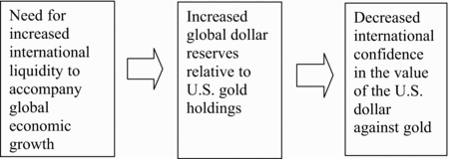pound was devalued in November of 1967. President Johnson issued a statement recommitting the United States to $35 per ounce gold price. However, in the early months of 1968, the rush out of dollars began. In early 1971, capital began to flow out of dollar assets and into German mark assets. Thereafter, capital flowed from dollar assets to yen assets. US President Nixon accepted US Treasury Secretary John Connally’s recommendation to close its “gold window”.

THE NON-SYSTEM

At a Smithsonian conference in 1971, several countries revalued their currencies against dollar; the gold price was raised to $38 per ounce.

In June 1972, a large flow out of US dollars into European currencies and Japanese yen occurred. Flows stabilised, but a new crisis reappeared in January 1973. On February 12th, the US announced a second devaluation of the dollar against gold to $42. The international financial system had crossed a threshold, although this was not fully appreciated at the time.

In 1974 and 1975, countries went through nearly continuous consultation and disagreement in a process of accommodating their thinking to floating rates. In November 1975, proposed amendment to IMF’s Articles of Agreement restricted allowable exchange rate arrangements to:

1. Currencies fixed to anything other than gold
2. Cooperative arrangements to managed values among countries
3. Floating

THE OPERATION OF THE IMF

The IMF is an international financial organisation comprised of 187 member countries. Its purposes, as stipulated in its Articles of Agreement, are to:

1. Promote international monetary cooperation
2. Facilitate the expansion of international trade
3. Promote exchange stability and a multilateral system of 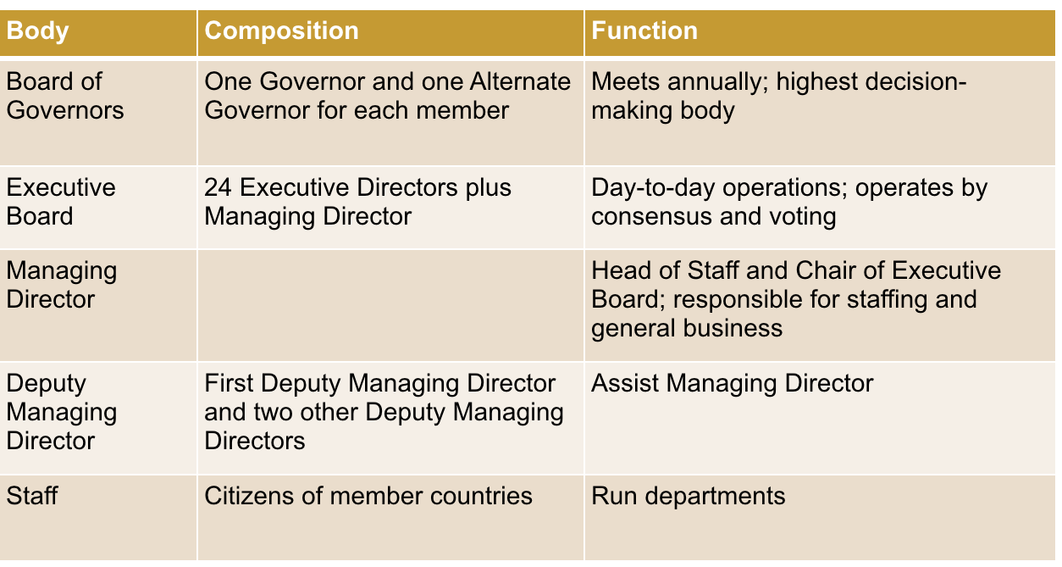payments
4. Make temporary financial resources available to members under “adequate safeguards”
5. Reduce the duration and degree of international payments imbalances

THE ADMINISTRATIVE STRUCTURE OF THE IMF

IMF QUOTA SYSTEM

The IMF can be thought of as a global credit union in which countries’ shares are determined by their quotas. Quotas determine both the amount members can borrow from the IMF and their voting power within the IMF. 1/4 of a member’s quota is held in a reserve currency. 3/4 of the quota is held in a members own currency.

Here are the IMF’s quotes, as of 2008, are:

IMF LENDING

IMF lending takes place through a complex process involving three stages:

1. Reserve tranche: 25 percent of quota

Since the reserve tranche is considered to be part of a member’s foreign reserves, it is automatic and free of policy conditions.

1. Credit tranche

Each credit tranche is in terms of 25 percent of a member’s quota. With regard to lower credit tranches, the first 25% o quote is above reserve tranche, while in upper credit tranches, the subsequent 25% of quote increments. Thus is obtained through Stand-By Arrangements (SBA’s) and conditions set out in letter of intent. The higher the 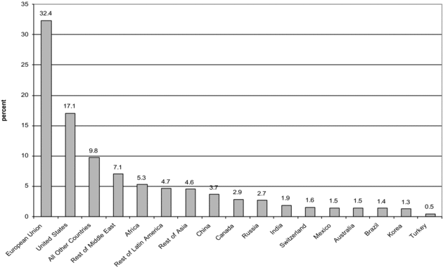credit tranche, the more conditions placed on the borrowing member.

1. Special or extended facilities

The credit and special or extended facilities are not automatic and involve policy conditions. In special non-concessional lending, the IMF charges a purchase-repurchase standard:

* Extended fund facility (EFF)
* Flexible Credit Line (FCL)
* Emergency assistance

With special concessional lending, on the other hand, the IMF charges below the standard rate:

* Extended Credit Facility (ECF)
* Standby Credit Facility (SCF)
* Rapid Credit Facility (RCF)

PURCHASE-REPURCHASE ARRANGEMENTS

IMF lending above the reserve tranche can be conceived of as a purchase-repurchase arrangement, as we can see in the figure below. When the IMF lends to a member, that member purchases foreign reserves using its own domestic currency. The member then repays the IMF by repurchasing its domestic currency reserves with foreign reserves.

SOURCES OF IMF FUNDS

IMF funds mostly derive from:

1. Members’ quotes
2. Selling gold holdings
3. Multilateral borrowing arrangements (the General Arrangements to Borrow, GAB, and the New Arrangements to Borrow, NAB)

As of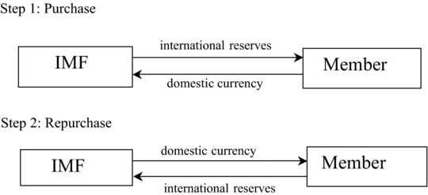 2009, the total resources available to the IMF were increased to $750 billion. Ongoing discussions are considering raising this to $1 trillion.

HISTORY OF IMF OPERATIONS (1950’S)

In its initial years, the IMF was nearly irrelevant. However, the Suez crisis of 1956 forced Britain to draw on its reserve and first credit tranches. Japan drew on its reserve tranche in 1957. From 1956 through 1958, the IMF was involved in policies that lead to the convertibility of both British pound and French frank. The IMF then began to sign a number of SGA with a growing number of countries, including developing countries.

HISTORY OF IMF OPERATIONS (1960’S)

Reflecting the Triffin dilemma, the IMF became concerned about the United States’ ability to defend the dollar and other major industrialised countries’ abilities to maintain their parities. This lead the IMF to introduce the General Arrangements to Borrow (GAB) in 1962. The GAB involved the central banks of ten countries, setting aside a $6 billion pool to maintain the stability of the Bretton Woods system.

Over time, the Group of 11 (including Switzerland) expanded the GAB. The GAB and NAB are currently funded to $750 billion.

By 1965, the US faced two unappealing options:

1. Reduce world supply of dollars to enhance international confidence by reducing international liquidity
2. Expand world supply of dollars to enhance international liquidity by reducing international confidence

But where would the world turn for a reserve asset? In 1969, the IMF introduced the special drawing right (SDR) as a new reserve asset. This was initially defined in value in terms of gold, it is now defined as a basket of: the US dollar, the British pound, the yen, and the euro.

THE OIL SHOCKS OF THE 1970’S

The oil price increases of 1973-1974 caused substantial balance of payments difficulties for many countries of the world. In 1974 and 1975, the IMF established special oil facilities to assist these countries and acted as an intermediary, borrowing the funds from oil-producing countries and lending them to oil-importing countries.

Despite these facilities, most of the oil producing country revenues were “recycled” to other countries via the commercial banking system.

DEBT CRISIS

In 1976, IMF began to sound warnings about sustainability of developing-country borrowing from commercial banking system. The banking system reacted with hostility to these warnings, arguing that the IMF had no place interfering with private transactions. The 1980’s began with a significant increase in real interest rates and a significant decline in non-oil commodity prices. An increased cost of borrowing and reduced export revenues followed as a consequence.

In 1982, IMF calculated that US banking system outstanding loans to Latin America represented approximately 100% of total bank capital. In August 1982 Mexico announced it would stop servicing its foreign currency debt. At the end of the month, the Mexican government nationalised its banking system.

The year 1982 also saw the beginnings of a debt crisis in Argentina and Brazil, and the IMF introduced a number of SBAs and special facilities to address what became a global debt crisis.

Starting in the 1990’s, private, non-bank capital began to flow to developing countries in the form of both direct and portfolio investment. The number of highly-indebted countries began to show increasing unpaid IMF obligations, and in November 1992, a Third Amendment to the Articles of Agreement allowed for suspension of voting rights in the face of large, unpaid obligations. Mexico underwent a second crisis in late 1994 and early 1995, and the IMF responded in cooperation with the US Treasury.

ASIAN CRISIS

In 1997-1998, crises struck a number of Asian countries — most notably Thailand, Indonesia, South Korea, and Malaysia. This resulted in sharp depreciations of the currencies.

In the cases of Thailand, Indonesia and South Korea, the IMF played substantial and controversial roles in addressing the crises. Loan packages were designed with accompanying conditionality agreements. Questions were raised about the appropriateness of the packages and the IMF’s advocacy of liberalising capital accounts.

RUSSIAN CRISIS

The Russian economy was hit by a crisis in 1998. IMF support of the Russian transition had begun in the early 1990’s. The IMF arranged a very large loan to Russia in 1995, and this proved to be insufficient, as a full-fledged banking and currency crisis occurred in 1998. This required the IMF to draw on the GAB for the first time since 1978. The IMF’s role here was severely criticised.

BRAZIL AND ARGENTINA

In 1998, the IMF tried to support the Brazilian currency to attempt to insulate it from the Asian and Russian crises. The IMF failed, however, and Brazil was forced to devalue in 1999. The IMF had also been involved for some years in supporting a currency board in Argentina. This came spectacularly undone in 2001 and left the IMF open to criticism for not having mapped out an exit strategy for the country.

RECENT CHANGES

The early 2000’s found the IMF sinking into irrelevancy. Between 2001 and 2008, the number of new arrangements declined precipitously. This reflected booming private capital markets and the accumulation of large foreign reserve balances in many Asian countries. Because the IMF’s operating budget depends on its loan charges, this proved to be difficult.

The figure below depicts the new arrangements approved from 1990 to 2009:

The IMF was unprepared for the global financial crisis that began in 2007. The IMF’s 2007 World Economic Outlook stated:

“Notwithstanding the recent bout of financial volatility, the world economy still looks well set for robust growth in 2007 and 2008.”

The crisis, however, put the IMF back into business with agreements increasing substantially in 2009, many to European countries. 2008 was also a year when the quotas rep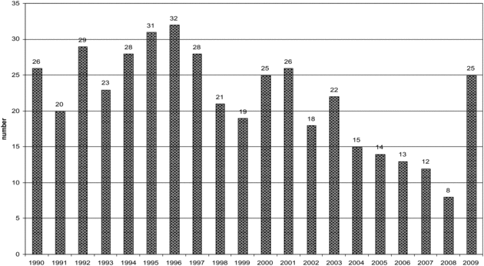orted in the figure above were established.

POLITICAL ECONOMY OF IMF LENDING

The analysis of the political economy of IMF lending takes place in terms of two variables:

1. The value of loans (L)
2. The number and strengths of conditions (C)

These are depicted in the figure below in terms of a “hard bargaining” line and an “easy bargaining” line. IMF member country governments weigh the (marginal) benefits and costs of approaching the IMF for a loan, and sovereignty costs are part of these calculations.

Newer thinking and research suggests that, in some cases, country governments might prefer points along line B in this figure to points along line A. This would be to push reforms through in the face of domestic political opposition.

Here, the blame is shifted to the IMF. Tis research also suggests that country government failures to abide by conditionality agreements can simply be the result of a change in the benefit-cost calculations of member country governments.

AN ASSESSMENT

The IMF was originally designed to support the Bretton Woods system, a system the no longer e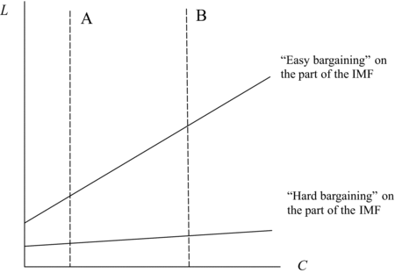xists. It is now operating in an era of unforeseen capital mobility and has an uneven record of success. International financial arrangements are often evaluated in terms of their contributions to liquidity and adjustment; the IMF has never had the resources necessary to contribute substantially to global liquidity. By only penalising debtor members (no matter what the source of the adjustment problem) and not creditor members, it has also been limited in its ability to facilitate adjustment.

OPTIONS FOR REFORM

The options for radical reform of the IMF fall into two categories:

1. Reconstitution would also be possible in the form of a global central bank that reaffirms the SDR as a reserve asset, giving the IMF responsibility for regulating global liquidity.
2. Spreading adjustment requirements over both debtor and creditor members.

Chapter 18

GDP

Gross Domestic Product (GDP) is the market value of all final goods and services produced within a country in a given period of time (usually a year or 3 months). All goods are measured in the same unit (e.g.: dollars in the U.S.), and things that don’t have a market value are excluded.

What are final goods? Final goods are intended for the end user, and intermediate goods are used as components for ingredients in the production of other goods. GDP only includes final goods – they already embody the value of the intermediate goods   
used in their production. GDP includes tangible goods (like DVDs, mountain bikes, beer) and intangible services (dry cleaning, concerts, cell phone service). GDP also includes currently produced goods, not goods produced in the past. GDP measures the value of production that occurs within a country’s borders, whether done by its own citizens or by foreigners located there.

GDP is total spending and is made up of Consumption (C), Investment (I), Government Purchases (G), and Net Exports (NX):

Y = C + I + G + NX

Consumption is total spending by households on goods and services. For renters, consumption includes rent payments, while for homeowners, consumption includes the imputed rental value of the house, but not the purchase price or mortgage payments.

Investment is total spending on goods that will be used in the future to produce more goods. It includes spending on capital equipment, structures, and inventories.

Government Purchases are all spending on the goods and services purchased by the government at the federal, state, and local levels. It includes transfer payments, such as Social Security or unemployment insurance benefits. They are not purchases of goods and services.

Net exports represent foreign spending on the economy’s goods and services. Imports are the portions of C, I, and G that are spent on goods and services produces abroad.

NX = exports - imports

Chapter 19

Balance of Payments

In economics, a basic principle is that “things add up”; open-economy macroeconomic accounts and balance of payment accounts provide us with powerful tools to analyse aspects of open economies in their interactions with the world economy.

This is an example of an open economy with government, savings, and investment:

In Open-Economy Accounts:

CAPITAL ACCOUNT

* I = (SH + SG) + SF
* I - (SH + SG) = SF

REST OF THE WORLD ACCOUNT

* E + SF 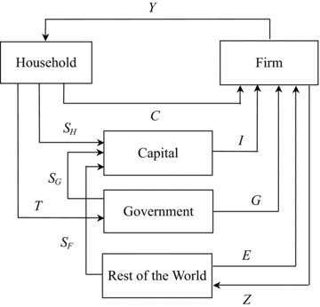= Z
* SF = Z - E

FUNDAMENTAL ACCOUNTING EQUATIONS

* I - (SH + SG) = SF = Z - E
* (SH + SG) - I = -SF = E - Z

Domestic savings, domestic investment, foreign savings, and the trade balance can be expressed as: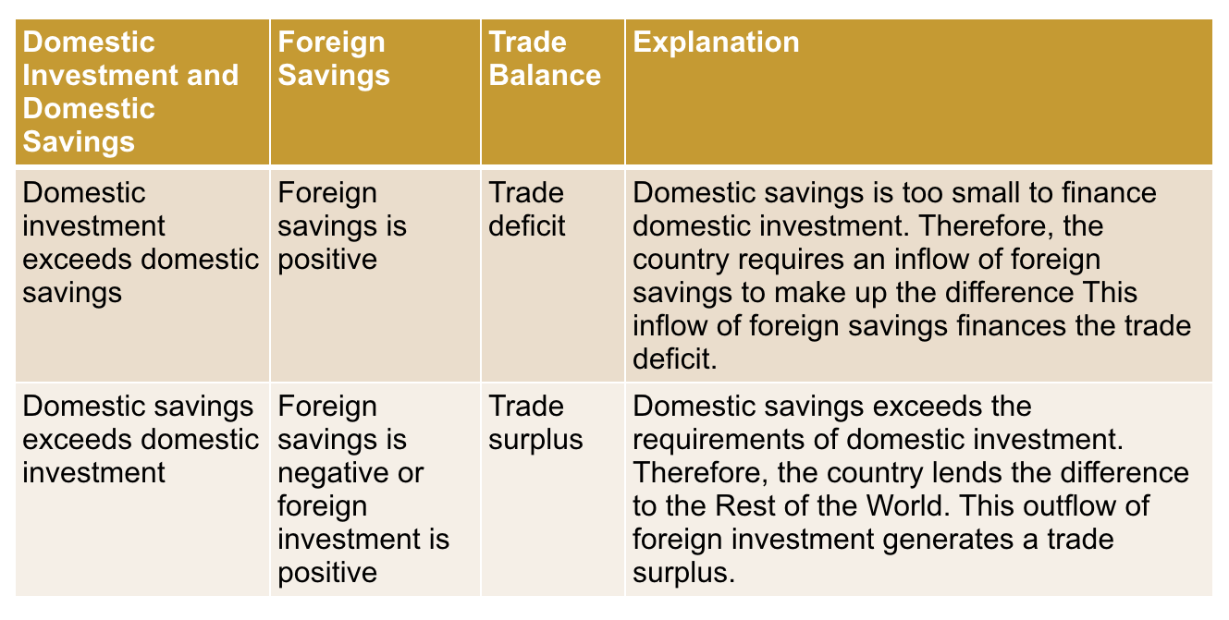

FUNDAMENTAL ACCOUNTING EQUATION INTUITION

* Trade deficit

Domestic investment actually exceeds domestic savings, creating a trade deficit. A trade deficit means that the Mexican economy is importing more goods and services in value terms than it is exporting. Therefore, Mexico must sell something else other than goods and services to the rest of the world to make up the difference. This “something else” turns out to be assets: government and corporate bonds, corporate equities, and even real estate. The purchase of Mexican assets by the Rest of the World is the very thing that generates the inflow of foreign savings into Mexico.

* Trade surplus

Domestic savings exceed domestic investment, creating a trade surplus. A trade surplus means that the Mexican economy is exporting more goods and services in value terms than it is importing. Therefore, Mexico must buy something else other than goods and services from the rest of the world to make up the difference. That “something else” again is assets. The purchase of foreign assets by Mexico generates the outflow of foreign investment to the Rest of the World.

BALANCE OF PAYMENT ACCOUNTS

The *balance of payments* accounts of any country focus exclusively on the relationship of the country with the Rest of the World. It is composed of five parts:

1. CURRENT ACCOUNT
2. CAPITAL/FINANCIAL ACCOUNT
3. OFFICIAL RESERVE TRANSACTIONS
4. ERRORS AND OMISSIONS
5. OVERALL BALANCE

The overall balance (point 5) must be zero, as things add up:

Current Account + Capital/Financial Account + Official Reserves Transactions + Errors and Omissions = 0

For ease of analysis, we remove the errors and omissions major balance:

Current Account + Capital/Financial Account + Official Reserves Transactions = 0

If two of the items in this equation have the same sign (positive or negative), then the third must have the opposite sign (negative or positive):

Current Account + Capital/Financial Account + Official Reserves Transactions = 0

If the current and capital/financial accounts are both positive (negative), then official reserve transactions must be negative (positive).

If the current and official reserve transaction accounts are both positive (negative), then the capital/financial account must by negative (positive).

If the capital/financial and official reserve transaction accounts are both positive (negative), then the current account must be negative (positive).

GLOBAL IMBALANCES

A basic proposition in international economics is that capital will flow from developed to developing economies:

1. Developed economies will therefore have capital/financial account deficits/outflows
2. Developing economies with therefore have capital/financial account surpluses/inflows

This, however, is not the current pattern in the world economy.

Chapter 20

Migration

Beath, Goldin and Reinert (2009) distinguished among nine different types of international migration:

1. PERMANENT HIGH-SKILLED MIGRATION

Involves permanent residence and is sometimes granted to high-skilled migrants often at the urging of hiring corporations such as the multinational enterprises (MNEs).

1. TEMPORARY HIGH-SKILLED MIGRATION

Similar in motivation to permanent high-skilled migration but can be more politically palatable in some cases where there is political resistance to granting permanent residence.

1. TEMPORARY LOW-SKILLED MIGRATION

Includes migrant workers in the areas of manual labor, construction, domestic service and nursing.

1. FAMILY MIGRATION

A large flow that allows permanent residence to the families of those who have already gained this residence.

1. COETHNIC AND NATIONAL PRIORITY MIGRATION

Involves granting permanent residence based on ethnic background, religious affiliation and national origin.

1. ASYLUM SEEKERS

Granted certain rights by the 1951 Geneva Convention addressing persons with well-founded fears of persecution.

1. REFUGEES

Those who flee to neighbouring countries to escape war, famine or environmental catastrophes.

1. UNDOCUMENTED MIGRATION

A large category that involves both voluntary and non-voluntary (trafficked) illegal migrants.

1. VISA-FREE MIGRATION

Exists in some common markets (e.g., the EU) that involve the free movement of both labor and capital.

However, the most important ones are high-skilled and low-skilled migration.

MIGRATION FACTORS

1. RELATIVE WAGES

The larger the relative wage, the more Moroccans would like to emigrate to the EU, a movement up the emigration supply curve.

1. YOUTH POPULATION GROWTH

Youth population grown in Morocco will increase the number of risk-taking individuals who are considering emigrating to the EU.

1. FINANCIAL RESOURCES

Given the direct and opportunity costs of migration, as GDP per capita rises, the supply curve shifts to the right.

1. EDUCATION LEVELS

Increasing education levels increases the information and aspiration of Moroccans to migrate, shifting the supply curve to the right.

1. MIGRATION NETWORKS

Networks of migrants in the EU are conduits of information back to potential migrants in Morocco.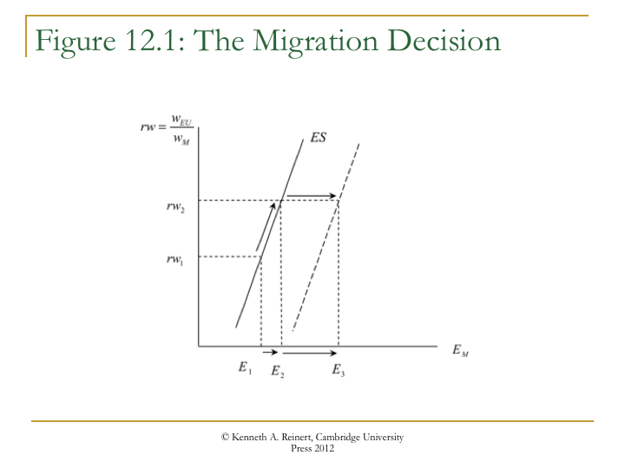

THE EMIGRATION SUPPLY CURVE

Historical evidence suggests that shifts of the EScurve in the figure above can be more significant than movements along the curve. Additionally, the four shift factors can work together as origin countries develop. The approximate correlation of all four shift factors in time can lead to a phenomenon known as the migration hump shown below:

The migration hump indicates that:

* Barring political or ecological impetus, most international migration is from middle-income countries
* The migration flows that occur near the peak of the migration hump can persist for some time

HIGH-SKILLED MIGRATION

Data on high-skilled migration (HSM) are both scarce and unreliable, but nevertheless some patterns are discernible. HSM has been on an upward trend for some time now, and this appears to be related to skills-biased technological change in high-income destination countries that is related to the information and communication technology (ICT). The types 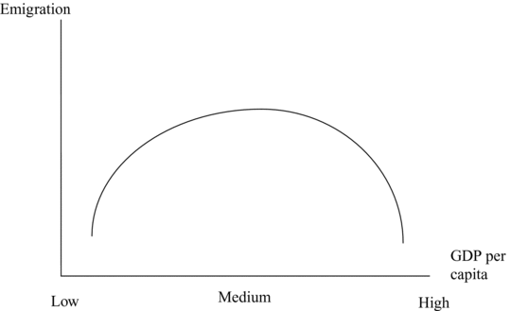of firms who hire HSM tend to be larger firms that are more internationalised via foreign ownership and exports.

Firms active in HSM face volatile policy regimes in terms of visa requirements and quotas. HSM can contribute to what is known as brain drain, which is the loss of human capital in low-income source countries due to the migration of citizens to foreign destination countries. This is of particular concern in the health sector.

More positively, return migration back to home countries has begun, and these new flows can transfer technology and entrepreneurial skills back to the origin countries.

It is possible that the phenomenon of brain drain can evolve into brain circulation, in which expatriates from developing countries return either temporarily or permanently to contribute to what might be called intellectual remittances. These return migrants can even have a subsequent, positive effect on inflows of FDI. The return migration and subsequent enterprise development act as a signal to foreign MNEs that conditions are ripe for FDI by enhancing the location advantages.

LOW-SKILLED MIGRATION

There is a supply and a demand side to this argument. With regards to the demand side, a number of key destination countries are experiencing a “birth dearth” 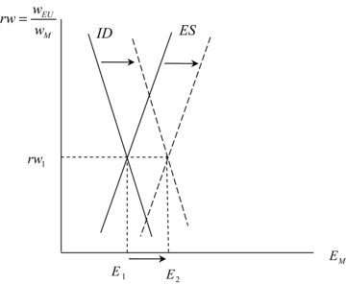or a decline in populations due to low fertility rates. The persistence of low-skilled, non-tradable services in destination countries.

These two demand-side factors cause the demand curve for LSM to shift to the right. This graph is drawn, the relative unskilled wage remains the same, but it could either increase or decrease.

LSM is much more likely than HSM to also fall into the categories of refugees and undocumented migration. The illegal nature of much LSM makes it politically volatile but also economically attractive to firms hiring them since the workers have no bargaining power. Illegality also makes the migrants open to exploitation and abuse.

REMITTANCES

Remittances are flows of money from emigrants to their countries of origin, and remittance flows have increased dramatically since the mid-1990s in middle-income countries. Remittances can have significant and positive impacts in developing countries by directly transferring income more efficiently than foreign aid.

MIGRATION POLICY

Unlike in the realms of international trade (the World Trade Organisation), international finance (the International Monetary Fund), and international development (the World Bank), there is no multilateral organisation for migration policy.

In most cases, the policy locus of international migration policy is the nation state based on the principle of sovereignty.

In contrast to the “pro-market” orientations of policy regimes in trade, finance and development policy, intervention and coercion are the order of the day in migration policy.

Some observers have suggested that such a multilateral organisation would be a good idea. Others have emphasised that, given political realities, migration policy advances can best be achieved bilaterally. This does not rule out the pursuit of limited, basic principles at the multilateral level.

The International Organisation for Migration (IOM) oversees an International Dialogue on Migration. This is “an opportunity for governments, inter-governmental and non- governmental organisations and other stakeholders to discuss migration policy issues, in order to explore and study policy issues of common interest and cooperate in addressing them.”

MIGRATION AND COMPARATIVE ADVANTAGE

What difference does migration make to the comparative advantage model of Chapter 3? A migration flow from Vietnam to Japan changes the relative factor/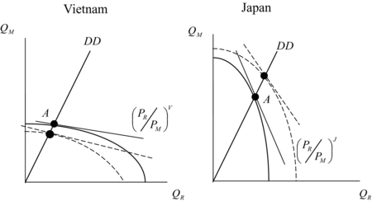resource endowments of both countries. Japan becomes more labor abundant (less capital abundant). Vietnam becomes less labor abundant (more capital abundant). These changes shift the PPFs of the two countries.

Vietnam’s PPF shifts in biased away from the labor intensive good (rice). Japan’s PPF shifts out biased towards from the labor intensive good. These changes lessen the strength of comparative advantage. Migration can therefore be a substitute for trade. In other more specific cases, however, FDI can be a complement to trade.

Chapter 21

International Migration

Refugee numbers and their share of total migrants, 19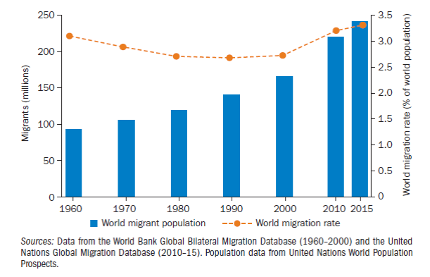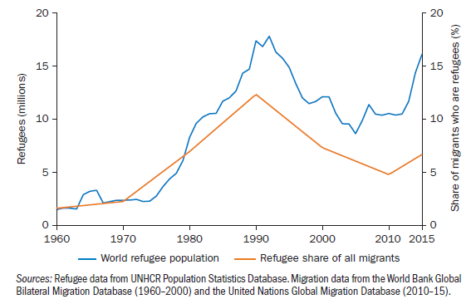60-2015

Distribution of global migration, by destination region in 1970, 1990, and 2010

Most international migrants move to other countries within their re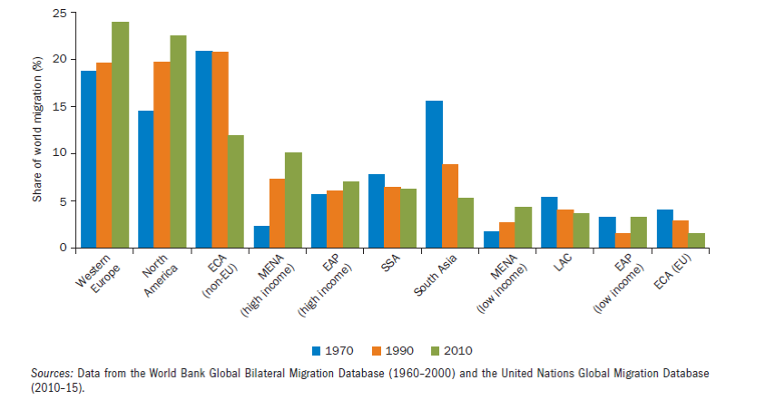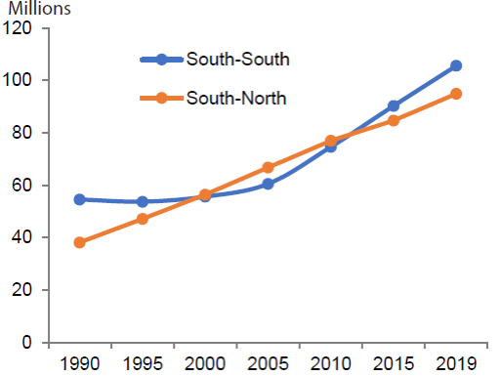gion, and South-South migration flows have overcome South-North flows:

WHY DO PEOPLE MIGRATE?

Push factors are conditions that drive people to leave the origin country, while pull factors are conditions that induce people to enter a destination country. Some are:

1. Wage/income differentials and income volatility: individuals move from low income/wage countries 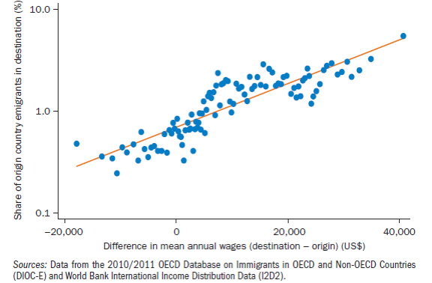to high income/wage countries to increase their income and to gain stable income streams
2. Income inequality within host countries: “There is a higher incentive to migrate if one is poor among rich than if one is poor among poor”
3. Network in the host country: family ties and friendship

EFFECTS ON MIGRANTS: INCOME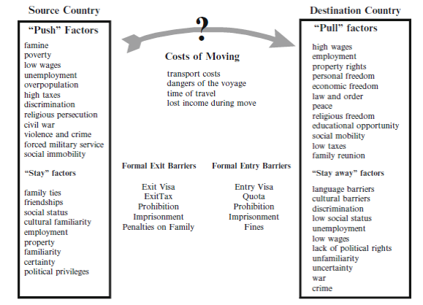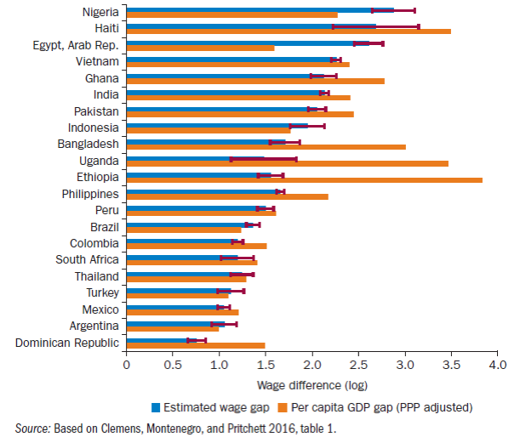 GAINS

GAINS AND LOSSES FROM IMMIGRATION

Low-income country:

* Remaining workers gain B
* Owners of other factors lose -(B+C)
* Net loss: -C

Immigrants:

* Lose F and gain M
* Net gain: M-F

High-income country:

* Workers originally in the country lose -H
* Owners of other factors gain (H+I)
* Net gain: I

Net gain in the world: (I+M) - (C+F) > 0

EFFECTS OF MIGRATION ON DESTINATION COUNTRIES

Empirical evidence exploiting exogenous supply shocks shows that, in the short run:

* Immigration displaces groups of native workers who directly compete with the immigrant labour (i.e. low skilled and less-educated workers)
* Groups of native workers that do not directly compete with the immigrants frequently experience significant gains, as they increase their productivity with the entry of complementary foreign workers. These natives complement immigrants.
* Overall wage effects tend to be small compared to the employment and reallocation of natives to others sectors, occupations, regions.
* New immigration flows decrease wages of existing immigrants because they are the closest substitutes to the newly arrived migrants
* Evidence finds no effect on natives’ wages or even positive effects but very small. These studies acknowledge that there is imperfect substitutability between immigrants and native workers even when considering individuals with the same level of education
* Immigration reduces labour-market constraints, filling occupations where natives are in short supply. This effect may refer to low and high skill intensive activities.
* Immigrants drive to an increase in the demand of goods and services and may lower prices for consumers.
* The inflow of foreign young workers could ease the strain on retirement systems and play a positive effect on the fiscal system
* Immigrants may increase productivity
* Migrants are often innovators and inventors, they promote innovation, and support the creation and expansion of high-tech and knowledge intensive industries
* Evidence often does not support that migrants are more likely to commit crimes

The overall contributions of immigrants depend on the degree of their integration and assimilation and on the investments in skills and human capital by migrants and by their employers.

EFFECTS OF MIGRATION ON ORIGI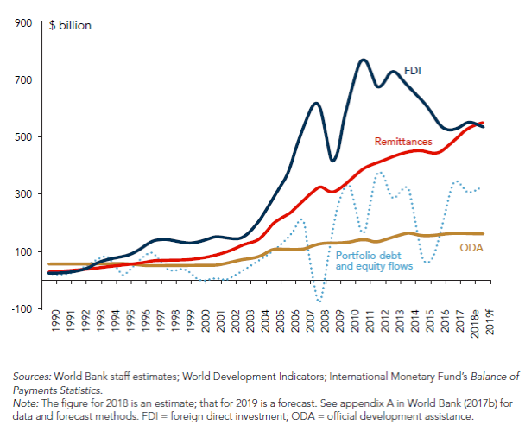N COUNTRIES

International migration can importantly affect the development and growth of origin countries:

* Migration can reduce unemployment and underemployment and facilitate access to more-productive and higher-paying jobs. Example: Poland following its entry into the European Union
* Remittances: remittances are stable monetary flows, they are directly received by the recipients and they act as insurance allowing recipients to smooth consumption.
* Trade of goods and services and FDI: migrants transfers knowledge and information about the markets of both countries and ease the contacts between the countries

NEGATIVE EFFECTS OF BRAIN DRAIN

* Reduction of human capital endowment and loss of positive externalities stemming from education
* High-skilled emigrants do not pay taxes after having enjoyed the benefits of public education ➔ reduction of public investments on education
* Worsening of institutions
* Brain drain induces shortages of manpower in key activities (high-tech, health)
* Brain drain increases the technological gap between leading and developing countries

POSITIVE EFFECTS OF BRAIN DRAIN

* The possibility of emigration creates additional incentives to undertake further education even if people end up never migrating
* Return and circular migration: return migrants’ additional knowledge and financial capital acquired in the destination country generates important benefits, especially for technology adoption, entrepreneurship, and productivity
* Diaspora externalities: skilled migrants can reduce information and transaction costs between countries, they can facilitate exchange of knowledge and skills. They can promote trade, FDI and technology transfers between sending and receiving countries.

PUBLIC ATTITUDES TOWARDS IMMIGRATION

Public opinions about immigration are not constant, they change over time and across countries; they depend on immigration experiences, composition of immigrants, and existing immigration policies. However, recent surveys suggest that in most developed countries the majority of people support relatively restrictive immigration policies and would like to see a decrease in the number of immigrants.

Public views on immigration and immigration policies are importantly affected by:

1. Immigrants’ qualifications and personal characteristics: education level, language proficiency, country of origin, ethnic group, religion.
2. Considerations of survey respondents about the effects of migration (on labour markets, crime, education,..).

Public perceptions sometimes exaggerate the migrant share in the population and these wrong perceptions may contribute to a negative view on immigration.

Chapter 22

Monetary Union

Monetary unions are groups of member countries in a common market all using a common currency, and the most notable example is the European Monetary Unions (EMU). Monetary unions also exist in Africa, such as the Communauté Financière Africaine (CFA) franc zone in central and west Africa and the rand zone or Common Monetary Area (CMA) in southern Africa.

THE EMU (history)

The European Monetary Union (EMU) is a monetary union among 17 countries (as of late 2011) in which the euro (€) serves as the shared currency. The euro is administered by the European Central Bank (ECB). With the exceptions of the United Kingdom and Denmark with their opt-outs, all EU members are expected to eventually join the EMU. With the exceptions of the United Kingdom and Denmark with their opt-outs, all EU members are expected to eventually join the EMU.

The monetary union initiative began in 1970 when a commission chaired by the then Prime Minister of Luxembourg, Pierre Werner, issued a report providing a detailed plan for a step-by-step movement to a EMU by 1980. However, the early 1970’s were characterised by the demise of the Bretton Woods system. During 1971, key European currencies, including the German Deutsche mark, began to float as the previous monetary era came to an end.

The EMS came into being as a fixed-rate system in 1979, and the original hope was that each country would peg their currency to a European Currency Unit (ECU). Instead, countries began to peg their currencies to the German mark.

In 1988, the European Council called upon then President of the European Commission, Jacques Delors, to study the steps required to move towards a monetary Union. The subsequent Delors Report was issued in 1989. The report called for a single currency and an integrated system of European central banks.

In response to the end of Bretton Woods, the members of the EEC decide to bind their exchange rates within 2.25 percent of each other. This became known as the “snake in a tunnel” or “snake”. Despite a number of instances when European currencies were forced out of the snake, it continued through 1978. In 1977, European Commission President Roy Jenkins called for Europe to return to the Werner vision and adopt monetary union as a goal. Negotiations began to create a European Monetary System (EMS) in 1978.

In 1991, a meeting of the European Community took place in the Dutch town of Maastricht. The Maastricht Treaty, agreed to at this meeting, was to serve as a constitution of the new European Union or EU, replacing the Treaty of Rome, and was signed in 1992. The Maastricht Treaty set 1999 as a target date for the EMU.

In 1994, as specified by the Maastricht treaty, a European Monetary Institute (EMI) came into being. The EMI was to plan for the future European System of Central Banks or ESCB and to plot the course towards monetary integration. The EMI was to also monitor the progress of member countri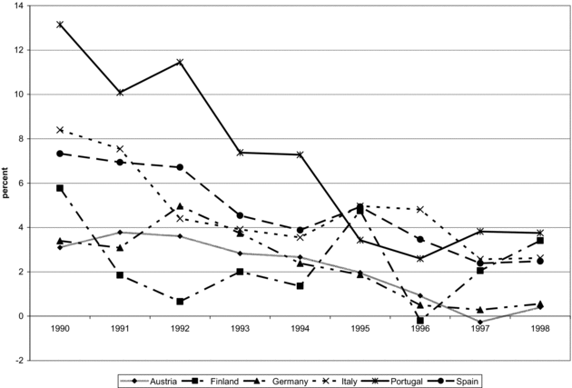es toward meeting a set of convergence criteria, which concerned price stability, levels of government deficits and debt, exchange rate targets, and interest rate targets. Government deficits (a flow) were required to be less than 3 percent of gross domestic product(GDP), and government debts (a stock) were required to be less than 60 percent of GDP.

The evolution towards the EMU, however, proved to be more difficult than envisioned. In 1990, East and West Germany had reunified and this required unprecedented increases in public expenditure on the part of the German government. To prevent the German economy from expanding too quickly, the German central bank pursued a tight or restrictive monetary policy. This kept German interest rates high and put downward pressure on the value of other European currencies. The EMS par-value system consequently came under pressure.

In May 1998, the European Council met in Brussels to determine which countries were to take part in the EMU on January 1st 1999. The figure below plots inflation rates for the six countries ultimately included in the EMU with the highest inflation rates in 1990; there was a significant degree of convergence in inflation rates between 1990 and 1998. The second and third convergence criteria concerned central government deficits and debt. However, t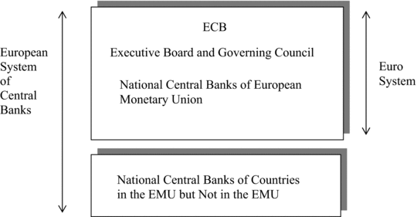here was a political decision made to admit these countries, as well as Greece in 2001.

THE EUROPEAN CENTRAL BANK

The centrepiece of the EMU is the Frankfurt-based European Central Bank (ECB). As specified in the Maastricht Treaty, the primary objective of the ECB in its monetary policy decisions is to maintain price stability within the EMU. The ECB is required to maintain annual increases in a Harmonised Index of Consumer Prices (HICP) at or below 2%. This is widely regarded as a very stringent rule.

THE EURO

The euro was launched in January 1999. EMU member exchange rates became “irrevocably” locked, and monetary policy was transferred to the ECB. The value of the euro was initially set at 0.85 €/US$ or 1.18 US$/€ in a flexible exchange rate regime. The euro’s value initially fell against the US dollar and the Japanese yen, despite predictions that it would appreciate. From 2001 through 2008, the euro strengthened against the yen and dollar, but with the onset of crises in selected euro countries, the euro began to weaken again.

OPTIMUM CURRENCY AREAS

An optimum currency area is a collection of countries characterised by:

1. Well-integrated factor markets
2. Well-integrated fiscal systems
3. Economic disturbances that affect each country in a symmetrical manner

It is not clear whether the EMU is an optimum currency area. There are limits to the mobility of labor and physical capital among the countries of the EMU, and its budget is relatively small in proportion to the size of the economies involved, indicating a lack of fiscal integration of the EMU economy. Furthermore, business cycles among the members of the EMU are somewhat asymmetrical.

ADJUSTMENT IN THE EMU

The absence of an optimum currency area in the EMU leaves some room for worry over how economic adjustment will occur within it. In a face of a recession in one country, unemployment can be addressed in four ways:

1. An overall decline in wage rates leading to increases in quantity demanded for labor
2. Labor mobility out of areas of unemployment
3. Expansionary monetary policy (at the EU level)
4. Expansionary fiscal policies (at the member country level)

In practice, these adjustment pathways prove to be difficult. Adjustment via wages can be understood with reference to:

1. With the EMU in place, the foreign currency wage can no longer be reduced by national currency depreciations (increase in “e”)
2. An increase in the EMU-wide price level (“P”) is ruled out by the policy of the ECB
3. A decrease in the nominal wage () is difficult because these tend to be downward inflexible in the EMU

Adjustment via labor mobility is limited in the EMU, while adjustment via monetary policy is limited by the ECB’s rules of operation. Adjustment via national fiscal policy, on the other hand, is limited by the EU’s Stability and Growth Pact that limits deficits and debt. These considerations have left some observers worried about how the EMU would operate in practice as a less-than-optimal currency area.

CRISIS IN THE EMU

The 2007 subprime crisis quickly began to affect banks in the EU through their exposures to US mortgages. By late 2008, the EU convened an emergency summit to address the crisis. By 2009, difficulties entered on a sub-group of countries (Portugal, Italy, Ireland, Greece and Spain) with the unfortunate acronym PIIGS. All of these countries are experiencing long-term current account deficits through 2008, some of large magnitudes relative to GDP. Beginning in 2009, these current account deficits began to shrink.

In mid 2010, first Greece and then Ireland were caught up in market speculation of government or sovereign default. Bond yield spreads widened, with Greece (at approximately 12 percent) and Ireland and Portugal (at approximately 6 percent) paying much higher rates than Germany (at approximately 2 percent) on new 10-year bond issues. The EU set up the European Financial Stability Facility (EFSF) and it and the IMF began to commit funds in order to help soothe the markets. Eventually, the EFSF morphed into the European Stability Mechanism (ESM), a permanent bail-out fund.

From 2010 to 2012, EU handling of what proved to be an ongoing crisis was not adept, seeming to lurch from one half-measure to another. During this time, a focus was on Greece, which even in 2011 had a current account deficit of approximately 10 percent of GDP and received large bailouts in 2011 and 2012. In early 2012, holders of Greek government debt underwent a “haircut,” having to exchange old bond for new worth less than half of the original value. This was the largest sovereign default in history.

In September 2012, events seemed to take a turn for the better. Germany’s constitutional court gave its long-awaited approval of the ESM. The European Commission set out its plan for a long-called-for, EU-wide banking union, and Mario Draghi, head of the ECB, announced that it would begin to purchase the bonds of the PIIGS to aid in their adjustment and thus begin to act as a lender of last resort. Bond yields began rot decline, and this might have been a point at which the euro crisis began to resolve itself.

MONETARY UNIONS IN AFRICA

Monetary unions in Africa include the CFA franc zone in central and west Africa and the rand zone in southern Africa. The Communauté Financière Africaine (CFA) franc zone is a monetary union among 14 member countries that have adopted the CFA franc as a common currency. The CFA franc zone actually consists of two sub-unions, the West African Monetary Union (WAMU) and the Central African Monetary Area (CAMA), associated with the Central Bank for West African States and the Bank for Central African States, respectively.

The CFA franc was pegged to the French franc and underwent a notable devaluation in 1994. In 1999, the CFA franc was pegged to the euro. The rand zone or Common Monetary Area (CMA) is a smaller endeavour than the CFA franc zone and includes South Africa, Lesotho, Namibia and Swaziland.

Chapter 23

Institutional and Economic Development

Economic growth is related to the amount of labour, physical capital, human capital and technology:

yt=f(At, kt, ht)

Here:

* yt : income per capita (per worker)
* kt : physical capital intensity (per worker)
* ht : human capital intensity (per worker)
* At : productivity (residual, proxy for technology)

But why do income per capita and economic growth differ across countries? Some standard economic answers are:

1. Physical capital differences (differences in saving rates)
2. Human capital differences (differences in investments in education and skills)
3. Technology differences (investments in R&D and technology adoption, managerial practices, organisation)

Why do countries differ in human capital, physical capital, and technology? We need to understand why poor countries do not save enough and why they do not invest enough in education, R&D and technologies.

Some potential fundamental causes are:

* Geography
* Culture
* Integration (trade and FDI)
* Institutions (matter for economic growth)

Recent literature suggests that different laws and regulations, different levels of corruption, different political systems have a major effect on investment, education, production structure, R&D.

INSTITUTIONS

Institutions are any form of constraint that human beings devise to shape human interaction, and are the “rules of the game” in economic, political and social interactions. They also include all constraints imposed on individuals and groups by a society's system of beliefs and values, shape incentives, and are ultimately under human control.

Without quality institutions, transaction costs will be higher and less economic development is likely to take place. They allow to solve a number of problems associated with economic transactions, such as informational problems, hold-up problems, commitment problems, cooperation problems, and coordination problems. The more complex products and markets, the greater the importance of institutions. Since complexity increases with development, institutions become more important over time.

There are generally two types of institutions:

1. FORMAL INSTITUTIONS

These are institutions created, communicated and enforced through official channels. They are usually codified in writing.

* Political institutions set rules for major political figures, bodies, parties, etc. Political rules of the game (democracy versus dictatorship, electoral laws).
* Legal institutions: Non-political institutions codified by laws. Example: common law and civil law systems, religious law.
* Economic institutions: economic rules of the game (property rights, contracting institutions)

1. INFORMAL INSTITUTIONS

These are not legally codified, based on social norms, conventions, social values, and culture. They determine how a given set of formal rules and formal institutions function in practice. Formal institutions evolve with informal institutions, and it is difficult to establish formal laws which conflict with social norms (e.g., border versus ethnic division in Africa). Formal institutions can strengthen informal institutions and vice versa. They are complementary.

We can also classify institutions as:

1. INCLUSIVE INSTITUTIONS

Those that allow and encourage broad participation by the great mass of people in political and economic activities. Secure property rights, law and order, markets and state support (public services and regulation) for markets; open to relatively free entry of new businesses; access to education and opportunity for the great majority of citizens.

1. EXTRACTIVE INSTITUTIONS

Those that do not provide broad participation; political power is concentrated in the hands of a small economic or political elite. Powerful elites extract resources from the rest of society.

HOW DO INSTITUTIONS FORM?

Societies will choose the institutions that maximise their total surplus. It is based on the Coase Theorem, which says:

“If property rights are well-defined and there are no transaction costs, economic agents will contract to achieve an efficient outcome, irrespective of who holds the property rights on particular assets” (Coase, 1960)

The change of institutions creates losers and beneficiaries. It is necessary that either the losers are compensated or the beneficiaries impose their choice. But in the real world, this does not apply; losers are not compensated ex-post, and they block institutional change.

From an ideological point of view, beliefs and values across societies differ and this will drive to different institutions. Existing regimes remain in place by gaining some degree of approval. This view explains some real world cases, but many empirical patterns cannot be explained by ideology.

The Incidental institutions view downplays choices and emphasises instead that the development of institutions is a by-product of other social interactions or historical accidents. Institutions originating from historical accidents tend to persist. (e.g.: civil vs common law countries).

In some cases, social interactions or historical accidents are key to understand the formation of institutions but institutions are also choices and they are not simply dictated by history. Furthermore, institutional changes – even big changes – are possible and are not rare even it they are challenging (as we will explain).

From a social contract point of view, institutions are not chosen by the whole society, but by the groups that control political power at the time. These groups holding political power will choose the economic institutions that maximise their own rents. This view is empirically more promising as it is more consistent with empirical evidence. It can explain inefficient choices, even when their consequences are understood by the key actors.

TOWARDS A THEORY OF INSTITUTIONS

Three main elemen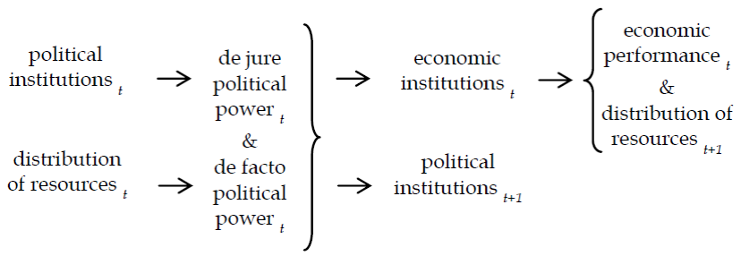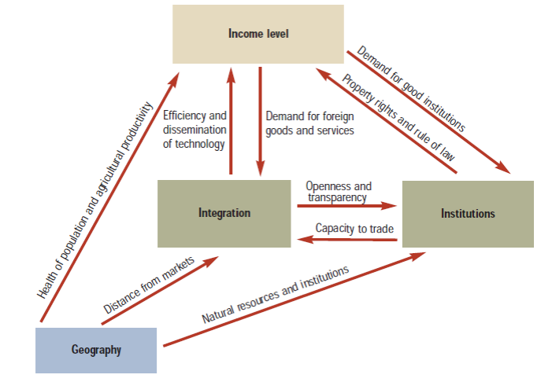ts form our theory:

1. POLITICAL POWER

This is the ability to change economic institutions or undertake redistribution of income and assets. De jure/formal political power is when it’s allocated by political institutions, while de facto political power is determined by economic/military power, collective action, etc.

1. POLITICAL INSTITUTIONS

These determine the “rules of the political game”. They help to regulate the limits of political power and determine how political power changes hands.

1. ECONOMIC INSTITUTIONS

These determine the “economic rules of the game”, in particular, the degree of property rights enforcement, the set of contracts that can be written and enforced, and the rules and regulations that determine the economic opportunities open to agents.

The distribution of resources and institutions tend to be persistent. The groups holding political power will opt to maintain the current political institutions in order to maximise their own rents even in the future. Higher economic wealth delivers higher de facto political power and enable the group holding it to preserve economic and political institutions which are favourable to its interests.

THE PRIMACY OF INSTITUTIONS

Rodrik, Subramanian, and Trebbi (2004) have explored the linkages between income levels, geography, integration (trade) and institutions.

They have implemented an econometric study, by simultaneously estimating different equations capturing the relations between the variables listed above. They have solved endogeneity issues, and found that the role of quality of institutions overrides geography and trade. Both trade and geography influence institutional quality. Institutional quality can produce large increases in income per capita.

WHICH FORMS OF INSTITUTIONS MATTER?

1. MARKET-CREATING INSTITUTIONS
2. MARKET-REGULATING INSTITUTIONS
3. MARKET-STABILISING INSTITUTIONS
4. MARKET-LEGITIMISING INSTITUTIONS

While it is clear that all the forms of institutions — listed before — are relevant, research has no answer about which is the most favourite type of institution to achieve a certain aim. The best institutions could be context specific, and the context specificity arises from differences in historical trajectories, geography, political economy, and other initial conditions.

GOVERNANCE EFFECTIVENESS

1. VOICE AND ACCOUNTABILITY

Captures perceptions of the extent to which a country's citizens are able to participate in selecting their government, as well as freedom of expression, freedom of association, and a free media.

1. POLITICAL STABILITY AND ABSENCE OF VIOLENCE

Captures perceptions of the likelihood that the government will be destabilised or overthrown by unconstitutional or violent means, including politically, motivated violence and terrorism.

1. GOVERNMENT EFFECTIVENESS

Captures perceptions of the quality of public services, the quality of the civil service and the degree of its independence from political pressures, the quality of policy formulation and implementation, and the credibility of the government's commitment to such policies.

1. REGULATORY QUALITY

Captures perceptions of the ability of the government to formulate and implement sound policies and regulations that permit and promote private sector development.

1. RULE OF LAW

Captures perceptions of the extent to which agents have confidence in and respect the rules of society, and in particular the quality of contract enforcement, property rights, the police, and the courts.

1. CONTROL OF CORRUPTION

Captures perceptions of the extent to which public power is exercised for private gain, including both petty and grand forms of corruption, as well as "capture“ of the state by elites and private interests.

INDICATORS OF POLITICAL INSTITUTIONS

There are two main political regime types:

1. AUTOCRACY

All power resides in a single person or a narrow group.

1. DEMOCRACY

Power held by citizens through elections of representative government.

Chapter 24

Development Concepts

From an economic standpoint, the primary goal of international economic development is the improvement of human well-being. It is difficult to isolate a universal conception of human well being, and without such a universal conception, there can be no single concept and measure of international development. However, we can try dividing it into sectors:

1. DEVELOPMENT AS GROWTH

Views development as the sustained increase in either output per capita or income per capita. This is related to the conception of poverty as a deprivation of income.

1. DEVELOPMENT AS HUMAN DEVELOPMENT

Views development as an increase in what individuals can achieve in the broadest sense of that word, and is related to another conception of poverty as deprivations of achievements of various kinds, namely education and health.

1. DEVELOPMENT AS STRUCTURAL CHANGE

Views development as involving significant alterations in patterns of production, consumption and even social relations.

GROWTH

A basic conception of international development is in terms of the sustained increase in either per capita production or per capita income, or, in other words, growth. The focus here is either on gross domestic production (GDP) or gross national income (GNI).

Per capita GDP, however, does not account for factor income flows among countries of the world. It only includes market activities, and many activities in developing countries take place outside the market.

Per capita GDP does not account for certain costs associated with development, either, such as the use of nonrenewable resources. It is an average measure that hides the distribution of income among households of a country. It is not always an accurate depiction of human development, and the nominal or currency exchange rates used to convert GDP into US dollars for comparison among countries are misleading.

ADJUSTING FOR PPP

The last of the above limitations is addressed by adjusting GDP per capita for purchasing power parity (PPP). The PPP methodology uses US dollar prices to value all goods in all countries, and this has the effect of increasing the GDP of developing countries.

POVERTY

Deprivations in per capita GDP (and therefore of per capita GNI) is a central measure of poverty, namely poverty as income deprivation. The number of extremely poor individuals living on US$1.25 or US$1.00 per day is declining over time. The number of poor, while appearing to be on a recent downward trend, is still approximately 2.5 billion.

PRO-POOR GROWTH

Poverty reduction depends on initial inequality levels and changes in inequality as well as growth itself. The possibility of pro-poor growth related to the growth elasticity of poverty, which is the ratio of the percentage change in a poverty rate to the percentage change in a growth measure such as GDP per capita. This elasticity can vary by country, time period and region within a country.

HUMAN DEVELOPMENT

The human development perspective sees the growth of GDP or GNI per capita as an important but limited measure of the rate of economic development. The most fundamental contribution of the human development perspective is the *human development index* (HDI), which consists of equal, one-third components of per capita income, life expectancy, and education.

Chapter 25

The Development Gap

Differences in economic development between the advanced economies of the United States, Japan, and Western Europe and the poorer economies of Africa, Asia, Latin America, and Eastern Europe can be measured in terms of income, life expectancy, health, education, and level of urbanisation.

The development gap **evolves over time**. Currently, it is decreasing for some countries (e.g. recently, China and India) while increasing for others (e.g. Democratic Republic of the Congo). Economic development is **not irreversible**. Even some rich economies have displayed protracted decline (Argentina). Poor economies tend to grow faster when they do grow, but experience shows that protracted declines occur more frequently than for rich countries.

THE INCOME GAP

The first basic indicator of development is **real income per capita, measured by:**

1. **GDP (Y = C + I + G + NX)**

**The market value of all final goods and services produced within a country in a given period of time. It is not a proper income measure because it does not account for net foreign income, foreign aid, and remittances.**

1. **GNI (GNI = GDP + net factor income from abroad)**

**This is** the market value of all final goods and services produced by permanent residents of a country in a given period of time.

The World Bank scheme actually ranks countries on GNI per capita:

1. LOW INCOME COUNTRIES (LIC)
2. LOWER MIDDLE INCOME COUNTRIES (LMC)
3. UPPER MIDDLE INCOME COUNTRIES (UMC)
4. HIGH INCOME COUNTRIES (HIC)

GNI and GDP per capita data, and income-level aggregations are available in the **World Development Indicators database** at data.worldbank.org.

THE POVERTY GAP

The poverty headcount ratio measures the number of the world’s population living on less than $1.9 a day (in a 2011 PPP basis). This is the measure used by the World Bank to gauge “extreme poverty.” The number of people in extreme poverty has fallen from nearly 1.9 billion in 1990 to about 650 million in 2018, but if we increase the poverty line, the number of the poor sensitively increases.

THE HEALTH GAP

There are large differences in life expectancy and infant mortality between developed and developing countries. Life expectancy measures the number of years a newborn infant would live if health and living conditions at the time of its birth remained the same throughout its life.

The infant (child) mortality rate measures the probability that a child will die before reaching the age of 1 (5). It is computed as the number of children dying before age 1 (5) per 1,000 live births in the same year, and this is negatively correlated with income. Policy interventions can make a difference in lowering infant and child mortality.

THE EDUCATION GAP

Countries that invest in near-universal, quality education can realise high productivity gains and economic growth. Many poor countries cannot afford a good educational system, which, if it existed, would sustain growth, reduce child mortality, and promote democratisation processes. Large differences in the mean years of schooling are recorded across countries.

THE URBANISATION GAP

Urbanisation rate measures the proportion of population living in urban areas as opposed to rural areas. Development drives urbanisation as workers flow to industries and services located in cities. Urbanisation is increasing rapidly across the world.

The life in urban centres is not related to increased and better living conditions. Most of the world’s largest cities are in the developing world. There is a great need for public policy to address how to improve housing, infrastructure, health and education in large cities of the developing world.

THE EVOLVING DEVELOPMENT GAP

The highest growth rates in GDP per capita in the last 3 decades have been recorded in East Asia, the Pacific and South Asia. The lowest growth rates in GDP per capita in the last 3 decades have been in Sub-Saharan Africa, the Middle East, North Africa, Latin America, and the Caribbean. These averages hide a large heterogeneity across countries.

POPULATION GROWTH

Population growth contributes to GDP growth because a larger population increases the labor force and thus should increase economic output. However, if output growth is slower than population growth, GDP per capita falls. Sub-Saharan African countries, which are the poorest countries, have had the highest population growth. Population growth has been also high in other poor regions: the Middle East and North Africa, South Asia, Latin America. If this trend continues, the proportion of the world’s population living in poverty will increase.

STORIES OF CATCH-UP AND DECLINE

The development gap emerged because some countries developed earlier than others. There are different examples of rich countries that in the past underwent economic decline, such as China, Argentina, and the Ottoman Empire (Turkey). There are also some countries that in history underwent a process of decline.

CHARACTERISTICS OF THE DEVELOPING WORLD

* Lower levels of living and productivity
* Lower levels of human capital (health, education, skills)
* Higher Levels of Inequality and Absolute Poverty
* Higher Population Growth Rates
* Greater Social Fractionalisation
* Larger Rural Populations but Rapid Rural-to-Urban Migration
* Lower Levels of Industrialisation and Manufactured Exports
* Underdeveloped Financial and Other markets
* Colonial Legacy and External Dependence

Chapter 26

Population Growth

There are certain factors behind population growth:

1. Number of births
2. Number of deaths
3. Net international migration flows

Population growth is behind the labour force and behind the demand of goods and services. However, a world with finite resources cannot sustain unlimited population growth. Variations in fertility alter the age composition of the population, which has consequences on saving rates (the young save more) and the sustainability of the pension system. Furthermore, fertility influences women’s participation to the labor market, choices about children education, health care, nutrition.

Up to the 1800’s, world’s population was fairly stable through history. Wars, famine and disease played a role in holding down growth. The last two centuries, however, have seen an unprecedented population increase.

THE EVOLUTION OF POPULATION OVER TIME

The growth rate of the population is the percentage change in population due to natural increase (e.g.: differences in fertility and mortality rate) and net international migration. The growth rate of the population has increased dramatically since the Industrial Revolution, and the global population growth rate increased steadily from the 1800’s to the 1960’s, peaking at about 2%. Since then it has decreased, to around 1.06% in 2019.

According to demographers, the world, like individual countries, is undergoing a **demographic transition. A shift from a stabilised population with high birth and high mortality rates to a stabilised population.**

**DEMOGRAPHIC TRANSITION**

1. **STAGE 1: High birth rates and high death rates**

**Population is relatively stable; with high birth rates there is little or no family planning. With high death rates, however, there is f**amine, uncertain food supplies, and poor diet; Poor hygiene, no piped clean water.

1. **STAGE 2: Continued high birth rates, declining death rates**

**Death rates fall with improved medical care (e.g.: vaccines). There are significant improvements in food production in terms of quality and quantity.**

1. **STAGE 3: Falling birth rates and death rates**

**Contraceptives, abortions, and sterilisation are utilised. A lower infant mortality rates means less pressure to have children.**

**Demographers expect the world population to stabilise at around 8 to 12 billion.**

**COMPONENTS OF POPULATION CHANGE**

1. **ADDITIONS (births;** Bt**)**
2. **DEDUCTIONS (deaths;** Dt**)**
3. **NET IN-MIGRATION (immigration - emigration;** NMt **)**
4. **RATE OF GROWTH (CBR: crude birth rate, CDR: crude death rate, NMR: Net migration rate)**
5. **BIRTH RATE (**number of babies born each year per 1000 inhabitants)
6. **DEATH RATE (**number of deaths each year per 1000 inhabitants)
7. **NET MIGRATION RATE (**he difference between the number of persons entering and leaving a country per 1000 inhabitants)

The birth and death depend on the **age distribution** defined as the percentage of the population belonging to different age groups.

Birth rate is determined by:

1. TOTAL FERTILITY RATE
2. NUMBER OF WOMEN OF CHILDBEARING AGE

There is usually a high proportion of young people in developing countries, while there is usually a high proportion of elderly people in developed countries. Even when mortality and fertility rates are the same the age distribution significantly affects population growth.

AGE STRUCTURE AND POPULATION

1. AGE DEPENDENCY RATIO

Ratio between “dependents” (young and elderly) and the working-age population (aged 15-64 years old).

1. OLD AGE DEPENDENCY RATIO

Ratio of people older than 64 years old over the working-age population (aged 15-64 years old).

1. YOUTH DEPENDENCY RATIO

Ratio of people younger than 15 years old over the working-age population (aged 15-64 years old).

Population growth has a built-in tendency to continue. High birth and fertility rates cannot change overnight. The hidden momentum of population growth is a a dynamic latent process where population continues to grow despite a fall in the fertility rate due to a larger number of child bearing couples.

Even temporary fertility shocks to a stationary population creates inertia, leading to growth long after the shock (e.g, U.S. baby boom and baby boom echo). Therefore, family planning policies tend to have a delayed effect. This must be taken into account when evaluating their effectiveness.

THE DETERMINANTS OF FERTILITY

The Microeconomic Household Theory of Fertility makes economic sense of fertility decisions:

Max. U = U (N, C)

s.t. Y >= PnN + PcC

* N: number of children
* C: composite consumer good
* Y: level of household income
* Pn: net price of children
* Pc: price of all other goods
* Tc: taste for goods relative to children

The shape of the utility function ultimately depends on tc. A change in the price of a good relative to other goods leads to an income effect and a substitution effect:

1. SUBSTITUTION EFFECT

When the price of a good falls (increases), the good becomes cheaper (more expensive) relative to other goods. The substitution effect reflects the change in the quantity of the good the consumer would purchase after the relative price change to achieve the same level of utility.

1. INCOME EFFECT

When the price of a good falls (increases), the consumer’s purchasing power increases (falls). If the price falls, the consumer can now buy the same basket of goods and still have money left. On the contrary, if the price increases, the consumer can no longer afford to buy the same basket of goods. The income effect reflects the change in the quantity of the good the consumer would purchase due to the change in the purchasing power.

If the income effect dominates, then it is possible to increase consumption of all goods. If the substitution effect dominates, people tend to increase consumption of cheaper good, and reduce consumption of more expensive goods.

Typically, poor families have more children that rich families. Are children inferior goods? No, they aren’t, because:

1. The opportunity cost of having children, especially for women, increases with economic development.
2. There is a quantity-quality trade off. At higher levels of development, parents choose to invest more time and money per child.
3. A shift of preferences related to the economic development

The change in the relative benefits of having children translates into a change in the shape of indifference curves between consumption and children. Preference can change for noneconomic reasons, especially for social norms.

WHAT DEVELOPING COUNTRIES CAN DO

1. Persuasion through education
2. Family planning programs
3. Address incentives and disincentives for having children through the principal variables influencing the demand for children
4. Raise the socioeconomic status of women: increase employment opportunities for women

WHAT DEVELOPED COUNTRIES CAN DO

1. Address resources using inequities
2. More open migration policies