SQL NOTES :

In this we covered
- Querying
- DML
- DDL
- Grouping of data

QUERING OF DATA

Grouping of data

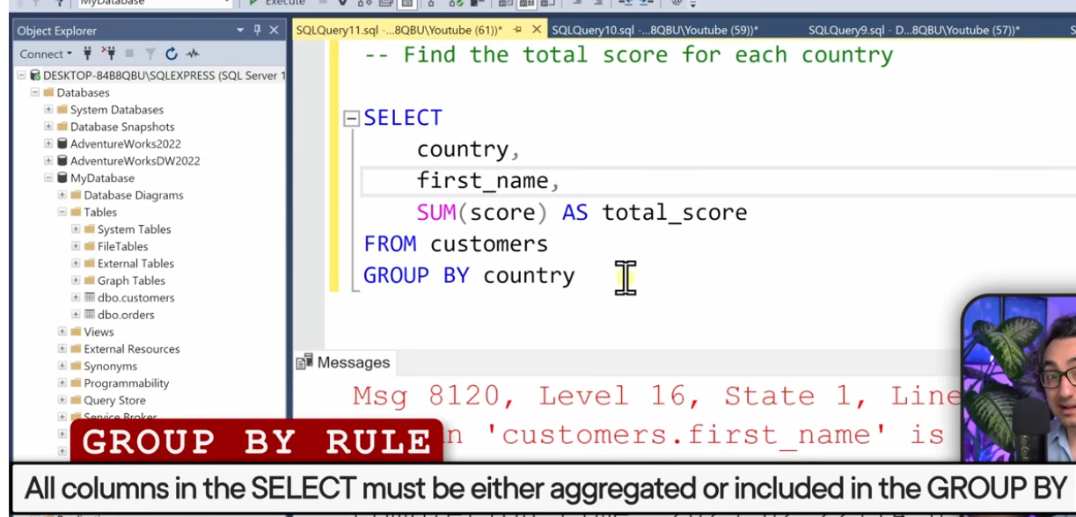

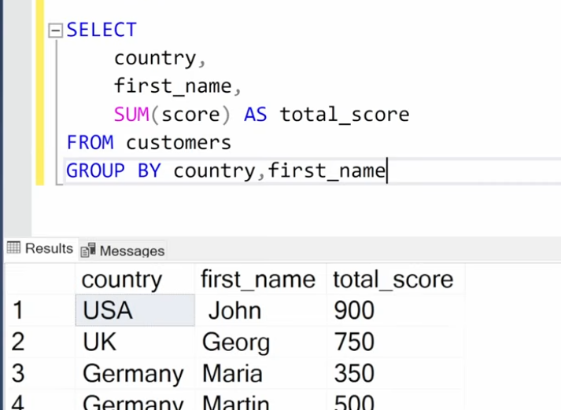

Note: when using groupby all the columns must be included in groupby except the aggregate or calculation once

2. Having clause

Filter data after aggregation ie. we can use having only after group by
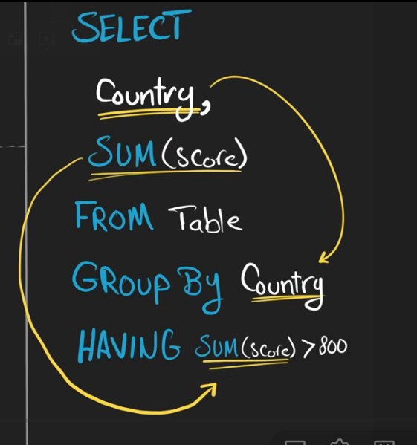
From ->where-> groupby->aggregates->having

Before aggregation - where clause group by
After aggregation - having clause
Foreach-group by

Tip - start by reading the question and first write what columns are needed

3. Distinct - no duplicates - each value appears only once in result

(2)Select (3)distinct country from(1) table

The numbers here say in what order it is executed

4. To ( used to limit data )
Restricts the number of rows returned in results

(2)Select (3)top n* (1)from table

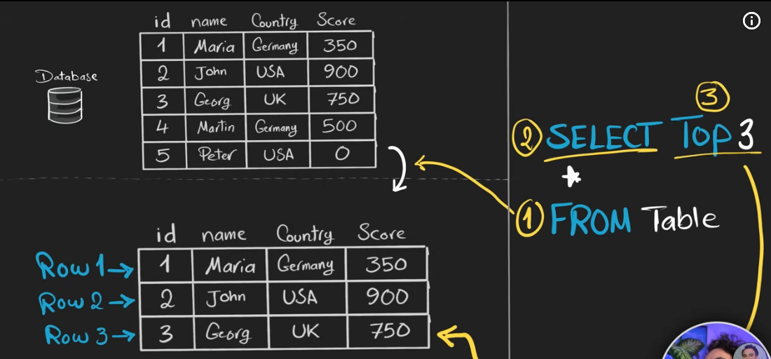

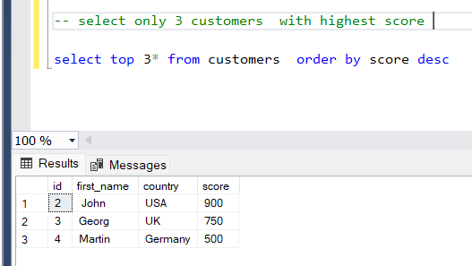

STATIC FIXED VALUES - JUST A COOL TRICK

Select 19 as static_number
U can mix data from db and static values that u put in

The Coding order
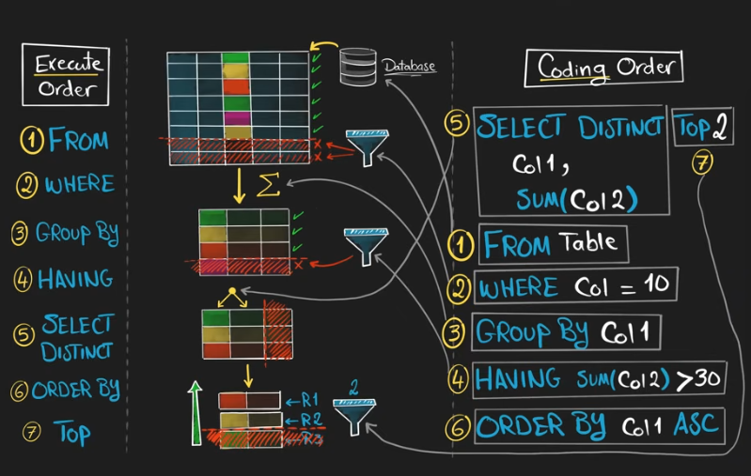

How to define structure of our database - DATA DEFINATION LANGUAGE

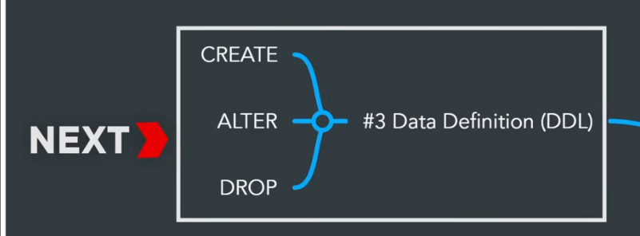

Create - creates a new object in database which is initially empty with no data

1.CREATE
- CREATE is used to create a new object in the database.
- The newly created object is initially empty and contains no data.

CREATE TABLE Syntax
CREATE TABLE table_name (
column_name data_type,
column2 data_type2 CONSTRAINT
);

Common Constraints
- NOT NULL – ensures that a column cannot contain NULL values.
- PRIMARY KEY – uniquely identifies each record in a table.
- FOREIGN KEY – creates a relationship between two tables.
Data Types: INT, SMALLINT, BIGINT, DECIMAL, NUMERIC, FLOAT, REAL, DOUBLE, CHAR, VARCHAR, TEXT, DATE, TIME, DATETIME, TIMESTAMP, YEAR, BOOLEAN, BINARY, VARBINARY, BLOB, JSON, XML, ENUM, UUID.
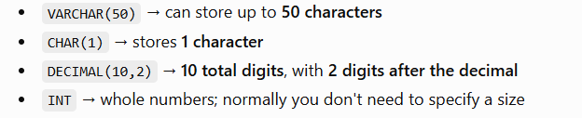
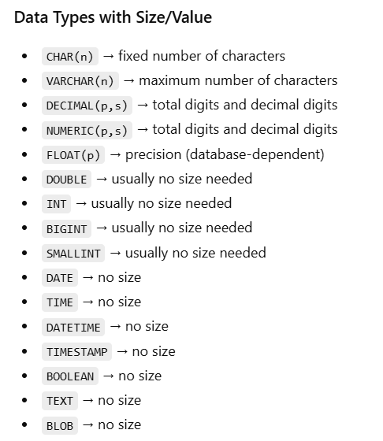
- time TIME
- dob DATE
- created_at TIMESTAMP
- date DATE

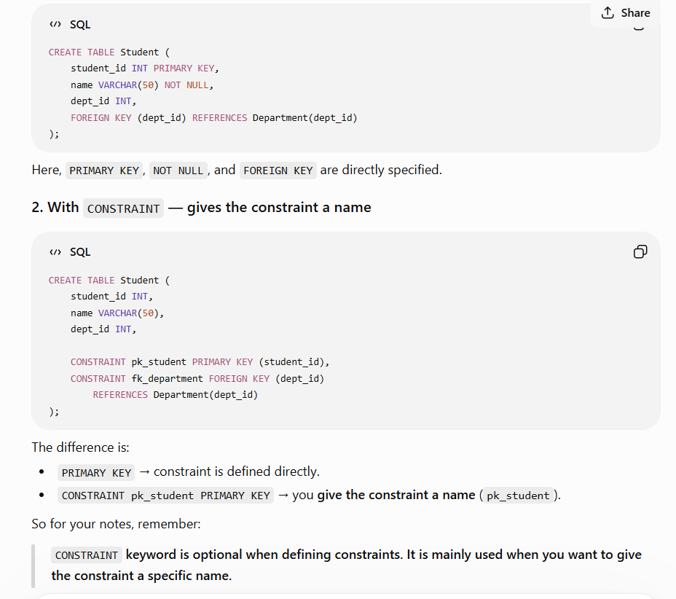

To edit the definition of your table

2. ALTER,

ALTER is used to modify the structure of an existing database object, such as a table.
The new columns are added at the end by default

Common Uses of ALTER TABLE
1. Add a column
ALTER TABLE Student
ADD email VARCHAR(50);

2. Modify a column
ALTER TABLE Student
MODIFY name VARCHAR(100);

3. Drop a column
ALTER TABLE Student
DROP COLUMN email;

4. Add a constraint
ALTER TABLE Student
ADD CONSTRAINT pk_student PRIMARY KEY (student_id);

5. Drop a constraint
ALTER TABLE Student
DROP CONSTRAINT pk_student;

Syntax
ALTER TABLE table_name
action;

3.DROP
DROP is used to permanently remove a database object, such as a table, from the database.

Drop a Table
DROP TABLE Student;

This removes the entire table along with all its data.

Drop a Database
DROP DATABASE College;

This removes the entire database and its objects.

Syntax
DROP TABLE table_name;
DROP DATABASE database_name;

Important: DROP removes the object itself, not just its data.
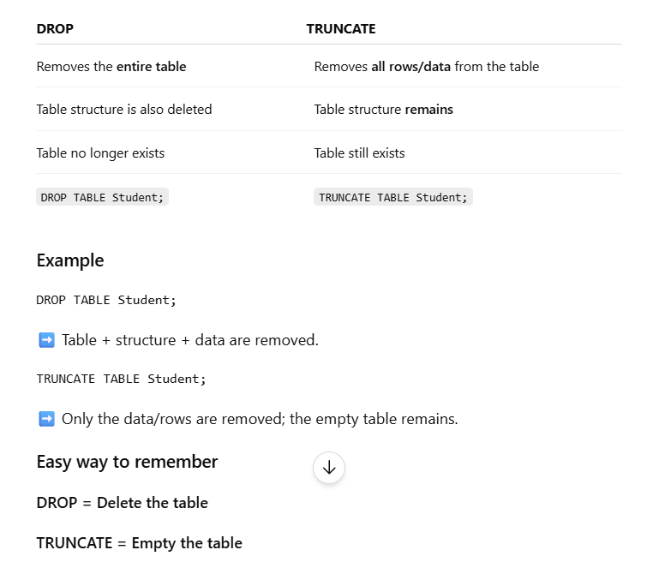

DATA MANIPULATION - modify ur data
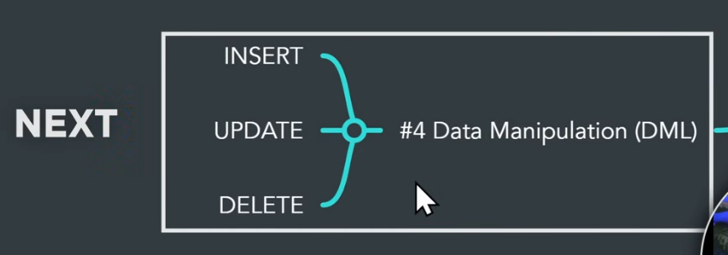

DML Commands

1. INSERT
INSERT is used to add new records/rows into a table.
INSERT INTO Student (id, name, age)
VALUES (1, 'Rahul', 20);

Syntax:
INSERT INTO table_name (column1, column2)
VALUES (value1, value2);

Put null when u do not know the value
Order matters cols and values should be in order

Assume a table already exits and we need data from the source table to target table:

2. UPDATE
UPDATE is used to modify existing records/rows in a table.
UPDATE Student
SET age = 21
WHERE id = 1;

Syntax:
UPDATE table_name
SET column_name = value
WHERE condition;

⚠️ Without WHERE → all rows will be updated.

3. DELETE
DELETE is used to remove existing records/rows from a table.
DELETE FROM Student
WHERE id = 1;

Syntax:
DELETE FROM table_name
WHERE condition

⚠️ Without WHERE → all rows will be deleted, but the table structure remains.

Quick Difference
INSERT → Add data
UPDATE → Modify data
DELETE → Remove data

DELETE | TRUNCATE
Removes rows from a table | Removes all rows from a table
Can use WHERE | Cannot use WHERE
Can delete specific rows | Deletes all rows
Table structure remains | Table structure remains
DML command | DDL command
Generally slower | Generally faster

