Question 2:

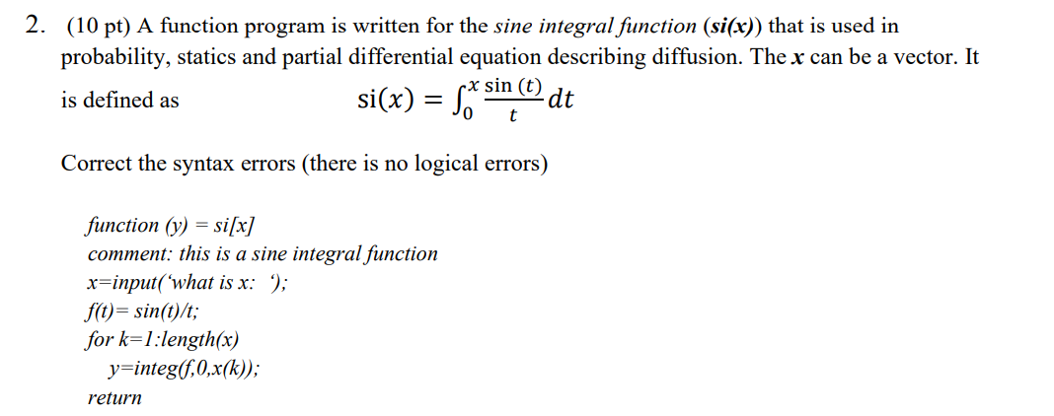
The correct syntax should be
function y = si(x)
%this is a sine integral function
x = input(‘what is x: ‘);
%f(t) = sin(t)/t
for k = 1:length(x)
y = integral(f,0,x(k);
end

Question 1:

script.m file:
x = [65, 55, 87, 76, 90, 83, 74];
q = stand(x);
fprintf('The answer to Question 1 is: %.4f \n',q)

xavg function file:
function out = avg(x)
%Finds average of x

c = 0;
for i = 1:1:length(x)
c = c + x(i);
end

out = c/length(x);

end

stand function file:
function out = stand(x)
%Standard deviation function

tot = 0;
for i = 1:length(x)
tot = tot + (x(i) - avg(x))^2;
end
out = sqrt(tot/length(x));

end

Results from terminal:

Question 3:

Script file:
prompt = "Please input the load amount P: ";
P = input(prompt);

prompt = "Please input the loan periods in months: ";
n = input(prompt);

prompt = "Please input the annual interest rate: ";
ai = input(prompt);

%testing
% P = 10;
% n = 11;
% ai = 12;
i = ai/1200;

A = P * [i*(1 + i)^n]/[(1 + i)^n - 1];

fprintf('Loan = $%d, loan periods in month = %d, annual interest rate %.4g percent\n',P,n,ai)
fprintf('The monthly payment is $%.4f\n',A)

results from terminal:

case 1: 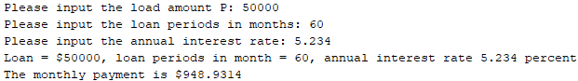

case 2: 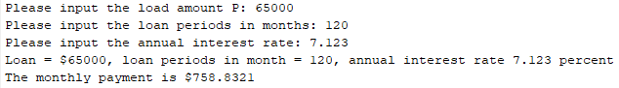

Question 4:

script.m file:
h = linspace(0,20);
V = vol(h);

figure;
plot(h,V);
title('Graph of question 4')
xlabel('h'); ylabel('V');
axis;

%starting part c
prompt = "Please input the height: ";
h = input(prompt);
if h < 0
error('Height cannot be negative. Please rerun script and try again.')
return;
elseif h > 20
error('Height cannot be over 20. Please rerun script and try again.')
end
V = vol(h);
fprintf('Radius = 30.00 ft, height = %d ft, and volume = %.4f\n',h,V)

vol function file:
function V = vol(h)
%Finds volume of h or vector h
% R is the radius in feet
% V is volume in ft^3
% h is depth of water in ft

R = 10;
for k = 1:length(h)
V(k) = pi.*h(k).^2 .* [(3*R - h(k))]./[3];
end
% V = pi.*h.^2 .* [(3*R - h)]./[3];
End

Graph:
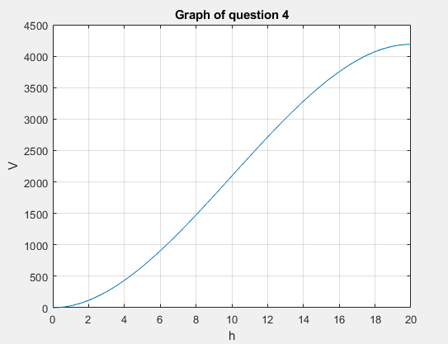

Results from terminal:

Case 1:

Case 2: 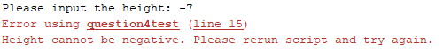

Case 3: 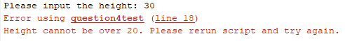

Question 5:

Script.m file
prompt = "Please enter number of students to be calculated: ";
n = input(prompt);

%testing
% n = 6;

for k = 1:n

prompt = "Please enter 3 test scores in vector form, [], : ";
score = input(prompt);

%testing
% score = [100 -90 80];

if min(score) < 0
warning('score cannot be negative')
end

best2 = [sum(score) - min(score)]/[2];
fprintf('Test scores %g, %g, %g; Average of best two = %g\n',score(1),score(2),score(3),best2)
end

results from terminal:

