**Package Name:** AMECO

**Author:** Graeme Walsh

**Date:** 07/08/2018

**Add-in Type:** Global

**Default Proc Name:** AMECO

**Default Menu Text:** AMECO

**Interface:** Menu and Command Line

**Description:**

This EViews add-in imports the latest AMECO database into EViews as a workfile object. It does this by downloading the data directly from the zipped text files on the AMECO website.

The AMECO database is the annual macro-economic database of the European Commission and can be found at the following address: <https://ec.europa.eu/info/business-economy-euro/indicators-statistics/economic-databases/macro-economic-database-ameco/download-annual-data-set-macro-economic-database-ameco_en>

**Technical Notes:**

* This add-in uses the native EViews R connector interface.
* The R programming language is required to use this add-in.
* The speed of the add-in will depend on both your internet connection and hardware.
* The add-in source code is open and commented.

**Interactive Use:**

Running this add-in will present a @uidialog to the user. The user is shown the URL from where the data is retrieved from. This URL should not be changed by the user (unless the location of the zipped files changes).[1] The add-in then establishes a connection with R, downloads the data, and finally imports the data as a workfile called AMECO.wf1. The add-in concludes by issuing a @uiprompt notifying the user when the AMECO database was last updated.

**Command line:**

Syntax : AMECO

**Screenshots:**

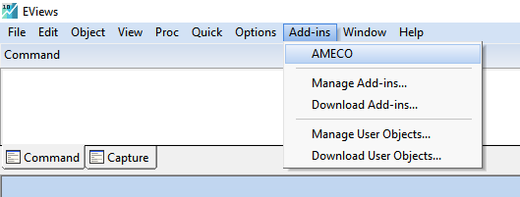

Figure 1 Accessing the AMECO add-in in EViews

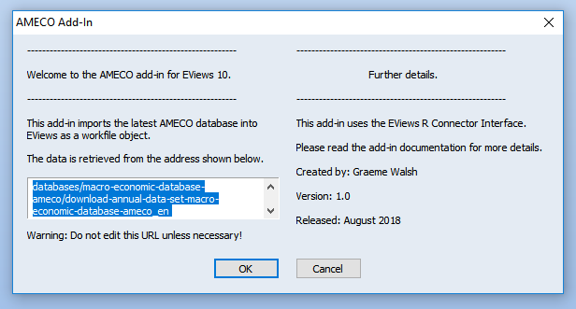

Figure 2 The AMECO add-in @uidialog

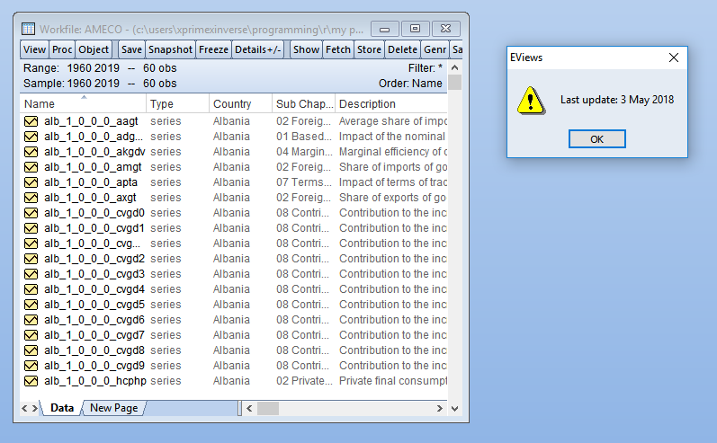

Figure 3 The add-in output (workfile and @uiprompt)

1. If this address changes causing any problems with the download, either change the URL in the @uidialog as appropriate or contact me with a request to update the add-in.