**Package Name:** EurostatBDF

**Author:** Graeme Walsh

**Date:** 18/08/2018

**Add-in Type:** Global

**Default Proc Name:** EurostatBDF

**Default Menu Text:** EurostatBDF

**Interface:** Menu and Command Line

**Description:**

This EViews add-in imports datasets from the Eurostat Bulk Download Facility into EViews as a workfile object.

The Eurostat Bulk Download Facility can be found at the following address: <http://ec.europa.eu/eurostat/estat-navtree-portlet-prod/BulkDownloadListing>

**Technical Notes:**

* This add-in uses the native EViews R connector interface.
* The R programming language is required to use this add-in.
* The speed of the add-in will depend on both your internet connection and hardware.
* The add-in source code is open and commented.

**Interactive Use:**

Running this add-in will present a @uidialog to the user. The user is then asked to choose a dataset. To do this, the user should enter into the textbox the code name of a Eurostat dataset. For example, the code name for the Quarterly National Accounts dataset is namq_10_gdp. The add-in then establishes a connection with R, downloads the data, and finally imports the data as a workfile.

**Command line:**

Syntax : EurostatBDF

**Screenshots:**

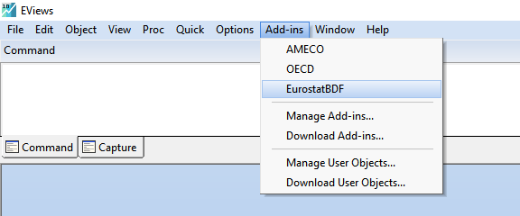

Figure 1 Accessing the EurostatBDF add-in in EViews

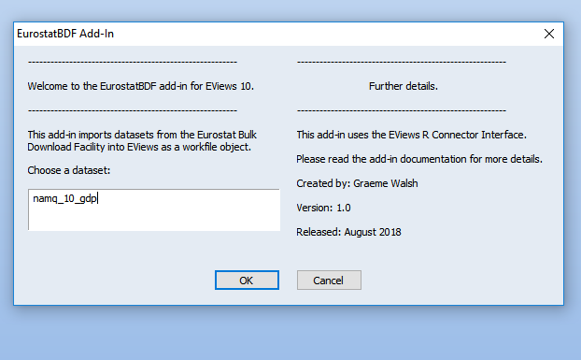

Figure 2 The EurostatBDF add-in @uidialog

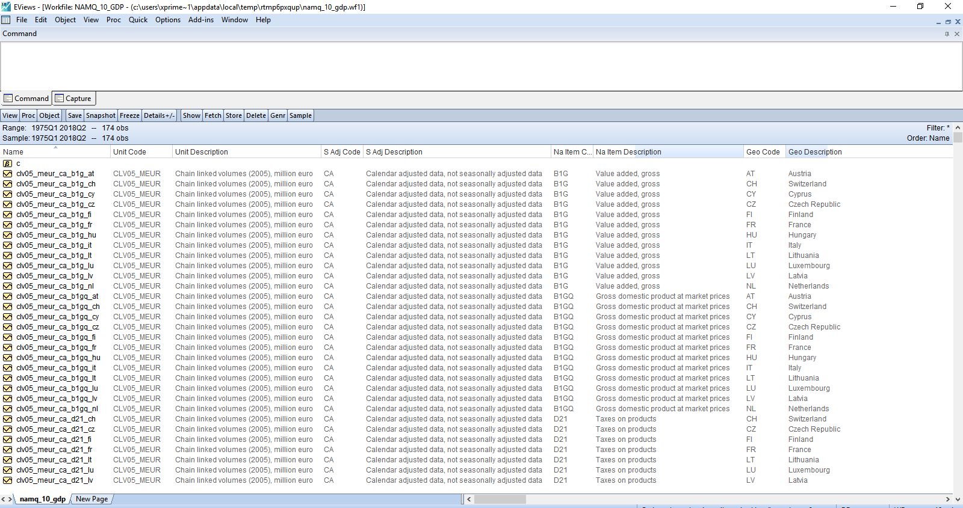

Figure 3 The add-in output (workfile)