**Package Name:** OECD

**Author:** Graeme Walsh

**Date:** 08/08/2018

**Add-in Type:** Global

**Default Proc Name:** OECD

**Default Menu Text:** OECD

**Interface:** Menu and Command Line

**Description:**

This EViews add-in imports the OECD Economic Outlook database into EViews as a workfile object. It does this by downloading the data from the OECD website using the OECD R package.

**Technical Notes:**

* This add-in uses the native EViews R connector interface.
* The R programming language is required to use this add-in.
* The speed of the add-in will depend on both your internet connection and hardware.
* The add-in source code is open and commented.

**Interactive Use:**

Running this add-in will present a @uidialog to the user. The user can choose a dataset to be downloaded. The add-in then establishes a connection with R, downloads the data, and finally imports the data as a workfile called OECD.wf1. The add-in concludes by issuing a @uiprompt notifying the user which version of the database has been loaded.

**Command line:**

Syntax : OECD

**Screenshots:**

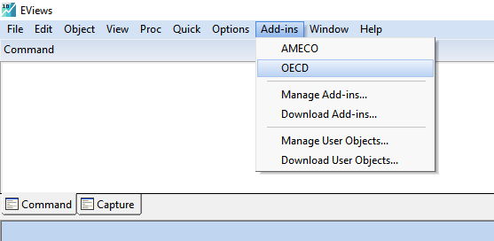

Figure 1 Accessing the OECD add-in in EViews

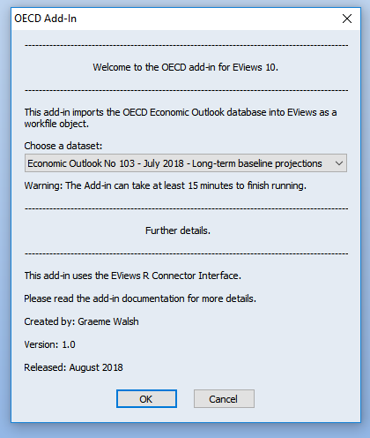

Figure 2 The OECD add-in @uidialog

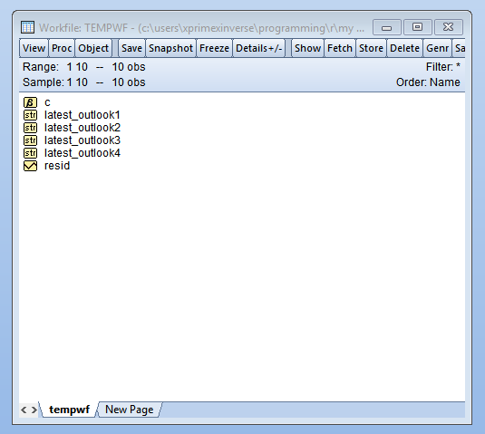

Figure 3 The add-in will create (and later delete) this temporary workfile

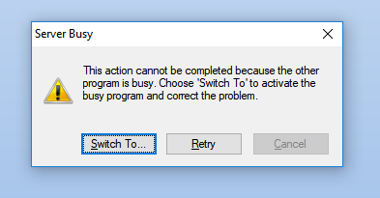

Figure 4 A notification that may appear when downloading a large database (tip: just ignore it, it should close by itself)

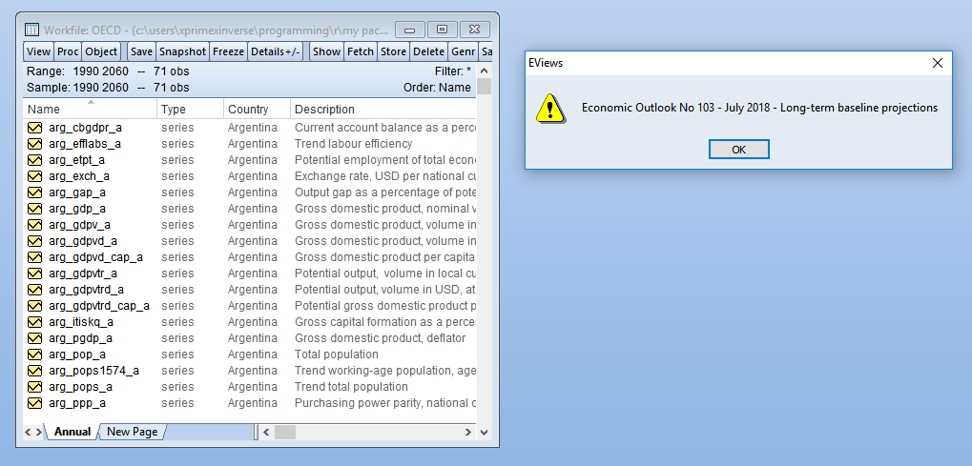

Figure 5 The add-in output (workfile and @uiprompt)

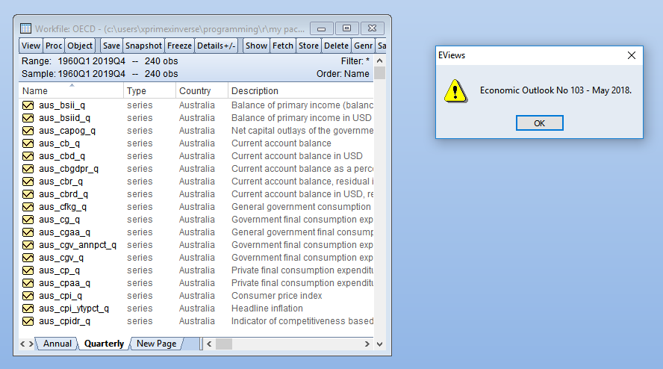

Figure The add-in output (workfile and @uiprompt) - Note: workfile contains both annual and quarterly data