Contents
File Movement Onboarding — How to Add a New Integration 1
The movement patterns 1
Which pattern do I need? 3
Configure the tables for your pattern 4
Add a new integration, step by step 5
Worked example: the ProductFeed sample 6
Checklist and common mistakes 7
The four tables and how they connect 8
What goes in every field 9
How the legs hand the file along 12

File Movement Onboarding — How to Add a New Integration
Every file this stark system moves takes the same journey like Source → a staging blob → Destination and a new integration is nothing more than a few rows in database tables that describe that journey across tables.
This guide gives a developer the mental model, a plain-English meaning for every field, the movement patterns the team already uses, and a worked example from the attached sample so they can add an file based integration without much help.
You never write code for a file movement. What you need create is Azure Function Trigger i.e, timer or blob (named in SchedulerName) run on its schedule, reads these config rows from SQL and passes the parameters to n already existing generic Synapse pipeline (named in each step's PipelineName) that performs the actual copy. Your only job is to describe the journey correctly in the tables schema, the scheduler and the pipeline do the work.
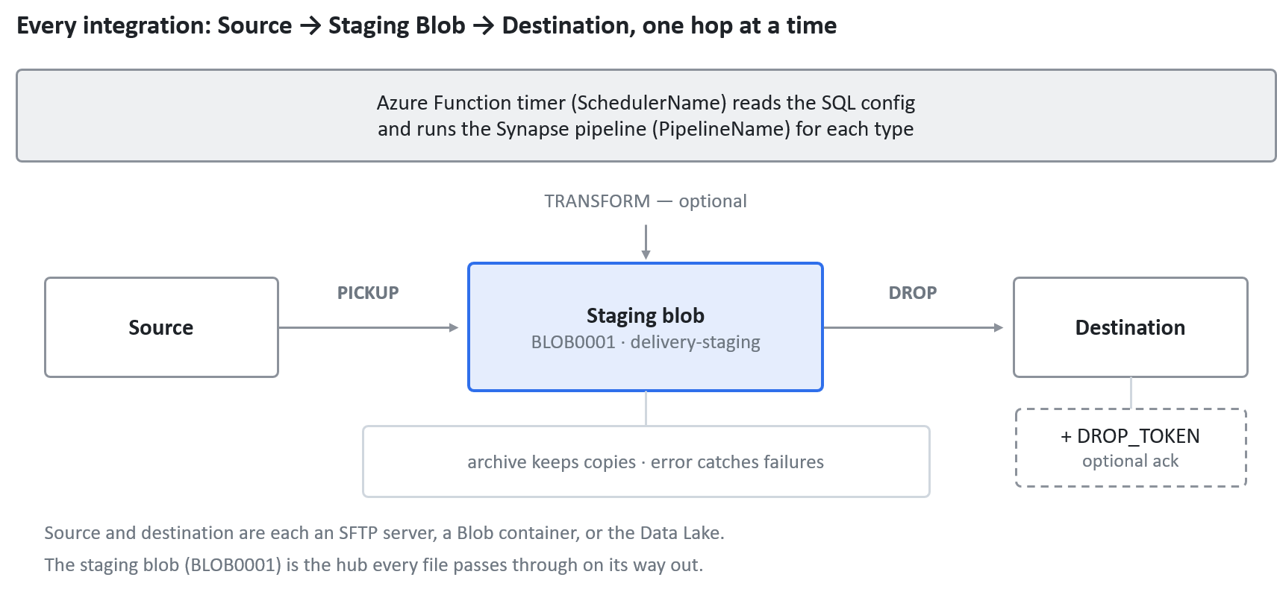
High level synapse pipeline workflow: PICKUP → optional TRANSFORM → DROP
A file is picked up into the staging blob, optionally transformed there, then dropped to the destination and the same scheduler and Synapse pipeline drive every leg.

The movement patterns
Across every integration in the data, the journeys fall into a small number of shapes. Almost any new feed is one of these, assembled from PICKUP / TRANSFORM / DROP legs. Find the row that matches where your file starts and ends, then copy that shape.
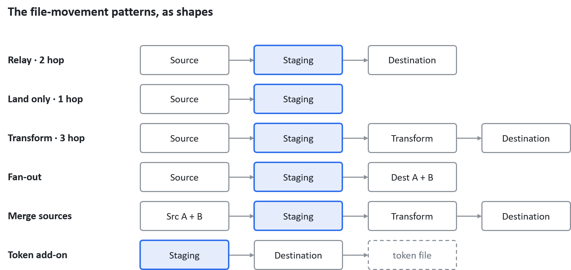
Six defined patterns · a center box is the intermediate staging blob.
Each row is one pattern shape and the center blue box is the staging blob location where every file passes through. Several named patterns share the Relay shape only the endpoints differ, so the table below lists all of them with a real example of each.
Pattern | Journey | Step sequence | Typical pipeline(s) | Example feed
Land only | SFTP → Blob | PICKUP | SFTP_To_Blob | FIGP00017 (GetPaid mail PDFs)
SFTP → Blob relay | SFTP → Blob | PICKUP → DROP | SFTP_OnPrem_To_Blob + Blob_To_Blob | FIPF001 (ProductFeed)
SFTP → SFTP via blob | SFTP → SFTP | PICKUP → DROP | SFTP_OnPrem_To_Blob + Blob_To_SFTP | FICE0001 (Tradex orders)
SFTP → Data Lake | SFTP → Data Lake | PICKUP → DROP (→ DROP_TOKEN) | SFTP_OnPrem_To_Blob + Blob_To_DataLake | FIDL0001 (Datalake product)
Transform in the middle | any → any | PICKUP → TRANSFORM → DROP | + Blob_To_Blob + | FICT0001 (Chevin → Trakm8)
Fan-out to several places | 1 source → 2+ dests | PICKUP → DROP → DROP2 | Blob_To_MultiBlob | FIPH0025 (supplier → two SFTPs)
Merge several sources | 2+ sources → 1 dest | PICKUP + PICKUP → TRANSFORM → DROP | AR_*_Transform + Blob_To_SFTP | FIGP00003 (GetPaid master)
Outbound from Data Lake | Data Lake → SFTP/Blob | PICKUP → DROP | Datalake_To_Blob + Blob_To_SFTP | FIERP0016 (CTM extract)
Token / ack add-on | (adds to any) | … → DROP_TOKEN | token variant pipeline | FISP0003 (SwissPost token)

Reading the pipeline-name suffixes. The base name says the direction (SFTP_OnPrem_To_Blob, Blob_To_SFTP, Blob_To_DataLake); the suffixes add behavior:
- _WithToken / _WithGroupToken : This handles a token file (a single token, or one grouped across files).
- _OnPrem : the SFTP endpoint is the on-prem ICON server (SFTP0001), as opposed to a cloud or partner SFTP.
- _MultipleStartFilter : pick several file-name patterns in one leg; _FilterBlankFiles also skips empty files.
- _Disable_Chunking : for servers that reject chunked transfers; _Without_log / _WithLogs control logging.
- _API / _SSH : delivery variants (API-based drop, or SSH-key SFTP).
Named pipelines such as AR_Master_Transform, GetPaid_RemoveDoubleQuotes and FnApp are custom transform steps written for one feed , you need to reuse them only for that feed not as generic building blocks.

Which pattern do I need?
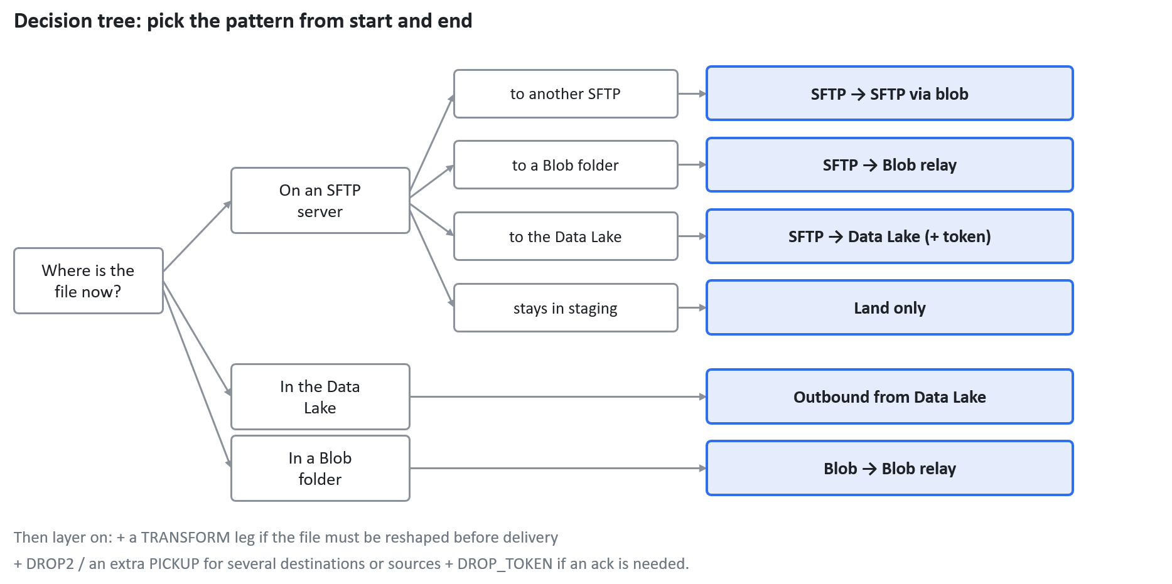

decision tree · source + destination → pattern
Follow the arrows from where the file sits now to the pattern on the right. The five questions below spell out the same choices, plus the modifiers, in words.
Answer five questions about the file and the shape falls out:
- Where does the file start? An SFTP server → a PICKUP with an SFTP_..._To_Blob pipeline. The Data Lake → a PICKUP with Datalake_To_Blob. Already in a blob folder → start from a Blob_To_... leg.
- Does it need reshaping by logic (not just a rename)? Yes → add a TRANSFORM leg (Blob_To_Blob, or a custom transform) between the PICKUP and the DROP.
- Where must it end? Another SFTP → a DROP with Blob_To_SFTP. Another blob folder → Blob_To_Blob. The Data Lake → Blob_To_DataLake.
- Must the destination be told the delivery is complete? Yes → add a DROP_TOKEN leg and set the header's TokenAckRequired / TokenFileName.
- Does one file go to several places, or do several files combine into one? Several destinations → add DROP2 / extra DROP legs (fan-out). Several sources into one output → add one PICKUP per source into the same transform-staging, then a single TRANSFORM to merge.
In short, every feed is: one PICKUP per source → an optional TRANSFORM → one DROP per destination → an optional DROP_TOKEN. Everything else is just folder paths and file names.

Configure the tables for your pattern
With a pattern chosen, here is exactly what to put in the rows. Always create one FilesIntegration header per file type, then its FileActions legs in order. The first table gives the field values by type, the second gives the pipelines and endpoints per pattern.
What each leg type gets (the fields that change between type):
Field | PICKUP | TRANSFORM (optional) | DROP
SourceID | the real source | BLOB0001 | BLOB0001
DestinationID | BLOB0001 | BLOB0001 | the final endpoint
SourceFolderPath | real source folder | transform-staging | delivery-staging
DestinationFolderPath | delivery-staging (or transform-staging) | delivery-staging | final destination folder
DestinationFileNameFormat | <next-leg-ID>_{filename} | <next-leg-ID>_{filename} | final name, or {filename}
BlobTriggerPath | — | transform-staging | delivery-staging
Pipelines and endpoints per pattern (the type and which PipelineName each uses):
Pattern | Type : ActionName : PipelineName | Endpoints
SFTP → Blob relay | PICKUP : SFTP_OnPrem_To_Blob · DROP : Blob_To_Blob | SFTP → BLOB0001 → blob
SFTP → SFTP via blob | PICKUP : SFTP_OnPrem_To_Blob · DROP : Blob_To_SFTP | SFTP → BLOB0001 → SFTP
SFTP → Data Lake | PICKUP : SFTP_OnPrem_To_Blob · DROP : Blob_To_DataLake · DROP_TOKEN | SFTP → BLOB0001 → DL0001
Transform in the middle | PICKUP · TRANSFORM : Blob_To_Blob · DROP | per the endpoints above
Outbound from Data Lake | PICKUP : Datalake_To_Blob · DROP : Blob_To_SFTP | DL0001 → BLOB0001 → SFTP
Fan-out | PICKUP · DROP + DROP2 : Blob_To_MultiBlob | 1 source → 2 endpoints
Merge sources | PICKUP per source · TRANSFORM · DROP | 2 sources → 1 endpoint
Whatever the pattern, also set these:
- On the FilesIntegration header: ProjectName, a new SchedulerName timer, and StartsWith / EndsWith / FileContainsFilter so only the intended files are caught.
- For any pattern with a token (Data Lake loads and some partner SFTPs): set TokenAckRequired = True and TokenFileName, and add the DROP_TOKEN leg.
- Copy RetryCount, SourceArchive / SourceArchivePath, SourceErrorPath, RetentionNoofDays / RetentionNoofFiles, and SourceDelete from a similar existing feed.
The ProductFeed worked example below is a filled-in instance of the SFTP → Blob relay row use it as a copy-and-adjust template.

Add a new integration, step by step
Work top-down. Steps 1–2 are one-time setup you can often skip because the endpoints already exist; steps 3–4 are the real work.
- Pick the shape. Use the five questions above to choose a pattern and count your legs (how many PICKUPs, whether there's a TRANSFORM, how many DROPs, whether there's a token).
- Make sure both endpoints exist. Look in SFTPConfig and BLOBConfig for a row for your source and your destination. If one is missing, add it with the host / account and the Key Vault secret names. The staging account BLOB0001 already exists — reuse it, don't create a new one.
- Create the header row in FilesIntegration (one per file type). Give it a new ID, set SourceSystem, ProjectName, and a new SchedulerName timer, and set StartsWith / EndsWith / FileContainsFilter so only the intended files are picked up. If the destination needs an ack, set TokenAckRequired and TokenFileName.
- Create the FileActions legs in order, all sharing the new IntegrationKeyID:
  - PICKUP : SourceID = the real source, DestinationID = BLOB0001, PipelineName = the matching ..._To_Blob template, SourceFolderPath = the real source folder, DestinationFolderPath = <project>/<flow>/delivery-staging (or transform-staging), DestinationFileNameFormat = <NEXT_STEP_ID>_{filename}. Set SourceArchive, SourceArchivePath, SourceDelete, RetryCount.
  - TRANSFORM (only if reshaping) : source and destination BLOB0001, read from transform-staging, write to delivery-staging, DestinationFileNameFormat = <NEXT_STEP_ID>_{filename}, BlobTriggerPath = the transform-staging folder.
  - DROP : SourceID = BLOB0001, DestinationID = the final endpoint, PipelineName = Blob_To_SFTP / Blob_To_Blob / Blob_To_DataLake, SourceFolderPath = delivery-staging, DestinationFolderPath = the final folder, DestinationFileNameFormat = the name the destination expects.
  - DROP_TOKEN (only if an ack is needed) : a final leg that writes the token file to signal completion.
- Wire the chain. Confirm each leg's SourceFolderPath + SourceFileNameFormat matches the previous leg's DestinationFolderPath + DestinationFileNameFormat, and that BlobTriggerPath points at the folder the previous leg writes to.
- Set retention and error paths on every leg : SourceErrorPath, RetentionNoofDays, RetentionNoofFiles : copying the values a similar feed already uses.
- Test end-to-end. Drop a test file in the source, let the scheduler run, and watch it move source → staging → destination. Confirm the -archive folder fills, and that a deliberately malformed file lands in -error.

Worked example: the ProductFeed sample
The attached sample adds one project, ProductFeed, carrying two feeds , a product feed and a Hybris stock feed. Each is the simplest shape: a two-leg SFTP → Blob relay (PICKUP → DROP) that lands an ICON file in staging and then drops it into the Hybris hot-folder.
Header rows (FilesIntegration) both use the ICON on-prem server and the same scheduler, the filters make sure each picks only its own files:
ID | IntegrationKey | ProjectName | SchedulerName | StartsWith | EndsWith
FIPF001 | products-<ts14>.csv | ProductFeed | productfeed-scheduler | products- | .csv
FIPF002 | HybStk_<ts14>_<branch4>.csv | ProductFeed | productfeed-scheduler | HybStk | .csv
Step rows (FileActions) — two legs per feed, each pair sharing one IntegrationKeyID:
ID | Feed | Action | Source → Dest | Pipeline | Reads → Writes
FAPF001 | FIPF001 | PICKUP | SFTP0001 → BLOB0001 | SFTP_OnPrem_To_Blob | products-<ts14>.csv from /k8data/ICON/Mule/OUT/Hybris/ → FAPF002_{filename} in productfeed/delivery-staging
FAPF002 | FIPF001 | DROP | BLOB0001 → BLOB0001 | Blob_To_Blob | FAPF002_{filename} from productfeed/delivery-staging → products.master-<ts14>.csv in hybris/hot-folder
FAPF003 | FIPF002 | PICKUP | SFTP0001 → BLOB0001 | SFTP_OnPrem_To_Blob | HybStk_<ts14>_<branch4>.csv → FAPF004_{filename} in productfeed/delivery-staging
FAPF004 | FIPF002 | DROP | BLOB0001 → BLOB0001 | Blob_To_Blob | FAPF004_{filename} → original name in hybris/hot-folder
Tracing the product feed (FIPF001): FAPF001 renames the file to FAPF002_... and drops it in productfeed/delivery-staging; the next leg is FAPF002, so it picks up exactly those files, renames to products.master-<ts14>.csv, and delivers to hybris/hot-folder. Processed files archive to productfeed/delivery-staging-archive, failures go to productfeed/delivery-staging-error.
Two things worth copying from this sample:
- The two feeds share one project and one staging folder but each has its own header and its own pair of legs — that is the normal way to run several file types under one integration.
- The angle-bracket tokens are naming placeholders: <ts14> is a 14-character timestamp and <branch4> a 4-character branch code, describing the variable parts of the file name so the filters and renames line up. They are different from the curly-brace {filename}, which carries the whole original name through the chain. Note that FIPF001 renames on delivery while FIPF002 leaves DestinationFileNameFormat blank and keeps the original name — the final name is yours to choose per feed.

Checklist and common mistakes
Before you call a new integration done:
- Both endpoints have a row in SFTPConfig / BLOBConfig (source and destination).
- One FilesIntegration header per file type, with a working SchedulerName and filters that catch only the intended files.
- All legs of the feed share the same IntegrationKeyID.
- Every non-final leg renames to <NEXT_STEP_ID>_{filename}, and the next leg reads that exact prefix.
- Staging folders follow <project>/<flow>/delivery-staging with -archive and -error siblings.
- BlobTriggerPath points at the folder the previous leg writes to.
- SourceArchive, SourceDelete, retention, and error paths set on every leg.
- Token leg and header token fields set if the destination needs an ack.
- Tested with a real file end-to-end, including a deliberate error case.
The mistakes that trip people up most often:
- Broken chain : the DROP's SourceFileNameFormat prefix doesn't match the PICKUP's DestinationFileNameFormat, so the file sits in staging forever. This is the number-one issue.
- Wrong staging folder : a typo in delivery-staging, or a missing -archive / -error sibling, means files vanish or can never be cleaned up.
- Filters too loose : blank StartsWith / EndsWith picks up files meant for another feed that shares the same source folder; use FileContainsFilter or an Except- filter to exclude them.
- Forgot the token : a Data Lake or partner destination that expects an ack is never triggered because the DROP_TOKEN leg or the header token fields are missing.
- SourceDelete surprises : SourceDelete = True on a shared source folder can delete files another feed still needs; leave it False when in doubt.
- Reusing a custom pipeline : named transforms such as AR_*_Transform only work for their own feed; use a generic Blob_To_Blob for a new transform step.
- Scheduler not deployed : SchedulerName must match a real Azure Function timer; a name with no function behind it means the feed never runs.

The four file integration tables and how they connect
Two of the tables are address books, one is the feed's header, and one is the list of steps. You will touch all four for most new integrations.
- SFTPConfig : the address book of SFTP servers. One row per server: host, port, and the Key Vault secret names for its credentials (never the secrets themselves). A step points at a server by its ID, e.g. SFTP0001.
- BLOBConfig : the address book of Azure Blob storage accounts. One row per storage account. BLOB0001 is the shared staging account that almost every integration uses for its middle-of-the-belt folders.
- FilesIntegration (the header) : one row per feed. It says what file to watch for, which source system it comes from, which scheduler runs it, and the filters that recognise the right files. Think of it as the cover sheet for one feed.
- FileActions (the steps) : the step-by-step moves. One row per leg of the journey (a PICKUP, a TRANSFORM, a DROP). Every leg of one integration shares the same IntegrationKeyID, which points back to its FilesIntegration row.
The links are simple: a FileActions row names its feed through IntegrationKeyID, and names its two endpoints through SourceID and DestinationID. Those endpoint IDs resolve to a row in SFTPConfig or BLOBConfig. The Data Lake and a couple of databases are referenced the same way, by IDs such as DL0001 or TimberDb, which live in their own config tables not shown in these four files.
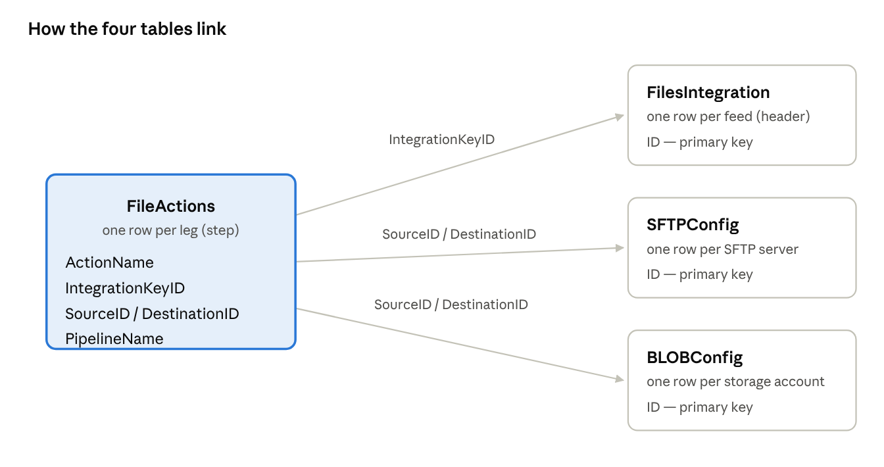
table relationships · FileActions is the hub
FileActions is the hub: each leg names its feed through IntegrationKeyID and its two endpoints through SourceID and DestinationID, which resolve to a row in SFTPConfig or BLOBConfig.

What goes in every field
Credentials are never stored in these tables the ...Key columns hold the name of a Key Vault secret, and the actual Password column stays blank. Audit columns (CreationDateTime, UpdationDateTime) are filled automatically; ignore them when adding rows.
SFTPConfig - one row per SFTP server
Field | What to put
ID | The handle you reference from a step, e.g. SFTP0001.
IPAddress | The SFTP host name.
Port | The SFTP port, almost always 22.
Username | The SFTP login name.
Password | Leave blank — the real value lives in Key Vault.
FolderPath | Optional default base path on the server.
PasswordKey | Key Vault secret name holding the password.
RSABase64Key / SSHKey / PassPhraseKey | Key Vault references for key-based auth; set only when the server uses an SSH key instead of a password.
BLOBConfig - one row per storage account
Field | What to put
ID | The handle you reference, e.g. BLOB0001 (the shared staging account).
StorageName | The Azure storage account name.
ServiceEndPoint / URL | The blob endpoint URL for the account.
ContainerName | Default container; often blank, because the container is the first segment of each folder path.
ServicePrincipal / ClientId / ClientSecretKey | Key Vault-backed service-principal auth, when the account is not reached by account key.
FilesIntegration - one row per feed (the header)
Field | What to put
ID | Feed id, e.g. FIPF001. Steps link to it through IntegrationKeyID.
IntegrationKey | A label for the feed, usually the file name or pattern.
SourceSystem | Where the file originates: ICON, HX, FELIX, Phocas, etc.
Description | Free text — by convention the schedule in words (“Every 15 min 24x7”).
ProjectName | Groups related feeds together; also feeds the folder naming.
SchedulerName | The Azure Function timer that runs this feed.
StartsWith / EndsWith | File-name filters — only files whose name starts / ends with these are picked up. Either can be a JSON list for several patterns.
FileContainsFilter | Extra include/exclude filter; Except-X excludes files containing X.
TokenAckRequired / TokenFileName / IsSynchronizedToken | Set when the destination needs a token (ack) file; name it and mark whether it must be synchronised with the data file.
FileActions - one row per leg (the steps)
Field | What to put
ID | Step id, e.g. FAPF001. The next step's ID is used as this file's rename prefix (see the next section).
IntegrationKeyID | The FilesIntegration.ID this step belongs to; all legs of one feed share it.
ActionName | PICKUP, TRANSFORM, DROP, DROP_TOKEN, or DROP2 (a second parallel drop).
SourceID / DestinationID | The endpoint IDs to read from / write to (an SFTPConfig, BLOBConfig, or Data Lake id).
PipelineName | The Synapse pipeline template that performs this leg, e.g. SFTP_OnPrem_To_Blob, Blob_To_Blob, Blob_To_SFTP.
SourceFileNameFormat | What names to look for at the source; wildcards (*) and the {filename} token are allowed.
SourceFolderPath | The folder to read from. For a PICKUP it is the real source folder; for later legs it is a staging folder.
DestinationFolderPath | The folder to write to. For PICKUP/TRANSFORM this is a staging folder; for DROP it is the final destination.
DestinationFileNameFormat | The name to give the file on arrival. {filename} keeps the original; a prefix such as FAPF002_{filename} hands it to the next leg. Blank = keep original.
SourceArchive / SourceArchivePath | True to move the processed file into an archive folder, and where.
SourceErrorPath | Where files that fail this leg are placed.
BlobTriggerPath | The blob folder whose new file triggers this leg — how one leg hands off to the next.
RetryCount | How many times to retry the leg on failure.
RetentionNoofDays / RetentionNoofFiles | How long and how many files to keep in the archive before cleanup.
SourceDelete | True to delete the file from the source after a successful move.

How the steps chain together
Two naming conventions wire the steps of one feed together. Get these right and the file flows by itself; get them wrong and it simply disappears into a folder nobody watches. This is where most mistakes happen.
1. The staging folders. Every feed owns a small set of folders inside BLOB0001, named by a fixed pattern <project>/<flow>/...:
- .../delivery-staging the working folder the file passes through on its way to the destination.
- .../delivery-staging-archive where the file is kept after it has been processed (trimmed by the retention settings).
- .../delivery-staging-error where the file lands if a leg fails.
A feed that transforms also has a matching transform-staging / -archive / -error set, used before delivery-staging.
2. The file-name prefix (the chain). Steps run in order, and each leg hands the file to the next by renaming it with the next leg's ID as a prefix. The {filename} token stands for the original file name:
- The PICKUP writes into staging as FAPF002_{filename} FAPF002 is the ID of the next leg.
- That next leg (the DROP) looks for exactly that prefix: its SourceFileNameFormat is FAPF002_{filename}.
The shared FAPF002_ prefix is the thread that stitches the two rows together, and BlobTriggerPath points at the staging folder so that the renamed file arriving there is what triggers the next leg.
The golden rule: a leg's SourceFolderPath + SourceFileNameFormat must exactly match the previous leg's DestinationFolderPath + DestinationFileNameFormat. A quick trace of the ProductFeed example:
- PICKUP reads products-<ts14>.csv from the ICON server → writes FAPF002_products-<ts14>.csv into productfeed/delivery-staging.
- DROP reads FAPF002_* from productfeed/delivery-staging → writes products.master-<ts14>.csv into hybris/hot-folder.
The original name rides through on {filename}, and the final DROP is free to rename it to whatever the destination expects.

