Operational Notifications — Integration Layer: Design & Estimation
Prepared following the STARK UK estimation template. As-of 28 October 2026.

Overview
To deliver operational notifications to Jewson customers (order, account, invoice and selected branch events), the integration layer must detect business events in the persistence layer and hand them to a third-party Notification Service that performs delivery across push, SMS and email. This document covers the integration-layer scope only: the EVENT table, how it is populated, and the Azure Function that forwards events to the Notification Service.
The scope boundary is the hand-off from the dispatcher Function to the Notification Service. Delivery, channel fallback and consent sit with the vendor and are out of scope. Marketing notifications remain in Salesforce Marketing Cloud and are out of scope.
The detailed design (schema, population approaches, dispatcher, duplicate detection, failure handling and testing) is maintained separately; this document carries the analysis and estimation.

Key components
The solution involves the following key components:
Component/System | Description
JCA | The Jewson Customer App. Consumer of the in-app notification inbox, if in scope.
Persistence Layer DBs | Accounts DB and Orders DB holding the source data that events are derived from.
Data-lake sync (ETL) | Loads data back into the persistence-layer DBs and raises events as part of the load.
NotificationEvent (3 tables) | Three standalone tables per service in the notification schema — NotificationEvent (live outbox), NotificationEventAudit (delivered), NotificationEventDeadLetter (permanent failures). No foreign keys.
Detection SPs | usp_RaiseNotificationEvent and per-domain usp_RaiseOrderEvents / usp_RaiseAccountEvents.
DB triggers | Field-watching triggers for credit limit, credit status and strategic balance.
Dispatcher Function | Timer-triggered Azure Function that claims events from the table and POSTs them over HTTPS to the Notification Service. One instance per service domain. No queue or broker.
Notification Service | Third-party (vendor) platform that delivers push, SMS and email.
SFMC | Salesforce Marketing Cloud — marketing notifications, out of scope.

Assumptions
In this document the following assumptions were made:
Assumption | Description | Verified
A01 | It is possible to modify the data-lake sync to call detection stored procedures after each domain load. | TBV
A02 | Field-watching triggers can be added to ACCOUNTS and ACCOUNTS_EXTENSION_GETPAID without unacceptable bulk-load overhead (to be confirmed by load test). | TBV
A03 | The Notification Service exposes an HTTPS API that accepts an idempotency key per event. | TBV
A04 | The Notification Service deduplicates on the idempotency key, so at-least-once delivery yields no duplicate the customer sees. Required for the no-duplicates requirement. | TBV
A05 | SOS can see orders across all channels and emit order-status changes to the EVENT table via an Assistive API. Gates the four order-lifecycle events. | TBV
A06 | Branch opening hours are not fed from SAPCC back to the Store DB, so branch opening-hours notifications are out of scope in the current model. | NO
A07 | The EVENT table resides in the same database as its source data (per domain), so the outbox write is transactional with the data change. | YES
A08 | The dispatcher Function runs on a Premium/Dedicated plan in UK South, VNet-integrated with Private Endpoints and Managed Identity. | TBV
A09 | Marketing notifications are delivered by SFMC and are out of scope for this integration. | YES

Entities
The solution uses a hot / cold split across three standalone tables in a notification schema (per service domain), so the table the dispatcher scans every run holds only live work and stays small. No foreign keys link them — they are related only by the lifecycle movement shown in the diagram.
notification.NotificationEvent — the live outbox. Holds only in-flight records: Pending (not yet sent), InProgress (claimed, being sent) and Retry (transient failure, awaiting backoff). The moment a record reaches a terminal state it leaves this table, so it never accumulates history and the dispatch claim scan is always fast. One primary key (EventId) and one business key (DedupeKey).
notification.NotificationEventAudit — the permanent record of delivered notifications. On a successful send the record is moved here in one transaction (inserted into Audit, deleted from the live table), carrying the full event plus the delivery time (SentAt). It is append-only, never scanned by the dispatcher, and is the natural source for audit, reconciliation and an in-app notification inbox.
notification.NotificationEventDeadLetter — permanent failures. A record that fails permanently (4xx) or exhausts its retries is moved here with its failure detail (FailedAt, FailureReason, LastError). Operators triage from this table; replaying a record means moving it back to the live table as Pending.
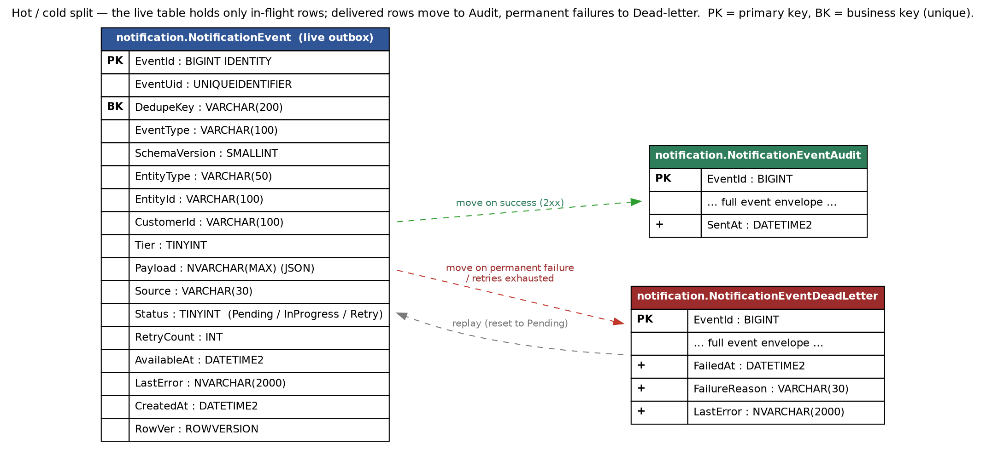
Figure 1 — Three-table hot / cold split: live outbox, Audit, Dead-letter.
Note: the three tables share the same event envelope and carry no foreign keys. EventId is the primary key and DedupeKey the business key (enforced unique on the live table, to block duplicate in-flight inserts). EntityId and CustomerId are plain identifier columns, not foreign keys. A row moves atomically on completion — a DELETE from the live table with OUTPUT INTO the Audit or Dead-letter table — so it is never in two tables or none. Because terminal rows leave immediately, the live table needs no archive job; the Audit table instead carries the long-term retention policy. Crash recovery resets any InProgress rows to Pending at the start of the next run (the timer is singleton), and the idempotency key prevents any double send.
The live NotificationEvent fields (the Audit and Dead-letter tables carry the same envelope plus the outcome columns shown in the diagram):
Field | Type | Purpose
EventId | BIGINT IDENTITY, PK | Surrogate key; orders the outbox and drives the claim ordering. Internal only.
EventUid | UNIQUEIDENTIFIER | Message id for one physical row; the correlation id carried to the Notification Service and logs.
DedupeKey | VARCHAR(200), business key | Deterministic business key (EventType | EntityId | discriminator); unique, so it blocks duplicate inserts, and it is the idempotency key sent downstream.
EventType | VARCHAR(100) | The notification type, e.g. Account.Restricted; selects the message template.
SchemaVersion | SMALLINT | Version of the Payload contract, so it can evolve without schema change.
EntityType | VARCHAR(50) | The kind of business entity the event is about: Account, Invoice or Order.
EntityId | VARCHAR(100) | The identifier of the related business record (account no, invoice id, order no), carried for context. Not a foreign key.
CustomerId | VARCHAR(100) | The recipient key; the Notification Service resolves contact details and consent from it.
Tier | TINYINT | SLA lane: 1 RealTime, 2 Scheduled, 3 Batch; lets the Function fast-poll urgent events.
Payload | NVARCHAR(MAX) (JSON) | The business data for the message template (amounts, dates, branch, order number, etc.).
Source | VARCHAR(30) | Which producer wrote the row: EtlSproc, DbTrigger, ScheduledFn or AppService.
Status | TINYINT | In-flight state only: 0 Pending, 1 InProgress, 3 Retry. A row that reaches a terminal state (Sent or DeadLetter) leaves the table, moving to Audit or Dead-letter.
RetryCount | INT | Delivery attempts; drives the backoff and the dead-letter threshold.
AvailableAt | DATETIME2 | Earliest time the row may be processed; used for backoff and scheduling.
LastError | NVARCHAR(2000) | The last failure detail, for triage of retried or dead-lettered rows.
CreatedAt | DATETIME2 | When the event row was written.
RowVer | ROWVERSION | Optimistic-concurrency token.

Analysis
The pipeline is a transactional outbox with a polling dispatcher. The operational-flow diagram below shows the components and the numbered steps — black is existing, green is new. The scenarios that follow describe the base case and the failure / duplicate handling.
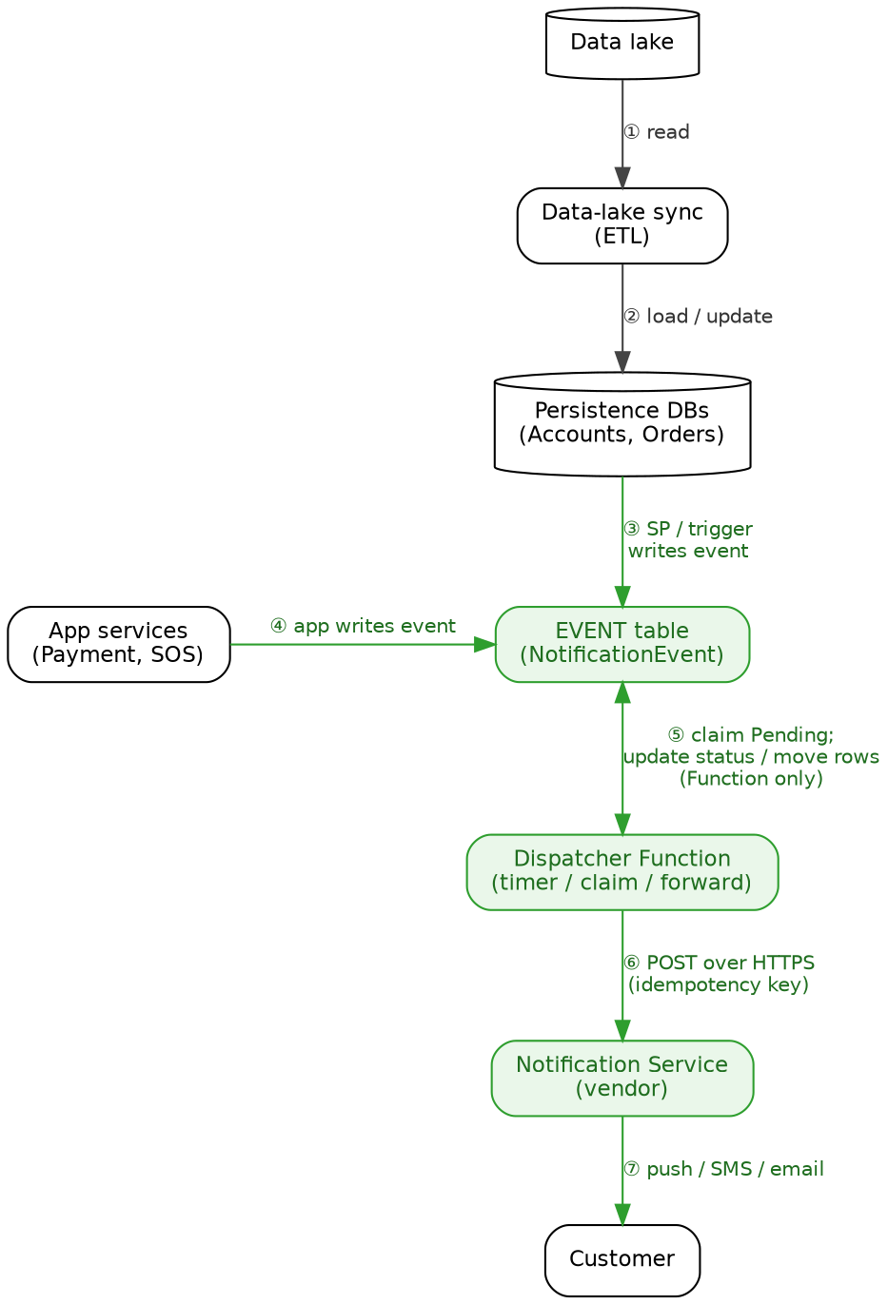
Figure 2 — Operational flow (black existing, green new).
Step | Description
1 | The data-lake sync reads source data from the data lake.
2 | The sync loads and updates the persistence databases (Accounts, Orders).
3 | On a watched change, a detection stored procedure (called by the sync) or a field-watching trigger writes an event row to the EVENT table, in the same transaction as the change.
4 | An application service (Payment at stage 2, SOS on an order status change) writes an event row to the EVENT table.
5 | The dispatcher Function timer fires and claims Pending rows from the EVENT table using READPAST. The Function is the only component that reads or writes the table.
6 | The Function POSTs each event, with its idempotency key, to the Notification Service over HTTPS.
7 | On the Notification Service’s response, the Function settles the row — moving it to Audit on success or to Dead-letter on permanent failure. The Notification Service never writes to the table.
8 | The Notification Service resolves recipient, consent and channel and delivers push / SMS / email to the customer (out of scope).

Dispatch sequence
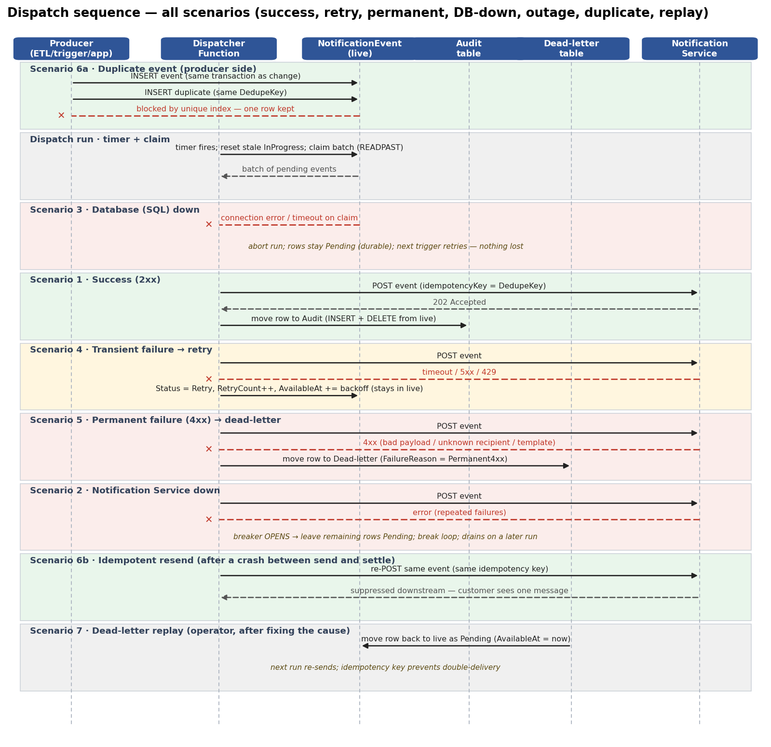
Figure 3 — Dispatch sequence: every scenario (success → Audit, retry, permanent → Dead-letter, DB-down, outage, duplicate, replay).

Scenarios
Each scenario below traces one dispatcher run, step by step. The sequence diagram above shows them together; the tables below walk each path on its own.

1. Base case — all successful
Step | Description
1 | The timer fires; the Function resets any stale InProgress rows to Pending (startup recovery).
2 | The Function claims a batch of Pending rows from the EVENT table using READPAST and marks them InProgress.
3 | For each event, the Function builds the envelope: messageId (EventUid), idempotencyKey (DedupeKey), eventType, customerId and the JSON payload.
4 | The Function POSTs the event to the Notification Service with the idempotency key.
5 | The Notification Service accepts it (2xx); the Function moves the row to the Audit table (insert + delete in one transaction) with SentAt.
6 | The Function repeats for the next event; when the batch is done, the run ends.
7 | The Notification Service resolves recipient, consent and channel and delivers push / SMS / email (out of scope).

2. Notification Service down
Step | Description
1 | The Function claims a batch and begins the per-event loop.
2 | It POSTs the first event; the Notification Service does not respond (timeout or 5xx).
3 | The Function marks the row Retry (RetryCount++, AvailableAt = now + backoff) and tries the next event.
4 | Consecutive failures exceed the breaker threshold and the circuit breaker opens.
5 | The Function stops sending, leaves the remaining rows Pending, and ends the run — nothing is lost.
6 | While the breaker is open, later runs probe periodically and the backlog grows in the outbox.
7 | A probe succeeds; the breaker closes and the backlog drains. Urgent events breach their latency SLA during the outage but still arrive.

3. Database (SQL) down
Step | Description
1 | The timer fires and the Function attempts to claim a batch.
2 | The database is unavailable; the claim query fails with a connection error or timeout.
3 | The Function logs the error and ends the run without sending anything.
4 | No rows were claimed, so every pending event remains Pending and durable in the table.
5 | The next timer run retries the claim; once the database is back, processing resumes.
6 | No events are lost or duplicated — nothing left the outbox.

4. Transient failure — retry
Step | Description
1 | The Function POSTs an event to the Notification Service.
2 | The service returns a transient error (timeout, 5xx or 429).
3 | The Function marks the row Retry: RetryCount++, AvailableAt = now + backoff (honouring Retry-After on 429).
4 | A later run re-claims the row once AvailableAt has passed and POSTs again — the idempotency key makes a repeat safe.
5 | The service accepts it (2xx); the Function moves the row to the Audit table.
6 | If attempts reach the maximum first, the row is moved to the Dead-letter table instead (Scenario 5).

5. Permanent failure — dead-letter
Step | Description
1 | The Function POSTs an event to the Notification Service.
2 | The service returns a permanent error (4xx — malformed payload, unknown recipient or bad template).
3 | The Function moves the row to the Dead-letter table immediately with FailureReason and LastError; retrying cannot help.
4 | An alert fires on Dead-letter table depth and the row is visible for triage.
5 | Once the cause is fixed, the row is replayed (Scenario 7).

6. Duplicate event — idempotent handling
Step | Description
1 | The same logical event is raised twice — an ETL re-run, a scheduled job firing twice, or an app retry.
2 | The insert carries the same DedupeKey; the unique index blocks the second row (Layer 1).
3 | Separately, the Function may resend a row after a crash between send and mark-Sent (at-least-once).
4 | The resend carries the same idempotency key; the Notification Service suppresses it before delivery (Layer 2).
5 | The customer sees exactly one message.

7. Dead-letter replay
Step | Description
1 | One or more rows are in the Dead-letter table after a permanent failure or exhausted retries.
2 | An operator triages the cause from LastError and fixes it.
3 | The rows are moved back to the live table as Pending with AvailableAt = now.
4 | The next run re-claims and re-sends them.
5 | Anything already delivered is suppressed by the idempotency key, so replay cannot double-deliver.

Implementation rules

Event identity and duplicate detection
- Each event carries three identifiers: EventId (surrogate, ordering), EventUid (message id for tracing), and DedupeKey (the business key: EventType | EntityId | discriminator).
- Layer 1 (producer): a unique index on DedupeKey makes every insert idempotent — a re-run cannot create a second row for the same logical event.
- Layer 2 (consumer): the idempotency key (DedupeKey) is sent on every request so the Notification Service suppresses a resend before it reaches a channel. Depends on A04.

Failure handling
There is no Service Bus or queue — the live EVENT table is the durable queue. Retry is an in-table state; successful and permanently-failed records move to the Audit and Dead-letter tables, so the live table only ever holds in-flight work.
- Transient failures (timeout, 5xx, 429) are retried with exponential backoff and bounded attempts, driven by RetryCount and AvailableAt (the row’s next-visible time); honour Retry-After on 429. The row stays in the live table while retrying.
- Permanent failures (4xx), and transient failures past the max attempts, are moved to the Dead-letter table with FailureReason and LastError; retrying cannot help.
- Because dead-lettered rows live in a separate table, a poison event never touches the live outbox or the dispatch scan — the isolation a broker DLQ would give, by table separation.
- Replay moves a row from the Dead-letter table back to the live outbox as Pending; the next run re-sends it and the idempotency key prevents any double-delivery.
- A full outage opens a circuit breaker; the live table buffers the backlog so nothing is lost. The breaker matters more without a broker — it stops the Function burning retries and moving the whole backlog to Dead-letter during the outage.

Database operations
- All access is via stored procedures, set-based, using async/await; reuse the connection for related operations.
- The outbox write is in the same transaction as the source change (per-domain table), guaranteeing no lost or phantom events.

Residency, observability and retention
- Message content and contact details are processed in the UK/EU; the Function runs in UK South with Private Endpoints and Managed Identity (no secrets).
- Emit pending depth, oldest-pending lag against each tier SLA, send latency, retry rate, dead-letter count and breaker state; alert on lag, dead-letter count and breaker.
- The live table self-trims — rows leave on completion — so it needs no purge job; the Audit table carries the long-term retention policy (archive to cold storage after N months).

Ingestion analysis
Requirement | Description
FR-01 | Must capture a notification event when a watched field changes or a relevant record is loaded or changed in the persistence layer.
FR-02 | Must write the event in the same transaction as the source change (transactional outbox).
FR-03 | Must assign a deterministic business key (DedupeKey) so a re-run cannot create a duplicate event.
FR-04 | Must tag each event with its SLA tier (real-time, scheduled or batch).
FR-05 | Must carry the recipient key (CustomerId) and the business payload required by the message template, and nothing more.

Dispatcher analysis
Requirement | Description
FR-01 | Must claim unsent events without double-claiming across instances.
FR-02 | Must forward each event to the Notification Service with an idempotency key.
FR-03 | Must retry transient failures with backoff and dead-letter after a bounded number of attempts.
FR-04 | Must stop sending during a full outage (circuit breaker) and resume without losing events.
FR-05 | Must record the delivery outcome and expose operational metrics (lag, dead-letter count, breaker state).
FR-06 | Must process real-time events within the 60-second tier and scheduled events within the 15-minute tier, subject to upstream data cadence.

Adding a new notification
A new notification is additive and does not change the dispatcher Function. The Function is notification-agnostic — it claims any Pending row and forwards any envelope — so a new notification touches only the producer side and the vendor template.
To add one:
- Define a new EventType and its DedupeKey discriminator (what makes each occurrence unique).
- Define the Payload fields the message needs; because Payload is JSON with a SchemaVersion, no table change is required.
- Add the change-detection rule that emits the event: a new branch in the domain’s detection SP, or a new trigger predicate on the watched field — additive and set-based.
- Register the EventType in a small configuration table (tier, template key, enabled flag).
- Author the message template in the Notification Service.
What does not change: the EVENT table schema, the dispatcher Function, the claim / retry / dead-letter logic, the envelope contract, or the infrastructure. A new notification is therefore a small, low-risk change — one detection rule plus a template — typically 0.5–1 day of development per notification (plus the vendor template), not a Function change.
A metadata-driven EventType registry (a config table mapping EventType to tier, template key, required payload fields and an enabled flag) makes this cleaner still: new notifications become a config row plus a detection rule, and can be enabled or disabled without a deploy.

Estimation
The following is a pre-estimation breakdown prepared for the estimation session, which is to be scheduled. The proposed participants are:
Name | Role
TBC | Architect
TBC | Architect
TBC | Software Developer
TBC | Software Developer
TBC | QA Engineer
TBC | PA Engineer

The following points are to be discussed:
- Review of the integration-layer design
- Event-source approach (SP vs trigger) per domain and field
- Duplicate detection and the idempotency contract with the vendor
- Failure handling and the circuit breaker
- SLA tiers versus upstream data cadence
- QA strategy (scenario coverage and the stub service)
- PA strategy (load at ETL volume)
The following open points / missing aspects are identified:
- Confirm the Notification Service deduplicates on the idempotency key (A04) — required for the no-duplicates commitment.
- Confirm SOS cross-channel order visibility and the Assistive API (A05) — gates the four order events; they may move to a later phase if unresolved.
- Confirm the max retry count and backoff schedule before a row is dead-lettered — handled in the EVENT table, since there is no queue.
- Decide the scheduled run time for the invoice due/overdue reminders.
- Confirm tier assignment against real data cadence — account-status and balance events are ETL-bound and cannot be 60-second.
- Encryption / PII handling of the payload at rest and UK/EU residency sign-off.
- Whether an in-app notification inbox is in scope (adds an API endpoint and a persistence read).
The following tasks are identified:
Task | Description | Owner
T-01 | Create the three tables (live, Audit, Dead-letter), indexes and move-on-completion logic in each service DB. | Developers
T-02 | Create usp_RaiseNotificationEvent and the per-domain detection SPs (usp_RaiseOrderEvents, usp_RaiseAccountEvents). | Developers
T-03 | Create the field-watching triggers (credit limit, credit status, strategic balance). | Developers
T-04 | Coordinate with the data-lake / ETL team to call the detection SPs after each domain load. | Developers
T-05 | Implement per-event-type change detection and payload shaping (approx. 17 buildable events). | Developers
T-06 | Build the dispatcher Azure Function: claim query, envelope, forward. | Developers
T-07 | Implement retry/backoff, dead-letter and replay. | Developers
T-08 | Implement the circuit breaker and the fast/standard timer split. | Developers
T-09 | Define the boundary contract with the Notification Service (HTTPS endpoint, envelope, idempotency header). | Developers
T-10 | Observability: metrics, dashboards and alerts (lag, dead-letter count, breaker). | Developers
T-11 | Infrastructure: Premium plan, VNet, Private Endpoints, Managed Identity, UK South. | Developers
T-12 | Build the Notification Service stub / surrogate for testing. | Developers
T-13 | CI/CD pipeline for the Function and the stub. | Developers
T-14 | Create test cases from the scenarios (dedup, idempotent resend, retry, permanent failure, outage, dead-letter replay, concurrency). | QA Engineers
T-15 | Execute test cases. | QA Engineers
T-16 | Execute performance / load tests at ETL volume (trigger and claim under contention; dispatch latency). | PA Engineers

Scope of the estimate: the first service carries the full build — the one-time shared framework plus that service’s event population. Every service after that is a copy-paste of the same machine (the three tables and the dispatcher Function come straight from the templates and library); the only real per-service work is populating the EVENT table for that domain’s events, which scales with how many notifications the domain has.

Shared (one-time)
Built once and reused by every service domain:
Activity | Dev (days) | QA (days) | PA (days)
Shared dispatcher-Function library (claim, forward, settle, retry / dead-letter / replay, circuit breaker, timers) | 6
Boundary contract + envelope (HTTPS) | 2
Object + CI/CD templates (3 tables, SPs, pipeline) | 2
Infrastructure pattern (plan, VNet, Private Endpoints, Managed Identity) | 2
Observability dashboards + alert templates | 2
Notification Service stub / surrogate | 2
Reusable scenario test pack |  | 4
Load-test harness + prove the pattern |  |  | 2
Subtotal — shared | 16 | 4 | 2

Per service
The shared framework is paid once (with the first service). After that, each service is a copy-paste stamp-out — deploy the three tables from the template, instantiate the dispatcher Function from the library, wire its pipeline and smoke-test — plus the event-population work (detection SPs / triggers, DedupeKey, payload and tests) for that domain’s events. Event population is the dominant cost and scales with the domain’s event count.
Service | Events (~) | Copy-paste stamp-out (Dev) | Event population (Dev) | QA | PA
Account | 13 | 1 | 6 | 4 | 1
Order | 4 | 1 | 2 | 2 | 1
Each further service | n | 1 | ~0.4n | ~0.3n | 1

Worked total
Shared once, plus each service in scope. Example for Account (built first) and Order:
Build | Dev (days) | QA (days) | PA (days)
Shared (one-time) | 16 | 4 | 2
+ Account (13 events) | 7 | 4 | 1
+ Order (4 events) | 3 | 2 | 1
Total — shared + Account + Order | 26 | 10 | 4

Notes: figures are a pre-estimation proposal to be confirmed in the session. The shared framework is built once (with the first service) and never repeated; every service after that is copy-paste plus its event population. Event counts are approximate and drive each service’s event-population line — Account carries the bulk, Order is light. Excludes the two blocked branch opening-hours notifications (A06) and all marketing (A09); assumes the vendor provides idempotency on the key (A04). Order’s events depend on SOS cross-channel visibility and the Assistive API (A05); if unresolved, Order moves to a later phase.

