Integration boundary — SIF & Snowflake data platform
Two hand-offs, one contract, no reaching across.
The SIF and the data platform integrate through two governed hand-off points only — a push-in and a serve-out — sharing one canonical boundary contract, with Zero-Trust controls on every hop and a named owner for the contract and for incidents at the seam. Everything inside the platform is theirs (all transformation and bulk movement, ADF as internal ELT); everything in-flight is ours; nothing reaches across the line directly.
- The SIF triggers movement across a hand-off — it never becomes a bulk mover.
- If a curated result must update an operational system it returns as a governed event/API through the SIF — the warehouse informs, it never overwrites.
The two hand-offs
Hand-off | Recommended mechanism | Why
Push-in  landing stage | ADLS Gen2 container as external stage; Snowpipe auto-ingest via Event Grid. Parquet, write-once files, private endpoints. Snowpipe Streaming via Event Hubs only where sub-second latency is required. | Hand-off is an immutable object with an owner. SIF drops a file and raises 'available' — it triggers, never bulk-moves. No live socket into either estate.
Serve-out  serving layer | Serving store the SIF owns — ADLS Gen2 (file/bulk export for large result sets), Azure SQL (relational lookups) or Cosmos DB (high-QPS key reads) — populated by the platform pushing a curated slice. APIM/consumers read the store, not Snowflake. Direct Snowflake SQL-API (Function + APIM) only for low-QPS, freshness-critical ad-hoc reads. | Keeps warehouse compute and cost out of the request path; SLA under our control. The read-model is analytical and eventually-consistent — not a system of record.
Structural note: both defaults are 'push to a store the receiver owns' — SIF pushes to the landing stage, the platform pushes a curated slice to the serving store. Neither side holds a live connection into the other's internals. Symmetric and clean.
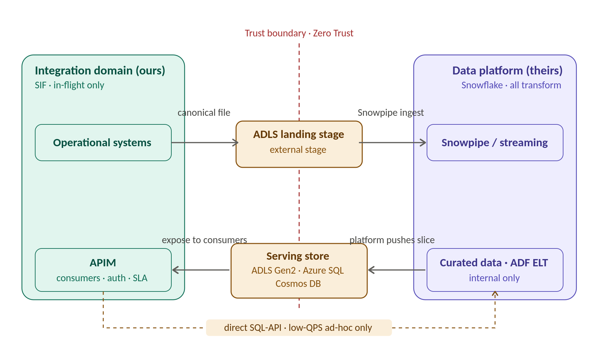
Zero-Trust posture — identical on both hand-offs
- Private-only connectivity — Private Endpoints / Private Link; no public paths.
- Identity, not keys — Entra managed identity, least-privilege RBAC; secrets as Key Vault references only if unavoidable.
- Encrypt every hop — TLS in transit even on private paths; at rest, CMK where classification demands.
- PII tokenised at the line — the platform matches on a token we provide, never the raw value. This is also the GDPR-erasure lever: kill the token mapping, the analytical estate is neutralised — no estate-wide deletion sweep.
- Default-deny & observability without leakage — access scoped to the specific stage/serving objects; correlation IDs and metadata in logs, not payloads.
Integration options — full pattern menu
Path | Pattern | When to use / caveat
Import · preferred | AIS → Blob → Snowpipe → Snowflake | Default for batch and near-real-time loads. File hand-off; SIF triggers, platform ingests.
Import · exception | AIS → Snowflake (direct) | Only where a connector or sub-second streaming path is mandated. Couples AIS to Snowflake internals — govern tightly, not a default.
Import · API-based | AIS → APIM → Snowflake SQL API | Small, event-driven writes needing APIM auth/throttling/logging. Not for bulk; per-call warehouse cost.
Export · file | Snowflake → Blob → AIS | Bulk / large result sets. Platform unloads to Blob, AIS reads. Best for batch volumes.
Export · service/API | Snowflake → API → APIM → AIS | On-demand, small, low-latency reads. Warehouse sits in the request path — front with a SIF-owned serving store (Azure SQL / Cosmos) or reserve for low-QPS.
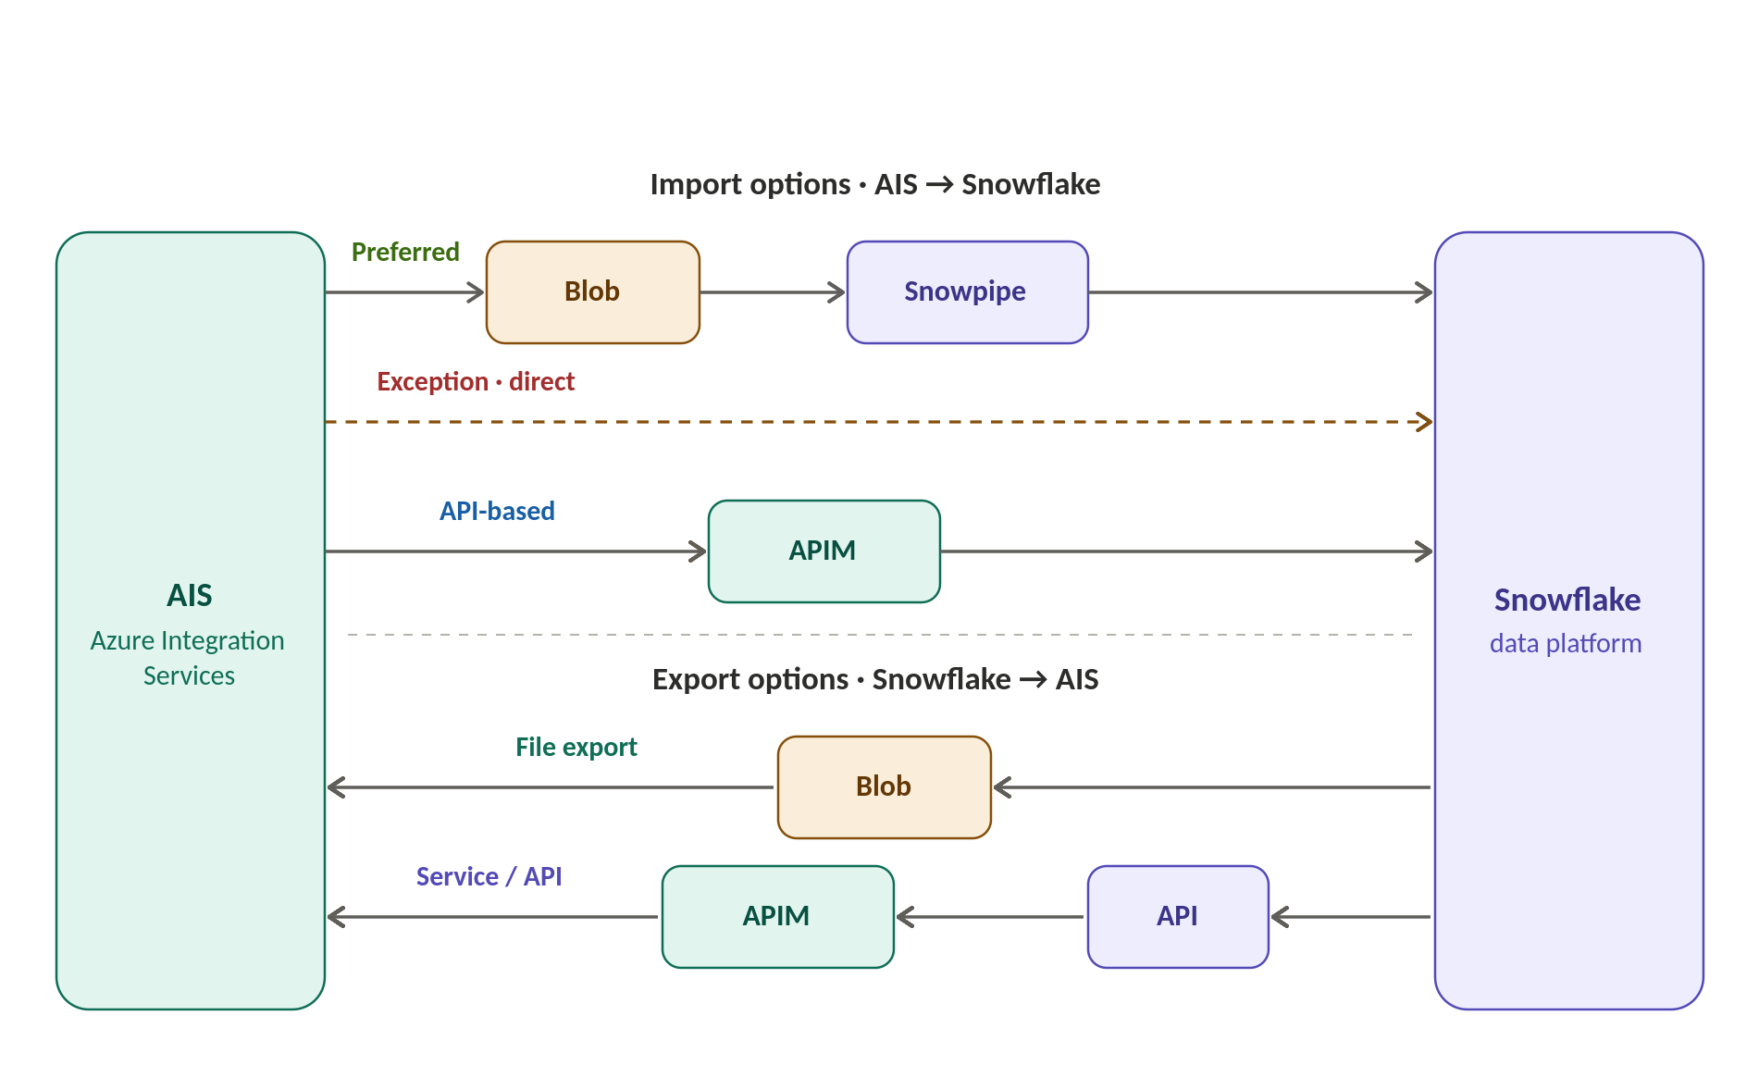
What to agree in the room
Decision | Owner | Date
Push-in path & trigger; serve-out path & trigger
Landing stage & serving store locations (one owner each)
Canonical / boundary contract — version, correction & idempotency semantics
PII handling at the line — tokenise before crossing
ADF boundary, enforced by network + identity (not goodwill)
Incident demarcation at each hand-off + incident command owner
Prepared by Puneet Kumar · Enterprise Integration & Solution Architect

