Systems Integration Framework

Enterprise Reference Framework and Pattern Catalogue
Version 1.0 (Draft)
Author: Puneet Kumar, Enterprise Integration and Solution Architect

Table of Contents
Table of Contents 2
1. Document Control 5
1.1 Document History 5
1.2 Authors and Contributors 5
1.3 Approvals and Assurance 5
1.4 Source Documents and Supersession 5
2. Executive Summary 6
2.1 Why the Framework Exists 6
2.2 Framework Scope 6
2.3 Intended Outcomes 6
3. How to Use This Framework 7
3.1 Intended Audience 7
3.2 How to Use This Framework 7
3.3 Relationship to Chaucer Principles 7
4. Architectural Position 9
4.1 Architectural Stance 9
4.2 SOA Positioning Statement 9
4.3 Strategic Objectives 9
4.4 What Counts as a Service 9
4.5 Core Principles and Design Tenets 10
5. Reference Architecture 11
5.1 Conceptual Reference Architecture 11
5.2 Logical Layered Reference Architecture 11
5.3 Security and Trust Boundary Architecture 12
5.4 Target Integration Platform 13
5.5 Messaging Backbone Selection 14
5.5.1 Service Bus 14
5.5.2 Event Grid 14
5.5.3 Event Hubs 14
5.6 Connectivity, Identity and Secrets 14
5.7 Deployment and Resilience 14
5.8 Data Protection and Classification 15
5.9 Observability and Monitoring 16
5.9.1 Azure Resource Observability Matrix 16
6. Core SIF Principles 17
Architecture Principles 17
7. Choosing an Integration Pattern 17
7.1 How to Use This Section 17
7.2 Primary Decision Matrix 17
7.3 Common Use Cases 18
7.4 Detailed Architecture Decision Tree 19
7.5 Worked Example TBD 19
8. Enterprise Pattern Catalogue 20
8.1 Enterprise Pattern Index and Boundary Applicability 20
Pattern Catalogue with Boundary Applicability 20
Pattern Grouping by Integration Boundary 21
Internal Chaucer Integration Patterns 21
Third Party to Chaucer Inbound Patterns 21
Chaucer to Third Party Outbound Patterns 22
SIF to Data Platform / Snowflake Exchange Patterns 22
8.2 Detailed Practitioner Patterns 22
8.3 API Patterns 23
8.3.1 Managed API façade (SFINT1) 23
8.3.2 API composition / aggregation (SFINT2) 24
8.3.3 Protocol / format mediation (SFINT3) 25
8.3.4 Synchronous request-reply (bounded) (SFINT4) 26
8.4 Messaging Patterns 26
8.4.1 Queue-based load levelling (SFINT5) 26
8.4.2 Competing consumers (SFINT6) 27
8.4.3 Asynchronous request-reply (SFINT7) 28
8.4.4 Claim-check (SFINT8) 29
8.4.5 Reliable messaging (SFINT9) 30
8.4.6 Scheduled / timed trigger (SFINT10) 31
8.5 Event Patterns 32
8.5.1 Publish / subscribe fan-out (SFINT11) 32
8.5.2 Discrete event notification (SFINT12) 33
8.5.3 Inbound webhook ingestion (SFINT13) 34
8.5.4 Outbound webhook / notification (SFINT14) 34
8.5.5 Stream / telemetry ingestion (SFINT15) 35
8.6 Orchestration Patterns 36
8.6.1 Stateful process orchestration (SFINT16) 36
8.6.2 Process with compensation (SFINT17) 37
8.6.3 Human-in-the-loop / approval (SFINT18) 38
8.7 File Patterns 39
8.7.1 Event-driven file ingestion (SFINT19) 39
8.7.2 File generation and delivery (SFINT20) 40
8.8 Data Platform Patterns 41
8.8.1 Push to the data platform (SFINT21) 41
8.8.2 Consume from the data platform and serve to a consumer (SFINT22) 42
8.8.3 Bulk data movement (the boundary) (SFINT23) 42
8.9 Transformation and Routing Patterns 43
8.9.1 Canonical data model and message translator (SFINT24) 43
8.9.2 Content-based routing (SFINT25) 45
9. Insurance Integration Scenarios 47
10. Data Platform Position and Guardrails 48
10.1 Core Position 48
10.2 Appropriate Uses 48
10.3 Inappropriate Uses 48
10.4 Exchange Patterns 48
Import: to the data platform 48
Export: from the data platform 49
11. Guardrails and Governance 50
11.1 Mandatory Guardrails 50
11.2 When you need to deviate 50
11.3 Per-pattern security conformance 50
11.4 Boundary Controls 51
11.5 Pattern Controls 51
11.6 Design Evidence Requirements 51
12. Exception Process and TDA Governance 52
12.1 Exceptions 52
12.2 TDA Gates 52
12.3 Security Conformance 52
12.4 Exception Lifecycle 52
13. Anti-Patterns 53
14. Glossary 54
15. Cross-Reference and Traceability 55
15.1 Pattern Mapping 55
15.2 Azure Pattern Mapping 55
15.3 Source Reconciliation 55
16. Future Enhancements and Open Items 57

1. Document Control

1.1 Document History
Version | Date | Author | Notes
1.0 |  | Puneet Kumar | Initial framework draft.

1.2 Authors and Contributors
Role | Name | Area
Author | Puneet Kumar | Enterprise Integration and Solution Architecture
Contributor | Security Architect | Security workshop input and review
Contributor | Portfolio Architect | Security workshop input and review
Contributor | Data Platform | Data boundary and Snowflake exchange
Contributor | Cloud Operations | RBAC, policy enforcement and monitoring

1.3 Approvals and Assurance
This document is a conceptual framework intended for Technical Design Authority review. Approval covers the reference architecture, the pattern catalogue and the governance model. Security exceptions are approved separately by Security Architecture as set out in Sections 11 and 12.
Role | Name | Decision
Reviewer | Security Architecture | Pending
Reviewer | Enterprise Architecture | Pending
Approver | TDA Chair | Pending

1.4 Source Documents and Supersession
The following documents were used as inputs and should be read in conjunction with this framework.
Reference | Document | Status
1 | Enterprise Architecture Principles | Input
2 | Engineering Standards (Cloud) | Input
3 | Workshops conducted with team | Input
4 | Cloud Security Framework | Pending from Security Architecture
5 | Azure Policies | Pending upload
6 | Systems Integration Framework (earlier draft) | Superseded by this version

2. Executive Summary
Chaucer requires a formal Systems Integration Framework to provide consistent architectural direction for system-to-system integration across internal applications, third-party platforms, SaaS services, vendor integrations and the enterprise data platform.

The framework is based on a Service-Oriented Architecture approach and explicitly avoids adopting a microservices model as the default integration paradigm. The focus is on practical enterprise integration across existing Chaucer systems, external vendors, Azure PaaS services and the data platform.

The framework establishes a single catalogue of patterns with clear boundary applicability across internal Chaucer integration, third-party to Chaucer inbound integration, Chaucer to third-party outbound integration and SIF-to-data-platform exchange. It also defines decision guidance for API, messaging, eventing, orchestration and data-platform usage, supported by mandatory guardrails and a controlled exception process.

2.1 Why the Framework Exists
Integration at Chaucer is functional but has grown one project at a time. Each interface has been implemented in isolation, a synchronous point-to-point call in one case and a file transfer in another, with no shared contract or common runtime. The result is a tightly coupled estate that is costly to change, difficult to observe and offers no route to reuse. Each tactical fix increases coupling and raises the cost of the next change.
This framework establishes a single reference architecture for integration so that recurring problems are solved through consistent, repeatable patterns. It defines an approved set of integration patterns, a standard set of Azure services as the target platform, and the governance guardrails that delivery teams and suppliers need in order to build correctly without re-opening architectural decisions on every engagement.

2.2 Framework Scope
The framework covers the following.
- A reference architecture for integration across Azure Integration Services.
- An enterprise catalogue of approved integration patterns with the Azure components for each.
- Decision guidance, guardrails and an exception process for delivery teams and suppliers.
- The position of the data platform boundary and the approved exchange patterns with Snowflake.
The following are out of scope for this version.
- Implementation, provisioning and deployment, which are future-phase activities.
- The detailed API Management high-level design, which is produced as a separate phase.
- Any redefinition of Chaucer's cloud strategy.

2.3 Intended Outcomes
- Fewer point-to-point interfaces and a measurable reduction in bespoke coupling.
- Greater reuse through shared integration components and published services.
- Loose coupling and asynchronous messaging as the default interaction style.
- Consistent, governed delivery that any internal team or third-party supplier can follow.
- Faster onboarding of new integrations through a known catalogue and decision path.

3. How to Use This Framework

3.1 Intended Audience
- Delivery teams and suppliers - building or changing an integration
- Solution and domain architects - selecting an approved pattern
- Technical Design Authority - assessing a design against the guardrails
- Security Architecture and Cloud Operations - assessing controls, identity, and monitoring

3.2 How to Use This Framework
If you are about to build an integration, start with the decision tree in Section 6. A short set of questions resolves to the appropriate pattern. Section 7 then specifies that pattern in full, including the problem it addresses, a reference diagram, the Azure services in scope, the failure modes to design for and the anti-patterns to avoid. Before implementation, validate the design against the guardrails in Sections 11 and 12. Deviation is permitted, but only through the formal exception process.
Two principles take precedence over all others.
- Reuse before you build. Check the service catalogue for an existing service or API before provisioning a new one.
- Favour integrating with an existing system over standing up new infrastructure. There is no approved pattern for a direct, unmediated connection between two systems, as all integration flows through the mediation layer.

3.3 Relationship to Chaucer Principles
The framework does not introduce a new set of principles. It inherits the principles Chaucer already holds and translates them into practical integration choices. The stack below shows where those principles originate and where they are enforced in this document.
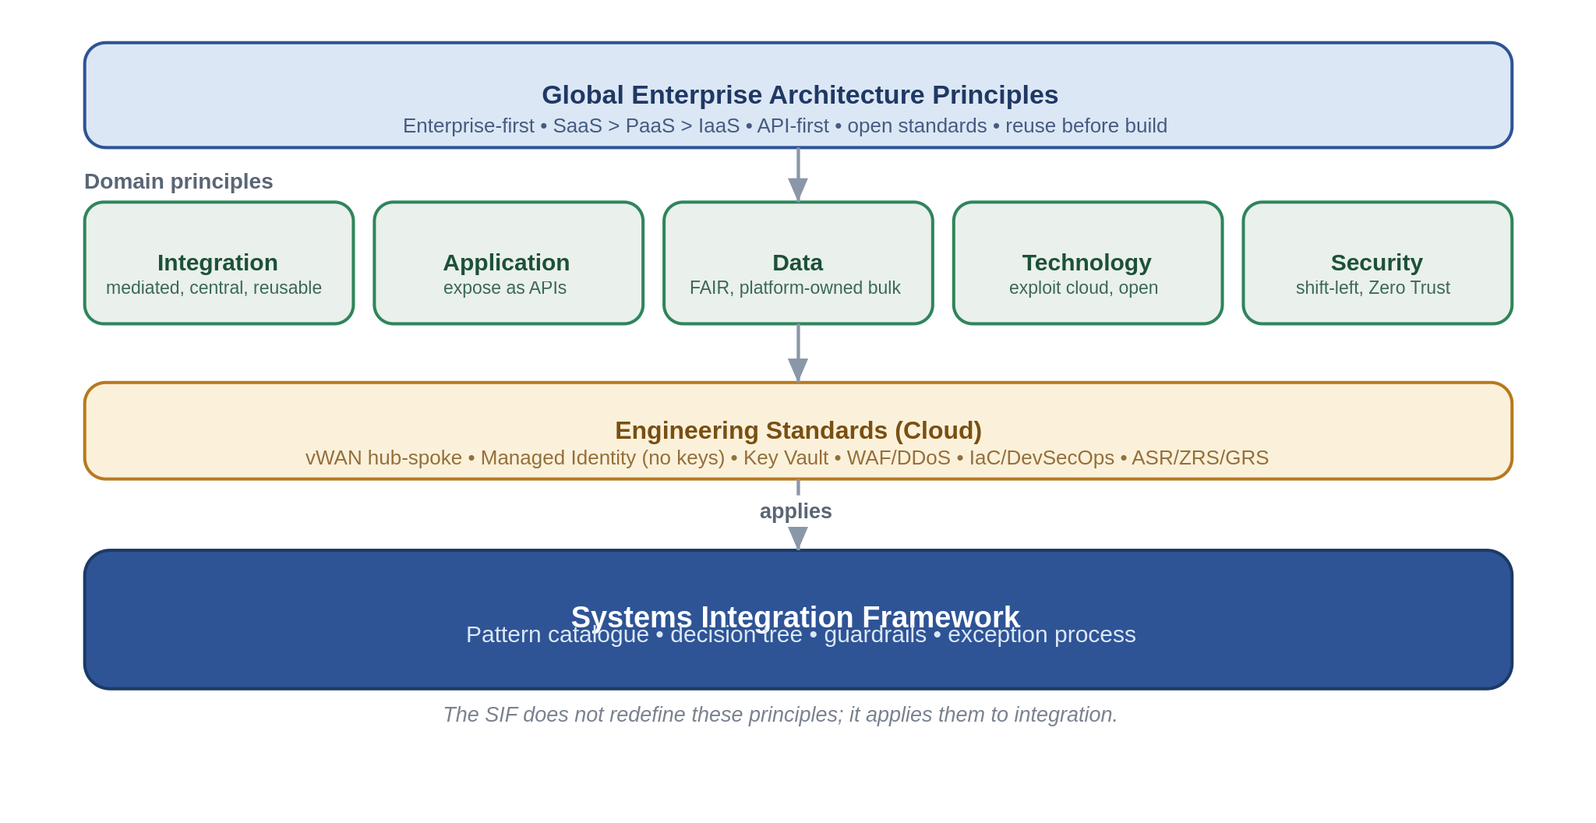
Enterprise Architecture to Engineering Standards to SIF traceability

Principle (source) | How the SIF embeds it | Where it is enforced
API-first, reuse-first, enterprise-first (Global EA, Application) | Capabilities are exposed as coarse-grained, reusable APIs and events through the platform, new build only after reuse is ruled out. | SOA service model (2.2), catalogue (App. A), TDA design gate (6.3)
All integration mediated through a single central platform (Integration) | One shared, centrally-operated platform, no direct point-to-point pattern exists. | Reference architecture (3), anti-patterns (5, App. B)
Loose coupling, asynchronous where availability/latency matters (Integration) | Messaging and events are the default for anything that can tolerate deferral, APIs are contract-bound. | Decision tree (4), patterns (5)
Secure by design, Zero Trust, least privilege (Security) | Every pattern carries a security position, identity is Entra + Managed Identity, no keys, ingress is gated. | Per-pattern risks (5), guardrails (6.1)
Managed Identity, Private Endpoints, WAF/DDoS, IaC (Engineering Standards) | Baked into the reference architecture and the non-negotiable guardrails. | Reference architecture (3.3), guardrails (6.1)
Mission-critical resilience, design for failure (Integration, Resilience) | Tiered multi-region posture and zone-redundancy by default. | Deployment & resilience (3.4)
Data is platform-owned, FAIR (Data) | Bulk and analytics stay on Snowflake, the SIF exchanges with it across a defined boundary. | Data platform exchange (5.6), boundary (3.1)

4. Architectural Position

4.1 Architectural Stance
The framework takes a clear and consistent position, summarised below and expanded in the sections that follow.
Area | Position
Architecture model | Service-Oriented Architecture, not microservices.
Primary objective | Integrate and reuse existing systems and services before creating new ones.
Service model | Business-capability aligned enterprise services.
Integration style | API-led, event-capable, orchestration-supported.
Platform alignment | Azure PaaS integration services.
Governance model | TDA-approved standards, reusable patterns, controlled exceptions.
.

4.2 SOA Positioning Statement
Chaucer's Systems Integration Framework adopts a Service-Oriented Architecture, not a microservices architecture, aligned to Chaucer's operating model.
A service in this framework is a coarse-grained capability aligned to a business domain such as Policy, Claims, or Client rather than an entity-level or table-level endpoint. Services are stable, reused across Chaucer's business and technology teams, and governed through clear ownership, defined contracts, and lifecycle controls. Each service has a named owner and is exposed through the platform.
Microservices are not adopted as the default integration paradigm. The framework's focus is not service decomposition for independent product or application engineering, but pragmatic enterprise integration across existing Chaucer platforms, SaaS services, data platforms, and vendor systems. Accordingly, services are not one of many fine-grained components communicating over a service mesh.

4.3 Strategic Objectives
Objective | SIF Direction
Increase automation | Promote API, event, and workflow-based integrations over manual re-keying.
Reduce point-to-point integrations | Introduce reusable service contracts, APIM-mediated APIs, and shared messaging patterns.
Improve system-to-system data flow | Standardize integration approaches across synchronous, asynchronous, file, and data-platform exchange.
Enable vendor integration | Provide secure, governed, and reusable ingress/egress patterns for external suppliers and systems.
Support straight-through processing | Use orchestration where business process coordination is required; avoid embedding logic in consuming systems.
Align to Azure PaaS | Use Azure API Management, Logic Apps, Service Bus, Event Grid, Event Hubs, Azure Functions, and Azure Data Factory as the primary Azure PaaS integration components, with ADF specifically positioned for data ingestion, ELT orchestration, and controlled Snowflake/data-platform exchange rather than real-time operational integration.

4.4 What Counts as a Service
A service that belongs in the catalogue meets the following tests.
- It aligns to a business capability rather than a table or a technical function.
- It has a stable, versioned contract that hides the implementation behind it.
- It has a named owner who is accountable for its behaviour and its change.
- It is exposed and consumed through the platform, not through a direct connection.
- It is coarse grained, so that a typical business interaction is one call rather than many.

4.5 Core Principles and Design Tenets
- Platform-mediated only. All integration is mediated through the platform. There is no approved direct connection between two systems.
- Reuse before build. Reuse is assessed before new build is considered.
- Asynchronous by preference. Asynchronous messaging and events are preferred wherever the interaction can tolerate deferral.
- Centralised orchestration. Orchestration logic resides in Logic Apps and Functions, not in source or target systems.
- Managed identity and secrets. Identity uses managed identity and OAuth 2.0. Secrets are held in Key Vault and, where static, managed through privileged access management.
- Infrastructure as code. Integration assets are defined as code and deployed through pipelines.
- Observability by design. Observability is designed in from the outset, not added afterwards.
- Designed for failure. Every pattern is designed for failure, with retries, idempotency, and clear compensation.

5. Reference Architecture

5.1 Conceptual Reference Architecture
At the conceptual level the framework places a single integration layer between the consumers of integration and the systems, suppliers and data platform that provide or receive information. The integration layer is the only sanctioned route between parties. It presents governed contracts to consumers, mediates protocol and format, and applies security, routing and observability consistently.
Role of the framework
To provide one mediated, observable and governed integration layer that removes direct point-to-point coupling.
Integration boundaries
Consumers reach the platform through the exposure layer. Systems and suppliers are reached through private connectivity. The data platform is reached only across a defined exchange boundary.
Systems, suppliers and Snowflake
Internal systems and external suppliers integrate through the platform. Snowflake is the analytical data platform and is exchanged with across the boundary described in Sections 8.4 and 10, not treated as a general integration endpoint.
Enterprise governance position
The framework sits beneath the enterprise principles and engineering standards and applies them to integration, as shown in Section 3.3.

5.2 Logical Layered Reference Architecture
The logical view resolves the conceptual layer into five bands. The diagram should be read from the consumer at the top to the systems and data platform at the base.
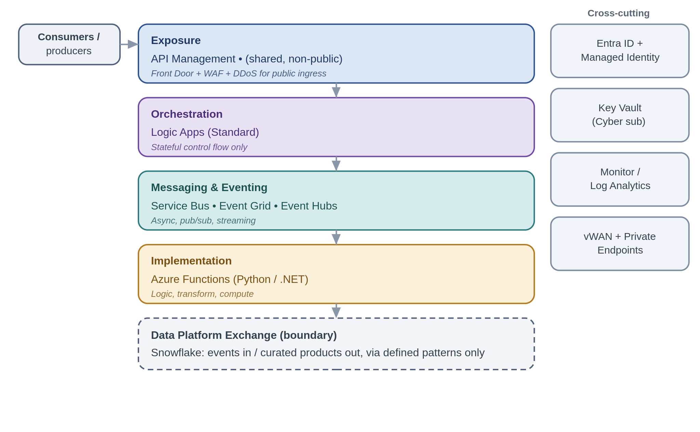
Layer | Description
Exposure layer | API Management is the single ingress for synchronous traffic, applying authentication, rate limiting, product and subscription control, and observability.
Orchestration layer | Logic Apps coordinate stateful, multi-step processes. Orchestration owns process control rather than embedding it in systems.
Messaging and eventing layer | Service Bus, Event Grid and Event Hubs provide asynchronous messaging, discrete eventing and streaming respectively.
Implementation layer | Azure Functions host the discrete implementation logic invoked by the layers above.
Data platform boundary | The framework meets Snowflake at two governed hand-offs only: a push into the platform and a curated consume from it.

5.3 Security and Trust Boundary Architecture
Security is the principle the organisation takes most seriously. The framework sets out the trust zones once and holds every pattern to them. The diagram shows the zones a request crosses and the control at each boundary.
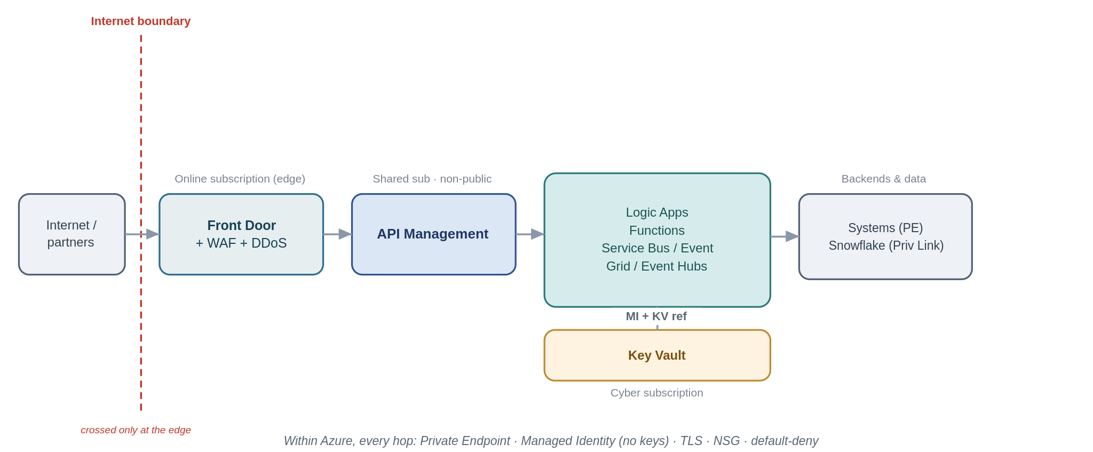
Layer | Description
Internet boundary | Public exposure is an exception only. Where unavoidable, traffic is fronted by Front Door with a Web Application Firewall and DDoS protection, with authentication at the edge.
Front Door and API Management | API Management is shared and internal. It is never exposed directly to the internet.
Backend systems | Systems are reached over Private Endpoints on the private network, authenticated with managed identity.
Key Vault | Managed cloud service for securely storing and controlling access to secrets, keys, and certificates, so credentials never sit in code or configuration. It centralises secret management with access governed by Entra identity and full audit logging, letting applications retrieve what they need at runtime without holding the secrets themselves.

5.4 Target Integration Platform
The framework standardises on the following Azure Integration Services. Delivery teams select from these components and do not introduce alternatives without an exception.
Component | Framework Role | Recommended Use | Do Not Use
Azure API Management | Enterprise API gateway and single API ingress point | Exposing REST APIs to internal systems, vendors, applications, or digital channels | For long-running business processes or data transformation pipelines
Azure Logic Apps | Workflow orchestration and cross-system process coordination | Multi-step integrations, long-running workflows, connector-based automation, exception paths | For low-level compute-heavy logic or high-throughput streaming
Azure Service Bus | Reliable enterprise messaging | Guaranteed delivery, commands, queues, topics, retries, dead-letter handling | For lightweight notifications where message state is not required
Azure Event Grid | Event notification and reactive event routing | Resource/event notifications, event fan-out, near-real-time triggers | For ordered business messaging or complex message settlement
Azure Event Hubs | High-throughput event streaming | Telemetry, high-volume event ingestion, streaming analytics | For command-style workflow messaging or request/response integration
Azure Functions | Low-level implementation logic | Lightweight code extensions, transformation helpers, protocol adapters, custom validation | As the default orchestration engine or business process owner
Azure Data Factory / Data Platform | Data ingestion and analytical pipeline orchestration | Batch/ELT, Snowflake loading, analytical data movement | Real-time operational integration or transient system-to-system messaging

5.5 Messaging Backbone Selection
Three services form the asynchronous backbone. They are not interchangeable. The table sets out the intent of each with an insurance example, and the subsections give the selection rule.
Service | Purpose | Choose it when | Insurance example
Service Bus | Reliable command and message delivery | You need ordered, transactional, at-least-once delivery between systems | A bind instruction placed on a queue for the policy system to process reliably
Event Grid | Discrete event notification | You need lightweight fan-out of business events to multiple handlers | A claim status change notifying downstream teams and the customer channel
Event Hubs | High-throughput streaming | You need to ingest a continuous, high-volume stream for processing or analytics | Telemetry or high-frequency pricing and exposure feeds ingested for the data platform

5.5.1 Service Bus
Service Bus is the default for system-to-system messaging where delivery must be reliable and, where required, ordered. It supports queues for point-to-point work, topics for publish and subscribe, sessions for ordering, and dead-lettering for poison messages.

5.5.2 Event Grid
Event Grid is used for discrete business or resource events where the publisher does not need to know the consumers. It suits lightweight fan-out and reactive processing rather than reliable command delivery or high-volume streams.

5.5.3 Event Hubs
Event Hubs is used for high-throughput streaming and telemetry. It is selected for continuous, high-volume feeds, and is not a general business-messaging channel. An existing Event Hub pattern is also used by Security to stream logs to CrowdStrike, as noted in Section 5.9.

5.6 Connectivity, Identity and Secrets
- Private by default. Components communicate over Private Endpoints on the private network, not the public internet.
- Managed identity for service-to-service auth. Where a token is required, OAuth 2.0 client credentials or authorisation code flows are used.
- Centralised secrets. Secrets and certificates are held in Key Vault and referenced, never copied into configuration.
- Static secrets and certificates (which cannot use managed identity) are managed centrally through a privileged access solution such as CyberArk. As an interim model, CyberArk manages rotation and policy while applications retrieve values through Key Vault, preserving low-latency access.

5.7 Deployment and Resilience
The framework is delivered as one centralised, shared platform rather than as per-project instances. Centralisation is a principle, not a preference hence it is what makes consistent security, shared skills, single-pane operations and genuine reuse possible, and it is the only way to run integration as the mission-critical service it is. A single platform team owns it, operates it to stringent SLAs, and changes it carefully. Everything is deployed from infrastructure-as-code held in Azure DevSecOps.
Resilience is tiered by business criticality rather than applied as a single blanket, because reliability has a cost and not every integration warrant Tier 0 spend. Zone-redundancy within a region is the baseline everywhere; the cross-region posture is chosen per tier.
Tier | Posture | Approach
Tier 0, mission-critical | Active-active / hot standby | Multi-region, fronted by Front Door / global load balancing; near-zero RTO/RPO where the service supports it.
Tier 1, business-important | Warm active-passive | Secondary paired region kept warm; controlled failover; ASR where a service lacks native HA.
Tier 2, standard | Backup / restore | Redundant storage (ZRS/GRS) and re-provision from IaC; a higher RTO is acceptable.

A note that is easy to miss: Logic Apps (Standard) run history is region-bound, so orchestration DR is active-passive and in-flight runs do not migrate automatically, orchestration steps must be idempotent and restartable. Service Bus and Event Hubs use their Premium geo-DR/geo-replication with alias failover. API Management Premium runs multi-region gateways, Key Vault replicates to its paired region automatically. Security posture is identical in DR, a failover is not a drop in control.
.

5.8 Data Protection and Classification
Zone controls protect the paths, this section protects the data itself, which the asset-protection and Zero Trust principles treat as valuable independent of where it sits. It matters more than usual here because specialty insurance handles a great deal of personal data, some of it special-category, health and medical data in personal-accident and life lines, and criminal-conviction data in parts of liability, which attracts the strictest handling under UK GDPR.

In transit, TLS 1.2 or higher is applied on every hop, private path or not, because Zero Trust does not assume the network; there are no plaintext protocols anywhere in the platform. External partners are authenticated with mutual TLS or OAuth at the edge, file transfer is SFTP-over-SSH with key or certificate authentication, and sensitive files are additionally signed or encrypted at the payload level (for example PGP) so their protection outlives the transport. Certificates and keys are managed in Key Vault in the Cyber subscription, rotated, revocable, never carried in configuration.

At rest, every store is encrypted, Blob, Service Bus, Event Hubs, Snowflake and any database, with platform-managed keys by default and customer-managed keys through Key Vault where a data classification or a regulatory requirement calls for key control. Storage accounts and databases are firewalled with public access disabled and reached over Private Endpoints, and transient stores such as claim-check blobs and stream capture carry lifecycle policies so sensitive data does not linger beyond its purpose.

Data is classified and handled to its tier, and the framework carries only the minimum it needs, it never moves or exposes internal data models wholesale. PII is minimised, and pseudonymised or tokenised before it crosses into analytics or leaves the operational boundary; special-category data attracts additional access restriction and, where required, customer-managed keys and field-level protection. Retention and erasure are owned per flow by the named owner of each result store, balancing regulatory retention (claims records are often long-lived) against data-subject erasure rights, and data residency is considered wherever partners or the market operate across jurisdictions.
Classification tier | Examples in this estate | Handling
Public | Published rates, public policy documents. | Standard controls, may be served externally through the edge.
Internal | Operational metadata, non-personal business data. | Entra + least privilege, not exposed externally; private-only.
Confidential (PII) | Claimant and insured personal data, policy and claim details. | Minimize, Private Endpoint, encrypted, access logged, pseudonymize before analytics.
Highly confidential (special-category PII) | Health/medical data, criminal-conviction data. | Additional access restriction, customer-managed keys or field-level protection where required, tokenize, strict audit.

Because PII risk concentrates at the boundaries, the outward-facing patterns carry specific handling, summarised here and reflected in each pattern's Security boundary note:
Boundary flow | PII handling control
Push to the platform / offload (SFINT21) | Classify and minimize before landing; pseudonymize or tokenize special-category fields, publish the canonical contract, never raw internal models.
Consume and serve (SFINT22) | Least-privilege data access, serve curated rather than raw data, mask fields the consumer does not need.
File ingestion and egress over SFTP (SFINT19 and SFINT20) | Encrypt files at the payload level beyond transport, minimize fields, quarantine on validation failure, enforce retention/lifecycle.
Inbound and outbound webhooks (SFINT13 and SFINT14) | Validate and sign payloads, keep PII out of URLs and logs, TLS/mTLS, redact in observability.

For the SOC, one consequence matters: observability must not become a PII leak. Logs, metrics and traces carry correlation IDs and metadata, not payloads. PII is redacted or hashed where it would otherwise appear. That gives the SOC the visibility the standards require (it has access to the logs it needs) without over-collecting personal data into the logging estate.

5.9 Observability and Monitoring
Operational monitoring uses Application Insights and Log Analytics, with dashboards and alerts for delivery and issue resolution. Security monitoring is a separate concern that must be satisfied in addition. Relevant security events are forwarded to CrowdStrike, and any newly introduced gateway or security service is assessed for security-event capture before use. LogicMonitor is treated as operational monitoring, distinct from security monitoring.

5.9.1 Azure Resource Observability Matrix
Resource | Operational signal | Security signal | Destination
API Management | Latency, throughput, failures | Authentication failures, policy violations | Log Analytics, CrowdStrike
Logic Apps | Run success and failure, duration | Connection and identity events | Log Analytics, CrowdStrike
Service Bus | Queue depth, dead-letters | Access and authorisation events | Log Analytics
Functions | Executions, errors, duration | Managed identity and Key Vault access | Log Analytics, CrowdStrike
Key Vault | Availability | Secret and certificate access | Log Analytics, CrowdStrike
Event Hubs | Throughput, lag | Namespace access | Log Analytics, CrowdStrike

6. Core SIF Principles

Architecture Principles
Principle | Statement | Practical Implication
Loose coupling by default | Systems should interact through contracts, APIs, messages, or events rather than direct dependencies. | Avoid direct database access, shared file dependencies, and tightly coupled point-to-point calls unless explicitly approved.
Reuse before new build | Reuse of existing services, APIs, workflows, and platform components must be assessed before creating new integrations. | Every design should document reuse assessment.
Business capability alignment | Services should expose meaningful business capabilities, not raw system internals. | APIs should represent business functions such as policy, claim, submission, party, document, or finance capability.
APIM as API publishing and ingress control | Chaucer-owned APIs exposed for internal or external consumption should be published through Azure API Management unless an exception is approved. | APIM is the standard control point for API discovery, policy enforcement, authentication, throttling, monitoring, versioning, and lifecycle governance. Direct exposure of backend APIs, Logic Apps, Functions, or internal service endpoints should be avoided.
Third-party API egress is governed by reuse and risk | Chaucer integrations may call third-party APIs directly from Logic Apps or Functions where the integration is workflow-specific, low reuse, and appropriately governed. | APIM should be used as a Chaucer-owned facade where third-party APIs are reused, business-critical, strategically important, externally sensitive, or require centralized policy, monitoring, or lifecycle control.
Asynchronous-first where resilience matters | When availability, retry, load levelling, or latency tolerance is important, prefer messaging/events. | Use Service Bus queues/topics for reliable enterprise messaging.
Orchestration usage is explicit | Cross-system business process logic should sit in the integration platform, not in hidden scripts or consuming applications. | Logic Apps should own workflow coordination; Functions should not become hidden orchestration engines.
Implementation logic is separated | Low-level code should be isolated from orchestration and API policy concerns. | Functions should implement narrow code tasks. They should not be implemented in end-to-end business workflows.
Secure by design | Managed identities for authentication, RBAC, private endpoints where possible, Key Vault for storing credentials, access monitoring, and least privilege should be the default security controls. | Security patterns should be explicitly included in every design review.
Observable by default | Every integration must be traceable, monitored, and supportable. | Correlation IDs, diagnostics, alerts, and operational runbooks are mandatory to ensure long term supportability.
Data platform is not integration technology | Snowflake and the data platform should not be used as a substitute for operational integration. | Data platform should be used as intended for analytical, historical, reporting, and governance across data products.

7. Choosing an Integration Pattern

7.1 How to Use This Section
This section works at two levels. For a leadership or high-level view, the primary decision matrix in 6.2 and the common use cases in 6.3 identify the appropriate integration style in plain terms, without technical depth. For design and delivery, the decision tree in 6.4 and the secondary considerations in 6.5 lead into the enterprise pattern catalogue in Section 7, where each pattern is specified in full.

7.2 Primary Decision Matrix
The matrix reads by question. For a given need, it shows at a glance which platform capability is normally suitable, which may be suitable subject to design review, and which is not the right tool. It indicates the interaction style, and the catalogue in Section 7 remains authoritative for the detailed pattern.
Does the need involve... | API | Service Bus | Event Grid | Event Hubs | Logic Apps
A consumer that needs an immediate response | ✅ | ❌ | ❌ | ❌ | ⚠️
Guaranteed delivery | ⚠️ | ✅ | ⚠️ | ⚠️ | ⚠️
A business command or transaction | ✅ | ✅ | ❌ | ❌ | ⚠️
A notification that something happened | ⚠️ | ⚠️ | ✅ | ⚠️ | ⚠️
High-volume telemetry or an event stream | ❌ | ⚠️ | ❌ | ✅ | ❌
A process that spans multiple systems and steps | ⚠️ | ⚠️ | ⚠️ | ❌ | ✅
Long-running state or retry orchestration | ❌ | ⚠️ | ❌ | ❌ | ✅
Analytics or data warehousing as the main purpose | ❌ | ⚠️ | ⚠️ | ⚠️ | ⚠️
Legend.
✅ The pattern is normally suitable for the use case.
⚠️ The pattern may be suitable, but requires additional design rationale, controls or governance review.
❌ The pattern is not normally suitable for the use case.
Analytics and data warehousing are served by the data platform, using ADF, Blob, Snowpipe and Snowflake, rather than by an integration pattern. See Section 10.

7.3 Common Use Cases
The table maps everyday scenarios to the recommended pattern and to the catalogue entry that specifies it in full.
Scenario | Recommended pattern | Catalogue reference
Retrieve or update business data immediately | REST API through API Management | SFINT1
Tell another system to perform work, where delayed processing is acceptable | Service Bus queue, load levelling | SFINT5
Have multiple systems react to the same business message | Service Bus topic, publish and subscribe | SFINT11
Notify that a resource change or event occurred | Event Grid notification | SFINT12
Ingest a high-volume stream, telemetry or near-real-time feed | Event Hubs stream ingestion | SFINT15
Run a multi-step process with conditional routing and exception handling | Logic Apps orchestration | SFINT16
Apply a small code-based transformation or validation step | Azure Function, message translator | SFINT24
Ingest a batch into Snowflake for reporting or analytics | Data platform pattern, ADF, Blob, Snowpipe | SFINT21, Section 10
Run an operational real-time transaction between applications | API or messaging pattern, not Snowflake as an intermediary | SFINT1 to SFINT10

7.4 Detailed Architecture Decision Tree
The decision tree resolves an integration need to a pattern family by asking about interaction style, timing and delivery guarantees. It should be read from the top.
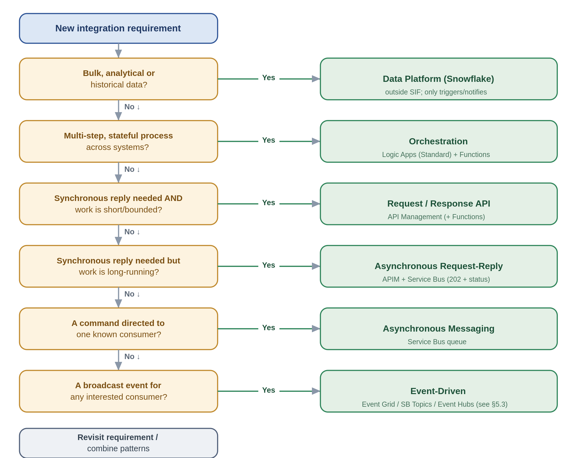

7.5 Worked Example TBD
A broker submits a delegated-authority bordereau that must update exposure before a bind is confirmed. The interaction is not a simple request and reply, because processing is multi-step and must be reliable. The decision tree resolves to file ingestion for the inbound file, canonical translation to the internal model, and orchestration to validate, calculate accumulation and confirm the bind. Reliable messaging carries the confirmed instruction to the policy system, and a discrete event notifies the downstream teams. The result uses file ingestion (SFINT19), canonical model (SFINT24), orchestration (SFINT16), reliable messaging (SFINT9) and event notification (SFINT12), each governed by the guardrails in Section 11.

8. Enterprise Pattern Catalogue

8.1 Enterprise Pattern Index and Boundary Applicability
The Systems Integration Framework defines a single enterprise pattern catalogue that applies across internal Chaucer integrations and Chaucer-to-third-party integrations. Patterns are intentionally classified by integration boundary to ensure that delivery teams and suppliers understand where each pattern is appropriate and what additional controls are required.
Internal integrations may use approved API, messaging, event, workflow, and file exchange patterns within Chaucer’s controlled Azure integration platform. Third-party integrations must use approved ingress and egress patterns, with stronger controls for API exposure, identity, network boundary, payload validation, monitoring, support ownership, and data protection.
The data platform, including Snowflake, is included as a controlled exchange boundary but is not the default mechanism for operational integration, transient messaging, or real-time process orchestration. Data platform integration should be used where the objective is analytical ingestion, reporting or controlled data exchange.

Pattern Catalogue with Boundary Applicability
Pattern ID | Pattern | Primary Boundary | Internal | 3rd Party to Chaucer | Chaucer to 3rd Party | SIF to Data Platform | Primary Technology | Usage Approval
SIF-P01 | Internal REST API | Internal | ✅ | ❌ | ❌ | ⚠️ | Azure API Management + backend API / Logic App / Function | Standard
SIF-P02 | External API Ingress | Third party to Chaucer | ⚠️ | ✅ | ❌ | ❌ | Azure API Management | Standard
SIF-P03 | External API Egress | Chaucer to third party | ⚠️ | ❌ | ✅ | ⚠️ | Azure API Management / Logic Apps / Functions | Standard
SIF-P04 | API Facade / API Mediation | Internal and external | ✅ | ✅ | ✅ | ⚠️ | Azure API Management + Logic App / Function | Standard
SIF-P05 | Reliable Queue Messaging | Primarily internal | ✅ | ⚠️ | ⚠️ | ⚠️ | Azure Service Bus Queue | Standard internally; controlled externally
SIF-P06 | Publish / Subscribe Messaging | Primarily internal | ✅ | ⚠️ | ⚠️ | ⚠️ | Azure Service Bus Topic | Standard internally; external by exception
SIF-P07 | Event Notification | Internal and external | ✅ | ✅ | ✅ | ✅ | Event Grid / Webhook / Logic App Trigger | Standard
SIF-P08 | High-Volume Event Streaming | Internal / analytics / selected external | ✅ | ⚠️ | ⚠️ | ✅ | Azure Event Hubs | Conditional
SIF-P09 | Workflow Orchestration | Internal and external | ✅ | ✅ | ✅ | ⚠️ | Azure Logic Apps | Standard
SIF-P10 | Long-Running Workflow | Internal and external | ✅ | ✅ | ✅ | ⚠️ | Azure Logic Apps Standard | Standard
SIF-P11 | Third-Party Webhook Ingress | Third party to Chaucer | ⚠️ | ✅ | ❌ | ⚠️ | APIM + Logic App / Function | Standard for SaaS/vendor callback scenarios
SIF-P12 | Managed File Exchange | Internal and external | ✅ | ✅ | ✅ | ✅ | Logic Apps / Storage / SFTP / Service Bus where required | Conditional
SIF-P13 | Data Platform Exchange | SIF to Snowflake / Snowflake to SIF | ⚠️ | ✅ | ✅ | ✅ | ADF / Blob or ADLS / Snowpipe / COPY INTO / controlled APIs | Conditional; not default operational integration
SIF-P14 | Custom Code Extension | Internal and external | ✅ | ✅ | ✅ | ⚠️ | Azure Functions | Standard with constraints

✅ | Pattern is applicable and normally acceptable for this boundary.
⚠️ | Pattern may be applicable, but requires additional design rationale, controls, or governance review.
❌ | Pattern is not normally appropriate for this boundary.

Note: Any pattern implementation for a specific scenario which necessitates the use of technologies not mentioned above requires approval.

Pattern Grouping by Integration Boundary

Internal Chaucer Integration Patterns
Pattern ID | Pattern | Typical Use
SIF-P01 | Internal REST API | Internal application-to-application request/response integration.
SIF-P04 | API Facade / Mediation | Shielding consumers from backend complexity or legacy constraints.
SIF-P05 | Reliable Queue Messaging | Decoupled internal processing with retry and dead-letter handling.
SIF-P06 | Publish / Subscribe Messaging | Internal business event transfer to one or to multiple consumers.
SIF-P07 | Event Notification | Lightweight internal notification that something has happened.
SIF-P09 | Workflow Orchestration | Multi-step integration across Chaucer-owned systems.
SIF-P10 | Long-Running Workflow | Stateful processes, callbacks, retry cycles, or human/system delays.
SIF-P12 | Managed File Exchange | Controlled file movement between Chaucer systems.
SIF-P14 | Custom Code Extension | Small transformation, validation, enrichment, or protocol adaptation.

Third Party to Chaucer Inbound Patterns
Pattern ID | Pattern | Typical Use | Additional Controls
SIF-P02 | External API Ingress | Supplier, SaaS, broker, or vendor calls a Chaucer API. | APIM, OAuth/OIDC or approved auth model, throttling, usage quota, validation, logging.
SIF-P04 | API Facade / Mediation | Chaucer exposes stable contract while shielding internal systems. | Contract ownership, versioning, backend isolation.
SIF-P07 | Event Notification | Third party notifies Chaucer that an event has occurred. | Schema validation, replay controls, monitoring.
SIF-P11 | Third-Party Webhook Ingress | SaaS callback or vendor event pushed to Chaucer. | Signature validation, replay protection, APIM mediation.
SIF-P12 | Managed File Exchange | Supplier, broker, or vendor sends files to Chaucer. | Malware scanning, encryption, metadata capture, reconciliation.
SIF-P13 | Data Platform Exchange | External data is provided for analytical ingestion. | Data ownership, lineage, classification, ingestion controls.

Chaucer to Third Party Outbound Patterns
Pattern ID | Pattern | Typical Use | Additional Controls
SIF-P03 | External API Egress | Chaucer calls supplier, SaaS, market, or vendor APIs. | Credential management, timeout, retry with exponential fall back, throttling, error mapping.
SIF-P04 | API Facade / Mediation | Chaucer standardises access to third-party APIs for internal consumers. | Abstraction, versioning, supplier contract management.
SIF-P07 | Event Notification | Chaucer notifies an external party of a process or status event. | Contracted endpoint, failure handling, audit trail.
SIF-P09 | Workflow Orchestration | Chaucer coordinates multi-step third-party process. | Operational ownership, compensating action, monitoring.
SIF-P10 | Long-Running Workflow | Supplier interaction requires polling, callbacks, or delayed response. | State management, timeout, escalation, retry policy.
SIF-P12 | Managed File Exchange | Chaucer sends files to supplier, broker, or vendor. | Encryption, confirmation handling, reconciliation, support model.
SIF-P14 | Custom Code Extension | Adapter logic for supplier-specific payload, protocol, or transformation. | Code review, testing, version control, CI/CD.

SIF to Data Platform / Snowflake Exchange Patterns
Pattern ID | Pattern | Typical Use | Guardrail
SIF-P07 | Event Notification | Notify data platform that data is available for ingestion. | Notification only; not operational process orchestration.
SIF-P08 | High-Volume Event Streaming | Stream high-volume events or telemetry for analytical use. | Use only where event-streaming requirements are proven.
SIF-P12 | Managed File Exchange | Land files for analytical ingestion. | Must include ownership, metadata, retention, and monitoring.
SIF-P13 | Data Platform Exchange | Controlled exchange between SIF and Snowflake. | Data platform must not be the default operational integration mechanism.
SIF-P14 | Custom Code Extension | Lightweight extraction, validation, or formatting helper. | Avoid embedding business process orchestration in code.

8.2 Detailed Practitioner Patterns
The following patterns retain the detailed problem, solution, use, avoid, risks, security boundary, anti-pattern and Chaucer example format from the expert draft.
The catalogue is organised by interaction style, request/response, asynchronous messaging, event-driven, orchestration, file-based exchange, and data-platform exchange. That is a considered choice. It mirrors the very first decision a developer makes. it lines up one-to-one with the decision tree, and each style maps cleanly onto a primary Azure service, file-based being the one that spans a few, because a file is a transport rather than a service.
Each pattern is written the same way, so you can read any of them quickly. A one-line statement of what it is for, a diagram, the problem and the solution in plain terms, when to use and avoid it, the risks worth planning for, the anti-pattern to steer around, and a Chaucer-flavoured example. The diagrams share a visual language, blue is the gateway, purple is orchestration, teal is Service Bus, green is Event Grid, orange is Event Hubs, amber is Functions, and a cylinder is a store.

8.3 API Patterns

8.3.1 Managed API facade (SFINT1)
Put every exposed capability behind the shared gateway, so consumers never bind to a backend directly.
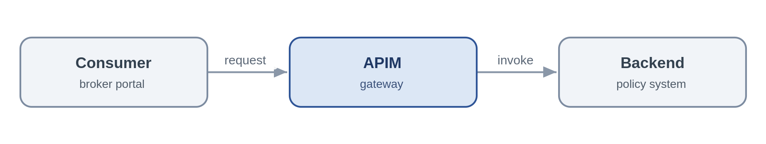
Problem. A consumer needs an immediate answer from a system of record. Letting it call that system directly couples the two together, scatters authentication and throttling across the estate, and makes the backend impossible to version or move, the tactical, point-to-point coupling this framework exists to remove.
Solution. Expose the capability as a coarse-grained REST/JSON operation on API Management. APIM authenticates the caller with an Entra token, applies a rate limit and a product subscription, and forwards to the backend over a Private Endpoint using a managed identity. The consumer knows only the contract, so the backend can be re-platformed behind a stable façade. Where the capability must be reachable from the internet, APIM sits behind Front Door with a WAF and DDoS, it is never public itself.
Azure components
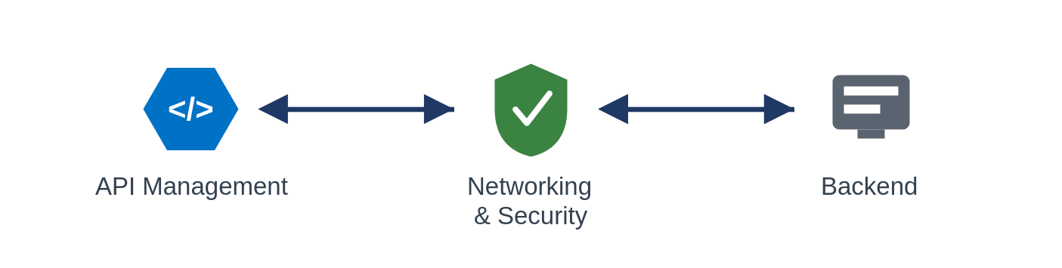
Use it when. the caller needs a synchronous answer to a query or short command and you want one governed, reusable front door to a capability.
Avoid it when. the work is long-running or unpredictable (orchestrate it), or the interaction is really fire-and-forget (use messaging).
Risks and considerations. APIM is a shared chokepoint, so its availability is everyone's availability, run it zone-redundant, and multi-region for Tier 0, and treat its capacity and policy changes as mission-critical. The façade adds a hop and a few milliseconds; keep policies lean and cache idempotent reads. And the gateway does not absolve the backend of protecting itself, it still needs its own throttling behind the façade.
Security boundary. Landing zone: APIM sits in the shared subscription (non-public); the backend in its workload spoke. For internal consumers the whole flow is private and crosses no internet boundary. Within Azure: consumer-to-APIM and APIM-to-backend both over Private Endpoints, APIM authenticates to the backend with a managed identity, TLS on every hop. Outside Azure: only where the API must be public, then it is fronted from the online subscription by Front Door + WAF + DDoS with OAuth or mTLS at the edge, as a registered exception; APIM is never exposed directly.
Anti-pattern. A pass-through proxy that adds no policy, security or versioning, or, worse, business logic buried in gateway policies.
In practice. The underwriting system exposes get-policy-summary through APIM; the broker portal calls the API and has no knowledge of the policy admin system behind it.

8.3.2 API composition / aggregation (SFINT2)
Assemble one coarse-grained business response from a few backend reads, so the consumer makes a single call.
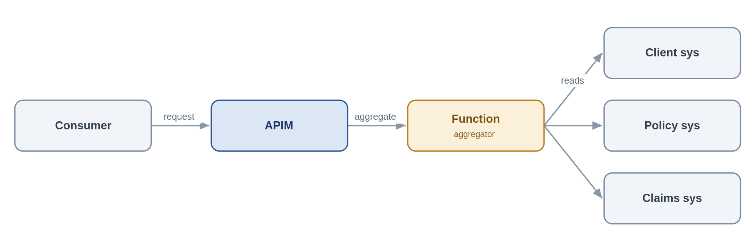
Problem. A servicing screen needs a "client 360" view whose data lives across three systems. Making the consumer call all three couples it to three contracts and three failure modes; doing the joins in the browser is worse.
Solution. Expose a single composed API on APIM backed by a Function that fans out to the underlying systems, assembles a coarse-grained response and returns it. The composition stays read-mostly and business-shaped, SOA granularity, not a chatty mesh of fine-grained calls.
Azure components
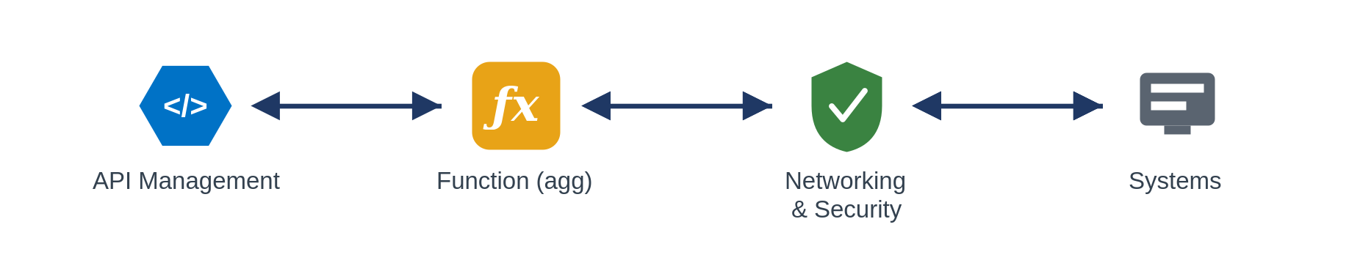
Use it when. a consumer needs one logical business object drawn from two or three sources and a single round-trip materially simplifies the caller.
Avoid it when. the composition needs transactional writes or long-running steps (orchestrate), or you find yourself fanning out to many fine-grained services, that is a granularity problem to fix, not to aggregate around.
Risks and considerations. Response time is governed by the slowest dependency and availability by their product, so decide up front how the API behaves when one source is down, a partial response with a clear indicator usually beats failing the whole call. Put a timeout and a circuit breaker around each backend, and cache what you safely can.
Security boundary. Landing zone: APIM (shared subscription) and the aggregator Function (workload spoke); the source systems in their spokes. Fully internal. Within Azure: the Function reaches each source over a Private Endpoint with a managed identity, no secrets in configuration (Key Vault references only), TLS throughout. Outside Azure: none.
Anti-pattern. Fine-grained, chatty aggregation that recreates a distributed monolith; pushing heavy composition into APIM policies instead of a Function.
In practice. A client-servicing screen calls one "client 360" API; the aggregator Function reads client, policy and claims summaries and returns a single object.

8.3.3 Protocol / format mediation (SFINT3)
Translate a legacy protocol to REST/JSON at the edge so modern consumers stay clean.
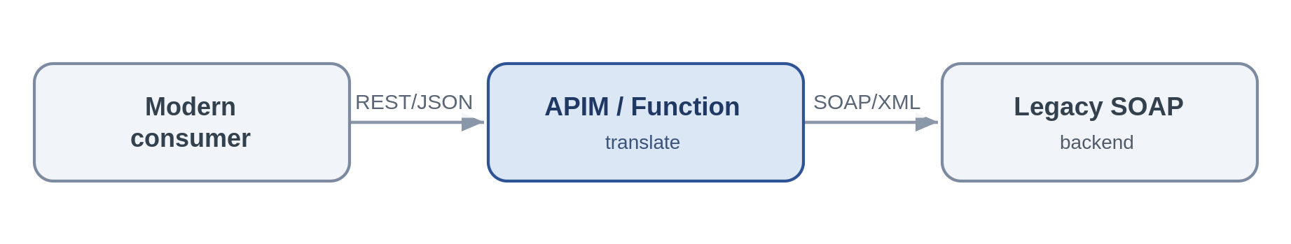
Problem. A cloud-native consumer must talk to a system that only speaks SOAP/XML or a fixed-width format. Letting that leak into the consumer spreads legacy concerns across the estate.
Solution. Terminate the modern REST/JSON contract at APIM for light transforms, or a Function for heavier ones, and translate to the backend's protocol. Consumers see only REST/JSON; the legacy quirks are contained in one place.
Azure components
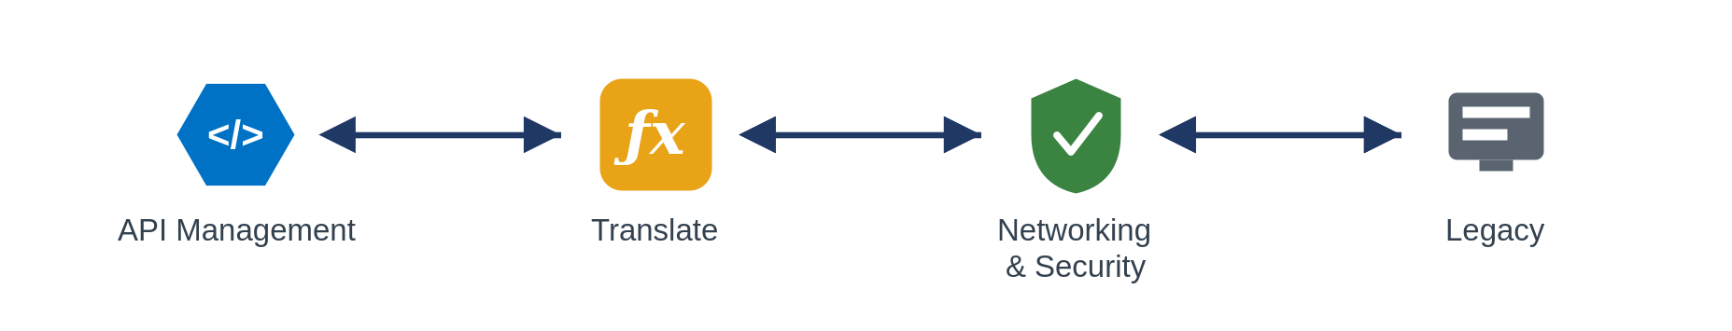
Use it when. you are standardising the estate on REST/JSON and need to front a legacy protocol.
Avoid it when. the requirement is really business transformation rather than protocol translation, that is implementation logic and belongs in a Function with tests, not in a mediation policy.
Risks and considerations. Keep the translation stateless and mechanical; the moment business rules creep in you have hidden, untested logic sitting in the edge. Validate schemas on the way through so malformed legacy payloads fail fast rather than propagating.
Security boundary. Landing zone: APIM or the mediation Function in the shared subscription / a spoke; the legacy backend in its spoke or on-premises. Within Azure: Private Endpoint, managed identity and TLS; an on-premises backend is reached over the private vWAN path, not the internet. Outside Azure: none, an internet-only legacy partner uses the inbound-webhook edge instead.
Anti-pattern. Business rules embedded in the translation layer; unbounded transformation inside APIM policies.
In practice. A legacy SOAP reinsurance service is fronted as a REST/JSON API for cloud-native consumers.

8.3.4 Synchronous request-reply (bounded) (SFINT4)
The considered synchronous exception, a short, bounded call where the caller needs the answer now.
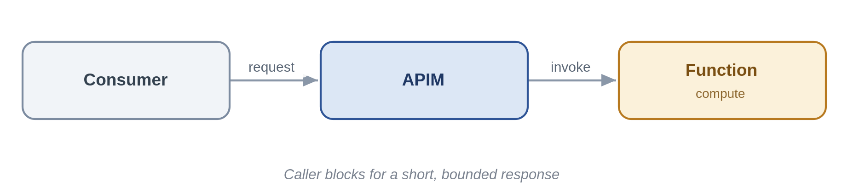
Problem. Some interactions really are synchronous: a quote figure the user is waiting on. The danger is that "synchronous" quietly becomes "long-running", and callers start timing out and retrying.
Solution. Expose the operation on APIM to a Function that completes in sub-second-to-low-second time, with a hard timeout. If the work cannot reliably finish that quickly, it is not this pattern, move to asynchronous request-reply or orchestration.
Azure components
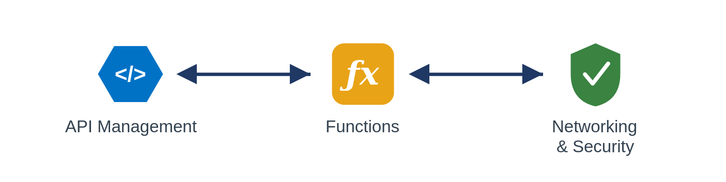
Use it when. the work is short and bounded and the caller must have the result to proceed.
Avoid it when. the duration is unpredictable or can run long, the classic cause of retry storms.
Risks and considerations. Enforce timeouts and make the operation idempotent so a client retry cannot double-apply. Treat a creeping p99 latency as an early signal that this should become asynchronous.
Security boundary. Landing zone: APIM (shared) and Function (spoke), fully internal. Within Azure: Private Endpoint, managed identity, TLS, with enforced timeouts. Outside Azure: none.
Anti-pattern. Long-running or unbounded work behind a synchronous endpoint.
In practice. A real-time premium calculation returns a figure within a second.

8.4 Messaging Patterns

8.4.1 Queue-based load levelling (SFINT5)
Put a queue between a spiky producer and a limited backend so load is absorbed, not amplified.
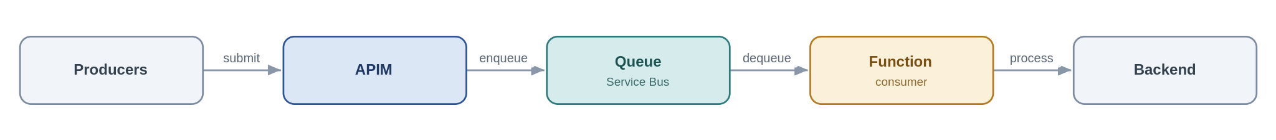
Problem. At renewal season broker submissions arrive far faster than the policy admin system can process them. Calling it synchronously either overwhelms it or fails the callers.
Solution. Accept the work at APIM, drop it on a Service Bus queue, and let a Function consumer process at the rate the backend can sustain. Producer and consumer are now decoupled in time, so a backend outage becomes a growing queue rather than a wave of errors.
Azure components
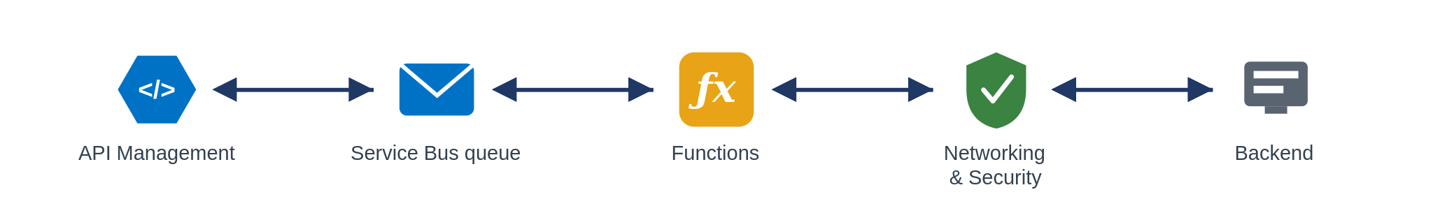
Use it when. the producer is spikier or faster than the consumer, or the backend's availability must be decoupled from producer load.
Avoid it when. the caller needs an immediate answer (request/response), or you are ingesting a high-volume telemetry firehose (Event Hubs).
Risks and considerations. A queue is a buffer, not infinite capacity, under sustained overload the backlog grows, so monitor queue depth and consumer lag and alert on them. Handle poison messages with a dead-letter queue and a max-delivery count, and make the consumer idempotent, because delivery is at-least-once. Global ordering is lost unless you use sessions.
Security boundary. Landing zone: APIM (shared), Service Bus and the consumer Function (spokes), internal. Within Azure: producers and consumer reach Service Bus over a Private Endpoint using a managed identity with Sender/Receiver RBAC (no SAS keys); TLS throughout. Outside Azure: none, an external producer is taken through the edge first.
Anti-pattern. Hammering a fragile backend synchronously; ignoring the dead-letter queue; reaching for storage queues where you need sessions, DLQ and richer delivery semantics.
In practice. Renewal submissions are buffered on Service Bus so the policy admin system drains them at a steady rate.

8.4.2 Competing consumers (SFINT6)
Scale out throughput by letting several workers pull from one queue.
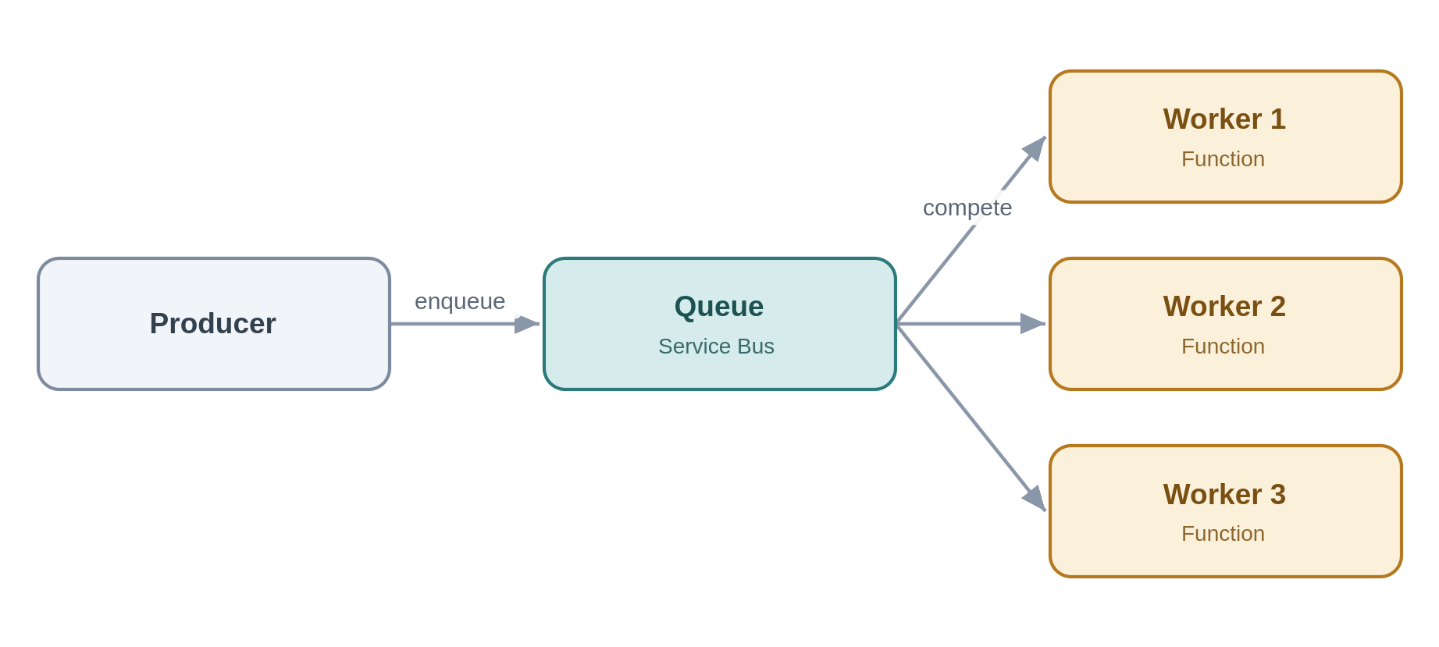
Problem. One consumer cannot keep up; work is piling up but the items are independent of each other.
Solution. Run multiple consumer instances against the same queue. Service Bus hands each message to exactly one worker and the pool scales with load; for per-entity ordering, sessions pin related messages to one consumer.
Azure components
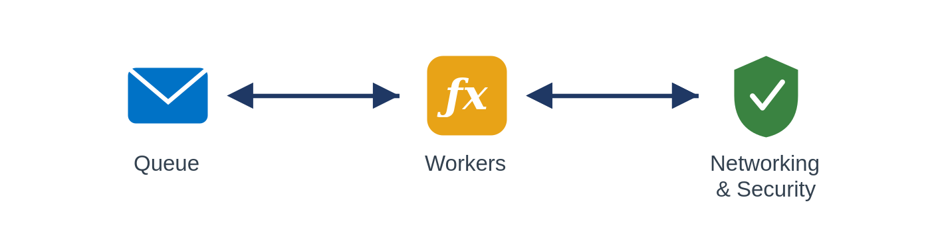
Use it when. throughput exceeds a single consumer and the work items are independent and parallelisable.
Avoid it when. you need strict global ordering without sessions, or workers must share mutable state.
Risks and considerations. Duplicate delivery still happens, so idempotency remains mandatory. Watch for hot sessions that serialise work and cap your scale-out, and autoscale on queue depth rather than CPU.
Security boundary. Landing zone: Service Bus and the Function pool in spokes, internal. Within Azure: Private Endpoint, managed identity with least-privilege RBAC, TLS. Outside Azure: none.
Anti-pattern. Assuming ordering without sessions; sharing mutable state between workers.
In practice. A backlog of document-processing jobs is cleared by an autoscaling pool of Function workers.

8.4.3 Asynchronous request-reply (SFINT7)
Accept now, answer later, a 202 and a status endpoint instead of a held-open connection.
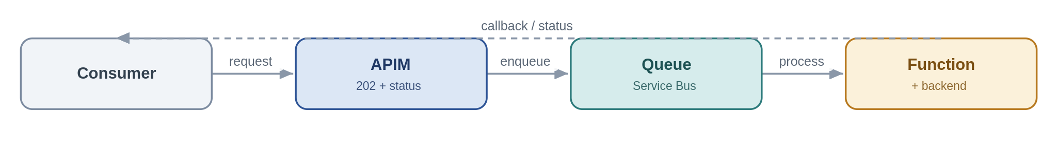
Problem. A caller wants a result from an operation that takes too long to hold a synchronous HTTP connection open for.
Solution. APIM accepts the request, returns 202 with a status URL and a correlation id, and drops the work on a queue. A Function processes it and updates a status store or calls back; the caller polls the status endpoint or receives the callback.
Azure components
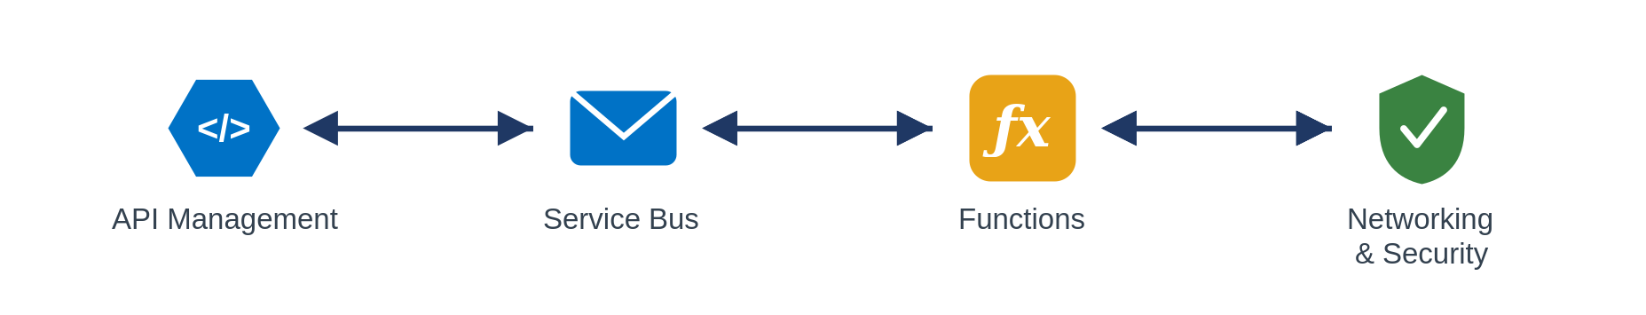
Use it when. the operation is too long for a synchronous reply but the caller still needs the eventual result.
Avoid it when. the result is instant (keep it synchronous) or there is no way to correlate request and reply.
Risks and considerations. The client contract is now two-phase, document the 202/polling behaviour clearly. Keep a durable status store and expire abandoned requests so they do not accumulate, and carry the correlation id end-to-end or you lose traceability.
Security boundary. Landing zone: APIM (shared), Service Bus and Function (spokes), internal. Within Azure: Private Endpoints, managed identity, TLS; the correlation id carries no secret material. Outside Azure: none unless the caller is external, in which case the request and status endpoints are exposed through the edge (Front Door + WAF + APIM, OAuth).
Anti-pattern. Holding a synchronous connection open for minutes; omitting a correlation id.
In practice. A bulk quote request returns 202 and a status URL; the completed result is available when processing finishes.

8.4.4 Claim-check (SFINT8)
Keep large payloads off the bus, pass a reference, store the body in Blob.
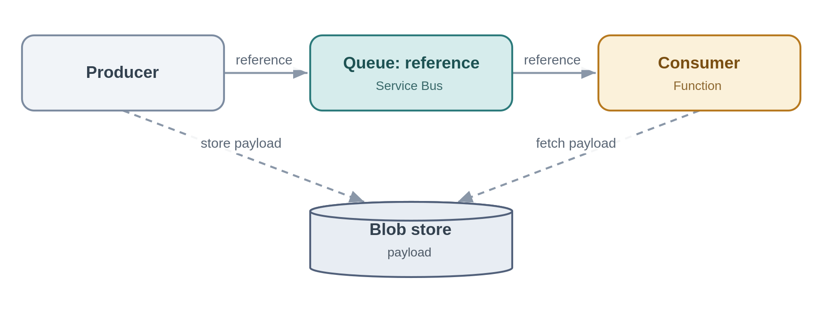
Problem. A message-based flow needs to carry a large document, but the bus has size limits and large messages are slow and expensive.
Solution. The producer writes the payload to Blob storage and puts only a reference on the queue; the consumer reads the reference and fetches the body from Blob. The messaging layer stays lean.
Azure components
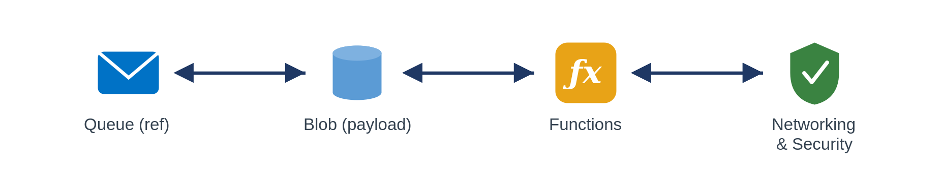
Use it when. payloads approach or exceed message-size limits within an otherwise message-based flow.
Avoid it when. payloads are small enough to carry inline, or the data is really a bulk data-platform concern.
Risks and considerations. Reference and payload now have independent lifetimes, a lifecycle policy must purge transient blobs or you leak cost, and the reference is useless if the blob has gone. Reach Blob over a Private Endpoint with RBAC; no account keys, no public SAS.
Security boundary. Landing zone: Service Bus, Blob and Function in spokes; the storage account is firewalled with public access disabled. Within Azure: Blob is reached over a Private Endpoint with managed-identity RBAC, no account keys, no public SAS, and TLS. Outside Azure: none; the payload never leaves the private boundary.
Anti-pattern. Large binaries on the bus; public or long-lived SAS URLs to the payload.
In practice. A large bordereaux file is staged in Blob and only its reference flows through the pipeline.

8.4.5 Reliable messaging (SFINT9)
For business-critical messages: never lost, and effectively processed once.
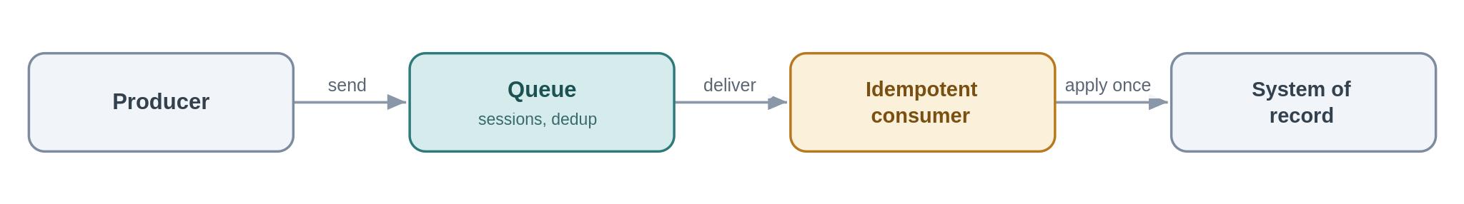
Problem. A financial posting must not be lost, and must never be applied twice, even if the broker retries or the platform redelivers.
Solution. Use Service Bus with duplicate detection and, where order matters, sessions; make the consumer idempotent so redelivery is safe; and where the event must be published in step with a local state change, use a transactional outbox. "Exactly once" is not something the transport gives you, you engineer it from at-least-once delivery plus idempotency.
Azure components
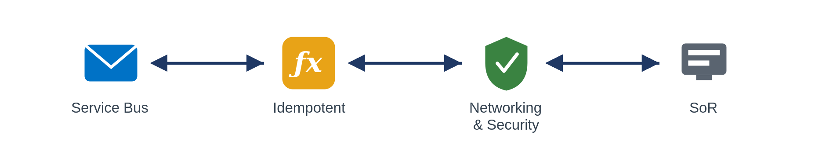
Use it when. message loss or double-processing has real financial or data-integrity impact.
Avoid it when. the notification is best-effort and replaceable, use Event Grid.
Risks and considerations. Duplicate-detection windows are finite, so design the idempotency key to outlive them. Premium throughput costs money, size it to the criticality tier, not to the peak of peaks.
Security boundary. Landing zone: Service Bus and consumer in spokes, internal. Within Azure: Private Endpoint, managed identity, TLS; idempotency keys carry no secrets. Outside Azure: none.
Anti-pattern. Assuming exactly-once delivery; non-idempotent consumers that double-apply effects.
In practice. A finance-posting message carries an idempotency key, so a redelivery is recognised and ignored.

8.4.6 Scheduled / timed trigger (SFINT10)
Kick off integration work on a clock when there is no event to react to.
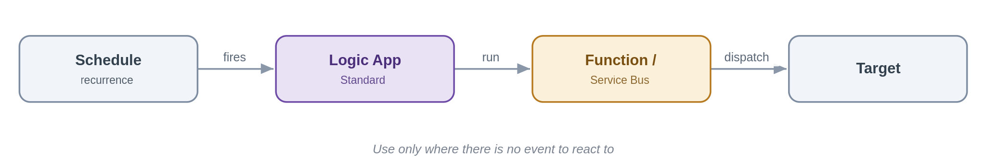
Problem. Some work is inherently periodic, an end-of-day reconciliation, a scheduled extract for a partner, a nightly sweep of a source that cannot emit events. Event-driven is the default in this framework, but forcing an event where none exists is its own contortion.
Solution. A Logic App (Standard) Recurrence trigger fires on a schedule and runs the work, calling a Function or dropping messages on Service Bus for downstream processing. It is the considered, bounded exception to asynchronous-first: a clock, not a poll of a data source pretending to be real-time.
Azure components
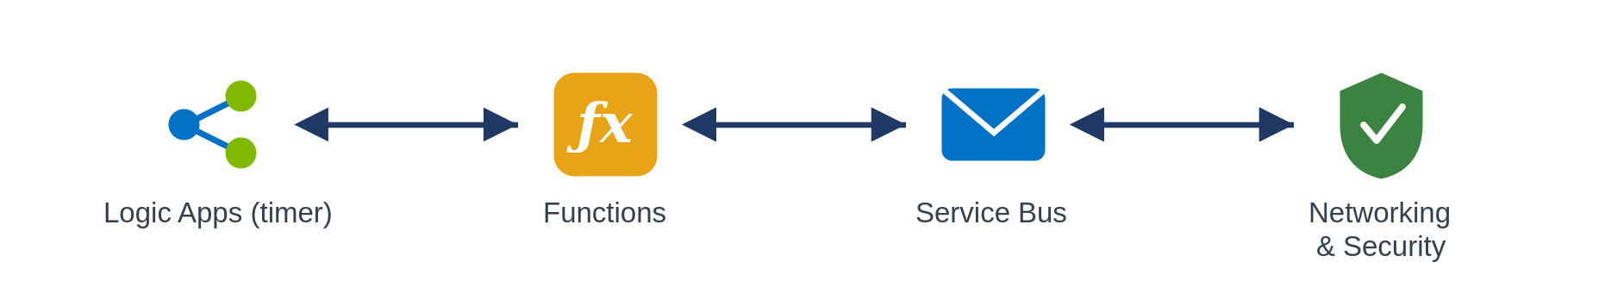
Use it when. the cadence is time-based (end-of-day, regulatory windows) or the source cannot notify and there is no event to subscribe to.
Avoid it when. an event exists to react to, use it (5.3.x); or you are timer-polling a folder or table to fake real-time, which is an anti-pattern, not this pattern.
Risks and considerations. Schedules drift into hidden coupling and surprise load spikes, document the cadence, stagger jobs, and make each run idempotent and safe to re-run after a missed or overlapping execution. Alert on missed runs; a silent scheduler is worse than a failed call.
Security boundary. Landing zone: the Logic App runs in a workload spoke; the schedule is internal and crosses no boundary. Within Azure: managed identity to any Function/Service Bus it calls, Private Endpoints, TLS. Outside Azure: none, if a scheduled run reaches a partner (an extract), that egress follows the file-egress edge controls (SFINT20).
Anti-pattern. Timer-polling a data source or folder to simulate real-time; overlapping runs with no idempotency; schedules scattered across teams with no visibility.
In practice. An end-of-day reconciliation between the policy system and finance runs on a Logic App recurrence and dispatches the day's deltas onto Service Bus.

8.5 Event Patterns

8.5.1 Publish / subscribe fan-out (SFINT11)
Publish a business event once; let interested consumers subscribe independently.
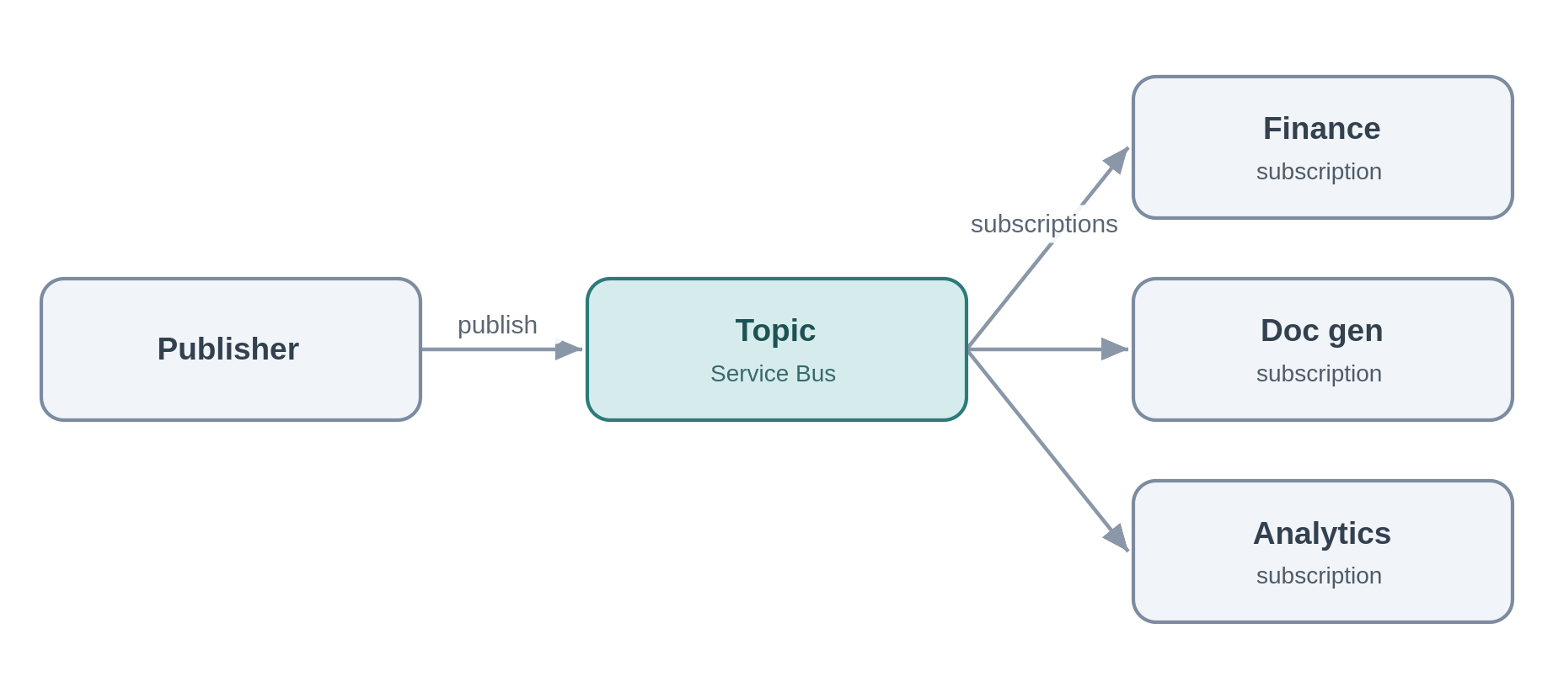
Problem. When a policy is bound, finance, document generation and the analytics offload all need to know. Wiring the publisher to each recreates point-to-point coupling and means changing the publisher every time a consumer is added.
Solution. The publisher emits a "PolicyBound" event to a Service Bus topic; each consumer owns a subscription with its own filter and dead-letter queue. Consumers come and go without the publisher knowing. This is the primary tool for eliminating point-to-point integration.
Azure components
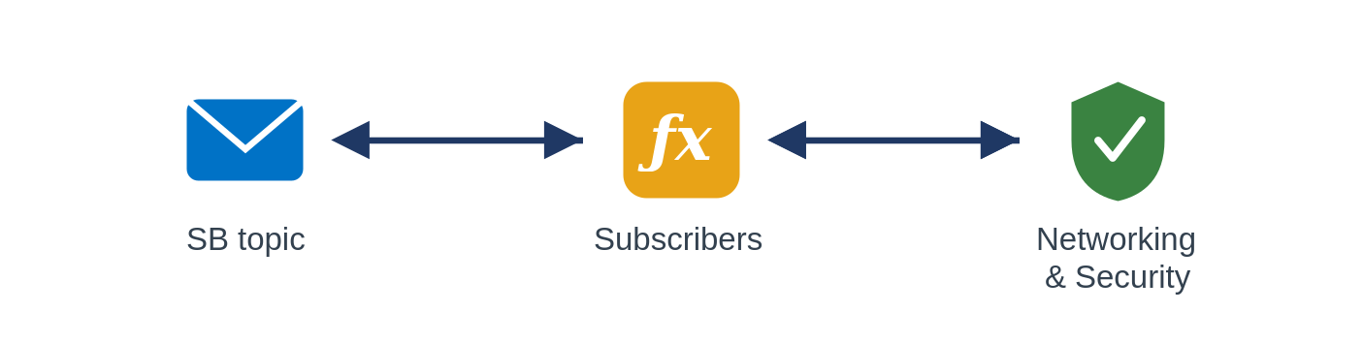
Use it when. several consumers must react to the same business event and you want durable, filterable, independently-consumed delivery.
Avoid it when. it is a lightweight reactive trigger with no durability need (Event Grid), or a high-volume stream (Event Hubs).
Risks and considerations. Subscriptions proliferate, so govern them and monitor each one's dead-letter queue, a broken filter silently drops messages. A slow subscriber builds its own backlog without affecting the others, which is the point, but it needs its own alerting.
Security boundary. Landing zone: the Service Bus topic and its subscribers in spokes, internal. Within Azure: Private Endpoint, per-subscription managed-identity RBAC, TLS. Outside Azure: none.
Anti-pattern. Hardwiring point-to-point instead of publishing; a publisher that knows its subscribers; using Event Grid where you need durable, ordered, competing-consumer delivery.
In practice. "PolicyBound" is consumed independently by finance, document generation and the analytics offload.

8.5.2 Discrete event notification (SFINT12)
A thin "it happened" signal for near-real-time reactions.
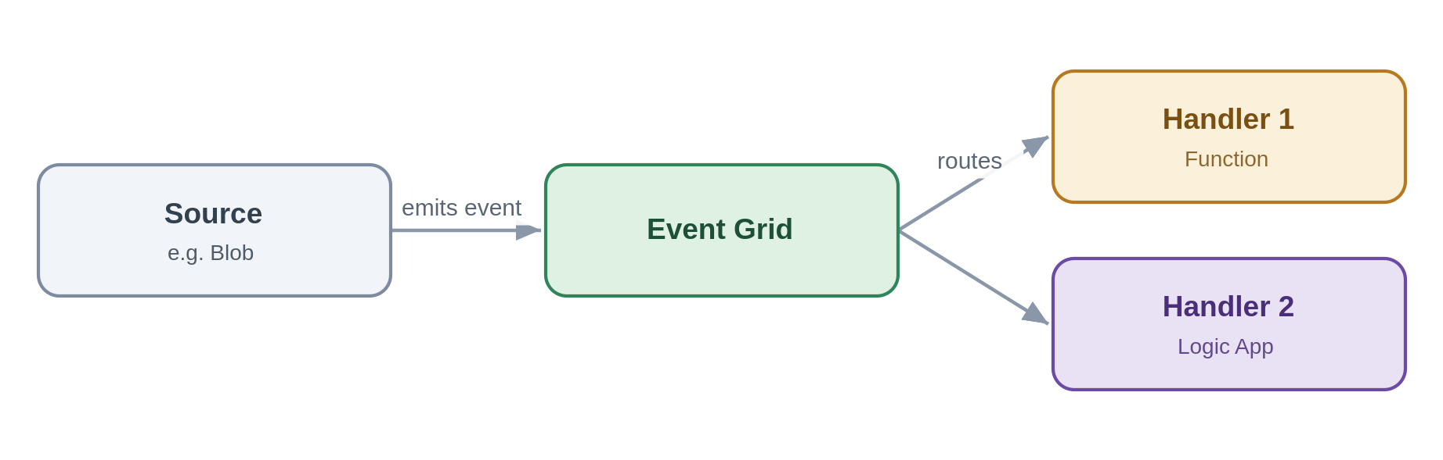
Problem. Something occurred, a file landed, a record changed, and one or two handlers should react quickly. A durable business-messaging topic is heavier than the job needs.
Solution. Emit a thin event to Event Grid; handlers (Functions, Logic Apps, webhooks) subscribe and react. The event is a pointer, not a state carrier, a handler fetches authoritative state if it needs it.
Azure components
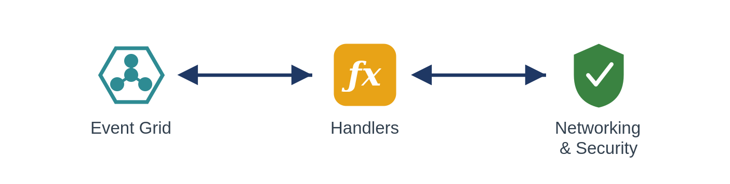
Use it when. you want lightweight, low-latency reactive fan-out to Azure-native handlers.
Avoid it when. consumers need durable ordered delivery or competing consumers (Service Bus topics), or the volume is a stream (Event Hubs).
Risks and considerations. Delivery is at-least-once and unordered, so handlers must be idempotent and order-independent, and a dead-letter destination must be configured so undeliverable events are not simply lost. Resist fattening the event into a pseudo source-of-truth, it hides coupling and goes stale.
Security boundary. Landing zone: Event Grid and its handlers in spokes, reached privately. Within Azure: managed-identity delivery, Private Endpoint where supported, handler-side validation, TLS. Outside Azure: none, a handler that must be internet-reachable is the inbound-webhook pattern, not this one.
Anti-pattern. Fat events that carry full state consumers come to trust; using Event Grid for streaming or durable business messaging.
In practice. A blob-created event triggers a document-ingestion workflow.

8.5.3 Inbound webhook ingestion (SFINT13)
Take partner callbacks safely through the front door, then process them asynchronously.
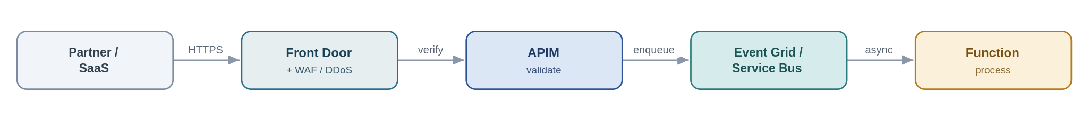
Problem. A partner or SaaS pushes events to Chaucer over HTTPS. Exposing an internal trigger to the internet is exactly the risk the security standards forbid.
Solution. This is the sanctioned public-ingress exception. Traffic enters through Front Door with a WAF and DDoS, terminates at APIM as the single ingress point, is authenticated (mTLS, OAuth, or a signed-payload check) and validated, then dropped onto Service Bus or Event Grid for asynchronous processing. No Function or Logic App HTTP trigger is ever exposed directly.
Azure components
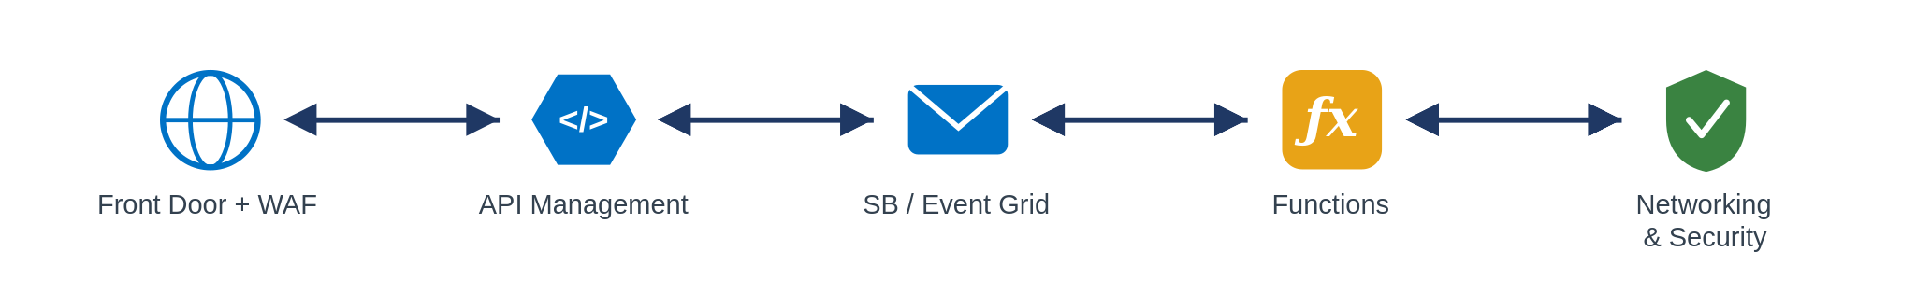
Use it when. an external party must push events to us and private networking is not possible.
Avoid it when. the integration can use private networking, prefer that every time.
Risks and considerations. You are internet-facing now, so assume replay and forgery: validate signatures, enforce rate limits, and deduplicate, because providers retry. Acknowledge fast and process asynchronously so a slow backend cannot be used to hold connections open. Record the exception with an owner and an expiry.
Security boundary. Landing zone: this is the one pattern that crosses the internet boundary, and it does so only in the online subscription. Front Door + WAF + DDoS terminate the public endpoint, APIM (shared subscription) is the single ingress, and processing happens back in the private spokes. Within Azure: past the edge everything is private, Service Bus/Event Grid and Functions over Private Endpoints with managed identity and TLS. Outside Azure: mTLS, OAuth or signed-payload validation, IP allow-listing and rate-limiting at the edge; no Function or Logic App trigger is ever exposed; the exposure is a registered, time-boxed exception.
Anti-pattern. Exposing a Logic App or Function HTTP trigger straight to the internet, bypassing APIM and the WAF; processing synchronously in the handler.
In practice. A payment provider posts settlement webhooks; APIM validates the signature and drops the event on Service Bus.

8.5.4 Outbound webhook / notification (SFINT14)
Push events out to subscribers instead of making them poll.
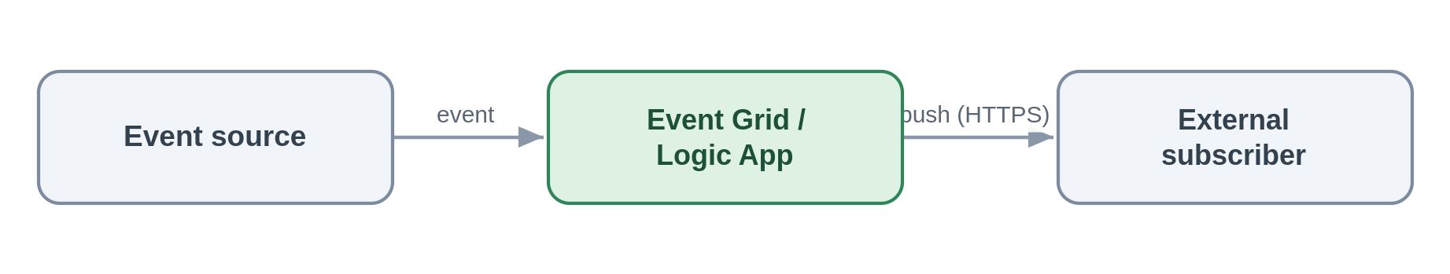
Problem. An external or internal party wants to be told when something changes, rather than polling us for it.
Solution. On the event, dispatch via Event Grid subscriptions or a Logic App connector, webhook, email or Teams. Subscribers are configured, not coded into the publisher.
Azure components
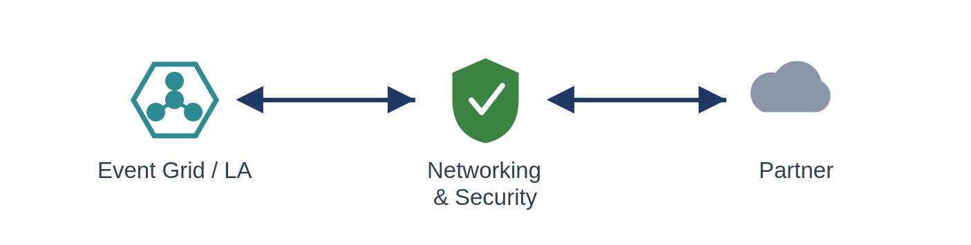
Use it when. subscribers expect to be pushed to on an event.
Avoid it when. subscribers should really pull current state through an API.
Risks and considerations. A subscriber endpoint being down creates retries and back-pressure, so retry with backoff and dead-letter the undeliverable. Hold partner secrets in Key Vault, sign payloads where supported, and put a circuit breaker around flaky endpoints.
Security boundary. Landing zone: Event Grid or the Logic App in spokes; the egress to an external subscriber leaves through the controlled path, not default internet routing (routing intent enforced). Within Azure: managed identity, partner secrets held in Key Vault and referenced, TLS. Outside Azure: TLS to the subscriber, payload signing where supported, partner endpoints allow-listed, and secrets rotated/revoked through Key Vault.
Anti-pattern. Polling to simulate push; bespoke per-subscriber dispatch code instead of subscriptions.
In practice. The broker's system is notified automatically when a claim status changes.

8.5.5 Stream / telemetry ingestion (SFINT15)
Ingest high-volume continuous data and hand it to processors or the data platform.
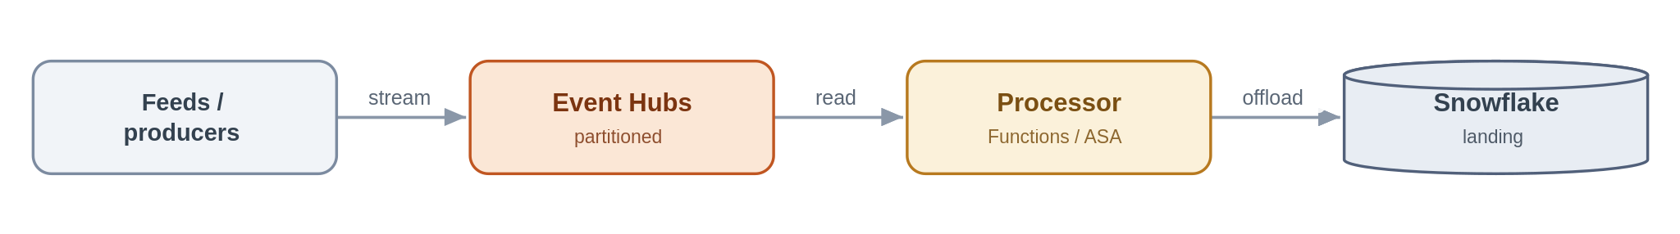
Problem. A high-frequency feed produces far more events than a business-messaging queue is designed for, and it needs partitioned, ordered processing.
Solution. Ingest into Event Hubs, partitioned for throughput; process with Functions or Stream Analytics; and typically capture or offload to Snowflake for analytics. Event Hubs is the firehose; Service Bus is not.
Azure components
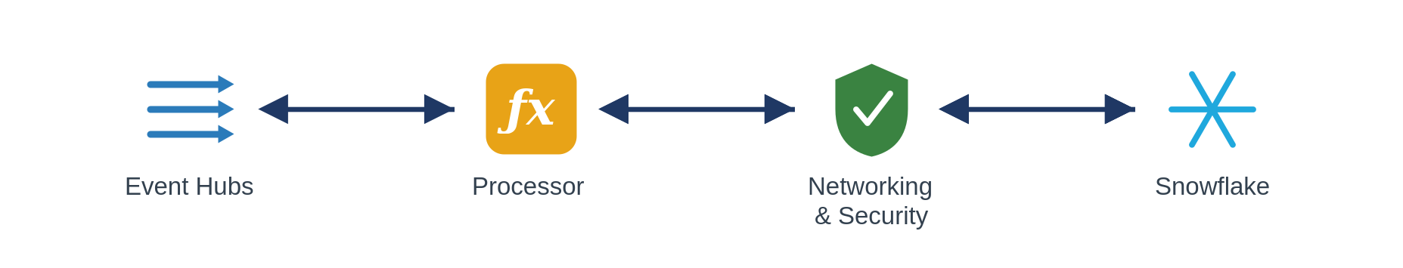
Use it when. sustained high event rates need partitioned stream processing.
Avoid it when. these are transactional business commands needing per-message dead-lettering and sessions (Service Bus), or low-volume discrete notifications (Event Grid).
Risks and considerations. Partition count is a capacity decision you largely live with, so plan it against throughput and consumer parallelism. Manage checkpoints, monitor consumer lag, and remember ordering holds only within a partition. Premium or Dedicated capacity is a real cost line.
Security boundary. Landing zone: Event Hubs and its processors in spokes; capture to a firewalled storage account. Within Azure: Private Endpoint, managed identity, TLS, with capture storage under RBAC. Outside Azure: an external feed enters through the edge; internal streams cross no boundary.
Anti-pattern. Service Bus for firehose volumes; Event Hubs for transactional commands; synchronous consumers on a stream.
In practice. A high-frequency exposure feed is ingested, processed near-real-time and offloaded to Snowflake.

8.6 Orchestration Patterns

8.6.1 Stateful process orchestration (SFINT16)
Coordinate a multi-step, multi-system business process with state, retries and visibility.
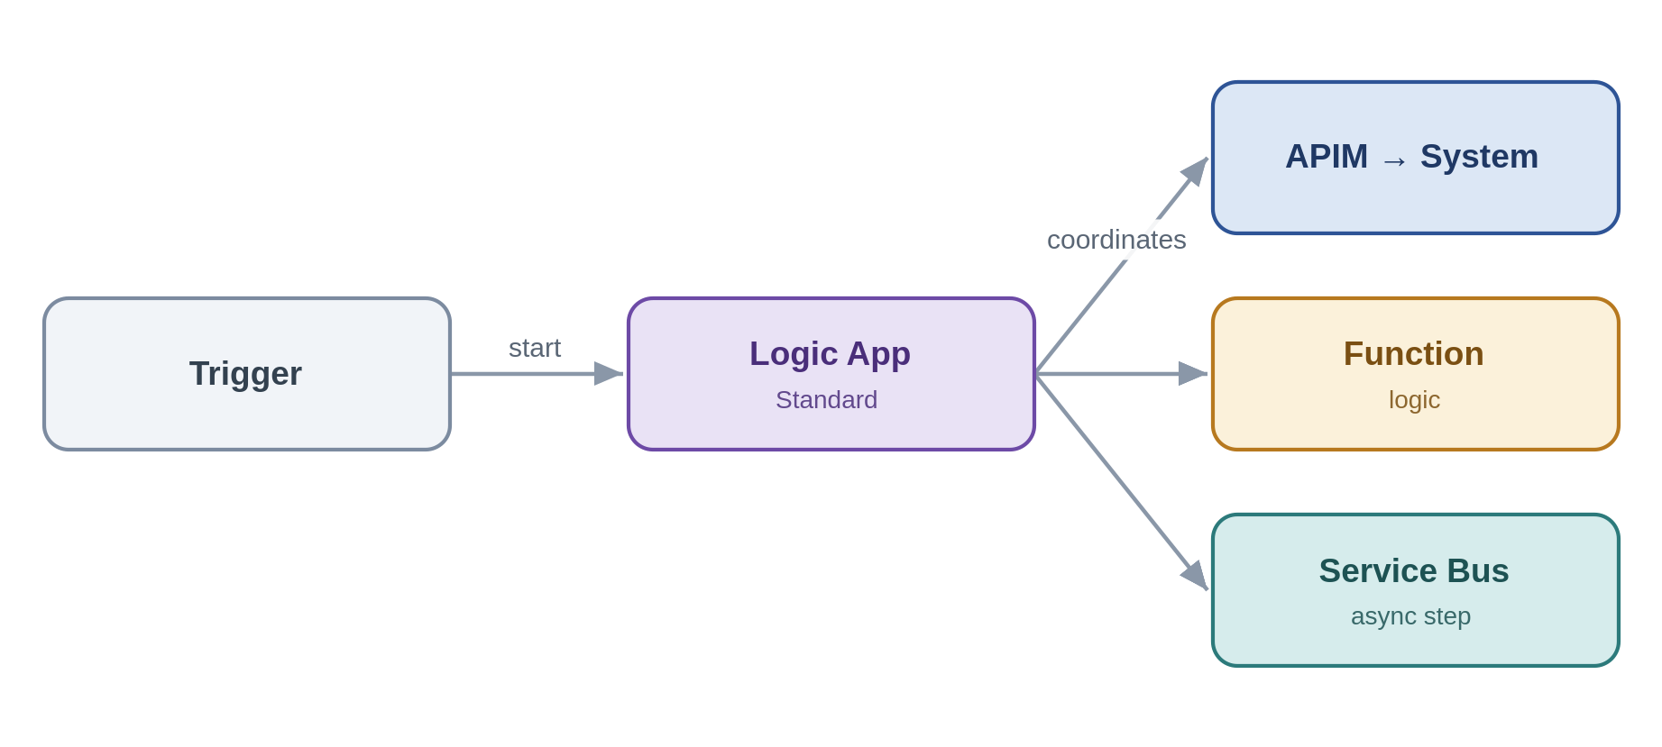
Problem. New-business onboarding spans validation, pricing, document generation, notification and system updates. No single system owns the process, and stitching it together point-to-point makes it invisible and brittle.
Solution. A Logic App (Standard) owns the process: it sequences the steps, calls capabilities through APIM, delegates computation to Functions, and hands asynchronous work to Service Bus. It keeps run state and history, so the process is observable and recoverable, and, per the rule above, it holds control flow only.
Azure components
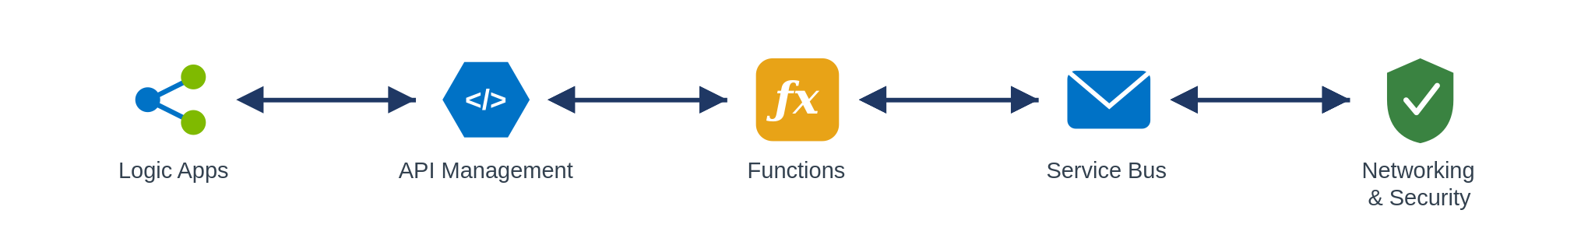
Use it when. a business process crosses several systems and steps and needs state, retries and auditability over minutes, hours or days.
Avoid it when. a single synchronous call suffices, or it is really just message buffering.
Risks and considerations. Without discipline the workflow accretes business logic and becomes a monolith, keep logic in Functions and the workflow readable. Standard run history is region-bound, so DR is active-passive and in-flight runs do not migrate; design steps to be idempotent and restartable. Connectors have throttling limits, long-running state has a cost, and you need a versioning strategy for changing a workflow while runs are in flight.
Security boundary. Landing zone: the Logic App (Standard) is VNet-integrated in a workload spoke and calls APIM (shared), Functions and Service Bus (spokes), all internal. Within Azure: every connector authenticates with a managed identity (no keys), Key Vault references for any unavoidable secret, Private Endpoints, TLS. Outside Azure: none directly, external calls leave through APIM and the edge, not from the workflow.
Anti-pattern. Business, compute or transformation logic inside the workflow; orchestration smeared across many uncoordinated workflows; microservices-style choreography with no owning process.
In practice. New-business onboarding is coordinated end-to-end by one Logic App calling Functions and systems in turn.

8.6.2 Process with compensation (SFINT17)
When a later step fails, undo the earlier ones, orchestrated centrally, not choreographed.
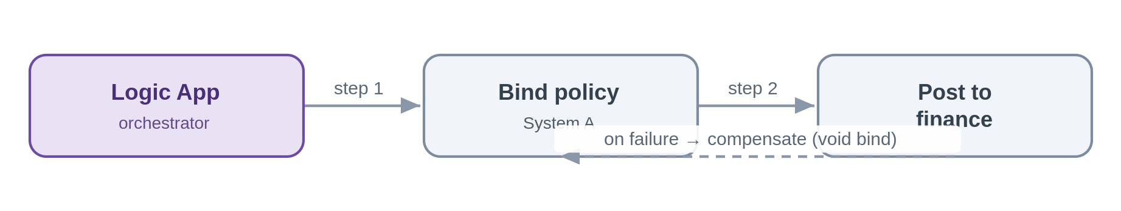
Problem. A policy is bound in one system and then the finance posting fails. There is no distributed transaction across these systems, but the bind must not be left dangling.
Solution. The orchestrator drives compensating actions on failure, here, voiding the bind. Because Chaucer's model is SOA, the process is centrally owned and its compensation logic lives with it, not scattered across services reacting to each other.
Azure components
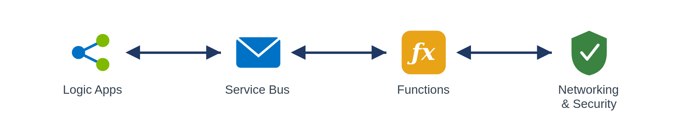
Use it when. you need cross-system consistency without distributed transactions and a single process can own the compensation.
Avoid it when. an ACID transaction within one system suffices, or someone proposes a microservices-style distributed saga (out of scope here).
Risks and considerations. Compensation is best-effort, not atomic, a compensation can itself fail, so make compensations idempotent and retryable, and use the run history as the saga log. Watch ordering and the possibility of duplicate compensation.
Security boundary. Landing zone: Logic App, Service Bus and Functions in spokes, internal. Within Azure: managed identity, Private Endpoints, TLS, with each step and each compensation audited in run history. Outside Azure: none, cross-system calls are to internal systems over private connectivity.
Anti-pattern. Choreographed sagas with no central owner; relying on two-phase or distributed transactions.
In practice. If the bind succeeds but the finance posting fails, the orchestration compensates by voiding the bind.

8.6.3 Human-in-the-loop / approval (SFINT18)
Insert a human decision into an automated process, with audit and escalation.
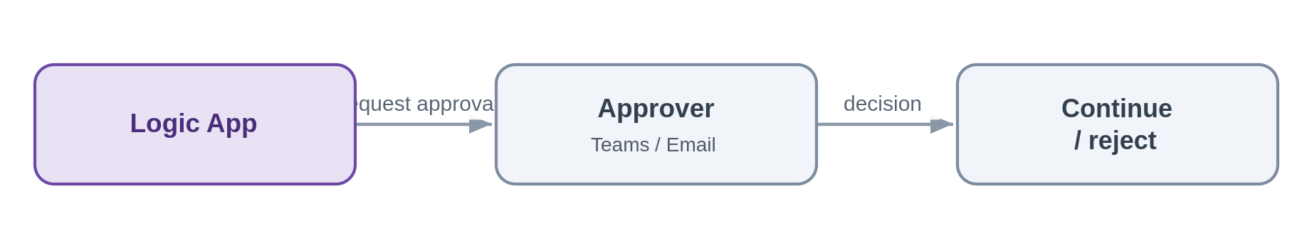
Problem. A referral needs underwriter sign-off before the process continues, and the decision must be captured.
Solution. The Logic App pauses for an approval over Teams or email, captures the decision with the approver's identity, and resumes. Timeouts and escalation keep the process from stalling.
Azure components
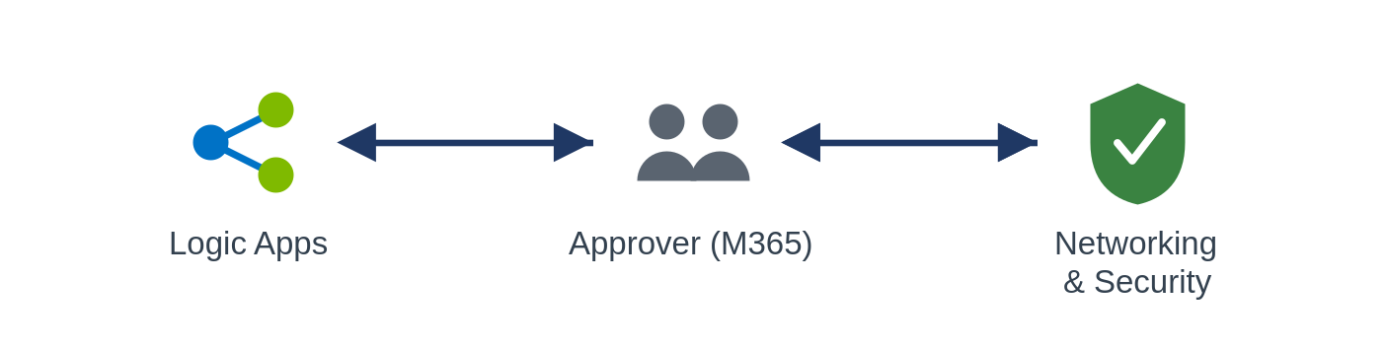
Use it when. a process needs human sign-off and an audit trail.
Avoid it when. the decision can be made by rules, keep it straight-through.
Risks and considerations. Un-answered approvals stall processes, so always set timeouts, reminders and an escalation path. Authenticate approvers through Entra and record the decision for audit.
Security boundary. Landing zone: the Logic App in a spoke; approvals run over Teams or Outlook, which are Entra-authenticated Microsoft 365 services, not arbitrary internet endpoints. Within Azure: managed identity, TLS, and an audit of the decision and the approver's identity. Outside Azure: approver interaction is over Entra-authenticated Microsoft 365; there is no bespoke internet exposure.
Anti-pattern. Approvals handled over untracked email outside the platform; no timeout or escalation.
In practice. A referral waits for underwriter sign-off before the workflow proceeds to bind.

8.7 File Patterns

8.7.1 Event-driven file ingestion (SFINT19)
A partner or system drops a file; pick it up on arrival, validate and parse it, and turn its contents into messages the platform can process.
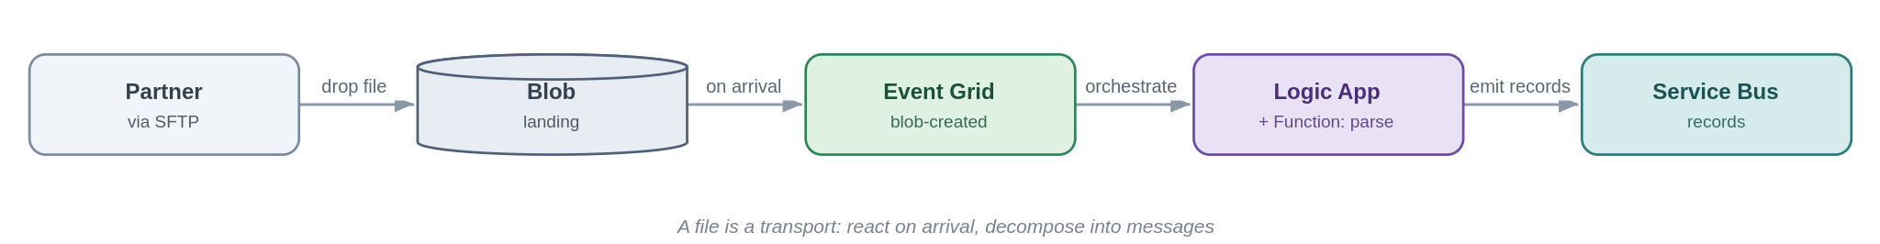
Problem. Two systems must exchange data but one can only produce files, a broker's daily SFTP drop, a legacy nightly extract. The tactical habit is to poll a folder on a timer and process the whole file in one lump, which trades latency for load, hammers storage, and leaves the file layout as a brittle point-to-point contract.
Solution. Land the file in Blob (an SFTP endpoint can be backed by Blob) and react to its arrival with an Event Grid blob-created event, event-driven, not polled. A Logic App orchestrates the handling: a Function validates and parses the file, and each record is emitted onto Service Bus so downstream processing uses the platform's ordinary messaging patterns. The file becomes a transport; the records become the integration.
Azure components
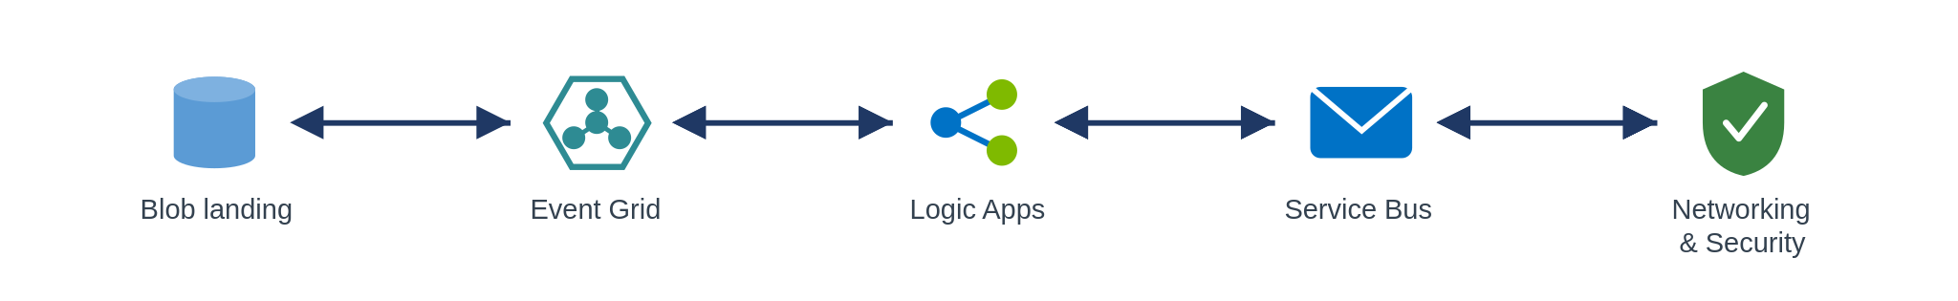
Use it when. a source can only deliver operational data as files (partner SFTP, legacy extract, scheduled drop) and the contents are records to process.
Avoid it when. the systems can expose an API or emit events directly, prefer that; or the file is a large bulk/analytical dataset, which is a data-platform concern (SFINT23).
Risks and considerations. Do not timer-poll, react to arrival events, or you reintroduce latency and load. Handle partial files with a completion marker or a write-then-rename so you never read a half-written file. Validate up front and move bad files to an error/quarantine container rather than half-processing them, the file equivalent of a dead-letter queue. Make ingestion idempotent and dedupe on filename plus content hash, because partners resend. Large files follow claim-check semantics (SFINT8), pass the reference, don't shuttle the bytes. Secure the transport: SFTP over a Private Endpoint with no anonymous access, a managed identity to Blob, encryption in transit and at rest, and PII handling for the contents.
Security boundary. Landing zone: the Blob landing (firewalled, public access disabled), Event Grid, the Logic App/Function and Service Bus all sit in spokes; a partner SFTP drop is the external boundary. Within Azure: Blob over a Private Endpoint with managed-identity RBAC (no account keys, no public SAS); Event Grid and the Function private; TLS. Outside Azure: the SFTP endpoint is fronted through the online-subscription edge or reached over private connectivity, requires SFTP-over-SSH with key or certificate auth and no anonymous access, is IP allow-listed, and files are encrypted in transit and at rest, a registered exception where it is internet-facing.
Anti-pattern. Timer-polling a folder to fake real-time; processing the whole file as one monolithic blob with no per-record error handling; treating the file layout as a permanent contract instead of decomposing to messages.
In practice. A broker SFTPs a daily submissions file; arrival triggers a Logic App that validates and parses it, emitting each submission as a Service Bus message into the policy admin flow.

8.7.2 File generation and delivery (SFINT20)
The platform produces a file from records or events and delivers it to a partner or system that can only consume files.
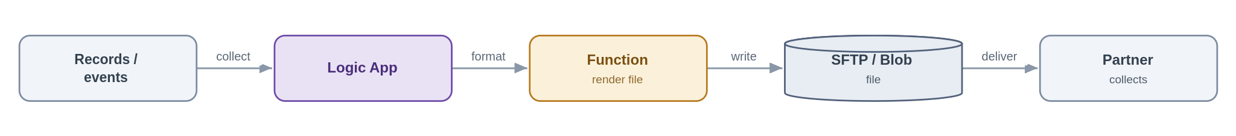
Problem. A downstream party, a partner, a legacy system, a regulator, needs data as a file, on a schedule or on an event, but we hold it as records and events.
Solution. A Logic App collects the data (from events, a query, or accumulated messages), a Function renders it into the required file format, and the file is written to Blob and delivered, pushed to the partner's SFTP or staged for collection, with a completion event so downstream teams know it went. Delivery status is tracked and retried.
Azure components
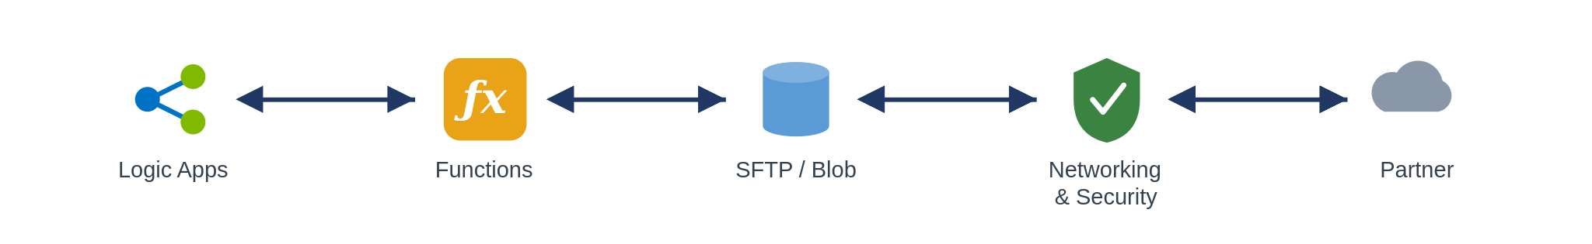
Use it when. a consumer can only ingest files, or a scheduled or regulatory extract is required.
Avoid it when. the consumer could call an API or subscribe to events, offer that instead.
Risks and considerations. Delivery guarantees to third parties are weak, so retry with backoff, track delivery status and alert on failure; use idempotent naming so a retry does not duplicate. Hold partner SFTP credentials in Key Vault, and sign or encrypt sensitive files (PGP where required). Write-then-rename so a partner never collects a half-written file, and manage retention so generated files do not accumulate cost.
Security boundary. Landing zone: the Logic App, Function and Blob/SFTP staging sit in spokes; delivery to the partner is the external boundary. Within Azure: managed identity to Blob (no keys), partner SFTP credentials held in Key Vault and referenced, TLS. Outside Azure: SFTP-over-SSH with key auth to an allow-listed partner host, sensitive files signed or encrypted (for example PGP), and egress over the controlled path rather than default routing.
Anti-pattern. Hand-rolled scheduled scripts running outside the platform with credentials in config; no delivery confirmation or retry.
In practice. A nightly settlement extract is generated and pushed to the partner's SFTP, with a completion event notifying the finance team.

8.8 Data Platform Patterns

8.8.1 Push to the data platform (SFINT21)
Push operational data and events into the platform's landing zone, without coupling operations to the warehouse.
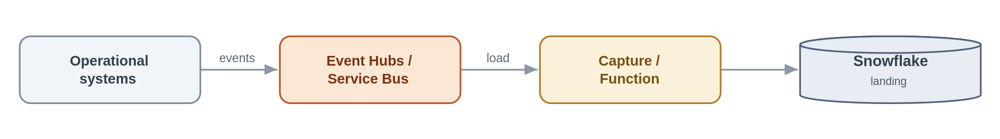
Problem. Reporting and analytics need operational data, but pointing operational systems at the warehouse, or the warehouse at them, couples the two and drags analytical latency into the transaction path.
Solution. Publish operational events to Event Hubs or Service Bus in the canonical form; a capture process or Function lands them in the platform's landing zone. Operations never depend on the warehouse, and the warehouse consumes at its own pace. The SIF's job ends at the landing zone, everything downstream is the platform's.
Azure components
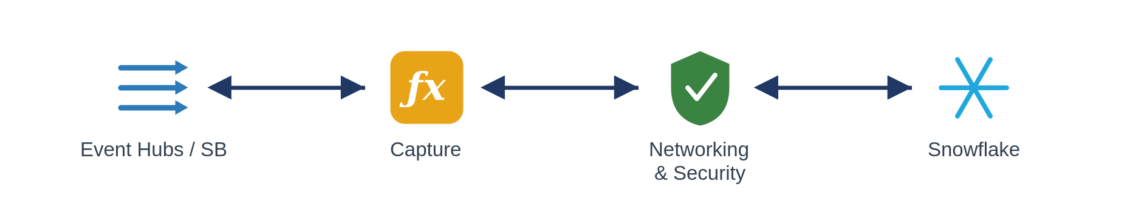
Use it when. operational events are needed for analytics and must stay out of the transaction path.
Avoid it when. the data is needed synchronously in an operational flow (keep it in the SIF), or it is a bulk historical load.
Risks and considerations. Guard against schema drift between operations and analytics with an explicit event contract, and classify and minimise PII before it lands in the warehouse. Loads are at-least-once, so make them idempotent.
Security boundary. Landing zone: Event Hubs/Service Bus and the capture Function in spokes; the Snowflake landing sits across the data-platform boundary. Within Azure: Private Endpoints, managed identity, TLS, with PII classified and minimised before it lands. Into the platform: Snowflake is reached over Private Link (not public) with OAuth or a managed identity; the SIF's control ends at the landing zone.
Anti-pattern. Snowflake as a real-time hub between operational systems; operational systems querying the warehouse in a transactional path.
In practice. Claim-lifecycle events are offloaded to Snowflake for management reporting.

8.8.2 Consume from the data platform and serve to a consumer (SFINT22)
Pull curated data from the platform and serve it to a consumer through the gateway, analytical, not a system of record.
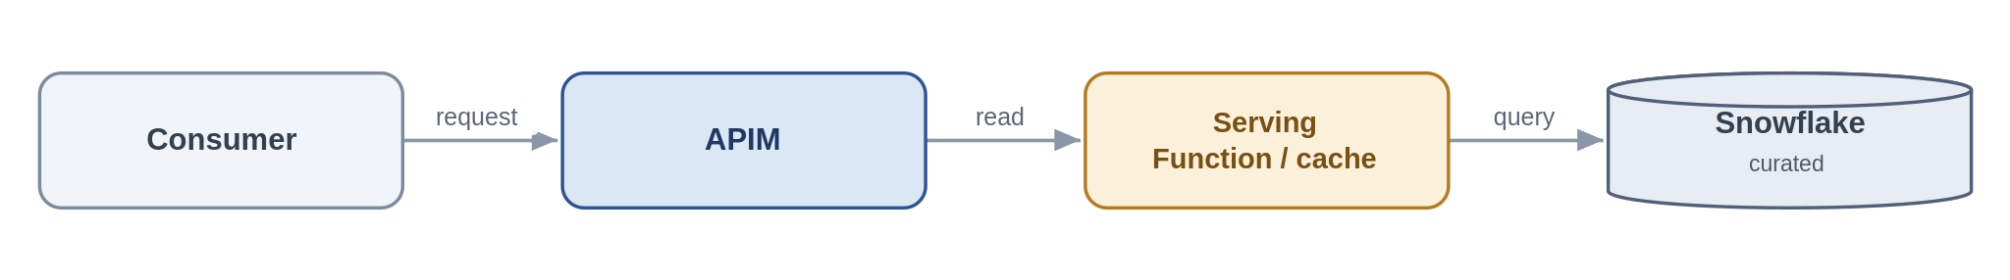
Problem. An internal app or partner wants curated, aggregated data that lives in Snowflake, but it should not be running warehouse queries in a latency-sensitive path or treating analytics as the source of truth.
Solution. Expose the curated data through an APIM product backed by a thin serving Function or cache over Snowflake via Private Link. The platform owns the curation; the SIF owns only the exposure, the API contract, authentication, caching and SLA. The contract is explicitly analytical and eventually-consistent.
Azure components
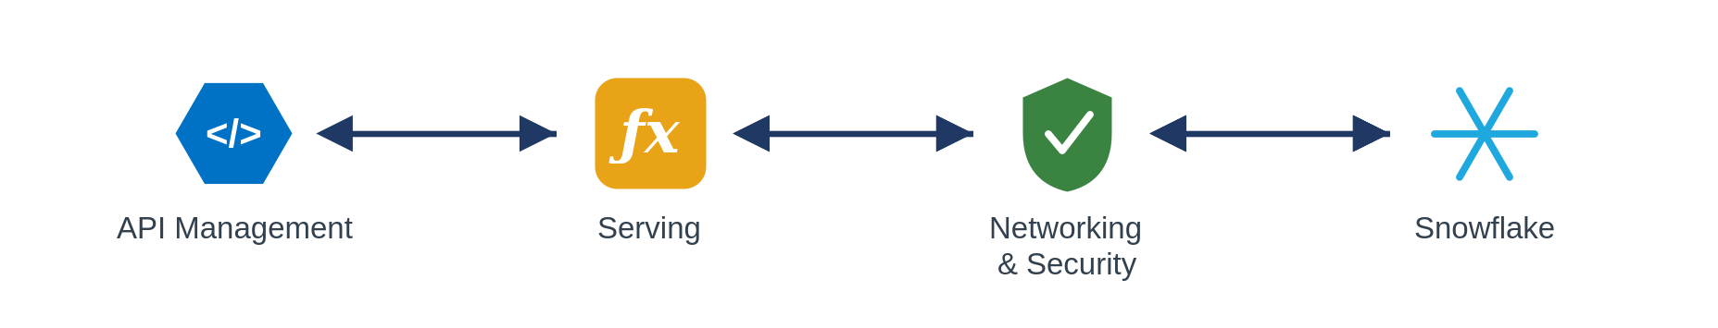
Use it when. consumers need governed, curated data products and can tolerate analytical latency.
Avoid it when. the read is latency-sensitive or transactional, go to the operational system through a request/response API.
Risks and considerations. Warehouse latency and cost under API load are real, so cache aggressively and set a clear SLA. Make consumers understand this is a curated, eventually-consistent product, not the operational source of truth.
Security boundary. Landing zone: APIM (shared) and the serving Function (spoke); Snowflake read over Private Link. Within Azure: Private Endpoint, managed identity, TLS; the consumer is authenticated at APIM (Entra), data access is least-privilege, and caching limits how much is exposed. Outside Azure: only where the consumer is external, through the edge (Front Door + WAF + APIM, OAuth).
Anti-pattern. Synchronous warehouse queries in a hot transactional path; bypassing APIM to hit Snowflake directly.
In practice. Aggregated exposure metrics are exposed as a governed product API to an internal application.

8.8.3 Bulk data movement (the boundary) (SFINT23)
Bulk and batch belong to the data platform; the SIF only signals.
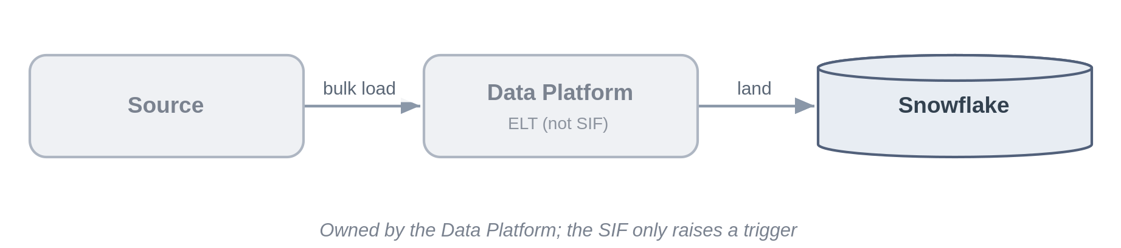
Problem. There is always pressure to build "just a quick nightly load" inside the integration platform. That crosses the boundary and puts the wrong workload on the wrong tool.
Solution. Large-volume and batch movement is executed by the data platform as ELT into Snowflake. The SIF's only role is to raise a trigger or completion event, and the owner of the output store is named explicitly.
Azure components
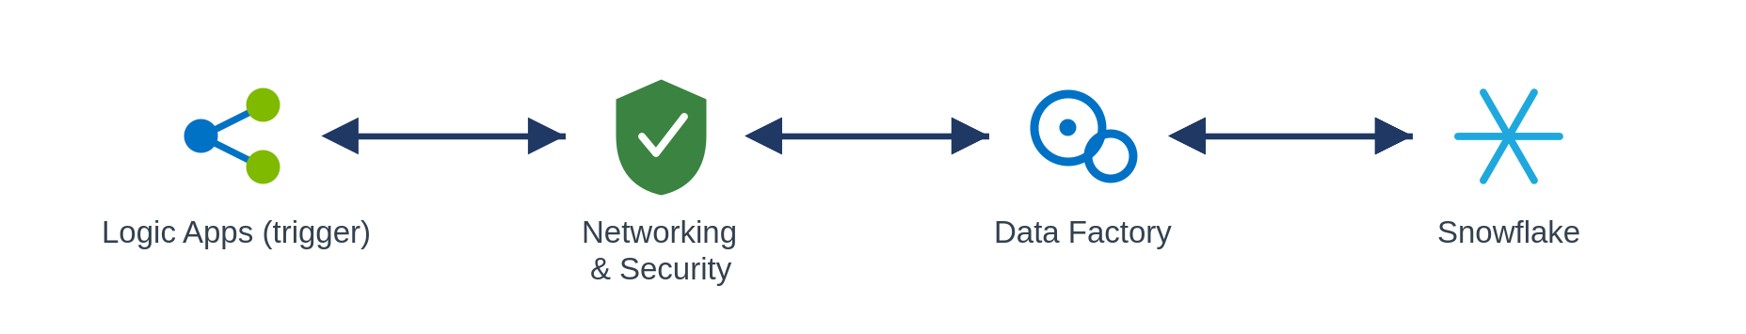
Use it when. the movement is large-volume, scheduled or historical, in which case it is not an AIS job at all.
Avoid it when. always, for building batch ETL inside Logic Apps or Functions to sidestep the data platform.
Risks and considerations. The real risk here is organisational, boundary erosion. Enforce it at design review, and make output ownership explicit so result stores do not become orphaned.
Security boundary. Landing zone: not a SIF data flow, the SIF only raises a trigger event from within its spokes, and the movement runs on the data platform. Within Azure: the trigger uses managed identity, a Private Endpoint and TLS. Outside Azure: none for the SIF.
Anti-pattern. Batch ETL built inside the integration platform; using the SIF as a bulk data mover.
In practice. The nightly bordereaux load runs on the data platform; the SIF only signals that source data is available.

8.9 Transformation and Routing Patterns

8.9.1 Canonical data model and message translator (SFINT24)
Map every external format to one internal canonical model, so internal systems never bind to a partner's format.
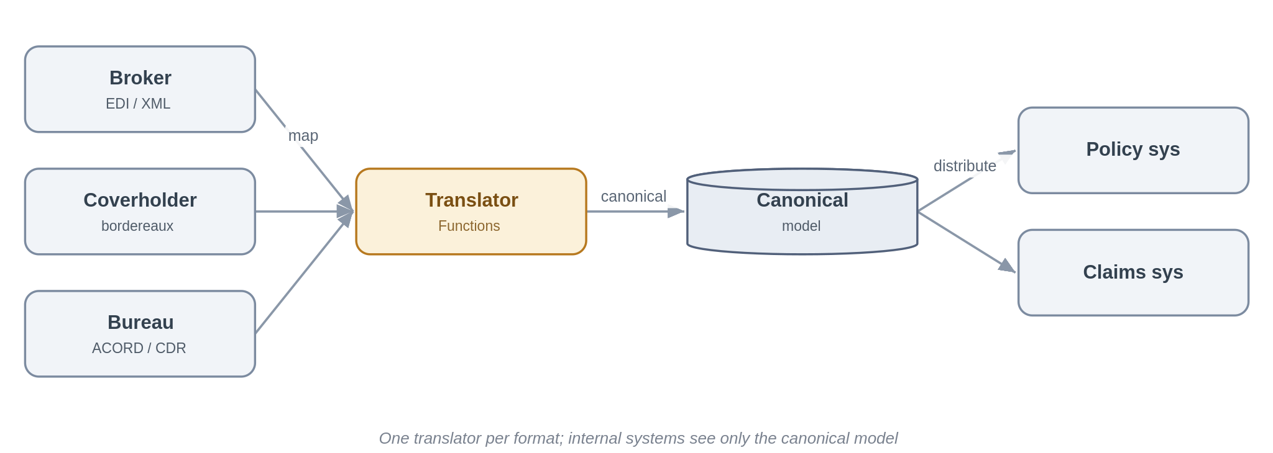
Problem. Insurance means integrating with many parties, brokers, coverholders, delegated claims administrators, reinsurers, the bureau, each with its own format and its own version of the truth: EDI, ACORD XML, bordereaux spreadsheets, the Core Data Record. If each internal system integrates directly with each external format, every new partner multiplies the interfaces and every format change ripples across the estate.
Solution. Define one internal canonical model per business concept, risk, premium, claim, and translate at the edge. A Function maps each inbound external format into the canonical model, and the reverse on the way out. Internal systems and the downstream patterns only ever see the canonical form, so adding a partner means writing one translator rather than touching every consumer. The same canonical model is the contract used when publishing to the data platform (Section 5.6), so a single semantics serves both operational and analytical consumers.
Azure components
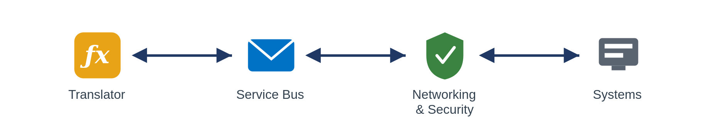
Use it when. you integrate with several external parties or standards for the same business concept, which, in this domain, is almost always.
Avoid it when. there really is a single, stable format on both sides (rare here), a straight protocol mediation (SFINT3) is enough.
Risks and considerations. The canonical model is a shared asset and a governance responsibility, it needs an owner, versioning and a change process, or it rots. Keep mappings declarative and tested, and treat a field that has no canonical home as a design conversation, not a silent drop. This is a message translator doubling as an anti-corruption layer, so resist the gravitational pull of letting a dominant partner's or the bureau's schema quietly become the internal model.
Security boundary. Landing zone: the translator Function runs in a workload spoke, sitting at the seam between external formats and the internal canonical model. Within Azure: internal distribution over Private Endpoints with managed identity and TLS. Outside Azure: inbound external formats arrive via the relevant boundary pattern, the edge for internet partners, private connectivity for peered ones, and the translator itself is never internet-exposed.
Anti-pattern. Point-to-point mapping between every internal system and every partner format; letting one broker's or the bureau's schema become the de facto internal model.
In practice. Broker EDI, coverholder bordereaux and bureau messages are each translated into Chaucer's canonical risk, premium and claim model; the policy and claims systems consume only the canonical form.

8.9.2 Content-based routing (SFINT25)
Route a message or event to the right destination based on what is in it.
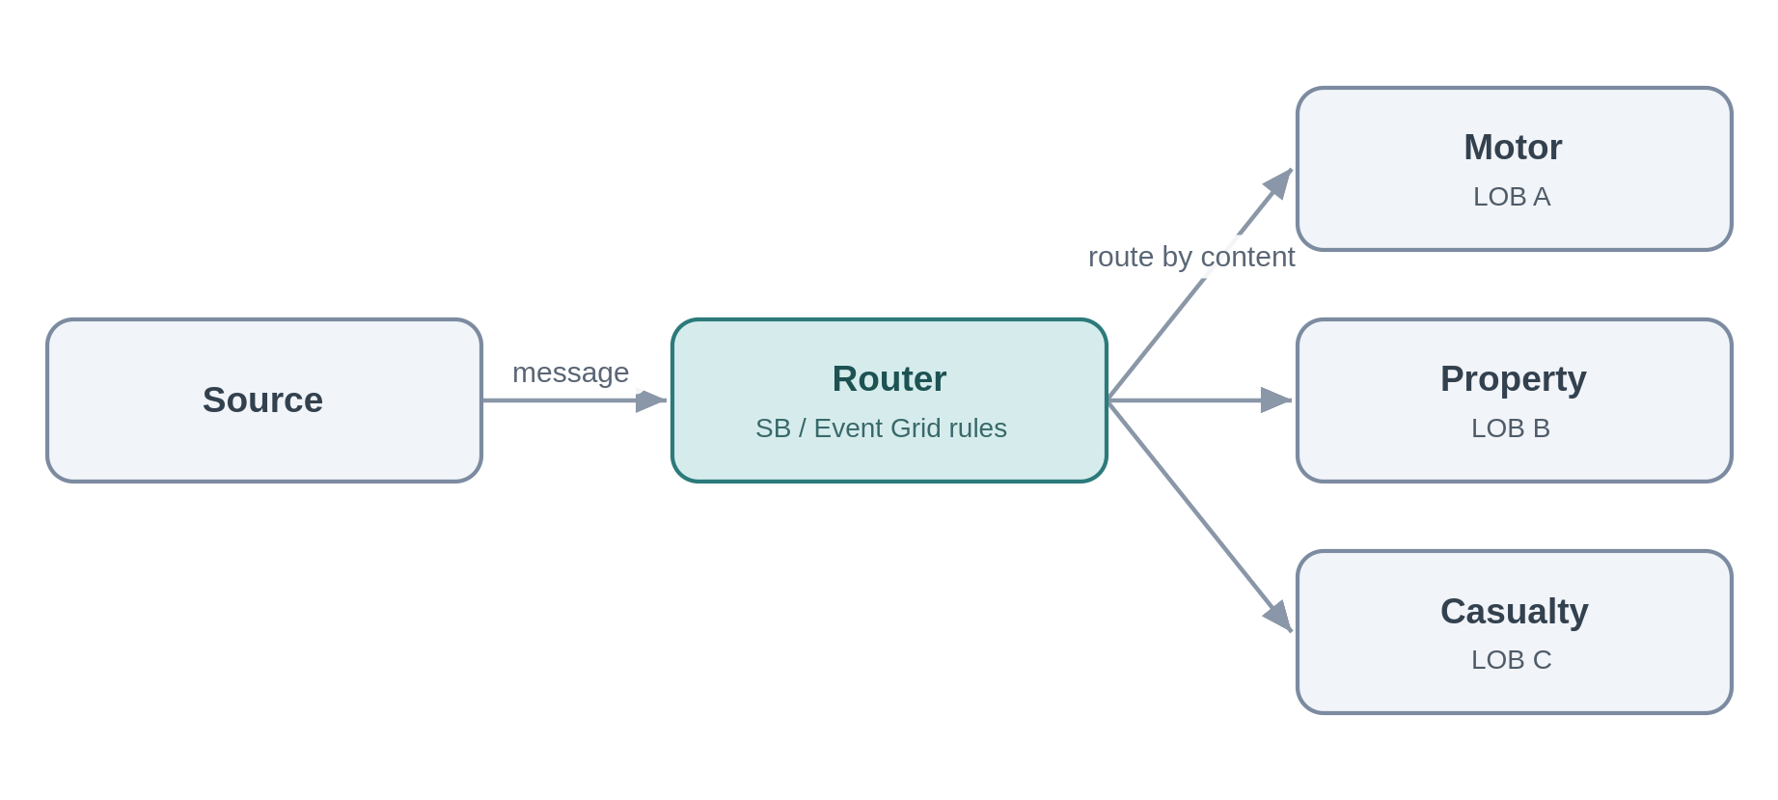
Problem. Submissions, bordereaux and claims arrive on a common channel but need to go to different places, by line of business, territory, coverholder or claim type.
Solution. Route on content using Service Bus subscription filters or Event Grid routing, or a Function for richer rules, so each message reaches the right handler without the producer knowing the routing map.
Azure components
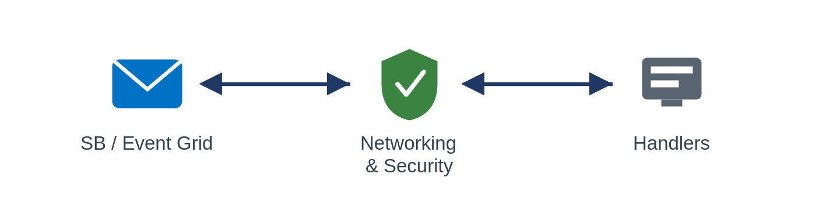
Use it when. items on a shared channel need to diverge to different handlers according to their content.
Avoid it when. there is only one destination, or the routing depends on external lookups better handled by a short orchestration.
Risks and considerations. Routing rules are logic and they drift, so keep them declarative and versioned, and always provide a default or dead-letter route, anything that matches no rule must be caught, not silently lost.
Security boundary. Landing zone: the Service Bus/Event Grid routing rules, or a routing Function, in spokes, internal. Within Azure: Private Endpoint, managed identity, TLS, with a default/dead-letter route captured. Outside Azure: none.
Anti-pattern. A monolithic if/else router hard-coded in one place; no default route for unmatched content.
In practice. Inbound submissions are routed to the motor, property or casualty underwriting queues by line of business.

9. Insurance Integration Scenarios
The table shows how the catalogue resolves characteristic Chaucer integrations. Each scenario names the patterns it composes, the primary Azure components and the purpose it serves. Pattern references point to the catalogue in Section 7.
Scenario | Patterns | Primary components | Purpose
9.1 Delegated Authority | File ingestion (SFINT19), canonical model (SFINT24), content routing (SFINT25), push to platform (SFINT21) | Logic Apps, Functions, Blob, Service Bus, Snowflake | Validate coverholder reporting, capture at source where possible, and retire manual bordereau re-keying.
9.2 London Market | Canonical model (SFINT24), messaging (SFINT9), orchestration (SFINT16), push to platform (SFINT21) | API Management, Logic Apps, Service Bus, Functions | Align processing to the core data record and design for incremental modernisation.
9.3 Submissions | Inbound webhook or API (SFINT1, SFINT13), file ingestion (SFINT19), content routing (SFINT25), composition (SFINT2) | API Management, Front Door and WAF, Logic Apps, Functions | Accept submissions by API, file or portal, triage and route to the right underwriting team and system.
9.4 Claims | Inbound webhook or API (SFINT13), orchestration with compensation (SFINT16 and SFINT17), outbound webhook (SFINT14), push to platform (SFINT21) | API Management, Logic Apps, Service Bus, Functions | First notification of loss from portals and third-party administrators, orchestrated across systems, with status notifications outbound.
9.5 Reinsurance | Canonical model (SFINT24), file and messaging (SFINT19, SFINT9), orchestration (SFINT16) | Logic Apps, Functions, Service Bus, Snowflake | Cede risk, premium and claims to treaty and facultative systems and reinsurers, and manage recoveries.
9.6 Regulatory Reporting | Event offload (SFINT21), consume and serve (SFINT22), orchestration (SFINT16), file delivery (SFINT20) | Snowflake, Logic Apps, Functions, API Management | Assemble regulatory and tax reporting on the data platform and submit through orchestrated feeds or files.

10. Data Platform Position and Guardrails

10.1 Core Position
The data platform is owned by the data team and is not a general integration endpoint. The framework meets Snowflake at two governed hand-offs only, a push into the platform and a curated consume from it. Bulk movement and transformation remain inside the data platform. This boundary keeps operational integration and analytical data cleanly separated and governed.

10.2 Appropriate Uses
Landing operational data into the platform for analytics and reporting.
Serving a curated, read-only dataset back to an operational consumer through the platform's serving layer.
Streaming high-volume telemetry into the platform for downstream processing.

10.3 Inappropriate Uses
Treating Snowflake as an operational source of truth for live transactions.
Reaching into the platform's internals from an integration flow, or into operational systems from the platform.
Using the platform as a message bus or a general-purpose integration hub.

10.4 Exchange Patterns
Three import routes and two export routes are approved. Each marks the framework side, the platform side and the hand-off boundary, with private connectivity, managed identity and TLS on every hop.

Import: to the data platform [To be enhanced]
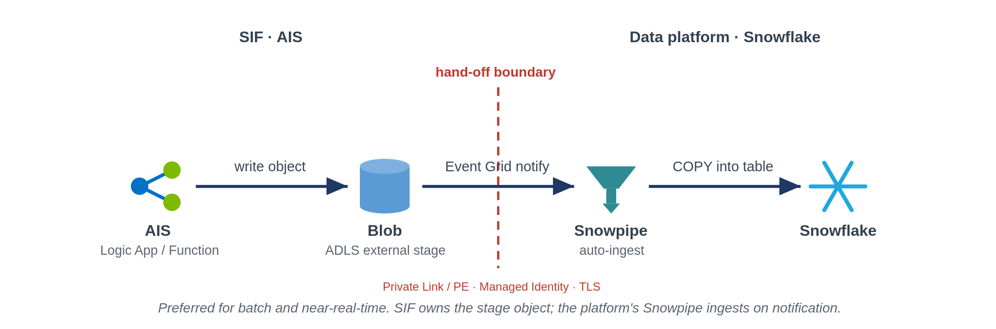
Preferred: land to a stage, the platform ingests
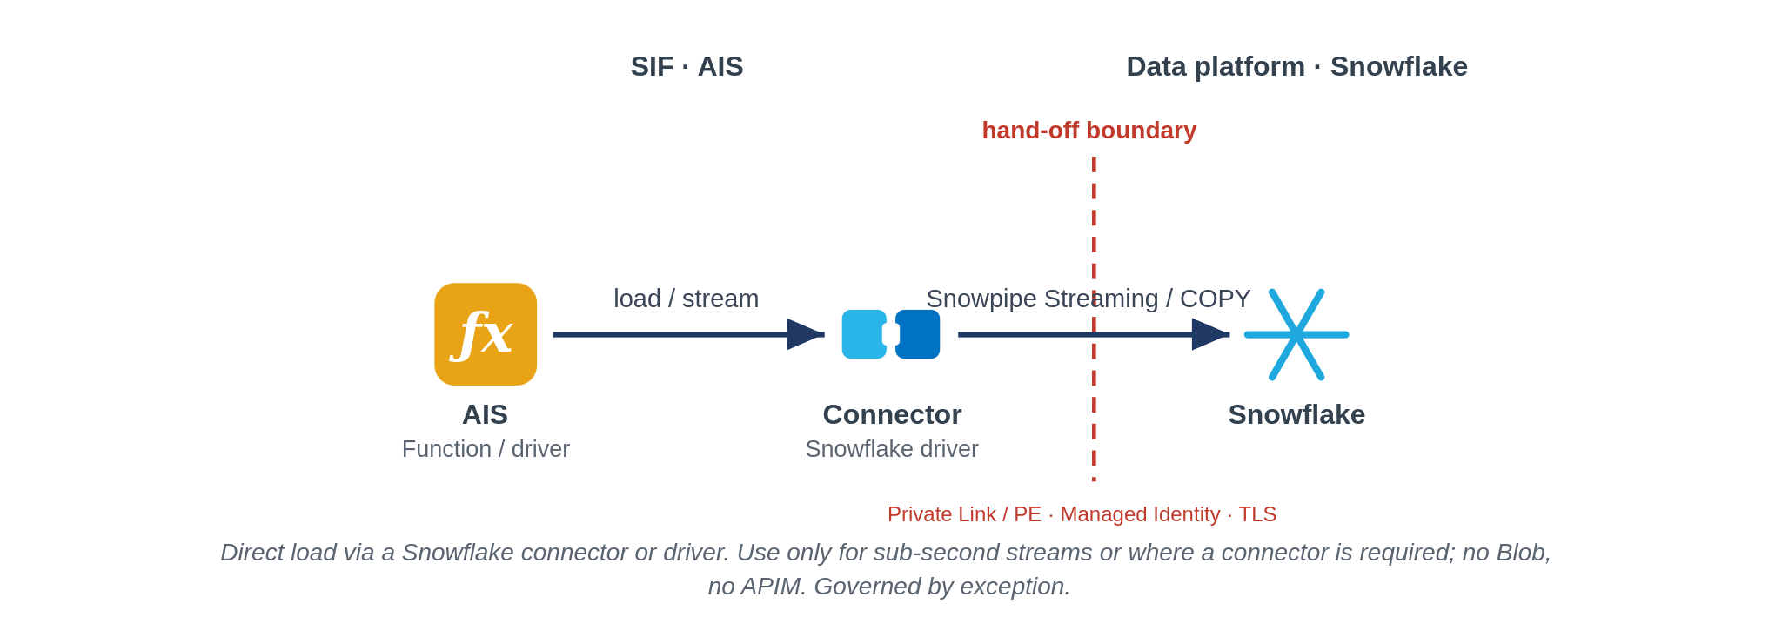
Direct connector, for streaming only, as a governed exception
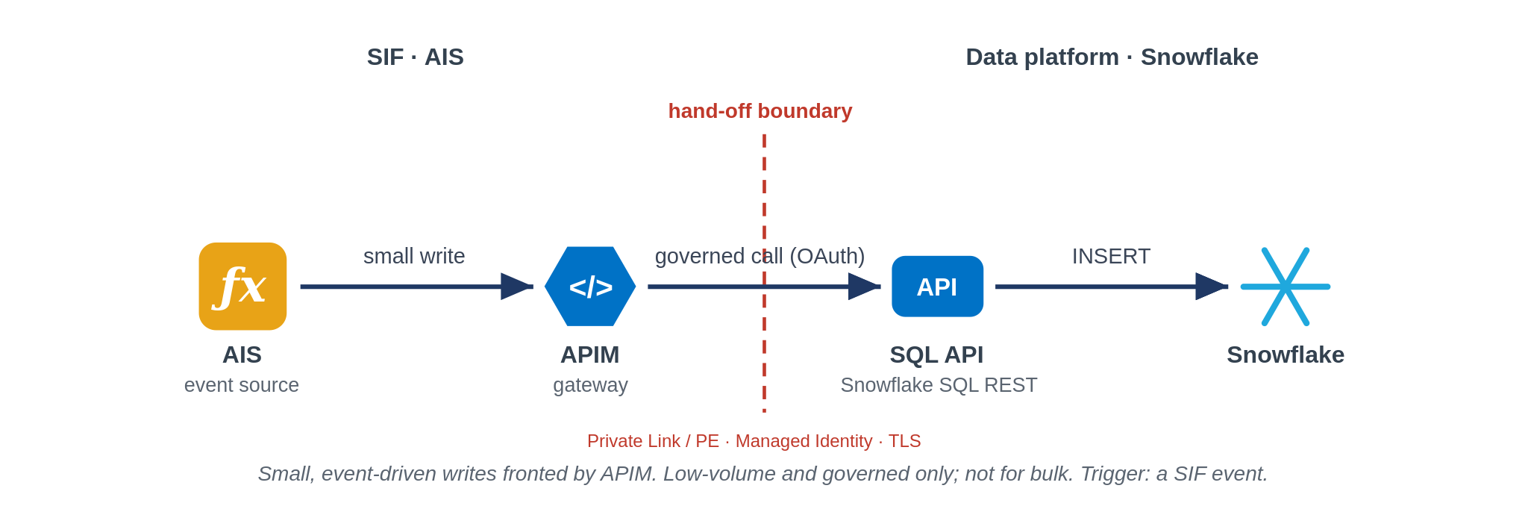
Small governed writes through API Management

Export: from the data platform
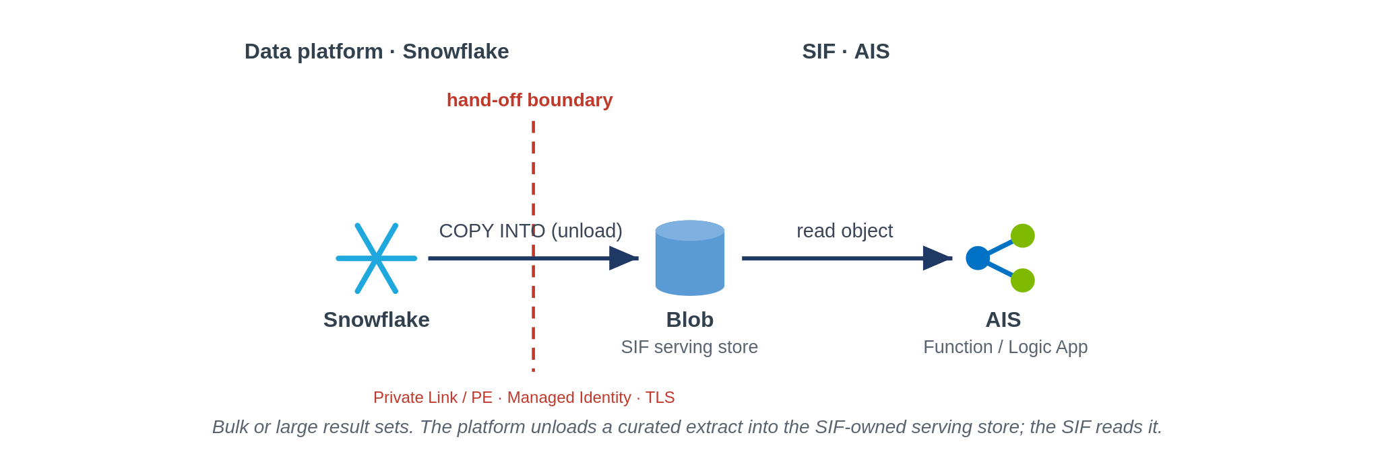
Bulk unload to a framework-owned serving store
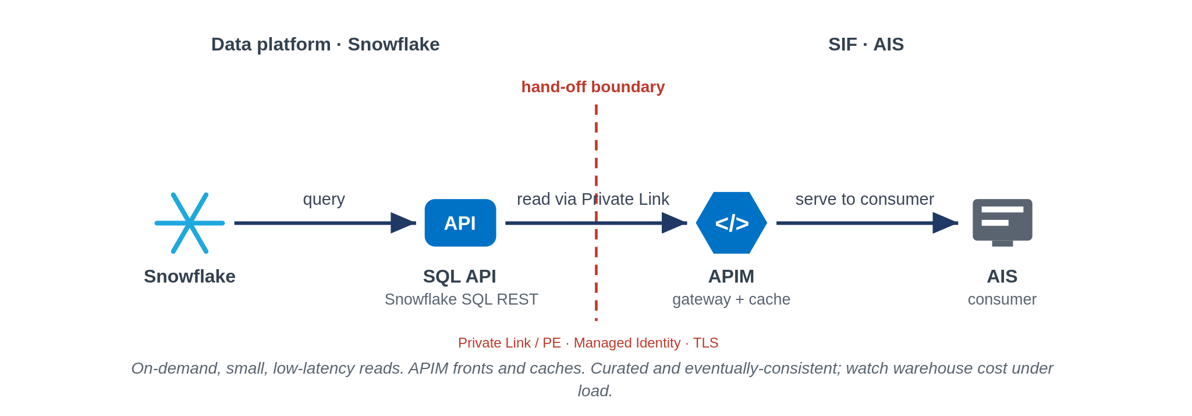
On-demand curated reads through API Management

11. Guardrails and Governance

11.1 Mandatory Guardrails
These are assessed on every integration, regardless of pattern. They are inherited from the security principles and engineering standards and are not open to per-project renegotiation.
Area | The rule
Identity | Entra managed identity for every service-to-service call, least privilege, no account keys or shared keys.
Secrets | Held in Key Vault and referenced, never copied into configuration, with privileged access management for static secrets.
Network | Private Endpoints to dependencies. API Management shared and internal. Public ingress only as an exception.
Encryption | TLS on every hop, private network where possible, encryption at rest.
Observability | Correlation identifiers end to end, and security events forwarded to CrowdStrike.
Resilience | Zone redundant by default, with cross-region posture set by criticality tier.
Reuse | Check the catalogue first, and publish new services so the next team can find them.
Everything as code | Assets in source control and deployed through pipelines, authenticating as managed identities.

11.2 When you need to deviate
The framework is opinionated, but it is not a straitjacket. A genuine need to depart from a mandated component, a guardrail or the data-platform boundary is handled openly: document the deviation and why the standard pattern does not fit, complete a security and risk assessment and identify compensating controls; take it to the TDA for approval and record it in the exception register with a named owner and an expiry, with remediation back to the standard pattern scheduled. The public-ingress path in Section 5.3.3 is the worked example of a controlled, time-boxed exception.

11.3 Per-pattern security conformance
Rather than repeat an identical verdict twenty times, the patterns are grouped below by their security profile. The internal group shares one posture the boundary-crossing group is where TDA attention is warranted.
Pattern group | Internet boundary | Controlling security posture | TDA verdict
Internal patterns: SFINT2 to SFINT4, SFINT5 to SFINT10, SFINT11 to SFINT12, SFINT15 (internal feeds), SFINT16 to SFINT18, SFINT21, SFINT23, SFINT24 to SFINT25 | Not crossed | Components in shared subscription / private workload spokes, Private Endpoints, Entra managed identity, no keys, Key Vault references, TLS every hop,NSG-segmented, default-deny. | Conforms
Managed API facade, SFINT1 (internal use) | Not crossed | APIM shared and non-public, Private Endpoint to backend, managed identity, TLS. | Conforms
Consume-and-serve, SFINT22 (internal consumer) | Not crossed | APIM (Entra auth) over a serving layer, Snowflake via Private Link, least-privilege data access, caching. | Conforms
Inbound webhook, SFINT13 | Crossed (ingress) | Online subscription only Front Door + WAF + DDoS,APIM single ingress, mTLS/OAuth/signature; IP allow-list, async processing in private spokes, no direct triggers. | Conforms with registered exception
Public API / external consumer, SFINT1, SFINT7, SFINT22 when exposed externally | Crossed (ingress) | Same edge as SFINT13: Front Door + WAF + DDoS + APIM, OAuth/mTLS, online subscription, APIM never exposed directly. | Conforms with registered exception
Outbound webhook / notification, SFINT14 | Crossed (egress) | Controlled egress path (routing intent), not default internet; TLS, signed payloads, partner allow-list, Key Vault-held secrets. | Conforms
File-based with partner SFTP, SFINT19, SFINT20 | Crossed | Edge or private connectivity, SFTP-over-SSH with key/cert auth, no anonymous access, IP allow-list, encryption in transit and at rest, Key Vault credentials. | Conforms with registered exception

11.4 Boundary Controls
Internet boundary. Public exposure is an exception with a business need, defined controls, security approval and risk acceptance.
Third-party boundary. Modern authentication with Entra application registrations, defined key ownership and rotation.
Data platform boundary. Exchange only at the two governed hand-offs, with tokenised personal data.

11.5 Pattern Controls
Each pattern in Section 8 carries a security boundary statement that sets out its landing zone, its in-Azure controls and any external exposure. Those statements are the pattern-level controls and are assessed alongside the mandatory guardrails.

11.6 Design Evidence Requirements
A design brought to review is expected to evidence the following.
The pattern selected and the decision path that led to it.
The identity model, the network path and the secrets approach.
The observability and security-logging approach.
The resilience tier and the failure and compensation design.
Any deviation, with the exception reference and the compensating controls.

12. Exception Process and TDA Governance

12.1 Exceptions
The framework is opinionated but not a straitjacket. A genuine need to depart from a mandated component, a guardrail or the data-platform boundary is handled openly. The deviation and its rationale are documented, a security and risk assessment is completed, compensating controls are identified, and the exception is recorded with a named owner and an expiry, with remediation back to the standard pattern scheduled.

12.2 TDA Gates
Governance is applied at defined points. At design, the chosen pattern and interaction style are confirmed against the decision tree and the boundary. At build, guardrail conformance is evidenced across identity, network, secrets, observability and resilience. Any exception is logged and approved before build proceeds.

12.3 Security Conformance
Standard private patterns proceed on the agreed security baseline without additional gates. A pattern that cannot meet the baseline triggers the exception process, which must complete before engineering starts. Security approval is required, and TDA approval alone does not authorise a security exception. Where the wider security posture is affected, the exception is escalated to the risk register and senior leadership. Reusable, pre-reviewed permission sets are defined for recurring cases, and where a later solution repeats an approved design with the same front-end and back-end pattern, the previous approval is reusable as a recognised pattern.

12.4 Exception Lifecycle
Raise: Document the deviation, the rationale and the proposed compensating controls.
Assess: Security and risk assessment, with escalation to the risk register where the posture is affected.
Approve: Security approval and, where required, senior leadership. Record owner and expiry.
Review: Re-examine at expiry, and remediate to the standard pattern where possible.

13. Anti-Patterns
The following are treated as anti-patterns. Where one cannot be avoided it is handled through the exception process.
Anti-pattern | Preferred approach
Direct point-to-point connection between two systems | Mediate through the platform using an approved pattern
Public exposure justified by a firewall alone | Treat public exposure as an exception with approval and risk acceptance
Timer-polling a source to simulate real-time | React to an event, or use a scheduled trigger only where no event exists
Long-lived SAS tokens for access | Managed identity and OAuth 2.0, with the risk register where unavoidable
Large binary payloads on the message bus | Claim-check, with the payload in storage and a reference on the bus
Business logic embedded in gateway policy | Keep logic in Functions, and keep the gateway to mediation
Distributed transactions across services | Orchestrated compensation owned by the process
Secrets in configuration or code | Key Vault references and privileged access management

14. Glossary
Term | Meaning
SIF | Systems Integration Framework, this document.
AIS | Azure Integration Services, comprising API Management, Logic Apps, Service Bus, Event Grid, Event Hubs and Functions.
SOA | Service-oriented architecture, coarse-grained services aligned to business capabilities.
APIM | Azure API Management.
Managed identity | An Entra identity for an Azure resource that authenticates without stored secrets.
PAM | Privileged access management, for example CyberArk.
Claim-check | A pattern that keeps a large payload in storage and passes a reference on the message.
Idempotency | The property that applying the same message more than once has no additional effect.
Bordereau | A delegated-authority premium or claims report provided by a coverholder.
TDA | Technical Design Authority.
MoM | Minutes of meeting.

15. Cross-Reference and Traceability

15.1 Pattern Mapping
The catalogue groups patterns by interaction style. The table maps each group to its section and the primary Azure services.
Group | Section | Primary services
API patterns | 8.3 (SFINT1 to SFINT4) | API Management, Functions
Messaging patterns | 8.4 (SFINT5 to SFINT10) | Service Bus, Functions
Event patterns | 8.5 (SFINT11 to SFINT15) | Event Grid, Event Hubs, Service Bus
Orchestration patterns | 8.6 (SFINT16 to SFINT18) | Logic Apps, Functions
File patterns | 8.7 (SFINT19 to SFINT20) | Blob, Event Grid, Logic Apps
Data platform patterns | 8.8 (SFINT21 to SFINT23) | Event Hubs, Functions, Snowflake
Transformation and routing | 8.9 (SFINT24 to SFINT25) | Functions, Service Bus

15.2 Azure Pattern Mapping
The framework was cross-checked against the Azure integration-patterns reference. Almost every reference pattern maps onto a pattern here. The single intentional difference is that the reference treats extract, transform and load as an integration pattern, whereas this framework places it inside the data platform across the boundary in Section 10.
Reference pattern | Where it lives here
Simple Service | Implementation layer, Functions (5.2)
Composite Service | API composition (SFINT2) and orchestration (SFINT16)
Service Proxy | Managed API facade (SFINT1) and mediation (SFINT3)
Reliable Acquisition | Load levelling (SFINT5), inbound webhook (SFINT13), file ingestion (SFINT19)
Timed Event and Timed Data Sync | Scheduled trigger (SFINT10)
Queuing Proxy | Reliable messaging (SFINT9)
Extract, Transform, Load | Data platform, across the boundary (Section 10)
Message Bridge and Async Mediation | Messaging (SFINT5 to SFINT10) and publish and subscribe (SFINT11)

15.3 Source Reconciliation
This version supersedes the earlier Systems Integration Framework draft. Content is carried forward as follows.
The architectural position, reference architecture and pattern catalogue are carried forward and restructured to this skeleton.
The Security and Monitoring Principles are incorporated from the Security Workshop minutes of 27 August 2026.
The data platform position and the Snowflake exchange patterns are incorporated from the integration boundary work.
Alignment to the Cloud Security Framework and Azure policies is pending receipt of those documents.

16. Future Enhancements and Open Items
To be completed.

