Enterprise Systems Integration Framework (SIF)
Azure Cloud-Native Integration Architecture & Governance
Draft v0.1 — For SME Collaboration & Architect Review
Includes: Reference Architecture, Integration Pattern Catalogue, Decision Guidance, Governance Guardrails, APIM HLD

Table of Contents
Table of Contents 2
1. Purpose and Scope 4
1.1 In Scope 4
1.2 Out of Scope 4
1.3 Outputs of This Engagement 4
2. Strategic Context 4
2.1 Drivers 5
2.2 Architectural Positioning 5
3. Core Architectural Principles 5
4. Reference Architecture 6
4.1 Component Mapping 7
5. Integration Pattern Catalogue 8
5.1 Pattern: Synchronous Request/Response (API) 8
5.2 Pattern: Asynchronous Point-to-Point Messaging 9
5.3 Pattern: Event-Driven Notification 9
5.4 Pattern: High-Volume Streaming Ingestion 9
5.5 Pattern: Cross-System Process Orchestration 10
5.6 Pattern: Webhook Ingress/Egress 10
5.7 Pattern: Data Platform Exchange (Boundary Pattern) 11
6. Decision Guidance: API vs Event vs Orchestration 11
6.1 Summary Decision Table 12
7. Data Platform Guardrails 12
7.1 When Data Platform Processing Is Appropriate 12
7.2 When It Is Not Appropriate 12
7.3 Ownership and Patterns 13
8. Recommended Guardrails and Exception-Handling Process 13
8.1 Mandatory Guardrails 13
8.2 Exception-Handling Process 13
8.3 Governance Cadence 14
9. Part 2 — Azure API Management High-Level Design 14
9.1 API Discovery and Consumption 15
9.2 Secure Access and Authentication 15
9.3 Network Exposure — Private and Public Endpoints 15
9.4 Protection — Web and API Attack Surface 15
9.5 High Availability, Backup and DR 16
9.6 Versioning and Lifecycle 16
9.7 Observability and Policies 16
9.8 Traffic Manager / Front Door and Supporting Components 16
9.9 Environment Strategy — Cost-Effective Segregation 16
10. Next Steps and Review Process 17

1. Purpose and Scope
This document defines the Enterprise Systems Integration Framework (SIF): the set of architectural principles, reference patterns, decision guidance and governance guardrails that delivery teams and vendors must follow when designing system-to-system integration on our Azure cloud and data operating model.
This is an architecture and governance artefact, not a tool-selection exercise or a platform redesign. It establishes “how we integrate” consistently, so that delivery teams and suppliers can design and build integrations independently while remaining aligned to a common architectural direction.

1.1 In Scope
- Synchronous data exchange via REST APIs
- Asynchronous messaging and event-driven integration
- Webhooks and notification patterns
- Cross-system process orchestration and long-running workflow
- Decision guidance: when to use API vs event vs orchestration
- Guardrails for the boundary between integration and the Data Platform (Snowflake)
- Azure API Management (APIM) high-level design, including security, HA/DR and environment strategy

1.2 Out of Scope
- A generic SOA/integration textbook or vendor-neutral manual
- Tool or vendor comparison/selection exercises
- Redefinition of the broader enterprise cloud strategy
- Adoption of a microservices architecture model — this framework is explicitly SOA-aligned, not microservices-aligned

1.3 Outputs of This Engagement
- Documented Systems Integration Framework (this document)
- Reference architecture diagrams (logical and Azure physical/deployable view)
- Integration pattern catalogue
- Decision guidance — API vs event vs orchestration
- Recommended guardrails and exception-handling process
- APIM high-level design (Part 2)
All outputs are intended to be peer-produced and peer-reviewed with the Client lead Architect, and published to TDA as a shared deliverable.

2. Strategic Context
Integration is a critical enabler of the wider enterprise transformation programme. Today, integration patterns and approaches vary across the estate; this framework establishes a cohesive, enterprise-level approach that favours reuse, loose coupling and cloud-native services.

2.1 Drivers
- Increased automation and straight-through processing, reducing manual re-key and workarounds
- Improved, consistent system-to-system data flow
- Scalable, consistent vendor and partner integration
- Reduction in point-to-point integration sprawl
- Consistent API usage across the technology estate
- Event-driven and asynchronous processing where appropriate to latency and availability needs
- Alignment to Azure cloud-native PaaS services

2.2 Architectural Positioning
The framework is grounded in Service-Oriented Architecture (SOA), not microservices:
- Enterprise service reuse over point solutions
- Business-capability aligned services with clear, named ownership
- Clear service ownership and governance, tracked via the Architecture Review Board
- Explicit non-adoption of a microservices architecture model — services are coarse-grained, business-capability aligned, not independently deployed fine-grained microservices
- Priority on integrating and exposing existing systems and services before building new ones — “integrate before you build”

3. Core Architectural Principles
The following principles apply to every integration designed, built or operated under this framework. They are mandatory unless an exception has been formally approved (see Section 8).
Principle | Statement | Rationale
Loose coupling by default | Integrations minimise direct, tightly-coupled dependencies between systems. | Limits blast radius of change; enables independent system evolution.
REST and JSON as standard | REST over HTTPS with JSON payloads is the default synchronous integration standard. | Industry-standard, broad tooling support, consistent contract style.
“Just enough” API surface | APIs expose only the business capability required; no generic CRUD pass-through of internal data models. | Avoids tight coupling to internal schemas; protects consumers from change.
Integration logic lives in the platform | Transformation, routing, and orchestration logic resides in Logic Apps/Functions/APIM — not duplicated in source/target systems. | Centralises change, testability and reuse; avoids logic sprawl.
APIM as single ingress | All synchronous API traffic, internal and external, passes through APIM. | Single point of policy enforcement, security, observability and discovery.
Asynchronous-first under latency/availability risk | Where target systems are slow, unreliable, or processing is non-blocking, use messaging/events rather than synchronous calls. | Improves resilience and avoids cascading failure.
Separation of orchestration and implementation | Logic Apps orchestrate; Functions implement discrete logic. Orchestration does not embed low-level code, and Functions do not directly orchestrate cross-system workflow. | Keeps each layer simple, testable and independently scalable.
Reuse before build | New integration needs are first assessed against the pattern catalogue and existing services before new services are built. | Reduces duplication and point-to-point sprawl.
Security by default | Managed Identity for Azure-to-Azure auth; Key Vault for all secrets; no embedded credentials. | Removes credential sprawl and manual rotation risk.
Everything as code | All integration assets (Logic Apps, Functions, APIM config) are source-controlled and deployed via CI/CD. | Auditable, repeatable, environment-consistent deployments.

4. Reference Architecture
The diagram below shows the logical building blocks of the SIF mapped to deployable Azure resources. It should be read top-to-bottom as a request/event flow: consumers reach the platform through the edge layer, are authenticated and routed through APIM, processed by the integration platform (Logic Apps, Functions, messaging), and connected securely to backend systems and the data platform. Governance wraps the entire estate.
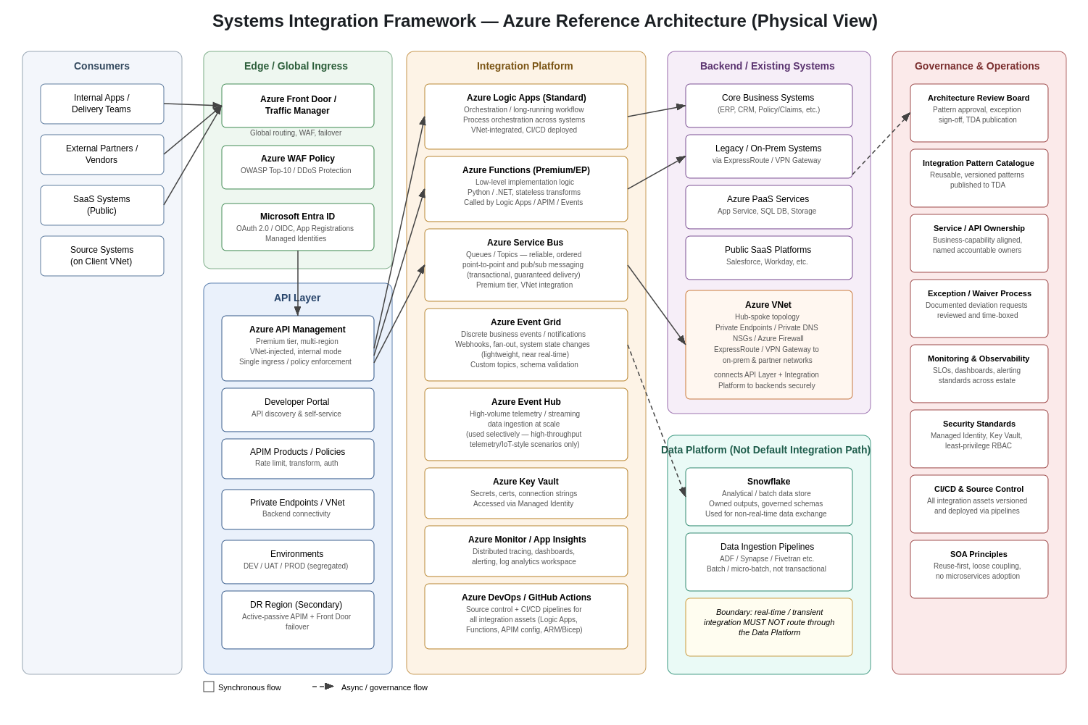
Figure 1 — Systems Integration Framework: Azure Reference Architecture (physical / deployable component view)

4.1 Component Mapping
Logical Capability | Azure Physical Component | Purpose in the Framework
Global ingress & WAF | Azure Front Door / Traffic Manager + WAF Policy | Public entry point, global routing, DDoS/OWASP Top-10 protection, multi-region failover
Identity & access | Microsoft Entra ID (Azure AD) | OAuth 2.0/OIDC token issuance, app registrations, Managed Identity assignment
API gateway / single ingress | Azure API Management (Premium, VNet-injected) | Single entry point for all REST APIs; policy enforcement, throttling, transformation, discovery
Orchestration | Azure Logic Apps (Standard) | Long-running, stateful, cross-system process orchestration
Implementation logic | Azure Functions (Premium/Elastic) | Stateless, fine-grained logic in Python/.NET invoked by Logic Apps, APIM, or events
Reliable point-to-point / pub-sub messaging | Azure Service Bus (Premium) | Guaranteed-delivery, ordered, transactional asynchronous messaging
Discrete event notification | Azure Event Grid | Lightweight business-event distribution, webhooks, fan-out
High-volume streaming ingestion | Azure Event Hub | Selective use for high-throughput telemetry/streaming, not general business events
Secrets management | Azure Key Vault | Centralised storage of secrets/certs, accessed via Managed Identity
Observability | Azure Monitor / Application Insights / Log Analytics | Distributed tracing, dashboards, alerting across the integration estate
Network connectivity | Azure VNet, Private Endpoints, Private DNS, ExpressRoute/VPN Gateway | Secure connectivity between APIM, the integration platform and backend/on-prem systems
CI/CD & source control | Azure DevOps / GitHub + IaC (Bicep/ARM) | Versioned, pipeline-driven deployment of all integration assets
Analytical data store | Snowflake (via Data Platform pipelines) | Owned analytical outputs; explicitly not a default integration mechanism

5. Integration Pattern Catalogue
This catalogue defines the approved, reusable integration patterns. Each pattern lists its purpose, the Azure components used, and when it should (and should not) be applied. Delivery teams should select from this catalogue first; new patterns require Architecture Review Board approval before adoption.

5.1 Pattern: Synchronous Request/Response (API)
Attribute | Detail
Purpose | Real-time, request-driven exchange where the caller needs an immediate response.
Components | Azure Front Door → APIM → Azure Function or backend service (direct or via Private Endpoint)
Use when | Low-latency requirement; caller blocks on result; idempotent or safely retryable operation; capability is naturally request/response (e.g. “get customer”, “validate address”).
Avoid when | Target system is slow/unreliable; operation triggers long-running processing; multiple downstream systems must be updated atomically.
Guardrails | All requests through APIM; OAuth2 token required; response times monitored with SLOs; circuit breaker/retry policy defined at APIM or Function level.

5.2 Pattern: Asynchronous Point-to-Point Messaging
Attribute | Detail
Purpose | Reliable, ordered, guaranteed delivery of a message between a known producer and consumer(s), decoupled in time.
Components | Producer → Azure Service Bus (Queue/Topic) → Azure Function or Logic App consumer
Use when | Delivery guarantee matters; consumer may be temporarily unavailable; ordering matters; workload should be smoothed (load levelling); transactional outbox pattern is required.
Avoid when | Caller needs an immediate response; the interaction is a one-off lightweight notification (use Event Grid instead).
Guardrails | Dead-letter queue configured and monitored; idempotent consumers; message schema versioned and documented in the catalogue.

5.3 Pattern: Event-Driven Notification
Attribute | Detail
Purpose | Broadcast a discrete business event (e.g. “order cancelled”) to one or many interested subscribers without the publisher knowing who consumes it.
Components | Source system → Azure Event Grid (custom topic) → Webhook / Function / Logic App subscribers
Use when | Multiple, evolving consumers; publisher should not be coupled to subscriber list; near-real-time (not guaranteed-order) delivery is acceptable.
Avoid when | Strict ordering or guaranteed delivery is required (use Service Bus); high-volume telemetry/streaming (use Event Hub).
Guardrails | Event schema registered centrally; at-least-once delivery assumed — consumers must be idempotent; dead-lettering/retry configured.

5.4 Pattern: High-Volume Streaming Ingestion
Attribute | Detail
Purpose | Ingest high-throughput telemetry or streaming data (not general business events) for downstream analytics or processing.
Components | Source → Azure Event Hub → Stream processing (Functions / Stream Analytics) → Data Platform
Use when | Volume/velocity is materially higher than typical business events (e.g. IoT, clickstream, system telemetry).
Avoid when | Volume is moderate and the requirement is a standard business event (use Event Grid) or transactional message (use Service Bus).
Guardrails | Partition strategy reviewed by Architecture Review Board; consumer groups documented; not used as a substitute for Service Bus/Event Grid.

5.5 Pattern: Cross-System Process Orchestration
Attribute | Detail
Purpose | Coordinate a multi-step business process spanning several systems, potentially long-running, with state, retries and compensation.
Components | Trigger (API/event/schedule) → Azure Logic Apps (Standard) → calls to Functions / APIs / Service Bus as steps
Use when | Process spans multiple systems/steps; needs visibility, retries, human-in-the-loop or compensation logic; business stakeholders need to understand/trace the flow.
Avoid when | The task is a single, simple call (use direct API/Function); core implementation logic should NOT be embedded inside the orchestrator — delegate to Functions.
Guardrails | Each orchestration version-controlled; run history retained per data-retention policy; compensation/error-handling branches mandatory for multi-step writes.

5.6 Pattern: Webhook Ingress/Egress
Attribute | Detail
Purpose | Receive (ingress) or send (egress) event notifications to/from external SaaS or partner systems that only support webhooks.
Components | External system → Front Door/APIM → Function (validate & translate) → Event Grid/Service Bus internally; or internal event → Function → partner webhook URL
Use when | Integrating with a SaaS/partner system whose only push mechanism is a webhook.
Avoid when | An internal-to-internal pattern is needed — use Event Grid/Service Bus directly rather than a webhook wrapper.
Guardrails | Signature/HMAC validation mandatory on ingress; retry with backoff on egress; payloads logged for traceability (with PII handling per data policy).

5.7 Pattern: Data Platform Exchange (Boundary Pattern)
Attribute | Detail
Purpose | Move data between operational systems and the analytical Data Platform (Snowflake) for reporting/analytics — not for operational integration.
Components | Source system → Data Platform ingestion pipeline (ADF/Synapse/Fivetran-class tooling) → Snowflake
Use when | Data is for analytical, reporting, or batch consumption; near-real-time (minutes-to-hours) latency is acceptable; output ownership can sit with the Data Platform team.
Avoid when | Real-time or transactional integration is required between operational systems — this must use SIF patterns (API/Service Bus/Event Grid), never the Data Platform as a relay.
Guardrails | Data Platform is never used as a default integration mechanism; ownership of result stores is explicitly assigned; see Section 7 for full guardrails.

6. Decision Guidance: API vs Event vs Orchestration
Use the following decision flow and table when selecting a pattern for a new integration requirement.
Question | If yes → | If no → ask next question
Does the caller need an immediate response to continue? | Synchronous API (5.1) via APIM | Continue
Does the interaction need guaranteed, ordered delivery to a known consumer? | Asynchronous messaging — Service Bus (5.2) | Continue
Is this a discrete business event with potentially multiple/unknown subscribers? | Event-driven notification — Event Grid (5.3) | Continue
Is the data high-volume telemetry/streaming rather than a discrete business event? | Streaming ingestion — Event Hub (5.4) | Continue
Does the requirement span multiple systems/steps needing coordination, retries or compensation? | Process orchestration — Logic Apps (5.5) | Continue
Is the requirement analytical/reporting in nature, with batch latency acceptable? | Data Platform exchange (5.7) | Escalate to Architecture Review Board — likely a new/variant pattern

6.1 Summary Decision Table
Dimension | API (Synchronous) | Event/Message (Asynchronous) | Orchestration
Coupling | Tighter — caller waits | Loose — producer/consumer decoupled | Coordinates multiple loosely-coupled calls
Latency tolerance | Low (sub-second to seconds) | Tolerant (seconds to minutes) | Tolerant (can be long-running, hours/days)
Delivery guarantee | None beyond the call itself | Service Bus: guaranteed; Event Grid: at-least-once | Inherits guarantees of the steps it calls
Typical use | Lookup, validation, simple write | State change notification, decoupled processing | Multi-step business process, human-in-the-loop
Primary Azure service | APIM + Function/backend | Service Bus / Event Grid / Event Hub | Logic Apps (Standard)

7. Data Platform Guardrails
The Data Platform (Snowflake and its ingestion pipelines) is an analytical capability, not a default integration mechanism. The boundary below must be respected by all delivery teams and vendors.

7.1 When Data Platform Processing Is Appropriate
- Reporting, analytics, BI, and data science consumption
- Batch or micro-batch latency is acceptable (minutes to hours, not seconds)
- Cross-domain data consolidation for analytical purposes
- Historical/trend data not required for an operational decision in real time

7.2 When It Is Not Appropriate
- Real-time or near-real-time operational integration between systems
- Transient integration where data has no analytical value once consumed
- Using Snowflake as a message bus or relay between operational systems — this must use SIF messaging/API patterns instead

7.3 Ownership and Patterns
- Ownership of data outputs and result stores in Snowflake sits with the Data Platform/domain data owner, defined at design time, not assumed by the integration team
- Data exchange between SIF and the Data Platform uses the Data Platform Exchange pattern (5.7) — ingestion pipelines, not point-to-point database connections
- Any proposed exception (e.g. an operational system reading data back out of Snowflake in near-real-time) must go through the exception process in Section 8

8. Recommended Guardrails and Exception-Handling Process

8.1 Mandatory Guardrails
Area | Guardrail
API ingress | All synchronous API traffic must route through APIM — no direct, un-gated backend exposure.
Authentication | Microsoft Entra ID (OAuth 2.0/OIDC) for human/application access; Managed Identity for Azure-to-Azure service calls.
Secrets | No credentials in code, config files, or Logic App connections — Key Vault only, accessed via Managed Identity.
Network | Backend connectivity via Private Endpoints/VNet integration; no public-internet-exposed backend services for internal systems.
Source control & CI/CD | All integration assets (APIM config, Logic Apps, Functions, IaC) are source-controlled and deployed via pipeline — no manual production changes.
Observability | Every integration emits traceable logs/metrics to Azure Monitor with an owner-defined SLO and alerting.
Architecture model | No microservices decomposition — services remain coarse-grained and business-capability aligned.
Data Platform boundary | Data Platform is never used as a default or transient integration mechanism (see Section 7).
Reuse-first | New integration requirements are checked against the pattern catalogue and existing services before new build.

8.2 Exception-Handling Process
Where a delivery team or vendor believes a guardrail or pattern cannot be applied, the following process applies:
- Document the proposed deviation: which guardrail/pattern, why it cannot be applied, and the proposed alternative.
- Submit to the Architecture Review Board (or designated lead Architect) for review, alongside the integration design.
- Review considers risk, precedent, and whether the deviation should become a new catalogued pattern rather than a one-off exception.
- Decision is recorded (approved / approved with conditions / rejected) with rationale, and time-boxed where applicable (e.g. “approved pending migration to standard pattern by Q-date”).
- Approved exceptions and their rationale are published to TDA alongside the framework, so they are visible to all delivery teams and not silently repeated.

8.3 Governance Cadence
- New patterns and significant exceptions are reviewed at a regular Architecture Review Board cadence (recommended: fortnightly or aligned to sprint/release cycle)
- The pattern catalogue and this framework are version-controlled, with changes tracked and published to TDA
- Service/API ownership is reviewed periodically to ensure it remains current as teams and capabilities change

9. Part 2 — Azure API Management High-Level Design
This section addresses the APIM-specific high-level design requirements: discovery and consumption, secure access, authentication, network exposure, protection, availability/DR, versioning, observability, and environment strategy.
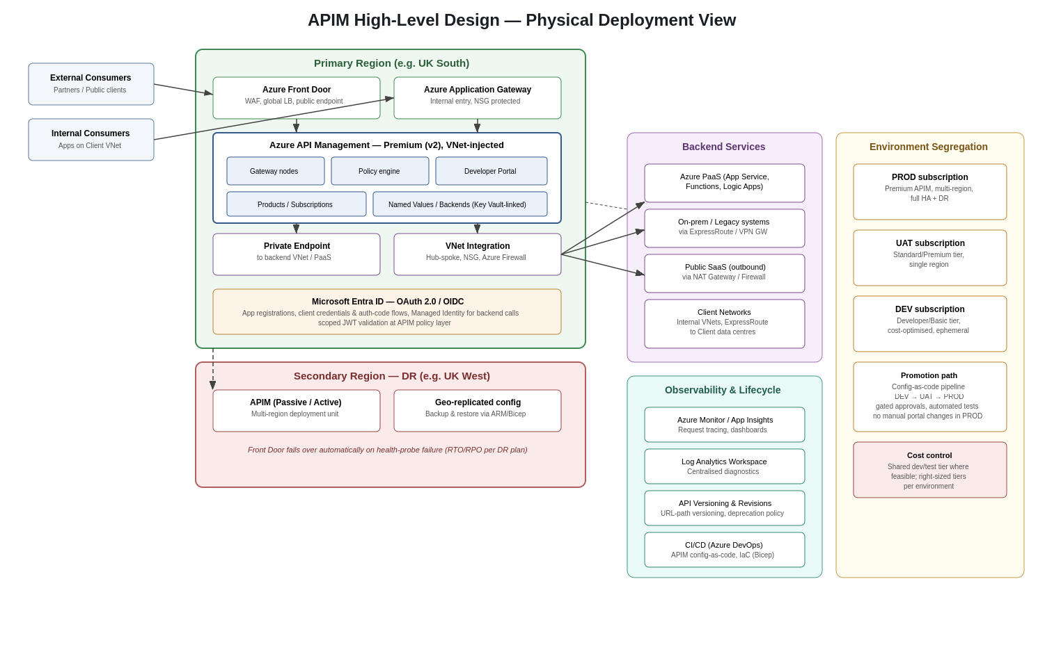
Figure 2 — APIM High-Level Design: physical deployment view

9.1 API Discovery and Consumption
- The APIM Developer Portal is the system of record for API discovery, documentation and self-service subscription for internal and (where applicable) external consumers
- APIs are published as Products with defined terms (rate limits, required subscription) so consumption is governed, not ad-hoc
- API specifications (OpenAPI) are version-controlled alongside the APIM configuration and published automatically to the portal via CI/CD

9.2 Secure Access and Authentication
- Microsoft Entra ID is the identity provider for all API access; OAuth 2.0/OIDC is the standard authentication mechanism
- Client-credentials flow for service-to-service/system integration; authorization-code flow for interactive/user-delegated access
- JWT validation is enforced as an APIM inbound policy — tokens are validated at the gateway before any request reaches a backend
- Managed Identity is used for APIM-to-backend and Logic App/Function-to-Azure-service authentication, removing embedded credentials

9.3 Network Exposure — Private and Public Endpoints
Consumer type | Entry point | Mechanism
External (public/partner) | Azure Front Door (public) | WAF-protected public endpoint, routed to APIM's external/public gateway hostname
Internal (Client VNet) | Azure Application Gateway / internal APIM gateway hostname | Resolved via internal DNS, traffic stays on Client private network
Backend services (Azure VNet, PaaS) | Private Endpoint from APIM | APIM (VNet-injected) reaches backends over private connectivity, no public backend exposure
Backend services (public SaaS) | Outbound via NAT Gateway / Azure Firewall | Controlled, logged egress with allow-listed destinations

9.4 Protection — Web and API Attack Surface
- Azure Front Door WAF policy applies OWASP Top-10 managed rule sets at the edge, before traffic reaches APIM
- DDoS Protection (Azure DDoS Protection, integrated with Front Door/VNet) mitigates volumetric attacks
- APIM policies enforce rate limiting/throttling per product/subscription to prevent abuse and protect backend capacity
- Request/response validation policies (schema validation) reject malformed payloads at the gateway

9.5 High Availability, Backup and DR
- APIM Premium tier deployed across multiple Azure availability zones in the primary region for intra-region resilience
- A secondary-region APIM unit (multi-region deployment) provides cross-region resilience; Azure Front Door performs health-probe-based failover
- APIM configuration is defined as code (Bicep/ARM) and stored in source control, enabling backup and full environment restore independent of the portal
- RTO/RPO targets are agreed with the business and validated through periodic DR exercises

9.6 Versioning and Lifecycle
- APIs are versioned explicitly (recommended: URL-path versioning, e.g. /v1/, /v2/) to give consumers a clear, stable contract
- Breaking changes are released as a new version; the previous version is supported for a published deprecation window before retirement
- APIM Revisions are used for non-breaking changes that need staged rollout/testing before becoming the current version
- Lifecycle status (active / deprecated / retired) is tracked in the pattern catalogue/TDA so consumers can plan migration

9.7 Observability and Policies
- All APIM traffic is logged to Azure Monitor/Application Insights with distributed tracing correlation IDs propagated to backend calls
- Dashboards track latency, error rate, and throughput per API/product against agreed SLOs, with alerting on breach
- Standard policy fragments (auth validation, rate limiting, CORS, logging) are defined centrally and reused across APIs, not duplicated per API

9.8 Traffic Manager / Front Door and Supporting Components
- Azure Front Door provides global entry, WAF, TLS termination and latency-based/priority routing across regions
- Azure Traffic Manager may be used for non-HTTP or DNS-level routing scenarios where Front Door's Layer-7 capabilities are not required
- Azure Application Gateway provides an internal-facing entry point for traffic that should remain on the Client network rather than traverse the public edge
- Supporting components: Private DNS zones (name resolution for private endpoints), Azure Firewall/NSGs (network-level control), Key Vault (TLS certs and secrets for APIM)

9.9 Environment Strategy — Cost-Effective Segregation
Environment | APIM tier (indicative) | Topology | Notes
PROD | Premium (v2), multi-region | Full HA + DR, VNet-injected | Production traffic only; changes via pipeline, no manual portal edits
UAT | Standard/Premium, single region | VNet-injected (if integration testing needs private connectivity) | Mirrors PROD configuration for realistic pre-release testing
DEV | Developer/Basic | Single region, may be shared across workstreams | Cost-optimised; can be ephemeral / provisioned via pipeline on demand
- Environment promotion (DEV → UAT → PROD) follows the same config-as-code pipeline used for all integration assets, with gated approvals
- Lower environments use right-sized tiers and, where appropriate, shared/non-HA configurations to control cost without compromising PROD resilience

10. Next Steps and Review Process
- Joint review of this draft with the Client lead Architect — walk through principles, patterns, decision guidance and APIM HLD
- Validate the pattern catalogue against 2–3 real current/planned integrations as a sense-check
- Agree any amendments and finalise the Architecture Review Board's exception-handling cadence and membership
- Publish the agreed framework, diagrams and catalogue to TDA as the shared, owned artefact
- Socialise the framework with delivery teams and vendors as the baseline for new integration design

This document is intended to evolve: as new patterns are approved through the exception process, they should be folded back into the catalogue, keeping it the single current source of truth for integration design.

