Systems Integration Framework

Version 0.1 (Draft)
Author: Puneet Kumar, Enterprise Integration and Solution Architect

Table of Contents
Table of Contents 2
1. Document Control 5
1.1 Document History 5
1.2 Authors and Contributors 5
1.3 Approvals and Assurance 5
1.4 Source Documents and Supersession 5
1.5 Document References 6
2. How to Use This System Integration framework 7
3. Executive Summary 7
3.1 Why the System Integration framework Exists 8
3.2 System Integration framework Scope 8
3.3 Intended Outcomes 9
4. Architectural Position 9
4.1 Architectural Stance 9
4.2 SOA Positioning Statement 9
4.3 Strategic Objectives 9
4.4 What Counts as a Service 10
4.5 Core System Integration Framework Principles 10
5. Reference Architecture 11
5.1 Conceptual Reference Architecture 11
5.2 Logical Layered Reference Architecture 12
5.3 Security and Trust Boundary 13
5.4 Target Integration Platform 14
6. Choosing an Integration Pattern 15
6.1 Primary Decision Matrix 15
6.2 Common Use Cases 16
6.3 Detailed Decision Tree 16
7. Enterprise Pattern Catalogue 18
7.1 Enterprise Pattern Index and Boundary Applicability 18
7.2 Detailed Practitioner Patterns 22
7.3 API Patterns 23
7.3.1 Managed API facade (SFINT1) 23
7.3.2 API composition / aggregation (SFINT2) 24
7.3.3 Protocol / format mediation (SFINT3) 25
7.4 Messaging Patterns 25
7.4.1 Queue-based load levelling (SFINT5) 25
7.4.2 Competing consumers (SFINT6) 26
7.4.3 Asynchronous request-reply (SFINT7) 27
7.4.4 Claim-check (SFINT8) 27
7.4.5 Reliable messaging (SFINT9) 28
7.4.6 Scheduled / timed trigger (SFINT10) 29
7.5 Event Patterns 29
7.5.1 Publish / subscribe fan-out (SFINT11) 29
7.5.2 Discrete event notification (SFINT12) 30
7.5.3 Inbound webhook ingestion (SFINT13) 31
7.5.4 Outbound webhook / notification (SFINT14) 31
7.5.5 Stream / telemetry ingestion (SFINT15) 32
7.6 Orchestration Patterns 33
7.6.1 Stateful process orchestration (SFINT16) 33
7.6.2 Process with compensation (SFINT17) 34
7.6.3 Human-in-the-loop / approval (SFINT18) 34
7.7 File Patterns 35
7.7.1 Event-driven file ingestion (SFINT19) 35
7.7.2 File generation and delivery (SFINT20) 36
7.8 Transformation and Routing Patterns 36
7.8.1 Canonical data model and message translator (SFINT21) 36
7.8.2 Content-based routing (SFINT22) 37
7.9 Anti Patterns 38
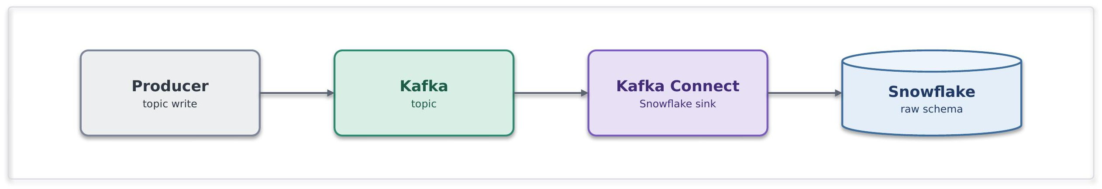 40
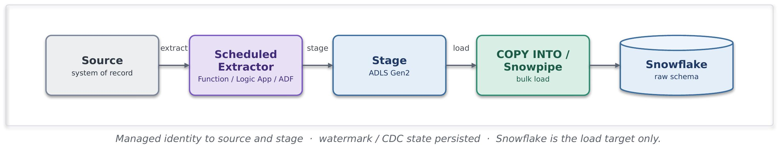 41
Export Patterns 43
9. Insurance Integration Scenarios 46
10. Security and Operational Excellence 46
10.1 Security Principles 47
10.2 Data Protection and Classification 47
10.3 Observability and Monitoring 48
10.3.1 Azure Resource Observability Matrix 48
10.4 Operational Excellence 49
10.5 Delivery Pipeline 49
11 Guardrails 51
11.1 Mandatory Guardrails 51
11.2 When you need to deviate 51
11.3 Per-pattern security conformance 52
12. Exception Process and TDA Governance 52
12.1 Exceptions 52
12.2 TDA Gates 52
12.3 Security Conformance 53
12.4 Exception Lifecycle 53
13. Glossary 54
14. Cross-Reference and Traceability 54
14.1 Pattern Grouping 54
15. Future Enhancements and Open Items 55

1. Document Control

1.1 Document History
Version | Date | Author | Notes
1.0 |  | Puneet Kumar | Initial System Integration framework draft.

1.2 Authors and Contributors
Role | Name | Area
Author | Puneet Kumar | Enterprise Integration and Solution Architecture
Contributor | Security Architect | Security workshop input and review
Contributor | Portfolio Architect | Security workshop input and review
Contributor | Data Platform | Data boundary and Snowflake exchange
Contributor | Cloud Operations | RBAC, policy enforcement and monitoring

1.3 Approvals and Assurance
This document is a conceptual System Integration framework intended for Technical Design Authority review. Approval covers the reference architecture, the pattern catalogue and the governance model
Role | Name | Decision
Reviewer | Security Architecture | Pending
Reviewer | Enterprise Architecture | Pending
Approver | TDA Chair | Pending

1.4 Source Documents and Supersession
The following documents were used as inputs and should be read in conjunction with this System Integration framework.
Reference | Document | Status
1 | Enterprise Architecture Principles | Input
2 | Engineering Standards (Cloud) | Input
3 | Workshops conducted with team | Input
4 | Cloud Security Framework | Pending from Security Architecture
5 | Azure Policies | Pending upload
6 | Systems Integration Framework (earlier draft) | Superseded by this version

1.5 Document References
The following documents should be read in conjunction with this document:
Reference | Document | Version | Author | Source
1 | Enterprise Architecture Principles | 0.1 | Jamie Barclay | Source
2 | Data Classification Policy | 9.1 | D.Beck | Source
3 | Enterprise DevOps Principles | 0.1 | Gary Milton | Source
4 | Architecture Principles | 0.1 |  | Source
5 | Architecture  Engineering Standard AIS | 1.0 | Nikhil Rokade | Source
6 | Architecture  Engineering Standard Cloud | 1.3 | Jamie Barclay | Source

2. How to Use This System Integration framework
This System Integration framework serves several audiences, the recommended reading path for specific roles is described below as guideline. Each entry points to the sections most relevant to that role. The second column is the shortest route to what is important. If your work spans more than one role, each relevant path can be followed and the broader path can used as the superset.
Role | Start Here | Then Read | Outcome
Executive Sponsor / Leadership | Section 3 Executive Summary | Section 4 Architectural Position →  Section 11 Guardrails →  Section 12 Governance & Exceptions | Understand why the framework exists, its strategic direction, governance model and key controls.
Solution / Portfolio / Domain Architect | Section 4 Architectural Position | Section 5 Reference Architecture →  Section 6 Choosing an Integration Pattern → Section 7 Enterprise Pattern Catalogue | Design solutions aligned to Chaucer's approved integration architecture and patterns.
Integration SME / Developer | Section 6 Choosing an Integration Pattern | Section 7 Enterprise Pattern Catalogue →  Section 8 Data Platform Position & Guardrails Section 10 Security & Operational Excellence | Build integrations using approved patterns, services and operational controls.
Data Architect /  Data Platform Lead / Data Engineer | Section 8 Data Platform Position & Guardrails | Section 10 Security & Operational Excellence → Section 11 Guardrails | Understand approved SIF-to-Data Platform boundaries, exchange patterns, ownership responsibilities and governance controls.
Security Architect / Cloud Operations | Section 5.3 Security & Trust Boundary | Section 10 Security & Operational Excellence → Section 11 Guardrails →  Section 12 Security Conformance | Assess security posture, operational controls, identity, monitoring and compliance requirements.
Technical Design Authority (TDA) | Section 11 Guardrails | Section 12 Governance & Exceptions →  Section 7 Enterprise Pattern Catalogue → Section 9 Data Platform Position & Guardrails | Assess architecture conformance, exceptions, integration pattern selection and data platform boundary compliance.

3. Executive Summary
Chaucer requires a formal Systems Integration Framework to provide consistent architectural direction for system-to-system integration across internal applications, third-party platforms, SaaS services, vendor integrations and the enterprise data platform.
The System Integration framework is based on a Service-Oriented Architecture approach and explicitly avoids adopting a microservices model as the default integration paradigm. The focus is on practical enterprise integration across existing Chaucer systems, external vendors, Azure PaaS services and the data platform.
The System Integration framework establishes a single catalogue of patterns with clear boundary applicability across internal Chaucer integration, third-party to Chaucer inbound integration, Chaucer to third-party outbound integration and SIF-to-data-platform exchange. It also defines decision guidance for API, messaging, eventing, orchestration and data-platform usage, supported by mandatory guardrails and a controlled exception process.

3.1 Why the System Integration framework Exists
Chaucer has successfully modernised much of its integration estate onto Azure Integration Services and established a number of robust integration patterns, security controls and operational practices. However, these capabilities currently co-exist with direct point-to-point integrations, application-specific interfaces and data-platform-led exchanges that have evolved independently over time. Whilst effective in addressing individual business needs, these approaches can lead to tighter coupling, duplicated integration capabilities, inconsistent design decisions and increased change complexity across the wider technology estate.
By leveraging existing best practices and principles within a Systems Integration Framework, Chaucer can build upon its current strengths, promote reuse, improve governance and provide a consistent enterprise approach for future integration initiatives. This System Integration framework establishes a single reference architecture for integration so that recurring problems are solved through consistent, repeatable patterns. It defines an approved set of integration patterns, a standard set of Azure services as the target platform, and the governance guardrails that delivery teams and suppliers need in order to build correctly without re-opening architectural decisions on every engagement.
The System Integration Framework does not introduce a new set of principles. It inherits the principles Chaucer already holds and translates them into practical integration choices. The stack below shows where those principles originate and where they are enforced in this document.
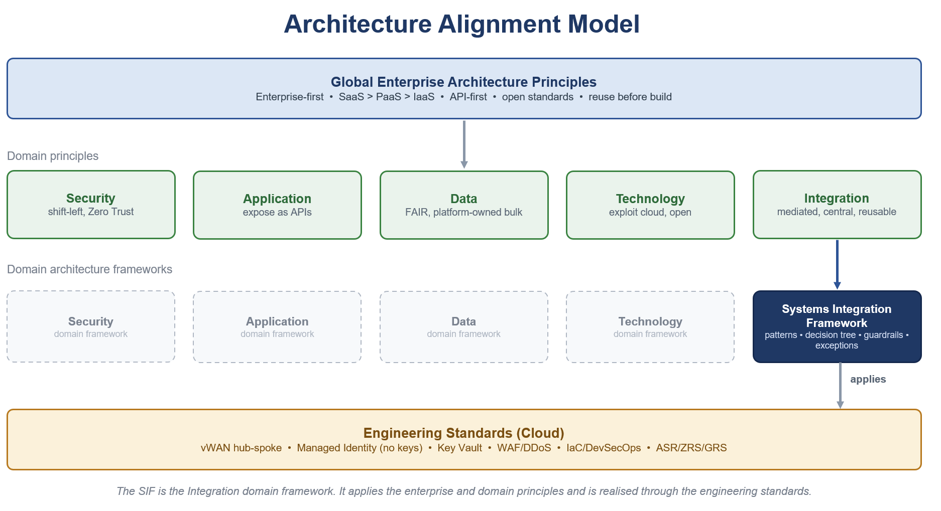

3.2 System Integration framework Scope
The System Integration framework covers the following.
- A reference architecture for integration across Azure Integration Services.
- An enterprise catalogue of approved integration patterns with the Azure components for each.
- Decision guidance, guardrails and an exception process for delivery teams and suppliers.
- The position of the data platform boundary and the approved exchange patterns with Snowflake.
The following are out of scope for this version.
- Implementation, provisioning and deployment, which are future-phase activities.
- The detailed API Management high-level design, which is produced as a separate phase.
- Any redefinition of Chaucer's cloud strategy.

3.3 Intended Outcomes
- Fewer point-to-point interfaces and a measurable reduction in bespoke coupling.
- Greater reuse through shared integration components and published services.
- Loose coupling and asynchronous messaging as the default interaction style.
- Consistent, governed delivery that any internal team or third-party supplier can follow.
- Faster onboarding of new integrations through a known catalogue and decision path.

4. Architectural Position

4.1 Architectural Stance
The System Integration framework takes a clear and consistent position, summarised below and expanded in the sections that follow.
Area | Position
Architecture model | Service-Oriented Architecture, not microservices.
Primary objective | Integrate and reuse existing systems and services before creating new ones. Reference – section 5 EAG2, AAP1 , AAP2
Service model | Business-capability aligned enterprise services. Reference – section 11
Integration style | API-led, event-capable, orchestration-supported.
Platform alignment | Azure PaaS integration services. Reference – section 5 EAG4
Governance model | TDA-approved standards, reusable patterns, controlled exceptions.

4.2 SOA Positioning Statement
Chaucer's Systems Integration Framework adopts a Service-Oriented Architecture, not a microservices architecture, aligned to Chaucer's operating model.
A service in this System Integration framework is a coarse-grained capability aligned to a business domain such as Policy, Claims, or Client rather than an entity-level or table-level endpoint. Services are stable, reused across Chaucer's business and technology teams, and governed through clear ownership, defined contracts, and lifecycle controls. Each service has a named owner and is exposed through the platform.
Microservices are not adopted as the default integration paradigm. The System Integration framework focus is not service decomposition for independent product or application engineering, but pragmatic enterprise integration across existing Chaucer platforms, SaaS services, data platforms, and vendor systems. Accordingly, services are not one of many fine-grained components communicating over a service mesh.

4.3 Strategic Objectives
Objective | SIF Direction
Increase automation | Promote API, events, and workflow-based integrations over manual re-keying.
Reduce point-to-point integrations | Introduce reusable service contracts, APIM-mediated APIs, and shared messaging patterns.
Improve system-to-system data flow | Standardized integration approaches across synchronous, asynchronous, file, and data-platform exchange.
Enable vendor integration | Provide secure, governed, and reusable ingress / egress patterns for external suppliers and systems.
Support straight-through processing | Use orchestration where business process coordination is required; avoid embedding logic in consuming systems.
Align to Azure PaaS | Use Azure API Management, Logic Apps, Service Bus, Event Grid, Event Hubs, Azure Functions, and Azure Data Factory as the primary Azure PaaS integration components, with ADF specifically positioned for data ingestion, ELT orchestration, and controlled Snowflake/data-platform exchange rather than real-time operational integration.

4.4 What Counts as a Service
A service that belongs in the catalogue meets the following tests.
- It aligns to a business capability rather than a table or a technical function.
- It has a stable, versioned contract that hides the implementation behind it.
- It has a named owner who is accountable for its behaviour and its change.
- It is exposed and consumed through the platform, not through a direct connection.
- It is coarse grained, so that a typical business interaction is one call rather than many.

4.5 Core System Integration Framework Principles
Note : The SIF is grounded in Chaucer's Enterprise Architecture and Cloud Engineering principles and does not redefine them. It either complies, extends, or reconciles those principles within the integration domain so that every integration decision traces back to a ratified principle rather than a new one.
Two principles take precedence over all others.
- Reuse is preferred over build - Recommendation is to check the service catalogue for an existing service or API before provisioning a new one.
- Favour integrating with an existing system over standing up new infrastructure – There is no approved pattern for a direct, unmediated connection between two systems, as all integration flows through the mediation layer.

Principle | Statement | Practical Implication | Where it is enforced
Loose coupling by default (Integration)  Source - IAP10 | Systems should interact through contracts, APIs, messages, or events rather than direct dependencies. | Avoid direct database access, shared file dependencies, and tightly coupled point-to-point calls unless explicitly approved. | Ref architecture (5), Decision tree (7.4), Catalogue (8)
Reuse before new build (Global EA, Application)  Source - EAG2 | Reuse of existing services, APIs, workflows, and platform components must be assessed before creating new integrations. | Every design should document reuse assessment. | Architectural Position (4), Catalogue (8), Guardrails (13.1)
Business capability alignment (Application)  Source - AAP1 | Services should expose meaningful business capabilities, not raw system internals. | APIs should represent business functions such as policy, claim, submission, party, document, or finance capability. | Architectural Position (4), Catalogue (8))
APIM as API publishing and ingress control (Integration, Security)  Source - EAG3  Source - AAP1 | Chaucer-owned APIs exposed for internal or external consumption should be published through Azure API Management unless an exception is approved. | APIM is the standard control point for API discovery, policy enforcement, authentication, throttling, monitoring, versioning, and lifecycle governance. Direct exposure of backend APIs, Logic Apps, Functions, or internal service endpoints should be avoided. | Ref architecture (5), Security (12), Guardrails (13.1)
Third-party API egress is governed by reuse and risk (Integration, Security)  Source - EAG6  Source - AAP2 | Chaucer integrations may call third-party APIs directly from Logic Apps or Functions where the integration is workflow-specific, low reuse, and appropriately governed. | APIM should be used as a Chaucer-owned facade where third-party APIs are reused, business-critical, strategically important, externally sensitive, or require centralised policy, monitoring, or lifecycle control. | Catalogue (8)), Exception and TDA (14)
Asynchronous-first where resilience matters (Integration, Resilience)  Source - IAP10 | When availability, retry, load levelling, or latency tolerance is important, prefer messaging/events. | Use Service Bus queues/topics for reliable enterprise messaging. | Decision tree (7.4), Catalogue (8),
Orchestration usage is explicit (Integration) Source - IAP11  Source - IAP8 | Cross-system business process logic should sit in the integration platform, not in hidden scripts or consuming applications. | Logic Apps should own workflow coordination; Functions should not become hidden orchestration engines. | Catalogue (8), Anti-Patterns (15
Implementation logic is separated (Integration)  Source - IAP11  Source - IAP8 | Low-level code should be isolated from orchestration and API policy concerns. | Functions should implement narrow code tasks. They should not be implemented in end-to-end business workflows. | Catalogue (8), Anti-Patterns (15)
Secure by design (Security)  Source - SECP1 | Managed identities for authentication, RBAC, private endpoints where possible, Key Vault for storing credentials, access monitoring, and least privilege should be the default security controls. | Security patterns should be explicitly included in every design review. | Security (12), Guardrails (13.1)
Observable by default (Engineering Standards)  Logging | Every integration must be traceable, monitored, and supportable. | Correlation IDs, diagnostics, alerts, and operational runbooks are mandatory to ensure long term supportability. | Security (12), Guardrails (13.1)
Data platform is not integration technology (Data)  DATP9 | Snowflake and the data platform should not be used as a substitute for operational integration. | Data platform should be used as intended for analytical, historical, reporting, and governance across data products. | Data Platform (10)

5. Reference Architecture

5.1 Conceptual Reference Architecture
At the conceptual level the System Integration Framework places a single integration layer between the consumers of integration and the systems, suppliers and data platform that provide or receive information. The integration layer is the only sanctioned route between parties. It presents governed contracts to consumers, mediates protocol and format, and applies security, routing and observability consistently.

5.2 Logical Layered Reference Architecture
The logical view resolves the conceptual layer into five bands. The diagram should be read from the consumer at the top to the systems and data platform at the base.
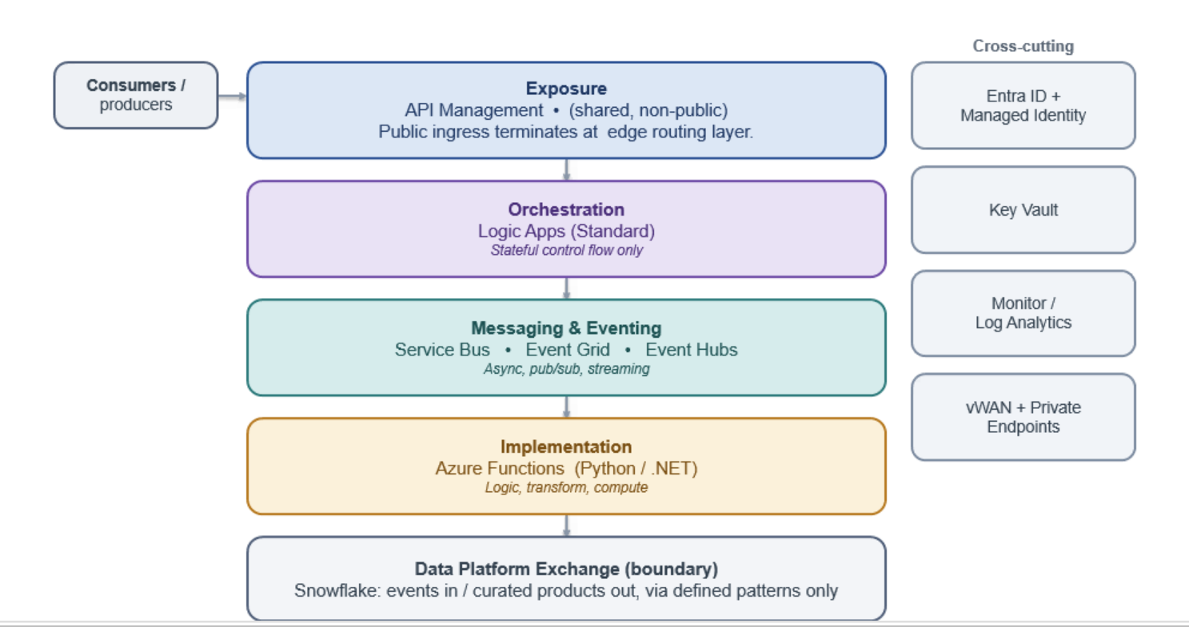
Layer | Description
Exposure layer | API Management is the single ingress for synchronous traffic, applying authentication, rate limiting, product and subscription control, and observability.
Orchestration layer | Logic Apps coordinate stateful, multi-step processes. Orchestration owns process control rather than embedding it in systems.
Messaging and eventing layer | Service Bus, Event Grid and Event Hubs provide asynchronous messaging, discrete eventing and streaming respectively.
Implementation layer | Azure Functions host the discrete implementation logic invoked by the layers above.
Data platform boundary | The System Integration framework meets Snowflake at two governed hand-offs only: a push into the platform and a curated consume from it.

5.3 Security and Trust Boundary
Security is the principle the organisation takes most seriously. The System Integration framework sets out the trust zones once and holds every pattern to them. The diagram shows the zones a request crosses and the control at each boundary.
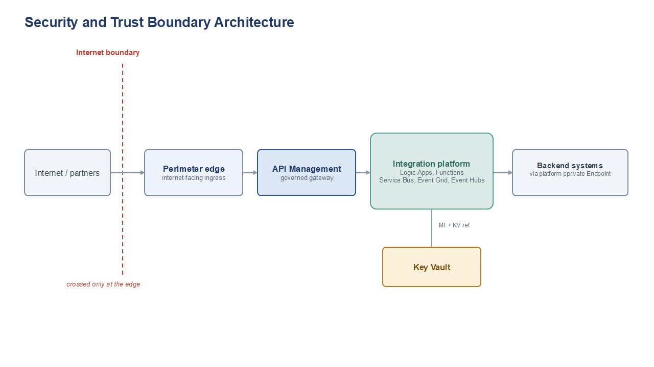
Layer | Description
Internet boundary | The line between the public internet and the estate. It is crossed only at the edge, and public exposure is an exception approved separately rather than a default.
Perimeter edge | The internet-facing ingress and the only point where the boundary is crossed. Anything reachable from outside is fronted here by a managed edge that applies the required protections and keeps everything behind it privately connected. The edge technology is chosen with security and network stakeholders.
APIM gateway | The single, non-public control point for APIs. It authenticates callers, applies policy, throttling and versioning, and mediates all API traffic. It is internal and is never exposed to the internet directly.
Integration platform | The private runtime where integrations execute, providing messaging, eventing, orchestration and lightweight compute. It runs on the private network and is reached only through the gateway or private connectivity.
Backends and data | Systems of record and the analytical data platform. Both are reached only over private connectivity and authenticated by identity, never on a public path. The data platform is reached across a governed boundary, not on the live operational path.
Secrets and certificates | Held in a managed store and referenced by identity at run time, never copied into configuration or code.

5.4 Target Integration Platform
The System Integration framework standardises on the following Azure Integration Services. Delivery teams select from these components and do not introduce alternatives without an exception.
Component | System Integration framework Role | Recommended Use | Do Not Use
Azure API Management | Enterprise API gateway and single API ingress point | Exposing REST APIs to internal systems, vendors, applications, or digital channels | For long-running business processes or data transformation pipelines
Azure Logic Apps | Workflow orchestration and cross-system process coordination | Multi-step integrations, long-running workflows, connector-based automation, exception paths | For low-level compute-heavy logic or high-throughput streaming
Azure Service Bus | Reliable enterprise messaging | Guaranteed delivery, commands, queues, topics, retries, dead-letter handling | For lightweight notifications where message state is not required
Azure Event Grid | Event notification and reactive event routing | Resource/event notifications, event fan-out, near-real-time triggers | For ordered business messaging or complex message settlement
Azure Event Hubs | High-throughput event streaming | Telemetry, high-volume event ingestion, streaming analytics | For command-style workflow messaging or request/response integration
Azure Functions | Low-level implementation logic | Lightweight code extensions, transformation helpers, protocol adapters, custom validation | As the default orchestration engine or business process owner
Azure Data Factory / Data Platform | Data ingestion and analytical pipeline orchestration | Batch/ELT, Snowflake loading, analytical data movement | Real-time operational integration or transient system-to-system messaging

6. Choosing an Integration Pattern
This section works at two levels. For a leadership or high-level view, the primary decision matrix in 6.1 and the common use cases in 6.2 provide a concise view of the approved integration styles. For architecture and delivery teams, the decision tree in 6.3 supports pattern selection, while the worked example in 6.4 illustrates the application of the framework. The enterprise pattern catalogue in Section 7 provides the detailed specification of each pattern.
I am here to | Go to | Go through
Understand the options in plain terms | 6.1 Primary Decision Matrix | 6.2 Common Use Cases
Choose a pattern for a specific need | 6.3 Decision Tree | 7 Pattern Catalogue
See it worked through end to end | 6.4 Worked Example | 7 Pattern Catalogue

6.1 Primary Decision Matrix
The matrix provides a high-level guide to selecting the most appropriate integration capability for a given requirement. It identifies whether a platform capability is normally suitable, conditionally suitable, or not recommended for a specific interaction style. The enterprise pattern catalogue in Section 7 remains the authoritative source for detailed pattern guidance.
Does the need involve... | API | Functions | Service Bus | Event Grid | Event Hubs | Logic Apps | ADF
A consumer that needs an immediate response | ✅ | ⚠️ | ❌ | ❌ | ❌ | ⚠️ | ❌
Guaranteed delivery | ⚠️ | ❌ | ✅ | ⚠️ | ⚠️ | ⚠️ | ❌
A business command or transaction | ✅ | ⚠️ | ✅ | ❌ | ❌ | ⚠️ | ❌
A small code-based transformation or enrichment | ⚠️ | ✅ | ⚠️ | ❌ | ❌ | ⚠️ | ⚠️
A notification that something happened | ⚠️ | ⚠️ | ⚠️ | ✅ | ⚠️ | ⚠️ | ❌
High-volume telemetry or an event stream | ❌ | ⚠️ | ⚠️ | ❌ | ✅ | ❌ | ❌
A process that spans multiple systems and steps | ⚠️ | ⚠️ | ⚠️ | ⚠️ | ❌ | ✅ | ❌
Long-running state or retry orchestration | ❌ | ❌ | ⚠️ | ❌ | ❌ | ✅ | ❌
Analytics or data warehousing as the main purpose | ❌ | ❌ | ⚠️ | ⚠️ | ⚠️ | ⚠️ | ✅
Legend.
✅ The pattern is normally suitable for the use case.
⚠️ The pattern may be suitable, but requires additional design rationale, controls or governance review.
❌ The pattern is not normally suitable for the use case.
Note: Analytics and data warehousing are served by the data platform, using ADF, Blob, Snowpipe and Snowflake, rather than by an integration pattern. Please see Section 8.

6.2 Common Use Cases
The table maps everyday scenarios to the recommended pattern and to the catalogue entry that specifies it in full.
Scenario | Recommended pattern | Catalogue reference
Retrieve or update business data immediately | REST API through API Management | SFINT1
Tell another system to perform work, where delayed processing is acceptable | Service Bus queue, load levelling | SFINT5
Have multiple systems react to the same business message | Service Bus topic, publish and subscribe | SFINT11
Notify that a resource change or event occurred | Event Grid notification | SFINT12
Ingest a high-volume stream, telemetry or near-real-time feed | Event Hubs stream ingestion | SFINT15
Run a multi-step process with conditional routing and exception handling | Logic Apps orchestration | SFINT16
Apply a small code-based transformation or validation step | Azure Function, message translator | SFINT21
Ingest a batch into Snowflake for reporting or analytics | Data platform pattern, ADF, Blob, Snowpipe | Section 8
Run an operational real-time transaction between applications | API or messaging pattern, not Snowflake as an intermediary | SFINT1 to SFINT10

6.3 Detailed Decision Tree
The decision tree below resolves an integration need to a pattern family by asking about interaction style, timing and delivery guarantees, read from the top, and it names no technology. The matrix in 6.1 then maps the chosen family to the Azure capabilities that realise it, and the catalogue in Section 7 specifies each pattern in full.
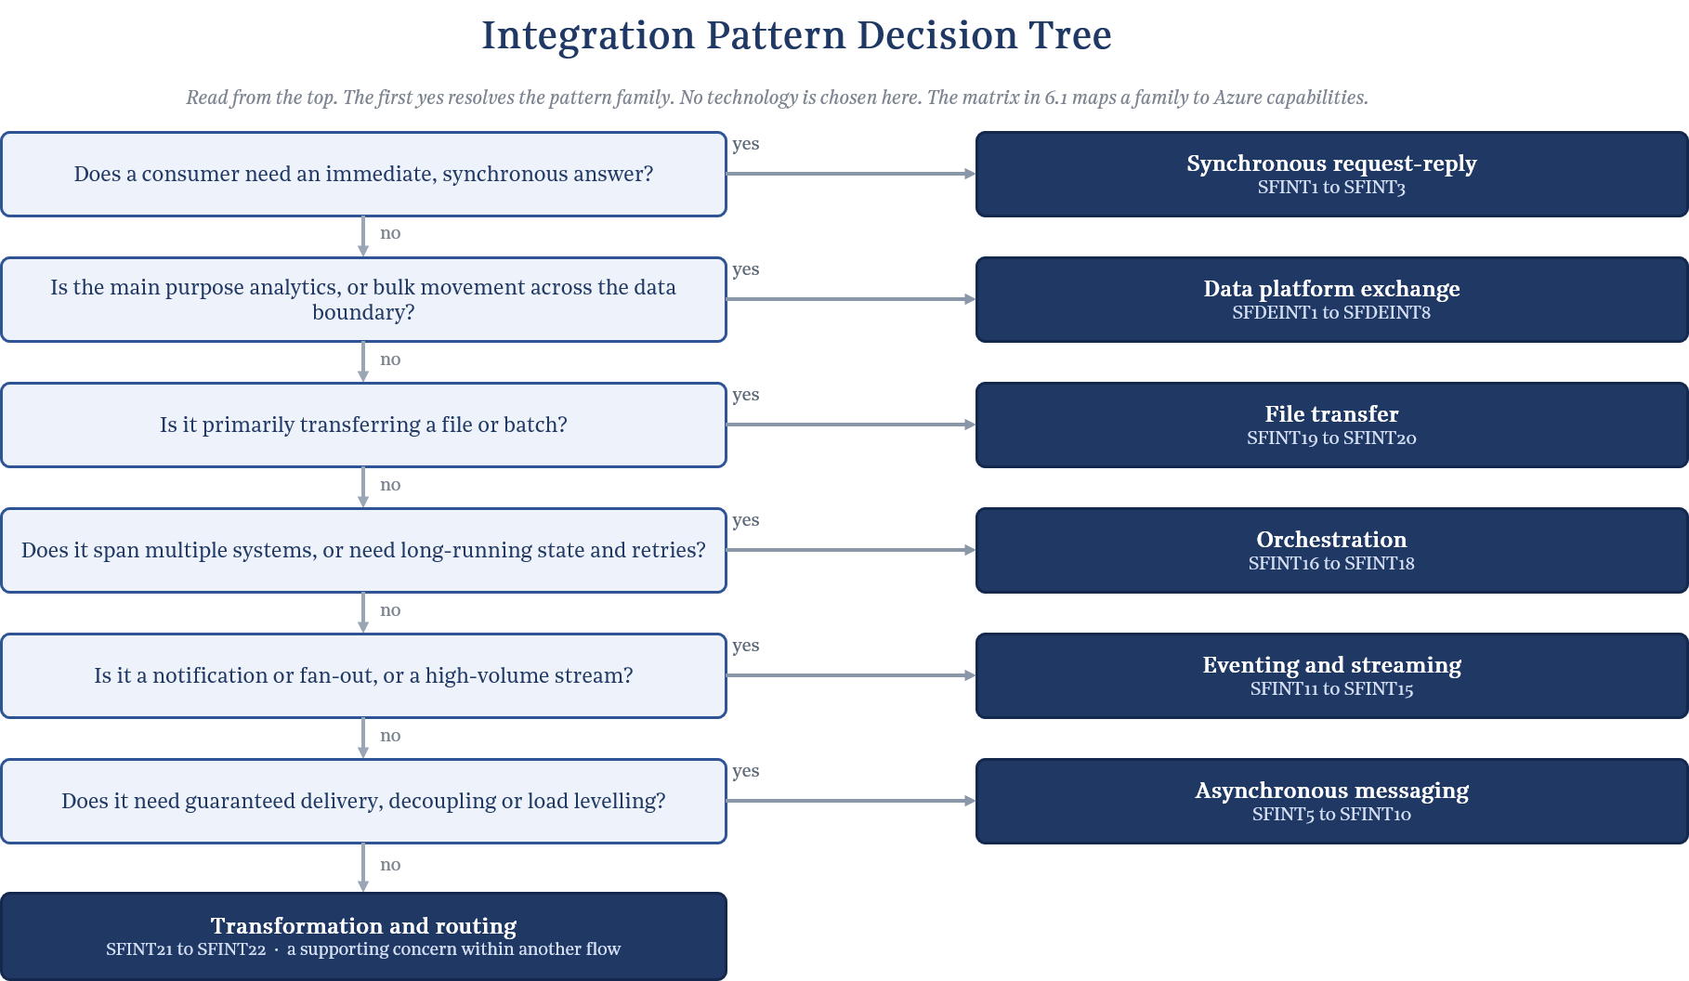
6.4 Example
This example demonstrates the application of the System Integration Framework to a representative insurance integration scenario, illustrating how decision guidance, architectural patterns and governance controls are applied together.
The problem. A broker operating under a delegated authority submits a bordereau, a batch file of bound risks, that must update Chaucer exposure before the bind is confirmed back to them. This is not a simple request and reply. A file arrives, it is translated to the internal model, exposure and accumulation are calculated and validated, the bind is confirmed to the broker system, and the downstream teams are told. The steps are ordered, some run long, and none can be silently lost, so reliability and traceability matter as much as the logic.
Using the document.
- Pattern Selection Process - The task is to choose a pattern for a specific need, so the reading path sends the reader to the decision tree in 6.3 and then the catalogue in Section 7.
- The decision tree (6.3) - The scenario is plainly multi-step, so it is split into its parts, and each part is read from the top of the tree, landing on one pattern family with no technology chosen yet.
- The matrix and use cases (6.1 and 6.2) - The matrix confirms the Azure capability that realises each family, and the common use cases show the same scenarios already recognised, so nothing is invented.
- The catalogue (Section 7) - Each chosen pattern is opened for its full specification, the problem it solves, the solution, when to use and avoid it, its security boundary and its non-functional profile.
- Scope and governance (Sections 9, 11 and 12) - Section 9 places the insurance scenario, Section 11 sets the guardrails and Section 12 describes how the design goes to the Technical Design Authority for sign-off.
Walking the decision.
- Inbound bordereau. The submission is a file, so it is taken in through event-driven file ingestion (SFINT19).
- Into the internal model. The broker format is not the Chaucer format, so the payload is translated to the canonical model before anything downstream sees it (SFINT21).
- The core process. The work spans several systems and runs long, with validation and calculation, so it resolves to orchestration (SFINT16), which sequences validate, calculate accumulation and confirm the bind.
- The confirmed instruction. It must reach the policy system without loss, so it travels as guaranteed-delivery reliable messaging (SFINT9).
Telling the rest. Downstream teams need to know but are not on the critical path, so they are told through a discrete event notification (SFINT12).
The solution. End to end, the bordereau lands and file ingestion (SFINT19) pick it up, canonical translation (SFINT21) maps it to the internal model, and an orchestration (SFINT16) validates the risks, calculates the accumulation against current exposure and confirms the bind. Reliable messaging (SFINT9) carries the confirmed instruction to the policy system, and a discrete event (SFINT12) notifies the downstream teams. No step calls another synchronously across the whole chain, so a slow or unavailable system never fails the broker submission.
Architectural Rationale. A real, multi-step scenario resolves through the decision tree into named catalogue patterns rather than a bespoke design. Each pattern defines its associated security boundary, operational considerations and non-functional characteristics. The resulting solution is governed through the framework's mandatory guardrails in Section 11 and the Technical Design Authority (TDA) review process. The required levels of reliability, traceability and governance are achieved through the application of approved integration patterns and supporting framework controls.

7. Enterprise Pattern Catalogue

7.1 Enterprise Pattern Index and Boundary Applicability
The Systems Integration Framework defines a single enterprise pattern catalogue that applies across internal Chaucer integrations and Chaucer-to-third-party integrations. Patterns are classified by integration boundary to ensure that delivery teams and suppliers understand where each pattern is appropriate and what additional controls are required.
Internal integrations may use approved API, messaging, event, workflow, and file exchange patterns within Chaucer’s controlled Azure integration platform. Third-party integrations must use approved ingress and egress patterns, with stronger controls for API exposure, identity, network boundary, payload validation, monitoring, support ownership, and data protection.
The data platform, including Snowflake, is included as a controlled exchange boundary but is not the default mechanism for operational integration, transient messaging, or real-time process orchestration. Data platform integration should be used where the objective is analytical ingestion, reporting or controlled data exchange.
Pattern Catalogue with Boundary Applicability
Pattern ID | Pattern | Primary Boundary | Internal | 3rd Party to Chaucer | Chaucer to 3rd Party | SIF to Data Platform | Primary Technology | Usage Approval
SIF-P01 | Internal REST API | Internal | ✅ | ❌ | ❌ | ⚠️ | Azure API Management + backend API / Logic App / Function | Standard
SIF-P02 | External API Ingress  (Third Party invoking Chaucer API) | Third party to Chaucer | ⚠️ | ✅ | ❌ | ❌ | Azure API Management | Standard
SIF-P03 | External API Egress (Chaucer invoking Third Party API) | Chaucer to Third party | ⚠️ | ❌ | ✅ | ⚠️ | Azure API Management / Logic Apps / Functions | Standard
SIF-P04 | API Facade / API Mediation | Internal and external | ✅ | ✅ | ✅ | ⚠️ | Azure API Management + Logic App / Function | Standard
SIF-P05 | Reliable Queue Messaging | Primarily internal | ✅ | ⚠️ | ⚠️ | ⚠️ | Azure Service Bus Queue | Standard internally; controlled externally
SIF-P06 | Publish / Subscribe Messaging | Primarily internal | ✅ | ⚠️ | ⚠️ | ⚠️ | Azure Service Bus Topic | Standard internally; external by exception
SIF-P07 | Event Notification | Internal and external | ✅ | ✅ | ✅ | ✅ | Event Grid / Webhook / Logic App Trigger | Standard
SIF-P08 | High-Volume Event Streaming | Internal / analytics / selected external | ✅ | ⚠️ | ⚠️ | ✅ | Azure Event Hubs | Conditional
SIF-P09 | Workflow Orchestration | Internal and external | ✅ | ✅ | ✅ | ⚠️ | Azure Logic Apps | Standard
SIF-P10 | Long-Running Workflow | Internal and external | ✅ | ✅ | ✅ | ⚠️ | Azure Logic Apps Standard | Standard
SIF-P11 | Third-Party Webhook Ingress | Third party to Chaucer | ⚠️ | ✅ | ❌ | ⚠️ | APIM + Logic App / Function | Standard for SaaS/vendor callback scenarios
SIF-P12 | Managed File Exchange | Internal and external | ✅ | ✅ | ✅ | ✅ | Logic Apps / Storage / SFTP / Service Bus where required | Conditional
SIF-P13 | Data Platform Exchange | SIF to Snowflake / Snowflake to SIF | ⚠️ | ✅ | ✅ | ✅ | ADF / Blob or ADLS / Snowpipe / COPY INTO / controlled APIs | Conditional; not default operational integration
SIF-P14 | Custom Code Extension | Internal and external | ✅ | ✅ | ✅ | ⚠️ | Azure Functions | Standard with constraints

✅ | Pattern is applicable and normally acceptable for this boundary.
⚠️ | Pattern may be applicable, but requires additional design rationale, controls, or governance review.
❌ | Pattern is not normally appropriate for this boundary.

Note: Any pattern implementation for a specific scenario which necessitates the use of technologies not mentioned above requires approval.
Enterprise pattern | Realised by practitioner patterns
SIF-P01 Internal REST API | SFINT1 (7.3)
SIF-P02 External API Ingress  (Third Party invoking Chaucer API) | SFINT1 (7.3)
SIF-P03 External API Egress (Chaucer invoking Third Party API) | SFINT1 (7.3)
SIF-P04 API Facade / Mediation | SFINT1, SFINT2, SFINT3 (7.3)
SIF-P05 Reliable Queue Messaging | SFINT5, SFINT6, SFINT7, SFINT8, SFINT9, SFINT10 (7.4)
SIF-P06 Publish / Subscribe Messaging | SFINT11 (7.5)
SIF-P07 Event Notification | SFINT12, SFINT14 (7.5)
SIF-P08 High-Volume Event Streaming | SFINT15 (7.5)
SIF-P09 Workflow Orchestration | SFINT16 (7.6)
SIF-P10 Long-Running Workflow | SFINT16, SFINT17, SFINT18 (7.6)
SIF-P11 Third-Party Webhook Ingress | SFINT13 (7.5)
SIF-P12 Managed File Exchange | SFINT10, SFINT19, SFINT20 (7.4, 7.7)
SIF-P13 Data Platform Exchange | SFDEINT1–SFDEINT10 (9.4)
SIF-P14 Custom Code Extension | SFINT3, SFINT21 (7.3, 7.8)
Pattern Grouping by Integration Boundary
Internal Chaucer Integration Patterns
Pattern ID | Pattern | Typical Use
SIF-P01 | Internal REST API | Internal application-to-application request/response integration.
SIF-P04 | API Facade / Mediation | Shielding consumers from backend complexity or legacy constraints.
SIF-P05 | Reliable Queue Messaging | Decoupled internal processing with retry and dead-letter handling.
SIF-P06 | Publish / Subscribe Messaging | Internal business event transfer to one or to multiple consumers.
SIF-P07 | Event Notification | Lightweight internal notification that something has happened.
SIF-P09 | Workflow Orchestration | Multi-step integration across Chaucer-owned systems.
SIF-P10 | Long-Running Workflow | Stateful processes, callbacks, retry cycles, or human/system delays.
SIF-P12 | Managed File Exchange | Controlled file movement between Chaucer systems.
SIF-P14 | Custom Code Extension | Small transformation, validation, enrichment, or protocol adaptation.
Third Party to Chaucer Inbound Patterns
Pattern ID | Pattern | Typical Use | Additional Controls
SIF-P02 | External API Ingress  (Third Party invoking Chaucer API) | Supplier, SaaS, broker, or vendor calls a Chaucer API. | APIM, OAuth/OIDC or approved auth model, throttling, usage quota, validation, logging.
SIF-P04 | API Facade / Mediation | Chaucer exposes stable contract while shielding internal systems. | Contract ownership, versioning, backend isolation.
SIF-P07 | Event Notification | Third party notifies Chaucer that an event has occurred. | Schema validation, replay controls, monitoring.
SIF-P11 | Third-Party Webhook Ingress | SaaS callback or vendor event pushed to Chaucer. | Signature validation, replay protection, APIM mediation.
SIF-P12 | Managed File Exchange | Supplier, broker, or vendor sends files to Chaucer. | Malware scanning, encryption, metadata capture, reconciliation.
SIF-P13 | Data Platform Exchange | External data is provided for analytical ingestion. | Data ownership, lineage, classification, ingestion controls.
Chaucer to Third Party Outbound Patterns
Pattern ID | Pattern | Typical Use | Additional Controls
SIF-P03 | External API Egress (Chaucer invoking Third Party API) | Chaucer calls supplier, SaaS, market, or vendor APIs. | Credential management, timeout, retry with exponential fall back, throttling, error mapping.
SIF-P04 | API Facade / Mediation | Chaucer standardizes access to third-party APIs for internal consumers. | Abstraction, versioning, supplier contract management.
SIF-P07 | Event Notification | Chaucer notifies an external party of a process or status event. | Contracted endpoint, failure handling, audit trail.
SIF-P09 | Workflow Orchestration | Chaucer coordinates multi-step third-party process. | Operational ownership, compensating action, monitoring.
SIF-P10 | Long-Running Workflow | Supplier interaction requires polling, callbacks, or delayed response. | State management, timeout, escalation, retry policy.
SIF-P12 | Managed File Exchange | Chaucer sends files to supplier, broker, or vendor. | Encryption, confirmation handling, reconciliation, support model.
SIF-P14 | Custom Code Extension | Adapter logic for supplier-specific payload, protocol, or transformation. | Code review, testing, version control, CI/CD.

SIF to Data Platform / Snowflake Exchange Patterns
Pattern ID | Pattern | Typical Use | Guardrail
SIF-P07 | Event Notification | Notify data platform that data is available for ingestion. | Notification only, not operational process orchestration.
SIF-P08 | High-Volume Event Streaming | Stream high-volume events or telemetry for analytical use. | Use only where event-streaming requirements are proven.
SIF-P12 | Managed File Exchange | Land files for analytical ingestion. | Must include ownership, metadata, retention, and monitoring.
SIF-P13 | Data Platform Exchange | Controlled exchange between SIF and Snowflake. | Data platform must not be the default operational integration mechanism.
SIF-P14 | Custom Code Extension | Lightweight extraction, validation, or formatting helper. | Avoid embedding business process orchestration in code.

7.2 Detailed Practitioner Patterns
The catalogue is organised by interaction style: request/response, asynchronous messaging, event-driven, orchestration, file-based exchange, and data-platform exchange. It mirrors the very first decision a developer makes.
It lines up one-to-one with the decision tree, and each style maps cleanly onto a primary Azure service, file-based being the one that spans a few, because a file is a transport rather than a service.
Each pattern is written the same way, so any of them can be read quickly. A one-line statement of what it is for, a diagram, the problem and the solution in plain terms, when to use and avoid it, the risks worth planning for, the common pitfall to steer around, and an insurance example. The diagrams share a visual language, blue is the gateway, purple is orchestration, teal is Service Bus, green is Event Grid, orange is Event Hubs, amber is Functions, and a cylinder is a store.
Security, routing and observability are established once at the conceptual level (5.1) and held constant here: every pattern below applies that same baseline, through its Security boundary and common pitfalls, to its own interaction style, rather than each pattern reinventing its own approach. A pattern that needs to depart from the baseline is an exception to raise through the TDA process (12.1), not a design choice to make pattern by pattern. Concretely, every pattern inherits the same set of cross-cutting concerns: secrets and credentials held in Key Vault and referenced, never embedded (10.1); logs, metrics and traces surfaced through the standard observability matrix (10.3); and delivery through the single DevSecOps pipeline, built once and promoted unchanged through every environment (10.5).

7.3 API Patterns

7.3.1 Managed API facade (SFINT1)
Put every exposed capability behind the shared gateway, so consumers never bind to a backend directly.
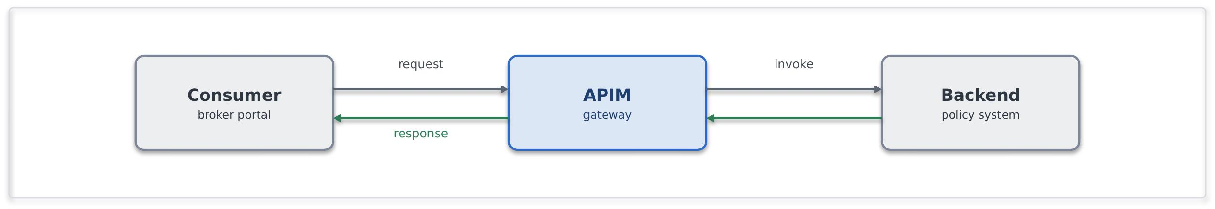
Problem. Some business interactions genuinely require synchronous access to a capability exposed by another system, particularly where the consumer is waiting for an immediate response, such as a quote or validation. However, synchronous integration should remain limited to short-lived requests. When direct backend access is allowed, it creates tight coupling, distributes security and access-control responsibilities, and increases the impact of change across dependent consumers. Equally, when synchronous interactions evolve into long-running processes, they increase the risk of timeouts, retries, and degraded reliability.
Solution. Expose the capability as a coarse-grained REST/JSON operation on API Management. APIM authenticates the caller with an Entra token, applies a rate limit and a product subscription, and forwards to the backend over a Private Endpoint using a managed identity. The consumer knows only the contract, so the backend can be re-platformed behind a stable façade. Where the capability must be reachable from the internet, APIM sits behind an appropriate network edge protection service, it is never public itself.
Use it when. A consumer requires an immediate response, and the capability must be exposed through a governed, reusable, and discoverable API. Standardising on REST/JSON provides a consistent integration approach across the estate and allows legacy protocols and backend implementations to be abstracted behind a common API contract. This simplifies consumption, reduces coupling, and enables backend services to evolve without impacting consumers.
Avoid it when. This pattern is not suitable for long-running, unpredictable, or fire-and-forget workloads. Where multiple steps, orchestration, or transactional processing are required, use an asynchronous or orchestration-based pattern instead.
Risks and considerations. APIM provides a consistent API facade that centralises policy enforcement, security controls, traffic management, and API governance. To minimise latency and operational overhead, policies should remain focused and efficient, with caching applied where appropriate. Backend services remain responsible for implementing their own security, validation, and throttling controls rather than relying solely on the gateway layer.
Security boundary. For internal consumers, the entire interaction remains private and does not traverse the public internet. Consumer-to-APIM and APIM-to-backend communications use Private Endpoints, with TLS enforced on every hop. APIM authenticates to backend services using managed identities. Where an API must be externally accessible, it is exposed through an approved secure access layer or network edge protection service with OAuth or mTLS protection at the edge, managed as a registered exception. APIM is not exposed directly to the internet.
Common pitfall. Implementing the API facade as a simple pass-through layer with no governance value or embedding business logic and orchestration behaviour within API policies.
In practice. A broker portal requires real-time access to policy information. Instead of integrating directly with the policy administration platform, the capability is exposed through APIM as a managed API facade. The policy system exposes get-policy-summary through APIM , the broker portal calls the API and has no knowledge of the policy admin system behind it.

7.3.2 API composition / aggregation (SFINT2)
Assemble one coarse-grained business response from a few backend reads, so the consumer makes a single call.
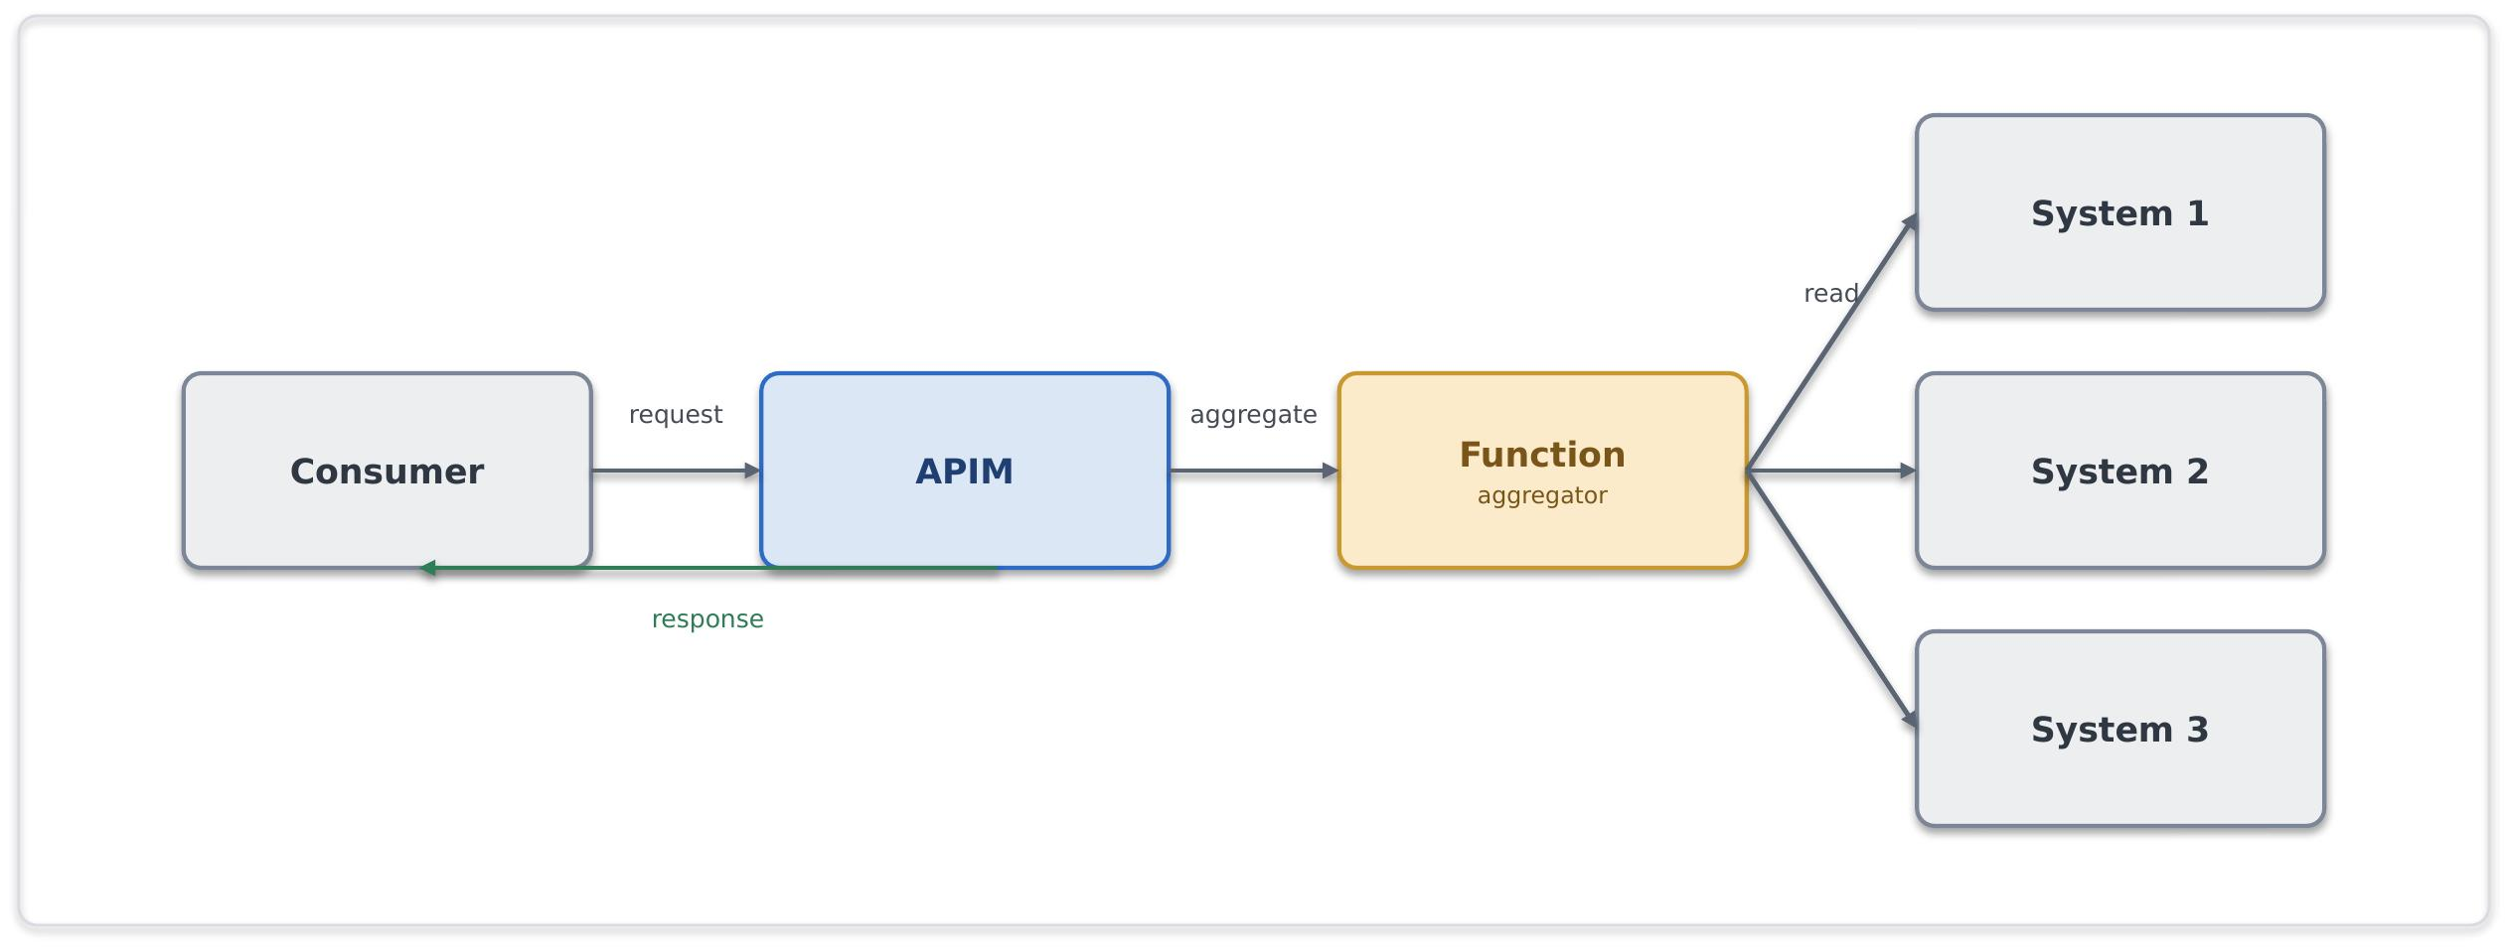
Problem. A servicing screen needs a "client 360" view whose data lives across three systems. Making the consumer call all three couples it to three contracts and three failure modes; doing the joins in the browser is worse.
Solution. Exposing a single composed API on APIM backed by a Function that fans out to the underlying systems, assembles a coarse-grained response and returns it. The composition stays read-mostly and business-shaped, SOA granularity, not a mesh of fine-grained calls.
Use it when. A consumer needs one logical business object drawn from two or three sources and a single round-trip materially simplifies the caller.
Avoid it when. The composition needs transactional writes or long-running steps (orchestrate), or the need is to fan out to many fine-grained services, that is a granularity problem to fix, not to aggregate around.
Risks and considerations. Response time is governed by the slowest dependency and availability by their product, so decide up front how the API behaves when one source is down, a partial response with a clear indicator usually beats failing the whole call. Put a timeout and a circuit breaker around each backend and cache responses wherever feasible.
Security boundary. APIM is hosted as a shared service, with workload services deployed in their own workload boundaries. All communication remains internal, using private connectivity, managed identities, and TLS encryption end-to-end. No services are exposed directly to the internet.
Common pitfall. Fine-grained, chatty aggregation that recreates a distributed monolith; pushing heavy composition into APIM policies instead of a Function.
In practice. A servicing application requires a consolidated client view spanning policy, claims and customer systems. Rather than calling multiple backend services directly, the application consumes a single aggregated API exposed through APIM. A composition service retrieves and assembles the required information, providing a unified response while maintaining separation between consumers and source systems.

7.3.3 Protocol / format mediation (SFINT3)
Translate a legacy protocol to REST/JSON at the edge so modern consumers stay clean.
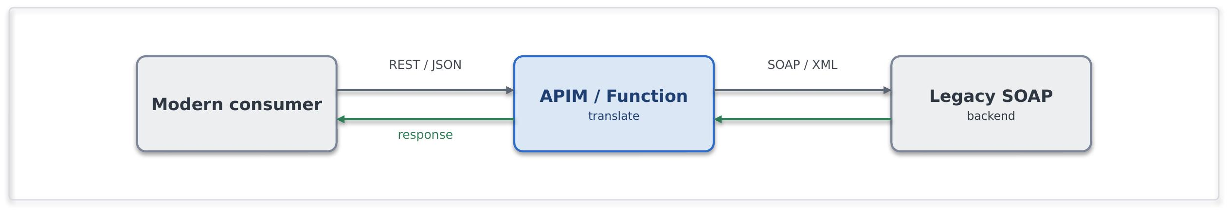
Use it when. Standardising the estate on REST/JSON and need to front a legacy protocol.
Avoid it when. The requirement is really business transformation rather than protocol translation, that is implementation logic and belongs in a Function with tests, not in a mediation policy.
Risks and considerations. Translation should remain stateless and limited to protocol and format conversion. Introducing business logic into the mediation layer increases complexity and can result in hidden or difficult-to-test behaviour. Schema validation should be applied during transformation to identify malformed payloads before they propagate downstream.
Security boundary. APIM or the mediation Function in the shared subscription / a spoke; the legacy backend in its spoke or on-premises. Within Azure: Private Endpoint, managed identity and TLS, an on-premises backend is reached over the private vWAN path, not the internet. Outside Azure: none, an internet-only legacy partner uses the inbound-webhook edge instead.
Common pitfall. Business rules embedded in the translation layer; unbounded transformation inside APIM policies.
In practice. A cloud-native application requires access to a reinsurance capability exposed through a legacy SOAP/XML interface. Protocol mediation presents the capability through a REST/JSON contract while isolating legacy implementation details from consuming applications.

7.4 Messaging Patterns

7.4.1 Queue-based load levelling (SFINT5)
Put a queue between a spiky producer and a limited backend so load is absorbed, not amplified.
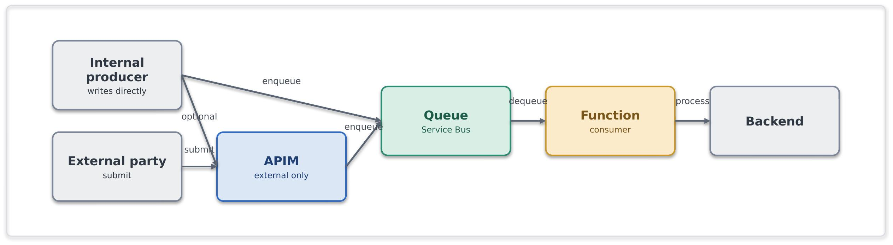
Problem. A producer generates work at a higher rate than a consuming system can process it. Tight coupling between producer and consumer can result in reduced availability, processing bottlenecks and failure propagation during periods of increased load.
Solution. Introduce a Service Bus queue between the producer and the backend so each run at its own pace. An internal producer writes to the queue directly, authenticated with managed identity, so no gateway sits in the path. An external producer, which cannot reach the bus, is fronted by API Management or a small Function that validates the request and enqueues it. A Function consumer then drains the queue at the rate the backend can sustain, so producer and consumer are decoupled in time, and a backend outage becomes a growing queue rather than a wave of errors.
Use it when. The producer is spikier or faster than the consumer, or the backend's availability must be decoupled from producer load.
Avoid it when. The caller needs an immediate answer (request/response), the input being ingested is a high-volume telemetry (Event Hubs).
Risks and considerations. Service Bus provides buffering rather than unlimited capacity. Queue depth, consumer lag and dead-letter queues should be monitored to identify processing bottlenecks and capacity constraints. Consumers should support idempotent processing, as delivery semantics remain at-least-once and duplicate deliveries may occur.
Security boundary. APIM (shared), Service Bus and the consumer Function (spokes), internal. Within Azure: producers and consumer reach Service Bus over a Private Endpoint using a managed identity with Sender/Receiver RBAC (no SAS keys), TLS throughout. Outside Azure: none, an external producer is taken through the edge first.
Common pitfall. Hammering a fragile backend synchronously; ignoring the dead-letter queue; reaching for storage queues when sessions, DLQ and richer delivery semantics are needed
In practice. During renewal season, large volumes of broker submissions may arrive within a short period of time. Rather than overloading downstream policy administration systems, submissions are queued and processed asynchronously, allowing business operations to continue without affecting service availability or delivery reliability.

7.4.2 Competing consumers (SFINT6)
Scale out throughput by letting several workers pull from one queue.
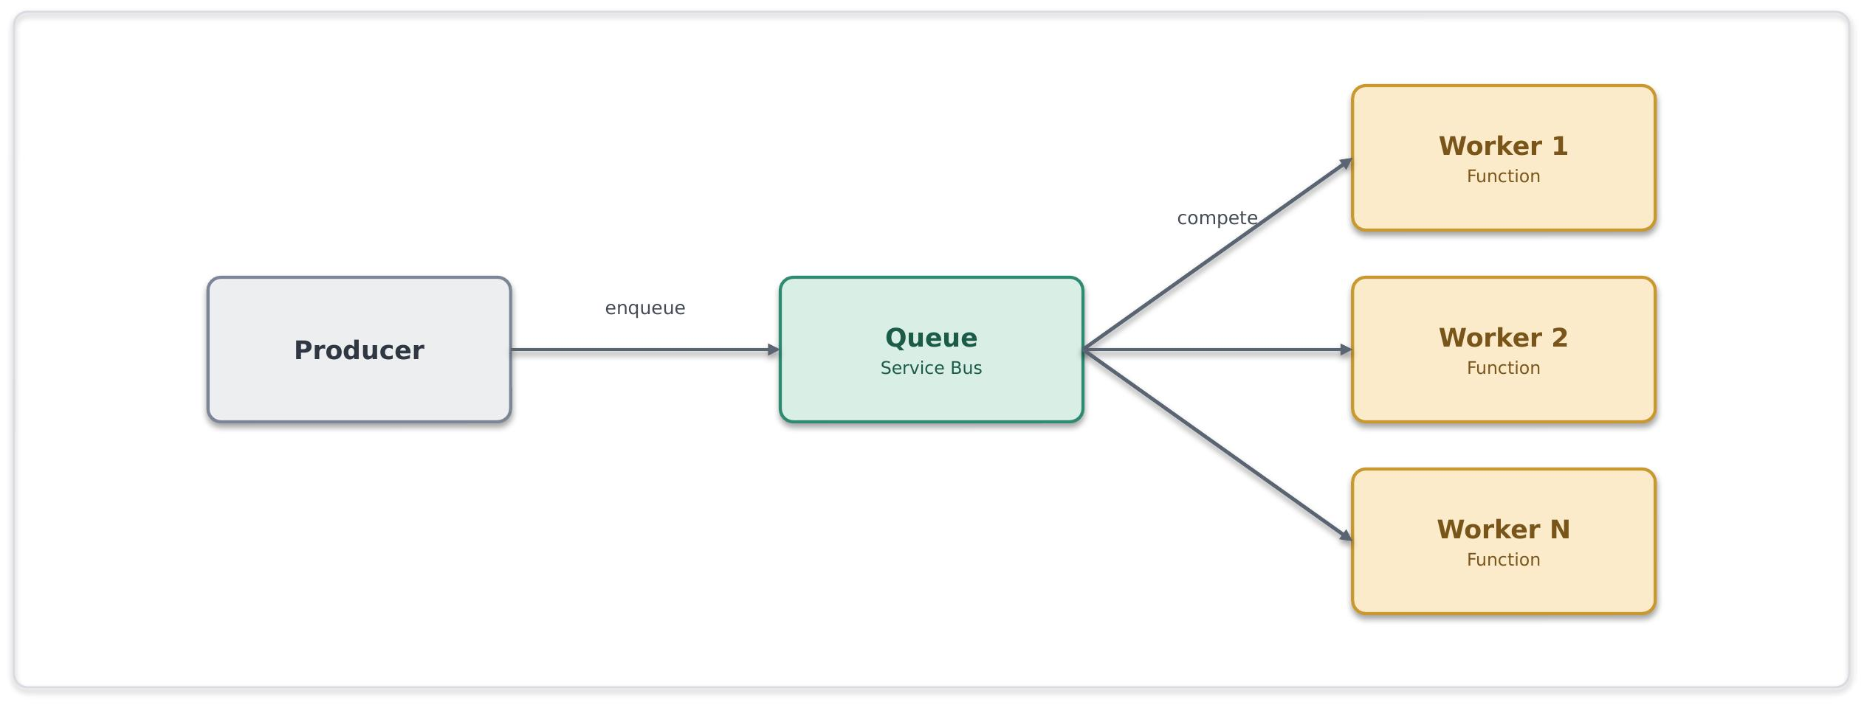
Problem. A single consumer instance is unable to process incoming work at the required rate. As message volumes increase, processing latency and queue backlogs can grow, limiting overall throughput and responsiveness.
Solution. Multiple consumer instances process messages from a shared queue in parallel. Service Bus distributes messages across available consumers, enabling horizontal scale-out while maintaining controlled processing.
Use it when. Throughput exceeds a single consumer, and the work items are independent and can be run in parallel.
Avoid it when. Strict global ordering without sessions is needed, or workers must share mutable state.
Risks and considerations. Duplicate delivery is still a possibility; therefore, consumers should be idempotent. Monitor for hot sessions that serialise work and cap the scale-out. To address this auto scale on queue depth rather than CPU.
Security boundary. Service Bus and the Function pool in spokes, internal. Within Azure: Private Endpoint, managed identity with least-privilege RBAC, TLS. Outside Azure: none.
Common pitfall. Assuming ordering without sessions or sharing mutable state between workers.
In practice. A backlog of document-processing jobs is cleared by an autoscaling pool of Function workers.

7.4.3 Asynchronous request-reply (SFINT7)
Accept now, answer later, a 201/202 and a status endpoint instead of a held-open connection.
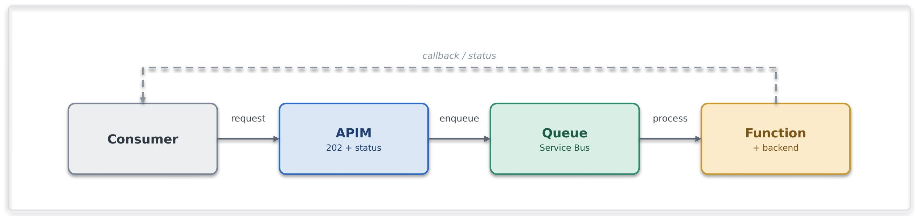
Problem. A consumer wants a result from an operation that takes too long to hold a synchronous HTTP connection open for.
Solution. APIM accepts the request, returns 201/202 with a status URL and a correlation id, and drops the work on a queue. A Function processes it and updates a status store or calls back; the caller polls the status endpoint or receives the callback.
Use it when. The operation is too long for a synchronous reply, but the caller still needs the eventual result.
Avoid it when. The result is instant (synchronous) or there is no way to correlate request and reply.
Risks and considerations. This interaction model becomes multi-stage and requires clear status-tracking behaviour. Correlation identifiers should be maintained throughout the processing lifecycle, and status information should be stored durably with appropriate retention and cleanup controls. Documentation should clearly define the expected client interaction pattern.
Security boundary. APIM (shared), Service Bus and Function (spokes), internal. Within Azure: Private Endpoints, managed identity, TLS, the correlation id carries no secret material. Outside Azure: none unless the caller is external, in which case the request and status endpoints are exposed through the edge (Network Edge Service, OAuth).
Common pitfall. Holding a synchronous connection open for minutes; omitting a correlation id.
In practice. A bulk quotation or pricing request cannot be completed within the expected synchronous response window. The request is accepted immediately and processed asynchronously, while the consumer retrieves the final outcome through a status endpoint once processing has completed.

7.4.4 Claim-check (SFINT8)
Keep large payloads off the bus, pass a reference, store the body in Blob.
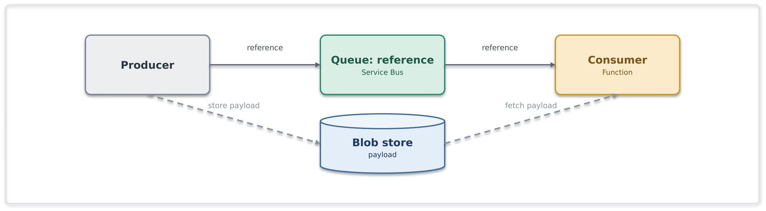
Problem. A messaging-based integration needs to process payloads created by the producer that exceed recommended message sizes.
Solution. The producer writes the payload to Blob storage and puts only a reference on the queue; the consumer reads the reference and fetches the body from blob. The messaging layer stays lean.
Use it when. Payloads approach or exceed message-size limits within an otherwise message-based flow.
Avoid it when. Payloads are small enough to carry inline, or the data is really a bulk data-platform concern.
Risks and considerations. Reference and payload now have independent lifetimes, a lifecycle policy must purge transient blobs, to avoid cost increase, and the reference is ineffective if the blob has gone. The Blob should be reached over a Private Endpoint with RBAC; no account keys, no public SAS.
Security boundary. Service Bus, Blob and Function in spokes, the storage account is firewalled with public access disabled. Within Azure: Blob is reached over a Private Endpoint with managed-identity RBAC, no account keys, no public SAS, and TLS. Outside Azure: none, the payload never leaves the private boundary.
Common pitfall. Large binaries on the bus; public or long-lived SAS URLs to the payload.
In practice. A bordereau, claims file or other large business document exceeds recommended message sizes for direct transport through the messaging platform. The document is stored in Blob Storage, while a reference is distributed through Service Bus for downstream processing and orchestration.

7.4.5 Reliable messaging (SFINT9)
For business-critical messages never lost and effectively processed once.
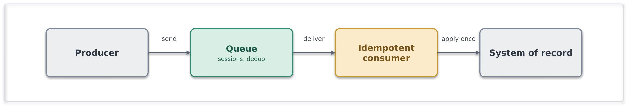
Problem. A messaging scenario requires reliable delivery and protection against duplicate processing, where message loss or repeated processing would result in operational, financial or data-integrity impacts.
Solution. Use Service Bus with appropriate delivery controls, including duplicate detection and sessions where message ordering is required. Consumers should implement idempotent processing to safely handle redelivery scenarios. Where message publication must remain consistent with local state changes, a transactional outbox pattern should be considered. Exactly-once outcomes are achieved through at-least-once delivery combined with idempotent processing.
Use it when. Message loss or double-processing has real financial or data-integrity impact.
Avoid it when. The notification is best-effort and replaceable, use Event Grid.
Risks and considerations. Duplicate-detection windows are finite; idempotent processing should remain the primary protection against duplicate message handling. Capacity and resilience should align to the required service level.
Security boundary. Service Bus and consumer in spokes, internal. Within Azure: Private Endpoint, managed identity, TLS, idempotency keys carry no secrets. Outside Azure: none.
Common pitfall. Assuming transport-level exactly-once delivery guarantees and implementing consumers without idempotent processing controls.
In practice. A financial or policy-processing workflow requires reliable message delivery and protection against duplicate processing. Service Bus provides durable message handling, while consumers use idempotent processing to ensure a message can be safely reprocessed without introducing duplicate business outcomes.

7.4.6 Scheduled / timed trigger (SFINT10)
Kick off integration work on a clock when there is no event to react to.
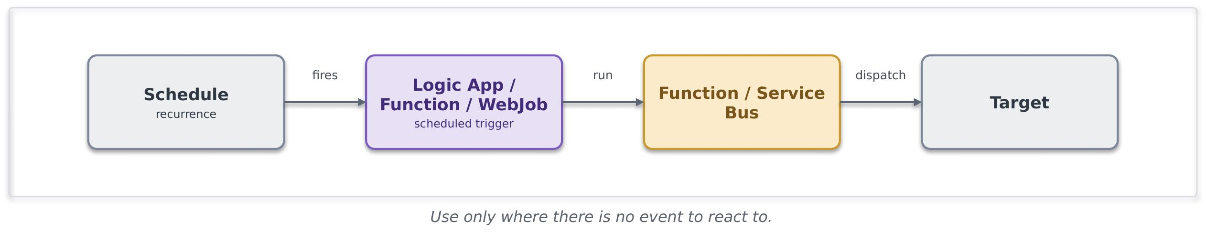
Problem. Certain integrations are inherently time-based and require execution on a defined schedule. In these scenarios, event-driven approaches may not be available or appropriate.
Solution. A Logic App (Standard)/Function recurrence trigger or web job fires on a schedule and runs the work, calling a Function or dropping messages on Service Bus for downstream processing.
Use it when. The cadence is time-based (end-of-day, regulatory windows) or the source cannot notify and there is no event to subscribe to.
Avoid it when. An event source is available, or polling is being used to emulate near-real-time processing.
Risks and considerations. Schedules can result into hidden coupling and surprise load spikes. Execution schedules should be documented, idempotent and monitored, with alerts configured for missed or failed runs.
Security boundary. The trigger runs in a workload spoke; the schedule is internal and crosses no boundary. Within Azure: managed identity to any Function/Service Bus it calls, Private Endpoints, TLS. Outside Azure: none, if a scheduled run reaches a partner (an extract), that egress follows the file-egress edge controls (SFINT20).
Common pitfall. Timer-polling a data source or folder to simulate real-time; overlapping runs with no idempotency; schedules scattered across teams with no visibility.
In practice. Financial reconciliation processes often run at defined business intervals rather than in response to events. A scheduled integration executes at the required time, identifies changes and distributes them for downstream processing and reporting.

7.5 Event Patterns

7.5.1 Publish / subscribe fan-out (SFINT11)
Publish a business event once; let interested consumers subscribe independently.
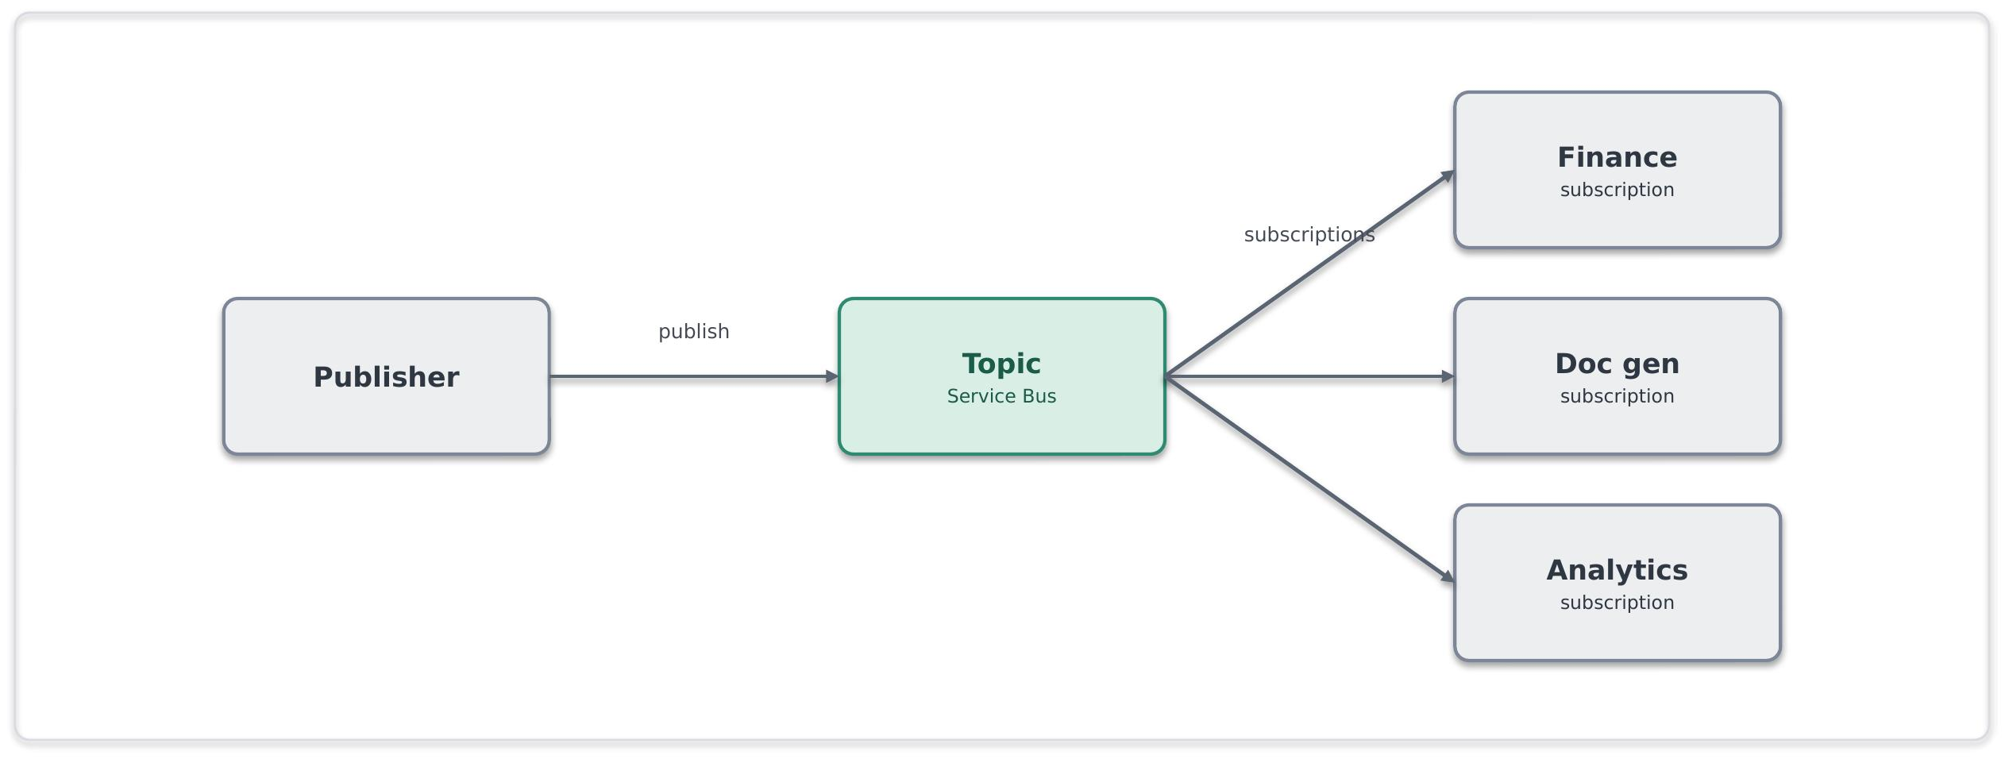
Problem. Multiple consumers need to react to the same business event independently. Direct point-to-point integration between the publisher and each consumer increases coupling and creates additional maintenance overhead
Solution. The publisher emits an event to a Service Bus topic; each consumer owns a subscription with its own filter and dead-letter queue. Consumers come and go without the publisher knowing. This is the primary tool for eliminating point-to-point integration.
Use it when. Several consumers must react to the same business event, and durable, filterable, independently-consumed delivery is required.
Avoid it when. It is a lightweight reactive trigger with no durability need (Event Grid), or a high-volume stream (Event Hubs).
Risks and considerations. Subscription growth should be governed and monitored. Each subscription should implement appropriate dead-letter handling, monitoring and alerting. Consumer backlogs should be monitored independently to prevent processing delays
Security boundary. The Service Bus topic and its subscribers in spokes, internal. Within Azure: Private Endpoint, per-subscription managed-identity RBAC, TLS. Outside Azure: none.
Common pitfall. Creating direct dependencies between publishers and consumers, or using Event Grid where durable, filterable and independently consumable messaging is required.
In practice. When a policy is bound, multiple downstream functions such as finance processing, document generation and analytics require notification of the event. Publish/subscribe messaging enables each consumer to process the event independently without introducing direct dependencies on the publishing application.

7.5.2 Discrete event notification (SFINT12)
A thin "it happened" signal for near-real-time reactions.
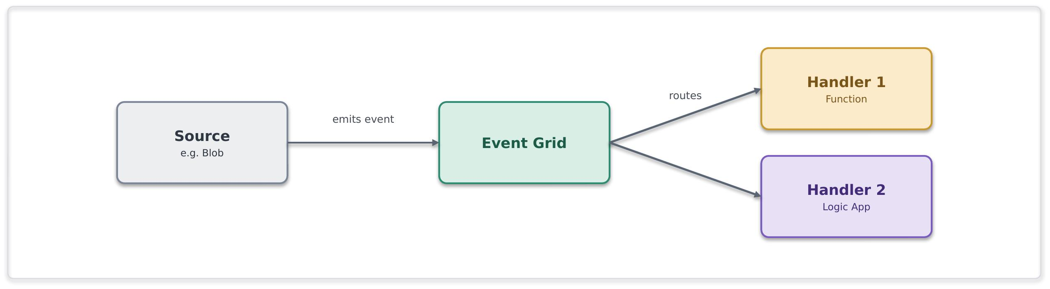
Problem. A change in state or business event must be communicated to one or more consumers with minimal latency, without requiring durable enterprise messaging or workflow orchestration.
Solution. Emit a thin event to Event Grid, handlers (Functions, Logic Apps, webhooks) subscribe and react. The event is a pointer, not a state carrier, a handler fetches authoritative state if it needs it.
Use it when. Lightweight, low-latency reactive fan-out to Azure-native handlers is needed
Avoid it when. Consumers need durable ordered delivery or competing consumers (Service Bus topics), or the volume is a stream (Event Hubs).
Risks and considerations. Delivery is at-least-once and unordered, so handlers must be idempotent and order-independent. Dead-letter handling should be configured for failed deliveries. Events should not be treated as authoritative business records, as this can introduce coupling and data-consistency challenges.
Security boundary. Event Grid and its handlers in spokes, reached privately. Within Azure: managed-identity delivery, Private Endpoint where supported, handler-side validation, TLS. Outside Azure: none, a handler that must be internet-reachable is the inbound-webhook pattern, not this one.
Common pitfall. Using event notifications for streaming workloads or durable business messaging, or publishing events that become de facto sources of truth.
In practice. A document, file or business record changes state and downstream services need to react quickly. Event notifications allow interested consumers to respond independently without introducing direct dependencies or additional workflow coordination.

7.5.3 Inbound webhook ingestion (SFINT13)
Take partner callbacks safely through the network edge service, then process them asynchronously.
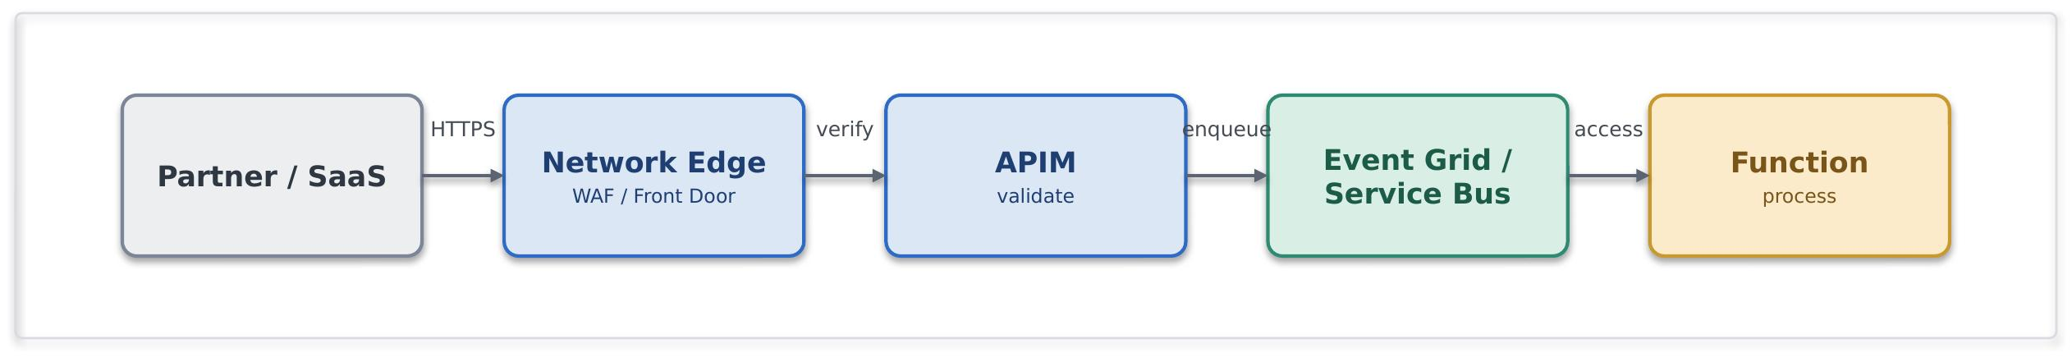
Problem. An external party needs to notify Chaucer of an event through a callback or webhook mechanism. Direct exposure of internal integration endpoints is a security risk.
Solution. This is the sanctioned public-ingress exception. Traffic enters through an appropriate network edge service, terminates at APIM as the single ingress point, is authenticated (mTLS, OAuth, or a signed-payload check) and validated, then dropped onto Service Bus or Event Grid for asynchronous processing. No Function or Logic App HTTP trigger is ever exposed directly.
Use it when. An external party must push events to us and private networking is not possible.
Avoid it when. The integration can use private networking, prefer that every time.
Risks and considerations. Internet-facing integrations require additional controls to mitigate replay, forgery and abuse scenarios. Request validation, rate limiting, deduplication and asynchronous processing should be implemented. Where public exposure is required, the integration should follow the approved exception process and maintain clear ownership and review arrangements.
Security boundary. This pattern crosses the internet boundary, so an appropriate network edge service terminates the public endpoint, APIM is the single ingress, and processing happens back in the private spokes. Within Azure: past the edge everything is private, Service Bus/Event Grid and Functions over Private Endpoints with managed identity and TLS. Outside Azure: mTLS, OAuth or signed-payload validation, IP allow-listing and rate-limiting at the edge, no Function or Logic App trigger is ever exposed, the exposure is a registered, time-boxed exception.
Common pitfall. Exposing a Logic App or Function HTTP trigger straight to the internet, bypassing APIM and the network edge service; processing synchronously in the handler.
In practice. A payment provider posts settlement events webhooks; APIM validates the signature and drops the event on Service Bus.

7.5.4 Outbound webhook / notification (SFINT14)
Push events out to subscribers instead of making them poll.
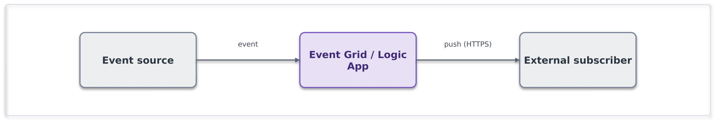
Problem. An external consumer requires timely notification of a business or system event without repeatedly polling for status or changes.
Solution. On the event, dispatch via Event Grid subscriptions or a Logic App connector, webhook, email or Teams. Subscribers are configured, not coded into the publisher.
Use it when. Subscribers expect to be pushed to on an event.
Avoid it when. Subscribers should really pull current state through an API.
Risks and considerations. Subscriber availability can impact delivery success and increase retry activity. Appropriate retry, backoff and dead-letter handling should be implemented. Authentication material should be managed through, sign payloads where supported, and use a circuit breaker around inconsistent endpoints.
Security boundary. Event Grid or the Logic App in spokes, the egress to an external subscriber leaves through the controlled path, not default internet routing (routing intent enforced). Within Azure: managed identity, partner secrets held in Key Vault and referenced, TLS. Outside Azure: TLS to the subscriber, payload signing where supported, partner endpoints allow-listed, and secrets rotated/revoked through Key Vault.
Common pitfall. Polling to simulate push; bespoke per-subscriber dispatch code instead of subscriptions.
In practice. The broker's system is notified automatically when a claim status changes.

7.5.5 Stream / telemetry ingestion (SFINT15)
Ingest high-volume continuous data and hand it to processors or the data platform.
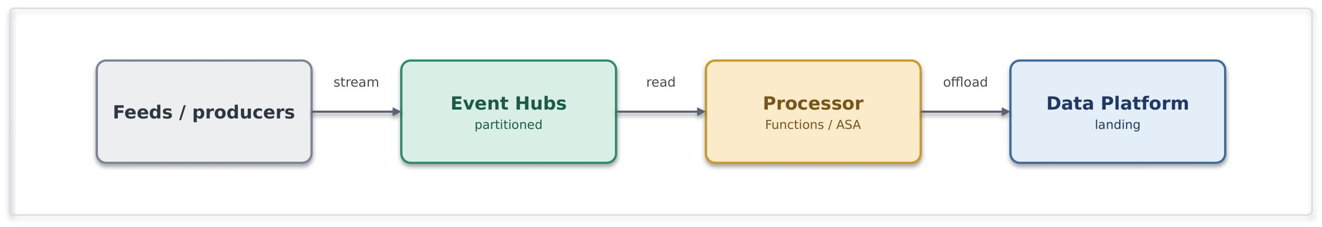

Problem. A high-frequency feed produces far more events than a business-messaging queue is designed for, and it needs partitioned, ordered processing.
Solution. Ingest into Event Hubs, partitioned for throughput; process with Functions; and typically capture or offload to Data Platform for analytics. Event Hubs is designed for high-volume event ingestion and streaming; Service Bus is not.
Use it when. Sustained high event rates need partitioned stream processing.
Avoid it when. These are transactional business commands needing per-message dead-lettering and sessions (Service Bus), or low-volume discrete notifications (Event Grid).
Risks and considerations. Partitioning strategy should be planned against throughput and consumer parallelism requirements. Consumer lag, checkpoint management and processing latency should be monitored. Ordering guarantees apply only within an individual partition, and capacity requirements should be aligned to expected event volumes
Security boundary. Event Hubs and its processors in spokes, capture to a firewalled storage account. Within Azure: Private Endpoint, managed identity, TLS, with capture storage under RBAC. Outside Azure: an external feed enters through the edge; internal streams cross no boundary.
Common pitfall. Usage of Service Bus for high volumes, Event Hubs for transactional commands; or designing synchronous consumers on a stream.
In practice. A high-frequency exposure feed is ingested, processed near-real-time and offloaded to Snowflake.

7.6 Orchestration Patterns

7.6.1 Stateful process orchestration (SFINT16)
Coordinate a multi-step, multi-system business process with state, retries and visibility.
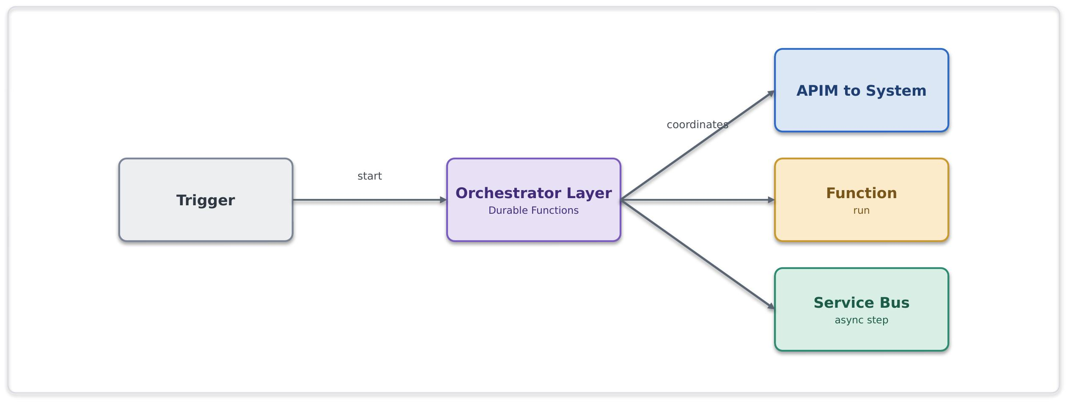
Problem. A business process spans multiple systems, requires coordinated execution across several steps, and cannot be reliably owned or managed by a single application
New-business onboarding spans validation, pricing, document generation, notification and system updates. No single system owns the process and stitching it together point-to-point makes it invisible and brittle.
Solution. The orchestration layer owns the process: it sequences the steps, calls capabilities through APIM, delegates computation to Functions, and hands asynchronous work to Service Bus. It maintains workflow state and execution history, making the process observable and recoverable. The implementation may use Logic Apps Standard or Azure Durable Functions, depending on the orchestration requirements. Use Logic Apps Standard for integration-centric workflows and connector-based automation; use Durable Functions for code-centric, stateful, or complex long-running orchestrations.
Use it when. A business process crosses several systems and steps and needs state, retries and auditability over minutes, hours or days.
Avoid it when. A single synchronous call suffices, or it is really just message buffering.
Risks and considerations. Workflow orchestration should remain focused on process coordination rather than business logic execution. Process steps should support restartability and idempotent execution. Orchestrations should be designed with appropriate retry, timeout, and compensation strategies, recognising that long-running state has an operational cost. Where workflows evolve over time, maintain a versioning strategy to support in-flight executions without disruption.
Security boundary. The orchestration service is deployed within the workload boundary and coordinates calls to APIM, Functions, and Service Bus. All communication uses private connectivity, managed identities, Key Vault references where required, and TLS encryption. External access is routed through APIM and approved edge services, never directly from the orchestration workflow.

Common pitfall. Embedding business, compute, or transformation logic within the orchestration layer; spreading a single process across multiple uncoordinated workflows; or relying entirely on choreography with no clear process owner.
In practice. A new-business onboarding process requires validation, pricing, document generation, notifications, and updates across multiple systems. A centrally managed orchestration coordinates the end-to-end process, maintaining visibility, traceability, state, and controlled error handling across all participating services.

7.6.2 Process with compensation (SFINT17)
When a later step fails, undo the earlier ones, orchestrated centrally, not choreographed.
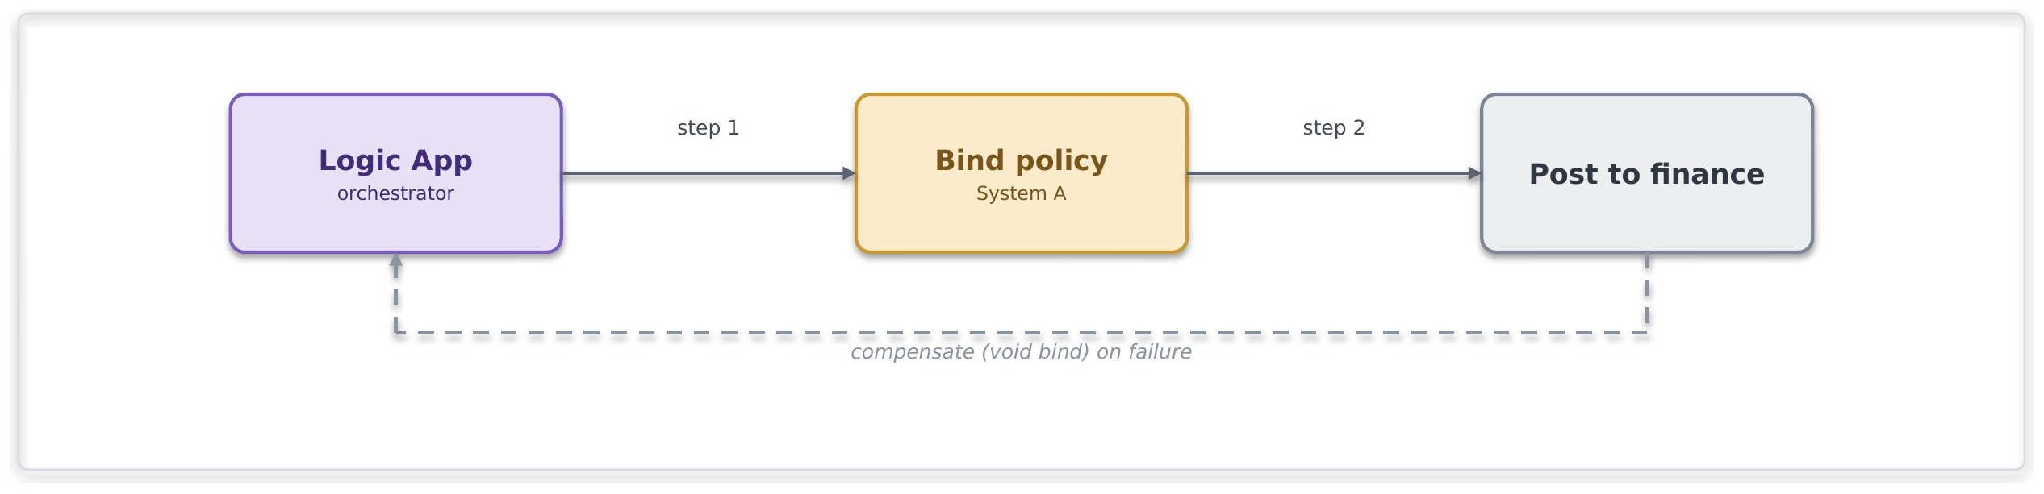
Problem. A process spans multiple systems where a later step may fail after earlier steps have completed, creating the need to restore a consistent business state without relying on distributed transactions.
Solution. The orchestration layer coordinates compensating actions when a downstream failure occurs. Compensation logic is centrally managed as part of the overall process, ensuring that recovery actions are applied consistently and remain traceable
Use it when. Cross-system consistency is needed without distributed transactions, and a single process can own the compensation.
Avoid it when. An ACID transaction within one system suffices, or a microservices-style distributed style is proposed (out of scope here).
Risks and considerations. Compensation actions are not transactional and may themselves fail. Compensation steps should therefore be idempotent, retryable and fully auditable. Recovery paths should be monitored and tested to ensure consistent behaviour during failure scenarios.
Security boundary. Logic App, Service Bus and Functions in spokes, internal. Within Azure: managed identity, Private Endpoints, TLS, with each step and each compensation audited in run history. Outside Azure: none, cross-system calls are to internal systems over private connectivity.
Common pitfall. Relying on distributed transaction models across systems or implementing compensation logic without clear process ownership.
In practice. A multi-step underwriting or policy-processing workflow completes activity in several systems before a downstream validation or financial operation fails. The orchestration process coordinates compensating actions to restore a consistent business outcome and prevent partially completed processing from remaining unresolved.

7.6.3 Human-in-the-loop / approval (SFINT18)
Insert a human decision into an automated process, with audit and escalation.
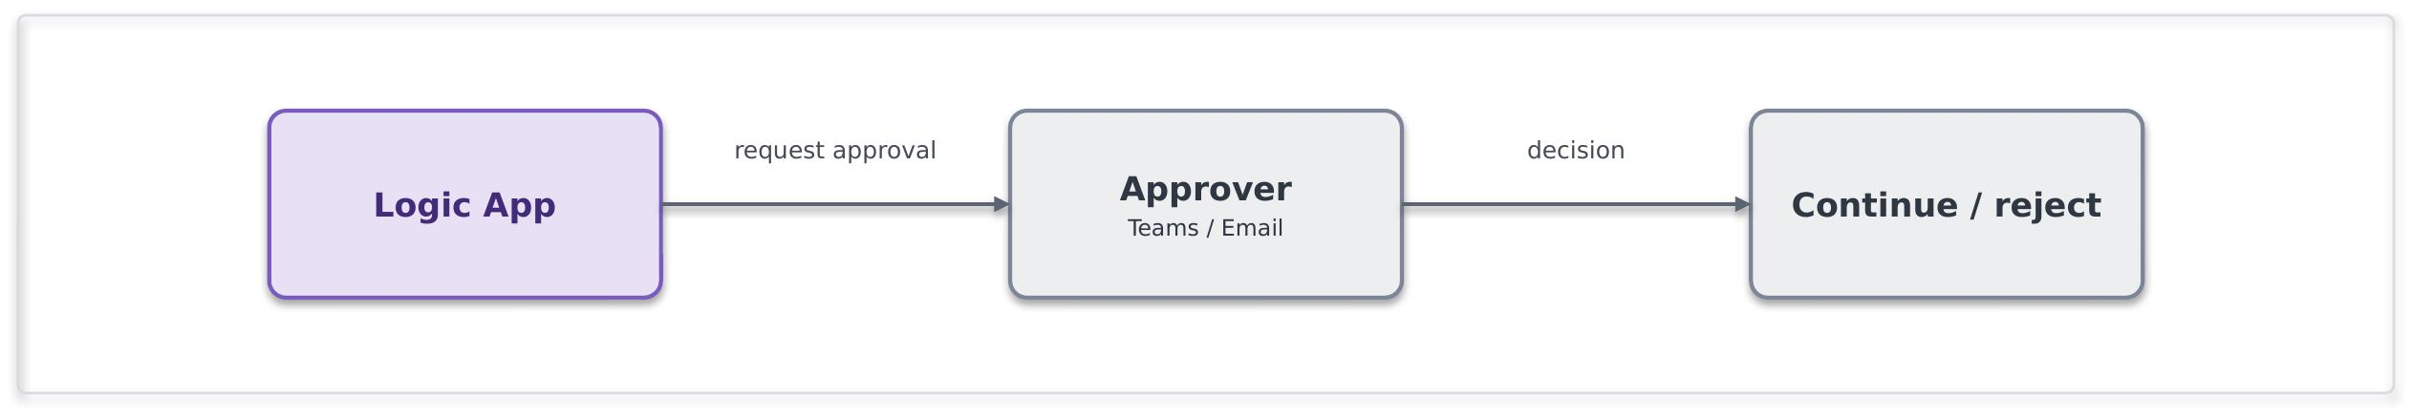
Problem. A process requires a human decision or approval before it can continue, with the decision and approval outcome needing to be auditable and traceable.
Solution. The Logic App pauses for an approval over Teams or email, captures the decision with the approver's identity, and resumes. Timeouts and escalation keep the process from stalling.
Use it when. A process needs human sign-off and an audit trail.
Avoid it when. The decision can be made by rules, keep it straight-through.
Risks and considerations. Approval steps introduce dependency on human response times and may delay overall process completion. Timeouts, reminders and escalation paths should be defined, and approval outcomes recorded for audit and compliance purposes.
Security boundary. the Logic App in a spoke; approvals run over Teams or Outlook, which are Entra-authenticated Microsoft 365 services, not arbitrary internet endpoints. Within Azure: managed identity, TLS, and an audit of the decision and the approver's identity. Outside Azure: approver interaction is over Entra-authenticated Microsoft 365 there is no bespoke internet exposure.
Common pitfall. Approvals handled over untracked email outside the platform, no timeout or escalation.
In practice. An underwriting referral requires manual review and approval before a policy can proceed to the next stage of processing. The approval is captured within the workflow, providing a complete audit trail while ensuring the process resumes automatically once a decision has been made.

7.7 File Patterns

7.7.1 Event-driven file ingestion (SFINT19)
A partner or system drops a file; pick it up on arrival, validate and parse it, and turn its contents into messages the platform can process.
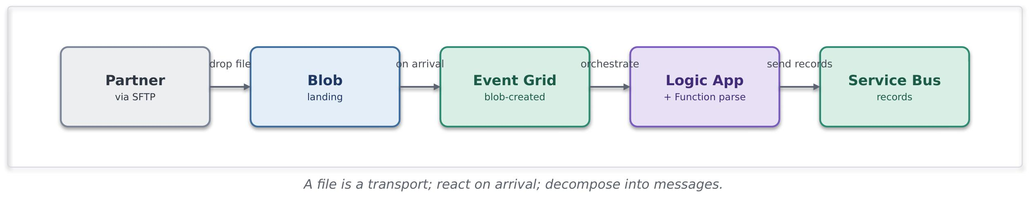
Problem. A source system can provide data only through file-based exchange mechanisms. Traditional polling approaches can introduce unnecessary latency, operational overhead and tighter coupling between systems.
Solution. Files are landed in Blob using Logic App or Azure Function, and they can react to its arrival with an Event Grid blob-created event, event-driven, not polled. Validation, transformation and downstream distribution are performed through standard integration services, allowing file exchange to act as a transport mechanism while processing continues using approved messaging and orchestration patterns.
Use it when. A source can only deliver operational data as files (partner SFTP, legacy extract, scheduled drop) and the contents are records to process.
Avoid it when. Direct API or event-based integration is available, or the primary objective is analytical or bulk data ingestion better suited to the data platform.
Risks and considerations. File completeness, validation, replay and duplicate handling should be considered during design. Invalid files should be isolated using approved error-handling processes. File lifecycle, retention and storage costs should also be governed appropriately.
Security boundary. The Blob landing (firewalled, public access disabled), Event Grid, the Logic App/Function and Service Bus all sit in spokes; a partner SFTP is the external boundary. Within Azure: Blob over a Private Endpoint with managed-identity RBAC (no account keys, no public SAS), Event Grid and the Function private, TLS. Outside Azure: the SFTP endpoint is fronted through the edge or reached over private connectivity, requires SFTP-over-SSH with key or certificate auth and no anonymous access, is IP allow-listed, and files are encrypted in transit and at rest, a registered exception where it is internet-facing.
Common pitfall. Treating file structures as long-term system contracts or processing large files without validation, decomposition and error-handling controls.
In practice. A delegated authority or third-party provider delivers operational data through an SFTP-based file exchange. The file is validated, transformed (if applicable) and distributed through messaging and orchestration patterns, allowing downstream systems to process individual business records independently of the original file format.

7.7.2 File generation and delivery (SFINT20)
The platform produces a file from records or events and delivers it to a partner or system that can only consume files.
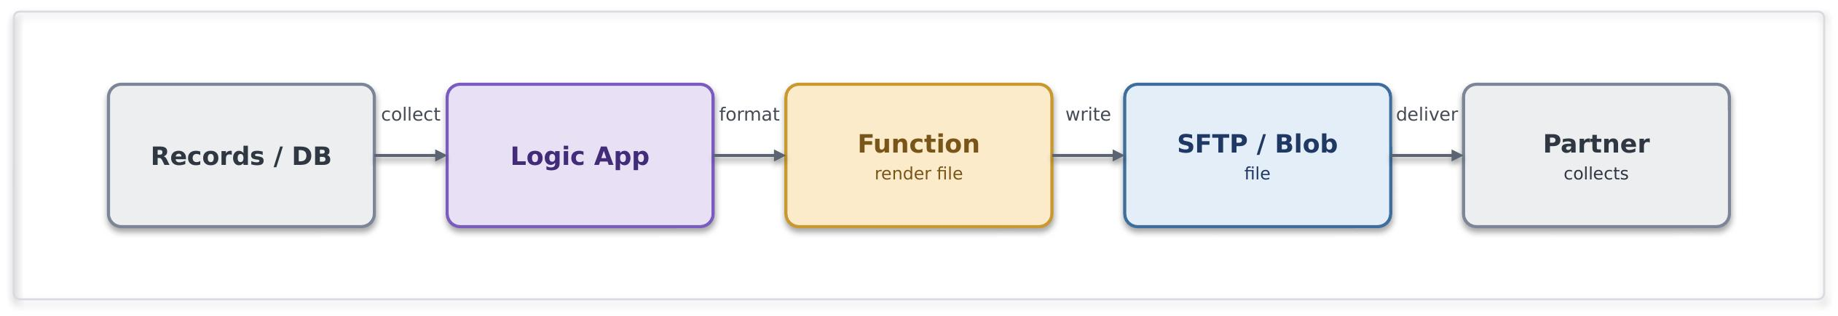
Problem. A downstream party, a partner, a legacy system, a regulator, needs data as a file, on a schedule or on an event.
Solution. A Logic App collects the data (from events, a query, or accumulated messages), a Function renders it into the required file format, and the file is written to Blob and delivered, pushed to the partner's SFTP or staged for collection, with a completion event so downstream teams know it went. Delivery status is tracked and retried.
Use it when. A consumer can only ingest files, or a scheduled or regulatory extract is required.
Avoid it when. The consumer could call an API or subscribe to events, offer that instead.
Risks and considerations. File delivery should include confirmation, retry and monitoring mechanisms. File retention, encryption, naming standards and delivery reconciliation should be considered as part of the solution design. Partner SFTP credentials are held in Key Vault, and sign or encrypt sensitive files (where required). Write-then-rename so a partner never collects a half-written file and manage retention so generated files do not accumulate cost.
Security boundary. The Logic App, Function and Blob/SFTP staging sit in spokes; delivery to the partner is the external boundary. Within Azure: managed identity to Blob (no keys), partner SFTP credentials held in Key Vault and referenced, TLS. Outside Azure: SFTP-over-SSH with key auth to an allow-listed partner host, sensitive files signed or encrypted, and egress over the controlled path rather than default routing.
Common pitfall. Hand-rolled scheduled scripts running outside the platform with credentials in config with no delivery confirmation or retry.
In practice. A nightly settlement extract is generated and pushed to the partner's SFTP, with a completion event notifying the finance team.

7.8 Transformation and Routing Patterns

7.8.1 Canonical data model and message translator (SFINT21)
Map every external format to one internal canonical model, so internal systems never bind to a partner's format.
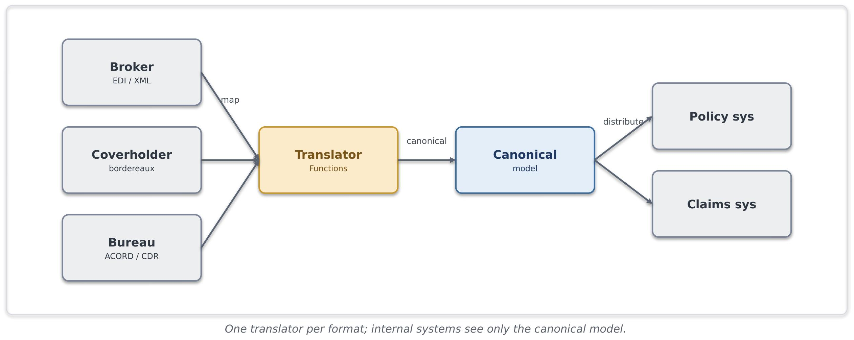
Problem. Multiple external and internal systems exchange information using different schemas, message formats and data models. Direct system-to-system mappings increase complexity, coupling and change impact across the integration landscape
Solution. Define a canonical enterprise model for each business domain and perform translation at the integration boundary. External formats are mapped to the canonical model on ingress and transformed from the canonical model on egress. Internal systems interact using the canonical representation rather than external schemas.
Use it when. Integration is needed with several external parties or standards for the same business concept
Avoid it when. There really is a single, stable format on both sides, a straight protocol mediation (SFINT3) is enough.
Risks and considerations. Canonical models require clear ownership, versioning and governance. Mapping rules should be maintained, tested and reviewed as part of the integration lifecycle. Schema changes should be assessed against the canonical model before implementation.
Security boundary. The translator Function runs in a workload spoke, sitting at the seam between external formats and the internal canonical model. Within Azure: internal distribution over Private Endpoints with managed identity and TLS. Outside Azure: inbound external formats arrive via the relevant boundary pattern, the edge for internet partners, private connectivity for peered ones, and the translator itself is never internet-exposed.
Common pitfall. Point-to-point mapping between every internal system and every partner format
In practice. Insurance integrations frequently involve brokers, cover holders, delegated claims administrators, reinsurers, bureau services and market platforms, each exposing different formats such as EDI, ACORD XML, bordereaux spreadsheets or Core Data Record structures. Without a canonical model, each internal system must integrate directly with each external format, increasing the number of interfaces and amplifying the impact of schema changes. The canonical data model and message translator pattern provides a consistent internal representation of business concepts such as risk, premium and claims, reducing coupling and simplifying partner onboarding and change management.

7.8.2 Content-based routing (SFINT22)
Route a message or event to the right destination based on what is in it.
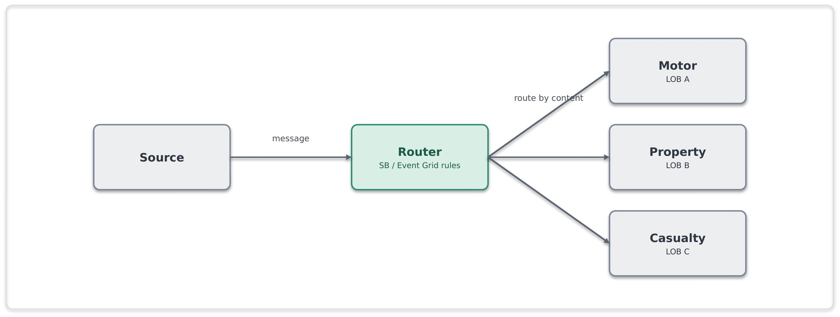
Problem. Messages received through a shared channel require routing to different processing paths based on their content, attributes or business context
Solution. Route on content using Service Bus subscription filters or Event Grid routing, or a Function for richer rules, so each message reaches the right handler without the producer knowing the routing map.
Use it when. Items on a shared channel need to diverge to different handlers according to their content.
Avoid it when. There is only one destination, or the routing depends on external lookups better handled by a short orchestration.
Risks and considerations. Routing rules should be centrally governed, version-controlled and regularly reviewed. Messages that do not match an expected route should be directed to a default handling path or dead-letter destination to avoid silent processing failures.
Security boundary. The Service Bus/Event Grid routing rules, or a routing Function, in spokes, internal. Within Azure: Private Endpoint, managed identity, TLS, with a default/dead-letter route captured. Outside Azure: none.
Common pitfall. A monolithic if/else router hard-coded in one place; no default route for unmatched content.
In practice. Insurance integrations frequently receive submissions, bordereaux, claims notifications and market messages through shared channels. These messages often require processing by different systems, teams or business functions based on attributes such as line of business, territory, cover holder or claim type. Content-based routing enables a single intake channel while directing messages to the appropriate downstream processing path without creating direct dependencies between producers and consumers.

7.9 Anti Patterns
The following are treated as anti-patterns. Where an anti-pattern cannot be avoided it is must be reviewed and approved through the exception process.
Each pattern within the Integration Pattern Catalogue includes a "Common pitfall" heading, providing guidance on practices that may lead to increased coupling, operational complexity or deviation from the principles defined in this System Integration framework
Anti-pattern | Preferred approach
Direct point-to-point connection between two systems | Mediate through the platform using an approved pattern
Public exposure justified by a firewall alone | Treat public exposure as an exception with approval and risk acceptance
Timer-polling a source to simulate real-time | React to an event, or use a scheduled trigger only where no event exists
Long-lived SAS tokens for access | Managed identity and OAuth 2.0, with the risk register where unavoidable
Large binary payloads on the message bus | Claim-check, with the payload in storage and a reference on the bus
Business logic embedded in gateway policy | Keep logic in Functions, and keep the gateway to mediation
Distributed transactions across services | Orchestrated compensation owned by the process
Secrets in configuration or code | Key Vault references and privileged access management
8. Data Platform Position
8.1 Core Position
The data platform is owned by the data team and is not a general integration endpoint. The System Integration framework interacts with data platform at two governed hand-offs only, a push into the Data platform and a curated data to be consume from it. Bulk movement and transformation remain inside the data platform. This boundary keeps operational integration and analytical data cleanly separated and governed.
8.2 Appropriate Uses
Landing operational data into the platform for analytics and reporting.
Serving a curated, read-only dataset back to an operational consumer through the platform's serving layer.
Streaming high-volume telemetry into the platform for downstream processing.

8.3 Inappropriate Uses
Treating Snowflake as an operational source of truth for live transactions.
Reaching into the platform's internals from an integration flow, or into operational systems from the platform.
Using the platform as a message bus or a general-purpose integration hub.

8.4 Exchange Patterns
Import Patterns
8.4.1 Event Streaming to the Data Platform (SFDEINT1)
Stream operational events into the data platform for near real-time analytics, without coupling producers directly to Snowflake.
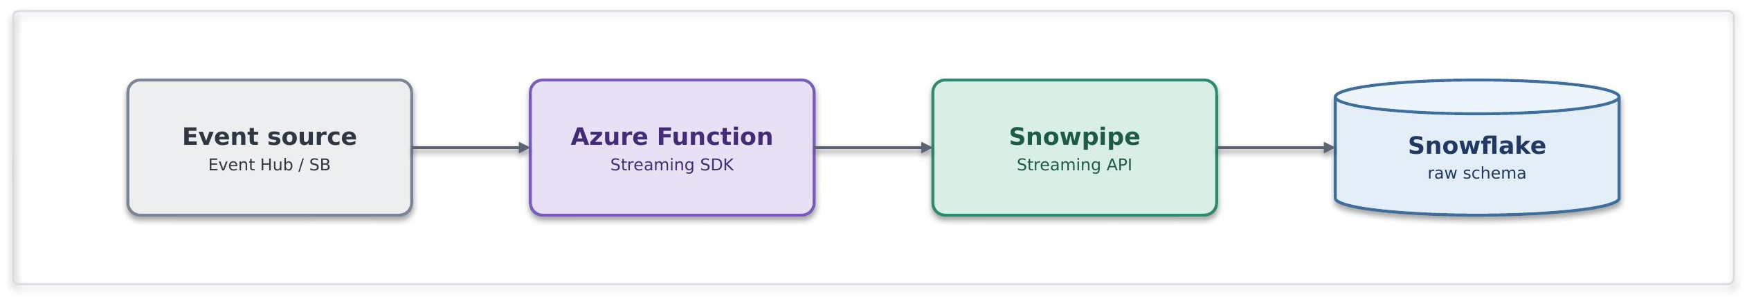
Problem. Events from Azure messaging services must be delivered to Snowflake continuously and with low latency, without building and maintaining custom ingestion services.
Solution. An Azure Function is triggered by events from Event Hub, Service Bus or Event Grid and uses Snowpipe Streaming API ( Python SDK published by Snowflake) to write data directly into Snowflake. The approach provides low-latency, near real-time ingestion without intermediate files. The Function manages batching, retries and reliable delivery.
Use it when. The source already publishes events through Azure event services, near real-time ingestion is required, and you want full control of the ingestion logic in code.
Avoid it when. A connector-based approach can meet the requirement, data arrives in files rather than events, or ingestion volumes are high enough that a managed ingestion service is a better fit.
Risks and considerations. The Function is now operational code on the ingest path. Its scaling, cold starts, retries and offset/checkpoint behaviour are yours to own. Channel and SDK lifecycle open, reopen, per-channel ordering - needs deliberate design. Duplicate and late-event handling is your responsibility, as is SDK version currency.
Security boundary. The trust boundary is the event source and the Function's managed identity, not Snowflake. Event source reached over private endpoint, the Function authenticates to Snowflake via key-pair / OAuth held in a secrets vault, never account passwords. Managed identity for the event-source binding. Data-in-transit posture inherits from the Cloud Engineering Standards.
Common pitfall. Writing one row per invocation instead of batching, increasing API calls, latency, and cost. Failing to design for throughput, back-pressure, and ingestion failures, leading to reduced performance and operational instability.
In practice. Connected-property or fleet telemetry lands on Event Hub, an Azure Function enriches each reading (for example attaching a peril zone) and streams rows via the Snowpipe Streaming API into a raw schema for near-real-time exposure aggregation. Underwriting dashboards read the conformed product, never the live stream.

8.4.2 Streaming Ingestion via Kafka Connect (SFDEINT2)

Continuously ingest Kafka events into the data platform through a managed connector, without building custom ingestion services.


Problem. An existing Kafka platform already carries event data, and that data needs to be delivered continuously to Snowflake. Building and operating custom ingestion services for every topic creates unnecessary complexity, duplication, and operational overhead at scale.
Solution. Producers publish events to Kafka topics. The Snowflake Sink Connector running in Kafka Connect continuously delivers topic data to Snowflake, leveraging Snowpipe Streaming for low-latency ingestion. The approach is configuration-driven and reusable, avoiding bespoke ingestion code for each topic.
Use it when. Use this pattern when Kafka is already the enterprise event backbone, ingestion should be managed through configuration rather than custom code and multiple topics require a consistent and repeatable landing approach into Snowflake. It also suits scenarios that benefit from built-in batching, retries, and offset management provided by the connector platform.
Avoid it when. Avoid this pattern when Kafka is not already part of the platform and introducing it solely for Snowflake ingestion would add unnecessary complexity. It is also not suitable where ingestion requires significant per-record transformation, enrichment, or business logic, or where data naturally arrives as files and batch ingestion is the more appropriate approach
Risk & consideration. Kafka Connect is itself a platform to run and govern. Connector workers, scaling and dead-letter topics need ownership. The connector version and its Snowflake-side mechanism (Snowpipe vs Snowpipe Streaming mode) is a decision to validate against current capability. Schema evolution and topic-to-table mapping need design.
Security boundary. The trust boundary is the Kafka platform and the Kafka Connect runtime. Kafka brokers, Connect workers, and Snowflake are connected through private network paths. The connector authenticates to Snowflake using centrally managed credentials or federated identity, and topic-level access controls restrict producer and consumer permissions. Data-in-transit protection follows the Cloud Engineering Standards.
Common pitfall. Treating Kafka Connect as zero-ops because it is config-driven. An unmonitored connector silently lagging or dead-lettering is a common failure. Unmanaged schema drift between producers and the connector breaking the sink is another.
In practice. Policy and claims domain events are published to Kafka topics and continuously landed into Snowflake raw schemas through the Snowflake Sink Connector. New topics are onboarded through configuration, providing a consistent ingestion approach without bespoke loader code.

8.4.3 File Ingestion (SFDEINT3)

Automatically ingest files into the data platform as they arrive, without custom loading processes.
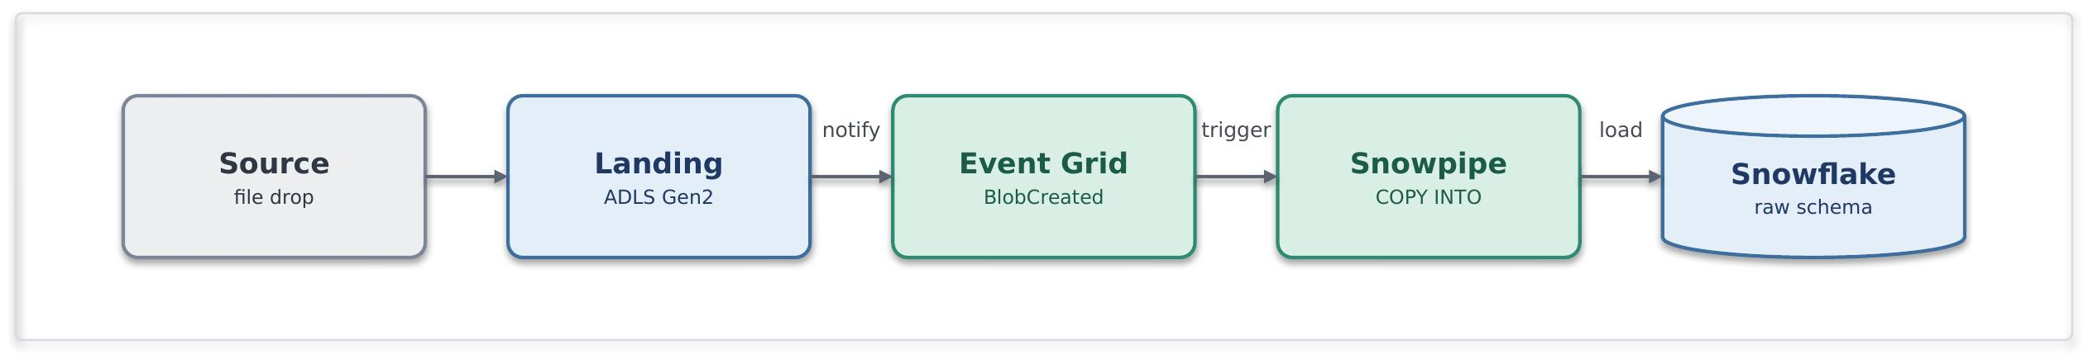
Problem. Source systems and third parties deliver data as files on their own schedule. Polling for new files wastes compute; hand-built loaders drift and fail silently. We need near-real-time, event-triggered loading without an operational service owning the load path.
Solution. A file lands in an ADLS Gen2 landing zone. Blob creation raises an Event Grid notification that triggers Snowpipe auto-ingest, which runs COPY INTO the target raw schema. Loading is serverless and notification-driven; no compute to run or scale.
Use it when. Data arrives as discrete files (CSV, Parquet, JSON), near-real-time (seconds-to-minutes) is sufficient; volume is continuous or unpredictable rather than one large periodic dump; the producer can write to a landing zone.
Avoid it when. You need sub-second streaming (stream instead); the load is a single massive periodic file where scheduled bulk COPY is cheaper and simpler; the file needs heavy pre-load validation belonging in an orchestrated pipeline; ordering or transactional grouping across files matters.
Risk & consideration. Snowpipe carries per-file overhead, so many small files can increase cost disproportionately. Landing-zone retention, replay, and reconciliation should be designed explicitly. Regular comparison of landed files against Snowpipe load history helps identify and recover from missed notifications or failed loads.
Security boundary. The trust boundary is the landing zone, not Snowflake. Storage is reached over private endpoint with public access disabled; Snowflake authenticates via storage integration / managed identity, never account keys; storage firewall and RBAC scope write access to the producer and read access to Snowflake only. Data-in-transit posture inherits from the Cloud Engineering Standards.
Common pitfall. Treating the landing zone as durable or queryable storage. It is a transient ingress buffer; wherever possible, lifecycle-expire loaded files and reconcile landed-vs-loaded counts. Unbatched fan-out of tiny files quietly inflates Snowpipe cost.
In practice. Delegated-authority bordereaux from a coverholder arrive as monthly spreadsheet/CSV files. Each land in that coverholder's landing-zone path; Event Grid triggers Snowpipe to load it into a raw bordereaux schema for downstream conforming and exposure aggregation. Underwriting reporting consumes the conformed data, never the raw landing zone.

8.4.4 Scheduled batch: CDC/ Watermark (SFDEINT4)

Extract and load operational data into the platform in batches, without placing analytics workloads on the operational path.



Problem. Data needs to be extracted from a system of record and loaded into the platform on a scheduled basis. Near-real-time delivery is not required, but the process must be reliable, repeatable, and efficient for moving large volumes of data without unnecessary reprocessing.
Solution A scheduled Azure Data Factory pipeline or Azure Function extracts new or changed data from the source system, stages it in ADLS Gen2, and Snowflake bulk-loads it using COPY INTO. ADF is preferred for standard connector-based data movement, Azure Functions for custom extraction logic, and Logic Apps for workflow orchestration where the ingestion process spans multiple systems and actions. The approach is periodic, incremental, and cost-efficient.
Use it when. Use this pattern when data needs to be moved on a scheduled basis (for example hourly or daily), the source provides a reliable watermark or CDC capability, near-real-time delivery is not required, and large data volumes are more efficiently processed in batches than as individual events.
Avoid it when. Sub-minute latency is required (stream instead), the source has no dependable change marker, forcing brittle full scans, the extraction is really transformation that belongs pushed down into Snowflake.
Risk & consideration. Watermark/CDC state must be persisted and idempotent so failed runs resume without gaps or duplicates. Clock skew and soft-deletes need handling. Schedule contention and source load windows must be respected. Schema drift breaks loads
Security boundary. The trust boundaries are the source system connection and the staging area. Authentication uses managed identities wherever supported, with no embedded credentials. The stage is accessed through private connectivity and least-privilege RBAC. Data-in-transit protection follows the Cloud Engineering Standards. Snowflake acts solely as the ingestion target and does not require direct access to the source system.
Common pitfall. A watermark that is not transactional with the read, causing silent gaps under concurrency. Full reloads quietly replacing incremental logic when CDC breaks, inflating cost and load time.
In practice. Nightly incremental extract of policy and premium movements from a policy-administration system, staged and loaded for finance and actuarial reporting. The operational system is never queried live by reporting.

8.4.5 Staged Multi Source Ingestion (SFDEINT5)

Ingest data into the platform in batches, decoupling operational systems from analytics workloads.

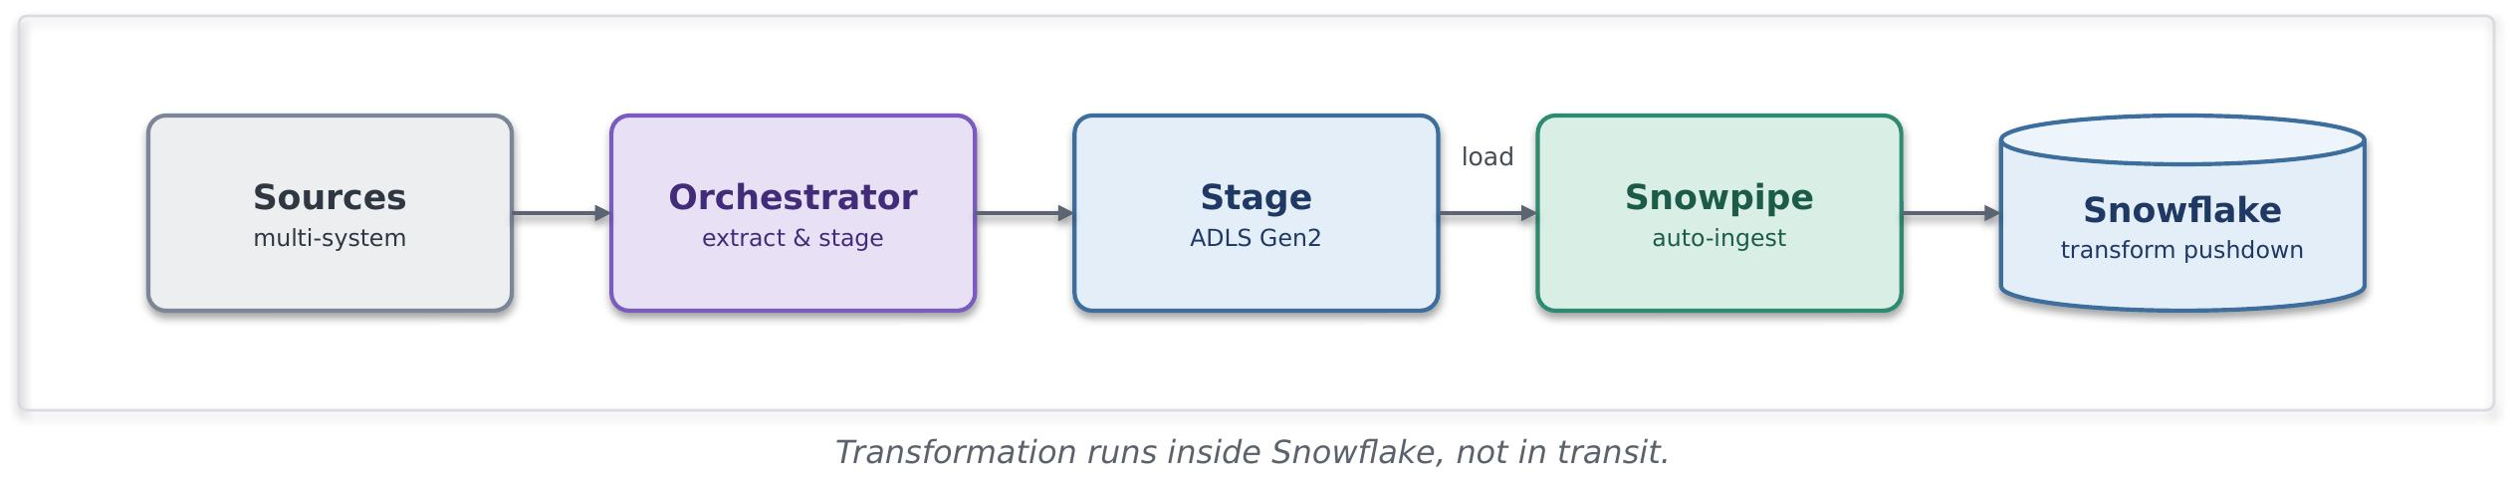
Problem. Multiple related sources must be brought together with dependencies, retries and observability, and transformation should happen where compute is cheapest and closest to the data.
Solution. An orchestration layer (ADF) coordinates extract → stage → load across sources, then triggers transformation pushed down into Snowflake (ELT, not ETL). The orchestrator owns sequencing and recovery; Snowflake owns the transform.
Use it when. Coordinated multi-source loads with inter-dependencies; you want lineage, retries and alerting over the pipeline; transformation is set-based and belongs in the warehouse.
Avoid it when. A single simple feed (a plain batch or Snowpipe load is lighter); transformation must happen before landing for compliance or redaction; latency needs are real-time.
Risk & consideration. The orchestrator becomes a critical dependency—its availability, secrets and permissions need the same rigour as any operational service. Partial failures and re-run semantics must be idempotent. Pushdown transforms consume Snowflake compute and need cost governance.
Security boundary. The orchestrator holds credentials to many systems—managed identity and a secrets vault are mandatory, with least-privilege per connection. Staging over private endpoint. Transformation runs inside Snowflake, keeping data off intermediate compute in transit.
Common pitfall. Letting the orchestrator become a transformation engine (row-by-row processing in transit) instead of pushing set-based work into Snowflake. Unbounded retries that mask a persistent upstream failure.
In practice. Building a conformed claims dataset that joins claims, policy and reinsurance-treaty feeds. The orchestrator sequences the loads and kicks off in-warehouse conforming for exposure and recoveries reporting.

8.4.6 Governed API Import Pattern(SFDEINT6)
A small, well-defined set of records is imported into the platform through a governed API on the shared gateway, avoiding the complexity of file or streaming pipelines for low-volume data exchange.
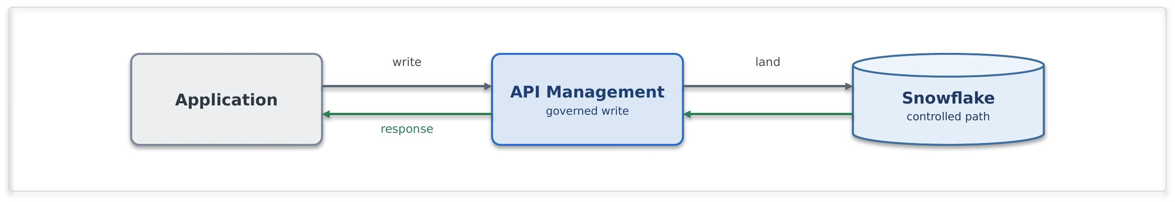
Problem. A consumer application needs to submit small volumes of data directly into the platform, such as reference data updates, corrections, overrides, or operational adjustments, where standing up a file or streaming pipeline would be disproportionate.
Solution. A governed write API is exposed through API Management. APIM authenticates and authorises callers, applies validation, throttling, and access policies, and forwards requests to approved Snowflake APIs. Snowflake invokes controlled stored procedures to validate and persist the data through a managed import path. The API contract is the integration boundary, and consumers never connect directly to Snowflake.
Use it when. The write is small, well-defined, and low-volume, and requires synchronous or near-synchronous processing. The consumer needs a governed API-based import mechanism rather than a file or event-based ingestion pattern.
Avoid it when. The volume is high, the payload shape is variable, or data arrives in bulk. In these scenarios, staged file ingestion or streaming patterns are more appropriate. An API is not a bulk-loading mechanism
In practice.An operations tool submits a corrected reference value through an APIM operation. APIM validates the request and forwards it to a controlled Snowflake ingestion endpoint, which invokes a stored procedure to persist the update. The transaction is audited end-to-end, and the consumer never accesses Snowflake directly.

Export Patterns

8.4.7 Consume Platform Data via API(SFDEINT7)
Pull curated data from the platform and serve it to a consumer through the gateway, analytical, not a system of record.
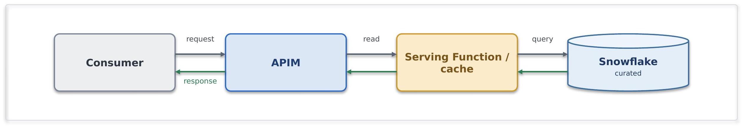
Problem. An internal app or partner wants curated, aggregated data that lives in Snowflake, but it should not be running warehouse queries in a latency-sensitive path or treating analytics as the source of truth.
Solution. Expose the curated data through an APIM product backed by an appropriate service layer over Snowflake privately. The platform owns the curation the SIF owns only the exposure, the API contract, authentication, caching and SLA. The contract is explicitly analytical and eventually-consistent.
Use it when. consumers need governed, curated data products and can tolerate analytical latency.
Avoid it when. The read is latency-sensitive or transactional, go to the operational system through a request/response API.
Risks and considerations. Warehouse latency and cost under API load are real, so cache aggressively and set a clear SLA. Make consumers understand this is a curated, eventually-consistent product, not the operational source of truth.
Security boundary. APIM (shared) and the serving Function (spoke); Snowflake read privately. Within Azure: Private Endpoint, managed identity, TLS, the consumer is authenticated at APIM (Entra), data access is least-privilege, and caching limits how much is exposed. Outside Azure: only where the consumer is external, through the network edge and OAuth.
Common pitfall. Synchronous warehouse queries in a hot transactional path, bypassing APIM to hit Snowflake directly.
In practice. Aggregated exposure metrics are exposed as a governed product API to an internal application.

8.4.8 Scheduled Data Export Pattern (SFDEINT8)
Publish curated data from the platform through managed file exports, keeping analytical and operational workloads decoupled.
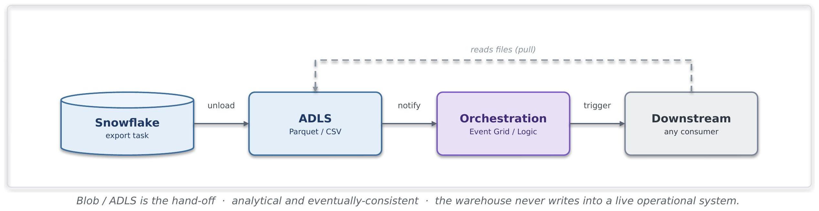
Problem. Downstream systems (analytical, operational, integration, third-party) need periodic curated datasets from Snowflake in file form and should be triggered automatically when new exports arrive, without querying Snowflake directly or polling.
Solution. A Snowflake scheduled task exports a curated data product as a file (Parquet, CSV, Delta format) to ADLS. Event Grid, Logic Apps, or scheduled orchestration detects the file arrival and triggers the downstream system to consume it, or the downstream system polls on schedule.
Use it when. Downstream systems consume data in file/batch form, you want Snowflake off the hot path, export scheduling can be coordinated with downstream processing windows; the data is a complete dataset or meaningful slice, orchestration is already in place to handle the file consumption.
Avoid it when. The downstream system needs real-time or near-real-time data (use push-out pattern); the downstream system can query APIM-served data efficiently (use System API), data volumes are so large that file transfer is uneconomical compared to direct query.
Risk & consideration. File export costs (compute in Snowflake for extraction, ADLS storage, network transfer). Coordination between Snowflake export schedule and downstream processing schedule—lag or missed exports cause stale data or processing delays. File schema versioning-downstream systems must handle format changes gracefully.
Security boundary. The file is the exchange point. ADLS storage reached over private endpoint, exported file scoped by Snowflake managed identity. Downstream consumer identity has read-only access to the export path, never to Snowflake directly. Data-in-transit posture inherits from Cloud Engineering Standards.
Common pitfall. Exporting full tables when slices would suffice, inflating transfer and storage cost. No reconciliation of export schedule vs. downstream consumption, so data sits in ADLS waiting or processing runs stale. Schema drift breaking downstream parsing.
In practice. Curated features for a claims prediction model are exported nightly as Parquet from Snowflake to ADLS, an Azure ML scheduled training pipeline picks up the file and retrains the model. Or: policy and claims data are exported daily for a third-party integration system that consumes it via a Logic App orchestration. Or: aggregated loss triangles are exported weekly as CSV for a Synapse analytics workspace to compute reserve adequacy metrics.
8.4.9 File Export (SFDEINT8)

Data Serving Store Pattern (SFDEINT9)

Analytical results are unloaded in bulk to a framework-owned serving store on the boundary, from where framework services read them, so consumers never query the platform directly.
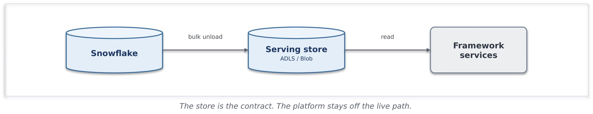
Problem. Downstream framework services need sizeable analytical outputs, such as scored datasets or aggregated results, without querying the analytical platform live and without coupling to its internals.
Solution. The platform writes results in bulk to an agreed serving store on the framework side, normally ADLS or Blob, over private connectivity. Framework services read from that store. The store is the contract, and the platform stays off the live request path.
Use it when. The consumer needs whole datasets or large result sets, on a schedule or after a platform job completes, and can read from a serving store rather than call live.
Avoid it when. The consumer needs a small, specific, on-demand answer, where a curated read through API Management fits better. Avoid exposing the platform itself as the serving layer.
In practice. A nightly risk-scoring job unloads its output to a framework-owned ADLS container, and the pricing service reads the scored dataset from there the next morning.
8.4.10 Governed API read (SFDEINT10)
Small, curated analytical results are served on demand through a governed API on the shared gateway, so callers get a specific answer without reaching into the platform.
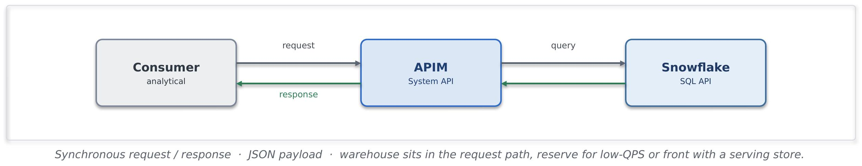
Problem. A consumer needs a specific analytical value or small result on demand, such as an aggregate or a lookup, and should not be given a live connection into the analytical platform.
Solution. A curated read operation is published through API Management, backed by a controlled query against the platform or a serving store. APIM applies identity, caching and throttling, and returns a shaped response. The platform stays behind the boundary.
Use it when. The result is small and well defined, needs to be on demand and synchronous, and benefits from caching and rate control.
Avoid it when. The consumer needs large or whole datasets, where a bulk unload is the right route. An API is not a bulk extract path.
In practice. A portal requests an aggregated exposure figure through an APIM operation, which reads a curated result and returns it in milliseconds, cached for repeat calls.

9. Insurance Integration Scenarios
The table illustrates how the catalogue resolves characteristic Chaucer integrations. Each scenario names the patterns it composes, the primary Azure components and the purpose it serves. Pattern references point to the catalogue in Section 7.
Scenario | Patterns | Primary components | Purpose
Delegated Authority | File ingestion (SFINT19), canonical model (SFINT21), content routing (SFINT22), micro-batch file ingestion to the data platform (SFDEINT3) | Logic Apps, Functions, Blob, Service Bus, Snowflake | Validate cover holder reporting, capture at source where possible, and retire manual bordereau re-keying.
London Market | Canonical model (SFINT21), messaging (SFINT9), orchestration (SFINT16), data platform exchange (9.4) | API Management, Logic Apps, Service Bus, Functions | Align processing to the core data record and design for incremental modernisation.
Submissions | Inbound webhook or API (SFINT1, SFINT13), file ingestion (SFINT19), content routing (SFINT22), composition (SFINT2) | API Management, Front Door and WAF, Logic Apps, Functions | Accept submissions by API, file or portal, triage and route to the right underwriting team and system.
Claims | Inbound webhook or API (SFINT13), orchestration with compensation (SFINT16 and SFINT17), outbound webhook (SFINT14), data platform exchange (9.4) | API Management, Logic Apps, Service Bus, Functions | First notification of loss from portals and third-party administrators, orchestrated across systems, with status notifications outbound.
Reinsurance | Canonical model (SFINT21), file and messaging (SFINT19, SFINT9), orchestration (SFINT16) | Logic Apps, Functions, Service Bus, Snowflake | Cede risk, premium and claims to treaty and facultative systems and reinsurers and manage recoveries.
Regulatory Reporting | Event offload to the data platform (9.4), consume and serve (SFDEINT9), orchestration (SFINT16), file delivery (SFINT20) | Snowflake, Logic Apps, Functions, API Management | Assemble regulatory and tax reporting on the data platform and submit through orchestrated feeds or files.

10. Security and Operational Excellence
This section sets out the security and operational baseline every integration inherits by default. It states the outcomes the framework requires, while the mandatory rules and their enforcement sit in Sections 12 and 13.
The standards behind this posture are not defined here. They are owned by Chaucer's Cloud Engineering Standards document, listed as an input in Section 1, and the framework inherits from it rather than setting rules of its own. The estate-wide requirements, for example the zero-trust model, the logging the security operations centre needs for incident response and forensics, protection for anything exposed to the internet, network firewalling and isolation, Defender for Cloud and vulnerability management, landing zones and infrastructure-as-code through the DevSecOps toolchain, and the redundancy and resilience posture, all sit there. This section does not restate or vary them. It sets out only how an integration applies them, and every integration follows the Cloud Engineering Standards for the detail.

10.1 Security Principles
Security is at the core of the System Integration framework, and the System Integration framework does not invent principles of its own. It follows the enterprise and cloud security principles Chaucer already holds, inherits them in full, and applies them to integration without reinventing anything. The table summarises how those inherited principles shape every integration across identity, connectivity, network, secrets and public exposure.
Security area | What the System Integration framework requires
Guiding principles  Source : Security Principles | Private by default and least privilege, with zero trust across identity, network and data. The System Integration framework states the security outcome, and the protection technology is chosen to meet it. Every design is secure by design and evidenced at the Technical Design Authority.
Connectivity  Source : PC05  Source : Privatization | Integrations run on the private network over Private Endpoints, and the internet boundary is crossed only at a controlled edge.
Identity  Source : SECP14 | Managed identity for service-to-service calls, so no credential is stored, and OAuth 2.0 tokens where a token is needed. External parties authenticate through Entra application registrations with short-lived tokens.
Secrets and certificates  Source : PC05 | Held in a managed store such as Key Vault and referenced at run time, never copied into configuration or code. Rotation and policy are handled through privileged access management. Long-lived shared access signatures are discouraged and recorded on the risk register where unavoidable.
Network isolation  Source : PC05 | Traffic is segmented east to west with network security groups and private connectivity, in line with the zero-trust direction, so a component is reachable only by the services that genuinely need it.
Access control  Source : SECP4 | Least-privilege role-based access, with higher-risk permissions peer-reviewed and enforced through privileged identity management. An approved permission set is reused as a recognised pattern rather than reassessed from scratch.
Public exposure and edge  Source : PC05  Source : Privatization | Public exposure is an exception, not a default. Private Endpoints and Private Link are preferred, and a firewall in front does not make a public endpoint acceptable. Any exposure needs a business need, security approval and escalation to the risk register, and the edge technology is chosen for the required outcome.

10.2 Data Protection and Classification
Data protection carries particular weight here, because specialty insurance handles a great deal of personal data, including the special-category health and criminal-conviction data that attract the strictest handling under UK GDPR. The System Integration framework does not classify data itself. Chaucer's Data Classification Policy is the authoritative source and sets six tiers in order of sensitivity, and the System Integration framework applies the handling each tier requires as data crosses a boundary. Where a payload could meet more than one tier, the higher classification applies.
The baseline is the same for every integration. Data is encrypted in transit on every hop and at rest in every store, carried in the minimum the integration needs rather than as whole data models, reached only over private connectivity and never placed in configuration. Sensitive payloads are additionally signed or encrypted so their protection outlives the transport.
Classification | Risk | How the System Integration framework handles it across a boundary
Sensitive Personal Data (special categories) | Very High | Minimised and pseudonymised or tokenised before it crosses a boundary. Processing is pre-approved by the Lead Data Protection Officer. Encrypted in transit and at rest, reached only over private connectivity, access logged, and never on a public path or in observability.
Personal Data | High | Minimised to what the integration needs, encrypted in transit and at rest, reached over private connectivity with least-privilege access, pseudonymised or tokenised before analytics, and kept out of logs and traces.
Restricted Commercial | Medium High | Encrypted in transit and at rest, reached over private connectivity with access restricted and audited, and not exposed externally except as an approved exception.
Commercial | Medium | Encrypted in transit and at rest on the private network, with standard least-privilege access.
Internal | Low | The default classification. Encrypted in transit and at rest, kept on the private network and not exposed externally.
Public | None | May be served externally through the governed edge as an exception, still over TLS and through the gateway.

10.3 Observability and Monitoring
Operational monitoring uses Application Insights and Log Analytics, with dashboards and alerts for delivery and issue resolution. Security monitoring is a separate concern that must be satisfied in addition. Relevant security events are forwarded to CrowdStrike, and any newly introduced gateway or security service is assessed for security-event capture before use. LogicMonitor is treated as operational monitoring, distinct from security monitoring.
Security monitoring is satisfied separately from operational monitoring. Relevant security events, for example Key Vault activity, deployment and administrative actions, are forwarded to CrowdStrike, the Group Security tooling, and any new gateway or edge component is assessed for security-event capture before it goes live.
An established pattern already streams Azure, Key Vault, storage and security logs to CrowdStrike through Event Hubs, and the System Integration framework reuses that path rather than inventing a new one. Performance monitoring is kept distinct from security monitoring, with ownership confirmed with the relevant service owners.

10.3.1 Azure Resource Observability Matrix
Resource | Operational signal | Security signal | Destination
API Management | Latency, throughput, failures | Authentication failures, policy violations | Log Analytics, CrowdStrike
Logic Apps | Run success and failure, duration | Connection and identity events | Log Analytics, CrowdStrike
Service Bus | Queue depth, dead-letters | Access and authorisation events | Log Analytics
Functions | Executions, errors, duration | Managed identity and Key Vault access | Log Analytics, CrowdStrike
Key Vault | Availability | Secret and certificate access | Log Analytics, CrowdStrike
Event Hubs | Throughput, lag | Namespace access | Log Analytics, CrowdStrike

10.4 Operational Excellence
The discipline that keeps an integration secure also keeps it operable.
Deployed as code. Integrations are provisioned through infrastructure-as-code and delivered through DevSecOps pipelines, so an environment is reproducible and reviewable, and nothing is configured by hand.
Resilience matched to criticality. The redundancy and recovery posture of an integration follows its criticality tier, set with business continuity and risk and evidenced at design time
Owned and kept live. Each integration has monitoring, alerting and a defined support model with named ownership, and the System Integration framework itself is maintained as a live artefact, reviewed continuously rather than only before a Technical Design Authority submission.

10.5 Delivery Pipeline
Every integration is delivered through a single pipeline, and the pipeline is where quality, security and controlled promotion are enforced. This applies the automation and DevSecOps direction inherited from the Cloud Engineering Standards to integration delivery and sets out the agreed practice every integration follows so that nothing reaches an environment by hand.
Source : DevOpsPrinciples
Practice | What the pipeline does
Pipeline foundation | Source code and infrastructure-as-code live in the Chaucer repository under the DevSecOps project, and every change is built and deployed through the pipeline. The pipeline is the only route to an environment.
Pull-request validation | Every change enters through a pull request. The pipeline builds it, lints it, runs its automated tests and its security scans, and the change cannot merge until those checks pass and a peer has approved the request.
Immutable artefacts | A versioned artefact is built once and promoted unchanged through every environment. Nothing is rebuilt per environment, so what runs in production is exactly what was tested.
Deploy to development first | A merged change deploys automatically to development, where it runs against real dependencies. Development is where integration behaviour is proven before anything is promoted.
Integration and automation testing | Automated unit, integration, and end-to-end testing should be implemented wherever feasible within the delivery pipeline, including relevant contract and schema validations. Changes should only progress once the applicable automated and manual quality checks have been successfully completed.
Environment validation checks | Configuration, connectivity, identity, secrets, and health checks should be automated before and after deployment wherever feasible. Where automation is not practical, appropriate validation controls are applied to ensure an environment is proven ready rather than assumed to be.
Security testing | Static analysis through SonarQube checks code quality and known weaknesses, and artefact and dependency scanning through JFrog checks the build and its libraries. Findings gate promotion, in line with the security testing the Cloud Engineering Standards require.
Controlled promotion | Promotion from development to test and on to production is gated and approved. A higher environment accepts only an artefact whose checks have passed and whose sign-off is recorded, and production promotion follows change control.
DAST coverage | Incorporate future DAST coverage for exposed APIs into the SIF recommendations and identify the appropriate pipeline stage as the approach is developed.

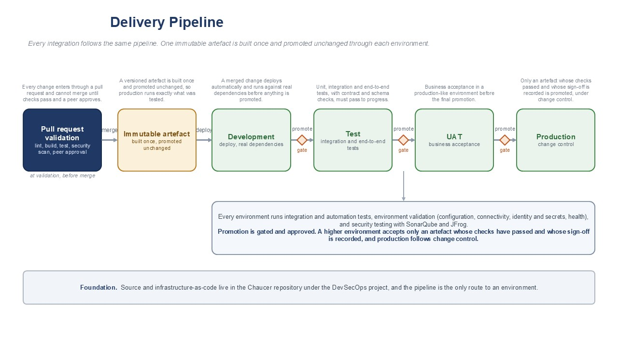

11 Guardrails

11.1 Mandatory Guardrails
These are assessed on every integration, regardless of pattern. They are inherited from the security principles and engineering standards and are not open to per-project renegotiation.
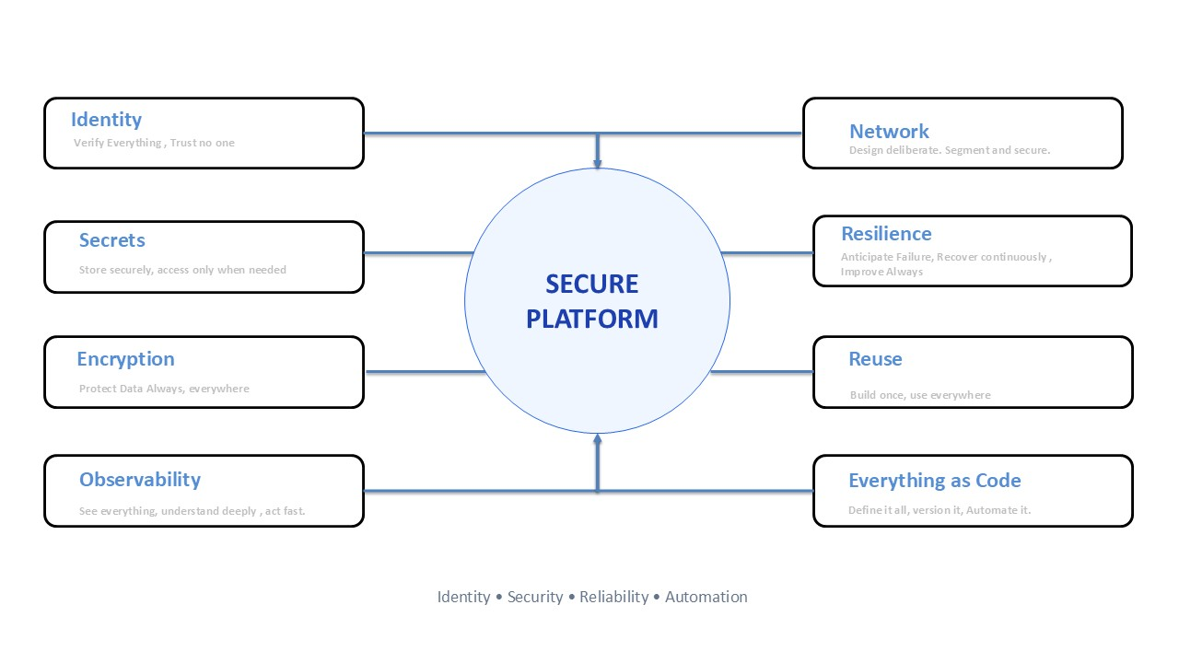Source : EAPrinciples, Architecture Principles , EngineeringStandards

11.2 When you need to deviate
The System Integration framework provides clear standards and recommended approaches, but it is flexible when there is a valid business or technical reason to do something different. If a team needs to use a different component, work outside a guardrail, or operate beyond the data platform boundary, the exception must be documented with a clear justification. The team should complete a security and risk assessment, identify any compensating controls, and submit the exception to the TDA for approval. Approved exceptions must be recorded in the exception register with a named owner, an expiry date, and a plan to return to the standard approach where possible.

11.3 Per-pattern security conformance
Rather than repeat an identical verdict again and again, the patterns are grouped below by their security profile. The internal group shares one posture the boundary-crossing group is where TDA attention is warranted.
Pattern group | Internet boundary | Controlling security posture
Internal patterns: SFINT2 to SFINT4, SFINT5 to SFINT10, SFINT11 to SFINT12, SFINT15 (internal feeds), SFINT16 to SFINT18, SFINT21, SFINT23, SFINT24 to SFINT25 | Not crossed | Components in shared subscription / private workload spokes, Private Endpoints, Entra managed identity, no keys, Key Vault references, TLS every hop, NSG-segmented, default-deny.
Managed API facade, SFINT1 (internal use) | Not crossed | APIM shared and non-public, Private Endpoint to backend, managed identity, TLS.
Consume-and-serve, SFINT22 (internal consumer) | Not crossed | APIM (Entra auth) over a serving layer, Snowflake privately, least-privilege data access, caching.
Inbound webhook, SFINT13 | Crossed (ingress) | Internet-facing services are protected via a secured access layer with integrated threat protection. All APIs are exposed through a single managed entry point, enforcing strong authentication, mutual trust verification, digital request validation, and network access controls. Workloads execute asynchronously within isolated private environments, with no direct external invocation of backend services
Public API / external consumer, SFINT1, SFINT7, SFINT22 when exposed externally | Crossed (ingress) | Same edge as SFINT13: APIM never exposed directly.
Outbound webhook / notification, SFINT14 | Crossed (egress) | Controlled egress path (routing intent), not default internet; TLS, signed payloads, partner allow-list, Key Vault-held secrets.
File-based with partner SFTP, SFINT19, SFINT20 | Crossed | Edge or private connectivity, SFTP-over-SSH with key/cert auth, no anonymous access, IP allow-list, encryption in transit and at rest, Key Vault credentials.

12. Exception Process and TDA Governance

12.1 Exceptions
The System Integration framework is principles-driven but pragmatic. Where a justified need exists to deviate from an approved pattern, guardrail, or architectural boundary, the exception must be formally documented, risk-assessed, assigned an owner, and reviewed periodically. Appropriate compensating controls must be implemented, with a defined path and timeline to return to the standard approach where practical.

12.2 TDA Gates

Governance is applied at defined points. At design, the selected integration pattern and interaction style are confirmed against the decision tree and the boundary. At build, guardrail conformance is evidenced across identity, network, secrets, observability and resilience. Any exception is logged and approved before build proceeds.

12.3 Security Conformance
Standard private patterns proceed on the agreed security baseline. A pattern that cannot meet the baseline triggers the exception process, which requires a security review prior to TDA Where the wider security posture is affected, the exception is escalated to the risk register and senior leadership and managed via ERM framework.

12.4 Exception Lifecycle
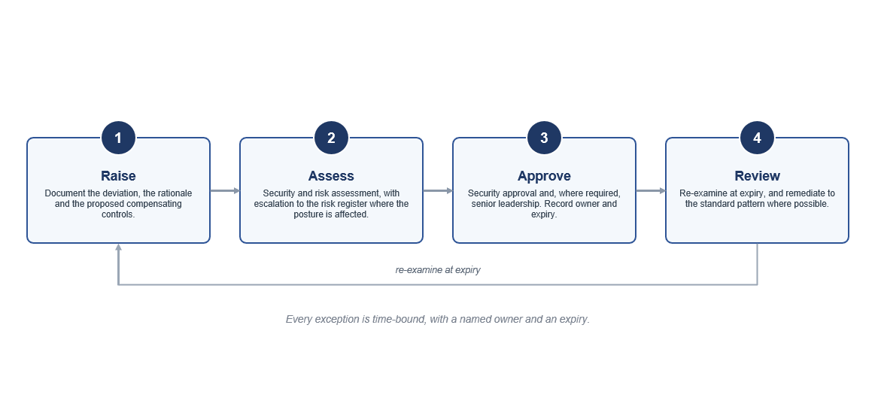

13. Glossary
Term | Meaning
SIF | Systems Integration Framework, this document.
AIS | Azure Integration Services, comprising API Management, Logic Apps, Service Bus, Event Grid, Event Hubs and Functions.
SOA | Service-oriented architecture, coarse-grained services aligned to business capabilities.
APIM | Azure API Management.
Managed identity | An Entra identity for an Azure resource that authenticates without stored secrets.
PAM | Privileged access management, for example CyberArk.
Claim-check | A pattern that keeps a large payload in storage and passes a reference on the message.
Idempotency | The property that applying the same message more than once has no additional effect.
Bordereau | A delegated-authority premium or claims report provided by a cover holder.
TDA | Technical Design Authority.
MoM | Minutes of meeting.

14. Cross-Reference and Traceability

14.1 Pattern Grouping
The catalogue groups patterns by interaction style. The table maps each group to its section and the primary Azure services.
Group | Section | Primary services
API patterns | 8.3 (SFINT1 to SFINT4) | API Management, Functions
Messaging patterns | 8.4 (SFINT5 to SFINT10) | Service Bus, Functions
Event patterns | 8.5 (SFINT11 to SFINT15) | Event Grid, Event Hubs, Service Bus
Orchestration patterns | 8.6 (SFINT16 to SFINT18) | Logic Apps, Functions
File patterns | 8.7 (SFINT19 to SFINT20) | Blob, Event Grid, Logic Apps
Data platform patterns | 8.8 (SFINT21 to SFINT23) | Event Hubs, Functions, Snowflake
Transformation and routing | 8.9 (SFINT24 to SFINT25) | Functions, Service Bus

15. Future Enhancements and Open Items
To be completed.

