Azure API Management

High Level Design

v0.1 (DRAFT)

Contents
1. Document Control 6
1.1. Document History 6
1.2. Authors and Contributors 6
1.3. Assurance 6
1.4. TDA Approval 6
1.5. Related Documents 6
1.6. Definitions 6
2. Executive Summary 7
2.1. Purpose 7
2.2. Context 7
2.3. Scope 7
2.4. Out of Scope 7
2.5. Audience 7
2.6. Proposed Solution 7
3. Requirements and Design Drivers 7
3.1. Source Requirements 7
3.2. Requirements Traceability 7
3.3. Architecture Principles 7
3.4. Non-Functional Requirements 7
4. Architecture Decisions 7
4.1. Architecture Decision Summary and Detailed Rationale 7
4.1.1 ADR-01: Managed API Exposure through APIM 7
4.1.2 ADR-02: Azure Front Door Premium with WAF 7
4.1.3 ADR-03: APIM Premium v2 7
4.1.4 ADR-04: Private APIM Network Model 7
4.1.5 ADR-05: Separate Internal and External Access Paths 7
4.1.6 ADR-06: Entra ID and OAuth 2.0 7
4.1.7 ADR-07: User-Assigned Managed Identity 7
4.1.8 ADR-08: Products, Groups and Subscriptions without Workspaces Initially 7
4.1.9 ADR-09: APIOps and Infrastructure as Code 7
4.1.10 DR-10: Silver Production Resilience 7
4.1.11 ADR-11: Conditional Gold Multi-Region Resilience 7
4.1.12 ADR-12: Developer Portal 7
4.2. Decision Approval Position 7
5. Target Architecture Overview 7
5.1. APIM Role in the Systems Integration Framework 7
5.2. Logical Architecture 8
5.3. Access and Security Boundary 8
5.4. Deployment Architecture 8
5.5. Component Responsibilities 8
6. API Access, Edge Security and Traffic Management 8
6.1. API Audience Classes 8
6.2. Internal Access 8
6.3. External Access 8
6.4. Webhooks 8
6.5. DNS and Custom Domains 8
6.6. Front Door Decision 8
6.7. Edge Controls 8
7. Network and Connectivity Architecture 8
7.1. Network Context 8
7.2. Connectivity Matrix 8
7.3. Egress 8
7.4. Private Backends 8
7.5. DNS and Hybrid Connectivity 8
7.6. Subnet Sizing 8
8. Security and Identity Architecture 8
8.1. Security Model 8
8.2. Control Responsibilities 8
8.3. Authentication 8
8.4. Authorisation Boundary 8
8.5. Administrative Access 8
8.6. Secrets and Certificates 8
8.7. Data Classification and Logging 8
8.8. Non-OAuth Exceptions 9
8.9. External Identity 9
9. API Products, Consumers and Developer Portal 9
9.1. Governance Model 9
9.2. Developer Portal Purpose 9
9.3. Portal Access Model 9
9.4. Portal Deployment and Hosting 9
9.5. Internal Onboarding 9
9.6. Partner Onboarding 9
9.7. Portal Open Questions 9
10. API Design, Policies and Lifecycle 9
10.1. Standards Relationship 9
10.2. API Contract 9
10.3. Policy Hierarchy 9
10.4. Mandatory Policy Capabilities 9
10.5. Lifecycle and Versioning 9
11. Environments, APIOps and Release Management 9
11.1. Environment Model 9
11.2. Toolchain 9
11.3. Delivery Controls 9
11.4. Quality Gates 9
12. Reliability, Backup and Disaster Recovery 9
12.1. Resilience Tiers 9
12.2. Deployment-Unit Implication 9
12.3. Backup, Restore and Rebuild 9
12.4. RTO and RPO 9
12.5. Resilience Testing 10
13. Observability and Operational Management 10
13.1. Monitoring Architecture 10
13.2. Telemetry 10
13.3. Dashboards and Alerts 10
13.4. Retention 10
14. Capacity and Cost 10
14.1. Capacity 10
14.2. Cost Drivers 10
14.3. Cost Controls 10
15. Governance and Operating Model 10
15.1. Ownership Model 10
15.2. Exceptions 10
15.3. Existing Processes 10
16. Implementation and Service Readiness 10
16.1. Implementation Stages 10
16.2. Readiness Criteria 10
17. RAID and TDA Conditions 10
17.1. Assumptions 10
17.2. Key Risks 10
17.3. Dependencies 10
17.4. Independent Verification Required 10
17.5. TDA Approval Conditions 10
18. Appendices 10
18.1. Appendix A: Requirements Traceability 10
18.2. Appendix B: Options and Decisions 11
18.3. Appendix C: Network Flow Matrix 11
18.4. Appendix D: High-Level Component Configuration 11
18.5. Appendix E: API Onboarding Checklist 11
18.6. Appendix F: Reference Sources 11

Document Control

Document History
Version | Date | Author | Change
0.1 | 21 September 2026 | Puneet Kumar | Initial draft restructured to the Organization’s HLD template

Version | Date | Author | Change
0.1 | 21 September 2026 | Puneet Kumar | Initial draft restructured to the Organization’s HLD template

Authors and Contributors
Role | Name / Team

Role | Name / Team

Assurance
This document has been reviewed and approved by the following, the list has been grouped into different sections to aid readability as this document will be required at TDA.

Role | Description
Information | Shared for informational purposes including use as reference document for their domain’s documentation and processes
Reviewer | Actively reviews the content to ensure alignment to guidelines and policies and technical accuracy, will contribute as required
Approver | Provides assurance that their domain is correct in context of the HLSA

Date | Role | Name | Title
DD/MM/YY | Approver
DD/MM/YY | Approver
This document has been reviewed and approved by the following, the list has been grouped into different sections to aid readability as this document will be required at TDA.

Role | Description
Information | Shared for informational purposes including use as reference document for their domain’s documentation and processes
Reviewer | Actively reviews the content to ensure alignment to guidelines and policies and technical accuracy, will contribute as required
Approver | Provides assurance that their domain is correct in context of the HLSA

Date | Role | Name | Title
DD/MM/YY | Approver
DD/MM/YY | Approver

TDA Approval
The TDA approval date to be updated by the author once full TDA approval has been granted.
The document should then be updated to a major revision number and stored in the solution repository.

Date | Minutes (link) | TDA Chair Name | TDA Chair Title
DD/MM/YY
The TDA approval date to be updated by the author once full TDA approval has been granted.
The document should then be updated to a major revision number and stored in the solution repository.

Date | Minutes (link) | TDA Chair Name | TDA Chair Title
DD/MM/YY

Related Documents
The following documents should be read in conjunction with this document:

Reference | Document | Version | Author | Source
1.

The following documents should be read in conjunction with this document:

Reference | Document | Version | Author | Source
1.

Definitions
The terms below are used throughout this document.
Term | Meaning
APIM | Azure API Management, the managed API gateway service
WAF | Web Application Firewall
Entra ID | Microsoft Entra ID, the identity provider (formerly Azure AD)
UDR | User-Defined Route, a custom route-table entry
NVA | Network Virtual Appliance, here the Palo Alto firewall
APIOps | Managing APIM configuration as code through a CI/CD pipeline
RTO / RPO | Recovery Time / Point Objective
mTLS | Mutual TLS
FNOL | First Notification of Loss, the initial report of an insurance claim
SIF | Systems Integration Framework, the client’s integration reference document
RACI | Responsible, Accountable, Consulted, Informed, a responsibility model
BOLA | Broken Object-Level Authorization, an OWASP API risk
SoD | Segregation of Duties
HLSA | High-Level Solution Architecture
DNAT / SNAT | Destination / Source Network Address Translation
IPAM | IP Address Management
SIEM | Security Information and Event Management
DPIA | Data Protection Impact Assessment
FCA | Financial Conduct Authority, a UK regulator
PRA | Prudential Regulation Authority, a UK regulator
UK GDPR | UK General Data Protection Regulation
JWT | JSON Web Token
DDoS | Distributed Denial of Service
SLA | Service-Level Agreement
VNet | Azure Virtual Network
Private Link | Private connectivity to an Azure service over the Microsoft backbone

Executive Summary

Purpose
Azure API Management provides a single, secure and governed platform for all organisational APIs internal, external, and partner. This document sets out the guidelines for standing up and operating the APIM platform and for onboarding APIs onto it, covering architecture, security, operational governance, and cost.

Context
Chaucer does not currently operate a dedicated API management platform. API consumption and exposure are delivered through a mixture of point-to-point integrations, file-based exchanges, and direct connections between internal systems and external partners.
As the integration landscape has grown, these interfaces have been managed independently, limiting consistency, visibility, and reuse. Azure API Management (APIM) will introduce a central API layer that provides standardised security, governance, monitoring, and access management capabilities, complementing the existing integration estate and enabling a more scalable API-led approach.

.

Scope
This High-Level Design defines the target architecture and operating model for the Chaucer API Management Platform. It establishes Azure API Management (APIM) as Chaucer's strategic enterprise API gateway and describes the security, networking, governance, resilience, observability, cost, and API onboarding capabilities required to support enterprise API consumption and exposure. Detailed design of individual applications, backend integrations, and infrastructure-specific configurations is outside the scope of this document and will be addressed during subsequent design and implementation phases.

Out of Scope
The following are explicitly outside the scope of this High-Level Design and will be addressed through separate design, engineering or operational activities:
- Detailed backend and application design. The internal design, data models and integration logic of the backend systems exposed through APIM.
- Individual API specifications. The detailed OpenAPI contract, request/response schema and policy configuration for each specific API, which are delivered per API during onboarding.
- Device-level network configuration. The specific rule configuration of the central firewall, routers and other network appliances, which remains with the network team.
- Identity platform design. The design of Microsoft Entra ID itself, tenant configuration and the broader identity estate, which APIM consumes as an existing service.
- Commercial and licensing procurement. Azure subscription, licensing and enterprise-agreement commercial activities.

Audience
This document is intended for the Chaucer Technical Design Authority, enterprise and solution architects, and the platform, networking, security and integration teams who will build and operate the platform. It assumes familiarity with Azure and with enterprise integration concepts.

Proposed Solution
The proposed solution establishes Azure API Management (Premium v2) as Chaucer's central, governed API gateway, deployed in internal VNet-injection mode with no public endpoint. All external traffic enters through Azure Front Door Premium with WAF over Private Link, while internal consumers reach the same gateway directly over the private network. Identity is provided by Microsoft Entra ID with OAuth 2.0, secrets and certificates are held in Azure Key Vault, and the platform is delivered and operated entirely as code through an APIOps pipeline.
The detailed architecture, decisions and rationale behind this solution are set out in the sections that follow.

Requirements and Design Drivers

Source Requirements
The requirements for the APIM platform are drawn from the Chaucer Systems Integration Framework (SIF) and the agreed scope for enterprise API management. They cover the secure exposure and consumption of APIs by internal and external consumers, authentication through Microsoft Entra ID and OAuth 2.0, protection of API endpoints from common web and API threats, high availability and disaster recovery, observability, and cost-effective but segregated environments to support release management.
Each source requirement is traced to the section of this document where it is designed and addressed in the Requirements Traceability matrix that follows.

Requirements Traceability
High-Level Requirements Traceability Matrix
Chaucer's stated high-level requirements for the APIM platform, drawn from the Systems Integration Framework and the agreed scope, are traced below to the section of this HLD where each is designed and addressed.
Ref | Requirement (from the SIF and Chaucer’s stated scope) | Primarily addressed in
R1 | Enable API discovery and consumption by internal and external users | Section 8
R2 | Provide secure access to services exposed by the API | Section 7
R3 | Authentication approach (Azure Entra ID / OAuth 2.0) | Section 7
R4 | Allow controlled access to APIs from Chaucer private and public endpoints | Section 6.1, Section 6.2, Section 7
R5 | Provide access to backend APIs from Chaucer networks (Azure VNets, Azure PaaS, public SaaS) | Section 6
R6 | Protect API endpoints from common web and API hacking techniques, including but not limited to DDoS and OWASP Top 10 | Section 2.2, Section 7
R7 | Provide a robust service with High Availability | Section 13
R8 | Provide backup and disaster recovery | Section 13
R9 | Detail HLD-relevant versioning and lifecycle | Section 10
R10 | Detail HLD-relevant observability and policies | Section 9, Section 11
R11 | Traffic Manager concepts and supporting components | Section 5,
R12 | Cost-effective but segregated environments to support release management (Prod/UAT/Dev) | Section 14, Section 12

Architecture Principles
The following principles guide the design decisions recorded in this document:
- Secure and private by default. APIM has no public endpoint; every API is private and unauthenticated until explicitly published and approved.
- Single governed entry point. All managed APIs are exposed and mediated through APIM; direct backend exposure and informal bypasses are not permitted.
- Zero Trust. Every call is authenticated and authorised at the gateway regardless of its network origin; internal traffic is never implicitly trusted.
- Everything as code. Platform and API configuration is version-controlled, peer-reviewed and deployed exclusively through automated pipelines.
- Cost proportionate to criticality. Resilience and capacity are tiered to business need rather than applied uniformly across the estate.
- Alignment to Microsoft guidance. The design follows Microsoft's published reference architectures and the Azure Well-Architected Framework.

Non-Functional Requirements
Category | Requirement
Availability | Services are expected to remain available in accordance with the capabilities and deployment model of the selected Azure platform components.
Performance | API requests should be processed within acceptable response times to meet business and consumer expectations.
Scalability | The architecture accommodates future growth in transaction volumes and the onboarding of additional APIs and services.
Security | Authentication, authorisation, encryption, and network protection controls are implemented in line with enterprise security standards.
Resilience | Architectural components are designed to minimise service disruption and maintain continuity during infrastructure or service failures.
Observability | Monitoring, logging, alerting, and auditing capabilities provide operational visibility and support effective incident management.
Maintainability | Automated deployment, configuration management, and controlled release processes facilitate ongoing support and maintenance activities.
Recoverability | Recovery procedures and environment rebuild capabilities enable restoration of service following a major incident or outage.
Compliance | Governance, security, and regulatory obligations are considered throughout the design and operation of the platform.

Architecture Decisions

Architecture Decision Summary and Detailed Rationale
This section records the design decision chosen for each key architectural area. Each row states the option selected not the full set of alternatives considered. Full comparison and why each choice was made, see the section where that decision is covered in detail. (sections 2.2 to 2.4) and the tier and cost options are compared in section 15 (Capacity, Cost and Service Tiers).
This table lists all the decisions in one place.
Area | Decision | Rationale
API Exposure | All managed APIs are published and exposed through Azure API Management. | Every API must be onboarded through a centralized gateway, direct backend exposure or informal bypasses are strictly prohibited.
External Access | Azure Front Door Premium with Web Application Firewall (WAF) is selected as the primary edge entry point over Application Gateway v2 (see the Edge Service Selection Decision section 2.2). | Similar baseline operational cost to Application Gateway WAF_v2, provides global edge routing, integrated CDN/caching, and future multi-region failover capabilities while reducing regional ingress and routing complexity.
APIM Tier | Azure API Management Premium v2. | Higher baseline cost than lower tiers, accepted for modernized architecture, enhanced scalability, complete networking flexibility, and alignment with Microsoft’s long-term APIM platform strategy.
Network Model | APIM deployed in Internal VNet integration mode with Private Endpoints / Private Link for backend services. | More network configuration up front, in exchange for no direct internet exposure anywhere
Resilience | Tiered Resilience Framework (Preferred: Silver)  • Bronze: Single-region, 1 unit.  • Silver (Default Production): Single-region, 2 units distributed across Availability Zones.  • Gold: Active-Active Multi-Region (Tier-1 mission-critical only). | Accepts an extended Recovery Time Objective (RTO) during a total regional outage while automated pipelines provision and configure the secondary region. In exchange, this eliminates 24/7 idle secondary region costs while maintaining a near-zero Recovery Point Objective (RPO) via Git-driven infrastructure configuration.
Identity | Entra ID and OAuth 2.0 as the default authentication mechanism. | Legacy non-OAuth partners require a formally documented and approved architectural exception rather than ad-hoc configurations, Use a User-Assigned Managed Identity (UAMI) as the strategic standard for APIM integrations with Azure services such as Key Vault, Storage Accounts, Event Hubs, and other Entra-protected resources
Delivery | All infrastructure, APIM policies, and route configurations are fully defined as code (IaC) and deployed via automated CI/CD pipelines | Slower initial setup and onboarding times compared to manual portal edits, in exchange for predictable, audited, and repeatable deployment workflows.

ADR-01: Managed API Exposure through APIM
Decision: All managed APIs are published and exposed through Azure API Management. Every API is onboarded through the centralised gateway; direct backend exposure and informal point-to-point bypasses are prohibited.
Rationale: A single governed entry point provides consistent security, policy enforcement, observability and access control across the API estate, replacing the inconsistent point-to-point integrations in the current operating model. The trade-off is that APIM becomes a platform that must be kept highly available and scaled for all API traffic.
Status: Approved. The detailed architecture is set out in Section 5.

ADR-02: Azure Front Door Premium with WAF
The table below shows how each edge gateway option aligns with the defined requirements, providing the basis for selecting the preferred edge gateway service.
Criteria  (Aligned to requirement) | Front Door Premium + WAF | App Gateway v2 + WAF | Front Door Premium + App Gateway  (Both Combined)
Global routing (R1, R11) | Yes | No | Yes
Multi-region support (R7, R8) | Yes | Limited | Yes
WAF protection (R6) | Yes | Yes | Yes
Private Link to APIM (R4, R5) | Yes | Limited | Yes
Performance (R7) | High | Regional | Highest
Operational complexity (R12) | Low | Medium | High
Cost (R12)  Monthly Indicative | Medium (330 $) | Medium (328 $) | High (670 $)
Recommended | Yes | No | No

Selection rationale, when to choose which edge gateway:
Option | Primary Architectural Intent | Reasoning
Front Door Premium + WAF (chosen) | Global Edge, Multi-Region & Unified Ingress | Front Door Premium + WAF is the requirements-aligned, cost-effective choice: it meets every requirement in this matrix. It combines global routing, managed WAF/DDoS, and native Private Link into APIM within a single, low-maintenance service, satisfying R1 (discovery and consumption by internal and external users), R4 (controlled private and public endpoint access), R6 (DDoS and OWASP Top 10 protection), R7 (high availability), R11 (Traffic Manager-equivalent global routing) and R12 (low operational complexity for cost-effective,segregated environments).
Application Gateway v2 + WAF | Regional-Only Ingress & Strict Data Residency | Application Gateway v2 + WAF was not selected because it only partially meets the defined requirements. Although it satisfies R5 (backend network access) and R6 (WAF protection), it lacks native global routing (R11), does not fully support the target consumption model (R1), and requires additional components to achieve multi-region resilience (R7/R8). Consequently, it offers lower overall requirement alignment than Azure Front Door Premium + WAF.
Front Door Premium + Application Gateway | N-Tier Ingress & Deep Defence-in-Depth | Front Door Premium + Application Gateway v2 + WAF was not selected because solution increases operational complexity by introducing another ingress layer with its own routing configuration, WAF policies, certificates, monitoring, and lifecycle management requirements. This creates additional operational overhead and makes troubleshooting and change management more complex across the end-to-end request path.
Direct APIM ingress  (No edge service) | Private / Internal-Only Services | Direct APIM ingress was not selected because it only aligns with internal-only API consumption scenarios. It does not meet the requirements for external access (R1), edge security protection (R6), or global routing and availability (R11). Consequently, it provides insufficient requirement coverage for the target API platform.
Microsoft Source: learn.microsoft.com/azure/architecture/web-apps/api-management/architectures/protect-apis

ADR-03: APIM Premium v2
This section evaluates APIM Premium v2 against the available APIM tiers and identifies Premium v2 as the preferred platform standard. Premium v2 best aligns with the target architecture requirements for security, scalability, networking, and resilience, while the Developer and Standard v2 tiers provide insufficient secure capability needed for Production and UAT environments.

Capability | Premium v2 | Classic Premium | Decision & Rationale
Simplified Networking Model | Yes | No | Premium v2 significantly reduces virtual network governance overhead by eliminating dedicated control-plane routing dependencies.
Private Networking / Isolation | Yes | Yes | Both tiers fulfil strict security policies by providing private endpoint connectivity and network isolation
Workspaces | Yes | Yes | Both tiers support workspaces for decentralized API publishing and domain isolation across business units.
Futureproofing | Yes | No | Premium v2 positions the platform on Microsoft's newest architecture, avoiding future migration rework from Classic Premium.
Multi-Region Topology Strategy | Regional Deployment | Native multi-Region | Premium v2 supports single-region zone redundancy per instance, aligning perfectly with our Silver Resilience Tier

Premium v2 GA backed by Microsoft: Premium v2 general availability announcement, techcommunity.microsoft.com/.../premium-v2-tier-ga; multi-region tier support confirmed in Microsoft’s reliability guidance for API Management.

ADR-04: Private APIM Network Model
To ensure a strict security boundary, Azure API Management must be isolated from direct internet exposure. Selecting the deployment mode dictates how the gateway integrates with our virtual network (VNet) and forces all external consumer traffic through Azure Front Door Premium WAF via Private Link.
The table below details the evaluation between Internal VNet, External VNet modes and VNet Integration.
Option | Description | Status | Architectural Rationale
VNET Injection Internal mode | APIM is deployed fully inside a dedicated VNet subnet with no public IP address. Ingress from Front Door Premium is routed privately via Private Link / Private Endpoints, and backend access uses private VNet routing. | Chosen | Zero Internet Exposure: Completely isolates the API gateway from the public internet. Guarantees that all external traffic is inspected and forced through Azure Front Door Premium WAF before reaching APIM.
VNET Injection External mode | APIM sits inside a VNet but maintains a direct, publicly accessible IP address on the internet, allowing clients to bypass or hit the gateway alongside an optional edge service. | Not Chosen | Security & Compliance Risk: Exposes a public surface area directly to the internet, creating potential governance bypasses where consumers can hit APIM endpoints without traversing the centralized Front Door WAF edge.
VNET Integration | APIM connects to backend services through a dedicated integration subnet, allowing private access to internal networks, Azure services, and external SaaS platforms without exposing a public IP for outbound traffic. | Not Chosen | Backend Reachability: This option still exposes a public surface area to the internet while the backend access can be achieved without introducing a dedicated integration subnet and associated networking complexity. While it supports private access to Azure and external services, the selected approach provides sufficient connectivity while maintaining a simpler operational model and lower cost.

ADR-05: Separate Internal and External Access Paths
Decision: Internal and external consumers reach the same internal-mode APIM instance through separate access paths. External traffic enters through Azure Front Door with WAF over Private Link; internal traffic reaches the gateway directly over the private network.
Rationale: Both audiences are served by one gateway and one backend estate, keeping policy and governance consistent, while the entry point and authentication differ according to whether the caller sits inside or outside the network boundary. External traffic crosses the internet boundary once, at the inspected edge; internal traffic never crosses it. The access model and boundary are detailed in Section 5.3.
Status: Approved.

ADR-06: Entra ID and OAuth 2.0
Decision: Microsoft Entra ID is the single identity provider for the platform, and OAuth 2.0 is the default authentication standard for API access. Tokens are validated at the gateway on every call.
Rationale: A single identity provider for both consumer authentication and platform administration simplifies governance, lifecycle management and access review. Where a partner cannot support OAuth 2.0, an approved, time-bound exception with compensating controls may be granted. Authentication is detailed in Section 8.3.
Status: Approved.

ADR-07: User-Assigned Managed Identity
Decision: APIM uses a managed identity to retrieve secrets and certificates from Azure Key Vault at runtime, rather than storing credentials in policy configuration.
Rationale: Runtime retrieval from Key Vault removes stored secrets from the platform entirely and supports automatic certificate rotation without redeployment, consistent with the Zero Secrets in Code principle. Secrets and certificate management is detailed in Section 8.6.
Status: Approved.

ADR-08: Products, Groups and Subscriptions without Workspaces Initially
Decision: API governance is implemented initially through products, Microsoft Entra ID groups and subscriptions, without adopting APIM workspaces in the first phase.
Rationale: Products, groups and subscriptions provide sufficient access control and consumer segmentation for the initial platform, while deferring workspaces avoids added complexity until decentralised team-based API ownership is required. The governance model is detailed in Section 9.1.
Status: Approved. Workspace adoption may be revisited as the platform matures.

ADR-09: APIOps and Infrastructure as Code
Decision: The platform is delivered and operated as code. Terraform provisions the Azure infrastructure, and APIM APIs, products, policies and named values are managed in source control and deployed through automated pipelines.
Rationale: An everything-as-code operating model provides reproducible, auditable and peer-reviewed change, aligned to Chaucer's existing Azure delivery approach. Direct portal changes are not permitted except through approved emergency procedures. The delivery model is detailed in Section 11.
Status: Approved.

DR-10: Silver Production Resilience
Decision: Production is deployed on the Silver resilience tier — a single region with multiple units distributed across Availability Zones.
Rationale: Zone redundancy within a single region provides high intra-region availability and fault tolerance against datacentre or maintenance failures, without the cost and complexity of a permanently running secondary region. This accepts an extended recovery-time objective during a total regional outage in exchange for avoiding secondary-region running costs. Resilience tiers are detailed in Section 12.
Status: Approved as the production baseline.

ADR-11: Conditional Gold Multi-Region Resilience
Decision: The Gold tier — active-active across two regions — is available but applied conditionally, only to business-critical APIs that justify the cost.
Rationale: Active-active multi-region deployment roughly doubles platform running cost and is not justified across the whole estate. Tiering resilience to criticality allows the few APIs that require automated geographic failover to use Gold while the majority remain on the Silver baseline. Resilience tiers are detailed in Section 12.
Status: Approved as a conditional option, subject to per-API business justification.

ADR-12: Developer Portal
Decision: The Azure APIM developer portal is used as the self-service interface for API discovery, documentation, testing and subscription, with identity delegated to Microsoft Entra ID for internal users and Entra External ID (B2B) for partners.
Rationale: The managed developer portal enables zero-touch onboarding for internal and external developers without manual support tickets, while keeping access governed through the same identity model as the gateway. The portal model is detailed in Section 9.
Status: Approved.

Decision Approval Position

Target Architecture Overview

APIM Role in the Systems Integration Framework
Within the Chaucer Systems Integration Framework, APIM is the managed API layer that sits in front of the existing integration estate. It does not replace the messaging, file-based or event integration patterns described in the SIF; it adds a standardised, governed entry point specifically for API-based (synchronous, request/response) integration.
Existing integration services continue to operate unchanged. APIM provides consistent security, policy enforcement, observability and access management for the APIs exposed through it, complementing the broader integration landscape rather than consolidating it.

Logical Architecture

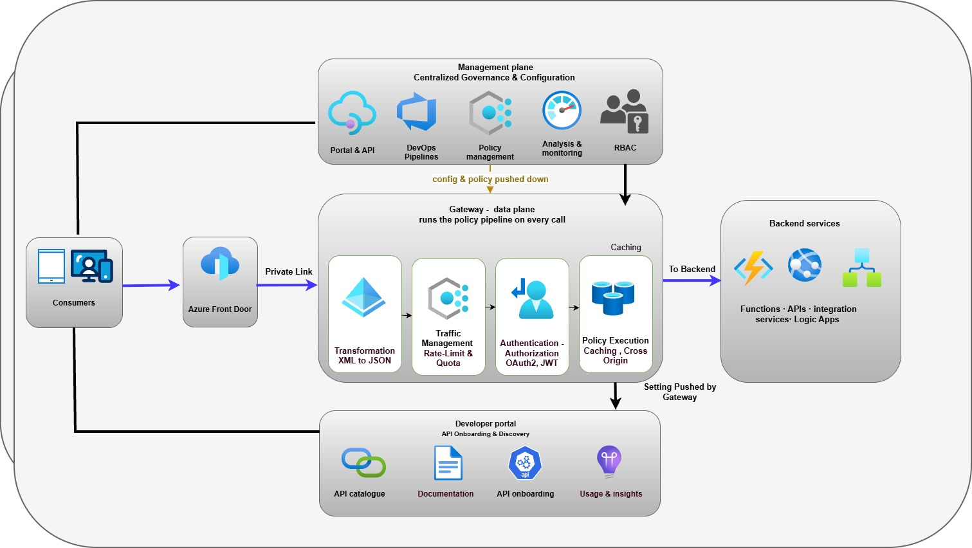
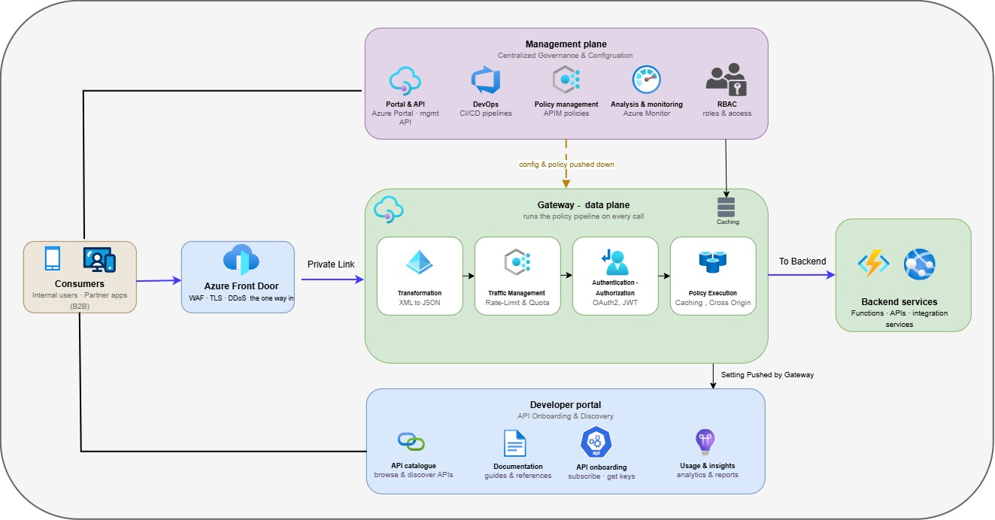
The Architecture has these parts:
- Gateway (data plane). The engine that handles live traffic. Every call pass through it and it applies the same set of rules, authentication, rate limits, validation, routing and logging, to each one. This is where the platform actually does its work.
- Management plane. Where the platform is configured. Teams define their APIs, products and policies here, and those definitions are pushed down to the gateway. It is used to set the platform up and change it, not to serve live traffic.
- Developer portal. The self-service website where consumers find the APIs they are allowed to use, read the documentation, and request a subscription. It is covered in full in section 9.
- Backend Services
- The systems that provide the business functionality exposed through APIs and ultimately process requests. These may include business applications, integration platforms, Azure services, and third-party SaaS solutions. APIM routes requests to the appropriate backend service after applying security, policy, and governance controls, providing a consistent and controlled access layer regardless of where the underlying capability resides.

The diagram below illustrates the high-level architecture of the Chaucer API Management platform, showing how API traffic flows from consumers through security and governance controls to backend services. It also highlights the supporting identity, secret management, and API management capabilities that enable secure and controlled API exposure.

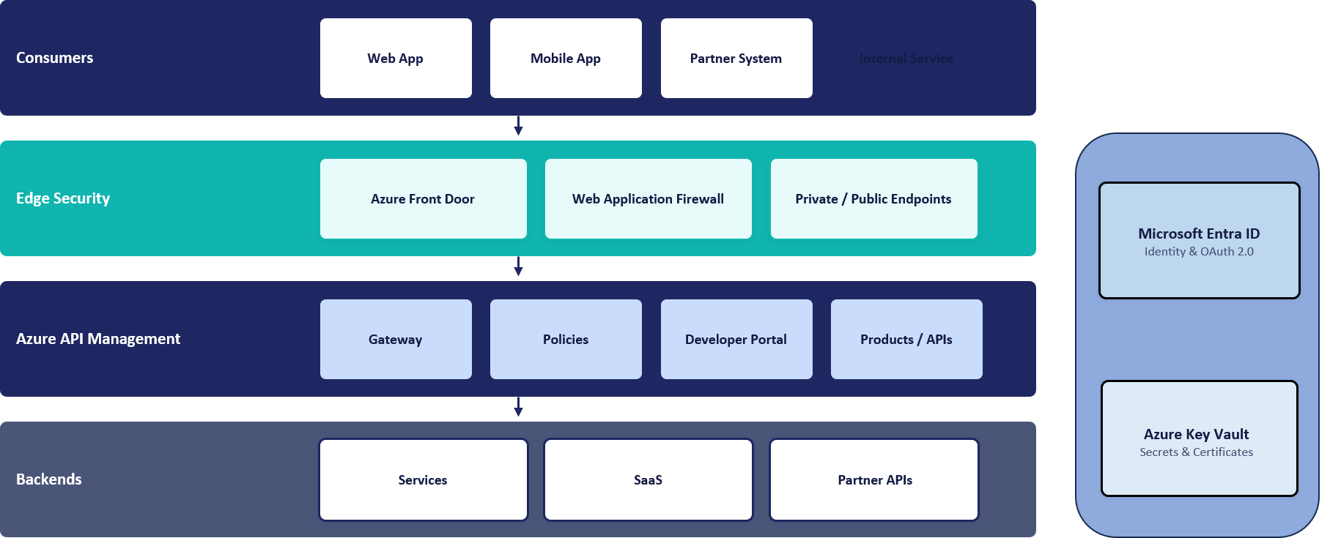
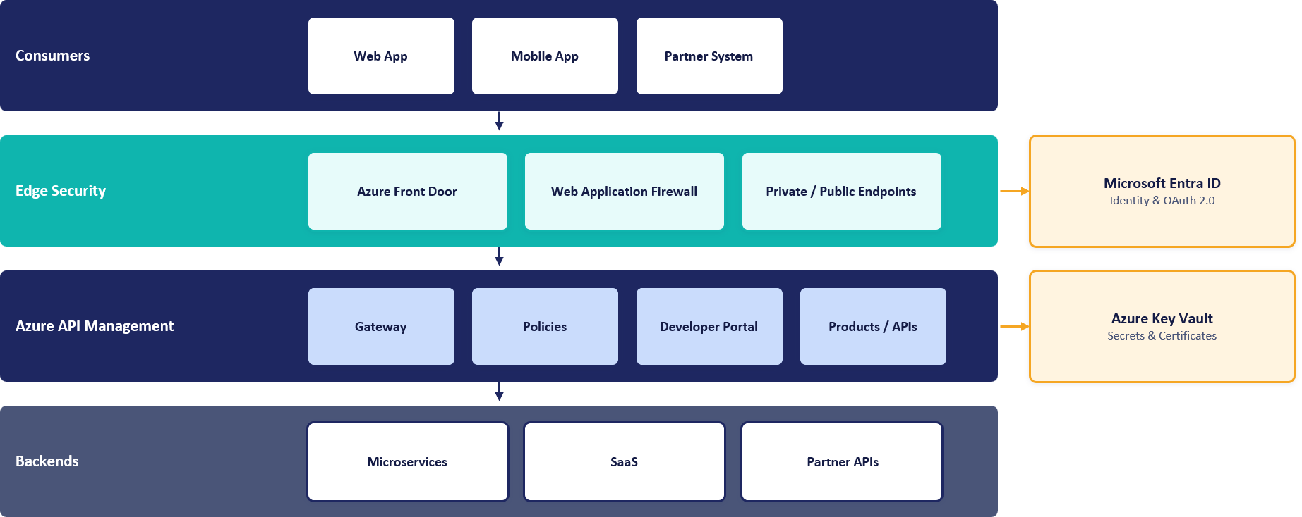

APIM service reference architecture, the logical components and how a request flows between them
Two shared Azure services sit alongside the gateway and are called on every request: Microsoft Entra ID validates the caller's token, and Azure Key Vault holds the secrets and certificates the gateway needs.

Access and Security Boundary
All requests are processed by the same Azure API Management instance, but the path differs depending on where the consumer is located. External consumers enter through Azure Front Door and cross the internet boundary once, while internal consumers access APIM directly from within the corporate network and remain on private connectivity throughout.
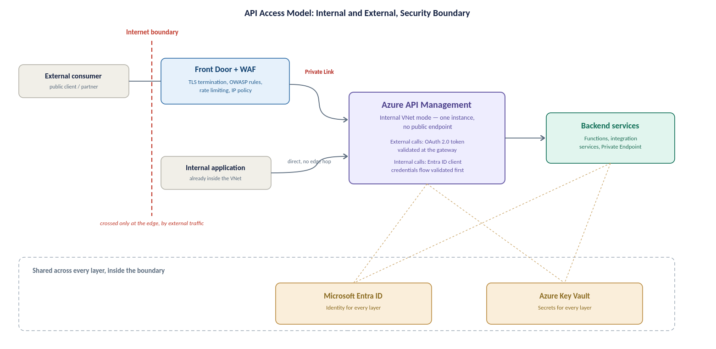
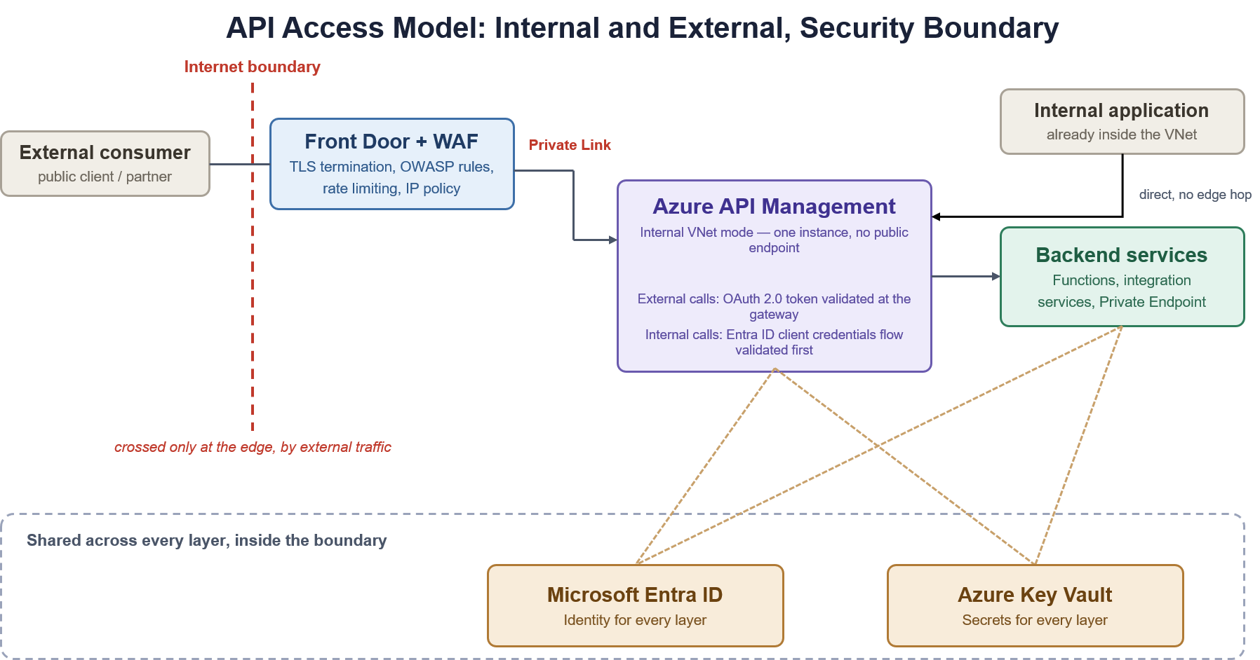
API access model and security boundary, internal and external paths converging on the same internal-mode gateway
External path: a public client or partner reaches Azure Front Door with WAF, which terminates TLS and applies OWASP protection at the edge before anything reaches APIM. The call then travels over Private Link to APIM, which validates the OAuth 2.0 token before forwarding it to the backend.
Internal path: an internal application calls APIM directly over the private VNet, with no edge service in the path because there is no public exposure to guard against. APIM authenticates the caller against Microsoft Entra ID, then routes the request to the target backend.
Both paths terminate at the same internal-mode gateway and the same backend estate; only the entry point and the authentication mechanism differ.

Deployment Architecture
APIM is deployed in internal VNet-injection mode on the Premium v2 tier, within a dedicated delegated subnet. It has no public data-plane endpoint; inbound external traffic arrives only through Azure Front Door over a Private Link private endpoint, and internal traffic arrives over private network connectivity.
Production is deployed zone-redundant across Availability Zones (the Silver tier). The platform is provisioned and changed exclusively through infrastructure-as-code and APIOps pipelines, so its deployed configuration is reproducible and auditable. The concrete instance composition and network topology are detailed in Sections 7 and the appendices.

Component Responsibilities
The platform is made up of a small number of components, each with a distinct responsibility:
- Gateway (data plane). Handles all live API traffic, applying authentication, authorisation, rate limiting, validation, routing and logging to every call.
- Management plane. Where APIs, products and policies are defined; configuration is pushed down to the gateway and is not part of the live traffic path.
- Developer portal. The self-service interface where consumers discover APIs, read documentation and manage subscriptions.
- Azure Front Door with WAF. The inspected public edge for external traffic, providing TLS termination, OWASP protection and DDoS mitigation.
- Microsoft Entra ID. Provides identity and token validation for every call and for platform administration.
- Azure Key Vault. Holds the secrets and certificates the gateway retrieves at runtime.
- Backend services. The business applications, integration services, Azure services and SaaS platforms that ultimately process requests.

API Access, Edge Security and Traffic Management

API Audience Classes
APIs exposed through the platform serve distinct audience classes, each with a different access path and authentication expectation:
- Internal consumers. Chaucer applications and services, and on-premises systems reaching Azure over private connectivity, calling internal APIs from within the network boundary.
- External partners (B2B). Known partner organisations — brokers, market participants, suppliers and service providers — represented through Microsoft Entra External ID (B2B) with partner-specific application registrations.
- Public or third-party clients. External clients reaching published APIs through the inspected edge, subject to WAF, OAuth 2.0 and per-subscription rate limits and quotas.
Access, visibility and policy are governed per audience class through products, subscriptions and Entra ID groups, as detailed in Section 9.

Internal Access
Internal consumers call APIM directly over the private network — via VNet peering, or over ExpressRoute or VPN for on-premises systems — with no edge service in the path, because there is no public exposure to guard against on this route.
Internal traffic stays on the private network and does not traverse the central egress firewall. Internal consumers never bypass the gateway: every internal call is authenticated against Microsoft Entra ID and policy-checked at APIM, in line with the Zero Trust principle. The detailed internal ingress flow is set out in Section 7.

External Access
External consumers reach the platform through Azure Front Door with WAF, which terminates TLS and applies OWASP protection and DDoS mitigation at the edge before any traffic reaches APIM. Front Door forwards the validated request to the internal-mode gateway over a Private Link private endpoint.
Because APIM is internal-mode it has no public endpoint; the only way in from outside the network is through Front Door over Private Link. At the gateway, the OAuth 2.0 token is validated and per-subscription rate limits and quotas are enforced before the request is routed to the backend. The detailed external ingress flow is set out in Section 7.

Webhooks
Where APIs need to deliver asynchronous event notifications to external consumers (webhooks), the outbound call leaves Azure through the central egress firewall, which applies outbound security and URL-filtering policy to the permitted destinations. Approved outbound endpoints are documented per API, and all outbound traffic is logged and auditable at the firewall.
Webhook delivery targets, retry behaviour and authentication to the receiving endpoint are defined per API during onboarding.

DNS and Custom Domains
External API and developer-portal endpoints are published on Chaucer custom domains presented at Azure Front Door, with TLS certificates managed through the edge. Internal name resolution for the private APIM endpoint is provided through Azure Private DNS using the privatelink.azure-api.net zone, linked to the VNets and on-premises networks that need to resolve it.
The specific custom-domain names and certificate sources are confirmed during detailed design and alignment with Chaucer's naming standards.

Front Door Decision
Although Azure Front Door and Azure Traffic Manager share the primary goal of routing traffic to healthy regional origins, their underlying mechanics differ significantly:
- Azure Traffic Manager (DNS-Based Routing): Operates strictly at the DNS level. It directs clients by returning the IP address of a regional gateway based on health probes. Because failover depends on client applications and intermediate DNS resolvers respecting DNS Time-To-Live (TTL) values, failover is not always instantaneous and can cause persistent traffic to hit an unhealthy region.
- Azure Front Door (Layer 7 Anycast Reverse Proxy): Operates at the application layer via a global network of edge locations. Client connections terminate directly at the nearest Front Door PoP (Point of Presence). Front Door continuously monitors origin health and instantly redirects incoming HTTP/S requests to a healthy backend region at the proxy layer completely bypassing client DNS caching delays.
Why Azure Front Door is Required for this APIM Architecture:
- Zero-Latency Failover: Eliminates client-side DNS TTL caching risks during a regional UK South outage.
- Perimeter Security Convergence: Integrates Layer 7 Web Application Firewall (WAF) and DDoS protection into the same routing hop.
- Private Link Support: Natively routes traffic directly into internal APIM instances via Azure Private Link, eliminating public IP exposure.
Decision flow illustrating why Azure Front Door is selected over Azure Traffic Manager for HTTP/HTTPS API traffic. Front Door provides integrated Layer 7 WAF security and sub-minute failover, whereas Traffic Manager operates strictly at the DNS level without application-layer security features.
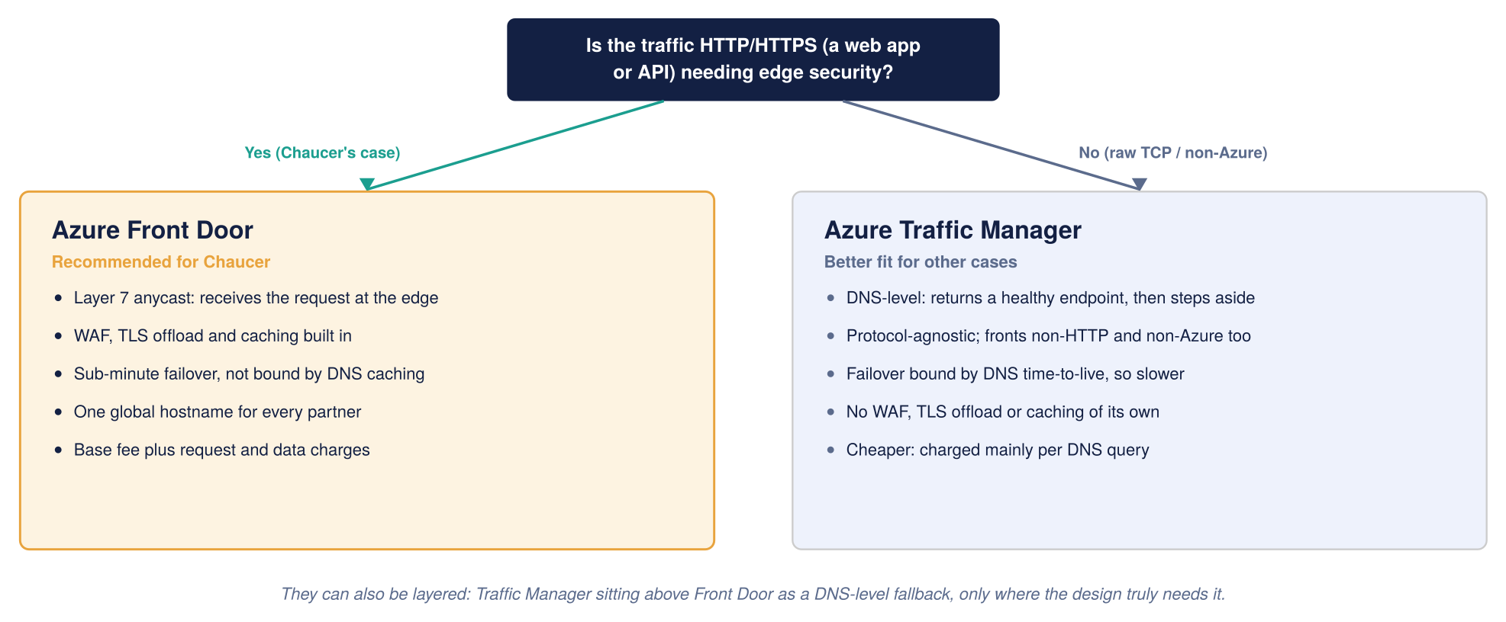
Global routing, Front Door compared with Traffic Manager

Edge Controls
The following controls are applied at the Azure Front Door edge for external traffic:
- Web Application Firewall (WAF). The Microsoft Default Rule Set (OWASP coverage) plus the Bot Manager rule set, run in Prevention mode in Production.
- TLS termination. TLS 1.2 minimum, with modern cipher suites; legacy protocols disabled.
- DDoS mitigation. Volumetric and protocol attack mitigation inherent to Front Door, complemented by Azure DDoS protection on the hub.
- Rate limiting. Edge rate-limit rules protect against abusive request volumes, with tighter thresholds on sensitive endpoints.
- Private Link origin. Traffic is forwarded to the internal APIM endpoint over Private Link, with no public IP exposure.

Network and Connectivity Architecture

Network Context
This section operationalizes the core design choices established and justified in Section 2 specifically the selection of Azure Front Door Premium with WAF as the edge perimeter and APIM deployed in Internal (VNet) Mode. by detailing the concrete network topology required to implement them.

It describes how traffic reaches APIM (the ingress path) and how APIM reaches out (the egress path), how the Palo Alto firewall fits in and which flows pass through it, and the routing and subnet design that underpins all of it. The step-by-step configuration of each flow is detailed at the end.
Azure Front Door + WAF with Internal APIM - The selected entry pattern positions Azure Front Door + WAF in front of an internal-mode APIM instance (Option A). Across all options evaluated, APIM remains strictly in internal mode and is never exposed to the internet; the only difference lies in the edge service. The complete decision framework and option comparisons are detailed in Section 2 (Edge Service Selection).
This diagram shows the inbound (ingress) request flow, how a request travels from a consumer through the edge and APIM to the backend.

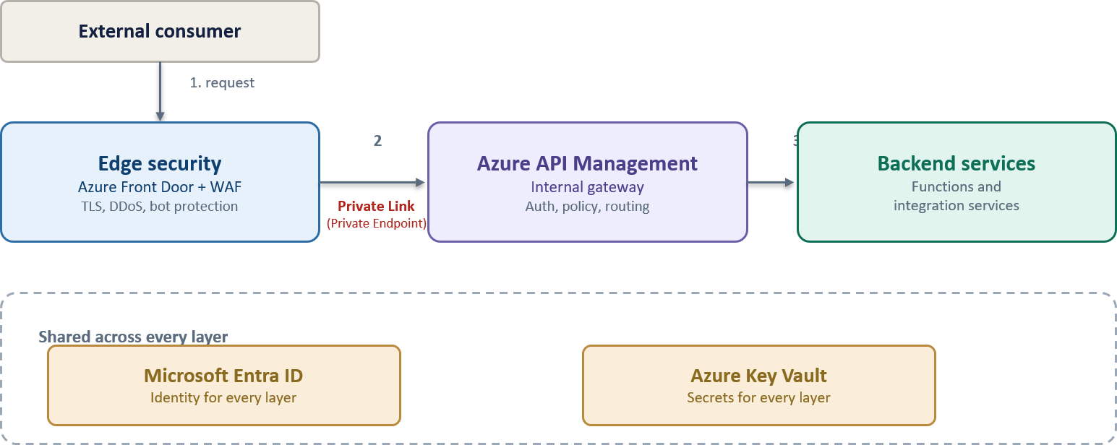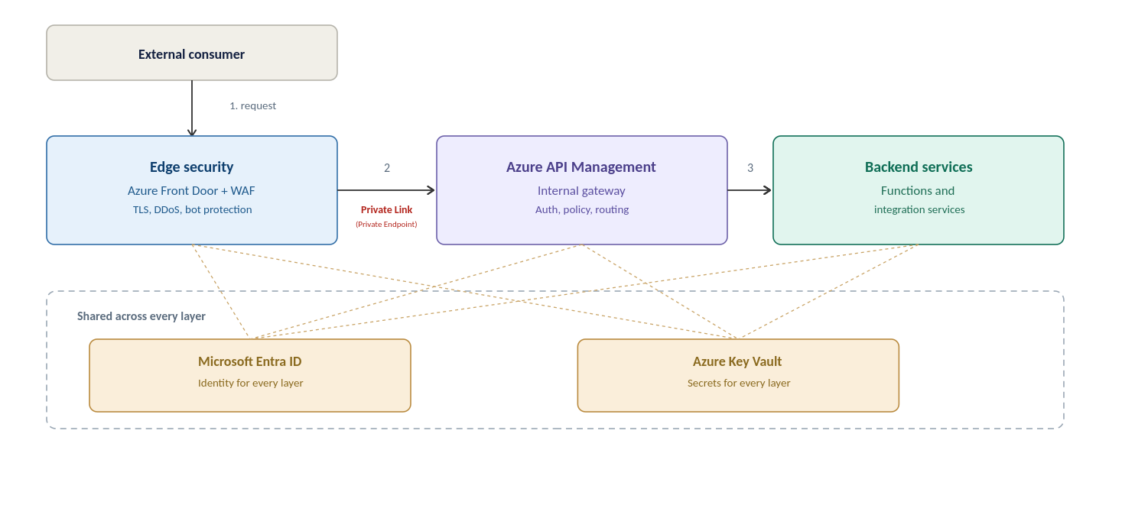
High-level Azure APIM architecture for the Organization

This diagram shows the outbound (egress) traffic flow, how APIM and backends reach external third-party APIs through the Palo Alto firewall.
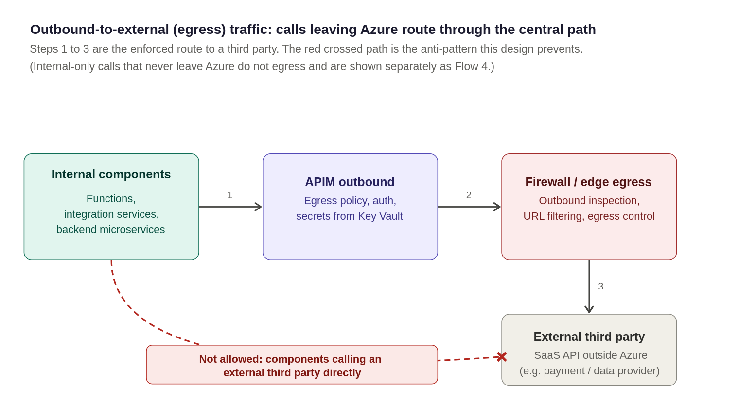
Outbound-to-external (egress) traffic, calls leaving Azure to a third-party route through the central egress path

Egress Control
- Approved outbound endpoints documented per API.
- All outbound traffic is logged and auditable at firewall
- Premium V2 isolates platform dependencies from Chaucer VNet and no firewall exemptions required
This subsection elaborates the four main traffic flows possible in the estate.. The summary table in section 6.3 provides a quick reference and this provides some further details.
Flow 1: External inbound
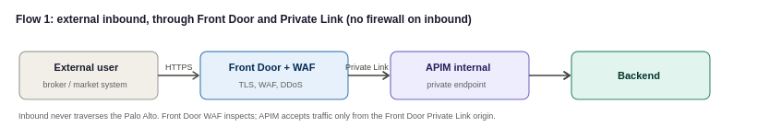

An external consumer, reaches the Organization over the internet. Traffic lands at Azure Front Door, where the WAF, TLS termination and DDoS protection are applied, and Front Door forwards the validated request to APIM over a Private Link inbound private endpoint. Because APIM is internal-mode it has no public endpoint; the only way in is through Front Door over Private Link. Inbound traffic does not traverse the Palo Alto firewall, which is an egress control mechanism.
- Front Door: WAF (OWASP + bot rules), TLS termination and DDoS protection at the edge; Private Link origin to the APIM inbound private endpoint.
- APIM NSG: Inbound traffic is permitted only through the approved Azure Front Door Private Link connection. Direct internet access to APIM is denied.
- No firewall on this path: the return path is symmetric because Front Door and APIM communicate over Private Link on the Azure backbone, with no NVA in the middle.
Flow 2: Internal Inbound

An internal Organization system, or an on-premises system reaching Azure over ExpressRoute or VPN, calls an internal API. The call reaches the APIM internal gateway directly over the private network (VNet peering, or ExpressRoute/VPN for on-premises), and APIM applies authentication and policy before forwarding to the backend. Internal traffic stays on the private network and does not traverse the Palo Alto, which handles egress to external third parties only. Internal consumers still never bypass the gateway: every internal call is authenticated and policy-checked at APIM, in line with the zero-trust principle in the security section.
Flow 3: Outbound

When APIM or a backend needs to call out, to a public SaaS provider such as Salesforce, or to any internet endpoint, that traffic must be inspected on the way out. Routing intent forces all outbound data-plane traffic through the firewall, where egress policy and threat prevention apply. This is the flow that gives the Organization the outbound inspection and audit it runs the Palo Alto for in the first place.
- Routing Intent: Azure Routing Intent is enabled to direct APIM traffic through the central Palo Alto firewall, ensuring both north-south and east-west traffic flows are subject to centralized inspection, policy enforcement, and monitoring.
- Palo Alto: outbound security and URL-filtering policy for the destinations APIM is permitted to reach; SNAT as required.
- Credentials for SaaS calls stay in Key Vault-backed named values; the firewall controls the path.
Flow 4: APIM to private backends

Calls from APIM to backends that live inside the Organization’s own network, integration services and Functions, or PaaS reached over Private Endpoint, stay on the private network. East-west traffic is routed through the central firewall using Azure Routing Intent. This ensures traffic between platform components is consistently subject to security inspection, policy enforcement, and monitoring before reaching its destination, providing a uniform security posture across the environment.

Connectivity Matrix
The platform's connectivity requirements span four principal flows, each enforced at a defined point:
- External inbound. Internet → Azure Front Door (WAF, TLS, DDoS) → Private Link → APIM internal gateway. Does not traverse the egress firewall.
- Internal inbound. Internal or on-premises consumer → APIM internal gateway over private connectivity. Stays on the private network.
- Outbound to external third parties. APIM or backend → central egress firewall (inspection, URL filtering) → external SaaS or internet endpoint.
- APIM to private backends. APIM → private backends over Private Endpoint or private connectivity, subject to east-west inspection.
The detailed, per-flow configuration and the summary routing table are provided in Section 7 and the Network Flow Matrix appendix.

Egress
Outbound data-plane traffic from APIM and backends to external third parties is routed through the central firewall, where egress security and threat-prevention policy apply. This provides the outbound inspection and audit the platform is required to deliver.
- Approved endpoints. Permitted outbound destinations are documented per API.
- Logging. All outbound traffic is logged and auditable at the firewall.
- Credentials. Credentials for outbound SaaS calls are held as Key Vault-backed named values; the firewall controls the network path.
Premium v2 isolates the platform's own management dependencies from the Chaucer VNet, so no firewall exemptions are required for platform traffic.

Private Backends
Backends that live inside the Chaucer network — integration services, Azure Functions, and PaaS services reached over Private Endpoint — are called over private connectivity and stay on the private network. East-west traffic between platform components is subject to the same centralised inspection and policy enforcement as other flows, providing a uniform security posture.

DNS and Hybrid Connectivity
Private name resolution for the APIM endpoint and its dependencies is provided through Azure Private DNS, using the privatelink.azure-api.net zone linked to the VNets and, via conditional forwarding, to on-premises networks that consume internal APIs. Hybrid connectivity for on-premises consumers is provided over the existing ExpressRoute or VPN connections into the Azure landing zone.
Symmetric return routing must be maintained for on-premises consumers reaching the internal endpoint; the specific DNS and routing configuration is confirmed against the landing zone during detailed design.

Subnet Sizing

Path / Flow Type | Where enforced | Routing & Security Policy Rule
External Inbound | Front Door + WAF (Edge) | WAF inspection, TLS offloading, and DDoS mitigation at the edge. Front Door routes to APIM via Private Link Origin (Private Endpoint). Subnet NSG denies direct public internet ingress.
Internal Inbound | APIM (Private Network) | Reaches APIM internal gateway directly over VNet Peering or ExpressRoute. Authenticated and policy-checked at APIM without traversing the perimeter firewall.
Outbound to External 3rd Party | Routing Intent + Palo Alto Firewall | Routing Intent redirects outbound traffic to Palo Alto firewall; egress inspection, domain filtering, and threat protection on the firewall.
APIM to Private / Internal Backend | NSG + Private Endpoint | Private path stays strictly on the Azure backbone via Private Endpoints or VNet integration
Control Plane (Mandatory) | APIM v2 Managed Platform | APIM Premium v2 native behaviour: control plane management traffic flows securely over internal Microsoft platform infrastructure. Inbound management ports and explicit Api Management UDRs are not required.
Platform Dependencies | Network Security Controls | APIM Premium v2 relies on several Azure platform services, including Azure Monitor, Key Vault, and Storage. Connectivity to these services must be permitted through the organization's network security controls to support normal platform operation.

Proposed Subnet sizing (to confirm against the landing zone)
Sizing the APIM delegated subnet and its neighbours correctly the first time avoids a disruptive resize later, since an Azure subnet cannot easily be shrunk or re-carved once resources are deployed into it. The figures below are starting points for detailed design, not a final IP plan; the actual VNet address space must come from the Organization’s IPAM and hub-spoke allocation.
Subnet | Minimum size | Why
APIM delegated subnet (Premium V2, VNet injection) | /27 minimum, /26 recommended | APIM Premium v2 requires a dedicated subnet. A /26 provides additional capacity for future scale-out and platform address consumption, reducing the risk of subnet resizing later.
Application Gateway subnet (if Option B/C is used) | /27 minimum, /26 preferred, /24 Microsoft recommended for maximum auto scale capacity | Each Application Gateway instance consumes an IP address. Larger subnets provide headroom for autoscaling and maintenance operations.
Palo Alto internal load balancer / hub subnet | Per the Organization’s existing hub design | Owned by the network team; not part of this HLD’s sizing, referenced here for completeness
Private Endpoint subnet(s) for backends | Size according to expected endpoint count (typically /27 or larger) | Each Private Endpoint consumes an IP address. Allow sufficient headroom for future backend services

Network artefact | Requirement | Owner
NSG: gateway | Allow 443 from the Front Door Private Link path and internal ranges only; deny the Internet service tag | Network
DNAT (not used) | Not used in this design: inbound arrives via Front Door Private Link, not a firewall public VIP | Network
Private DNS | Do NOT create a Private DNS zone for azure-api.net. Create explicit A records mapping each APIM endpoint FQDN to the private VIP, resolvable from all VNets and on-prem networks that need access | Platform + Network
Backend DNS resolution | Azure Private DNS Resolver with forwarding rulesets for APIM-to-on-prem backend name resolution | Network
ExpressRoute / VPN return-path symmetry | Ensure symmetric routing for on-prem consumers reaching the internal VIP: UDRs and firewall rules must be consistent on both the Azure and on-prem sides so return traffic follows the forward path | Network

Security and Identity Architecture

Security Model
Security is the foundational principle of this architecture. Access is explicitly validated at every hop and never assumed based on network location or prior perimeter checks—traffic originating from within the internal network is subject to the exact same verification standard as external requests.
A single security control failure must never expose a backend service. Each request passes through a mandatory, ordered sequence of defence-in-depth controls before reaching downstream targets:
- Perimeter & Edge Protection: Mitigates volumetric attacks and inspects web application firewalls (WAF).
- Identity & Access Management: Validates caller identity (Microsoft Entra ID / OAuth 2.0 / Mutual TLS).
- Gateway Policy Enforcement: Applies schema validation, scope authorization, rate limits, and throttling.
- Isolated Network Routing: Ensures traffic travels strictly via Private Endpoints and internal VNet injection.

The access models in sections 5.3 and 5.4 rely on four security pillars applied consistently across the platform:
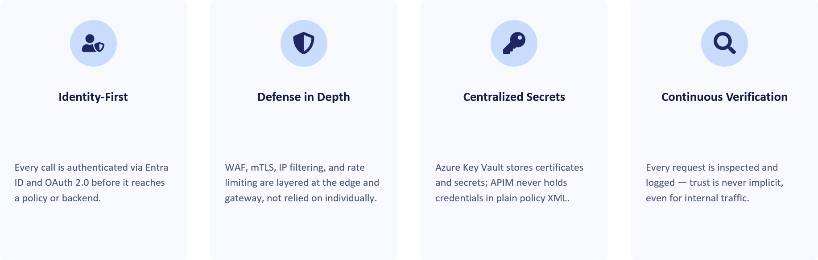
Security architecture: defence in depth at a glance
The diagram below illustrates the defence-in-depth model for a private-mode APIM deployment protected by an edge security service. Requests traverse multiple control layers before reaching backend services, with each layer applying a specific security function. Security is achieved through the combined operation of all layers rather than reliance on any single control.
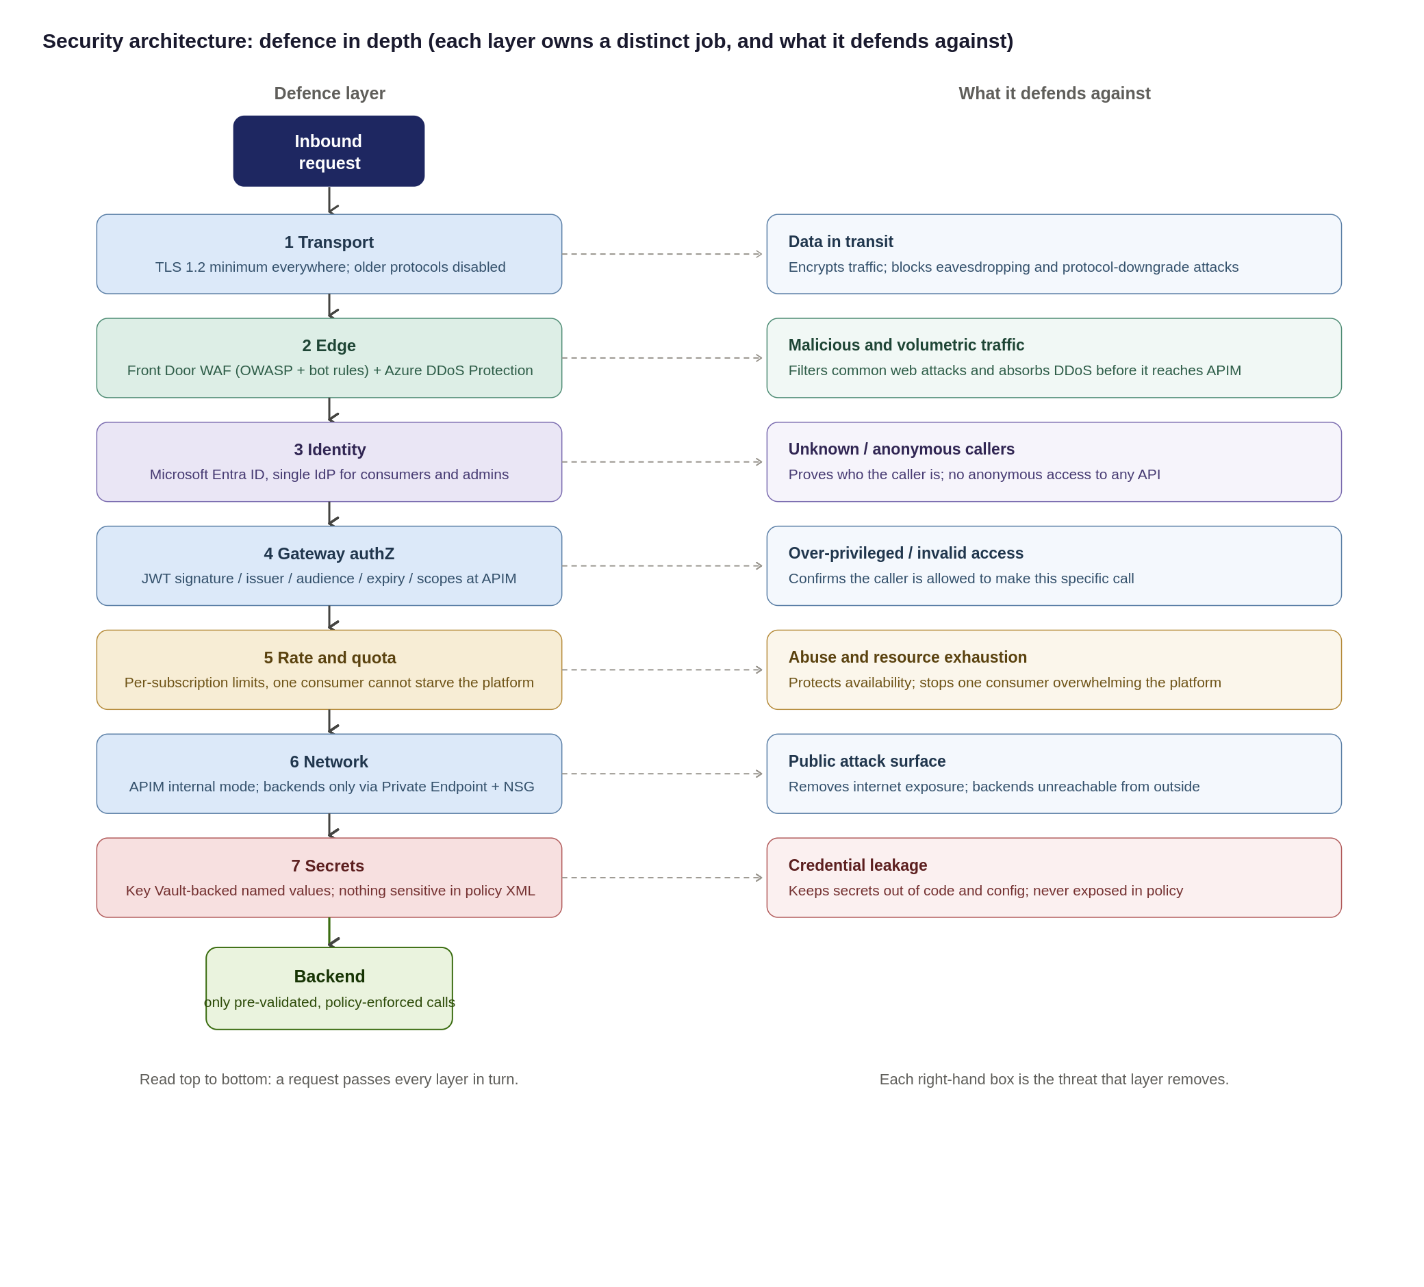
Control Responsibilities
Security controls are implemented as a layered model and are not interchangeable. Each control addresses a specific security concern, and the overall security posture depends on the combined operation of all controls rather than reliance on any single mechanism.
Control | Primary responsibility
Microsoft Entra ID | Identity and authentication
OAuth 2.0 / JWT | Authorisation context per request
APIM | API gateway and policy enforcement
WAF (Front Door / App Gateway) | HTTP and API-layer attack protection
Azure DDoS Protection | Volumetric and network DDoS
Azure Firewall / NVA | Network segmentation and egress control
Private Endpoint | Private connectivity to backends
the Organization’s SIEM | Detection and investigation
APIM policies | Rate limits, quotas, validation, transformation

Security design principles Source
The controls detailed in this section enforce seven foundational security principles across the platform:
- Verify Explicitly (Zero-Trust): Validate every hop independently; no request is trusted simply because it originates from within the corporate network.
- Defence-in-Depth: No single control is load-bearing; security relies on layered edge WAF, gateway policies, and network isolation working in unison.
- Least Privilege: Consumers, APIOps deployment pipelines, and administrators are granted the minimum permissions necessary to perform their roles.
- Secure & Deny by Default: All APIs remain private and unauthenticated by default until explicitly configured and approved for publication.
- Single Identity Provider: Microsoft Entra ID serves as the central Identity Provider (IdP) for both consumer OAuth validation and platform administration.
- Everything as Code (APIOps): Platform and API security configurations are version-controlled, peer-reviewed, and deployed exclusively via automated pipelines.
- Zero Secrets in Code: No credentials or secrets are committed to repositories or hard-coded in policies all use Key Vault-backed Named Values
<Refer Primary ref here >
Residual Risk & Mitigation Matrix
Residual risks remain after the application of the defined controls. The table below identifies those risks, the associated compensating controls and the accountable owner to ensure they are explicitly understood, managed and tracked.
Residual Risk | Risk Rationale & Root Cause | Compensating Control & Mitigation Strategy | Risk Owner
Backend Object-Level Authorization (BOLA / OWASP API1) | APIM validates token signature and passes claims, but only the downstream domain service understands its internal domain object model. | Mandatory domain backend-authorization standard, static code review, and automated contract testing per API. | Domain Teams
Non-OAuth Exception Consumers | Legacy partners or constrained systems that cannot support modern OAuth 2.0 / OIDC authentication flows. | mTLS or static IP allow-listing combined with short-lived rotating secrets; enforced via time-boxed, reviewed security exception. | Security
Peak Load Capacity Behaviour | Exact peak request-per-second (RPS) metrics have not been benchmarked under real production conditions. | Mandatory pre-go-live performance/load testing; dynamic autoscaling based on gateway CPU and memory metrics. | Platform Team
Single Gateway Ingress Concentration | A multi-tenant shared platform concentrates blast radius compared to isolated, scattered backend endpoints. | Rate limiting, , multi-region Front Door routing, WAF/DDoS, and Emergency Administrative Access runbooks. | Platform & Security

Threat model: STRIDE and the OWASP API Security Top 10
To ensure comprehensive coverage, the platform security model is evaluated against two complementary frameworks:
- STRIDE: Evaluates platform and infrastructure-level threat vectors (Spoofing, Tampering, Repudiation, Information Disclosure, Denial of Service, Elevation of Privilege).
- OWASP API Security Top 10: Addresses API-specific application vulnerabilities (BOLA, Broken Authentication, Mass Assignment, Unmanaged APIs).
Threat Vector & Key Risk Area | Framework Mapping | Architectural Control & Enforcement Strategy
Identity Spoofing & Broken Authentication | STRIDE: Spoofing  OWASP: API2:2023 | Mandatory Microsoft Entra ID OAuth 2.0 / JWT validation at gateway; strict claim inspection; mTLS and static IP allow-listing for authorized legacy exceptions.
Data Tampering & Payload Injection | STRIDE: Tampering  OWASP: API8:2023 | Enforcement of TLS 1.2+ end-to-end; edge Azure Front Door WAF rulesets; strict OpenAPI request schema validation at gateway ingress.
Repudiation & Audit Gaps | STRIDE: Repudiation  OWASP: API10:2023 | Centralized, immutable Azure Monitor / Log Analytics audit trail for all management and control plane actions; structured APIOps deployment logging.
Information Disclosure & Secret Exposure | STRIDE: Info Disclosure  OWASP: API3:2023 | Strict Private Endpoints / VNet isolation; zero plain-text secrets in policies (Azure Key Vault-backed Named Values); payload logging disabled by default with strict PII redaction rules.
Denial of Service & Resource Exhaustion | STRIDE: Denial of Service  OWASP: API4:2023 | Edge Azure DDoS Protection; per-subscription rate limits and quotas; dynamic gateway autoscaling based on CPU/Memory thresholds.
Broken Authorization (BOLA / BFLA) | STRIDE: Elevation of Privilege  OWASP: API1 & API5:2023 | Shared Responsibility Boundary: APIM validates caller identity/scopes and forwards claims. Downstream domain backends must enforce object-level and function-level authorization checks.
Shadow / Unmanaged API Proliferation | STRIDE: All Categories  OWASP: API9:2023 | Single ingress path via central APIM catalogue;; mandatory metadata tagging (audience, lifecycle status, data sensitivity); structured APIOps deprecation pipelines.

Data Classification, Payload Logging and PII
Because the gateway processes bearer tokens, sensitive header claims, and business payloads, strict data handling rules must be enforced across all environments. The platform position enforces three core tenets: classify data at onboarding, disable body logging by default, and keep telemetry free of personally identifiable information (PII).
Focus Area | Architecture Position & Governance Rule | Technical Enforcement Mechanism
Data Classification | Every API must be tagged during onboarding using the classifications defined in Chaucer's Data Classification Policy. The API classification must reflect the highest classification of any data transmitted, processed, or returned by the API, ensuring that APIM security, access control, logging, and governance requirements are aligned with Chaucer's data handling standards.  ChArch-CFG-AzurePolicy | Enforced via APIM Tags, dictates required product subscriptions, encryption levels, and logging verbosity.
Payload & Body Logging | Request and response bodies are not logged by default in any environment. Diagnostic payload logging requires sensitive field masking and is strictly time-boxed. | Managed via APIM <log-to-analytics> policies with regex field masking. Verbose logging auto-expires (max 48 hours).
Correlation & Telemetry | All logs, metrics, and trace spans must use opaque correlation identifiers (trace parent, X-Correlation-ID). PII is strictly prohibited in telemetry attributes. | System generates random UUIDs. Sensitive identifiers (emails, account numbers) are stripped at gateway ingress.
Secrets Exclusion | Bearer tokens, API keys, and Key Vault secret references must never be captured in diagnostic or gateway log output. | Header stripping policies sanitize Authorization (Bearer ***) and Ocp-Apim-Subscription-Key headers before logging.
Data Retention | Log retention balances investigation capabilities against UK GDPR / DPA 2018 data-minimization and storage limitation rules. | Default Log Analytics workspace retention set to 30 days (interactive), offloading to immutable storage for compliance.

Exception process for non-OAuth consumers
OAuth 2.0 with Entra ID is the default authentication standard. Where a partner cannot support this approach, an approved exception may be granted. Exceptions must be documented, risk-assessed, supported by compensating controls, time-bound and subject to periodic review.
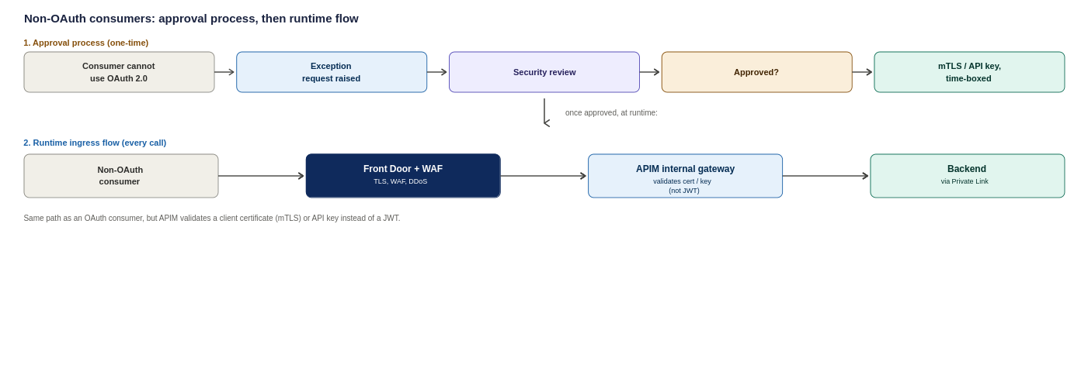
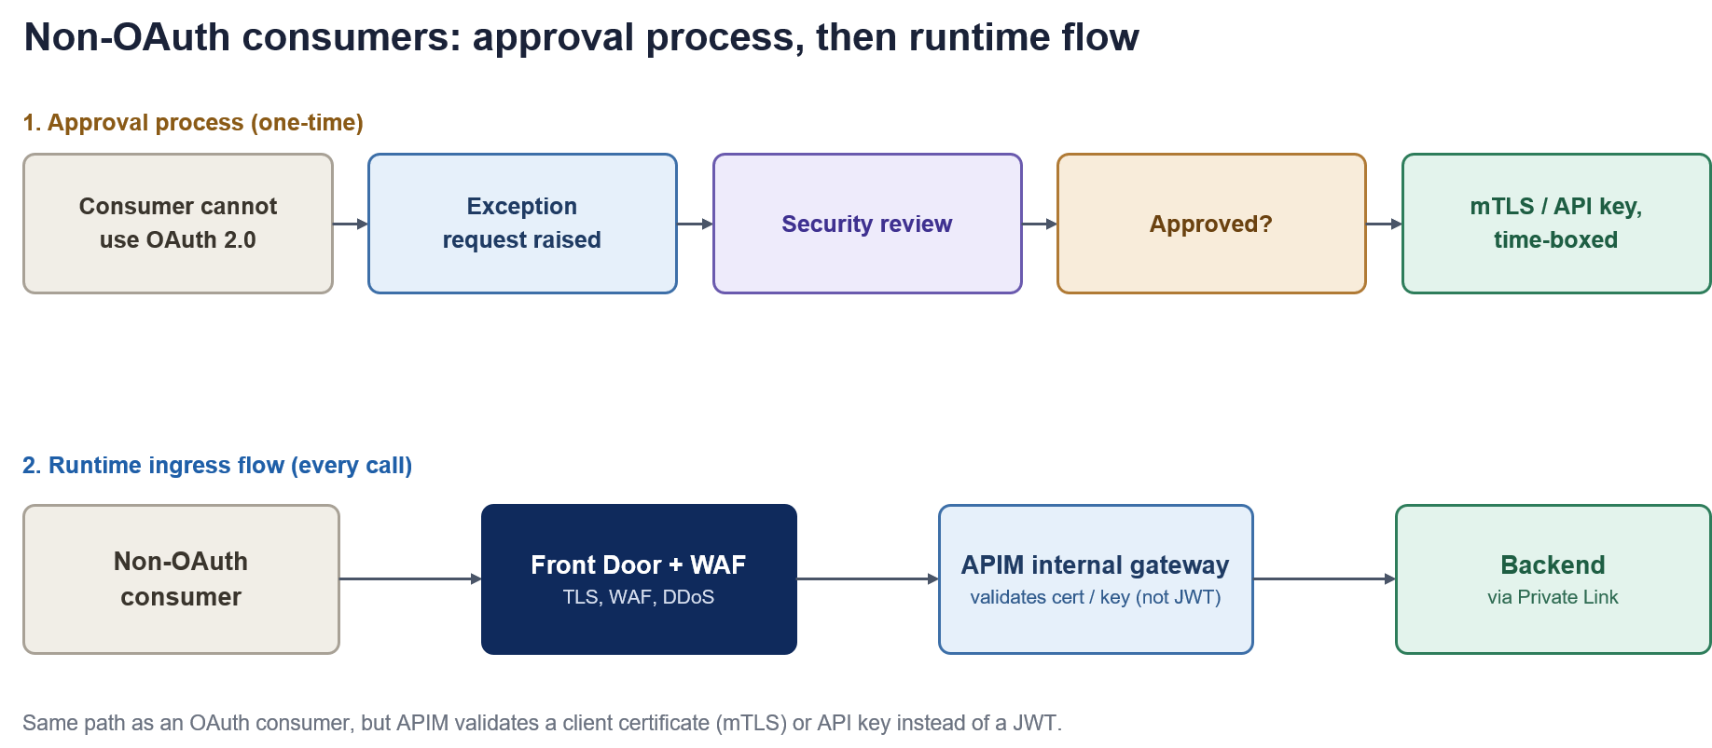
Figure 11: Non-OAuth consumers, the one-time approval process and the resulting runtime ingress flow
How each consumer type proves who they are
Consumer | Primary Authentication Method | Secondary / Compensating Control
External partner | OAuth 2.0 token issued by Entra ID and validated at APIM | Subscription key, IP allow-list where fixed egress IPs exist
Internal Organization system | Managed Identity (no stored credentials) | Entra ID conditional access on the calling service
Inbound webhook from a vendor | Shared secret header, checked against Key Vault | IP allow-list restricting the source range

Partner and External Identity
The Organisation's external consumers include brokers, market participants, strategic partners, suppliers and third-party service providers. Authentication and onboarding approaches may vary by consumer type and technical capability.
- Preferred approach: External organisations are represented through Microsoft Entra External ID (B2B) using partner-specific application registrations and controlled access assignments.
- Approved alternatives: Where Entra-based integration is not supported, approved federated identity, OAuth 2.0, mTLS, HMAC-signed requests or other approved authentication mechanisms may be used through the exception process.
- Governance requirement: Partner onboarding, application registration, credential and certificate lifecycle management, access reviews, rotation and revocation responsibilities must be defined and owned by the appropriate Identity and Access Management function before implementation.

Identity Resilience and Break-Glass
The platform relies heavily on Entra ID and must remain operational during identity-service outages or administrative-access incidents. To support this, the following controls must be defined and maintained:
- Break-glass access: Emergency-access accounts with monitored and audited use, held outside normal access-management processes.
- Credential lifecycle monitoring :Proactive monitoring of certificate and secret expiry, including automated alerting.
- Partner credential revocation: Defined processes for partner credential suspension, rotation and revocation.
Application registration ownership: Clear ownership and lifecycle management for application registrations and associated identities.

Control Responsibilities
Security is implemented as a layered model in which each control addresses a specific concern and no single control is load-bearing. The principal controls and their responsibilities are:
- Microsoft Entra ID. Identity and authentication of callers and administrators.
- Azure Front Door with WAF. Perimeter and edge protection — OWASP, TLS and DDoS — for external traffic.
- APIM gateway policies. Schema validation, scope authorisation, rate limiting and throttling on every call.
- Network isolation. Private Link and internal VNet injection ensure traffic travels only over private paths.
- Azure Key Vault. Custody of secrets and certificates, retrieved by the gateway at runtime.
The overall security posture depends on the combined operation of all controls. The detailed security model is set out in Section 8.1.

Authentication
This is the detailed token exchange behind the authentication step referenced in sections 5.3 and 5.4, shown here as the standard OAuth 2.0 sequence APIM enforces on every call.
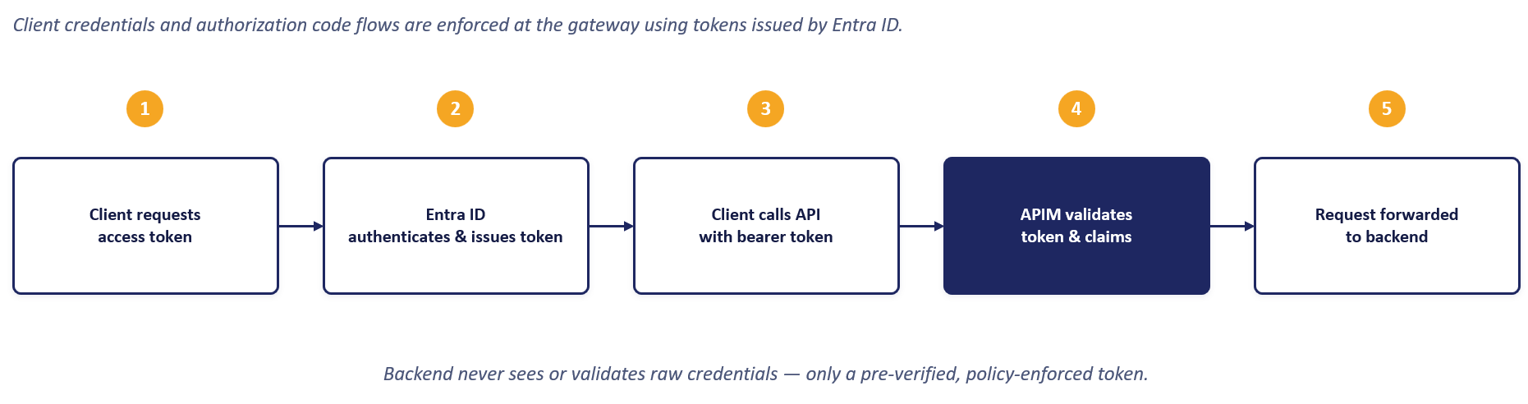
Token validation is performed independently of client authentication. APIM validates incoming JWT bearer tokens against the configured issuer, audience, signature and expiry requirements before the request is processed.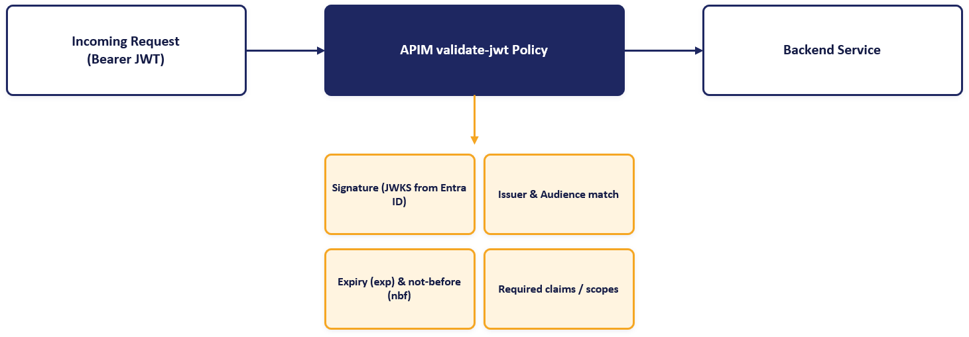
Microsoft Entra ID provides the foundation for platform identity and access management. It supports client authentication, application registration, token issuance, administrative access control and the managed identities used by APIM to securely access backend services and Azure Key Vault.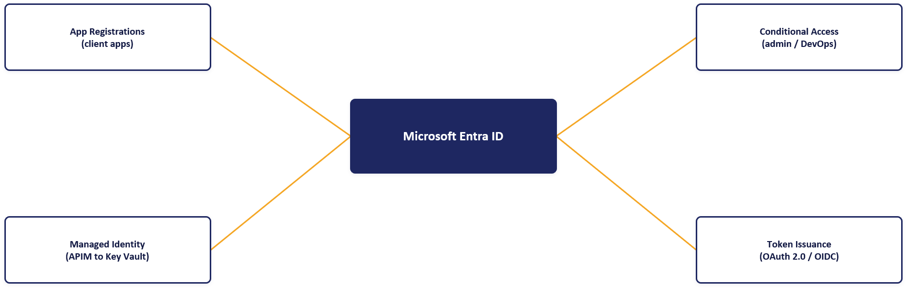

Authorisation Boundary
Authentication establishes who the caller is; authorisation determines what they may access. Authorisation is enforced at the gateway: the validated token's scopes and claims are checked against the requirements of the requested API and operation, and the caller's subscription determines which product's APIs they may call and under what rate limits and quotas.
Access is secure and deny-by-default: an API is not reachable by a consumer until their Entra ID group has been granted visibility of the relevant product and a subscription has been issued. The product, subscription and group model is detailed in Section 9.

Administrative Access
These three principles extend the access models above to every call, including internal traffic, which is never trusted by default.
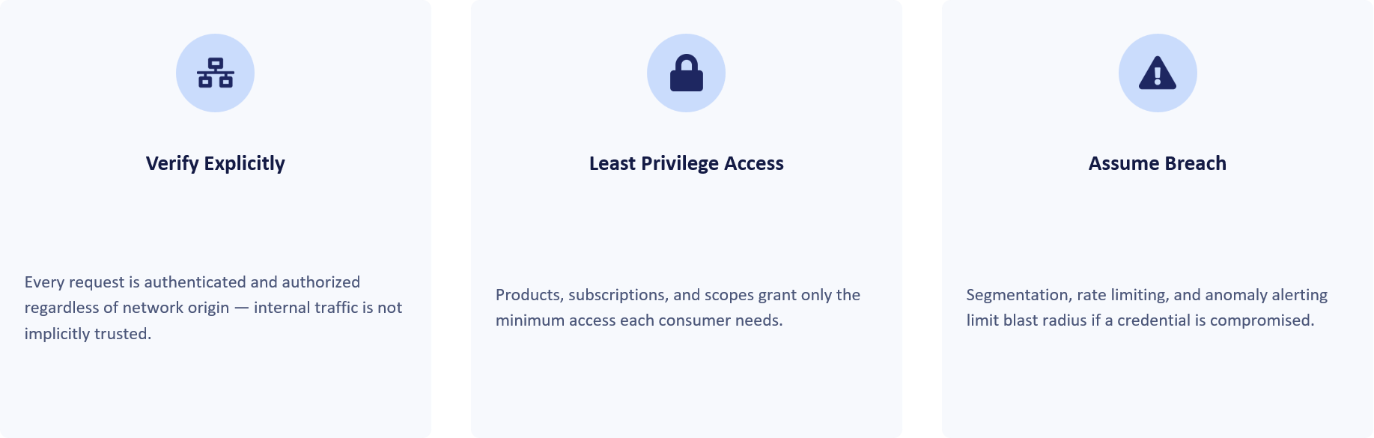

Secrets and Certificates
The preferred implementation is that APIM does not store application secrets locally. Required certificates, keys and credentials are retrieved from Azure Key Vault at runtime using the APIM managed identity.
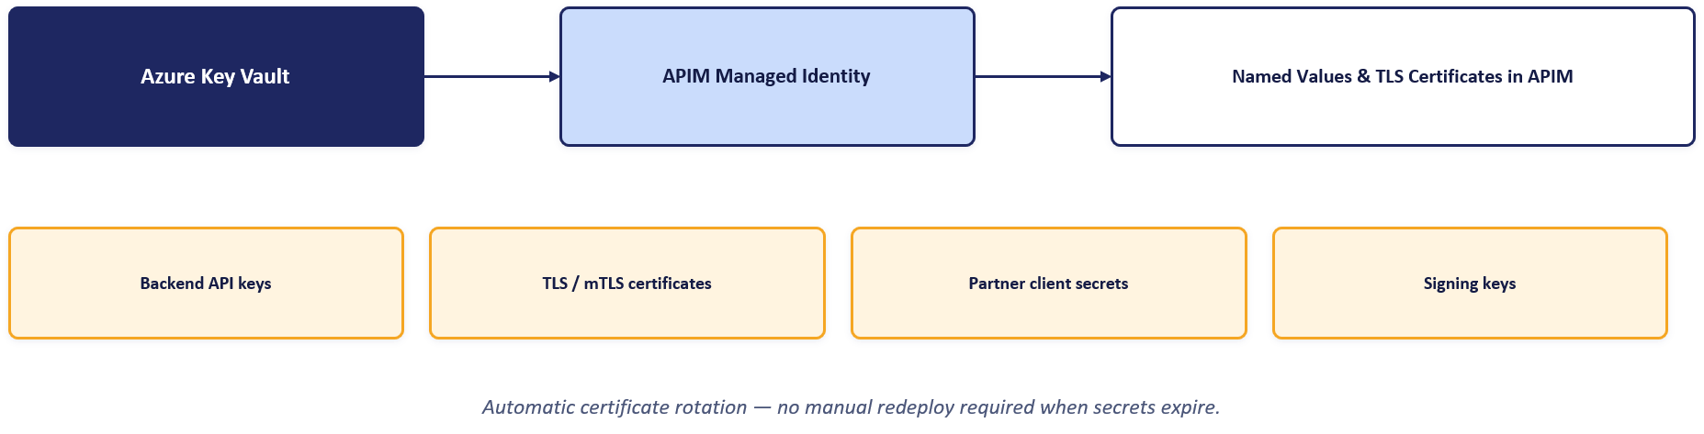

Data Classification and Logging
Because the gateway processes bearer tokens, sensitive header claims and business payloads, strict data-handling rules apply across all environments. The platform position enforces three tenets:
- Classify at onboarding. Data sensitivity is classified when an API is onboarded, determining its logging and handling requirements.
- No body logging by default. Request and response body logging is disabled by default and enabled only where explicitly justified.
- No PII in telemetry. Authorization headers and personally identifiable information are redacted before telemetry is logged, keeping monitoring data free of secrets and personal data.
Retention of logs is aligned to Chaucer's logging, security and compliance standards, as set out in Section 13.

Non-OAuth Exceptions
OAuth 2.0 with Microsoft Entra ID is the default authentication standard. Where a partner cannot support this approach, an approved exception may be granted through a defined process. Exceptions must be documented, risk-assessed, supported by compensating controls (such as mutual TLS, IP allow-listing or HMAC-signed requests), time-bound, and subject to periodic review.
The exception approval process and the resulting runtime ingress handling are set out with the security model in Section 8.1.

External Identity
External consumers are known partner organisations rather than anonymous members of the public, so the external identity default is Microsoft Entra External ID (B2B), using partner-specific application registrations and controlled access assignments. Azure AD B2C is not used, as it is no longer available for new deployments and B2B is the correct model for partner organisations.
Partner onboarding, application registration, credential and certificate lifecycle management, access reviews, rotation and revocation must be owned by the appropriate Identity and Access Management function. Where Entra-based integration is not supported, approved alternative mechanisms may be used through the exception process in Section 8.8.

API Products, Consumers and Developer Portal

Governance Model
API platform governance requires clear separation of ownership while maintaining centralised visibility and control. Workspaces provide logical isolation between teams, while products, subscriptions and Microsoft Entra ID groups control API exposure, access and administration. This approach enables decentralised API ownership within a centrally governed platform.
Choosing each layer: a clear strategy for Products, Consumers and the Portal
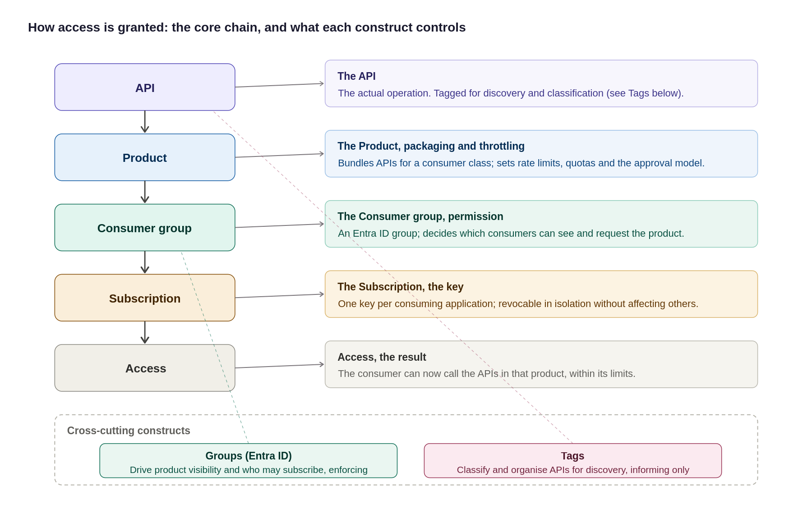
Figure 17: The access model, the core chain plus what each construct controls, including Groups and Tags
In summary:
Layer | Purpose | Recommended Approach
Product | Which APIs a consumer can access and under what controls | Group APIs into products by consumer type. Apply policies, quotas and approval controls at product level.
Consumer / subscription | How access is granted, managed and revoked | Use Entra ID groups for organisational ownership and separate subscriptions per consuming application. Avoid local APIM users.
Developer portal | How consumers discover, subscribe to and test APIs | Enable SSO, disable self-registration and expose APIs through a governed product catalogue with controlled visibility.

The diagram below illustrates the APIM governance hierarchy and access model. APIs are grouped into products, consumers are authorised through subscriptions, and access is governed through Microsoft Entra ID groups and RBAC controls..
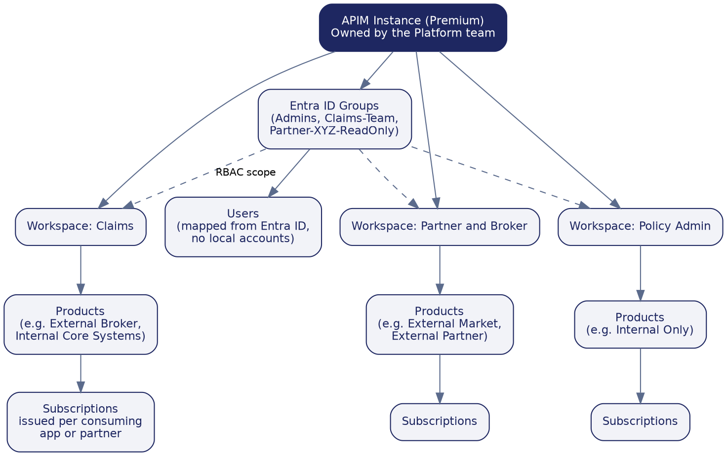
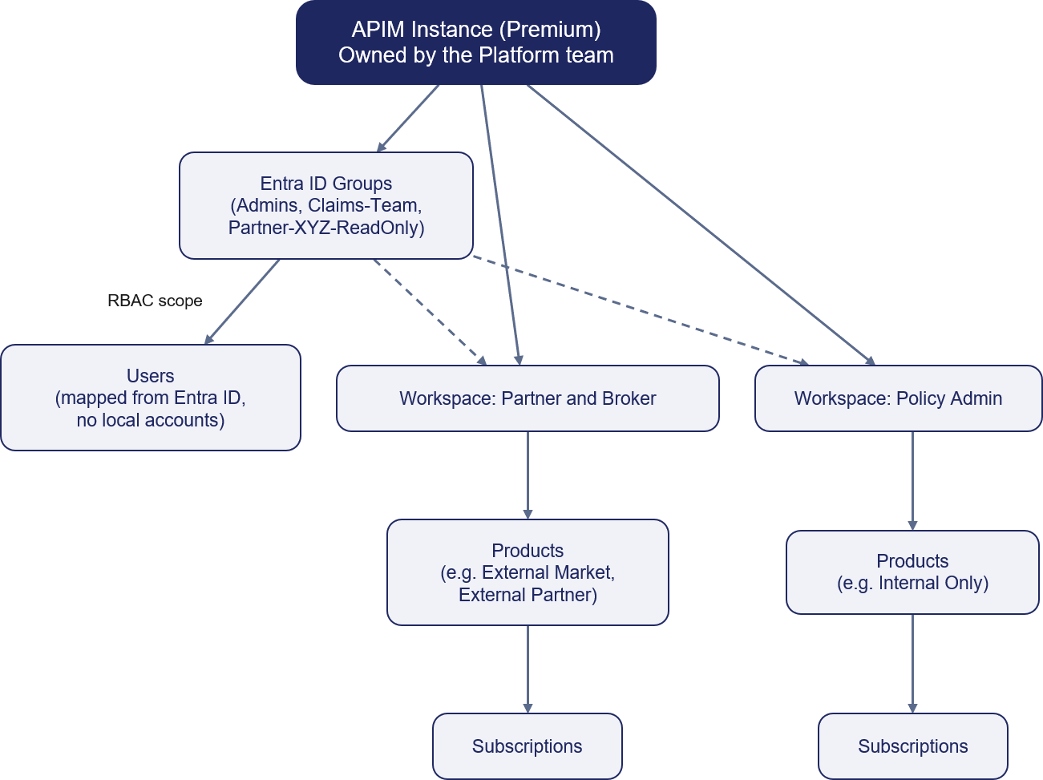
Figure 18: Recommended workspace, product, subscription, and group structure

Products, subscriptions, groups and users
- Products group related APIs and define access, subscription and policy boundaries for a consumer class..
- Subscriptions are issued per consuming application or partner, allowing access to be managed, rotated or revoked independently..
- Groups map to Microsoft Entra ID groups and control visibility and access to APIs and products.
- Users are authenticated through Microsoft Entra ID. APIM access is governed through group membership and the organisation's existing identity lifecycle processes..
Governance Construct | Core Purpose & Architectural Behaviour | Key Governance Rule & Enforcement
Backends | Abstracts downstream target URLs and centralizes runtime resilience rules (circuit breaking, load balancing, retries). | Target URLs and health check policies are managed centrally outside individual API definitions.
Named Values | Provides APIM's key-value store for plain settings (URLs, limits) and Key Vault-backed secret references. | Zero secrets hard-coded in policies. All secrets use Key Vault integration and are version-controlled via APIOps.
Policies | Enforces execution logic, transformations, authentication, and rate limits at global, product, or API scopes. | Policies reference Named Values for config; product-level policies enforce class-wide rules once.
Products | Group APIs into consumable offerings with common access and subscription controls. | Consumers subscribe to products rather than individual APIs.
Groups | Controls visibility and subscription access to Products based on user membership. | Custom groups map strictly to Microsoft Entra ID. No local user accounts are created inside APIM.
Tags | Provide categorisation, discovery and reporting metadata. | Tags support discovery and governance only and do not influence runtime behaviour.

How the Governance Constructs Fit Together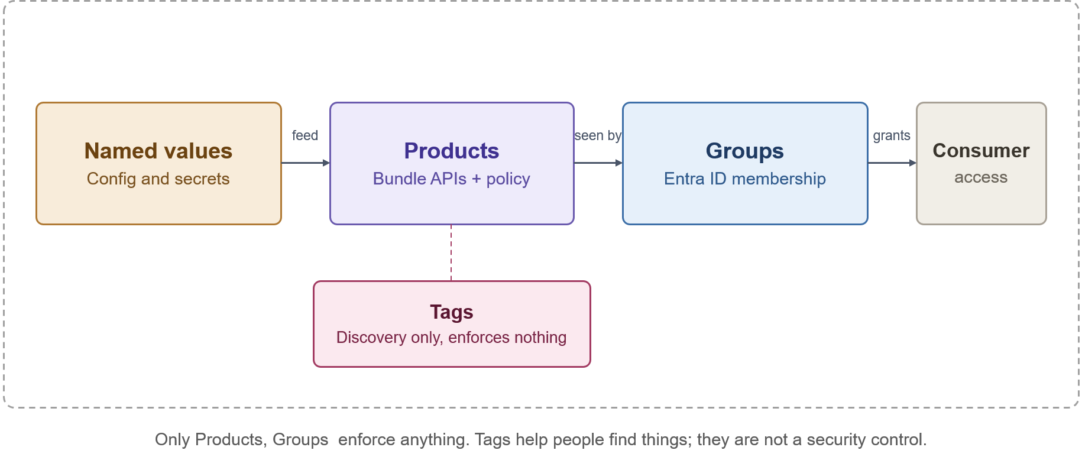
How the governance constructs relate to each other

Developer Portal Purpose
Purpose
The Azure APIM Developer Portal serves as the primary self-service interface for API consumers, publishing and automatically generated catalogue, interactive documentation, testing consoles, and automated subscription workflows. Its core objective is zero-touch onboarding—enabling internal and external developers to discover and adopt APIs without manual support tickets.
The platform distinguishes between two operational roles:
- API Publishers (Platform & Internal Teams): Operate exclusively via APIOps pipelines to deploy APIs, products, and policies into the management plane.
- API Consumers (Developers & Partners): Interact strictly through the Developer Portal to consume documentation, manage subscriptions, and generate access keys.
Reference architecture
The Developer Portal is hosted independently as a managed web application and is completely isolated from the gateway runtime path:
- Catalogue Publishing: The APIM management plane dynamically projects published APIs, schemas, and products onto the portal interface.
- Identity & Access Control: Authentication delegates directly to Microsoft Entra ID for internal workforce users and Entra ID B2B for external partners.
- Runtime Isolation: The portal handles metadata and subscription lifecycle only. Once a subscription key is issued, consumer application traffic bypasses the portal entirely, invoking the APIM Gateway directly where policy enforcement and security controls occur.

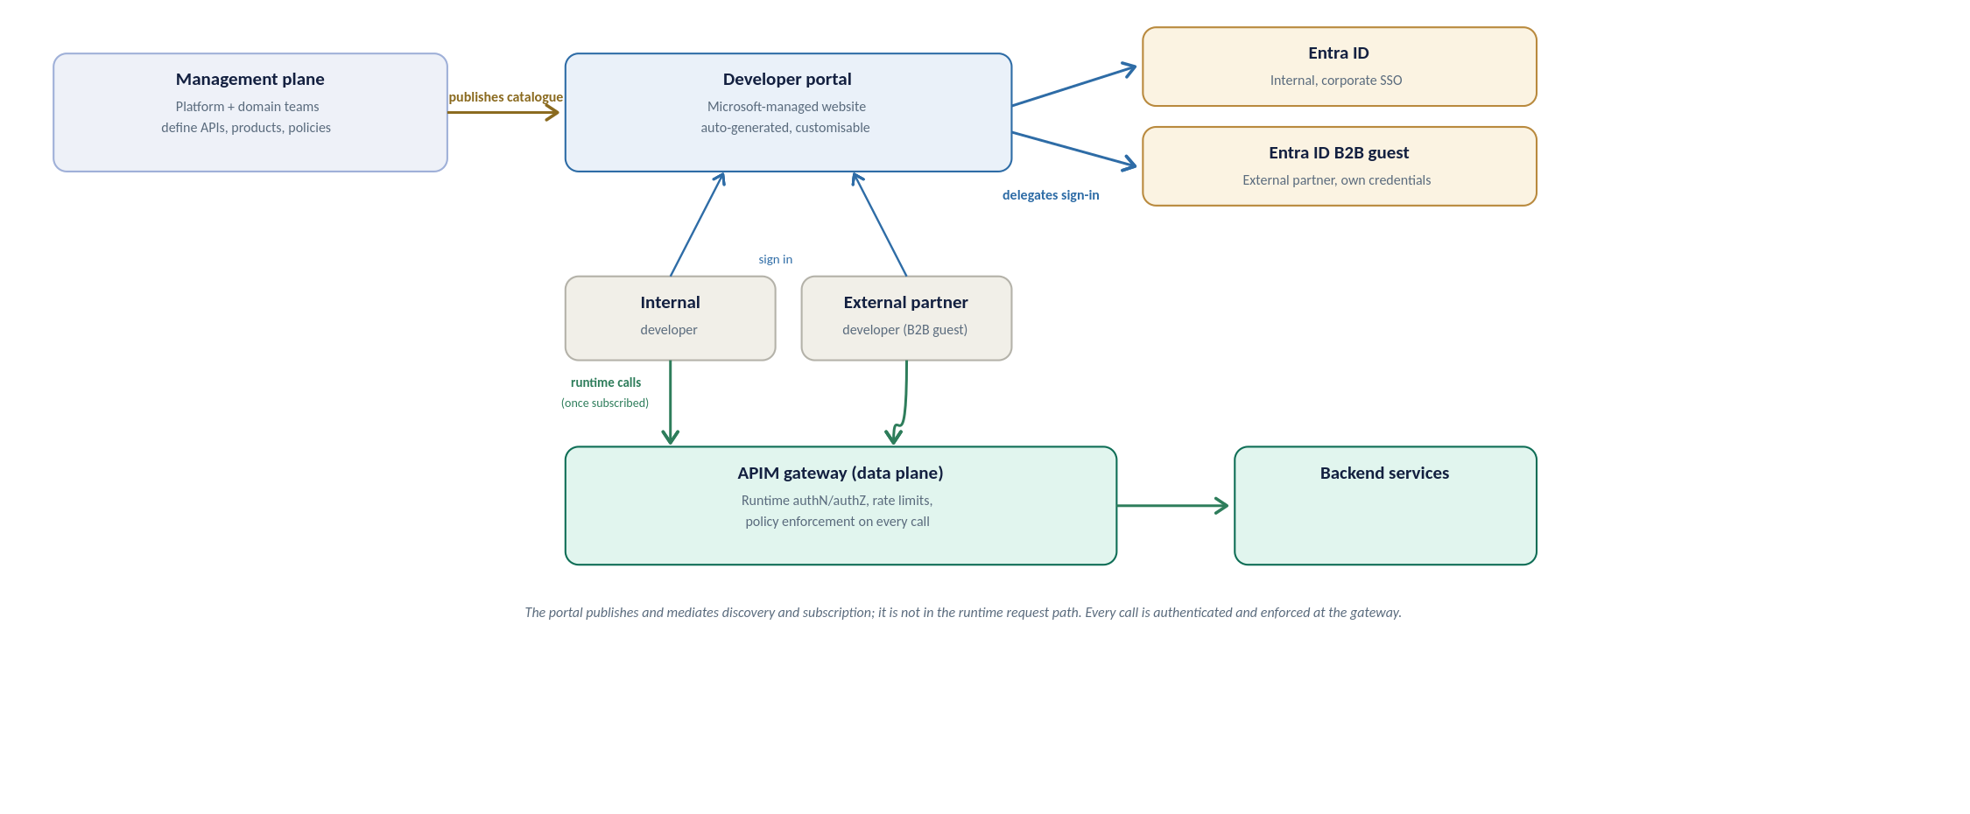
Developer portal reference architecture, how the portal relates to the management plane, identity providers, and the runtime gateway
API discovery strategy
Discovery is deliberately curated, not a raw API list. Three rules shape what a developer finds:
- Visibility follows identity: the portal shows only the products a signed-in developer’s Entra ID group permits, so a broker sees broker products and never an internal-only API.
- Grouping is by product, not raw API: a developer opens a product tile (for example External Broker), sees the APIs it bundles, and subscribes to the product as a unit; the subscription then works across every API in it.
- Tags are the search axis: consistent tags (section 10) let developers filter and search a growing catalogue, and each API page carries its operations, request and response schemas, and an interactive console for trying a call.
Built-in roles and RBAC
Two separate layers of access apply to the portal: who can see and use it as a consumer, and who can administer or publish its content. Neither creates a local account; both resolve back to Entra ID, consistent with the access model set out above.
Portal groups: who can see and use the portal
Group | Membership | What it grants
Administrators | Azure subscription administrators (system-managed) | Manages the APIM service and defines APIs, products and policies; not a consumer-facing role
Developers | Every signed-in, authenticated portal user (system-managed) | Base authenticated access; which products they actually see still comes from their Entra ID group
Guests | Anonymous portal visitors (system-managed) | Read-only browse of products marked visible to Guests; cannot subscribe or call an API
Custom / Entra ID groups | One per consumer class, for example Claims-Team or Partner-XYZ | Scopes visibility to the products that class of consumer may see, per the access model set out above

RBAC for administering portal content
Customising or publishing the portal is a service-administration action, controlled through Azure RBAC rather than the portal groups above.
Role | Scope | Use
API Management Developer Portal Content Editor | APIM service | Customise, edit and publish developer portal content; no API or service administration rights
API Management Service Contributor | APIM service | Full administration of the service and every entity; reserved for the platform team (see the RBAC set out in section 10), not for portal content editors

Configuration is two steps: grant a consumer's Entra ID group visibility on the relevant product, as set out above, so they can see and subscribe to it; and assign the Developer Portal Content Editor role to the named content owner so they can maintain the portal itself without broader service rights.
User onboarding flow
Ownership differs by direction, so the path is set out separately below for internal and external consumers; Figure 20 shows the shared journey once access has been granted.
Internal user onboarding
- Request: the consumer's manager or the team identifies the product needed.
- Group membership: the user is added to the relevant Entra ID group through the Organization's existing joiner-mover-leaver process; no APIM account is created.
- Sign-in: the user signs into the developer portal with corporate SSO and is automatically a Developer.
- Discover and subscribe: they see only the products their group permits; internal products are typically auto-approved.
- Credentials: a subscription key is issued, and OAuth-protected calls use a token obtained from Entra ID.
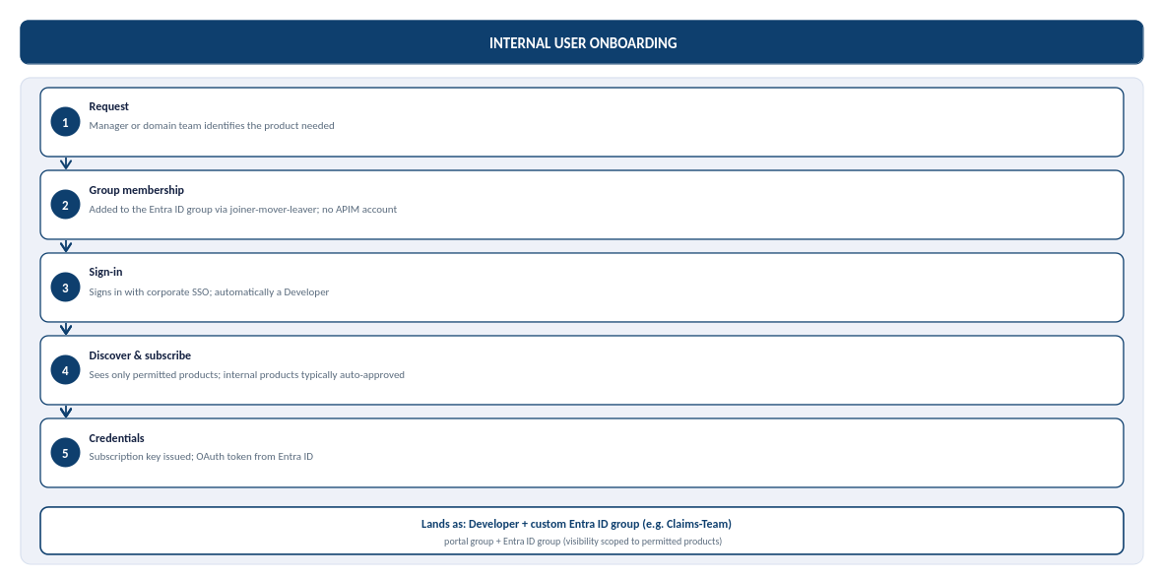
Figure 19b: Internal user onboarding, from request to credentials, and where the user lands in the portal groups
External user onboarding (partner, B2B)
The Organization's external identity default is Microsoft Entra External ID (B2B) for partner organisations, not Azure AD B2C: B2C is no longer available for new deployments, and Microsoft's current recommendation for consumer-facing sign-up is Microsoft Entra External ID. B2B is the correct model here because every external consumer is a known partner organisation, not an anonymous member of the public.
- Sponsorship: a named internal owner sponsors the partner and confirms which product they may access.
- Guest invitation: the partner user is invited as a Microsoft Entra ID B2B guest, authenticating with their own organisation's credentials rather than an organization-issued account.
- Group membership: once the invitation is redeemed, the guest identity is added to a per-partner Entra ID group, scoping visibility to that partner's product only.
- Sign-in and subscribe: the partner signs into the developer portal through B2B guest SSO and requests a subscription; external subscriptions are gated by approval, not automatic.
- Credentials: on approval, a subscription key is issued and, for OAuth-protected APIs, the partner's registered application obtains a token from Entra ID.
Partner sponsorship and credential-rotation ownership are not yet named, alongside the related gaps below.
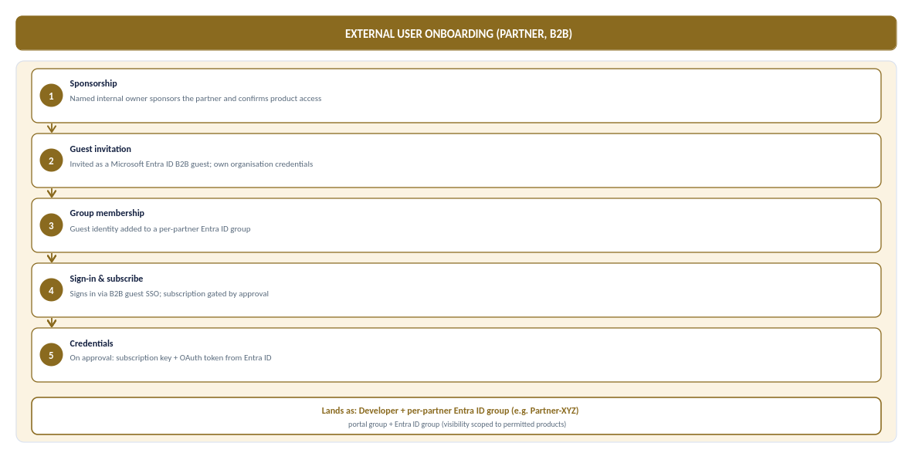
Figure 19c: External (partner, B2B) user onboarding, from sponsorship to credentials, and where the partner lands in the portal groups
In steady-state production the same consumer calls the API through APIM, where JWT validation and per-subscription rate limits and quotas are enforced on every call, and manages their own subscriptions and key rotation from the portal profile area without an organization ticket. The full journey, from access granted to steady-state use, is shown below.
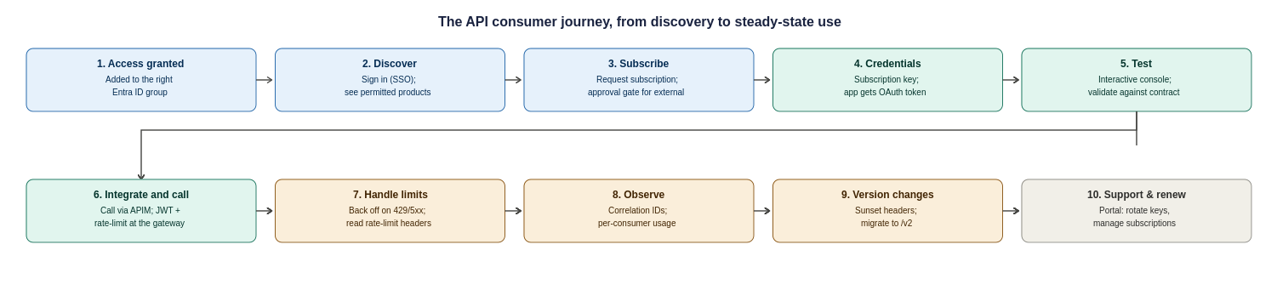
Figure 20: The API consumer journey, ten steps from access granted to steady-state use, support and versioning
Two responsibilities sit with the Organization to make this journey real, and are recorded as operational tasks in the assumptions register: a named owner for approving external subscription requests within an agreed SLA, and a defined support and escalation path (who a partner contacts when a call fails, and how correlation IDs are used to resolve it).

Portal Access Model
Access to the developer portal resolves back to Microsoft Entra ID; the portal creates no local accounts. Two layers of access apply: who can see and use the portal as a consumer, and who can administer or publish its content.
- Visibility follows identity. A signed-in developer sees only the products their Entra ID group permits — a broker sees broker products and never an internal-only API.
- Consumers. Internal users authenticate with corporate SSO; external partners authenticate as Entra External ID (B2B) guests with their own organisation's credentials.
- Content administration. Customising or publishing portal content is controlled through Azure RBAC (the Developer Portal Content Editor role), separate from consumer visibility.
The governance model and access chain are detailed in Section 9.1.

Portal Deployment and Hosting
The developer portal is hosted as the Microsoft-managed portal and is isolated from the gateway runtime path. The management plane dynamically projects published APIs, schemas and products onto the portal; the portal itself handles only metadata and the subscription lifecycle.
Once a subscription key is issued, consumer application traffic bypasses the portal entirely and calls the APIM gateway directly, where policy enforcement and security controls apply. Portal configuration is managed as code through the APIOps pipeline, consistent with the rest of the platform.

Internal Onboarding
Internal consumer onboarding follows the organisation's existing joiner-mover-leaver process and creates no APIM account:
- Request. The consumer's manager or team identifies the product needed.
- Group membership. The user is added to the relevant Entra ID group through the existing identity process.
- Sign-in. The user signs into the developer portal with corporate SSO and is automatically a Developer.
- Discover and subscribe. They see only the products their group permits; internal products are typically auto-approved.
- Credentials. A subscription key is issued, and OAuth-protected calls use a token obtained from Entra ID.

Partner Onboarding
Partner (B2B) onboarding is sponsored and gated by approval rather than automatic:
- Sponsorship. A named internal owner sponsors the partner and confirms which product they may access.
- Guest invitation. The partner user is invited as an Entra ID B2B guest, authenticating with their own organisation's credentials.
- Group membership. Once the invitation is redeemed, the guest is added to a per-partner Entra ID group, scoping visibility to that partner's product only.
- Sign-in and subscribe. The partner signs in through B2B guest SSO and requests a subscription; external subscriptions are gated by approval.
- Credentials. On approval, a subscription key is issued and, for OAuth-protected APIs, the partner's registered application obtains a token from Entra ID.

Portal Open Questions
The following portal-related responsibilities require a named owner before external onboarding begins and are tracked in the assumptions and RAID registers:
- External subscription approval. A named owner for approving external subscription requests within an agreed SLA.
- Partner sponsorship and credential rotation. Ownership of partner sponsorship and of credential and certificate rotation and revocation.
- Support and escalation. A defined support and escalation path for partners, including how correlation IDs are used to resolve failed calls.

API Design, Policies and Lifecycle

Standards Relationship
This section complements existing Chaucer Engineering Standards and Cloud Adoption Framework (CAF) guidance and highlights the controls most relevant to APIM. Where any conflict exists, approved enterprise standards take precedence.
Further guidance is available in the Chaucer Engineering Standards and API Governance documentation on Confluence : APIM-Engineering-Standards

API Contract
Every API is defined by an OpenAPI contract that serves as the single source of truth for its operations, request and response schemas, and error responses. The contract is version-controlled and deployed through the APIOps pipeline, and is projected onto the developer portal for discovery and testing.
API contracts follow Chaucer's engineering standards for naming, versioning and schema design. Detailed contract standards are maintained in the Chaucer Engineering Standards and API Governance documentation.

Policy Hierarchy
APIM policies are applied in a hierarchy, with each level inheriting from the one above and able to extend it. This allows platform-wide controls to be enforced centrally while individual APIs add their own behaviour:
- Global (all APIs). Baseline controls applied to every call — correlation ID propagation, base security headers and platform-wide defaults.
- Product. Controls applied to all APIs in a product — typically the subscription rate limits and quotas for that consumer class.
- API. Controls specific to an API — JWT validation parameters, backend routing and transformation.
- Operation. Controls specific to a single operation, where finer-grained behaviour is required.
Policies are maintained as code and deployed through the pipeline; they are not edited directly in the portal except through approved emergency procedures.

Mandatory Policy Capabilities
The following policy capabilities are mandatory across the platform and enforced at the appropriate level of the hierarchy:
- Authentication and token validation. JWT validation (signature, issuer, audience, expiry and required claims) on protected APIs.
- Rate limiting and quotas. Per-subscription rate limits and quotas to protect backends and ensure fair use.
- Schema validation. Validation of requests against the API's OpenAPI contract where enabled.
- Correlation. Propagation of a correlation identifier on every call for end-to-end tracing.
- Secret handling. Use of Key Vault-backed named values for any credential; no secrets in policy configuration.
- Logging controls. Redaction of sensitive data and suppression of body logging by default.

Lifecycle and Versioning
Every API follows a standard lifecycle from design through retirement, ensuring consistent governance, security and operational management. The lifecycle aligns with Chaucer's engineering standards and API governance practices, with operational insights and monitoring data feeding future enhancements and design decisions.
Further guidance on API delivery, governance and lifecycle management is available in the Chaucer Engineering Standards and API Governance documentation on Confluence: API Life cycle
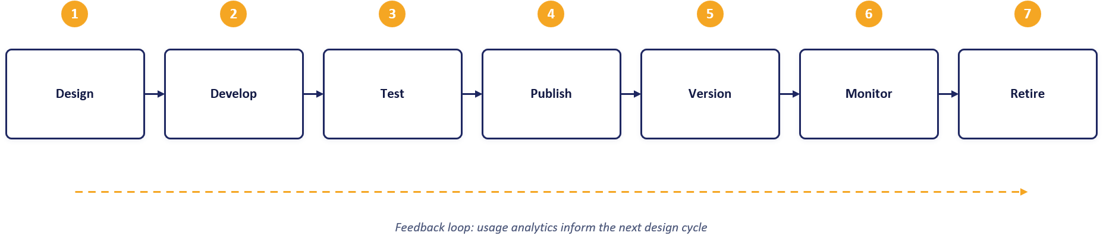

Environments, APIOps and Release Management

Environment Model
Environment | Service tier | Target SLA | Purpose
Dev | Developer | None (No SLA)) | Functional API policy development, mock backend testing, and automated pipeline builds at minimum cost. Non-production evaluation tier.
SIT | Developer | None (No SLA) | Functional API policy development, mock backend testing, and automated pipeline builds at minimum cost. Non-production evaluation tier.
UAT | Premium V2 | 99.95% | Pre-production business sign-off and user acceptance. Guarantees complete architectural parity with Production (VNet Injection, Private Endpoints, isolated networking) on a single scale unit.
Production | Premium V2 | 99.95% | Live customer traffic, high availability. Deployed across 2 Availability Zones (Silver Tier) with dynamic autoscaling based on gateway CPU/Memory load

The platform environment strategy uses four distinct environments: Dev, SIT, UAT, and Production.
- Dev and SIT: Provisioned on the cost-effective Developer tier to support functional API policy development, mock testing, and automated integration pipeline builds at minimal cost.
- UAT: Provisioned on Premium v2 (1 scale unit) to ensure complete pre-production architectural and network parity (VNet Injection, Private Endpoints) with Production, providing a supported, SLA-backed platform for business sign-off and user acceptance testing.
- Production: Provisioned on Premium v2 with Zone Redundancy enabled (Silver Tier across 2 Availability Zones) for live customer traffic, maximum platform availability, and dynamic autoscaling capabilities.
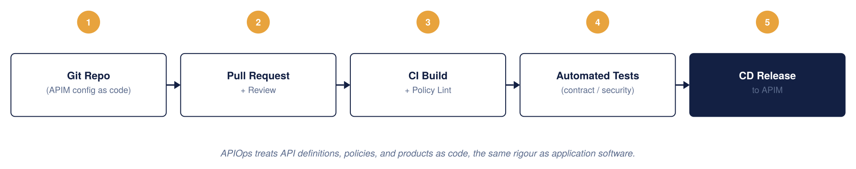
APIM CI/CD model, APIOps
APIOps Tooling and Deployment Pipeline
This design adopts an APIOps operating model, aligned to Chaucer's existing Azure delivery approach and platform engineering standards.
- Infrastructure as code: Terraform is used to provision and manage APIM, networking, Front Door, Key Vault and supporting Azure resources. Environment-specific behaviour is controlled through approved configuration and parameterisation rather than separate infrastructure definitions..
- Configuration as Code: APIM APIs, products, policies, named values and related configuration are maintained in source control and deployed through automated pipelines. Configuration is managed as code rather than through manual changes in the Azure portal
- Source Control and CI/CD: Azure Repos provides source control, with Azure DevOps Pipelines used for build, validation and deployment. All changes are subject to pull-request review and approval prior to deployment..
- Environment promotion: Changes are deployed to Development through the CI/CD pipeline and promoted through SIT, UAT and Production using the same approved artefacts. Production deployments are governed through approval gates and change management processes

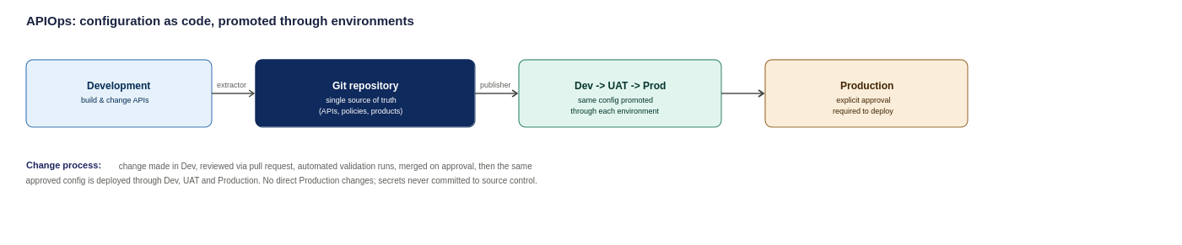
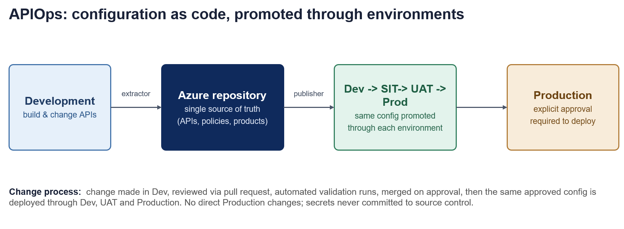
APIOps deployment pipeline, from development through to production

Configuration Management & Security Principles

Environment-Specific Settings
Environment-specific configuration (e.g., backend endpoints, rate-limit thresholds, and timeout values) are managed via environment-specific configuration files. API schemas, OpenAPI specs, and XML policies remain identical across all deployment stages.

Security Baseline
- Secrets Governance: Credentials, certificates and keys are stored in Azure Key Vault and referenced securely during deployment and runtime.; zero plain-text secrets are committed to source control.
- Least Privilege: APIOps deployment identities use scoped Workload Identity / Service Principal credentials with minimal required Azure RBAC roles.
- Pipeline Enforcement: Production changes are deployed exclusively through approved CI/CD pipelines. Direct portal modifications are not permitted except through approved emergency procedures.
- Emergency Override: Direct production portal access is restricted to time-bound Emergency Administrative Access (via Azure PIM) and is reserved strictly for pipeline outages.
Repository Structure
The APIOps repository maintains a single, standardized layout containing:
- APIs/ OpenAPI definitions and endpoint configurations
- Policies/ Inbound, outbound, backend, and error XML policies
- Products/ —API product groupings and subscription key settings
- NamedValues/ APIM-level global properties and Key Vault references
- Backends/ Gateway backend target pool definitions
- Environments/ —Environment-specific config mapping files (Dev, SIT, UAT, Production)
- Pipelines/ CI/CD deployment workflow and validation scripts
Configuration is promoted through Dev $→$ SIT $→$ UAT $→$ Production via automated promotion gates, ensuring consistency across environments.

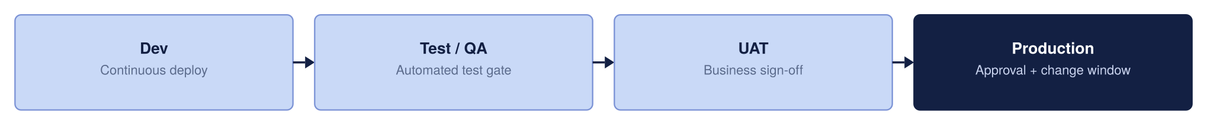
Environment promotion strategy

Toolchain
The APIOps toolchain is aligned to Chaucer's existing Azure delivery approach:
- Infrastructure as code. Terraform provisions and manages APIM, networking, Front Door, Key Vault and supporting Azure resources, with environment-specific behaviour controlled through parameterisation.
- Configuration as code. APIM APIs, products, policies and named values are maintained in source control and deployed through automated pipelines.
- Source control and CI/CD. Azure Repos provides source control; Azure DevOps Pipelines are used for build, validation and deployment, with pull-request review and approval before deployment.

Delivery Controls
Delivery is governed by a defined set of controls across the pipeline:
- Environment promotion. Changes are deployed to Development and promoted through SIT, UAT and Production using the same approved artefacts.
- Approval gates. Production deployments are governed through approval gates and change-management processes.
- Least privilege. Deployment identities use scoped credentials with the minimum required Azure RBAC roles.
- No manual changes. Direct portal modifications are not permitted except through approved, time-bound emergency access.

Quality Gates
Changes pass through quality gates before promotion to ensure consistency and safety:
- Validation. API definitions, policies and configuration are validated automatically in the pipeline.
- Static security analysis. Configuration is checked for policy and security issues, including scanning for accidentally committed secrets.
- Peer review. All changes are subject to pull-request review and approval.
- Promotion gates. Automated promotion gates enforce that each stage's criteria are met before the next deployment.

Reliability, Backup and Disaster Recovery

Resilience Tiers
High Availability ensures the platform survives a datacentre failure within a region without disrupting users. By deploying APIM across independent Azure Availability Zones, traffic is automatically routed only to healthy zones.
Active-active multi-region deployment roughly doubles overall platform running costs, which is not justified for every API. To balance high availability with fiscal responsibility, resilience is tiered based on business criticality rather than paying a multi-region cost premium across the entire estate
Bronze (Single Region – Single Unit): Deployed in a single Azure region without secondary region or cross-zone failover. Service recovery relies on standard platform restoration processes, prioritizing cost efficiency for non-critical workloads where extended recovery times are acceptable.
Silver (Single Region – More Than 1 Unit): Preferred Baseline: Deployed within a single Azure region using multiple units distributed across Availability Zones (e.g., Zone 1 and Zone 2). This provides high intra-region capacity and local fault tolerance against underlying infrastructure or maintenance failures without incurring the cost and complexity of a secondary standby region.
Gold (Multiple Region – Multiple Units): Deployed across multiple Azure regions with multiple units provisioned in each region, offering geographic distribution, active load balancing, and cross-region failover for business-critical production services.

Resilience Tier | Deployment Topology | Architectural Scope | Operational Effect | Key Benefits | Architectural Trade-offs
Bronze | Single Region,  Single Unit | APIOps / IaC Git Config Recovery  Azure Front Door Anycast & WAF Edge | Environment can be completely rebuilt from code (near-zero config RPO).  DDoS and web attacks absorbed at the edge. | Minimizes platform infrastructure, licensing, and operational management costs. | No cross-zone or cross-region failover. Relies entirely on standard platform recovery procedures during outages.
Silver (Chosen Baseline & Production Standard) | Single Region,  Multiple Units (2 AZs) | Zone-Redundant APIM Gateway | Survives single physical datacentre loss within the region.  Traffic automatically routes around failed zones without manual intervention. | High intra-region availability and fault tolerance against local zonal/maintenance events. | Accepts an RTO window during a total regional outage in exchange for avoiding secondary-region running costs.
Gold | Multi-Region,  Multiple Units | Multi-Region Active-Active APIM (UK South / UK West)  Front Door Global Health Probes | Full regional disaster recovery.  Total UK South outage automatically routes traffic to UK West or another approved region with no client DNS changes. | Highest possible resilience tier with automated geographic failover and continuous multi-region availability. | High operational complexity; roughly doubles platform infrastructure and licensing costs.

Bronze and Silver run the primary region only, to keep cost minimal. Gold runs actively across both regions.
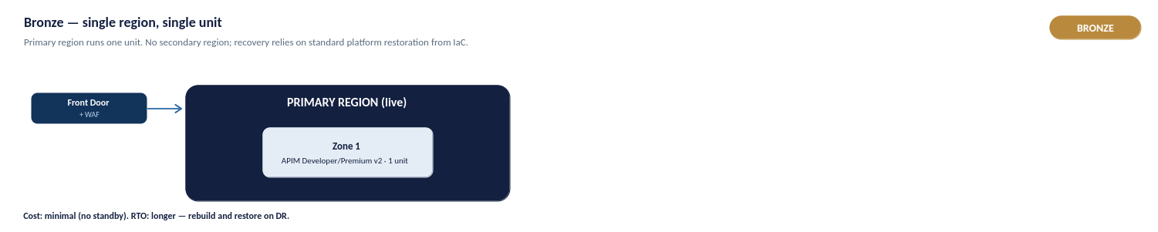
Figure 32a: Bronze — single region, single unit
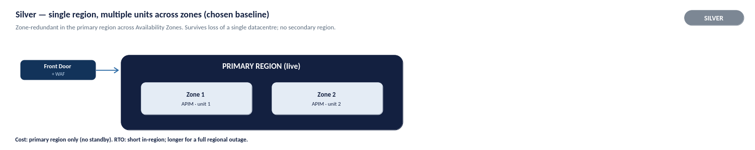
Figure 32b: Silver — single region, multiple units across zones (chosen baseline)
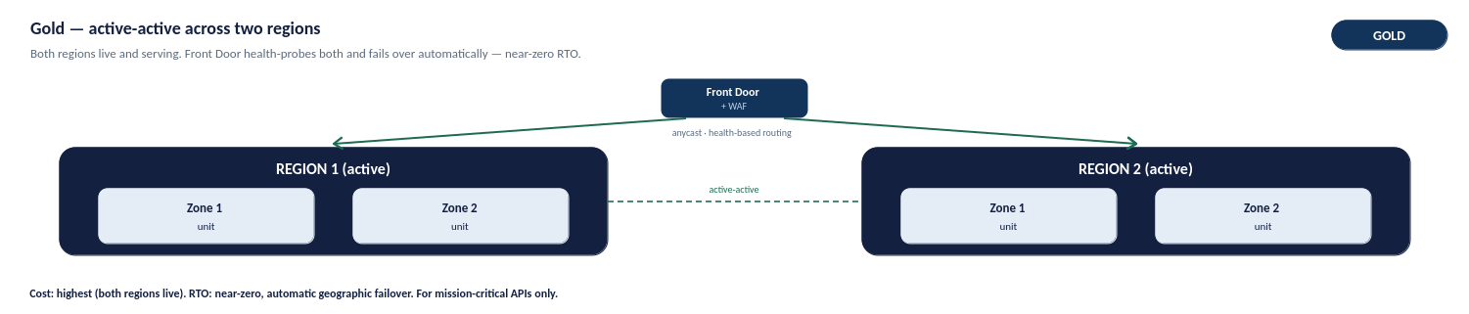
Figure 32c: Gold — active-active across two regions

Deployment-Unit Implication
Platform capacity and resilience scale with the number of provisioned units. The chosen Silver production baseline uses multiple units distributed across Availability Zones, so the loss of a single zone does not take the platform offline and traffic is automatically served by the remaining healthy zones.
For the conditional Gold tier, each active region must carry enough unit headroom to absorb the full peak workload during a single-region failover. Unit counts per environment are set out in the capacity and cost sections.

Backup, Restore and Rebuild
Because the platform is delivered entirely as code, its primary recovery mechanism is rebuild-from-code rather than conventional backup. The APIM configuration, policies, products and infrastructure definitions are held in source control, so an environment can be reprovisioned to a known-good state from the repository.
- Configuration recovery. APIM APIs, products, policies and named values are restored by redeploying the versioned configuration through the pipeline.
- Infrastructure recovery. The Terraform definitions reprovision the APIM instance, networking and supporting resources.
- Secrets and certificates. These remain in Azure Key Vault and are referenced at runtime, so they are not re-created as part of a configuration rebuild.

RTO and RPO
Recovery objectives differ by resilience tier. Because configuration is held as code, the configuration recovery-point objective is effectively near-zero — the last committed state can always be redeployed.
- Silver (production baseline). Zone failure is handled automatically within the region with no meaningful interruption. A total regional outage is recovered by deploying to the secondary region from code, accepting an extended recovery-time objective in exchange for not running a permanent standby region.
- Gold (conditional). Active-active across two regions provides automated geographic failover with a minimal recovery-time objective for the business-critical APIs that use it.
Specific RTO and RPO targets per API are agreed with the business during onboarding and validated through resilience testing.

Resilience Testing
Resilience is validated rather than assumed. The following should be exercised before and periodically after go-live:
- Zone-failure behaviour. Confirm that traffic continues to be served when a zone is unavailable.
- Regional failover. For Gold-tier APIs, confirm automated failover to the secondary region and the associated recovery times.
- Rebuild-from-code. Confirm that an environment can be reprovisioned from source control to a known-good state within the expected timeframe.
Resilience testing outcomes feed the RTO and RPO targets and the operational runbooks.

Observability and Operational Management

Monitoring Architecture
Azure Monitor provides a unified observability platform across APIM, policies and backend services. Application Insights delivers end-to-end tracing, Log Analytics stores diagnostic telemetry, and dashboards provide operational, security and management reporting..
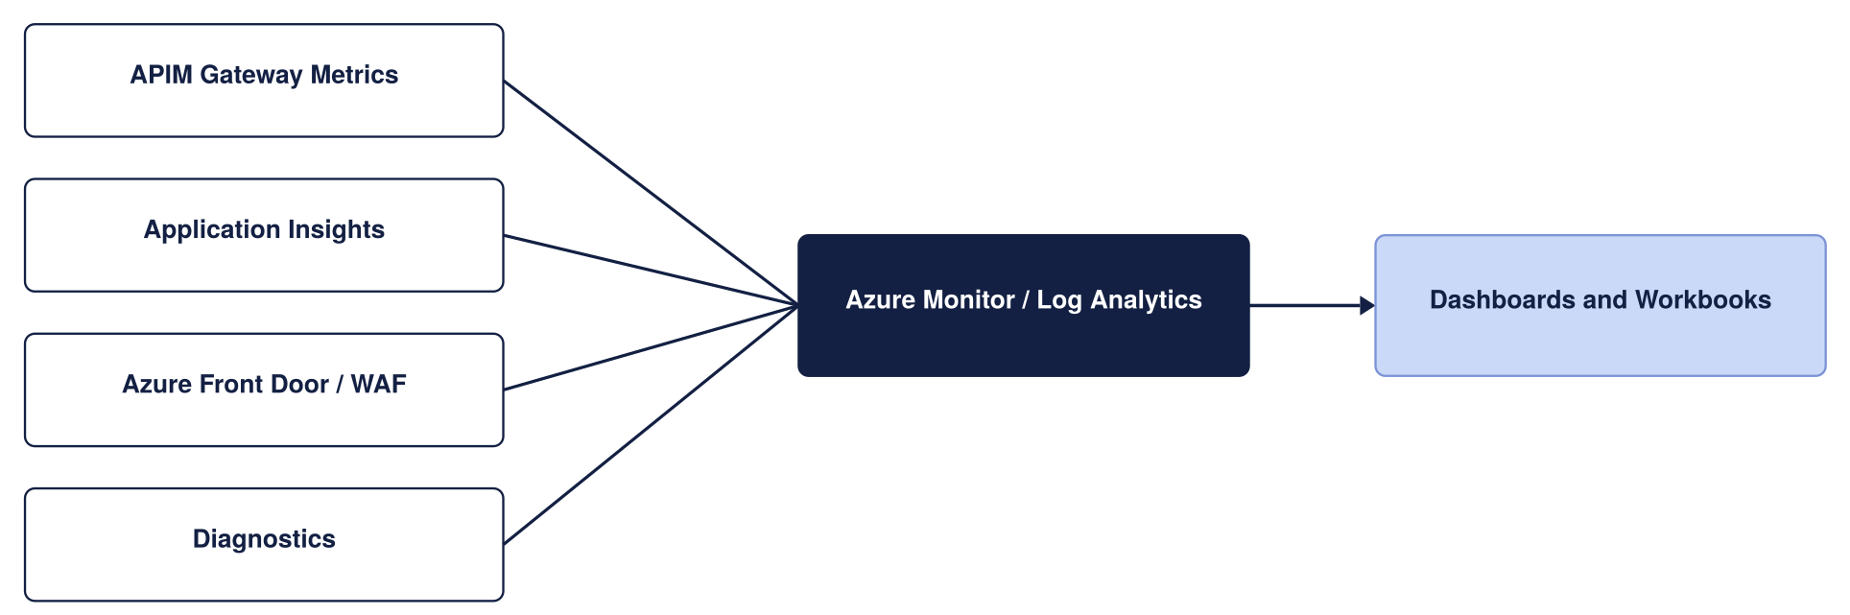
Monitoring architecture
Telemetry and diagnostics are captured through APIM diagnostic settings and correlated using a common correlation identifier. Operational, performance and security telemetry is routed to the appropriate monitoring platform based on its purpose and retention requirements.
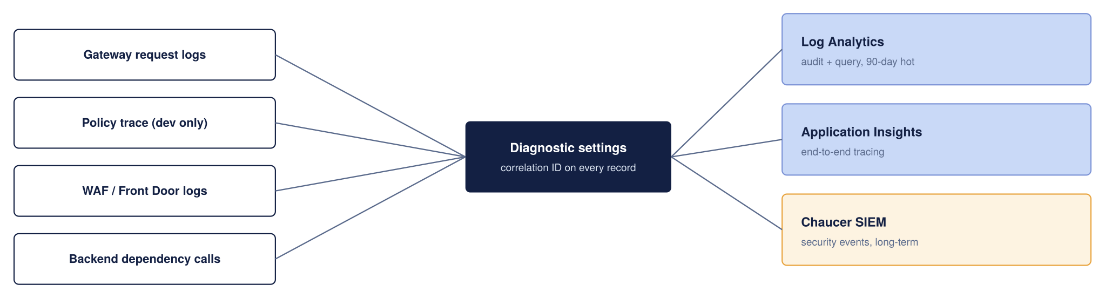
Telemetry Collection and Retention
Telemetry Retention
The retention values below are indicative and should be aligned with the Organisation's logging, security and compliance retention standards..
Telemetry | Sink | Retention (proposed)
Gateway request and response metadata | Log Analytics | 90 days hot, then archived per the Organization’s log policy
End-to-end distributed traces | Application Insights | Sampled in production to control cost
Policy trace (verbose) | Application Insights | Enabled in Dev only; off in production by default
WAF and Front Door logs | Log Analytics | 90 days, forwarded to the security dashboard if applicable
Security-relevant events | Organization SIEM | Retained in accordance with SIEM policy

Correlation and Tracing
Correlation IDs are propagated from APIM to backend services to support end-to-end request tracing. Propagation should be validated during implementation to ensure trace continuity. Verbose policy tracing is restricted to non-production environments due to cost and potential exposure of sensitive information.
Dashboards and Alerting
Dashboards are provided for operational, integration, security and management audiences. Alert thresholds below are proposed defaults and should be refined based on production usage patterns..
Metric | Alert Threshold (Proposed)
Failed requests (5xx) | Greater than 1% of total requests
Gateway response time | p95 above 500ms
Unauthorized requests (401) | Greater than 10 per minute
Certificate expiry | Less than 30 days to expiry

Telemetry
Telemetry is captured through APIM diagnostic settings and correlated using a common correlation identifier propagated from the gateway to backend services. Telemetry is routed to the appropriate platform based on its purpose and retention requirement:
- Operational and performance. Gateway request and response metadata, latencies and throughput, used for health and capacity monitoring.
- Diagnostic. Detailed diagnostic logs in Log Analytics; verbose policy tracing is restricted to non-production due to cost and sensitivity.
- Security. WAF and security-relevant logs, routed also to the security monitoring platform.
Correlation-ID propagation is validated during implementation to ensure end-to-end trace continuity.

Dashboards and Alerts
Dashboards are provided for operational, integration, security and management audiences, giving each a view appropriate to its needs — an operational health view for the platform team and an availability and SLA view for management.
Alerting covers the platform's principal health signals — failed-request (5xx) rate, request latency, gateway capacity and certificate expiry. Alert thresholds are proposed defaults and are refined against observed production usage patterns, as set out in Section 13.1.

Retention
Telemetry retention is set per sink according to its purpose, balancing operational need, cost and compliance. Interactive log retention follows the platform default, with longer retention applied through archive where compliance requires it.
The specific retention values are indicative and must be aligned with Chaucer's logging, security and compliance retention standards before go-live.

Capacity and Cost

Capacity
The costs below are indicative UK South list prices and should be validated against current Microsoft pricing, enterprise agreements and expected traffic volumes..
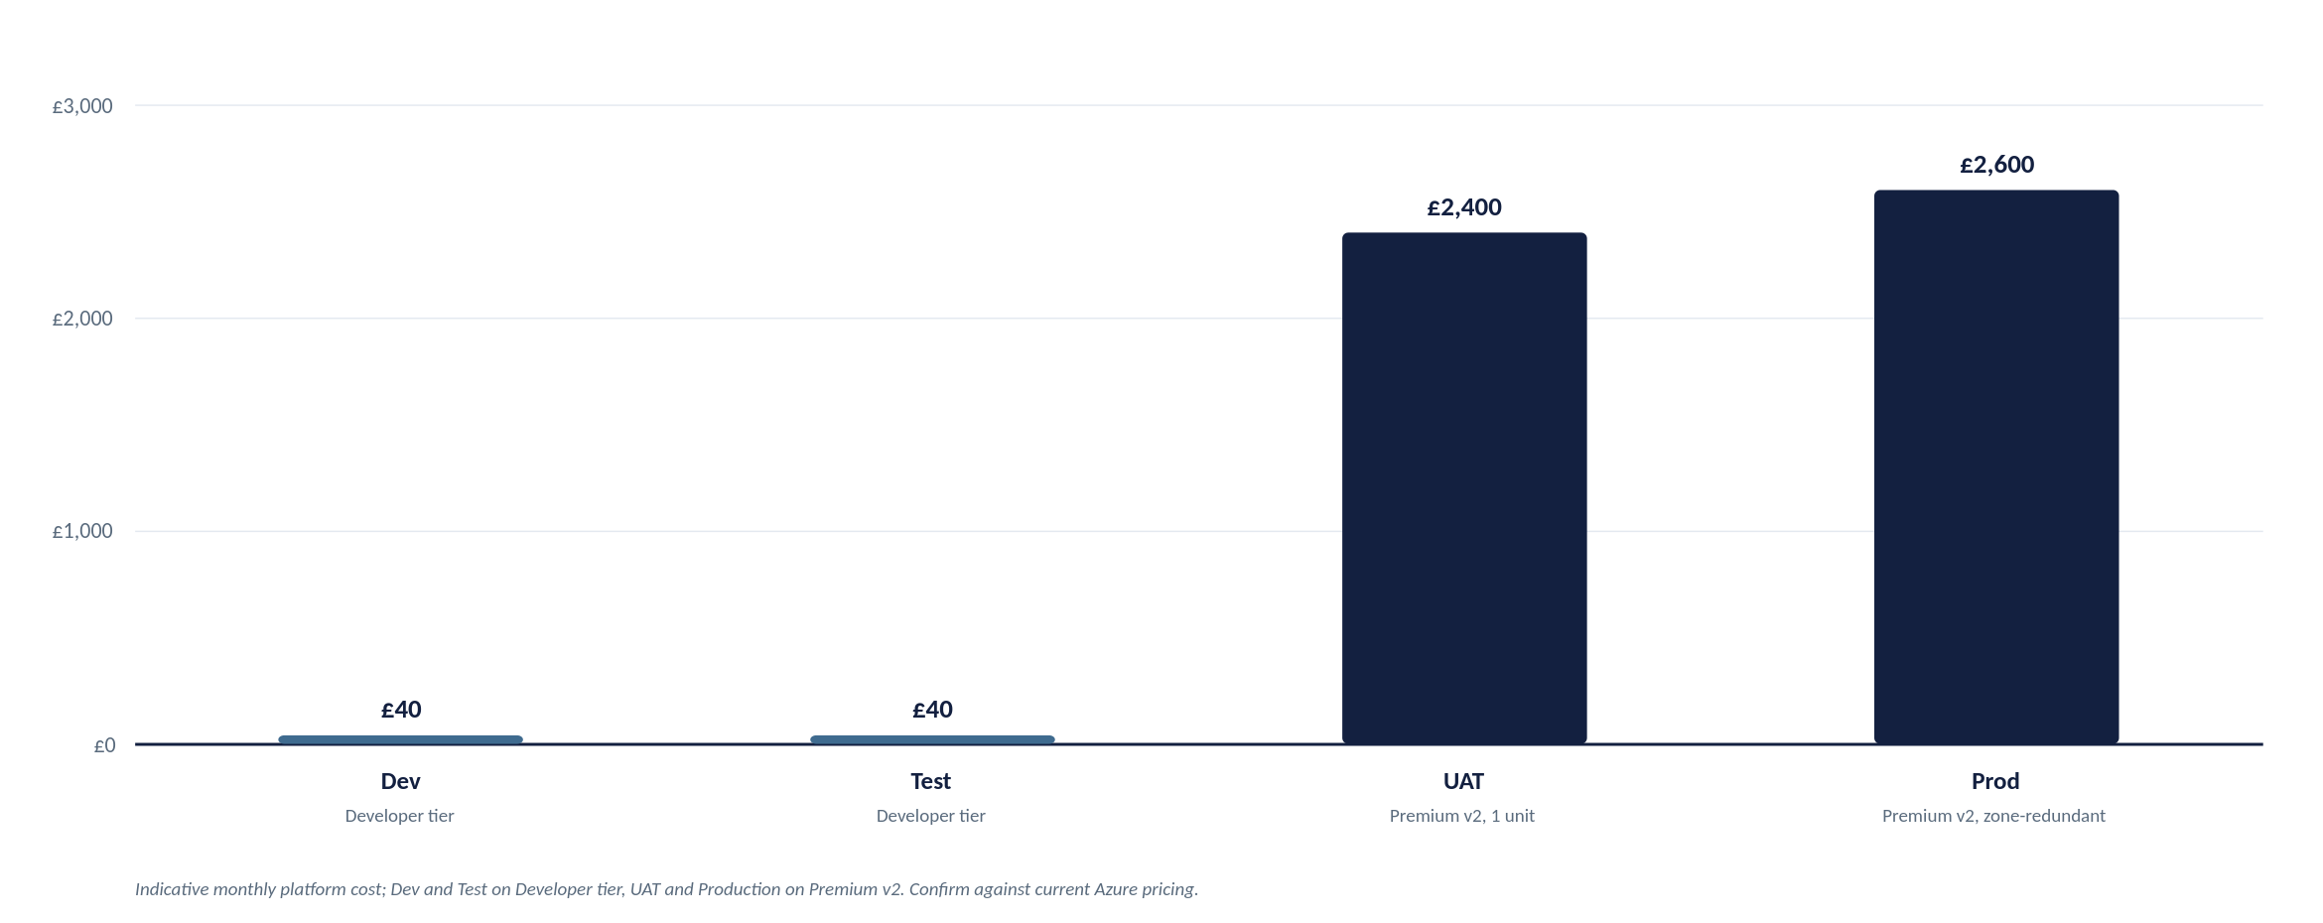
Indicative monthly platform cost by environment
Figures are indicative and must be confirmed against current Azure pricing: azure.microsoft.com/pricing/details/api-management
Cost per Component (Production)

Component | Indicative monthly cost | Notes
APIM Premium V2 | ~ £2,100 to £2,300 (per unit) | Modern v2 architecture eliminates legacy Cloud Services (Classic) dependencies. Zone redundancy (2 AZs) is configured within the region.
Azure Front Door Premium + WAF | ~ £260 base, plus usage | In Premium v2, multi-region failover relies on Front Door orchestrating independent regional v2 instances. Includes WAF base rules
Azure Key Vault | Low cost | Centralized secret and TLS certificate storage; operational cost is negligible.
Azure Monitor and Application Insights | Usage-Based | Cost driven by telemetry volume and retention requirements.
Azure DDoS Protection (Dedicated Plan) | ~ £2,300 per month per tenant | Flat tenant-wide fee covering up to 100 public IPs (optional if relying purely on Front Door edge protection).

Recommendation: Dedicated Azure DDoS Protection is not included in the baseline design. Front Door Premium and WAF provide the primary perimeter protection model for the proposed architecture.
Cost Optimization Strategies
- Tier Sizing Across Environments:
  - Dev / Test: Deploy a single Developer tier instance to provide functional parity with Premium v2 capabilities, including policy development, API lifecycle testing, products, subscriptions and networking validation, while avoiding Premium-tier cost in non-production environments.
  - UAT / Pre-Prod: Deploy a single Premium v2 unit aligned to the Silver deployment model. This provides production-equivalent networking, security and SLA characteristics without the cost of a multi-region deployment.
- Demand-Driven Capacity Scaling: Start production with a single Premium v2 unit and scale based on observed workload characteristics, gateway utilisation and service-level requirements. Additional capacity should be added only when supported by operational metrics and demand trends.
- Observability & Log Ingestion Management: Application Insights and Log Analytics are usage-based services. Apply telemetry sampling where appropriate, retain verbose diagnostics only for troubleshooting or high-value APIs, and align retention settings with operational and compliance requirements.

Capacity Planning and Scaling

Platform cost and throughput scale directly with the number of provisioned units. As an initial planning baseline, 1 Premium v2 unit handles roughly 1,000 requests/sec, but this is an estimate. Actual throughput varies based on payload size, policy evaluation complexity, and TLS overhead, requiring validation against real production traffic.
Scaling Principles:
- Auto scale Thresholds: For multi-unit instances, scale out when sustained gateway CPU or memory exceeds ~70%, and scale in below ~35% over a 30-minute average.
- Provisioning Lead Time: Scale operations take 15–30 minutes to complete. Auto scale rules must react to sustained trends rather than short bursts.
- Active-Active Sizing: Each active region must carry sufficient unit headroom to absorb 100% of the peak workload during a single-region failover.

Environment | Service Tier | Starting Capacity | Indicative Throughput | Architectural & Sizing Justification
Dev | Developer | 1 Unit | N/A  (Build / Unit Test) | Supports API development, policy authoring, functional testing and APIOps validation with capabilities aligned to the target production model at minimal cost.
SIT | Developer | 1 Unit | N/A  (Build / Unit Test) | Supports integration testing, environment validation and pre-UAT verification without Premium-tier licensing costs.
UAT | Premium v2 | 1 Unit | ~1,000 req/sec | Production-aligned environment supporting VNet Injection, private connectivity and enterprise networking validation prior to business sign-off.
Production | Premium v2 | 2 Unit | ~1,000 req/sec  per unit | Recommended Silver-tier production baseline. Deployed across Availability Zones for high availability and scaled based on observed demand, operational metrics and service-level objectives.

Cost Drivers
Platform cost is driven principally by a small number of factors:
- APIM units. The number of provisioned Premium v2 units, which scales both capacity and cost; Production additionally carries zone redundancy.
- Edge. Azure Front Door Premium and the WAF, providing the inspected public edge.
- Observability. Application Insights and Log Analytics, which are usage-based and scale with telemetry volume and retention.
- Non-production environments. The tier chosen for Dev, SIT and UAT, where lower tiers are used to avoid Premium cost outside Production and pre-production parity.
Indicative costs are set out in Section 14.1 and must be validated against current Azure pricing and expected traffic.

Cost Controls
The following controls keep platform cost proportionate to need:
- Tiered environments. Dev and SIT use the cost-effective Developer tier; UAT uses a single Premium v2 unit for production parity; Production starts at the Silver baseline.
- Demand-driven scaling. Production starts with a single Premium v2 unit and scales out only when supported by observed utilisation and demand.
- Telemetry management. Sampling is applied where appropriate, verbose diagnostics are retained only for troubleshooting or high-value APIs, and retention is aligned to requirement.
- Resilience by criticality. Multi-region Gold resilience is applied only to APIs that justify it, rather than across the whole estate.

Governance and Operating Model

Ownership Model
Introducing APIM adds a centrally governed API platform in front of the existing integration estate. Existing integration services continue to operate unchanged, with APIM providing a standardised entry point for API exposure, governance and policy enforcement. Primary dependencies include networking, identity and APIOps capabilities

Exceptions
Where a requirement of this design cannot be met — for example a partner unable to support OAuth 2.0, or a workload requiring a deviation from the standard pattern — an exception may be granted through a defined process. Exceptions must be documented, risk-assessed, supported by compensating controls, time-bound and subject to periodic review.
Approved enterprise standards take precedence where any conflict exists, and exceptions are recorded and tracked through the platform's governance process.

Existing Processes
The operating model reuses Chaucer's existing processes rather than creating parallel ones. Identity lifecycle follows the existing joiner-mover-leaver process; change is governed through existing change-management and approval processes; and service transition, incident and problem management follow the organisation's existing service-management framework.
This section is complemented by the Chaucer Engineering Standards and API Governance documentation, which remains the authoritative source for delivery and governance detail.

Implementation and Service Readiness

Implementation Stages
Implementation proceeds in stages, each building on the last and governed by the delivery controls in Section 11:
- Foundation. Provision the landing-zone networking, APIM instance, Front Door, Key Vault and identity integration as code.
- Platform configuration. Establish the global and product policies, developer portal, and the APIOps pipeline and repository structure.
- Pilot onboarding. Onboard an initial internal API and a pilot partner to validate the end-to-end access, security and onboarding flows.
- Production readiness. Complete the readiness criteria, resilience testing and observability before production go-live.
Detailed implementation planning is delivered through the project's delivery governance.

Readiness Criteria
The following capabilities must be in place prior to production onboarding:
- Operational ownership assigned.
- Monitoring and alerting configured.
- APIOps pipeline operational.
- Backup and recovery procedures documented.
- Security logging integrated with organisational monitoring platforms.
- Runbooks and support documentation completed.
Detailed service acceptance, hypercare and operational handover activities are managed through the Organisation's existing service transition and operational governance processes.
This section sets out what must be true before the platform moves from build into business-as-usual operation, and how that transition is managed. It is the operational counterpart to the Technical Design Authority approval in section 1: TDA approval signs off the design. The criteria below sign off that the live service is ready to run.
Handover is not a single event but a checklist: the items below should be true, or have a named owner and a date to become true, before the service is accepted into live support.
Governance & Operational Area | Service Readiness Criterion | Design & Reference
Platform Ownership | Accountable primary and secondary owners assigned for every RACI role defined in Section 10.2. | Section 10.2 (Closes Risk A.13)
Support Readiness | Support Tiers 1 through 3 staffed, briefed on operational escalation paths, and on-call rosters established. | Section 16.1
Observability & Alerting | Azure Monitor dashboards live, Log Analytics ingestion verified, and alert routing/thresholds tested end-to-end with Operations. | Section 12 (Closes Risk A.09)
Platform Resilience | Front Door health probes and multi-region failover (or single-region AZ availability) tested and documented prior to go-live. | Section 14
Policy Exceptions | Operational process, ownership, and SLA established for evaluating and approving non-OAuth or legacy policy exception requests. | Closes Risk A.16
Operational Documentation | Operational runbooks, final HLD architecture, and the assumptions/risk register delivered to support teams. | Section 17.3
Identity & Access Control | CI/CD APIOps pipeline permissions, Git repositories, Key Vault access, and Emergency Administrative Access (PIM) transferred to operational owners. | Section 10.2 & Section 13
Vendor & Commercial | Active Microsoft Enterprise Support agreement (Premier/Unified) confirmed, with support ticket logging paths validated. | Section 16.1

Industry practice for a core platform of this nature requires a defined Hypercare period immediately following Production go-live, typically spanning two to four weeks.
During Hypercare:
- Joint Operational Standing: The engineering and build team remain actively engaged alongside Tiers 1 and 2 support to ensure rapid incident triage and direct knowledge transfer.
- Aggressive Escalation: Escalation thresholds are intentionally lowered compared to steady-state operations to resolve early adoption friction rapidly.
- Daily Incident Review: A daily operational cadence reviews open tickets, pipeline health, telemetry logs, and emerging usage patterns.
Transition Gate: Hypercare concludes and the standard operational support tiers (Section 16.1) take over full steady-state ownership only when formal Hypercare Exit Criteria are satisfied, including:
- Zero Sev-1 or Sev-2 incidents for a minimum of 5 consecutive business days.
- Zero unresolved high-priority bugs in the APIOps deployment pipeline.
- Formal sign-off on operational runbooks and all completed items in the Handover Readiness Checklist
To ensure seamless operational continuity, the delivery team will formally transfer the following key assets to operational owners prior to Hypercare exit, rather than retaining them within project delivery:
- APIM High-Level Design (HLD): Maintained as a living architectural baseline and updated via version control as the platform evolves, consistent with the broader Systems Integration Framework governance model.
- Operational RACI & Contact Directory: Sections 10.2 and 16.1 updated with named primary/secondary contacts, on-call schedules, and escalation paths substituted for generic roles.
- Operational & Resilience Runbooks: Operational runbooks specifically including the Emergency Administrative Access procedure (Section 10.2) and the Front Door / Regional resilience playbook (Section 14) stored as Markdown directly alongside infrastructure-as-code (IaC) repositories.
- Risk, Assumption, Issue & Dependency (RAID) Register: Section 18 carried forward into steady-state operations and reviewed on a scheduled cadence during periodic platform service reviews (Section 16.4).
- APIOps & Security Access Control: Full administrative ownership of the APIOps CI/CD pipelines, Git control repositories, Key Vault access policies, and Azure Privileged Identity Management (PIM) roles transferred to designated operational platform owners.
Formal acceptance into live production operation is a distinct governance gate, separate from the initial Technical Design Authority (TDA) approval in Section 1:
- TDA Approval (Section 1): Signs off on the technical architecture, security baseline, and sizing strategy prior to build execution.
- Service Acceptance Sign-Off: Formally validates that every criterion in the Handover Readiness Checklist (Section 17.1) is fully met, verified during Hypercare, and ready for steady-state operation

RAID and TDA Conditions

Assumptions
This register identifies assumptions and outstanding decisions requiring validation and approval prior to implementation.
Ref | Assumption or open item | Impact if Incorrect | Owner to confirm
A.01 | Backend services are reachable through approved private connectivity. | Backend connectivity design may require rework. | Network team
A.02 | The Organization’s landing zone follows a standard hub-spoke with private DNS zones available | Affects DNS, egress, and how APIM reaches each backend | Platform Team
A.03 | Entra ID is the Organization’s identity provider and can extend to API consumers | Authentication and authorization model may require redesign. | Identity Team
A.04 | Proposed RTO/RPO, retention periods, and alert thresholds are acceptable | Operational targets and cost may change | Operations Team
A.05 | Initial workloads can be supported by a single Premium v2 unit. | Additional capacity may be required earlier than planned. | Integration Team
A.06 | Expected and peak API request rate (RPS) are not yet confirmed | Capacity planning remains indicative until validated. | Platform team
A.07 | Operational ownership and RACI assignments are not yet confirmed. | Governance and support responsibilities remain incomplete. | Platform Team and Service Owners
A.08 | Log retention and correlation-data retention requirements are not yet confirmed. | Compliance and audit requirements may not be fully satisfied. | Security Teams
A.09 | Network sizing and IP allocation requirements are not yet validated. | Subnet sizing and platform scalability assumptions may be affected. | Network Team
A.10 | Exception ownership and approval processes for non-standard authentication methods are not yet defined | Authentication exceptions may lack governance and review ownership. | Security Team and API Platform Team

Key Risks
No live issues are recorded at draft stage. Issues raised during TDA review or build will be logged here.

Dependencies
Ref | Dependency | Owner
D.01 | Entra ID app registrations provisioned before build | Identity Team
D.02 | Azure Key Vault provisioned and access policies configured in the target subscription. | Platform team
D.03 | Landing-zone network connectivity, subnets and Palo Alto routing paths available in the target environment. | Network Team
D.04 | RTO, RPO, retention requirements and alert thresholds agreed and approved. | Operations team

Independent Verification Required
The following aspects of the design should be independently verified before or during implementation, as they depend on confirmation against Chaucer's environment or on validation with real traffic:
- Network and IP allocation. VNet address space, subnet sizing and routing confirmed against the landing zone and IPAM.
- Capacity and throughput. Per-unit throughput and autoscale thresholds validated against real production traffic rather than planning estimates.
- Cost. Indicative costs validated against current Azure pricing, enterprise agreements and expected volumes.
- Identity ownership. Partner sponsorship, approval and credential-rotation ownership confirmed with the Identity and Access Management function.

TDA Approval Conditions

Appendices

Appendix A: Requirements Traceability

Appendix B: Options and Decisions
This design has been benchmarked against Microsoft's Well-Architected Framework (WAF) guidance for API Management, which sets out best practice across five pillars. The table below summarises each pillar, the key practices Microsoft recommends, and where this HLD addresses them. The alignment is high because the design was built to these patterns; the few items marked as configuration are settings to apply at build time rather than design gaps.
WAF Pillar | Key Microsoft Recommendations | How This APIM Design Addresses It
Reliability | Zone redundancy, autoscaling, multi-region failover, policy validation, reliability metrics, and GitOps rebuild capabilities. | APIM Premium v2 deployed as active-active independent regional instances behind Azure Front Door Premium (Silver Resiliency Tier). Native Availability Zone redundancy; APIOps config-as-code enables rapid automated environment recreation.
Security | ARM-only control plane, strict TLS, Key Vault integration, network-isolated backends, OAuth 2.0, Managed Identity, edge WAF, and production trace restrictions. | Microsoft Entra ID OAuth 2.0 with JWT validation, TLS 1.2+ minimum, Key Vault-backed Named Values, Azure Front Door WAF edge inspection; Managed Identity for backend access, Private Endpoints; verbose tracing restricted to Dev/Test.
Cost Optimization | Cost-effective tiering across non-prod, auto-scale based on load, edge malicious traffic filtering, built-in caching, and policy efficiency. | 4-Environment Topology: Developer tier for Dev and Test, Premium v2 for UAT and Production (ensuring strict VNet/Private Endpoint parity). Edge DDoS and WAF filtering via Azure Front Door blocks malicious calls prior to gateway ingress.
Operational Excellence | Diagnostic resource logging, APIOps / GitOps workflows, Azure Policy governance, automated load testing, standard hostnames, and Backend construct abstraction. | Azure Monitor / Log Analytics / App Insights integration with trace parent correlation IDs, APIOps CI/CD pipelines across Dev/Test/UAT/Prod, standardized API onboarding, backend health probes managed via APIM Backends.
Performance Efficiency | Dynamic scaling, efficient policy execution, performance metric collection, adaptive App Insights sampling, and upstream limits evaluation. | Autoscaling driven by Gateway Capacity and CPU/Memory metrics, lean, modular policy library, p95 latency and capacity alerts, production Application Insights adaptive sampling to minimize overhead.

Based on Microsoft’s Azure Well-Architected Framework guidance for API Management: learn.microsoft.com/azure/well-architected/service-guides/api-management
Source: Microsoft Azure Well-Architected Framework, Architecture best practices for Azure API Management. The full checklist and per-recommendation detail are maintained by Microsoft at learn.microsoft.com and are summarised, not reproduced, here.

Appendix C: Network Flow Matrix
This section demonstrates sample configurations for Azure front door and APIM Instance

Appendix D: High-Level Component Configuration
Following the APIM tier selection in Section 3.4, this section describes the proposed target configuration for the APIM platform, including service tier, regional deployment, network mode, custom domains, TLS, and identity. The values shown represent the target-state design; custom domains are illustrative, and regional and networking choices remain subject to alignment with Chaucer's landing zone and naming standards.
Attribute | Proposed value | Status | Technical Rationale
Service Tier | Premium v2 | Proposed | Unlocks v2 architecture benefits, eliminates legacy cloud service (Classic) dependencies.
Region | UK South | Strategic | Deployed as in regional instances orchestrated via Azure Front Door.
Availability Zones | Zone-Redundant – 2 zone | Proposed | Deployed across 2 Availability Zones within single region.
Networking Mode | VNet Injection & Private Endpoints | Proposed | Standard v2 private networking pattern (Inbound via Private Endpoints, Outbound via VNet Integration subnet).
Custom domain | api.organization.com (external), api-internal.organization.com (internal) | Dummy placeholder | Domain names map to Front Door (External) and Private IP / Internal DNS (Internal).
TLS | TLS 1.2 Minimum | Proposed standard | Enforces TLS 1.2+ minimum across all endpoints, legacy ciphers disabled by policy.
Managed identity | User-Assigned Managed Identity | Proposed | Enables resilient, cross-resource access to Azure Key Vault and Azure Monitor without lifecycle coupling.
Developer Portal | Internal-Only | Proposed | Public access disabled, access restricted via internal VNet routing or Entra ID SSO.

The service scales in units, each a fixed block of gateway capacity. Production runs zone-redundant across Availability Zones and adds units as sustained traffic requires, rather than over-provisioning up front the capacity and cost model behind this is in section 15. The instance is deployed and changed only through code and pipelines, so its configuration is reproducible and auditable, as described in section 13.
Illustrative artefacts to make the standards concrete for build teams. These are examples to adapt, not final Organization policy.
JWT validation (inbound) with Entra ID:
<validate-jwt header-name="Authorization" failed-validation-httpcode="401"
failed-validation-error-message="Unauthorized">
<openid-config url="https://login.microsoftonline.com/{tenant}/v2.0/.well-known/openid-configuration" />
<required-claims>
<claim name="aud"><value>api://organization-apim</value></claim>
</required-claims>
</validate-jwt>
Rate limiting and quota, per subscription:
<rate-limit-by-key calls="100" renewal-period="60"
counter-key="@(context.Subscription.Id)" />
<quota-by-key calls="100000" renewal-period="86400"
counter-key="@(context.Subscription.Id)" />
Sunset header during a deprecation window:
<set-header name="Sunset" exists-action="override">
<value>Sat, 30 Nov 2026 23:59:59 GMT</value>
</set-header>
<set-header name="Deprecation" exists-action="override"><value>true</value></set-header>
Backend authentication using a managed identity (no secret in policy):
<authentication-managed-identity resource="api://organization-backend" />
Resource and API naming examples:
Resource group : rg-apim-prod-uksouth
APIM instance : apim-organization-prod-uksouth
API path : /api/claims/v2/claims
Named value : nv-claims-backend-baseurl
Product : prod-external-broker
Entra group : grp-apim-external-broker
OpenAPI skeleton (the contract every API starts from):
openapi: 3.0.3
info:
title: Claims API
version: "2.0.0"
servers:
- url: https://api.organization.example/api/claims/v2
paths:
/claims/{id}:
get:
summary: Retrieve a claim
security:
- oauth2: [claims.read]
parameters:
- name: id
in: path
required: true
schema: { type: string }
responses:
"200": { description: OK }
"401": { description: Unauthorized }
"429": { description: Too Many Requests }

Appendix E: API Onboarding Checklist
This appendix synthesizes the complete platform journey into a single end-to-end swim lane diagram. Positioned as the final summary, it maps the lifecycle from business need through go-live to ongoing API onboarding.
How to Read the Diagram:
- Phases (Columns): Read left-to-right across seven sequential execution phases.
- Ownership (Rows): Read top-to-bottom to see which team owns each activity.
- Handovers & Gates: Arrows indicate team handovers; red markers highlight mandatory Technical Design Authority (TDA) approval gates.
- Document References: Each activity box cites its corresponding HLD section for detailed reference.
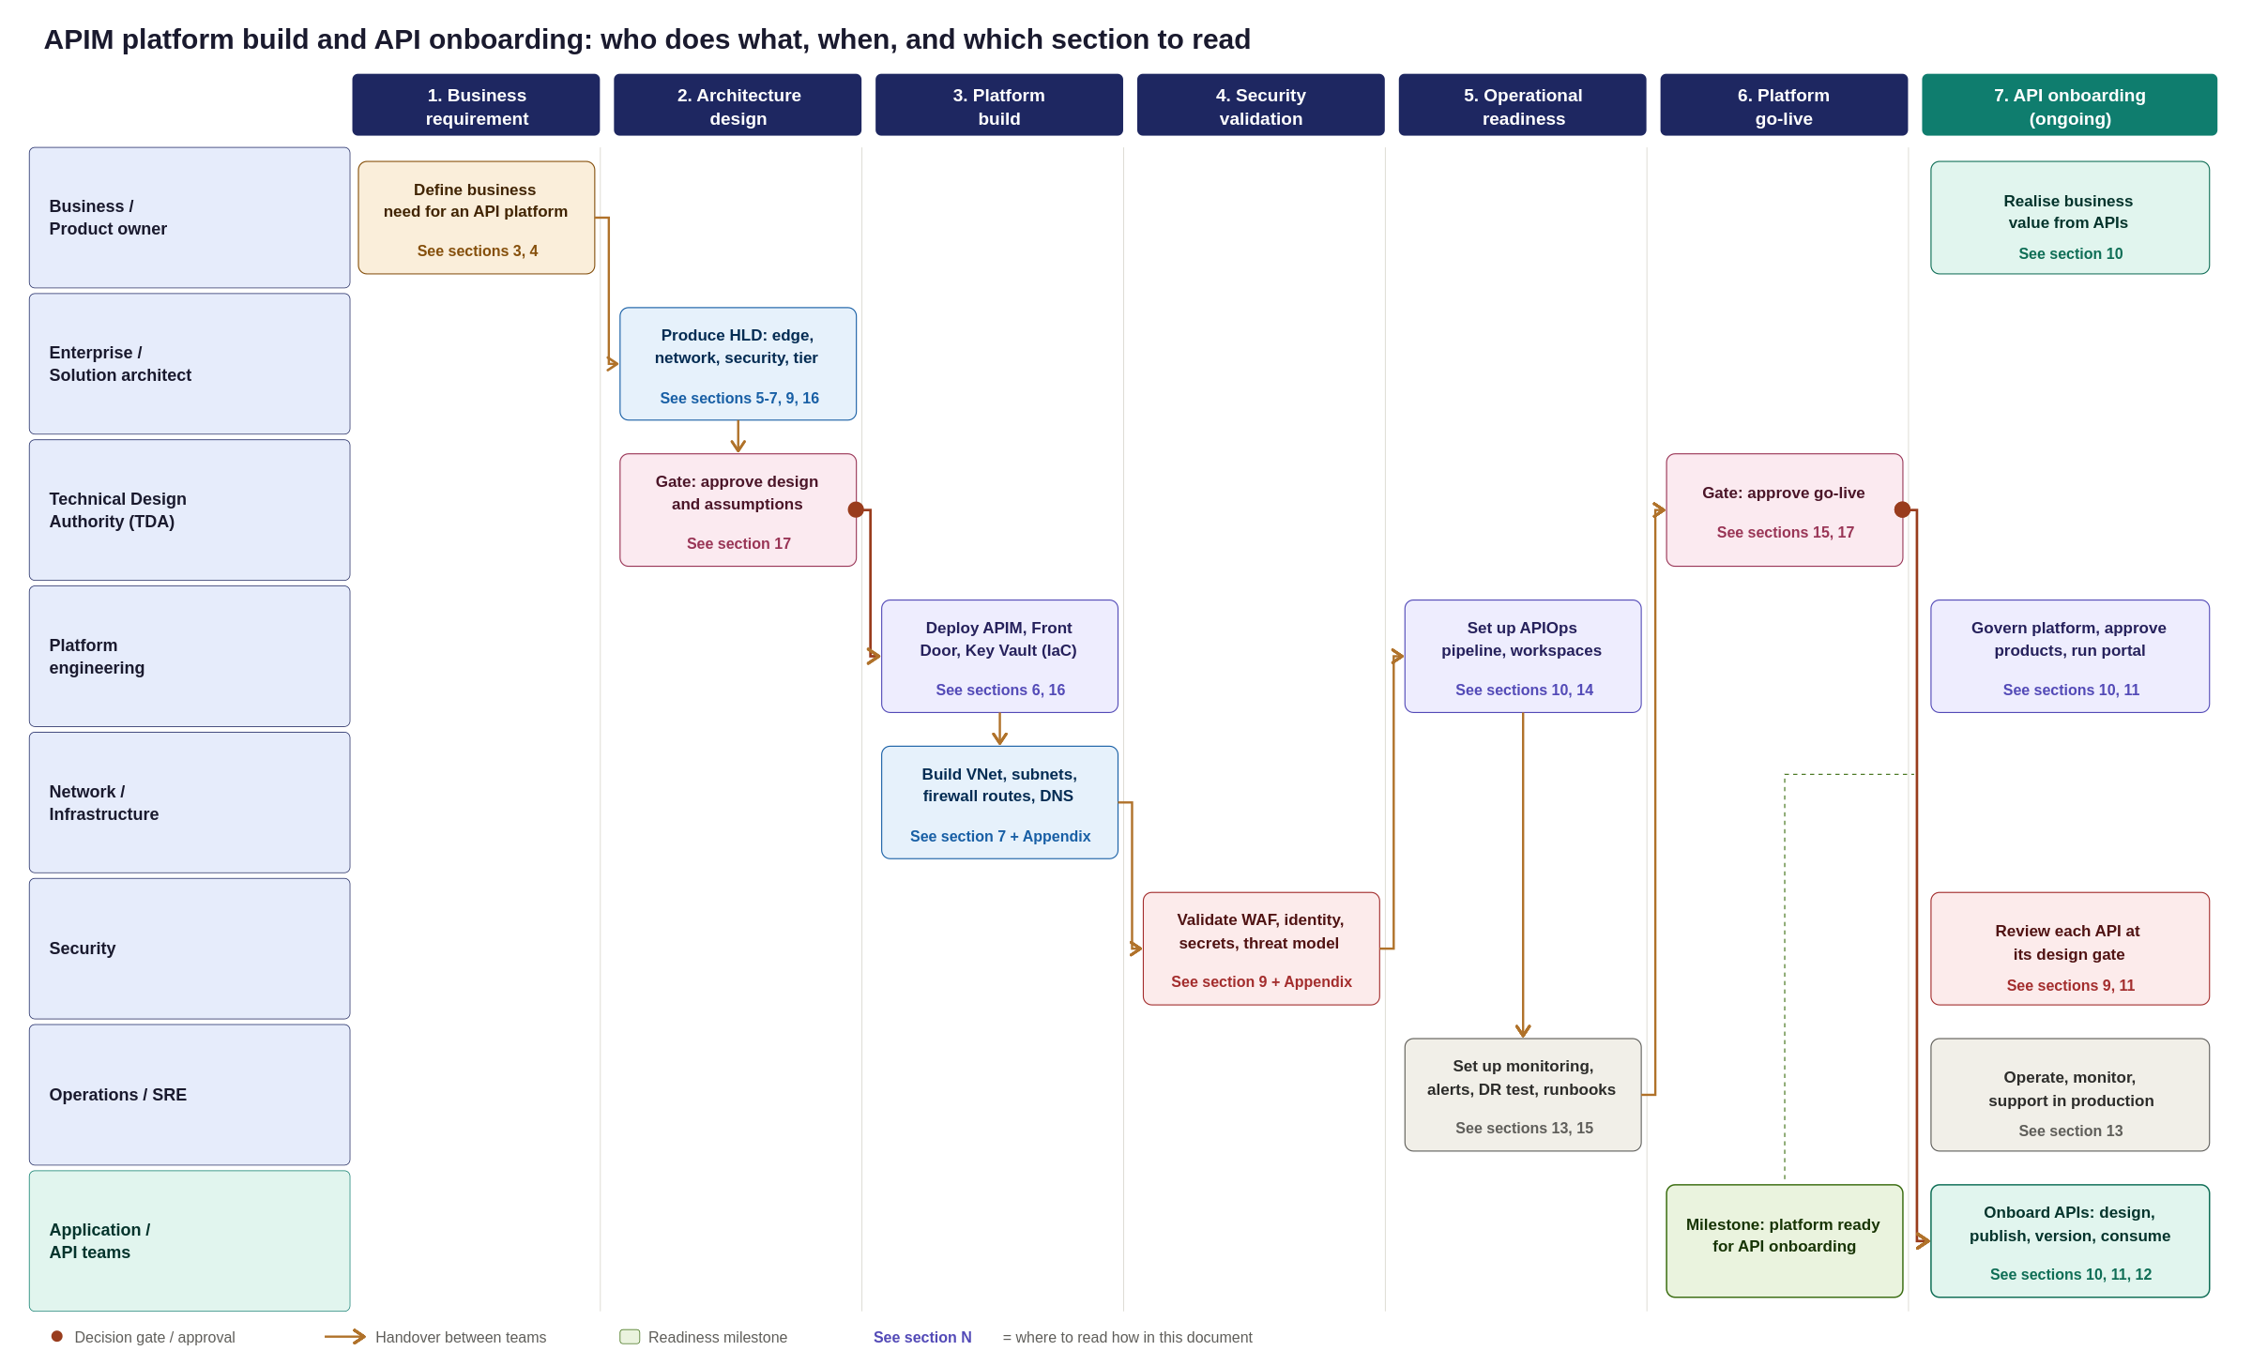
Figure 34: APIM platform builds and API onboarding swim lane, from business requirement to production consumption
Platform Implementation Roadmap & Team Execution
This appendix synthesizes the preceding design sections into a single, end-to-end swim lane diagram, mapping the platform journey from initial business demand to a live operational state.
Key Planning Takeaways
Standing up the APIM platform is a sequenced, multi-team program with a clear critical path:
- Architecture & Governance: TDA sign-off and baseline design approval.
- Infrastructure Build: Parallel execution of platform and network provisioning.
- Validation & Readiness: Security assessment, APIOps integration, and operational handover.
- Go-Live Gate: Final operational acceptance sign-off.
- Continuous Onboarding: Application teams begin onboarding APIs only after the platform go-live gate is passed.
How to Read the Swimlane Diagram
- Phases (Columns): Read left-to-right across the seven sequential execution phases.
- Ownership (Rows): Read top-to-bottom to see which team owns each specific activity.
- Handovers & Gates: Arrows indicate team handovers, while red markers highlight mandatory TDA approval gates.
- Section References: Each activity box references its corresponding HLD section for detailed technical specifications.

Appendix F: Reference Sources
Diagrams in this document are the Organization-adapted renderings of the pattern each article describes, not reproductions of Microsoft's own diagrams. Refer to the linked articles for Microsoft's original diagrams and downloadable Visio files.
- Basic enterprise integration on Azure: learn.microsoft.com/azure/architecture/reference-architectures/enterprise-integration/basic-enterprise-integration
- Protect APIs with Front Door and API Management: learn.microsoft.com/azure/architecture/web-apps/api-management/architectures/protect-apis
- Azure API Management landing zone accelerator: learn.microsoft.com/azure/cloud-adoption-framework/scenarios/app-platform/api-management/landing-zone-accelerator

