Systems Integration Framework

v0.2 (DRAFT)
Table of Contents
2 Document Control 4
2.1 Document History 4
2.2 Document Authors 4
2.3 Document Assurance 5
2.4 TDA Approval 5
2.5 Document References 5
3 Reader Guide 6
4 Executive Summary 7
4.1 Why the Systems Integration Framework Exists 7
4.2 Systems Integration Framework Scope 8
4.3 Intended Outcomes 8
5 Architectural Position 9
5.1 Architectural Stance 9
5.2 SOA Positioning Statement 9
5.3 Strategic Objectives 9
5.4 What Counts as a Service 10
5.5 Service Catalogue, Lifecycle and Governance 10
5.6 Core Systems Integration Framework Principles 10
6 Reference Architecture 13
6.1 Conceptual Reference Architecture 13
6.2 Logical Layered Reference Architecture 14
6.3 Security and Trust Boundary 15
6.4 Target Integration Platform 16
7 Choosing an Integration Pattern 17
7.1 Primary Decision Matrix 17
7.2 Common Use Cases 18
7.3 Detailed Decision Tree 18
7.4 Example 19
8 Enterprise Integration Profile and Pattern Catalogue 20
8.1 Enterprise Pattern Index and Boundary Applicability 20
8.2 Detailed Practitioner Patterns 27
8.3 API Patterns 30
8.4 Messaging Patterns 32
8.5 Event Patterns 37
8.6 Orchestration Patterns 40
8.7 File Patterns 44
8.8 Transformation and Routing Patterns 46
8.9 Anti Patterns 48
9 Data Platform Position 49
9.1 Core Position 49
9.2 Appropriate Uses 49
9.3 Inappropriate Uses 49
9.4 Exchange Patterns 49
10 Insurance Integration Scenarios 57
11 Security and Operational Excellence 58
11.1 Security Principles 58
11.2 Data Protection and Classification 59
11.3 Observability and Monitoring 59
11.4 Operational Excellence 60
11.5 Delivery Pipeline 60
12 Guardrails 62
12.1 Mandatory Guardrails 62
12.2 When you need to deviate 62
12.3 Per-Pattern Security Conformance 63
13 TDA Governance and Exceptions 71
13.1 TDA Gates 71
13.2 Security Conformance 71
13.3 Exceptions 71
14 Glossary 72
15 Cross-Reference and Traceability 73
15.1 Pattern Grouping 73
16 Appendices 74

Document Control
This section provides a history of how the document has been changed and how the changes have been governed.

Document History
The following provides a log of changes to this document:
Version | Date | Author | Notes
0.1 | 11/09/2026 | Puneet Kumar | Initial Draft
0.2 | 14/09/2026 | Puneet Kumar | Details added for per pattern security considerations

Document Authors
Role | Name | Title
Author | Puneet Kumar | Consulting Integration Architect
Author | Nikhil Rokade | Portfolio Architect
Author | Joycell Sundararaj | Integration Architect
Contributor | Phanindra Nizalapuram | Integration Architect
Contributor | Pragyan Tripathy | Integration Developer

Document Assurance
This document has been reviewed and approved by the following, the list has been grouped into different sections to aid readability as this document will be required at DLRM PDG and possibly TDA.

Role | Description
Information | Shared for informational purposes including use as reference document for their domain’s documentation and processes
Reviewer | Actively reviews the content to ensure alignment to guidelines and policies and technical accuracy, will contribute as required
Approver | Provides assurance that their domain is correct in context of the HLSA

Date | Role | Name | Title
DD/MM/YY | Approver | Kosta Konstantinov | Enterprise Architect
DD/MM/YY | Approver | Steve Coldwell | CTO
DD/MM/YY | Approver | Kate Enright | Head of Data
DD/MM/YY | Approver | Ryan Freund | Information Security Officer
DD/MM/YY | Approver | Dave Ewles | Data Architect and Engineering Lead
DD/MM/YY | Information | Chad Ozdil | Security Architect
DD/MM/YY | Information | Jamie Barclay | Cloud Architect
DD/MM/YY | Information | Sean Dodd | Cloud Architect
DD/MM/YY | Information | Diana Constable | Head of Engineering
DD/MM/YY | Information | Stuart Clark | DevSecOps (Software & Data) Lead
DD/MM/YY | Information | Pragnesh Solanki | DevSecOps (Build) Lead
DD/MM/YY | Information | Ian Danbury | DevSecOps (Platform) Lead
DD/MM/YY | Information | Kevin Harrop | Security Engineering Lead

TDA Approval
The TDA approval date to be updated by the author once full TDA approval has been granted.
The document should then be updated to a major revision number and stored in the solution repository.

Date | Minutes (link) | TDA Chair Name | TDA Chair Title
DD/MM/YY

Note – documents that have conditional TDA approval must be completed before the Date of TDA Approval can be entered by the author, and the major revision saved in the solution repository.

Document References
The following documents should be read in conjunction with this document:

Reference | Document | Version | Author | Source
1 | Enterprise Architecture Principles | 0.1 | Jamie Barclay | Source
2 | Data Classification Policy | 9.1 | D.Beck | Source
3 | Enterprise DevOps Principles | 0.1 | Gary Milton | Source
4 | Architecture  Engineering Standard AIS | 1.0 | Nikhil Rokade | Source
5 | Architecture  Engineering Standard Cloud | 1.3 | Jamie Barclay | Source
6 | Azure Component Decision | 1.0 | Steve Coldwell | Source
7 | Azure Policy
8 | Cloud Security Framework | 1.0 | Chad Ozdil | Source

Reader Guide

This Systems Integration Framework serves several audiences, the recommended reading path for specific roles is described below as guideline. Each entry points to the sections most relevant to that role. The second column is the shortest route to what is important. If your work spans more than one role, each relevant path can be followed and the broader path can used as the superset.
Recommended reading paths:
Role | Start Here | Then Read | Outcome
Executive Sponsor / Leadership | Executive Summary | Architectural Position  Guardrails  Governance & Exceptions | Understand why the framework exists, its strategic direction, governance model and key controls.
Solution / Portfolio / Domain Architect | Architectural Position | Reference Architecture  Choosing an Integration Pattern  Enterprise Pattern Catalogue | Design solutions aligned to Chaucer's approved integration architecture and patterns.
Integration SME / Developer | Choosing an Integration Pattern | Enterprise Pattern Catalogue  Data Platform Position & Guardrails  Security & Operational Excellence | Build integrations using approved patterns, services and operational controls.
Data Architect /  Data Platform Lead / Data Engineer | Data Platform Position & Guardrails | Security & Operational Excellence  Guardrails | Understand approved SIF-to-Data Platform boundaries, exchange patterns and governance controls.
Security Architect / Cloud Operations | Security & Trust Boundary | Security & Operational Excellence  Guardrails  Security Conformance | Assess security posture, operational controls, identity, monitoring and compliance requirements.
Technical Design Authority (TDA) | Guardrails | Governance & Exceptions  Enterprise Pattern Catalogue  Data Platform Position & Guardrails | Assess architecture conformance, exceptions, integration pattern selection and data platform boundary compliance.

Executive Summary

Chaucer requires a formal Systems Integration Framework to provide consistent architectural direction for system-to-system integration across internal applications, third-party platforms, SaaS services, vendor integrations and the enterprise data platform.

The Systems Integration Framework is based on a Service-Oriented Architecture approach and explicitly avoids adopting a microservices model as the default integration paradigm. The focus is on practical enterprise integration across existing Chaucer systems, external vendors, Azure PaaS services and the data platform.

The Systems Integration Framework establishes a single catalogue of patterns with clear boundary applicability across internal Chaucer integration, third-party to Chaucer inbound integration, Chaucer to third-party outbound integration and SIF-to-data-platform exchange. It also defines decision guidance for API, messaging, eventing, orchestration and data-platform usage, supported by mandatory guardrails and a controlled exception process.

Why the Systems Integration Framework Exists
Chaucer has successfully modernised much of its integration estate onto Azure Integration Services and established a number of robust integration patterns, security controls and operational practices. However, these capabilities currently co-exist with direct point-to-point integrations, application-specific interfaces and data-platform-led exchanges that have evolved independently over time. Whilst effective in addressing individual business needs, these approaches can lead to tighter coupling, duplicated integration capabilities, inconsistent design decisions and increased change complexity across the wider technology estate.
By leveraging existing best practices and principles within a Systems Integration Framework, Chaucer can build upon its current strengths, promote reuse, improve governance and provide a consistent enterprise approach for future integration initiatives. This Systems Integration Framework establishes a single reference architecture for integration so that recurring problems are solved through consistent, repeatable patterns. It defines an approved set of integration patterns, a standard set of Azure services as the target platform, and the governance guardrails that delivery teams and suppliers need in order to build correctly without re-opening architectural decisions on every engagement.
The Systems Integration Framework does not introduce a new set of principles. It inherits the principles Chaucer already holds and translates them into practical integration choices. The stack below shows where those principles originate and where they are enforced in this document.
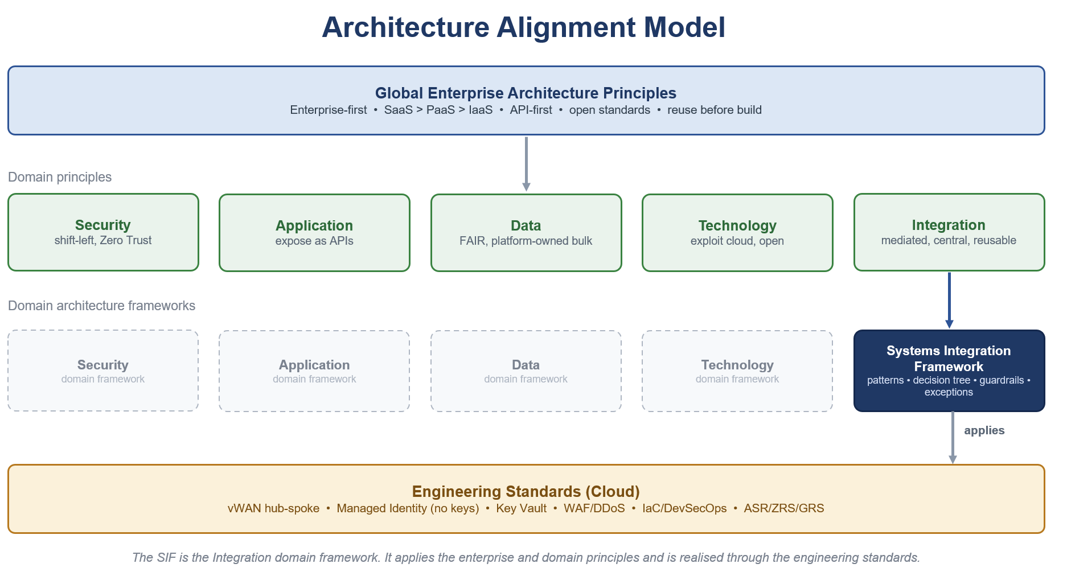

Systems Integration Framework Scope

The Systems Integration Framework covers the following.
- A reference architecture for integration across Azure Integration Services.
- An enterprise catalogue of approved integration patterns with the Azure components for each.
- Decision guidance, guardrails and an exception process for delivery teams and suppliers.
- The position of the data platform boundary and the approved exchange patterns with Snowflake.
The following are out of scope for this version.
- Implementation, provisioning and deployment, which are future-phase activities.
- The detailed API Management high-level design, which is produced as a separate phase.
- Any redefinition of Chaucer's cloud strategy.

Intended Outcomes
- Fewer point-to-point interfaces and a measurable reduction in bespoke coupling.
- Greater reuse through shared integration components and published services.
- Loose coupling and asynchronous messaging as the default interaction style.
- Consistent, governed delivery that any internal team or third-party supplier can follow.
- Faster onboarding of new integrations through a known catalogue and decision path.

Architectural Position

Architectural Stance
The Systems Integration Framework takes a clear and consistent position, summarised below and expanded in the sections that follow.

Area | Position
Architecture model | Service-Oriented Architecture, not microservices.
Primary objective | Integrate and reuse existing systems and services before creating new ones. Ref 1
Service model | Business-capability aligned enterprise services. Ref 1
Integration style | API-led, event-capable, orchestration-supported. Ref 1
Platform alignment | Azure PaaS integration services. Ref 1
Governance model | TDA-approved standards, reusable patterns, controlled exceptions.

SOA Positioning Statement

Chaucer's Systems Integration Framework adopts a Service-Oriented Architecture, not a microservices architecture, aligned to Chaucer's operating model.
A service in this Systems Integration Framework is a coarse-grained capability aligned to a business domain such as Policy, Claims, or Client rather than an entity-level or table-level endpoint. Services are stable, reused across Chaucer's business and technology teams, and governed through clear ownership, defined contracts, and lifecycle controls. Each service has a named owner and is exposed through the platform.
Microservices are not adopted as the default integration paradigm. The Systems Integration Framework focus is not service decomposition for independent product or application engineering, but pragmatic enterprise integration across existing Chaucer platforms, SaaS services, data platforms, and vendor systems. Accordingly, services are not one of many fine-grained components communicating over a service mesh.

Strategic Objectives

Objective | SIF Direction
Increase automation | Promote API, events, and workflow-based integrations over manual re-keying.
Reduce point-to-point integrations | Introduce reusable service contracts, APIM-mediated APIs, and shared messaging patterns.
Improve system-to-system data flow | Standardized integration approaches across synchronous, asynchronous, file, and data-platform exchange.
Enable vendor integration | Provide secure, governed, and reusable ingress / egress patterns for external suppliers and systems.
Support straight-through processing | Use orchestration where business process coordination is required; avoid embedding logic in consuming systems.
Align to Azure PaaS | Use Azure API Management, Logic Apps, Service Bus, Event Grid, Event Hubs, Azure Functions, and Azure Data Factory as the primary Azure PaaS integration components, with ADF specifically positioned for data ingestion, ELT orchestration, and controlled Snowflake/data-platform exchange rather than real-time operational integration.

What Counts as a Service

A service that belongs in the catalogue meets the following tests.
- It aligns to a business capability rather than a table or a technical function.
- It has a stable, versioned contract that hides the implementation behind it.
- It has a named owner who is accountable for its behaviour and its change. It is exposed and consumed through the platform, not through a direct connection.
It is coarse grained, so that a typical business interaction is one call rather than many.

Service Catalogue, Lifecycle and Governance

Defining a service is only the starting point, governance ensures it delivers long-term value. Every service meeting our core criteria must be registered in the Enterprise Service Catalogue- the single source of truth for platform integration. Unregistered services cannot consume or expose platform capabilities.
Each service shall:
- Catalogue & Ownership: Each entry maps directly to a business capability, holding a documented contract, semantic versioning, and a named Service Owner accountable for its operation and evolution, maintain a documented, versioned contract and follow approved version management practices.
- Lifecycle Management: Services progress through five explicit states: Proposed, Approved, Active, Deprecated, and Retired. Transitions require Technical Design Authority (TDA) review to guarantee alignment and security.
- Change & Stability: Contract updates must maintain backward compatibility. Deprecation follows a managed timeline, ensuring downstream consumers transition smoothly before retirement.

Core Systems Integration Framework Principles

Note : The SIF is grounded in Chaucer's Enterprise Architecture and Cloud Engineering principles and does not redefine them. It either complies, extends, or reconciles those principles within the integration domain so that every integration decision traces back to a ratified principle rather than a new one.

Two principles take precedence over all others.
- Reuse is preferred over build - Recommendation is to check the service catalogue for an existing service or API before provisioning a new one.
Favour integrating with an existing system over standing up new infrastructure – There is no approved pattern for a direct, unmediated connection between two systems, as all integration flows through the approved integration platform using an approved integration pattern.

Principle | Statement | Practical Implication | Where it is enforced
Loose coupling by default (Integration)  Ref 1 | Systems should interact through contracts, APIs, messages, or events rather than direct dependencies. | Avoid direct database access, shared file dependencies, and tightly coupled point-to-point calls unless explicitly approved. | Ref architecture (6), Decision tree (7.3), Catalogue (8)
Reuse before new build (Global EA, Application)  Ref 1 | Reuse of existing services, APIs, workflows, and platform components must be assessed before creating new integrations. | Every design should document reuse assessment. | Architectural Position (5), Catalogue (8), Guardrails (12.1)
Business capability alignment (Application)  Ref 1 | Services should expose meaningful business capabilities, not raw system internals. | APIs should represent business functions such as policy, claim, submission, party, document, or finance capability. | Architectural Position (5), Catalogue (8),
APIM as API publishing and ingress control (Integration, Security)  Ref 1  Ref 8 | Chaucer-owned APIs exposed for internal or external consumption should be published through Azure API Management unless an exception is approved. | APIM is the standard control point for API discovery, policy enforcement, authentication, throttling, monitoring, versioning, and lifecycle governance. Direct exposure of backend APIs, Logic Apps, Functions, or internal service endpoints should be avoided. | Ref architecture (6), Security (11), Guardrails (12.1)
Third-party API egress is governed by reuse and risk (Integration, Security)  Ref 1 | Chaucer integrations may call third-party APIs directly from Logic Apps or Functions where the integration is workflow-specific, low reuse, and appropriately governed. | APIM should be used as a Chaucer-owned facade where third-party APIs are reused, business-critical, strategically important, externally sensitive, or require centralised policy, monitoring, or lifecycle control. | Catalogue (8)), Exception and TDA (13)
Asynchronous-first where resilience matters (Integration, Resilience)  Ref 1 | When availability, retry, load levelling, or latency tolerance is important, prefer messaging/events. | Use Service Bus queues/topics for reliable enterprise messaging. | Decision tree (7.3), Catalogue (8),
Orchestration usage is explicit (Integration) Ref 1 | Cross-system business process must have explicit ownership and coordination within integration platform rather being embedded in consuming applications, scripts or custom code. | Logic Apps Standard is the default orchestrator. Azure Durable Functions may be used only as an explicitly declared and governed orchestrator where the published selection criteria are met. Plain Azure Functions must not become hidden orchestration engines. | Catalogue (8), Anti-Patterns (8.9)
Implementation logic is separated (Integration)  Ref 1 | Low-level code should be isolated from orchestration and API policy concerns. | Functions should implement narrow code tasks. They should not be implemented in end-to-end business workflows. | Catalogue (8), Anti-Patterns (8.9)
Secure by design (Security)  Ref 1  Ref 8 | Managed identities for authentication, RBAC, private endpoints where possible, Credentials, secrets, and certificates must be securely managed through an approved enterprise capability, with access monitoring, least-privilege access, and auditability enforced by default | Security patterns should be explicitly included in every design review. | Security (11), Guardrails (12.1)
Observable by default (Engineering Standards)  Ref 1 | Every integration must be traceable, monitored, and supportable. | Correlation IDs, diagnostics, alerts, and operational runbooks are mandatory to ensure long term supportability. | Security (11), Guardrails (12.1)
Data platform is not integration technology (Data)  Ref 1 | Snowflake and the data platform should not be used as a substitute for operational integration. | Data platform should be used as intended for analytical, historical, reporting, and governance across data products. | Data Platform (9)

Reference Architecture

Conceptual Reference Architecture

At the conceptual level the Systems Integration Framework places a single integration layer between the consumers of integration and the systems, suppliers and data platform that provide or receive information. The integration layer is the only sanctioned route between parties. It presents governed contracts to consumers, mediates protocol and format, and applies security, routing and observability consistently.

Logical Layered Reference Architecture

The logical view resolves the conceptual layer into five bands. The diagram should be read from the consumer at the top to the systems and data platform at the base.
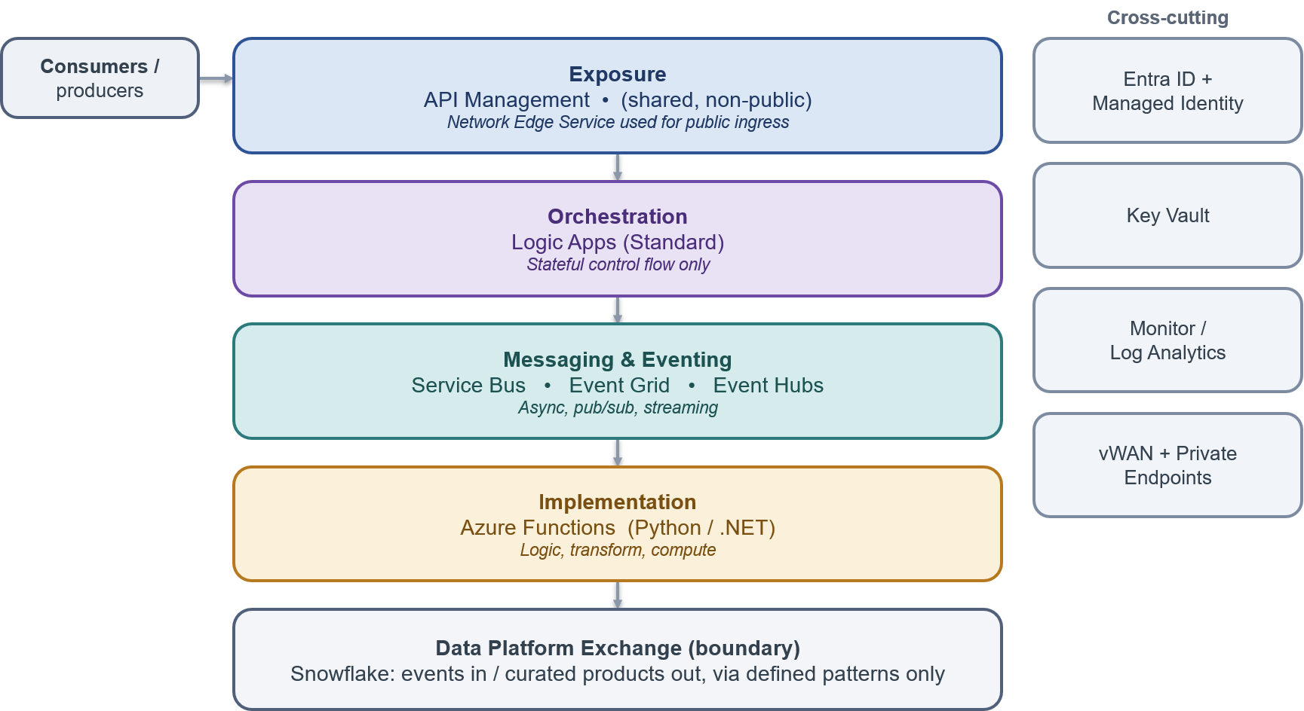

Layer | Description
Exposure layer | API Management is the single ingress for synchronous traffic, applying authentication, rate limiting, product and subscription control, and observability.
Orchestration layer | Logic Apps coordinate stateful, multi-step business processes. and own workflow control rather than embedding process logic within consuming applications or systems. Logic Apps Standard is the default orchestration platform. Azure Durable Functions may be used only as an explicitly declared and governed orchestrator where the approved selection criteria and exception process are met. Plain Azure Functions must not be used as hidden orchestration engines.
Messaging and eventing layer | Service Bus, Event Grid and Event Hubs provide asynchronous messaging, discrete eventing and streaming respectively.
Implementation layer | Azure Functions host the discrete implementation logic invoked by the layers above.
Data platform boundary | The Systems Integration Framework meets Snowflake at two governed hand-offs only: a push into the platform and a curated consume from it.

Security and Trust Boundary

Security is the principle the organisation takes most seriously. The Systems Integration Framework sets out the trust zones once and holds every pattern to them. The diagram shows the zones a request crosses and the control at each boundary.
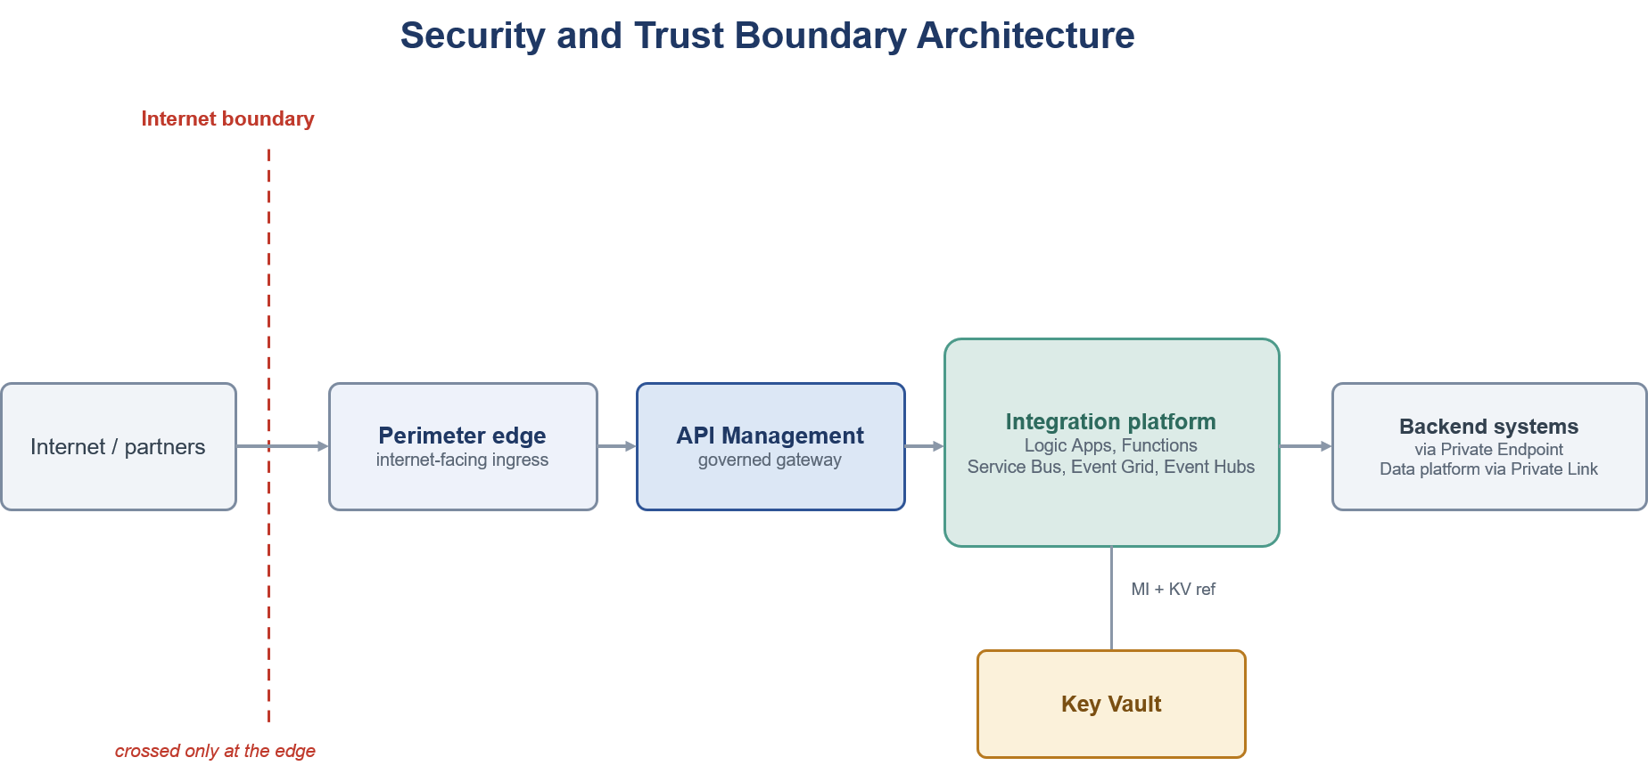

Layer | Description
Internet boundary | The line between the public internet and the estate. It is crossed only at the edge, and public exposure is an exception approved separately rather than a default.
Perimeter edge | The internet-facing ingress and the only point where the boundary is crossed. Anything reachable from outside is fronted here by a managed edge that applies the required protections and keeps everything behind it privately connected. The edge technology is chosen with security and network stakeholders.
APIM gateway | The single, non-public control point for APIs. It authenticates callers, applies policy, throttling and versioning, and mediates all API traffic. It is internal and is never exposed to the internet directly.
Integration platform | The private runtime where integrations execute, providing messaging, eventing, orchestration and lightweight compute. It runs on the private network and is reached only through the gateway or private connectivity.
Backends and data | Systems of record and the analytical data platform. Both are reached only over private connectivity and authenticated by identity, never on a public path. The data platform is reached across a governed boundary, not on the live operational path.
Secrets and certificates | Held in a managed store and referenced by identity at run time, never copied into configuration or code.

Target Integration Platform

The Systems Integration Framework standardises on the following Azure Integration Services which have been selected as part of the requirements -
SIF Requirements
Delivery teams are expected to select from these components and are expected to implement integration solutions conforming to Chaucer’s Azure policies and Azure Integration Services engineering standards introduce. [Ref 5, 8]

Component | Systems Integration Framework Role | Recommended Use | Do Not Use
Azure API Management | Enterprise API gateway and single API ingress point | Exposing REST APIs to internal systems, vendors, applications, or digital channels | For long-running business processes or data transformation pipelines
Azure Logic Apps | Workflow orchestration and cross-system process coordination | Multi-step integrations, long-running workflows, connector-based automation, exception paths | For low-level compute-heavy logic or high-throughput streaming
Azure Service Bus | Reliable enterprise messaging | Guaranteed delivery, commands, queues, topics, retries, dead-letter handling | For lightweight notifications where message state is not required
Azure Event Grid | Event notification and reactive event routing | Resource/event notifications, event fan-out, near-real-time triggers | For ordered business messaging or complex message settlement
Azure Event Hubs | High-throughput event streaming | Telemetry, high-volume event ingestion, streaming analytics | For command-style workflow messaging or request/response integration
Azure Functions | Low-level implementation logic | Lightweight code extensions, transformation helpers, protocol adapters, custom validation | As the default orchestration engine or business process owner (plain Functions chained into hidden orchestration). Azure Durable Functions is permitted only as an explicit, declared orchestrator under the Orchestration Patterns selection criteria.
Azure Data Factory / Data Platform | Data ingestion and analytical pipeline orchestration | Batch/ELT, Snowflake loading, analytical data movement | Real-time operational integration or transient system-to-system messaging

Choosing an Integration Pattern

For a leadership or high-level view, the primary decision matrix in 7.1 and the common use cases in 7.2 provide a concise view of the approved integration styles.
For architecture and delivery teams, the decision tree in 7.3 supports pattern selection, while the worked example in 7.4 illustrates the application of the framework. The enterprise pattern catalogue in Section 8 provides the detailed specification of each pattern.
I am here to | Start Here | Then Read
Understand the options in plain terms | Primary Decision Matrix | Common Use Cases
Choose a pattern for a specific need | Decision Tree | Pattern Catalogue
See it worked through end to end | Worked Example

Primary Decision Matrix
The matrix provides a high-level guide to selecting the most appropriate integration capability for a given requirement. It identifies whether a platform capability is normally suitable, conditionally suitable, or not recommended for a specific interaction style. The enterprise pattern catalogue in Section 8 remains the authoritative source for detailed pattern guidance.

Does the need involve... | API | Functions | Service Bus | Event Grid | Event Hubs | Logic Apps | ADF
A consumer that needs an immediate response | ✅ | ⚠️ | ❌ | ❌ | ❌ | ⚠️ | ❌
Guaranteed delivery | ⚠️ | ❌ | ✅ | ⚠️ | ⚠️ | ⚠️ | ❌
A business command or transaction | ✅ | ⚠️ | ✅ | ❌ | ❌ | ⚠️ | ❌
A small code-based transformation or enrichment | ⚠️ | ✅ | ⚠️ | ❌ | ❌ | ⚠️ | ⚠️
A notification that something happened | ⚠️ | ⚠️ | ⚠️ | ✅ | ⚠️ | ⚠️ | ❌
High-volume telemetry or an event stream | ❌ | ⚠️ | ⚠️ | ❌ | ✅ | ❌ | ❌
A process that spans multiple systems and steps | ⚠️ | ⚠️ | ⚠️ | ⚠️ | ❌ | ✅ | ❌
Long-running state or retry orchestration | ❌ | ❌ | ⚠️ | ❌ | ❌ | ✅ | ❌
Analytics or data warehousing as the main purpose | ❌ | ❌ | ⚠️ | ⚠️ | ⚠️ | ⚠️ | ✅

Legend.
✅ Preferred service for the stated use case.
⚠️ Possible service where specific requirements justify its use.
❌ Not normally recommended for the stated use case.

Note: Analytics and data warehousing are served by the data platform, using ADF, Blob, Snowpipe and Snowflake, rather than by an integration pattern. Please see Section 9.

Common Use Cases
The table maps everyday scenarios to the recommended pattern and to the catalogue entry that specifies it in full.
Scenario | Recommended pattern | Catalogue reference
Retrieve or update business data immediately | REST API through API Management | SFINT1
Tell another system to perform work, where delayed processing is acceptable | Service Bus queue, load levelling | SFINT4
Have multiple systems react to the same business message | Service Bus topic, publish and subscribe | SFINT10
Notify that a resource change or event occurred | Event Grid notification | SFINT11
Ingest a high-volume stream, telemetry or near-real-time feed | Event Hubs stream ingestion | SFINT14
Run a multi-step process with conditional routing and exception handling | Logic Apps orchestration | SFINT15
Apply a small code-based transformation or validation step | Azure Function, message translator | SFINT21
Ingest a batch into Snowflake for reporting or analytics | Data platform pattern, ADF, Blob, Snowpipe | Section 9
Run an operational real-time transaction between applications | API or messaging pattern, not Snowflake as an intermediary | SFINT1 to SFINT9

Detailed Decision Tree
The decision tree below resolves an integration need to a pattern family by asking about interaction style, timing and delivery guarantees, read from the top, and it names no technology. The matrix in 7.1 then maps the chosen family to the Azure capabilities that realise it, and the catalogue in Section 8 specifies each pattern in full.
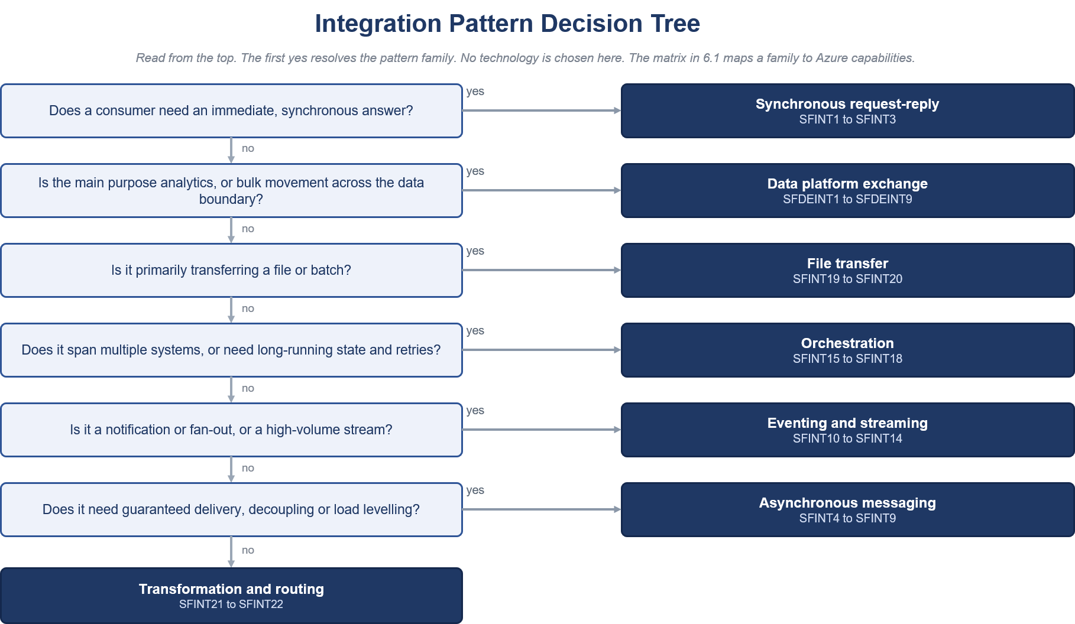

Example
This example demonstrates the application of the Systems Integration Framework to a representative insurance integration scenario, illustrating how decision guidance, architectural patterns and governance controls are applied together.

The problem. A broker operating under a delegated authority submits a bordereau, a batch file of bound risks, that must update Chaucer exposure before the bind is confirmed back to them. This is not a simple request and reply. A file arrives, it is translated to the internal model, exposure and accumulation are calculated and validated, the bind is confirmed to the broker system, and the downstream teams are told. The steps are ordered, some run long, and none can be silently lost, so reliability and traceability matter as much as the logic.
Using the document.
- Pattern Selection Process - The task is to choose a pattern for a specific need, so the reading path sends the reader to the decision tree in 7.3 and then the catalogue in Section 8.
- The decision tree (7.3) - The scenario is plainly multi-step, so it is split into its parts, and each part is read from the top of the tree, landing on one pattern family with no technology chosen yet.
- The matrix and use cases (7.1 and 7.2) - The matrix confirms the Azure capability that realises each family, and the common use cases show the same scenarios already recognised, so nothing is invented.
- The catalogue (Section 8) - Each chosen pattern is opened for its full specification, the problem it solves, the solution, when to use and avoid it, its security boundary and its non-functional profile.
- Scope and governance (Sections 10, 12 and 13) - Section 10 places the insurance scenario, Section 12 sets the guardrails and Section 13 describes how the design goes to the Technical Design Authority for sign-off.

Walking the decision.
- Inbound bordereau. The submission is a file, so it is taken in through event-driven file ingestion (SFINT19).
- Into the internal model. The broker format is not the Chaucer format, so the payload is translated to the canonical model before anything downstream sees it (SFINT21).
- The core process. The work spans several systems and runs long, with validation and calculation, so it resolves to orchestration (SFINT15), which sequences validate, calculate accumulation and confirm the bind.
- The confirmed instruction. It must reach the policy system without loss, so it travels as guaranteed-delivery reliable messaging (SFINT8).
Telling the rest. Downstream teams need to know but are not on the critical path, so they are told through a discrete event notification (SFINT11).
The solution. End to end, the bordereau lands and file ingestion (SFINT19) pick it up, canonical translation (SFINT21) maps it to the internal model, and an orchestration (SFINT15) validates the risks, calculates the accumulation against current exposure and confirms the bind. Reliable messaging (SFINT8) carries the confirmed instruction to the policy system, and a discrete event (SFINT11) notifies the downstream teams. No step calls another synchronously across the whole chain, so a slow or unavailable system never fails the broker submission.
Architectural Rationale. A real, multi-step scenario resolves through the decision tree into named catalogue patterns rather than a bespoke design. Each pattern defines its associated security boundary, operational considerations and non-functional characteristics. The resulting solution is governed through the framework's mandatory guardrails in Section 12 and the Technical Design Authority (TDA) review process. The required levels of reliability, traceability and governance are achieved through the application of approved integration patterns and supporting framework controls.

Enterprise Integration Profile and Pattern Catalogue

The Systems Integration Framework defines a governed catalogue for selecting, designing and reviewing integrations across internal Chaucer systems, third-party services, SaaS platforms and the enterprise data platform.

The catalogue has two complementary levels:
- Enterprise Integration Profiles classify the enterprise interaction, the boundary crossed, the expected governance treatment and the applicable control posture.
- Detailed Integration Patterns define the implementation approach used to realise an Enterprise Integration Profile.
These levels are complementary and must not be treated as competing pattern catalogues. An Enterprise Integration Profile describes the architectural context of an integration. A Detailed Integration Pattern describes how a specific part of the integration is implemented. One Enterprise Integration Profile may be realised through several Detailed Integration Patterns, and one Detailed Integration Pattern may support more than one Enterprise Integration Profile.

For example, the same Managed API Facade pattern may be used for an internal API, an externally consumed Chaucer API or a governed facade over a third-party API. The implementation pattern is similar, but the trust boundary, security controls and governance evidence differ.

Every architecture design must identify:
- The selected Enterprise Integration Profile.
- The integration boundary crossed.
- Each Detailed Integration Pattern used to realise the integration.
- The applicable security, operational and data-handling controls.
- The governance evidence required for the selected profile and patterns.
- Any approved exception or deviation.
The expected architecture traceability is:
Business requirement → Enterprise Integration Profile → Detailed Integration Pattern or Patterns → Approved platform capability → Mandatory guardrails → Governance evidence

- Enterprise Integration Profiles use the identifier format SIF-Pnn.
- Operational integration patterns use the identifier format SFINTnn.
- Data-platform exchange patterns use the identifier format SFDEINTnn.
- All identifiers use two digits to support consistent sorting, referencing and future catalogue expansion.
- Existing references such as SFINT1 and SFDEINT1 should be read as SFINT01 and SFDEINT01. All new and updated documentation must use the two-digit format.
- The Detailed Integration Pattern identifier is authoritative for implementation guidance. The Enterprise Integration Profile identifier is authoritative for boundary classification and governance assessment.

Enterprise Pattern Index and Boundary Applicability

Enterprise Integration Profiles provide the architecture and governance view of an integration.

Each profile identifies:
- The enterprise interaction being performed.
- The primary integration boundary.
- Where the profile is normally applicable.
- The primary platform capabilities.
- The expected governance classification.
- The Detailed Integration Patterns that may realise the profile.
Internal integrations may use approved API, messaging, eventing, orchestration, file-exchange, transformation and routing patterns within Chaucer’s controlled integration platform.

Third-party integrations must use an approved ingress or egress profile. These integrations require additional controls for identity, authentication, network boundaries, payload validation, data protection, monitoring, operational ownership and support.
The data platform is treated as a governed analytical exchange boundary. It is not the default mechanism for operational integration, transient messaging, real-time transaction processing or cross-system process orchestration.

Applicability and governance classifications
The following applicability notation is used throughout the catalogue:
Symbol | Meaning
✅ | The profile is normally applicable to the boundary.
⚠️ | The profile may be applicable but requires additional design rationale, controls or governance review.
❌ | The profile is not normally appropriate for the boundary.

The following governance classifications are used:
Governance classification | Meaning
Standard | The profile may be used through the normal architecture-governance route when all mandatory guardrails are satisfied.
Standard with boundary controls | The profile crosses an organisational, external, internet or data-platform boundary and requires the additional controls defined for that boundary.
Conditional | Use requires documented selection rationale and confirmation that the stated conditions are satisfied.
Exception required | Use deviates from an approved pattern, technology, guardrail or boundary and requires formal exception approval before implementation.
Not applicable | The profile is not an appropriate solution for the stated boundary or requirement.
A profile classified as Standard with boundary controls does not automatically require an exception. An exception is required only when the implementation cannot satisfy the approved boundary controls or otherwise deviates from the Systems Integration Framework.

Enterprise Integration Profile Catalogue

Profile ID | Enterprise Integration Profile | Primary boundary | Internal | Third party to Chaucer | Chaucer to third party | SIF to data platform | Primary capabilities | Governance classification
SIF-P01 | Internal REST API | Internal | ✅ | ❌ | ❌ | ⚠️ | API Management with backend API, Logic App or Function | Standard
SIF-P02 | External API Ingress | Third party to Chaucer | ⚠️ | ✅ | ❌ | ❌ | Approved network edge and API Management | Standard with boundary controls
SIF-P03 | External API Egress | Chaucer to third party | ⚠️ | ❌ | ✅ | ⚠️ | API Management, Logic Apps or Functions | Standard with boundary controls
SIF-P04 | API Facade and Mediation | Internal or external | ✅ | ✅ | ✅ | ⚠️ | API Management with Logic App or Function | Standard, with boundary controls where external
SIF-P05 | Reliable Queue Messaging | Primarily internal | ✅ | ⚠️ | ⚠️ | ⚠️ | Service Bus Queue | Standard internally; controlled externally
SIF-P06 | Publish and Subscribe Messaging | Primarily internal | ✅ | ⚠️ | ⚠️ | ⚠️ | Service Bus Topic and subscriptions | Standard internally; controlled externally
SIF-P07 | Event Notification | Internal or external | ✅ | ⚠️ | ✅ | ✅ | Event Grid, Service Bus Topic or Logic App | Standard internally; boundary controls where external
SIF-P08 | High-Volume Event Streaming | Internal, analytical or selected external | ✅ | ⚠️ | ⚠️ | ✅ | Event Hubs | Conditional
SIF-P09 | Workflow Orchestration | Internal or external | ✅ | ✅ | ✅ | ⚠️ | Logic Apps Standard | Standard, with boundary controls where external
SIF-P10 | Long-Running and Stateful Workflow | Internal or external | ✅ | ✅ | ✅ | ⚠️ | Logic Apps Standard or approved Durable Functions | Standard for Logic Apps; Durable Functions by approved exception
SIF-P11 | Third-Party Webhook Ingress | Third party to Chaucer | ⚠️ | ✅ | ❌ | ❌ | Approved network edge, API Management and asynchronous processing | Standard with boundary controls
SIF-P12 | Managed File Exchange | Internal or external | ✅ | ✅ | ✅ | ✅ | Logic Apps, Functions, Storage, SFTP and Event Grid | Standard internally; boundary controls where external
SIF-P13 | Data Platform Exchange | SIF to data platform or data platform to governed consumer | ⚠️ | ⚠️ | ⚠️ | ✅ | ADF, ADLS, Event Hubs, Snowpipe, Snowflake and governed APIs | Conditional; not an operational integration default
SIF-P14 | Specialist Mediation and Transformation | Internal or external | ✅ | ✅ | ✅ | ⚠️ | Functions, API Management, Service Bus or Event Grid | Standard with constraints
Profile Interpretation

The Primary capabilities column identifies the normal platform capabilities used to realise the profile. It does not prescribe every component required in an end-to-end design.
The Detailed Integration Patterns remain authoritative for:
- Pattern-selection criteria.
- Implementation structure.
- Appropriate and inappropriate use.
- Security boundaries.
- Operational considerations.
- Reliability and resilience controls.
- Common pitfalls.
- Representative insurance scenarios.
Any implementation that requires a technology not included in the target platform or an arrangement not covered by an approved profile and Detailed Integration Pattern requires documented architecture justification and approval through the exception process.

Relationship between Enterprise Integration Profiles and Detailed Integration Patterns
The following table maps each Enterprise Integration Profile to the Detailed Integration Patterns that may be used to realise it.
The mapping identifies permitted and commonly applicable patterns. It does not imply that every listed pattern is required in every implementation.

Enterprise Integration Profile | Profile name | Commonly applicable Detailed Integration Patterns | Detailed section
SIF-P01 | Internal REST API | SFINT01 Managed API Facade | 8.3
SIF-P02 | External API Ingress | SFINT01 Managed API Facade | 8.3
SIF-P03 | External API Egress | SFINT01 Managed API Facade; SFINT03 Protocol and Format Mediation; SFINT09 Scheduled or Timed Trigger; SFINT15 Stateful Process Orchestration | 8.3, 8.4 and 8.6
SIF-P04 | API Facade and Mediation | SFINT01 Managed API Facade; SFINT02 API Composition and Aggregation; SFINT03 Protocol and Format Mediation | 8.3
SIF-P05 | Reliable Queue Messaging | SFINT04 Queue-Based Load Levelling; SFINT05 Competing Consumers; SFINT06 Asynchronous Request-Reply; SFINT07 Claim-Check; SFINT08 Reliable Messaging; SFINT09 Scheduled or Timed Trigger | 8.4
SIF-P06 | Publish and Subscribe Messaging | SFINT10 Publish-Subscribe Fan-Out | 8.5
SIF-P07 | Event Notification | SFINT11 Discrete Event Notification; SFINT13 Outbound Webhook or Notification | 8.5
SIF-P08 | High-Volume Event Streaming | SFINT14 Stream and Telemetry Ingestion | 8.5
SIF-P09 | Workflow Orchestration | SFINT15 Stateful Process Orchestration; SFINT18 Scatter-Gather | 8.6
SIF-P10 | Long-Running and Stateful Workflow | SFINT15 Stateful Process Orchestration; SFINT16 Process with Compensation; SFINT17 Human-in-the-Loop Approval; SFINT18 Scatter-Gather | 8.6
SIF-P11 | Third-Party Webhook Ingress | SFINT12 Inbound Webhook Ingestion | 8.5
SIF-P12 | Managed File Exchange | SFINT09 Scheduled or Timed Trigger; SFINT19 Event-Driven File Ingestion; SFINT20 File Generation and Delivery | 8.4 and 8.7
SIF-P13 | Data Platform Exchange | SFDEINT01 to SFDEINT09 | 9.4
SIF-P14 | Specialist Mediation and Transformation | SFINT03 Protocol and Format Mediation; SFINT21 Canonical Data Model and Message Translator; SFINT22 Content-Based Routing | 8.3 and 8.8

Pattern selection and recording requirements
Every integration design must record the selected Enterprise Integration Profile and Detailed Integration Patterns. The minimum pattern-selection record is:
Required information | Description
Business requirement | The business capability, process or data-exchange requirement being addressed.
Enterprise Integration Profile | The selected SIF-Pnn profile and profile name.
Boundary | Internal, third party to Chaucer, Chaucer to third party, or SIF to data platform.
Detailed Integration Patterns | Each selected SFINTnn or SFDEINTnn identifier and pattern name.
Decision rationale | The decision-tree outcome and reason the selected profile and patterns meet the requirement.
Primary capabilities | The approved platform capabilities used to realise the patterns.
Data classification | The applicable data classification and handling implications.
Security controls | Identity, authentication, authorisation, connectivity, secret-management and boundary controls.
Operational controls | Monitoring, alerting, reliability, recovery, retry, support ownership and runbook arrangements.
Mandatory guardrails | Evidence that the controls in Section 12.1 are satisfied.
Exception status | The exception reference, owner, approval and expiry date where applicable.

A design must not record only a technology choice such as “Logic Apps,” “Service Bus” or “Functions.” The selected technology must be linked to an approved profile and one or more Detailed Integration Patterns.
Selection example
- Business requirement: A third-party payment provider must notify Chaucer when a settlement event occurs.
- Enterprise Integration Profile: SIF-P11 Third-Party Webhook Ingress.
- Detailed Integration Pattern: SFINT12 Inbound Webhook Ingestion.
- Boundary: Third party to Chaucer.
- Primary capabilities: Approved network edge, API Management, Service Bus and Function.
- Governance classification: Standard with boundary controls.
Required evidence: Authentication, payload validation, replay protection, rate limiting, private downstream processing, monitoring, support ownership and public-exposure approval.

Composite-pattern example
- Business requirement: A delegated-authority bordereau is received as a file, translated to Chaucer’s internal model, validated across several systems and delivered reliably to the policy system.
- Enterprise Integration Profiles: SIF-P12 Managed File Exchange, SIF-P14 Specialist Mediation and Transformation, SIF-P09 Workflow Orchestration and SIF-P05 Reliable Queue Messaging.
- Detailed Integration Patterns: SFINT19 Event-Driven File Ingestion, SFINT21 Canonical Data Model and Message Translator, SFINT15 Stateful Process Orchestration and SFINT08 Reliable Messaging.
Where several profiles or patterns are combined, each profile and pattern must be listed separately. Combining patterns does not create a new pattern identifier.

Pattern Grouping by Integration Boundary
Internal Chaucer Integration Profiles
Profile ID | Enterprise Integration Profile | Typical use | Governance treatment
SIF-P01 | Internal REST API | Synchronous application-to-application retrieval or update of a governed business capability. | Standard
SIF-P04 | API Facade and Mediation | Shield consumers from backend implementation, protocol or system complexity. | Standard
SIF-P05 | Reliable Queue Messaging | Decouple producers and consumers and provide retry, load levelling and dead-letter handling. | Standard
SIF-P06 | Publish and Subscribe Messaging | Distribute durable business messages to multiple independent consumers. | Standard
SIF-P07 | Event Notification | Notify internal consumers that a resource or business event has occurred. | Standard
SIF-P08 | High-Volume Event Streaming | Ingest sustained high-volume event or telemetry streams. | Conditional
SIF-P09 | Workflow Orchestration | Coordinate a multi-step process across Chaucer-owned systems. | Standard
SIF-P10 | Long-Running and Stateful Workflow | Coordinate state, retries, compensation, callbacks or human approval over an extended process. | Standard for Logic Apps; exception required for Durable Functions
SIF-P12 | Managed File Exchange | Move or process files between Chaucer systems using governed storage and processing controls. | Standard
SIF-P14 | Specialist Mediation and Transformation | Perform bounded protocol adaptation, format transformation, validation or content-based routing. | Standard with constraints
Internal use assumes that the implementation satisfies the private connectivity, managed identity, least-privilege access, Key Vault/ Cyber Ark, TLS, monitoring and delivery-pipeline controls specified elsewhere in the framework.

Third Party to Chaucer Inbound Profiles
Profile ID | Enterprise Integration Profile | Typical use | Additional controls
SIF-P02 | External API Ingress | A supplier, SaaS platform, broker, market service or vendor invokes a Chaucer-owned API. | Approved edge, API Management, approved authentication, authorisation, throttling, validation, monitoring and backend isolation.
SIF-P04 | API Facade and Mediation | Chaucer exposes a stable contract while shielding internal systems and legacy interfaces. | Contract ownership, versioning, backend isolation, schema validation and controlled public exposure.
SIF-P11 | Third-Party Webhook Ingress | A SaaS platform or vendor pushes a callback or event to Chaucer. | Approved edge, API Management, signature or token validation, replay protection, rate limiting, deduplication and asynchronous downstream processing.
SIF-P12 | Managed File Exchange | A supplier, broker, cover holder or vendor sends files to Chaucer. | Approved SFTP or private connectivity, encryption, source authentication, malware scanning where required, metadata capture, validation and reconciliation.
SIF-P13 | Data Platform Exchange | External data is supplied for governed analytical ingestion. | Data ownership, classification, lineage, landing-zone controls, ingestion monitoring and approved data-platform ownership.
SIF-P14 | Specialist Mediation and Transformation | An inbound payload requires protocol conversion, canonical translation, validation or routing. | The transformation component remains private and is invoked only after the approved ingress controls have been applied.
External parties must not connect directly to Service Bus, Event Grid, Functions, Logic App HTTP triggers, backend APIs or the data platform unless a separate approved pattern and exception explicitly permit the arrangement.

Chaucer to Third Party Outbound Profiles

Profile ID | Enterprise Integration Profile | Typical use | Additional controls
SIF-P03 | External API Egress | Chaucer invokes a supplier, SaaS, market or vendor API. | Controlled egress, credential or token management, timeout, exponential backoff, throttling, circuit breaking, error mapping and dependency monitoring.
SIF-P04 | API Facade and Mediation | Chaucer provides a reusable internal facade over a third-party API. | Contract abstraction, versioning, supplier lifecycle management and centralised policy where reuse or criticality justifies it.
SIF-P07 | Event Notification | Chaucer notifies an external party of a business event or status change. | Contracted destination, authentication, delivery audit, retry, dead-letter handling and payload protection.
SIF-P09 | Workflow Orchestration | Chaucer coordinates a multi-step process involving one or more third-party systems. | Named process owner, controlled egress, dependency timeouts, monitoring and compensating actions.
SIF-P10 | Long-Running and Stateful Workflow | A supplier interaction requires polling, callback, delayed response, escalation or compensation. | Durable state, timeout policy, retry policy, escalation, versioning and support ownership.
SIF-P12 | Managed File Exchange | Chaucer sends a file to a supplier, broker, regulator or vendor. | Approved delivery path, encryption, confirmation handling, reconciliation, retention and named support ownership.
SIF-P14 | Specialist Mediation and Transformation | Supplier-specific payload, format, validation or protocol adaptation is required. | Source-controlled mappings, testing, private execution, Key Vault / CyberArk integration and DevSecOps deployment.

Third-party API egress may be implemented directly from an approved Logic App or Function when the integration is workflow-specific, has limited reuse and is appropriately governed. A Chaucer-owned facade through API Management should be used where the third-party API is reused, business-critical, strategically important, externally sensitive or requires centralised policy, monitoring or lifecycle control.

SIF to Data Platform Profiles
Profile ID | Enterprise Integration Profile | Typical use | Guardrail
SIF-P07 | Event Notification | Notify the data platform that governed data is available for ingestion. | Notification only. Do not use the data platform to coordinate an operational process.
SIF-P08 | High-Volume Event Streaming | Stream high-volume events or telemetry into the data platform for analytical processing. | Use only where the streaming requirement and expected volume are demonstrated.
SIF-P12 | Managed File Exchange | Land files in an approved data-platform landing zone or export curated data through a governed file boundary. | Ownership, classification, metadata, retention, reconciliation and monitoring must be defined.
SIF-P13 | Data Platform Exchange | Governed ingestion into the data platform or governed consumption of curated data products. | The data platform must not become the default operational integration mechanism.
SIF-P14 | Specialist Mediation and Transformation | Perform bounded extraction, validation, redaction or format preparation at the exchange boundary. | Do not embed operational process orchestration or warehouse transformation logic in custom integration code.

Detailed Practitioner Patterns

The Detailed Integration Pattern Catalogue is the authoritative source for pattern implementation guidance. Patterns are organised by interaction style:

- Request and response.
- Asynchronous messaging.
- Eventing and streaming.
- Process orchestration.
- File exchange.
- Transformation and routing.
- Data-platform exchange.
The catalogue is aligned to the decision process in Section 7. The decision tree first identifies the appropriate interaction style. The detailed catalogue then provides the approved pattern for implementing that interaction.

Authoritative pattern identifiers
The following identifier formats are used
Identifier format | Scope | Example
SFINTnn | Operational integration patterns | SFINT08 Reliable Messaging
SFDEINTnn | Data-platform exchange patterns | SFDEINT03 File Ingestion
The Detailed Integration Pattern identifier must be used in:
- High-level and low-level solution designs.
- Architecture decision records.
- Interface and integration specifications.
- Service-catalogue entries.
- Security and operational-readiness assessments.
- Exception requests.
- TDA submissions.
- Delivery and support documentation.
A design must reference both the pattern identifier and the pattern name.

For example:
Selected pattern: SFINT08 Reliable Messaging

Detailed pattern structure
Each Detailed Integration Pattern is described using a consistent structure:
- Purpose statement: A concise description of what the pattern achieves.
- Problem: The integration problem or architectural concern addressed by the pattern.
- Solution: The approved pattern structure and division of responsibilities.
- Use it when: The conditions under which the pattern is appropriate.
- Avoid it when: The conditions under which another pattern should be selected.
- Risks and considerations: Reliability, performance, capacity, lifecycle and operational factors.
- Security boundary: The trust zones crossed and the required identity, connectivity and security treatment.
- Common pitfall: Common implementation choices that weaken the intended pattern.
- In practice: A representative insurance or enterprise integration example.
Detailed patterns do not redefine the cross-cutting security and operational baseline.
Every Detailed Integration Pattern inherits:
- Private connectivity by default.
- Managed identity wherever supported.
- Least-privilege access.
- Approved secret, key, and certificate management services.
- TLS on every network hop.
- Data minimisation and classification controls.
- Correlation, logging, metrics, traces and alerting.
- Infrastructure-as-code and controlled DevSecOps deployment.
- Named service and support ownership.
- Resilience and recovery aligned to business criticality.
- TDA exception approval where the standard baseline cannot be met.
The Security boundary entry within each pattern explains how the common security baseline applies to that pattern’s interaction style and boundary. It does not replace the mandatory guardrails or per-pattern security-conformance assessment.

Combining patterns
An end-to-end integration will often combine multiple Detailed Integration Patterns.
Pattern composition is expected where each pattern has a clear and bounded responsibility.

For example: An external webhook triggers processing within the platform. After validation, the request is queued, translated into the platform's standard model, processed through an orchestrated workflow, and relevant events are published for downstream consumers, then pattern used are.
- SFINT12 Inbound Webhook Ingestion receives and validates an external callback.
- SFINT08 Reliable Messaging places the validated business instruction onto Service Bus.
- SFINT15 Stateful Process Orchestration coordinates the cross-system process.
- SFINT21 Canonical Data Model and Message Translator converts the external payload to the internal model.
- SFINT11 Discrete Event Notification informs non-critical downstream consumers.
Combining patterns does not create a new pattern identifier.
Each selected pattern must be documented independently, including its:
- Purpose in the end-to-end design.
- Boundary and data classification.
- Technology implementation.
- Security and operational controls.
- Ownership and support model.
- Applicable guardrails.
- Exception status.
The overall solution must also identify the component that owns the end-to-end process and the authoritative system of record for each business state.

Pattern governance
A Detailed Integration Pattern may be used through the normal governance process when:

- The pattern is selected consistently with the decision guidance in Section 7.
- The associated Enterprise Integration Profile is applicable to the boundary.
- Approved platform capabilities are used.
- All mandatory guardrails are satisfied.
- The required security and operational evidence are present.
- No prohibited anti-pattern is introduced.
Exceptions must be recorded and approved in accordance with Sections 12 and 13.

API Patterns

Managed API facade (SFINT1)
Put every exposed capability behind the shared gateway, so consumers never bind to a backend directly.

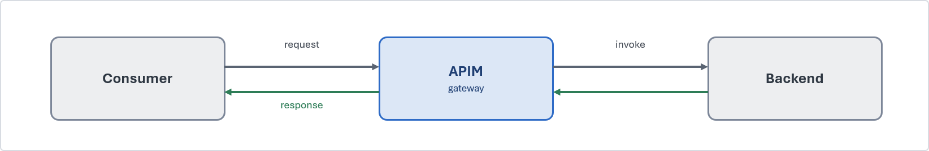

Problem. Some business interactions genuinely require synchronous access to a capability exposed by another system, particularly where the consumer is waiting for an immediate response, such as a quote or validation. However, synchronous integration should remain limited to short-lived requests. When direct backend access is allowed, it creates tight coupling, distributes security and access-control responsibilities, and increases the impact of change across dependent consumers. Equally, when synchronous interactions evolve into long-running processes, they increase the risk of timeouts, retries, and degraded reliability.
Solution. Expose the capability as a coarse-grained REST/JSON operation on API Management. APIM authenticates the caller with an Entra token, applies a rate limit and a product subscription, and forwards to the backend over a Private Endpoint using a managed identity. The consumer knows only the contract, so the backend can be re-platformed behind a stable façade. Where the capability must be reachable from the internet, APIM sits behind an appropriate network edge protection service, it is never public itself.
Use it when. A consumer requires an immediate response, and the capability must be exposed through a governed, reusable, and discoverable API. Standardising on REST/JSON provides a consistent integration approach across the estate and allows legacy protocols and backend implementations to be abstracted behind a common API contract. This simplifies consumption, reduces coupling, and enables backend services to evolve without impacting consumers.
Avoid it when. This pattern is not suitable for long-running, unpredictable, or fire-and-forget workloads. Where multiple steps, orchestration, or transactional processing are required, use an asynchronous or orchestration-based pattern instead.
Risks and considerations. APIM provides a consistent API facade that centralises policy enforcement, security controls, traffic management, and API governance. To minimise latency and operational overhead, policies should remain focused and efficient, with caching applied where appropriate. Backend services remain responsible for implementing their own security, validation, and throttling controls rather than relying solely on the gateway layer.
Security boundary. For internal consumers, the entire interaction remains private and does not traverse the public internet. Consumer-to-APIM and APIM-to-backend communications use Private Endpoints, with TLS enforced on every hop. APIM authenticates to backend services using managed identities. Where an API must be externally accessible, it is exposed through an approved secure access layer or network edge protection service with OAuth or mTLS protection at the edge, managed as a registered exception. APIM is not exposed directly to the internet.
Common pitfall. Implementing the API facade as a simple pass-through layer with no governance value or embedding business logic and orchestration behaviour within API policies.
In practice. A broker portal requires real-time access to policy information. Instead of integrating directly with the policy administration platform, the capability is exposed through APIM as a managed API facade. The policy system exposes get-policy-summary through APIM , the broker portal calls the API and has no knowledge of the policy admin system behind it.

API composition / aggregation (SFINT2)
Assemble one coarse-grained business response from a few backend reads, so the consumer makes a single call.

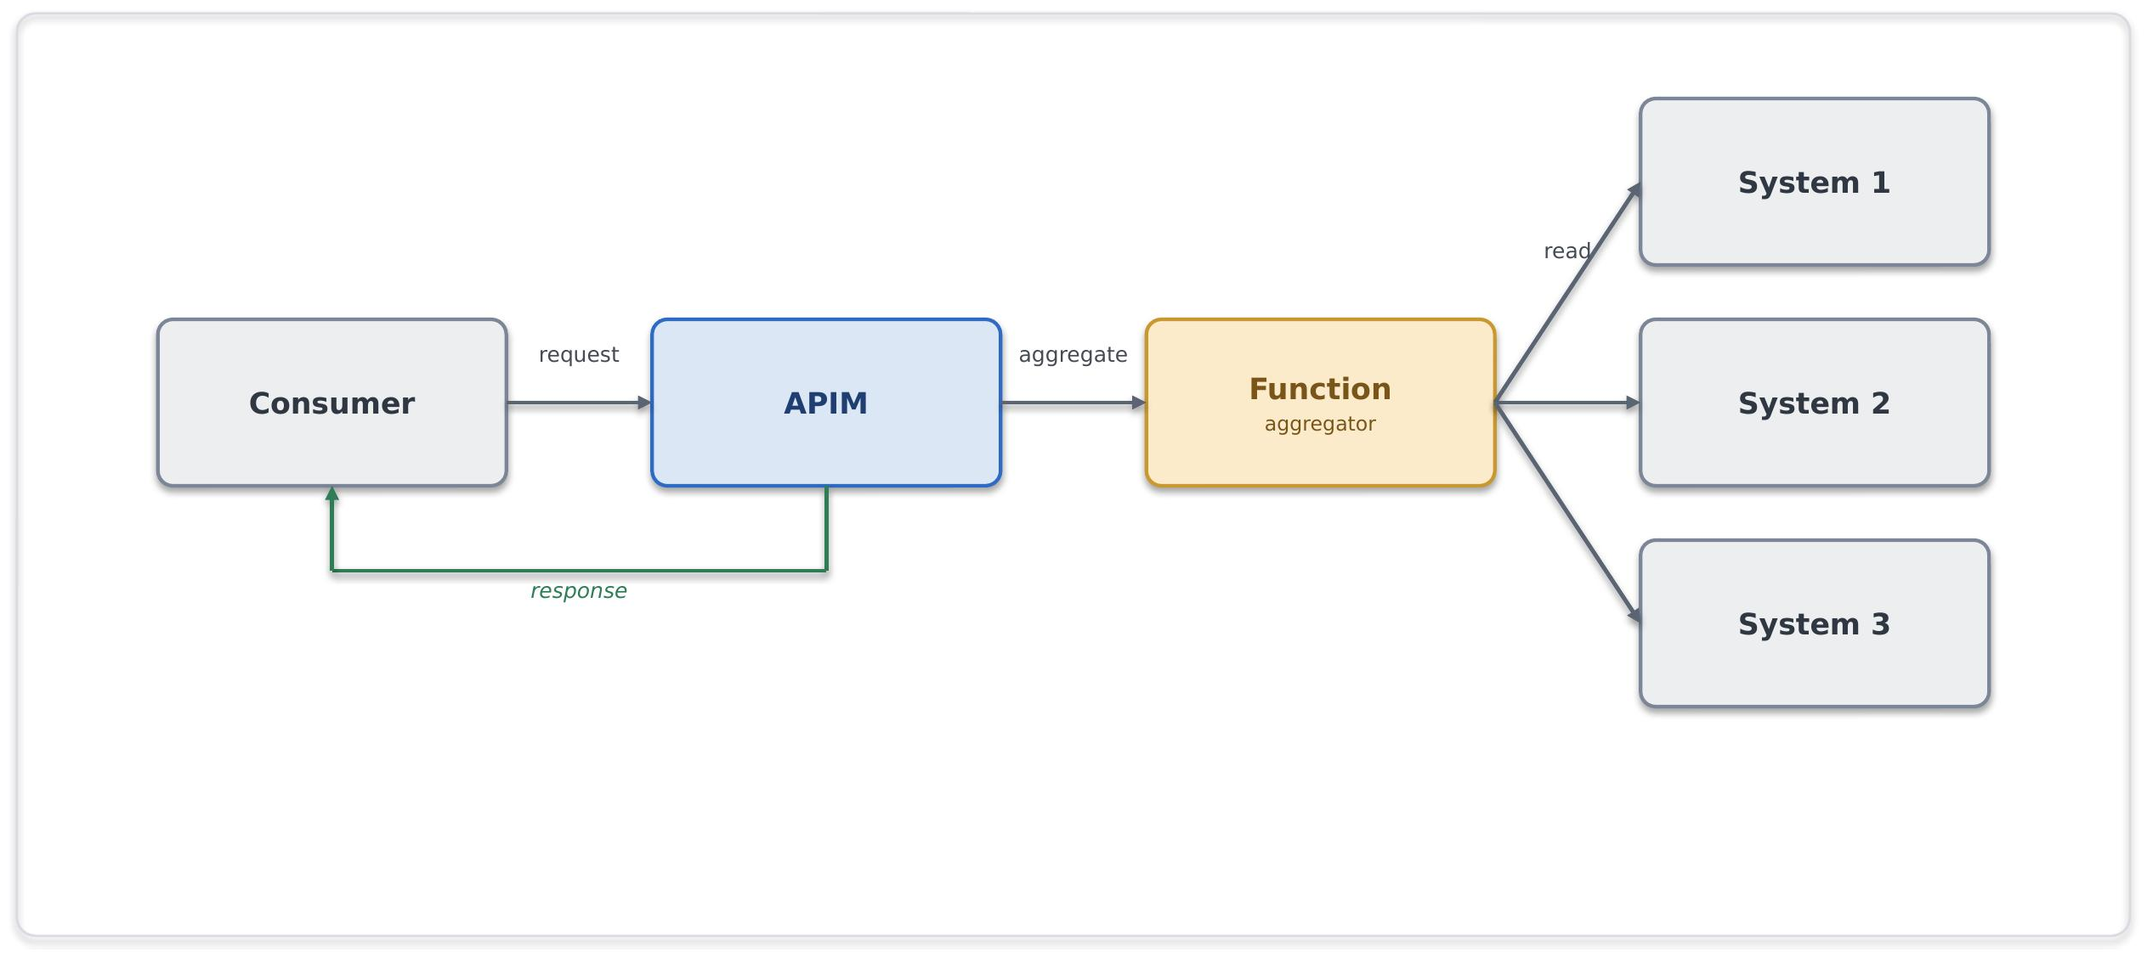

Problem. A servicing application needs a consolidated client view, but the required data is spread across multiple systems. Having the application call each system directly creates unnecessary dependencies on multiple interfaces and increases the impact of failures. Combining the data in the user interface adds complexity and makes the solution harder to maintain.
Solution. Exposing a single composed API on APIM backed by a Function that fans out to the underlying systems, assembles a coarse-grained response and returns it. The composition stays read-mostly and business-shaped, SOA granularity, not a mesh of fine-grained calls.
Use it when. A consumer needs one logical business object drawn from two or three sources and a single round-trip materially simplifies the caller.
Avoid it when. The composition needs transactional writes or long-running steps (orchestrate), or the need is to fan out to many fine-grained services, that is a granularity problem to fix, not to aggregate around.
Risks and considerations. Response time is governed by the slowest dependency and availability by their product, so decide up front how the API behaves when one source is down, a partial response with a clear indicator usually beats failing the whole call. Put a timeout and a circuit breaker around each backend and cache responses wherever feasible.
Security boundary. APIM is hosted as a shared service, with workload services deployed in their own workload boundaries. All communication remains internal, using private connectivity, managed identities, and TLS encryption end-to-end. No services are exposed directly to the internet.
Common pitfall. Fine-grained, chatty aggregation that recreates a distributed monolith; pushing heavy composition into APIM policies instead of a Function.
In practice. A servicing application requires a consolidated client view spanning policy, claims and customer systems. Rather than calling multiple backend services directly, the application consumes a single aggregated API exposed through APIM. A composition service retrieves and assembles the required information, providing a unified response while maintaining separation between consumers and source systems.

Protocol / format mediation (SFINT3)
Translate a legacy protocol to REST/JSON at the edge so modern consumers stay clean.

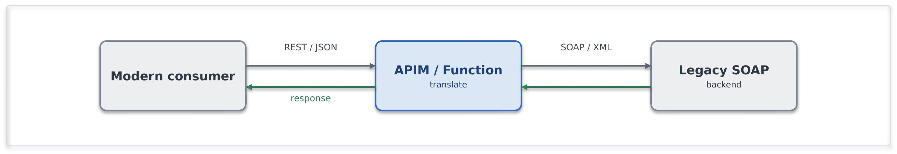
Use it when. Standardising the estate on REST/JSON and need to front a legacy protocol.
Avoid it when. The requirement is really business transformation rather than protocol translation, that is implementation logic and belongs in a Function with tests, not in a mediation policy.
Risks and considerations. Translation should remain stateless and limited to protocol and format conversion. Introducing business logic into the mediation layer increases complexity and can result in hidden or difficult-to-test behaviour. Schema validation should be applied during transformation to identify malformed payloads before they propagate downstream.
Security boundary. APIM or the mediation Function in the shared subscription / a spoke; the legacy backend in its spoke or on-premises. Within Azure: Private Endpoint, managed identity and TLS, an on-premises backend is reached over the private vWAN path, not the internet. Outside Azure: none, an internet-only legacy partner uses the inbound-webhook edge instead.
Common pitfall. Business rules embedded in the translation layer; unbounded transformation inside APIM policies.
In practice. A cloud-native application requires access to a reinsurance capability exposed through a legacy SOAP/XML interface. Protocol mediation presents the capability through a REST/JSON contract while isolating legacy implementation details from consuming applications.

Messaging Patterns

Queue-based load levelling (SFINT4)
Put a queue between a spiky producer and a limited backend so load is absorbed, not amplified.

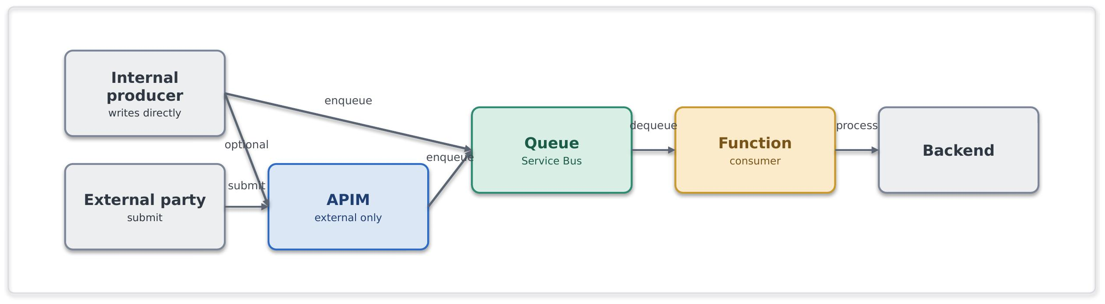
Problem. A producer generates work at a higher rate than a consuming system can process it. Tight coupling between producer and consumer can result in reduced availability, processing bottlenecks and failure propagation during periods of increased load.
Solution. Introduce a Service Bus queue between the producer and the backend so each run at its own pace. An internal producer writes to the queue directly, authenticated with managed identity, so no gateway sits in the path. An external producer, which cannot reach the bus, is fronted by API Management or a small Function that validates the request and enqueues it. A Function consumer then drains the queue at the rate the backend can sustain, so producer and consumer are decoupled in time, and a backend outage becomes a growing queue rather than a wave of errors.
Use it when. The producer is spikier or faster than the consumer, or the backend's availability must be decoupled from producer load.
Avoid it when. The caller needs an immediate answer (request/response), the input being ingested is a high-volume telemetry (Event Hubs).
Risks and considerations. Service Bus provides buffering rather than unlimited capacity. Queue depth, consumer lag and dead-letter queues should be monitored to identify processing bottlenecks and capacity constraints. Consumers should support idempotent processing, as delivery semantics remain at-least-once and duplicate deliveries may occur.
Security boundary. APIM (shared), Service Bus and the consumer Function (spokes), internal. Within Azure: producers and consumer reach Service Bus over a Private Endpoint using a managed identity with Sender/Receiver RBAC (no SAS keys), TLS throughout. Outside Azure: none, an external producer is taken through the edge first.
Common pitfall. Hammering a fragile backend synchronously; ignoring the dead-letter queue; reaching for storage queues when sessions, DLQ and richer delivery semantics are needed
In practice. During renewal season, large volumes of broker submissions may arrive within a short period of time. Rather than overloading downstream policy administration systems, submissions are queued and processed asynchronously, allowing business operations to continue without affecting service availability or delivery reliability.

Competing consumers (SFINT5)
Scale out throughput by letting several workers pull from one queue.

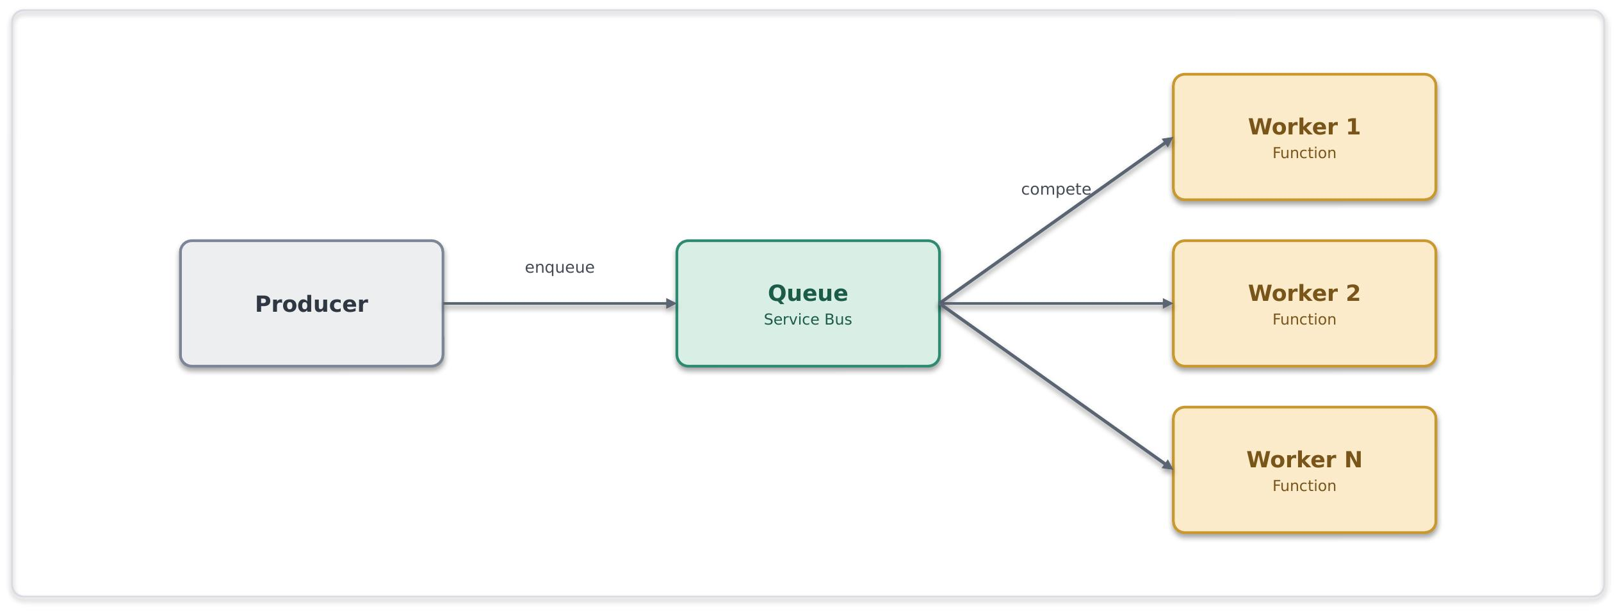
Problem. A single consumer instance is unable to process incoming work at the required rate. As message volumes increase, processing latency and queue backlogs can grow, limiting overall throughput and responsiveness.
Solution. Multiple consumer instances process messages from a shared queue in parallel. Service Bus distributes messages across available consumers, enabling horizontal scale-out while maintaining controlled processing.
Use it when. Throughput exceeds a single consumer, and the work items are independent and can be run in parallel.
Avoid it when. Strict global ordering without sessions is needed, or workers must share mutable state.
Risks and considerations. Duplicate delivery is still a possibility; therefore, consumers should be idempotent. Monitor for hot sessions that serialise work and cap the scale-out. To address this auto scale on queue depth rather than CPU.
Security boundary. Service Bus and the Function pool in spokes, internal. Within Azure: Private Endpoint, managed identity with least-privilege RBAC, TLS. Outside Azure: none.
Common pitfall. Assuming ordering without sessions or sharing mutable state between workers.
In practice. A backlog of document-processing jobs is cleared by an autoscaling pool of Function workers.

Asynchronous request-reply (SFINT6)
Accept now, answer later, a 201/202 and a status endpoint instead of a held-open connection.

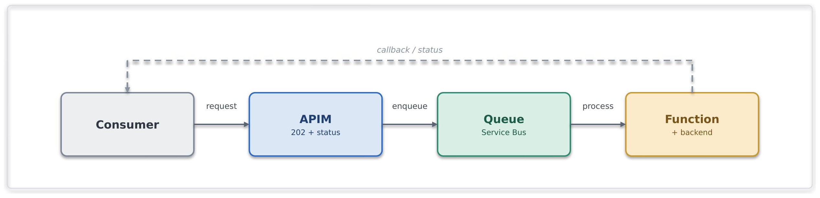

Problem. A consumer wants a result from an operation that takes too long to hold a synchronous HTTP connection open for.
Solution. APIM accepts the request, returns 201/202 with a status URL and a correlation id, and drops the work on a queue. A Function processes it and updates a status store or calls back; the caller polls the status endpoint or receives the callback.
Use it when. The operation is too long for a synchronous reply, but the caller still needs the eventual result.
Avoid it when. The result is instant (synchronous) or there is no way to correlate request and reply.
Risks and considerations. This interaction model becomes multi-stage and requires clear status-tracking behaviour. Correlation identifiers should be maintained throughout the processing lifecycle, and status information should be stored durably with appropriate retention and cleanup controls. Documentation should clearly define the expected client interaction pattern.
Security boundary. APIM (shared), Service Bus and Function (spokes), internal. Within Azure: Private Endpoints, managed identity, TLS, the correlation id carries no secret material. Outside Azure: none unless the caller is external, in which case the request and status endpoints are exposed through the edge (Network Edge Service, OAuth).
Common pitfall. Holding a synchronous connection open for minutes; omitting a correlation id.
In practice. A bulk quotation or pricing request cannot be completed within the expected synchronous response window. The request is accepted immediately and processed asynchronously, while the consumer retrieves the final outcome through a status endpoint once processing has completed

.

Claim-check (SFINT7)
Keep large payloads off the bus, pass a reference, store the body in Blob.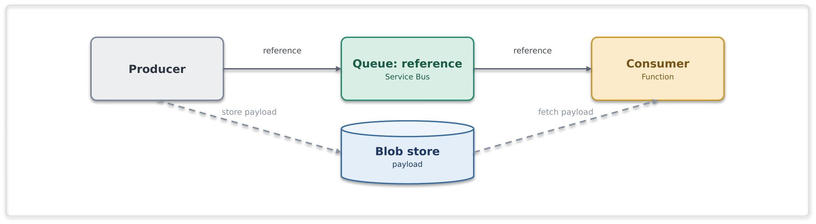
Problem. A messaging-based integration needs to process payloads created by the producer that exceed recommended message sizes.
Solution. The producer writes the payload to Blob storage and puts only a reference on the queue; the consumer reads the reference and fetches the body from blob. The messaging layer stays lean.
Use it when. Payloads approach or exceed message-size limits within an otherwise message-based flow.
Avoid it when. Payloads are small enough to carry inline, or the data is really a bulk data-platform concern.
Risks and considerations. Reference and payload now have independent lifetimes, a lifecycle policy must purge transient blobs, to avoid cost increase, and the reference is ineffective if the blob has gone. The Blob should be reached over a Private Endpoint with RBAC; no account keys, no public SAS.
Security boundary. Service Bus, Blob and Function in spokes, the storage account is firewalled with public access disabled. Within Azure: Blob is reached over a Private Endpoint with managed-identity RBAC, no account keys, no public SAS, and TLS. Outside Azure: none, the payload never leaves the private boundary.
Common pitfall. Large binaries on the bus; public or long-lived SAS URLs to the payload.
In practice. A bordereau, claims file or other large business document exceeds recommended message sizes for direct transport through the messaging platform. The document is stored in Blob Storage, while a reference is distributed through Service Bus for downstream processing and orchestration.

Reliable messaging (SFINT8)
For business-critical messages never lost and effectively processed once.

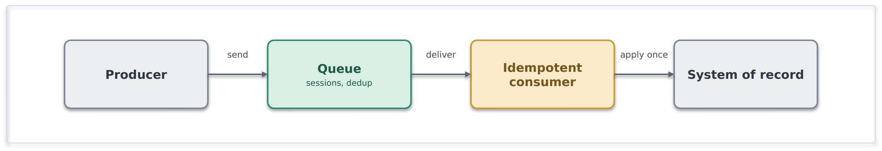
Problem. A messaging scenario requires reliable delivery and protection against duplicate processing, where message loss or repeated processing would result in operational, financial or data-integrity impacts.
Solution. Use Service Bus with appropriate delivery controls, including duplicate detection and sessions where message ordering is required. Consumers should implement idempotent processing to safely handle redelivery scenarios. Where message publication must remain consistent with local state changes, a transactional outbox pattern should be considered. Exactly-once outcomes are achieved through at-least-once delivery combined with idempotent processing.
Use it when. Message loss or double-processing has real financial or data-integrity impact.
Avoid it when. The notification is best-effort and replaceable, use Event Grid.
Risks and considerations. Duplicate-detection windows are finite; idempotent processing should remain the primary protection against duplicate message handling. Capacity and resilience should align to the required service level.
Security boundary. Service Bus and consumer in spokes, internal. Within Azure: Private Endpoint, managed identity, TLS, idempotency keys carry no secrets. Outside Azure: none.
Common pitfall. Assuming transport-level exactly-once delivery guarantees and implementing consumers without idempotent processing controls.
In practice. A financial or policy-processing workflow requires reliable message delivery and protection against duplicate processing. Service Bus provides durable message handling, while consumers use idempotent processing to ensure a message can be safely reprocessed without introducing duplicate business outcomes.

Scheduled / timed trigger (SFINT9)
Kick off integration work on a clock when there is no event to react to.

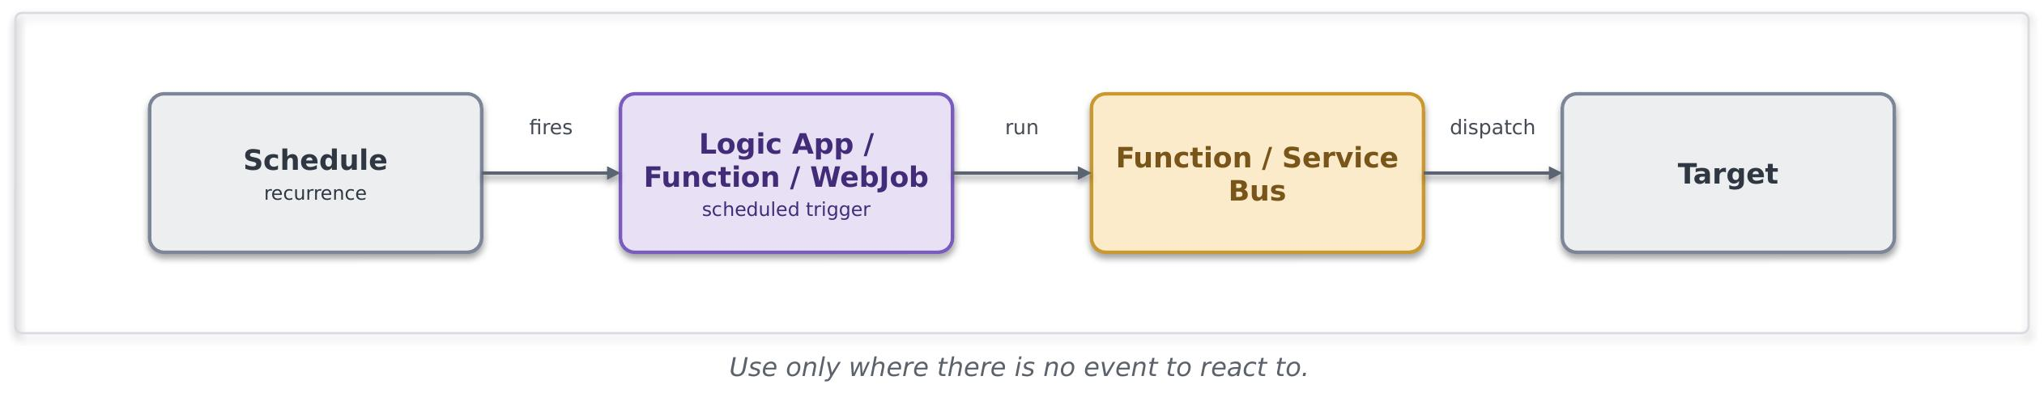
Problem. Certain integrations are inherently time-based and require execution on a defined schedule. In these scenarios, event-driven approaches may not be available or appropriate.
Solution. A Logic App (Standard)/Function recurrence trigger or web job fires on a schedule and runs the work, calling a Function or dropping messages on Service Bus for downstream processing.
Use it when. The cadence is time-based (end-of-day, regulatory windows) or the source cannot notify and there is no event to subscribe to.
Avoid it when. An event source is available, or polling is being used to emulate near-real-time processing.
Risks and considerations. Schedules can result into hidden coupling and surprise load spikes. Execution schedules should be documented, idempotent and monitored, with alerts configured for missed or failed runs.
Security boundary. The trigger runs in a workload spoke; the schedule is internal and crosses no boundary. Within Azure: managed identity to any Function/Service Bus it calls, Private Endpoints, TLS. Outside Azure: none, if a scheduled run reaches a partner (an extract), that egress follows the file-egress edge controls (SFINT20).
Common pitfall. Timer-polling a data source or folder to simulate real-time; overlapping runs with no idempotency; schedules scattered across teams with no visibility.
In practice. Financial reconciliation processes often run at defined business intervals rather than in response to events. A scheduled integration executes at the required time, identifies changes and distributes them for downstream processing and reporting.

Event Patterns

Publish / subscribe fan-out (SFINT10)
Publish a business event once; let interested consumers subscribe independently.

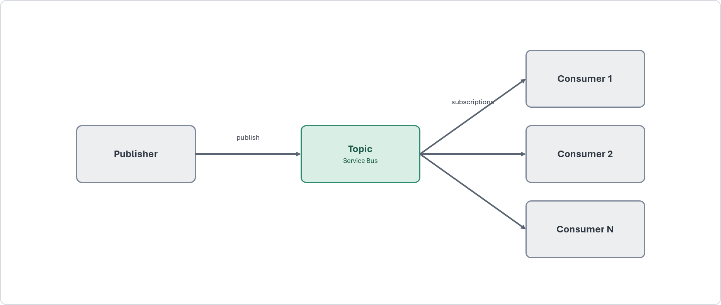

Problem. Multiple consumers need to react to the same business event independently. Direct point-to-point integration between the publisher and each consumer increases coupling and creates additional maintenance overhead
Solution. The publisher emits an event to a Service Bus topic; each consumer owns a subscription with its own filter and dead-letter queue. Consumers come and go without the publisher knowing. This is the primary tool for eliminating point-to-point integration.
Use it when. Several consumers must react to the same business event, and durable, filterable, independently-consumed delivery is required.
Avoid it when. It is a lightweight reactive trigger with no durability need (Event Grid), or a high-volume stream (Event Hubs).
Risks and considerations. Subscription growth should be governed and monitored. Each subscription should implement appropriate dead-letter handling, monitoring and alerting. Consumer backlogs should be monitored independently to prevent processing delays
Security boundary. The Service Bus topic and its subscribers in spokes, internal. Within Azure: Private Endpoint, per-subscription managed-identity RBAC, TLS. Outside Azure: none.
Common pitfall. Creating direct dependencies between publishers and consumers, or using Event Grid where durable, filterable and independently consumable messaging is required.
In practice. When a policy is bound, multiple downstream functions such as finance processing, document generation and analytics require notification of the event. Publish/subscribe messaging enables each consumer to process the event independently without introducing direct dependencies on the publishing application.

Discrete event notification (SFINT11)
A thin "it happened" signal for near-real-time reactions.

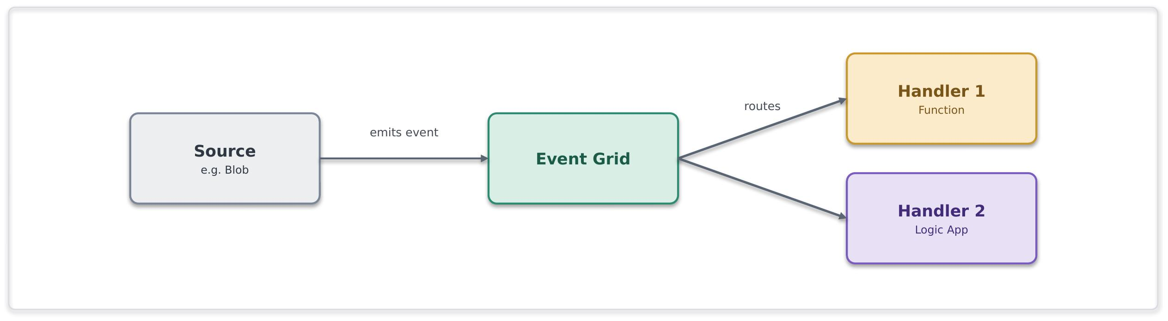
Problem. A change in state or business event must be communicated to one or more consumers with minimal latency, without requiring durable enterprise messaging or workflow orchestration.
Solution. Emit a thin event to Event Grid, handlers (Functions, Logic Apps, webhooks) subscribe and react. The event is a pointer, not a state carrier, a handler fetches authoritative state if it needs it.
Use it when. Lightweight, low-latency reactive fan-out to Azure-native handlers is needed
Avoid it when. Consumers need durable ordered delivery or competing consumers (Service Bus topics), or the volume is a stream (Event Hubs).
Risks and considerations. Delivery is at-least-once and unordered, so handlers must be idempotent and order-independent. Dead-letter handling should be configured for failed deliveries. Events should not be treated as authoritative business records, as this can introduce coupling and data-consistency challenges.
Security boundary. Event Grid and its handlers in spokes, reached privately. Within Azure: managed-identity delivery, Private Endpoint where supported, handler-side validation, TLS. Outside Azure: none, a handler that must be internet-reachable is the inbound-webhook pattern, not this one.
Common pitfall. Using event notifications for streaming workloads or durable business messaging, or publishing events that become de facto sources of truth.
In practice. A document, file or business record changes state and downstream services need to react quickly. Event notifications allow interested consumers to respond independently without introducing direct dependencies or additional workflow coordination.

Inbound webhook ingestion (SFINT12)
Take partner callbacks safely through the network edge service, then process them asynchronously.

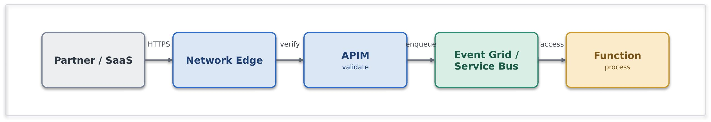
Problem. An external party needs to notify Chaucer of an event through a callback or webhook mechanism. Direct exposure of internal integration endpoints is a security risk.
Solution. This is the sanctioned public-ingress exception. Traffic enters through an appropriate network edge service, terminates at APIM as the single ingress point, is authenticated (mTLS, OAuth, or a signed-payload check) and validated, then dropped onto Service Bus or Event Grid for asynchronous processing. No Function or Logic App HTTP trigger is ever exposed directly.
Use it when. An external party must push events to us and private networking is not possible.
Avoid it when. Avoid this pattern when private connectivity is available. Private connectivity must be preferred over public ingress.
Risks and considerations. Internet-facing integrations require additional controls to mitigate replay, forgery and abuse scenarios. Request validation, rate limiting, deduplication and asynchronous processing should be implemented. Where public exposure is required, the integration should follow the approved exception process and maintain clear ownership and review arrangements.
Security boundary. This pattern crosses the internet boundary. An approved network edge service terminates the public endpoint, APIM provides the single API ingress, and all subsequent processing occurs within private workload spokes.. Within Azure: past the edge everything is private, Service Bus/Event Grid and Functions over Private Endpoints with managed identity and TLS. For external traffic, the edge must enforce an approved authentication mechanism such as mTLS, OAuth or signed-payload validation, together with IP allow-listing and rate limiting where appropriate. Functions and Logic App HTTP triggers must not be exposed directly. Public exposure must be registered as a time-bound exception
Common pitfall. Exposing a Logic App or Function HTTP trigger straight to the internet, bypassing APIM and the network edge service; processing synchronously in the handler.
In practice. A payment provider posts settlement events to a webhook; APIM validates the signature and publishes the event on Service Bus.

Outbound webhook / notification (SFINT13)
Push events out to subscribers instead of making them poll.

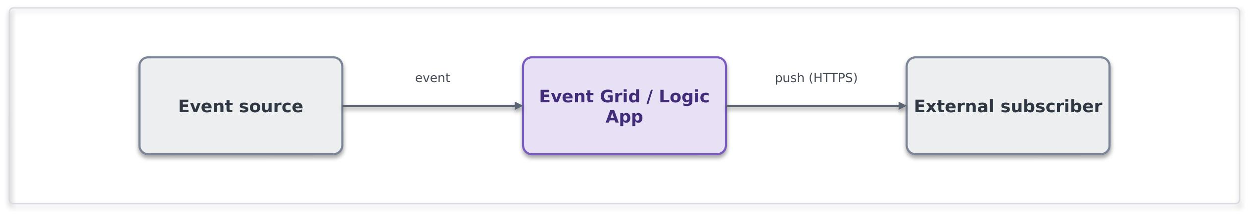
Problem. An external consumer requires timely notification of a business or system event without repeatedly polling for status or changes.
Solution. When the event occurs, dispatch the notification through an Event Grid subscription or a Logic App using an appropriate delivery channel, such as a webhook, email or Teams notification. Subscribers are configured, not coded into the publisher.
Use it when. Use this pattern when subscribers require notifications to be pushed automatically when a defined event occurs.
Avoid it when. Subscribers should really pull current state through an API.
Risks and considerations. Subscriber availability can impact delivery success and increase retry activity. Appropriate retry, backoff and dead-letter handling should be implemented.
Authentication material must be stored in and referenced from Approved secret, key, and certificate management services. Payloads should be signed where supported, and circuit-breaker controls should protect the integration from persistently unavailable or unreliable subscriber endpoints.
Security boundary. Event Grid or the Logic App runs within a private workload spoke. Traffic to an external subscriber must leave through the controlled egress path rather than through default internet routing. Within Azure: managed identity, partner secrets held in Approved secret, key, and certificate management servicesand referenced, TLS. Outside Azure: TLS to the subscriber, payload signing where supported, partner endpoints allow-listed, and secrets rotated/revoked Approved secret, key, and certificate management services.
Common pitfall. Polling to simulate push; bespoke per-subscriber dispatch code instead of subscriptions.
In practice. The broker's system is notified automatically when a claim status changes.

Stream / telemetry ingestion (SFINT14)
Ingest high-volume continuous data and hand it to processors or the data platform.
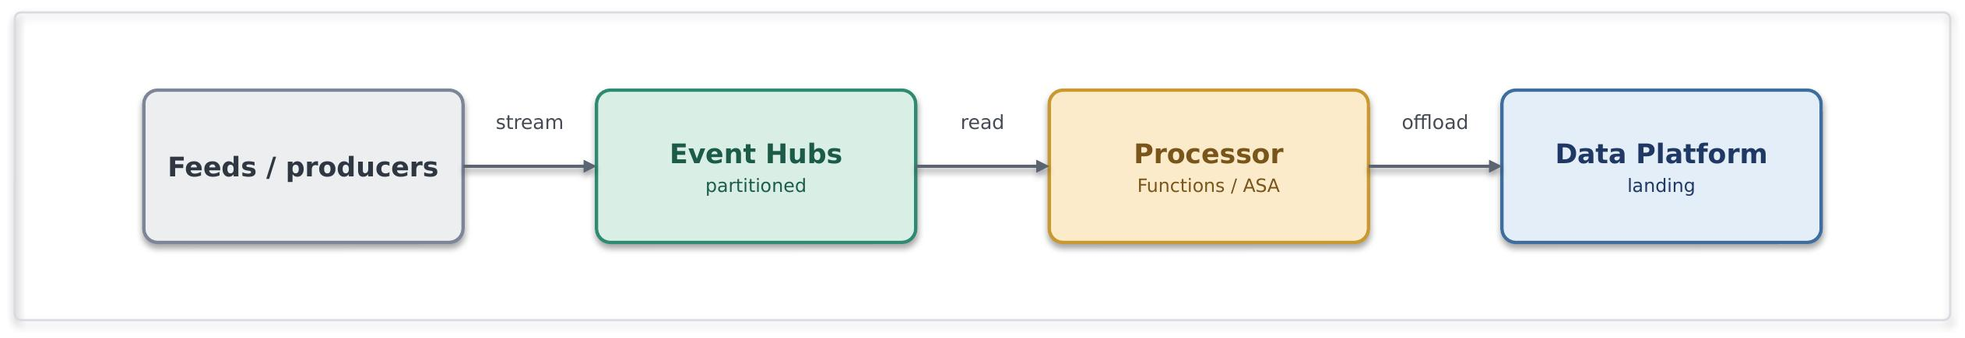

Problem. A high-frequency feed produces far more events than a business-messaging queue is designed for, and it needs partitioned, ordered processing.
Solution. Ingest into Event Hubs, partitioned for throughput; process with Functions; and typically capture or offload to Data Platform for analytics. Event Hubs is designed for high-volume event ingestion and streaming; Service Bus is not.
Use it when. Sustained high event rates need partitioned stream processing.
Avoid it when. These are transactional business commands needing per-message dead-lettering and sessions (Service Bus), or low-volume discrete notifications (Event Grid).
Risks and considerations. Partitioning strategy should be planned against throughput and consumer parallelism requirements. Consumer lag, checkpoint management and processing latency should be monitored. Ordering guarantees apply only within an individual partition, and capacity requirements should be aligned to expected event volumes
Security boundary. Event Hubs and its processors in spokes, capture to a firewalled storage account. Within Azure: Private Endpoint, managed identity, TLS, with capture storage under RBAC. Outside Azure: an external feed enters through the edge; internal streams cross no boundary.
Common pitfall. Usage of Service Bus for high volumes, Event Hubs for transactional commands; or designing synchronous consumers on a stream.
In practice. A high-frequency exposure feed is ingested, processed near-real-time and offloaded to Snowflake.

Orchestration Patterns

Choosing between Logic Apps and Durable Functions
Default. Logic Apps Standard is the default orchestration platform for the Systems Integration Framework and requires no exception. It is used for integration-centric workflows, connector-based automation, long-running processes, approvals and any workflow that can be delivered using platform-managed orchestration capabilities. The orchestrator owns workflow state, process progression, retries and compensation logic.
When Durable Functions is permitted. Azure Durable Functions may be used only where the orchestration is genuinely code-centric and cannot reasonably be delivered using Logic Apps Standard without introducing excessive complexity, performance limitations or maintainability concerns. Typical examples include dynamic fan-out/fan-in processing, custom aggregation of parallel results, highly dynamic execution paths or high-throughput coordination scenarios. Durable Functions must be implemented as an explicit, named orchestrator with checkpointed state and observable execution history. Plain Azure Functions chained together to coordinate process steps are not permitted.
Governance threshold. Logic Apps Standard is the default and requires no approval. Selecting Azure Durable Functions is an architecture exception requiring documented justification and TDA approval prior to implementation. Plain Azure Functions performing workflow coordination are prohibited.
Decision evidence. Approval must be supported by an architecture decision record describing the orchestration requirements, the specific limitation of Logic Apps Standard, the approach to observability and recovery, and the accountable service owner. The decision must be linked to the service catalogue entry and recorded through the appropriate TDA gate.
Reconciliation with the platform guidance. This approach maintains the principle that Azure Functions are not the default orchestration engine. The prohibition applies to plain Azure Functions coordinating workflow logic. Azure Durable Functions remain a permitted orchestration technology when explicitly declared, governed and approved through the framework's orchestration governance process.

Stateful process orchestration (SFINT15)
Coordinate a multi-step, multi-system business process with state, retries and visibility.
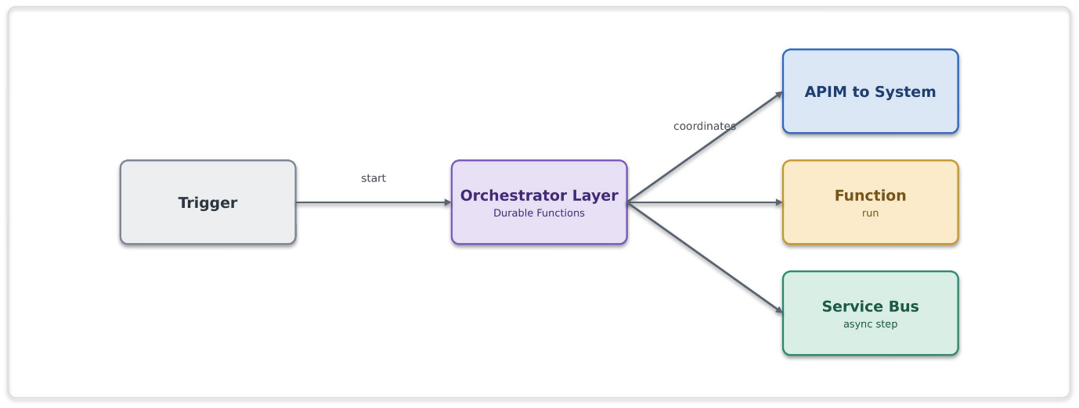
Problem. A business process spans multiple systems, requires coordinated execution across several steps, and cannot be reliably owned or managed by a single application
Solution. The orchestration layer owns the process: it sequences the steps, calls capabilities through APIM, delegates computation to Functions, and hands asynchronous work to Service Bus. It maintains workflow state and execution history, making the process observable and recoverable. The implementation may use Logic Apps Standard or Azure Durable Functions, depending on the orchestration requirements. Use Logic Apps Standard for integration-centric workflows and connector-based automation; use Durable Functions for code-centric, stateful, or complex long-running orchestrations.
Use it when. A business process crosses several systems and steps and needs state, retries and auditability over minutes, hours or days.
Avoid it when. A single synchronous call suffices, or it is really just message buffering.
Risks and considerations. Workflow orchestration should remain focused on process coordination rather than business logic execution. Process steps should support restartability and idempotent execution. Orchestrations should be designed with appropriate retry, timeout, and compensation strategies, recognising that long-running state has an operational cost. Where workflows evolve over time, maintain a versioning strategy to support in-flight executions without disruption.
Security boundary. The orchestration service is deployed within the workload boundary and coordinates calls to APIM, Functions, and Service Bus. All communication uses private connectivity, managed identities, Key Vault/Cyber Ark references where required, and TLS encryption. External access is routed through APIM and approved edge services, never directly from the orchestration workflow.
Common pitfall. Embedding business, compute, or transformation logic within the orchestration layer; spreading a single process across multiple uncoordinated workflows; or relying entirely on choreography with no clear process owner.
In practice. A new-business onboarding process requires validation, pricing, document generation, notifications, and updates across multiple systems. A centrally managed orchestration coordinates the end-to-end process, maintaining visibility, traceability, state, and controlled error handling across all participating services.

Process with compensation (SFINT16)
When a later step fails, undo the earlier ones, orchestrated centrally, not choreographed.
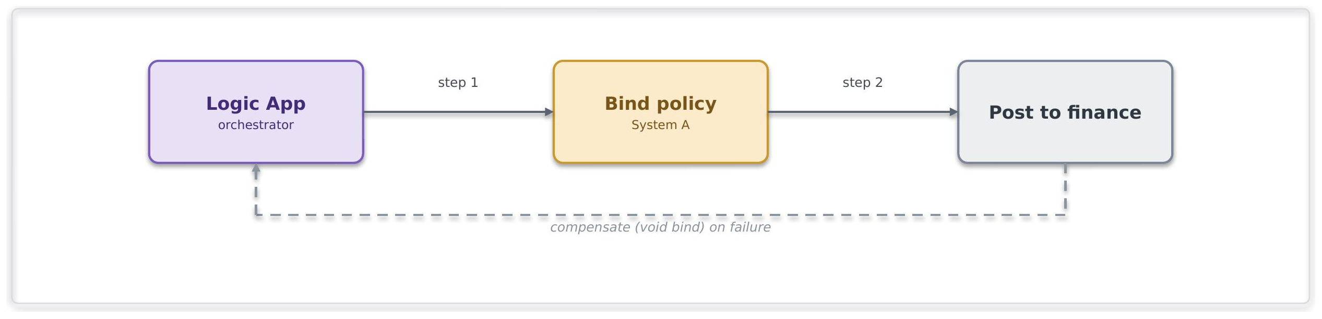
Problem. A process spans multiple systems where a later step may fail after earlier steps have completed, creating the need to restore a consistent business state without relying on distributed transactions.
Solution. The orchestration layer coordinates compensating actions when a downstream failure occurs. Compensation logic is centrally managed as part of the overall process, ensuring that recovery actions are applied consistently and remain traceable
Use it when. Cross-system consistency is needed without distributed transactions, and a single process can own the compensation.
Avoid it when. An ACID transaction within one system suffices, or a microservices-style distributed style is proposed (out of scope here).
Risks and considerations. Compensation actions are not transactional and may themselves fail. Compensation steps should therefore be idempotent, retryable and fully auditable. Recovery paths should be monitored and tested to ensure consistent behaviour during failure scenarios.
Security boundary. Logic App, Service Bus and Functions in spokes, internal. Within Azure: managed identity, Private Endpoints, TLS, with each step and each compensation audited in run history. Outside Azure: none, cross-system calls are to internal systems over private connectivity.
Common pitfall. Relying on distributed transaction models across systems or implementing compensation logic without clear process ownership.
In practice. A multi-step underwriting or policy-processing workflow completes activity in several systems before a downstream validation or financial operation fails. The orchestration process coordinates compensating actions to restore a consistent business outcome and prevent partially completed processing from remaining unresolved.

Human-in-the-loop / approval (SFINT17)
Insert a human decision into an automated process, with audit and escalation.

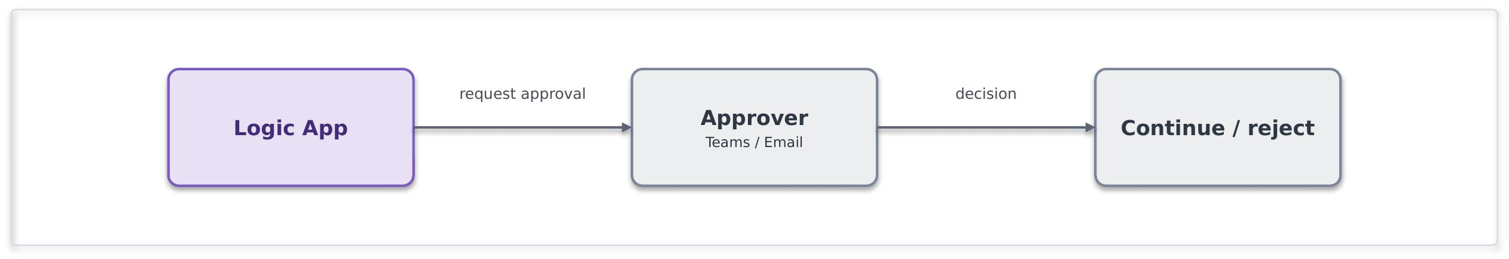

Problem. A process requires a human decision or approval before it can continue, with the decision and approval outcome needing to be auditable and traceable.
Solution. The Logic App pauses for an approval over Teams or email, captures the decision with the approver's identity, and resumes. Timeouts and escalation keep the process from stalling.
Use it when. A process needs human sign-off and an audit trail.
Avoid it when. The decision can be made by rules, keep it straight-through.
Risks and considerations. Approval steps introduce dependency on human response times and may delay overall process completion. Timeouts, reminders and escalation paths should be defined, and approval outcomes recorded for audit and compliance purposes.
Security boundary. The Logic App in a spoke; approvals run over Teams or Outlook, which are Entra-authenticated Microsoft 365 services, not arbitrary internet endpoints. Within Azure: managed identity, TLS, and an audit of the decision and the approver's identity. Outside Azure: approver interaction is over Entra-authenticated Microsoft 365 there is no bespoke internet exposure.
Common pitfall. Approvals handled over untracked email outside the platform, no timeout or escalation.
In practice. An underwriting referral requires manual review and approval before a policy can proceed to the next stage of processing. The approval is captured within the workflow, providing a complete audit trail while ensuring the process resumes automatically once a decision has been made.

Scatter-Gather (SFINT18)
Execute independent activities in parallel and combine the results into a single outcome, reducing end-to-end processing time.

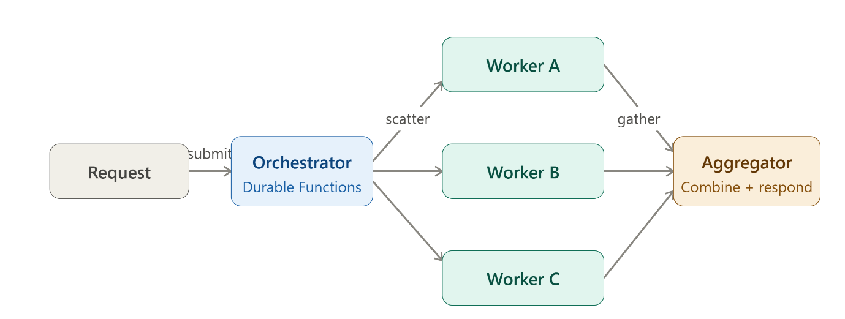

Problem. A business operation requires results from multiple independent services before processing can continue. Executing the requests sequentially increases latency and extends the overall processing time.

Solution. An orchestration service distributes requests to multiple independent services in parallel, waits for the responses, and then aggregates the results into a single outcome. The orchestration layer manages execution, correlation, completion tracking, and timeout handling while keeping worker services independent.

Use it when. Multiple independent tasks can execute concurrently, performance is improved through parallel processing, and a combined result is required before the process can continue.

Avoid it when. Tasks depend on the results of earlier tasks, no aggregated response is required, or a single task dominates the overall execution time and limits any benefit from parallelisation.

Risks and considerations. Slow or unavailable downstream services can delay completion. Timeouts, partial-failure handling, concurrency limits, and response aggregation strategies should be defined explicitly. Correlation tracking and monitoring are essential for troubleshooting and operational support. Excessive parallelism can overwhelm dependent services and reduce overall system stability.

Security boundary. The orchestrator, worker services, and aggregation components operate within the private integration platform. Within Azure: managed identities, Private Endpoints, RBAC, and TLS are used throughout. Authentication occurs once at the entry point, with downstream services authorised using least-privilege access. Outside Azure: any external service interaction follows the approved boundary pattern and security controls for that integration.

Common pitfall. Implementing the pattern with sequential service calls rather than parallel execution or waiting indefinitely for all responses without timeout or partial-result handling.

In practice. A broker submission requires validation from multiple systems before a quotation can be returned. The orchestration service simultaneously invokes pricing, fraud, and capacity services. Once all required responses are received, the results are aggregated into a single response and returned to the broker, reducing overall response time to approximately that of the slowest service rather than the combined duration of all services.

File Patterns

Event-driven file ingestion (SFINT19)
A partner or system drops a file; pick it up on arrival, validate and parse it, and turn its contents into messages the platform can process.

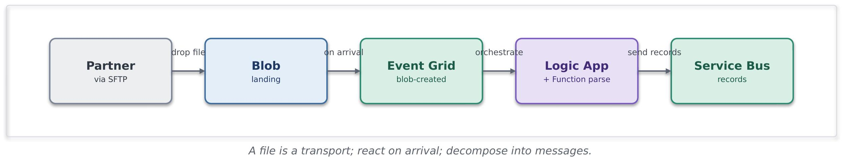
Problem. A source system can provide data only through file-based exchange mechanisms. Traditional polling approaches can introduce unnecessary latency, operational overhead and tighter coupling between systems.
Solution. Files are landed in Blob using Logic App or Azure Function, and they can react to its arrival with an Event Grid blob-created event, event-driven, not polled. Validation, transformation and downstream distribution are performed through standard integration services, allowing file exchange to act as a transport mechanism while processing continues using approved messaging and orchestration patterns.
Use it when. A source can only deliver operational data as files (partner SFTP, legacy extract, scheduled drop) and the contents are records to process.
Avoid it when. Direct API or event-based integration is available, or the primary objective is analytical or bulk data ingestion better suited to the data platform.
Risks and considerations. File completeness, validation, replay and duplicate handling should be considered during design. Invalid files should be isolated using approved error-handling processes. File lifecycle, retention and storage costs should also be governed appropriately.
Security boundary. The Blob landing (firewalled, public access disabled), Event Grid, the Logic App/Function and Service Bus all sit in spokes; a partner SFTP is the external boundary. Within Azure: Blob over a Private Endpoint with managed-identity RBAC (no account keys, no public SAS), Event Grid and the Function private, TLS. Outside Azure: the SFTP endpoint is fronted through the edge or reached over private connectivity, requires SFTP-over-SSH with key or certificate auth and no anonymous access, is IP allow-listed, and files are encrypted in transit and at rest, a registered exception where it is internet-facing.
Common pitfall. Treating file structures as long-term system contracts or processing large files without validation, decomposition and error-handling controls.
In practice. A delegated authority or third-party provider delivers operational data through an SFTP-based file exchange. The file is validated, transformed (if applicable) and distributed through messaging and orchestration patterns, allowing downstream systems to process individual business records independently of the original file format.

File generation and delivery (SFINT20)
The platform produces a file from records or events and delivers it to a partner or system that can only consume files.
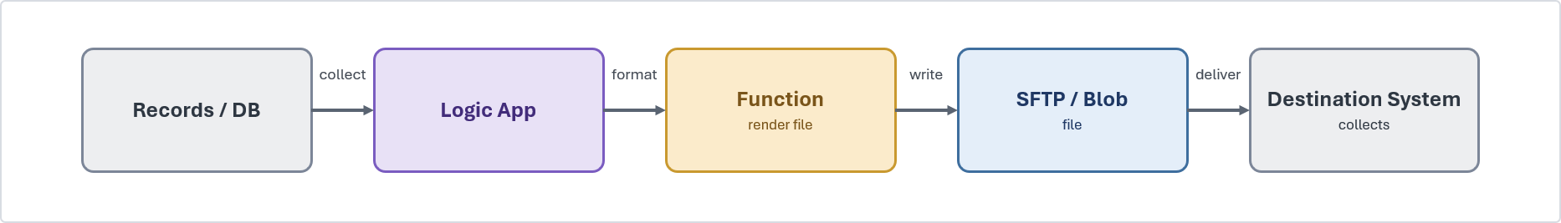
Problem. A downstream party, a partner, a legacy system, a regulator, needs data as a file, on a schedule or on an event.
Solution. A Logic App collects the data (from events, a query, or accumulated messages), a Function renders it into the required file format (if required), and the file is written to Blob and delivered, pushed to the partner's SFTP or staged for collection, with a completion event. Delivery status is tracked and retried. Depending on destination system, additional components like Data Gateway, ASE, Express Route, Hybrid Worker may be needed.
Use it when. A consumer can only ingest files, or a scheduled or regulatory extract is required.
Avoid it when. The consumer could call an API or subscribe to events.
Risks and considerations. File delivery should include confirmation, retry and monitoring mechanisms. File retention, encryption, naming standards and delivery reconciliation should be considered as part of the solution design. Partner SFTP credentials are held in Approved secret, key, and certificate management services, and sign or encrypt sensitive files (where required). Write-then-rename so a partner never collects a half-written file and manage retention so generated files do not accumulate cost.
Security boundary. The Logic App, Function and Blob/SFTP staging sit in spokes, delivery to the consumer is the external boundary in case of SFTP Partner and in all other cases it will be internal systems. Within Azure: managed identity to Blob (no keys), partner SFTP credentials held in Approved secret, key, and certificate management servicesand referenced, TLS. Outside Azure: SFTP-over-SSH with key auth to an allow-listed partner host, sensitive files signed or encrypted, and egress over the controlled path rather than default routing.
Common pitfall. Hand-rolled scheduled scripts running outside the platform with credentials in config with no delivery confirmation or retry.
In practice. A nightly settlement extract is generated and pushed to the partner's SFTP, with a completion event notifying the finance team.

Transformation and Routing Patterns

Canonical data model and message translator (SFINT21)
Map every external format to one internal canonical model, so internal systems never bind to a partner's format.

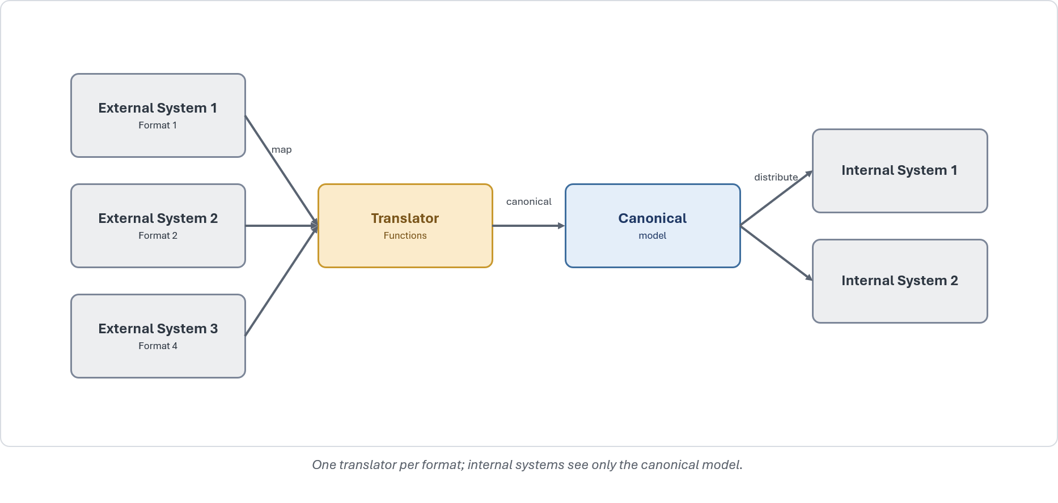
Problem. Multiple external and internal systems exchange information using different schemas, message formats and data models. Direct system-to-system mappings increase complexity, coupling and change impact across the integration landscape
Solution. Define a canonical enterprise model for each business domain and perform translation at the integration boundary. External formats are mapped to the canonical model on ingress and transformed from the canonical model on egress. Internal systems interact using the canonical representation rather than external schemas.
Use it when. Integration is needed with several external parties or standards for the same business concept
Avoid it when. There really is a single, stable format on both sides, a straight protocol mediation (SFINT3) is enough.
Risks and considerations. Canonical models require clear ownership, versioning and governance. Mapping rules should be maintained, tested and reviewed as part of the integration lifecycle. Schema changes should be assessed against the canonical model before implementation.
Security boundary. The translator Function runs in a workload spoke, sitting at the seam between external formats and the internal canonical model. Within Azure: internal distribution over Private Endpoints with managed identity and TLS. Outside Azure: inbound external formats arrive via the relevant boundary pattern, the edge for internet partners, private connectivity for peered ones, and the translator itself is never internet-exposed.
Common pitfall. Point-to-point mapping between every internal system and every partner format
In practice. Insurance integrations frequently involve brokers, cover holders, delegated claims administrators, reinsurers, bureau services and market platforms, each exposing different formats such as EDI, ACORD XML, bordereaux spreadsheets or Core Data Record structures. Without a canonical model, each internal system must integrate directly with each external format, increasing the number of interfaces and amplifying the impact of schema changes. The canonical data model and message translator pattern provides a consistent internal representation of business concepts such as risk, premium and claims, reducing coupling and simplifying partner onboarding and change management.

Content-based routing (SFINT22)
Route a message or event to the right destination based on what is in it.

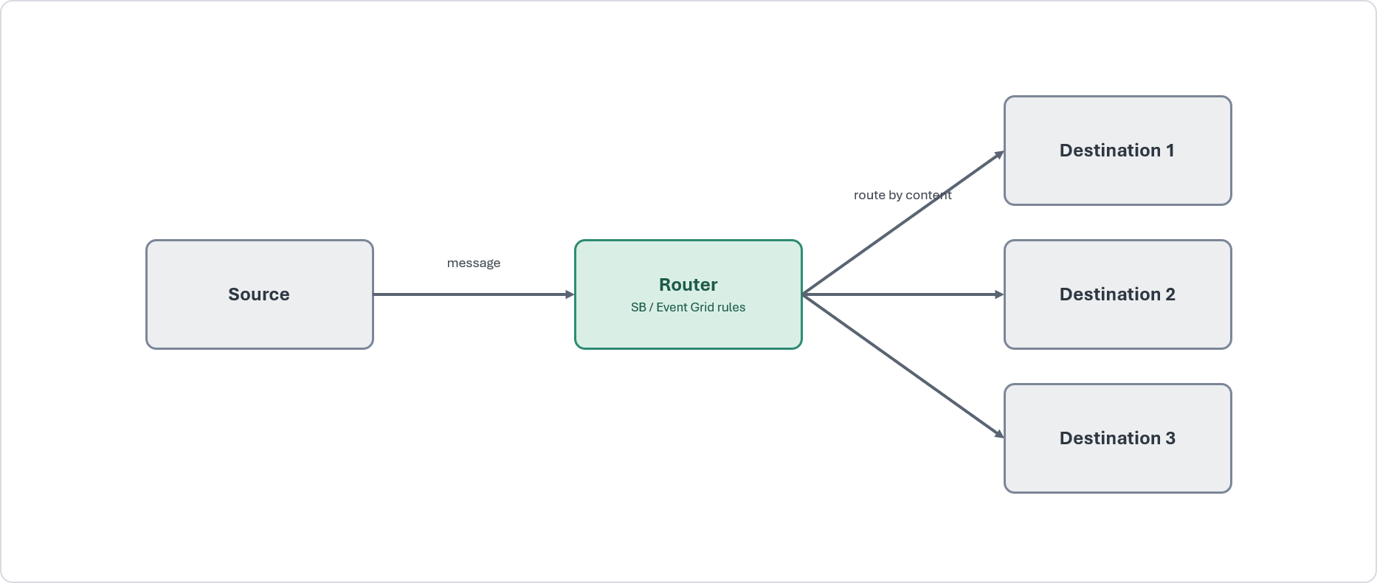
Problem. Messages received through a shared channel require routing to different processing paths based on their content, attributes or business context
Solution. Route on content using Service Bus subscription filters or Event Grid routing, or a Function for richer rules, so each message reaches the right handler without the producer knowing the routing map.
Use it when. Items on a shared channel need to diverge to different handlers according to their content.
Avoid it when. There is only one destination, or the routing depends on external lookups better handled by a short orchestration.
Risks and considerations. Routing rules should be centrally governed, version-controlled and regularly reviewed. Messages that do not match an expected route should be directed to a default handling path or dead-letter destination to avoid silent processing failures.
Security boundary. The Service Bus/Event Grid routing rules, or a routing Function, in spokes, internal. Within Azure: Private Endpoint, managed identity, TLS, with a default/dead-letter route captured. Outside Azure: none.
Common pitfall. A monolithic if/else router hard-coded in one place; no default route for unmatched content.
In practice. Insurance integrations frequently receive submissions, bordereaux, claims notifications and market messages through shared channels. These messages often require processing by different systems, teams or business functions based on attributes such as line of business, territory, cover holder or claim type. Content-based routing enables a single intake channel while directing messages to the appropriate downstream processing path without creating direct dependencies between producers and consumers.

Anti Patterns

The following are treated as anti-patterns. Where an anti-pattern cannot be avoided, it must be reviewed and approved through the exception process.
Each pattern within the Integration Pattern Catalogue includes a "Common pitfall" heading, providing guidance on practices that may lead to increased coupling, operational complexity or deviation from the principles defined in this Systems Integration Framework
Anti-pattern | Preferred approach
Direct point-to-point connection between two systems | Mediate through the platform using an approved pattern
Public exposure justified by a firewall alone | Treat public exposure as an exception with approval and risk acceptance
Timer-polling a source to simulate real-time | React to an event, or use a scheduled trigger only where no event exists
Long-lived SAS tokens for access | Managed identity and OAuth 2.0, with the risk register where unavoidable
Large binary payloads on the message bus | Claim-check, with the payload in storage and a reference on the bus
Business logic embedded in gateway policy | Keep logic in Functions, and keep the gateway to mediation
Distributed transactions across services | Orchestrated compensation owned by the process
Secrets in configuration or code | Approved secret, key, and certificate management services  references and privileged access management

Data Platform Position

Core Position

The data platform is owned by the data team and is not a general integration endpoint.
The Systems Integration Framework interacts with the data platform through two governed hand-offs only: the ingestion of data into the platform and the consumption of curated data products from it.
Bulk movement and transformation remain inside the data platform. This boundary keeps operational integration and analytical data cleanly separated and governed.

Appropriate Uses

Landing operational data into the platform for analytics and reporting.
Serving a curated, read-only dataset back to an operational consumer through the platform's serving layer.
Streaming high-volume telemetry into the platform for downstream processing.

Inappropriate Uses

Treating Snowflake as an operational source of truth for live transactions.
Reaching into the platform's internals from an integration flow, or into operational systems from the platform.
Using the platform as a message bus or a general-purpose integration hub.

Exchange Patterns

Import Patterns

Event Streaming to the Data Platform (SFDEINT1)
Stream operational events into the data platform for near real-time analytics, without coupling producers directly to Snowflake.

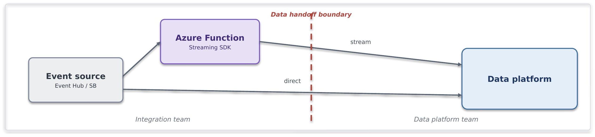

Problem. Events from Azure messaging services must be delivered to Snowflake continuously and with low latency, without building and maintaining custom ingestion services.
Solution. An Azure Function is triggered by events from Event Hubs, Service Bus or Event Grid and uses the Snowpipe Streaming API through Snowflake’s Python SDK to write data directly to Snowflake. The approach provides low-latency, near real-time ingestion without intermediate files. The Function manages batching, retries and reliable delivery.
Use it when. The source already publishes events through Azure event services, near real-time ingestion is required, and you want full control of the ingestion logic in code.
Avoid it when. A connector-based approach can meet the requirement, data arrives in files rather than events, or ingestion volumes are high enough that a managed ingestion service is a better fit.
Risks and considerations. The Function becomes operational code on the ingestion path, so its scaling, cold-start behaviour, retries, offsets and checkpoints require active ownership. Channel lifecycle management, SDK version management, per-channel ordering, duplicate handling and late-event handling must be designed explicitly.
Security boundary. The trust boundary is the event source and the Function's managed identity, not Snowflake. The event source is reached through a private endpoint, and the Function uses managed identity for the event-source binding. The Function authenticates to Snowflake using an approved key-pair or OAuth mechanism, with applicable secrets held in the approved secrets vault. Account passwords must not be used. Data-in-transit posture inherits from the Cloud Engineering Standards.
Common pitfall. Writing one row per invocation instead of batching, increasing API calls, latency, and cost. Failing to design for throughput, back-pressure, and ingestion failures, leading to reduced performance and operational instability.
In practice. Connected-property or fleet telemetry lands on Event Hub, an Azure Function enriches each reading (for example attaching a peril zone) and streams rows via the Snowpipe Streaming API into a raw schema for near-real-time exposure aggregation. Underwriting dashboards read the conformed product, never the live stream.

Streaming Ingestion via Kafka Connect (SFDEINT2)
Continuously ingest Kafka events into the data platform through a managed connector, without building custom ingestion services

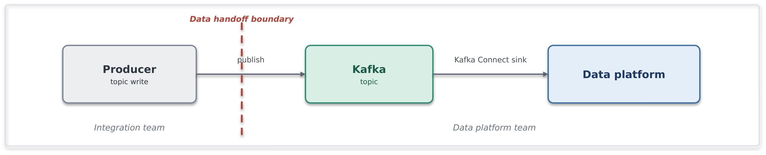
Problem. An existing Kafka platform already carries event data, and that data needs to be delivered continuously to Snowflake. Building and operating custom ingestion services for every topic creates unnecessary complexity, duplication, and operational overhead at scale.
Solution. Producers publish events to Kafka topics. The Snowflake Sink Connector running in Kafka Connect continuously delivers topic data to Snowflake, leveraging Snowpipe Streaming for low-latency ingestion. The approach is configuration-driven and reusable, avoiding bespoke ingestion code for each topic.
Use it when. Use this pattern when Kafka is already the enterprise event backbone, when configuration-driven ingestion is preferable to custom code, and when multiple topics require a consistent and repeatable ingestion route into Snowflake. It also suits scenarios that benefit from built-in batching, retries, and offset management provided by the connector platform.
Avoid it when. Avoid this pattern when Kafka is not already part of the platform and would be introduced solely for Snowflake ingestion. It is also unsuitable when significant per-record transformation, enrichment or business logic is required, or when the data naturally arrives as files and is better served by batch ingestion.
Risk & consideration. Kafka Connect requires operational ownership, including connector lifecycle management, scaling, monitoring and dead-letter handling. Connector configuration, schema evolution and topic-to-table mapping should be governed as part of the ingestion platform design.
Security boundary. The trust boundary is the Kafka platform and the Kafka Connect runtime. Kafka brokers, Connect workers, and Snowflake are connected through private network paths. The connector authenticates to Snowflake using centrally managed credentials or federated identity, and topic-level access controls restrict producer and consumer permissions. Data-in-transit protection follows the Cloud Engineering Standards.
Common pitfall. Assuming Kafka Connect requires minimal operational oversight. Connector lag, dead-letter accumulation and unmanaged schema evolution can result in ingestion failures and delayed data availability.
In practice. Policy and claims domain events are published to Kafka topics and continuously ingested into Snowflake raw schemas through the Snowflake Sink Connector. New topics are onboarded through configuration, providing a consistent ingestion approach without bespoke loader implementations.

File Ingestion (SFDEINT3)
Automatically ingest files into the data platform as they arrive, without custom loading processes.
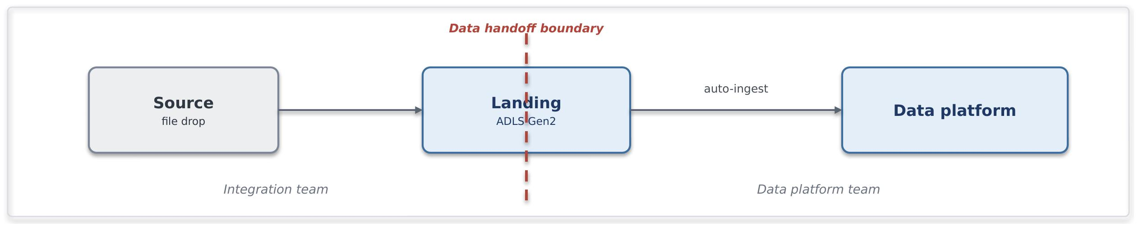

Problem. Source systems and third parties deliver data as files on their own schedule. Polling for new files wastes compute; hand-built loaders drift and fail silently. We need near-real-time, event-triggered loading without an operational service owning the load path.

Solution. A file lands in an ADLS Gen2 landing zone. Blob creation raises an Event Grid notification that triggers Snowpipe auto-ingest, which runs COPY INTO the target raw schema. Loading is serverless and notification-driven; no compute to run or scale.
Use it when. Use this pattern when data arrives as discrete CSV, Parquet or JSON files, seconds-to-minutes latency is acceptable, volumes are continuous or unpredictable rather than a single large periodic load, and the producer can write to an approved landing zone.
Avoid it when. You need sub-second streaming (stream instead); the load is a single massive periodic file where scheduled bulk COPY is cheaper and simpler; the file needs heavy pre-load validation belonging in an orchestrated pipeline; ordering or transactional grouping across files matters.
Risk & consideration. Snowpipe carries per-file overhead, so many small files can increase cost disproportionately. Landing-zone retention, replay, and reconciliation should be designed explicitly. Regular comparison of landed files against Snowpipe load history helps identify and recover from missed notifications or failed loads.
Security boundary. The trust boundary is the landing zone, not Snowflake. Storage is reached over private endpoint with public access disabled; Snowflake authenticates via storage integration / managed identity, never account keys; storage firewall and RBAC scope write access to the producer and read access to Snowflake only. Data-in-transit posture inherits from the Cloud Engineering Standards.
Common pitfall. Treating the landing zone as a long-term storage or query layer rather than a transient ingestion boundary. Excessive numbers of small files can also increase Snowpipe processing costs.
In practice. Delegated-authority bordereaux from a cover holder arrive as monthly spreadsheet or CSV files, and each file lands in that cover holder’s designated landing-zone path. Event Grid triggers Snowpipe to load it into a raw bordereaux schema for downstream conforming and exposure aggregation. Underwriting reporting consumes the conformed data, never the raw landing zone.

Scheduled batch: CDC/ Watermark (SFDEINT4)
Extract and load operational data into the platform in batches, without placing analytics workloads on the operational path.

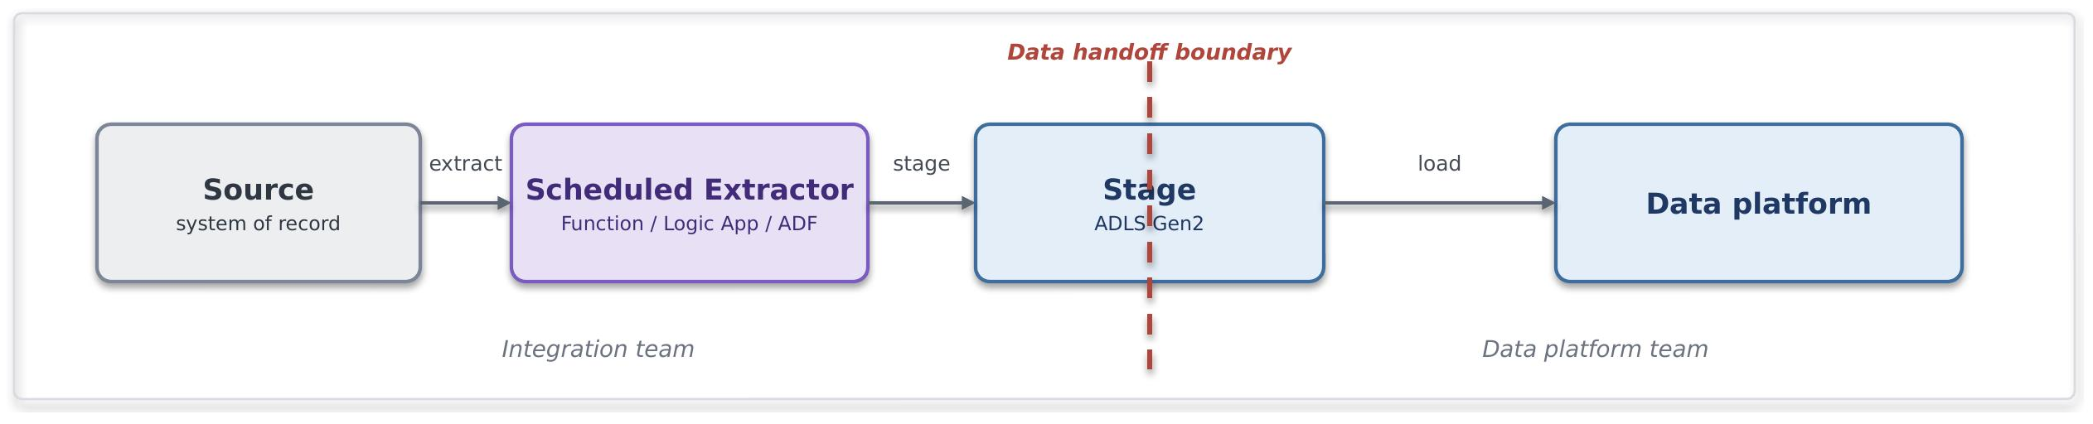

Problem. Data needs to be extracted from a system of record and loaded into the platform on a scheduled basis. Near-real-time delivery is not required, but the process must be reliable, repeatable, and efficient for moving large volumes of data without unnecessary reprocessing.
Solution. A scheduled Azure Data Factory pipeline or Azure Function extracts new or changed data from the source system, stages it in ADLS Gen2, and loads it into Snowflake using COPY INTO. ADF is preferred for standard connector-based data movement, Azure Functions for custom extraction logic, and Logic Apps for workflow orchestration where the ingestion process spans multiple systems and actions. The approach is periodic, incremental, and cost-efficient.
Use it when. Use this pattern when data needs to be moved on a scheduled basis (for example hourly or daily), the source provides a reliable watermark or CDC capability, near-real-time delivery is not required, and large data volumes are more efficiently processed in batches than as individual events.
Avoid it when. Avoid this pattern when sub-minute latency is required, when the source lacks a dependable change marker and would require brittle full scans, or when the required transformation should be performed within Snowflake rather than during extraction.
Risk & consideration. Watermark/CDC state should be persisted and managed so failed executions can resume without introducing gaps or duplicates. Considerations include clock skew, soft deletes, source-system load windows and schema evolution.
Security boundary. The trust boundaries are the source system connection and the staging area. Authentication uses managed identities wherever supported, with no embedded credentials. The stage is accessed through private connectivity and least-privilege RBAC. Data-in-transit protection follows the Cloud Engineering Standards. Snowflake acts solely as the ingestion target and does not require direct access to the source system.
Common pitfall. Implementing watermark logic that is not transactional with the data read process, or reverting to full reloads when CDC mechanisms fail, resulting in increased cost and processing time.
In practice. Nightly incremental extract of policy and premium movements from a policy-administration system, staged and loaded for finance and actuarial reporting. The operational system is never queried live by reporting.

Staged Multi Source Ingestion (SFDEINT5)
Ingest data into the platform in batches, decoupling operational systems from analytics workloads.

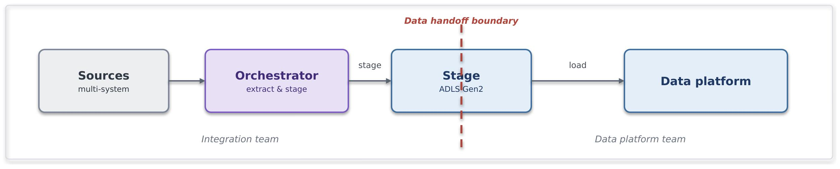

Problem. Multiple related sources must be brought together with dependencies, retries and observability, and transformation should happen where compute is cheapest and closest to the data.
Solution. An orchestration layer (ADF) coordinates extract → stage → load across sources, then triggers transformation pushed down into Snowflake (ELT, not ETL). The orchestrator owns sequencing and recovery; Snowflake owns the transform.
Use it when. Coordinated multi-source loads with inter-dependencies; you want lineage, retries and alerting over the pipeline; transformation is set-based and belongs in the warehouse.
Avoid it when. A single simple feed (a plain batch or Snowpipe load is lighter); transformation must happen before landing for compliance or redaction; latency needs are real-time.
Risk & consideration. The orchestration layer becomes a critical dependency and should be subject to the same availability, security and operational controls as other platform services. Partial failures and re-run scenarios should be designed for idempotent execution. Transformation workloads consume Snowflake compute and should be governed accordingly.
Security boundary. The orchestrator connects to multiple source systems, so managed identity must be used wherever supported. Any remaining secrets must be stored in the approved secrets vault, and each connection must use least-privilege permissions. The staging area must be accessed through a private endpoint. Transformation runs inside Snowflake, keeping data off intermediate compute in transit.
Common pitfall. Using the orchestration layer for row-level transformation rather than orchestration and coordination. Excessive retry strategies can also delay identification of persistent upstream failures.
In practice. Building a conformed claims dataset that joins claims, policy and reinsurance-treaty feeds. The orchestrator sequences the loads and kicks off in-warehouse conforming for exposure and recoveries reporting.

Governed API Write (SFDEINT6)
A small, well-defined set of records is imported into the platform through a governed API on the shared gateway, avoiding the complexity of file or streaming pipelines for low-volume data exchange.

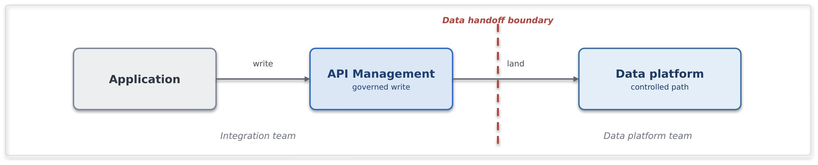

Problem. A consumer application needs to submit small volumes of data directly into the platform, such as reference data updates, corrections, overrides, or operational adjustments, where standing up a file or streaming pipeline would be disproportionate.
Solution. A governed write API is exposed through API Management. APIM authenticates and authorises callers, applies validation, throttling, and access policies, and forwards requests to approved Snowflake APIs. Snowflake invokes controlled stored procedures to validate and persist the data through a managed import path. The API contract is the integration boundary, and consumers never connect directly to Snowflake.
Use it when. The write is small, well-defined, and low-volume, and requires synchronous or near-synchronous processing. The consumer needs a governed API-based import mechanism rather than a file or event-based ingestion pattern.
Avoid it when. The volume is high, the payload shape is variable, or data arrives in bulk. In these scenarios, staged file ingestion or streaming patterns are more appropriate. APIs should not be used as a bulk-loading mechanism.
Risks and considerations. API-based ingestion introduces dependency on API availability, request validation and platform capacity controls. Payload size, rate limits, idempotency and transactional requirements should be considered during design. Data imports should remain targeted and low-volume to avoid introducing operational and performance risks.
Security boundary. APIM acts as the integration boundary between consumers and the data platform. Authentication and authorisation are enforced through approved identity providers and access controls. Consumers do not receive direct access to Snowflake. Communications follow approved enterprise connectivity, encryption and secret-management standards.
Common pitfall. Using API-based ingestion for bulk data movement or large-scale operational data loads instead of approved file, batch or streaming ingestion patterns.
In practice. An operations tool submits a corrected reference value through an APIM operation. APIM validates the request and forwards it to a controlled Snowflake ingestion endpoint, which invokes a stored procedure to persist the update. The transaction is audited end-to-end, and the consumer never accesses Snowflake directly.

Export Patterns

Scheduled Data Export Pattern (SFDEINT7)
Publish curated data from the platform through managed file exports, keeping analytical and operational workloads decoupled.

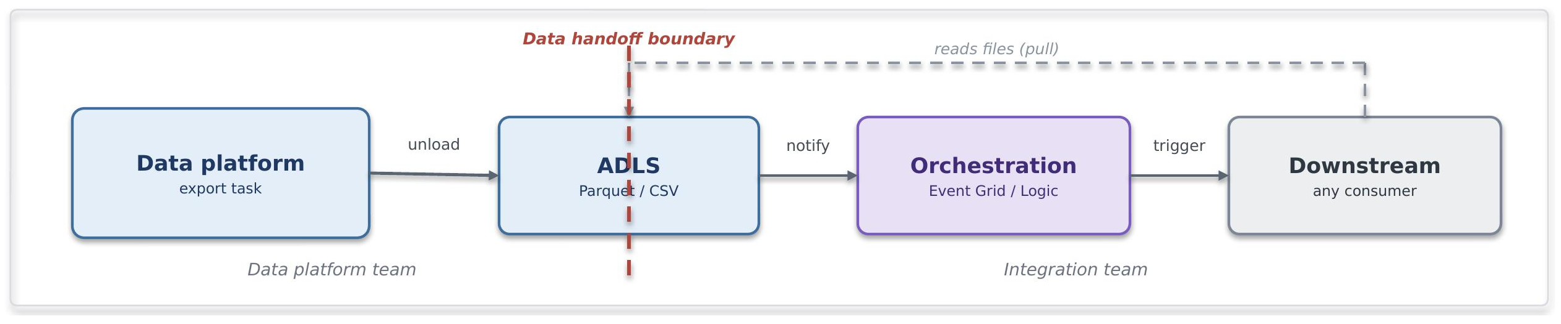

Problem. Downstream systems (analytical, operational, integration, third-party) need periodic curated datasets from Snowflake in file form and should be triggered automatically when new exports arrive, without querying Snowflake directly or polling.
Solution. A Snowflake scheduled task exports a curated data product as a file (Parquet, CSV, Delta format) to ADLS. Event Grid, Logic Apps, or scheduled orchestration detects the file arrival and triggers the downstream system to consume it, or the downstream system polls on schedule.
Use it when. Use this pattern when downstream systems consume data in file or batch form, Snowflake must remain outside the operational processing path, and export schedules can be aligned with downstream processing windows. The exported content should be a complete dataset or a meaningful subset, and an orchestration mechanism should be available to manage consumption.
Avoid it when. Avoid this pattern when the downstream system requires real-time or near-real-time access, can consume the data efficiently through a governed API, or would make file-based transfer operationally inefficient because of data volume.
Risk & consideration. File export introduces platform compute, storage and transfer costs. Export schedules should be coordinated with downstream processing requirements to avoid stale or delayed data consumption. File schemas must be versioned, and downstream systems must handle format changes gracefully.
Security boundary. The file is the exchange point. ADLS must be reached through a private endpoint, and the exported file must be written using the approved Snowflake service identity with access scoped to the designated export path. Downstream consumer identity has read-only access to the export path, never to Snowflake directly. Data-in-transit posture inherits from Cloud Engineering Standards.
Common pitfall. Exporting larger datasets than required, failing to reconcile export and consumption schedules, or not managing schema changes between producers and consumers.
In practice. Curated features for a claims prediction model are exported nightly as Parquet from Snowflake to ADLS, an Azure ML scheduled training pipeline picks up the file and retrains the model. Or: policy and claims data are exported daily for a third-party integration system that consumes it via a Logic App orchestration. Or: aggregated loss triangles are exported weekly as CSV for a Synapse analytics workspace to compute reserve adequacy metrics.

Governed API Read (SFDEINT8)
Small, curated analytical results are served on demand through a governed API on the shared gateway, so callers get a specific answer without reaching into the platform.

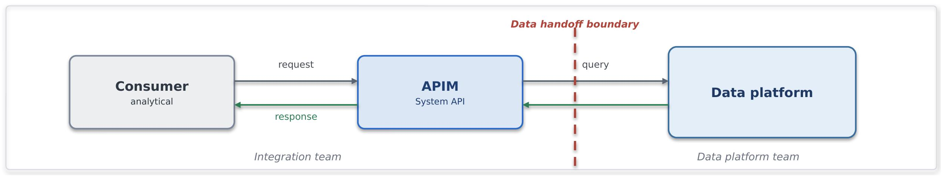
Problem. A consumer needs a specific analytical value or small result on demand, such as an aggregate or a lookup, and should not be given a live connection into the analytical platform.
Solution. Expose the curated data through an API Management product backed by a controlled service layer or approved Snowflake access path. The data platform owns the curation and query logic for the data product, while the integration platform owns the governed API exposure, including authentication, authorisation, throttling, caching, and API lifecycle management. The response is a curated analytical view rather than direct access to underlying data structures.
Use it when. The result is small and well defined, needs to be on demand and synchronous, and benefits from caching and rate control.
Avoid it when. The consumer needs large or complete datasets, where bulk export, data sharing, or file-based delivery is more appropriate. Also avoid it for latency-sensitive or transactional reads, where the source of truth is an operational system rather than the analytical platform.
Risks and considerations. Warehouse latency and consumption costs should be considered when exposing platform data through APIs. Appropriate caching and clearly defined service expectations should be applied. Consumers should treat the data as curated and eventually consistent rather than as an operational system of record.
Security boundary. APIM acts as the consumption boundary between consumers and the data platform. Consumers authenticate through approved identity providers, while access to the underlying platform remains restricted to approved service identities and private connectivity paths.
Common pitfall. Using governed analytical APIs for transactional processing or exposing large datasets through synchronous API calls rather than using the approved export patterns.
In practice. Aggregated metrics, analytical summaries, and lookup data are exposed through a governed API for consumption by internal applications and reporting solutions, enabling access to curated analytical data without requiring direct connectivity to Snowflake.

Insurance Integration Scenarios

The table illustrates how the catalogue resolves characteristic Chaucer integrations. Each scenario names the patterns it composes, the primary Azure components and the purpose it serves. Pattern references point to the catalogue in Section 8.
Scenario | Patterns | Primary components | Purpose
Delegated Authority | File ingestion (SFINT19), canonical model (SFINT21), content routing (SFINT22), file ingestion to the data platform (SFDEINT3) | Logic Apps, Functions, Blob, Service Bus, Snowflake | Validate cover holder reporting, capture at source where possible, and retire manual bordereau re-keying.
London Market | Canonical model (SFINT21), messaging (SFINT8), orchestration (SFINT15), data platform exchange (9.4) | API Management, Logic Apps, Service Bus, Functions | Align processing to the core data record and design for incremental modernisation.
Submissions | Inbound webhook or API (SFINT1, SFINT12), file ingestion (SFINT19), content routing (SFINT22), composition (SFINT2) | API Management, Approved network edge service, Logic Apps, Functions | Accept submissions by API, file or portal, triage and route to the right underwriting team and system.
Claims | Inbound webhook or API (SFINT12), orchestration with compensation (SFINT15 and SFINT16), outbound webhook (SFINT13), data platform exchange (9.4) | API Management, Logic Apps, Service Bus, Functions | First notification of loss from portals and third-party administrators, orchestrated across systems, with status notifications outbound.
Reinsurance | Canonical model (SFINT21), file and messaging (SFINT20, SFINT8), orchestration (SFINT15) | Logic Apps, Functions, Service Bus, Snowflake | Cede risk, premium and claims to treaty and facultative systems and reinsurers and manage recoveries.
Regulatory Reporting | Event offload to the data platform (9.4), consume and serve (SFDEINT7), orchestration (SFINT15), file delivery (SFINT20) | Snowflake, Logic Apps, Functions, API Management | Assemble regulatory and tax reporting on the data platform and submit through orchestrated feeds or files.

Security and Operational Excellence

This section sets out the security and operational baseline every integration inherits by default. It states the outcomes the framework requires, while the mandatory rules and their enforcement sit in Sections 12 and 13.
The standards behind this posture are not defined here. They are owned by Chaucer's Cloud Engineering Standards document, listed as an input in Section 1, and the framework inherits from it rather than setting rules of its own. The estate-wide requirements, for example the zero-trust model, the logging the security operations centre needs for incident response and forensics, protection for anything exposed to the internet, network firewalling and isolation, Defender for Cloud and vulnerability management, landing zones and infrastructure-as-code through the DevSecOps toolchain, and the redundancy and resilience posture, all sit there. This section does not restate or vary them. It sets out only how an integration applies them, and every integration follows the Cloud Engineering Standards for the detail.

Security Principles

Security is at the core of the Systems Integration Framework, and the Systems Integration Framework does not invent principles of its own. It follows the enterprise and cloud security principles Chaucer already holds, inherits them in full, and applies them to integration without reinventing anything. The table summarises how those inherited principles shape every integration across identity, connectivity, network, secrets and public exposure.

Security area | What the Systems Integration Framework requires
Guiding principles  Ref 1  Ref 8 | Private by default and least privilege, with zero trust across identity, network and data. The Systems Integration Framework states the security outcome, and the protection technology is chosen to meet it. Every design is secure by design and evidenced at the Technical Design Authority.
Connectivity  Ref 1 | Integrations run on the private network over Private Endpoints, and the internet boundary is crossed only at a controlled edge.
Identity  Ref 1  Ref 8 | Managed identity for service-to-service calls, so no credential is stored, and OAuth 2.0 tokens where a token is needed. External parties authenticate through Entra application registrations with short-lived tokens.
Secrets and certificates  Ref 1 | Held in a managed store in Approved secret, key, and certificate management services and referenced at run time, never copied into configuration or code. Rotation and policy are handled through privileged access management. Long-lived shared access signatures are discouraged and recorded on the risk register where unavoidable.
Network isolation  Ref 1  Ref 8 | Traffic is segmented east to west with network security groups and private connectivity, in line with the zero-trust direction, so a component is reachable only by the services that genuinely need it.
Access control  Ref 1 | Least-privilege role-based access, with higher-risk permissions peer-reviewed and enforced through privileged identity management. An approved permission set is reused as a recognised pattern rather than reassessed from scratch.
Public exposure and edge  Ref 1  Ref 8 | Public exposure is an exception, not a default. Private Endpoints and Private Link are preferred, and a firewall in front does not make a public endpoint acceptable. Any exposure needs a business need, security approval and escalation to the risk register, and the edge technology is chosen for the required outcome.

Data Protection and Classification

Data protection carries particular weight here, because specialty insurance handles a great deal of personal data, including the special-category health and criminal-conviction data that attract the strictest handling under UK GDPR. The Systems Integration Framework does not classify data itself. Chaucer's Data Classification Policy [Ref 2] is the authoritative source and sets six tiers in order of sensitivity, and the Systems Integration Framework applies the handling each tier requires as data crosses a boundary. Where a payload could meet more than one tier, the higher classification applies.

The baseline is the same for every integration. Data is encrypted in transit on every hop and at rest in every store, carried in the minimum the integration needs rather than as whole data models, reached only over private connectivity and never placed in configuration. Sensitive payloads are additionally signed or encrypted so their protection outlives the transport.

Classification | Risk | How the Systems Integration Framework handles it across a boundary
Sensitive Personal Data (special categories) | Very High | Minimised and pseudonymised or tokenised before it crosses a boundary. Processing is pre-approved by the Lead Data Protection Officer. Encrypted in transit and at rest, reached only over private connectivity, access logged, and never on a public path or in observability.
Personal Data | High | Minimised to what the integration needs, encrypted in transit and at rest, reached over private connectivity with least-privilege access, pseudonymised or tokenised before analytics, and kept out of logs and traces.
Restricted Commercial | Medium High | Encrypted in transit and at rest, reached over private connectivity with access restricted and audited, and not exposed externally except as an approved exception.
Commercial | Medium | Encrypted in transit and at rest on the private network, with standard least-privilege access.
Internal | Low | The default classification. Encrypted in transit and at rest, kept on the private network and not exposed externally.
Public | None | May be served externally through the governed edge as an exception, still over TLS and through the gateway.

Observability and Monitoring

Operational monitoring uses Application Insights and Log Analytics, with dashboards and alerts for delivery and issue resolution. Security monitoring is a separate concern that must be satisfied in addition. Relevant security events are forwarded to CrowdStrike, and any newly introduced gateway or security service is assessed for security-event capture before use. LogicMonitor is treated as operational monitoring, distinct from security monitoring.
Security monitoring is satisfied separately from operational monitoring. Relevant security events, for example Key Vault/Cyber Ark activity, deployment and administrative actions, are forwarded to CrowdStrike, the Group Security tooling, and any new gateway or edge component is assessed for security-event capture before it goes live.
An established pattern already streams Azure, Key Vault/ Cyber Ark, storage and security logs to CrowdStrike through Event Hubs, and the Systems Integration Framework reuses that path rather than inventing a new one. Performance monitoring is kept distinct from security monitoring, with ownership confirmed with the relevant service owners.

Resource | Operational signal | Security signal | Destination
API Management  Source | Latency, throughput, failures | Authentication failures, policy violations | Log Analytics, CrowdStrike
Logic Apps | Run success and failure, duration | Connection and identity events | Log Analytics, CrowdStrike
Service Bus | Queue depth, dead-letters | Access and authorisation events | Log Analytics
Functions | Executions, errors, duration | Managed identity and Key Vault access | Log Analytics, CrowdStrike
Key Vault | Availability | Secret and certificate access | Log Analytics, CrowdStrike
Event Hubs | Throughput, lag | Namespace access | Log Analytics, CrowdStrike

Azure Resource Observability Matrix

Operational Excellence

The discipline that keeps an integration secure also keeps it operable.
Deployed as code. Integrations are provisioned through infrastructure-as-code and delivered through DevSecOps pipelines, so an environment is reproducible and reviewable, and nothing is configured by hand.
Resilience matched to criticality. The redundancy and recovery posture of an integration follows its criticality tier, set with business continuity and risk and evidenced at design time
Owned and kept live. Each integration has monitoring, alerting and a defined support model with named ownership, and the Systems Integration Framework itself is maintained as a live artefact, reviewed continuously rather than only before a Technical Design Authority submission.

Delivery Pipeline

Every integration is delivered through a single pipeline, and the pipeline is where quality, security and controlled promotion are enforced. This applies the automation and DevSecOps direction inherited from the Cloud Engineering Standards to integration delivery and sets out the agreed practice every integration follows so that nothing reaches an environment by hand.
Source : Ref 3

Practice | What the pipeline does
Pipeline foundation | Source code and infrastructure-as-code live in the Chaucer repository and every change is built and deployed through the pipeline. The pipeline is the only route to an environment.
Pull-request validation | Every change enters through a pull request. The pipeline builds it, lints it, runs its automated tests and its security scans, and the change cannot merge until those checks pass and a peer has approved the request.
Immutable artefacts | A versioned artefact is built once and promoted unchanged through every environment. Nothing is rebuilt per environment, so what runs in production is exactly what was tested.
Deploy to development first | A merged change deploys automatically to development, where it runs against real dependencies. Development is where integration behaviour is proven before anything is promoted.
Integration and automation testing | Automated unit, integration, and end-to-end testing should be implemented wherever feasible within the delivery pipeline, including relevant contract and schema validations. Changes should only progress once the applicable automated and manual quality checks have been successfully completed.
Environment validation checks | Configuration, connectivity, identity, secrets, and health checks should be automated before and after deployment wherever feasible. Where automation is not practical, appropriate validation controls are applied to ensure an environment is proven ready rather than assumed to be.
Security testing | Static analysis through SonarQube checks code quality and known weaknesses, and artefact and dependency scanning through JFrog checks the build and its libraries. Issues block deployment, in line with the security testing the Cloud Engineering Standards require.
Controlled promotion | Promotion from development to test to UAT and on to production is gated and approved. A higher environment accepts only an artefact whose checks have passed and whose sign-off is recorded, and production promotion follows change control.
DAST coverage | DAST coverage will be included in the delivery pipeline once this capability is established in Chaucer.

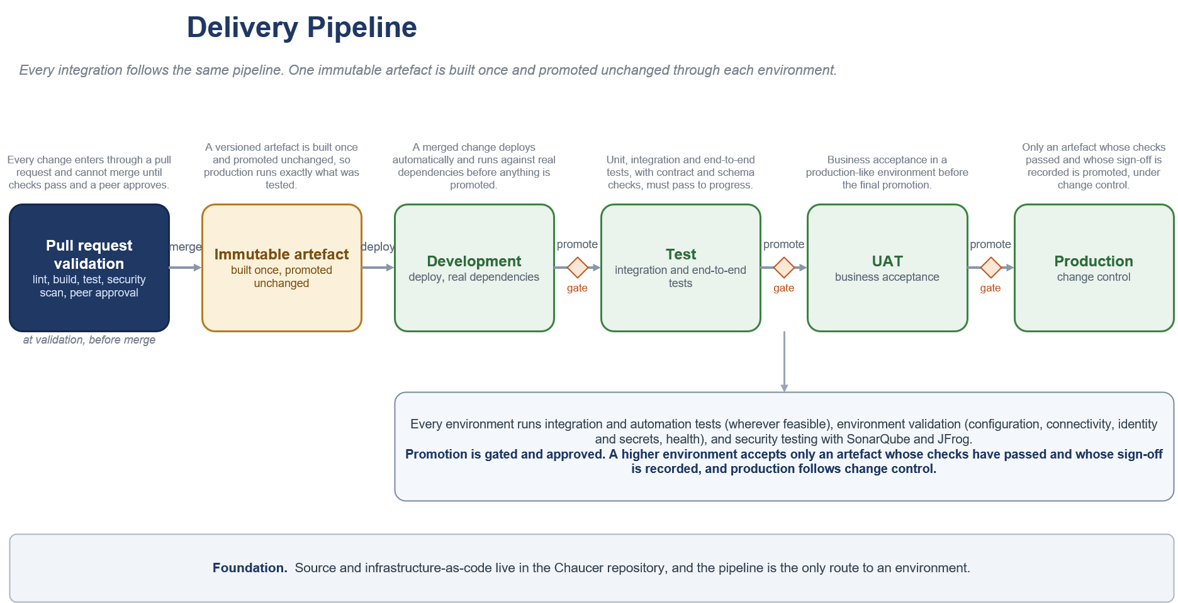

Guardrails

Mandatory Guardrails

These are assessed on every integration, regardless of pattern. They are inherited from the security principles and engineering standards and are not open to per-project renegotiation.

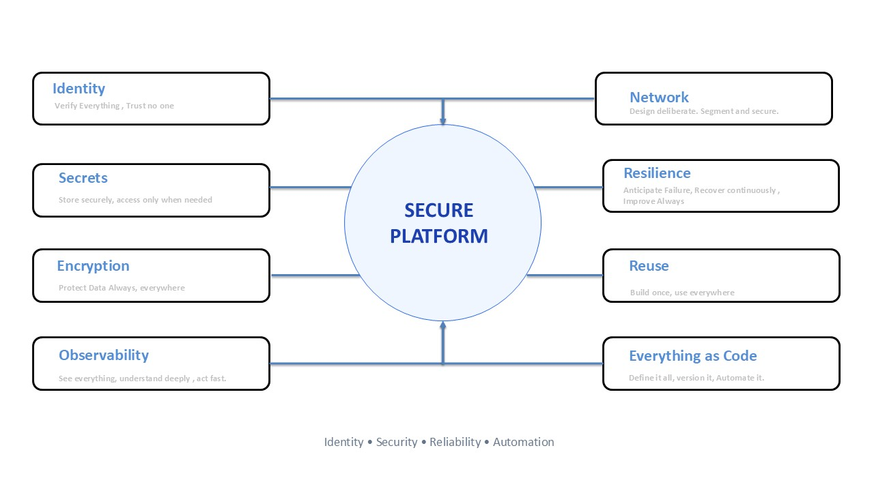
Source : Ref 1, Ref 4, Ref 5

When you need to deviate

The Systems Integration Framework provides clear standards and recommended approaches, but it is flexible when there is a valid business or technical reason to do something different. If a team needs to use a different component, work outside a guardrail, or operate beyond the data platform boundary, the exception must be documented with a clear justification.

The team should complete a security and risk assessment, identify any compensating controls, and submit the exception to the TDA for approval. Approved exceptions must be recorded in the exception register with a named owner, an expiry date, and a plan to return to the standard approach where possible.

Per-Pattern Security Conformance

Purpose
Every selected integration pattern must be assessed against the security baseline defined in Section 11 and the mandatory guardrails in Section 12.1.
The detailed pattern catalogue defines a security boundary for each pattern. This section consolidates those requirements into a single conformance matrix so that an architecture review can confirm:
- The pattern and boundary being used.
- Whether an internet or third-party boundary is crossed.
- The applicable identity and authentication controls.
- The required connectivity and network controls.
- The required secrets and certificate controls.
- The pattern-specific security considerations.
- Whether standard conformance is possible or an exception is required.
The security baseline is:
- Private connectivity by default.
- Managed identity for Azure service-to-service authentication wherever supported.
- Least-privilege RBAC.
- Approved secret, key, and certificate management services.
- TLS for every network hop.
- Public exposure only through an approved network edge and API Management where applicable.
- No direct exposure of Functions, Logic App HTTP triggers, backend APIs or internal service endpoints.
- Data minimisation and handling according to the applicable data classification.
- Security and administrative events forwarded through the approved security-monitoring route.
- Formal exception approval where the baseline cannot be met.
These controls consolidate the identity, connectivity, secrets, access-control and public-exposure requirements already defined in Section 11.1.

Conformance classifications
Classification | Meaning
Standard | The pattern can normally operate within the approved private security baseline.
Standard with boundary controls | The pattern crosses a controlled system, data or organisational boundary and requires the additional controls listed in this section.
Exception required | The proposed implementation cannot meet the standard baseline, introduces public exposure, uses unsupported authentication or connectivity, or bypasses an approved platform control.
Not applicable | The pattern is not appropriate for the proposed boundary or use case.

A pattern identified as Standard with boundary controls does not automatically require an exception. An exception is required only where the implementation cannot satisfy the specified boundary controls or otherwise deviates from the framework.

Operational integration pattern conformance
API and request-response patterns

Pattern | Normal security classification | Required security conformance | Exception triggers
SFINT1 Managed API Facade, internal | Standard | APIM must remain non-public. Consumer-to-APIM and APIM-to-backend communication must use approved private connectivity and TLS. APIM must authenticate to the backend using managed identity wherever supported. The consumer must be authenticated and authorised through the approved identity model. | Direct backend exposure,public APIM endpoint,public backend endpoint,stored credentials where managed identity is supported,bypassing APIM.
SFINT1 Managed API Facade, external | Standard with boundary controls | An approved network edge must terminate the public endpoint. APIM must remain behind the edge and must not be exposed directly. OAuth, OIDC, mTLS or another approved authentication mechanism must be applied. Rate limiting, request validation, monitoring and backend isolation must be implemented. | Direct public APIM exposure; direct Function, Logic App or backend exposure, missing edge protection, unsupported authentication, unregistered public exposure.
SFINT2 API Composition and Aggregation | Standard | APIM and the composition service must remain private. The composition service must use managed identities and least-privilege access for each backend. Per-backend timeout and failure handling must be defined. Sensitive data must be minimised in the aggregated response. | Public composition Function; shared credentials across backends, excessive data aggregation; composition bypassing APIM.
SFINT3 Protocol and Format Mediation | Standard, or standard with boundary controls for external partners | APIM or the mediation Function must remain inside the approved integration boundary. Connectivity to Azure or on-premises backends must use approved private paths. Schema validation must be applied before forwarding malformed or untrusted payloads. | Internet-exposed mediator, credentials in transformation code, business logic embedded in gateway policy, internet-only legacy connection without approved boundary controls.
These requirements reflect the API-pattern security boundaries, including private APIM, private backend access, managed identity, TLS, and controlled external exposure.

Messaging patterns
Pattern | Normal security classification | Required security conformance | Exception triggers
SFINT4 Queue-Based Load Levelling | Standard | Producers and consumers must access Service Bus through approved private connectivity. Managed identity and separate Sender and Receiver RBAC roles must be used. External producers must enter through an approved ingress pattern rather than connect directly to Service Bus. | Public Service Bus access; SAS keys where managed identity is supported, an external producer connecting directly to the namespace, shared sender and receiver identities.
SFINT5 Competing Consumers | Standard | Service Bus and workers must remain private. Each consumer workload must use least-privilege Receiver permissions. Consumer identities and processing activity must be traceable. | Public queue access; shared high-privilege identities, credentials embedded in worker configuration.
SFINT6 Asynchronous Request-Reply, internal | Standard | Request, status and callback components must use private connectivity, managed identity and TLS. Correlation IDs must not contain secret or sensitive information. Access to status data must be authorised. | Public status store, sensitive information embedded in correlation IDs, unauthorised access to another caller’s result.
SFINT6 Asynchronous Request-Reply, external | Standard with boundary controls | Request and status endpoints must be exposed through the approved edge and APIM. The same identity and authorisation model must protect request submission and result retrieval. Callback endpoints must use an approved outbound or webhook pattern. | Direct public Function or Logic App endpoint, predictable or unauthorised status URLs,callback credentials outside Key Vault.
SFINT7 Claim-Check | Standard | Blob Storage and Service Bus must remain private. Blob access must use managed identity and RBAC. Public access, account keys and public or long-lived SAS URLs must not be used. Payload retention and reference expiry must be aligned. | Public blob access, long-lived SAS references, account keys,payload retained beyond the approved period, message references accessible by unauthorised consumers.
SFINT8 Reliable Messaging | Standard | Service Bus access must use managed identity, least-privilege RBAC, private connectivity and TLS. Idempotency keys must not contain secrets. Dead-letter access must be restricted and monitored because dead-lettered messages may contain business data. | Public access, SAS-based application access where managed identity is supported, unprotected dead-letter data, secrets in message metadata.
SFINT9 Scheduled or Timed Trigger | Standard, or standard with boundary controls for external egress | The scheduler must run inside an approved workload boundary and use managed identity for downstream calls. Configuration and schedules must be source-controlled. Any external delivery must use the relevant approved outbound API or file-transfer controls. | Credentials embedded in schedules, public unauthenticated triggers, uncontrolled default internet egress, scheduled process bypassing the approved integration platform.
These controls are based on the detailed messaging-pattern boundaries, which require private Service Bus and storage access, managed identity, least privilege and controlled treatment of external producers or consumers.

Eventing and streaming patterns
Pattern | Normal security classification | Required security conformance | Exception triggers
SFINT10 Publish-Subscribe Fan-Out | Standard | Service Bus Topics and subscriptions must remain private. Publisher and subscribers must use separate least-privilege identities. Each subscriber must be limited to its own subscription where practicable. Dead-letter queues must be access-controlled and monitored. | Subscriber access to unrelated subscriptions, shared high-privilege identities, public namespace access,unauthorised subscription creation.
SFINT11 Discrete Event Notification | Standard | Event Grid and Azure-native handlers must use private connectivity where supported, managed-identity delivery and handler-side validation. Events must contain the minimum data needed and must not become an uncontrolled copy of the source record. | Internet-reachable handler treated as an internal Event Grid pattern, sensitive records included unnecessarily in events, unauthenticated handlers.
SFINT12 Inbound Webhook Ingestion | Standard with boundary controls | An approved network edge must terminate the public endpoint. APIM must provide the API ingress. Authentication must use mTLS, OAuth, signed-payload validation or another approved mechanism. Rate limiting, replay protection, deduplication and request validation must be implemented. Downstream processing must occur asynchronously within private workload boundaries. | Direct public Function or Logic App trigger, direct APIM exposure, no replay protection, no caller authentication, synchronous processing of untrusted requests, public exposure not recorded and approved.
SFINT13 Outbound Webhook or Notification | Standard with boundary controls | Traffic must leave through the approved controlled egress route. TLS must be enforced. Partner endpoints should be allow-listed where applicable. Authentication material must be held in Approved secret, key, and certificate management services. Payload signing, retry, circuit breaking and delivery auditing must be used where supported and required. | Default internet routing, secrets in configuration, unsigned sensitive payload where signing is required, uncontrolled subscriber registration, unrestricted destination endpoints.
SFINT14 Stream and Telemetry Ingestion, internal | Standard | Event Hubs, processors and capture storage must use approved private connectivity, managed identities, RBAC and TLS. Producer and consumer-group permissions must be separated. Capture storage must have public access disabled. | Public Event Hubs access, shared access keys for workload code where managed identity is supported, public capture storage, unrestricted consumer-group access.
SFINT14 Stream and Telemetry Ingestion, external feed | Standard with boundary controls | The external feed must enter through an approved boundary mechanism. Authentication, source validation, throughput controls and monitoring must be defined. Internal Event Hubs and processors must remain private. | External producer connecting through an uncontrolled public namespace, unauthenticated feed, missing source validation or capacity protection.

The inbound and outbound webhook patterns explicitly cross the internet boundary, while internal event patterns inherit private connectivity and managed-identity controls.

Orchestration patterns
Pattern | Normal security classification | Required security conformance | Exception triggers
SFINT15 Stateful Process Orchestration | Standard | The orchestrator must run inside the private workload boundary. Connections to APIM, Functions, Service Bus and other services must use managed identities and approved private connectivity. Secrets must be referenced from Approved secret, key, and certificate management services. External initiation must enter through an approved ingress pattern. | Direct external invocation of the workflow, embedded connection secrets, excessive permissions across participating systems, public orchestration endpoints.
SFINT16 Process with Compensation | Standard | The orchestrator and compensation components must use the controls for SFINT15. Access to compensation operations must be restricted because they can reverse or modify completed business actions. Execution and compensation history must be auditable. | Unauthorised manual invocation of compensation, compensation credentials stored in code, missing audit trail, broad write access across systems.
SFINT17 Human-in-the-Loop Approval | Standard | Approval interactions must use approved, identity-authenticated channels. The approver identity, decision and time of decision must be auditable. Approval links must not provide unauthenticated or transferable authority. | Anonymous approval, approval through an untracked external email process, shared approver identity, decision data exposed publicly.
SFINT18 Scatter-Gather | Standard, or standard with boundary controls where external services participate | The orchestrator and internal workers must remain private and use managed identity and least-privilege access. External calls must follow the applicable approved egress pattern. Responses must be validated before aggregation. | Public worker endpoints, single broad identity across all workers, unvalidated external responses, external services called through default internet routing.
The orchestration patterns require private deployment, managed identities, Key Vault/Cyber Ark references, TLS and approved boundary patterns for external calls.

File, transformation and routing patterns
Pattern | Normal security classification | Required security conformance | Exception triggers
SFINT19 Event-Driven File Ingestion, internal | Standard | Landing storage must have public access disabled and use private connectivity, managed identity, RBAC and TLS. File validation, isolation of invalid files, retention and replay controls must be implemented. | Public storage, account keys, unvalidated processing, unrestricted landing-zone access.
SFINT19 Event-Driven File Ingestion, partner SFTP | Standard with boundary controls | SFTP must use SSH with key or certificate authentication. Anonymous access must be disabled. Source restrictions, encryption, malware scanning where required, file validation and reconciliation must be implemented. Internet-facing SFTP must follow the approved exception process. | Password-only or anonymous SFTP, public storage behind the SFTP endpoint, no file validation, unregistered internet exposure.
SFINT20 File Generation and Delivery, internal | Standard | Files must be generated and staged in private storage. Managed identity and RBAC must be used. Access must be limited to the intended consumer, and retention and delivery confirmation must be defined. | Public collection path; shared account key, unrestricted access to generated files.
SFINT20 File Generation and Delivery, external | Standard with boundary controls | External SFTP delivery must use SSH key or certificate authentication, destination allow-listing, controlled egress and Key Vault/Cyber Ark-held credentials. Sensitive files must be signed or encrypted where required. Delivery confirmation and reconciliation must be retained. | Credentials in configuration, default internet routing, unencrypted sensitive file, delivery to an unapproved destination, no delivery reconciliation.
SFINT21 Canonical Data Model and Message Translator | Standard | Translation components must remain private and use managed identity and TLS. Incoming payloads must arrive through the applicable boundary pattern. Schema validation and data minimisation must occur before internal distribution. | Internet-exposed translator, unaudited mappings of sensitive data, credentials embedded in transformation code; bypassing the relevant ingress pattern.
SFINT22 Content-Based Routing | Standard | Routing components and rules must remain private, source-controlled and access-restricted. Unmatched messages must be sent to an approved default or dead-letter path. Routing decisions must not expose data to unauthorised destinations. | Dynamically supplied unrestricted destinations, missing default route, unauthorised modification of routing rules, routing based on unvalidated data.
The file patterns identify storage, SFTP and external-delivery boundaries, while the transformation patterns require private execution and controlled inbound boundary handling.

Data-platform exchange pattern conformance
The data platform remains a controlled analytical boundary rather than a general operational integration endpoint. The approved interaction is limited to governed ingestion into the platform and governed consumption of curated data products.
Pattern | Normal security classification | Required security conformance | Exception triggers
SFDEINT1 Event Streaming to the Data Platform | Standard with data-platform boundary controls | The Azure event source and Function must use private connectivity and managed identity. Snowflake authentication must use an approved key-pair, OAuth or equivalent approved mechanism, with applicable secrets in the approved vault. Account passwords must not be used. | Account-password authentication, secrets embedded in Function configuration, public event-source access,unrestricted Snowflake role.
SFDEINT2 Streaming Ingestion through Kafka Connect | Standard with data-platform boundary controls | Kafka brokers, Connect workers and Snowflake must use approved private network paths. Snowflake authentication must use centrally managed credentials or federated identity. Topic-level access controls must restrict publisher, connector and administrative permissions. | Public broker or connector path, shared unrestricted Snowflake credentials, connector access to unrelated topics or schemas.
SFDEINT3 File Ingestion | Standard with data-platform boundary controls | The ADLS landing zone must have public access disabled and use private connectivity. Producer write access and Snowflake read access must be separately scoped. Snowflake must authenticate through an approved storage integration or service identity rather than account keys. | Public landing zone, account keys; producer read access where not required, Snowflake access beyond the approved landing path.
SFDEINT4 Scheduled CDC or Watermark Ingestion | Standard with data-platform boundary controls | Source connectivity and staging must use approved private paths. Managed identity must be used wherever supported. Any residual secrets must be held in the approved vault. Snowflake must not require direct access to the operational source. | Snowflake direct access to the operational system, embedded source credentials; public staging, broad source-system permissions.
SFDEINT5 Staged Multi-Source Ingestion | Standard with data-platform boundary controls | Each source connection must use a separate least-privilege identity. Managed identity must be used wherever supported. Remaining secrets must be stored in the approved vault. Staging must use private connectivity, and transformation must remain within Snowflake where the pattern specifies ELT. | One unrestricted identity for all source systems, public staging, row-level sensitive transformation on uncontrolled intermediate compute, secrets in the pipeline definition.
SFDEINT6 Governed API Write | Standard with API and data-platform boundary controls | APIM must enforce authentication, authorisation, validation, throttling and access policy. Consumers must not receive direct Snowflake access. The Snowflake import path must use approved service identities and controlled procedures or APIs. | Direct consumer connection to Snowflake, bulk loading through the synchronous API, unauthorised procedure invocation, public backend bypassing APIM.
SFDEINT7 Consume Platform Data through an API | Standard with API and data-platform boundary controls | APIM must provide governed exposure. The serving layer must access Snowflake through approved private connectivity and least-privilege identity. The response must be curated, minimised and treated as analytical and eventually consistent. External consumers must use the approved edge and identity model. | Direct consumer access to Snowflake, transactional dependency on analytical data, public serving Function, excessive or uncurated response data.
SFDEINT8 Scheduled Data Export | Standard with file-exchange and data-platform boundary controls | ADLS must use private connectivity. The Snowflake service identity must be restricted to the designated export path. Downstream consumers must receive read-only access to the required path only. Sensitive exports must follow applicable encryption, retention and external-delivery controls. | Direct downstream access to Snowflake, public export storage, consumer write access, unencrypted sensitive external export, unrestricted export path.
SFDEINT9 Governed API Read | Standard with API and data-platform boundary controls | APIM must authenticate and authorise consumers and apply caching, throttling and access policy. The approved serving or query identity must have least-privilege access. The response must contain only the defined curated result. | Direct Snowflake credentials supplied to consumers, bulk extraction through the API, transactional use of analytical results, public backend exposure.
These controls consolidate the identity, private-connectivity and data-platform boundary requirements already present in the nine detailed data-platform patterns.

Required conformance evidence
Each integration design must record the following evidence for every selected pattern:
Evidence area | Required design evidence
Pattern selection | Selected pattern ID and name, decision-tree outcome and boundary crossed.
Data classification | Applicable classification, fields exchanged, minimisation decision and restrictions on logging.
Identity | Caller, workload and backend identities, authentication method; RBAC or platform permissions.
Connectivity | Private endpoints, private network routes, approved ingress or controlled egress path.
Secrets and certificates | Secrets and certificates must be managed through an approved enterprise capability with defined ownership, lifecycle management, and rotation processes.
API or webhook controls | Authentication, authorisation, validation, throttling, replay protection and edge controls where applicable.
Messaging controls | Sender and Receiver permissions, idempotency, dead-letter access and message-retention controls.
File controls | Landing or export path, access permissions, encryption, validation, retention and reconciliation.
Data-platform controls | Storage integration, Snowflake service role, approved schemas or procedures, and confirmation that consumers have no direct platform access.
Monitoring | Operational signals, security events, alert ownership and destination.
Exception status | Exception reference, owner, compensating controls, approval, expiry and remediation plan.
The framework already requires governance evidence across identity, network, secrets, observability and resilience at build time, with deviations approved before build proceeds.

TDA Governance and Exceptions

TDA Gates

Governance is applied at defined points. At design, the selected integration pattern and interaction style are confirmed against the decision tree and the boundary. At build, guardrail conformance is evidenced across identity, network, secrets, observability and resilience. Any exception is logged and approved before build proceeds.

Security Conformance

Standard private patterns proceed on the agreed security baseline. A pattern that cannot meet the baseline triggers the exception process, which requires a security review prior to TDA. Where the wider security posture is affected, the exception is escalated to the risk register and senior leadership and managed via ERM framework.

Exceptions

The Systems Integration Framework is principles-driven but pragmatic. Where a justified need exists to deviate from an approved pattern, guardrail, or architectural boundary, the exception must be formally documented, risk-assessed, assigned an owner, and reviewed periodically. Appropriate compensating controls must be implemented, with a defined path and timeline to return to the standard approach where practical.

Glossary

Term | Meaning
SIF | Systems Integration Framework, this document.
AIS | Azure Integration Services, comprising API Management, Logic Apps, Service Bus, Event Grid, Event Hubs and Functions.
SOA | Service-oriented architecture, coarse-grained services aligned to business capabilities.
APIM | Azure API Management.
Managed identity | An Entra identity for an Azure resource that authenticates without stored secrets.
Claim-check | A pattern that keeps a large payload in storage and passes a reference on the message.
Idempotency | The property that applying the same message more than once has no additional effect.
Bordereau | A delegated-authority premium or claims report provided by a cover holder.
TDA | Technical Design Authority.
ADF | Azure Data Factory.
ADLS | Azure Data Lake Storage.
HLSA | High Level Solution Architecture.
SME | Subject Matter Expert.
RBAC | Role-Based Access Control.
NSG | Network Security Group.
OAuth | Open Authorization framework used for delegated access to protected resources.
OIDC | OpenID Connect; an authentication protocol built on OAuth 2.0.
mTLS | Mutual Transport Layer Security, where both client and server authenticate each other.
TLS | Transport Layer Security, the standard protocol for encrypting network communications.
CDC | Change Data Capture, a technique for identifying and processing data changes incrementally.
DLQ | Dead Letter Queue, a queue used to hold messages that cannot be processed successfully.
ELT | Extract, Load, Transform.
ETL | Extract, Transform, Load.
SDK | Software Development Kit.
Snowpipe | Snowflake's continuous data ingestion service.
Correlation ID | A unique identifier used to trace a transaction or message across multiple systems and services.
ACORD | Insurance industry standards organisation providing standardised data models and message formats.
CDR | Core Data Record, the London Market standard for structured insurance data exchange.
DLRM | Delivery Lifecycle Review Meeting.
PDG | Project Delivery Governance.
ERM | Enterprise Risk Management.
Kafka | An open-source distributed event streaming platform that publishes, stores, and delivers data streams reliably and at scale between systems in real time.

Cross-Reference and Traceability

Pattern Grouping

The catalogue groups patterns by interaction style. The table maps each group to its section and the primary Azure services.

Group | Section | Primary services
API patterns | 8.3 (SFINT1 to SFINT3) | API Management, Functions
Messaging patterns | 8.4 (SFINT4 to SFINT9) | Service Bus, Functions
Event patterns | 8.5 (SFINT10 to SFINT14) | Event Grid, Event Hubs, Service Bus
Orchestration patterns | 8.6 (SFINT15 to SFINT18) | Logic Apps, Functions
File patterns | 8.7 (SFINT19 to SFINT20) | Blob, Event Grid, Logic Apps
Transformation and routing | 8.8 (SFINT21 to SFINT22) | Functions, Service Bus
Data platform patterns | 9 (SFDEINT1 to SFDEINT9) | Event Hubs, Functions, Snowflake

Appendices

