CHAUCER
Technology & Architecture
Systems Integration Framework
A service-oriented framework for building integrations on Azure

Version 0.9 · Draft for TDA review
Prepared by the supporting integration SME with Chaucer Integration Architecture

Document control
This is a working draft, produced jointly by Chaucer's lead integration architect and the supporting SME, for review and approval by the Technical Design Authority. It supersedes v0.22013v0.4. Reference-architecture diagrams are embedded inline rather than supplied separately.
Status | Draft v0.9 — for TDA review
Architecture style | Service-Oriented Architecture (SOA). Microservices are explicitly out of scope.
Sits under | Chaucer's Global EA, Integration, Application, Data, Technology and Security principles, and the Cloud Engineering Standards. This framework applies them; it does not restate or change them.
Target platform | Azure integration PaaS — API Management, Logic Apps (Standard), Service Bus, Event Grid, Event Hubs, Functions — with Snowflake as the data platform across a defined boundary.
Change control | Managed on a service lifecycle, versioned; patterns and reusable services are published to the asset catalogue.

Contents

1. Introduction

1.1 Why this framework exists
Integration at Chaucer works, but it has grown one delivery at a time. Each new interface tends to be solved on its own terms — a direct call here, a bespoke file drop there — and the result is a web of point-to-point couplings that is expensive to change, hard to monitor, and impossible to reuse. Every tactical integration we add makes the next change more difficult.
This framework sets a single, deliberate way to build integrations. It is not a catalogue of everything possible; it is an opinionated set of patterns, backed by the Azure services we have standardised on, with the guardrails and decisions a delivery team needs to build the right thing without re-litigating the architecture each time. The aim is straightforward: fewer point-to-point interfaces, more reuse, loose coupling by default, and integrations that are consistent enough that any team — or any supplier — can pick this up and build to the same shape.

1.2 How to use it
If you are about to build an integration, start at the decision tree in Section 4. A handful of questions takes you to the right pattern. Section 5 then gives you that pattern in full: the problem it solves, a diagram of how it fits together, the Azure building blocks and their roles, the risks to plan for, and the mistakes to avoid. Before you build, check your design against the guardrails in Section 6 — those are the things that will be looked for at TDA. If you find yourself wanting to deviate, that is allowed, but it goes through the exception process rather than quietly into the code.
Two rules sit above everything else and are worth stating before the detail. First, reuse before you build — check the asset catalogue for an existing service or API before creating a new one, and prefer integrating an existing system over standing up a new one. Second, everything goes through the platform; there is no sanctioned pattern for a direct, unmediated system-to-system interface.

1.3 How this framework relates to Chaucer's principles
The SIF does not introduce a new belief system. It inherits Chaucer's existing principles and turns them into concrete integration choices. The stack below shows what it draws from and where those principles are actually enforced in this document.
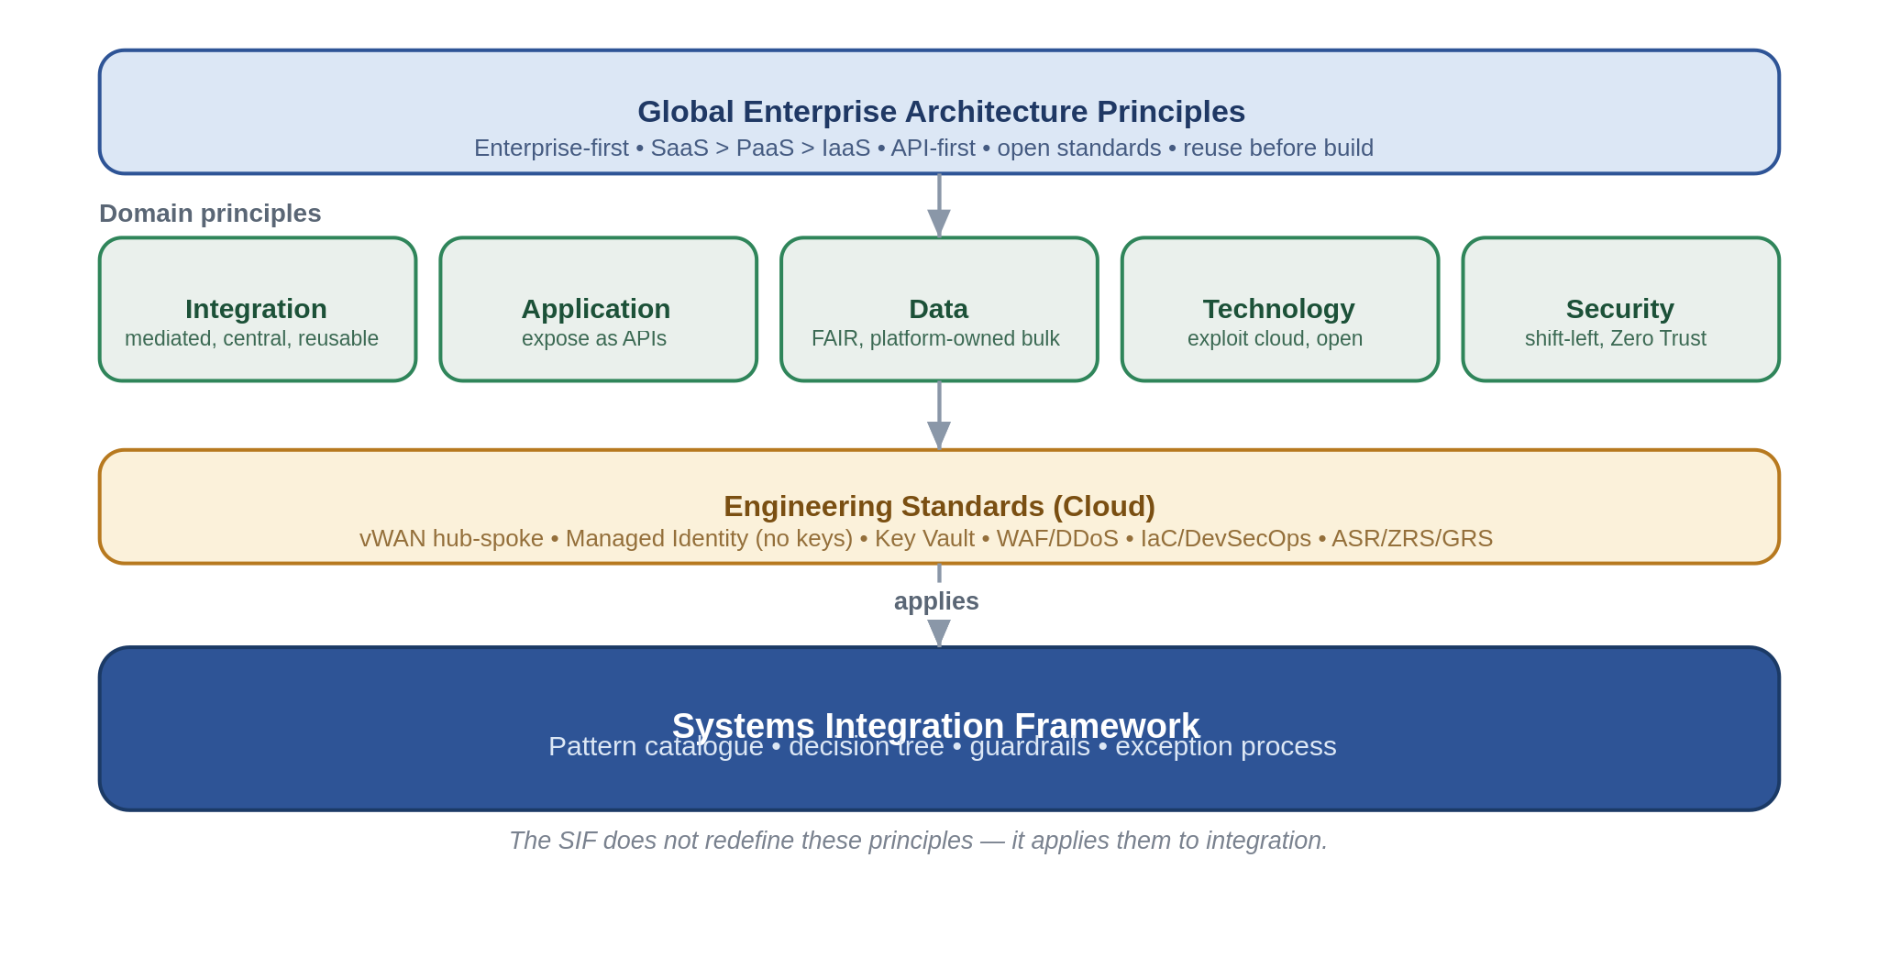
The mapping is worth making explicit, because "aligned to our principles" is easy to assert and harder to evidence. The table below is the traceability a reviewer can check.
Principle (source) | How the SIF embeds it | Where it is enforced
API-first, reuse-first, enterprise-first (Global EA; Application) | Capabilities are exposed as coarse-grained, reusable APIs and events through the platform; new build only after reuse is ruled out. | SOA service model (§2.2); catalogue (App. A); TDA design gate (§6.3)
All integration mediated through a single central platform (Integration) | One shared, centrally-operated platform; no direct point-to-point pattern exists. | Reference architecture (§3); anti-patterns (§5, App. B)
Loose coupling; asynchronous where availability/latency matters (Integration) | Messaging and events are the default for anything that can tolerate deferral; APIs are contract-bound. | Decision tree (§4); patterns (§5)
Secure by design, Zero Trust, least privilege (Security) | Every pattern carries a security position; identity is Entra + Managed Identity, no keys; ingress is gated. | Per-pattern risks (§5); guardrails (§6.1)
Managed Identity, Private Endpoints, WAF/DDoS, IaC (Engineering Standards) | Baked into the reference architecture and the non-negotiable guardrails. | Reference architecture (§3.3); guardrails (§6.1)
Mission-critical resilience; design for failure (Integration; Resilience) | Tiered multi-region posture and zone-redundancy by default. | Deployment & resilience (§3.4)
Data is platform-owned; FAIR (Data) | Bulk and analytics stay on Snowflake; the SIF exchanges with it across a defined boundary. | Data platform exchange (§5.6); boundary (§3.1)

1.4 Integration in a Lloyd's context
This is a framework for a specialty insurer operating in the Lloyd's and London markets, and that shapes what "good" looks like. Insurance integration has a particular character: we exchange data with a large and shifting population of external parties — brokers, coverholders and MGAs, delegated claims administrators, reinsurers, and the market's central processing bureau — and each brings its own format and its own standards, from ACORD messages to delegated-authority bordereaux to the market's Core Data Record. A great deal of the work is turning that heterogeneity into clean, canonical, once-keyed data, which is exactly the manual re-keying and workaround problem this programme was set up to remove.
Three domain forces run through the rest of this document. First, heterogeneity of partners and standards, which is why a canonical data model and translation (Section 5.7.1) is not an optional nicety here but a load-bearing pattern. Second, the market's central processing: the London market clears risk, premium, accounting, settlement and claims through the bureau operated by Velonetic, on heritage systems that are being modernised incrementally — the broader Blueprint Two vision was retired in 2026 — so integrations should align to common data standards and the bureau's services while assuming the roadmap will keep evolving, rather than hard-wiring to any single programme milestone. Third, a heavy regulatory and tax reporting obligation (Solvency II, Lloyd's returns, coverholder reporting standards) that pulls the data platform into many flows. Section 5.8 shows how the patterns compose to meet these; the specifics of any market service should always be checked against current Lloyd's and Velonetic guidance, since that landscape moves.

2. Architectural position

2.1 SOA, deliberately not microservices
Chaucer's model is service-oriented, and the framework is built around that choice rather than drifting toward microservices because they are fashionable. The distinction matters in practice. A service here is a coarse-grained, business-capability-aligned unit — "Policy", "Claims", "Client" — with a clear contract and a named owner, exposed through the platform. It is not an entity- or table-level endpoint, and it is not one of dozens of fine-grained services chattering over a mesh.
This shapes the whole catalogue. Orchestration is centralised and process-owned, not choreographed across services. Consistency across systems is handled with orchestrated compensation, not distributed sagas or two-phase commits. Composition assembles a coarse business object from a few reads, and if a design finds itself fanning out to many fine-grained calls, that is treated as a granularity problem to fix, not a pattern to build around. Where the two models would diverge, this framework takes the SOA path every time.

2.2 What counts as a service
Because reuse is the point, it helps to be precise about the unit we are reusing. A service in this framework has four properties, and a design that is missing any of them is not yet a service.
- It is business-capability aligned and coarse-grained — it means something to the business, not just to a database.
- It has a versioned contract — an API definition or a published event schema — that consumers bind to, and that can evolve without breaking them.
- It has a named owner accountable for its behaviour, its SLA and its lifecycle, and it is managed on a service lifecycle rather than being abandoned at the end of a project.
- It is published and discoverable in the asset catalogue, so the next team finds it before building their own.
The corollary is the integrate-before-build stance: a new requirement should first try to reuse or extend an existing service, then integrate an existing system, and only then justify building something new. That justification is a TDA conversation, not a default.

2.3 Design tenets
Everything in the catalogue is an expression of a small number of tenets. They are stated here in plain terms so the reasoning behind a pattern is never a mystery: mediate everything through the platform; couple loosely and lean asynchronous where you can; keep process control (Logic Apps) separate from business logic (Functions); expose just enough capability and never internal data models; secure every hop by design; make the platform resilient because it is mission-critical; and tie every integration to a real business outcome so we are not building interfaces for their own sake.

3. Reference architecture

3.1 The layered model
The platform is organised into four layers plus a governed boundary to the data platform. Each layer has one job and maps to one set of Azure services, which is what keeps responsibilities — and the scope boundary — clear.
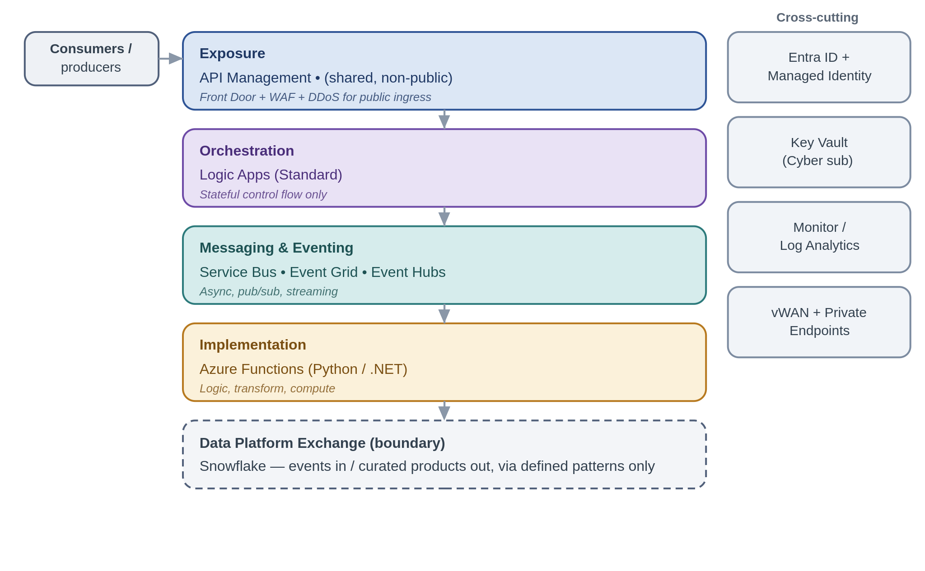
Requests enter only through the exposure layer. API Management is the single front door and is a shared, internal service; it is deliberately not internet-facing, so anything that must be reached from outside is fronted by Front Door with a WAF and DDoS protection first. Orchestration, when a process needs it, sits in Logic Apps (Standard) and holds control flow only. Asynchronous work, events and streams run through the messaging and eventing layer. Actual computation — transformation, validation, custom logic — lives in Functions. And bulk or analytical data does not belong in any of these layers; it crosses a defined boundary to Snowflake, in both directions, using the exchange patterns in Section 5.6.

3.2 Choosing the messaging backbone: Service Bus, Event Grid or Event Hubs
Three services cover asynchronous and event-driven integration, and picking the wrong one is one of the more common and costly mistakes. They are not interchangeable. The rationale for each, and where the lines fall, is below.
Aspect | Service Bus | Event Grid | Event Hubs
What it is for | Reliable messaging and commands; durable pub/sub between systems. | Lightweight reactive event notification and routing. | High-throughput ingestion of event streams and telemetry.
Nature of a message | A business message or command that must be processed. | A thin "this happened" signal; a pointer, not state. | One record in a continuous, high-volume stream.
Delivery & ordering | At-least-once; ordering via sessions; per-message dead-lettering; duplicate detection. | At-least-once; unordered; dead-letter to storage. | At-least-once; ordering within a partition; consumer checkpoints.
Throughput shape | Moderate, transactional. | Reactive, event-by-event. | Very high, sustained (thousands+/sec).
Use in the SIF for | Load-levelling, competing consumers, reliable messaging, durable pub/sub fan-out. | Discrete notifications, webhook routing, lightweight fan-out to Azure handlers. | Feeds, telemetry, stream processing, analytics offload.
Don't use it for | Firehose telemetry volumes. | Durable, ordered, competing-consumer business messaging. | Transactional commands needing per-message DLQ and sessions.
A useful shorthand: if a message must be processed reliably and possibly in order, it is Service Bus; if it is a lightweight signal to react to, it is Event Grid; if it is a stream, it is Event Hubs.

3.3 Connectivity, identity and secrets
The platform lives on the Secure vWAN hub-and-spoke network and reaches its dependencies over Private Endpoints; storage and databases are not publicly reachable. Every service-to-service call authenticates with a Microsoft Entra managed identity under least-privilege RBAC — no account keys, no shared keys, no secret-bearing connection strings. Where a secret is genuinely unavoidable (a partner credential, say), it is held in Key Vault in the Cyber subscription and referenced, never copied into configuration. All channels are encrypted regardless of whether the network is private, because Zero Trust does not assume the network. None of this is optional per pattern; it is the floor, and Section 6 restates it as guardrails.

3.4 Deployment and resilience
The framework is delivered as one centralised, shared platform rather than as per-project instances. Centralisation is a principle, not a preference: it is what makes consistent security, shared skills, single-pane operations and genuine reuse possible, and it is the only way to run integration as the mission-critical service it is. A single platform team owns it, operates it to stringent SLAs, and changes it carefully. Everything is deployed from infrastructure-as-code held in Azure DevSecOps.
Resilience is tiered by business criticality rather than applied as a single blanket, because reliability has a cost and not every integration warrants Tier 0 spend. Zone-redundancy within a region is the baseline everywhere; the cross-region posture is chosen per tier.
Tier | Posture | Approach
Tier 0 — mission-critical | Active-active / hot standby | Multi-region, fronted by Front Door / global load balancing; near-zero RTO/RPO where the service supports it.
Tier 1 — business-important | Warm active-passive | Secondary paired region kept warm; controlled failover; ASR where a service lacks native HA.
Tier 2 — standard | Backup / restore | Redundant storage (ZRS/GRS) and re-provision from IaC; a higher RTO is acceptable.

A note that catches teams out: Logic Apps (Standard) run history is region-bound, so orchestration DR is active-passive and in-flight runs do not migrate automatically — orchestration steps must be idempotent and restartable. Service Bus and Event Hubs use their Premium geo-DR/geo-replication with alias failover; API Management Premium runs multi-region gateways; Key Vault replicates to its paired region automatically. Security posture is identical in DR — a failover is not a drop in control.

3.5 Security zones and trust boundaries
Security is the principle this organisation takes most seriously, so it is worth drawing the zones and boundaries once, explicitly, and then holding every pattern to them. The framework is default-deny and private-by-default: the overwhelming majority of integration never touches the internet, and the small number of flows that must are forced through a single, hardened edge. The diagram shows where components live and where the one hard boundary sits.
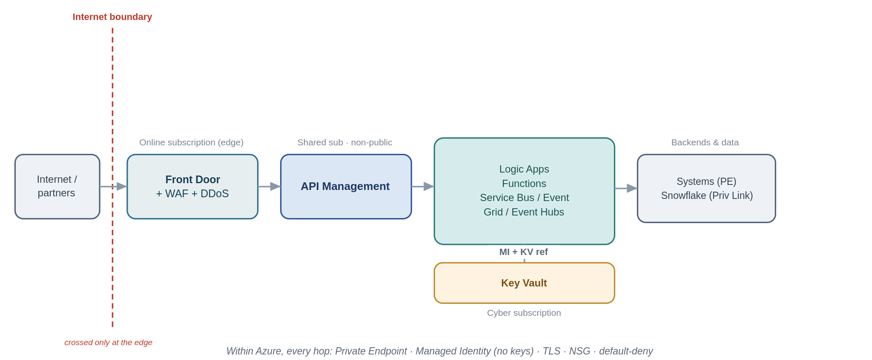
Three landing-zone boundaries matter, and every pattern in Section 5 is described against them:
- The internet boundary. This is the only boundary that faces untrusted networks, and it is crossed in one place only — the online subscription, behind Azure Front Door with a WAF and DDoS Protection Standard, terminating at API Management as the single ingress. Public-facing services live only in the online subscription; APIM itself is a shared, non-public service. Most patterns never cross this boundary at all.
- Boundaries within Azure. Between the edge, the shared APIM subscription, the workload spokes and the Cyber subscription, traffic moves over the Secure vWAN with NSG segmentation and reaches every dependency over a Private Endpoint. Nothing authenticates with a key: every hop uses a Microsoft Entra managed identity with least-privilege RBAC, secrets (where truly unavoidable) are Key Vault references from the Cyber subscription, and TLS is applied on every hop regardless of how private the path is — Zero Trust does not trust the network.
- The boundary to systems and the data platform outside the SIF. Backends, on-premises systems and Snowflake are reached over Private Endpoints or Private Link, never the public internet; where a partner genuinely cannot be reached privately (an internet-only SFTP or webhook), that traffic is pulled back through the edge above and the exposure is a registered, time-boxed exception.
Each pattern below therefore carries an explicit Security boundary note answering three questions: which zone its components sit in and whether the flow crosses the internet boundary; how it is secured within Azure; and how it is secured across any boundary outside Azure. Section 6.4 then rolls these up into a per-pattern conformance view for TDA.

3.6 Data protection: encryption and classification
Zone controls protect the paths; this section protects the data itself, which the asset-protection and Zero Trust principles treat as valuable independent of where it sits. It matters more than usual here because specialty insurance handles a great deal of personal data, some of it special-category — health and medical data in personal-accident and life lines, and criminal-conviction data in parts of liability — which attracts the strictest handling under UK GDPR.
In transit, TLS 1.2 or higher is applied on every hop, private path or not, because Zero Trust does not assume the network; there are no plaintext protocols anywhere in the platform. External partners are authenticated with mutual TLS or OAuth at the edge, file transfer is SFTP-over-SSH with key or certificate authentication, and sensitive files are additionally signed or encrypted at the payload level (for example PGP) so their protection outlives the transport. Certificates and keys are managed in Key Vault in the Cyber subscription — rotated, revocable, never carried in configuration.
At rest, every store is encrypted — Blob, Service Bus, Event Hubs, Snowflake and any database — with platform-managed keys by default and customer-managed keys through Key Vault where a data classification or a regulatory requirement calls for key control. Storage accounts and databases are firewalled with public access disabled and reached over Private Endpoints, and transient stores such as claim-check blobs and stream capture carry lifecycle policies so sensitive data does not linger beyond its purpose.
Data is classified and handled to its tier, and the framework carries only the minimum it needs — it never moves or exposes internal data models wholesale. PII is minimised, and pseudonymised or tokenised before it crosses into analytics or leaves the operational boundary; special-category data attracts additional access restriction and, where required, customer-managed keys and field-level protection. Retention and erasure are owned per flow by the named owner of each result store, balancing regulatory retention (claims records are often long-lived) against data-subject erasure rights, and data residency is considered wherever partners or the market operate across jurisdictions.
Classification tier | Examples in this estate | Handling
Public | Published rates, public policy documents. | Standard controls; may be served externally through the edge.
Internal | Operational metadata, non-personal business data. | Entra + least privilege; not exposed externally; private-only.
Confidential (PII) | Claimant and insured personal data, policy and claim details. | Minimise; Private Endpoint; encrypted; access logged; pseudonymise before analytics.
Highly confidential (special-category PII) | Health/medical data, criminal-conviction data. | Additional access restriction; customer-managed keys or field-level protection where required; tokenise; strict audit.

Because PII risk concentrates at the boundaries, the outward-facing patterns carry specific handling, summarised here and reflected in each pattern's Security boundary note:
Boundary flow | PII handling control
Push to the platform / offload (5.6.1) | Classify and minimise before landing; pseudonymise or tokenise special-category fields; publish the canonical contract, never raw internal models.
Consume and serve (5.6.2) | Least-privilege data access; serve curated rather than raw data; mask fields the consumer does not need.
File ingestion and egress over SFTP (5.5.1–2) | Encrypt files at the payload level beyond transport; minimise fields; quarantine on validation failure; enforce retention/lifecycle.
Inbound and outbound webhooks (5.3.3–4) | Validate and sign payloads; keep PII out of URLs and logs; TLS/mTLS; redact in observability.

One operational consequence is worth stating plainly for the SOC: observability must not become a PII leak. Logs, metrics and traces carry correlation IDs and metadata, not payloads; PII is redacted or hashed where it would otherwise appear. That gives the SOC the visibility the standards require (it has access to the logs it needs) without over-collecting personal data into the logging estate.

4. Choosing a pattern

4.1 The decision tree
Work down the tree in order and take the first branch that matches — the questions are arranged so that the earlier ones catch the cases that must not be built any other way (bulk data, stateful process) before the finer distinctions between synchronous and asynchronous styles.
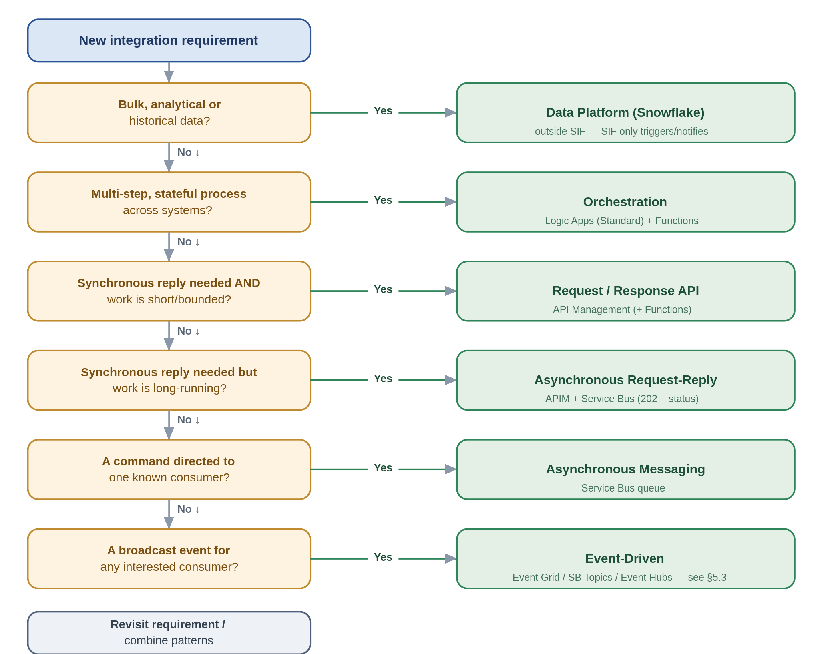

4.2 Walking it through — a worked example
Suppose you have been asked to make the following happen: when a policy is bound in the policy admin system, the finance system should raise the corresponding entries, the document system should generate the policy schedule, and the analytics team should get the data for reporting. You sit down with the decision tree.
Is this bulk or analytical data? No — it is a business event with immediate operational consequences, so you pass the first gate (the analytics need is a downstream consumer, not the shape of the whole integration). Is it a multi-step, stateful process across systems? The finance and document steps are consequences of one event rather than a single owned sequence with state, so this is not primarily an orchestration — though if the bind itself had to be coordinated with a rollback, Section 5.4 would come into play. Does anyone need a synchronous reply? No; nothing is waiting on a held-open call. Is it a command to one known consumer? No — several parties care, and more may care later. Is it a broadcast event for any interested consumer? Yes.
That lands you in event-driven territory, and the comparison in Section 3.2 tells you which service: this is durable, multi-consumer, business-critical delivery, so it is a Service Bus topic, not Event Grid. You publish a single "PolicyBound" event; finance, document generation and the analytics offload each take it on their own subscription (the last one via the offload pattern in Section 5.6). Adding a fourth consumer later changes nothing about the publisher. You have removed three would-be point-to-point interfaces and replaced them with one event — which is exactly the outcome the framework is trying to make the path of least resistance.

4.3 Secondary considerations
The tree gets you to the right family; a few cross-checks refine the choice. How tightly can the systems afford to be coupled — can the caller tolerate the other side being down? What delivery guarantee does the data need, and therefore how much idempotency work is implied? Is any part of this internet-facing, which pulls in the ingress guardrails? And what criticality tier is it, which sets the resilience posture from Section 3.4? These do not usually change the pattern, but they change how you build it.
One thing the tree deliberately does not have is a "file" branch, because a file is a transport rather than a semantic. If the data arrives as a file, you still classify it by what it is: operational records to process go to file-based exchange (Section 5.5), which handles the file event-driven and turns it into messages; a bulk or analytical dataset goes to the data platform (Section 5.6.3). The file itself never dictates the pattern — what is in it does.

5. Pattern catalogue
The catalogue is organised by interaction style — request/response, asynchronous messaging, event-driven, orchestration, file-based exchange, and data-platform exchange. That is a deliberate choice. It mirrors the very first decision a developer makes (does the caller wait for an answer, or not?), it lines up one-to-one with the decision tree, and each style maps cleanly onto a primary Azure service — file-based being the one that deliberately spans a few, because a file is a transport rather than a service. Two alternatives were considered and set aside: grouping by the classic enterprise-integration-pattern taxonomy (accurate but academic, and not how our teams think), and grouping by business capability (which belongs in the service catalogue, not the pattern framework).
Each pattern is written the same way, so you can read any of them quickly: a one-line statement of what it is for, a diagram, the problem and the solution in plain terms, when to use and avoid it, the risks worth planning for, the anti-pattern to steer around, and a Chaucer-flavoured example. The diagrams share a visual language — blue is the gateway, purple is orchestration, teal is Service Bus, green is Event Grid, orange is Event Hubs, amber is Functions, and a cylinder is a store.

5.1 Request / response — synchronous APIs
Synchronous request/response is the right tool when a caller genuinely needs an answer before it can continue. Everything here goes through API Management; the differences are in what sits behind it and how much work it does.

5.1.1 Managed API façade
Put every exposed capability behind the shared gateway, so consumers never bind to a backend directly.
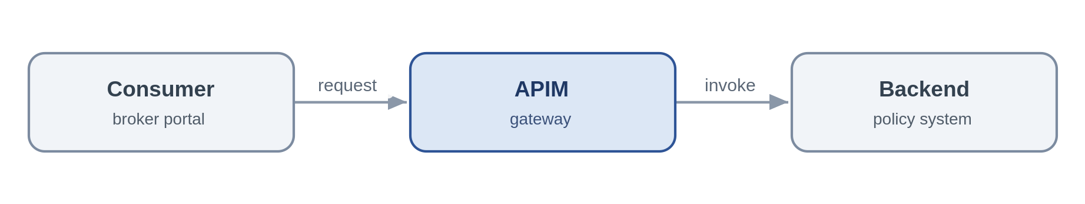
Problem. A consumer needs an immediate answer from a system of record. Letting it call that system directly couples the two together, scatters authentication and throttling across the estate, and makes the backend impossible to version or move — the tactical, point-to-point coupling this framework exists to remove.
Solution. Expose the capability as a coarse-grained REST/JSON operation on API Management. APIM authenticates the caller with an Entra token, applies a rate limit and a product subscription, and forwards to the backend over a Private Endpoint using a managed identity. The consumer knows only the contract, so the backend can be re-platformed behind a stable façade. Where the capability must be reachable from the internet, APIM sits behind Front Door with a WAF and DDoS — it is never public itself.
Use it when the caller needs a synchronous answer to a query or short command and you want one governed, reusable front door to a capability. Avoid it when the work is long-running or unpredictable (orchestrate it), or the interaction is really fire-and-forget (use messaging).
Risks & considerations. APIM is a deliberately shared chokepoint, so its availability is everyone's availability — run it zone-redundant, and multi-region for Tier 0, and treat its capacity and policy changes as mission-critical. The façade adds a hop and a few milliseconds; keep policies lean and cache idempotent reads. And the gateway does not absolve the backend of protecting itself — it still needs its own throttling behind the façade.
Security boundary. Landing zone: APIM sits in the shared subscription (non-public); the backend in its workload spoke. For internal consumers the whole flow is private and crosses no internet boundary. Within Azure: consumer-to-APIM and APIM-to-backend both over Private Endpoints, APIM authenticates to the backend with a managed identity, TLS on every hop. Outside Azure: only where the API must be public — then it is fronted from the online subscription by Front Door + WAF + DDoS with OAuth or mTLS at the edge, as a registered exception; APIM is never exposed directly.
Anti-pattern. A pass-through proxy that adds no policy, security or versioning — or, worse, business logic buried in gateway policies.
In practice. The underwriting system exposes get-policy-summary through APIM; the broker portal calls the API and has no knowledge of the policy admin system behind it.

5.1.2 API composition / aggregation
Assemble one coarse-grained business response from a few backend reads, so the consumer makes a single call.
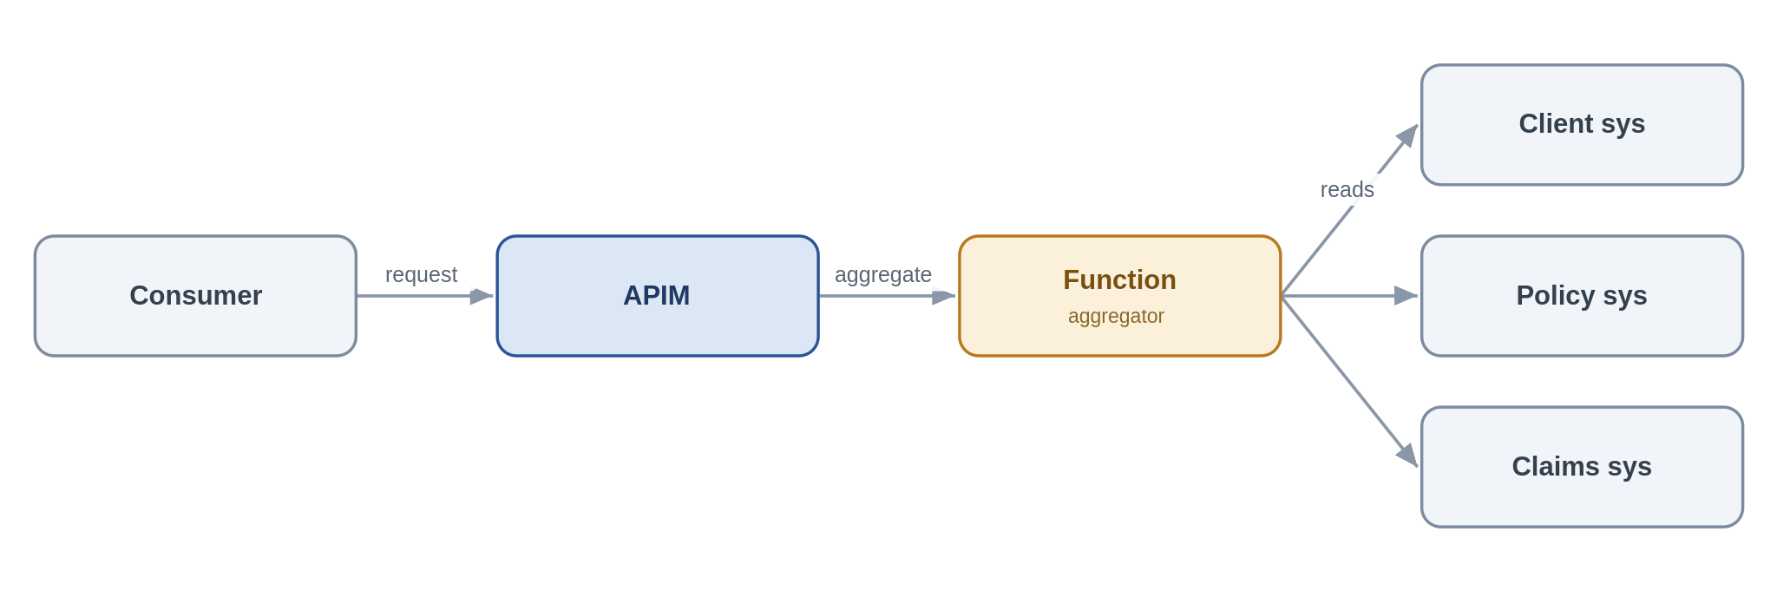
Problem. A servicing screen needs a "client 360" view whose data lives across three systems. Making the consumer call all three couples it to three contracts and three failure modes; doing the joins in the browser is worse.
Solution. Expose a single composed API on APIM backed by a Function that fans out to the underlying systems, assembles a coarse-grained response and returns it. The composition stays read-mostly and business-shaped — SOA granularity, not a chatty mesh of fine-grained calls.
Use it when a consumer needs one logical business object drawn from two or three sources and a single round-trip materially simplifies the caller. Avoid it when the composition needs transactional writes or long-running steps (orchestrate), or you find yourself fanning out to many fine-grained services — that is a granularity problem to fix, not to aggregate around.
Risks & considerations. Response time is governed by the slowest dependency and availability by their product, so decide up front how the API behaves when one source is down — a partial response with a clear indicator usually beats failing the whole call. Put a timeout and a circuit breaker around each backend, and cache what you safely can.
Security boundary. Landing zone: APIM (shared subscription) and the aggregator Function (workload spoke); the source systems in their spokes. Fully internal. Within Azure: the Function reaches each source over a Private Endpoint with a managed identity, no secrets in configuration (Key Vault references only), TLS throughout. Outside Azure: none.
Anti-pattern. Fine-grained, chatty aggregation that recreates a distributed monolith; pushing heavy composition into APIM policies instead of a Function.
In practice. A client-servicing screen calls one "client 360" API; the aggregator Function reads client, policy and claims summaries and returns a single object.

5.1.3 Protocol / format mediation
Translate a legacy protocol to REST/JSON at the edge so modern consumers stay clean.
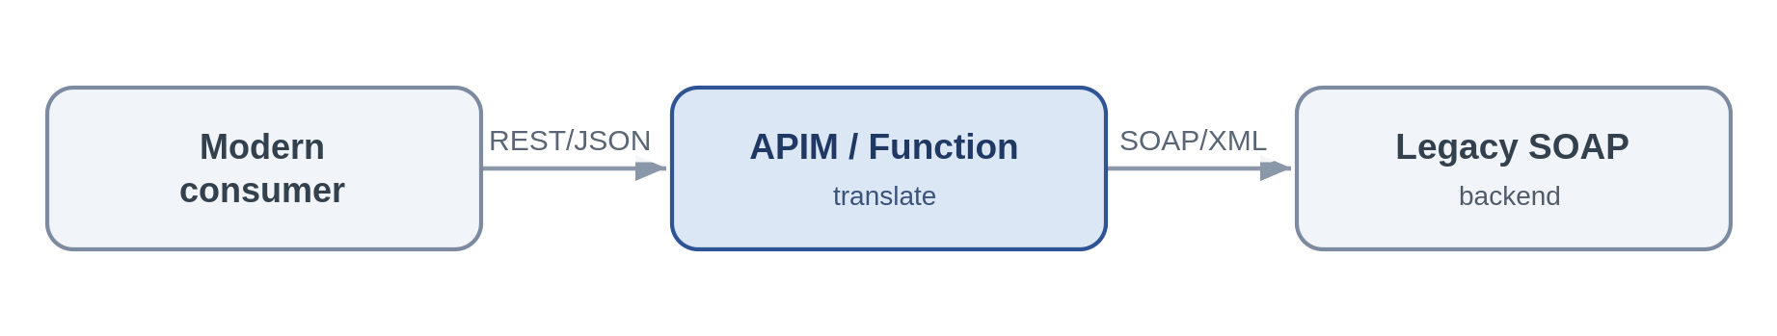
Problem. A cloud-native consumer must talk to a system that only speaks SOAP/XML or a fixed-width format. Letting that leak into the consumer spreads legacy concerns across the estate.
Solution. Terminate the modern REST/JSON contract at APIM for light transforms, or a Function for heavier ones, and translate to the backend's protocol. Consumers see only REST/JSON; the legacy quirks are contained in one place.
Use it when you are standardising the estate on REST/JSON and need to front a legacy protocol. Avoid it when the requirement is really business transformation rather than protocol translation — that is implementation logic and belongs in a Function with tests, not in a mediation policy.
Risks & considerations. Keep the translation stateless and mechanical; the moment business rules creep in you have hidden, untested logic sitting in the edge. Validate schemas on the way through so malformed legacy payloads fail fast rather than propagating.
Security boundary. Landing zone: APIM or the mediation Function in the shared subscription / a spoke; the legacy backend in its spoke or on-premises. Within Azure: Private Endpoint, managed identity and TLS; an on-premises backend is reached over the private vWAN path, not the internet. Outside Azure: none — an internet-only legacy partner uses the inbound-webhook edge instead.
Anti-pattern. Business rules embedded in the translation layer; unbounded transformation inside APIM policies.
In practice. A legacy SOAP reinsurance service is fronted as a REST/JSON API for cloud-native consumers.

5.1.4 Synchronous request-reply (bounded)
The deliberate synchronous exception — a short, bounded call where the caller genuinely needs the answer now.
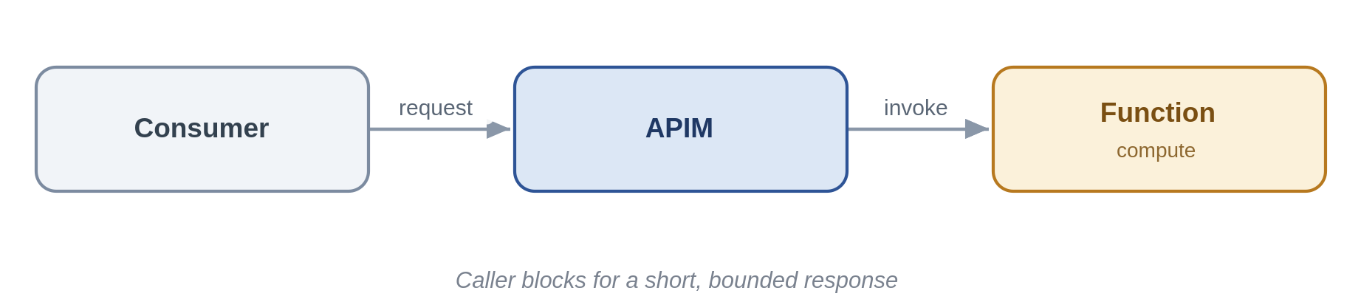
Problem. Some interactions really are synchronous: a quote figure the user is waiting on. The danger is that "synchronous" quietly becomes "long-running", and callers start timing out and retrying.
Solution. Expose the operation on APIM to a Function that completes in sub-second-to-low-second time, with a hard timeout. If the work cannot reliably finish that quickly, it is not this pattern — move to asynchronous request-reply or orchestration.
Use it when the work is genuinely short and bounded and the caller must have the result to proceed. Avoid it when the duration is unpredictable or can run long — the classic cause of retry storms.
Risks & considerations. Enforce timeouts and make the operation idempotent so a client retry cannot double-apply. Treat a creeping p99 latency as an early signal that this should become asynchronous.
Security boundary. Landing zone: APIM (shared) and Function (spoke), fully internal. Within Azure: Private Endpoint, managed identity, TLS, with enforced timeouts. Outside Azure: none.
Anti-pattern. Long-running or unbounded work behind a synchronous endpoint.
In practice. A real-time premium calculation returns a figure within a second.

5.2 Asynchronous messaging
When the caller does not need to wait, messaging decouples systems in time and turns spikes and outages into manageable backlogs rather than cascading failures. Service Bus is the backbone here.

5.2.1 Queue-based load levelling
Put a queue between a spiky producer and a limited backend so load is absorbed, not amplified.
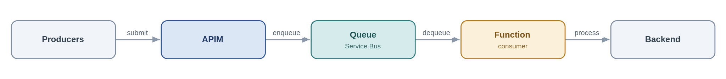
Problem. At renewal season broker submissions arrive far faster than the policy admin system can process them. Calling it synchronously either overwhelms it or fails the callers.
Solution. Accept the work at APIM, drop it on a Service Bus queue, and let a Function consumer process at the rate the backend can sustain. Producer and consumer are now decoupled in time, so a backend outage becomes a growing queue rather than a wave of errors.
Use it when the producer is spikier or faster than the consumer, or the backend's availability must be decoupled from producer load. Avoid it when the caller needs an immediate answer (request/response), or you are ingesting a high-volume telemetry firehose (Event Hubs).
Risks & considerations. A queue is a buffer, not infinite capacity — under sustained overload the backlog grows, so monitor queue depth and consumer lag and alert on them. Handle poison messages with a dead-letter queue and a max-delivery count, and make the consumer idempotent, because delivery is at-least-once. Global ordering is lost unless you use sessions.
Security boundary. Landing zone: APIM (shared), Service Bus and the consumer Function (spokes) — internal. Within Azure: producers and consumer reach Service Bus over a Private Endpoint using a managed identity with Sender/Receiver RBAC (no SAS keys); TLS throughout. Outside Azure: none — an external producer is taken through the edge first.
Anti-pattern. Hammering a fragile backend synchronously; ignoring the dead-letter queue; reaching for storage queues where you need sessions, DLQ and richer delivery semantics.
In practice. Renewal submissions are buffered on Service Bus so the policy admin system drains them at a steady rate.

5.2.2 Competing consumers
Scale out throughput by letting several workers pull from one queue.
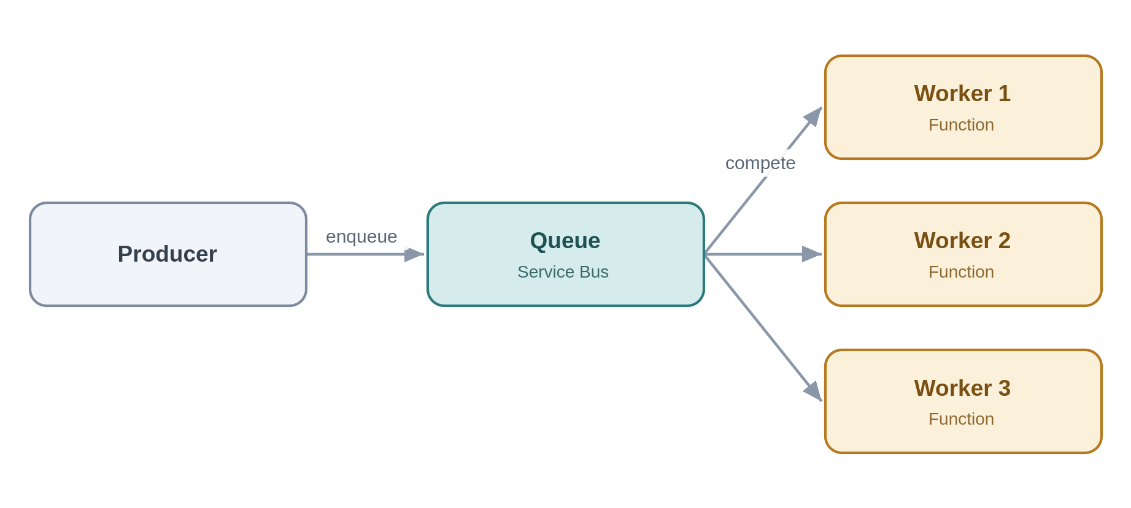
Problem. One consumer cannot keep up; work is piling up but the items are independent of each other.
Solution. Run multiple consumer instances against the same queue. Service Bus hands each message to exactly one worker and the pool scales with load; for per-entity ordering, sessions pin related messages to one consumer.
Use it when throughput exceeds a single consumer and the work items are independent and parallelisable. Avoid it when you need strict global ordering without sessions, or workers must share mutable state.
Risks & considerations. Duplicate delivery still happens, so idempotency remains mandatory. Watch for hot sessions that serialise work and cap your scale-out, and autoscale on queue depth rather than CPU.
Security boundary. Landing zone: Service Bus and the Function pool in spokes, internal. Within Azure: Private Endpoint, managed identity with least-privilege RBAC, TLS. Outside Azure: none.
Anti-pattern. Assuming ordering without sessions; sharing mutable state between workers.
In practice. A backlog of document-processing jobs is cleared by an autoscaling pool of Function workers.

5.2.3 Asynchronous request-reply
Accept now, answer later — a 202 and a status endpoint instead of a held-open connection.
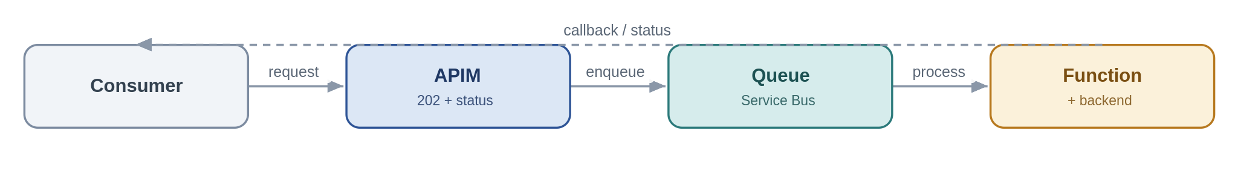
Problem. A caller wants a result from an operation that takes too long to hold a synchronous HTTP connection open for.
Solution. APIM accepts the request, returns 202 with a status URL and a correlation id, and drops the work on a queue. A Function processes it and updates a status store or calls back; the caller polls the status endpoint or receives the callback.
Use it when the operation is too long for a synchronous reply but the caller still needs the eventual result. Avoid it when the result is genuinely instant (keep it synchronous) or there is no way to correlate request and reply.
Risks & considerations. The client contract is now two-phase — document the 202/polling behaviour clearly. Keep a durable status store and expire abandoned requests so they do not accumulate, and carry the correlation id end-to-end or you lose traceability.
Security boundary. Landing zone: APIM (shared), Service Bus and Function (spokes), internal. Within Azure: Private Endpoints, managed identity, TLS; the correlation id carries no secret material. Outside Azure: none unless the caller is external, in which case the request and status endpoints are exposed through the edge (Front Door + WAF + APIM, OAuth).
Anti-pattern. Holding a synchronous connection open for minutes; omitting a correlation id.
In practice. A bulk quote request returns 202 and a status URL; the completed result is available when processing finishes.

5.2.4 Claim-check
Keep large payloads off the bus — pass a reference, store the body in Blob.
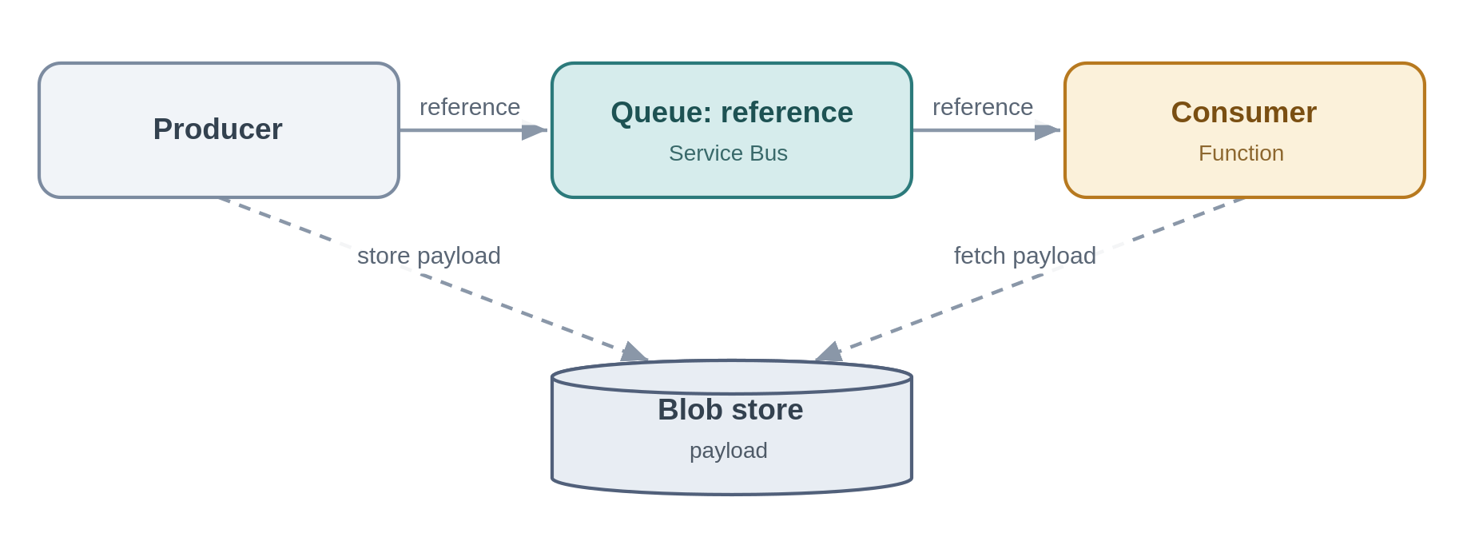
Problem. A message-based flow needs to carry a large document, but the bus has size limits and large messages are slow and expensive.
Solution. The producer writes the payload to Blob storage and puts only a reference on the queue; the consumer reads the reference and fetches the body from Blob. The messaging layer stays lean.
Use it when payloads approach or exceed message-size limits within an otherwise message-based flow. Avoid it when payloads are small enough to carry inline, or the data is really a bulk data-platform concern.
Risks & considerations. Reference and payload now have independent lifetimes — a lifecycle policy must purge transient blobs or you leak cost, and the reference is useless if the blob has gone. Reach Blob over a Private Endpoint with RBAC; no account keys, no public SAS.
Security boundary. Landing zone: Service Bus, Blob and Function in spokes; the storage account is firewalled with public access disabled. Within Azure: Blob is reached over a Private Endpoint with managed-identity RBAC — no account keys, no public SAS — and TLS. Outside Azure: none; the payload never leaves the private boundary.
Anti-pattern. Large binaries on the bus; public or long-lived SAS URLs to the payload.
In practice. A large bordereaux file is staged in Blob and only its reference flows through the pipeline.

5.2.5 Reliable messaging
For business-critical messages: never lost, and effectively processed once.
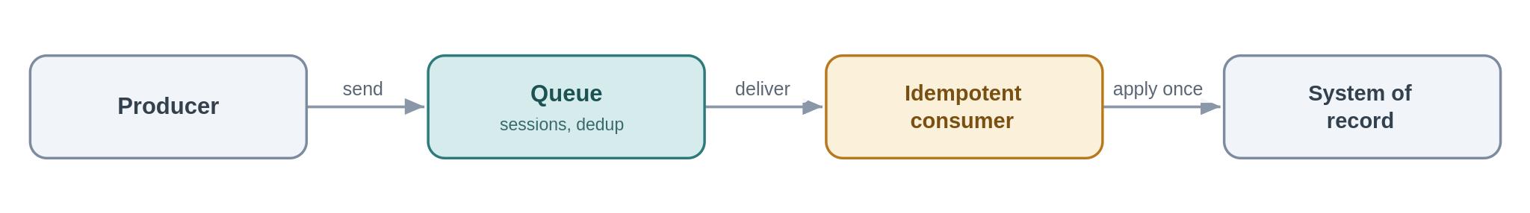
Problem. A financial posting must not be lost, and must never be applied twice — even if the broker retries or the platform redelivers.
Solution. Use Service Bus with duplicate detection and, where order matters, sessions; make the consumer idempotent so redelivery is safe; and where the event must be published in step with a local state change, use a transactional outbox. "Exactly once" is not something the transport gives you — you engineer it from at-least-once delivery plus idempotency.
Use it when message loss or double-processing has real financial or data-integrity impact. Avoid it when the notification is best-effort and replaceable — use Event Grid.
Risks & considerations. Duplicate-detection windows are finite, so design the idempotency key to outlive them. Premium throughput costs money — size it to the criticality tier, not to the peak of peaks.
Security boundary. Landing zone: Service Bus and consumer in spokes, internal. Within Azure: Private Endpoint, managed identity, TLS; idempotency keys carry no secrets. Outside Azure: none.
Anti-pattern. Assuming exactly-once delivery; non-idempotent consumers that double-apply effects.
In practice. A finance-posting message carries an idempotency key, so a redelivery is recognised and ignored.

5.3 Event-driven — events, webhooks and streaming
Event-driven integration is the strongest lever for removing point-to-point coupling: a producer announces that something happened and interested parties react, without the producer knowing who they are. The three services behind this style are not interchangeable — Section 3.2 is the reference for choosing between them.

5.3.1 Publish / subscribe fan-out
Publish a business event once; let interested consumers subscribe independently.
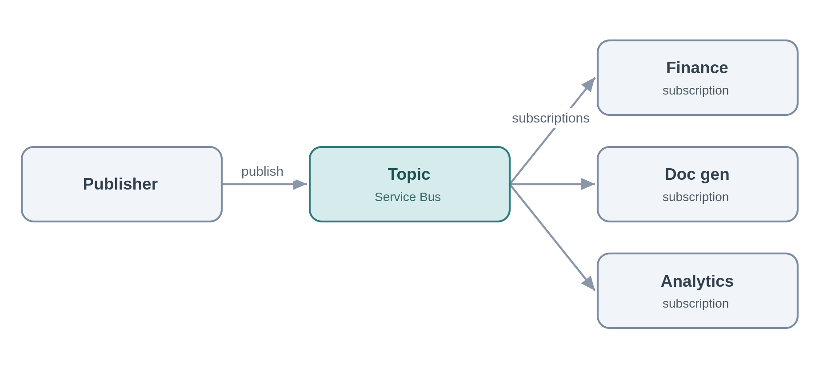
Problem. When a policy is bound, finance, document generation and the analytics offload all need to know. Wiring the publisher to each recreates point-to-point coupling and means changing the publisher every time a consumer is added.
Solution. The publisher emits a "PolicyBound" event to a Service Bus topic; each consumer owns a subscription with its own filter and dead-letter queue. Consumers come and go without the publisher knowing. This is the primary tool for eliminating point-to-point integration.
Use it when several consumers must react to the same business event and you want durable, filterable, independently-consumed delivery. Avoid it when it is a lightweight reactive trigger with no durability need (Event Grid), or a high-volume stream (Event Hubs).
Risks & considerations. Subscriptions proliferate, so govern them and monitor each one's dead-letter queue — a broken filter silently drops messages. A slow subscriber builds its own backlog without affecting the others, which is the point, but it needs its own alerting.
Security boundary. Landing zone: the Service Bus topic and its subscribers in spokes, internal. Within Azure: Private Endpoint, per-subscription managed-identity RBAC, TLS. Outside Azure: none.
Anti-pattern. Hardwiring point-to-point instead of publishing; a publisher that knows its subscribers; using Event Grid where you need durable, ordered, competing-consumer delivery.
In practice. "PolicyBound" is consumed independently by finance, document generation and the analytics offload.

5.3.2 Discrete event notification
A thin "it happened" signal for near-real-time reactions.
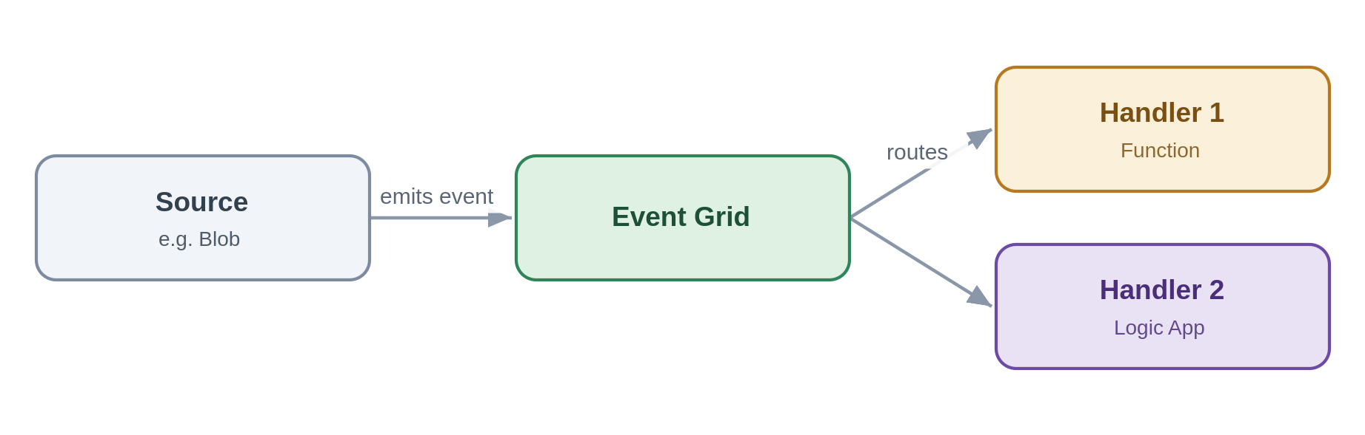
Problem. Something occurred — a file landed, a record changed — and one or two handlers should react quickly. A durable business-messaging topic is heavier than the job needs.
Solution. Emit a thin event to Event Grid; handlers (Functions, Logic Apps, webhooks) subscribe and react. The event is a pointer, not a state carrier — a handler fetches authoritative state if it needs it.
Use it when you want lightweight, low-latency reactive fan-out to Azure-native handlers. Avoid it when consumers need durable ordered delivery or competing consumers (Service Bus topics), or the volume is a stream (Event Hubs).
Risks & considerations. Delivery is at-least-once and unordered, so handlers must be idempotent and order-independent, and a dead-letter destination must be configured so undeliverable events are not simply lost. Resist fattening the event into a pseudo source-of-truth — it hides coupling and goes stale.
Security boundary. Landing zone: Event Grid and its handlers in spokes, reached privately. Within Azure: managed-identity delivery, Private Endpoint where supported, handler-side validation, TLS. Outside Azure: none — a handler that must be internet-reachable is the inbound-webhook pattern, not this one.
Anti-pattern. Fat events that carry full state consumers come to trust; using Event Grid for streaming or durable business messaging.
In practice. A blob-created event triggers a document-ingestion workflow.

5.3.3 Inbound webhook ingestion
Take partner callbacks safely through the front door, then process them asynchronously.
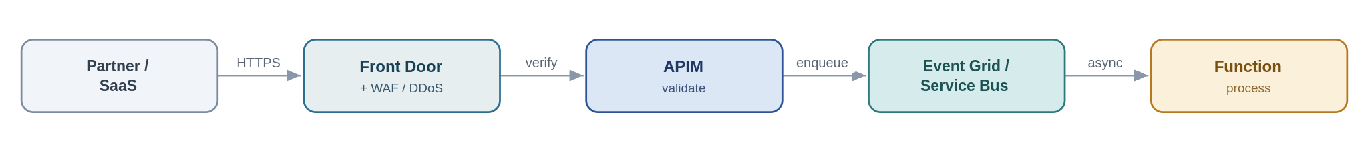
Problem. A partner or SaaS pushes events to Chaucer over HTTPS. Exposing an internal trigger to the internet is exactly the risk the security standards forbid.
Solution. This is the sanctioned public-ingress exception. Traffic enters through Front Door with a WAF and DDoS, terminates at APIM as the single ingress point, is authenticated (mTLS, OAuth, or a signed-payload check) and validated, then dropped onto Service Bus or Event Grid for asynchronous processing. No Function or Logic App HTTP trigger is ever exposed directly.
Use it when an external party must push events to us and private networking is not possible. Avoid it when the integration can use private networking — prefer that every time.
Risks & considerations. You are internet-facing now, so assume replay and forgery: validate signatures, enforce rate limits, and deduplicate, because providers retry. Acknowledge fast and process asynchronously so a slow backend cannot be used to hold connections open. Record the exception with an owner and an expiry.
Security boundary. Landing zone: this is the one pattern that deliberately crosses the internet boundary, and it does so only in the online subscription. Front Door + WAF + DDoS terminate the public endpoint, APIM (shared subscription) is the single ingress, and processing happens back in the private spokes. Within Azure: past the edge everything is private — Service Bus/Event Grid and Functions over Private Endpoints with managed identity and TLS. Outside Azure: mTLS, OAuth or signed-payload validation, IP allow-listing and rate-limiting at the edge; no Function or Logic App trigger is ever exposed; the exposure is a registered, time-boxed exception.
Anti-pattern. Exposing a Logic App or Function HTTP trigger straight to the internet, bypassing APIM and the WAF; processing synchronously in the handler.
In practice. A payment provider posts settlement webhooks; APIM validates the signature and drops the event on Service Bus.

5.3.4 Outbound webhook / notification
Push events out to subscribers instead of making them poll.
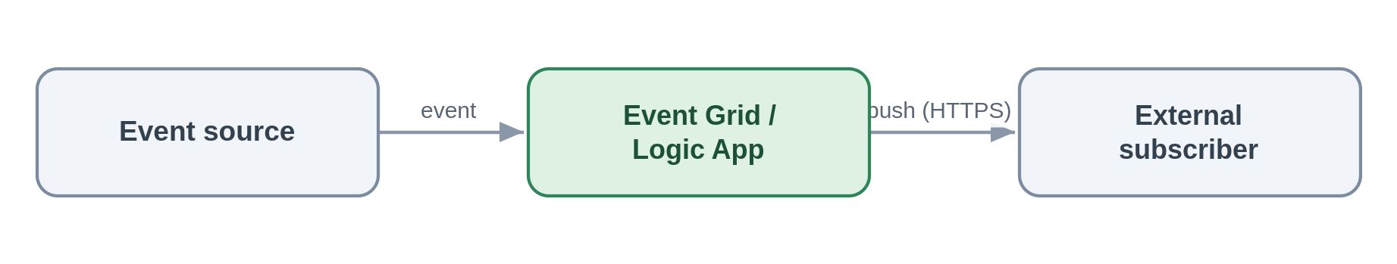
Problem. An external or internal party wants to be told when something changes, rather than polling us for it.
Solution. On the event, dispatch via Event Grid subscriptions or a Logic App connector — webhook, email or Teams. Subscribers are configured, not coded into the publisher.
Use it when subscribers expect to be pushed to on an event. Avoid it when subscribers should really pull current state through an API.
Risks & considerations. A subscriber endpoint being down creates retries and back-pressure, so retry with backoff and dead-letter the undeliverable. Hold partner secrets in Key Vault, sign payloads where supported, and put a circuit breaker around flaky endpoints.
Security boundary. Landing zone: Event Grid or the Logic App in spokes; the egress to an external subscriber leaves through the controlled path, not default internet routing (routing intent enforced). Within Azure: managed identity, partner secrets held in Key Vault and referenced, TLS. Outside Azure: TLS to the subscriber, payload signing where supported, partner endpoints allow-listed, and secrets rotated/revoked through Key Vault.
Anti-pattern. Polling to simulate push; bespoke per-subscriber dispatch code instead of subscriptions.
In practice. The broker's system is notified automatically when a claim status changes.

5.3.5 Stream / telemetry ingestion
Ingest high-volume continuous data and hand it to processors or the data platform.
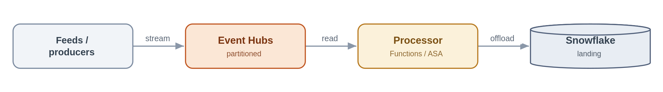
Problem. A high-frequency feed produces far more events than a business-messaging queue is designed for, and it needs partitioned, ordered processing.
Solution. Ingest into Event Hubs, partitioned for throughput; process with Functions or Stream Analytics; and typically capture or offload to Snowflake for analytics. Event Hubs is the firehose; Service Bus is not.
Use it when sustained high event rates need partitioned stream processing. Avoid it when these are transactional business commands needing per-message dead-lettering and sessions (Service Bus), or low-volume discrete notifications (Event Grid).
Risks & considerations. Partition count is a capacity decision you largely live with, so plan it against throughput and consumer parallelism. Manage checkpoints, monitor consumer lag, and remember ordering holds only within a partition. Premium or Dedicated capacity is a real cost line.
Security boundary. Landing zone: Event Hubs and its processors in spokes; capture to a firewalled storage account. Within Azure: Private Endpoint, managed identity, TLS, with capture storage under RBAC. Outside Azure: an external feed enters through the edge; internal streams cross no boundary.
Anti-pattern. Service Bus for firehose volumes; Event Hubs for transactional commands; synchronous consumers on a stream.
In practice. A high-frequency exposure feed is ingested, processed near-real-time and offloaded to Snowflake.

5.4 Orchestration — stateful process coordination
When a business process spans several systems and needs state, retries and visibility, it is orchestrated centrally in Logic Apps (Standard). One rule governs this whole style and is worth stating on its own before the patterns: the workflow owns control flow, and nothing else. Business logic, computation and transformation live in Functions that the workflow calls. Keeping the two apart is what stops orchestrations turning into unmaintainable monoliths.
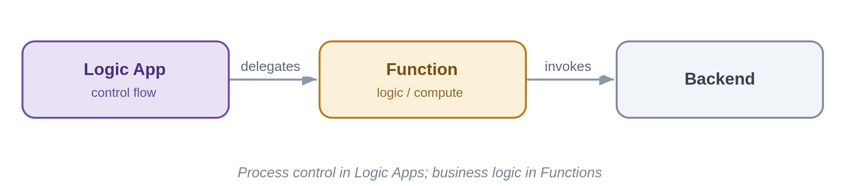

5.4.1 Stateful process orchestration
Coordinate a multi-step, multi-system business process with state, retries and visibility.
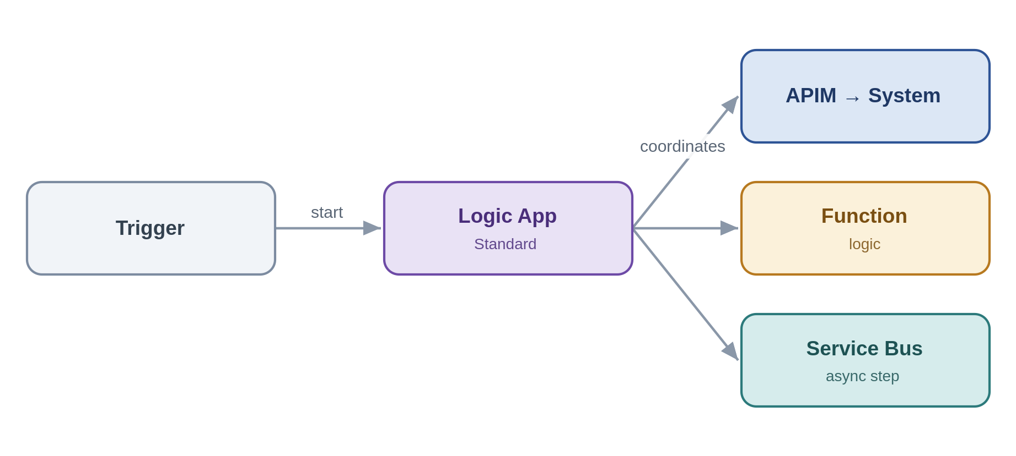
Problem. New-business onboarding spans validation, pricing, document generation, notification and system updates. No single system owns the process, and stitching it together point-to-point makes it invisible and brittle.
Solution. A Logic App (Standard) owns the process: it sequences the steps, calls capabilities through APIM, delegates computation to Functions, and hands asynchronous work to Service Bus. It keeps run state and history, so the process is observable and recoverable — and, per the rule above, it holds control flow only.
Use it when a business process crosses several systems and steps and needs state, retries and auditability over minutes, hours or days. Avoid it when a single synchronous call suffices, or it is really just message buffering.
Risks & considerations. Without discipline the workflow accretes business logic and becomes a monolith — keep logic in Functions and the workflow readable. Standard run history is region-bound, so DR is active-passive and in-flight runs do not migrate; design steps to be idempotent and restartable. Connectors have throttling limits, long-running state has a cost, and you need a versioning strategy for changing a workflow while runs are in flight.
Security boundary. Landing zone: the Logic App (Standard) is VNet-integrated in a workload spoke and calls APIM (shared), Functions and Service Bus (spokes) — all internal. Within Azure: every connector authenticates with a managed identity (no keys), Key Vault references for any unavoidable secret, Private Endpoints, TLS. Outside Azure: none directly — external calls leave through APIM and the edge, not from the workflow.
Anti-pattern. Business, compute or transformation logic inside the workflow; orchestration smeared across many uncoordinated workflows; microservices-style choreography with no owning process.
In practice. New-business onboarding is coordinated end-to-end by one Logic App calling Functions and systems in turn.

5.4.2 Process with compensation
When a later step fails, undo the earlier ones — orchestrated centrally, not choreographed.
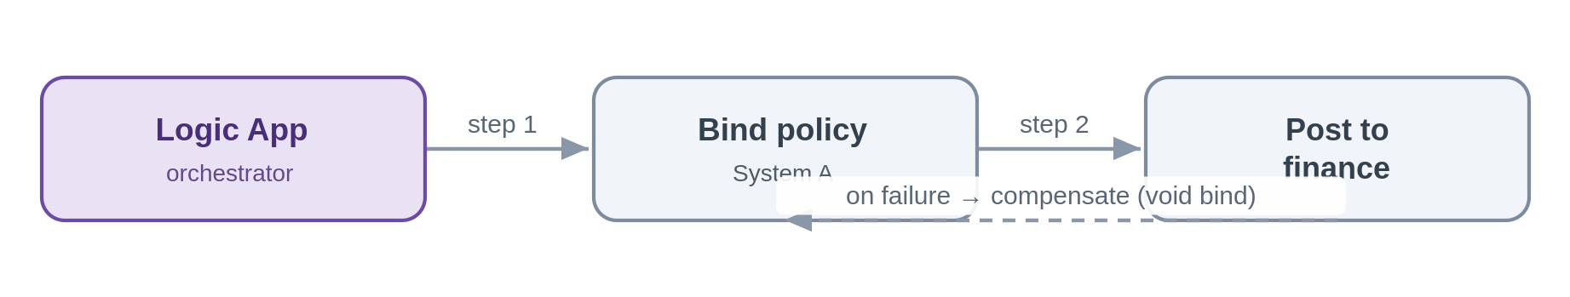
Problem. A policy is bound in one system and then the finance posting fails. There is no distributed transaction across these systems, but the bind must not be left dangling.
Solution. The orchestrator drives compensating actions on failure — here, voiding the bind. Because Chaucer's model is SOA, the process is centrally owned and its compensation logic lives with it, not scattered across services reacting to each other.
Use it when you need cross-system consistency without distributed transactions and a single process can own the compensation. Avoid it when an ACID transaction within one system suffices, or someone proposes a microservices-style distributed saga (out of scope here).
Risks & considerations. Compensation is best-effort, not atomic — a compensation can itself fail, so make compensations idempotent and retryable, and use the run history as the saga log. Watch ordering and the possibility of duplicate compensation.
Security boundary. Landing zone: Logic App, Service Bus and Functions in spokes, internal. Within Azure: managed identity, Private Endpoints, TLS, with each step and each compensation audited in run history. Outside Azure: none — cross-system calls are to internal systems over private connectivity.
Anti-pattern. Choreographed sagas with no central owner; relying on two-phase or distributed transactions.
In practice. If the bind succeeds but the finance posting fails, the orchestration compensates by voiding the bind.

5.4.3 Human-in-the-loop / approval
Insert a human decision into an automated process, with audit and escalation.
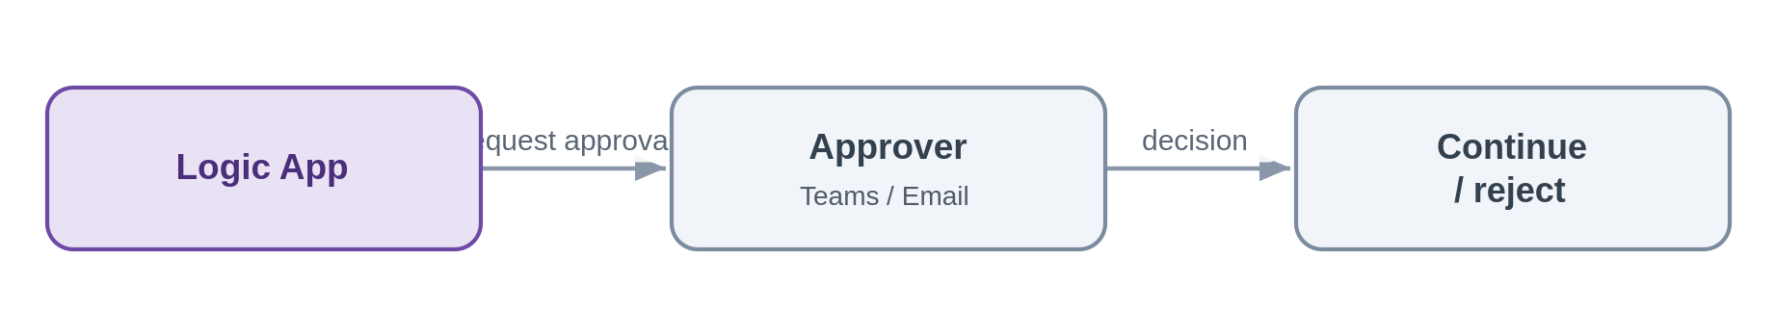
Problem. A referral needs underwriter sign-off before the process continues, and the decision must be captured.
Solution. The Logic App pauses for an approval over Teams or email, captures the decision with the approver's identity, and resumes. Timeouts and escalation keep the process from stalling.
Use it when a process genuinely needs human sign-off and an audit trail. Avoid it when the decision can be made by rules — keep it straight-through.
Risks & considerations. Un-answered approvals stall processes, so always set timeouts, reminders and an escalation path. Authenticate approvers through Entra and record the decision for audit.
Security boundary. Landing zone: the Logic App in a spoke; approvals run over Teams or Outlook, which are Entra-authenticated Microsoft 365 services, not arbitrary internet endpoints. Within Azure: managed identity, TLS, and an audit of the decision and the approver's identity. Outside Azure: approver interaction is over Entra-authenticated Microsoft 365; there is no bespoke internet exposure.
Anti-pattern. Approvals handled over untracked email outside the platform; no timeout or escalation.
In practice. A referral waits for underwriter sign-off before the workflow proceeds to bind.

5.5 File-based exchange
Files are the oldest integration mechanism and, for partners and legacy systems, still unavoidable. The framework's position is that a file is a transport, not an integration contract: prefer an API or an event, and where a file is the only option, handle it event-driven — react when it lands, never poll a folder on a timer — and decompose its contents into records the rest of the platform can process like any other message. Operational, per-record files belong here; large bulk or analytical files cross to the data platform (see 5.6.3).

5.5.1 Event-driven file ingestion
A partner or system drops a file; pick it up on arrival, validate and parse it, and turn its contents into messages the platform can process.
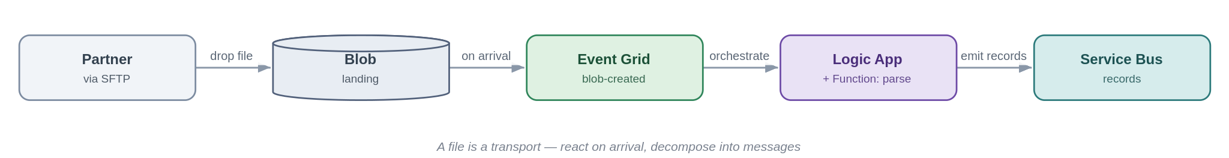
Problem. Two systems must exchange data but one can only produce files — a broker's daily SFTP drop, a legacy nightly extract. The tactical habit is to poll a folder on a timer and process the whole file in one lump, which trades latency for load, hammers storage, and leaves the file layout as a brittle point-to-point contract.
Solution. Land the file in Blob (an SFTP endpoint can be backed by Blob) and react to its arrival with an Event Grid blob-created event — event-driven, not polled. A Logic App orchestrates the handling: a Function validates and parses the file, and each record is emitted onto Service Bus so downstream processing uses the platform's ordinary messaging patterns. The file becomes a transport; the records become the integration.
Use it when a source can only deliver operational data as files (partner SFTP, legacy extract, scheduled drop) and the contents are records to process. Avoid it when the systems can expose an API or emit events directly — prefer that; or the file is a large bulk/analytical dataset, which is a data-platform concern (5.6.3).
Risks & considerations. Do not timer-poll — react to arrival events, or you reintroduce latency and load. Handle partial files with a completion marker or a write-then-rename so you never read a half-written file. Validate up front and move bad files to an error/quarantine container rather than half-processing them — the file equivalent of a dead-letter queue. Make ingestion idempotent and dedupe on filename plus content hash, because partners resend. Large files follow claim-check semantics (5.2.4) — pass the reference, don't shuttle the bytes. Secure the transport: SFTP over a Private Endpoint with no anonymous access, a managed identity to Blob, encryption in transit and at rest, and PII handling for the contents.
Security boundary. Landing zone: the Blob landing (firewalled, public access disabled), Event Grid, the Logic App/Function and Service Bus all sit in spokes; a partner SFTP drop is the external boundary. Within Azure: Blob over a Private Endpoint with managed-identity RBAC (no account keys, no public SAS); Event Grid and the Function private; TLS. Outside Azure: the SFTP endpoint is fronted through the online-subscription edge or reached over private connectivity, requires SFTP-over-SSH with key or certificate auth and no anonymous access, is IP allow-listed, and files are encrypted in transit and at rest — a registered exception where it is internet-facing.
Anti-pattern. Timer-polling a folder to fake real-time; processing the whole file as one monolithic blob with no per-record error handling; treating the file layout as a permanent contract instead of decomposing to messages.
In practice. A broker SFTPs a daily submissions file; arrival triggers a Logic App that validates and parses it, emitting each submission as a Service Bus message into the policy admin flow.

5.5.2 File generation and delivery
The platform produces a file from records or events and delivers it to a partner or system that can only consume files.
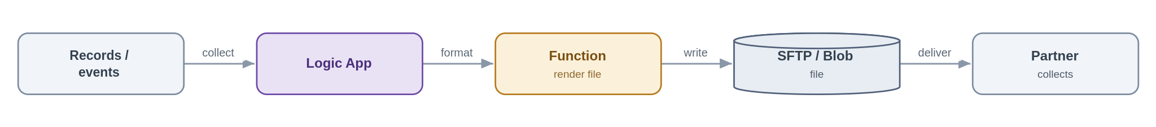
Problem. A downstream party — a partner, a legacy system, a regulator — needs data as a file, on a schedule or on an event, but we hold it as records and events.
Solution. A Logic App collects the data (from events, a query, or accumulated messages), a Function renders it into the required file format, and the file is written to Blob and delivered — pushed to the partner's SFTP or staged for collection — with a completion event so downstream teams know it went. Delivery status is tracked and retried.
Use it when a consumer can only ingest files, or a scheduled or regulatory extract is required. Avoid it when the consumer could call an API or subscribe to events — offer that instead.
Risks & considerations. Delivery guarantees to third parties are weak, so retry with backoff, track delivery status and alert on failure; use idempotent naming so a retry does not duplicate. Hold partner SFTP credentials in Key Vault, and sign or encrypt sensitive files (PGP where required). Write-then-rename so a partner never collects a half-written file, and manage retention so generated files do not accumulate cost.
Security boundary. Landing zone: the Logic App, Function and Blob/SFTP staging sit in spokes; delivery to the partner is the external boundary. Within Azure: managed identity to Blob (no keys), partner SFTP credentials held in Key Vault and referenced, TLS. Outside Azure: SFTP-over-SSH with key auth to an allow-listed partner host, sensitive files signed or encrypted (for example PGP), and egress over the controlled path rather than default routing.
Anti-pattern. Hand-rolled scheduled scripts running outside the platform with credentials in config; no delivery confirmation or retry.
In practice. A nightly settlement extract is generated and pushed to the partner's SFTP, with a completion event notifying the finance team.

For large, bulk or analytical files — a full bordereaux dataset for reporting, say — this is a data-platform concern, not a SIF one: see the boundary pattern in 5.6.3. The SIF handles operational, per-record file exchange; the data platform handles bulk file loads.

5.6 Data-platform exchange
The SIF's relationship with the data platform is deliberately narrow. It comes down to two integration patterns and one hard boundary: the SIF pushes operational data to the platform, and it consumes curated data from the platform to serve a consumer. The SIF does not store, transform, curate or analyse data, and it does not move data in bulk — those are the platform's job. Snowflake is a destination and a source across a governed boundary, never a default integration mechanism between operational systems.
Keeping that boundary explicit is what stops the two worlds bleeding into each other. The table below states, for each direction, what the SIF owns and what the data platform owns. The canonical model (5.7.1) is the shared contract across the line, so operational and analytical consumers see one semantics rather than two.
Direction | The SIF is responsible for | The data platform is responsible for
Push — to the platform (5.6.1) | Publishing operational data and events to the landing zone; the canonical contract; reliable, idempotent delivery up to landing. | Everything from landing onward — ingestion, storage, transformation, curation, analytics; ownership of the result stores.
Consume & serve — from the platform (5.6.2) | Exposing a curated product to consumers through APIM — contract, authentication, caching, SLA — and pulling it via a thin serving layer. | Producing and curating the data product; its quality and freshness; the analytical model behind it.
Bulk / batch (5.6.3) | Only raising a trigger or completion event. | Executing the bulk load and owning the pipeline and its outputs.

5.6.1 Push to the data platform
Push operational data and events into the platform's landing zone — without coupling operations to the warehouse.
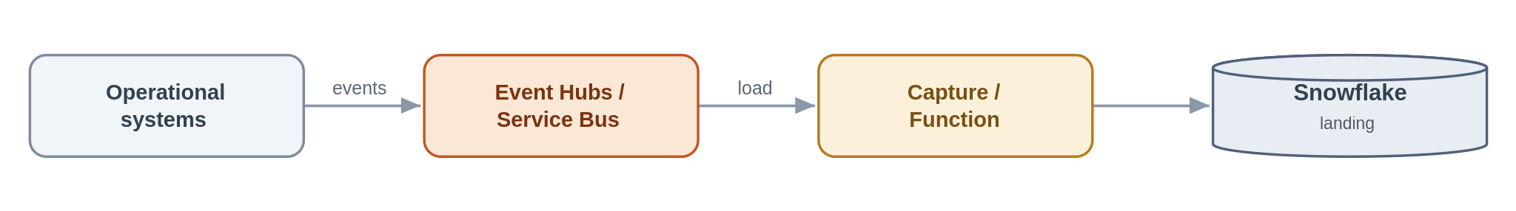
Problem. Reporting and analytics need operational data, but pointing operational systems at the warehouse — or the warehouse at them — couples the two and drags analytical latency into the transaction path.
Solution. Publish operational events to Event Hubs or Service Bus in the canonical form; a capture process or Function lands them in the platform's landing zone. Operations never depend on the warehouse, and the warehouse consumes at its own pace. The SIF's job ends at the landing zone — everything downstream is the platform's.
Use it when operational events are needed for analytics and must stay out of the transaction path. Avoid it when the data is needed synchronously in an operational flow (keep it in the SIF), or it is a bulk historical load.
Risks & considerations. Guard against schema drift between operations and analytics with an explicit event contract, and classify and minimise PII before it lands in the warehouse. Loads are at-least-once, so make them idempotent.
Security boundary. Landing zone: Event Hubs/Service Bus and the capture Function in spokes; the Snowflake landing sits across the data-platform boundary. Within Azure: Private Endpoints, managed identity, TLS, with PII classified and minimised before it lands. Into the platform: Snowflake is reached over Private Link (not public) with OAuth or a managed identity; the SIF's control ends at the landing zone.
Anti-pattern. Snowflake as a real-time hub between operational systems; operational systems querying the warehouse in a transactional path.
In practice. Claim-lifecycle events are offloaded to Snowflake for management reporting.

5.6.2 Consume from the data platform and serve to a consumer
Pull curated data from the platform and serve it to a consumer through the gateway — analytical, not a system of record.
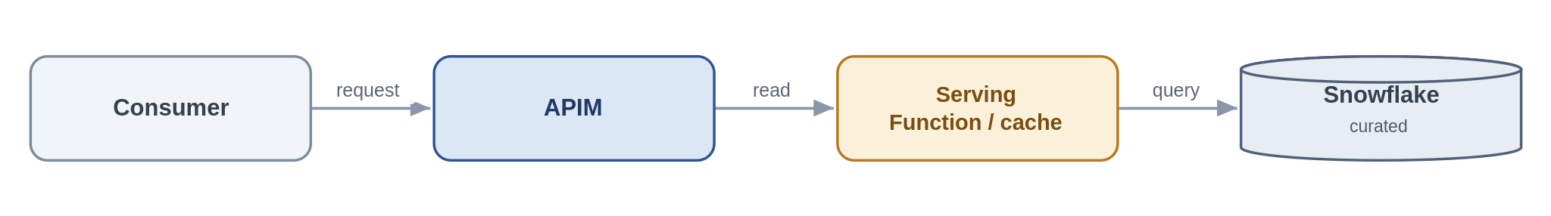
Problem. An internal app or partner wants curated, aggregated data that lives in Snowflake, but it should not be running warehouse queries in a latency-sensitive path or treating analytics as the source of truth.
Solution. Expose the curated data through an APIM product backed by a thin serving Function or cache over Snowflake via Private Link. The platform owns the curation; the SIF owns only the exposure — the API contract, authentication, caching and SLA. The contract is explicitly analytical and eventually-consistent.
Use it when consumers need governed, curated data products and can tolerate analytical latency. Avoid it when the read is latency-sensitive or transactional — go to the operational system through a request/response API.
Risks & considerations. Warehouse latency and cost under API load are real, so cache aggressively and set a clear SLA. Make consumers understand this is a curated, eventually-consistent product, not the operational source of truth.
Security boundary. Landing zone: APIM (shared) and the serving Function (spoke); Snowflake read over Private Link. Within Azure: Private Endpoint, managed identity, TLS; the consumer is authenticated at APIM (Entra), data access is least-privilege, and caching limits how much is exposed. Outside Azure: only where the consumer is external — through the edge (Front Door + WAF + APIM, OAuth).
Anti-pattern. Synchronous warehouse queries in a hot transactional path; bypassing APIM to hit Snowflake directly.
In practice. Aggregated exposure metrics are exposed as a governed product API to an internal application.

5.6.3 Bulk data movement — the boundary
Bulk and batch belong to the data platform; the SIF only signals.
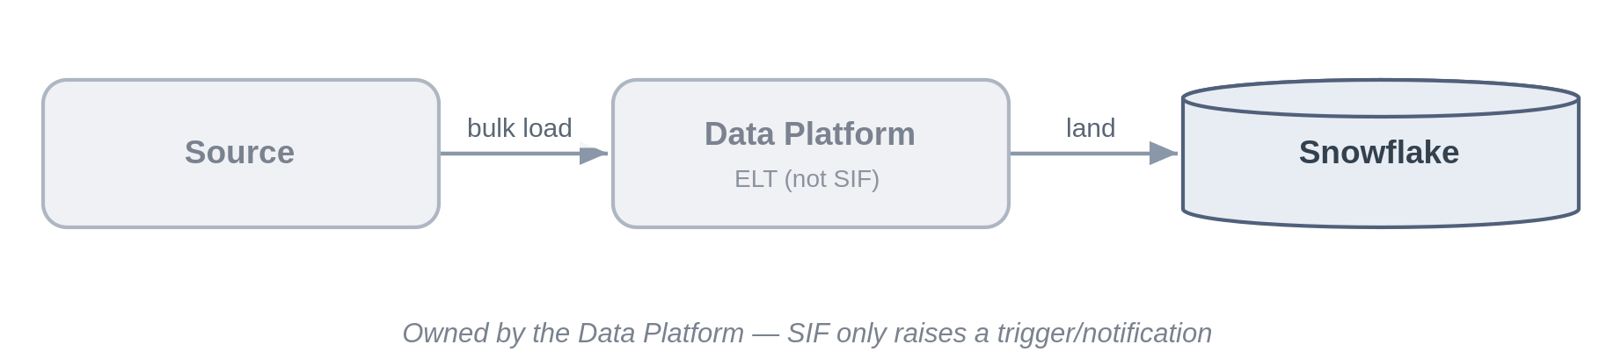
Problem. There is always pressure to build "just a quick nightly load" inside the integration platform. That crosses the boundary and puts the wrong workload on the wrong tool.
Solution. Large-volume and batch movement is executed by the data platform as ELT into Snowflake. The SIF's only role is to raise a trigger or completion event, and the owner of the output store is named explicitly.
Use it when the movement is large-volume, scheduled or historical — in which case it is not an AIS job at all. Avoid it when always, for building batch ETL inside Logic Apps or Functions to sidestep the data platform.
Risks & considerations. The real risk here is organisational — boundary erosion. Enforce it at design review, and make output ownership explicit so result stores do not become orphaned.
Security boundary. Landing zone: not a SIF data flow — the SIF only raises a trigger event from within its spokes, and the movement runs on the data platform. Within Azure: the trigger uses managed identity, a Private Endpoint and TLS. Outside Azure: none for the SIF.
Anti-pattern. Batch ETL built inside the integration platform; using the SIF as a bulk data mover.
In practice. The nightly bordereaux load runs on the data platform; the SIF only signals that source data is available.

5.7 Transformation and routing
These two patterns are cross-cutting — they apply within several of the styles above rather than being a style of their own — but they are important enough, and in this domain common enough, to stand as first-class patterns. Both are classic enterprise-integration patterns; both are heavily used wherever the estate meets external parties.

5.7.1 Canonical data model and message translator
Map every external format to one internal canonical model, so internal systems never bind to a partner's format.
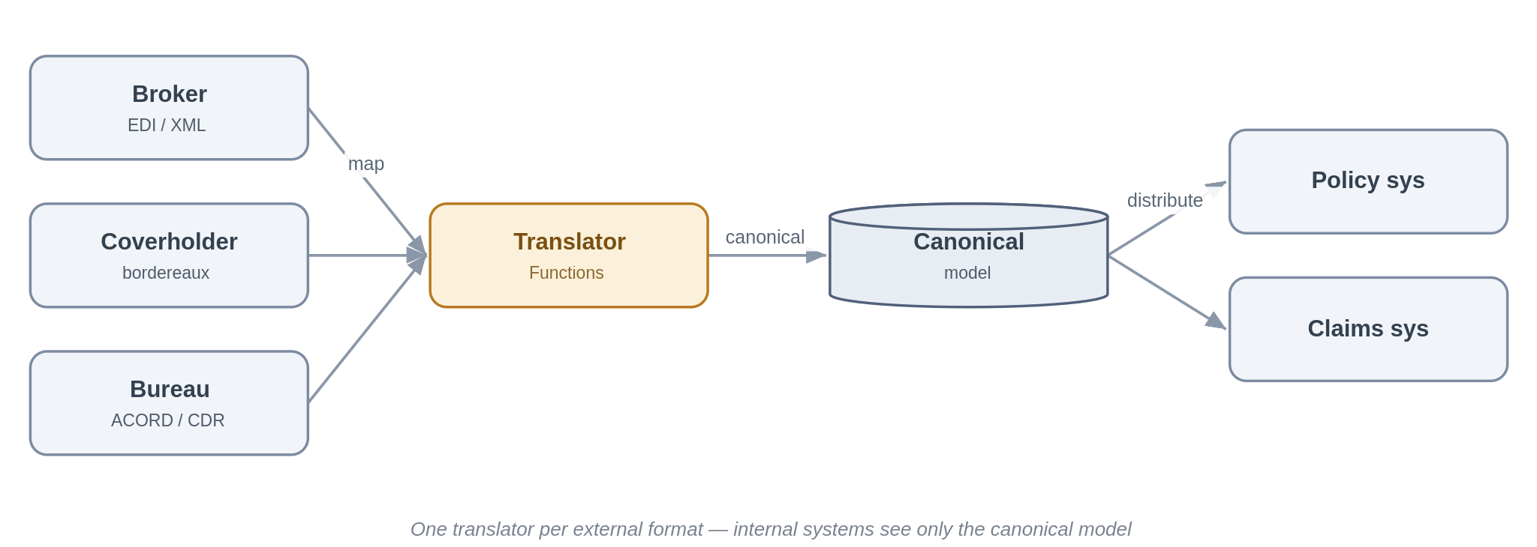
Problem. Insurance means integrating with many parties — brokers, coverholders, delegated claims administrators, reinsurers, the bureau — each with its own format and its own version of the truth: EDI, ACORD XML, bordereaux spreadsheets, the Core Data Record. If each internal system integrates directly with each external format, every new partner multiplies the interfaces and every format change ripples across the estate.
Solution. Define one internal canonical model per business concept — risk, premium, claim — and translate at the edge. A Function maps each inbound external format into the canonical model, and the reverse on the way out. Internal systems and the downstream patterns only ever see the canonical form, so adding a partner means writing one translator rather than touching every consumer. The same canonical model is the contract used when publishing to the data platform (Section 5.6), so a single semantics serves both operational and analytical consumers.
Use it when you integrate with several external parties or standards for the same business concept — which, in this domain, is almost always. Avoid it when there really is a single, stable format on both sides (rare here) — a straight protocol mediation (5.1.3) is enough.
Risks & considerations. The canonical model is a shared asset and a governance responsibility — it needs an owner, versioning and a change process, or it rots. Keep mappings declarative and tested, and treat a field that has no canonical home as a design conversation, not a silent drop. This is a message translator doubling as an anti-corruption layer, so resist the gravitational pull of letting a dominant partner's or the bureau's schema quietly become the internal model.
Security boundary. Landing zone: the translator Function runs in a workload spoke, sitting at the seam between external formats and the internal canonical model. Within Azure: internal distribution over Private Endpoints with managed identity and TLS. Outside Azure: inbound external formats arrive via the relevant boundary pattern — the edge for internet partners, private connectivity for peered ones — and the translator itself is never internet-exposed.
Anti-pattern. Point-to-point mapping between every internal system and every partner format; letting one broker's or the bureau's schema become the de facto internal model.
In practice. Broker EDI, coverholder bordereaux and bureau messages are each translated into Chaucer's canonical risk, premium and claim model; the policy and claims systems consume only the canonical form.

5.7.2 Content-based routing
Route a message or event to the right destination based on what is in it.
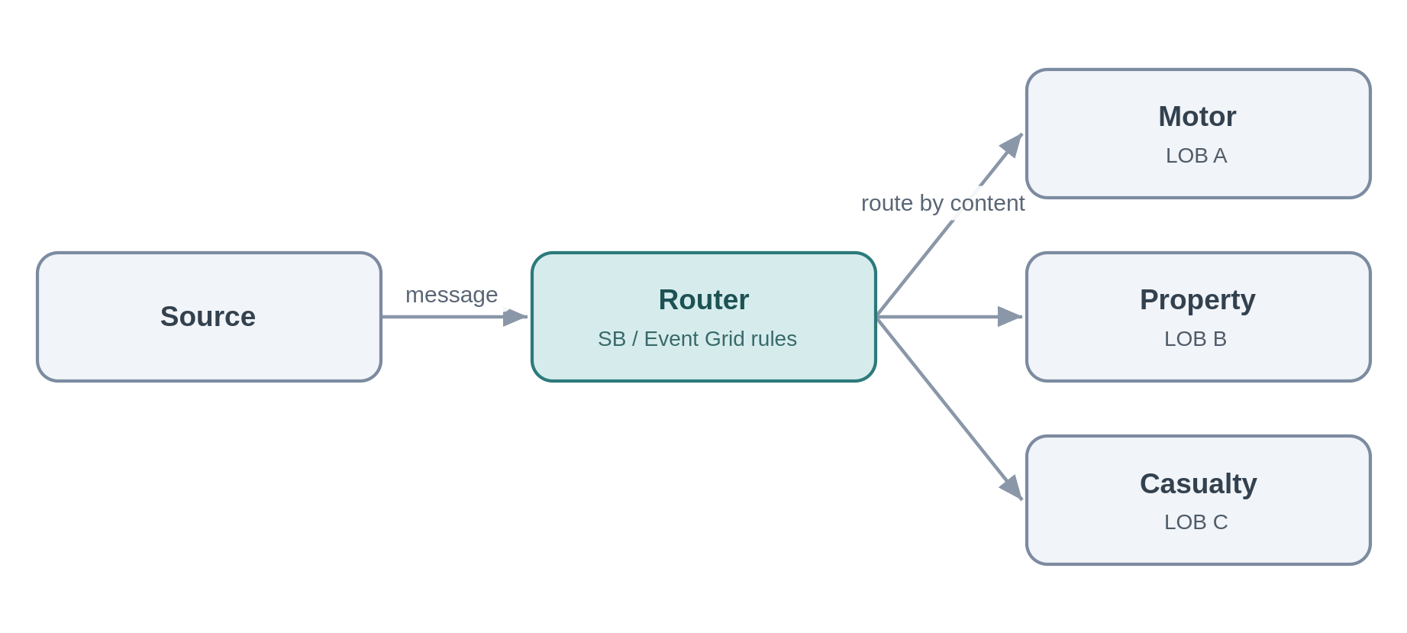
Problem. Submissions, bordereaux and claims arrive on a common channel but need to go to different places — by line of business, territory, coverholder or claim type.
Solution. Route on content using Service Bus subscription filters or Event Grid routing, or a Function for richer rules, so each message reaches the right handler without the producer knowing the routing map.
Use it when items on a shared channel need to diverge to different handlers according to their content. Avoid it when there is only one destination, or the routing depends on external lookups better handled by a short orchestration.
Risks & considerations. Routing rules are logic and they drift, so keep them declarative and versioned, and always provide a default or dead-letter route — anything that matches no rule must be caught, not silently lost.
Security boundary. Landing zone: the Service Bus/Event Grid routing rules, or a routing Function, in spokes — internal. Within Azure: Private Endpoint, managed identity, TLS, with a default/dead-letter route captured. Outside Azure: none.
Anti-pattern. A monolithic if/else router hard-coded in one place; no default route for unmatched content.
In practice. Inbound submissions are routed to the motor, property or casualty underwriting queues by line of business.

5.8 Applying the patterns — insurance integration scenarios
The patterns above are the vocabulary; real integrations are sentences built from several of them. This section maps the integrations a Lloyd's specialty insurer actually runs onto the catalogue, so a team recognises their problem and knows where to start. It also serves as a completeness check: every characteristic insurance integration below resolves to patterns already in the framework.
Scenario | Patterns it composes | Primary components | Domain notes
Delegated authority & bordereaux (coverholder / DCA risk, premium, claims reporting) | File-based ingestion (5.5.1); canonical model (5.7.1); content routing (5.7.2); push to platform (5.6.1) | Logic Apps, Functions, Blob, Service Bus, Snowflake | Validate to Lloyd's Coverholder Reporting Standards; strategic target is API capture-at-source (the DDM direction), retiring manual bordereaux re-key.
London market bureau & settlement | Canonical model (5.7.1); messaging (5.2); orchestration (5.4); push to platform (5.6.1) | APIM, Logic Apps, Service Bus, Functions | Integrate with Velonetic core processing (accounting, settlement, claims); align to Core Data Record / ACORD; design for incremental modernisation.
Broker submission & placement intake | Inbound API/webhook (5.1.1, 5.3.3); file-based (5.5.1); content routing (5.7.2); composition (5.1.2) | APIM, Front Door/WAF, Logic Apps, Functions | Accept submissions by API, file or portal; triage and route to the right underwriting team and system.
Sanctions & financial-crime screening | Synchronous request-reply (5.1.4); async with hold (5.2.3); human-in-the-loop (5.4.3) | APIM, Functions, Logic Apps | Real-time screening at onboarding and bind; block or refer on a hit; full audit trail.
Claims lifecycle (FNOL to settlement) | Inbound webhook/API (5.3.3); orchestration + compensation (5.4.1–2); outbound webhook (5.3.4); push to platform (5.6.1) | APIM, Logic Apps, Service Bus, Functions | FNOL intake from portals and TPAs; orchestrate across DCA and loss adjuster; electronic claims to the bureau; status notifications to brokers.
Reinsurance (ceded) | Canonical model (5.7.1); file/messaging (5.5, 5.2); orchestration (5.4.1) | Logic Apps, Functions, Service Bus, Snowflake | Cede risk, premium and claims to treaty and facultative systems and reinsurers; outbound bordereaux; manage recoveries.
Regulatory & tax reporting | Event offload (5.6.1); consume & serve (5.6.2); orchestration (5.4.1); file egress (5.5.2) | Snowflake, Logic Apps, Functions, APIM | Solvency II, Lloyd's returns and tax; assembled on the data platform and submitted via orchestrated feeds or files.
Rating & pricing | Synchronous request-reply (5.1.4); façade (5.1.1) | APIM, Functions | Real-time rating-engine calls during quote and bind.
Document generation & delivery | Orchestration (5.4.1); file egress (5.5.2); outbound webhook (5.3.4) | Logic Apps, Functions, Blob | Policy schedules and certificates generated and delivered to brokers and insureds.

Flagship: delegated authority and bordereaux
Bordereaux processing is the integration that most defines specialty insurance, and today it is mostly manual: coverholders and delegated claims administrators send risk, premium and claims spreadsheets on a schedule, and technicians re-key and reconcile them. That is precisely the cost and error the framework targets. The pattern-based approach lands the bordereaux in Blob, reacts on arrival, validates it against the Lloyd's Coverholder Reporting Standards, maps it into the canonical model, quarantines anything that fails, emits clean per-record events into the operational flow, and offloads to Snowflake for regulatory and analytical use.
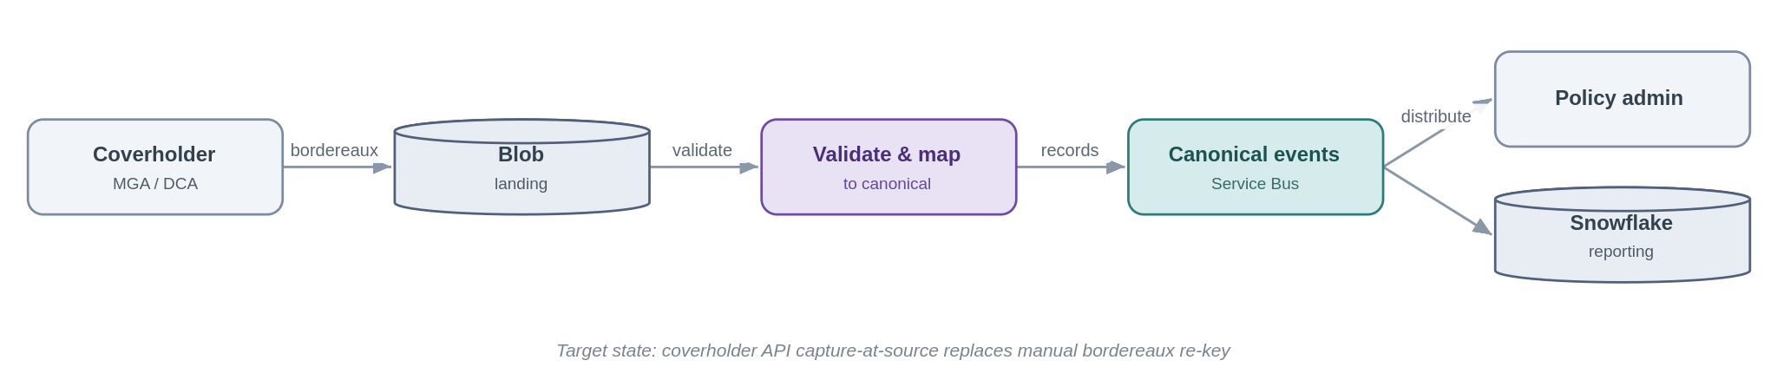
The important point is direction of travel. This file-based flow is the transition state; the strategic target across the market — and the SIF's own preference — is to capture the same data at source through coverholder APIs, so the bordereaux and its re-keying disappear entirely. The framework supports both, and deliberately makes the API-at-source option the cleaner path, so each new coverholder onboarding is a nudge toward the target state rather than another spreadsheet feed to maintain.

The market bureau and settlement
The London market clears accounting, settlement and claims centrally through the bureau operated by Velonetic (the DXC, IUA and Lloyd's joint venture), on long-standing core systems that are being modernised incrementally. The original Blueprint Two vision was retired in 2026, with the market refocusing on protecting the resilience of those core services and evolving them step by step. The architectural implication for Chaucer is steadiness rather than a big-bang: integrate with the bureau's services through the canonical model and the messaging and orchestration patterns, align data to the common standards (the Core Data Record and ACORD) so that policies and claims match cleanly through their lifecycle, and treat the modernisation roadmap as a moving target to track rather than a fixed milestone to build against. Because the framework decouples internal systems from external formats, a change at the bureau becomes a translator change, not an estate-wide one — which is exactly the insulation you want against a roadmap that has already moved several times.
Two everyday flows are worth naming because they exercise the webhook and screening patterns directly: first notification of loss typically arrives as an inbound webhook or API call (5.3.3) that is acknowledged fast and processed through claims orchestration, with claim-status changes pushed back to brokers as outbound notifications (5.3.4); and sanctions and financial-crime screening runs as a synchronous call at onboarding and bind (5.1.4), referring hits to a human-in-the-loop hold (5.4.3) rather than letting a risk bind unchecked.

6. Guardrails and exceptions

6.1 Non-negotiable guardrails
These are the things a TDA reviewer will look for on every integration, regardless of pattern. They are inherited directly from the security principles and engineering standards, so they are not up for per-project renegotiation — but the exception process below exists for the genuine edge cases.
Area | The rule
Identity | Entra ID with managed identities for every service-to-service call, least privilege. No account keys, shared keys or secret-bearing connection strings.
Secrets | Only where unavoidable, held in Key Vault (Cyber subscription) and referenced — never copied into configuration.
Network | Private Endpoints to dependencies; APIM shared and internal; public ingress only through Front Door with WAF and DDoS.
Encryption | TLS on every hop, private network or not.
Observability | Correlation IDs end-to-end; logs, metrics and traces centralised; the SOC has the access it needs.
Resilience | Zone-redundant by default; cross-region posture set by criticality tier; DR runs at the same security posture as production.
Contracts & versioning | APIs and event schemas are versioned and evolve without silently breaking consumers.
Reuse & publication | Check the catalogue first; publish new services and patterns so the next team can find them.
Delivery & build | All assets in source control; repeatable IaC deployment; automation authenticates as managed identities or SPNs.
Business traceability | Every integration ties to a business outcome and is assigned a criticality tier.

6.2 When you need to deviate
The framework is opinionated, but it is not a straitjacket. A genuine need to depart from a mandated component, a guardrail or the data-platform boundary is handled openly: document the deviation and why the standard pattern does not fit; complete a security and risk assessment and identify compensating controls; take it to the TDA for approval; and record it in the exception register with a named owner and an expiry, with remediation back to the standard pattern scheduled. The public-ingress path in Section 5.3.3 is the worked example of a controlled, time-boxed exception.

6.3 TDA gates
Governance is light but real. At design, the chosen pattern and interaction style are confirmed against the decision tree and the scope boundary. At build, guardrail conformance is evidenced — identity, network, secrets, observability and resilience. And any exception is logged and approved before build proceeds. The intent is not to slow teams down but to make sure the easy path and the approved path are the same path.

6.4 Per-pattern security conformance for TDA
The direct question a TDA reviewer will ask is: does each pattern satisfy the security principles? The honest answer is yes, when built as specified — and the reason is structural rather than incidental. Almost every pattern is fully internal and never crosses the internet boundary; identity is Entra with managed identities and no keys; secrets live in Key Vault in the Cyber subscription; all dependencies are reached over Private Endpoints with TLS on every hop; and the handful of flows that must face outward are forced through one hardened edge and registered as exceptions. That is defence-in-depth, least-privilege, default-deny and Zero Trust applied by construction, not by good intentions.
Rather than repeat an identical verdict twenty times, the patterns are grouped below by their security profile. The internal group shares one posture; the boundary-crossing group is where TDA attention is warranted.
Pattern group | Internet boundary | Controlling security posture | TDA verdict
Internal patterns — 5.1.2–5.1.4, 5.2.x, 5.3.1–5.3.2, 5.3.5 (internal feeds), 5.4.x, 5.6.1, 5.6.3, 5.7.x | Not crossed | Components in shared subscription / private workload spokes; Private Endpoints; Entra managed identity, no keys; Key Vault references; TLS every hop; NSG-segmented; default-deny. | Conforms
Managed API façade — 5.1.1 (internal use) | Not crossed | APIM shared and non-public; Private Endpoint to backend; managed identity; TLS. | Conforms
Consume-and-serve — 5.6.2 (internal consumer) | Not crossed | APIM (Entra auth) over a serving layer; Snowflake via Private Link; least-privilege data access; caching. | Conforms
Inbound webhook — 5.3.3 | Crossed (ingress) | Online subscription only; Front Door + WAF + DDoS; APIM single ingress; mTLS/OAuth/signature; IP allow-list; async processing in private spokes; no direct triggers. | Conforms with registered exception
Public API / external consumer — 5.1.1, 5.2.3, 5.6.2 when exposed externally | Crossed (ingress) | Same edge as 5.3.3: Front Door + WAF + DDoS + APIM; OAuth/mTLS; online subscription; APIM never exposed directly. | Conforms with registered exception
Outbound webhook / notification — 5.3.4 | Crossed (egress) | Controlled egress path (routing intent), not default internet; TLS; signed payloads; partner allow-list; Key Vault-held secrets. | Conforms
File-based with partner SFTP — 5.5.1, 5.5.2 | Crossed | Edge or private connectivity; SFTP-over-SSH with key/cert auth; no anonymous access; IP allow-list; encryption in transit and at rest; Key Vault credentials. | Conforms with registered exception
Two honest caveats for the review, so this is not read as a rubber stamp. First, the verdicts assume the pattern is built to the stated posture — TDA's build gate exists precisely to evidence that (managed identity in place, no keys, Private Endpoints, WAF tuned, exception registered). Second, the boundary-crossing patterns carry residual risk that is managed, not eliminated: partner authentication strength, payload validation, PII handling in files and offloads, and the discipline of keeping the exception register current and time-boxed. Those are the items worth a reviewer's time; the internal majority of the framework is conformant by design.

Appendix A — Anti-pattern quick reference
A consolidated list of what the framework is trying to prevent, and where to go instead. If a design review turns up any of these, it is a signal to stop and re-choose.
Anti-pattern | Instead
Direct, unmediated point-to-point integration | Mediate through the platform — an API, a queue or an event (§5).
Bypassing APIM to expose a backend | APIM as the single front door; Front Door + WAF for public (§5.1.1).
Microservices choreography / distributed saga | Centrally-owned orchestration with compensation (§5.4.2).
Business logic in gateway policies or Logic Apps | Logic in Functions; control flow in Logic Apps (§5.4).
Long-running work behind a synchronous call | Asynchronous request-reply or orchestration (§5.2.3, §5.4).
Snowflake as a real-time integration hub | Event offload and data-as-a-product across the boundary (§5.6).
Batch ETL built inside the integration platform | The data platform owns bulk movement (§5.6.3).
Account keys or connection strings for auth | Managed Identity and Key Vault references (§6.1).
Public Function/Logic App HTTP triggers | Front Door + WAF + APIM ingress (§5.3.3).
Fat events treated as source of truth | Thin events plus an authoritative read (§5.3.2).
Assuming exactly-once delivery | At-least-once plus idempotent consumers (§5.2.5).
Timer-polling a folder for files | React to blob-created arrival events; decompose to messages (§5.5.1).
Manually re-keying bordereaux; mapping every partner format point-to-point | Canonical model + translator; capture at source via API (§5.7.1, §5.8).
Using the data platform as a hop between two operational systems | The platform is a destination/source only; integrate operationally through the SIF (§5.6).
Two different data models for operational vs analytical use | One canonical model as the shared contract across the boundary (§5.6, §5.7.1).
PII in logs or URLs, or unmasked in analytics | Classify, minimise and tokenise; log metadata not payloads (§3.6).

Appendix B — Glossary
Term | Meaning
SIF | This framework — the Systems Integration Framework.
AIS | Azure Integration Services: APIM, Logic Apps, Service Bus, Event Grid, Event Hubs, Functions.
SOA | Service-Oriented Architecture — coarse-grained, capability-aligned services with clear ownership. Chaucer's chosen model.
Idempotent | Safe to apply more than once with the same effect as applying it once — the antidote to at-least-once delivery.
Claim-check | Passing a reference to a large payload rather than the payload itself.
Data platform | Snowflake — the analytical platform, reached only across a defined boundary.
TDA | Technical Design Authority — approves the framework and any exceptions to it.

Appendix C — Open items for the next revision
A short, honest list of what still needs confirming, mostly from the workshops and from TDA, before this moves past draft:
- Criticality-tier definitions and their SLA / RTO / RPO targets, to finalise the resilience posture in Section 3.4.
- Whether partner B2B / EDI (AS2, X12) is in scope for the SIF or handled separately.
- How hard the delivery-guarantee requirement is per domain — i.e. where idempotency and outbox move from recommended to mandatory.
- Mapping each pattern to the specific current pain-points surfacing in the workshops, so the framework visibly resolves named problems.
- A network-topology diagram to accompany Section 3.3, drawn from the existing vWAN landing-zone design rather than re-derived here.

End of draft v0.9

