Integration options: SIF and the Snowflake data platform
Five approved paths across the hand-off boundary: three to get data into the platform, two to get it out. Each diagram marks the SIF side, the platform side, the hand-off boundary and the security applied on every hop. Pick the path from the guidance under each diagram; anything outside these five is an exception.

Import: getting data into Snowflake

Option 1 · AIS to Blob to Snowpipe to Snowflake (preferred)
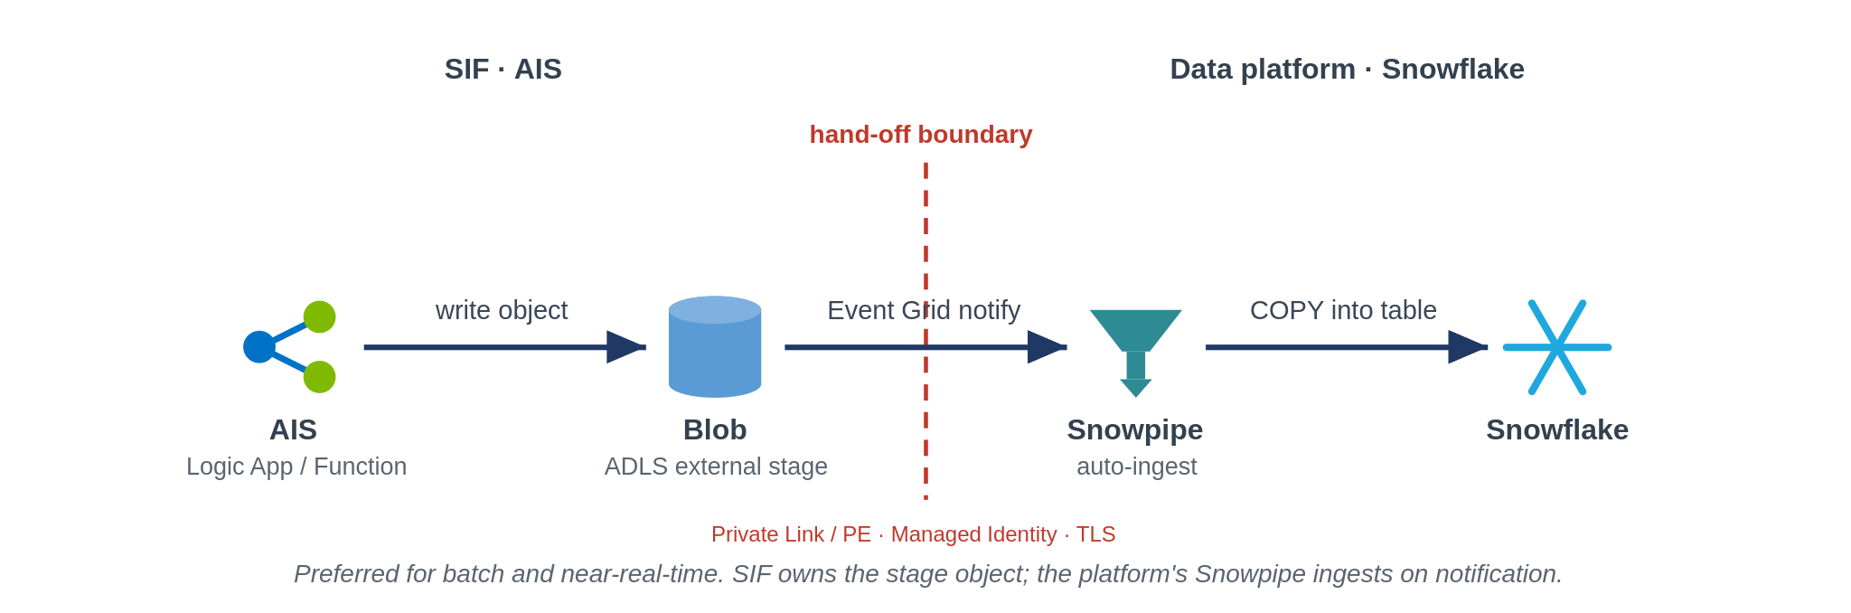
Use this by default for batch and near-real-time loads. The SIF writes an object to the ADLS external stage and a Blob event triggers Snowpipe, which copies it into the table. The SIF owns the stage object up to the boundary; the platform owns ingestion from there.

Option 2 · AIS to Snowflake (direct connector)
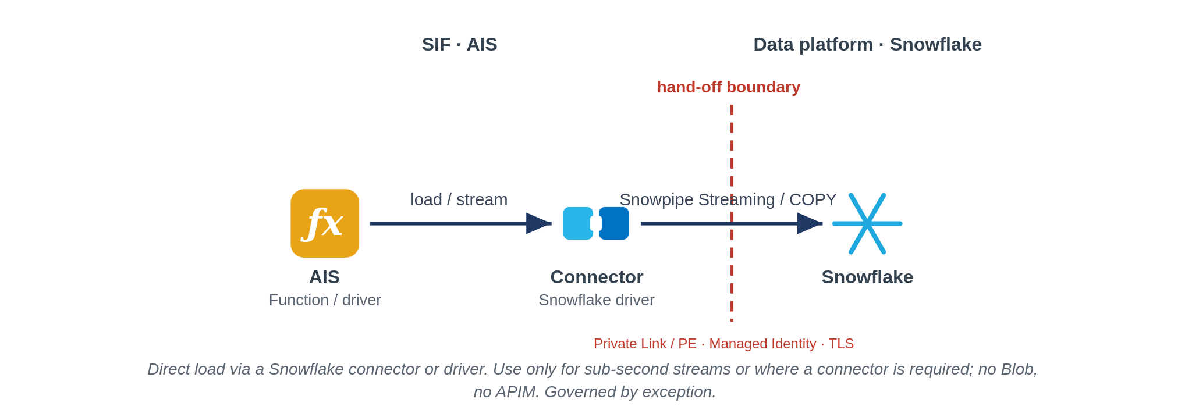
Use only where a sub-second stream is needed or a Snowflake connector or driver is the only practical route, for example Snowpipe Streaming or the Data Factory Snowflake connector. There is no Blob stage and no APIM, so it is tighter coupling and runs as a governed exception, not the default.

Option 3 · AIS to APIM to Snowflake SQL API
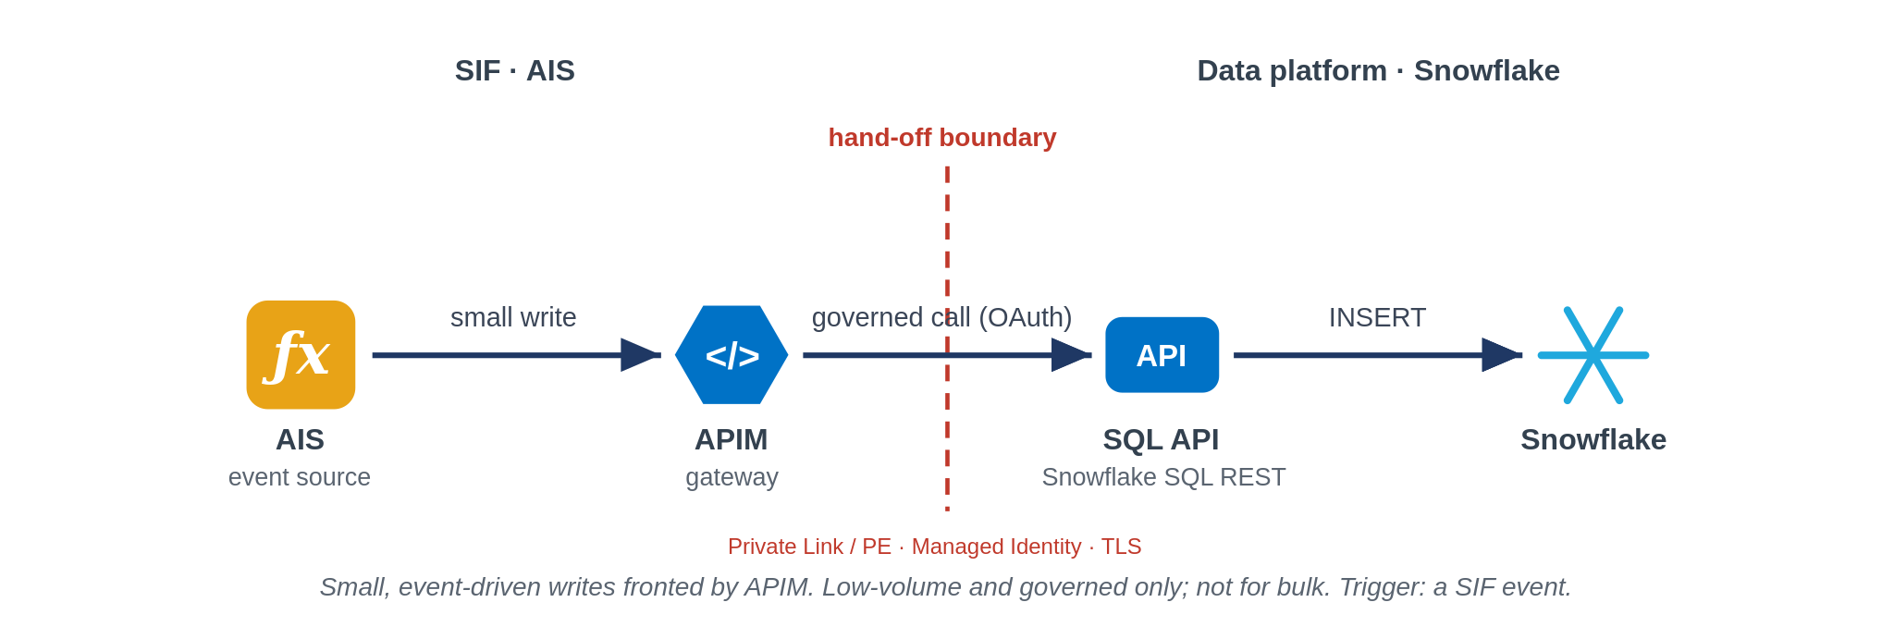
Use for small, event-driven writes that should be governed at the gateway. APIM authenticates and rate-limits the call to the Snowflake SQL REST API. Keep it to low-volume writes; it is not a bulk-load path.

Export: getting data out of Snowflake

Option 1 · Snowflake to Blob to AIS (file)
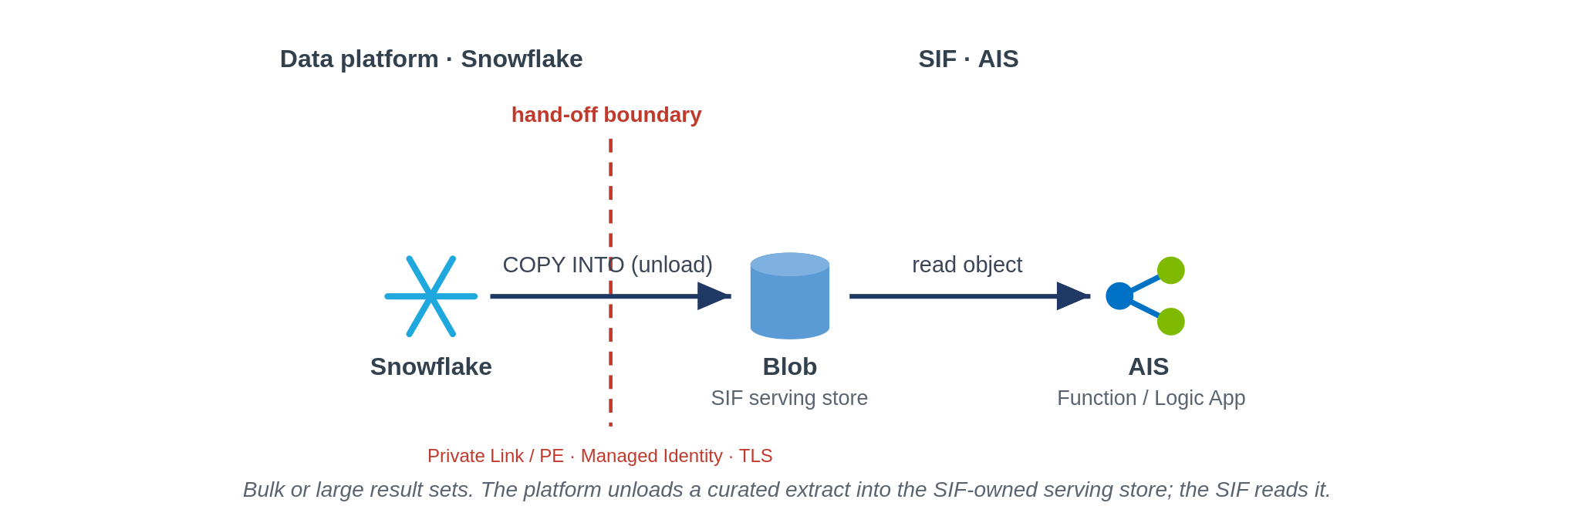
Use for bulk or large result sets. The platform unloads a curated extract (COPY INTO stage) into the serving store the SIF owns, and the SIF reads it. Keeps warehouse compute and cost out of the read path.

Option 2 · Snowflake to API to APIM to AIS (service)
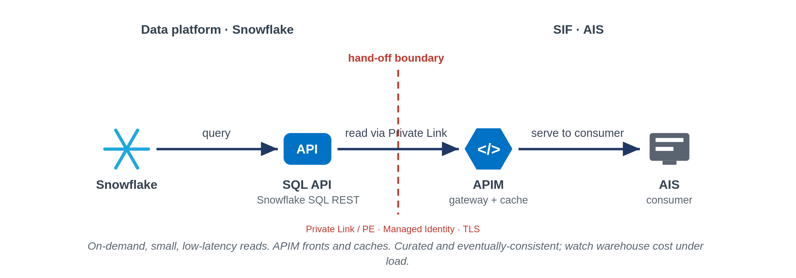
Use for on-demand, small, low-latency reads. The SIF calls the Snowflake SQL API through APIM, which fronts and caches it. The data is curated and eventually-consistent, not an operational source of truth, and warehouse cost needs watching under load.

The boundary is the same on every path: private connectivity (Private Endpoint or Private Link), Entra managed identity rather than keys, TLS on every hop, and PII tokenised before it crosses the line. The default on both sides is to push to a store the receiver owns, so neither team reaches into the other.
Prepared by Puneet Kumar · Enterprise Integration & Solution Architect

