Azure API Management

High Level Design

v0.1 (DRAFT)

Contents
1. Document Control 5
1.1. Document History 5
1.2. Authors and Contributors 5
1.3. Assurance 5
1.4. TDA Approval 6
1.5. Related Documents 6
1.6. Definitions 6
2. Executive Summary 8
2.1. Purpose 8
2.2. Context 8
2.3. Scope 8
2.4. Out of Scope 8
2.5. Audience 8
2.6. Proposed Solution 8
3. Requirements and Design Drivers 9
3.1. Source Requirements 9
3.2. Requirements Traceability 9
3.3. Architecture Principles 9
3.4. Non-Functional Requirements 10
4. Architecture Decisions 10
4.1. Architecture Decision Summary and Detailed Rationale 10
4.1.1 ADR-01: Managed API Exposure through APIM 10
4.1.2 ADR-02: Azure Front Door Premium with WAF 10
4.1.3 ADR-03: APIM Premium v2 11
4.1.4 ADR-04: Private APIM Network Model 12
4.1.5 ADR-05: Separate Internal and External Access Paths 13
4.1.6 ADR-06: Entra ID and OAuth 2.0 13
4.1.7 ADR-07: User-Assigned Managed Identity 13
4.1.8 ADR-08: Products, Groups and Subscriptions without Workspaces Initially 13
4.1.9 ADR-09: APIOps and Infrastructure as Code 13
4.1.10 DR-10: Silver Production Resilience 13
4.1.11 ADR-12: Developer Portal 14
4.2. Decision Approval Position 14
5. Target Architecture Overview 14
5.1. APIM Role in the Systems Integration Framework 14
5.2. High-Level Azure APIM Architecture 14
5.3. Logical Architecture 15
5.4. Access and Security Boundary 16
5.5. Deployment Architecture 17
5.6. Component Responsibilities 17
6. API Access, Edge Security and Traffic Management 17
6.1. API Audience Classes 17
6.2. Internal Access 17
6.3. External Access 17
6.4. Webhooks 18
6.5. DNS and Custom Domains 18
6.6. Front Door Decision 18
6.7. Edge Controls 19
7. Network and Connectivity Architecture 19
7.1. Network Context 19
7.2. Connectivity Matrix 22
7.3. Egress 22
7.4. Private Backends 22
7.5. DNS and Hybrid Connectivity 22
7.6. Subnet Sizing 23
8. Security and Identity Architecture 24
8.1. Security Model 24
8.2. Control Responsibilities 30
8.3. Authentication 30
8.4. Authorisation Boundary 31
8.5. Administrative Access 31
8.6. Secrets and Certificates 32
8.7. Data Classification and Logging 32
8.8. Non-OAuth Exceptions 32
9. API Products, Consumers and Developer Portal 33
9.1. Governance Model 33
9.2. Developer Portal Purpose 36
9.3. Portal Access Model 39
9.4. Portal Deployment and Hosting 40
9.5. Internal Onboarding 40
9.6. Partner Onboarding 40
10. API Design, Policies and Lifecycle 41
10.1. Standards Relationship 41
10.2. API Contract 41
10.3. Policy Hierarchy 41
10.4. Mandatory Policy Capabilities 42
10.5. Lifecycle and Versioning 42
11. Environments, APIOps and Release Management 42
11.1. Environment Model 42
11.2. Toolchain 45
11.3. Delivery Controls 45
11.4. Quality Gates 46
12. Reliability, Backup and Disaster Recovery 46
12.1. Resilience Tiers 46
12.2. Deployment-Unit Implication 47
12.3. Backup, Restore and Rebuild 48
12.4. RTO and RPO 48
12.5. Resilience Testing 48
13. Observability and Operational Management 48
13.1. Monitoring Architecture 48
13.2. Telemetry 50
13.3. Dashboards and Alerts 50
13.4. Retention 50
14. Capacity and Cost 50
14.1. Capacity 50
14.2. Cost Drivers 53
14.3. Cost Controls 53
15. Governance and Operating Model 53
15.1. Ownership Model 53
15.2. Exceptions 53
15.3. Existing Processes 53
16. Implementation and Service Readiness 54
16.1. Implementation Stages 54
16.2. Readiness Criteria 54
17. RAID and TDA Conditions 56
17.1. Assumptions 56
17.2. Key Risks 57
17.3. Dependencies 57
17.4. Independent Verification Required 57
17.5. TDA Approval Conditions 57
18. Appendices 57
18.1. Appendix A: Requirements Traceability 57
18.2. Appendix B: Options and Decisions 57
18.3. Appendix C: Network Flow Matrix 58
18.4. Appendix D: High-Level Component Configuration 58
18.5. Appendix E: API Onboarding Checklist 60
18.6. Appendix F: Reference Sources 62

Document Control

Document History
Version | Date | Author | Change
0.1 | 21 September 2026 | Puneet Kumar | Initial draft restructured to the Organization’s HLD template

Version | Date | Author | Change
0.1 | 21 September 2026 | Puneet Kumar | Initial draft restructured to the Organization’s HLD template

Authors and Contributors
Role | Name / Team

Role | Name / Team

Assurance
This document has been reviewed and approved by the following, the list has been grouped into different sections to aid readability as this document will be required at TDA.

Role | Description
Information | Shared for informational purposes including use as reference document for their domain’s documentation and processes
Reviewer | Actively reviews the content to ensure alignment to guidelines and policies and technical accuracy, will contribute as required
Approver | Provides assurance that their domain is correct in context of the HLSA

Date | Role | Name | Title
DD/MM/YY | Approver
DD/MM/YY | Approver
This document has been reviewed and approved by the following, the list has been grouped into different sections to aid readability as this document will be required at TDA.

Role | Description
Information | Shared for informational purposes including use as reference document for their domain’s documentation and processes
Reviewer | Actively reviews the content to ensure alignment to guidelines and policies and technical accuracy, will contribute as required
Approver | Provides assurance that their domain is correct in context of the HLSA

Date | Role | Name | Title
DD/MM/YY | Approver
DD/MM/YY | Approver

TDA Approval
The TDA approval date to be updated by the author once full TDA approval has been granted.
The document should then be updated to a major revision number and stored in the solution repository.

Date | Minutes (link) | TDA Chair Name | TDA Chair Title
DD/MM/YY
The TDA approval date to be updated by the author once full TDA approval has been granted.
The document should then be updated to a major revision number and stored in the solution repository.

Date | Minutes (link) | TDA Chair Name | TDA Chair Title
DD/MM/YY

Related Documents
The following documents should be read in conjunction with this document:

Reference | Document | Version | Author | Source
1.

The following documents should be read in conjunction with this document:

Reference | Document | Version | Author | Source
1.

Definitions
The terms below are used throughout this document.
Term | Meaning
APIM | Azure API Management, the managed API gateway service
WAF | Web Application Firewall
Entra ID | Microsoft Entra ID, the identity provider (formerly Azure AD)
UDR | User-Defined Route, a custom route-table entry
NVA | Network Virtual Appliance, here the Palo Alto firewall
APIOps | Managing APIM configuration as code through a CI/CD pipeline
RTO / RPO | Recovery Time / Point Objective
mTLS | Mutual TLS
FNOL | First Notification of Loss, the initial report of an insurance claim
SIF | Systems Integration Framework, the client’s integration reference document
RACI | Responsible, Accountable, Consulted, Informed, a responsibility model
BOLA | Broken Object-Level Authorization, an OWASP API risk
SoD | Segregation of Duties
HLSA | High-Level Solution Architecture
DNAT / SNAT | Destination / Source Network Address Translation
IPAM | IP Address Management
SIEM | Security Information and Event Management
DPIA | Data Protection Impact Assessment
FCA | Financial Conduct Authority, a UK regulator
PRA | Prudential Regulation Authority, a UK regulator
UK GDPR | UK General Data Protection Regulation
JWT | JSON Web Token
DDoS | Distributed Denial of Service
SLA | Service-Level Agreement
VNet | Azure Virtual Network
Private Link | Private connectivity to an Azure service over the Microsoft backbone

Executive Summary

Purpose
Azure API Management provides a single, secure and governed platform for all organisational APIs internal, external, and partner. This document sets out the guidelines for standing up and operating the APIM platform and for onboarding APIs onto it, covering architecture, security, operational governance, and cost.

Context

Chaucer does not currently operate a dedicated API management platform. API consumption and exposure are delivered through a mixture of point-to-point integrations, file-based exchanges, and direct connections between internal systems and external partners.

As the integration landscape has grown, these interfaces have been managed independently, limiting consistency, visibility, and reuse. Azure API Management (APIM) will introduce a central API layer that provides standardised security, governance, monitoring, and access management capabilities, complementing the existing integration estate and enabling a more scalable API-led approach.

Scope
This High-Level Design defines the target architecture and operating model for the Chaucer API Management Platform. It establishes Azure API Management (APIM) as Chaucer's strategic enterprise API gateway and describes the security, networking, governance, resilience, observability, cost, and API onboarding capabilities required to support enterprise API consumption and exposure. Detailed design of individual applications, backend integrations, and infrastructure-specific configurations is outside the scope of this document and will be addressed during subsequent design and implementation phases.

Out of Scope
The following are explicitly outside the scope of this High-Level Design and will be addressed through separate design, engineering or operational activities:
- Detailed backend and application design. The internal design, data models and integration logic of the backend systems exposed through APIM.
- Individual API specifications. The detailed OpenAPI contract, request/response schema and policy configuration for each specific API, which are delivered per API during onboarding.
- Device-level network configuration. The specific rule configuration of the central firewall, routers and other network appliances, which remains with the network team.
- Identity platform design. The design of Microsoft Entra ID itself, tenant configuration and the broader identity estate, which APIM consumes as an existing service.

Audience
This document is intended for the Chaucer Technical Design Authority, enterprise and solution architects, and the platform, networking, security and integration teams who will build and operate the platform. It assumes familiarity with Azure and with enterprise integration concepts.

Proposed Solution
The proposed solution establishes Azure API Management (Premium v2) as Chaucer's central, governed API gateway, deployed in internal VNet-injection mode with no public endpoint. All external traffic enters through Azure Front Door Premium with WAF over Private Link, while internal consumers reach the same gateway directly over the private network. Identity is provided by Microsoft Entra ID with OAuth 2.0, secrets and certificates are held in Azure Key Vault, and the platform is delivered and operated entirely as code through an APIOps pipeline. Add dev portal ?

Requirements and Design Drivers

Source Requirements
The requirements for the APIM platform are drawn from the Chaucer Systems Integration Framework (SIF) and the agreed scope for enterprise API management. They cover the secure exposure and consumption of APIs by internal and external consumers, authentication through Microsoft Entra ID and OAuth 2.0, protection of API endpoints from common web and API threats, high availability and disaster recovery, observability, and cost-effective but segregated environments to support release management.
Each source requirement is traced to the section of this document where it is designed and addressed in the Requirements Traceability matrix that follows.

Requirements Traceability
Chaucer's stated high-level requirements for the APIM platform, drawn from the Systems Integration Framework and the agreed scope, are traced below to the section of this HLD where each is designed and addressed.
Ref | Requirement (from the SIF and Chaucer’s stated scope) | Primarily addressed in
R1 | Enable API discovery and consumption by internal and external users | Section 8
R2 | Provide secure access to services exposed by the API | Section 7
R3 | Authentication approach (Azure Entra ID / OAuth 2.0) | Section 7
R4 | Allow controlled access to APIs from Chaucer private and public endpoints | Section 6.1, Section 6.2, Section 7
R5 | Provide access to backend APIs from Chaucer networks (Azure VNets, Azure PaaS, public SaaS) | Section 6
R6 | Protect API endpoints from common web and API hacking techniques, including but not limited to DDoS and OWASP Top 10 | Section 2.2, Section 7
R7 | Provide a robust service with High Availability | Section 13
R8 | Provide backup and disaster recovery | Section 13
R9 | Detail HLD-relevant versioning and lifecycle | Section 10
R10 | Detail HLD-relevant observability and policies | Section 9, Section 11
R11 | Traffic Manager concepts and supporting components | Section 5,
R12 | Cost-effective but segregated environments to support release management (Prod/UAT/Dev) | Section 14, Section 12

Architecture Principles
The following principles guide the design decisions recorded in this document:
<Add existing source>
- Secure and private by default. APIM has no public endpoint; every API is private and unauthenticated until explicitly published and approved.
- Single governed entry point. All managed APIs are exposed and mediated through APIM; direct backend exposure and informal bypasses are not permitted.
- Zero Trust. Every call is authenticated and authorised at the gateway regardless of its network origin; internal traffic is never implicitly trusted.
- Everything as code. Platform and API configuration is version-controlled, peer-reviewed and deployed exclusively through automated pipelines.
- Cost proportionate to criticality. Resilience and capacity are tiered to business need rather than applied uniformly across the estate.
- Alignment to Microsoft guidance. The design follows Microsoft's published reference architectures and the Azure Well-Architected Framework.

Non-Functional Requirements
Category | Requirement
Availability | Services are expected to remain available in accordance with the capabilities and deployment model of the selected Azure platform components.
Performance | API requests should be processed within acceptable response times to meet business and consumer expectations.
Scalability | The architecture accommodates future growth in transaction volumes and the onboarding of additional APIs and services.
Security | Authentication, authorisation, encryption, and network protection controls are implemented in line with enterprise security standards.
Resilience | Architectural components are designed to minimise service disruption and maintain continuity during infrastructure or service failures.
Observability | Monitoring, logging, alerting, and auditing capabilities provide operational visibility and support effective incident management.
Maintainability | Automated deployment, configuration management, and controlled release processes facilitate ongoing support and maintenance activities.
Recoverability | Recovery procedures and environment rebuild capabilities enable restoration of service following a major incident or outage.
Compliance | Governance, security, and regulatory obligations are considered throughout the design and operation of the platform.

Architecture Decisions

Architecture Decision Summary and Detailed Rationale
The table below summarises the architecture decisions recorded in this section. Each decision is described in full in the subsections that follow; the options comparisons behind the edge service, APIM tier and network model decisions are provided in Appendix 19.2.
ID | Area | Decision | Status | Rationale
ADR-01 | Edge Service | Azure Front Door Premium with WAF is the selected edge entry point, over Application Gateway v2 and over a combined Front Door + Application Gateway topology. | Approved | See Appendix 19.2 (Architecture Decisions Explained) for the full options comparison.
ADR-03 | APIM Tier | Azure API Management Premium v2 is the platform tier, over the Developer, Standard v2 and Classic Premium tiers. | Approved | See Appendix 19.2 (Architecture Decisions Explained) for the full options comparison.
ADR-04 | Network Model | APIM is deployed in internal VNet (injection) mode with no public endpoint; ingress is via Front Door over Private Link and backends are reached over private routing. | Approved | See Appendix 19.2 (Architecture Decisions Explained) for the full options comparison.
ADR-05 | Access Paths | Internal and external consumers reach the same internal-mode instance through separate access paths — external via Front Door over Private Link, internal direct over the private network. | Approved | One gateway and one backend estate keep policy and governance consistent, while the entry point and authentication differ by whether the caller is inside or outside the network boundary.
ADR-06 | Identity | Microsoft Entra ID is the single identity provider and OAuth 2.0 is the default authentication standard; tokens are validated at the gateway on every call. | Approved | A single identity provider for consumers and administrators simplifies governance, lifecycle and access review. Partners unable to support OAuth 2.0 may use an approved, time-bound exception with compensating controls.
ADR-07 | Secrets and Certificates | APIM uses a managed identity to retrieve secrets and certificates from Azure Key Vault at runtime, rather than storing credentials in policy configuration. | Approved | Runtime retrieval from Key Vault removes stored secrets from the platform entirely and supports automatic certificate rotation without redeployment, consistent with the Zero Secrets in Code principle.
ADR-08 | API Governance | API governance is implemented initially through products, Entra ID groups and subscriptions, without adopting APIM workspaces in the first phase. | Approved | Products, groups and subscriptions provide sufficient access control and consumer segmentation for the initial platform, while deferring workspaces avoids complexity until decentralised team-based ownership is required.
ADR-10 | Resilience | Production is deployed on the Silver resilience tier — a single region with multiple units distributed across Availability Zones. | Approved | Zone redundancy provides high intra-region availability and fault tolerance without a permanently running secondary region, accepting an extended recovery-time objective during a total regional outage in exchange for avoiding secondary-region cost.
ADR-12 | Developer Portal | The Azure APIM developer portal is the self-service interface for discovery, documentation, testing and subscription, with identity delegated to Entra ID (internal) and Entra External ID / B2B (partners). | Approved | The managed portal enables zero-touch onboarding for internal and external developers without manual support tickets, while keeping access governed through the same identity model as the gateway.
This section records the design decision chosen for each key architectural area. Each row states the option selected not the full set of alternatives considered.

ADR-01: Edge Service Components

ADR-03: APIM Premium v2

ADR-04: APIM Network Model

ADR-05: Separate Internal and External Access Paths
Decision: Internal and external consumers reach the same internal-mode APIM instance through separate access paths. External traffic enters through Azure Front Door with WAF over Private Link, internal traffic reaches the gateway directly over the private network.
Rationale: Both audiences are served by one gateway and one backend estate, keeping policy and governance consistent, while the entry point and authentication differ according to whether the caller sits inside or outside the network boundary. External traffic crosses the internet boundary once, at the inspected edge; internal traffic never crosses it.

ADR-06: Entra ID and OAuth 2.0
Decision: Microsoft Entra ID is the single identity provider for the platform, and OAuth 2.0 is the default authentication standard for API access. Tokens are validated at the gateway on every call.
Rationale: A single identity provider for both consumer authentication and platform administration simplifies governance, lifecycle management and access review. Where a partner cannot support OAuth 2.0, an approved, time-bound exception with compensating controls may be granted.

ADR-07: User-Assigned Managed Identity
Decision: APIM uses a managed identity to retrieve secrets and certificates from Azure Key Vault at runtime, rather than storing credentials in policy configuration.
Rationale: Runtime retrieval from Key Vault removes stored secrets from the platform entirely and supports automatic certificate rotation without redeployment, consistent with the Zero Secrets in Code principle.

ADR-08: API Governance hierarchy
Decision: API governance is implemented initially through products, Microsoft Entra ID groups and subscriptions, without adopting APIM workspaces in the first phase.
Rationale: Products, groups and subscriptions provide sufficient access control and consumer segmentation for the initial platform, while deferring workspaces avoids added complexity until decentralised team-based API ownership is required.

ADR-10: Silver Resilience for Production
Decision: Production is deployed on the Silver resilience tier — a single region with multiple units distributed across Availability Zones.
Rationale: Zone redundancy within a single region provides high intra-region availability and fault tolerance against datacentre or maintenance failures, without the cost and complexity of a permanently running secondary region. This accepts an extended recovery-time objective during a total regional outage in exchange for avoiding secondary-region running costs.

ADR-12: Developer Portal
Decision: The Azure APIM developer portal is used as the self-service interface for API discovery, documentation, testing and subscription, with identity delegated to Microsoft Entra ID for internal users and Entra External ID (B2B) for partners.
Rationale: The managed developer portal enables zero-touch onboarding for internal and external developers without manual support tickets, while keeping access governed through the same identity model as the gateway.

Target Architecture Overview

High-Level Architecture
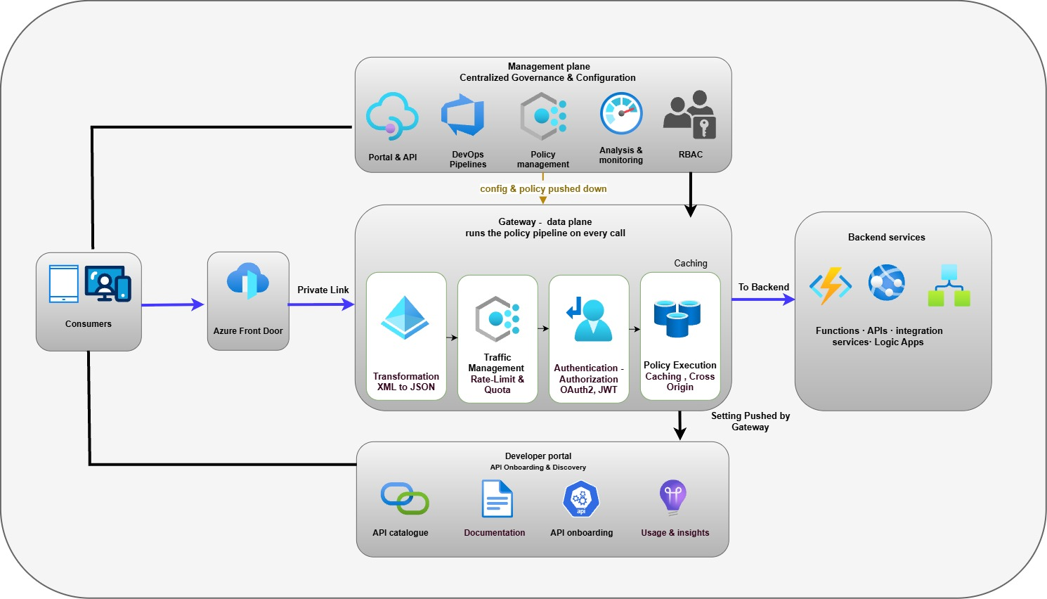
The Architecture has these parts:
- Edge Service (Azure Front Door)
- Gateway (data plane). The engine that handles live traffic. Every call pass through it and it applies the same set of rules, authentication, rate limits, validation, routing and logging, to each one. This is where the platform actually does its work.
- Management plane. Where the platform is configured. Teams define their APIs, products and policies here, and those definitions are pushed down to the gateway. It is used to set the platform up and change it, not to serve live traffic.
- Developer portal. The self-service website where consumers find the APIs they are allowed to use, read the documentation, and request a subscription.
- Backend Services : The systems that provide the business functionality exposed through APIs and ultimately process requests. These may include business applications, integration platforms, Azure services, and third-party SaaS solutions. APIM routes requests to the appropriate backend service after applying security, policy, and governance controls, providing a consistent and controlled access layer regardless of where the underlying capability resides.
Within the Chaucer Systems Integration Framework, APIM is the managed API layer that sits in front of the existing integration estate. It does not replace the messaging, file-based or event integration patterns described in the SIF, it adds a standardised, governed entry point specifically for API-based (synchronous, request/response) integration.
Existing integration services continue to operate unchanged. APIM provides consistent security, policy enforcement, observability and access management for the APIs exposed through it, complementing the broader integration landscape rather than consolidating it.

Logical Architecture

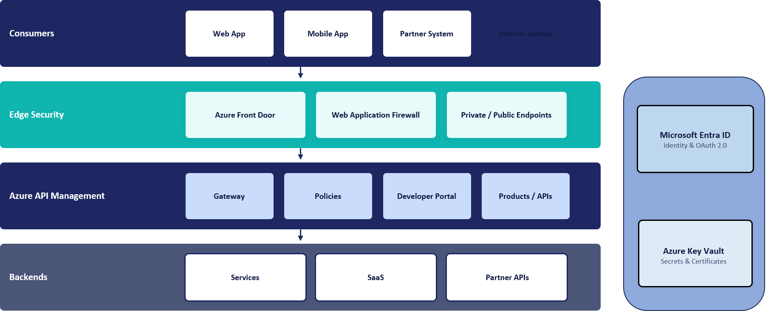

Access and Security Boundary
All requests are processed by the same Azure API Management instance, but the path differs depending on where the consumer is located. External consumers enter through Azure Front Door and cross the internet boundary once, while internal consumers access APIM directly from within the corporate network and remain on private connectivity throughout.
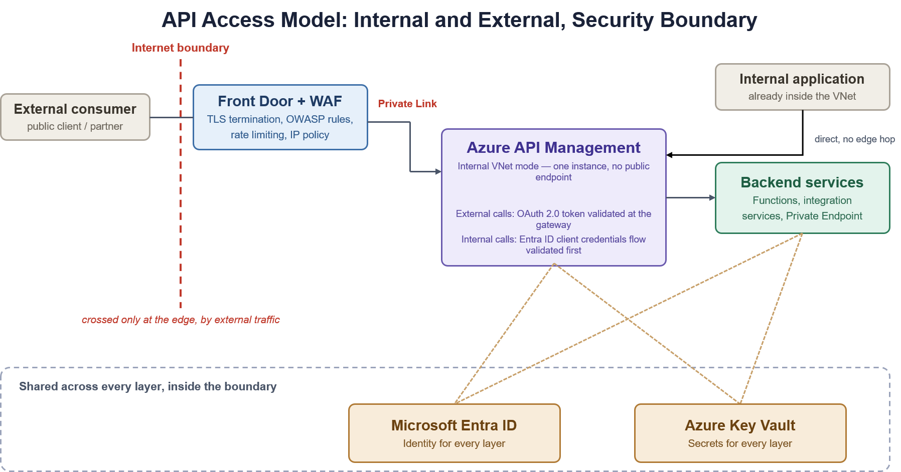
API access model and security boundary, internal and external paths converging on the same internal-mode gateway
External path: a public client or partner reaches Azure Front Door with WAF, which terminates TLS and applies OWASP protection at the edge before anything reaches APIM. The call then travels over Private Link to APIM, which validates the OAuth 2.0 token before forwarding it to the backend.
Internal path: an internal application calls APIM directly over the private VNet, with no edge service in the path because there is no public exposure to guard against. APIM authenticates the caller against Microsoft Entra ID, then routes the request to the target backend.
Both paths terminate at the same internal-mode gateway and the same backend estate; only the entry point and the authentication mechanism differ.

Deployment Architecture
APIM is deployed in internal VNet-injection mode on the Premium v2 tier, within a dedicated delegated subnet. It has no public data-plane endpoint; inbound external traffic arrives only through Azure Front Door over a Private Link private endpoint, and internal traffic arrives over private network connectivity.
Production is deployed zone-redundant across Availability Zones (the Silver tier). The platform is provisioned and changed exclusively through infrastructure-as-code and APIOps pipelines, so its deployed configuration is reproducible and auditable. The concrete instance composition and network topology are detailed in Sections 7 and the appendices.

Component Responsibilities
Component | Responsibility
Azure Front Door Premium | External HTTP routing, WAF, TLS and origin health
APIM Gateway | Runtime authentication, policy, throttling, routing and telemetry
APIM Management Plane | API, product, policy and platform administration
Developer Portal | Discovery, documentation and subscription management
Entra ID | Consumer, application and administrative identity
Key Vault | Secrets, signing material and certificates
Azure Monitor services | Logs, metrics, traces, dashboards and alerts
Backend Services | Business processing and domain-specific authorization
Azure DevOps | Source control, validation, approval and deployment

API Access, Edge Security and Traffic Management

API Users
APIs exposed through the platform serve distinct audience classes, each with a different access path and authentication expectation:
- Internal consumers. Chaucer applications and services, and on-premises systems reaching Azure over private connectivity, calling internal APIs from within the network boundary.
- External partners (B2B). Known partner organisations brokers, market participants, suppliers and service providers represented through Microsoft Entra External ID (B2B) with partner-specific application registrations.
- Public or third-party clients. External clients reaching published APIs through the inspected edge, subject to WAF, OAuth 2.0 and per-subscription rate limits and quotas.
Access, visibility and policy are governed per audience class through products, subscriptions and Entra ID groups, as detailed in Section 9.

Internal Access
Internal consumers call APIM directly over the private network via VNet peering, or over ExpressRoute or VPN for on-premises systems with no edge service in the path, because there is no public exposure to guard against on this route.
Internal traffic stays on the private network and does not traverse the central egress firewall. Internal consumers never bypass the gateway: every internal call is authenticated against Microsoft Entra ID and policy-checked at APIM, in line with the Zero Trust principle.

External Access
External consumers reach the platform through Azure Front Door with WAF, which terminates TLS and applies OWASP protection and DDoS mitigation at the edge before any traffic reaches APIM. Front Door forwards the validated request to the internal-mode gateway over a Private Link private endpoint.
Because APIM is internal-mode it has no public endpoint; the only way in from outside the network is through Front Door over Private Link. At the gateway, the OAuth 2.0 token is validated and per-subscription rate limits and quotas are enforced before the request is routed to the backend.

Webhooks
Where APIs need to deliver asynchronous event notifications to external consumers (webhooks), the outbound call leaves Azure through the central egress firewall, which applies outbound security and URL-filtering policy to the permitted destinations. Approved outbound endpoints are documented per API, and all outbound traffic is logged and auditable at the firewall.
Webhook delivery targets, retry behaviour and authentication to the receiving endpoint are defined per API during onboarding.

DNS and Custom Domains
External API and developer-portal endpoints are published on Chaucer custom domains presented at Azure Front Door, with TLS certificates managed through the edge. Internal name resolution for the private APIM endpoint is provided through Azure Private DNS using the privatelink.azure-api.net zone, linked to the VNets and on-premises networks that need to resolve it.

Edge Controls
The following controls are applied at the Azure Front Door Premium edge for external traffic, before any request reaches APIM. The table describes each control in turn: what it is, how it is applied, and where it is applied. The last column shows whether the control is inherited from the platform or set as a configuration parameter, and where that parameter is recorded.
The last column uses three labels:
- Inherited. Built into Front Door Premium. Nothing is set per deployment other than choosing the Premium tier.
- Configured. A setting chosen for this design and recorded as a parameter, in the APIM Setup Parameter Sheet (Edge Service Config tab, shown as “Parameter Sheet”) or the APIM Resources Sheet (Front Door tab, shown as “Resources Sheet”).
- Inherited + Configured. The platform provides the capability and a parameter sets how it behaves.

Control | What it is | How it is applied | Where it is applied | Inherited or configured
Web Application Firewall (managed rules) | Checks every request against Microsoft-maintained rules that detect common web attacks, such as SQL injection and cross-site scripting (the OWASP Top 10 categories). | A WAF policy is attached to the Front Door profile with the Microsoft Default Rule Set enabled. It runs in Prevention mode, so matching requests are blocked, not just logged. | Front Door edge, on every route, before traffic is forwarded to APIM. | Inherited + Configured. The WAF engine and rule content come with Front Door Premium; the rule set and mode are parameters. Parameter Sheet: WAF policy mode; Managed rule set.
Bot protection | Identifies automated traffic, such as scrapers and scanners, using Microsoft's bot intelligence so that malicious bots can be stopped. | The Microsoft Bot Manager Rule Set is enabled in the same WAF policy and acts according to the policy's Prevention mode. | Front Door edge (same WAF policy). | Inherited + Configured. Bot intelligence comes with Front Door Premium; enabling the rule set is a parameter. Parameter Sheet: Bot protection rule set.
Rate limiting | Limits how many requests one client can send in a short period, to blunt abuse, scraping and brute-force attempts. | WAF custom rules count requests per client IP address over a one-minute window and block requests above the threshold: 300 per minute for general API traffic, 15 per minute for sensitive or authentication endpoints. | Front Door edge. Finer per-subscription limits are applied separately at the APIM gateway. | Configured. Thresholds are starting values, tuned against real traffic. Parameter Sheet: Rate limit threshold (general API traffic); Rate limit threshold (sensitive/auth endpoints); Rate limit window.
DDoS mitigation | Absorbs floods of network and protocol traffic intended to make the service unavailable. | Protection against network-level DDoS attacks is built into Front Door's global edge network. Floods aimed at the application layer are additionally limited by the WAF and rate-limit rules above. | Front Door edge, so attack traffic is filtered before it reaches Chaucer's network. | Inherited. Nothing is set per deployment.
TLS termination and HTTPS enforcement | Encrypts traffic in transit. Front Door ends the client's TLS connection at the edge so the WAF can inspect the request, then re-encrypts it towards APIM. | HTTPS is required on every custom domain. The TLS policy sets a minimum of TLS 1.2, with TLS 1.3 used where the client supports it; TLS 1.0 and 1.1 are not available. Cipher suites follow the selected policy. Routes redirect HTTP to HTTPS and forward to APIM over HTTPS only. The certificate is Azure-managed. | Front Door edge (client to Front Door) and the Front Door routes (Front Door to APIM). APIM's own TLS minimum is set separately on the instance. | Inherited + Configured. TLS termination and managed certificates come with Front Door; the version, certificate source and route protocol are parameters. Parameter Sheet: TLS minimum version; Custom domain certificate. Resources Sheet (Front Door Routes): Forwarding Protocol; HTTPS Redirect.
Private Link origin | A private connection from Front Door to the APIM gateway, so the gateway needs no public IP address and cannot be reached directly from the internet. Supported with a VNet-injected Premium v2 instance when fronted by Front Door Premium. | The Front Door origin is created as type API Management with the Gateway Private Link sub-resource. Front Door sends a private endpoint connection request, which an owner of the APIM instance approves as a one-off deployment step. | Between Front Door and the APIM gateway endpoint. | Configured. Parameter Sheet: Origin type. Resources Sheet (Front Door Origins): Private Link Target and Sub-resource.
Origin lockdown (X-Azure-FDID) | A second check that a request really arrived through this organisation's Front Door and not through another Front Door profile. | Front Door adds an X-Azure-FDID header containing the unique ID of the Front Door profile. An APIM global inbound policy rejects any request whose header does not match. | APIM gateway, as a global inbound policy applied to every API. | Configured. An APIM policy rather than a Front Door setting; the Front Door profile ID is supplied at deployment.
Caching | Front Door can store copies of responses at the edge to speed up repeat requests. | Caching is left off on the API routes. API responses are dynamic and often specific to the caller, so they should not be served from a shared edge cache. It can be enabled for individual routes that serve cacheable GET responses. | Front Door routes. | Configured (off by default). Parameter Sheet: Caching.
Origin health probes | Regular checks that the APIM gateway is healthy, so Front Door only sends traffic to an origin that is working. | The gateway origin group probes APIM's built-in status endpoint over HTTPS every 30 seconds and treats the origin as healthy when 3 of the last 4 probes succeed. | Front Door origin group for the APIM gateway. | Configured. Parameter Sheet: Origin health probe path; Origin health probe protocol / interval. Resources Sheet (Front Door Origin Groups).

Points to note:
- Geo-filtering. Allowing or blocking requests by client country is available as a WAF rule but is not enabled by default. It would be enabled only if data-residency or partner-geography rules require it (Parameter Sheet: Geo-filtering).
- DDoS protection on the hub. Azure DDoS Network Protection on the hub VNet (Parameter Sheet: DDoS protection) is a separate control. It protects public IP addresses hosted in the hub; it does not sit on the Front Door inbound path, which is covered by the edge protection above.
- Mutual TLS. Front Door ends TLS at the edge. Microsoft currently documents client-certificate (mutual TLS) authentication on Front Door as a preview capability, so this design does not assume it is available at the edge. Where a partner needs mutual TLS, the approach is agreed through the exception process in Section 8.5.
- Developer portal. Private Link applies to the APIM gateway endpoint only; Microsoft supports inbound Private Link for the Gateway sub-resource only. Making the developer portal available to external users is therefore not provided by this control and is a separate design decision.
- Tuning. Rate-limit thresholds are indicative starting values and are tuned against real traffic.

Network and Connectivity Architecture

Network Context

APIM depends on the Chaucer landing-zone network, private DNS, hybrid connectivity and central security routing. The HLD defines required connectivity patterns; route tables, address allocation, firewall rules and DNS records including subnets is available in parameter sheet. [link]

Connectivity Matrix
This subsection elaborates the four main traffic flows possible.
Flow 1: External Inbound

An external consumer reaches the Organization over the internet. Traffic lands at Azure Front Door, where the WAF, TLS termination and DDoS protection are applied, and Front Door forwards the validated request to APIM over a Private Link inbound private endpoint. Because APIM is internal-mode it has no public endpoint; the only way in is through Front Door over Private Link. Inbound traffic does not traverse the Palo Alto firewall, which is an egress control mechanism.
- Front Door: WAF (OWASP + bot rules), TLS termination and DDoS protection at the edge; Private Link origin to the APIM inbound private endpoint.
- APIM NSG: Inbound traffic is permitted only through the approved Azure Front Door Private Link connection. Direct internet access to APIM is denied.
- No firewall on this path: the return path is symmetric because Front Door and APIM communicate over Private Link on the Azure backbone, with no NVA in the middle.
Flow 2: Internal Inbound
An internal Organization system, or an on-premises system reaching Azure over ExpressRoute or VPN, calls an internal API. The call reaches the APIM internal gateway directly over the private network (VNet peering, or ExpressRoute/VPN for on-premises), and APIM applies authentication and policy before forwarding to the backend. Internal traffic stays on the private network and does not traverse the Palo Alto, which handles egress to external third parties only. Internal consumers still never bypass the gateway: every internal call is authenticated and policy-checked at APIM, in line with the zero-trust principle in the security section.
Flow 3: External Outbound

When APIM or a backend needs to call out, to a public SaaS provider such as Salesforce, or to any internet endpoint, that traffic must be inspected on the way out. Routing intent forces all outbound data-plane traffic through the firewall, where egress policy and threat prevention apply. This is the flow that gives the Organization the outbound inspection and audit it runs the Palo Alto for in the first place.
- Routing Intent: Azure Routing Intent is enabled to direct APIM traffic through the central Palo Alto firewall, ensuring both north-south and east-west traffic flows are subject to centralized inspection, policy enforcement, and monitoring.
- Palo Alto: outbound security and URL-filtering policy for the destinations APIM is permitted to reach; SNAT as required.
- Credentials for SaaS calls stay in Key Vault-backed named values; the firewall controls the path.

Flow 4: Internal Outbound

Calls from APIM to backends that live inside the Organization’s own network, integration services and Functions, or PaaS reached over Private Endpoint, stay on the private network. East-west traffic is routed through the central firewall using Azure Routing Intent. This ensures traffic between platform components is consistently subject to security inspection, policy enforcement, and monitoring before reaching its destination, providing a uniform security posture across the environment.

Ingress Flow
This diagram shows the inbound (ingress) request flow, how a request travels from a consumer through the edge and APIM to the backend.

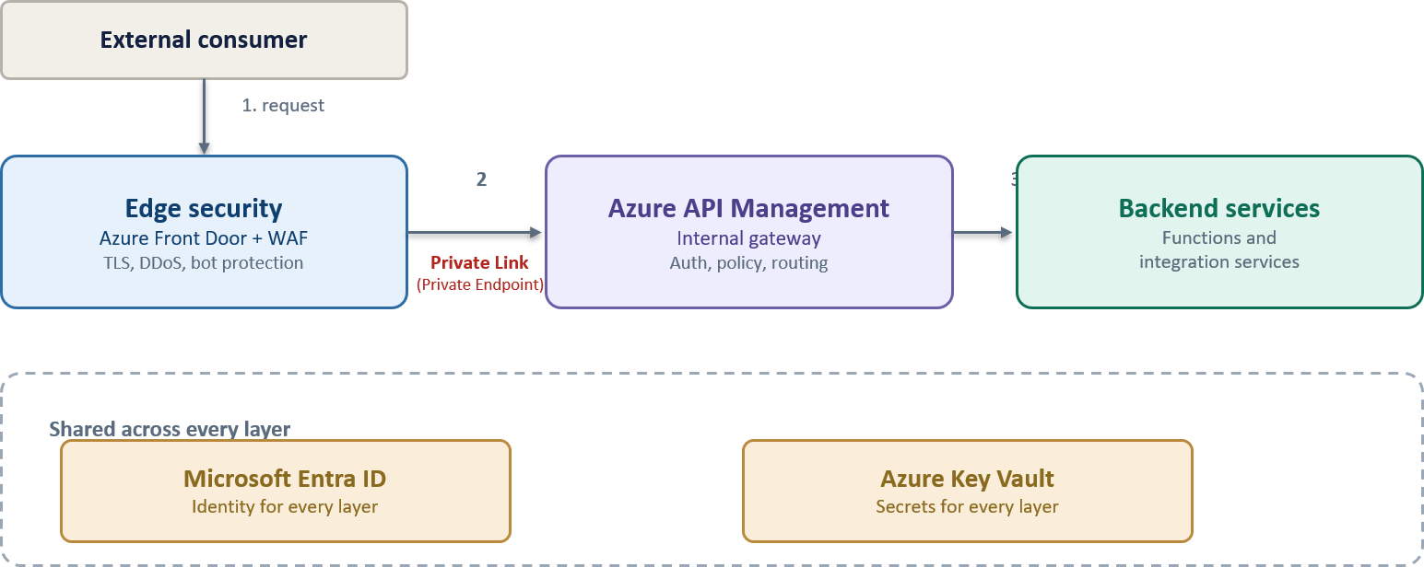High-level Azure APIM architecture for the Organization

Egress Flow
Outbound data-plane traffic from APIM and backends to external third parties is routed through the central firewall, where egress security and threat-prevention policy apply. This provides the outbound inspection and audit the platform is required to deliver.
This diagram shows the outbound (egress) traffic flow, how APIM and backends reach external third-party APIs through the Palo Alto firewall.
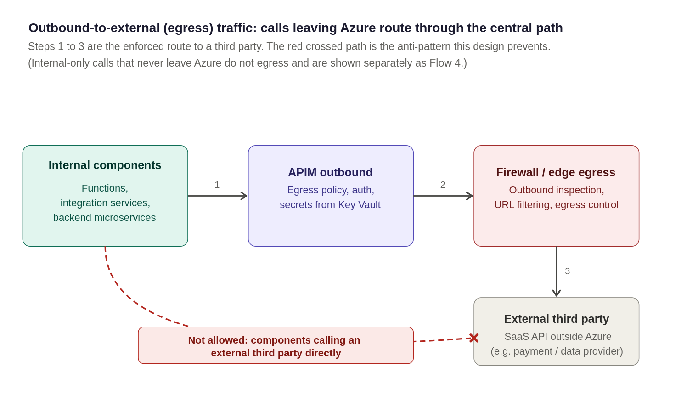
Outbound-to-external (egress) traffic, calls leaving Azure to a third-party route through the central egress path

Security and Identity Architecture

Security Model
Security is the foundational principle of this architecture. Access is explicitly validated at every hop and never assumed based on network location or prior perimeter checks—traffic originating from within the internal network is subject to the exact same verification standard as external requests.
A single security control failure must never expose a backend service. Each request passes through a mandatory, ordered sequence of defence-in-depth controls before reaching downstream targets.
Security architecture: Ingress Defence in Depth
The diagram below illustrates the defence-in-depth model for a private-mode APIM deployment protected by an edge security service. Requests traverse multiple control layers before reaching backend services, with each layer applying a specific security function. Security is achieved through the combined operation of all layers rather than reliance on any single control.
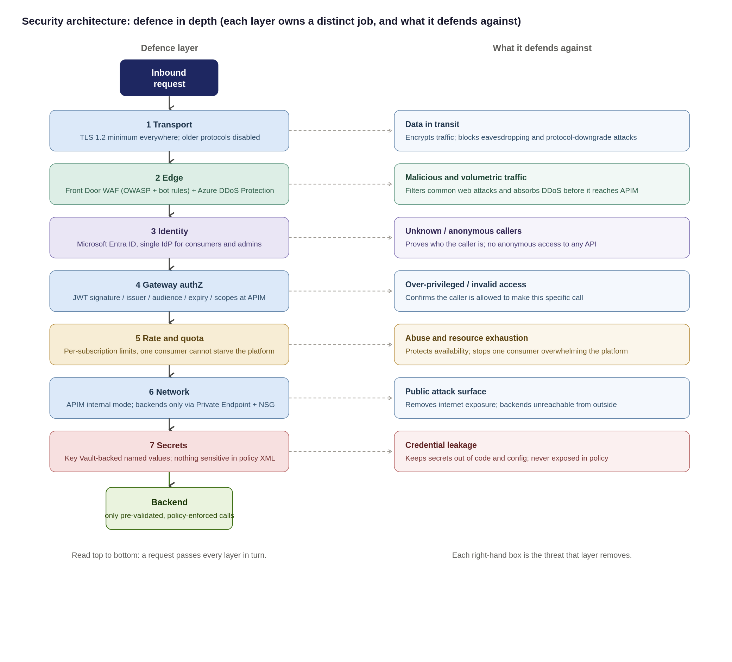

Security design principles Source
The controls detailed in this section enforce seven foundational security principles across the platform:
- Verify Explicitly (Zero-Trust): Validate every hop independently; no request is trusted simply because it originates from within the corporate network.
- Defence-in-Depth: No single control is load-bearing; security relies on layered edge WAF, gateway policies, and network isolation working in unison.
- Least Privilege: Consumers, APIOps deployment pipelines, and administrators are granted the minimum permissions necessary to perform their roles.
- Secure & Deny by Default: All APIs remain private and unauthenticated by default until explicitly configured and approved for publication.
- Single Identity Provider: Microsoft Entra ID serves as the central Identity Provider (IdP) for both consumer OAuth validation and platform administration.
- Everything as Code (APIOps): Platform and API security configurations are version-controlled, peer-reviewed, and deployed exclusively via automated pipelines.
- Zero Secrets in Code: No credentials or secrets are committed to repositories or hard-coded in policies all use Key Vault-backed Named Values

Threat model: STRIDE and the OWASP API Security Top 10
To ensure comprehensive coverage, the platform security model is evaluated against two complementary frameworks:
- STRIDE: Evaluates platform and infrastructure-level threat vectors (Spoofing, Tampering, Repudiation, Information Disclosure, Denial of Service, Elevation of Privilege).
- OWASP API Security Top 10: Addresses API-specific application vulnerabilities (BOLA, Broken Authentication, Mass Assignment, Unmanaged APIs).
Threat Vector & Key Risk Area | Framework Mapping | Architectural Control & Enforcement Strategy
Identity Spoofing & Broken Authentication | STRIDE: Spoofing  OWASP: API2:2023 | Mandatory Microsoft Entra ID OAuth 2.0 / JWT validation at gateway; strict claim inspection; mTLS and static IP allow-listing for authorized legacy exceptions.
Data Tampering & Payload Injection | STRIDE: Tampering  OWASP: API8:2023 | Enforcement of TLS 1.2+ end-to-end; edge Azure Front Door WAF rulesets; strict OpenAPI request schema validation at gateway ingress.
Repudiation & Audit Gaps | STRIDE: Repudiation  OWASP: API10:2023 | Centralized, immutable Azure Monitor / Log Analytics audit trail for all management and control plane actions; structured APIOps deployment logging.
Information Disclosure & Secret Exposure | STRIDE: Info Disclosure  OWASP: API3:2023 | Strict Private Endpoints / VNet isolation; zero plain-text secrets in policies (Azure Key Vault-backed Named Values); payload logging disabled by default with strict PII redaction rules.
Denial of Service & Resource Exhaustion | STRIDE: Denial of Service  OWASP: API4:2023 | Edge Azure DDoS Protection; per-subscription rate limits and quotas; dynamic gateway autoscaling based on CPU/Memory thresholds.
Broken Authorization (BOLA / BFLA) | STRIDE: Elevation of Privilege  OWASP: API1 & API5:2023 | Shared Responsibility Boundary: APIM validates caller identity/scopes and forwards claims. Downstream domain backends must enforce object-level and function-level authorization checks.
Shadow / Unmanaged API Proliferation | STRIDE: All Categories  OWASP: API9:2023 | Single ingress path via central APIM catalogue;; mandatory metadata tagging (audience, lifecycle status, data sensitivity); structured APIOps deprecation pipelines.

Data Classification, Payload Logging and PII
Because the gateway processes bearer tokens, sensitive header claims, and business payloads, strict data handling rules must be enforced across all environments. The platform position enforces three core tenets: classify data at onboarding, disable body logging by default, and keep telemetry free of personally identifiable information (PII).
Focus Area | Architecture Position & Governance Rule | Technical Enforcement Mechanism
Data Classification | Every API must be tagged during onboarding using the classifications defined in Chaucer's Data Classification Policy. The API classification must reflect the highest classification of any data transmitted, processed, or returned by the API, ensuring that APIM security, access control, logging, and governance requirements are aligned with Chaucer's data handling standards.  ChArch-CFG-AzurePolicy | Enforced via APIM Tags, dictates required product subscriptions, encryption levels, and logging verbosity.
Payload & Body Logging | Request and response bodies are not logged by default in any environment. Diagnostic payload logging requires sensitive field masking and is strictly time-boxed. | Managed via APIM <log-to-analytics> policies with regex field masking. Verbose logging auto-expires (max 48 hours).
Correlation & Telemetry | All logs, metrics, and trace spans must use opaque correlation identifiers (trace parent, X-Correlation-ID). PII is strictly prohibited in telemetry attributes. | System generates random UUIDs. Sensitive identifiers (emails, account numbers) are stripped at gateway ingress.
Secrets Exclusion | Bearer tokens, API keys, and Key Vault secret references must never be captured in diagnostic or gateway log output. | Header stripping policies sanitize Authorization (Bearer ***) and Ocp-Apim-Subscription-Key headers before logging.
Data Retention | Log retention balances investigation capabilities against UK GDPR / DPA 2018 data-minimization and storage limitation rules. | Default Log Analytics workspace retention set to 30 days (interactive), offloading to immutable storage for compliance.

Exception process for non-OAuth consumers
OAuth 2.0 with Entra ID is the default authentication standard. Where a partner cannot support this approach, an approved exception may be granted. Exceptions must be documented, risk-assessed, supported by compensating controls, time-bound and subject to periodic review.

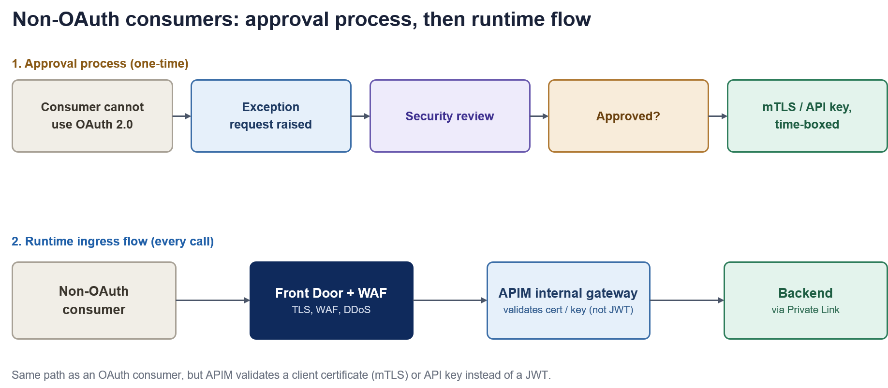
Figure 11: Non-OAuth consumers, the one-time approval process and the resulting runtime ingress flow
How each consumer type proves who they are
Consumer | Primary Authentication Method | Secondary / Compensating Control
External partner | OAuth 2.0 token issued by Entra ID and validated at APIM | Subscription key, IP allow-list where fixed egress IPs exist
Internal Organization system | Managed Identity (no stored credentials) | Entra ID conditional access on the calling service
Inbound webhook from a vendor | Shared secret header, checked against Key Vault | IP allow-list restricting the source range

Partner and External Identity
The Organisation's external consumers include brokers, market participants, strategic partners, suppliers and third-party service providers. Authentication and onboarding approaches may vary by consumer type and technical capability.
- Preferred approach: External organisations are represented through Microsoft Entra External ID (B2B) using partner-specific application registrations and controlled access assignments.
- Approved alternatives: Where Entra-based integration is not supported, approved federated identity, OAuth 2.0, mTLS, HMAC-signed requests or other approved authentication mechanisms may be used through the exception process.
- Governance requirement: Partner onboarding, application registration, credential and certificate lifecycle management, access reviews, rotation and revocation responsibilities must be defined and owned by the appropriate Identity and Access Management function before implementation.

Authentication & Role Based Authorisation (APIM, AFD, Developer Portal)
Authentication establishes who the caller is; authorisation determines what they may access. Authorisation is enforced at the gateway: the validated token's scopes and claims are checked against the requirements of the requested API and operation, and the caller's subscription determines which product's APIs they may call and under what rate limits and quotas.
Access is secure and deny-by-default: an API is not reachable by a consumer until their Entra ID group has been granted visibility of the relevant product and a subscription has been issued.

Secrets and Certificates
The preferred implementation is that APIM does not store application secrets locally. Required certificates, keys and credentials are retrieved from Azure Key Vault at runtime using the APIM managed identity.
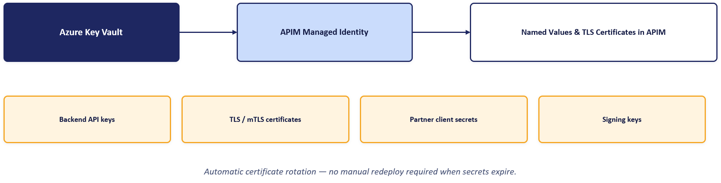

Data Classification and Logging
Because the gateway processes bearer tokens, sensitive header claims and business payloads, strict data-handling rules apply across all environments. The platform position enforces three tenets:
- Classify at onboarding. Data sensitivity is classified when an API is onboarded, determining its logging and handling requirements.
- No body logging by default. Request and response body logging is disabled by default and enabled only where explicitly justified.
- No PII in telemetry. Authorization headers and personally identifiable information are redacted before telemetry is logged, keeping monitoring data free of secrets and personal data.

Non-OAuth Exceptions
OAuth 2.0 with Microsoft Entra ID is the default authentication standard. Where a partner cannot support this approach, an approved exception may be granted through a defined process. Exceptions must be documented, risk-assessed, supported by compensating controls (such as mutual TLS, IP allow-listing or HMAC-signed requests), time-bound, and subject to periodic review.
External Identity
External consumers are known partner organisations rather than anonymous members of the public, so the external identity default is Microsoft Entra External ID (B2B), using partner-specific application registrations and controlled access assignments. Azure AD B2C is not used, as it is no longer available for new deployments and B2B is the correct model for partner organisations.
Partner onboarding, application registration, credential and certificate lifecycle management, access reviews, rotation and revocation must be owned by the appropriate Identity and Access Management function. Where Entra-based integration is not supported, approved alternative mechanisms may be used through the exception process in Section 8.8.

API Products, Consumers and Developer Portal

Governance Model
API platform governance requires clear separation of ownership while maintaining centralised visibility and control. Workspaces provide logical isolation between teams, while products, subscriptions and Microsoft Entra ID groups control API exposure, access and administration. This approach enables decentralised API ownership within a centrally governed platform.
Choosing each layer: a clear strategy for Products, Consumers and the Portal
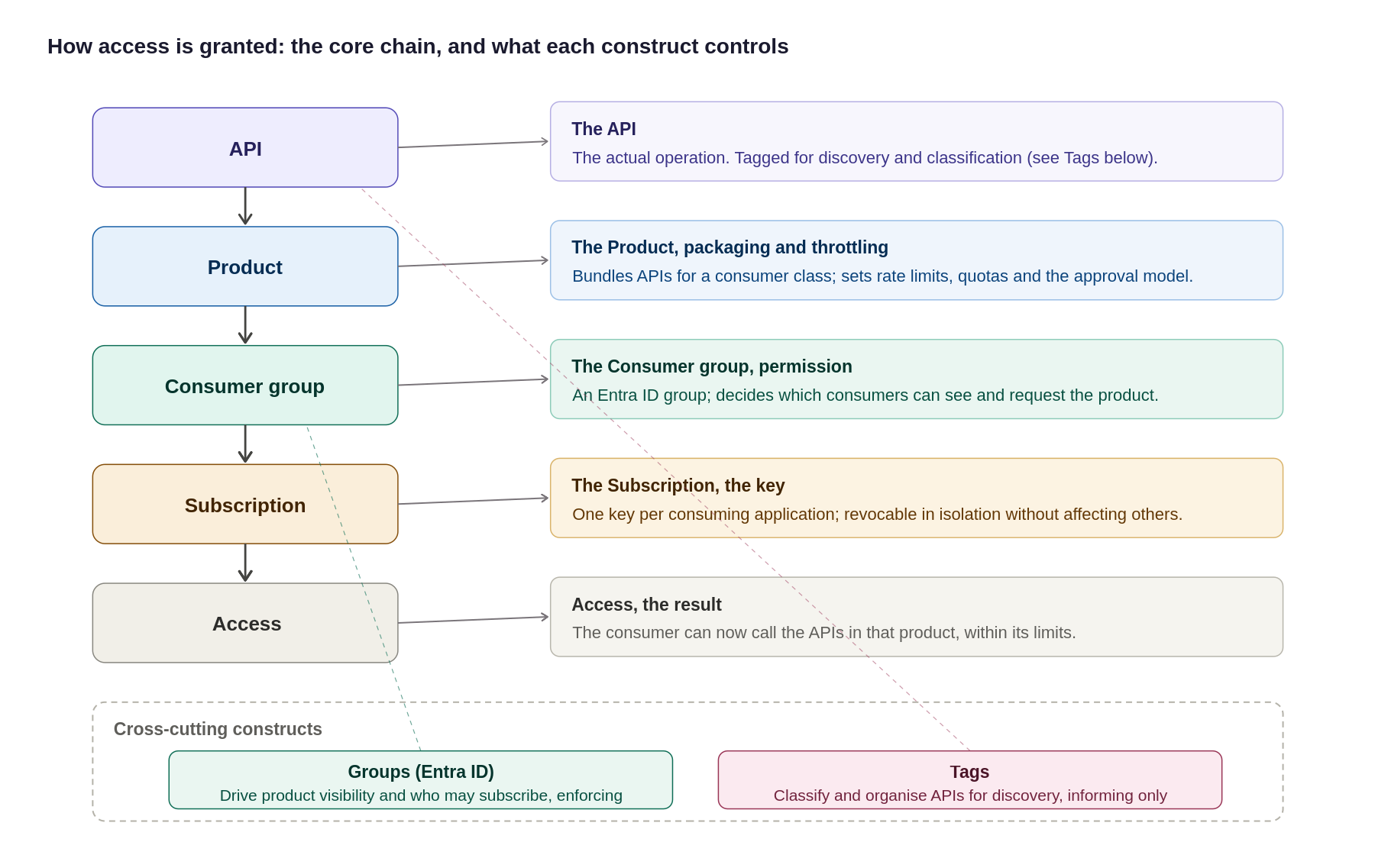
Figure 17: The access model, the core chain plus what each construct controls, including Groups and Tags
In summary:
Layer | Purpose | Recommended Approach
Product | Which APIs a consumer can access and under what controls | Group APIs into products by consumer type. Apply policies, quotas and approval controls at product level.
Consumer / subscription | How access is granted, managed and revoked | Use Entra ID groups for organisational ownership and separate subscriptions per consuming application. Avoid local APIM users.
Developer portal | How consumers discover, subscribe to and test APIs | Enable SSO, disable self-registration and expose APIs through a governed product catalogue with controlled visibility.

The diagram below illustrates the APIM governance hierarchy and access model. APIs are grouped into products, consumers are authorised through subscriptions, and access is governed through Microsoft Entra ID groups and RBAC controls..

Products, subscriptions, groups and users
- Products group related APIs and define access, subscription and policy boundaries for a consumer class..
- Subscriptions are issued per consuming application or partner, allowing access to be managed, rotated or revoked independently..
- Groups map to Microsoft Entra ID groups and control visibility and access to APIs and products.
- Users are authenticated through Microsoft Entra ID. APIM access is governed through group membership and the organisation's existing identity lifecycle processes..
Governance Construct | Core Purpose & Architectural Behaviour | Key Governance Rule & Enforcement
Backends | Abstracts downstream target URLs and centralizes runtime resilience rules (circuit breaking, load balancing, retries). | Target URLs and health check policies are managed centrally outside individual API definitions.
Named Values | Provides APIM's key-value store for plain settings (URLs, limits) and Key Vault-backed secret references. | Zero secrets hard-coded in policies. All secrets use Key Vault integration and are version-controlled via APIOps.
Policies | Enforces execution logic, transformations, authentication, and rate limits at global, product, or API scopes. | Policies reference Named Values for config; product-level policies enforce class-wide rules once.
Products | Group APIs into consumable offerings with common access and subscription controls. | Consumers subscribe to products rather than individual APIs.
Groups | Controls visibility and subscription access to Products based on user membership. | Custom groups map strictly to Microsoft Entra ID. No local user accounts are created inside APIM.
Tags | Provide categorisation, discovery and reporting metadata. | Tags support discovery and governance only and do not influence runtime behaviour.

How the Governance Constructs Fit Together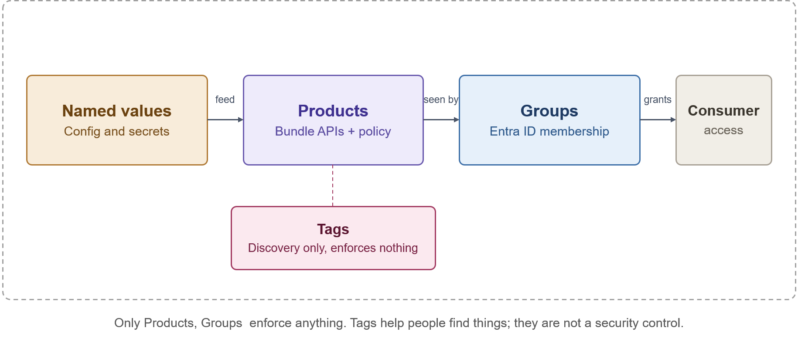
How the governance constructs relate to each other

Developer Portal Purpose
Purpose
The Azure APIM Developer Portal serves as the primary self-service interface for API consumers, publishing and automatically generated catalogue, interactive documentation, testing consoles, and automated subscription workflows. Its core objective is zero-touch onboarding—enabling internal and external developers to discover and adopt APIs without manual support tickets.
The platform distinguishes between two operational roles:
- API Publishers (Platform & Internal Teams): Operate exclusively via APIOps pipelines to deploy APIs, products, and policies into the management plane.
- API Consumers (Developers & Partners): Interact strictly through the Developer Portal to consume documentation, manage subscriptions, and generate access keys.
Reference architecture
The Developer Portal is hosted independently as a managed web application and is completely isolated from the gateway runtime path:
- Catalogue Publishing: The APIM management plane dynamically projects published APIs, schemas, and products onto the portal interface.
- Identity & Access Control: Authentication delegates directly to Microsoft Entra ID for internal workforce users and Entra ID B2B for external partners.
- Runtime Isolation: The portal handles metadata and subscription lifecycle only. Once a subscription key is issued, consumer application traffic bypasses the portal entirely, invoking the APIM Gateway directly where policy enforcement and security controls occur.

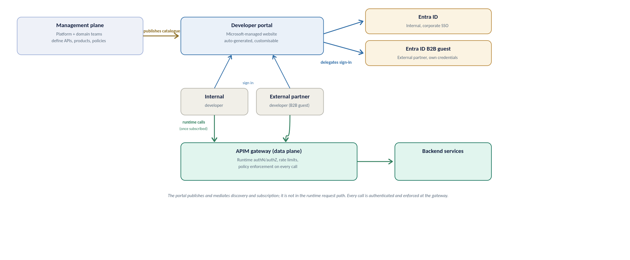
Developer portal reference architecture, how the portal relates to the management plane, identity providers, and the runtime gateway
API discovery strategy
Discovery is deliberately curated, not a raw API list. Three rules shape what a developer finds:
- Visibility follows identity: the portal shows only the products a signed-in developer’s Entra ID group permits, so a broker sees broker products and never an internal-only API.
- Grouping is by product, not raw API: a developer opens a product tile (for example External Broker), sees the APIs it bundles, and subscribes to the product as a unit; the subscription then works across every API in it.
- Tags are the search axis: consistent tags (section 10) let developers filter and search a growing catalogue, and each API page carries its operations, request and response schemas, and an interactive console for trying a call.
Built-in roles and RBAC
Two separate layers of access apply to the portal: who can see and use it as a consumer, and who can administer or publish its content. Neither creates a local account; both resolve back to Entra ID, consistent with the access model set out above.
Portal groups: who can see and use the portal
Group | Membership | What it grants
Administrators | Azure subscription administrators (system-managed) | Manages the APIM service and defines APIs, products and policies; not a consumer-facing role
Developers | Every signed-in, authenticated portal user (system-managed) | Base authenticated access; which products they actually see still comes from their Entra ID group
Guests | Anonymous portal visitors (system-managed) | Read-only browse of products marked visible to Guests; cannot subscribe or call an API
Custom / Entra ID groups | One per consumer class, for example Claims-Team or Partner-XYZ | Scopes visibility to the products that class of consumer may see, per the access model set out above

RBAC for administering portal content
Customising or publishing the portal is a service-administration action, controlled through Azure RBAC rather than the portal groups above.
Role | Scope | Use
API Management Developer Portal Content Editor | APIM service | Customise, edit and publish developer portal content; no API or service administration rights
API Management Service Contributor | APIM service | Full administration of the service and every entity; reserved for the platform team (see the RBAC set out in section 10), not for portal content editors

Configuration is two steps: grant a consumer's Entra ID group visibility on the relevant product, as set out above, so they can see and subscribe to it; and assign the Developer Portal Content Editor role to the named content owner so they can maintain the portal itself without broader service rights.
User onboarding flow
Ownership differs by direction, so the path is set out separately below for internal and external consumers; Figure 20 shows the shared journey once access has been granted.
Internal user onboarding
- Request: the consumer's manager or the team identifies the product needed.
- Group membership: the user is added to the relevant Entra ID group through the Organization's existing joiner-mover-leaver process; no APIM account is created.
- Sign-in: the user signs into the developer portal with corporate SSO and is automatically a Developer.
- Discover and subscribe: they see only the products their group permits; internal products are typically auto-approved.
- Credentials: a subscription key is issued, and OAuth-protected calls use a token obtained from Entra ID.
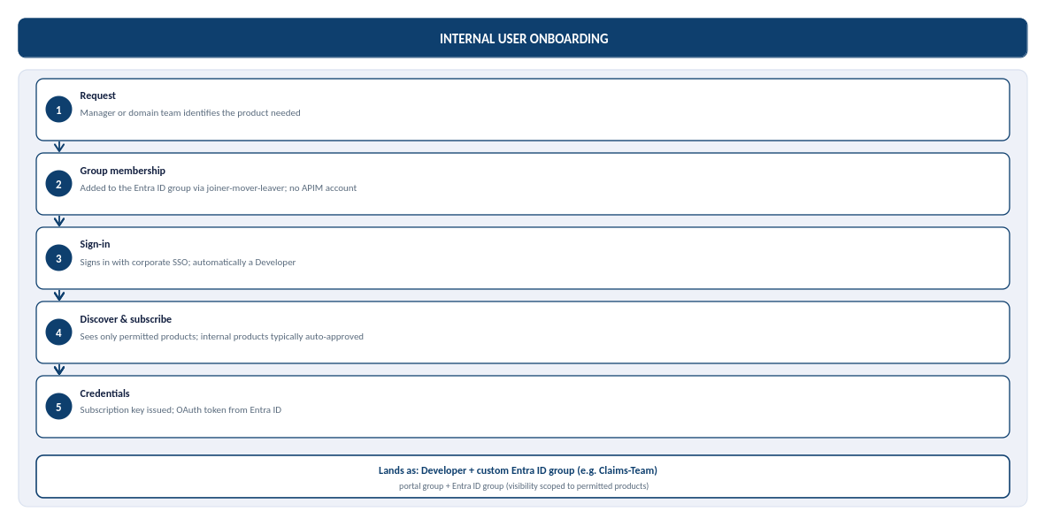
Figure 19b: Internal user onboarding, from request to credentials, and where the user lands in the portal groups
External user onboarding (partner, B2B)
The Organization's external identity default is Microsoft Entra External ID (B2B) for partner organisations, not Azure AD B2C: B2C is no longer available for new deployments, and Microsoft's current recommendation for consumer-facing sign-up is Microsoft Entra External ID. B2B is the correct model here because every external consumer is a known partner organisation, not an anonymous member of the public.
- Sponsorship: a named internal owner sponsors the partner and confirms which product they may access.
- Guest invitation: the partner user is invited as a Microsoft Entra ID B2B guest, authenticating with their own organisation's credentials rather than an organization-issued account.
- Group membership: once the invitation is redeemed, the guest identity is added to a per-partner Entra ID group, scoping visibility to that partner's product only.
- Sign-in and subscribe: the partner signs into the developer portal through B2B guest SSO and requests a subscription; external subscriptions are gated by approval, not automatic.
- Credentials: on approval, a subscription key is issued and, for OAuth-protected APIs, the partner's registered application obtains a token from Entra ID.
Partner sponsorship and credential-rotation ownership are not yet named, alongside the related gaps below.
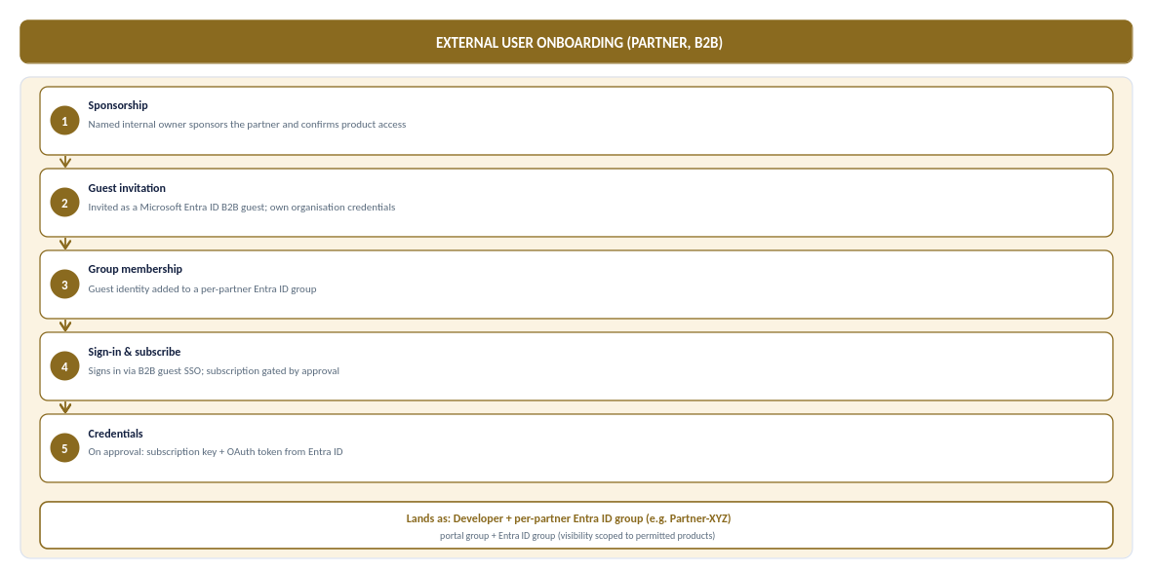
Figure 19c: External (partner, B2B) user onboarding, from sponsorship to credentials, and where the partner lands in the portal groups
In steady-state production the same consumer calls the API through APIM, where JWT validation and per-subscription rate limits and quotas are enforced on every call, and manages their own subscriptions and key rotation from the portal profile area without an organization ticket. The full journey, from access granted to steady-state use, is shown below.
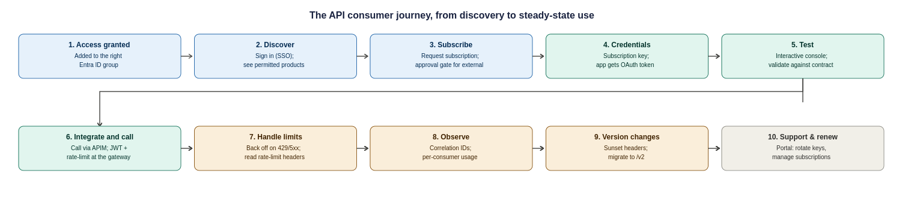
Figure 20: The API consumer journey, ten steps from access granted to steady-state use, support and versioning
Two responsibilities sit with the Organization to make this journey real, and are recorded as operational tasks in the assumptions register: a named owner for approving external subscription requests within an agreed SLA, and a defined support and escalation path (who a partner contacts when a call fails, and how correlation IDs are used to resolve it).

Portal Access Model
Access to the developer portal resolves back to Microsoft Entra ID; the portal creates no local accounts. Two layers of access apply: who can see and use the portal as a consumer, and who can administer or publish its content.
- Visibility follows identity. A signed-in developer sees only the products their Entra ID group permits — a broker sees broker products and never an internal-only API.
- Consumers. Internal users authenticate with corporate SSO; external partners authenticate as Entra External ID (B2B) guests with their own organisation's credentials.
- Content administration. Customising or publishing portal content is controlled through Azure RBAC (the Developer Portal Content Editor role), separate from consumer visibility.
The governance model and access chain are detailed in Section 9.1.

Portal Deployment and Hosting
The developer portal is hosted as the Microsoft-managed portal and is isolated from the gateway runtime path. The management plane dynamically projects published APIs, schemas and products onto the portal; the portal itself handles only metadata and the subscription lifecycle.
Once a subscription key is issued, consumer application traffic bypasses the portal entirely and calls the APIM gateway directly, where policy enforcement and security controls apply. Portal configuration is managed as code through the APIOps pipeline, consistent with the rest of the platform.

Internal Onboarding
Internal consumer onboarding follows the organisation's existing joiner-mover-leaver process and creates no APIM account:
- Request. The consumer's manager or team identifies the product needed.
- Group membership. The user is added to the relevant Entra ID group through the existing identity process.
- Sign-in. The user signs into the developer portal with corporate SSO and is automatically a Developer.
- Discover and subscribe. They see only the products their group permits; internal products are typically auto-approved.
- Credentials. A subscription key is issued, and OAuth-protected calls use a token obtained from Entra ID.

Partner Onboarding
Partner (B2B) onboarding is sponsored and gated by approval rather than automatic:
- Sponsorship. A named internal owner sponsors the partner and confirms which product they may access.
- Guest invitation. The partner user is invited as an Entra ID B2B guest, authenticating with their own organisation's credentials.
- Group membership. Once the invitation is redeemed, the guest is added to a per-partner Entra ID group, scoping visibility to that partner's product only.
- Sign-in and subscribe. The partner signs in through B2B guest SSO and requests a subscription; external subscriptions are gated by approval.
- Credentials. On approval, a subscription key is issued and, for OAuth-protected APIs, the partner's registered application obtains a token from Entra ID.

API Design, Policies and Lifecycle

Standards Relationship
This section complements existing Chaucer Engineering Standards and Cloud Adoption Framework (CAF) guidance and highlights the controls most relevant to APIM. Where any conflict exists, approved enterprise standards take precedence.
Further guidance is available in the Chaucer Engineering Standards and API Governance documentation on Confluence : APIM-Engineering-Standards

API Contract
Every API is defined by an OpenAPI contract that serves as the single source of truth for its operations, request and response schemas, and error responses. The contract is version-controlled and deployed through the APIOps pipeline, and is projected onto the developer portal for discovery and testing.
API contracts follow Chaucer's engineering standards for naming, versioning and schema design. Detailed contract standards are maintained in the Chaucer Engineering Standards and API Governance documentation.

Policy Hierarchy
APIM policies are applied in a hierarchy, with each level inheriting from the one above and able to extend it. This allows platform-wide controls to be enforced centrally while individual APIs add their own behaviour:
- Global (all APIs). Baseline controls applied to every call — correlation ID propagation, base security headers and platform-wide defaults.
- Product. Controls applied to all APIs in a product — typically the subscription rate limits and quotas for that consumer class.
- API. Controls specific to an API — JWT validation parameters, backend routing and transformation.
- Operation. Controls specific to a single operation, where finer-grained behaviour is required.
Policies are maintained as code and deployed through the pipeline; they are not edited directly in the portal except through approved emergency procedures.

Mandatory Policy Capabilities
The following policy capabilities are mandatory across the platform and enforced at the appropriate level of the hierarchy:
- Authentication and token validation. JWT validation (signature, issuer, audience, expiry and required claims) on protected APIs.
- Rate limiting and quotas. Per-subscription rate limits and quotas to protect backends and ensure fair use.
- Schema validation. Validation of requests against the API's OpenAPI contract where enabled.
- Correlation. Propagation of a correlation identifier on every call for end-to-end tracing.
- Secret handling. Use of Key Vault-backed named values for any credential; no secrets in policy configuration.
- Logging controls. Redaction of sensitive data and suppression of body logging by default.

Lifecycle and Versioning
Every API follows a standard lifecycle from design through retirement, ensuring consistent governance, security and operational management. The lifecycle aligns with Chaucer's engineering standards and API governance practices, with operational insights and monitoring data feeding future enhancements and design decisions.
Further guidance on API delivery, governance and lifecycle management is available in the Chaucer Engineering Standards and API Governance documentation on Confluence: API Life cycle
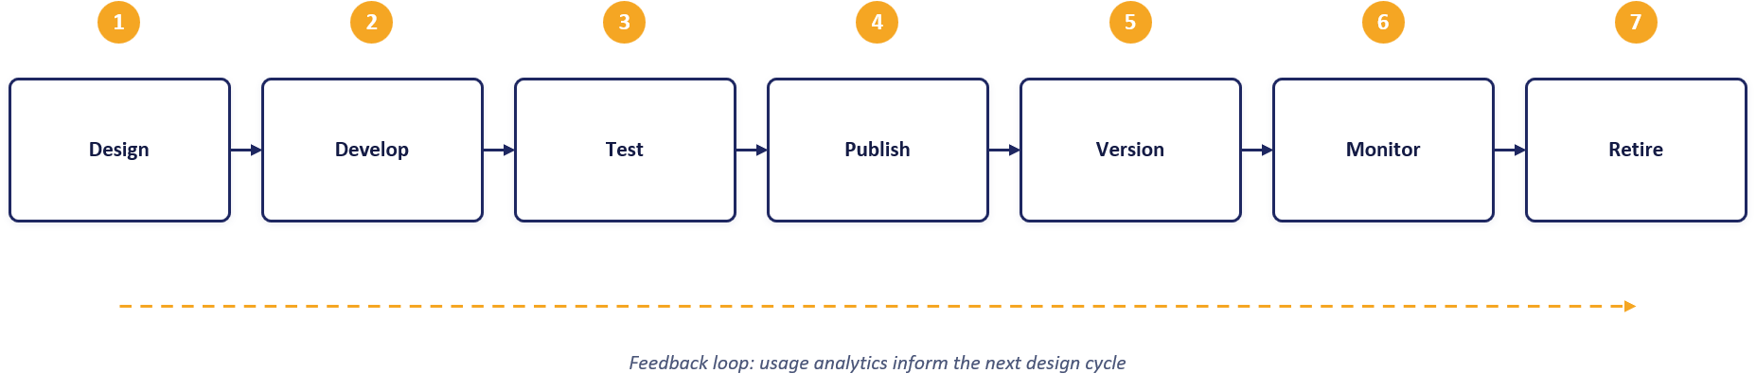

Environments, APIOps and Release Management

Environment Model
Environment | Service tier | Target SLA | Purpose
Dev | Developer | None (No SLA)) | Functional API policy development, mock backend testing, and automated pipeline builds at minimum cost. Non-production evaluation tier.
SIT | Developer | None (No SLA) | Functional API policy development, mock backend testing, and automated pipeline builds at minimum cost. Non-production evaluation tier.
UAT | Premium V2 | 99.95% | Pre-production business sign-off and user acceptance. Guarantees complete architectural parity with Production (VNet Injection, Private Endpoints, isolated networking) on a single scale unit.
Production | Premium V2 | 99.95% | Live customer traffic, high availability. Deployed across 2 Availability Zones (Silver Tier) with dynamic autoscaling based on gateway CPU/Memory load

The platform environment strategy uses four distinct environments: Dev, SIT, UAT, and Production.
- Dev and SIT: Provisioned on the cost-effective Developer tier to support functional API policy development, mock testing, and automated integration pipeline builds at minimal cost.
- UAT: Provisioned on Premium v2 (1 scale unit) to ensure complete pre-production architectural and network parity (VNet Injection, Private Endpoints) with Production, providing a supported, SLA-backed platform for business sign-off and user acceptance testing.
- Production: Provisioned on Premium v2 with Zone Redundancy enabled (Silver Tier across 2 Availability Zones) for live customer traffic, maximum platform availability, and dynamic autoscaling capabilities.
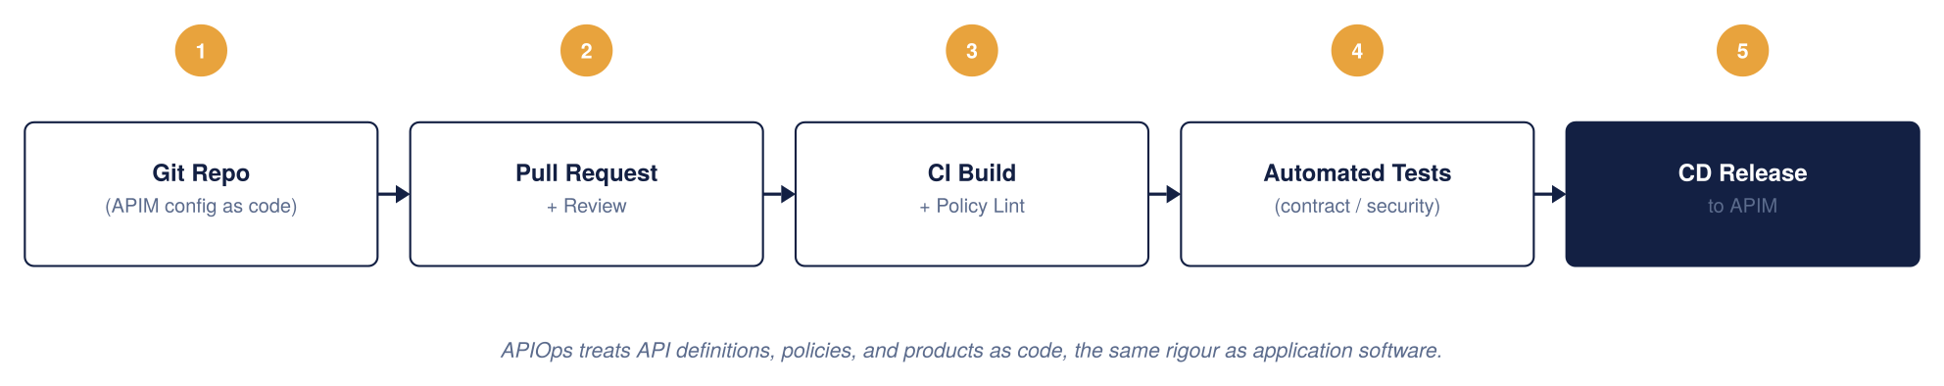
APIM CI/CD model, APIOps
APIOps Tooling and Deployment Pipeline
This design adopts an APIOps operating model, aligned to Chaucer's existing Azure delivery approach and platform engineering standards.
- Infrastructure as code: Terraform is used to provision and manage APIM, networking, Front Door, Key Vault and supporting Azure resources. Environment-specific behaviour is controlled through approved configuration and parameterisation rather than separate infrastructure definitions..
- Configuration as Code: APIM APIs, products, policies, named values and related configuration are maintained in source control and deployed through automated pipelines. Configuration is managed as code rather than through manual changes in the Azure portal
- Source Control and CI/CD: Azure Repos provides source control, with Azure DevOps Pipelines used for build, validation and deployment. All changes are subject to pull-request review and approval prior to deployment..
- Environment promotion: Changes are deployed to Development through the CI/CD pipeline and promoted through SIT, UAT and Production using the same approved artefacts. Production deployments are governed through approval gates and change management processes

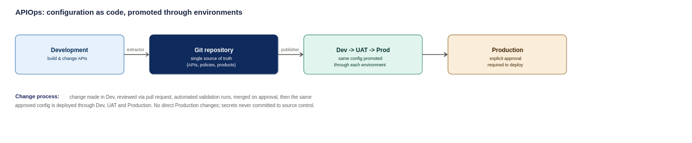
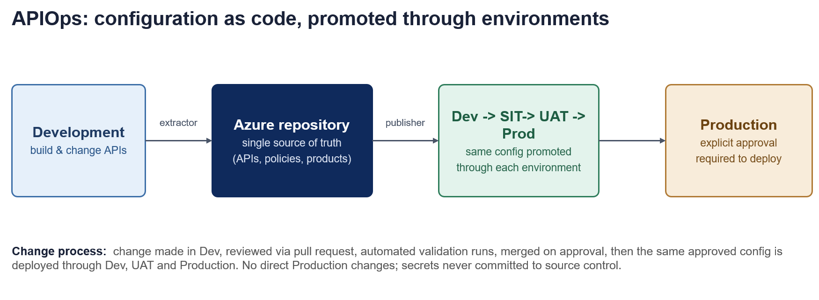
APIOps deployment pipeline, from development through to production

Configuration Management & Security Principles

Environment-Specific Settings
Environment-specific configuration (e.g., backend endpoints, rate-limit thresholds, and timeout values) are managed via environment-specific configuration files. API schemas, OpenAPI specs, and XML policies remain identical across all deployment stages.

Security Baseline
- Secrets Governance: Credentials, certificates and keys are stored in Azure Key Vault and referenced securely during deployment and runtime.; zero plain-text secrets are committed to source control.
- Least Privilege: APIOps deployment identities use scoped Workload Identity / Service Principal credentials with minimal required Azure RBAC roles.
- Pipeline Enforcement: Production changes are deployed exclusively through approved CI/CD pipelines. Direct portal modifications are not permitted except through approved emergency procedures.
- Emergency Override: Direct production portal access is restricted to time-bound Emergency Administrative Access (via Azure PIM) and is reserved strictly for pipeline outages.
Repository Structure
The APIOps repository maintains a single, standardized layout containing:
- APIs/ OpenAPI definitions and endpoint configurations
- Policies/ Inbound, outbound, backend, and error XML policies
- Products/ —API product groupings and subscription key settings
- NamedValues/ APIM-level global properties and Key Vault references
- Backends/ Gateway backend target pool definitions
- Environments/ —Environment-specific config mapping files (Dev, SIT, UAT, Production)
- Pipelines/ CI/CD deployment workflow and validation scripts
Configuration is promoted through Dev $→$ SIT $→$ UAT $→$ Production via automated promotion gates, ensuring consistency across environments.

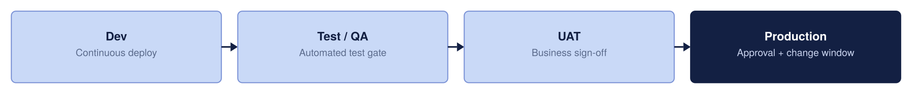
Environment promotion strategy

Toolchain
The APIOps toolchain is aligned to Chaucer's existing Azure delivery approach:
- Infrastructure as code. Terraform provisions and manages APIM, networking, Front Door, Key Vault and supporting Azure resources, with environment-specific behaviour controlled through parameterisation.
- Configuration as code. APIM APIs, products, policies and named values are maintained in source control and deployed through automated pipelines.
- Source control and CI/CD. Azure Repos provides source control; Azure DevOps Pipelines are used for build, validation and deployment, with pull-request review and approval before deployment.

Delivery Controls
Delivery is governed by a defined set of controls across the pipeline:
- Environment promotion. Changes are deployed to Development and promoted through SIT, UAT and Production using the same approved artefacts.
- Approval gates. Production deployments are governed through approval gates and change-management processes.
- Least privilege. Deployment identities use scoped credentials with the minimum required Azure RBAC roles.
- No manual changes. Direct portal modifications are not permitted except through approved, time-bound emergency access.

Quality Gates
Changes pass through quality gates before promotion to ensure consistency and safety:
- Validation. API definitions, policies and configuration are validated automatically in the pipeline.
- Static security analysis. Configuration is checked for policy and security issues, including scanning for accidentally committed secrets.
- Peer review. All changes are subject to pull-request review and approval.
- Promotion gates. Automated promotion gates enforce that each stage's criteria are met before the next deployment.

Component Configuration
Following the APIM tier selection in Section 3.4, this section describes the proposed target configuration for the APIM platform, including service tier, regional deployment, network mode, custom domains, TLS, and identity. The values shown represent the target-state design; custom domains are illustrative, and regional and networking choices remain subject to alignment with Chaucer's landing zone and naming standards.
Attribute | Proposed value | Status | Technical Rationale
Service Tier | Premium v2 | Proposed | Unlocks v2 architecture benefits, eliminates legacy cloud service (Classic) dependencies.
Region | UK South | Strategic | Deployed as in regional instances orchestrated via Azure Front Door.
Availability Zones | Zone-Redundant – 2 zone | Proposed | Deployed across 2 Availability Zones within single region.
Networking Mode | VNet Injection & Private Endpoints | Proposed | Standard v2 private networking pattern (Inbound via Private Endpoints, Outbound via VNet Integration subnet).
Custom domain | api.organization.com (external), api-internal.organization.com (internal) | Dummy placeholder | Domain names map to Front Door (External) and Private IP / Internal DNS (Internal).
TLS | TLS 1.2 Minimum | Proposed standard | Enforces TLS 1.2+ minimum across all endpoints, legacy ciphers disabled by policy.
Managed identity | User-Assigned Managed Identity | Proposed | Enables resilient, cross-resource access to Azure Key Vault and Azure Monitor without lifecycle coupling.
Developer Portal | Internal-Only | Proposed | Public access disabled, access restricted via internal VNet routing or Entra ID SSO.

e service scales in units, each a fixed block of gateway capacity. Production runs zone-redundant across Availability Zones and adds units as sustained traffic requires, rather than over-provisioning up front the capacity and cost model behind this is in section 15. The instance is deployed and changed only through code and pipelines, so its configuration is reproducible and auditable, as described in section 13.
Illustrative artefacts to make the standards concrete for build teams. These are examples to adapt, not final Organization policy.

Reliability, Backup and Disaster Recovery

Resilience Tiers
High Availability ensures the platform survives a datacentre failure within a region without disrupting users. By deploying APIM across independent Azure Availability Zones, traffic is automatically routed only to healthy zones.
Active-active multi-region deployment roughly doubles overall platform running costs, which is not justified for every API. To balance high availability with fiscal responsibility, resilience is tiered based on business criticality rather than paying a multi-region cost premium across the entire estate
Bronze (Single Region – Single Unit): Deployed in a single Azure region without secondary region or cross-zone failover. Service recovery relies on standard platform restoration processes, prioritizing cost efficiency for non-critical workloads where extended recovery times are acceptable.
Silver (Single Region – More Than 1 Unit): Preferred Baseline: Deployed within a single Azure region using multiple units distributed across Availability Zones (e.g., Zone 1 and Zone 2). This provides high intra-region capacity and local fault tolerance against underlying infrastructure or maintenance failures without incurring the cost and complexity of a secondary standby region.
Gold (Multiple Region – Multiple Units): Deployed across multiple Azure regions with multiple units provisioned in each region, offering geographic distribution, active load balancing, and cross-region failover for business-critical production services.

Resilience Tier | Deployment Topology | Architectural Scope | Operational Effect | Key Benefits | Architectural Trade-offs
Bronze | Single Region,  Single Unit | APIOps / IaC Git Config Recovery  Azure Front Door Anycast & WAF Edge | Environment can be completely rebuilt from code (near-zero config RPO).  DDoS and web attacks absorbed at the edge. | Minimizes platform infrastructure, licensing, and operational management costs. | No cross-zone or cross-region failover. Relies entirely on standard platform recovery procedures during outages.
Silver (Chosen Baseline & Production Standard) | Single Region,  Multiple Units (2 AZs) | Zone-Redundant APIM Gateway | Survives single physical datacentre loss within the region.  Traffic automatically routes around failed zones without manual intervention. | High intra-region availability and fault tolerance against local zonal/maintenance events. | Accepts an RTO window during a total regional outage in exchange for avoiding secondary-region running costs.
Gold | Multi-Region,  Multiple Units | Multi-Region Active-Active APIM (UK South / UK West)  Front Door Global Health Probes | Full regional disaster recovery.  Total UK South outage automatically routes traffic to UK West or another approved region with no client DNS changes. | Highest possible resilience tier with automated geographic failover and continuous multi-region availability. | High operational complexity; roughly doubles platform infrastructure and licensing costs.

Bronze and Silver run the primary region only, to keep cost minimal. Gold runs actively across both regions.
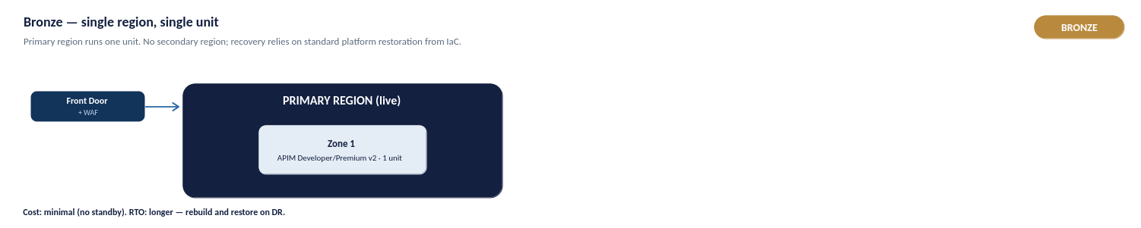
Figure 32a: Bronze — single region, single unit
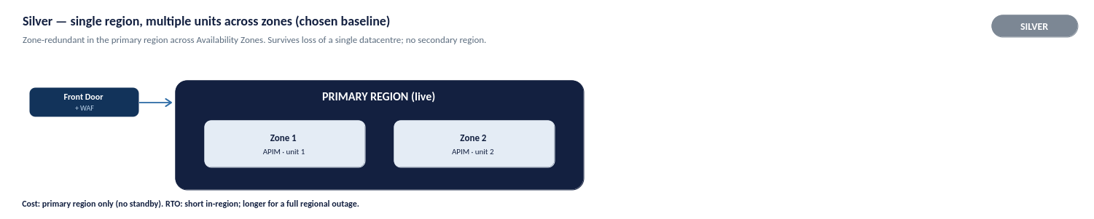
Figure 32b: Silver — single region, multiple units across zones (chosen baseline)
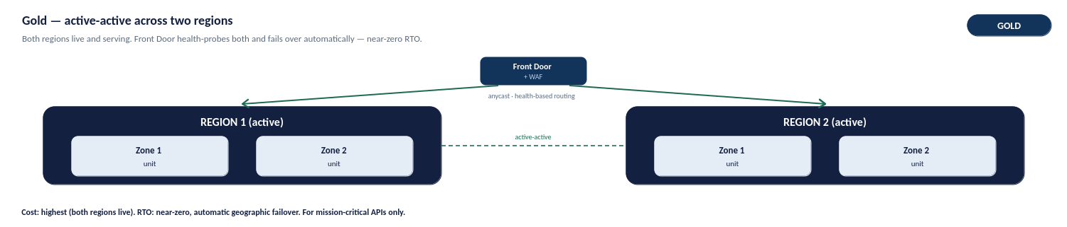
Figure 32c: Gold — active-active across two regions

Deployment-Unit Implication
Platform capacity and resilience scale with the number of provisioned units. The chosen Silver production baseline uses multiple units distributed across Availability Zones, so the loss of a single zone does not take the platform offline and traffic is automatically served by the remaining healthy zones.
For the conditional Gold tier, each active region must carry enough unit headroom to absorb the full peak workload during a single-region failover. Unit counts per environment are set out in the capacity and cost sections.

Backup, Restore and Rebuild
Because the platform is delivered entirely as code, its primary recovery mechanism is rebuild-from-code rather than conventional backup. The APIM configuration, policies, products and infrastructure definitions are held in source control, so an environment can be reprovisioned to a known-good state from the repository.
- Configuration recovery. APIM APIs, products, policies and named values are restored by redeploying the versioned configuration through the pipeline.
- Infrastructure recovery. The Terraform definitions reprovision the APIM instance, networking and supporting resources.
- Secrets and certificates. These remain in Azure Key Vault and are referenced at runtime, so they are not re-created as part of a configuration rebuild.

RTO and RPO
Recovery objectives differ by resilience tier. Because configuration is held as code, the configuration recovery-point objective is effectively near-zero , the last committed state can always be redeployed.
- Silver (production baseline). Zone failure is handled automatically within the region with no meaningful interruption. A total regional outage is recovered by deploying to the secondary region from code, accepting an extended recovery-time objective in exchange for not running a permanent standby region.

Resilience Testing
Resilience is validated rather than assumed. The following should be exercised before and periodically after go-live:
- Zone-failure behaviour. Confirm that traffic continues to be served when a zone is unavailable.
- Regional failover. Confirm that an environment can be reprovisioned from source control to a known-good state within the expected timeframe.
Resilience testing outcomes feed the RTO and RPO targets and the operational runbooks.

Observability and Operational Management

Monitoring Architecture
Azure Monitor provides a unified observability platform across APIM, policies and backend services. Application Insights delivers end-to-end tracing, Log Analytics stores diagnostic telemetry, and dashboards provide operational, security and management reporting.
As illustrated in the architecture below, telemetry is ingested from four primary sources:
- APIM Gateway Metrics capture platform performance and resource utilization.
- Application Insights records distributed request flows and application telemetry.
- Azure Front Door / WAF supplies edge security and traffic inspection logs.
- Diagnostics provide underlying component health data.
All incoming streams converge into Azure Monitor / Log Analytics as the central data store, which in turn powers role-specific Dashboards and Workbooks for integrated operational insight.

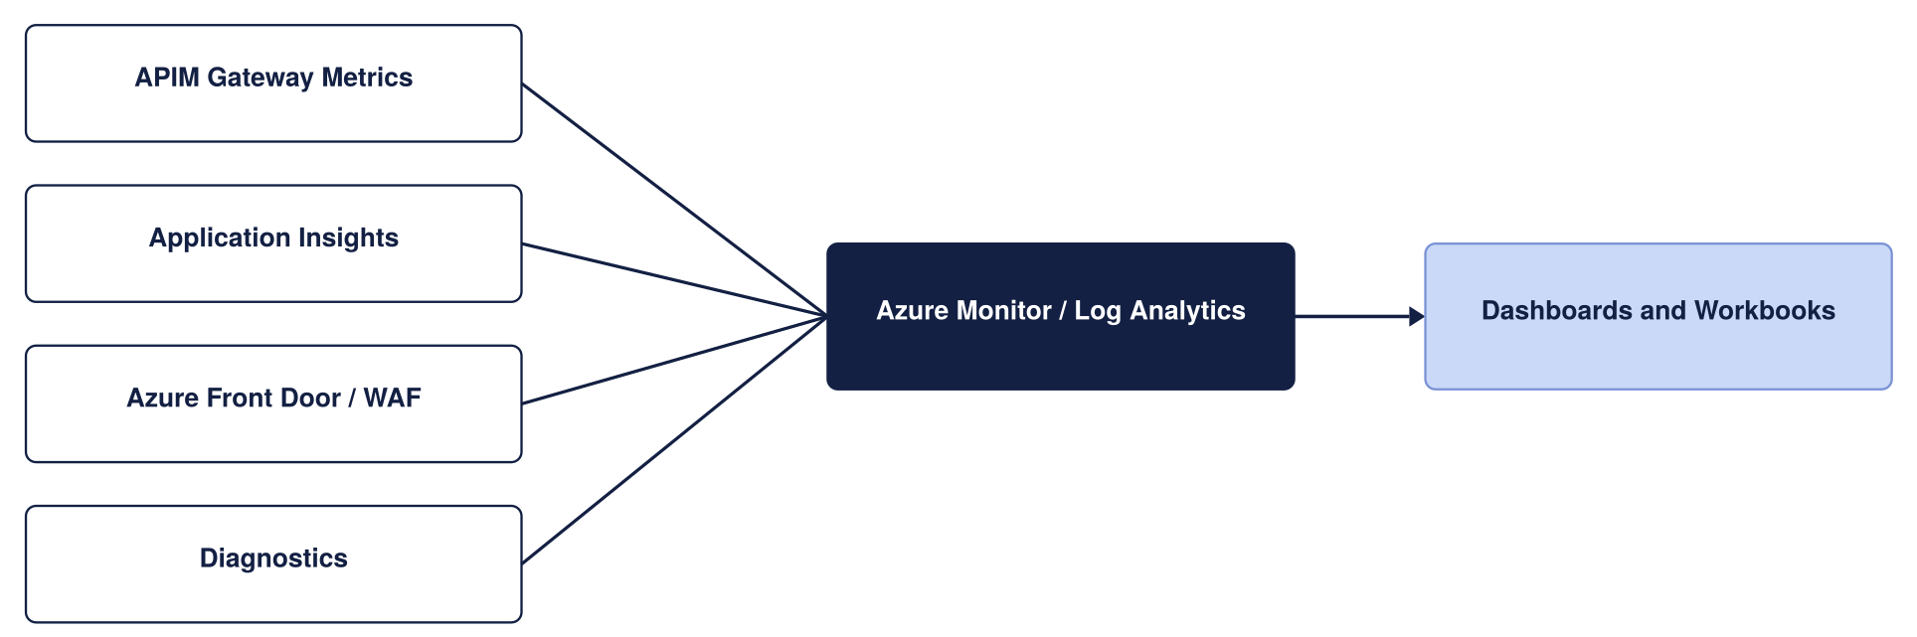
Monitoring architecture
Telemetry and diagnostics are captured through APIM diagnostic settings and correlated using a common correlation identifier. Operational, performance and security telemetry is routed to the appropriate monitoring platform based on its purpose and retention requirements.
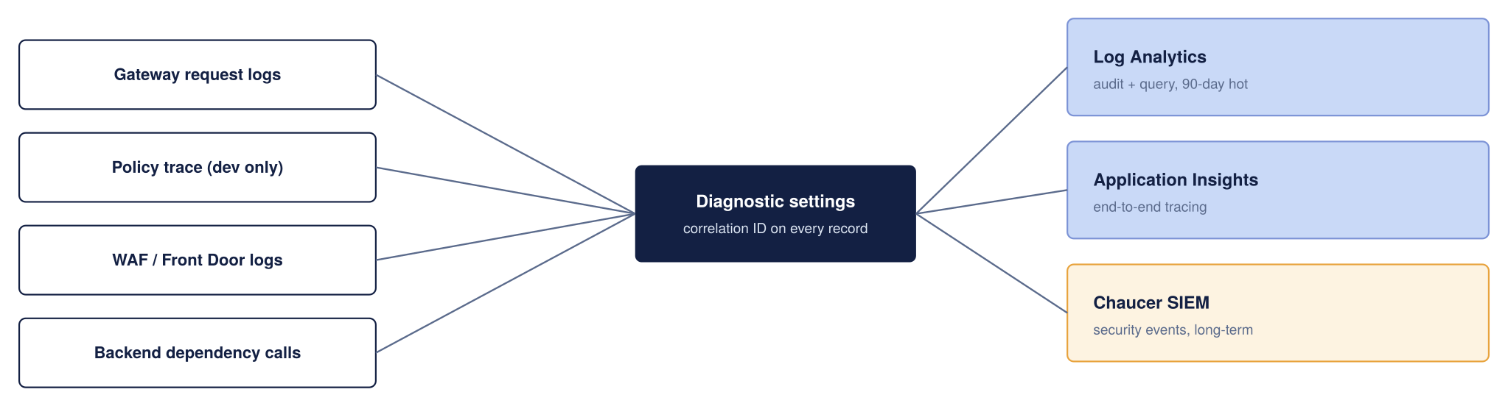
Telemetry Collection and Retention

Telemetry
Telemetry is captured through APIM diagnostic settings and routed to the appropriate platform based on its purpose, retention requirement, and security classification:
- Operational and performance: Gateway request and response metadata, latencies, and throughput, used for health and capacity monitoring.
- Diagnostic: Detailed diagnostic logs in Log Analytics; verbose policy tracing is restricted to non-production environments to control cost and protect sensitive data.
- Security: WAF and security-relevant logs, which are also forwarded to the central security monitoring platform (SIEM).

Telemetry | Sink | Retention (proposed)
Gateway request and response metadata | Log Analytics | 90 days hot, then archived per the Organization’s log policy
End-to-end distributed traces | Application Insights | Sampled in production to control cost
Policy trace (verbose) | Application Insights | Enabled in Dev only; off in production by default
WAF and Front Door logs | Log Analytics | 90 days, forwarded to the security dashboard if applicable
Security-relevant events & Auth failures | Organization SIEM | Retained in accordance with SIEM policy
Control-plane audit logs (APIM management operations) | Log Analytics | 365 days (or aligned to compliance mandate for administrative changes)
Platform infrastructure metrics (CPU, Memory, Capacity) | Azure Monitor / Log Analytics | 30–90 days for trend analysis and autoscaling tuning

Correlation and Tracing
Correlation IDs are systematically propagated from APIM to backend services to ensure seamless end-to-end request tracing. This propagation must be validated during implementation to guarantee trace continuity across distributed systems. To safeguard sensitive data and control telemetry storage costs, verbose policy tracing is strictly restricted to non-production environments.
Dashboards and Alerting
Dashboards are provided for operational, integration, security and management audiences. Alert thresholds below are proposed defaults and should be refined based on production usage patterns..
Metric | Alert Threshold (Proposed)
Failed requests (5xx) | Greater than 1% of total requests
Gateway response time | p95 above 500ms
Unauthorized requests (401) | Greater than 10 per minute
Certificate expiry | Less than 30 days to expiry

Dashboards and Alerts
Tailored dashboards are provided for operational, integration, security, and management audiences, ensuring each stakeholder group has the appropriate visibility such as real-time operational health for platform engineers and availability/SLA tracking for management. Alerting covers the platform's primary health signals: failed-request (5xx) rates, request latency, gateway capacity, and certificate expiration.

Retention
Telemetry retention is configured per sink according to its specific purpose, carefully balancing operational utility, cost efficiency, and compliance mandates. Interactive log retention follows platform defaults, while extended retention is handled via archiving where required.
Note: These retention periods are indicative and must be formally validated against Chaucer's logging, security, and compliance standards prior to go-live.

Capacity and Cost

Capacity
The costs below are indicative UK South list prices and should be validated against current Microsoft pricing, enterprise agreements and expected traffic volumes..
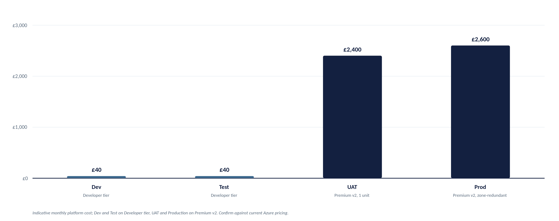
Indicative monthly platform cost by environment
Cost per Component (Production)
Component | Indicative monthly cost | Notes
APIM Premium V2 | ~ £2,100 to £2,300 (per unit) | Modern v2 architecture eliminates legacy Cloud Services (Classic) dependencies. Zone redundancy (2 AZs) is configured within the region.
Azure Front Door Premium + WAF | ~ £260 base, plus usage | In Premium v2, multi-region failover relies on Front Door orchestrating independent regional v2 instances. Includes WAF base rules
Azure Key Vault | Low cost | Centralized secret and TLS certificate storage; operational cost is negligible.
Azure Monitor and Application Insights | Usage-Based | Cost driven by telemetry volume and retention requirements.
Azure DDoS Protection (Dedicated Plan) | ~ £2,300 per month per tenant | Flat tenant-wide fee covering up to 100 public IPs (optional if relying purely on Front Door edge protection).

Capacity Planning and Scaling
Platform cost and throughput scale directly with the number of provisioned units. As an initial planning baseline, 1 Premium v2 unit handles roughly 1,000 requests/sec, but this is an estimate. Actual throughput varies based on payload size, policy evaluation complexity, and TLS overhead, requiring validation against real production traffic.
Scaling Principles:
- Auto scale Thresholds: For multi-unit instances, scale out when sustained gateway CPU or memory exceeds ~70%, and scale in below ~35% over a 30-minute average.
- Provisioning Lead Time: Scale operations take 15–30 minutes to complete. Auto scale rules must react to sustained trends rather than short bursts.
- Resilient Capacity Sizing: The deployment must carry sufficient unit headroom across its 2 availability zones to absorb peak workloads and maintain service availability during an individual zone or infrastructure failure.

Environment | Service Tier | Starting Capacity | Indicative Throughput | Architectural & Sizing Justification
Dev | Developer | 1 Unit | N/A  (Build / Unit Test) | Supports API development, policy authoring, functional testing and APIOps validation with capabilities aligned to the target production model at minimal cost.
SIT | Developer | 1 Unit | N/A  (Build / Unit Test) | Supports integration testing, environment validation and pre-UAT verification without Premium-tier licensing costs.
UAT | Premium v2 | 1 Unit | ~1,000 req/sec | Production-aligned environment supporting VNet Injection, private connectivity and enterprise networking validation prior to business sign-off.
Production | Premium v2 | 2 Unit | ~1,000 req/sec  per unit | Recommended Silver-tier production baseline. Deployed across Availability Zones for high availability and scaled based on observed demand, operational metrics and service-level objectives.

Cost Drivers
Platform cost is driven principally by a small number of factors:
- APIM Units: The number of provisioned Premium v2 units, which scales both capacity and cost; Production is optimized with local high-availability via two availability zones in a single region.
- Edge: Azure Front Door Premium and the WAF, providing the inspected public edge.
- Observability: Application Insights and Log Analytics, which are usage-based and scale with telemetry volume and retention.
- Non-Production Environments: The tier chosen for Dev, SIT, and UAT, where lower tiers are used to avoid Premium cost outside Production and pre-production parity.

Cost Controls
Platform costs are kept proportionate to business need through four core controls:
- Right-Sized Environments: Non-production environments leverage cost-effective tiers (Developer for Dev/SIT; Standard/Basic for UAT) while Production starts lean at the silver baseline.
- Just-In-Time Scaling: Production begins with a single baseline unit, scaling horizontally only in response to verified traffic and resource utilization.
- Disciplined Telemetry: Log volume is controlled via intelligent request sampling, selective verbose diagnostics for high-value APIs, and strict data retention limits.
- Tiered Resilience: High-availability is kept cost-effective by using 2-zone deployments within a single region for critical APIs, avoiding blanket multi-region footprints across the estate.

Governance and Operating Model

Ownership Model
Introducing APIM establishes a centrally governed platform capability that sits in front of the existing integration estate. Existing integration services continue to operate unchanged, with APIM providing a standardised entry point for API exposure, governance and policy enforcement. Primary dependencies include networking, identity and APIOps capabilities

Exceptions
Approved enterprise standards take precedence where any conflict exists, and exceptions are recorded and tracked through the platform's governance process.
Where a requirement of this design cannot be met (e.g., a partner unable to support OAuth 2.0 or a workload requiring a pattern deviation), an exception may be granted through a defined process. All exceptions must be:
- Documented and risk-assessed to understand the exposure.
- Backed by compensating controls (e.g., mTLS or IP restrictions) to mitigate the risk.
- Time-bound and subject to periodic review to prevent permanent architectural drift.

Existing Processes
The operating model reuses Chaucer's existing processes rather than creating parallel ones. Identity lifecycle follows the existing joiner-mover-leaver process, change is governed through existing change-management and approval processes, and service transition, incident and problem management follow the organisation's existing service-management framework.
This section is complemented by the Chaucer Engineering Standards and API Governance documentation, which remains the authoritative source for delivery and governance detail.

Implementation and Service Readiness

Implementation Stages
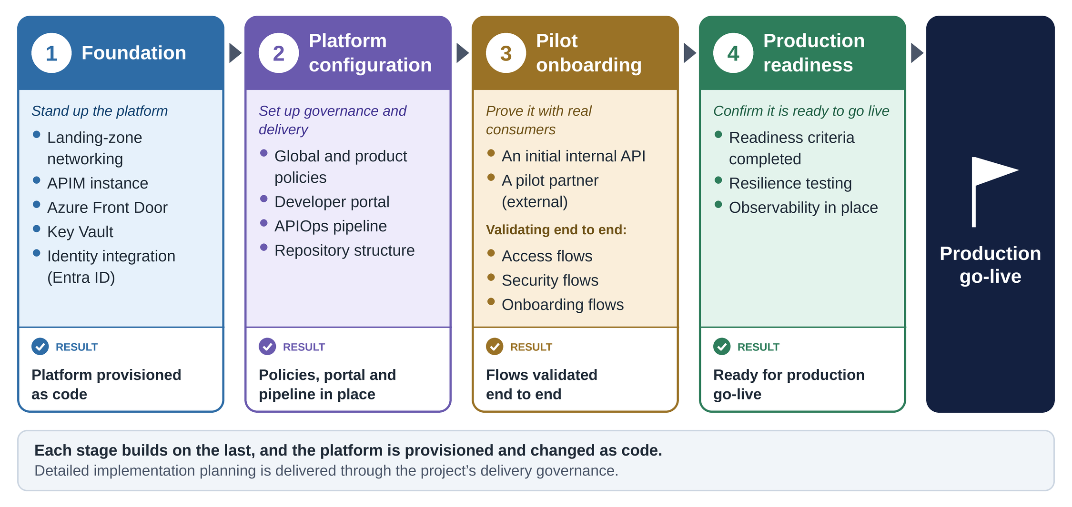
Implementation stages for the APIM platform, from foundation to production go-live

Readiness Criteria
This section sets out what must be true before the platform moves from build into business-as-usual operation. Handover is not a single event but a tracked checklist: the capabilities below must be true, or carry a named owner and target completion date, before a service is accepted into live support.
Prior to production onboarding, the following must be in place:
- Operational ownership assigned: Clear accountability for ongoing support.
- Monitoring and alerting configured: Proactive visibility into health and performance.
- APIOps pipeline operational: Automated, repeatable deployment mechanisms.
- Backup and recovery procedures documented: Tested resilience plans.
- Security logging integrated: Centralized ingestion into organizational SIEM/monitoring platforms.
- Runbooks and support documentation completed: Operational guides for support teams.

Governance & Operational Area | Service Readiness Criterion | Design & Reference
Platform Ownership | Accountable primary and secondary owners assigned for every RACI role defined in Section 10.2. | Section 10.2 (Closes Risk A.13)
Support Readiness | Support Tiers 1 through 3 staffed, briefed on operational escalation paths, and on-call rosters established. | Section 16.1
Observability & Alerting | Azure Monitor dashboards live, Log Analytics ingestion verified, and alert routing/thresholds tested end-to-end with Operations. | Section 12 (Closes Risk A.09)
Platform Resilience | Front Door health probes and multi-region failover (or single-region AZ availability) tested and documented prior to go-live. | Section 14
Policy Exceptions | Operational process, ownership, and SLA established for evaluating and approving non-OAuth or legacy policy exception requests. | Closes Risk A.16
Operational Documentation | Operational runbooks, final HLD architecture, and the assumptions/risk register delivered to support teams. | Section 17.3
Identity & Access Control | CI/CD APIOps pipeline permissions, Git repositories, Key Vault access, and Emergency Administrative Access (PIM) transferred to operational owners. | Section 10.2 & Section 13
Vendor & Commercial | Active Microsoft Enterprise Support agreement (Premier/Unified) confirmed, with support ticket logging paths validated. | Section 16.1

To ensure seamless operational continuity, the delivery team will formally transfer the following key assets to operational owners prior to Hypercare exit, rather than retaining them within project delivery:
- APIM High-Level Design (HLD): Maintained as a living architectural baseline and updated via version control as the platform evolves, consistent with the broader Systems Integration Framework governance model.
- Operational RACI & Contact Directory: Sections 10.2 and 16.1 updated with named primary/secondary contacts, on-call schedules, and escalation paths substituted for generic roles.
- Operational & Resilience Runbooks: Operational runbooks specifically including the Emergency Administrative Access procedure (Section 10.2) and the Front Door / Regional resilience playbook (Section 14) stored as Markdown directly alongside infrastructure-as-code (IaC) repositories.
- Risk, Assumption, Issue & Dependency (RAID) Register: Section 18 carried forward into steady-state operations and reviewed on a scheduled cadence during periodic platform service reviews (Section 16.4).
- APIOps & Security Access Control: Full administrative ownership of the APIOps CI/CD pipelines, Git control repositories, Key Vault access policies, and Azure Privileged Identity Management (PIM) roles transferred to designated operational platform owners.

RAID and TDA Conditions

Assumptions
This register identifies assumptions and outstanding decisions requiring validation and approval prior to implementation.
Ref | Assumption or open item | Impact if Incorrect | Owner to confirm
A.01 | Backend services are reachable through approved private connectivity. | Backend connectivity design may require rework. | Network team
A.02 | The Organization’s landing zone follows a standard hub-spoke with private DNS zones available | Affects DNS, egress, and how APIM reaches each backend | Platform Team
A.03 | Entra ID is the Organization’s identity provider and can extend to API consumers | Authentication and authorization model may require redesign. | Identity Team
A.04 | Proposed RTO/RPO, retention periods, and alert thresholds are acceptable | Operational targets and cost may change | Operations Team
A.05 | Initial workloads can be supported by a single Premium v2 unit. | Additional capacity may be required earlier than planned. | Integration Team
A.06 | Expected and peak API request rate (RPS) are not yet confirmed | Capacity planning remains indicative until validated. | Platform team
A.07 | Operational ownership and RACI assignments are not yet confirmed. | Governance and support responsibilities remain incomplete. | Platform Team and Service Owners
A.08 | Log retention and correlation-data retention requirements are not yet confirmed. | Compliance and audit requirements may not be fully satisfied. | Security Teams
A.09 | Network sizing and IP allocation requirements are not yet validated. | Subnet sizing and platform scalability assumptions may be affected. | Network Team
A.10 | Exception ownership and approval processes for non-standard authentication methods are not yet defined | Authentication exceptions may lack governance and review ownership. | Security Team and API Platform Team
A11 | Parameter sheet

Key Risks
No live issues are recorded at draft stage. Issues raised during TDA review or build will be logged here.

Dependencies
Ref | Dependency | Owner
D.01 | Entra ID app registrations provisioned before build | Identity Team
D.02 | Azure Key Vault provisioned and access policies configured in the target subscription. | Platform team
D.03 | Landing-zone network connectivity, subnets and Palo Alto routing paths available in the target environment. | Network Team
D.04 | RTO, RPO, retention requirements and alert thresholds agreed and approved. | Operations team

Independent Verification Required
The following aspects of the design should be independently verified before or during implementation, as they depend on confirmation against Chaucer's environment or on validation with real traffic:
- Network and IP allocation. VNet address space, subnet sizing and routing confirmed against the landing zone and IPAM.
- Capacity and throughput. Per-unit throughput and autoscale thresholds validated against real production traffic rather than planning estimates.
- Cost. Indicative costs validated against current Azure pricing, enterprise agreements and expected volumes.
- Identity ownership. Partner sponsorship, approval and credential-rotation ownership confirmed with the Identity and Access Management function.

TDA Approval Conditions

Appendices

Compliance with Microsoft Well Architected Framework
This design has been benchmarked against Microsoft's Well Architected Framework (WAF) guidance for API Management, which sets out best practice across five pillars. The table below summarises each pillar, the key practices Microsoft recommends, and where this HLD addresses them. The alignment is high because the design was built to these patterns; the few items marked as configuration are settings to apply at build time rather than design gaps.
WAF Pillar | Key Microsoft Recommendations | How This APIM Design Addresses It
Reliability | Zone redundancy, autoscaling, multi-region failover, policy validation, reliability metrics, and GitOps rebuild capabilities. | APIM Premium v2 deployed as active-active independent regional instances behind Azure Front Door Premium (Silver Resiliency Tier). Native Availability Zone redundancy APIOps config-as-code enables rapid automated environment recreation.
Security | ARM-only control plane, strict TLS, Key Vault integration, network-isolated backends, OAuth 2.0, Managed Identity, edge WAF, and production trace restrictions. | Microsoft Entra ID OAuth 2.0 with JWT validation, TLS 1.2+ minimum, Key Vault-backed Named Values, Azure Front Door WAF edge inspection; Managed Identity for backend access, Private Endpoints; verbose tracing restricted to Dev/Test.
Cost Optimization | Cost-effective tiering across non-prod, auto-scale based on load, edge malicious traffic filtering, built-in caching, and policy efficiency. | 4-Environment Topology: Developer tier for Dev and Test, Premium v2 for UAT and Production (ensuring strict VNet/Private Endpoint parity). Edge DDoS and WAF filtering via Azure Front Door blocks malicious calls prior to gateway ingress.
Operational Excellence | Diagnostic resource logging, APIOps / GitOps workflows, Azure Policy governance, automated load testing, standard hostnames, and Backend construct abstraction. | Azure Monitor / Log Analytics / App Insights integration with trace parent correlation IDs, APIOps CI/CD pipelines across Dev/Test/UAT/Prod, standardized API onboarding, backend health probes managed via APIM Backends.
Performance Efficiency | Dynamic scaling, efficient policy execution, performance metric collection, adaptive App Insights sampling, and upstream limits evaluation. | Autoscaling driven by Gateway Capacity and CPU/Memory metrics, lean, modular policy library, p95 latency and capacity alerts, production Application Insights adaptive sampling to minimize overhead.

Architecture Decisions Explained

Edge Service Components (ADR-01)
The table below shows how each edge gateway option aligns with the defined requirements, providing the basis for selecting the preferred edge gateway service.

Option | Architectural Intent | Requirements Alignment | Operational Complexity | Indicative Monthly Cost* | Recommended
Front Door Premium + WAF (Selected) | Global Edge, Multi-Region & Unified Ingress | ✓ R1, R4, R5, R6, R7, R8, R11, R12 | Low | ~$330 | Yes
Application Gateway v2 + WAF | Regional-Only Ingress & Data Residency | Partial alignment. Meets R5 and R6 but limited support for R1, R7, R8 and R11. | Medium | ~$328 | No
Front Door Premium + Application Gateway v2 + WAF | N-Tier Ingress & Defence-in-Depth | Meets all requirements but introduces additional infrastructure and management overhead. | High | ~$670 | No
Direct APIM Ingress (No Edge Service) | Internal-Only APIs | Suitable only for internal consumption scenarios. Does not meet R1, R6, R7, R8 or R11. | Low | Lowest | No
Traffic Manager

Front Door Premium + WAF (Selected)
Architectural Intent: Global Edge, Multi-Region & Unified Ingress
Front Door Premium + WAF is the requirements-aligned, cost-effective choice: it meets every requirement in this matrix. It combines global routing, managed WAF/DDoS, and native Private Link into APIM within a single, low-maintenance service, satisfying R1 (discovery and consumption by internal and external users), R4 (controlled private and public endpoint access), R6 (DDoS and OWASP Top 10 protection), R7 (high availability), R11 (Traffic Manager-equivalent global routing) and R12 (low operational complexity for cost-effective, segregated environments).

APIM Premium v2 (ADR-03)
This section evaluates APIM Premium v2 against the available APIM tiers and identifies Premium v2 as the preferred platform standard. Premium v2 best aligns with the target architecture requirements for security, scalability, networking, and resilience, while the Developer and Standard v2 tiers provide insufficient secure capability needed for Production and UAT environments.

Capability | Premium v2 | Classic Premium | Decision & Rationale
Simplified Networking Model | Yes | No | Premium v2 significantly reduces virtual network governance overhead by eliminating dedicated control-plane routing dependencies.
Private Networking / Isolation | Yes | Yes | Both tiers fulfil strict security policies by providing private endpoint connectivity and network isolation
Workspaces | Yes | Yes | Both tiers support workspaces for decentralized API publishing and domain isolation across business units.
Futureproofing | Yes | No | Premium v2 positions the platform on Microsoft's newest architecture, avoiding future migration rework from Classic Premium.
Multi-Region Topology Strategy | Regional Deployment | Native multi-Region | Premium v2 supports single-region zone redundancy per instance, aligning perfectly with our Silver Resilience Tier

APIM Network Model (ADR-04)
To ensure a strict security boundary, Azure API Management must be isolated from direct internet exposure. Selecting the deployment mode dictates how the gateway integrates with our virtual network (VNet) and forces all external consumer traffic through Azure Front Door Premium WAF via Private Link.
The table below details the evaluation between Internal VNet, External VNet modes and VNet Integration.
Option | Description | Status | Architectural Rationale
VNET Injection Internal mode | APIM is deployed fully inside a dedicated VNet subnet with no public IP address. Ingress from Front Door Premium is routed privately via Private Link / Private Endpoints, and backend access uses private VNet routing. | Chosen | Zero Internet Exposure: Completely isolates the API gateway from the public internet. Guarantees that all external traffic is inspected and forced through Azure Front Door Premium WAF before reaching APIM.
VNET Injection External mode | APIM sits inside a VNet but maintains a direct, publicly accessible IP address on the internet, allowing clients to bypass or hit the gateway alongside an optional edge service. | Not Chosen | Security & Compliance Risk: Exposes a public surface area directly to the internet, creating potential governance bypasses where consumers can hit APIM endpoints without traversing the centralized Front Door WAF edge.
VNET Integration | APIM connects to backend services through a dedicated integration subnet, allowing private access to internal networks, Azure services, and external SaaS platforms without exposing a public IP for outbound traffic. | Not Chosen | Backend Reachability: This option still exposes a public surface area to the internet while the backend access can be achieved without introducing a dedicated integration subnet and associated networking complexity. While it supports private access to Azure and external services, the selected approach provides sufficient connectivity while maintaining a simpler operational model and lower cost.

Network Flow Matrix

API Onboarding Checklist
This appendix synthesizes the complete platform journey into a single end-to-end swim lane diagram. Positioned as the final summary, it maps the lifecycle from business need through go-live to ongoing API onboarding.
How to Read the Diagram:
- Phases (Columns): Read left-to-right across seven sequential execution phases.
- Ownership (Rows): Read top-to-bottom to see which team owns each activity.
- Handovers & Gates: Arrows indicate team handovers; red markers highlight mandatory Technical Design Authority (TDA) approval gates.
- Document References: Each activity box cites its corresponding HLD section for detailed reference.
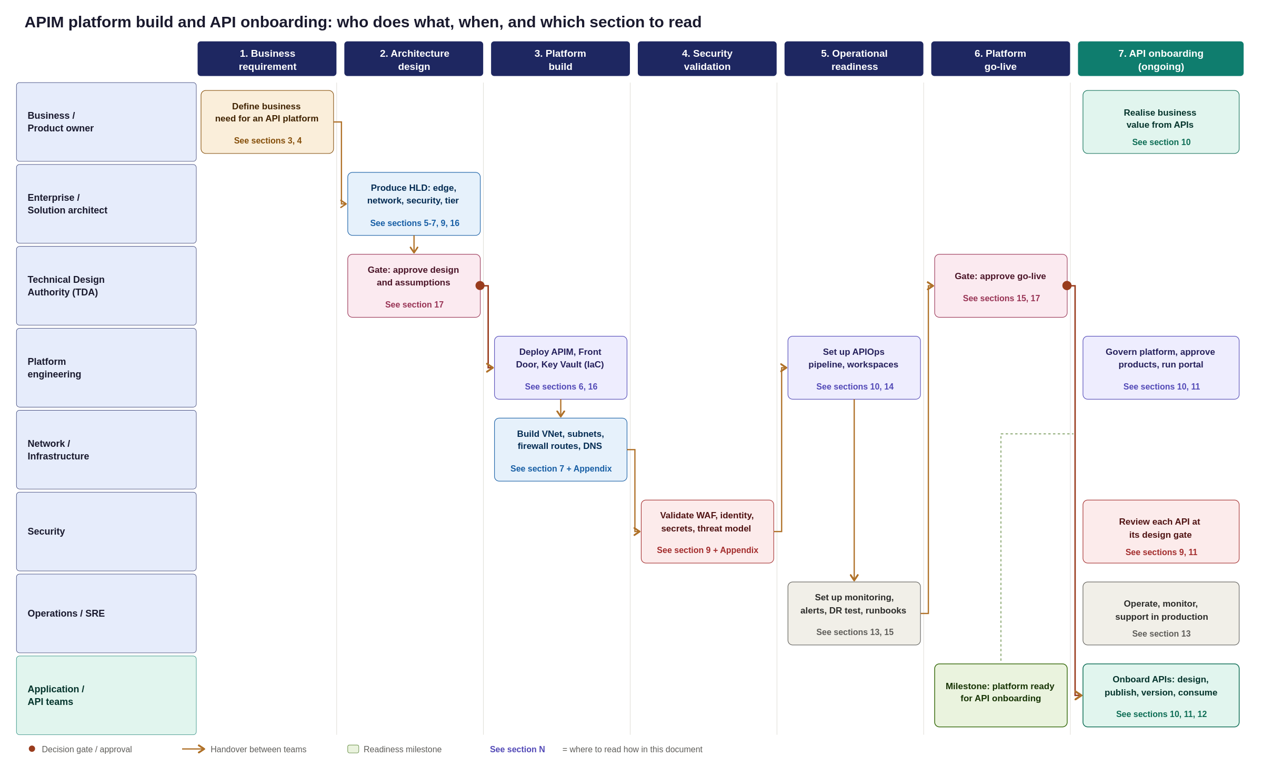
Figure 34: APIM platform builds and API onboarding swim lane, from business requirement to production consumption
Platform Implementation Roadmap & Team Execution
This appendix synthesizes the preceding design sections into a single, end-to-end swim lane diagram, mapping the platform journey from initial business demand to a live operational state.
Key Planning Takeaways
Standing up the APIM platform is a sequenced, multi-team program with a clear critical path:
- Architecture & Governance: TDA sign-off and baseline design approval.
- Infrastructure Build: Parallel execution of platform and network provisioning.
- Validation & Readiness: Security assessment, APIOps integration, and operational handover.
- Go-Live Gate: Final operational acceptance sign-off.
- Continuous Onboarding: Application teams begin onboarding APIs only after the platform go-live gate is passed.
How to Read the Swimlane Diagram
- Phases (Columns): Read left-to-right across the seven sequential execution phases.
- Ownership (Rows): Read top-to-bottom to see which team owns each specific activity.
- Handovers & Gates: Arrows indicate team handovers, while red markers highlight mandatory TDA approval gates.
- Section References: Each activity box references its corresponding HLD section for detailed technical specifications.

Reference Sources
Diagrams in this document are the Organization-adapted renderings of the pattern each article describes, not reproductions of Microsoft's own diagrams. Refer to the linked articles for Microsoft's original diagrams and downloadable Visio files.
- Basic enterprise integration on Azure: learn.microsoft.com/azure/architecture/reference-architectures/enterprise-integration/basic-enterprise-integration
- Protect APIs with Front Door and API Management: learn.microsoft.com/azure/architecture/web-apps/api-management/architectures/protect-apis
- Azure API Management landing zone accelerator: learn.microsoft.com/azure/cloud-adoption-framework/scenarios/app-platform/api-management/landing-zone-accelerator

