Azure API Management
High-Level Design
Prepared for Chaucer
Version 0.1, Draft for TDA review
September 2026

1. Table of Contents
The section list below is provided for navigation. Before final issue, replace it in Word with a field-generated Table of Contents (References › Table of Contents) to add live page numbers and automatic updates.
2. Document Control
2.1 Document History
2.2 Document Authors
2.3 Document Assurance
2.4 TDA Approval
2.5 Document References
3. Introduction
3.1 Executive Summary
3.2 Scope
3.3 Target Audience
4. Compliance
4.1 Architecture Principles
4.2 Engineering Standards
4.3 Architectural Decisions
4.4 Requirements Traceability
5. Baseline Architecture
5.1 Current State Summary
5.2 Existing API and Integration Landscape
5.3 Current Network and Connectivity Model
5.4 Existing Security and Access Model
5.5 Current API Consumption and Exposure Model
6. Target Architecture
6.1 Solution Summary
6.2 APIM Reference Architecture
6.3 Environment and Deployment Strategy
6.4 Network and Connectivity Design
6.5 Traffic Management and Edge Security
6.6 Authentication and Security Design
6.7 API Product, Consumer and Developer Portal Model
6.8 API Design Standards, Policies and Governance
6.9 API Lifecycle and Versioning Strategy
6.10 Observability and Operations
6.11 High Availability and Disaster Recovery Design
6.12 Cost, Capacity and Service Tier Strategy
7. Architecture Impact Assessment
7.1 High Level Impact Assessment
7.2 Business Architecture
7.3 Data Architecture
7.4 Application Architecture
7.5 Technology Architecture
7.6 Service Architecture
8. Risks and Issues
8.1 Assumptions
8.2 Risks
8.3 Issues
8.4 Dependencies
9. Appendices
9.1 Microsoft Reference Architectures
9.2 Companion Documents
9.3 Alignment with the Azure Well-Architected Framework
9.4 Glossary and Definitions
9.5 Non-Functional Requirements
9.6 Sample Policy Fragments, Naming and OpenAPI Skeleton
9.7 Disaster Recovery Testing Approach
9.8 Logic Apps Migration and Cut-over Strategy

2. Document Control

2.1 Document History
Version | Date | Author | Change
0.1 | September 2026 | Integration Architecture | Initial draft restructured to Chaucer HLD template

2.2 Document Authors
Role | Name / Team
Lead Architect | Integration Architecture
Contributing | Platform, Networking, Security teams

2.3 Document Assurance
[To be completed: assurance reviewers and sign-off to be recorded by Chaucer.]

2.4 TDA Approval
[To be completed: Technical Design Authority approval to be recorded.]

2.5 Document References
Diagrams in this document are Chaucer-adapted renderings of the pattern each article describes, not reproductions of Microsoft's own diagrams. Refer to the linked articles for Microsoft's original diagrams and downloadable Visio files.
- Basic enterprise integration on Azure: learn.microsoft.com/azure/architecture/reference-architectures/enterprise-integration/basic-enterprise-integration
- Protect APIs with Application Gateway and API Management: learn.microsoft.com/azure/architecture/web-apps/api-management/architectures/protect-apis
- Azure API Management landing zone accelerator: learn.microsoft.com/azure/cloud-adoption-framework/scenarios/app-platform/api-management/landing-zone-accelerator

3. Introduction

3.1 Executive Summary
Azure API Management gives Chaucer one secure, governed platform for every API the business runs, internal, external, and partner. This document sets out how we build it, how we secure it, and what it costs, using the same pattern that has already worked on a comparable insurance integration programme.
Three documents sit behind this one and are reflected throughout: the Systems Integration Framework, which sets the single-ingress principle; the detailed APIM High-Level Design already drafted for Chaucer; and Microsoft's own published reference architectures for enterprise integration and API protection.
Read this document as a proposal to test, not a build order. Section 8.1 records eleven open assumptions this design depends on; the most consequential, whether the platform must be active-active multi-region from day one (A.08), directly sets the production tier and roughly doubles the run cost if confirmed. TDA sign-off on the assumptions register is a prerequisite to starting build, not a parallel track: a build team working from this HLD before that register is confirmed risks building the wrong tier, the wrong region pair, or the wrong network topology.
The Ask | Our Response | The Outcome
Chaucer has no API layer today. Systems connect through point-to-point Logic Apps, each secured from scratch. | A hardened Azure APIM platform, Entra ID identity, Key Vault secrets, Zero Trust security, delivered in a phased rollout on top of the existing Logic Apps estate. | Faster API onboarding, one place to see and control every integration, and an audit-ready security posture.

3.2 Scope
This High-Level Design covers the introduction of Azure API Management as the enterprise API gateway for Chaucer: its architecture, network integration (including the existing Palo Alto firewall), security, API governance and lifecycle, observability, high availability and disaster recovery, and cost. It covers the platform and the pattern for onboarding APIs onto it. It does not cover the detailed configuration of individual backend systems, nor device-level firewall configuration, which are detailed-design activities.

3.3 Target Audience
This document is intended for Chaucer's Technical Design Authority, enterprise and solution architects, and the platform, networking, security and integration teams who will build and operate the platform. It assumes familiarity with Azure and with enterprise integration concepts.

4. Compliance

4.1 Architecture Principles
The overriding principle is single ingress: APIM is the mandatory ingress for every API governed by the enterprise API management capability, unless an explicit architecture exception is approved. The supporting principles are: identity on every call via Entra ID; secrets in Key Vault, never in policy; backends private by default; and every environment built from code, not by hand.
Azure API Management is the single entry point for all API traffic at Chaucer. Every consumer, whether a broker, a Lloyd's market system, or an internal application, talks to APIM first. APIM checks identity, applies rate limits, logs the call, and only then forwards it to the real backend. The principle is that APIM is the mandatory ingress for every API governed by the enterprise API management capability.
Traffic type | Route
External consumer to Chaucer API | External consumer, APIM external gateway, backend
Internal system to internal API | Internal system, APIM internal gateway, backend
Third-party webhook to Chaucer | Third party, APIM external gateway, Function or Logic App
Chaucer to third-party API | Logic App or Function, APIM outbound, third-party endpoint

APIM is the mandatory ingress for every API governed by the enterprise API management capability, unless an explicit architecture exception is approved. That qualifier matters: the intent is that no managed enterprise API is consumed by bypassing the gateway, not that literally every packet on Chaucer's network must traverse APIM. Legitimate exceptions, for example certain internal service-to-service calls, Azure platform callbacks, or temporary migration paths, are handled through an approved exception rather than by weakening the principle. Every such exception is recorded as an architecture decision so the boundary stays visible and governed.

4.2 Engineering Standards
These engineering standards are not invented for this platform; they follow Chaucer’s existing Engineering Standard and Cloud Adoption Framework conventions, and are restated here only where they bear on the APIM design. Where this document and the corporate standard differ, the corporate standard prevails and this design should be reconciled to it. [Placeholder: link to Chaucer Engineering Standard / CAF naming standard — to be inserted by Chaucer before issue.]
APIs follow the design and naming standards below; these are the engineering standards the platform enforces.
Every API follows the same conventions, so teams and consumers do not have to relearn a new shape for every integration.
Aspect | Standard | Example
Base path | /api/{domain}/{version}/{resource} | /api/claims/v1/claims
Resource naming | Plural nouns, lowercase, kebab-case | /api/policies/v1/policy-holders
Versioning | URL path, major version only for breaking changes | /api/claims/v2/claims
Response format | Consistent data / error / metadata envelope with a correlation ID | See Appendix A

Azure resource naming standard
The table above covers API path naming. The convention below extends the same discipline to the underlying Azure resources, so the estate is navigable from the portal and from Azure Resource Graph queries, not only from the developer portal.
Resource type | Convention | Example
Resource group | rg-{workload}-{env}-{region} | rg-apim-prod-uksouth
APIM instance | apim-{workload}-{env}-{region} | apim-chaucer-prod-uksouth
Virtual network / subnet | vnet-{workload}-{env}-{region} / snet-apim-{env} | vnet-apim-prod-uksouth / snet-apim-prod
Network security group | nsg-{subnet-purpose}-{env} | nsg-apim-prod
Key Vault | kv-{workload}-{env}-{region} | kv-apim-prod-uks (Key Vault names are globally unique and length-limited)
Front Door profile | afd-{workload}-{env} | afd-chaucer-prod
Log Analytics workspace | log-{workload}-{env}-{region} | log-apim-prod-uksouth
Application Insights | appi-{workload}-{env}-{region} | appi-apim-prod-uksouth
This should be reconciled with Chaucer’s existing Cloud Adoption Framework naming standard if one is already mandated; the pattern above follows the CAF convention as a sensible default where no Chaucer-specific standard yet exists.

4.3 Architectural Decisions
The architectural decisions this design depends on are summarised below in a single register, so a reviewer can see each decision, the main alternative it was weighed against, why it was chosen, and whether it is settled or still open. Each decision is carried in full in the accompanying Validation and Architecture Decisions (ADR) register; this table is the at-a-glance view.

Ref | Decision | Main alternative | Why chosen | Status
AD-01 | Single ingress through APIM for all managed enterprise APIs | Per-app gateways / direct backend exposure | One governed control plane; consistent identity, logging and rate-limiting; satisfies the SIF single-ingress principle | Proposed
AD-02 | Azure Front Door (Premium + WAF) for global routing | Azure Traffic Manager (DNS-layer) | All consumer traffic is HTTPS and benefits from edge WAF and sub-minute, non-DNS-bound failover; bundles WAF (see 6.5, 6.11) | Proposed — subject to SIF sign-off
AD-03 | APIM classic Premium as the production tier | Premium v2 single-region | Classic Premium is today the only tier offering multi-region + zones + workspaces together; v2 has no multi-region yet (confirmed, MS Learn Jan 2026) | Proposed — depends on A.08
AD-04 | VNet injection with Palo Alto firewall in the data path | External / external-VNet mode without NVA inspection | Keeps Chaucer’s existing inspection and egress-control point; backends stay private (see 6.4) | Proposed
AD-05 | Active-active multi-region DR (UK South + UK West) | Active-passive / single-region + zones | Sensitivity of claims and policy data; near-zero-downtime regional failover behind Front Door | Proposed — subject to business confirmation (A.08)
AD-06 | Entra ID + OAuth 2.0 as the enterprise auth default | Per-integration bespoke auth | One identity provider for consumers and admins; approved exceptions only where a party cannot support it | Proposed
AD-07 | APIOps (config + infra as code); no portal changes in Production | Manual portal configuration | Traceable, reviewable, repeatable promotion Dev→UAT→Prod; tooling to be confirmed by Chaucer Platform | Proposed

4.4 Requirements Traceability
Where this design departs from or interprets a stated requirement, the decision is traced explicitly. The clearest example is global routing: the Systems Integration Framework references Traffic Manager, and this design selects Azure Front Door instead, with the comparison and justification set out in section 6.5. Confirmation of whether the Traffic Manager reference is a hard mandate is an open item in the assumptions register (section 8.1).

5. Baseline Architecture

5.1 Current State Summary
Chaucer's integrations are built one at a time today: batch files, direct database links, and point-to-point Logic Apps, each wired to the system it talks to. That has worked, but it has three consequences worth naming plainly.
- Every new integration starts from a blank page. Security, authentication, and monitoring are rebuilt each time rather than reused.
- Nobody has one place to see what is talking to what, or who is consuming which piece of data.
- Partners and brokers cannot self-serve access to anything; every connection is a bespoke conversation.
Our working assumption is that this is a greenfield API platform build for Chaucer, adding APIM in front of the existing Logic Apps estate rather than migrating away from an established API gateway. This assumption is load-bearing, so it needs confirming: Part 1 of the wider scope references legacy on-premises systems, and if any of those must be exposed directly through APIM (rather than reached via the existing Logic Apps), that introduces a self-hosted-gateway and hybrid-connectivity requirement this design would need to absorb. Subject to that confirmation, the greenfield position lets the platform be designed cleanly from day one without working around an incumbent gateway.

5.2 Existing API and Integration Landscape
Chaucer's current integration landscape is built on point-to-point Azure Logic Apps, each wired directly to the system it connects, alongside batch files and direct database links. There is no central API gateway, catalogue or consistent security model today. This design adds APIM in front of that existing Logic Apps estate rather than replacing it.

5.3 Current Network and Connectivity Model
This is a greenfield API-platform build; there is no incumbent API gateway or established API network path to document. The relevant baseline is Chaucer's existing Azure landing zone and the Palo Alto firewall, whose actual topology is an open item to confirm (assumptions register, section 8.1). The target network design is set out in section 6.4.

5.4 Existing Security and Access Model
There is no consistent existing API security model; today each Logic App integration implements its own security, and there is no central authentication or authorisation layer. The target security model, standardised on Entra ID and OAuth 2.0, is set out in section 6.6.

5.5 Current API Consumption and Exposure Model
Today, consumers, whether internal systems or external partners, integrate through bespoke point-to-point connections. There is no self-service discovery, no product or subscription model, and partners cannot self-onboard. The target consumption and exposure model is set out in section 6.7.

6. Target Architecture

6.1 Solution Summary
One control plane. One security model. Every API, internal, external, and partner, governed consistently on Azure API Management.
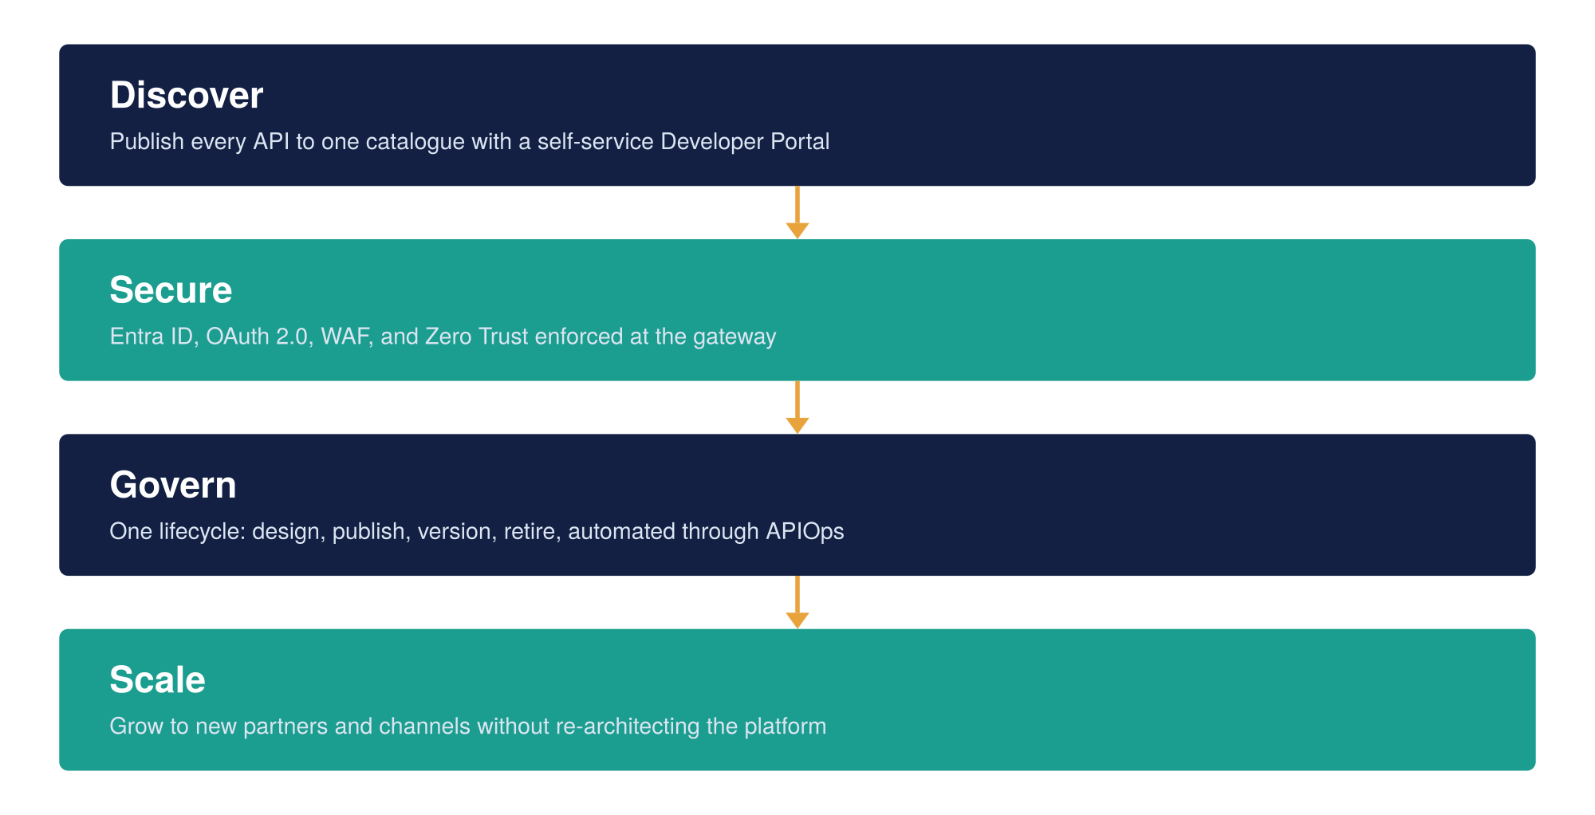
Figure 1: The APIM vision, four stages from discovery to scale
- Establish Azure APIM as the single enterprise API gateway and system of record for every published API.
- Make Microsoft Entra ID and OAuth 2.0 the enterprise default for API authentication, with formally approved exceptions for protocols or external parties that cannot support it.
- Automate the API lifecycle, design, publish, version, retire, through a Git-based APIOps pipeline.
- Enforce Zero Trust at the edge: WAF, private endpoints, and policy-based threat protection.
- Give developers a self-service Developer Portal for discovery, subscription, and testing.
The single-ingress principle, the traffic-routing model, and the approved-exception process that this vision depends on are set out in full in section 4.1 (Architecture Principles) and are not repeated here.

6.2 APIM Reference Architecture
The diagram below sits every consumer, security control, and backend into one governed flow: a client authenticates with Entra ID, passes through Front Door and WAF, reaches Azure API Management, and is forwarded to Logic Apps and the backend systems behind it. The layout follows the same layered pattern used in our proven reference architecture for this kind of platform, adapted here to Chaucer's own components, and lines up with Microsoft's Basic enterprise integration on Azure reference architecture.
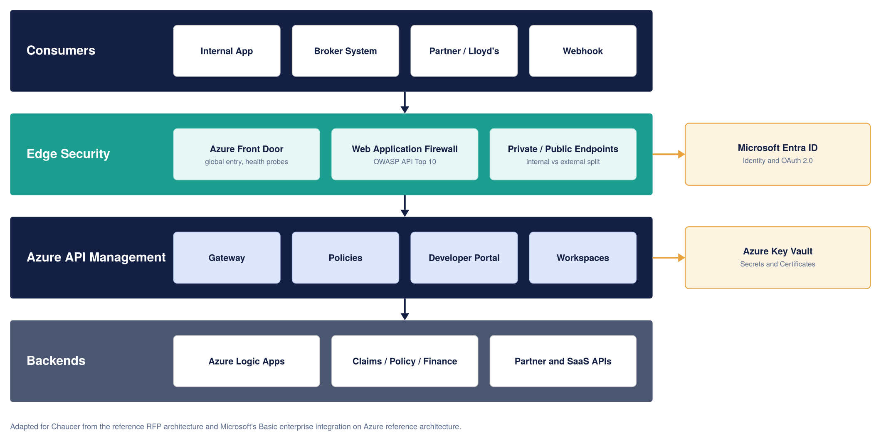
Figure 2: High-level Azure APIM architecture for Chaucer
This design is deliberately built on three architectures Microsoft publishes and maintains for exactly this scenario, rather than invented from scratch:
- Basic enterprise integration on Azure, Microsoft's reference pattern for APIM in front of Logic Apps, the closest published match to Chaucer's existing estate.
- Protect APIs with Application Gateway and API Management, Microsoft's reference pattern for a WAF-protected gateway splitting external and internal traffic.
- The Azure API Management landing zone accelerator, part of the Cloud Adoption Framework, covering enterprise-scale networking, governance, and identity.
Full diagrams and workflow detail for these three architectures are maintained by Microsoft at learn.microsoft.com; they are referenced and adapted here, not reproduced.

6.3 Environment and Deployment Strategy
Chaucer needs three environments, Dev, UAT, and Production, and the same configuration moves through all three the same way every time, never edited by hand directly in production.
Environment | Suggested tier | SLA | Purpose
Dev | Developer | None (by design) | Build and unit test, lowest cost
UAT | Standard v2 | 99.95% | Integration testing and business sign-off, production-like
Production | Classic Premium, two regions | 99.95%, or 99.99% across zones | Live traffic, full resilience and workspaces

The tier choice per environment is deliberate on the point of SLA. The Developer tier carries no SLA, which is why it is used only for Dev, where it does not matter: Dev is for building and unit testing, not for anything the business signs off against. UAT deliberately steps up to Standard v2, which does carry a 99.95% SLA, precisely so that pre-production sign-off happens on a supported, production-like tier rather than on an unsupported one. This keeps cost down where it is safe to (Dev) without compromising the environment the business actually validates against (UAT). If Chaucer's stakeholders require an even closer production match for UAT, for example zone redundancy, that is a straightforward and costed step up within Standard v2.
Every change, a new API, a policy update, a new product, is written as a file, reviewed by a colleague, and deployed by a pipeline through APIOps. Nobody, including the platform team, changes production directly through the portal.
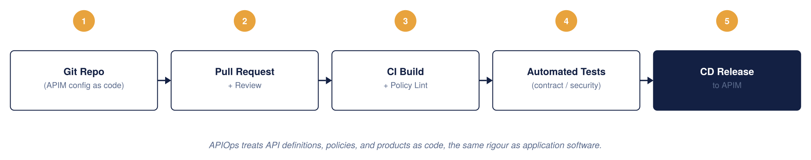
Figure 3: APIM CI/CD model, APIOps

APIOps tooling and pipeline (to confirm with Chaucer Platform)
This design assumes an APIOps model but does not yet commit to specific tooling; that choice belongs to Chaucer’s platform engineering standard rather than to this HLD, and should be confirmed and recorded as an architecture decision before build starts. The proposed default, consistent with a Microsoft-native Azure landing zone, is:
- Infrastructure as code: Bicep for the APIM instance, networking, Key Vault and Front Door resources, so the same templates promote unchanged through Dev, UAT and Production with only parameter files differing per environment.
- Configuration as code: the Azure API Management DevOps Resource Kit (APIOps) extractor/publisher tooling, or an equivalent, to represent APIs, products, policies and named values as files in Git rather than portal state.
- Source control and pipeline: a Git repository per the pattern already used elsewhere in Chaucer’s Azure estate (Azure Repos or GitHub, run through Azure DevOps Pipelines or GitHub Actions), with mandatory pull-request review before merge to the branch that triggers Production deployment.
- Environment promotion: Dev builds on every merge to the integration branch; UAT and Production promote the same reviewed artefact through a manual approval gate, never a fresh build per environment, so what was tested is what ships.
Whichever toolchain Chaucer selects, the non-negotiable outcome is the one stated in the paragraph above: no environment, including Production, is ever hand-configured through the portal outside an emergency break-glass procedure (section 6.6), and every change is traceable to a reviewed commit.

APIOps implementation: repositories, pipelines and promotion
The principle above (everything as code, nothing hand-configured in Production) becomes concrete through a well-known pattern: the APIOps model of an extractor and a publisher working against a Git repository that is the single source of truth. The mechanics below are the proposed implementation; the specific toolkit is Chaucer’s to confirm, but the shape is standard and low-risk.
Two pipelines. The extractor pipeline reads a live APIM instance (Dev) over the Azure REST API and writes its APIs, policies, products, subscriptions, named values, backends, tags, loggers and diagnostics into the repository as structured YAML and XML files, raising a pull request with the changes. The publisher pipeline does the reverse: on merge, it applies the repository’s files to the target instances, promoting the same reviewed artefacts through Dev, then UAT, then Production. The portal reflects what is in Git, never the other way around.
The change workflow. A change is authored in Dev (in the portal or as code) and the extractor run raises a PR; the PR is reviewed — with automated checks such as “HTTPS only” and required-policy enforcement running in the pipeline — and on approval is merged. The merge triggers the publisher, which deploys to Dev and then promotes to UAT and Production, each behind a manual approval gate so nothing reaches Production without an explicit sign-off. The same artefact is promoted unchanged; only environment-specific values differ.
Environment-specific configuration. Values that legitimately differ between environments — backend base URLs, timeouts, some named values — are handled by per-environment override files (a configuration.{env}.yaml pattern with token replacement), so the API, policy and product definitions promote byte-for-byte and only the parameters change. No environment is edited by hand to make it different.
Secrets and least privilege. Secrets are never committed to Git: they are Key Vault-backed named values referenced by name, or protected pipeline variables. Pipeline identities follow least privilege — the extractor identity has read access to Dev only, and each publisher stage has scoped write access limited to the single environment it deploys to — so the pipeline, not any individual, is the only path that writes to Production. Direct write access to Production APIM is reserved for the break-glass group (section 6.6).
Repository shape (illustrative). A single repository with an artefacts tree (apis/, products/, policies/, policy-fragments/, named-values/, backends/, tags/), the per-environment configuration.{env}.yaml overrides, and a pipelines/ folder holding the extractor and publisher definitions, with branch protection requiring pull-request review before merge to the branch that triggers Production promotion.

Configuration is promoted the same way through every environment; no environment is treated as a special case.
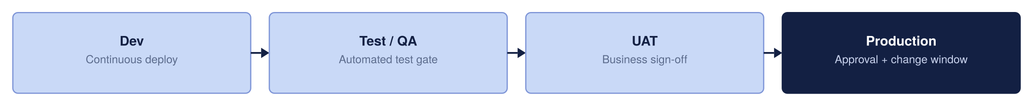
Figure 4: Environment promotion strategy

6.4 Network and Connectivity Design
Two decisions shape the instance design more than anything else: what sits in front of APIM for internet-facing traffic, and how APIM itself sits in the network. We treat both as explicit, reasoned decisions rather than defaults.

Decision 1: what sits in front of APIM
Recommendation: Azure Front Door Premium with WAF for external and partner traffic, giving Chaucer one global hostname and automatic regional failover. Application Gateway v2 with WAF_v2 is the fallback if a future requirement forces traffic to stay inside a single UK region. No edge layer is needed at all for internal-only APIs.
The decision tree below walks the choice of edge service from a single question — is this traffic internet-facing at all — down to a concrete recommendation, weighing the four factors that actually drive the decision for Chaucer: cost, security perimeter, high availability and disaster recovery. The matrix beneath it sets those same four factors side by side so the trade-off is explicit rather than implied.
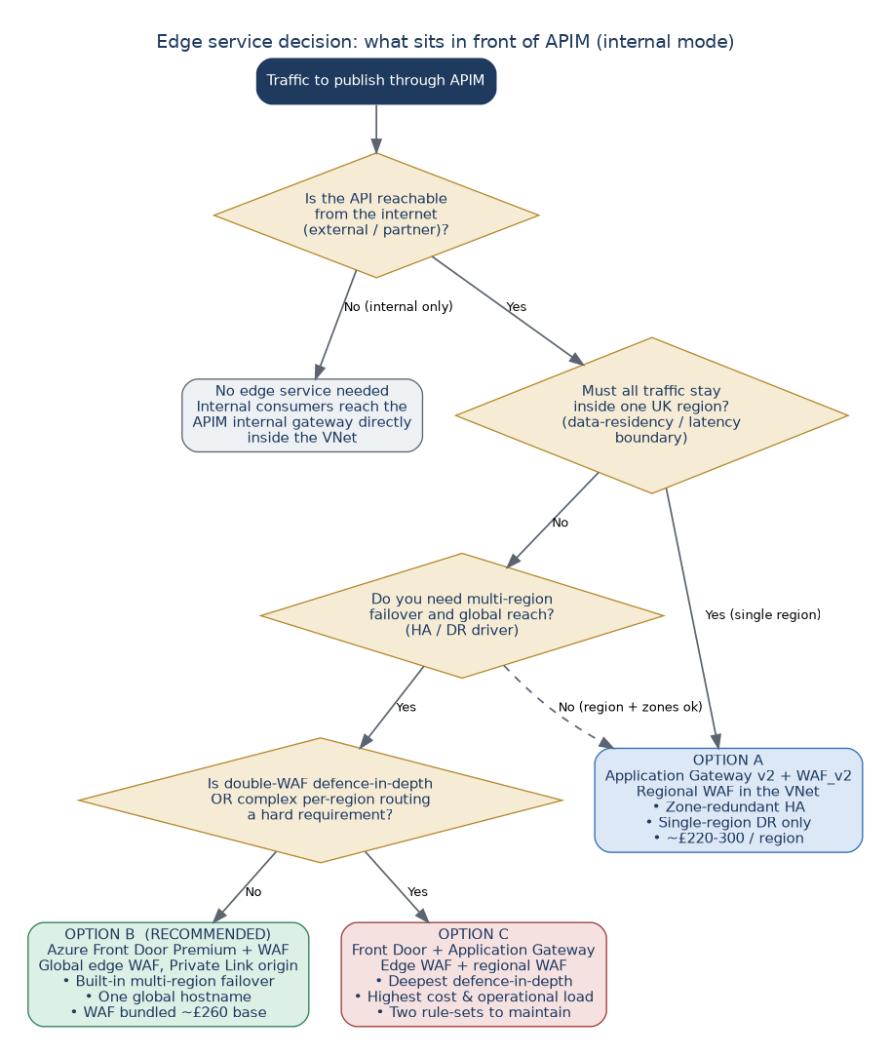
Figure 5: Edge service decision tree — choosing Front Door, Application Gateway, or both, against cost, security, HA and DR
The same four factors, compared directly across the three options:
Factor | Option A: App Gateway + WAF | Option B: Front Door + WAF (recommended) | Option C: Front Door + App Gateway
Cost | Lowest: one regional gateway, WAF billed with App Gateway | Low–medium: WAF bundled in Front Door Premium; no separate WAF bill; avoids region egress | Highest: two WAF-bearing services and two rule-sets to run
Security perimeter | Regional WAF inside the VNet; strong zero-trust in one region | Global edge WAF + DDoS + bot management absorbed before it reaches a region | Deepest: inspected twice, at the edge and again regionally
High availability | Zone-redundant within one region (autoscale across zones) | Global anycast; health-probes origins and routes only to healthy ones | Edge resilience + regional zone redundancy combined
Disaster recovery | Single-region only; needs a global layer added to fail over | Built-in multi-region failover — UK South→UK West automatically | Front Door cross-region failover plus per-region draining
Best fit for Chaucer | Only if all traffic must stay in one UK region | RECOMMENDED — HTTPS API traffic needing edge security + multi-region DR | Held in reserve for a hard double-WAF or complex-routing requirement

Option | Approximate monthly cost | When it earns its cost
Front Door Premium + WAF | Roughly £250 to £400 base, plus usage | Global reach, multi-region failover, one hostname for all partners
Application Gateway v2 + WAF_v2 | Roughly £220 to £300 per region, plus data processing | Single-region deployments, direct control over WAF rule tuning
No edge layer | No additional cost | Internal-only APIs with no internet exposure

Ingress topology options in depth
The edge decision above chooses what sits in front of APIM at a high level. Because it is the decision that most shapes Chaucer's security posture, cost and resilience, this section works through the three concrete ingress patterns in detail. All three share one deliberate choice: APIM itself runs in internal (VNet) mode, so the gateway is never directly exposed to the internet, and something in front of it terminates and inspects public traffic. What differs is what that something is, and where the web application firewall sits.
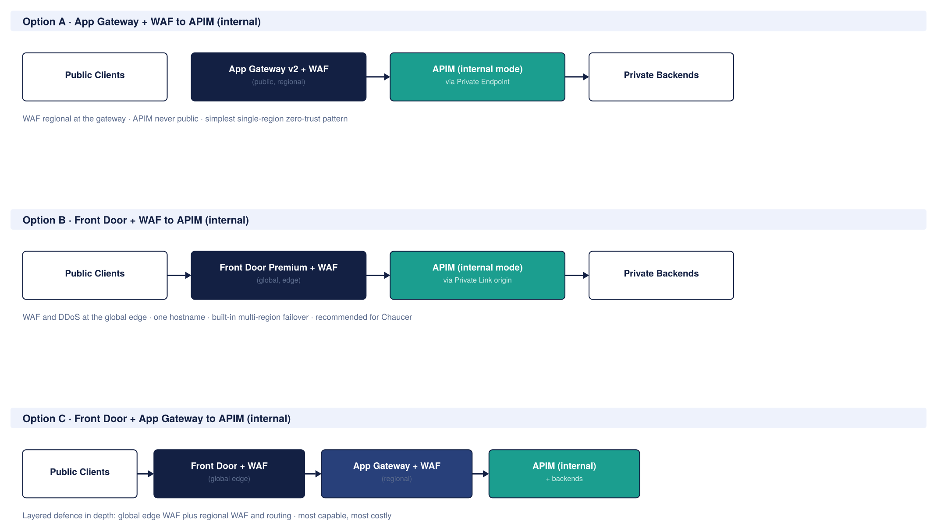
Figure 6: Three ingress options for APIM, all with APIM in internal mode
Option A: Application Gateway with WAF, to APIM in internal mode
Public clients reach an Azure Application Gateway v2 that holds the web application firewall and lives in its own dedicated subnet inside Chaucer's VNet. The gateway terminates TLS, inspects the request against the WAF ruleset, and forwards clean traffic to APIM over a Private Endpoint. APIM runs in internal mode, so it has no public IP at all; only Application Gateway can reach it, and only the intended backends sit behind it.
Security: this is a strong zero-trust regional pattern. The WAF runs the OWASP rulesets and custom rules, APIM is completely private, and unmatched paths can be routed to a dead-end sinkpool so probing traffic never reaches a real endpoint. Application Gateway can also integrate with Azure DDoS Protection Standard on the VNet for network-layer protection. Because the gateway sits inside the VNet, it also gives Chaucer fine-grained, region-local control over routing rules and rewrites.
High availability: Application Gateway v2 is zone-redundant within a region when deployed across Availability Zones, and autoscales with load. Paired with a zone-redundant APIM and zone-redundant backends, the whole regional path survives the loss of a single datacentre with no manual action.
Disaster recovery: this is the pattern's main limitation. Application Gateway is a regional service and cannot load-balance across regions on its own. To achieve multi-region DR with this option, Chaucer would need an Application Gateway in each region with Azure Traffic Manager or Front Door in front to steer between them, which reintroduces the very global-routing layer this option was chosen to avoid. On its own, Option A is a single-region pattern with zone-level HA but no native regional failover.
Option B: Azure Front Door with WAF, to APIM in internal mode
Public clients reach Azure Front Door Premium, a global edge service, which holds the WAF and terminates TLS at the Microsoft edge closest to the caller. Front Door forwards inspected traffic to APIM as a Private Link origin, so again APIM runs in internal mode with no public exposure. This is the pattern this HLD recommends for Chaucer's external and partner traffic.
Security: the WAF and DDoS protection run at the global edge, so malicious and volumetric traffic is absorbed before it ever consumes capacity in a Chaucer region. Front Door Premium's WAF adds bot-management rulesets built on Microsoft threat intelligence, challenging or blocking known-bad bots at the edge. Private Link origin support keeps APIM private while still benefiting from edge inspection. The one thing to design carefully is origin lock-down, so that APIM only accepts traffic from Chaucer's Front Door instance and cannot be reached by bypassing the edge.
High availability: Front Door is a global anycast service that is inherently resilient to the failure of an entire region; it health-probes every origin and routes only to healthy ones. Combined with a zone-redundant APIM, the ingress path has both edge resilience and in-region zone resilience.
Disaster recovery: this is where Option B is strongest. Because Front Door already fronts multiple regional origins and fails over between them automatically, multi-region DR is built in rather than bolted on. A UK South outage moves traffic to UK West with no manual failover and close to zero downtime, which is exactly what the active-active design in section 6.11 relies on. It also gives Chaucer a single global hostname for every partner, and avoids the region-to-internet egress charges that a regional gateway incurs.
Option C: Azure Front Door plus Application Gateway, to APIM in internal mode
The two are layered: Front Door provides the global edge, first-line WAF and regional failover, then hands traffic to a regional Application Gateway that provides a second WAF and sophisticated per-region routing before reaching APIM in internal mode. This is a recognised Microsoft pattern for large, complex estates, not an either-or.
Security: this is the deepest defence-in-depth of the three. A request is inspected twice, once at the global edge and again regionally, so traffic that slips a global rule can still be caught locally, and internal traffic that never touches Front Door is still protected by the regional WAF. For an insurer handling sensitive claims and market data, double inspection is a genuine, if expensive, benefit.
High availability and disaster recovery: Chaucer gets Front Door's cross-region failover and edge resilience together with Application Gateway's zone redundancy and connection draining within each region. The regional layer must itself be made zone-redundant in each region for the pattern to deliver on its promise.
The honest trade-off: Option C is the most capable and the most costly and complex. It runs two WAF-bearing services instead of one, with the operational overhead of maintaining rulesets in both. Microsoft's own guidance is to be sure you genuinely need both layers before committing, and to reserve the regional gateway for cases with real per-region routing complexity or a specific requirement the edge WAF cannot yet meet.
Recommendation and comparison
For Chaucer, Option B (Front Door plus WAF to an internal-mode APIM) is the recommended pattern for external and partner traffic, because all of that traffic is HTTPS API traffic, it benefits from edge security, and the design already depends on Front Door's automatic multi-region failover for DR. Option A remains the right choice if a future requirement forces all traffic to stay inside a single UK region, and Option C is held in reserve for the case where double-WAF defence in depth or complex regional routing becomes a hard requirement. Internal-only APIs need none of these: they reach the APIM internal gateway directly inside the VNet.
Aspect | Option A: App Gateway | Option B: Front Door | Option C: Both
WAF location | Regional, in the VNet | Global, at the edge | Both edge and regional
APIM exposure | Internal (private) | Internal (private) | Internal (private)
DDoS | VNet DDoS Standard | Built-in at the edge | Both
HA | Zones within a region | Global + zones | Global + zones
DR / multi-region | Not native; needs TM/FD on top | Built in, automatic failover | Built in
Global hostname | No | Yes | Yes
Relative cost | Lowest of the three | Moderate | Highest
Best fit | Single-region, zero-trust | Chaucer's default | Complex, high-assurance estates

These recommendations sit on top of the network-mode decision that follows, which determines how APIM is placed in the VNet in the first place.

Decision 2: how APIM sits in the network
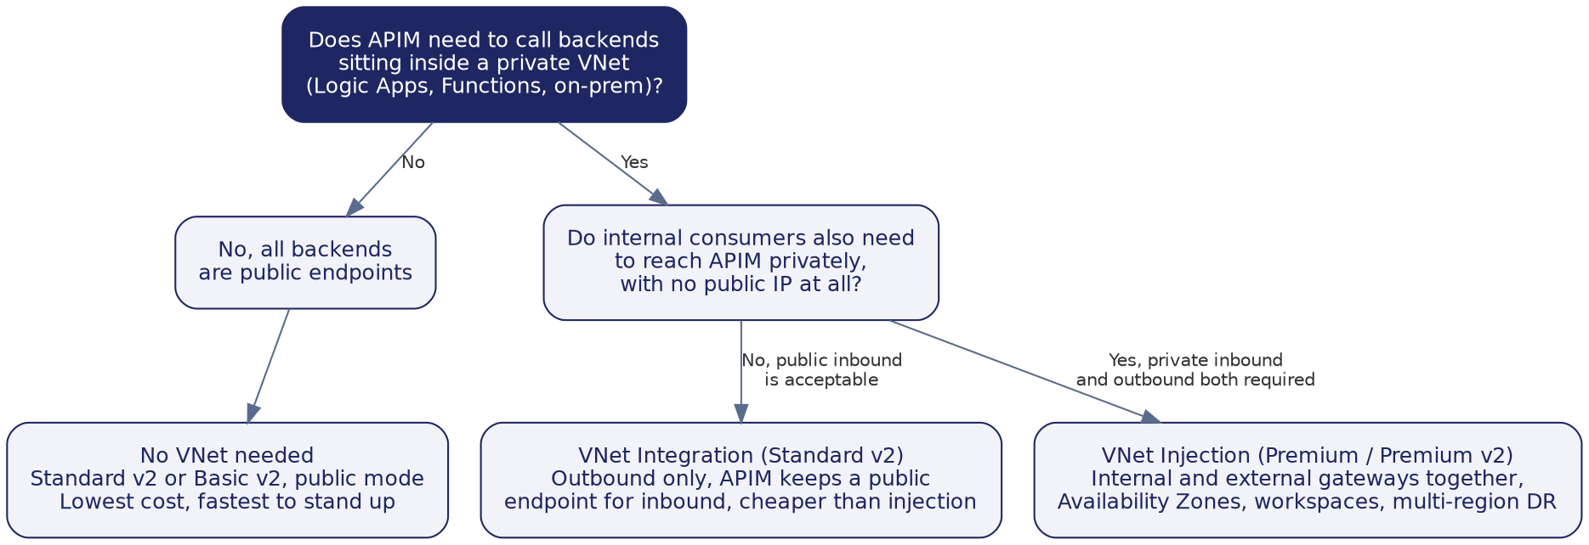
Figure 7: APIM network mode decision tree
Recommendation: VNet Injection on a Premium-class tier. This recommendation assumes Chaucer's backends already sit inside a VNet reachable over Private Endpoint, and that internal consumers need a private path to APIM; both assumptions need confirming against Chaucer's actual landing zone and network topology before this is treated as settled (see the assumptions register in section 8.1). On that basis, Premium is the tier that supports Availability Zones together with workspaces, both of which this design depends on. One thing to confirm early with Microsoft: the newer Premium v2 tier gives VNet injection, zones and workspaces, but at time of writing it does not yet support multi-region deployment or the self-hosted gateway, both of which remain classic Premium features. Because Chaucer's design calls for active-active multi-region (section 6.11), classic Premium is the safer assumption for production until Premium v2 closes that gap.

Classic Premium versus Premium v2: an honest trade-off
Choosing classic Premium is not cost-free in the long run, and the trade-off should be made with eyes open rather than defaulted. Microsoft is directing its feature investment towards the v2 line, so classic Premium, while fully supported today, is the older platform. Standing production up on classic Premium now, to get multi-region on day one, therefore carries a degree of migration debt: if Chaucer later wants to move to Premium v2 (for its newer capabilities or pricing model), that is a migration, not an in-place upgrade, since there is no automated path between the classic and v2 lines. The counter-risk is the opposite: building on Premium v2 today means accepting that multi-region is not yet available, so active-active DR would have to wait until Microsoft ships v2 multi-region parity.
There is a genuine phasing decision here that Chaucer should take deliberately. If active-active multi-region is truly required from day one, classic Premium is the only option that delivers it now, and the migration debt is the price. If, however, a single region with Availability Zone redundancy is acceptable for Phase 1, then starting on Premium v2 single-region avoids the migration debt entirely and lets Chaucer adopt v2 multi-region if and when it lands, with active-passive DR as an interim. This design assumes active-active from day one and therefore recommends classic Premium, but that assumption (A.08 in the register) is exactly the kind that should be confirmed with the business before the tier is locked, because it drives both the platform choice and the cost.
Two developments since this trade-off was first drafted are worth tracking rather than acting on yet. First, Microsoft has begun bringing multi-region capability to workspaces running on the built-in gateway across v2 tiers, which is a narrower feature than full instance-level multi-region on Premium v2 but signals the direction of travel; this does not change today’s recommendation, but the tier decision (A.08 in the assumptions register) should be revisited if Microsoft extends this to the whole Premium v2 instance before build starts. Second, Premium v2 uses a materially simpler network architecture that keeps Azure’s management traffic out of Chaucer’s VNet entirely, which would remove the need for the control-plane bypass route described in section 6.4 if the platform ever moves to v2. That is a genuine, if second-order, argument for revisiting the migration-debt trade-off above: standing up on classic Premium today is not just a pricing and multi-region decision, it also means carrying the extra network complexity that Premium v2 is designed to remove.
Tier | Approximate cost per unit per month | SLA | Supports
Basic v2 / Standard v2, no VNet | roughly £110 to £520 | 99.95% | Public only, cheapest way to start
Standard v2 with VNet Integration | roughly £520 | 99.95% | Outbound private connectivity, availability zones
Premium v2 (VNet Injection) | roughly £2,100 to £2,300 | 99.95%, or 99.99% across zones | Internal + external gateway, workspaces, zones (no multi-region yet)
Classic Premium | roughly £2,100 to £2,300 | 99.95%, or 99.99% across zones | Everything above plus multi-region and self-hosted gateway

These figures are indicative UK South list prices for planning purposes, not a quote; Chaucer's actual enterprise agreement will likely bring these down. Note that Premium v2 and classic Premium sit in a similar price band but are not identical; the exact per-unit figures should be confirmed against the current Azure pricing page before this goes external, since a reviewer with pricing-page access may question the near-equivalence.

Instance configuration
The values below are the proposed target configuration. Custom domain names are illustrative placeholders, and the VNet mode and region choices are proposals to confirm against Chaucer's landing zone and naming standards, not settled facts.
Attribute | Proposed value | Status
Tier | Classic Premium (production) | Proposed
Region | UK South, primary; UK West, secondary | To confirm (data residency)
VNet mode | Internal and external, hybrid | To confirm against landing zone
Custom domain | api.chaucer.com (external), api-internal.chaucer.com (internal) | Illustrative placeholder
TLS | 1.2 minimum | Proposed standard
Managed identity | System-assigned | Proposed

Why both an internal and an external gateway
Running the internal and external gateways from one instance is a deliberate choice with a cost, so it is worth stating the alternative it was weighed against. A single external gateway with IP restriction would be cheaper and simpler, and for a purely internet-facing pilot it could be enough. It was not chosen because Chaucer has genuinely internal consumers that should never traverse a public endpoint, even one IP-restricted: keeping internal traffic on a private gateway inside the VNet removes a class of exposure rather than mitigating it, and satisfies the single-ingress principle without punching internal systems out to the internet and back. The trade-off is that the hybrid instance costs more than a single external gateway. If phase one turns out to have no genuinely-internal consumers, a single external gateway is the cheaper fallback and this decision should be revisited.

Multi-region topology
Both regions run active behind the same Front Door entry point, each with its own APIM gateway and a geo-redundant backend replica. Front Door decides which region serves a given request and moves traffic away from a region automatically if its health probes fail.
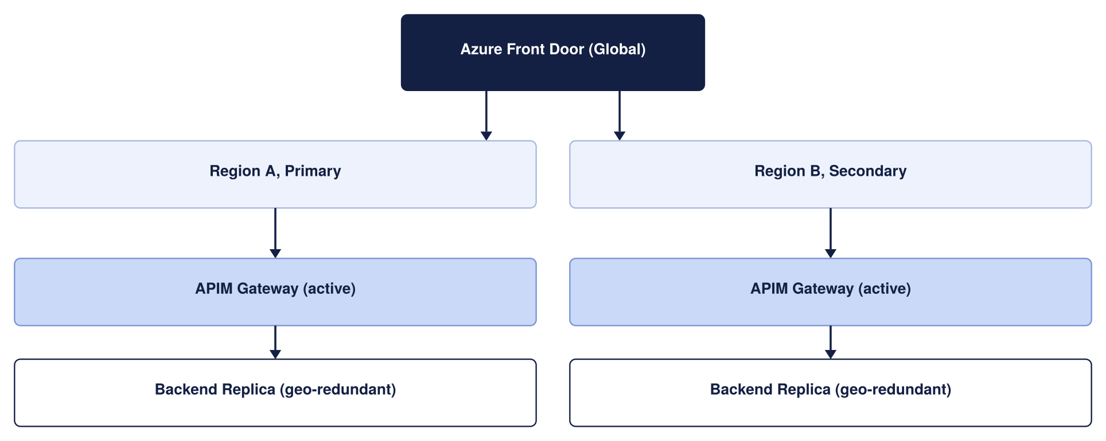
Figure 8: Multi-region APIM architecture
The target design places backends (Logic Apps Standard, Functions, Service Bus) in private subnets reachable only from APIM, using Private Endpoints and network security groups. Front Door or Application Gateway terminates public traffic and forwards only validated requests through to the APIM external gateway; the APIM internal gateway is reachable purely from within the VNet, with no public exposure at all. This describes the intended target state rather than a confirmed picture of Chaucer's current network: the actual VNet layout, private DNS zone ownership, and any forced-tunnelling or NVA egress rules must be validated against Chaucer's landing zone, because they can materially change how APIM reaches each backend. This is the single most important item to verify before detailed design (see section 8.1).
The two diagrams below set out exactly what each traffic type passes through, matching the pattern proven on our reference deployment.
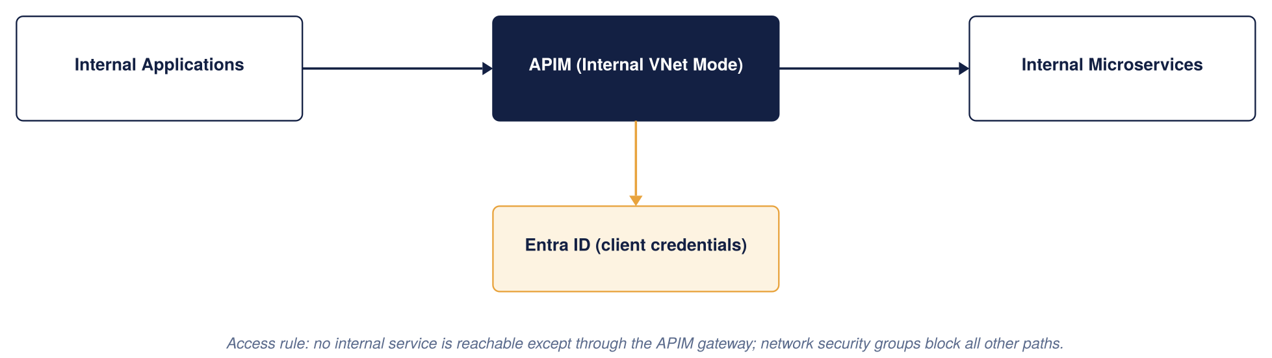
Figure 9: Internal API access model
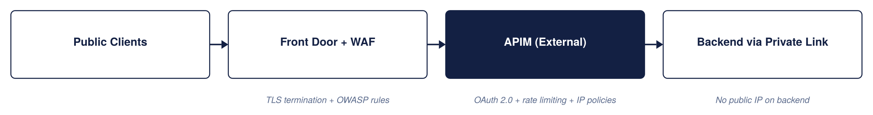
Figure 10: External API access model

Integrating APIM with Chaucer's Palo Alto firewall
Chaucer already operates a Palo Alto firewall as its network inspection point. Under the recommended inbound model (Model A, section “Reconciling the inbound edge”), external and partner traffic enters through Front Door over Private Link and does not traverse the firewall; the Palo Alto remains the inspection and control point for internal inbound traffic, all outbound/egress, and east-west traffic as configured. This section works through those firewall-governed flows; where a flow describes external inbound through the firewall, that is the Model B variant, called out explicitly.
Topology and the guiding principle
The Palo Alto firewall lives in the hub VNet as an NVA behind an internal load balancer. APIM sits in a delegated subnet in a spoke VNet, peered to the hub, and runs in internal mode so its data-plane gateway has a private virtual IP and no public data-plane address. A route table (UDR) on the APIM subnet sends outbound traffic to the Palo Alto for inspection. The guiding principle is that all data-plane traffic to and from APIM is inspected by the Palo Alto, with one deliberate, documented exception, Azure's own control-plane traffic, which must bypass the firewall for APIM to function at all.
That exception is the single most important design point when combining APIM with any NVA, so it is worth stating plainly before the flows: if Azure's management traffic to APIM is force-tunnelled through the firewall, the return path is asymmetric, the stateful firewall drops it, and APIM loses connectivity to the Azure control plane, breaking scaling, updates, and monitoring. The fix is a specific route, covered under the outbound and control-plane flows below.

Reconciling the inbound edge: Front Door (Private Link) versus the firewall (DNAT)
One point must be settled before the individual flows make sense, because the design as previously drafted implied two different inbound paths at once. External traffic cannot both arrive through Front Door over a Private Link origin and be DNAT-inspected by the Palo Alto on the way in — those are two mutually exclusive inbound models, and Chaucer must pick one for external and partner traffic. This section states the choice explicitly; the flows that follow assume it.
Model A — Front Door via Private Link (recommended). Public traffic reaches Azure Front Door at the Microsoft edge, where the WAF, TLS termination and DDoS protection are applied, and Front Door then forwards the request to APIM over a Private Link to an inbound private endpoint. This traffic travels the Azure backbone directly into the APIM spoke; by design it does not traverse the hub Palo Alto. Inbound inspection for external traffic is therefore performed by Front Door’s WAF, not by the firewall, and the origin is locked down so APIM accepts traffic only from Chaucer’s Front Door instance (Private Link approval plus an NSG that denies the internet, plus verification of the X-Azure-FDID header). The Palo Alto remains the inspection and control point for the other flows — internal inbound, all outbound/egress, and any east-west traffic Chaucer chooses to route to it — so nothing about outbound audit or internal zero-trust is weakened; it is only the external inbound leg that Front Door owns.
Model B — Front Door to a firewall public origin (only if policy mandates NGFW inspection of inbound). If Chaucer’s security standard requires the Palo Alto to inspect inbound external traffic as well, then Front Door must target a public-IP origin that is the firewall’s public VIP, which DNATs to the APIM internal gateway. Here the firewall is in the inbound path and traffic is inspected twice (Front Door WAF at the edge, NGFW in the region), at the cost of losing Private Link, having to lock the firewall’s public IP to Front Door service tags and the X-Azure-FDID header, and added operational complexity. This is the double-inspection variant of Option C from section 6.4, not the default.
A compatibility note to confirm at build time: routing Front Door to an internal-mode classic Premium instance over an inbound private endpoint depends on the specific tier and network-mode support in force at build time, which Microsoft has been actively extending (inbound private endpoints, and workspaces on the built-in gateway with Private Link, have both moved forward recently). Chaucer should validate the exact Front Door → Private Link → internal APIM path against the current Azure capability for the chosen tier before locking the network design. If it is not available for the chosen tier at build time, Model B is the fallback.
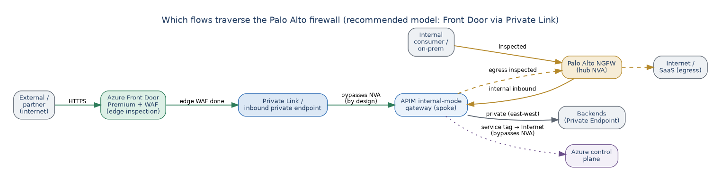
Figure 11: Which flows traverse the Palo Alto — external inbound via Front Door/Private Link bypasses the NVA by design; internal, egress and control-plane flows are unchanged
Summary of which flows traverse the firewall under the recommended model:
Traffic flow | Through Palo Alto? | How it is secured
External inbound (via Front Door) | No — bypasses the NVA by design | Front Door WAF at the edge; origin locked to Front Door (Private Link + NSG + X-Azure-FDID)
Internal inbound | Yes | Palo Alto inspects and forwards to the APIM internal VIP
Outbound / egress (APIM → internet/SaaS) | Yes | Forced-tunnel UDR to the Palo Alto; egress + URL-filtering policy
APIM → private backends (east-west) | Optional | Private Endpoint + NSG by default; /32 UDR to firewall only if policy requires
Azure control plane | No — must bypass | ApiManagement service tag UDR next-hop Internet (mandatory, section below)

Flow 1: external inbound (external to internal)
Scope note: this flow is the firewall-inspected inbound path. It always applies to internal inbound traffic, and it applies to external inbound only under Model B above. Under the recommended Model A, external and partner traffic instead enters through Front Door over Private Link and does not traverse the Palo Alto — so read the description below as the internal-inbound path, and as the external-inbound path only if Chaucer adopts Model B.
An external consumer, a broker or Lloyd's market system, reaches Chaucer over the internet. Traffic lands on the Palo Alto's public interface, where a destination NAT (DNAT) rule and the threat-prevention and URL-filtering policies inspect it, then forwards it to APIM's internal gateway private VIP in the spoke. Because APIM is internal-mode, it is never directly reachable from the internet; the only way in is through the Palo Alto. If Chaucer also wants a WAF at the edge, Azure Front Door or Application Gateway (per the ingress options in section 6.4) can sit in front of the Palo Alto or in the hub, adding OWASP inspection on top of the firewall's own.
- Palo Alto: DNAT rule mapping the public listener to the APIM internal VIP, with security policy allowing only the intended ports (443).
- APIM subnet NSG: allow inbound from the hub/firewall subnet on 443; deny direct internet inbound.
- Return path: the response follows the established firewall session back out, so no asymmetric-routing issue arises for this inspected data-plane flow.
Flow 2: internal inbound (internal to APIM)
An internal Chaucer system, or an on-premises system reaching Azure over ExpressRoute or VPN, calls an internal API. The call is routed to the Palo Alto (either directly in-hub or via the on-premises firewall path), inspected, and forwarded to the same APIM internal VIP. Internal consumers never bypass the gateway: the design treats an internal call exactly like an external one for inspection and authentication, in line with the zero-trust principle in the security section. For on-premises sources, gateway route propagation must be enabled so the return path stays symmetric.
Flow 3: outbound (internal to external)
When APIM or a backend needs to call out, to a public SaaS provider such as Salesforce, or to any internet endpoint, that traffic must be inspected on the way out. A UDR on the APIM subnet with destination 0.0.0.0/0 and next hop set to the Palo Alto's internal load-balancer IP forces all outbound data-plane traffic through the firewall, where egress policy and threat prevention apply. This is the flow that gives Chaucer the outbound inspection and audit it runs the Palo Alto for in the first place.
- APIM subnet UDR: 0.0.0.0/0 with next hop = Palo Alto internal LB IP (forced tunnelling).
- Palo Alto: outbound security and URL-filtering policy for the destinations APIM is permitted to reach; SNAT as required.
- Credentials for SaaS calls stay in Key Vault-backed named values; the firewall controls the path, not the secret.
Flow 4: APIM to private backends
Calls from APIM to backends that live inside Chaucer's own network, Logic Apps Standard, Functions, or PaaS reached over Private Endpoint, stay on the private network. These do not need to traverse the Palo Alto to reach the internet, since they never leave Azure's backbone. If Chaucer's security standard requires even east-west private traffic to be inspected, Private Endpoint traffic can be forced to the firewall with a /32 UDR per endpoint, at the cost of route-table management; most designs inspect north-south (internet-facing) traffic at the firewall and rely on NSGs and Private Link for east-west, which is the approach recommended here unless Chaucer's policy says otherwise.
Flow 5: the control-plane exception (mandatory)
Azure manages APIM over a control-plane channel using the ApiManagement service tag. This traffic uses Azure's own public IP ranges, so if it is force-tunnelled through the Palo Alto the responses do not map symmetrically back and the stateful firewall drops them. The required, Microsoft-documented configuration is a UDR on the APIM subnet for the ApiManagement service tag with next hop set to Internet, so control-plane traffic bypasses the firewall. Microsoft is explicit that allowing this management traffic to bypass the NVA is not a significant security risk, because it is Azure's own management channel, not Chaucer's data. The same bypass applies to the platform dependencies APIM needs (Azure Monitor, Storage, Key Vault, and similar), which should be allowed by service tag rather than by IP.
Required routing and firewall summary
Pulling the flows together, the concrete configuration is:
Path | Where enforced | Rule
External inbound | Palo Alto (hub) | DNAT public listener to APIM internal VIP; allow 443 only
Internal inbound | Palo Alto / on-prem FW | Inspect and forward to APIM VIP; enable gateway route propagation
Outbound to internet | APIM subnet UDR + Palo Alto | 0.0.0.0/0 next hop = firewall LB IP; egress policy on the firewall
APIM to private backend | NSG + Private Endpoint | Private path; optional /32 UDR to firewall if east-west inspection required
Control plane (mandatory) | APIM subnet UDR | ApiManagement service tag next hop = Internet (bypass firewall)
Platform dependencies | APIM subnet UDR / NSG | Allow AzureMonitor, Storage, Key Vault, etc. by service tag

Two failure modes to design out explicitly: asymmetric routing, prevented by the control-plane and dependency bypass routes above and by keeping the inbound DNAT return path on the firewall session; and route-table sprawl, avoided by using service tags rather than long lists of individual IP routes. With those in place, Chaucer keeps its existing Palo Alto as the single inspection and egress-control point for all of APIM's data-plane traffic, while APIM stays healthy on Azure's control plane.

Subnet sizing (to confirm against the landing zone)
Sizing the APIM delegated subnet and its neighbours correctly the first time avoids a disruptive resize later, since an Azure subnet cannot easily be shrunk or re-carved once resources are deployed into it. The figures below are starting points for detailed design, not a final IP plan; the actual VNet address space must come from Chaucer’s IPAM and hub-spoke allocation.
Subnet | Minimum size | Why
APIM delegated subnet (classic Premium, VNet injection) | /27 (32 addresses) per region as an absolute floor; /26 recommended | Classic Premium reserves a block of addresses per scale unit and for platform use; a /27 leaves little headroom for adding units, so /26 is the safer planning default
Application Gateway subnet (if Option A/C is used) | /26 recommended, /27 minimum | Autoscaling instances each consume an address; undersizing blocks scale-out under load
Palo Alto internal load balancer / hub subnet | Per Chaucer’s existing hub design | Owned by the network team; not part of this HLD’s sizing, referenced here for completeness
Private Endpoint subnet(s) for backends | /27 per subnet is usually sufficient | One address per Private Endpoint; size to the number of backend services expected, with headroom
This is flagged as an open item because it depends on facts this HLD does not have: the actual hub-spoke address plan, whether Chaucer reserves address space per environment or per region, and how many scale units Production is expected to reach. It should be resolved alongside the landing-zone validation already called out as the top item in the assumptions register (section 8.1, A.02 and A.03).

Required network artefacts and the asymmetric-routing gate
Section 6.4 sets the topology; this checklist is what a network engineer needs to produce the detailed design without re-deriving it. It also names the one failure mode that must be handled explicitly, because getting it wrong silently breaks the platform.
The non-negotiable gate: the APIM control-plane bypass. When APIM is injected into a VNet and outbound traffic is force-tunnelled through the Palo Alto, the return path for Azure’s own management traffic to the APIM management endpoint (port 3443) no longer maps back symmetrically. This asymmetric routing drops the management connection and, left unaddressed, breaks configuration, scaling and health of the instance. The documented fix is mandatory: a user-defined route for the ApiManagement service tag with next hop set to Internet, which steers that control-plane return traffic straight back to Azure rather than through the firewall. Microsoft is explicit that allowing this management traffic to bypass the NVA is not a meaningful security risk. This UDR is a required build artefact, not an optimisation, and should be treated as a design gate that TDA checks for.
Network artefact | Requirement | Owner
UDR — control-plane bypass | Route for ApiManagement service tag, next hop = Internet (MANDATORY — prevents the asymmetric-routing failure above) | Network
UDR — egress | Default route 0.0.0.0/0 → Palo Alto for outbound inspection and URL filtering | Network
UDR — east-west (optional) | /32 route to the firewall only if policy requires PE traffic to be inspected; otherwise Private Endpoint + NSG is the default and east-west does not traverse the NVA | Network + Security
NSG — management | Allow inbound TCP 3443 from the ApiManagement service tag only (use the service tag, not hard-coded IPs, which change) | Network
NSG — gateway | Allow 443 from permitted sources only (Front Door Private Link subnet under Model A, or internal ranges); deny the Internet service tag | Network
NSG — load balancer | Allow inbound from the AzureLoadBalancer service tag | Network
DNAT (Model B only) | Palo Alto public VIP → APIM internal gateway private VIP, locked to Front Door service tags + X-Azure-FDID | Network
Private DNS | Do NOT create a Private DNS zone for azure-api.net. Create explicit A records mapping each APIM endpoint FQDN to the private VIP, resolvable from all VNets and on-prem networks that need access | Platform + Network
Backend DNS resolution | Azure Private DNS Resolver with forwarding rulesets for APIM-to-on-prem backend name resolution | Network
ExpressRoute / VPN return-path symmetry | Ensure symmetric routing for on-prem consumers reaching the internal VIP — UDRs and firewall rules must be consistent on both the Azure and on-prem sides so return traffic follows the forward path | Network
IP plan (placeholder for the network team). Subnet sizing must be validated against Chaucer’s IPAM and expected scale. As a planning rule, one Premium unit in internal mode consumes about three subnet IPs (one private VIP plus one per gateway VM), and each additional scale unit consumes more, so the subnet must leave headroom for the maximum unit count the region will ever run; backends should allow-list the whole APIM subnet rather than individual instance IPs, which change on scale-out. A dedicated /26 per region is the recommended default, to be confirmed below.
Subnet (indicative name) | Purpose | Suggested size | Address range
snet-apim-prod-uksouth | APIM injection (internal mode), UK South | /26 (default) | To confirm vs IPAM
snet-apim-prod-ukwest | APIM injection (internal mode), UK West | /26 (default) | To confirm vs IPAM
snet-pe-backends-* | Private Endpoints for Logic Apps / Functions / Service Bus | /26 | To confirm vs IPAM
snet-frontdoor-pl-* | Front Door Private Link (Model A) | /27 | To confirm vs IPAM
hub firewall subnets | Palo Alto NVA (trust / untrust / mgmt) | Per vendor guidance | Owned by Network

6.5 Traffic Management and Edge Security
The edge and global-routing design, including the choice of Azure Front Door over Traffic Manager and the ingress topology options, is set out within the network design in section 6.4 (see the ingress options and the Front Door versus Traffic Manager comparison). In summary: Azure Front Door Premium with WAF provides the global entry point, edge security and automatic multi-region failover for external and partner traffic; the Palo Alto firewall provides network inspection; and APIM runs in internal mode behind them.

6.6 Authentication and Security Design
Security is the highest priority in this design. It is checked at every hop, never assumed at the backend, and never granted just because a call came from inside Chaucer's network.

Security architecture: defence in depth at a glance
Before the individual controls, the diagram below sets out the security architecture as a whole: seven layers, each owning a distinct job, that an inbound request passes through before any backend is reached. This is the standard Azure defence-in-depth pattern for a private-mode APIM behind an edge WAF, and it is the frame the rest of this section fills in. No single layer is a substitute for another; the security of the platform is the composition of all seven.
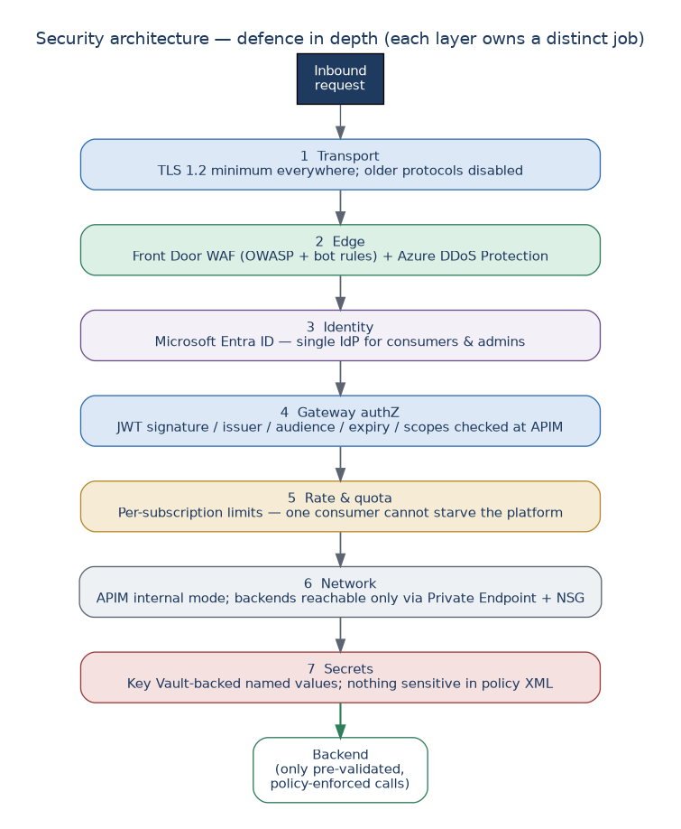
Figure 12: Security architecture — seven defence-in-depth layers from transport to secrets

Security design principles and residual risk
The controls in this section all serve a small set of principles, stated here so a reviewer can see the intent behind them: verify every hop (nothing is trusted because it came from inside the network); defence in depth (no single control is load-bearing); least privilege (consumers, pipelines and admins get the minimum access needed); deny by default and secure by default (APIs are private and authenticated unless a decision is made otherwise); one identity provider (Entra ID for consumers and administrators alike); everything as code (security configuration is reviewed and version-controlled, never hand-set in Production); and secrets never in code (Key Vault-backed named values only).
No design removes all risk. The residual risks below are the ones that remain after the controls, with the compensating measure and the owner who carries them — this is deliberately explicit so nothing is presented as fully solved when it is not.
Residual risk | Why it remains | Compensating control | Owner
Backend object-level authorization (BOLA) cannot be enforced at the gateway | APIM validates identity and passes claims, but only the backend knows its own object model | Mandatory backend-authorization standard, code review and contract tests per API | Domain teams
Non-OAuth exception consumers weaken the single-IdP model | Some partners cannot support OAuth 2.0 | mTLS or IP allow-list plus short-lived rotating secret; time-boxed, reviewed exception (below) | Security
Compliance mapping not yet independently verified | Chaucer control catalogue not cross-checked against this design | Compliance sign-off of the control-to-evidence matrix before go-live | Compliance
Capacity behaviour under real peak load unproven | Chaucer peak requests-per-second not yet provided | Load test before go-live; capacity-metric autoscale with headroom | Platform
Single ingress concentrates blast radius | A shared platform is a bigger target than scattered endpoints | Rate limits, workspace isolation, multi-region, WAF/DDoS, break-glass runbook | Platform + Security

Threat model: STRIDE and the OWASP API Security Top 10
The design has so far been described control by control; this maps those controls to two recognised frameworks so gaps are visible. The STRIDE view covers platform-level threat categories; the OWASP API Security Top 10 (2023) view covers the API-specific risks Compliance and Security will expect to see addressed. Where a risk can only be closed at the backend, that is stated plainly rather than implied to be handled at the gateway.
STRIDE category | Example threat | How this design addresses it
Spoofing | A caller impersonates a legitimate consumer | Entra ID OAuth 2.0 + JWT validation at the gateway; single IdP; mTLS/certificate for approved exceptions
Tampering | Request or response altered in transit | TLS 1.2+ end-to-end; Front Door WAF; request schema validation
Repudiation | A caller denies an action they performed | Correlation IDs on every request; per-consumer logging to Log Analytics/SIEM; immutable audit trail
Information disclosure | Sensitive data leaks to an unauthorised party | Least-privilege products/scopes; payload logging off by default with redaction; Private Endpoints; no secrets in policy
Denial of service | The platform is overwhelmed | Front Door DDoS + WAF; per-subscription rate limits and quotas; capacity-based autoscale
Elevation of privilege | A caller gains access beyond their grant | Product/group-scoped access and scopes; backend function/object-level checks; RBAC on the control plane; logged break-glass
OWASP API risk (2023) | How this design mitigates it | Primary owner
API1 Broken Object Level Authorization | Backend must authorize each object; APIM forwards validated identity/claims but cannot authorize objects itself | Domain teams
API2 Broken Authentication | Entra ID OAuth 2.0; JWT signature/issuer/audience/expiry validated at the gateway; no anonymous production APIs | Platform + Identity
API3 Broken Object Property Level Authorization | Response field filtering/schema validation in policy where applicable; backend enforces property-level access | Domain teams
API4 Unrestricted Resource Consumption | Per-subscription rate limit and quota; payload size limits; timeouts; autoscale | Platform
API5 Broken Function Level Authorization | Product/group scoping and JWT scopes; backend enforces function-level authorization | Platform + Domain
API6 Unrestricted Access to Sensitive Business Flows | Tighter per-flow rate/quota and Front Door bot protection on sensitive flows | Platform + Domain
API7 Server-Side Request Forgery | Backend URLs are allow-listed, never user-controlled; egress inspected by the firewall | Domain + Network
API8 Security Misconfiguration | Everything-as-code (APIOps); baseline policies; WAF managed rules; no portal edits in Production | Platform
API9 Improper Inventory Management | Central catalogue and developer portal; lifecycle/audience tagging; versioning + deprecation; single ingress prevents shadow APIs | Platform
API10 Unsafe Consumption of APIs | Validate, schema-check and time-limit calls to third-party APIs; TLS; circuit-breaking | Domain teams

Data classification, payload logging and PII
Because the platform carries claims and policy data, how it treats that data in transit and in logs matters as much as who can call it. The position is: classify what flows, do not log message bodies by default, and keep operational metadata free of personal data.
Classification. Traffic is treated by sensitivity tier — public/reference, internal, confidential (personal data), and restricted (special-category or highly sensitive claims data). The tier drives logging, masking and which products may carry it; each API is tagged with its highest data classification at onboarding.
Payload logging and redaction. Request and response bodies are not logged by default. Where a body must be captured for diagnostics, sensitive fields are masked in policy before the entry is written, and verbose payload logging is time-boxed and never left on in Production. Headers that can carry tokens or secrets (Authorization, subscription keys) are excluded from logs.
Correlation IDs and retention. Correlation IDs are opaque identifiers and must not embed personal data (no email, policy or customer numbers). Logs and traces are retained for a defined period aligned to Chaucer’s policy and UK GDPR data-minimisation — long enough for investigation and audit, no longer — with the exact retention confirmed with Compliance and recorded against the observability design (6.10).

Exception process for non-OAuth consumers
OAuth 2.0 with Entra ID is the default and the expectation. Where a partner genuinely cannot support it, an exception is allowed but governed — the point of the process is that exceptions are deliberate, compensated, time-boxed and reviewed, not permanent quiet workarounds.
Aspect | Requirement
Who approves | Joint approval by the Security lead and the API Platform lead — not the requesting team alone
Compensating controls required | mTLS or a strict IP allow-list, plus a short-lived secret with enforced rotation; least-privilege product scope
Maximum validity | Time-boxed (recommended 12 months) — an exception expires and must be re-approved, it does not roll over silently
Review cadence | Reviewed at least quarterly against continued need and the partner’s ability to move to OAuth
Record | Logged in a standing exception register with owner, justification, controls, approval date and expiry; referenced in the assumptions register (A.04)
Exit | Each exception carries a target date and named owner for moving the consumer onto OAuth

The diagram below adapts Microsoft's Protect APIs with Application Gateway and API Management reference architecture, showing how external and internal traffic are split at the edge before either ever reaches APIM.
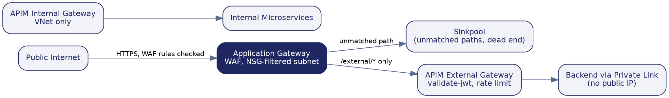
Figure 13: Edge routing pattern, adapted from Microsoft's Protect APIs with Application Gateway and API Management reference architecture

How each consumer type proves who they are
Consumer | How they authenticate | Backup control
Broker or partner | OAuth 2.0 token from Entra ID, validated on every call | Subscription key, IP allow-list where fixed egress IPs exist
Lloyd's market system | OAuth 2.0, with mutual TLS where the market requires certificate-based trust | Subscription key
Internal Chaucer system | Managed Identity, no secret ever stored or typed | Entra ID conditional access on the calling service
Inbound webhook from a vendor | Shared secret header, checked against Key Vault | IP allow-list restricting the source range

OAuth 2.0 flow at the gateway
Client credentials and authorization code flows are both enforced at the gateway using tokens issued by Entra ID. The backend never sees or validates a raw credential, only a pre-verified, policy-enforced token.
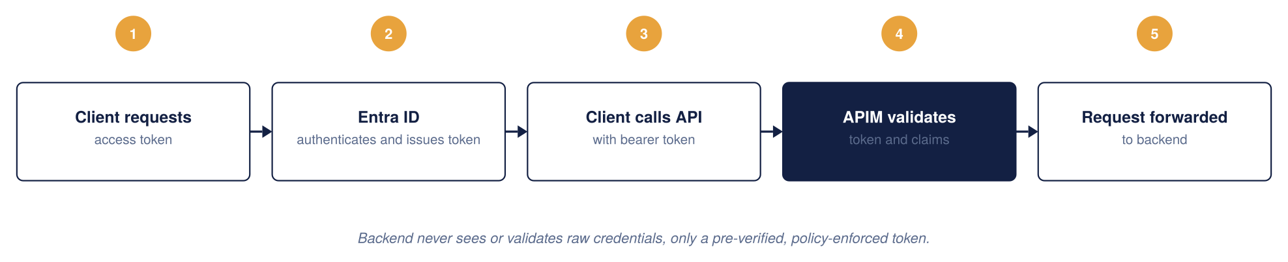
Figure 14: OAuth 2.0 architecture

JWT validation at the gateway
Every request is checked against four things before it is allowed through: signature, issuer and audience, expiry, and required claims or scopes. A failure on any of them is rejected with a 401 at the gateway; it never reaches the backend.
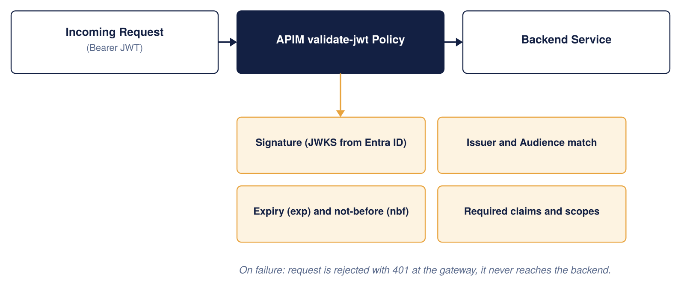
Figure 15: JWT validation architecture

Entra ID as the single identity provider
The same identity provider covers both API consumers and platform administrators, so there is one place, not two, where identity is managed.
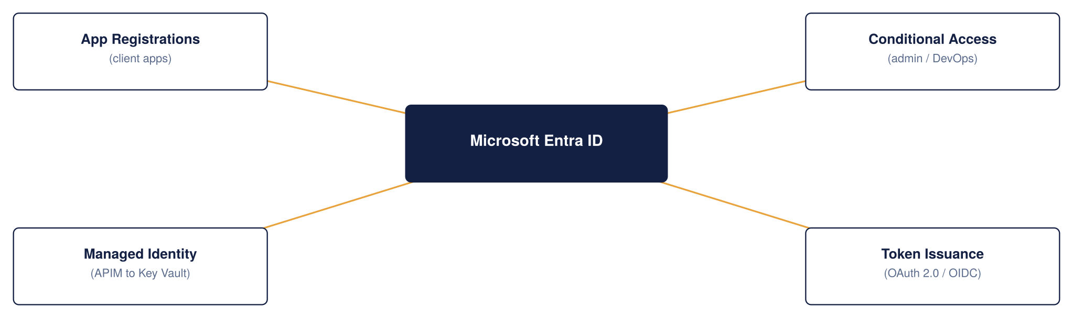
Figure 16: APIM and Entra ID integration

Secrets and certificate management
Azure Key Vault is the single source of truth for every secret, certificate, and key APIM depends on. Certificates rotate automatically; nothing sensitive is ever written into a policy file.
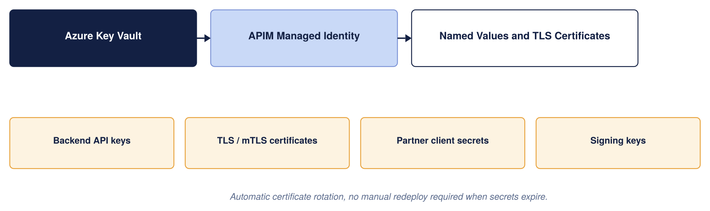
Figure 17: Secrets and certificates management

Which control owns what
These controls are layered deliberately, and they are not interchangeable. Each owns a distinct job, and the security of the whole depends on each doing its own rather than being treated as a substitute for another. The table makes the boundaries explicit so no control is assumed to cover a gap it does not.
Control | Primary responsibility
Microsoft Entra ID | Identity and authentication
OAuth 2.0 / JWT | Authorisation context per request
APIM | API gateway and policy enforcement
WAF (Front Door / App Gateway) | HTTP and API-layer attack protection
Azure DDoS Protection | Volumetric and network DDoS
Azure Firewall / NVA | Network segmentation and egress control
Private Endpoint | Private connectivity to backends
Chaucer SIEM | Detection and investigation
APIM policies | Rate limits, quotas, validation, transformation

Partner and external identity
"External" is not one thing, and the identity model needs to reflect that. Chaucer's external consumers span brokers, Lloyd's ecosystem participants, strategic partners, suppliers and third-party service providers, and these do not all fit a single pattern. The design's default is to represent partner organisations as Microsoft Entra External ID (B2B) identities where they can support it, with per-partner app registrations and subscriptions so access is granted and revoked per organisation. Where a partner cannot use Entra, a brokered or federated identity, or a certificate-based (mTLS) trust, is handled as an approved exception. The open questions this raises, who owns partner onboarding, who registers partner applications, and who rotates and revokes partner credentials, are recorded in the assumptions register (A.04 and the identity items) because they need Chaucer's identity team to confirm rather than the design to presume.

Identity resilience and break-glass
Because the design leans heavily on Entra ID, it must also say what happens when Entra ID, or normal administrative access, is unavailable. This is a deliberate operational design point, not an afterthought. The platform needs a documented break-glass process: a small number of emergency-access accounts held outside the normal flow, with their use alarmed and audited, so the platform can still be operated during an identity-provider outage without weakening the everyday model. Alongside this, the design must track certificate and secret expiry proactively (the 30-day certificate-expiry alert in section 6.10 is part of this), define partner-credential revocation, and own the application-registration lifecycle. The specifics of Chaucer's break-glass standard need confirming with the identity and security teams; the requirement is stated here so it is not missed.

Important policy snippets
The standard reusable policy fragments (OAuth/JWT validation, per-subscription rate limit and quota, and managed-identity backend authentication) are held once in Appendix 9.6 and referenced from here rather than repeated. The one fragment kept inline is the non-OAuth exception pattern, because it belongs with the exception process above:

Restrict an inbound webhook to a known partner IP range and a shared secret. Note that shared-secret and IP-allowlist authentication is an approved exception pattern, not a peer of OAuth: it is used only where a partner genuinely cannot support anything stronger. The preferred order is OAuth 2.0 where supported, then mutual TLS where appropriate, then a signed HMAC webhook signature, and only then a shared secret plus IP restriction. Wherever the shared-secret pattern is used, the design still requires defined secret rotation, revocation, replay protection, monitoring and a named owner.
<inbound>
<ip-filter action="allow">
<address-range from="203.0.113.0" to="203.0.113.255" />
</ip-filter>
<check-header name="x-api-key" failed-check-httpcode="401"
failed-check-error-message="Unauthorised: missing API key.">
<value>{{webhook-api-key}}</value>
</check-header>
</inbound>

Regulatory and compliance alignment
The alignment above is deliberately honest that it is not yet Chaucer-verified. To make it something Compliance can actually sign rather than a narrative, the matrix below restates it as control area → Azure capability that delivers it → evidence artefact that proves it → owner. It is still proposed until Compliance confirms it against Chaucer’s own control catalogue, but it is now in a form that can be confirmed line by line.
Control area (regulatory driver) | Azure capability | Evidence artefact | Owner
Access control & authentication (FCA SYSC; UK GDPR) | Entra ID OAuth 2.0, gateway JWT validation, control-plane RBAC | Entra sign-in/audit logs; policy config in Git; access-review records | Identity + Compliance
Encryption in transit (UK GDPR; Lloyd’s) | TLS 1.2+, Front Door, Private Endpoints | TLS/WAF configuration export; Private Endpoint inventory | Platform + Security
Audit & traceability (FCA; PRA operational resilience) | Log Analytics, App Insights, correlation IDs | Retained gateway logs; SIEM ingestion evidence; sample correlation-ID traces | Platform + Security
Threat protection | Front Door WAF, Azure DDoS, Defender for APIs | WAF rule set and logs; Defender for APIs findings report | Security
Availability & operational resilience (PRA; Lloyd’s) | Multi-region active-active, availability zones, Front Door failover | DR test reports; SLA evidence; TDA architecture sign-off | Platform
Secrets management | Key Vault-backed named values | Key Vault RBAC/access policy; secret-rotation records | Platform + Security
Data residency (UK GDPR) | UK South / UK West only | Region configuration; Azure Policy allowed-locations assignment | Platform + Compliance
Change control (FCA SYSC) | APIOps, pull-request review, approval gates | PR history; pipeline approval records | Platform
Data minimisation & PII (UK GDPR) | Payload logging off + redaction; data classification | Logging-policy configuration; DPIA reference | Compliance + Security
This matrix is the artefact Compliance signs; the regulatory references are indicative and must be reconciled with Chaucer’s obligations register before go-live.
As a Lloyd's market insurer, Chaucer operates under FCA and PRA regulation and, for market-facing integrations, Lloyd's own requirements, alongside UK GDPR for personal data. This design does not attempt to certify compliance, which is Chaucer's responsibility and a detailed-design activity, but it is built to support the controls those regimes expect. The table below maps each obligation to how the platform is positioned to meet it, and, honestly, to what still needs Chaucer input. This is the area of the design most dependent on Chaucer's own standards, and it should be treated as a set of requirements to confirm rather than settled controls.
Obligation | How the design supports it | Still needed from Chaucer
Data residency (FCA/PRA, UK data) | Primary and secondary regions both in the UK (UK South, UK West); no data leaves the UK by default | Confirm UK-only residency is sufficient and that no backend or SaaS dependency egresses data abroad
Personal data protection (UK GDPR) | TLS 1.2 in transit; payload masking possible at the gateway; PII kept out of verbose logs (Dev-only tracing) | Data Protection Impact Assessment; confirm what PII flows through which APIs
Audit trail and retention | Every request logged with a correlation ID; security events routed to Chaucer's SIEM | Confirm required retention periods against FCA/PRA record-keeping rules
Access control and segregation of duties | Entra ID identity for every consumer and admin; workspace-scoped RBAC; APIOps change approvals | Map to Chaucer's existing joiner-mover-leaver and SoD policies
Lloyd's market trust | Mutual TLS available where the market requires certificate-based trust; per-partner subscriptions and revocation | Confirm specific Lloyd's connectivity and certificate requirements per counterparty
Operational resilience (PRA/FCA) | Zone-redundant HA and multi-region DR with stated RTO/RPO targets | Agree RTO/RPO against Chaucer's operational-resilience impact tolerances

The honest position is that compliance is the least Chaucer-verified part of this HLD: the platform is designed to make these controls achievable, but none can be signed off without Chaucer's compliance and data-protection teams confirming the specifics. This is called out again in the assumptions register (section 8.1).
For detailed design, the control set maps to Azure capabilities and the evidence each would produce, so that compliance can be demonstrated rather than asserted:
Requirement | Control | Azure capability | Evidence
Data residency | Approved-region policy | Azure Policy, UK regions | Policy compliance report
API authentication | Strong authentication | Entra ID, OAuth 2.0 | App registration and token config
Audit trail | Full request logging | APIM diagnostics, Log Analytics | Log query evidence
Security monitoring | Detection and alerting | Chaucer SIEM | Alert and incident records
Access control | Least privilege | RBAC, Managed Identity | RBAC assignment export
Network isolation | Private access only | Private Endpoint, NSG, Firewall | Network config evidence
Availability | Resilience | Availability Zones, multi-region | DR test results

6.7 API Product, Consumer and Developer Portal Model
Once APIM is live, Chaucer needs a way for different teams to manage their own APIs without stepping on each other, while the platform team keeps one place to see and control everything. Workspaces, products, subscriptions, and groups fit together like a filing cabinet: workspaces are the drawers, products are the folders, subscriptions are the individual keys handed out, and Entra ID groups decide who can open which drawer.

Choosing each layer: a clear strategy for Products, Consumers and the Portal
The three constructs answer three different questions. Kept in that order — products first, then consumer access, then the portal that exposes them — the model stays clean as the estate grows.
Products — decide by consumer class, not by API. A product is the unit a consumer subscribes to, so define one product per class of consumer (for example External Broker, External Market, Internal Core Systems), bundle only the APIs that class may call, and attach the class-wide rules (rate limits, quota, approval model) at product level. The test for “do we need a new product?” is “is this a distinct audience with distinct access rules?” — if yes, new product; if no, add the API to an existing one.
Consumers — govern through Entra ID groups and per-application subscriptions, never through local APIM users. Represent each consuming organisation or team as an Entra ID group, issue one subscription (key) per consuming application so access can be revoked in isolation, and let product visibility follow group membership. This is what keeps Chaucer’s existing joiner-mover-leaver process authoritative: access is added and removed in Entra ID, and APIM follows automatically.
Developer portal — treat it as the single self-service surface and curate what each audience sees. Enable Entra ID single sign-on, disable self-registration, and rely on group-filtered visibility so a broker sees only broker products. Everything a consumer needs to self-serve — discovery, documentation, subscription, and an interactive test console — lives here and nowhere else; anything that needs a ticket or a conversation is a gap to close in the portal, not a process to keep.
In summary:
Layer | The question it answers | The strategy
Product | “Which APIs does this consumer class get, and under what rules?” | One product per consumer class; APIs bundled into it; policy, quota and approval set at product scope
Consumer / subscription | “Who is calling, and how is access granted and revoked?” | Entra ID group per organisation/team; one subscription per application; no local APIM users
Developer portal | “How does a consumer discover, subscribe and test without a ticket?” | SSO on, self-registration off, group-filtered catalogue; portal is the only self-service surface

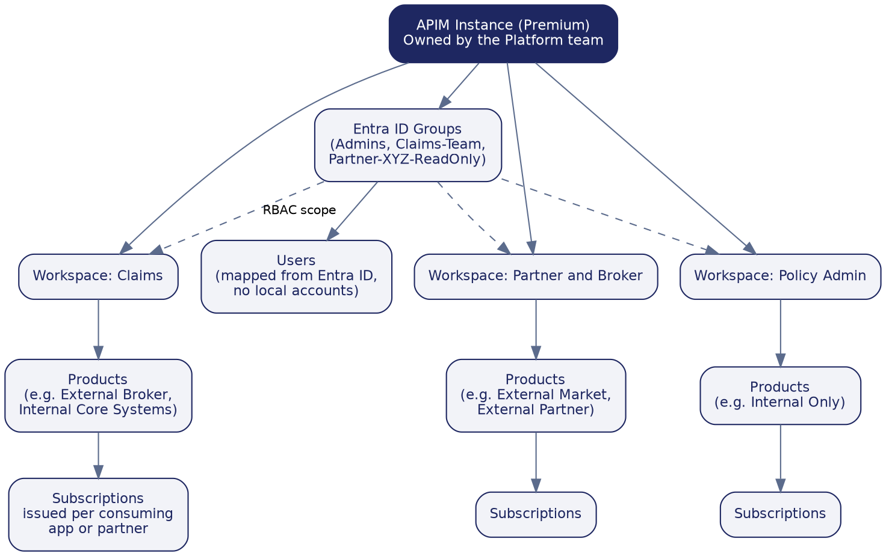
Figure 18: Recommended workspace, product, subscription, and group structure
Workspaces
One workspace per business domain that owns integrations: Claims, Policy Admin, Finance, and Partner and Broker are the natural starting set. Each domain team owns what happens inside its workspace; the platform team keeps ownership of the shared instance, networking, monitoring, and global policy. Workspaces are a Premium-tier capability, which lines up with the network mode decision above.
Products, subscriptions, groups and users
- Products group related APIs and carry the access rule for that group, for example an External Broker product bundling every API a broker may call.
- Subscriptions are individual keys issued per consuming application or partner, so one consumer's access can be revoked without affecting anyone else.
- Groups map to Entra ID, never to local APIM accounts, so a broker's technical team or the platform administrators are each represented by one Entra ID group.
- Users are never created directly inside APIM; access always flows from an Entra ID identity through a group, so Chaucer's existing joiner-mover-leaver process keeps APIM access correct automatically.

Backend governance constructs
Beyond the runtime architecture, APIM provides a set of backend constructs that decide how APIs are organised, secured, discovered, and extended over time. Used well, they let Chaucer add and evolve API capability without the platform becoming a tangle. Used poorly, they become the tangle. This section explains each construct and how Chaucer should use it. The constructs build on one another: named values feed policies, products group APIs and attach policies, groups decide who sees a product, tags make everything discoverable, and workspaces let teams own their slice of all of the above.

Named values
Named values are APIM's key-value store for configuration and secrets that policies reference by name rather than hard-coding. A named value can hold a plain setting (a backend URL, a rate-limit ceiling, a feature flag) or a secret, and a secret named value can be backed directly by Azure Key Vault so the actual secret never lives in APIM at all and rotates automatically when it changes in the vault.
The purpose is twofold: keep sensitive material out of policy XML, and keep environment-specific configuration in one place so the same policy works unchanged across Dev, UAT and Production. Typical uses at Chaucer:
- Key Vault-backed secrets: the webhook shared secret, partner client secrets, and signing keys referenced by policies but stored and rotated in Key Vault.
- Environment configuration: backend base URLs and timeouts that differ per environment, so promotion through APIOps changes the named value, not the policy.
- Reused constants: a standard rate-limit ceiling or a tenant ID referenced by many policies, changed once in one place.
Governance rule: no secret is ever typed into a policy; it is always a Key Vault-backed named value. Named values are themselves environment-scoped and version-controlled through APIOps, so a reviewer can see what changed.

Products
A product is a bundle of one or more APIs published together under a single set of access rules. It is the unit consumers actually subscribe to: a developer does not subscribe to an API directly, they subscribe to a product that contains it. A product carries its own policies (rate limits, quotas, and any product-specific behaviour), its own visibility (which groups can see it), and its own subscription approval model (automatic or requiring sign-off).
This is how Chaucer separates consumer classes cleanly. The natural product set mirrors the consumer model already in the design:
- External-facing products, for example External Broker, External Market and External Partner, each bundling only the APIs that class of partner may call, with stricter rate limits and manual subscription approval.
- Internal products, for example Internal Core Systems and Internal Data Platform, with higher limits and automatic approval for trusted internal consumers.
Because product policy sits above API policy in the scope order, a product is where Chaucer enforces the rules that should apply to every API a given consumer class touches, without repeating them per API.

Groups
Groups control who can see and subscribe to which products. A product's visibility is set by group membership, so a broker's group sees the broker products and nothing else, while an internal developer group sees the internal products. APIM has built-in groups (Administrators, Developers, Guests), but the important point for Chaucer is that custom groups map to Microsoft Entra ID, not to local APIM accounts.
This is what keeps access governance in one place. A partner's technical team, an internal domain team, or the platform administrators are each represented by an Entra ID group; adding or removing a person happens in Entra ID through Chaucer's existing joiner-mover-leaver process, and their APIM visibility follows automatically. No access is granted by creating a user inside APIM.

Tags
Tags are free-form labels attached to APIs (and products) purely for categorisation and discoverability. They do not enforce anything; their job is to make a growing catalogue navigable. In the developer portal, consumers can filter and search by tag, and internally the platform team can report on the estate by tag.
Chaucer should agree a small, consistent tag taxonomy up front, because tags are only useful if applied the same way by everyone. Sensible dimensions include business domain (claims, policy, finance), consumer audience (internal, partner, public), lifecycle status (preview, active, deprecated), and data sensitivity (contains-PII). A tag is discoverability, not a control: sensitivity tagging flags an API for review, it does not secure it.

Workspaces
Workspaces are how Chaucer decentralises day-to-day API management without losing central control. A workspace is a self-contained slice of the APIM instance, its own APIs, products, subscriptions, named values, tags and policies, that a specific team manages through Azure RBAC scoped to that workspace, while the platform team keeps ownership of the shared infrastructure, networking, monitoring and global policy. It is the federated model: central governance, delegated development.
Each workspace behaves like a folder within the service, holding its own copies of the constructs above. A few boundaries are worth knowing at design time:
- Names are unique across the whole service: two workspaces cannot both have an API, product or tag of the same name, even though they are otherwise isolated.
- Workspace policies can reference workspace-scoped named values and resources, but for security they cannot reach service-level named values or backends by name; anything shared must be provided within the workspace.
- Policy scope runs service, then workspace, then product, then API, then operation, so a workspace can apply a blanket policy to all of its own APIs beneath the global service policy.
Chaucer's recommended split is one workspace per business domain that owns integrations, Claims, Policy Admin, Finance, and Partner and Broker, so each domain team publishes and manages its own APIs and subscriptions while the platform team governs the whole. Workspaces are a Premium-tier capability, which aligns with the tier recommendation in section 6.12.

Refining the workspace strategy: gateway model, sizing and constraints
The one-workspace-per-domain split above is the right shape, but three decisions turn it from a sketch into something buildable: which gateway a workspace runs on, how many workspaces to create, and which platform constraints to design around.
Gateway model — use the built-in gateway, not dedicated workspace gateways. A workspace’s runtime can run on either the instance’s built-in (default managed) gateway or a separate, dedicated workspace-gateway resource. Dedicated gateways give stronger runtime isolation between domains, but they do not currently support multi-region deployment, Private Link, or custom hostnames, and they add cost, a separate scale surface, and a provisioning step that can take several hours. Because Chaucer’s design depends on exactly those three capabilities — multi-region (6.11), Private Link origin from Front Door (6.4), and custom hostnames — workspaces should be associated with the built-in gateway, which now supports workspaces and inherits all of those features. Dedicated workspace gateways are held in reserve for a future domain that needs hard runtime isolation and can accept the multi-region/Private Link trade-off.
Sizing — one workspace per domain that owns integrations, not per team or per API. The starting set stays Claims, Policy Admin, Finance, and Partner and Broker. The guardrail is ownership: create a workspace only where a distinct team will own the APIs, products and subscriptions inside it through their whole lifecycle. Splitting more finely than ownership creates administrative overhead without governance benefit; a workspace gateway can carry many workspaces (up to 30 as a shared gateway) so there is headroom, but the number should track real team boundaries, not be maximised.
Constraints to design around. Three platform boundaries shape the model and should be reflected in build standards: names are unique across the whole service, so two workspaces cannot share an API, product or tag name even though they are otherwise isolated; workspace policies cannot reach service-level named values or backends by name, so anything shared must be provided within the workspace or promoted into it through APIOps; and service-level managed identities are not available inside workspaces, which affects the “call the backend using Managed Identity” pattern — workspace-scoped APIs must use a user-assigned identity made available to the workspace, or have that backend authentication handled at service level. Each of these is a build-time rule, not a blocker.
The workspace decisions in one place:
Decision | The constraint | The Chaucer position
Gateway | Dedicated workspace gateway vs built-in gateway | Built-in gateway — it is the only option that keeps multi-region, Private Link and custom hostnames
Number | One per team-owned domain | 4 to start (Claims, Policy Admin, Finance, Partner & Broker); add only when a new owning team appears
Naming | Names unique across the whole service | Prefix API/product/tag names by domain to avoid collisions between workspaces
Shared config | Workspace policy cannot see service-level named values/backends | Provide shared named values within each workspace via APIOps promotion
Identity | No service-level managed identity inside workspaces | Use a user-assigned identity for workspace backend auth, or handle at service level

How the constructs fit together
Construct | Governs | Enforces or informs
Named values | Configuration and secrets used by policies | Enforces (Key Vault-backed, environment-scoped)
Products | Which APIs are bundled and their access rules | Enforces (policy, quota, approval)
Groups | Who can see and subscribe to a product | Enforces (via Entra ID membership)
Tags | Categorisation and search | Informs (discoverability only)
Workspaces | Which team owns which APIs | Enforces (RBAC-scoped isolation)

Developer portal
The developer portal is APIM's self-service front door for the people who consume APIs. It is an automatically generated, customisable website that publishes the API catalogue, its documentation, and the means to subscribe and test, so that discovering and adopting a Chaucer API does not require a ticket or a conversation. In the wider ecosystem it is the surface that turns the governance constructs above into something a developer actually experiences: products, tags and group visibility all show up here.

Its role in the ecosystem
APIM has two audiences. The platform and domain teams work in the management plane (portal, CLI, APIOps) to define APIs, products and policies. The consuming developers, internal or partner, live in the developer portal. It is where they find what exists, read how to use it, obtain a subscription key or token, and try calls interactively. Nothing a consumer needs to self-serve should live anywhere else.

How it supports discovery
The portal lists the products and APIs a signed-in developer is allowed to see, filtered by their Entra ID group membership, so a broker sees broker products and never an internal-only API. Within that, developers browse by product, search by name, and filter by tag, which is why a consistent tag taxonomy (section 6.7) matters: tags are the primary discovery axis in the portal. Each API page carries its operations, request and response schemas, and an interactive console for trying a call against a real or mock backend.

How products surface to developers
Grouping is expressed through products, not raw APIs. A developer sees a product tile, for example External Broker, opens it to view the APIs it bundles, and subscribes to the product as a unit. The subscription they receive then works across every API in that product. This is deliberate: it means Chaucer curates the consumer's experience at the product level, and a developer never has to assemble access API by API.

Onboarding a new consumer
The end-to-end path for bringing a new broker, partner or internal team onto the platform through the portal:
- Access: the consumer is added to the appropriate Entra ID group (for example, a specific partner's group). Sign-in to the portal is through Entra ID single sign-on; self-registration is disabled, so access is deliberate.
- Discover: signed in, they see only the products their group is permitted to view, and browse the APIs and documentation within them.
- Subscribe: they request a subscription to the relevant product. For external products this triggers an approval step; for trusted internal products it can be automatic.
- Credentials: on approval, a subscription key is issued, and for OAuth-protected APIs the consumer's application obtains a token from Entra ID. The backend never sees a raw credential, only a validated token or key.
- Test and integrate: using the interactive console and the published schemas, the consumer validates their calls, then integrates against the stable published contract rather than against a specific backend.

How to navigate the portal, in brief
For a first-time user, the flow through the portal is short and predictable: sign in with the corporate or partner identity; land on the catalogue of visible products; open a product to see its APIs; open an API to read its operations and schemas; use the built-in console to send a test call with a subscription key or token; and manage subscriptions and keys from the profile area. The platform team can brand and customise the portal, add getting-started pages and onboarding guidance, and control exactly which content each audience sees, so the portal Chaucer publishes is a curated experience rather than a raw list.

The API consumer journey, end to end
The portal navigation above covers a first visit; this section sets out the whole consumer journey, from being granted access to steady-state production use, so that what a broker or internal team actually experiences is designed rather than assumed. It runs in ten steps across two halves: getting connected (steps 1–5) and running in production (steps 6–10).
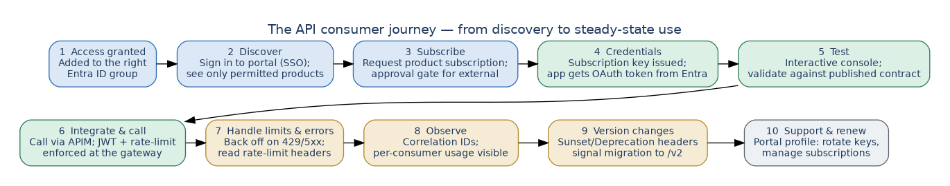
Figure 19: The API consumer journey — ten steps from access granted to steady-state use, support and versioning
Getting connected. A consumer is first added to the appropriate Entra ID group, which is what makes any products visible to them; there is no self-registration. Signing in to the developer portal through single sign-on, they see only the products their group permits, browse the APIs and documentation, and request a subscription to the product they need — automatic for trusted internal products, gated by approval for external ones. On approval a subscription key is issued, and for OAuth-protected APIs their application obtains a token from Entra ID; the backend never sees a raw credential. They validate their integration against the published contract using the interactive console before writing any real code.
Running in production. In steady state the consumer calls the API through APIM, where JWT validation and per-subscription rate limits and quotas are enforced at the gateway on every call. Their client is expected to handle throttling and transient failure gracefully — backing off on HTTP 429 and 5xx responses and honouring the rate-limit headers the gateway returns — rather than retrying blindly. Because every request carries a correlation ID and per-consumer telemetry is captured, both Chaucer and (through the portal) the consumer can see usage and diagnose issues against a single trace. When a breaking change is coming, the consumer’s own tooling is warned in-band by the Sunset and Deprecation headers described in section 6.9, giving a defined window to migrate to the next version. Day-to-day, the consumer manages their own subscriptions and rotates their keys from the portal profile area, so routine credential hygiene does not require a Chaucer ticket.
Two responsibilities sit with Chaucer to make this journey real and should be confirmed as operational tasks, not assumptions: a named owner for approving external subscription requests within an agreed SLA, and a defined support and escalation path (who a partner contacts when a call fails, and how correlation IDs are used to resolve it). Both are recorded against the identity and operating-model items in the assumptions register.

6.8 API Design Standards, Policies and Governance

Target operating model and RACI
Governance only works if ownership is unambiguous. The model is a federated one: a central Platform team owns and runs the shared APIM platform and its guardrails, while Domain teams own the APIs inside their workspace; Network, Identity, Security and Compliance own their respective controls across all domains. The RACI below fixes who is Responsible, Accountable, Consulted and Informed for the activities that recur.
Activity | Platform | Domain | Network | Identity | Security | Compliance
Run the APIM platform (upgrades, capacity, guardrails) | A/R | I | C | C | C | I
Design & build an API | C | A/R | I | I | C | I
Onboard & publish an API (gates) | A/R | R | I | C | C | I
Baseline policy & security configuration | A/R | C | I | C | C | I
Network changes (UDR/NSG/DNS/firewall) | C | I | A/R | I | C | I
Identity groups & app registrations | C | C | I | A/R | C | I
Security controls & threat monitoring | C | I | C | C | A/R | C
Compliance evidence & sign-off | C | I | I | I | C | A/R
Deprecation & partner migration | A/R | R | I | I | I | I
Incident response | A/R | C | C | C | R | I
R = Responsible (does the work), A = Accountable (owns the outcome), C = Consulted, I = Informed. Named individuals for each accountable role are to be recorded by Chaucer against this table before go-live.
APIM policies apply at four levels, and the most specific one always wins: Global, then Product, then API, then Operation. Chaucer should keep global policies to the handful that must never be skipped everywhere (correlation ID, HTTPS enforcement, header stripping), and push everything consumer-specific down to Product level, where it belongs.
Rather than let each team write policies from scratch, the platform ships a small library of reusable policy fragments that are referenced by name, so a fix to the standard JWT-validation fragment updates every API that includes it. The matrix below shows which standard policy applies at which scope. The full policy snippets themselves are in the Security section.
Policy | Scope | Purpose
Correlation ID injection | Global | Stamp every request with a trace ID carried through to the backend and logs
HTTPS and TLS 1.2 enforcement | Global | Reject any non-TLS or outdated-protocol request outright
Sensitive header stripping | Global | Remove internal headers before a response leaves the gateway
JWT validation | Product | Check token issuer, audience, expiry and scope per consumer group
Rate limit and quota | Product | Cap each subscription so one consumer cannot exhaust the platform
Managed identity to backend | API | Authenticate to the backend with no stored secret
Response caching | Operation | Cache safe, cacheable GETs where the backend allows it
IP allow-list and shared secret | Operation | Lock a specific webhook operation to a known source

This keeps the number of distinct policies small and consistent: a reviewer can see at a glance what is enforced everywhere versus what is specific to one consumer or one operation, which is the point of a policy design rather than a pile of per-API XML.
Governance matters as much as structure: the value of a shared policy library is lost if any team can quietly override a global control at a lower scope. The design therefore assigns clear ownership, and treats global security policies as protected, changeable only through the platform and security owners rather than by an individual API team. Who owns each policy area is set out below; the exception-approval row is the control that stops a lower scope silently weakening a global rule.
Policy area | Owner
Authentication | Platform / Security
Rate limiting | API Platform
Security headers | Platform / Security
Transformation | API team
Consumer-specific quota | Product / API owner
Logging | Platform / Security
Exception approval | Architecture / Security

RBAC role assignments (to confirm with Chaucer Identity and Platform)
Policy ownership above states who is accountable for each area; the table below maps that to the actual Azure role each group needs, so an implementer can create the role assignments directly rather than infer them. All assignments are scoped as narrowly as the built-in roles allow, and none are assigned to individuals, only to Entra ID groups.
Scope | Azure role | Assigned to
APIM service (full control) | API Management Service Contributor | Platform team break-glass group only (section 6.6); day-to-day changes flow through APIOps, not this role
Workspace (per business domain) | API Management Workspace Contributor / API Management Workspace API Developer | Domain team Entra ID group for that workspace (Claims, Policy Admin, Finance, Partner and Broker)
Named values and secrets | API Management Service Contributor scoped to named values, plus Key Vault Secrets User on the backing vault | Platform / Security group only; never assigned at workspace scope for Key Vault-backed secrets
APIOps pipeline service principal | API Management Service Contributor (or workspace-scoped equivalent for workspace-only pipelines) | Pipeline service connection / managed identity, not a human account
Read-only estate visibility | API Management Service Reader | Architecture, security and audit groups who need to see configuration without changing it
Resource group / networking | Network Contributor (subnet and NSG scope only) | Chaucer Network team, scoped to the APIM subnet, not the wider hub
This table proposes a starting model; the exact built-in role names should be validated against the current Azure role definitions at build time, since Microsoft periodically introduces more granular workspace-scoped roles.

A small, empowered governance board sets the standards; automation enforces them so governance never becomes a bottleneck.
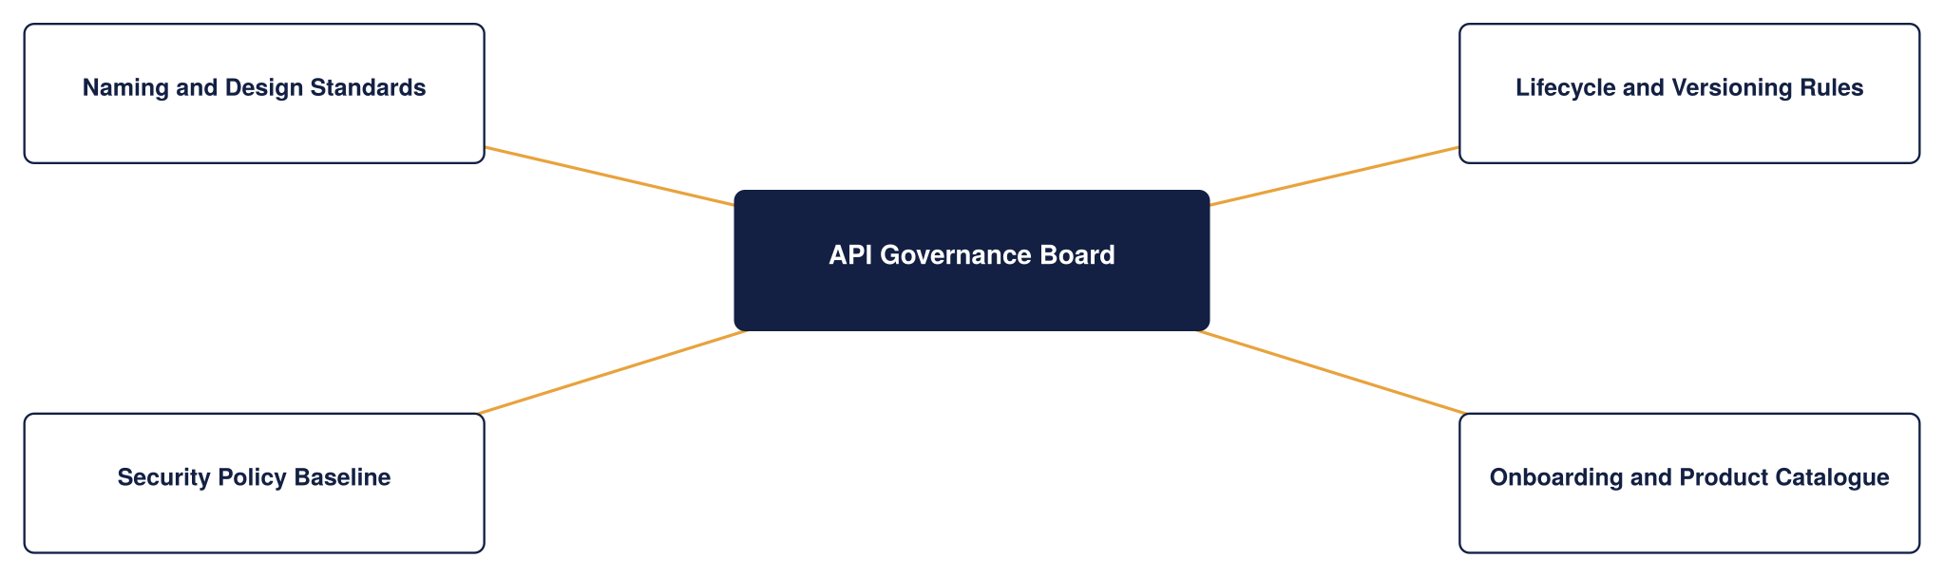
Figure 20: API governance framework
Every API also moves through the same seven lifecycle stages, with no manual hand-off between them, and usage analytics from the Monitor stage feed straight back into the next design cycle.
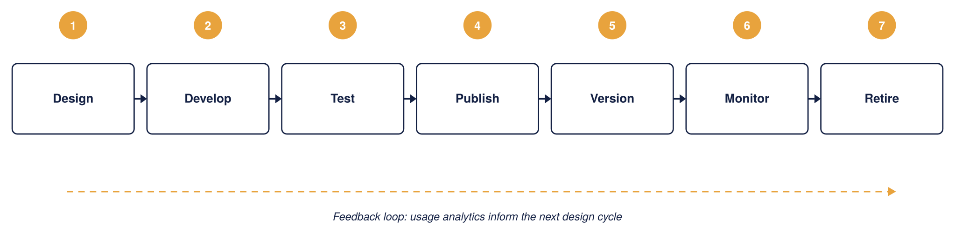
Figure 21: API lifecycle management, Chaucer
In practice, this maps onto concrete gates: intake registers the API and its intended consumers, design review checks schema and naming standards, a security gate confirms scopes and rate limits, pre-production sign-off requires automated policy and contract tests to pass, and production publish makes the API visible in the Developer Portal under an approved product. Retirement follows a defined deprecation notice and sunset window rather than a silent removal.

Onboarding a new API
This section describes the end-to-end path for bringing a new API onto the platform using the governance constructs above, so that every API added to Chaucer's estate is consistent, discoverable, secured and owned from day one. It ties together naming, product and group assignment, tagging and workspace placement into one repeatable process rather than a series of ad hoc choices.

The end-to-end flow
The diagram below shows the end-to-end onboarding path at a glance; the steps beneath it describe each stage in detail.
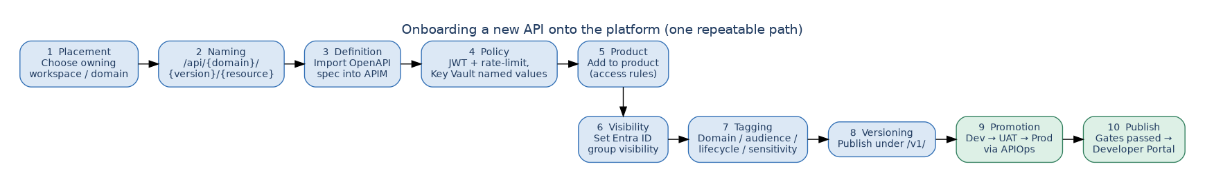
Figure 22: Onboarding a new API — the ten-step repeatable path from placement to publication
- Placement: decide which workspace owns the API, based on the business domain (Claims, Policy Admin, Finance, or Partner and Broker). The owning domain team, not the platform team, drives the rest of the process within that workspace.
- Naming: apply the naming convention from section 4.2, so the API's path follows /api/{domain}/{version}/{resource} with plural, lowercase, kebab-case resources. Consistent naming is what makes the estate navigable and routable.
- Definition: import or author the API (typically from an OpenAPI specification), which brings its operations and request and response schemas into APIM.
- Policy: attach the standard policy set at the right scope, JWT validation and rate limits at product level, managed-identity backend auth at API level, referencing Key Vault-backed named values rather than inline secrets.
- Product assignment: add the API to the appropriate product (for example Internal Core Systems or External Broker), which determines its access rules and which consumers can subscribe.
- Group visibility: confirm the product's visibility is set to the correct Entra ID groups, so only the intended audience sees it in the developer portal.
- Tagging: apply the agreed tags, business domain, audience, lifecycle status and any sensitivity flag, so the API is discoverable and reportable from the moment it is published.
- Versioning: publish under an explicit version (for example /v1/) using the strategy in section 6.9, so future breaking changes can be introduced as /v2/ without disruption.
- Promotion: move the API through Dev, UAT and Production via the APIOps pipeline, reviewed and deployed as code, never hand-configured in Production.
- Publication and governance: pass the design and security gates from section 6.8, then publish to the developer portal. The API is now live under an owner, in a product, visible to the right groups, tagged, versioned and monitored.

Onboarding checklist
Step | Governance construct | Outcome
Assign to workspace | Workspace | Clear domain ownership
Apply naming convention | Design standard | Consistent, routable path
Attach standard policies | Named values, policy scope | Secured with no inline secrets
Add to product | Product | Access rules and subscribers defined
Set product visibility | Groups (Entra ID) | Only the intended audience sees it
Apply tags | Tags | Discoverable and reportable
Publish under a version | Versioning | Future changes are non-breaking
Promote via APIOps | Environments | Consistent across Dev, UAT, Prod

Followed each time, this process means growth does not erode governance: the hundredth API onto the platform is organised exactly like the first.

Onboarding service levels (time-to-first-API)
The onboarding steps above have owners and target cycle times so “time-to-first-API” is a committed number rather than an open-ended process. The targets below are for a straightforward API on the happy path; complex or high-sensitivity APIs will take longer and that is expected.
Stage | Owner | Target cycle time
Intake & placement (workspace, ownership) | Platform | 2 business days
Design & naming review | Domain + Platform | 3 business days
Security review (classification, auth, policy) | Security | 3 business days
Build & policy in Dev | Domain | Domain-dependent
Promotion through gates to Production | Platform | 1 business day per gate
Overall time-to-first-API (simple API, happy path) | — | ~10 business days
These targets should be tracked as an operational metric; persistent breaches are a signal to simplify a gate, not to skip it.

6.9 API Lifecycle and Versioning Strategy
Versioning exists so that Chaucer can improve an API without breaking the systems already calling it. The design uses two distinct APIM mechanisms for two distinct situations, and it is worth being precise about which is which, because they are often confused.
Mechanism | When it is used | Consumer effect
Revision | A change that does not break the contract, for example adding an optional field or fixing a bug | Consumers keep calling the same URL; the new revision can be tested online, then made current
Version | A change that breaks the contract, for example removing a field or changing a type | A new version (v2) is published alongside v1; consumers move when they are ready

Versions are expressed in the URL path (for example /api/claims/v1/ and /api/claims/v2/), which is the clearest scheme for partners to read and the easiest to route on at the gateway. APIM also supports header-based and query-string versioning; path-based is the house standard here, with the others available only where a specific partner integration requires them.
The table below sets out how each kind of change is handled and what the consumer experiences.
Change type | Versioning approach | Consumer impact
Breaking change | New major version, for example /v2/, published alongside /v1/ | None until the consumer opts in
Non-breaking addition | Same version, new revision, additive fields only | Zero impact, backward compatible
Deprecated version | Marked deprecated in the Developer Portal; a Sunset response header advertises the retirement date | 90-day minimum notice period
Retired version | Removed after the sunset window; the gateway returns 410 Gone | Enforced by APIM policy, never a silent removal

The diagram below shows how a version transition plays out over time. A new version can be published as a preview while the current version is still live, the current version then enters a deprecation window of at least 90 days during which a Sunset header warns callers, and only after that window and confirmed consumer migration is it retired.
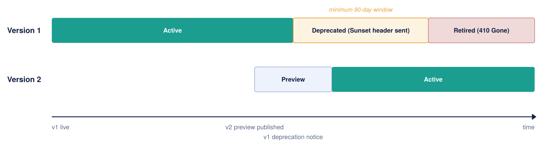
Figure 23: API version lifecycle over time
Deprecation is signalled in-band, not just in documentation: while a version is deprecated the gateway attaches a standard Sunset header (and, where useful, a Deprecation header) to every response, so a consumer's own tooling can flag the coming retirement automatically. This is what makes 'never a silent removal' enforceable rather than a promise.

Maintaining the lifecycle: deprecation, Sunset and retirement
Every published API is treated as having a full lifecycle, not just a launch. The mechanics below make each transition explicit and machine-readable, so consumers are never surprised and retirement is always a planned event.
Publish and run. A new version is published under an explicit path segment (/v1/, /v2/) and made visible in the Developer Portal under the product that governs it. While a version is current it is monitored through the same observability stack (section 6.10), and non-breaking changes are shipped as revisions against the same version so consumers keep calling the same URL.
Deprecate. When a breaking change requires a new version, the outgoing version enters a deprecation window of at least 90 days. During this window the gateway attaches a standard Sunset HTTP header (RFC 8594) to every response, giving the exact date the version will stop being served, and, where useful, a Deprecation header marking it as deprecated. Because these are response headers rather than documentation, a consumer’s own tooling can detect the coming retirement automatically. A policy fragment applied at the version scope adds the headers, so no per-API work is needed.
Notify and track. Deprecation is announced in the portal and, for external products, to the named technical contact on each subscription. The platform team tracks which subscriptions are still calling the deprecated version through per-consumer telemetry, so migration can be confirmed by data rather than assumed.
Retire. The version is removed only after the window has elapsed and telemetry confirms consumers have migrated. Retirement is a deliberate, logged step — never a silent removal — and the version’s routes return a clear gone/redirect response thereafter. All of this is driven from Git through APIOps, so a retired version is removed as reviewed code, not by a manual portal edit.
Operational ownership of deprecation. The headers and window make deprecation enforceable, but a person still owns the conversation. For every deprecation, the owning Domain team is responsible for the migration relationship with affected consumers, and the Platform team is accountable for the process being followed. For external partners this means: identify affected subscriptions from telemetry, contact the named technical and business contacts on each subscription, agree a migration date within the window, track progress, and escalate to the partner’s relationship owner if a consumer is not moving with the deadline approaching. Retirement proceeds only when telemetry confirms migration; if a critical partner genuinely cannot meet the date, an extension is a logged, approved decision, not a slipped deadline.
The headers attached during the deprecation window:
Header | Example value | What it tells the consumer
Sunset | Sunset: Sat, 30 Nov 2026 23:59:59 GMT | States the exact date/time the version stops being served (RFC 8594)
Deprecation | Deprecation: true | Marks the version as deprecated so tooling can flag it
Link (optional) | Link: <https://developer.chaucer.example/…/v2>; rel="successor-version" | Points callers at the version they should move to

6.10 Observability and Operations
Every gateway, policy, and backend call feeds into a single Azure Monitor view, so there are no blind spots between environments. Application Insights carries end-to-end tracing; Log Analytics holds the raw diagnostic logs; dashboards give operations, integration, security, and executive audiences the view each of them needs.
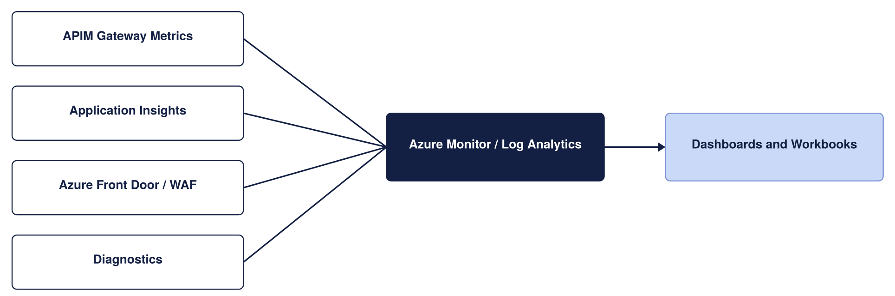
Figure 24: Monitoring architecture
What is actually logged, and where it goes, matters as much as the diagram. Each source emits structured telemetry through APIM's diagnostic settings, every record carries the same correlation ID so a single request can be followed end to end, and each stream lands in the sink suited to its purpose.
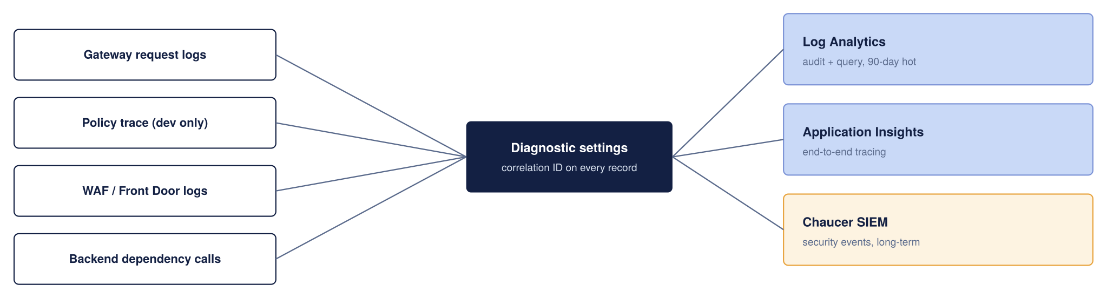
Figure 25: What is logged and where it goes
The retention periods below are proposed starting points to be reconciled with Chaucer's actual logging and data-retention standard, not confirmed values; the 90-day figures in particular should be checked against Chaucer's SIEM and compliance retention requirements.
Telemetry | Sink | Retention (proposed)
Gateway request and response metadata | Log Analytics | 90 days hot, then archived per Chaucer's log policy
End-to-end distributed traces | Application Insights | Sampled in production to control cost
Policy trace (verbose) | Application Insights | Enabled in Dev only; off in production by default
WAF and Front Door logs | Log Analytics | 90 days, feeding the security dashboard
Security-relevant events | Chaucer SIEM | Long-term, per existing SIEM retention standard

Correlation IDs are propagated from the gateway to the backend, so a trace does not stop at APIM; a support engineer can follow one broker request from the edge, through the policy pipeline, into Logic Apps and back. This propagation should be validated end to end during the pilot, since a correlation ID that is dropped by an intermediate hop breaks the trace. Verbose policy tracing is deliberately restricted to Dev, because it is expensive and can capture sensitive payload detail that has no place in a production log.
Dashboards are cut by audience rather than one generic view: an operations dashboard tracks latency, error rate and throttling; an integration dashboard tracks per-API and per-consumer volumes; a security dashboard surfaces 401s, WAF blocks and anomalous spikes; and an executive view rolls up availability against the SLA. The alert thresholds below are proposed defaults to be agreed with Chaucer's operations team, not fixed commitments; they are starting points for tuning against real traffic.
Metric | Alert threshold (proposed)
Failed requests, 5xx | More than 1% of total requests
Gateway response time | p95 above 500ms
Unauthorised requests, 401 | More than 10 per minute
Certificate expiry | Less than 30 days to expiry

Testing and non-functional assurance
Observability tells you how the platform behaves in production; testing proves it will behave before it gets there. The platform is assured across four kinds of test, and against the explicit non-functional requirements recorded in Appendix 9.5.
Functional and contract testing catches breaking changes early: every API is validated against its published OpenAPI contract in the pipeline, so a change that would break consumers fails the build rather than reaching them. Performance and load testing sizes and proves capacity: the platform is tested against Chaucer’s expected and peak requests-per-second before go-live, and the capacity metric behaviour under that load is used to set autoscale thresholds (6.12). Security testing is continuous and periodic: WAF and Defender for APIs run continuously, and independent penetration testing is performed before go-live and on a regular cadence thereafter, with findings tracked to closure. Resilience and chaos testing proves the DR design is real: regional failover is exercised on a schedule (Appendix 9.7) rather than assumed, including deliberately failing a region and confirming Front Door routes around it within the RTO.
The specific numeric targets these tests are measured against — latency, throughput, concurrency, availability, RTO/RPO and error budget — are stated as non-functional requirements in Appendix 9.5 so they are testable rather than implied.

6.11 High Availability and Disaster Recovery Design
High availability is about surviving a failure inside one Azure region without anyone outside noticing. Azure Availability Zones are physically separate datacentres with independent power and cooling; when APIM is deployed across zones, the edge layer only sends traffic to zones that are healthy.
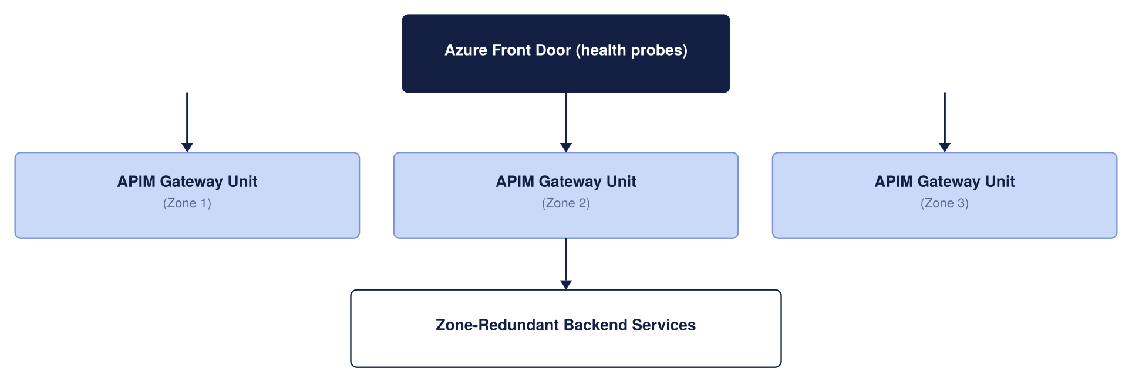
Figure 26: High availability architecture
Backend services should also be zone-redundant; a zone-resilient gateway in front of a single-zone backend only moves the weak point, it does not remove it. Zone redundancy carries no separate line-item cost on Premium or Standard v2; it is a configuration choice, not an add-on.

The whole chain is only as resilient as its weakest link
A highly available gateway does not make the transaction highly available on its own. The complete path, consumer to Front Door to WAF to APIM to the network to Logic Apps to the backend, is only as resilient as its least-resilient hop. Each component's resilience should be assessed and owned explicitly rather than assumed from APIM's own SLA.
Component | Resilience to confirm
Front Door + WAF | Global service; confirm health-probe paths touch a real dependency, not a static page
APIM | Zone-redundant; multi-region for regional failure
Network (Firewall / NVA / DNS) | Confirm the egress and DNS path is itself resilient, not a single point of failure
Logic Apps Standard | Confirm the hosting plan is zone-redundant to match the gateway
Backend data stores | Each has its own replication and RPO; the worst one sets the real data RPO
Entra ID | Identity outage needs a break-glass path (section 6.6)

The single most important item to confirm here is whether Logic Apps Standard is configured for the same zone and regional resilience as the gateway; if it is not, the platform's real availability is set by Logic Apps, not by APIM.
Disaster recovery covers the rarer case: an entire Azure region becomes unavailable, not just one zone. For an insurance platform handling claims and policy data, this has to be planned for rather than hoped against.
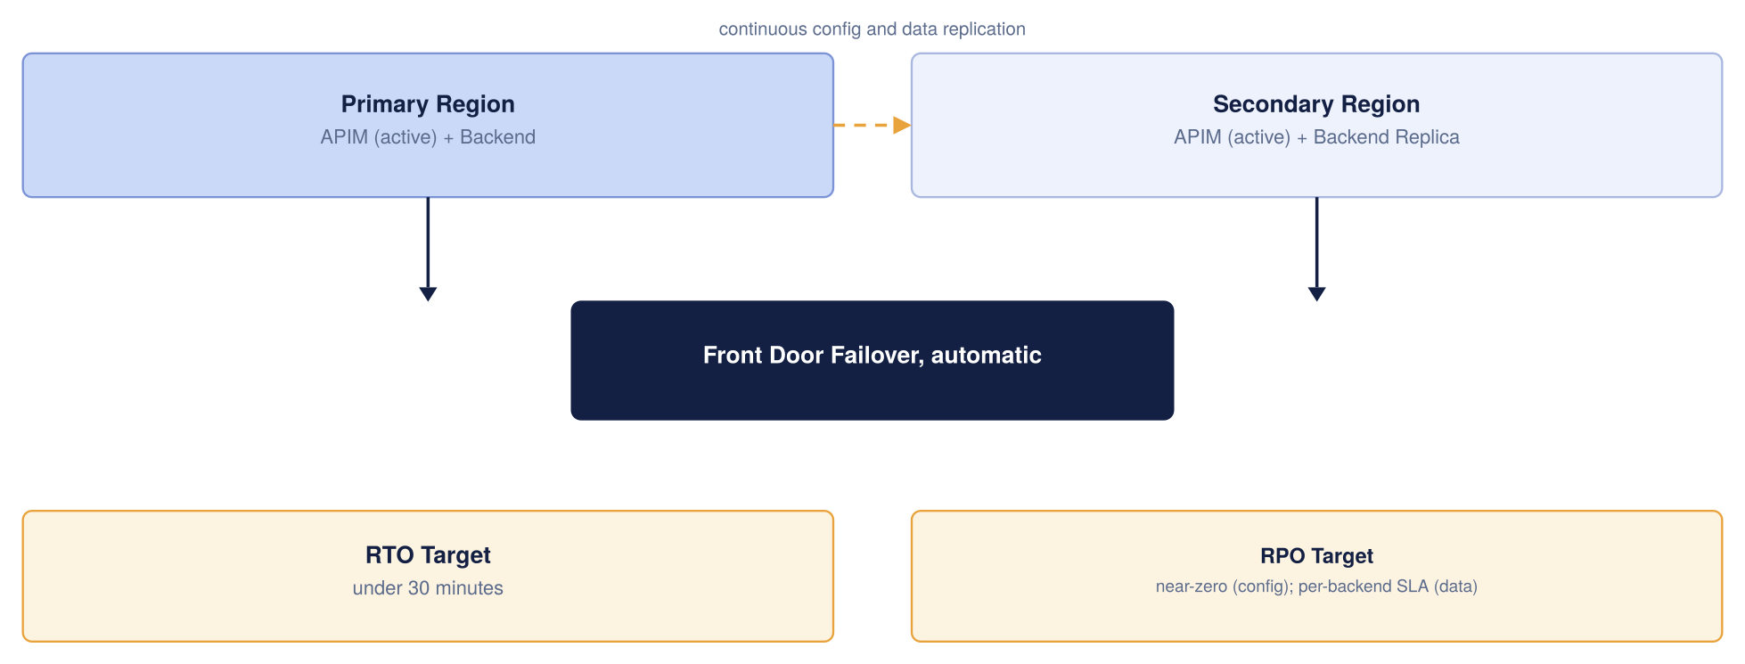
Figure 27: Disaster recovery architecture
Recommendation: run APIM Premium active in both UK South and UK West behind the same Front Door entry point. Front Door already health-checks both regions, so a UK South failure moves traffic to UK West automatically. All configuration lives in Git through APIOps, so a region can be rebuilt from nothing if it ever has to be.
Metric | Target | What it means
Recovery Time Objective | Under 30 minutes, often seconds with active-active | How long the API layer is unavailable after a regional failure
Recovery Point Objective, configuration | Near zero | Configuration is rebuilt from Git, nothing is lost
Recovery Point Objective, data | Depends on each backend's own replication SLA | APIM does not create or remove this risk

Active-active roughly doubles the APIM unit cost, since a live Premium unit runs in each region. Active-passive saves less than expected, since standby units still bill close to full price. Given the sensitivity of claims and policy data, we recommend active-active despite the higher run cost.

How this aligns with the chosen edge service (Front Door, Option B)
The HA/DR model here is not independent of the edge decision in section 6.4 — it is a direct consequence of choosing Azure Front Door (Option B). Front Door is what makes multi-region active-active practical: it health-probes both regional APIM gateways, holds the single global hostname every consumer uses, and moves traffic from UK South to UK West automatically when a region’s probes fail, with no DNS-cache delay. Had Chaucer chosen Option A (Application Gateway only), regional failover would not be built in and a separate global-routing layer would have to be added to achieve the same DR posture. The table makes the dependency explicit.
Resilience layer | Provided by (given Option B) | Effect
Regional failover | Front Door automatic origin failover (health-probed) | A UK South outage routes to UK West with no manual action or DNS wait
Single entry point | One Front Door global hostname for all consumers | Consumers are unaware of which region serves them; no client-side change on failover
Edge resilience | Front Door global anycast + edge WAF/DDoS | Volumetric and malicious traffic absorbed before it reaches either region
In-region HA | Zone-redundant APIM (classic Premium) behind Front Door | Survives loss of a single datacentre within a region
Backend resilience | Zone-redundant Logic Apps / Functions / Service Bus | Confirmed separately — the chain is only as resilient as its weakest hop (A.09)
Config recovery | APIOps / Git for both regions | A region can be rebuilt from code; RPO for configuration near zero

Global routing: Front Door or Traffic Manager
The SIF asks specifically about Traffic Manager, so it is worth setting out plainly why this design reaches for Azure Front Door instead, and when Traffic Manager would still be the right call. Both services do the same core job, steering traffic to a healthy region, but they operate at different layers, and that single difference drives the recommendation.
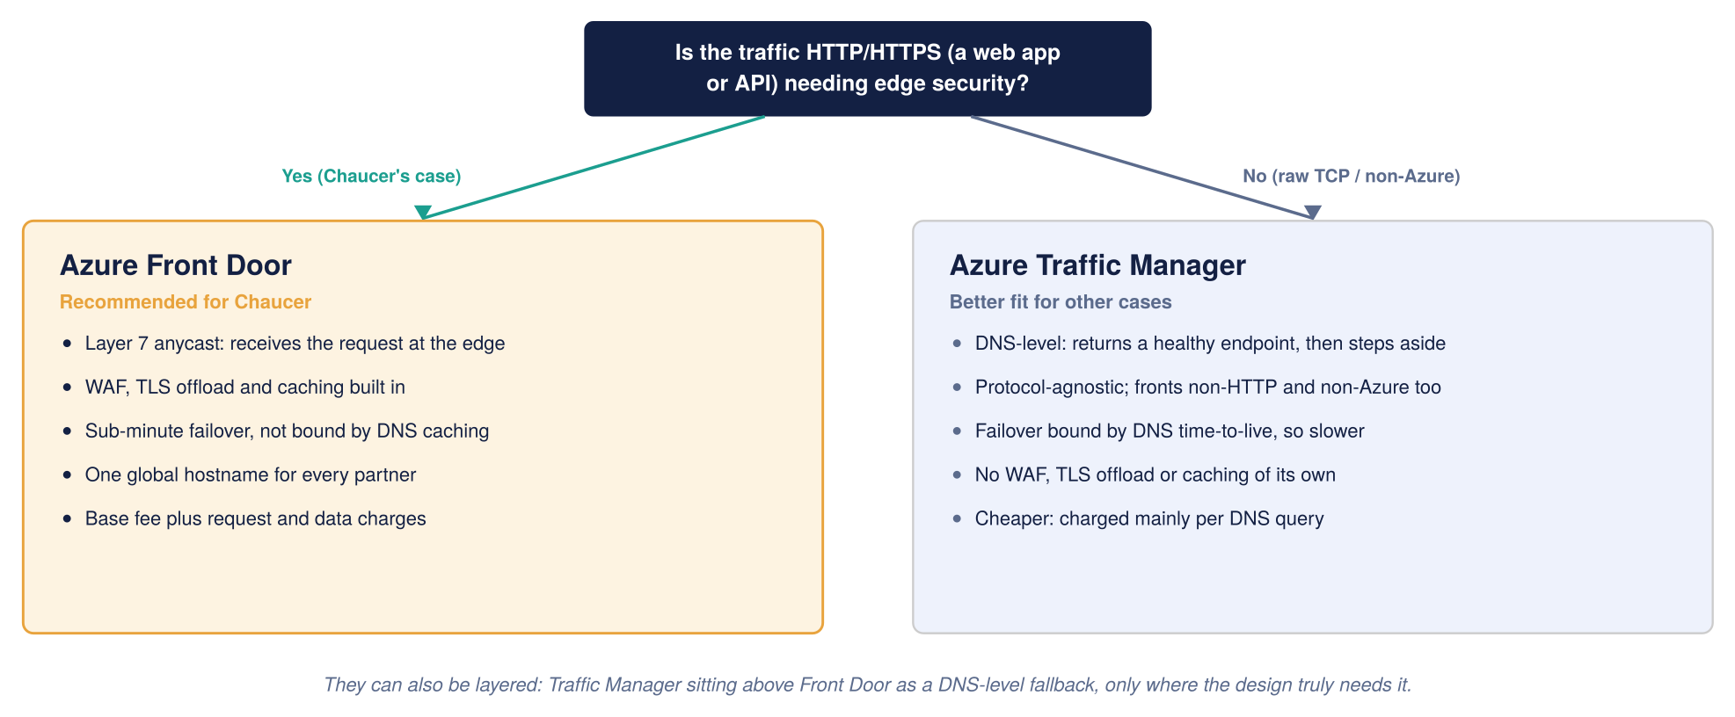
Figure 28: Global routing, Front Door compared with Traffic Manager
Traffic Manager works at the DNS layer: when a client looks up the API's name, Traffic Manager hands back the address of a healthy region and then steps out of the path. That makes it protocol-agnostic and cheap, and it can front non-HTTP endpoints and services outside Azure, which Front Door cannot. Its weakness is that failover is bounded by DNS caching, so clients can keep hitting a failed region until their cached lookup expires.
Front Door works at Layer 7 over a persistent anycast connection: it receives the HTTPS request at the Microsoft edge, applies WAF, TLS termination and caching, and forwards it to a healthy region. Because it stays in the path, failover is fast enough to meet an aggressive recovery-time target, and it is not held up by DNS caching.
For Chaucer, every consumer, brokers, Lloyd's market systems, internal apps, reaches the platform over HTTPS and benefits from edge security, so Front Door is the right global router. It also removes a separate WAF bill, since WAF is bundled into Front Door Premium. Traffic Manager would only become the better choice if Chaucer later needed to route non-HTTP traffic, or to steer between endpoints outside Azure. The two are not mutually exclusive: a common enterprise pattern layers Traffic Manager above Front Door purely as a DNS-level fallback, and Chaucer can adopt that later without redesign if a specific need arises.
Consideration | Azure Front Door | Azure Traffic Manager
Routing layer | Layer 7, anycast, stays in the request path | DNS layer, returns an address then steps aside
Failover speed | Sub-minute, not bound by DNS caching | Bounded by DNS time-to-live, slower
Edge security | WAF, TLS offload, caching built in | None of its own
Non-HTTP and non-Azure endpoints | Not supported | Supported
Cost shape | Base fee plus request and data charges | Mainly per DNS query, cheaper
Fit for Chaucer | Recommended, all traffic is HTTPS API traffic | Fallback only, or for future non-HTTP needs

On this basis the design standardises on Front Door as the global router and edge, with Application Gateway plus WAF retained only as the single-region fallback discussed in section 6.4, and Traffic Manager noted as an option Chaucer can layer in later if a non-HTTP or cross-cloud routing requirement emerges.

6.12 Cost, Capacity and Service Tier Strategy
The figures below are indicative UK South list prices, gathered to give Chaucer a realistic planning envelope. They are not a quote. Two things will move the real number: Chaucer's enterprise agreement with Microsoft usually discounts list price, and actual traffic volume drives the metered charges (requests, bandwidth, and log ingestion) that sit on top of the fixed platform cost.
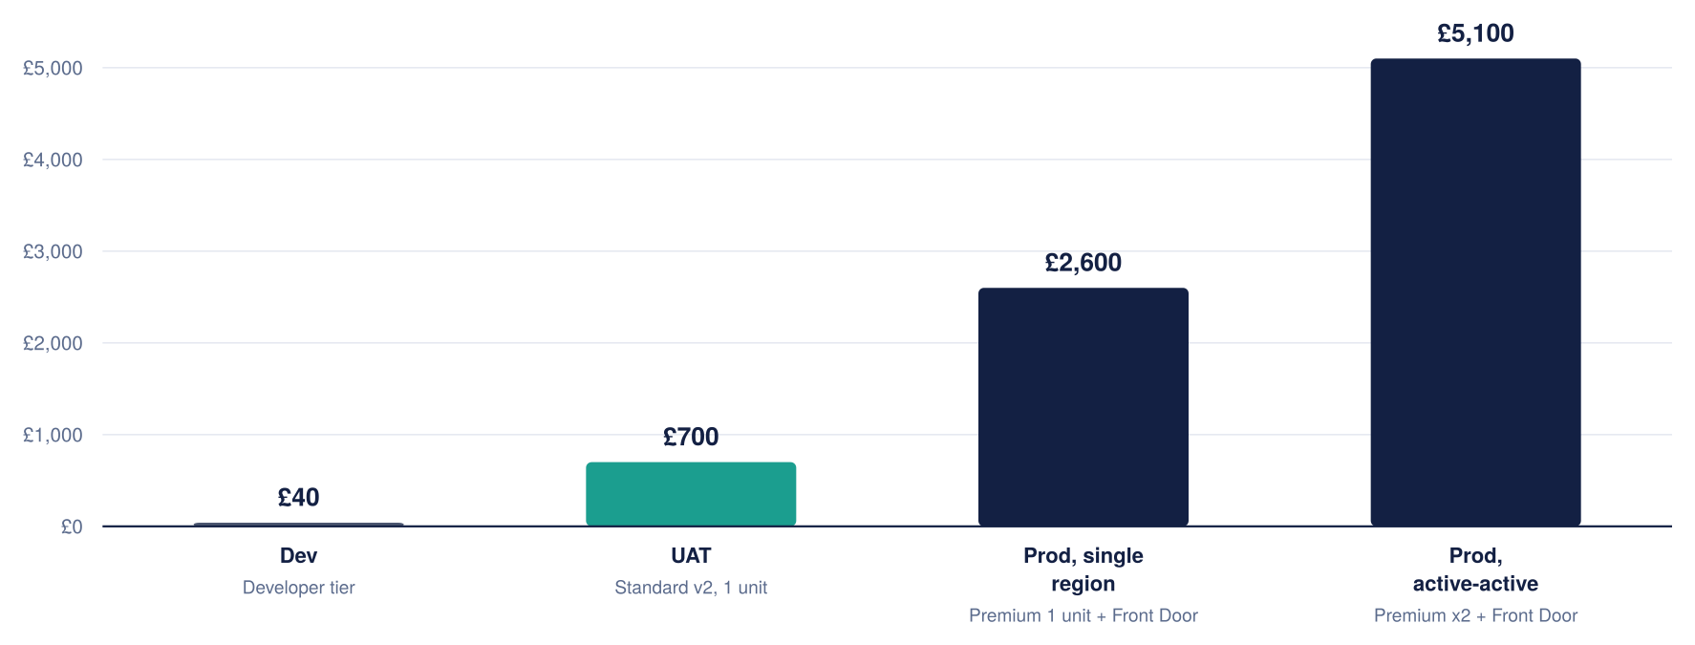
Figure 29: Indicative monthly platform cost by environment

Cost per component, production
For a production environment the fixed monthly cost breaks down roughly as follows. A single Premium unit is the largest line by far, which is why the tier and single-versus-multi-region decision matters so much to the bill.
Component | Indicative monthly cost | Notes
APIM Premium, per unit | roughly £2,100 to £2,300 | The core gateway; active-active production runs two of these
Azure Front Door Premium + WAF | roughly £260 base, plus usage | WAF rules included in the base; requests and egress billed on top
Azure Key Vault | a few pounds per month | Priced per operation; negligible at this scale
Azure Monitor and Application Insights | usage-based | Driven by log volume; the main variable operational cost
Azure DDoS Protection (if on a dedicated plan) | roughly £2,300 per month per tenant | Shared across all workloads in the tenant, not APIM-specific

DDoS Protection is listed for completeness, but it is a tenant-wide service Chaucer may already pay for; it should not be attributed to APIM alone. If Chaucer has no dedicated DDoS plan, the infrastructure-level DDoS protection that comes free with Azure still applies.

How to keep the cost down
- Run Dev on the Developer tier, not Premium. It has the full policy engine and portal for a fraction of the price; its lack of an SLA does not matter for a build-and-test environment. UAT steps up to Standard v2 so business sign-off happens on an SLA-backed, production-like tier.
- Add Premium units only when capacity metrics require it. One unit covers a comfortable pilot; scaling out is a deliberate choice, not a default.
- Watch log ingestion. Application Insights and Log Analytics are usage-billed, so sampling verbose logs in production keeps the observability bill predictable.
- Confirm whether active-active is needed from day one, or whether a single-region start with active-passive DR is acceptable for the first phase, deferring the second Premium unit's cost until partner traffic justifies it.
A sensible first-phase envelope, one Premium production unit plus Front Door, with Developer and Standard v2 lower environments, lands in the region of £3,500 to £4,000 per month before traffic and before any enterprise discount. Moving production to active-active adds roughly one more Premium unit's cost. These are planning numbers to frame the conversation with Microsoft, not a committed price.

Capacity planning and scaling
Cost and capacity are two views of the same decision: how many scale units each environment runs. This section makes the sizing explicit so the numbers above are traceable to expected load rather than picked. A dedicated-tier unit has a load-bearing capacity expressed as an approximate maximum throughput — on the order of 1,000 requests per second per unit as a planning figure — but this is a rough planning number, not a hard limit: real throughput varies with payload size, connection patterns, and especially the number and cost of policies each request runs, so it must be validated against Chaucer’s own traffic before it is treated as settled.
Scale by the capacity metric, not by guesswork. APIM exposes a capacity metric (a percentage of resource utilisation across the gateway) that is the correct signal for scaling. The recommended rules of thumb, to be tuned against real traffic: for a single-unit instance, upgrade or add a unit when sustained capacity exceeds about 40% (headroom is reserved for platform updates); for multi-unit instances, scale out when the 30-minute average exceeds ~70% and scale in below ~35%, using averaging windows of 30 minutes or longer to avoid flapping. A scale operation takes around 30 minutes to complete, so autoscale rules must act on sustained trends and leave time to take effect, and in a multi-region deployment only the primary region’s units autoscale — secondary regions are sized manually.
Right-size each environment to its job. Dev and UAT are not sized for production load; Production carries headroom for peak and for a region failover absorbing the other region’s share. The starting model, to be confirmed against Chaucer’s measured or forecast peak requests per second:
Environment | Starting size | Indicative capacity | Sizing basis
Dev | Developer, 1 unit | Not applicable | Build and unit test only; no load target
UAT | Standard v2, 1 unit | ~1,000 req/s planning figure | Production-like sign-off; scale for test load, not prod peak
Production (per region) | Classic Premium, 1 unit to start | ~1,000 req/s per unit planning figure | Add units on the capacity metric; each region must hold peak load alone for active-active failover
Two capacity items to resolve during detailed design, flagged so they are not missed: Chaucer’s expected and peak requests-per-second (which sets the real unit count and is not yet known to this design), and the active-active headroom rule — because either region must be able to carry the whole load during a failover, each region should be sized for peak on its own, not for half. Both feed the cost envelope in this section and are recorded in the assumptions register.

7. Architecture Impact Assessment

7.1 High Level Impact Assessment
Introducing APIM adds a new, centrally-governed platform layer in front of Chaucer's existing integration estate. The impact is additive rather than disruptive: existing Logic Apps continue to run, with APIM placed in front of them. The main new operational dependencies are the platform's networking (including the Palo Alto path), identity (Entra ID) and the APIOps pipeline. The subsections below summarise the impact by architecture domain.

7.2 Business Architecture
Business teams gain a governed, self-service route to expose data to brokers and partners without commissioning a bespoke integration each time. API onboarding moves from a multi-week bespoke build to a standard catalogued process, and partner onboarding becomes repeatable.

7.3 Data Architecture
Data in transit is protected end to end (TLS 1.2 minimum), and response payloads can be masked at the gateway before leaving Chaucer's network. Primary and secondary regions in the UK support data-residency expectations. APIM does not store business data; it forwards it, so the data-at-rest position is unchanged from the backends.

7.4 Application Architecture
Existing applications and Logic Apps are not replaced; APIM is added as a decoupling layer so that consumers integrate against a stable published API contract rather than a specific backend implementation. This reduces coupling between consumers and backends.

7.5 Technology Architecture
The design introduces APIM (classic Premium), Front Door with WAF, Key Vault, and the APIOps pipeline, integrated with the existing Azure landing zone and the Palo Alto firewall. It depends on Availability Zones and multi-region deployment for resilience, as set out in section 6.11.
The technology architecture follows Microsoft’s published reference patterns for enterprise integration and API protection, adapted to Chaucer’s estate. Consumers reach the platform through Azure Front Door (global edge WAF, TLS termination, DDoS and multi-region failover); internet and internal traffic are inspected by the existing Palo Alto next-generation firewall in the hub VNet; APIM runs in internal (VNet-injected) mode in a spoke, exposing an external and an internal gateway with no public data-plane address; and backends — Logic Apps Standard, Azure Functions and Service Bus — sit in a private backend spoke reachable only over Private Endpoints with NSG enforcement. Cutting across all of this are the shared platform services: Microsoft Entra ID for identity (OAuth 2.0 / JWT), Azure Key Vault for secrets and certificates, Azure Monitor with Application Insights and Log Analytics for observability, and the APIOps (Bicep + Git) pipeline that builds and promotes every environment as code.
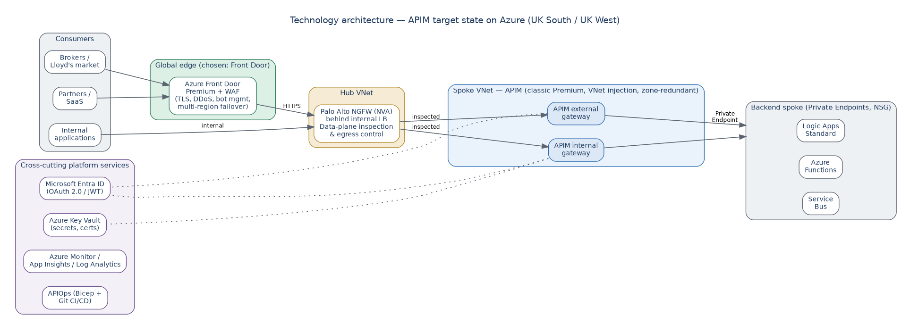
Figure 30: Technology architecture — APIM target state on Azure, aligned to Microsoft reference patterns

7.6 Service Architecture
Target service levels are 99.95 percent gateway availability, a recovery-time objective under 30 minutes for a regional failure, and API onboarding turnaround measured in days once the platform is live. Operational ownership follows the operating model in the accompanying Setup Handoff document.

8. Risks and Issues

8.1 Assumptions
This design is a well-formed proposal, not a Chaucer-verified fact base. The items below are assumptions or open decisions that carry real weight; several are stated as design choices elsewhere in this document for readability, but none should be treated as settled until confirmed. This register is the single place a reviewer, or Chaucer's TDA, should look to see where the design still depends on inputs we have not seen. It is deliberately blunt.
Ref | Assumption or open item | Impact if wrong | Owner to confirm
A.01 | This is a greenfield build; no legacy on-prem system needs direct APIM exposure | Introduces self-hosted gateway and hybrid connectivity, changing tier and topology | Chaucer EA / Integration
A.02 | Backends already sit in a VNet reachable via Private Endpoint | The whole backend-connectivity design (section 6.4) may need rework | Chaucer Network
A.03 | Chaucer's landing zone follows a standard hub-spoke with private DNS zones available | Affects DNS, egress, and how APIM reaches each backend | Chaucer Cloud Platform
A.04 | Entra ID is Chaucer's identity provider and can extend to API consumers | The entire authentication model shifts | Chaucer Identity
A.05 | UK South / UK West satisfy data-residency obligations | May force a different region pair or design | Chaucer Compliance
A.06 | Regulatory controls (FCA/PRA/Lloyd's/GDPR) can be met by the proposed design | Compliance is the least-verified area; controls need confirming | Chaucer Compliance
A.07 | The Traffic Manager reference in the SIF is shorthand for global routing, not a hard mandate | If mandated, the Front Door substitution needs explicit sign-off | Chaucer EA / TDA
A.08 | Active-active multi-region is required from day one | If not, active-passive defers significant cost | Chaucer + business
A.09 | Proposed RTO/RPO, retention periods, and alert thresholds are acceptable | Operational targets and cost may change | Chaucer Operations
A.10 | Traffic volumes fit one Premium unit for the pilot | Scaling changes the cost envelope | Chaucer + Microsoft
A.11 | Tier price bands (Premium v2, classic Premium, and Standard v2) are current | Cost planning figures shift | Verify vs Azure pricing page
A.12 | Expected and peak API request rate (RPS) is not yet provided | Production unit count and autoscale thresholds cannot be finalised; capacity is a planning estimate only | Chaucer Platform + business
A.13 | Named accountable owners for each RACI role are not yet assigned | Governance and approval gates lack a specific owner; onboarding SLAs cannot be enforced | Chaucer Platform + Domain leads
A.14 | Log and correlation-ID retention period not yet confirmed with Compliance | PII/data-minimisation posture and evidence retention may not meet UK GDPR expectations | Chaucer Compliance + Security
A.15 | Subnet address ranges and IPAM allocation not yet validated | Subnet sizing (/26) and scale-unit headroom may not fit the landing zone | Chaucer Network
A.16 | Ownership and SLA for approving non-OAuth exceptions not yet assigned | Exceptions may persist without review; single-IdP posture weakened | Chaucer Security + API Platform

8.2 Risks
Ref | Risk | Likelihood | Impact | Mitigation
R.01 | Active-active multi-region materially increases run cost | Low | Medium | Confirm budget tolerance vs RTO before committing (A.08)
R.02 | Workspaces and multi-region require classic Premium; a lower tier chosen for cost would block them | Low | Medium | Confirm tier before build (section 6.12)
R.03 | Palo Alto control-plane bypass mis-configured, breaking APIM connectivity | Medium | High | Follow the mandatory bypass route and gate in section 6.4
R.04 | Backend network topology differs from assumed, requiring rework | Medium | High | Validate landing zone early (A.02, A.03)

8.3 Issues
No live issues are recorded at draft stage. Issues raised during TDA review or build will be logged here.

8.4 Dependencies
Ref | Dependency | Owner
D.01 | Entra ID app registrations provisioned before build | Chaucer Identity
D.02 | Key Vault and access policy available in the target subscription | Chaucer Platform
D.03 | Landing-zone VNet, subnets and Palo Alto access for the firewall path | Chaucer Network
D.04 | Confirmed RTO/RPO, retention and alert thresholds | Chaucer Operations

9. Appendices

9.1 Microsoft Reference Architectures
Diagrams in this document are Chaucer-adapted renderings of the pattern each article describes, not reproductions of Microsoft's own diagrams. Refer to the linked articles for Microsoft's original diagrams and downloadable Visio files.
- Basic enterprise integration on Azure: learn.microsoft.com/azure/architecture/reference-architectures/enterprise-integration/basic-enterprise-integration
- Protect APIs with Application Gateway and API Management: learn.microsoft.com/azure/architecture/web-apps/api-management/architectures/protect-apis
- Azure API Management landing zone accelerator: learn.microsoft.com/azure/cloud-adoption-framework/scenarios/app-platform/api-management/landing-zone-accelerator

9.2 Companion Documents
- Validation and Architecture Decisions (ADR register and approval gates)
- Setup Handoff and Operating Model (team responsibilities)
- Build Runbook, Scratch to Live (step-by-step task list)

9.3 Alignment with the Azure Well-Architected Framework
This design has been benchmarked against Microsoft's Well-Architected Framework (WAF) guidance for API Management, which sets out best practice across five pillars. The table below summarises each pillar, the key practices Microsoft recommends, and where this HLD addresses them. The alignment is high because the design was built to these patterns; the few items marked as configuration are settings to apply at build time rather than design gaps.
WAF pillar | Key Microsoft recommendations | How this design addresses it
Reliability | Zone redundancy; auto-scale; multi-region topology; isolate APIs with workspaces; test policies; collect reliability metrics; use backup and restore. | Classic Premium across Availability Zones (6.11); active-active UK South / UK West behind Front Door; workspaces per domain (6.7); APIOps config-as-code gives rebuild-from-Git (6.3).
Security | ARM control plane only; narrow TLS; certificates and secrets in Key Vault; backends accept traffic only from the gateway; OAuth 2.0; managed identity; WAF in front of internet-facing APIs; private connectivity; no tracing in production. | Entra ID and OAuth 2.0 with JWT validation (6.6); TLS 1.2 minimum; Key Vault-backed named values; backends private behind APIM; Front Door / App Gateway WAF; managed identity to backends; verbose tracing restricted to Dev (6.10).
Cost Optimization | Least-expensive tier that meets need; non-production on lower tiers; scale in on low demand; evaluate workspace cost model; use built-in cache; block malicious traffic before the gateway; optimise policy compute. | Developer tier for Dev, Standard v2 for UAT, Premium for Prod (6.3, 6.12); scale units only when metrics require; DDoS and WAF at the edge; indicative cost model with cost-reduction guidance (6.12).
Operational Excellence | Diagnostic resource logs; APIOps / GitOps; govern with Azure Policy; define operational metrics and logs; load testing; consistent API onboarding process; standardise hostnames; define backends via the backends feature. | Azure Monitor / Log Analytics / App Insights with correlation IDs (6.10); APIOps pipeline through Dev/UAT/Prod (6.3); repeatable API onboarding process (6.8); alert thresholds and audience dashboards (6.10).
Performance Efficiency | Dynamically scale to demand; minimise expensive policy processing; collect performance metrics; set an Application Insights sampling percentage; evaluate logic placement; review service limits. | Auto-scale on capacity metrics (6.11); reusable, lean policy library (6.8); p95 latency and capacity alerting (6.10); App Insights sampling in production to control cost and overhead (6.10).
Two items from the WAF guidance are worth carrying forward as explicit build-time actions rather than design assumptions: enabling Microsoft Defender for APIs for runtime threat detection, and applying the built-in Azure Policy regulatory-compliance controls for API Management. Both strengthen the security and governance posture and should be picked up during detailed design.
Source: Microsoft Azure Well-Architected Framework, Architecture best practices for Azure API Management. The full checklist and per-recommendation detail are maintained by Microsoft at learn.microsoft.com and are summarised, not reproduced, here.

9.4 Glossary and Definitions
The terms below are used throughout this document. This glossary was relocated here from the introduction so that section 3 stays focused on scope and audience, and so the definitions sit alongside the other reference material in the appendices.
Term | Meaning
APIM | Azure API Management, the managed API gateway service
WAF | Web Application Firewall
Entra ID | Microsoft Entra ID, the identity provider (formerly Azure AD)
UDR | User-Defined Route, a custom route-table entry
NVA | Network Virtual Appliance, here the Palo Alto firewall
APIOps | Managing APIM configuration as code through a CI/CD pipeline
RTO / RPO | Recovery Time / Point Objective
mTLS | Mutual TLS

9.5 Non-Functional Requirements
These are the measurable targets the design is assured against (see 6.10 testing). Values marked to confirm depend on Chaucer inputs — chiefly expected and peak load — and are placeholders until provided.
Non-functional requirement | Target | Notes
Gateway-added latency | p95 < 50 ms, p99 < 100 ms added by APIM (excluding backend) | Policy-dependent; validate under load
End-to-end latency | p95 < 500 ms | Aligns with the existing p95 alert; backend-dependent
Throughput | Sized to Chaucer peak RPS (to confirm); ~1,000 req/s per unit planning figure | Scale on the capacity metric
Concurrent connections | Meet peak concurrency within gateway limits | Validate against documented APIM gateway limits
Gateway availability | ≥ 99.95% (multi-region + zones support higher) | SLA-backed
RTO (regional failover) | < 30 minutes | Front Door automatic failover; proven by DR test
RPO (configuration) | ~0 | APIOps/Git is the source of truth
Error budget | < 0.1% gateway-originated 5xx | Drives alerting threshold

9.6 Sample Policy Fragments, Naming and OpenAPI Skeleton
Illustrative artefacts to make the standards concrete for build teams. These are examples to adapt, not final Chaucer policy.
JWT validation (inbound), Entra ID:
<validate-jwt header-name="Authorization" failed-validation-httpcode="401"
failed-validation-error-message="Unauthorized">
<openid-config url="https://login.microsoftonline.com/{tenant}/v2.0/.well-known/openid-configuration" />
<required-claims>
<claim name="aud"><value>api://chaucer-apim</value></claim>
</required-claims>
</validate-jwt>
Rate limiting and quota, per subscription:
<rate-limit-by-key calls="100" renewal-period="60"
counter-key="@(context.Subscription.Id)" />
<quota-by-key calls="100000" renewal-period="86400"
counter-key="@(context.Subscription.Id)" />
Sunset header during a deprecation window (RFC 8594):
<set-header name="Sunset" exists-action="override">
<value>Sat, 30 Nov 2026 23:59:59 GMT</value>
</set-header>
<set-header name="Deprecation" exists-action="override"><value>true</value></set-header>
Backend authentication using a managed identity (no secret in policy):
<authentication-managed-identity resource="api://chaucer-backend" />
Resource and API naming examples:
Resource group : rg-apim-prod-uksouth
APIM instance : apim-chaucer-prod-uksouth
API path : /api/claims/v2/claims
Named value : nv-claims-backend-baseurl
Product : prod-external-broker
Entra group : grp-apim-external-broker
OpenAPI skeleton (the contract every API starts from):
openapi: 3.0.3
info:
title: Claims API
version: "2.0.0"
servers:
- url: https://api.chaucer.example/api/claims/v2
paths:
/claims/{id}:
get:
summary: Retrieve a claim
security:
- oauth2: [claims.read]
parameters:
- name: id
in: path
required: true
schema: { type: string }
responses:
"200": { description: OK }
"401": { description: Unauthorized }
"429": { description: Too Many Requests }

9.7 Disaster Recovery Testing Approach
DR is only real if it is exercised. The active-active design (6.11) is proven, not assumed, through scheduled failover testing with defined ownership and success criteria.
Aspect | Approach
Cadence | At least every six months, and after any material architecture change
Owner | Platform team runs it; Security and the affected Domain teams observe; results reported to TDA
Scope | Deliberately disable the primary region’s gateway and confirm Front Door routes all traffic to the secondary region
Success criteria | Failover completes within the RTO (< 30 min); no data loss (RPO ~0 for configuration); no consumer-side change required; no manual DNS action
Evidence | Test report with timings, screenshots/metrics and any defects, retained as compliance evidence (9.5 matrix)
Rollback | Re-enable the primary region and confirm traffic rebalances; document any anomalies

9.8 Logic Apps Migration and Cut-over Strategy
Existing Logic Apps are moved behind APIM one integration at a time using a strangler-fig approach, not a big-bang cut-over. Each integration is fronted by APIM, run in parallel while traffic is shifted gradually, then cut over and the old direct path retired — so risk is contained to one integration at a time and rollback is always available until retirement.
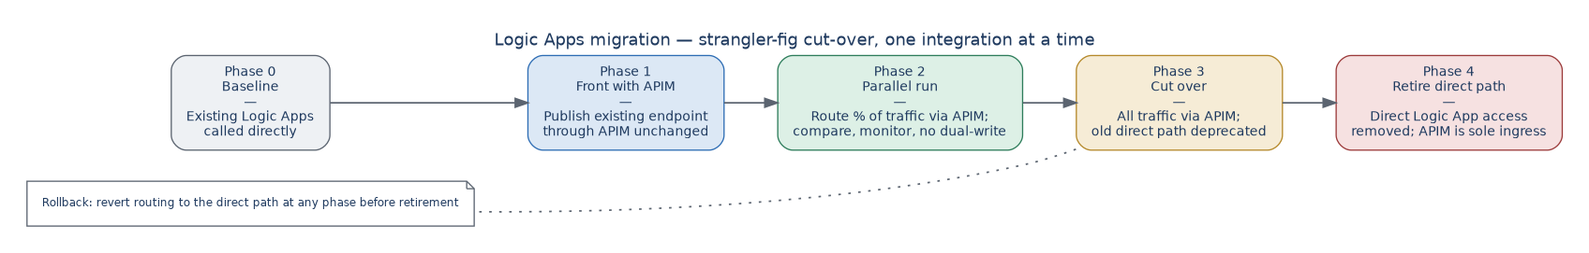
Figure 31: Logic Apps migration — strangler-fig cut-over per integration, with rollback available until retirement
Parallel running and dual-write. For read-style integrations, parallel running simply means routing a growing share of traffic through APIM while comparing results, with no data considerations. For write or stateful integrations, dual-write (both the old and new paths writing) is avoided unless idempotency and de-duplication are proven, because double-processing a financial or claims transaction is worse than a short cut-over; the default for write flows is a clean switch at low-traffic time with a tested rollback, rather than dual-write. Each integration keeps its old direct path available until telemetry confirms the APIM path is healthy, and only then is direct access removed so that APIM becomes the sole ingress.
Phase | What happens | Notes
Phase 0 — Baseline | Existing Logic Apps called directly | Inventory integrations, classify by read vs write and criticality
Phase 1 — Front with APIM | Publish the existing endpoint through APIM unchanged | Contract captured; policies applied; no behaviour change
Phase 2 — Parallel run | Shift a growing share of traffic via APIM | Monitor and compare; no dual-write for stateful flows
Phase 3 — Cut over | All traffic via APIM | Old direct path deprecated but still available for rollback
Phase 4 — Retire | Direct access removed | APIM is sole ingress; single-ingress principle satisfied

