Snowflake integration and data-exchange patterns
Systems Integration Framework – draft for TDA review

Organising principle
Snowflake is Chaucer's analytical platform. Data enters through one set of patterns—push ingestion—and leaves through another—service and consumption. Across all patterns, Snowflake never sits on the operational synchronous path. Any operational consumer reads from a decoupling layer: a materialised store, a cache, or an event. That boundary shapes every pattern.
These patterns inherit from and specialise Chaucer's TDA-ratified Enterprise Architecture and Cloud Engineering Standards. They are not a parallel standard. Connectivity and data-in-transit posture are referenced from the Cloud Engineering Standards rather than restated per pattern.
Scope note: three of the five ingestion patterns rely on a shared ADLS Gen2 staging zone as the ingress buffer and Snowflake external stage. This is treated here as a foundational prerequisite.

Responsibility
Every pattern crosses the seam between the integration team and the data team. The ownership line is straightforward: integration owns the operational integration estate and the movement itself (ingress, Event Hub, Service Bus, Event Grid, Functions, Logic Apps, APIM, Kafka, the landing zone, the operational stores, and the APIs that serve data back). The data team owns everything inside Snowflake: schemas, load targets, transformation, conforming, data modelling, and the definition and contract of every data product served back.
On the way in, integration delivers to the landing zone or broker; the data team owns ingestion into and inside Snowflake. On the way out, the data team defines and exposes the data product; integration consumes and serves it operationally. Where a pattern spans both—pattern 6 in particular—the two teams meet explicitly at the served interface.

Ingestion patterns

1 · Streaming ingestion: Azure Function calling Snowpipe Streaming

Problem
Event data flowing through Azure event services (Event Hub, Service Bus, Event Grid) must reach Snowflake continuously with low latency. Hand-built ingestion services drift and fail; event brokers are fire-and-forget unless something reliable is on the other end.

Solution
An Azure Function is triggered by the event source and uses the Snowpipe Streaming API (client SDK) to write rows directly into Snowflake table channels. Row-set, low-latency, file-less ingestion. The Function owns batching, delivery semantics and channel lifecycle.

Use it when
The source already flows through Azure event services; you want ingestion logic in first-party code you control and can test; sub-minute latency matters; there is no existing Kafka platform and you do not want to introduce one.

Avoid it when
You already run Kafka (pattern 2 is lighter); ingestion is genuinely config-not-code and a managed connector would suffice; data arrives as files (use micro-batch); throughput is so high that a managed connector's built-in scaling outweighs hand-managing Function concurrency.

Risk & consideration
The Function is now operational code on the ingest path. Its scaling, cold starts, retries and offset/checkpoint behaviour are yours to own. Channel and SDK lifecycle—open, reopen, per-channel ordering—needs deliberate design. Duplicate and late-event handling is your responsibility, as is SDK version currency.

Security boundary
The trust boundary is the event source and the Function's managed identity, not Snowflake. Event source reached over private endpoint; the Function authenticates to Snowflake via key-pair / OAuth held in a secrets vault, never account passwords. Managed identity for the event-source binding. Data-in-transit posture inherits from the Cloud Engineering Standards.

Common pitfall
Writing one row per invocation with no batching, multiplying API calls and cost. Treating the Function as stateless when channel/offset continuity matters, causing gaps or duplicates on restart.

In practice
Connected-property or fleet telemetry lands on Event Hub; an Azure Function enriches each reading (for example attaching a peril zone) and streams rows via the Snowpipe Streaming API into a raw schema for near-real-time exposure aggregation. Underwriting dashboards read the conformed product, never the live stream.
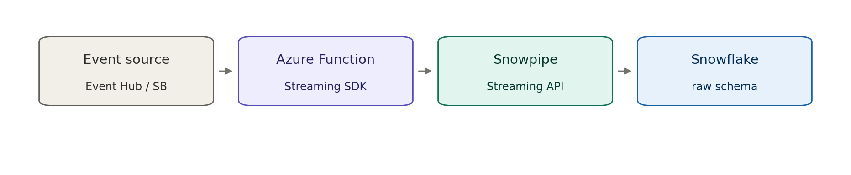

2 · Streaming ingestion: Kafka and Kafka Connect

Problem
A Kafka estate already carries event data, and it should reach Snowflake continuously without bespoke ingestion code for each topic. Managing ten topics with ten hand-built loaders scales poorly.

Solution
Producers write to Kafka topics; the Snowflake Kafka Connector runs in Kafka Connect as a sink and lands topic records into Snowflake using Snowpipe Streaming under the hood. Config-driven, declarative, no custom load code per topic.

Use it when
Kafka (or Kafka on Event Hubs) is already the backbone; you want ingestion managed by configuration rather than code; multiple topics need consistent, repeatable landing into Snowflake; you want the connector's built-in batching, retry and offset management.

Avoid it when
There is no Kafka estate and standing one up purely to ingest is disproportionate (use pattern 1 instead); ingestion genuinely needs bespoke per-record logic that belongs in code; data naturally arrives as files.

Risk & consideration
Kafka Connect is itself a platform to run and govern. Connector workers, scaling and dead-letter topics need ownership. The connector version and its Snowflake-side mechanism (Snowpipe vs Snowpipe Streaming mode) is a decision to validate against current capability. Schema evolution and topic-to-table mapping need design.

Security boundary
The trust boundary is the Kafka cluster and the Connect worker identity, not Snowflake. Cluster and Connect reached over private connectivity; the connector authenticates to Snowflake via key-pair / OAuth from a secrets store; topic ACLs scope producers and the connector. Data-in-transit posture inherits from the Cloud Engineering Standards.

Common pitfall
Treating Kafka Connect as zero-ops because it is config-driven. An unmonitored connector silently lagging or dead-lettering is a common failure. Unmanaged schema drift between producers and the connector breaking the sink is another.

In practice
Policy and claims domain events already published to Kafka topics are sinked by the Snowflake connector into raw schemas for conforming and cross-domain analytics, with no per-topic loader code. New topics are onboarded by configuration.
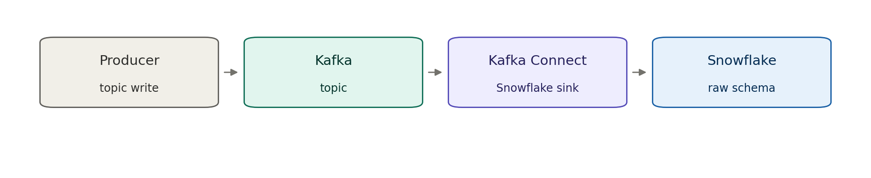

3 · Micro-batch file ingestion: Snowpipe auto-ingest

Problem
Source systems and third parties deliver data as files on their own schedule. Polling for new files wastes compute; hand-built loaders drift and fail silently. We need near-real-time, event-triggered loading without an operational service owning the load path.

Solution
A file lands in an ADLS Gen2 landing zone. Blob creation raises an Event Grid notification that triggers Snowpipe auto-ingest, which runs COPY INTO the target raw schema. Loading is serverless and notification-driven; no compute to run or scale.

Use it when
Data arrives as discrete files (CSV, Parquet, JSON); near-real-time (seconds-to-minutes) is sufficient; volume is continuous or unpredictable rather than one large periodic dump; the producer can write to a landing zone.

Avoid it when
You need sub-second streaming (stream instead); the load is a single massive periodic file where scheduled bulk COPY is cheaper and simpler; the file needs heavy pre-load validation belonging in an orchestrated pipeline; ordering or transactional grouping across files matters.

Risk & consideration
Snowpipe carries per-file overhead, so many tiny files cost disproportionately. Landing-zone retention, replay and idempotency need explicit design. Notification loss (rare) means a file can silently fail unless reconciliation exists. Schema drift in inbound files breaks COPY unless handled deliberately.

Security boundary
The trust boundary is the landing zone, not Snowflake. Storage is reached over private endpoint with public access disabled; Snowflake authenticates via storage integration / managed identity, never account keys; storage firewall and RBAC scope write access to the producer and read access to Snowflake only. Data-in-transit posture inherits from the Cloud Engineering Standards.

Common pitfall
Treating the landing zone as durable or queryable storage. It is a transient ingress buffer; wherever possible, lifecycle-expire loaded files and reconcile landed-vs-loaded counts. Unbatched fan-out of tiny files quietly inflates Snowpipe cost.

In practice
Delegated-authority bordereaux from a coverholder arrive as monthly spreadsheet/CSV files. Each lands in that coverholder's landing-zone path; Event Grid triggers Snowpipe to load it into a raw bordereaux schema for downstream conforming and exposure aggregation. Underwriting reporting consumes the conformed data, never the raw landing zone.
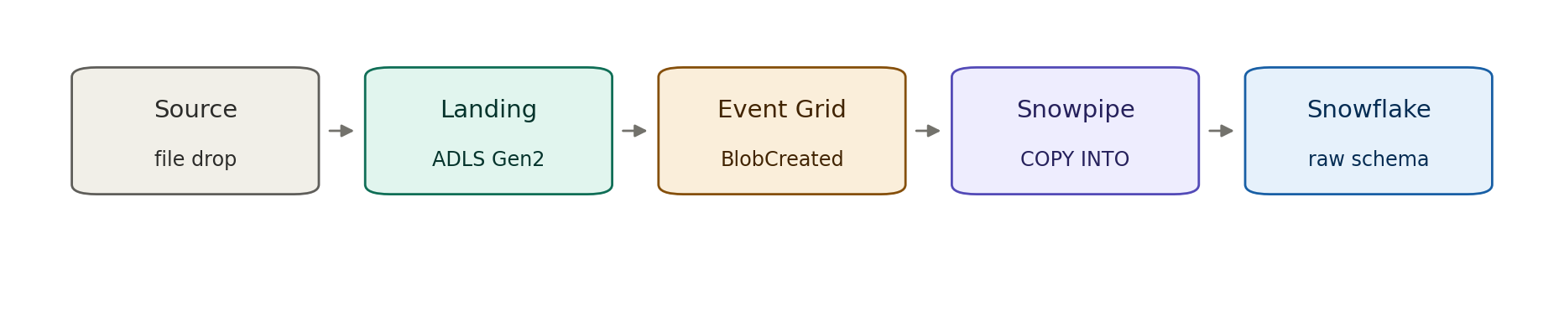

4 · Scheduled batch: watermark and CDC

Problem
Bulk or periodic movement of data from a system of record into the platform, where near-real-time is not needed and full reloads waste time and resources.

Solution
A scheduled Function or Logic App extracts changed rows by watermark or CDC, stages them to ADLS Gen2, and Snowflake bulk-loads via COPY. Periodic, incremental, cost-efficient.

Use it when
Movement is periodic (hourly, daily); the source supports a reliable watermark or CDC feed; near-real-time is unnecessary; large volumes are better moved in batches than per-event.

Avoid it when
Sub-minute latency is required (stream instead); the source has no dependable change marker, forcing brittle full scans; the extraction is really transformation that belongs pushed down into Snowflake.

Risk & consideration
Watermark/CDC state must be persisted and idempotent so failed runs resume without gaps or duplicates. Clock skew and soft-deletes need handling. Schedule contention and source load windows must be respected. Schema drift breaks loads.

Security boundary
Two trust boundaries—the source connection and the stage. Managed identity to both, no embedded credentials; stage reached over private endpoint with least-privilege RBAC. Data-in-transit posture inherits from the Cloud Engineering Standards. Snowflake is the load target only.

Common pitfall
A watermark that is not transactional with the read, causing silent gaps under concurrency. Full reloads quietly replacing incremental logic when CDC breaks, inflating cost and load time.

In practice
Nightly incremental extract of policy and premium movements from a policy-administration system, staged and loaded for finance and actuarial reporting. The operational system is never queried live by reporting.
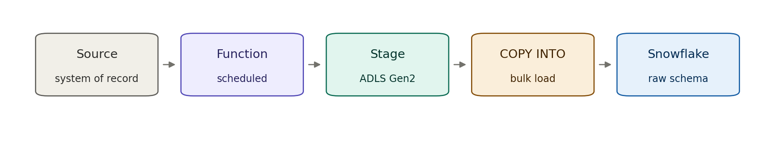

5 · Orchestrated ELT

Problem
Multiple related sources must be brought together with dependencies, retries and observability, and transformation should happen where compute is cheapest and closest to the data.

Solution
An orchestration layer coordinates extract → stage → load across sources, then triggers transformation pushed down into Snowflake (ELT, not ETL). The orchestrator owns sequencing and recovery; Snowflake owns the transform.

Use it when
Coordinated multi-source loads with inter-dependencies; you want lineage, retries and alerting over the pipeline; transformation is set-based and belongs in the warehouse.

Avoid it when
A single simple feed (a plain batch or Snowpipe load is lighter); transformation must happen before landing for compliance or redaction; latency needs are real-time.

Risk & consideration
The orchestrator becomes a critical dependency—its availability, secrets and permissions need the same rigour as any operational service. Partial failures and re-run semantics must be idempotent. Pushdown transforms consume Snowflake compute and need cost governance.

Security boundary
The orchestrator holds credentials to many systems—managed identity and a secrets vault are mandatory, with least-privilege per connection. Staging over private endpoint. Transformation runs inside Snowflake, keeping data off intermediate compute in transit.

Common pitfall
Letting the orchestrator become a transformation engine (row-by-row processing in transit) instead of pushing set-based work into Snowflake. Unbounded retries that mask a persistent upstream failure.

In practice
Building a conformed claims dataset that joins claims, policy and reinsurance-treaty feeds. The orchestrator sequences the loads and kicks off in-warehouse conforming for exposure and recoveries reporting.
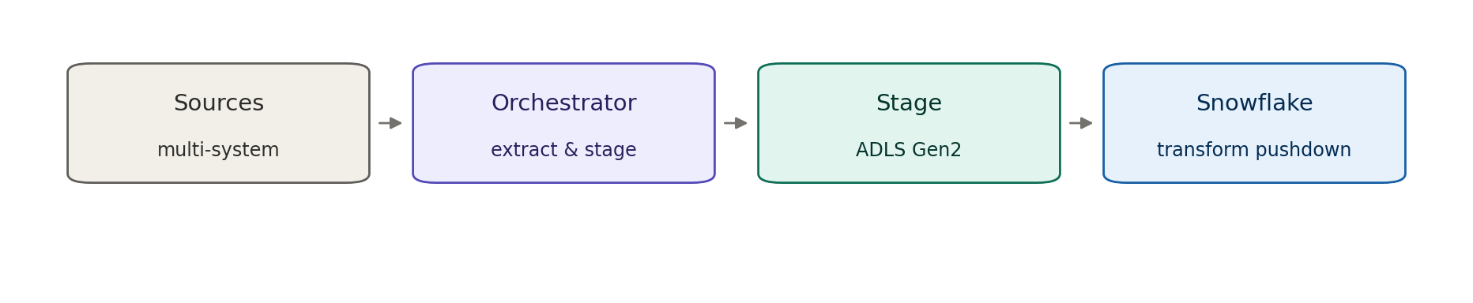

Consumption patterns

6 · Served data product: Snowflake SQL API behind APIM

Problem
Analytical consumers need curated data from Snowflake through a governed, discoverable interface rather than scattered direct database connections.

Solution
The Snowflake SQL API is fronted by APIM as a System API. Consumers call the managed endpoint; APIM enforces policy, authentication and throttling. Explicitly for analytical and reporting consumption where latency in the seconds range is acceptable.

Use it when
Reporting or analytical consumers need served data on request; you want governed, versioned, throttled access rather than raw DB credentials; latency in the seconds range is acceptable.

Avoid it when
The consumer is operational and synchronous—this must not become a runtime dependency on Snowflake (use materialised read or event push-out); request rates are high or latency SLAs are tight; per-row transactional access is needed.

Risk & consideration
This is the most boundary-sensitive pattern—easy to let an operational caller creep onto it and quietly make Snowflake a synchronous dependency. Query cost and concurrency limits must be enforced at APIM. Unbounded result sets and long-running queries need guarding.

Security boundary
APIM is the enforcement boundary; the Snowflake SQL API sits behind it, never exposed directly. OAuth at APIM, private connectivity to Snowflake, policy-based rate limiting and payload limits. The guardrail is explicit: analytical consumers only, never the operational synchronous path.

Common pitfall
An operational service adopting the System API for one call and creating a hidden hot-path dependency on the warehouse. Clients pulling large result sets synchronously instead of requesting a materialised product.

In practice
A reporting portal requests aggregated exposure or loss-ratio figures through the APIM-fronted SQL API. An operational pricing call at bind time does not—that reads a materialised product instead.
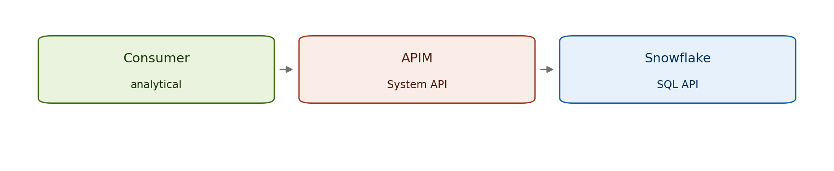

7 · Materialised / cached read

Problem
An operational integration needs data that originates in Snowflake but must never take a synchronous runtime dependency on the warehouse.

Solution
A scheduled job materialises the curated data product out into an operational store or cache; operational integrations read from that store at runtime. Snowflake stays off the hot path entirely.

Use it when
Operational, latency-sensitive consumers need Snowflake-derived data; the data changes slowly enough that a refresh cadence is acceptable; you need predictable operational read performance.

Avoid it when
The consumer genuinely needs the freshest possible value on every call (reconsider the source of truth); the dataset is too large or volatile to materialise economically.

Risk & consideration
Staleness is by design—the refresh cadence is a contract and must be understood by consumers. The materialised store needs its own sizing, availability and backup posture. Refresh failures must alert before data goes stale beyond tolerance.

Security boundary
The operational store is the runtime trust boundary; Snowflake is reached only by the refresh job over private connectivity with least-privilege. Consumers never hold Snowflake credentials. This pattern enforces the Snowflake-off-sync-path boundary.

Common pitfall
The refresh cadence drifting out of step with consumer expectations, leaving operational decisions running on stale data unnoticed. Treating the cache as authoritative when it is a projection.

In practice
Bind-time pricing or eligibility lookups read a materialised reference product (rating factors, sanctions / exposure flags) refreshed on a schedule from Snowflake. The quote path never queries the warehouse directly.
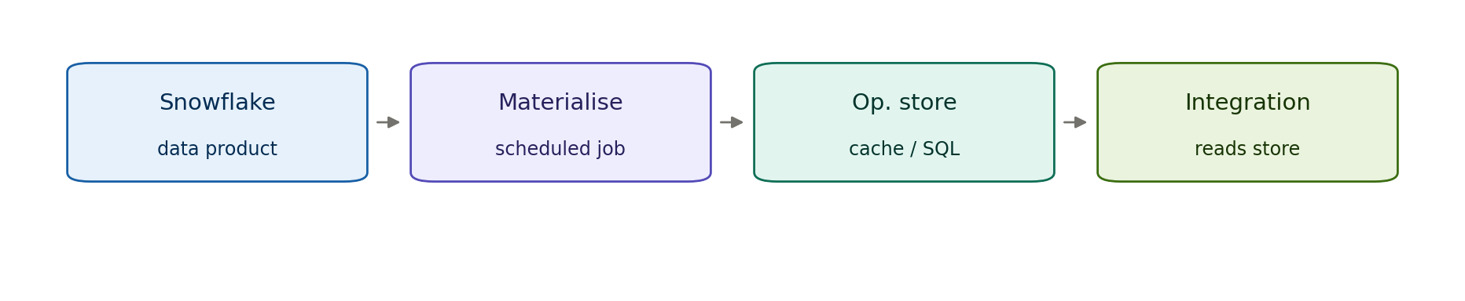

8 · Event-driven push-out: reverse feed

Problem
Downstream systems need to react to changes in Snowflake-held data but should be decoupled from it and not poll.

Solution
A Snowflake stream or task detects change and publishes an event to Service Bus or Event Grid. Downstream systems consume the event asynchronously. Change flows out; no one queries in.

Use it when
Downstream systems should react to curated-data changes; loose coupling and async delivery suit the consumers; change volume is moderate and event-shaped.

Avoid it when
Consumers need full-dataset snapshots rather than deltas (use extract or materialise instead); ultra-low-latency reaction is required that Snowflake task cadence cannot meet; strict ordering guarantees are needed without extra design.

Risk & consideration
Snowflake task cadence bounds latency—this is near-real-time, not real-time. The event schema is a contract needing versioning. Duplicate/at-least-once delivery must be handled idempotently downstream. Poison events need dead-lettering.

Security boundary
The messaging layer is the boundary; Snowflake publishes outward over private connectivity and downstream consumers never reach into the warehouse. Managed identity and topic authorisation. Snowflake initiates; it is never synchronously called.

Common pitfall
Emitting fat events carrying full records where a thin notify-and-fetch (against a materialised product) would be cleaner. No dead-letter path, so one bad event stalls a partition.

In practice
When a claim reaches a settled or reserved state in the conformed model, an event is published so downstream finance and bordereaux-reporting systems update without any of them querying Snowflake.
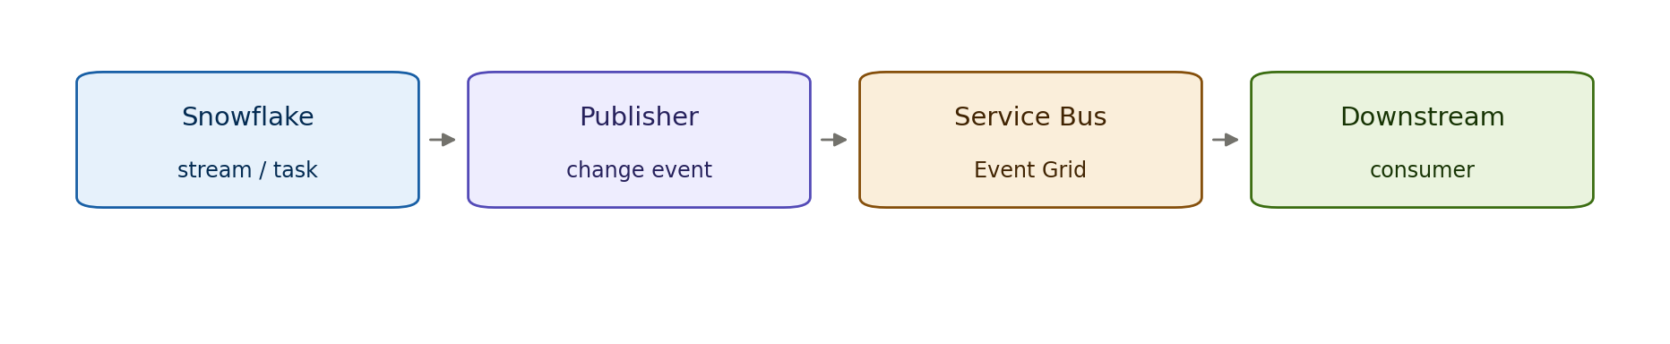

9 · Scheduled extract to operational store

Problem
An operational store needs a periodic refresh of curated data from Snowflake in bulk rather than event-by-event.

Solution
A scheduled job extracts a curated product from Snowflake and refreshes an operational datastore that consumers read. The batch equivalent of the materialised read, for whole-dataset refreshes.

Use it when
Whole-dataset or large-slice refreshes on a cadence; consumers need a complete local copy; event-by-event delivery would be inefficient.

Avoid it when
Consumers need change-level reactivity (use push-out); the dataset is small and better served materialised continuously; freshness tolerance is tighter than the batch window.

Risk & consideration
Refresh windows and volumes must fit within operational quiet periods. Partial or failed extracts need an atomic swap so consumers never read a half-loaded store. Version / rollback of the operational dataset needs design.

Security boundary
The operational datastore is the runtime boundary; the extract job reaches Snowflake over private connectivity with least-privilege; consumers hold no Snowflake credentials. This pattern enforces Snowflake off the operational read path.

Common pitfall
Non-atomic refresh that exposes a partially loaded dataset to live consumers. Ever-growing extract windows that eventually overrun the schedule.

In practice
Daily refresh of a curated reference dataset (for example an approved coverholder / broker registry) into an operational store that policy-administration services read during the day, with no live warehouse dependency.
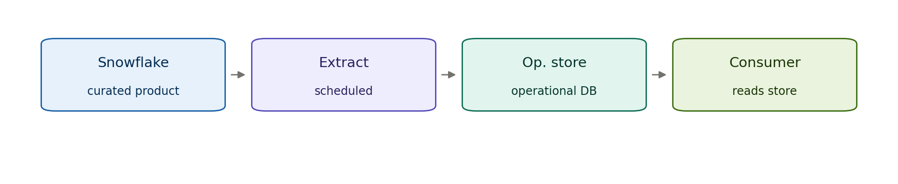

10 · Orchestrated file export to ADLS for downstream consumption

Problem
Downstream systems (analytical, operational, integration, third-party) need periodic curated datasets from Snowflake in file form and should be triggered automatically when new exports arrive, without querying Snowflake directly or polling.

Solution
A Snowflake scheduled task exports a curated data product as a file (Parquet, CSV, Delta format) to ADLS. Event Grid, Logic Apps, or scheduled orchestration detects the file arrival and triggers the downstream system to consume it, or the downstream system polls on schedule.

Use it when
Downstream systems consume data in file/batch form; you want Snowflake off the hot path; export scheduling can be coordinated with downstream processing windows; the data is a complete dataset or meaningful slice; orchestration is already in place to handle the file consumption.

Avoid it when
The downstream system needs real-time or near-real-time data (use push-out pattern); the downstream system can query APIM-served data efficiently (use System API); data volumes are so large that file transfer is uneconomical compared to direct query.

Risk & consideration
File export costs (compute in Snowflake for extraction, ADLS storage, network transfer). Coordination between Snowflake export schedule and downstream processing schedule—lag or missed exports cause stale data or processing delays. File schema versioning—downstream systems must handle format changes gracefully.

Security boundary
The file is the exchange point. ADLS storage reached over private endpoint, exported file scoped by Snowflake managed identity. Downstream consumer identity has read-only access to the export path, never to Snowflake directly. Data-in-transit posture inherits from Cloud Engineering Standards.

Common pitfall
Exporting full tables when slices would suffice, inflating transfer and storage cost. No reconciliation of export schedule vs. downstream consumption, so data sits in ADLS waiting or processing runs stale. Schema drift breaking downstream parsing.

In practice
Curated features for a claims prediction model are exported nightly as Parquet from Snowflake to ADLS; an Azure ML scheduled training pipeline picks up the file and retrains the model. Or: policy and claims data are exported daily for a third-party integration system that consumes it via a Logic App orchestration. Or: aggregated loss triangles are exported weekly as CSV for a Synapse analytics workspace to compute reserve adequacy metrics.
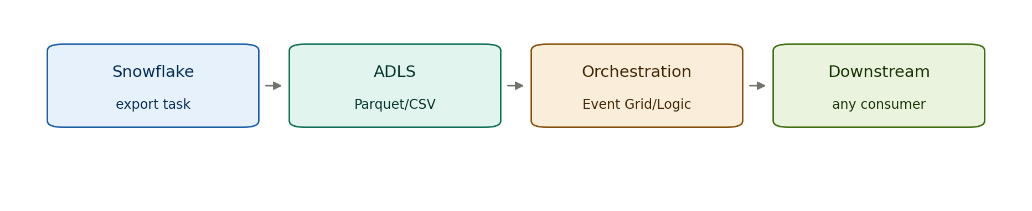

Open items
The Kafka connector choice and Snowpipe Streaming mode (pattern 2) are decisions to validate with the data owner. Insurance domain examples throughout are illustrative.

