Azure API Management

High Level Design

v0.1 (DRAFT)

Contents
1. Document Control 4
1.1. Document History 4
1.2. Document Authors 4
1.3. Document Assurance 4
1.4. TDA Approval 4
1.5. Document References 4
2. Executive Summary 5
2.1. Architectural Decisions 5
2.2. Edge Gateway Selection Matrix 6
2.3. APIM Deployment Mode Decision 7
2.4. APIM SKU & Tier Decision 7
2.5. Requirements Traceability 8
3. Architecture Context and Scope 9
3.1. Scope 9
3.2. Target Audience 9
3.3. Current State Summary 9
3.4. Existing API and Integration Landscape 9
3.5. Current API Consumption and Exposure Model 9
4. APIM Role and Positioning 11
4.1. Architecture Principles 11
4.2. Solution Summary 12
5. APIM Service Architecture 13
5.1. Architecture Overview 13
5.2. SKU Selection & Tiering Strategy 13
5.3. Ingress flow 13
5.4. Egress flow 14
6. Network Topology and Connectivity Design 16
6.1. Traffic flows in detail 21
7. Traffic Management and Edge Security 24
8. Authentication and Security Design 25
9. API Product, Consumer and Developer Portal Model 34
9.1. Developer Portal 36
10. API Design, Policies and Governance 40
10.1. Engineering and Naming Standards 40
10.2. Design Standards, Policy Enforcement and Governance 40
11. API Lifecycle and Versioning Strategy 45
12. Observability and Operations 48
13. Environment and Release Strategy 50
14. High Availability and Disaster Recovery 53
14.1. Resilience Strategy 53
14.2. Resilience Topology 54
14.3. Azure Front Door Vs Traffic Manager 54
15. Capacity, Cost and Service Tiers 56
16. Operating Model 58
16.1. Operational ownership and support tiers 58
16.2. Incident management 59
16.3. Change and release management 59
16.4. Capacity, cost and service reporting 60
17. Service Handover 60
17.1. Handover readiness checklist 60
17.2. Early-life support (hypercare) 61
17.3. Documentation and knowledge transfer 61
17.4. Service acceptance sign-off 61
18. Risks, Assumptions and Decisions 62
18.1. High Level Impact Assessment 62
18.2. Assumptions 62
18.3. Risks 63
18.4. Issues 64
18.5. Dependencies 64
19. Appendices 65
19.1. Microsoft Reference Architectures 65
19.2. Alignment with the Azure Well-Architected Framework 65
19.3. Glossary and Definitions 66
19.4. Sample Policy Fragments, Naming and OpenAPI Skeleton 66
19.5. Threat model: STRIDE and OWASP in detail 68
STRIDE: platform-level threats 68
OWASP API Security Top 10 (2023) 68
19.6. APIM End-to-end build and API onboarding flow 70

Document Control

Document History
Version | Date | Author | Change
0.1 | 21 September 2026 | Puneet Kumar | Initial draft restructured to the Organization’s HLD template

Document Authors
Role | Name / Team

Document Assurance
This document has been reviewed and approved by the following, the list has been grouped into different sections to aid readability as this document will be required at TDA.

Role | Description
Information | Shared for informational purposes including use as reference document for their domain’s documentation and processes
Reviewer | Actively reviews the content to ensure alignment to guidelines and policies and technical accuracy, will contribute as required
Approver | Provides assurance that their domain is correct in context of the HLSA

Date | Role | Name | Title
DD/MM/YY | Approver
DD/MM/YY | Approver

TDA Approval
The TDA approval date to be updated by the author once full TDA approval has been granted.
The document should then be updated to a major revision number and stored in the solution repository.

Date | Minutes (link) | TDA Chair Name | TDA Chair Title
DD/MM/YY

Document References
The following documents should be read in conjunction with this document:

Reference | Document | Version | Author | Source
1.

Executive Summary
Azure API Management provides a single, secure and governed platform for all organisational APIs internal, external, and partner. This document sets out the guidelines for standing up and operating the APIM platform and for onboarding APIs onto it, covering architecture, security, operational governance, and cost. comparable enterprise integration programme.
The Ask | Our Response | The Outcome
The Organization has no API layer today. Systems connect through point-to-point integrations, each built and secured from scratch. | A hardened Azure APIM platform, Entra ID identity, Key Vault secrets, Zero Trust security, delivered on top of the existing integration estate. | Faster API onboarding, a single place to see and govern every API and an audit-ready security posture.

Architectural Decisions
This section records the design decision chosen for each key architectural area. Each row states the option selected not the full set of alternatives considered. Full comparison and why each choice was made, see the section where that decision is covered in detail. (sections 2.2 to 2.4) and the tier and cost options are compared in section 15 (Capacity, Cost and Service Tiers).
This table lists all the decisions in one place. The edge service and the APIM deployment mode are the two most important design decisions in this architecture, so each is explained in full in the subsections that follow.
Area | Decision | Trade-off accepted
API Exposure | All managed APIs are published and exposed through Azure API Management. | Every API must be onboarded through a centralized gateway, direct backend exposure or informal bypasses are strictly prohibited.
External Access | Azure Front Door Premium with Web Application Firewall (WAF) is used as the primary edge entry point over Application Gateway v2 (see the Edge Service Selection Decision section 2.2). | Similar baseline operational cost to Application Gateway WAF_v2, accepted to gain global edge routing, integrated CDN/caching, and multi-region failover without adding virtual network infrastructure overhead.
APIM Tier | Classic Premium, multi-region. Azure API Management Premium v2. | Higher baseline cost than lower tiers, accepted for modernized architecture, enhanced scalability, elastic multi-region deployment, and alignment with Microsoft’s long-term APIM platform strategy.
Network Model | APIM deployed in Internal VNet integration mode with Private Endpoints / Private Link for backend services. | More network configuration up front, in exchange for no direct internet exposure anywhere
Resilience | Tiered Resilience Framework (Preferred: Silver)  • Bronze: Single-region, 1 unit. DR secondary region deployed on-demand via IaC/Pipelines.  • Silver (Default Production): Single-region, 2 units distributed across Availability Zones. DR secondary region deployed on-demand via IaC/Pipelines  • Gold: Active-Active Multi-Region (Tier-1 mission-critical only). | Accepts an extended Recovery Time Objective (RTO) during a total regional outage while automated pipelines provision and configure the secondary region. In exchange, this eliminates 24/7 idle secondary region costs while maintaining a near-zero Recovery Point Objective (RPO) via Git-driven infrastructure configuration.
Identity | Entra ID and OAuth 2.0 as the default authentication mechanism. | Legacy non-OAuth partners require a formally documented and approved architectural exception rather than ad-hoc configurations
Delivery | All infrastructure, APIM policies, and route configurations are fully defined as code (IaC) and deployed via automated CI/CD pipelines | Slower initial setup and onboarding times compared to manual portal edits, in exchange for predictable, audited, and repeatable deployment workflows.

Capability comparison backed by Microsoft: API Management gateways feature comparison, learn.microsoft.com/azure/api-management/api-management-gateways-overview

Edge Gateway Selection Matrix
Choosing the right edge gateway service to sit in front of APIM is a key design decision. The matrix below compares the three main options against our core criteria to highlight the clear recommendation.
Criteria | Front Door Premium + WAF | App Gateway v2 + WAF | Front Door + App Gateway (Both Combined)
Global routing | Yes | No | Yes
Multi-region support | Yes | Limited | Yes
WAF protection | Yes | Yes | Yes
Private Link to APIM | Yes | Limited | Yes
Performance | High | Regional | Highest
Operational complexity | Low | Medium | High
Cost | Medium | Medium | High
Recommended | Yes | No | No

Selection rationale, when to choose which:
Option | Primary Architectural Intent | Why
Front Door Premium + WAF (chosen) | Global Edge, Multi-Region DR & Unified Ingress | Combines global routing, managed WAF/DDoS, and native Private Link into APIM within a single, low-maintenance service
Application Gateway v2 + WAF | Regional-Only Ingress & Strict Data Residency | Provides regional WAF protection, custom URL rewrite rules, and VNet-native integration.
Front Door + Application Gateway | N-Tier Ingress & Deep Defense-in-Depth | Delivers maximum inspection depth and fine-grained regional traffic control
Direct APIM ingress (no edge gateway service) | Private / Internal-Only Services | Eliminates unnecessary public edge services for internal-only consumers, routing traffic directly to the APIM internal endpoint.
Recommended pattern backed by Microsoft: Protect APIs with Front Door and API Management, learn.microsoft.com/azure/architecture/web-apps/api-management/architectures/protect-apis
The full end-to-end network topology behind this choice is shown in section 6; the conditions under which the other two options would win are set out in the matrix above (Network and Connectivity Design).

APIM Deployment Mode Decision
To ensure a strict security boundary, Azure API Management must be isolated from direct internet exposure. Selecting the deployment mode dictates how the gateway integrates with our virtual network (VNet) and forces all external consumer traffic through Azure Front Door Premium WAF via Private Link.
The table below details the evaluation between Internal VNet and External VNet modes
Option | Description | Status | Architectural Rationale
Internal (VNet) mode | APIM is deployed fully inside a dedicated VNet subnet with no public IP address. Ingress from Front Door Premium is routed privately via Private Link / Private Endpoints, and backend access uses private VNet routing. | Chosen | Zero Internet Exposure: Completely isolates the API gateway from the public internet. Guarantees that all external traffic is inspected and forced through Azure Front Door Premium WAF before reaching APIM.
External mode | APIM sits inside a VNet but maintains a direct, publicly accessible IP address on the internet, allowing clients to bypass or hit the gateway alongside an optional edge service. | Not Chosen | Security & Compliance Risk: Exposes a public surface area directly to the internet, creating potential governance bypasses where consumers can hit APIM endpoints without traversing the centralized Front Door WAF edge.

The concrete network topology that implements this choice, Front Door + WAF in front of an internal-mode APIM, is shown in section 6.

APIM SKU & Tier Decision
This section evaluates Premium v2 against Classic Premium for the enterprise API gateway platform. Premium v2 is selected as the platform standard to leverage its simplified networking, improved security posture, and modernized platform architecture, establishing a future-proof foundation for API management.
Capability | Premium v2 | Classic Premium | Decision & Rationale
Simplified Networking Model | Yes | No | Premium v2 significantly reduces virtual network governance overhead by eliminating dedicated control-plane routing dependencies.
Private Networking / Isolation | Yes | Yes | Both tiers fulfill strict security policies by providing private endpoint connectivity and network isolation
Workspaces | Yes | Yes | Both tiers support workspaces for decentralized API publishing and domain isolation across business units.
Future-Proofing | Yes | No | Premium v2 positions the platform on Microsoft's newest architecture, avoiding future migration rework from Classic Premium.
Multi-Region Topology Strategy | Regional Deployment | Native multi-Region | Premium v2 supports single-region zone redundancy per instance, aligning perfectly with our Silver Resilience Tier
Chosen | Yes | No | Premium v2 is selected as the platform standard to establish a modernized, simplified, and future-proof API gateway foundation.

Premium v2 GA backed by Microsoft: Premium v2 general availability announcement, techcommunity.microsoft.com/.../premium-v2-tier-ga; multi-region tier support confirmed in Microsoft’s reliability guidance for API Management.

Requirements Traceability
Where this design departs from or interprets a stated requirement, the decision is traced explicitly. The clearest example is global routing: the Systems Integration Framework references Traffic Manager, and this design selects Azure Front Door instead, with the comparison and justification set out in section 14.2. Confirmation of whether the Traffic Manager reference is a hard mandate is an open item in the assumptions register (section 18).

Architecture Context and Scope

This document establishes the enterprise API architecture standards for the Organization. The platform design prioritizes security, compliance, and resilience to support critical business operations, secure external integrations, and internal system communication within a regulated operational environment

Scope
This High-Level Design sets out the architecture, network design, security, governance, resilience, and cost for adopting Azure API Management (APIM) as the central enterprise API gateway, together with the pattern for onboarding APIs onto it. It covers APIM deployed in internal VNet mode, edge routing via Azure Front Door Premium with a Private Link origin, outbound integration with the existing Palo Alto firewall, security policies with Entra ID and OAuth 2.0 authentication and Key Vault–backed secrets, federated workspace governance and APIOps onboarding pipelines, and observability, HA/DR, operating model and platform cost. It does not cover the detailed configuration of individual backend systems or device-level firewall configuration, which are detailed-design activities.

Target Audience
This document is intended for the Organization’s Technical Design Authority, enterprise and solution architects, and the platform, networking, security and integration teams who will build and operate the platform. It assumes familiarity with Azure and with enterprise integration concepts.

Current State Summary
Today, integrations are typically delivered on a case-by-case basis using approaches such as batch file transfers, direct database connectivity, and point-to-point integrations. While this has successfully met business needs to date, it creates a number of challenges as the integration landscape grows.
Challenge today | Business & Technical Impact
Lack of a Shared Gateway Platform | Every new integration must re-implement security, authentication, rate limiting, and operational logging from scratch, resulting in duplicated effort and inconsistent security postures.
Absence of Centralized Visibility | There is no single pane of glass to audit data flows, monitor traffic, or map dependencies making it difficult to determine who is consuming specific APIs or sensitive datasets.
No self-service onboarding | Both Internal and External parties cannot discover or onboard to existing capabilities, every new connection is bespoke effort.  Without a developer portal or self-service discovery, every new connection requires a bespoke engineering effort.
Point-to-Point Coupling | Direct database and system-level connections create tight coupling, making backend upgrades risky and costly to execute without breaking dependent consumer applications.

Existing API and Integration Landscape
The Organization’s current integration landscape is built on point-to-point integrations, each wired directly to the system it connects, alongside batch files and direct database links. There is no central API gateway, catalogue or consistent security model today. This design adds APIM in front of that existing integration estate rather than replacing it.

Current API Consumption and Exposure Model
This represents the Organization's first API management platform. APIM is being introduced as a new, governed layer in front of the existing integration estate, there is no existing API gateway, legacy API estate, or on-premises system to migrate, replace, or connect to.
Today, consumers whether internal systems or external partners integrate through bespoke, point-to-point connections. There is no self-service discovery, no product or subscription model, and no mechanism for partners to self-onboard. The target consumption and exposure model, which addresses these gaps, is set out in Section 9.

APIM Role and Positioning

Architecture Principles
This section sets out the core architectural standards and guardrails that every API on the platform must follow. They operationalize the single-ingress decision recorded in Section 2.1 and are stated here as concrete, enforceable rules rather than general narrative.
What this means in practice:
- Every API call is verified against Microsoft Entra ID rather than locally stored passwords or credentials. Every secret, certificate, and connection string resides in Azure Key Vault rather than in code, policy XML, or configuration files.
- No internet traffic reaches a backend system directly; all inbound traffic is strictly routed through perimeter security controls.
- Every platform and API modification is executed via a reviewed APIOps pipeline rather than manual portal adjustments.

The five non-negotiable platform guardrails and the layered traffic order they enforce are detailed below:
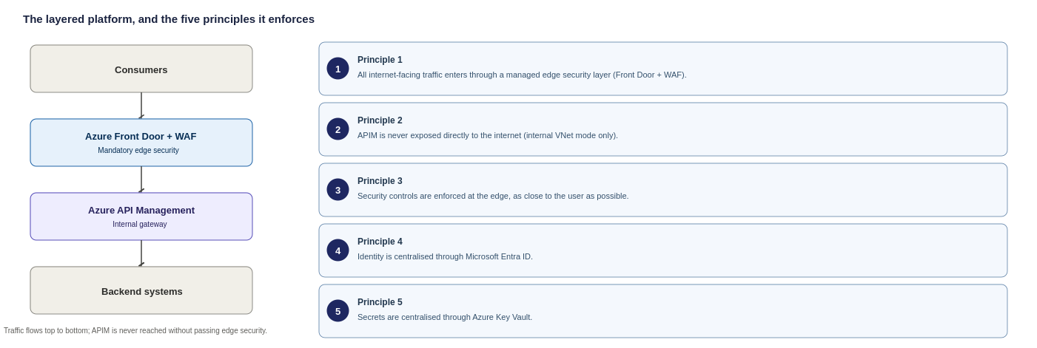
Figure 1: The mandatory layer order every request follows
These guardrails establish a single, consistent routing topology across the platform. The table below outlines how each traffic flow is controlled as a result: all external inbound paths are enforced through perimeter security, internal workloads connect directly to the internal gateway and outbound egress traffic is routed through central firewall controls.
Traffic type | Route
External consumer to organisational API | External Consumer → Edge Service (Azure Front Door) → APIM Gateway (internal) → Backend Service
Internal application to organisational API | Internal Application → APIM Internal Gateway → Backend Service
Third-party webhook inbound | Third Party → Edge Service (Azure Front Door) → APIM Gateway (internal) → Function or Backend Service
Outbound call to third-party API | Function or Application Service → APIM → Third-Party API

Solution Summary
One control plane. One security model. Every API- internal, external or partner facing is governed consistently on Azure API Management.
The diagram below illustrates how the Organization’s API estate matures over time, rather than representing a static, point-in-time architecture. Read from top to bottom as four progressive stages, each tier builds directly upon the last.
The fundamental takeaway is that the governance model never changes: a central platform team maintains the shared platform and standards, while domain teams own their respective APIs - with all updates flowing strictly through automated APIOps pipelines and design gates. The Organization is never rebuilding its foundation, only extending its capabilities.
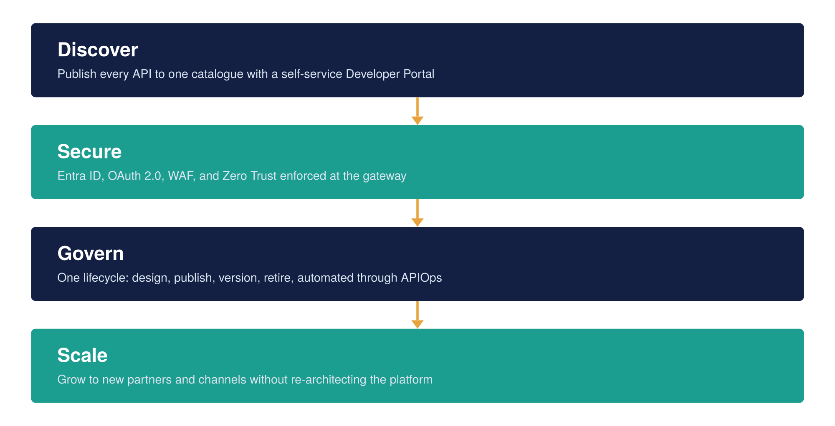
Figure 2: The APIM vision, four stages from discovery to scale

APIM Service Architecture

This section shows how a single API request travels from an external consumer through each security and routing layer to the backend that answers it and where the shared services (identity and secrets) sit relative to that path. The goal is one governed flow that every API follows, so security is applied consistently rather than rebuilt per integration.

Architecture Overview
Deployment Topology: Dedicated Internal Virtual Network (VNet) Injection Mode. APIM resides within a dedicated, delegated subnet with no public IP address assigned for inbound traffic.

Why the gateway is internal-only
APIM runs in internal (VNet) mode only, with no public gateway; the reasoning for choosing internal over external mode is recorded with the decision in section 2. All external and partner traffic reaches APIM only through Azure Front Door over Private Link, so there is a single, inspected way in and no internal system is exposed to the public internet. The table below compares the two modes at a glance.
 | Internal mode (chosen) | External mode (rejected)
Public endpoint | None, APIM sits inside the VNet | Yes, APIM is exposed on the internet
How consumers reach it | Only through Front Door over Private Link | Directly, even if IP-restricted
Attack surface | No public surface to reach APIM directly | A public surface an attacker can target
Fit with single-ingress / zero-trust | Consistent, one inspected way in | Weakens it, adds a second public gateway

Logical components of the service
The APIM platform is made up of a few distinct parts, each with a clear job. The diagram below shows how they fit together and how a request moves through them; the parts themselves are described underneath.
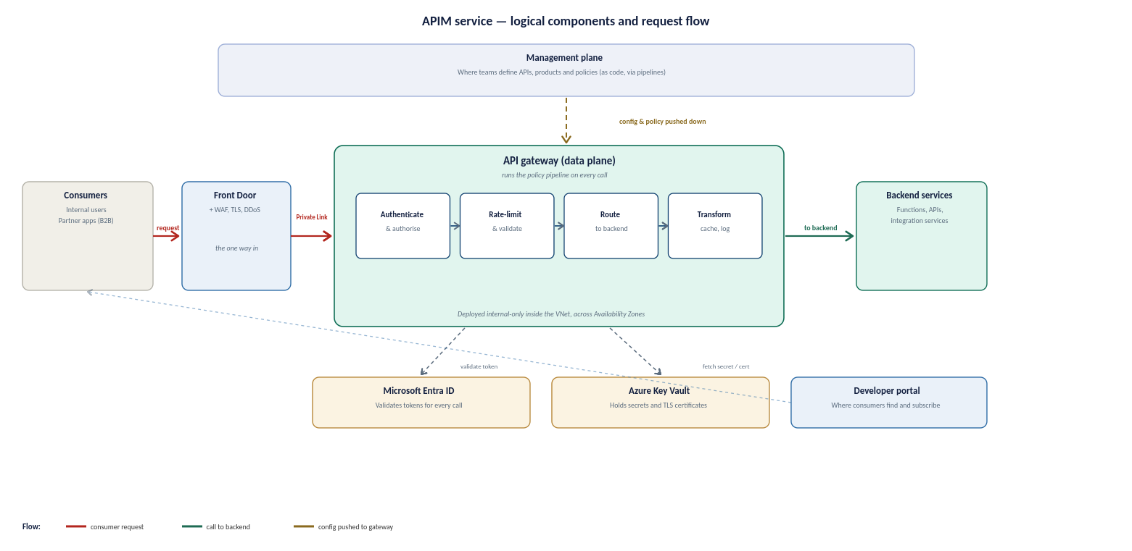
Figure 3: APIM service reference architecture, the logical components and how a request flows between them
The service has these parts:
- Gateway (data plane). The engine that handles live traffic. Every call passes through it, and it applies the same set of rules, authentication, rate limits, validation, routing and logging, to each one. This is where the platform actually does its work.
- Management plane. Where the platform is configured. Teams define their APIs, products and policies here, and those definitions are pushed down to the gateway. It is used to set the platform up and change it, not to serve live traffic.
- Developer portal. The self-service website where consumers find the APIs they are allowed to use, read the documentation, and request a subscription. It is covered in full in section 9.
- Workspaces. A way to give each team its own area to manage its own APIs without affecting anyone else, while the platform team keeps overall control. The workspace model is set out in section 9.
- Policies. The reusable rules the gateway runs on each call. They are written once and applied consistently, so security and behaviour do not have to be rebuilt for every API. Policy detail is in section 10.
Two shared Azure services sit alongside the gateway and are called on every request: Microsoft Entra ID validates the caller's token, and Azure Key Vault holds the secrets and certificates the gateway needs. Neither is part of APIM, but the platform depends on both.

How a request flows
Bringing the parts together, a single call follows the same path from start to finish:
- 1. A consumer, internal or partner, sends the request to the published address.
- 2. Azure Front Door receives it at the edge, applies the web application firewall and TLS, and forwards it over Private Link to the gateway. This is the only way in; nothing reaches the gateway directly.
- 3. The gateway authenticates and authorises the caller (checking the token with Entra ID), enforces rate limits and quotas, and validates the request.
- 4. It then routes the call to the correct backend, applies any transformation, and returns the response, recording the call for observability on the way out.
Because every API follows this one path, the same protections apply everywhere by default, rather than being added by hand for each new integration. The network detail behind this path, subnets, routing and egress, is in section 6, and the security controls are in section 8.

Instance composition
The concrete shape of the APIM instance is set out below: the tier, region and zone layout, network mode, custom domains, TLS and identity. These are proposed target values; the custom domain names are illustrative placeholders, and the network mode and region choices are to be confirmed against the Organization's landing zone and naming standards.
Attribute | Proposed value | Status | Technical Rationale
Service Tier | Premium v2 | Proposed | Unlocks v2 architecture benefits; eliminates legacy cloud service (Classic) dependencies.
Region | UK South | Strategic | Deployed as in regional instances orchestrated via Azure Front Door.
Availability Zones | Zone-Redundant – 2 zone | Proposed | Deployed across 2 Availability Zones within single region.
Networking Mode | VNet Integration & Private Endpoints | To confirm against landing zone | Standard v2 private networking pattern (Inbound via Private Endpoints; Outbound via VNet Integration subnet).
Custom domain | api.organization.com (external), api-internal.organization.com (internal) | Dummy placeholder | Domain names map to Front Door (External) and Private IP / Internal DNS (Internal).
TLS | TLS 1.2 Minimum | Proposed standard | Enforces TLS 1.2+ minimum across all endpoints; legacy ciphers disabled by policy.
Managed identity | User-Assigned Managed Identity | Proposed | Enables resilient, cross-resource access to Azure Key Vault and Azure Monitor without lifecycle coupling.
Developer Portal | Internal-Only | Proposed | Public developer portal disabled, access restricted via internal VNet routing or Entra ID SSO.
The service scales in units, each a fixed block of gateway capacity. Production runs zone-redundant across Availability Zones and adds units as sustained traffic requires, rather than over-provisioning up front; the capacity and cost model behind this is in section 15. The instance is deployed and changed only through code and pipelines, so its configuration is reproducible and auditable, as described in section 13.

SKU Selection & Tiering Strategy
For full justification on SKU tiering (Classic Premium vs. Premium v2) and scale-unit capacity models, see Section 2.4.

Network Topology and Connectivity Design
This section operationalizes the core design choices established and justified in Section 2 specifically the selection of Azure Front Door Premium with WAF as the edge perimeter and APIM deployed in Internal (VNet) Mode. Rather than re-evaluating those decisions, this section details the concrete network topology required to implement them.

It walks through how traffic reaches APIM (the ingress path) and how APIM reaches out (the egress path), how the Palo Alto firewall fits in and which flows pass through it, and the routing and subnet design that underpins all of it. The step-by-step configuration of each flow is collected at the end so it does not interrupt the overview.

Ingress flow
Azure Front Door + WAF with Internal APIM - The selected entry pattern positions Azure Front Door + WAF in front of an internal-mode APIM instance (Option A). Across all options evaluated, APIM remains strictly in internal mode and is never exposed to the internet; the only difference lies in the edge service. The diagram below contrasts the chosen topology against the two rejected alternatives to provide full context. The complete decision framework and option comparisons are detailed in Section 2 (Edge Service Selection).
This diagram shows the inbound (ingress) request flow, how a request travels from a consumer through the edge and APIM to the backend.
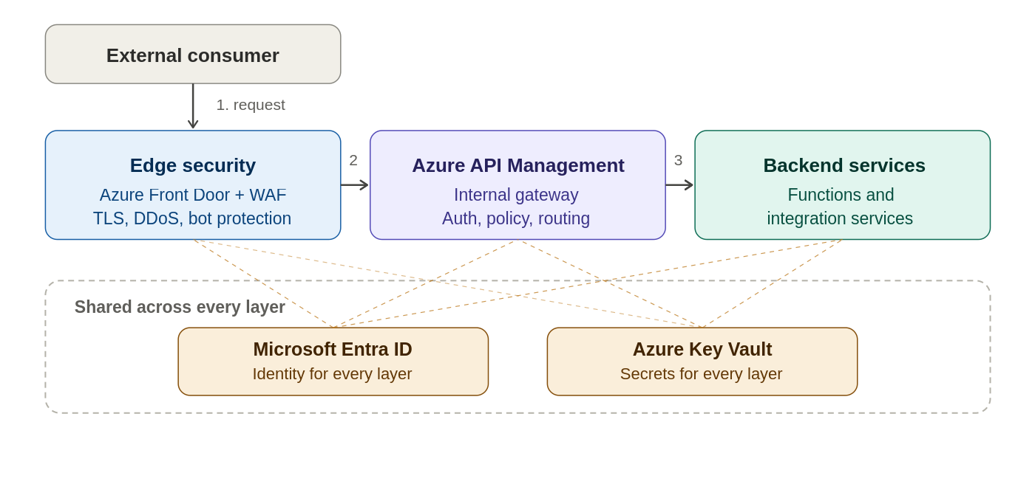
Figure 3a: High-level Azure APIM architecture for the Organization

Egress flow
This diagram shows the outbound (egress) traffic flow, how APIM and backends reach external third-party APIs through the Palo Alto firewall.
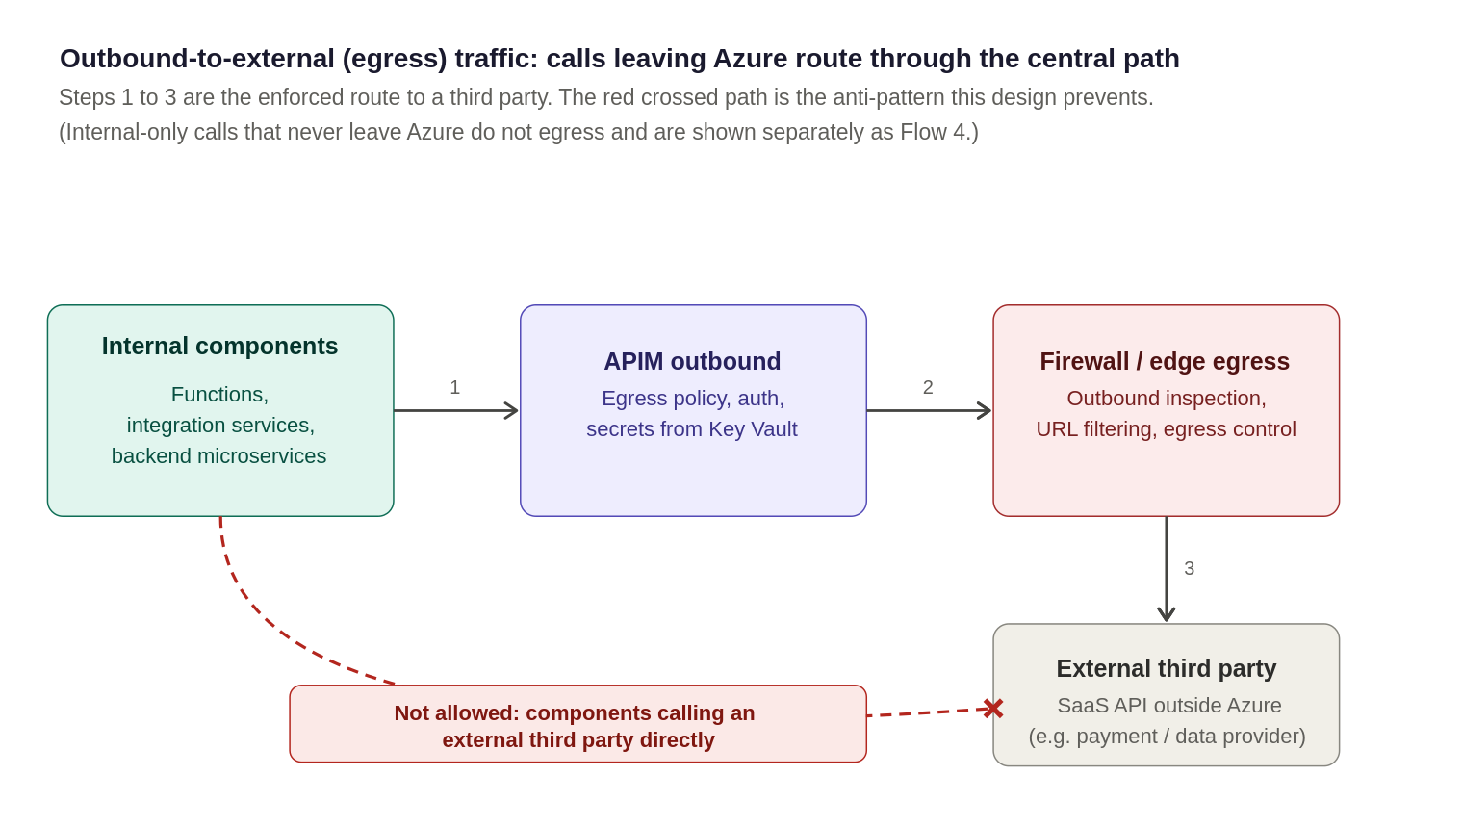
Figure 4: Outbound-to-external (egress) traffic, calls leaving Azure to a third-party route through the central egress path
Note: This section covers outbound-to-external traffic only. Internal calls (APIM to internal private backends) remain entirely within the private network perimeter over VNet peering/Private Endpoints, never hit the public internet, and are detailed separately as Flow 4 under "Traffic flows in detail".
The design workflow above follows three Microsoft-published reference architectures made for this exact scenario, so it's a proven, supported approach.
- Basic Enterprise Integration on Azure: Microsoft's reference architecture for exposing and managing integration services through API Management.
- Front Door in front of API Management: Microsoft's documented pattern for placing Azure Front Door ahead of API Management for global routing, WAF protection and Private Link connectivity into a VNet-injected gateway, the exact combination this design uses.
- API Management Landing Zone Accelerator: Guidance from the Cloud Adoption Framework for deploying API Management at enterprise scale, covering networking, security, governance, and identity.

Firewall integration
The Organization uses Palo Alto as its egress firewall. In this design it inspects and controls outbound traffic to external third parties only: inbound traffic enters through Front Door over Private Link and does not traverse the firewall, and internal-only calls stay on the private network. The egress flow is worked through step by step under "Traffic flows in detail" at the end of this section.
Implementing the egress firewall: NVA or Cloud NGFW
The egress firewall can be delivered two ways. Both are Palo Alto and both do the same job here (inspecting outbound third-party traffic); they differ in how the firewall is run and operated.
Option | What it is | Trade-offs
Traditional NVA | A Palo Alto firewall appliance the Organization runs itself in a hub VNet, behind an internal load balancer, with outbound routed to it by user-defined routes | Full control and reuses an existing hub firewall if one are already in place but the Organization builds, patches, scales and operates the appliance
Cloud NGFW (Azure-native) | Palo Alto’s firewall as a managed Azure service (the PaloAltoNetworks.Cloudngfw resource), provisioned from the Marketplace, billed through Azure and managed from the Azure portal or Panorama | Microsoft-and-Palo-Alto co-developed and managed, scales automatically and integrates natively with Azure routing, removing the build-and-patch burden, newer, and introduces a managed SaaS dependency

Topology and the guiding principle
The Palo Alto egress firewall sits in the hub (as a self-run NVA behind an internal load balancer, or as a Cloud NGFW resource). APIM sits in a delegated subnet in a spoke VNet, peered to the hub, and runs in internal mode so its data-plane gateway has a private virtual IP and no public data-plane address. A route table (UDR) on the APIM subnet sends outbound traffic destined for external third parties to the Palo Alto for inspection. The guiding principle is that outbound traffic leaving Azure to a third party is inspected by the Palo Alto, while inbound traffic (through Front Door) and internal-only traffic stay off the firewall. One deliberate, documented exception still applies to any outbound routing through a firewall: Azure's own control-plane traffic must bypass it for APIM to function at all.
That exception is the single most important design point when combining APIM with any NVA, so it is worth stating plainly before the flows: if Azure's management traffic to APIM is force-tunnelled through the firewall, the return path is asymmetric, the stateful firewall drops it, and APIM loses connectivity to the Azure control plane, breaking scaling, updates, and monitoring. The fix is a specific route, covered under Routing and subnet design below, and detailed with the flows at the end of this section.
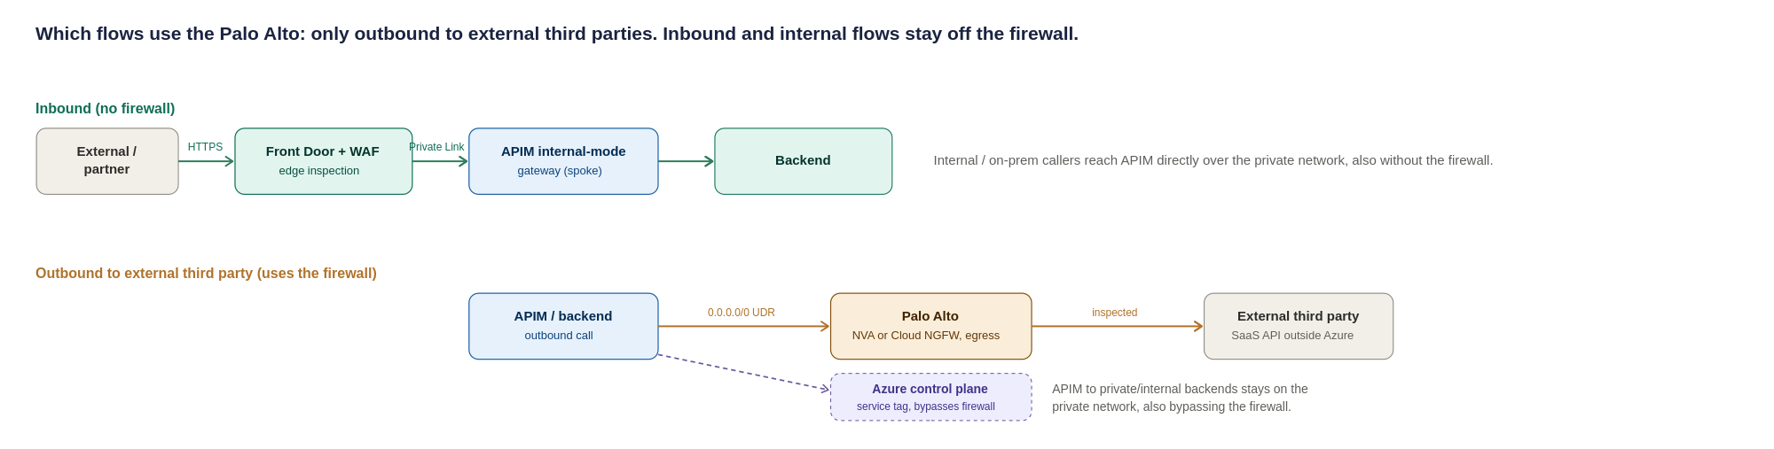
Figure 10: Which flows use the Palo Alto, only outbound traffic to external third parties; inbound (Front Door/Private Link) and internal flows stay off the firewall
Summary of which flows use the firewall:
Traffic flow | Through Palo Alto? | How it is secured
External inbound (via Front Door) | No, bypasses the firewall by design | Front Door WAF at the edge; origin locked to Front Door (Private Link + NSG + X-Azure-FDID)
Internal inbound | No, stays on the private network | Reaches the APIM internal gateway directly over peering/ExpressRoute; authenticated and policy-checked at APIM
Outbound to external third party | Yes | Forced-tunnel UDR to the Palo Alto; egress inspection and URL-filtering policy
APIM to private / internal backend | No, stays private | Private Endpoint + NSG; stays on the Azure backbone, does not traverse the firewall

The table above is the complete answer for most readers: it says which flows touch the firewall and how each is secured. The step-by-step configuration of all five flows, the exact user-defined routes and NSG entries a network engineer needs to build them, is set out under "Traffic flows in detail" at the end of this section so it does not interrupt the design narrative here. The one flow that must not be missed, the mandatory control-plane bypass, is also called out separately under Required network artefacts below because getting it wrong silently breaks the platform.

Routing and subnet design
Pulling the flows together, the concrete configuration is:
Path / Flow Type | Where enforced | Routing & Security Policy Rule
External Inbound | Front Door + WAF (Edge) | WAF inspection, TLS offloading, and DDoS mitigation at the edge. Front Door routes to APIM via Private Link Origin (Private Endpoint). Subnet NSG denies direct public internet ingress.
Internal Inbound | APIM (Private Network) | Reaches APIM internal gateway directly over VNet Peering or ExpressRoute. Authenticated and policy-checked at APIM without traversing the perimeter firewall.
Outbound to External 3rd Party | APIM Subnet UDR + Palo Alto Firewall | 0.0.0.0/0 (or third-party CIDRs) next hop = Palo Alto firewall; egress inspection, domain filtering, and threat protection on the firewall.
APIM to Private / Internal Backend | NSG + Private Endpoint | Private path stays strictly on the Azure backbone via Private Endpoints or VNet integration; does not traverse the firewall.
Control Plane (Mandatory) | APIM v2 Managed Platform | APIM Premium v2 native behaviour: control plane management traffic flows securely over internal Microsoft platform infrastructure. Inbound management ports and explicit Api Management UDRs are not required.
Platform Dependencies | APIM Subnet UDR / NSG | Allow direct egress to Azure PaaS dependencies (Azure Monitor, Key Vault, Storage) by Service Tag or Private Endpoints.

Subnet sizing (to confirm against the landing zone)
Sizing the APIM delegated subnet and its neighbours correctly the first time avoids a disruptive resize later, since an Azure subnet cannot easily be shrunk or re-carved once resources are deployed into it. The figures below are starting points for detailed design, not a final IP plan; the actual VNet address space must come from the Organization’s IPAM and hub-spoke allocation.
Subnet | Minimum size | Why
APIM delegated subnet (classic Premium, VNet injection) | /27 (32 addresses) per region as an absolute floor; /26 recommended | Classic Premium reserves a block of addresses per scale unit and for platform use; a /27 leaves little headroom for adding units, so /26 is the safer planning default
Application Gateway subnet (if Option B/C is used) | /26 recommended, /27 minimum | Autoscaling instances each consume an address, under sizing blocks scale-out under load
Palo Alto internal load balancer / hub subnet | Per the Organization’s existing hub design | Owned by the network team; not part of this HLD’s sizing, referenced here for completeness
Private Endpoint subnet(s) for backends | /27 per subnet is usually sufficient | One address per Private Endpoint; size to the number of backend services expected, with headroom

The non-negotiable gate: the APIM control-plane bypass. When APIM is injected into a VNet and outbound traffic is force-tunnelled through the Palo Alto, the return path for Azure’s own management traffic to the APIM management endpoint (port 3443) no longer maps back symmetrically. This asymmetric routing drops the management connection and, left unaddressed, breaks configuration, scaling and health of the instance. The documented fix is mandatory: a user-defined route for the Api Management service tag with next hop set to Internet, which steers that control-plane return traffic straight back to Azure rather than through the firewall. Microsoft is explicit that allowing this management traffic to bypass the NVA is not a meaningful security risk. This UDR is a required build artefact, not an optimisation, and should be treated as a design gate that TDA checks for.
Network artefact | Requirement | Owner
UDR: control-plane bypass | Route for Api Management service tag, next hop = Internet (MANDATORY: prevents the asymmetric-routing failure above) | Network
UDR: egress | Route for outbound-to-external traffic → Palo Alto for egress inspection and URL filtering (third-party destinations) | Network
UDR: east-west (optional) | /32 route to the firewall only if policy requires PE traffic to be inspected; otherwise, Private Endpoint + NSG is the default and east-west does not traverse the NVA | Network + Security
NSG: management | Allow inbound TCP 3443 from the Api Management service tag only (use the service tag, not hard-coded IPs, which change) | Network
NSG: gateway | Allow 443 from the Front Door Private Link path and internal ranges only; deny the Internet service tag | Network
NSG: load balancer | Allow inbound from the Azure Load Balancer service tag | Network
DNAT (not used) | Not used in this design: inbound arrives via Front Door Private Link, not a firewall public VIP | Network
Private DNS | Do NOT create a Private DNS zone for azure-api.net. Create explicit A records mapping each APIM endpoint FQDN to the private VIP, resolvable from all VNets and on-prem networks that need access | Platform + Network
Backend DNS resolution | Azure Private DNS Resolver with forwarding rulesets for APIM-to-on-prem backend name resolution | Network
ExpressRoute / VPN return-path symmetry | Ensure symmetric routing for on-prem consumers reaching the internal VIP: UDRs and firewall rules must be consistent on both the Azure and on-prem sides so return traffic follows the forward path | Network
IP plan (placeholder for the network team). Subnet sizing must be validated against the Organization’s IPAM and expected scale. As a planning rule, one Premium unit in internal mode consumes about three subnet IPs (one private VIP plus one per gateway VM), and each additional scale unit consumes more, so the subnet must leave headroom for the maximum unit count the region will ever run; backends should allow-list the whole APIM subnet rather than individual instance IPs, which change on scale-out. A dedicated /26 per region is the recommended default, to be confirmed below.
Subnet (indicative name) | Purpose | Suggested size | Address range
snet-apim-prod-uksouth | APIM injection (internal mode), UK South | /26 (default) | To confirm vs IPAM
snet-apim-prod-ukwest | APIM injection (internal mode), UK West | /26 (default) | To confirm vs IPAM
snet-pe-backends-* | Private Endpoints for integration services, Functions and Service Bus | /26 | To confirm vs IPAM
snet-frontdoor-pl-* | Front Door Private Link | /27 | To confirm vs IPAM
hub firewall subnets | Palo Alto NVA (trust / untrust / mgmt) | Per vendor guidance | Owned by Network

Traffic flows in detail
This subsection holds the step-by-step configuration of the five traffic flows. It is written for the network engineer building the platform and is deliberately kept to the end of the section, out of the main design narrative. Each flow states what it is, how it is routed through or around the Palo Alto firewall, and the specific routing and firewall rules it needs. The summary table in section 6.3 is the quick reference; this is the build detail behind it.
Flow 1: external inbound (external to internal)
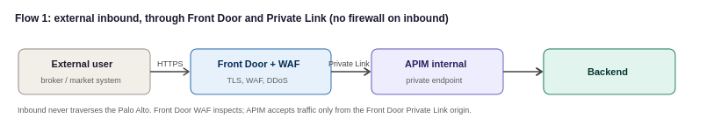
An external consumer, a broker or Lloyd’s market system, reaches the Organization over the internet. Traffic lands at Azure Front Door, where the WAF, TLS termination and DDoS protection are applied, and Front Door forwards the validated request to APIM over a Private Link inbound private endpoint. Because APIM is internal-mode it has no public endpoint; the only way in is through Front Door over Private Link. Inbound traffic does not traverse the Palo Alto, which is an egress control only.
- Front Door: WAF (OWASP + bot rules), TLS termination and DDoS protection at the edge; Private Link origin to the APIM inbound private endpoint.
- APIM subnet NSG: allow inbound only from the Front Door Private Link path; deny direct internet inbound. Origin locked to the Organization’s Front Door instance (Private Link approval + X-Azure-FDID header verification).
- No firewall on this path: the return path is symmetric because Front Door and APIM communicate over Private Link on the Azure backbone, with no NVA in the middle.
Flow 2: internal inbound (internal to APIM)
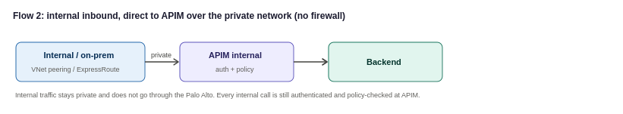
An internal Organization system, or an on-premises system reaching Azure over ExpressRoute or VPN, calls an internal API. The call reaches the APIM internal gateway directly over the private network (VNet peering, or ExpressRoute/VPN for on-premises), and APIM applies authentication and policy before forwarding to the backend. Internal traffic stays on the private network and does not traverse the Palo Alto, which handles egress to external third parties only. Internal consumers still never bypass the gateway: every internal call is authenticated and policy-checked at APIM, in line with the zero-trust principle in the security section. For on-premises sources, route propagation must be enabled so the return path stays symmetric.
Flow 3: outbound (internal to external)
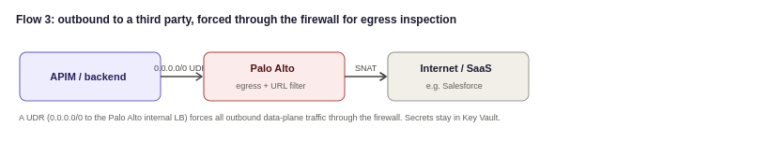
When APIM or a backend needs to call out, to a public SaaS provider such as Salesforce, or to any internet endpoint, that traffic must be inspected on the way out. A UDR on the APIM subnet with destination 0.0.0.0/0 and next hop set to the Palo Alto's internal load-balancer IP forces all outbound data-plane traffic through the firewall, where egress policy and threat prevention apply. This is the flow that gives the Organization the outbound inspection and audit it runs the Palo Alto for in the first place.
- APIM subnet UDR: 0.0.0.0/0 with next hop = Palo Alto internal LB IP (forced tunnelling).
- Palo Alto: outbound security and URL-filtering policy for the destinations APIM is permitted to reach; SNAT as required.
- Credentials for SaaS calls stay in Key Vault-backed named values; the firewall controls the path, not the secret.
Flow 4: APIM to private backends
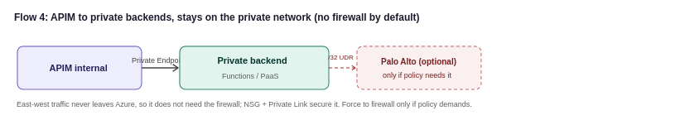
Calls from APIM to backends that live inside the Organization’s own network, integration services and Functions, or PaaS reached over Private Endpoint, stay on the private network. These do not need to traverse the Palo Alto to reach the internet, since they never leave Azure's backbone. If the Organization’s security standard requires even east-west private traffic to be inspected, Private Endpoint traffic can be forced to the firewall with a /32 UDR per endpoint, at the cost of route-table management; most designs inspect north-south (internet-facing) traffic at the firewall and rely on NSGs and Private Link for east-west, which is the approach recommended here unless the Organization’s policy says otherwise.
Flow 5: the control-plane exception (mandatory)
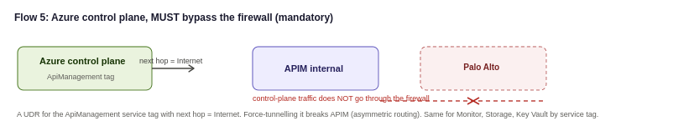
Azure manages APIM over a control-plane channel using the Api Management service tag. This traffic uses Azure's own public IP ranges, so if it is force-tunnelled through the Palo Alto the responses do not map symmetrically back and the stateful firewall drops them. The required, Microsoft-documented configuration is a UDR on the APIM subnet for the Api Management service tag with next hop set to Internet, so control-plane traffic bypasses the firewall. Microsoft is explicit that allowing this management traffic to bypass the NVA is not a significant security risk, because it is Azure's own management channel, not the Organization’s data. The same bypass applies to the platform dependencies APIM needs (Azure Monitor, Storage, Key Vault, and similar), which should be allowed by service tag rather than by IP.

Traffic Management and Edge Security
The edge and global-routing design, including the choice of Azure Front Door over Traffic Manager and the ingress topology, is set out within the network design in section 6 (see the ingress options and the Front Door versus Traffic Manager comparison). In summary: Azure Front Door Premium with WAF provides the global entry point, edge security and automatic multi-region failover for external and partner traffic; the Palo Alto firewall provides network inspection; and APIM runs in internal mode behind them.

Authentication and Security Design
Security is the foundational principle of this architecture. Access is explicitly validated at every hop and never assumed based on network location or prior perimeter checks—traffic originating from within the internal network is subject to the exact same verification standard as external requests.
A single security control failure must never expose a backend service. Each request passes through a mandatory, ordered sequence of Defense-in-depth controls before reaching downstream targets:
- Perimeter & Edge Protection: Mitigates volumetric attacks and inspects web application firewalls (WAF).
- Identity & Access Management: Validates caller identity (Microsoft Entra ID / OAuth 2.0 / Mutual TLS).
- Gateway Policy Enforcement: Applies schema validation, scope authorization, rate limits, and throttling.
- Isolated Network Routing: Ensures traffic travels strictly via Private Endpoints and internal VNet injection.
Security architecture: defence in depth at a glance
Before the individual controls, the diagram below sets out the security architecture as a whole: a mandatory transport layer, then the enforcement checks each owning a distinct job, that an inbound request passes before any backend is reached. This is the standard Azure defence-in-depth pattern for a private-mode APIM behind an edge WAF, and it is the frame the rest of this section fills in. No single layer is a substitute for another; the security of the platform is the composition of them all.
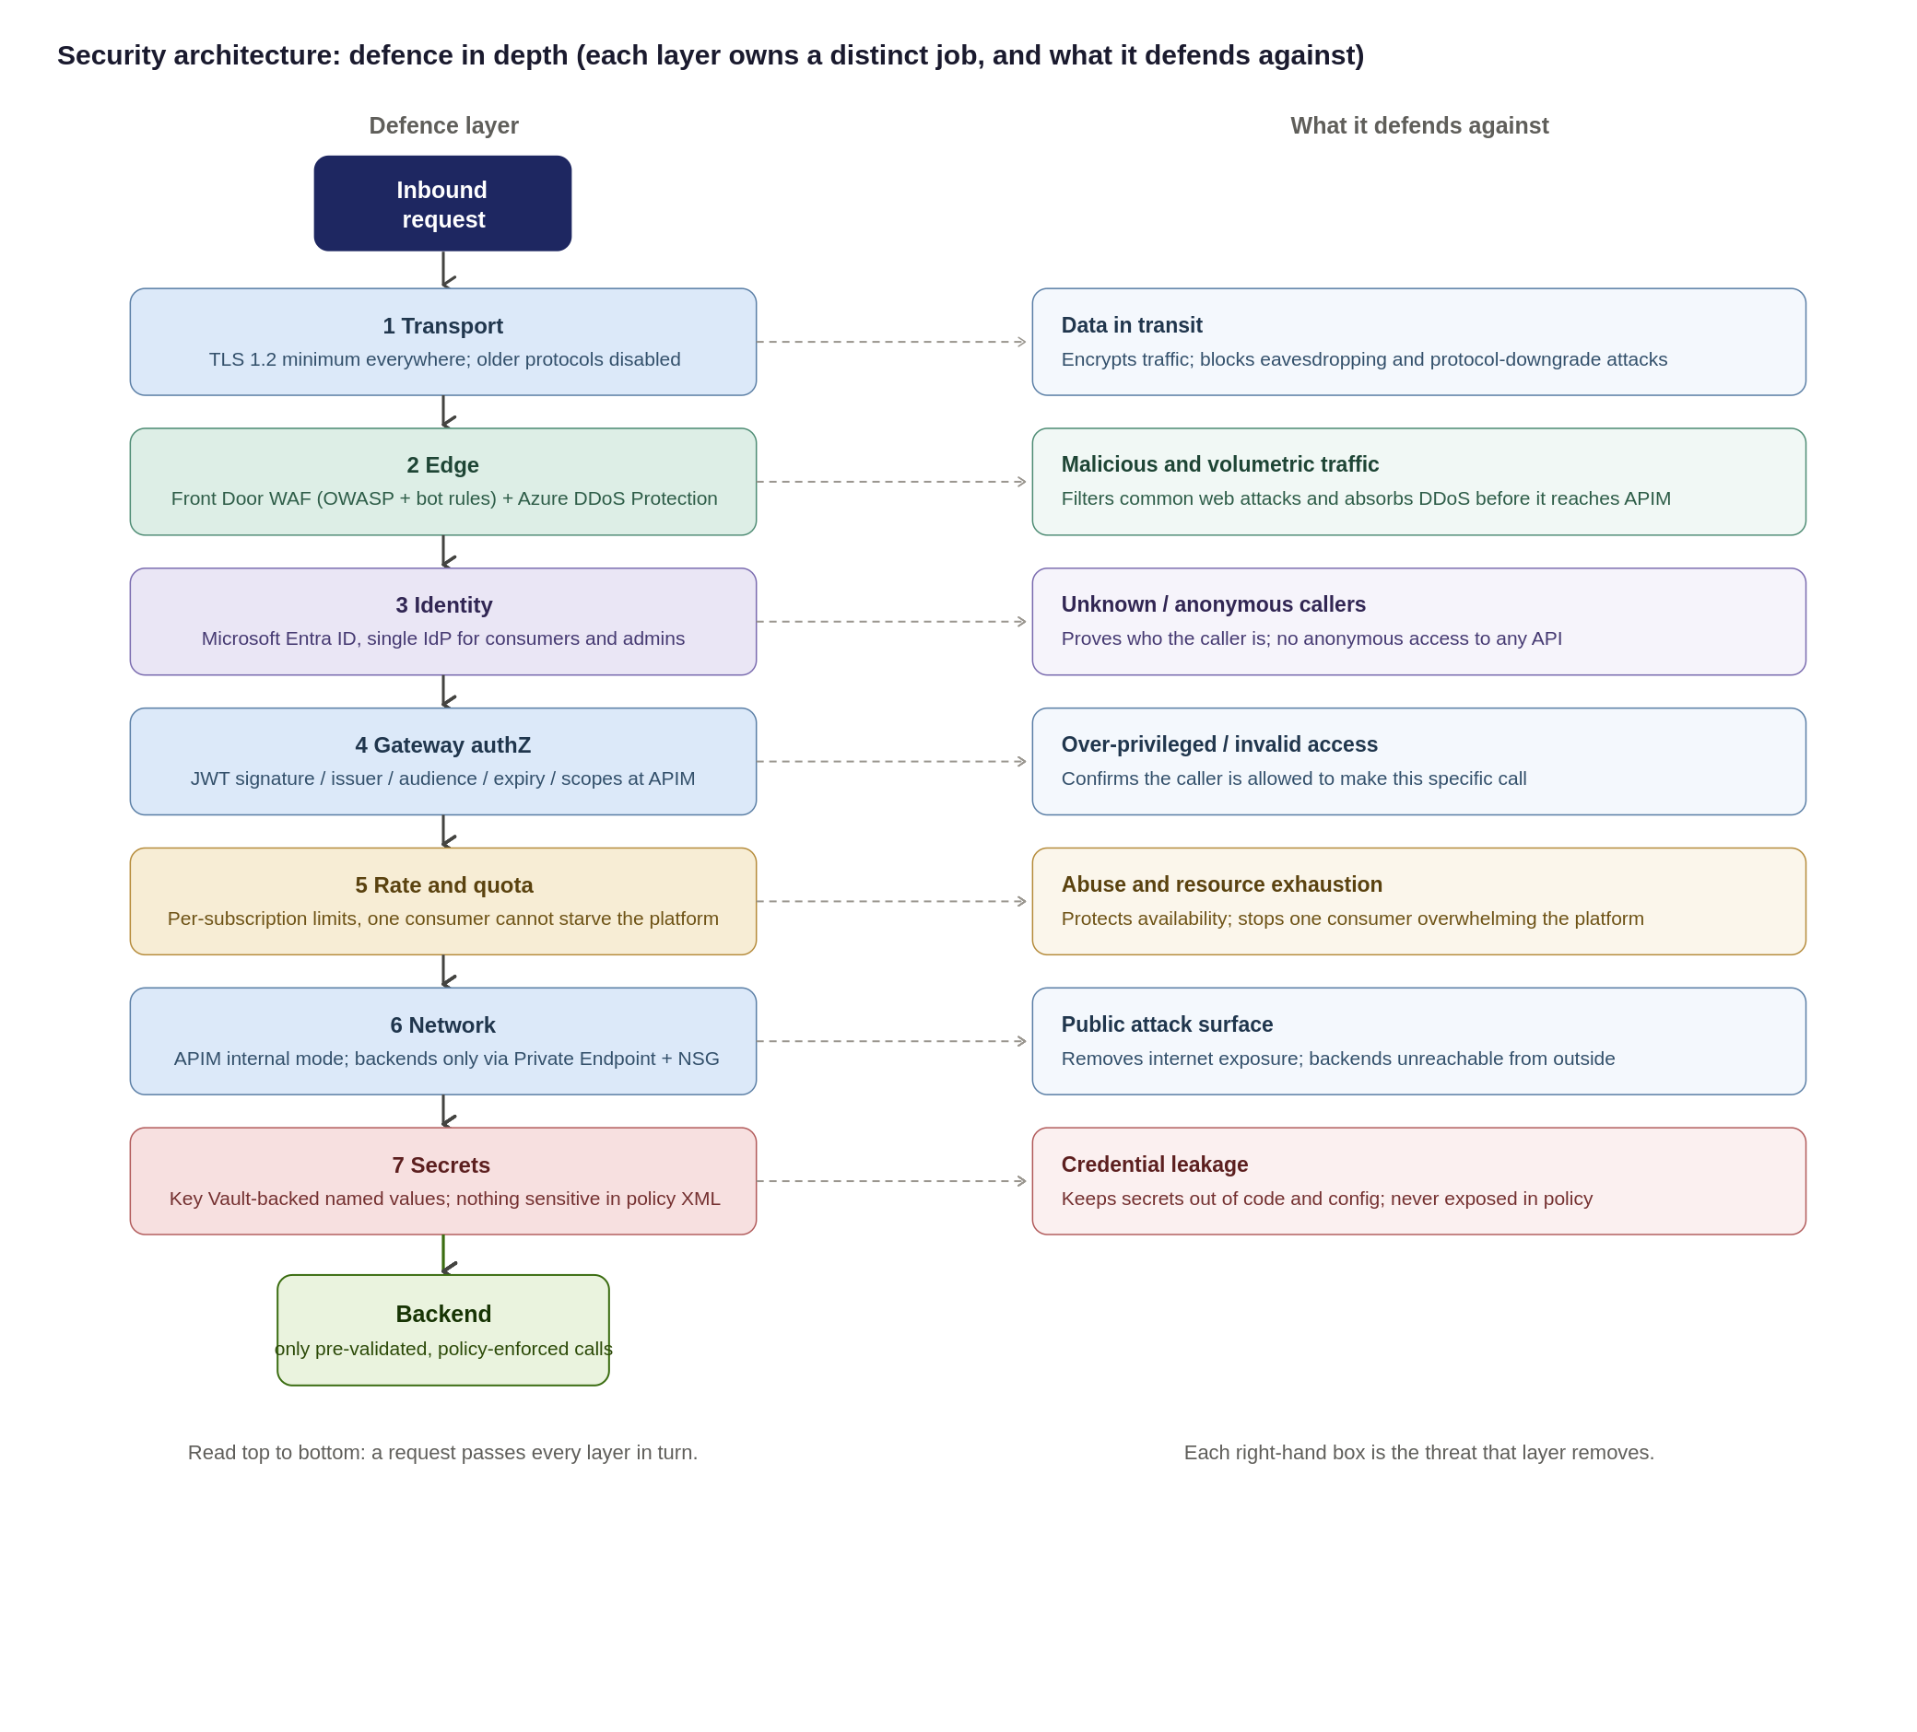
Security design principles
The controls detailed in this section enforce seven foundational security principles across the platform:
- Verify Explicitly (Zero-Trust): Validate every hop independently; no request is trusted simply because it originates from within the corporate network.
- Defense-in-Depth: No single control is load-bearing; security relies on layered edge WAF, gateway policies, and network isolation working in unison.
- Least Privilege: Consumers, APIOps deployment pipelines, and administrators are granted the minimum permissions necessary to perform their roles.
- Secure & Deny by Default: All APIs remain private and unauthenticated by default until explicitly configured and approved for publication.
- Single Identity Provider: Microsoft Entra ID serves as the central Identity Provider (IdP) for both consumer OAuth validation and platform administration.
- Everything as Code (APIOps): Platform and API security configurations are version-controlled, peer-reviewed, and deployed exclusively via automated pipelines.
- Zero Secrets in Code: No credentials or secrets are committed to repositories or hard-coded in policies all use Key Vault-backed Named Values
<Refer Primary ref here >
Residual Risk & Mitigation Matrix
No design removes all risk. The residual risks below are the ones that remain after the controls, with the compensating measure and the owner who carries them: this is deliberately explicit so nothing is presented as fully solved when it is not.
Residual Risk | Risk Rationale & Root Cause | Compensating Control & Mitigation Strategy | Risk Owner
Backend Object-Level Authorization (BOLA / OWASP API1) | APIM validates token signature and passes claims, but only the downstream domain service understands its internal domain object model. | Mandatory domain backend-authorization standard, static code review, and automated contract testing per API. | Domain Teams
Non-OAuth Exception Consumers | Legacy partners or constrained systems that cannot support modern OAuth 2.0 / OIDC authentication flows. | mTLS or static IP allow-listing combined with short-lived rotating secrets; enforced via time-boxed, reviewed security exception. | Security
Unverified Compliance Control Mapping | The Organization control catalogue has not yet been cross-checked and independently audited against this design. | Formal compliance sign-off of the Control-to-Evidence Matrix prior to passing the final Go-Live gate. | Compliance
Peak Load Capacity Behaviour | Exact peak request-per-second (RPS) metrics have not been benchmarked under real production conditions. | Mandatory pre-go-live performance/load testing; dynamic autoscaling based on gateway CPU and memory metrics. | Platform Team
Single Gateway Ingress Concentration | A multi-tenant shared platform concentrates blast radius compared to isolated, scattered backend endpoints. | Rate limiting, Workspace isolation, multi-region Front Door routing, WAF/DDoS, and Emergency Administrative Access runbooks. | Platform & Security

Threat model: STRIDE and the OWASP API Security Top 10
To ensure comprehensive coverage, the platform security model is evaluated against two complementary frameworks:
- STRIDE: Evaluates platform and infrastructure-level threat vectors (Spoofing, Tampering, Repudiation, Information Disclosure, Denial of Service, Elevation of Privilege).
- OWASP API Security Top 10: Addresses API-specific application vulnerabilities (BOLA, Broken Authentication, Mass Assignment, Unmanaged APIs).
Threat Vector & Key Risk Area | Framework Mapping | Architectural Control & Enforcement Strategy
Identity Spoofing & Broken Authentication | STRIDE: Spoofing  OWASP: API2:2023 | Mandatory Microsoft Entra ID OAuth 2.0 / JWT validation at gateway; strict claim inspection; mTLS and static IP allow-listing for authorized legacy exceptions.
Data Tampering & Payload Injection | STRIDE: Tampering  OWASP: API8:2023 | Enforcement of TLS 1.2+ end-to-end; edge Azure Front Door WAF rulesets; strict OpenAPI request schema validation at gateway ingress.
Repudiation & Audit Gaps | STRIDE: Repudiation  OWASP: API10:2023 | Centralized, immutable Azure Monitor / Log Analytics audit trail for all management and control plane actions; structured APIOps deployment logging.
Information Disclosure & Secret Exposure | STRIDE: Info Disclosure  OWASP: API3:2023 | Strict Private Endpoints / VNet isolation; zero plain-text secrets in policies (Azure Key Vault-backed Named Values); payload logging disabled by default with strict PII redaction rules.
Denial of Service & Resource Exhaustion | STRIDE: Denial of Service  OWASP: API4:2023 | Edge Azure DDoS Protection; per-subscription rate limits and quotas; dynamic gateway autoscaling based on CPU/Memory thresholds.
Broken Authorization (BOLA / BFLA) | STRIDE: Elevation of Privilege  OWASP: API1 & API5:2023 | Shared Responsibility Boundary: APIM validates caller identity/scopes and forwards claims. Downstream domain backends must enforce object-level and function-level authorization checks.
Shadow / Unmanaged API Proliferation | STRIDE: All Categories  OWASP: API9:2023 | Single ingress path via central APIM catalogue; workspace isolation; mandatory metadata tagging (audience, lifecycle status, data sensitivity); structured APIOps deprecation pipelines.

Data classification, payload logging and PII
Because the gateway processes bearer tokens, sensitive header claims, and business payloads, strict data handling rules must be enforced across all environments. The platform position enforces three core tenets: classify data at onboarding, disable body logging by default, and keep telemetry free of personally identifiable information (PII).
Focus Area | Architecture Position & Governance Rule | Technical Enforcement Mechanism
Data Classification | Every API must be tagged at onboarding with its highest data sensitivity tier: Public, Internal, Confidential (PII), or Restricted (Special-Category / High-Value). | Enforced via APIM Tags; dictates required product subscriptions, encryption levels, and logging verbosity.
Payload & Body Logging | Request and response bodies are not logged by default in any environment. Diagnostic payload logging requires sensitive field masking and is strictly time-boxed. | Managed via APIM <log-to-analytics> policies with regex field masking. Verbose logging auto-expires (max 48 hours).
Correlation & Telemetry | All logs, metrics, and trace spans must use opaque correlation identifiers (trace parent, X-Correlation-ID). PII is strictly prohibited in telemetry attributes. | System generates random UUIDs. Sensitive identifiers (emails, account numbers) are stripped at gateway ingress.
Secrets Exclusion | Bearer tokens, API keys, and Key Vault secret references must never be captured in diagnostic or gateway log output. | Header stripping policies sanitize Authorization (Bearer ***) and Ocp-Apim-Subscription-Key headers before logging.
Data Retention | Log retention balances investigation capabilities against UK GDPR / DPA 2018 data-minimization and storage limitation rules. | Default Log Analytics workspace retention set to 30 days (interactive), offloading to immutable storage for compliance.

Exception process for non-OAuth consumers
OAuth 2.0 with Entra ID is the default and the expectation. Where a partner genuinely cannot support it, an exception is allowed but governed: the point of the process is that exceptions are deliberate, compensated, time-boxed and reviewed, not permanent quiet workarounds.
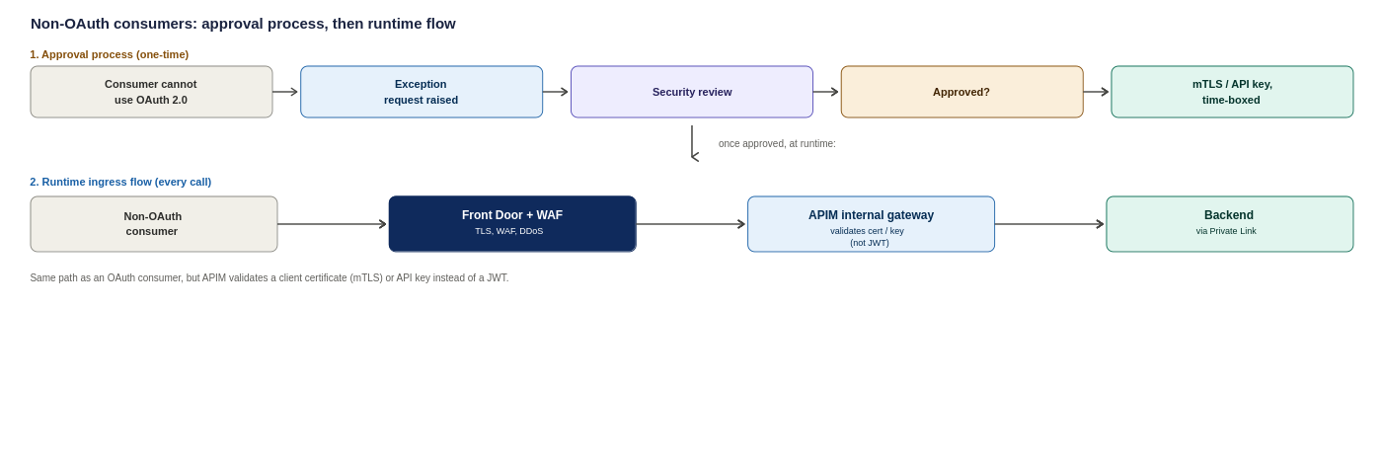
Figure 11: Non-OAuth consumers, the one-time approval process and the resulting runtime ingress flow
Aspect | Requirement
Who approves | Joint approval by the Security lead and the API Platform lead: not the requesting team alone
Compensating controls required | mTLS or a strict IP allow-list, plus a short-lived secret with enforced rotation; least-privilege product scope
Maximum validity | Time-boxed (recommended 12 months): an exception expires and must be re-approved; it does not roll over silently
Review cadence | Reviewed at least quarterly against continued need and the partner’s ability to move to OAuth
Record | Logged in a standing exception register with owner, justification, controls, approval date and expiry; referenced in the assumptions register (A.16)
Exit | Each exception carries a target date and named owner for moving the consumer onto OAuth

The diagram below adapts Microsoft's Protect APIs with Front Door and API Management reference architecture, showing how external and internal traffic are split at the edge before either ever reaches APIM.

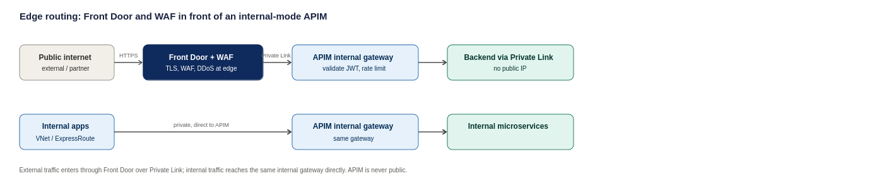
Figure 12: Edge routing pattern, adapted from Microsoft's Protect APIs with Front Door and API Management reference architecture
How each consumer type proves who they are
Consumer | How they authenticate | Backup control
Broker or partner | OAuth 2.0 token from Entra ID, validated on every call | Subscription key, IP allow-list where fixed egress IPs exist
Lloyd's market system | OAuth 2.0, with mutual TLS where the market requires certificate-based trust | Subscription key
Internal Organization system | Managed Identity, no secret ever stored or typed | Entra ID conditional access on the calling service
Inbound webhook from a vendor | Shared secret header, checked against Key Vault | IP allow-list restricting the source range

OAuth 2.0 flow at the gateway
Client credentials and authorization code flows are both enforced at the gateway using tokens issued by Entra ID. The backend never sees or validates a raw credential, only a pre-verified, policy-enforced token.
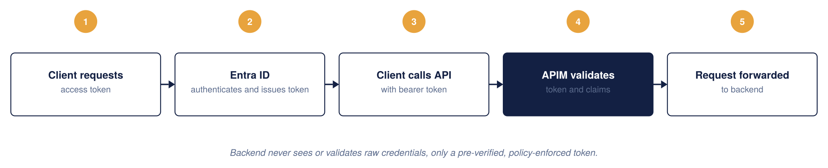
Figure 13: OAuth 2.0 architecture
JWT validation at the gateway
Every request is checked against four things before it is allowed through: signature, issuer and audience, expiry, and required claims or scopes. A failure on any of them is rejected with a 401 at the gateway; it never reaches the backend.
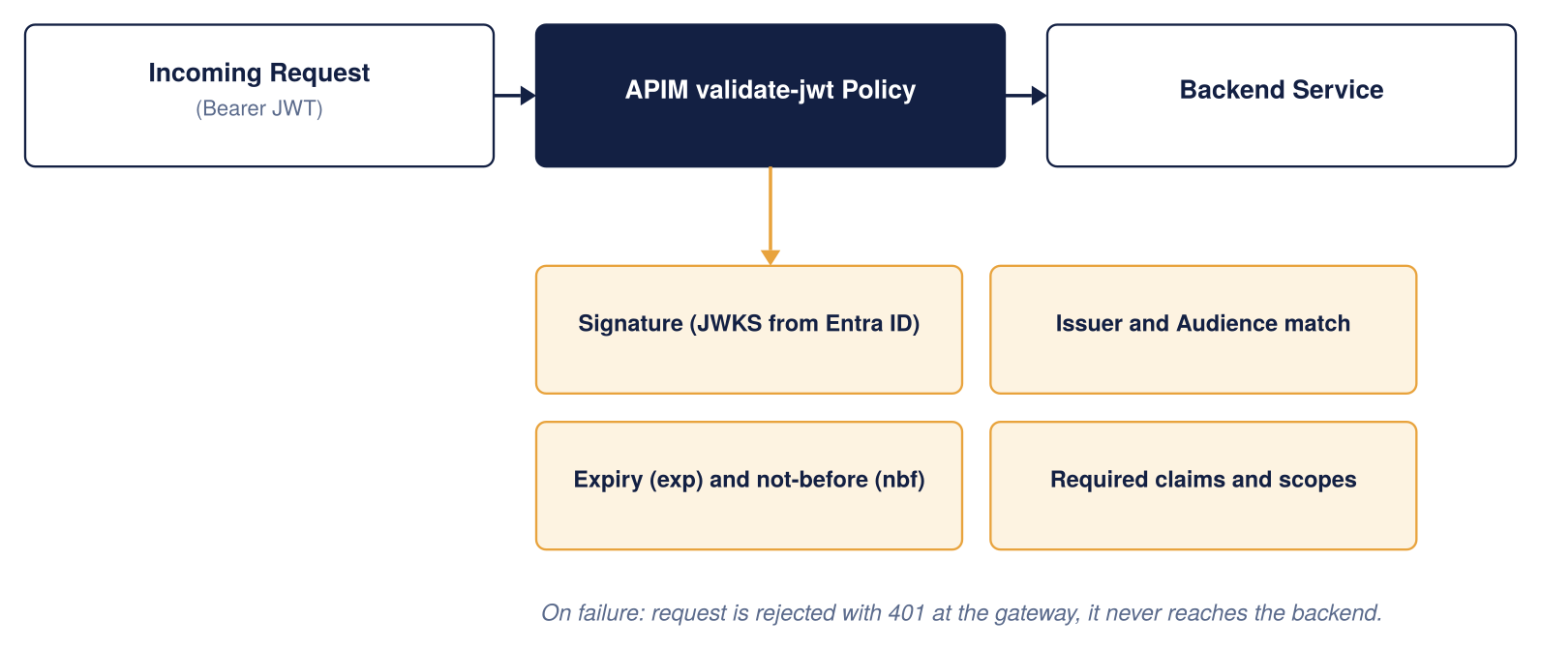
Figure 14: JWT validation architecture
Entra ID as the single identity provider
The same identity provider covers both API consumers and platform administrators, so there is one place, not two, where identity is managed.
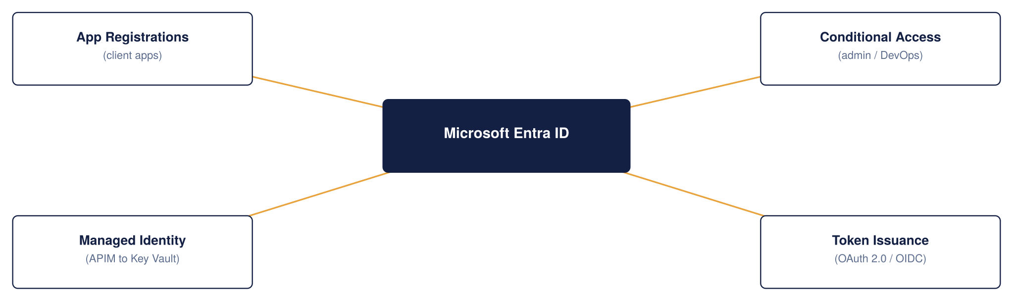
Figure 15: APIM and Entra ID integration
Secrets and certificate management
Azure Key Vault is the single source of truth for every secret, certificate, and key APIM depends on. Certificates rotate automatically; nothing sensitive is ever written into a policy file.
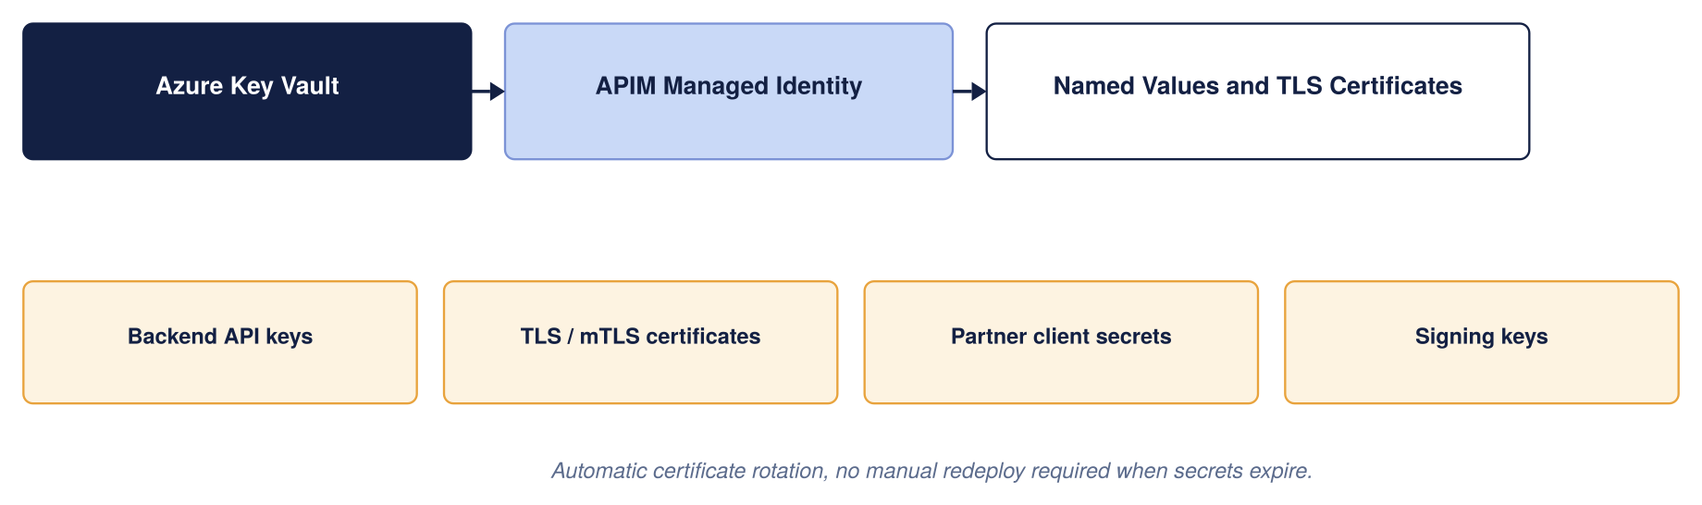
Figure 16: Secrets and certificates management
Which control owns what
These controls are layered deliberately, and they are not interchangeable. Each owns a distinct job, and the security of the whole depends on each doing its own rather than being treated as a substitute for another. The descriptions above make the boundaries explicit so no control is assumed to cover a gap it does not.
Control | Primary responsibility
Microsoft Entra ID | Identity and authentication
OAuth 2.0 / JWT | Authorisation context per request
APIM | API gateway and policy enforcement
WAF (Front Door / App Gateway) | HTTP and API-layer attack protection
Azure DDoS Protection | Volumetric and network DDoS
Azure Firewall / NVA | Network segmentation and egress control
Private Endpoint | Private connectivity to backends
the Organization’s SIEM | Detection and investigation
APIM policies | Rate limits, quotas, validation, transformation

Partner and external identity
"External" is not one thing, and the identity model reflects that: the Organization’s external consumers span brokers, Lloyd's ecosystem participants, strategic partners, suppliers and third-party service providers, and no single pattern fits all of them.
The default and the exception path:
- Default: partner organisations are represented as Microsoft Entra External ID (B2B) identities where they can support it, with a per-partner app registration and subscription so access is granted and revoked per organisation.
- Exception: where a partner cannot use Entra, a brokered or federated identity, or certificate-based (mTLS) trust, is handled as an approved exception (see the exception process above).
- Open questions for the Organization’s identity team, not presumed by this design: who owns partner onboarding, who registers partner applications, and who rotates and revokes partner credentials. Recorded in the assumptions register (A.16 and the identity items).
Identity resilience and break-glass
Because the design leans heavily on Entra ID, it must also say what happens when Entra ID, or normal administrative access, is unavailable. This is a deliberate operational design point, not an afterthought. In practice this means four things, each needing the Organization’s identity and security teams to confirm the specifics:
- A documented break-glass process: a small number of emergency-access accounts held outside the normal flow, with their use alarmed and audited, so the platform can still be operated during an identity-provider outage without weakening the everyday model.
- Proactive tracking of certificate and secret expiry (the 30-day certificate-expiry alert in section 12 is part of this).
- A defined partner-credential revocation process.
- Clear ownership of the application-registration lifecycle. The specifics of the Organization’s break-glass standard need confirming with the identity and security teams; the requirement is stated here so it is not missed.
Important policy snippets
The standard reusable policy fragments (OAuth/JWT validation, per-subscription rate limit and quota, and managed-identity backend authentication) are held once in Appendix 17.4 and referenced from here rather than repeated. The one fragment kept inline is the non-OAuth exception pattern, because it belongs with the exception process above:

Restrict an inbound webhook to a known partner IP range and a shared secret. Note that shared-secret and IP-allowlist authentication is an approved exception pattern, not a peer of OAuth: it is used only where a partner genuinely cannot support anything stronger. The preferred order is OAuth 2.0 where supported, then mutual TLS where appropriate, then a signed HMAC webhook signature, and only then a shared secret plus IP restriction. Wherever the shared-secret pattern is used, the design still requires defined secret rotation, revocation, replay protection, monitoring and a named owner.
<inbound> <ip-filter action="allow"> <address-range from="203.0.113.0" to="203.0.113.255" /> </ip-filter> <check-header name="x-api-key" failed-check-httpcode="401" failed-check-error-message="Unauthorised: missing API key."> <value>{{webhook-api-key}}</value> </check-header> </inbound>

Regulatory and compliance alignment
The alignment above is deliberately honest that it is not yet Organization-verified. To make it something Compliance can actually sign rather than a narrative, the matrix below restates it as control area → Azure capability that delivers it → evidence artefact that proves it → owner. It is still proposed until Compliance confirms it against the Organization’s own control catalogue, but it is now in a form that can be confirmed line by line.
Control area (regulatory driver) | Azure capability | Evidence artefact | Owner
Access control & authentication (FCA SYSC; UK GDPR) | Entra ID OAuth 2.0, gateway JWT validation, control-plane RBAC | Entra sign-in/audit logs; policy config in Git; access-review records | Identity + Compliance
Encryption in transit (UK GDPR; Lloyd’s) | TLS 1.2+, Front Door, Private Endpoints | TLS/WAF configuration export; Private Endpoint inventory | Platform + Security
Audit & traceability (FCA; PRA operational resilience) | Log Analytics, App Insights, correlation IDs | Retained gateway logs; SIEM ingestion evidence; sample correlation-ID traces | Platform + Security
Threat protection | Front Door WAF, Azure DDoS, Defender for APIs | WAF rule set and logs; Defender for APIs findings report | Security
Availability & operational resilience (PRA; Lloyd’s) | Multi-region active-active, availability zones, Front Door failover | DR test reports; SLA evidence; TDA architecture sign-off | Platform
Secrets management | Key Vault-backed named values | Key Vault RBAC/access policy; secret-rotation records | Platform + Security
Data residency (UK GDPR) | UK South / UK West only | Region configuration; Azure Policy allowed-locations assignment | Platform + Compliance
Change control (FCA SYSC) | APIOps, pull-request review, approval gates | PR history; pipeline approval records | Platform
Data minimisation & PII (UK GDPR) | Payload logging off + redaction; data classification | Logging-policy configuration; DPIA reference | Compliance + Security
This matrix is the artefact Compliance signs; the regulatory references are indicative and must be reconciled with the Organization’s obligations register before go-live.
As a Lloyd's market insurer, the Organization operates under FCA and PRA regulation and, for market-facing integrations, Lloyd's own requirements, alongside UK GDPR for personal data. This design does not attempt to certify compliance, which is the Organization’s responsibility and a detailed-design activity, but it is built to support the controls those regimes expect. The table below maps each obligation to how the platform is positioned to meet it, and to what still needs Organization input. This is the area of the design most dependent on the Organization’s own standards, and it should be treated as a set of requirements to confirm rather than settled controls.
Obligation | How the design supports it | Still needed from the Organization
Data residency (FCA/PRA, UK data) | Primary and secondary regions both in the UK (UK South, UK West); no data leaves the UK by default | Confirm UK-only residency is sufficient and that no backend or SaaS dependency egresses data abroad
Personal data protection (UK GDPR) | TLS 1.2 in transit; payload masking possible at the gateway; PII kept out of verbose logs (Dev-only tracing) | Data Protection Impact Assessment; confirm what PII flows through which APIs
Audit trail and retention | Every request logged with a correlation ID; security events routed to the Organization’s SIEM | Confirm required retention periods against FCA/PRA record-keeping rules
Access control and segregation of duties | Entra ID identity for every consumer and admin; workspace-scoped RBAC; APIOps change approvals | Map to the Organization’s existing joiner-mover-leaver and SoD policies
Lloyd's market trust | Mutual TLS available where the market requires certificate-based trust; per-partner subscriptions and revocation | Confirm specific Lloyd's connectivity and certificate requirements per counterparty
Operational resilience (PRA/FCA) | Zone-redundant HA and multi-region DR with stated RTO/RPO targets | Agree RTO/RPO against the Organization’s operational-resilience impact tolerances

The position is that compliance is the least Organization-verified part of this HLD: the platform is designed to make these controls achievable, but none can be signed off without the Organization’s compliance and data-protection teams confirming the specifics. This is called out again in the assumptions register (section 18).

API Product, Consumer and Developer Portal Model
Once APIM is live, the Organization needs a way for different teams to manage their own APIs without stepping on each other, while the platform team keeps one place to see and control everything. Workspaces, products, subscriptions, and groups fit together like a filing cabinet: workspaces are the drawers, products are the folders, subscriptions are the individual keys handed out, and Entra ID groups decide who can open which drawer.
Choosing each layer: a clear strategy for Products, Consumers and the Portal
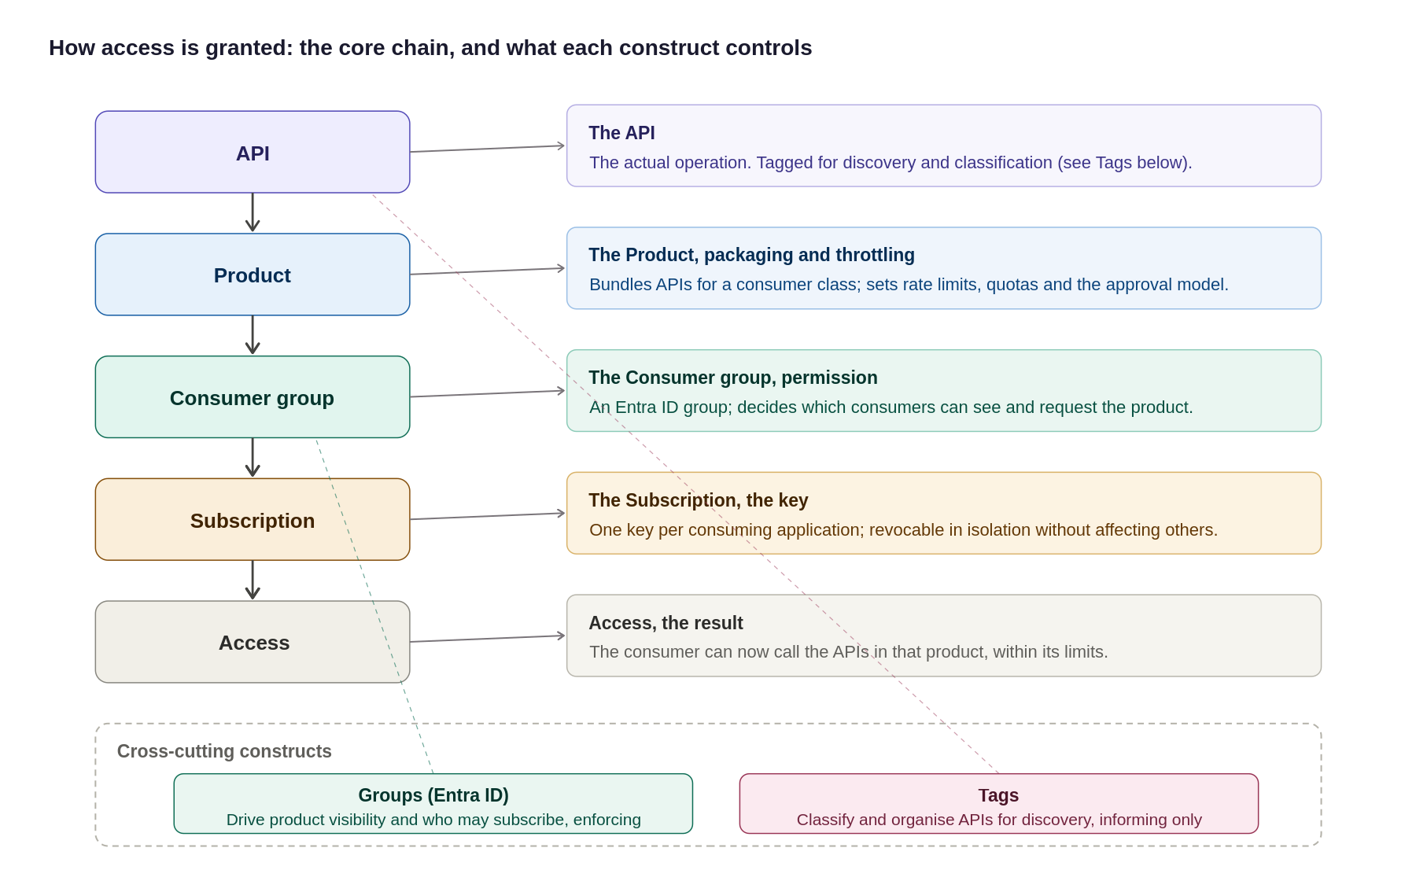
Figure 17: The access model, the core chain plus what each construct controls, including Groups and Tags
In summary:
Layer | The question it answers | The strategy
Product | “Which APIs does this consumer class get, and under what rules?” | One product per consumer class; APIs bundled into it; policy, quota and approval set at product scope
Consumer / subscription | “Who is calling, and how is access granted and revoked?” | Entra ID group per organisation/team; one subscription per application; no local APIM users
Developer portal | “How does a consumer discover, subscribe and test without a ticket?” | SSO on, self-registration off, group-filtered catalogue; portal is the only self-service surface

How the governance constructs fit together: the diagram below shows the hierarchy from the APIM instance down through workspaces, products and subscriptions, with Entra ID groups controlling access via RBAC.
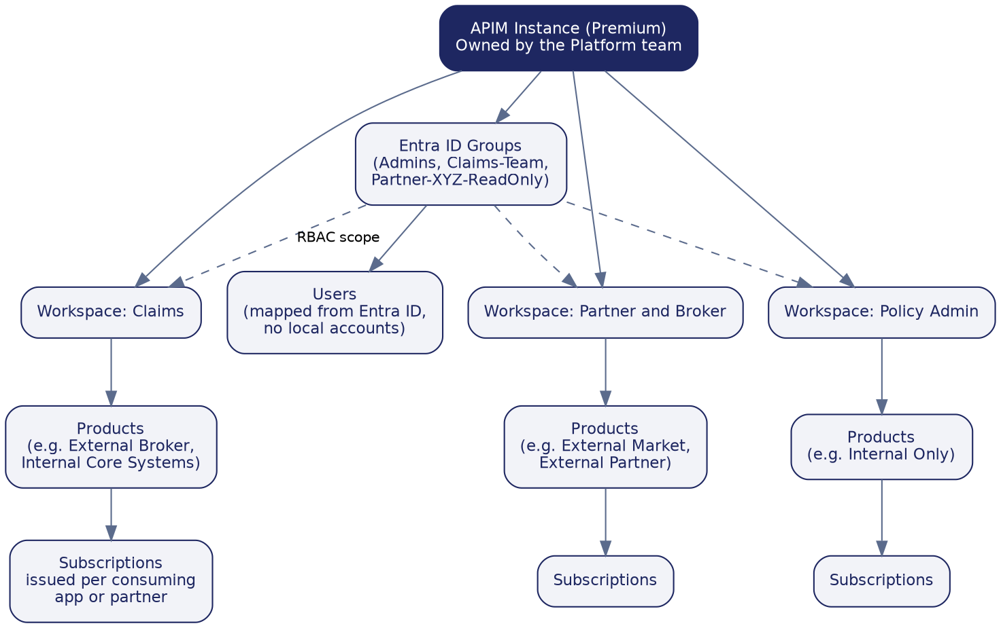
Figure 18: Recommended workspace, product, subscription, and group structure

Products, subscriptions, groups and users
- Products group related APIs and carry the access rule for that group, for example an External Broker product bundling every API a broker may call.
- Subscriptions are individual keys issued per consuming application or partner, so one consumer's access can be revoked without affecting anyone else.
- Groups map to Entra ID, never to local APIM accounts, so a broker's technical team or the platform administrators are each represented by one Entra ID group.
- Users are never created directly inside APIM; access always flows from an Entra ID identity through a group, so the Organization’s existing joiner-mover-leaver process keeps APIM access correct automatically.
Governance Construct | Core Purpose & Architectural Behaviour | Key Governance Rule & Enforcement
Backends | Abstracts downstream target URLs and centralizes runtime resilience rules (circuit breaking, load balancing, retries). | Target URLs and health check policies are managed centrally outside individual API definitions.
Named Values | Provides APIM's key-value store for plain settings (URLs, limits) and Key Vault-backed secret references. | Zero secrets hard-coded in policies. All secrets use Key Vault integration and are version-controlled via APIOps.
Policies | Enforces execution logic, transformations, authentication, and rate limits at global, product, or API scopes. | Policies reference Named Values for config; product-level policies enforce class-wide rules once.
Products | Bundles one or more APIs into a single subscription unit with class-wide rate limits, quotas, and approval models. | Consumers subscribe to Products, never APIs directly. Differentiates internal vs. external consumer tiers.
Groups | Controls visibility and subscription access to Products based on user membership. | Custom groups map strictly to Microsoft Entra ID. No local user accounts are created inside APIM.
Tags | Free-form metadata labels applied to APIs and Products to drive catalog discovery and estate reporting. | Tags provide discoverability only, not runtime control. Governed by a agreed taxonomy (Domain, Sensitivity).
Workspaces | Isolates administrative access and asset ownership, allowing delivery teams to manage their own APIs independently. | Provides decentralized API development with centralized platform guardrails and RBAC isolation.

How the constructs fit together
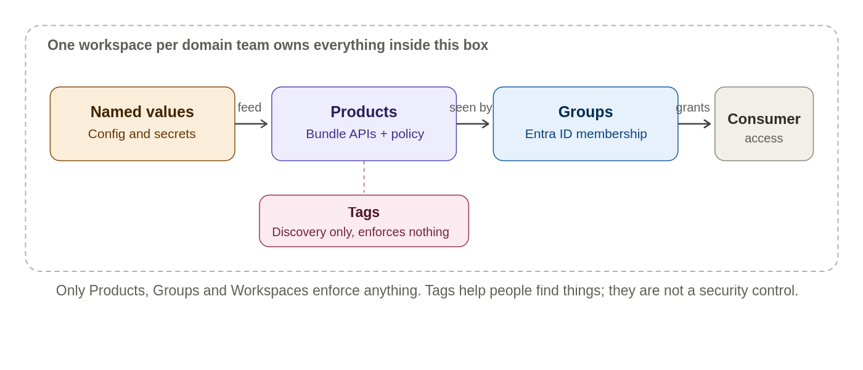
Figure 19: How the governance constructs relate to each other

Developer Portal
Purpose
The Azure APIM Developer Portal serves as the primary self-service interface for API consumers, publishing and automatically generated catalogue, interactive documentation, testing consoles, and automated subscription workflows. Its core objective is zero-touch onboarding—enabling internal and external developers to discover and adopt APIs without manual support tickets.
The platform distinguishes between two operational roles:
- API Publishers (Platform & Workspace Teams): Operate exclusively via APIOps pipelines to deploy APIs, products, and policies into the management plane.
- API Consumers (Developers & Partners): Interact strictly through the Developer Portal to consume documentation, manage subscriptions, and generate access keys.
Reference architecture
The Developer Portal is hosted independently as a managed web application and is completely isolated from the gateway runtime path:
- catalogue Publishing: The APIM management plane dynamically projects published APIs, schemas, and products onto the portal interface.
- Identity & Access Control: Authentication delegates directly to Microsoft Entra ID for internal workforce users and Entra ID B2B for external partners.
- Runtime Isolation: The portal handles metadata and subscription lifecycle only. Once a subscription key is issued, consumer application traffic bypasses the portal entirely, invoking the APIM Gateway directly where policy enforcement and security controls occur.

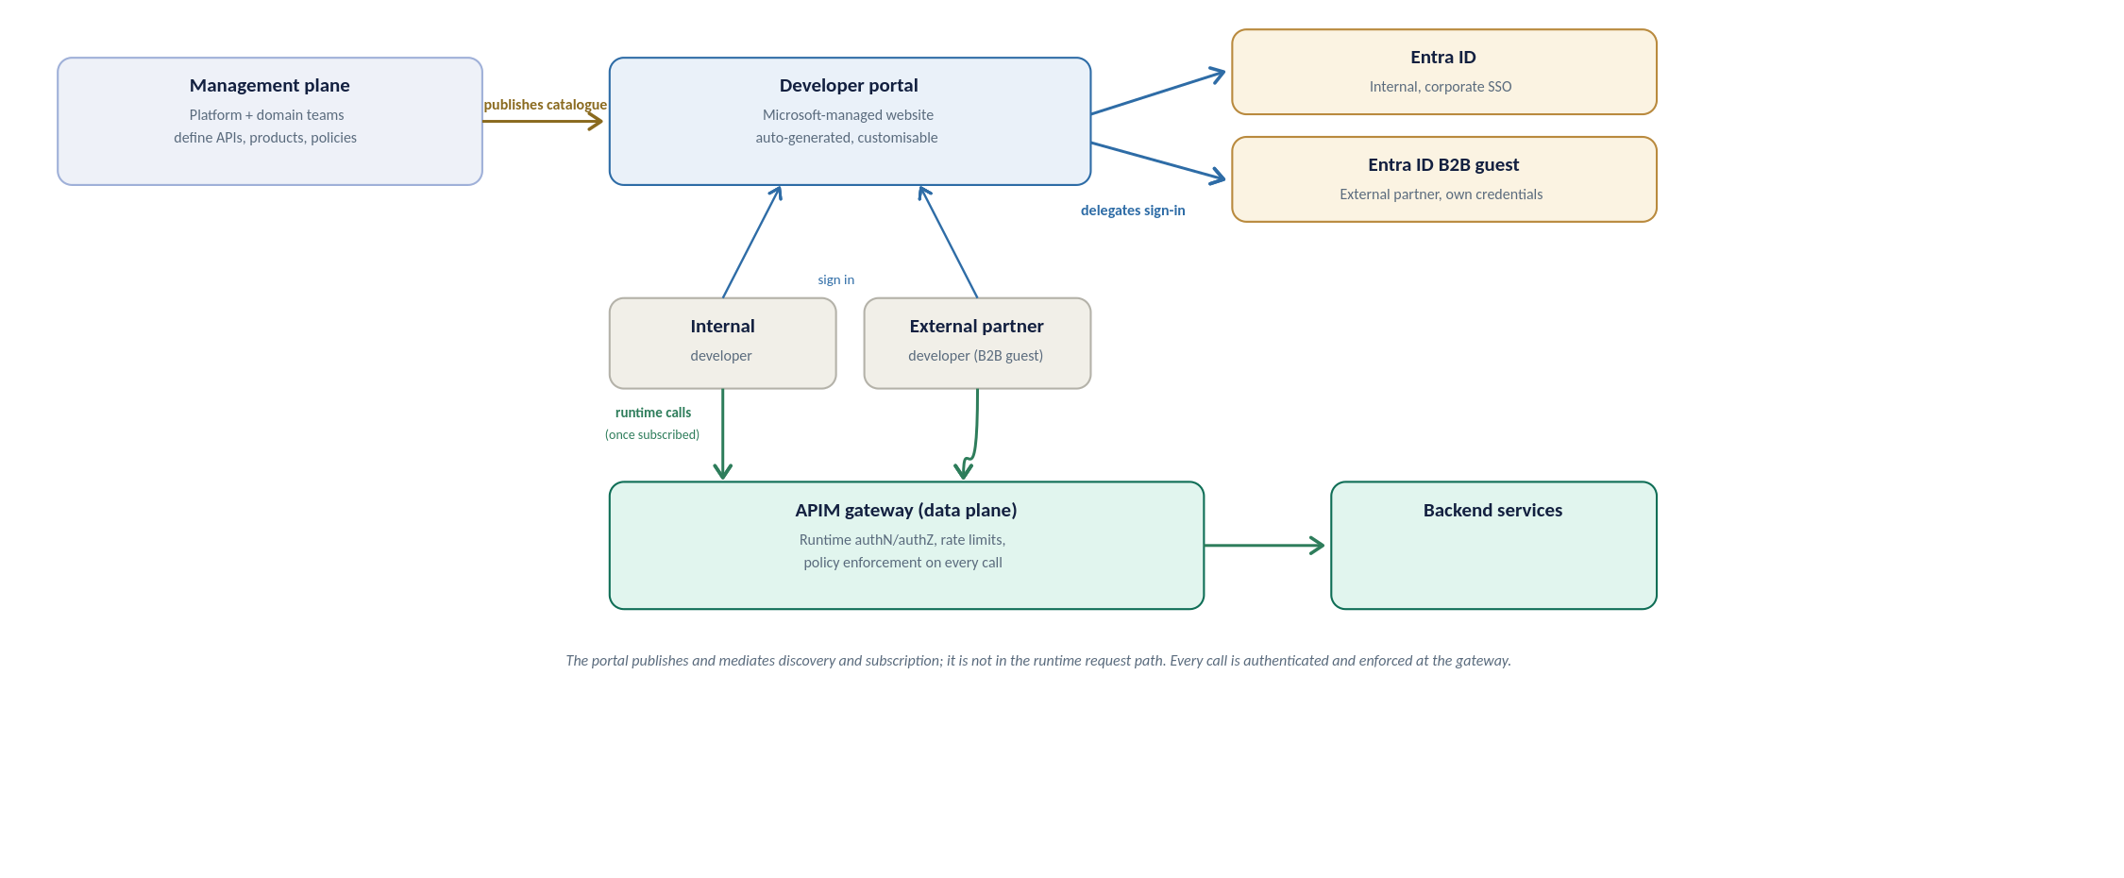
Figure 19a: Developer portal reference architecture, how the portal relates to the management plane, identity providers, and the runtime gateway
API discovery strategy
Discovery is deliberately curated, not a raw API list. Three rules shape what a developer finds:
- Visibility follows identity: the portal shows only the products a signed-in developer’s Entra ID group permits, so a broker sees broker products and never an internal-only API.
- Grouping is by product, not raw API: a developer opens a product tile (for example External Broker), sees the APIs it bundles, and subscribes to the product as a unit; the subscription then works across every API in it.
- Tags are the search axis: consistent tags (section 10) let developers filter and search a growing catalogue, and each API page carries its operations, request and response schemas, and an interactive console for trying a call.
Built-in roles and RBAC
Two separate layers of access apply to the portal: who can see and use it as a consumer, and who can administer or publish its content. Neither creates a local account; both resolve back to Entra ID, consistent with the access model set out above.
Portal groups: who can see and use the portal
Group | Membership | What it grants
Administrators | Azure subscription administrators (system-managed) | Manages the APIM service and defines APIs, products and policies; not a consumer-facing role
Developers | Every signed-in, authenticated portal user (system-managed) | Base authenticated access; which products they actually see still comes from their Entra ID group
Guests | Anonymous portal visitors (system-managed) | Read-only browse of products marked visible to Guests; cannot subscribe or call an API
Custom / Entra ID groups | One per consumer class, for example Claims-Team or Partner-XYZ | Scopes visibility to the products that class of consumer may see, per the access model set out above

RBAC for administering portal content
Customising or publishing the portal is a service-administration action, controlled through Azure RBAC rather than the portal groups above.
Role | Scope | Use
API Management Developer Portal Content Editor | APIM service | Customise, edit and publish developer portal content; no API or service administration rights
API Management Service Contributor | APIM service | Full administration of the service and every entity; reserved for the platform team (see the RBAC set out in section 10), not for portal content editors

Configuration is two steps: grant a consumer's Entra ID group visibility on the relevant product, as set out above, so they can see and subscribe to it; and assign the Developer Portal Content Editor role to the named content owner so they can maintain the portal itself without broader service rights.
User onboarding flow
Ownership differs by direction, so the path is set out separately below for internal and external consumers; Figure 20 shows the shared journey once access has been granted.
Internal user onboarding
- Request: the consumer's manager or the domain team identifies the product needed.
- Group membership: the user is added to the relevant Entra ID group through the Organization's existing joiner-mover-leaver process; no APIM account is created.
- Sign-in: the user signs into the developer portal with corporate SSO and is automatically a Developer.
- Discover and subscribe: they see only the products their group permits; internal products are typically auto-approved.
- Credentials: a subscription key is issued, and OAuth-protected calls use a token obtained from Entra ID.
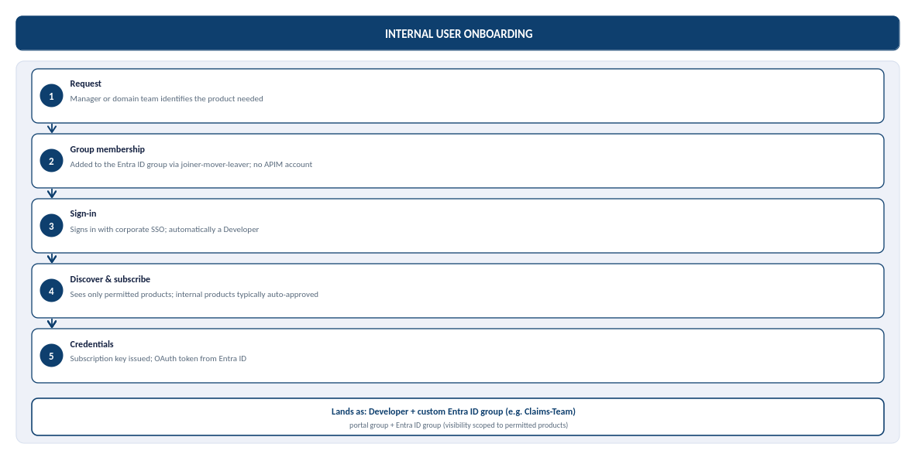
Figure 19b: Internal user onboarding, from request to credentials, and where the user lands in the portal groups
External user onboarding (partner, B2B)
The Organization's external identity default is Microsoft Entra External ID (B2B) for partner organisations, not Azure AD B2C: B2C is no longer available for new deployments, and Microsoft's current recommendation for consumer-facing sign-up is Microsoft Entra External ID. B2B is the correct model here because every external consumer is a known partner organisation, not an anonymous member of the public.
- Sponsorship: a named internal owner sponsors the partner and confirms which product they may access.
- Guest invitation: the partner user is invited as a Microsoft Entra ID B2B guest, authenticating with their own organisation's credentials rather than an organization-issued account.
- Group membership: once the invitation is redeemed, the guest identity is added to a per-partner Entra ID group, scoping visibility to that partner's product only.
- Sign-in and subscribe: the partner signs into the developer portal through B2B guest SSO and requests a subscription; external subscriptions are gated by approval, not automatic.
- Credentials: on approval, a subscription key is issued and, for OAuth-protected APIs, the partner's registered application obtains a token from Entra ID.
Partner sponsorship and credential-rotation ownership are not yet named, alongside the related gaps below.
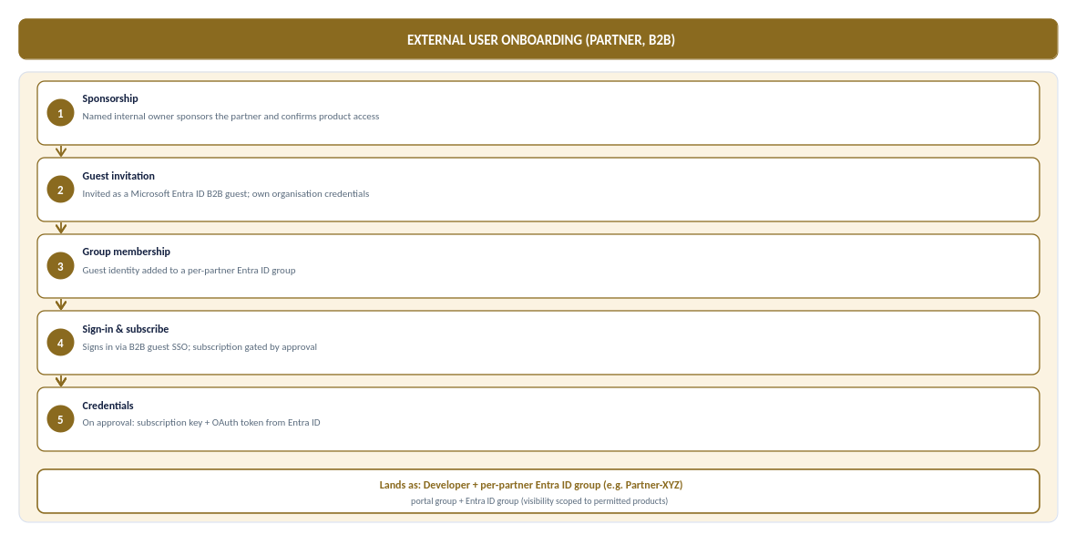
Figure 19c: External (partner, B2B) user onboarding, from sponsorship to credentials, and where the partner lands in the portal groups
In steady-state production the same consumer calls the API through APIM, where JWT validation and per-subscription rate limits and quotas are enforced on every call, and manages their own subscriptions and key rotation from the portal profile area without an organization ticket. The full journey, from access granted to steady-state use, is shown below.
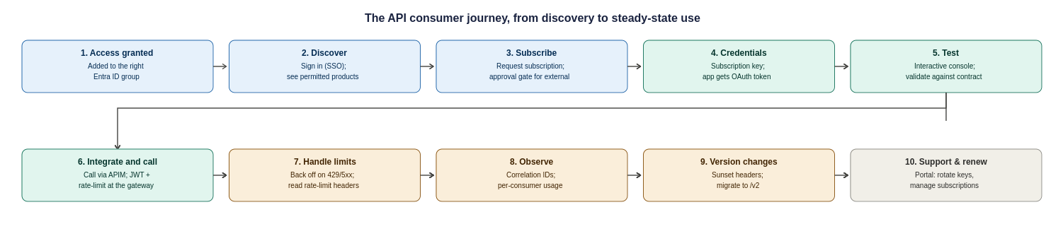
Figure 20: The API consumer journey, ten steps from access granted to steady-state use, support and versioning
Two responsibilities sit with the Organization to make this journey real, and are recorded as operational tasks in the assumptions register: a named owner for approving external subscription requests within an agreed SLA, and a defined support and escalation path (who a partner contacts when a call fails, and how correlation IDs are used to resolve it).

API Design, Policies and Governance

Engineering and Naming Standards
These engineering standards are not invented for this platform; they follow the Organization’s existing Engineering Standard and Cloud Adoption Framework conventions, and are restated here only where they bear on the APIM design. Where this document and the corporate standard differ, the corporate standard prevails and this design should be reconciled to it. [Placeholder: link to the Organization’s Engineering Standard / CAF naming standard: to be inserted by the Organization before issue.]
APIs follow the design and naming standards below; these are the engineering standards the platform enforces.
Every API follows the same conventions, so teams and consumers do not have to relearn a new shape for every integration.
Aspect | Standard | Example
Base path | /api/{domain}/{version}/{resource} | /api/claims/v1/claims
Resource naming | Plural nouns, lowercase, kebab-case | /api/policies/v1/policy-holders
Versioning | URL path, major version only for breaking changes | /api/claims/v2/claims
Response format | Consistent data / error / metadata envelope with a correlation ID | See Appendix 17.4

Design Standards, Policy Enforcement and Governance
Target operating model and RACI
Governance only works if ownership is unambiguous. The model is a federated one: a central Platform team owns and runs the shared APIM platform and its guardrails, while Domain teams own the APIs inside their workspace; Network, Identity, Security and Compliance own their respective controls across all domains. The RACI below fixes who is Responsible, Accountable, Consulted and Informed for the activities that recur.
Activity | Platform | Domain | Network | Identity | Security | Compliance
Run the APIM platform (upgrades, capacity, guardrails) | A/R | I | C | C | C | I
Design & build an API | C | A/R | I | I | C | I
Onboard & publish an API (gates) | A/R | R | I | C | C | I
Baseline policy & security configuration | A/R | C | I | C | C | I
Network changes (UDR/NSG/DNS/firewall) | C | I | A/R | I | C | I
Identity groups & app registrations | C | C | I | A/R | C | I
Security controls & threat monitoring | C | I | C | C | A/R | C
Compliance evidence & sign-off | C | I | I | I | C | A/R
Deprecation & partner migration | A/R | R | I | I | I | I
Incident response | A/R | C | C | C | R | I
R = Responsible (does the work), A = Accountable (owns the outcome), C = Consulted, I = Informed. Named individuals for each accountable role are to be recorded by the Organization against this table before go-live.
APIM policies apply at four levels, and the most specific one always wins: Global, then Product, then API, then Operation. The Organization should keep global policies to the handful that must never be skipped everywhere (correlation ID, HTTPS enforcement, header stripping), and push everything consumer-specific down to Product level, where it belongs.
Rather than let each team write policies from scratch, the platform ships a small library of reusable policy fragments that are referenced by name, so a fix to the standard JWT-validation fragment updates every API that includes it. The matrix below shows which standard policy applies at which scope. The full policy snippets themselves are in Appendix 17.4.
Policy | Scope | Purpose
Correlation ID injection | Global | Stamp every request with a trace ID carried through to the backend and logs
HTTPS and TLS 1.2 enforcement | Global | Reject any non-TLS or outdated-protocol request outright
Sensitive header stripping | Global | Remove internal headers before a response leaves the gateway
JWT validation | Product | Check token issuer, audience, expiry and scope per consumer group
Rate limit and quota | Product | Cap each subscription so one consumer cannot exhaust the platform
Managed identity to backend | API | Authenticate to the backend with no stored secret
Response caching | Operation | Cache safe, cacheable GETs where the backend allows it
IP allow-list and shared secret | Operation | Lock a specific webhook operation to a known source

This keeps the number of distinct policies small and consistent: a reviewer can see at a glance what is enforced everywhere versus what is specific to one consumer or one operation, which is the point of a policy design rather than a pile of per-API XML.
Governance matters as much as structure: the value of a shared policy library is lost if any team can quietly override a global control at a lower scope. The design therefore assigns clear ownership, and treats global security policies as protected, changeable only through the platform and security owners rather than by an individual API team. Who owns each policy area is set out below; the exception-approval row is the control that stops a lower scope silently weakening a global rule.
Policy area | Owner
Authentication | Platform / Security
Rate limiting | API Platform
Security headers | Platform / Security
Transformation | API team
Consumer-specific quota | Product / API owner
Logging | Platform / Security
Exception approval | Architecture / Security
RBAC role assignments (to confirm with the Organization’s Identity and Platform teams)
Policy ownership above states who is accountable for each area; the table below maps that to the actual Azure role each group needs, so an implementer can create the role assignments directly rather than infer them. All assignments are scoped as narrowly as the built-in roles allow, and none are assigned to individuals, only to Entra ID groups.
Scope | Azure role | Assigned to
APIM service (full control) | API Management Service Contributor | Platform team break-glass group only (section 8); day-to-day changes flow through APIOps, not this role
Workspace (per business domain) | API Management Workspace Contributor / API Management Workspace API Developer | Domain team Entra ID group for that workspace (Claims, Policy Admin, Finance, Partner and Broker)
Named values and secrets | API Management Service Contributor scoped to named values, plus Key Vault Secrets User on the backing vault | Platform / Security group only; never assigned at workspace scope for Key Vault-backed secrets
APIOps pipeline service principal | API Management Service Contributor (or workspace-scoped equivalent for workspace-only pipelines) | Pipeline service connection / managed identity, not a human account
Read-only estate visibility | API Management Service Reader | Architecture, security and audit groups who need to see configuration without changing it
Resource group / networking | Network Contributor (subnet and NSG scope only) | the Organization’s Network team, scoped to the APIM subnet, not the wider hub
This table proposes a starting model; the exact built-in role names should be validated against the current Azure role definitions at build time, since Microsoft periodically introduces more granular workspace-scoped roles.

A small, empowered governance board sets the standards; automation enforces them so governance never becomes a bottleneck.
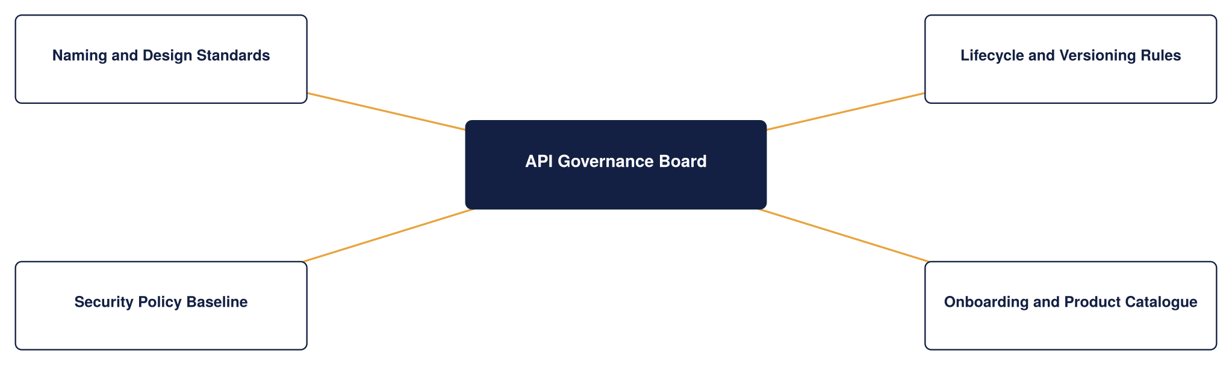
Figure 21: API governance framework
Onboarding a new API
This section describes the end-to-end path for bringing a new API onto the platform using the governance constructs above, so that every API added to the Organization’s estate is consistent, discoverable, secured and owned from day one. It ties together naming, product and group assignment, tagging and workspace placement into one repeatable process rather than a series of ad hoc choices.
The end-to-end flow
The diagram below shows the end-to-end onboarding path at a glance; the steps beneath it describe each stage in detail.
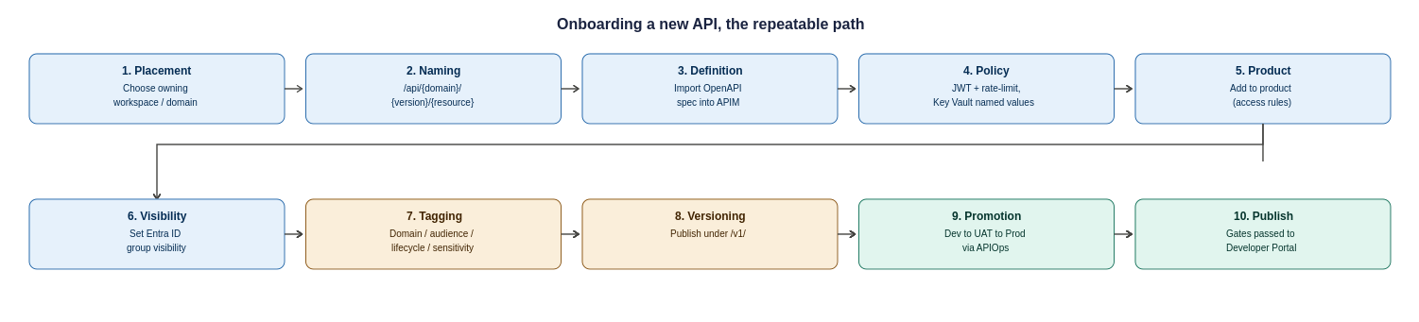
Figure 22: Onboarding a new API, the ten-step repeatable path from placement to publication
- Placement: decide which workspace owns the API, based on the business domain (Claims, Policy Admin, Finance, or Partner and Broker). The owning domain team, not the platform team, drives the rest of the process within that workspace.
- Naming: apply the naming convention from section 10.1, so the API's path follows /api/{domain}/{version}/{resource} with plural, lowercase, kebab-case resources. Consistent naming is what makes the estate navigable and routable.
- Definition: import or author the API (typically from an OpenAPI specification), which brings its operations and request and response schemas into APIM.
- Policy: attach the standard policy set at the right scope, JWT validation and rate limits at product level, managed-identity backend auth at API level, referencing Key Vault-backed named values rather than inline secrets.
- Product assignment: add the API to the appropriate product (for example Internal Core Systems or External Broker), which determines its access rules and which consumers can subscribe.
- Group visibility: confirm the product's visibility is set to the correct Entra ID groups, so only the intended audience sees it in the developer portal.
- Tagging: apply the agreed tags, business domain, audience, lifecycle status and any sensitivity flag, so the API is discoverable and reportable from the moment it is published.
- Versioning: publish under an explicit version (for example /v1/) using the strategy in section 11, so future breaking changes can be introduced as /v2/ without disruption.
- Promotion: move the API through Dev, UAT and Production via the APIOps pipeline, reviewed and deployed as code, never hand-configured in Production.
- Publication and governance: pass the design and security gates from section 10.2, then publish to the developer portal. The API is now live under an owner, in a product, visible to the right groups, tagged, versioned and monitored.

API Onboarding checklist
Step | Governance construct | Outcome
Assign to workspace | Workspace | Clear domain ownership
Apply naming convention | Design standard | Consistent, routable path
Attach standard policies | Named values, policy scope | Secured with no inline secrets
Add to product | Product | Access rules and subscribers defined
Set product visibility | Groups (Entra ID) | Only the intended audience sees it
Apply tags | Tags | Discoverable and reportable
Publish under a version | Versioning | Future changes are non-breaking
Promote via APIOps | Environments | Consistent across Dev, UAT, Prod

Followed each time, this process means growth does not erode governance: the hundredth API onto the platform is organised exactly like the first.
Onboarding service levels (time-to-first-API)
The onboarding steps above have owners and target cycle times so “time-to-first-API” is a committed number rather than an open-ended process. The targets below are for a straightforward API on the happy path; complex or high-sensitivity APIs will take longer and that is expected.
Stage | Owner | Target cycle time
Intake & placement (workspace, ownership) | Platform | 2 business days
Design & naming review | Domain + Platform | 3 business days
Security review (classification, auth, policy) | Security | 3 business days
Build & policy in Dev | Domain | Domain-dependent
Promotion through gates to Production | Platform | 1 business day per gate
Overall time-to-first-API (simple API, happy path) | : | ~10 business days
These targets should be tracked as an operational metric; persistent breaches are a signal to simplify a gate, not to skip it.

API Lifecycle and Versioning Strategy
Every API on the platform follows the same seven-stage lifecycle, from first design through to retirement, with no manual hand-off between stages and usage analytics from the Monitor stage feeding back into the next design cycle. This section explains what happens at each stage, then sets out how versioning keeps changes non-breaking as an API evolves.
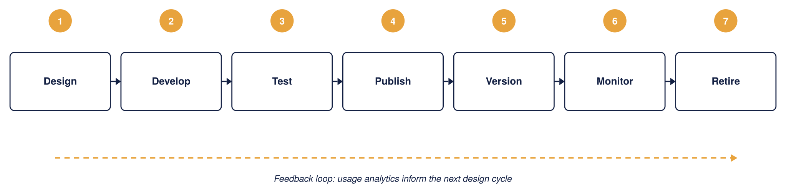
Figure 23: API lifecycle management, the Organization
The seven stages, what each one does, and who owns it:
Stage | What happens | Owner
1. Design | Define the API contract (OpenAPI), naming and schema; check against design and naming standards before any build | Domain team
2. Develop | Build the API and its policies as code, referencing Key Vault-backed secrets, never inline credentials | Domain team
3. Test | Run automated policy and contract tests in Dev/UAT; nothing proceeds until these pass | Domain team
4. Publish | Promote through the APIOps pipeline and publish to the developer portal under an approved product, visible only to the right groups | Platform team
5. Version | Introduce changes safely: additive changes as a new revision, breaking changes as a new version (v2) alongside v1 | Domain team
6. Monitor | Track usage, errors, latency and quota consumption per consumer; feed findings back into the next design cycle | Operations / SRE
7. Retire | Deprecate with a Sunset header and a defined notice window, then remove; the gateway returns 410 Gone, never a silent removal | Platform + Domain
In practice these stages map onto concrete gates: intake registers the API and its intended consumers, design review checks schema and naming standards, a security gate confirms scopes and rate limits, pre-production sign-off requires automated policy and contract tests to pass, and production publish makes the API visible in the developer portal under an approved product. Retirement follows a defined deprecation notice and sunset window rather than a silent removal. The full step-by-step onboarding path that walks a new API through these stages is in section 11 (Onboarding a new API).
Versioning: keeping change non-breaking
Versioning exists so that the Organization can improve an API without breaking the systems already calling it. The design uses two distinct APIM mechanisms for two distinct situations, and it is worth being precise about which is which, because they are often confused.
Mechanism | When it is used | Consumer effect
Revision | A change that does not break the contract, for example adding an optional field or fixing a bug | Consumers keep calling the same URL; the new revision can be tested online, then made current
Version | A change that breaks the contract, for example removing a field or changing a type | A new version (v2) is published alongside v1; consumers move when they are ready

Versions are expressed in the URL path (for example /api/claims/v1/ and /api/claims/v2/), which is the clearest scheme for partners to read and the easiest to route on at the gateway. APIM also supports header-based and query-string versioning; path-based is the house standard here, with the others available only where a specific partner integration requires them.
The table below sets out how each kind of change is handled and what the consumer experiences.
Change type | Versioning approach | Consumer impact
Breaking change | New major version, for example /v2/, published alongside /v1/ | None until the consumer opts in
Non-breaking addition | Same version, new revision, additive fields only | Zero impact, backward compatible
Deprecated version | Marked deprecated in the Developer Portal; a Sunset response header advertises the retirement date | 90-day minimum notice period
Retired version | Removed after the sunset window; the gateway returns 410 Gone | Enforced by APIM policy, never a silent removal

The diagram below shows how a version transition plays out over time. A new version can be published as a preview while the current version is still live, the current version then enters a deprecation window of at least 90 days during which a Sunset header warns callers, and only after that window and confirmed consumer migration is it retired.
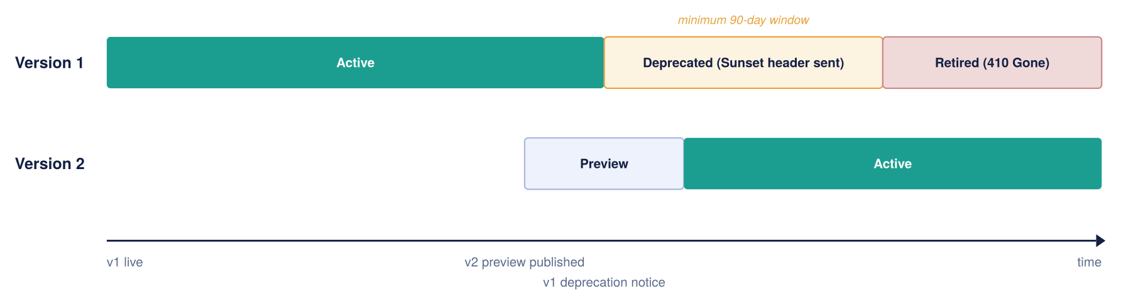
Figure 24: API version lifecycle over time
Deprecation is signalled in-band, not just in documentation: while a version is deprecated the gateway attaches a standard Sunset header (and, where useful, a Deprecation header) to every response, so a consumer's own tooling can flag the coming retirement automatically. This is what makes 'never a silent removal' enforceable rather than a promise.
Maintaining the lifecycle: deprecation, Sunset and retirement
Every published API is treated as having a full lifecycle, not just a launch. The mechanics below make each transition explicit and machine-readable, so consumers are never surprised and retirement is always a planned event.
Publish and run. A new version is published under an explicit path segment (/v1/, /v2/) and made visible in the Developer Portal under the product that governs it. While a version is current it is monitored through the same observability stack (section 12), and non-breaking changes are shipped as revisions against the same version so consumers keep calling the same URL.
Deprecate. When a breaking change requires a new version, the outgoing version enters a deprecation window of at least 90 days. During this window the gateway attaches a standard Sunset HTTP header (RFC 8594) to every response, giving the exact date the version will stop being served, and, where useful, a Deprecation header marking it as deprecated. Because these are response headers rather than documentation, a consumer’s own tooling can detect the coming retirement automatically. A policy fragment applied at the version scope adds the headers, so no per-API work is needed.
Notify and track. Deprecation is announced in the portal and, for external products, to the named technical contact on each subscription. The platform team tracks which subscriptions are still calling the deprecated version through per-consumer telemetry, so migration can be confirmed by data rather than assumed.
Retire. The version is removed only after the window has elapsed and telemetry confirms consumers have migrated. Retirement is a deliberate, logged step: never a silent removal: and the version’s routes return a clear gone/redirect response thereafter. All of this is driven from Git through APIOps, so a retired version is removed as reviewed code, not by a manual portal edit.
Operational ownership of deprecation. The headers and window make deprecation enforceable, but a person still owns the conversation. For every deprecation, the owning Domain team is responsible for the migration relationship with affected consumers, and the Platform team is accountable for the process being followed. For external partners this means: identify affected subscriptions from telemetry, contact the named technical and business contacts on each subscription, agree a migration date within the window, track progress, and escalate to the partner’s relationship owner if a consumer is not moving with the deadline approaching. Retirement proceeds only when telemetry confirms migration; if a critical partner genuinely cannot meet the date, an extension is a logged, approved decision, not a slipped deadline.
The headers attached during the deprecation window:
Header | Example value | What it tells the consumer
Sunset | Sunset: Sat, 30 Nov 2026 23:59:59 GMT | States the exact date/time the version stops being served (RFC 8594)
Deprecation | Deprecation: true | Marks the version as deprecated so tooling can flag it
Link (optional) | Link: <https://developer.organization.example/…/v2>; rel="successor-version" | Points callers at the version they should move to

Observability and Operations
Every gateway, policy, and backend call feeds into a single Azure Monitor view, so there are no blind spots between environments. Application Insights carries end-to-end tracing; Log Analytics holds the raw diagnostic logs; dashboards give operations, integration, security, and executive audiences the view each of them needs.
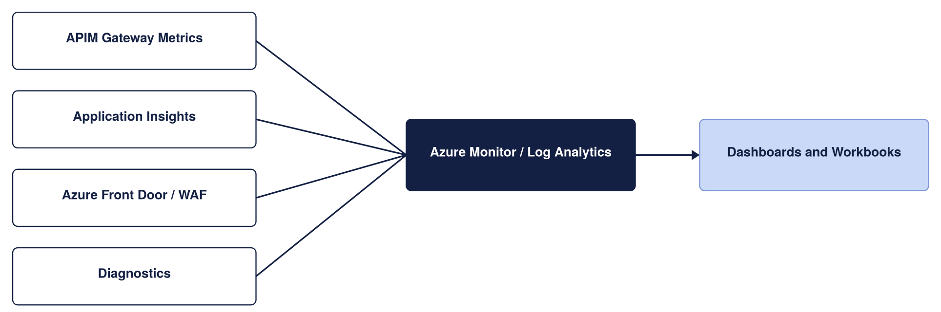
Figure 25: Monitoring architecture
What is actually logged, and where it goes, matters as much as the diagram. Each source emits structured telemetry through APIM's diagnostic settings, every record carries the same correlation ID so a single request can be followed end to end, and each stream lands in the sink suited to its purpose.
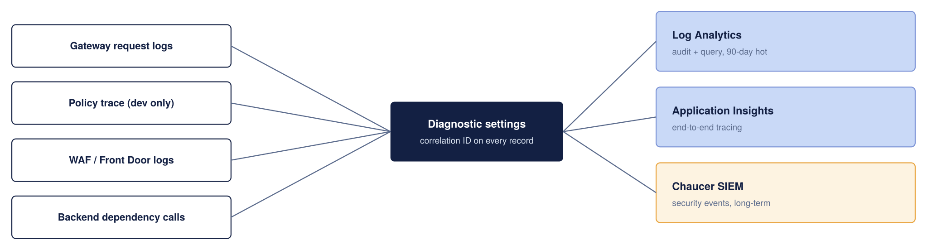
Figure 26: What is logged and where it goes
The retention periods below are proposed starting points to be reconciled with the Organization’s actual logging and data-retention standard, not confirmed values; the 90-day figures in particular should be checked against the Organization’s SIEM and compliance retention requirements.
Telemetry | Sink | Retention (proposed)
Gateway request and response metadata | Log Analytics | 90 days hot, then archived per the Organization’s log policy
End-to-end distributed traces | Application Insights | Sampled in production to control cost
Policy trace (verbose) | Application Insights | Enabled in Dev only; off in production by default
WAF and Front Door logs | Log Analytics | 90 days, feeding the security dashboard
Security-relevant events | the Organization’s SIEM | Long-term, per existing SIEM retention standard

Correlation IDs are propagated from the gateway to the backend, so a trace does not stop at APIM; a support engineer can follow one broker request from the edge, through the policy pipeline, into the backend and back. This propagation should be validated end to end during the pilot, since a correlation ID that is dropped by an intermediate hop breaks the trace. Verbose policy tracing is deliberately restricted to Dev, because it is expensive and can capture sensitive payload detail that has no place in a production log.
Dashboards are cut by audience rather than one generic view: an operations dashboard tracks latency, error rate and throttling; an integration dashboard tracks per-API and per-consumer volumes; a security dashboard surfaces 401s, WAF blocks and anomalous spikes; and an executive view rolls up availability against the SLA. The alert thresholds below are proposed defaults to be agreed with the Organization’s operations team, not fixed commitments; they are starting points for tuning against real traffic.
Metric | Alert threshold (proposed)
Failed requests, 5xx | More than 1% of total requests
Gateway response time | p95 above 500ms
Unauthorised requests, 401 | More than 10 per minute
Certificate expiry | Less than 30 days to expiry

Environment and Release Strategy
Environment | Service tier | Target SLA | Purpose
Dev | Developer | None (No SLA)) | Functional API policy development, mock backend testing, and automated pipeline builds at minimum cost. Non-production evaluation tier.
Test | Developer | None (No SLA) | Functional API policy development, mock backend testing, and automated pipeline builds at minimum cost. Non-production evaluation tier.
UAT | Premium V2 | 99.95% | Pre-production business sign-off and user acceptance. Guarantees complete architectural parity with Production (VNet integration, Private Endpoints, isolated networking) on a single scale unit.
Production | Premium V2 | 99.95% | Live customer traffic, high availability, and workspace isolation. Deployed across 3 Availability Zones (Silver Tier) with dynamic autoscaling based on gateway CPU/Memory load

The platform environment strategy uses four distinct environments: Dev, Test, UAT, and Production.
- Dev and Test: Provisioned on the cost-effective Developer tier to support functional API policy development, mock testing, and automated integration pipeline builds at minimal cost.
- UAT: Provisioned on Premium v2 (1 scale unit) to ensure complete pre-production architectural and network parity (VNet integration, Private Endpoints) with Production, providing a supported, SLA-backed platform for business sign-off and user acceptance testing.
- Production: Provisioned on Premium v2 with Zone Redundancy enabled (Silver Tier across 3 Availability Zones) for live customer traffic, maximum platform availability, and dynamic autoscaling capabilities.
All platform modifications including OpenAI definitions, policy updates, workspace provisions, and network routing configurations are managed strictly as infrastructure-as-code (IaC) and deployed through automated APIOps CI/CD pipelines. Every change undergoes mandatory peer-review pull requests and automated static checks prior to promotion, and direct manual modifications via the Azure Portal in Production are strictly prohibited.
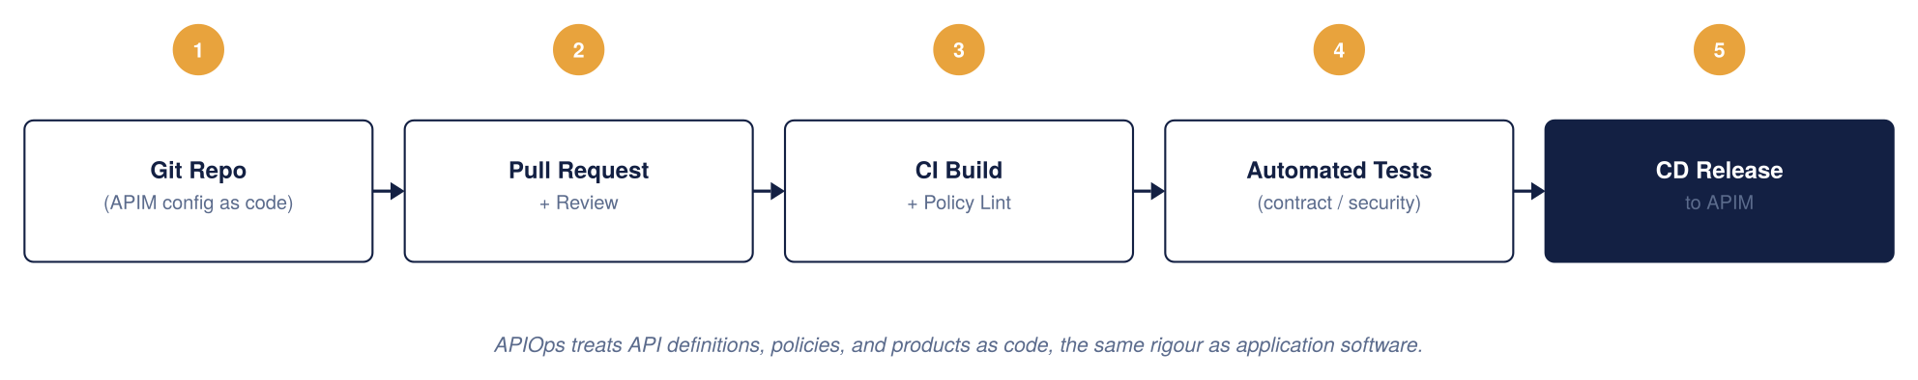
Figure 27: APIM CI/CD model, APIOps
APIOps tooling and pipeline (to be confirmed)
This design assumes an APIOps model but does not yet commit to specific tooling; that choice belongs to the Organization’s platform engineering standard rather than to this HLD, and should be confirmed and recorded as an architecture decision before build starts. The proposed default, consistent with a Microsoft-native Azure landing zone, is:
- Infrastructure as code: Bicep for the APIM instance, networking, Key Vault and Front Door resources, so the same templates promote unchanged through Dev, UAT and Production with only parameter files differing per environment.
- Configuration as code: the Azure API Management DevOps Resource Kit (APIOps) extractor/publisher tooling, or an equivalent, to represent APIs, products, policies and named values as files in Git rather than portal state.
- Source control and pipeline: a Git repository per the pattern already used elsewhere in the Organization’s Azure estate (Azure Repos or GitHub, run through Azure DevOps Pipelines or GitHub Actions), with mandatory pull-request review before merge to the branch that triggers Production deployment.
- Environment promotion: Dev builds on every merge to the integration branch; UAT and Production promote the same reviewed artefact through a manual approval gate, never a fresh build per environment, so what was tested is what ships.

APIOps and Deployment Approach
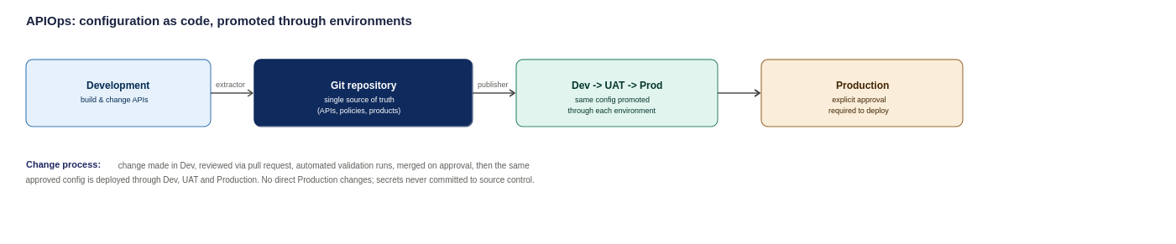
Figure 28: APIOps deployment pipeline, from development through to production
The proposed approach treats API Management configuration as code and stores it in a Git repository, which acts as the single source of truth. Changes are reviewed, approved, and deployed through automated pipelines rather than being made directly in Production.

Configuration Management & Security Principles

Environment-Specific Settings
Environment variables (e.g., backend endpoints, rate-limit thresholds, and timeout values) are managed via environment-specific configuration files. API schemas, OpenAPI specs, and XML policies remain identical across all deployment stages.
Security Baseline
- Secrets Governance: Credentials and keys are stored in Azure Key Vault and injected dynamically at deployment; zero plain-text secrets are committed to source control.
- Least Privilege: APIOps deployment identities use scoped Workload Identity / Service Principal credentials with minimal required Azure RBAC roles.
- Pipeline Enforcement: Production modifications occur exclusively through approved CI/CD deployment pipelines; direct Azure Portal updates are disabled.
- Emergency Override: Direct production portal access is restricted to time-bound Emergency Administrative Access (via Azure PIM) and is reserved strictly for pipeline outages.
Repository Structure
The APIOps repository maintains a single, standardized layout containing:
- APIs/ OpenAPI definitions and endpoint configurations
- Policies/ Inbound, outbound, backend, and error XML policies
- Products/ —API product groupings and subscription key settings
- NamedValues/ APIM-level global properties and Key Vault references
- Backends/ Gateway backend target pool definitions
- Environments/ —Environment-specific config mapping files (Dev, Test, UAT, Production)
- Pipelines/ CI/CD deployment workflow and validation scripts
Configuration is promoted identically through Dev $→$ Test $→$ UAT $→$ Production via automated promotion gates, ensuring no environment is treated as an ad-hoc exception.

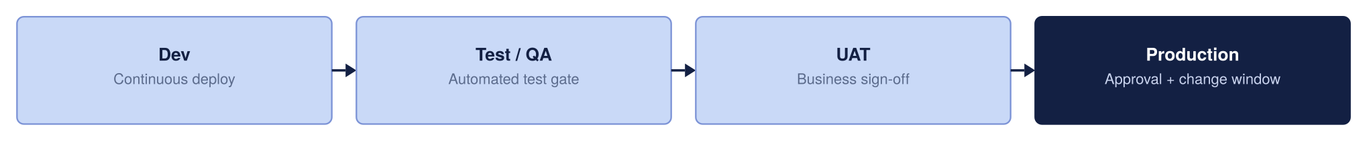
Figure 29: Environment promotion strategy

High Availability and Disaster Recovery
High Availability ensures the platform survives a datacentre failure within a region without disrupting users. By deploying APIM across independent Azure Availability Zones, traffic is automatically routed only to healthy zones.

Resilience Strategy
Active-active multi-region deployment roughly doubles overall platform running costs, which is not justified for every API. To balance high availability with fiscal responsibility, resilience is tiered based on business criticality rather than paying a multi-region cost premium across the entire estate
Bronze (Single Region – Single Unit): Deployed in a single Azure region without secondary region or cross-zone failover. Service recovery relies on standard platform restoration processes, prioritizing cost efficiency for non-critical workloads where extended recovery times are acceptable.
Silver (Single Region – More Than 1 Unit): Preferred Baseline: Deployed within a single Azure region using multiple units distributed across Availability Zones (e.g., Zone 1 and Zone 2). This provides high intra-region capacity and local fault tolerance against underlying infrastructure or maintenance failures without incurring the cost and complexity of a secondary standby region.
Gold (Multiple Region – Multiple Units): Deployed across multiple Azure regions with multiple units provisioned in each region, offering geographic distribution, active load balancing, and cross-region failover for business-critical production services.

Resilience Tier | Deployment Topology | Architectural Scope | Operational Effect | Key Benefits | Architectural Trade-offs
Bronze | Single Region,  Single Unit | APIOps / IaC Git Config Recovery  Azure Front Door Anycast & WAF Edge | Environment can be completely rebuilt from code (near-zero config RPO).  DDoS and web attacks absorbed at the edge. | Minimizes platform infrastructure, licensing, and operational management costs. | No cross-zone or cross-region failover. Relies entirely on standard platform recovery procedures during outages.
Silver (Chosen Baseline)  (Production Standard) | Single Region,  Multiple Units (3 AZs) | Zone-Redundant APIM Gateway  Zone-Redundant Integration Services (Functions, Service Bus) | Survives single physical datacenter loss within the region.  Traffic automatically routes around failed zones without manual intervention. | High intra-region availability and fault tolerance against local zonal/maintenance events. | Accepts an RTO window during a total regional outage in exchange for avoiding secondary-region running costs.
Gold  (Mission-Critical) | Multi-Region,  Multiple Units | Multi-Region Active-Active APIM (UK South / UK West)  Front Door Global Health Probes | Full regional disaster recovery.  Total UK South outage automatically routes traffic to UK West with no client DNS changes. | Highest possible resilience tier with automated geographic failover and continuous multi-region availability. | High operational complexity; roughly doubles platform infrastructure and licensing costs.

Bronze and Silver run the primary region only, standing up the secondary on DR via IaC to keep cost minimal. Gold runs active-active across both regions.
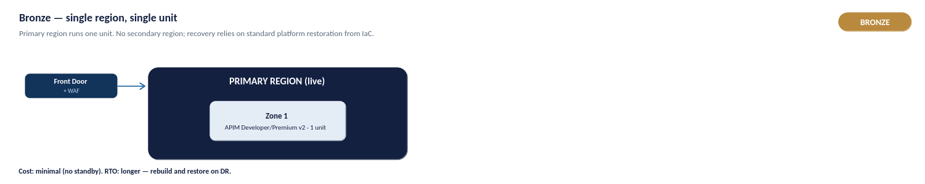
Figure 32a: Bronze — single region, single unit
Bronze is a single region running one unit, with no secondary region or cross-zone failover. Recovery relies on standard platform restoration, and the environment can be rebuilt from IaC (near-zero configuration RPO). It minimises infrastructure and licensing cost, and suits non-critical workloads where a longer recovery time is acceptable.
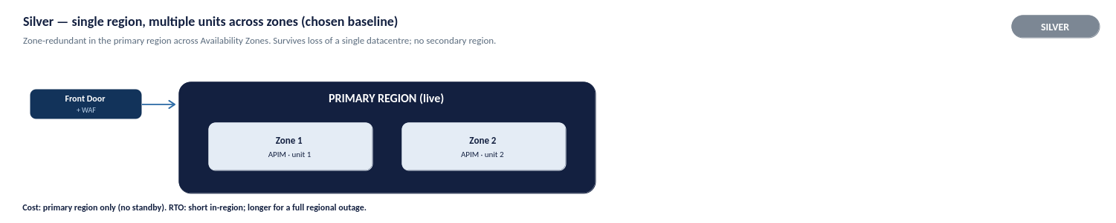
Figure 32b: Silver — single region, multiple units across zones (chosen baseline)
Silver is the chosen production baseline: a single region with multiple units distributed across Availability Zones. It survives the loss of a single datacentre within the region, with traffic automatically routed around a failed zone, and gives high intra-region availability without the cost of a standby region. It accepts an RTO window during a total regional outage in exchange for avoiding secondary-region running costs.
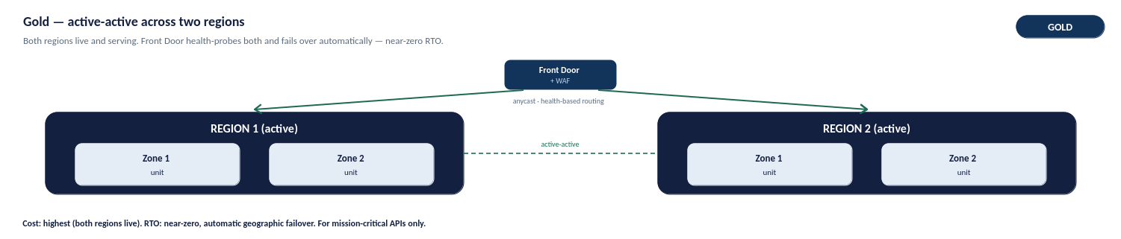
Figure 32c: Gold — active-active across two regions
Gold is reserved for mission-critical services: multiple units deployed active-active across two regions (UK South and UK West), with Front Door health-probing both and failing over automatically. A total regional outage reroutes traffic with no client DNS change, giving the highest resilience tier. The trade-off is higher operational complexity and roughly double the platform running cost, so it is applied only where the business case justifies it.

Azure Front Door Vs Traffic Manager
Although Azure Front Door and Azure Traffic Manager share the primary goal of routing traffic to healthy regional origins, their underlying mechanics differ significantly:
- Azure Traffic Manager (DNS-Based Routing): Operates strictly at the DNS level. It directs clients by returning the IP address of a regional gateway based on health probes. Because failover depends on client applications and intermediate DNS resolvers respecting DNS Time-To-Live (TTL) values, failover is rarely instantaneous and can cause lingering traffic to hit an unhealthy region.
- Azure Front Door (Layer 7 Anycast Reverse Proxy): Operates at the application layer via a global network of edge locations. Client connections terminate directly at the nearest Front Door POP (Point of Presence). Front Door continuously monitors origin health and instantly redirects incoming HTTP/S requests to a healthy backend region at the proxy layer completely bypassing client DNS caching delays.
Why Azure Front Door is Required for this APIM Architecture:
- Zero-Latency Failover: Eliminates client-side DNS TTL caching risks during a regional UK South outage.
- Perimeter Security Convergence: Integrates Layer 7 Web Application Firewall (WAF) and DDoS protection into the same routing hop.
- Private Link Support: Natively routes traffic directly into internal APIM instances via Azure Private Link, eliminating public IP exposure.
Decision flow illustrating why Azure Front Door is selected over Azure Traffic Manager for HTTP/HTTPS API traffic. Front Door provides integrated Layer 7 WAF security and sub-minute failover, whereas Traffic Manager operates strictly at the DNS level without application-layer security features.
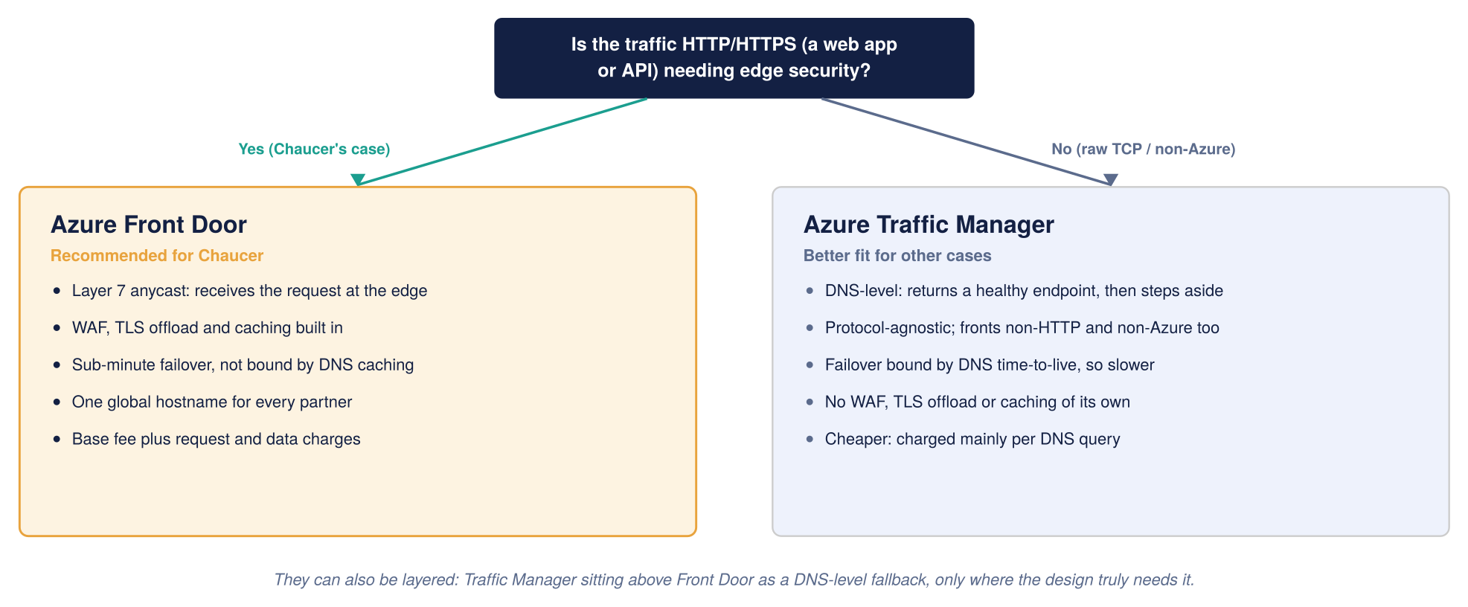
Figure 32d: Global routing, Front Door compared with Traffic Manager

Capacity, Cost and Service Tiers
The figures below are indicative UK South list prices, gathered to give the Organization a realistic planning envelope. They are not a quote. Two things will move the real number: the Organization’s enterprise agreement with Microsoft usually discounts list price, and actual traffic volume drives the metered charges (requests, bandwidth, and log ingestion) that sit on top of the fixed platform cost.
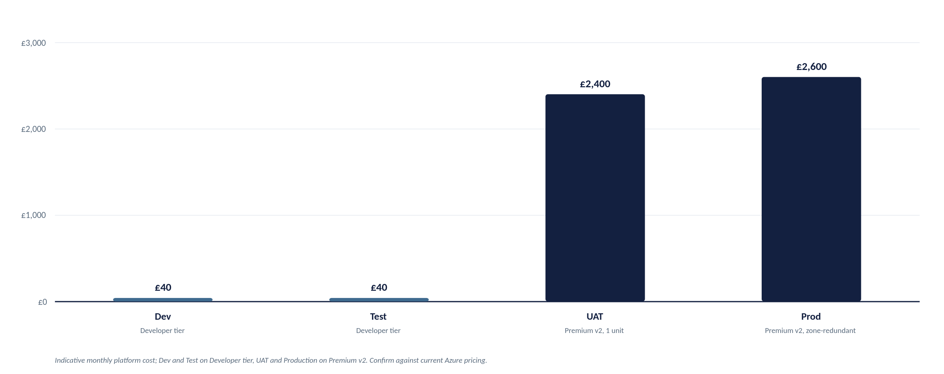
Figure 33: Indicative monthly platform cost by environment
Figures are indicative and must be confirmed against current Azure pricing: azure.microsoft.com/pricing/details/api-management
Cost per component, production
For a production environment the fixed monthly cost breaks down roughly as follows. A single Premium unit is the largest line by far, which is why the tier and single-versus-multi-region decision matters so much to the bill.
Component | Indicative monthly cost | Notes
APIM Premium V2 | roughly £2,100 to £2,300 (per unit)  Per unit (or scale unit) refers to a block of dedicated processing capacity (compute, memory, and networking throughput) allocated to your gateway instance. | Modern v2 architecture eliminates legacy Cloud Services (Classic) dependencies. Zone redundancy (3 AZs) is configured within the region.
Azure Front Door Premium + WAF | roughly £260 base, plus usage | In Premium v2, multi-region failover relies on Front Door orchestrating independent regional v2 instances. Includes WAF base rules
Azure Key Vault | a few pounds per month | Centralized secret and TLS certificate storage; operational cost is negligible.
Azure Monitor and Application Insights | usage-based | Billed on log ingestion volume; determined by API request volume and telemetry logging rules.
Azure DDoS Protection (if on a dedicated plan) | roughly £2,300 per month per tenant | Flat tenant-wide fee covering up to 100 public IPs (optional if relying purely on Front Door edge protection).

Dedicated Azure DDoS Network Protection is omitted from APIM's direct cost baseline. Perimeter DDoS mitigation is fully handled at the edge by Azure Front Door and its integrated WAF. Furthermore, deploying APIM in internal mode eliminates public IP exposure, making platform-level Azure infrastructure DDoS protection sufficient without incurring additional tenant-wide DDoS licensing fees.

Cost Optimization Strategies
- Tier Sizing Across Environments:
  - Dev / Test: Deploy on Basic v2 or Standard v2 for feature and integration testing. Note that if full internal VNet injection or private endpoint testing is required during dev, a single non-prod Premium v2 unit should be used.
  - UAT / Pre-Prod: Deploy a single unit of Premium v2 (Silver Tier topology). This ensures business sign-off occurs on a network-isolated, SLA-backed instance identical to production without incurring multi-region gold tier costs.
- Demand-Driven Capacity Scaling: Start production with a single Premium v2 scale unit (sufficient for initial pilot workloads). Scale out additional units only when gateway capacity metrics (CPU/Memory limits) reach established operational thresholds.
- Observability & Log Ingestion Management: Because Application Insights and Log Analytics are usage-billed per gigabyte, enforce telemetry sampling and restrict verbose payload logging in production to high-value endpoints or active troubleshooting windows.

Capacity planning and scaling

Platform cost and throughput scale directly with the number of provisioned units. As an initial planning baseline, 1 Premium v2 unit handles roughly 1,000 requests/sec, but this is an estimate. Actual throughput varies based on payload size, policy evaluation complexity, and TLS overhead, requiring validation against real production traffic.
Scaling MUST be driven by the Gateway CPU and Memory metrics, not static assumptions:
- Auto scale Thresholds: For multi-unit instances, scale out when sustained gateway CPU or memory exceeds ~70%, and scale in below ~35% over a 30-minute average.
- Provisioning Lead Time: Scale operations take 15–30 minutes to complete. Auto scale rules must react to sustained trends rather than short bursts.
- Active-Active Sizing: Each active region must carry sufficient unit headroom to absorb 100% of the peak workload during a single-region failover.

Environment | Service Tier | Starting Capacity | Indicative Throughput | Architectural & Sizing Justification
Dev | Standard v2 | 1 Unit | N/A  (Build / Unit Test) | Used for functional API development, policy testing, and automated pipeline builds at minimal cost. Single-node non-production evaluation tier without SLA.
Test | Standard v2 | 1 Unit | N/A  (Build / Unit Test) | Used for functional API development, policy testing, and automated pipeline builds at minimal cost. Single-node non-production evaluation tier without SLA.
UAT | Premium v2 | 1 Unit | ~1,000 req/sec | Pre-production business sign-off environment. Provides complete parity with Production architecture (VNet integration, Private Endpoints, isolated networking) on a single scale unit without multi-region costs.
Production | Premium v2 | 1 Unit | ~1,000 req/sec  per unit | Enterprise production baseline (Silver Tier: Zone-Redundant across 2 AZs). Scaled dynamically based on Gateway CPU and Memory metrics to handle peak traffic and regional redundancy.

Operating Model
This section details live platform operations: incident response, release management, capacity planning, and cost governance. It builds directly on the ownership model (Section 10.2), monitoring framework (Section 12), and release pipelines (Section 13)

Operational ownership and support tiers
Ownership follows the federated model already established: a central Platform team runs the shared APIM platform and its guardrails, Domain teams own the APIs inside their workspace, and Network, Identity, Security and Compliance own their respective controls across all domains. The RACI in section 10.2 fixes who is Responsible, Accountable, Consulted and Informed for each recurring activity; this section adds the support structure that activates when something needs fixing.
Figure 33a shows the same ownership expressed as an escalation path: a three-tier support model plus a direct route for security-flagged events, matching common industry practice for a platform with this many stakeholders.
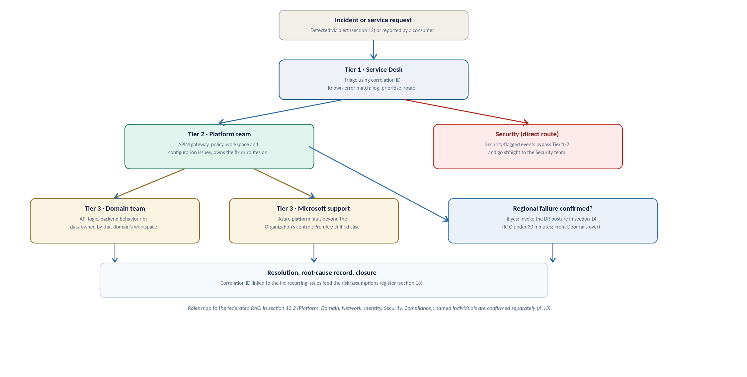
Figure 33a: Operating model at a glance, the support tiers and escalation path from an incident to closure
Support Tier | Scope of Ownership & Operational Responsibility | Escalation Path & Target
Tier 1  (Service Desk) | First Response & Triage. Ingests alerts, performs initial triage using the API Correlation ID (Section 12), and performs known-error matching. | Escalates to Tier 2 (Platform Team) for unresolved issues or platform-level errors.
Tier 2  (Platform Team) | APIM Platform Infrastructure. Owns the core gateway, global policies, shared infrastructure, workspace provisioning, and network routing configurations. | Escalates to Tier 3 (Domain Team) for application logic issues, or Microsoft Support for Azure platform outages.
Tier 3  (Domain Team) | API Logic & Backend Services. Owns backend microservices, domain-specific policies, API schemas, and data within their dedicated workspace. | Domain-owned internal resolution.
Tier 3  (Microsoft Support) | Azure Platform & Infrastructure. Handles platform-level outages, underlying hypervisor faults, or Microsoft-managed control plane failures. | Logged as a Premier / Unified Support ticket directly with Microsoft.
Security  (Direct Fast-Path) | Threat & Compliance Management. Direct escalation route for security-flagged events (e.g., active WAF attacks, credential leaks, or unauthorized access attempts), bypassing Tiers 1 and 2. | Managed directly by the InfoSec / SOC Team.

Named individuals for each tier are not yet assigned, this is the same open item as the RACI owners in A.13, and should be closed before go-live (see section 17.1).

Incident management
Severity is set by impact and matched to the alert thresholds already defined in section 12. These are proposed definitions to align with the Organization's ITSM standard, and final response and resolution targets are agreed with the Operations team, consistent with A.09.
Severity | Example trigger | Target response | Target resolution or mitigation
Sev 1, Critical | Regional outage, or 5xx errors above 1% platform-wide | 15 minutes | Automatic regional failover (section 14, RTO under 30 minutes); manual escalation if it does not clear
Sev 2, High | A single product degraded, or p95 latency sustained above 500ms | 1 hour | Same business day, through a standard or emergency change
Sev 3, Low | An isolated consumer issue, or a certificate nearing expiry | Next business day | Resolved through the standard change and release cadence

Every incident is linked to its correlation ID so the root cause can be traced end to end, and a recurring issue is fed into the risk register in section 18 rather than fixed quietly and forgotten.

Change and release management
Change control is embedded directly within the APIOps automated pipeline (Section 13) rather than operating as a separate manual CAB process. Every modification whether to an API policy, OpenAI spec, or gateway configuration passes through pull-request (PR) peer reviews, automated static security analysis, and environment promotion gates before reaching Production.
- Standard change: Any routine API definition, policy update, or workspace configuration change. Follows the standard multi-stage pipeline, requiring peer review, automated validation, and gated promotion through Dev, Test, UAT, and Production.
- Emergency change: A hotfix required to resolve an active Severity 1 or Severity 2 incident outside the normal release cadence. Emergency changes must still execute through the APIOps pipeline and Git history, utilizing an expedited PR approval path (e.g., single platform lead sign-off). A mandatory Post-Implementation Review (PIR) is logged against the incident ticket upon deployment.
- Emergency Administrative Access: The emergency platform-team access path (defined in Section 10.2), invoked only when the APIOps pipeline control plane is entirely unavailable (e.g., CI/CD provider outage). Access requires time-bound Azure Privileged Identity Management (PIM) elevation, triggers immediate security alerts, and undergoes mandatory post-incident auditing. It is strictly prohibited for routine operational changes.

Capacity, cost and service reporting
Capacity and cost are reviewed on a recurring cycle, not just at design time: actual traffic is compared against the planning assumptions in section 15 and A.10/A.12, and the tier, unit count, and multi-region posture are revisited as real volumes replace estimates.
Service reporting reuses the dashboards already defined in section 12 (Figure 25, Figure 26): an operational view for the Platform and Domain teams, and an executive view rolling up availability against the SLA. A regular service review, cadence to be agreed with the Organization's Operations team, is the forum where this reporting, open risks, and upcoming changes are reviewed together.

Service Handover
This section sets out what must be true before the platform moves from build into business-as-usual operation, and how that transition is managed. It is the operational counterpart to the Technical Design Authority approval in section 1: TDA approval signs off the design. The criteria below sign off that the live service is ready to run.

Handover readiness checklist
Handover is not a single event but a checklist: the items below should be true, or have a named owner and a date to become true, before the service is accepted into live support.
Governance & Operational Area | Service Readiness Criterion | Design & Reference
Platform Ownership | Accountable primary and secondary owners assigned for every RACI role defined in Section 10.2. | Section 10.2 (Closes Risk A.13)
Support Readiness | Support Tiers 1 through 3 staffed, briefed on operational escalation paths, and on-call rosters established. | Section 16.1
Observability & Alerting | Azure Monitor dashboards live, Log Analytics ingestion verified, and alert routing/thresholds tested end-to-end with Operations. | Section 12 (Closes Risk A.09)
Platform Resilience | Front Door health probes and multi-region failover (or single-region AZ availability) tested and documented prior to go-live. | Section 14
Policy Exceptions | Operational process, ownership, and SLA established for evaluating and approving non-OAuth or legacy policy exception requests. | Closes Risk A.16
Operational Documentation | Operational runbooks, final HLD architecture, and the assumptions/risk register delivered to support teams. | Section 17.3
Identity & Access Control | CI/CD APIOps pipeline permissions, Git repositories, Key Vault access, and Emergency Administrative Access (PIM) transferred to operational owners. | Section 10.2 & Section 13
Vendor & Commercial | Active Microsoft Enterprise Support agreement (Premier/Unified) confirmed, with support ticket logging paths validated. | Section 16.1

Early-life support (hypercare)
Industry practice for a core platform of this nature requires a defined Hypercare period immediately following Production go-live, typically spanning two to four weeks.
During Hypercare:
- Joint Operational Standing: The engineering and build team remain actively engaged alongside Tiers 1 and 2 support to ensure rapid incident triage and direct knowledge transfer.
- Aggressive Escalation: Escalation thresholds are intentionally lowered compared to steady-state operations to resolve early adoption friction rapidly.
- Daily Incident Review: A daily operational cadence reviews open tickets, pipeline health, telemetry logs, and emerging usage patterns.
Transition Gate: Hypercare concludes and the standard operational support tiers (Section 16.1) take over full steady-state ownership only when formal Hypercare Exit Criteria are satisfied, including:
- Zero Sev-1 or Sev-2 incidents for a minimum of 5 consecutive business days.
- Zero unresolved high-priority bugs in the APIOps deployment pipeline.
- Formal sign-off on operational runbooks and all completed items in the Handover Readiness Checklist

Documentation and knowledge transfer
To ensure seamless operational continuity, the delivery team will formally transfer the following key assets to operational owners prior to Hypercare exit, rather than retaining them within project delivery:
- APIM High-Level Design (HLD): Maintained as a living architectural baseline and updated via version control as the platform evolves, consistent with the broader Systems Integration Framework governance model.
- Operational RACI & Contact Directory: Sections 10.2 and 16.1 updated with named primary/secondary contacts, on-call schedules, and escalation paths substituted for generic roles.
- Operational & Disaster Recovery Runbooks: Operational runbooks specifically including the Emergency Administrative Access procedure (Section 10.2) and the Front Door / Regional DR failover playbook (Section 14) stored as Markdown directly alongside infrastructure-as-code (IaC) repositories.
- Risk, Assumption, Issue & Dependency (RAID) Register: Section 18 carried forward into steady-state operations and reviewed on a scheduled cadence during periodic platform service reviews (Section 16.4).
- APIOps & Security Access Control: Full administrative ownership of the APIOps CI/CD pipelines, Git control repositories, Key Vault access policies, and Azure Privileged Identity Management (PIM) roles transferred to designated operational platform owners.

Service acceptance sign-off
Formal acceptance into live production operation is a distinct governance gate, separate from the initial Technical Design Authority (TDA) approval in Section 1:
- TDA Approval (Section 1): Signs off on the technical architecture, security baseline, and sizing strategy prior to build execution.
- Service Acceptance Sign-Off: Formally validates that every criterion in the Handover Readiness Checklist (Section 17.1) is fully met, verified during Hypercare, and ready for steady-state operation

Risks, Assumptions and Decisions

High Level Impact Assessment
Introducing APIM adds a new, centrally-governed platform layer in front of the Organization’s existing integration estate. The impact is additive rather than disruptive: existing integration services continue to run, with APIM placed in front of them. The main new operational dependencies are the platform's networking (including the Palo Alto path), identity (Entra ID) and the APIOps pipeline. The subsections below summarise the impact by architecture domain.

Assumptions
This register highlights key open decisions and assumptions requiring TDA sign-off. Until confirmed, these items should be treated as proposed design choices rather than settled decisions.
The Azure-capability assumptions below (tier features, network modes, multi-region support) can be validated against Microsoft’s authoritative documentation: the API Management feature-by-tier comparison (learn.microsoft.com/azure/api-management/api-management-features) and the reliability guidance (learn.microsoft.com/azure/reliability/reliability-api-management).
Ref | Assumption or open item | Impact if wrong | Owner to confirm
A.01 | Backends already sit in a VNet reachable via Private Endpoint | The whole backend-connectivity design (section 6) may need rework | the Organization’s Network team
A.02 | The Organization’s landing zone follows a standard hub-spoke with private DNS zones available | Affects DNS, egress, and how APIM reaches each backend | the Organization’s Cloud Platform
A.03 | Entra ID is the Organization’s identity provider and can extend to API consumers | The entire authentication model shifts | the Organization’s Identity team
A.04 | UK South satisfy data-residency obligations | May force a different region pair or design | the Organization’s Compliance team
A.05 | Regulatory controls (FCA/PRA/Lloyd's/GDPR) can be met by the proposed design | Compliance is the least-verified area; controls need confirming | the Organization’s Compliance team
A.06 | Proposed RTO/RPO, retention periods, and alert thresholds are acceptable | Operational targets and cost may change | the Organization’s Operations team
A.7 | Traffic volumes fit one Premium unit for the pilot | Scaling changes the cost envelope | The Organization + Microsoft
A.8 | Expected and peak API request rate (RPS) is not yet provided | Production unit count and auto scale thresholds cannot be finalised; capacity is a planning estimate only | the Organization’s Platform team + business
A.9 | Named accountable owners for each RACI role are not yet assigned | Governance and approval gates lack a specific owner; onboarding SLAs cannot be enforced | the Organization’s Platform team + Domain leads
A.10 | Log and correlation-ID retention period not yet confirmed with Compliance | PII/data-minimisation posture and evidence retention may not meet UK GDPR expectations | the Organization’s Compliance team + Security
A.11 | Subnet address ranges and IPAM allocation not yet validated | Subnet sizing (/26) and scale-unit headroom may not fit the landing zone | the Organization’s Network team
A.12 | Ownership and SLA for approving non-OAuth exceptions not yet assigned | Exceptions may persist without review; single-IdP posture weakened | the Organization’s Security team + API Platform

Risks

Issues
No live issues are recorded at draft stage. Issues raised during TDA review or build will be logged here.

Dependencies
Ref | Dependency | Owner
D.01 | Entra ID app registrations provisioned before build | the Organization’s Identity team
D.02 | Key Vault and access policy available in the target subscription | the Organization’s Platform team
D.03 | Landing-zone VNet, subnets and Palo Alto access for the firewall path | the Organization’s Network team
D.04 | Confirmed RTO/RPO, retention and alert thresholds | the Organization’s Operations team

Appendices

Microsoft Reference Architectures
Diagrams in this document are the Organization-adapted renderings of the pattern each article describes, not reproductions of Microsoft's own diagrams. Refer to the linked articles for Microsoft's original diagrams and downloadable Visio files.
- Basic enterprise integration on Azure: learn.microsoft.com/azure/architecture/reference-architectures/enterprise-integration/basic-enterprise-integration
- Protect APIs with Front Door and API Management: learn.microsoft.com/azure/architecture/web-apps/api-management/architectures/protect-apis
- Azure API Management landing zone accelerator: learn.microsoft.com/azure/cloud-adoption-framework/scenarios/app-platform/api-management/landing-zone-accelerator

Alignment with the Azure Well-Architected Framework
This design has been benchmarked against Microsoft's Well-Architected Framework (WAF) guidance for API Management, which sets out best practice across five pillars. The table below summarises each pillar, the key practices Microsoft recommends, and where this HLD addresses them. The alignment is high because the design was built to these patterns; the few items marked as configuration are settings to apply at build time rather than design gaps.
WAF Pillar | Key Microsoft Recommendations | How This APIM Design Addresses It
Reliability | Zone redundancy, autoscaling, multi-region failover, policy validation, reliability metrics, and GitOps rebuild capabilities. | APIM Premium v2 deployed as active-active independent regional instances behind Azure Front Door Premium (Silver Resiliency Tier). Native Availability Zone redundancy; APIOps config-as-code enables rapid automated environment recreation.
Security | ARM-only control plane, strict TLS, Key Vault integration, network-isolated backends, OAuth 2.0, Managed Identity, edge WAF, and production trace restrictions. | Microsoft Entra ID OAuth 2.0 with JWT validation, TLS 1.2+ minimum, Key Vault-backed Named Values, Azure Front Door WAF edge inspection; Managed Identity for backend access, Private Endpoints; verbose tracing restricted to Dev/Test.
Cost Optimization | Cost-effective tiering across non-prod, auto-scale based on load, edge malicious traffic filtering, built-in caching, and policy efficiency. | 4-Environment Topology: Developer tier for Dev and Test, Premium v2 for UAT and Production (ensuring strict VNet/Private Endpoint parity). Edge DDoS and WAF filtering via Azure Front Door blocks malicious calls prior to gateway ingress.
Operational Excellence | Diagnostic resource logging, APIOps / GitOps workflows, Azure Policy governance, automated load testing, standard hostnames, and Backend construct abstraction. | Azure Monitor / Log Analytics / App Insights integration with trace parent correlation IDs, APIOps CI/CD pipelines across Dev/Test/UAT/Prod, standardized API onboarding, backend health probes managed via APIM Backends.
Performance Efficiency | Dynamic scaling, efficient policy execution, performance metric collection, adaptive App Insights sampling, and upstream limits evaluation. | Autoscaling driven by Gateway Capacity and CPU/Memory metrics, lean, modular policy library, p95 latency and capacity alerts, production Application Insights adaptive sampling to minimize overhead.

Based on Microsoft’s Azure Well-Architected Framework guidance for API Management: learn.microsoft.com/azure/well-architected/service-guides/api-management
Source: Microsoft Azure Well-Architected Framework, Architecture best practices for Azure API Management. The full checklist and per-recommendation detail are maintained by Microsoft at learn.microsoft.com and are summarised, not reproduced, here.

Glossary and Definitions
The terms below are used throughout this document.
Term | Meaning
APIM | Azure API Management, the managed API gateway service
WAF | Web Application Firewall
Entra ID | Microsoft Entra ID, the identity provider (formerly Azure AD)
UDR | User-Defined Route, a custom route-table entry
NVA | Network Virtual Appliance, here the Palo Alto firewall
APIOps | Managing APIM configuration as code through a CI/CD pipeline
RTO / RPO | Recovery Time / Point Objective
mTLS | Mutual TLS
FNOL | First Notification of Loss, the initial report of an insurance claim
SIF | Systems Integration Framework, the client’s integration reference document
RACI | Responsible, Accountable, Consulted, Informed, a responsibility model
BOLA | Broken Object-Level Authorization, an OWASP API risk
SoD | Segregation of Duties
HLSA | High-Level Solution Architecture
DNAT / SNAT | Destination / Source Network Address Translation
IPAM | IP Address Management
SIEM | Security Information and Event Management
DPIA | Data Protection Impact Assessment
FCA | Financial Conduct Authority, a UK regulator
PRA | Prudential Regulation Authority, a UK regulator
UK GDPR | UK General Data Protection Regulation
JWT | JSON Web Token
DDoS | Distributed Denial of Service
SLA | Service-Level Agreement
VNet | Azure Virtual Network
Private Link | Private connectivity to an Azure service over the Microsoft backbone

Sample Policy Fragments, Naming and OpenAPI Skeleton
Illustrative artefacts to make the standards concrete for build teams. These are examples to adapt, not final Organization policy.
JWT validation (inbound) with Entra ID:
<validate-jwt header-name="Authorization" failed-validation-httpcode="401"
failed-validation-error-message="Unauthorized">
<openid-config url="https://login.microsoftonline.com/{tenant}/v2.0/.well-known/openid-configuration" />
<required-claims>
<claim name="aud"><value>api://organization-apim</value></claim>
</required-claims>
</validate-jwt>
Rate limiting and quota, per subscription:
<rate-limit-by-key calls="100" renewal-period="60"
counter-key="@(context.Subscription.Id)" />
<quota-by-key calls="100000" renewal-period="86400"
counter-key="@(context.Subscription.Id)" />
Sunset header during a deprecation window:
<set-header name="Sunset" exists-action="override">
<value>Sat, 30 Nov 2026 23:59:59 GMT</value>
</set-header>
<set-header name="Deprecation" exists-action="override"><value>true</value></set-header>
Backend authentication using a managed identity (no secret in policy):
<authentication-managed-identity resource="api://organization-backend" />
Resource and API naming examples:
Resource group : rg-apim-prod-uksouth
APIM instance : apim-organization-prod-uksouth
API path : /api/claims/v2/claims
Named value : nv-claims-backend-baseurl
Product : prod-external-broker
Entra group : grp-apim-external-broker
OpenAPI skeleton (the contract every API starts from):
openapi: 3.0.3
info:
title: Claims API
version: "2.0.0"
servers:
- url: https://api.organization.example/api/claims/v2
paths:
/claims/{id}:
get:
summary: Retrieve a claim
security:
- oauth2: [claims.read]
parameters:
- name: id
in: path
required: true
schema: { type: string }
responses:
"200": { description: OK }
"401": { description: Unauthorized }
"429": { description: Too Many Requests }

APIM End-to-end build and API onboarding flow
This appendix synthesizes the complete platform journey into a single end-to-end swim lane diagram. Positioned as the final summary, it maps the lifecycle from business need through go-live to ongoing API onboarding.
How to Read the Diagram:
- Phases (Columns): Read left-to-right across seven sequential execution phases.
- Ownership (Rows): Read top-to-bottom to see which team owns each activity.
- Handovers & Gates: Arrows indicate team handovers; red markers highlight mandatory Technical Design Authority (TDA) approval gates.
- Document References: Each activity box cites its corresponding HLD section for detailed reference.
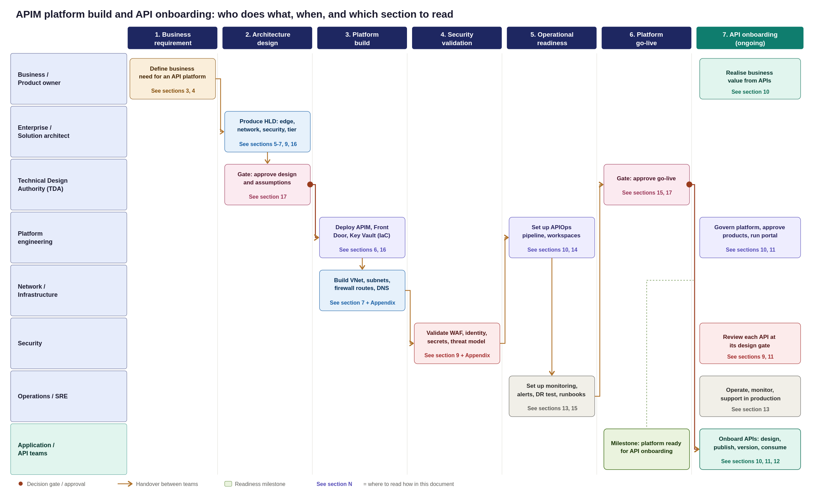
Figure 34: APIM platform builds and API onboarding swim lane, from business requirement to production consumption
Platform Implementation Roadmap & Team Execution
This appendix synthesizes the preceding design sections into a single, end-to-end swim lane diagram, mapping the platform journey from initial business demand to a live operational state.
Key Planning Takeaways
Standing up the APIM platform is a sequenced, multi-team program with a clear critical path:
- Architecture & Governance: TDA sign-off and baseline design approval.
- Infrastructure Build: Parallel execution of platform and network provisioning.
- Validation & Readiness: Security assessment, APIOps integration, and operational handover.
- Go-Live Gate: Final operational acceptance sign-off.
- Continuous Onboarding: Application teams begin onboarding APIs only after the platform go-live gate is passed.
How to Read the Swimlane Diagram
- Phases (Columns): Read left-to-right across the seven sequential execution phases.
- Ownership (Rows): Read top-to-bottom to see which team owns each specific activity.
- Handovers & Gates: Arrows indicate team handovers, while red markers highlight mandatory TDA approval gates.
- Section References: Each activity box references its corresponding HLD section for detailed technical specifications.

