Systems Integration Framework
Merged enterprise framework and practitioner pattern catalogue
ChArch-SIF-Merged | Draft
Chaucer | Technology & Architecture

Table of Contents

Right-click the table of contents in Microsoft Word and select Update Field.

1. Document Control
Primary source: ChArch-SystemsIntegrationFramework.docx; contributor details consolidated from both source drafts.
This section provides a history of how the document has been changed and how the changes have been governed.

Document History
Version | Date | Author | Notes
0.1 | 23 June 2026 | Nikhil Rokade - Chaucer | Initial draft prepared from the Systems Integration Framework Design page.

Document Authors
Role | Name | Title
Author | Nikhil Rokade | Portfolio Architect
Contributor
Reviewer

Document Assurance
Date | Role | Name | Title
DD/MM/YY | Approver | Kosta Konstantinov | Enterprise Architect
DD/MM/YY | Approver | Steve Coldwell | Head of Architecture

1.4 Source Documents and Supersession
This merged draft starts from ChArch-SystemsIntegrationFramework.docx and incorporates the detailed practitioner guidance from System_Integration_framework_Draft_v1.0.docx. It is intended to provide one framework with an accessible enterprise layer and an expert implementation layer.

2. Executive Summary
Chaucer requires a formal Systems Integration Framework to provide consistent architectural direction for system-to-system integration across internal applications, third-party platforms, SaaS services, vendor integrations and the enterprise data platform.
The framework is based on a Service-Oriented Architecture approach and explicitly avoids adopting a microservices model as the default integration paradigm. The focus is on practical enterprise integration across existing Chaucer systems, external vendors, Azure PaaS services and the data platform.
The framework establishes a single catalogue of patterns with clear boundary applicability across internal Chaucer integration, third-party to Chaucer inbound integration, Chaucer to third-party outbound integration and SIF-to-data-platform exchange. It also defines decision guidance for API, messaging, eventing, orchestration and data-platform usage, supported by mandatory guardrails and a controlled exception process.

2.1 Why This Framework Exists

The current integration estate at Chaucer is functional but has evolved organically, project by project. Each interface has been implemented in isolation like a synchronous point-to-point call in one case, a file-based batch transfer in another having no shared contract or common runtime. The result is tightly coupled, point-to-point topology, costly to change, difficult to observe, and offering no path to reuse. Each tactical remediation increases coupling and raises the cost of the next change.

This framework establishes a single reference architecture for integration, so recurring problems are solved through consistent, repeatable patterns. It defined set of integration patterns, a standardised set of Azure services (our target platform), and the governance guardrails teams need to deliver correctly without re-litigating architectural decisions on every engagement. The intent is pragmatic rather than theoretical to reduce point-to-point coupling, maximise reuse through shared integration components, adopt loose coupling and asynchronous messaging as the default, and enforce enough consistency that any internal team or third-party supplier can onboard and build to a common, well-defined shape.

3. How to Use This Framework

If you are about to build an integration, start with the decision tree in Section 4. A short set of questions resolves to the appropriate pattern. Section 5 then specifies that pattern in full details like the problem it addresses, a reference diagram showing how the components fit together, the Azure services in scope, the failure modes to design for, and the known anti-patterns to avoid.

Before you begin implementation, validate your design against the guardrails defined in Section 6. These are the criteria a reviewer will assess against. Deviation is permitted, but it must go through the formal exception process rather than being absorbed silently into the code.

Two principles take precedence over all others.

1.Reuse before you build check the service catalogue for an existing service or API before provisioning a new one.

2.Favour integrating with an existing system over standing up new infrastructure. There is no approved pattern for a direct, unmediated connection between two systems, all integration flows through the mediation layer.

3.1 Relationship to Chaucer Principles

The SIF doesn't ask you to adopt anything new. It builds on the principles Chaucer already holds and simply translates them into practical integration choices. The stack below shows where those principles come from, and where you'll find them put into practice in this document.
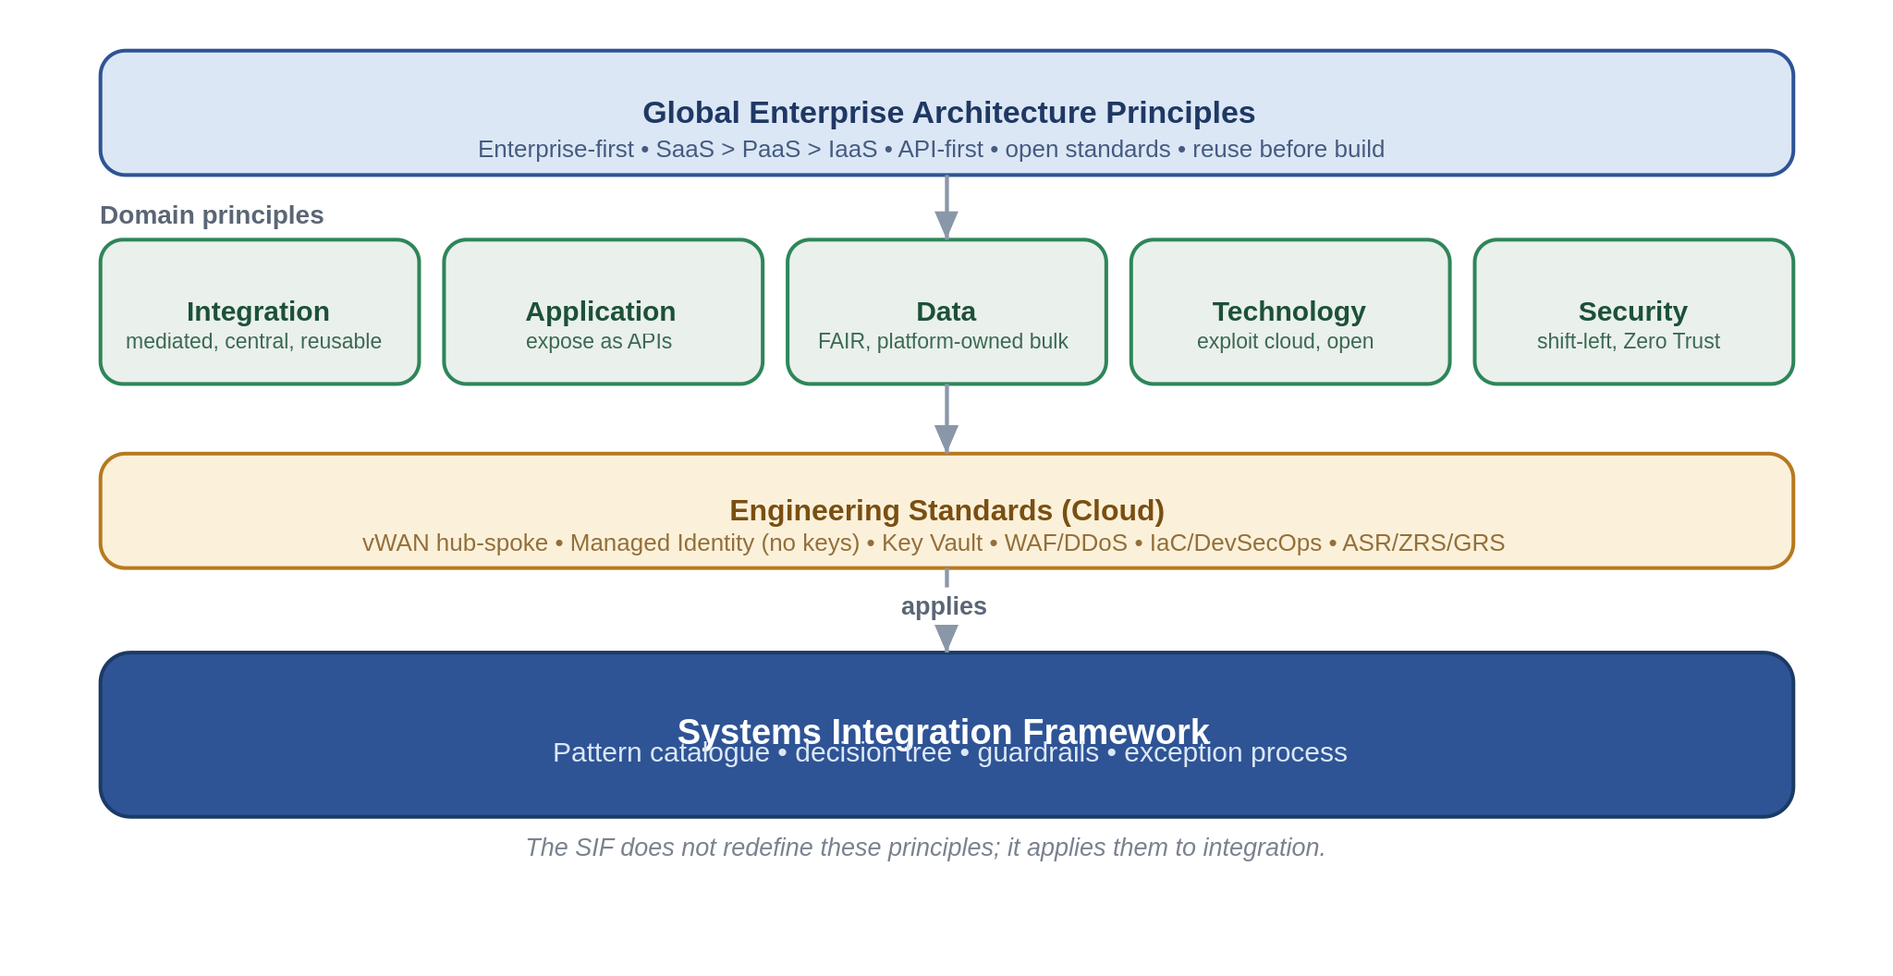
The mapping is worth making explicit, because "aligned to our principles" is easy to assert and harder to evidence. The table below is the traceability a reviewer can check.
Principle (source) | How the SIF embeds it | Where it is enforced
API-first, reuse-first, enterprise-first (Global EA, Application) | Capabilities are exposed as coarse-grained, reusable APIs and events through the platform, new build only after reuse is ruled out. | SOA service model (2.2), catalogue (App. A), TDA design gate (6.3)
All integration mediated through a single central platform (Integration) | One shared, centrally-operated platform, no direct point-to-point pattern exists. | Reference architecture (3), anti-patterns (5, App. B)
Loose coupling, asynchronous where availability/latency matters (Integration) | Messaging and events are the default for anything that can tolerate deferral, APIs are contract-bound. | Decision tree (4), patterns (5)
Secure by design, Zero Trust, least privilege (Security) | Every pattern carries a security position, identity is Entra + Managed Identity, no keys, ingress is gated. | Per-pattern risks (5),guardrails (6.1)
Managed Identity, Private Endpoints, WAF/DDoS, IaC (Engineering Standards) | Baked into the reference architecture and the non-negotiable guardrails. | Reference architecture (3.3),guardrails (6.1)
Mission-critical resilience, design for failure (Integration, Resilience) | Tiered multi-region posture and zone-redundancy by default. | Deployment & resilience (3.4)
Data is platform-owned, FAIR (Data) | Bulk and analytics stay on Snowflake, the SIF exchanges with it across a defined boundary. | Data platform exchange (5.6), boundary (3.1)

4. Architectural Position
Area | Position
Architecture model | Service-Oriented Architecture, not microservices.
Primary objective | Integrate and reuse existing systems and services before creating new ones.
Service model | Business-capability aligned enterprise services.
Integration style | API-led, event-capable, orchestration-supported.
Platform alignment | Azure PaaS integration services.
Governance model | TDA-approved standards, reusable patterns, controlled exceptions.

SOA Positioning Statement
Chaucer’s Systems Integration Framework will adopt a Service-Oriented Architecture approach, where integration services represent stable business capabilities, which are reused across business and technology teams, and are governed through clear ownership, contracts, and lifecycle controls.
The framework does not adopt a microservices architecture model as the default integration paradigm as the focus is not service decomposition for independent product or application engineering, but for pragmatic enterprise integration across existing Chaucer platforms, SaaS services, data platforms, and vendor systems.

Strategic Objectives
Objective | SIF Direction
Increase automation | Promote API, event, and workflow-based integrations over manual re-keying.
Reduce point-to-point integrations | Introduce reusable service contracts, APIM-mediated APIs, and shared messaging patterns.
Improve system-to-system data flow | Standardise integration approaches across synchronous, asynchronous, file, and data-platform exchange.
Enable vendor integration | Provide secure, governed, and reusable ingress/egress patterns for external suppliers and systems.
Support straight-through processing | Use orchestration where business process coordination is required; avoid embedding logic in consuming systems.
Align to Azure PaaS | Use Azure API Management, Logic Apps, Service Bus, Event Grid, Event Hubs, Azure Functions, and Azure Data Factory as the primary Azure PaaS integration components, with ADF specifically positioned for data ingestion, ELT orchestration, and controlled Snowflake/data-platform exchange rather than real-time operational integration.

4.3 What Counts as a Service
Because reuse is the point, it helps to be precise about the unit we are reusing. A service in this framework has four properties, and a design that is missing any of them is not yet a service.
It is business-capability aligned and coarse-grained, it means something to the business, not just to a database.
It has a versioned contract, an API definition or a published event schema, that consumers bind to, and that can evolve without breaking them.
It has a named owner accountable for its behaviour, its SLA and its lifecycle, and it is managed on a service lifecycle rather than being abandoned at the end of a project.
It is published and discoverable in the asset catalogue, so the next team finds it before building their own.
The corollary is the integrate-before-build stance. A new requirement should first try to reuse or extend an existing service, then integrate an existing system, and only then justify building something new.

4.4 Design Tenets
Everything in the catalogue is an expression of a small number of tenets. They are stated here in plain terms so the reasoning behind a pattern is never a mystery:
Mediate everything through the Integration platform.
Couple loosely and lean asynchronous where you can.
Keep process control (Logic Apps) separate from business logic (Functions).
Expose just enough capability and never internal data models.
Secure every hop by design.
Make the platform resilient.
Tie every integration to a real business outcome so we are not building interfaces for their own sake.

5. Reference Architecture

5.1 Conceptual Reference Architecture
Source: ChArch-SystemsIntegrationFramework.docx. Retained as the executive conceptual view.
Figure 1: Systems Integration Framework conceptual reference architecture

5.2 Logical Layered Reference Architecture
Source: System_Integration_framework_Draft_v1.0.docx. Practitioner view of platform layers and responsibilities.
The platform is organised into four layers plus a governed boundary to the data platform. Each layer has one job and maps to one set of Azure services, which is what keeps responsibilities, and the scope boundary, clear.
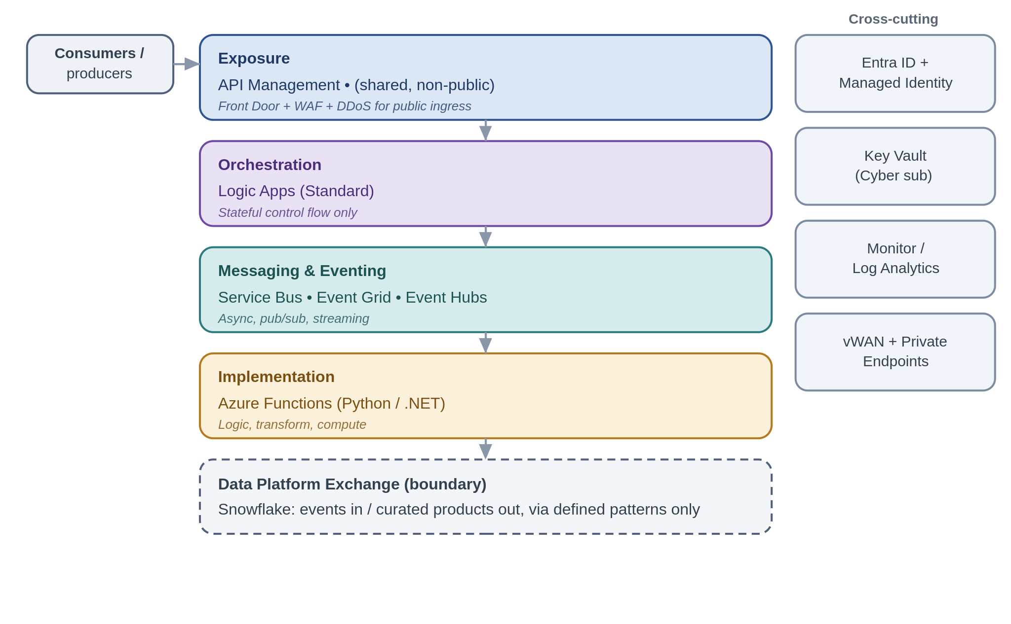
Requests enter only through the exposure layer. API Management is the single front door and is a shared, internal service. It is not internet-facing, so anything that must be reached from outside is fronted by Front Door with a WAF and DDoS protection first. Orchestration, when a process needs it, sits in Logic Apps (Standard) and holds control flow only. Asynchronous work, events and streams run through the messaging and eventing layer. Actual computation, transformation, validation, custom logic, lives in Functions. And bulk or analytical data does not belong in any of these layers, it crosses a defined boundary to Snowflake in both directions using the exchange patterns in Section 5.6.

5.3 Security and Trust Boundary Architecture
Security is the principle this organisation takes most seriously, so this section sets out the zones and boundaries once and holds every pattern to them. The framework is default-deny and private-by-default, the overwhelming majority of integration never touches the internet, and the small number of flows that must are forced through a single, hardened edge. The diagram shows where components live and where the one hard boundary sits.
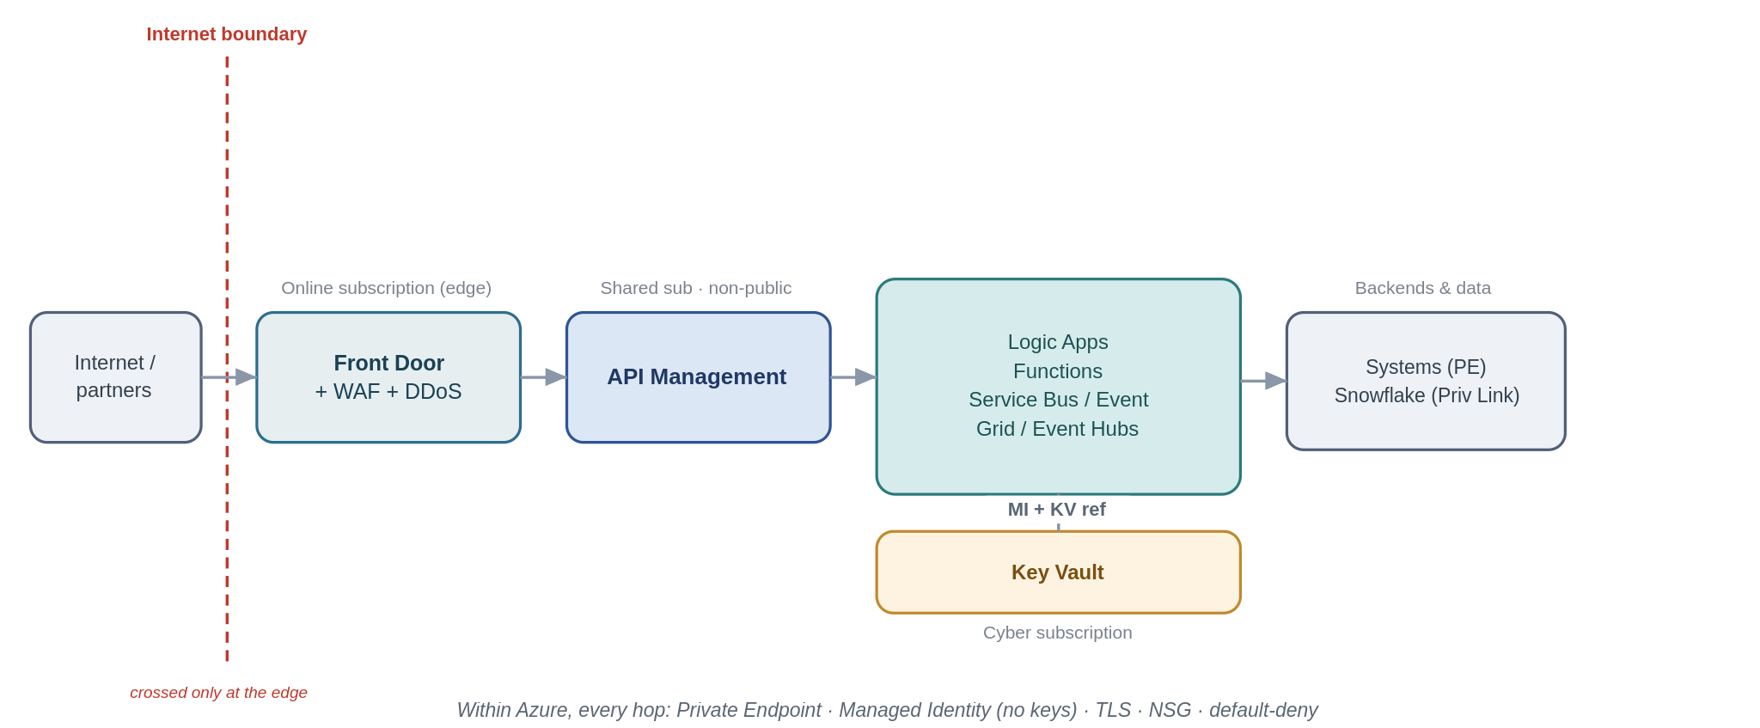
Three landing-zone boundaries matter, and every pattern in Section 5 is described against them:
The internet boundary. This is the only boundary that faces untrusted networks, and it is crossed in one place only, the online subscription, behind Azure Front Door with a WAF and DDoS Protection Standard, terminating at API Management as the single ingress. Public-facing services live only in the online subscription, APIM itself is a shared, non-public service. Most patterns never cross this boundary at all.
Boundaries within Azure. Between the edge, the shared APIM subscription, the workload spokes and the Cyber subscription, traffic moves over the Secure vWAN with NSG segmentation and reaches every dependency over a Private Endpoint. Nothing authenticates with a key: every hop uses a Microsoft Entra managed identity with least-privilege RBAC, secrets (where truly unavoidable) are Key Vault references from the Cyber Ark, and TLS is applied on every hop regardless of how private the path is, Zero Trust does not trust the network.
The boundary to systems and the data platform outside the SIF. Backends, on-premises systems and Snowflake are reached over Private Endpoints or Private Link, never the public internet, where a partner cannot be reached privately (an internet-only SFTP or webhook), that traffic is pulled back through the edge above and the exposure is a registered, time-boxed exception.
Each pattern below therefore carries an explicit Security boundary note answering three questions: which zone its components sit in and whether the flow crosses the internet boundary; how it is secured within Azure; and how it is secured across any boundary outside Azure. Section 6.4 then rolls these up into a per-pattern conformance view for TDA.

5.4 Target Integration Platform Components

Platform Components
Component | Framework Role | Recommended Use | Do Not Use
Azure API Management | Enterprise API gateway and single API ingress point | Exposing REST APIs to internal systems, vendors, applications, or digital channels | For long-running business processes or data transformation pipelines
Azure Logic Apps | Workflow orchestration and cross-system process coordination | Multi-step integrations, long-running workflows, connector-based automation, exception paths | For low-level compute-heavy logic or high-throughput streaming
Azure Service Bus | Reliable enterprise messaging | Guaranteed delivery, commands, queues, topics, retries, dead-letter handling | For lightweight notifications where message state is not required
Azure Event Grid | Event notification and reactive event routing | Resource/event notifications, event fan-out, near-real-time triggers | For ordered business messaging or complex message settlement
Azure Event Hubs | High-throughput event streaming | Telemetry, high-volume event ingestion, streaming analytics | For command-style workflow messaging or request/response integration
Azure Functions | Low-level implementation logic | Lightweight code extensions, transformation helpers, protocol adapters, custom validation | As the default orchestration engine or business process owner
Azure Data Factory / Data Platform | Data ingestion and analytical pipeline orchestration | Batch/ELT, Snowflake loading, analytical data movement | Real-time operational integration or transient system-to-system messaging

5.5 Messaging Backbone Selection
Three services cover asynchronous and event-driven integration and picking the wrong one is one of the more common and costly mistakes. They are not interchangeable. The rationale for each and where the lines fall is below.
Aspect | Service Bus | Event Grid | Event Hubs
What it is for | Reliable messaging and commands, durable pub/sub between systems. | Lightweight reactive event notification and routing. | High-throughput ingestion of event streams and telemetry.
Nature of a message | A business message or command that must be processed. | A thin “this happened” signal, a pointer, not state. | One record in a continuous, high-volume stream.
Delivery & ordering | At-least-once, ordering via sessions, per-message dead-lettering, duplicate detection. | At-least-once, unordered, dead-letter to storage. | At-least-once, ordering within a partition, consumer checkpoints.
Throughput shape | Moderate, transactional. | Reactive, event-by-event. | Very high, sustained (thousands+/sec).
Use in the SIF for | Load-levelling, competing consumers, reliable messaging, durable pub/sub fan-out. | Discrete notifications, webhook routing, lightweight fan-out to Azure handlers. | Feeds, telemetry, stream processing, analytics offload.
Don't use it for | Firehose telemetry volumes. | Durable, ordered, competing-consumer business messaging. | Transactional commands needing per-message DLQ and sessions.

Note: if a message must be processed reliably and possibly in order, it is Service Bus; if it is a lightweight signal to react to, it is Event Grid; if it is a stream, it is Event Hubs.

5.6 Connectivity, Identity and Secrets
The platform lives on the Secure vWAN hub-and-spoke network and reaches its dependencies over Private Endpoints, storage and databases are not publicly reachable. Every service-to-service call authenticates with a Microsoft Entra managed identity under least-privilege RBAC, no account keys, no shared keys, no secret-bearing connection strings. Where a secret is unavoidable (a partner credential, say), it is held in Key Vault in the Cyber Ark subscription and referenced, never copied into configuration. All channels are encrypted regardless of whether the network is private, because Zero Trust does not assume the network.

5.7 Deployment and Resilience
The framework is delivered as one centralised, shared platform rather than as per-project instances. Centralisation is a principle, not a preference hence it is what makes consistent security, shared skills, single-pane operations and genuine reuse possible, and it is the only way to run integration as the mission-critical service it is. A single platform team owns it, operates it to stringent SLAs, and changes it carefully. Everything is deployed from infrastructure-as-code held in Azure DevSecOps.
Resilience is tiered by business criticality rather than applied as a single blanket, because reliability has a cost and not every integration warrants Tier 0 spend. Zone-redundancy within a region is the baseline everywhere; the cross-region posture is chosen per tier.
Tier | Posture | Approach
Tier 0, mission-critical | Active-active / hot standby | Multi-region, fronted by Front Door / global load balancing; near-zero RTO/RPO where the service supports it.
Tier 1, business-important | Warm active-passive | Secondary paired region kept warm; controlled failover; ASR where a service lacks native HA.
Tier 2, standard | Backup / restore | Redundant storage (ZRS/GRS) and re-provision from IaC; a higher RTO is acceptable.

A note that is easy to miss: Logic Apps (Standard) run history is region-bound, so orchestration DR is active-passive and in-flight runs do not migrate automatically, orchestration steps must be idempotent and restartable. Service Bus and Event Hubs use their Premium geo-DR/geo-replication with alias failover. API Management Premium runs multi-region gateways, Key Vault replicates to its paired region automatically. Security posture is identical in DR, a failover is not a drop in control.

5.8 Data Protection and Classification
Zone controls protect the paths, this section protects the data itself, which the asset-protection and Zero Trust principles treat as valuable independent of where it sits. It matters more than usual here because specialty insurance handles a great deal of personal data, some of it special-category, health and medical data in personal-accident and life lines, and criminal-conviction data in parts of liability, which attracts the strictest handling under UK GDPR.
In transit, TLS 1.2 or higher is applied on every hop, private path or not, because Zero Trust does not assume the network; there are no plaintext protocols anywhere in the platform. External partners are authenticated with mutual TLS or OAuth at the edge, file transfer is SFTP-over-SSH with key or certificate authentication, and sensitive files are additionally signed or encrypted at the payload level (for example PGP) so their protection outlives the transport. Certificates and keys are managed in Key Vault in the Cyber subscription, rotated, revocable, never carried in configuration.
At rest, every store is encrypted, Blob, Service Bus, Event Hubs, Snowflake and any database, with platform-managed keys by default and customer-managed keys through Key Vault where a data classification or a regulatory requirement calls for key control. Storage accounts and databases are firewalled with public access disabled and reached over Private Endpoints, and transient stores such as claim-check blobs and stream capture carry lifecycle policies so sensitive data does not linger beyond its purpose.
Data is classified and handled to its tier, and the framework carries only the minimum it needs, it never moves or exposes internal data models wholesale. PII is minimised, and pseudonymised or tokenised before it crosses into analytics or leaves the operational boundary; special-category data attracts additional access restriction and, where required, customer-managed keys and field-level protection. Retention and erasure are owned per flow by the named owner of each result store, balancing regulatory retention (claims records are often long-lived) against data-subject erasure rights, and data residency is considered wherever partners or the market operate across jurisdictions.
Classification tier | Examples in this estate | Handling
Public | Published rates, public policy documents. | Standard controls, may be served externally through the edge.
Internal | Operational metadata, non-personal business data. | Entra + least privilege, not exposed externally; private-only.
Confidential (PII) | Claimant and insured personal data, policy and claim details. | Minimise, Private Endpoint, encrypted, access logged, pseudonymise before analytics.
Highly confidential (special-category PII) | Health/medical data, criminal-conviction data. | Additional access restriction, customer-managed keys or field-level protection where required, tokenise, strict audit.

Because PII risk concentrates at the boundaries, the outward-facing patterns carry specific handling, summarised here and reflected in each pattern's Security boundary note:
Boundary flow | PII handling control
Push to the platform / offload (5.6.1) | Classify and minimise before landing; pseudonymise or tokenise special-category fields, publish the canonical contract, never raw internal models.
Consume and serve (5.6.2) | Least-privilege data access, serve curated rather than raw data, mask fields the consumer does not need.
File ingestion and egress over SFTP (5.5.1–2) | Encrypt files at the payload level beyond transport, minimise fields, quarantine on validation failure, enforce retention/lifecycle.
Inbound and outbound webhooks (5.3.3–4) | Validate and sign payloads, keep PII out of URLs and logs, TLS/mTLS, redact in observability.

For the SOC, one consequence matters: observability must not become a PII leak. Logs, metrics and traces carry correlation IDs and metadata, not payloads. PII is redacted or hashed where it would otherwise appear. That gives the SOC the visibility the standards require (it has access to the logs it needs) without over-collecting personal data into the logging estate.

6. Core SIF Principles

Architecture Principles
Principle | Statement | Practical Implication
Loose coupling by default | Systems should interact through contracts, APIs, messages, or events rather than direct dependencies. | Avoid direct database access, shared file dependencies, and tightly coupled point-to-point calls unless explicitly approved.
Reuse before new build | Reuse of existing services, APIs, workflows, and platform components must be assessed before creating new integrations. | Every design should document reuse assessment.
Business capability alignment | Services should expose meaningful business capabilities, not raw system internals. | APIs should represent business functions such as policy, claim, submission, party, document, or finance capability.
APIM as API publishing and ingress control | Chaucer-owned APIs exposed for internal or external consumption should be published through Azure API Management unless an exception is approved. | APIM is the standard control point for API discovery, policy enforcement, authentication, throttling, monitoring, versioning, and lifecycle governance. Direct exposure of backend APIs, Logic Apps, Functions, or internal service endpoints should be avoided.
Third-party API egress is governed by reuse and risk | Chaucer integrations may call third-party APIs directly from Logic Apps or Functions where the integration is workflow-specific, low reuse, and appropriately governed. | APIM should be used as a Chaucer-owned facade where third-party APIs are reused, business-critical, strategically important, externally sensitive, or require centralised policy, monitoring, or lifecycle control.
Asynchronous-first where resilience matters | When availability, retry, load levelling, or latency tolerance is important, prefer messaging/events. | Use Service Bus queues/topics for reliable enterprise messaging.
Orchestration usage is explicit | Cross-system business process logic should sit in the integration platform, not in hidden scripts or consuming applications. | Logic Apps should own workflow coordination; Functions should not become hidden orchestration engines.
Implementation logic is separated | Low-level code should be isolated from orchestration and API policy concerns. | Functions should implement narrow code tasks. They should not be implemented in end-to-end business workflows.
Secure by design | Managed identities for authentication, RBAC, private endpoints where possible, Key Vault for storing credentials, access monitoring, and least privilege should be the default security controls. | Security patterns should be explicitly included in every design review.
Observable by default | Every integration must be traceable, monitored, and supportable. | Correlation IDs, diagnostics, alerts, and operational runbooks are mandatory to ensure long term supportability.
Data platform is not integration technology | Snowflake and the data platform should not be used as a substitute for operational integration. | Data platform should be used as intended for analytical, historical, reporting, and governance across data products.

7. Choosing an Integration Pattern

7.1 Quick Pattern Selector

Primary Decision Matrix
Scenario | Prefer API | Prefer Service Bus | Prefer Event Grid | Prefer Event Hubs | Prefer Logic Apps
Does the consumer need an immediate response? | ✅ | ❌ | ❌ | ❌ | ⚠️
Is guaranteed delivery required? | ⚠️ | ✅ | ⚠️ | ⚠️ | ⚠️
Is this a business command or transaction? | ✅ | ✅ | ❌ | ❌ | ⚠️
Is this a notification that something happened? | ⚠️ | ⚠️ | ✅ | ⚠️ | ⚠️
Is this high-volume telemetry or event stream? | ❌ | ⚠️ | ❌ | ✅ | ❌
Does the process span multiple systems and steps? | ⚠️ | ⚠️ | ⚠️ | ❌ | ✅
Is long-running state or retry orchestration required? | ❌ | ⚠️ | ❌ | ❌ | ✅
Is the main purpose analytics/data warehousing? | ❌ | ⚠️ | ⚠️ | ⚠️ | ⚠️ / ADF / Snowflake

✅ | Pattern is normally suitable for the use case
⚠️ | Pattern may be suitable, but requires additional design rationale, controls, or governance review.
❌ | Pattern is not normally suitable for this use case.

Common use cases
Scenario | Recommended Pattern
Consumer needs to retrieve or update business data immediately | REST API via APIM
A system needs to tell another system to perform work, but can tolerate delayed processing | Service Bus Queue
Multiple systems need to react to the same business message | Service Bus Topic
A system needs to notify that a resource change or event occurred | Event Grid
High-volume stream of events, telemetry, or near-real-time analytics feed | Event Hubs
Multi-step process across systems with conditional routing and exception handling | Logic Apps
Small code-based transformation or validation step | Azure Function
Batch ingestion into Snowflake for reporting or analytics | Data platform pattern using ADF / Blob / Snowpipe / Snowflake
Operational real-time transaction between applications | SIF/API/messaging pattern, not Snowflake as intermediary

7.2 Detailed Architecture Decision Tree
Work down the tree in order and take the first branch that matches, the questions are arranged so that the earlier ones catch the cases that must not be built any other way (bulk data, stateful process) before the finer distinctions between synchronous and asynchronous styles.
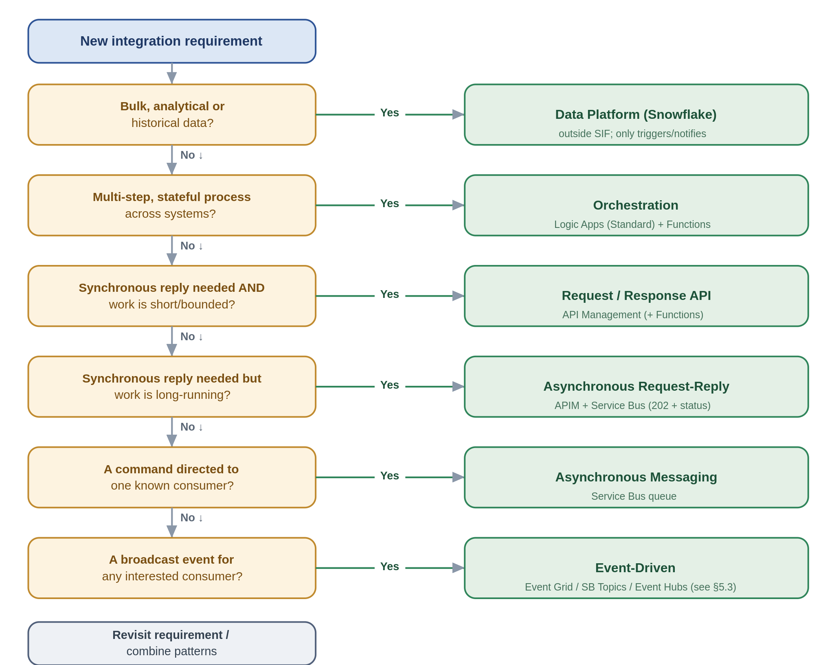

8. Enterprise Pattern Catalogue

8.1 Enterprise Pattern Index and Boundary Applicability
The Systems Integration Framework defines a single enterprise pattern catalogue that applies across internal Chaucer integrations and Chaucer-to-third-party integrations. Patterns are intentionally classified by integration boundary to ensure that delivery teams and suppliers understand where each pattern is appropriate and what additional controls are required.
Internal integrations may use approved API, messaging, event, workflow, and file exchange patterns within Chaucer’s controlled Azure integration platform. Third-party integrations must use approved ingress and egress patterns, with stronger controls for API exposure, identity, network boundary, payload validation, monitoring, support ownership, and data protection.
The data platform, including Snowflake, is included as a controlled exchange boundary but is not the default mechanism for operational integration, transient messaging, or real-time process orchestration. Data platform integration should be used where the objective is analytical ingestion, reporting or controlled data exchange.

Pattern Catalogue with Boundary Applicability
Pattern ID | Pattern | Primary Boundary | Internal | 3rd Party to Chaucer | Chaucer to 3rd Party | SIF to Data Platform | Primary Technology | Usage Approval
SIF-P01 | Internal REST API | Internal | ✅ | ❌ | ❌ | ⚠️ | Azure API Management + backend API / Logic App / Function | Standard
SIF-P02 | External API Ingress | Third party to Chaucer | ⚠️ | ✅ | ❌ | ❌ | Azure API Management | Standard
SIF-P03 | External API Egress | Chaucer to third party | ⚠️ | ❌ | ✅ | ⚠️ | Azure API Management / Logic Apps / Functions | Standard
SIF-P04 | API Facade / API Mediation | Internal and external | ✅ | ✅ | ✅ | ⚠️ | Azure API Management + Logic App / Function | Standard
SIF-P05 | Reliable Queue Messaging | Primarily internal | ✅ | ⚠️ | ⚠️ | ⚠️ | Azure Service Bus Queue | Standard internally; controlled externally
SIF-P06 | Publish / Subscribe Messaging | Primarily internal | ✅ | ⚠️ | ⚠️ | ⚠️ | Azure Service Bus Topic | Standard internally; external by exception
SIF-P07 | Event Notification | Internal and external | ✅ | ✅ | ✅ | ✅ | Event Grid / Webhook / Logic App Trigger | Standard
SIF-P08 | High-Volume Event Streaming | Internal / analytics / selected external | ✅ | ⚠️ | ⚠️ | ✅ | Azure Event Hubs | Conditional
SIF-P09 | Workflow Orchestration | Internal and external | ✅ | ✅ | ✅ | ⚠️ | Azure Logic Apps | Standard
SIF-P10 | Long-Running Workflow | Internal and external | ✅ | ✅ | ✅ | ⚠️ | Azure Logic Apps Standard | Standard
SIF-P11 | Third-Party Webhook Ingress | Third party to Chaucer | ⚠️ | ✅ | ❌ | ⚠️ | APIM + Logic App / Function | Standard for SaaS/vendor callback scenarios
SIF-P12 | Managed File Exchange | Internal and external | ✅ | ✅ | ✅ | ✅ | Logic Apps / Storage / SFTP / Service Bus where required | Conditional
SIF-P13 | Data Platform Exchange | SIF to Snowflake / Snowflake to SIF | ⚠️ | ✅ | ✅ | ✅ | ADF / Blob or ADLS / Snowpipe / COPY INTO / controlled APIs | Conditional; not default operational integration
SIF-P14 | Custom Code Extension | Internal and external | ✅ | ✅ | ✅ | ⚠️ | Azure Functions | Standard with constraints

✅ | Pattern is applicable and normally acceptable for this boundary.
⚠️ | Pattern may be applicable, but requires additional design rationale, controls, or governance review.
❌ | Pattern is not normally appropriate for this boundary.

Note: Any pattern implementation for a specific scenario which necessitates the use of technologies not mentioned above requires approval.

Pattern Grouping by Integration Boundary

Internal Chaucer Integration Patterns
Pattern ID | Pattern | Typical Use
SIF-P01 | Internal REST API | Internal application-to-application request/response integration.
SIF-P04 | API Facade / Mediation | Shielding consumers from backend complexity or legacy constraints.
SIF-P05 | Reliable Queue Messaging | Decoupled internal processing with retry and dead-letter handling.
SIF-P06 | Publish / Subscribe Messaging | Internal business event transfer to one or to multiple consumers.
SIF-P07 | Event Notification | Lightweight internal notification that something has happened.
SIF-P09 | Workflow Orchestration | Multi-step integration across Chaucer-owned systems.
SIF-P10 | Long-Running Workflow | Stateful processes, callbacks, retry cycles, or human/system delays.
SIF-P12 | Managed File Exchange | Controlled file movement between Chaucer systems.
SIF-P14 | Custom Code Extension | Small transformation, validation, enrichment, or protocol adaptation.

Third Party to Chaucer Inbound Patterns
Pattern ID | Pattern | Typical Use | Additional Controls
SIF-P02 | External API Ingress | Supplier, SaaS, broker, or vendor calls a Chaucer API. | APIM, OAuth/OIDC or approved auth model, throttling, usage quota, validation, logging.
SIF-P04 | API Facade / Mediation | Chaucer exposes stable contract while shielding internal systems. | Contract ownership, versioning, backend isolation.
SIF-P07 | Event Notification | Third party notifies Chaucer that an event has occurred. | Schema validation, replay controls, monitoring.
SIF-P11 | Third-Party Webhook Ingress | SaaS callback or vendor event pushed to Chaucer. | Signature validation, replay protection, APIM mediation.
SIF-P12 | Managed File Exchange | Supplier, broker, or vendor sends files to Chaucer. | Malware scanning, encryption, metadata capture, reconciliation.
SIF-P13 | Data Platform Exchange | External data is provided for analytical ingestion. | Data ownership, lineage, classification, ingestion controls.

Chaucer to Third Party Outbound Patterns
Pattern ID | Pattern | Typical Use | Additional Controls
SIF-P03 | External API Egress | Chaucer calls supplier, SaaS, market, or vendor APIs. | Credential management, timeout, retry with exponential fall back, throttling, error mapping.
SIF-P04 | API Facade / Mediation | Chaucer standardises access to third-party APIs for internal consumers. | Abstraction, versioning, supplier contract management.
SIF-P07 | Event Notification | Chaucer notifies an external party of a process or status event. | Contracted endpoint, failure handling, audit trail.
SIF-P09 | Workflow Orchestration | Chaucer coordinates multi-step third-party process. | Operational ownership, compensating action, monitoring.
SIF-P10 | Long-Running Workflow | Supplier interaction requires polling, callbacks, or delayed response. | State management, timeout, escalation, retry policy.
SIF-P12 | Managed File Exchange | Chaucer sends files to supplier, broker, or vendor. | Encryption, confirmation handling, reconciliation, support model.
SIF-P14 | Custom Code Extension | Adapter logic for supplier-specific payload, protocol, or transformation. | Code review, testing, version control, CI/CD.

SIF to Data Platform / Snowflake Exchange Patterns
Pattern ID | Pattern | Typical Use | Guardrail
SIF-P07 | Event Notification | Notify data platform that data is available for ingestion. | Notification only; not operational process orchestration.
SIF-P08 | High-Volume Event Streaming | Stream high-volume events or telemetry for analytical use. | Use only where event-streaming requirements are proven.
SIF-P12 | Managed File Exchange | Land files for analytical ingestion. | Must include ownership, metadata, retention, and monitoring.
SIF-P13 | Data Platform Exchange | Controlled exchange between SIF and Snowflake. | Data platform must not be the default operational integration mechanism.
SIF-P14 | Custom Code Extension | Lightweight extraction, validation, or formatting helper. | Avoid embedding business process orchestration in code.

8.2 Detailed Practitioner Patterns
The following patterns retain the detailed problem, solution, use, avoid, risks, security boundary, anti-pattern and Chaucer example format from the expert draft.
The catalogue is organised by interaction style, request/response, asynchronous messaging, event-driven, orchestration, file-based exchange, and data-platform exchange. That is a considered choice. It mirrors the very first decision a developer makes. it lines up one-to-one with the decision tree, and each style maps cleanly onto a primary Azure service, file-based being the one that spans a few, because a file is a transport rather than a service.
Each pattern is written the same way, so you can read any of them quickly. A one-line statement of what it is for, a diagram, the problem and the solution in plain terms, when to use and avoid it, the risks worth planning for, the anti-pattern to steer around, and a Chaucer-flavoured example. The diagrams share a visual language, blue is the gateway, purple is orchestration, teal is Service Bus, green is Event Grid, orange is Event Hubs, amber is Functions, and a cylinder is a store.

5.1 Request / response, synchronous APIs
Synchronous request/response is the right tool when a caller needs an answer before it can continue. Everything here goes through API Management, the differences are in what sits behind it and how much work it does.

5.1.1 Managed API façade
Put every exposed capability behind the shared gateway, so consumers never bind to a backend directly.
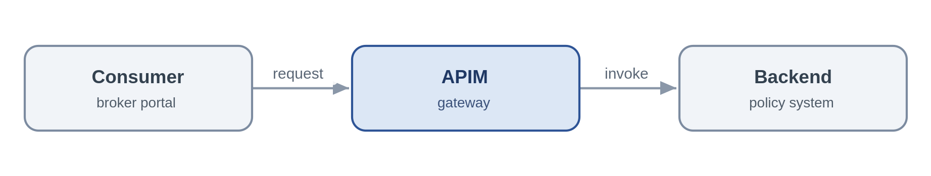
Problem. A consumer needs an immediate answer from a system of record. Letting it call that system directly couples the two together, scatters authentication and throttling across the estate, and makes the backend impossible to version or move, the tactical, point-to-point coupling this framework exists to remove.
Solution. Expose the capability as a coarse-grained REST/JSON operation on API Management. APIM authenticates the caller with an Entra token, applies a rate limit and a product subscription, and forwards to the backend over a Private Endpoint using a managed identity. The consumer knows only the contract, so the backend can be re-platformed behind a stable façade. Where the capability must be reachable from the internet, APIM sits behind Front Door with a WAF and DDoS, it is never public itself.
Azure components
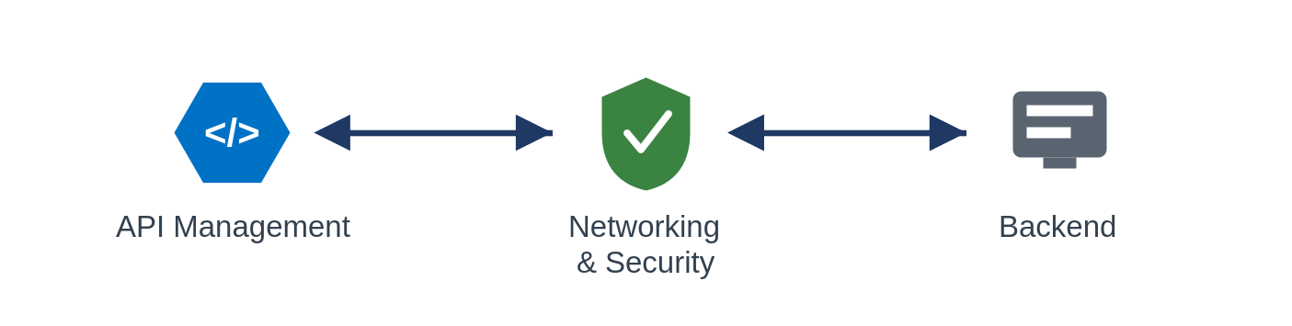
Use it when the caller needs a synchronous answer to a query or short command and you want one governed, reusable front door to a capability.
Avoid it when the work is long-running or unpredictable (orchestrate it), or the interaction is really fire-and-forget (use messaging).
Risks & considerations. APIM is a shared chokepoint, so its availability is everyone's availability, run it zone-redundant, and multi-region for Tier 0, and treat its capacity and policy changes as mission-critical. The façade adds a hop and a few milliseconds; keep policies lean and cache idempotent reads. And the gateway does not absolve the backend of protecting itself, it still needs its own throttling behind the facade.
Security boundary. Landing zone: APIM sits in the shared subscription (non-public), the backend in its workload spoke. For internal consumers the whole flow is private and crosses no internet boundary. Within Azure: consumer-to-APIM and APIM-to-backend both over Private Endpoints, APIM authenticates to the backend with a managed identity, TLS on every hop. Outside Azure: only where the API must be public, then it is fronted from the online subscription by Front Door + WAF + DDoS with OAuth or mTLS at the edge, as a registered exception, APIM is never exposed directly.
Anti-pattern. A pass-through proxy that adds no policy, security or versioning, or, worse, business logic buried in gateway policies.
In practice. The underwriting system exposes get-policy-summary through APIM, the broker portal calls the API and has no knowledge of the policy admin system behind it.

5.1.2 API composition / aggregation
Assemble one coarse-grained business response from a few backend reads, so the consumer makes a single call.
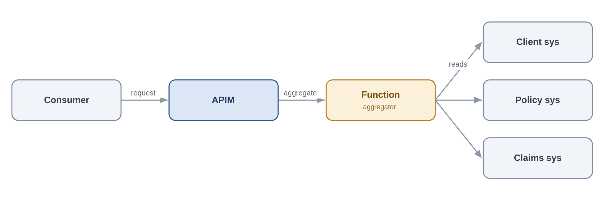
Problem. A servicing screen needs a "client 360" view whose data lives across three systems. Making the consumer call all three couples it to three contracts and three failure modes; doing the joins in the browser is worse.
Solution. Expose a single composed API on APIM backed by a Function that fans out to the underlying systems, assembles a coarse-grained response and returns it. The composition stays read-mostly and business-shaped, SOA granularity, not a chatty mesh of fine-grained calls.
Azure components
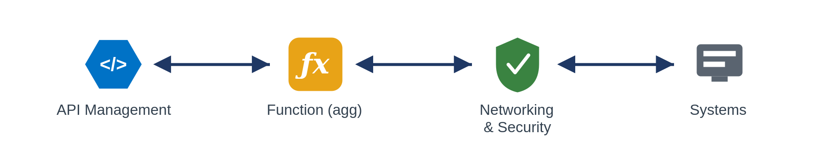
Use it when a consumer needs one logical business object drawn from two or three sources and a single round-trip materially simplifies the caller.
Avoid it when the composition needs transactional writes or long-running steps (orchestrate), or you find yourself fanning out to many fine-grained services, that is a granularity problem to fix, not to aggregate around.
Risks & considerations. Response time is governed by the slowest dependency and availability by their product, so decide up front how the API behaves when one source is down, a partial response with a clear indicator usually beats failing the whole call. Put a timeout and a circuit breaker around each backend, and cache what you safely can.
Security boundary. Landing zone: APIM (shared subscription) and the aggregator Function (workload spoke); the source systems in their spokes. Fully internal. Within Azure: the Function reaches each source over a Private Endpoint with a managed identity, no secrets in configuration (Key Vault references only), TLS throughout. Outside Azure: none.
Anti-pattern. Fine-grained, chatty aggregation that recreates a distributed monolith; pushing heavy composition into APIM policies instead of a Function.
In practice. A client-servicing screen calls one “client 360”API, the aggregator Function reads client, policy and claims summaries and returns a single object.

5.1.3 Protocol / format mediation
Translate a legacy protocol to REST/JSON at the edge so modern consumers stay clean.
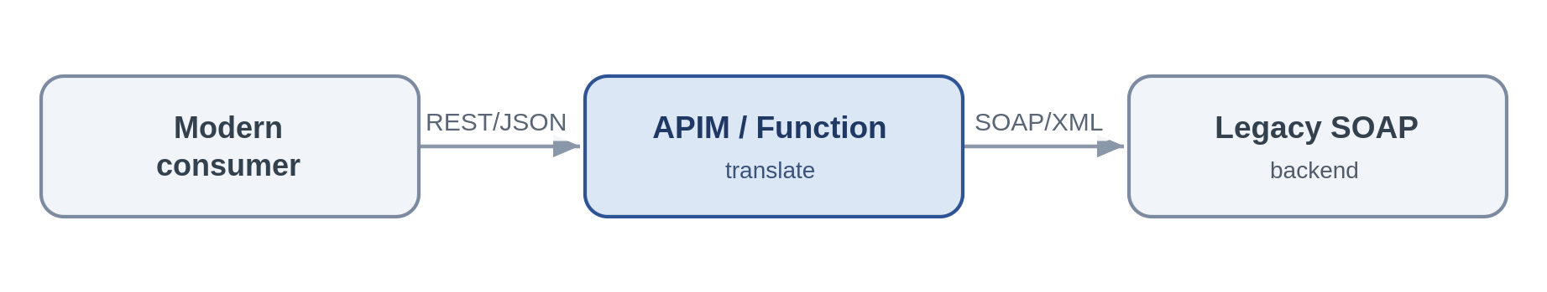
Problem. A cloud-native consumer must talk to a system that only speaks SOAP/XML or a fixed-width format. Letting that leak into the consumer spreads legacy concerns across the estate.
Solution. Terminate the modern REST/JSON contract at APIM for light transforms, or a Function for heavier ones, and translate to the backend's protocol. Consumers see only REST/JSON; the legacy quirks are contained in one place.
Azure components
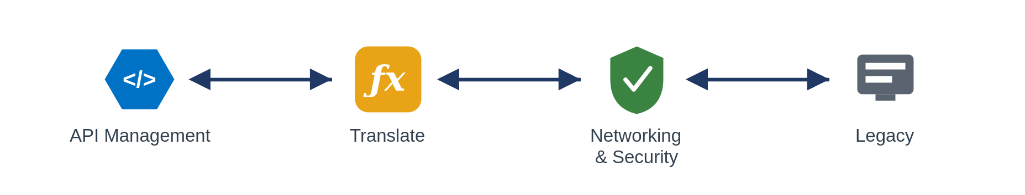
Use it when you are standardising the estate on REST/JSON and need to front a legacy protocol.
Avoid it when the requirement is really business transformation rather than protocol translation, that is implementation logic and belongs in a Function with tests, not in a mediation policy.
Risks & considerations. Keep the translation stateless and mechanical, the moment business rules creep in you have hidden, untested logic sitting in the edge. Validate schemas on the way through so malformed legacy payloads fail fast rather than propagating.
Security boundary. Landing zone: APIM or the mediation Function in the shared subscription / a spoke; the legacy backend in its spoke or on-premises. Within Azure: Private Endpoint, managed identity and TLS; an on-premises backend is reached over the private vWAN path, not the internet. Outside Azure: none, an internet-only legacy partner uses the inbound-webhook edge instead.
Anti-pattern. Business rules embedded in the translation layer, unbounded transformation inside APIM policies.
In practice. A legacy SOAP reinsurance service is fronted as a REST/JSON API for cloud-native consumers.

5.1.4 Synchronous request-reply (bounded)
The considered synchronous exception, a short, bounded call where the caller needs the answer now.
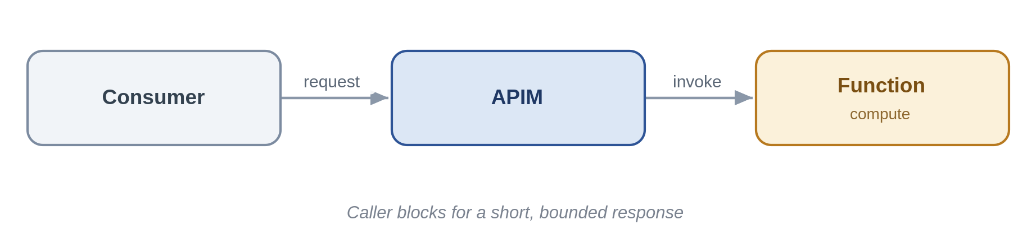
Problem. Some interactions really are synchronous: a quote figure the user is waiting on. The danger is that “synchronous” quietly becomes “long-running”, and callers start timing out and retrying.
Solution. Expose the operation on APIM to a Function that completes in sub-second-to-low-second time, with a hard timeout. If the work cannot reliably finish that quickly, it is not this pattern, move to asynchronous request-reply or orchestration.
Azure components
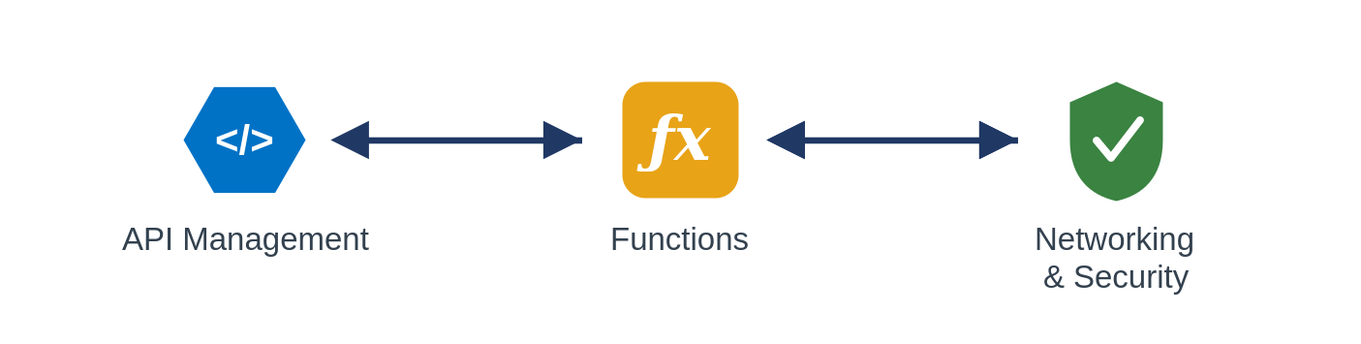
Use it when the work is short and bounded and the caller must have the result to proceed. Avoid it when the duration is unpredictable or can run long, the classic cause of retry storms.
Risks & considerations. Enforce timeouts and make the operation idempotent so a client retry cannot double-apply. Treat a creeping p99 latency as an early signal that this should become asynchronous.
Security boundary. Landing zone: APIM (shared) and Function (spoke), fully internal. Within Azure: Private Endpoint, managed identity, TLS, with enforced timeouts. Outside Azure: none.
Anti-pattern. Long-running or unbounded work behind a synchronous endpoint.
In practice. A real-time premium calculation returns a figure within a second.

5.2 Asynchronous messaging
When the caller does not need to wait, messaging decouples systems in time and turns spikes and outages into manageable backlogs rather than cascading failures. Service Bus is the backbone here.

5.2.1 Queue-based load levelling
Put a queue between a spiky producer and a limited backend so load is absorbed, not amplified.
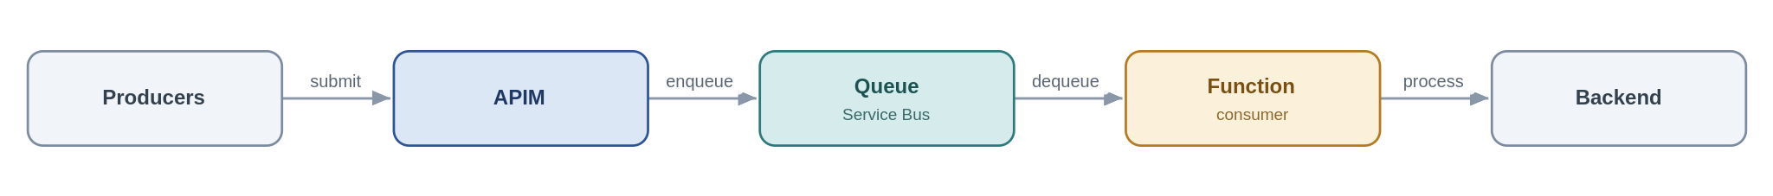
Problem. At renewal season broker submissions arrive far faster than the policy admin system can process them. Calling it synchronously either overwhelms it or fails the callers.
Solution. Accept the work at APIM, drop it on a Service Bus queue, and let a Function consumer process at the rate the backend can sustain. Producer and consumer are now decoupled in time, so a backend outage becomes a growing queue rather than a wave of errors.
Azure components
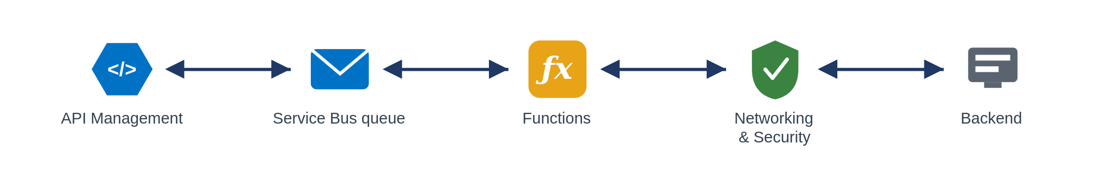
Use it when the producer is spikier or faster than the consumer, or the backend's availability must be decoupled from producer load.
Avoid it when the caller needs an immediate answer (request/response), or you are ingesting a high-volume telemetry firehose (Event Hubs).
Risks & considerations. A queue is a buffer, not infinite capacity, under sustained overload the backlog grows, so monitor queue depth and consumer lag and alert on them. Handle poison messages with a dead-letter queue and a max-delivery count, and make the consumer idempotent, because delivery is at-least-once. Global ordering is lost unless you use sessions.
Security boundary. Landing zone: APIM (shared), Service Bus and the consumer Function (spokes), internal. Within Azure: producers and consumer reach Service Bus over a Private Endpoint using a managed identity with Sender/Receiver RBAC (no SAS keys), TLS throughout. Outside Azure: none, an external producer is taken through the edge first.
Anti-pattern. Hammering a fragile backend synchronously; ignoring the dead-letter queue; reaching for storage queues where you need sessions, DLQ and richer delivery semantics.
In practice. Renewal submissions are buffered on Service Bus so the policy admin system drains them at a steady rate.

5.2.2 Competing consumers
Scale out throughput by letting several workers pull from one queue.
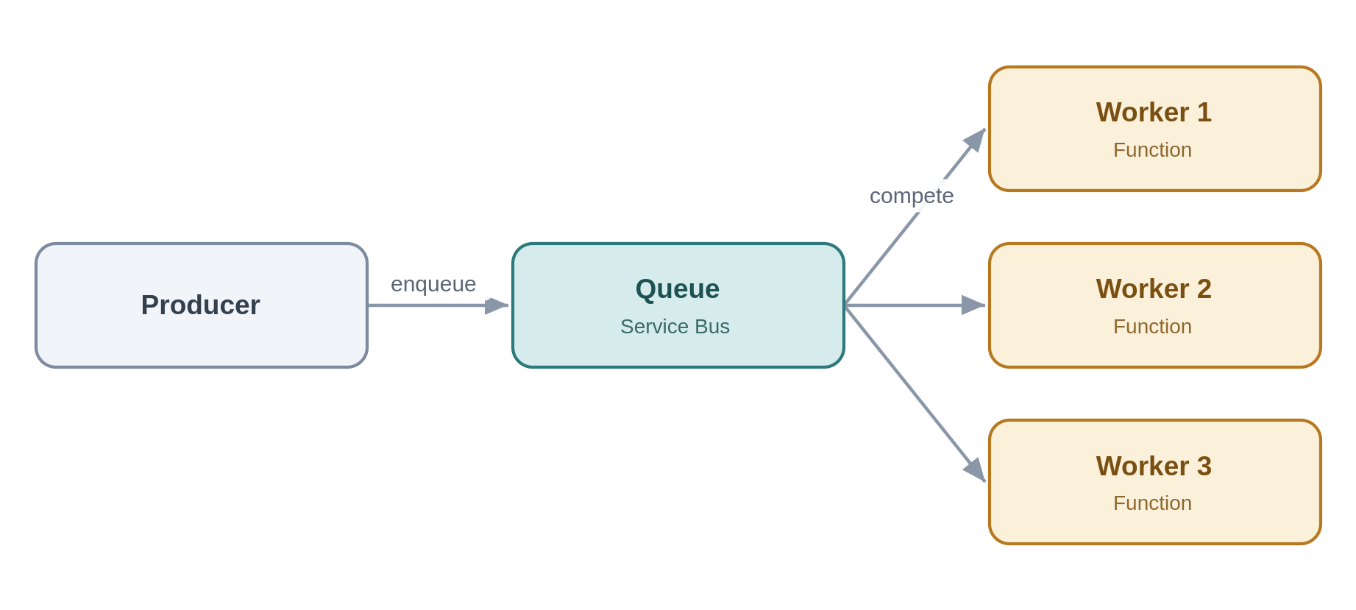
Problem. One consumer cannot keep up and work is piling up but the items are independent of each other.
Solution. Run multiple consumer instances against the same queue. Service Bus hands each message to exactly one worker and the pool scales with load, for per-entity ordering, sessions pin related messages to one consumer.
Azure components
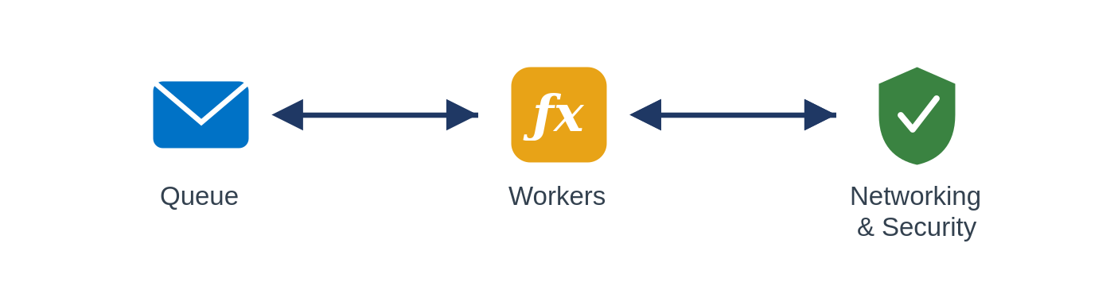
Use it when throughput exceeds a single consumer and the work items are independent and parallelisable. Avoid it when you need strict global ordering without sessions, or workers must share mutable state.
Risks & considerations. Duplicate delivery still happens, so idempotency remains mandatory. Watch for hot sessions that serialise work and cap your scale-out, and autoscale on queue depth rather than CPU.
Security boundary. Landing zone: Service Bus and the Function pool in spokes, internal. Within Azure: Private Endpoint, managed identity with least-privilege RBAC, TLS. Outside Azure: none.
Anti-pattern. Assuming ordering without sessions; sharing mutable state between workers.
In practice. A backlog of document-processing jobs is cleared by an autoscaling pool of Function workers.

5.2.3 Asynchronous request-reply
Accept now, answer later, a 202 and a status endpoint instead of a held-open connection.
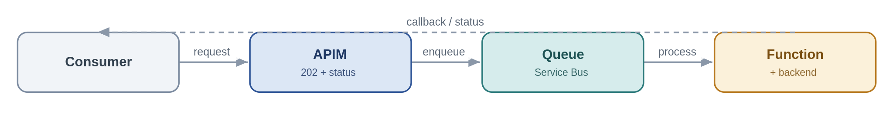
Problem. A caller wants a result from an operation that takes too long to hold a synchronous HTTP connection open for.
Solution. APIM accepts the request, returns 202 with a status URL and a correlation id, and drops the work on a queue. A Function processes it and updates a status store or calls back; the caller polls the status endpoint or receives the callback.
Azure components
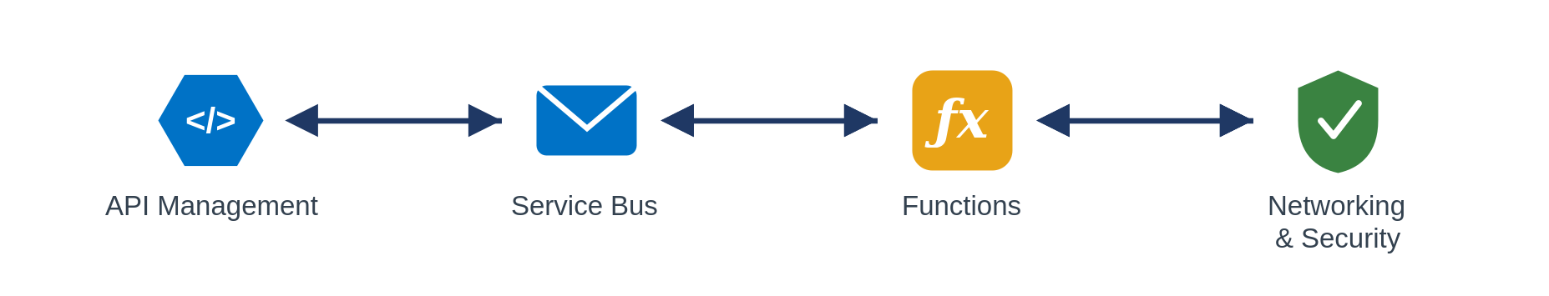
Use it when the operation is too long for a synchronous reply but the caller still needs the eventual result. Avoid it when the result is instant (keep it synchronous) or there is no way to correlate request and reply.
Risks & considerations. The client contract is now two-phase, document the 202/polling behaviour clearly. Keep a durable status store and expire abandoned requests so they do not accumulate, and carry the correlation id end-to-end or you lose traceability.
Security boundary. Landing zone: APIM (shared), Service Bus and Function (spokes), internal. Within Azure: Private Endpoints, managed identity, TLS. The correlation id carries no secret material. Outside Azure: none unless the caller is external, in which case the request and status endpoints are exposed through the edge (Front Door + WAF + APIM, OAuth).
Anti-pattern. Holding a synchronous connection open for minutes, omitting a correlation id.
In practice. A bulk quote request returns 202 and a status URL.The completed result is available when processing finishes.

5.2.4 Claim-check
Keep large payloads off the bus, pass a reference, store the body in Blob.
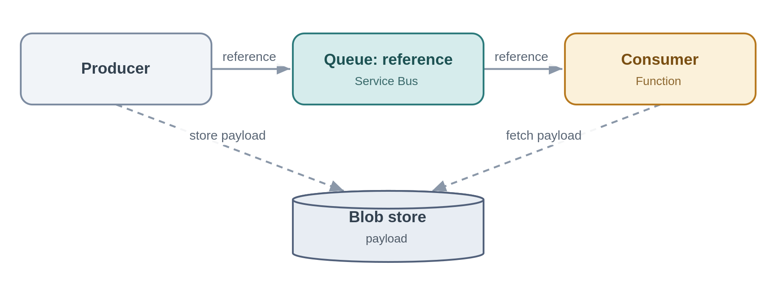
Problem. A message-based flow needs to carry a large document, but the bus has size limits and large messages are slow and expensive.
Solution. The producer writes the payload to Blob storage and puts only a reference on the queue; the consumer reads the reference and fetches the body from Blob. The messaging layer stays lean.
Azure components
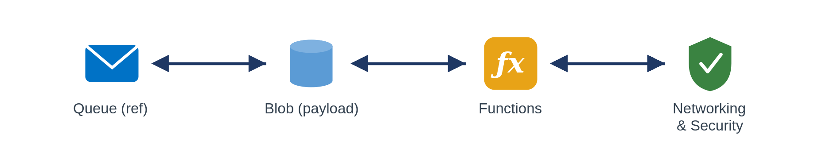
Use it when payloads approach or exceed message-size limits within an otherwise message-based flow. Avoid it when payloads are small enough to carry inline, or the data is really a bulk data-platform concern.
Risks & considerations. Reference and payload now have independent lifetimes, a lifecycle policy must purge transient blobs or you leak cost, and the reference is useless if the blob has gone. Reach Blob over a Private Endpoint with RBAC, no account keys, no public SAS.
Security boundary. Landing zone: Service Bus, Blob and Function in spokes, the storage account is firewalled with public access disabled. Within Azure: Blob is reached over a Private Endpoint with managed-identity RBAC, no account keys, no public SAS, and TLS. Outside Azure: none, the payload never leaves the private boundary.
Anti-pattern. Large binaries on the bus; public or long-lived SAS URLs to the payload.
In practice. A large bordereaux file is staged in Blob and only its reference flows through the pipeline.

5.2.5 Reliable messaging
For business-critical messages: never lost, and effectively processed once.
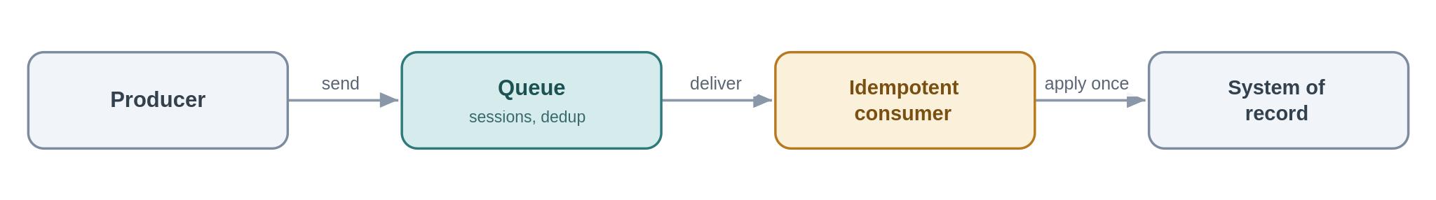
Problem. A financial posting must not be lost, and must never be applied twice, even if the broker retries or the platform redelivers.
Solution. Use Service Bus with duplicate detection and, where order matters, sessions; make the consumer idempotent so redelivery is safe and where the event must be published in step with a local state change, use a transactional outbox. “Exactly once” is not something the transport gives you, you engineer it from at-least-once delivery plus idempotency.
Azure components
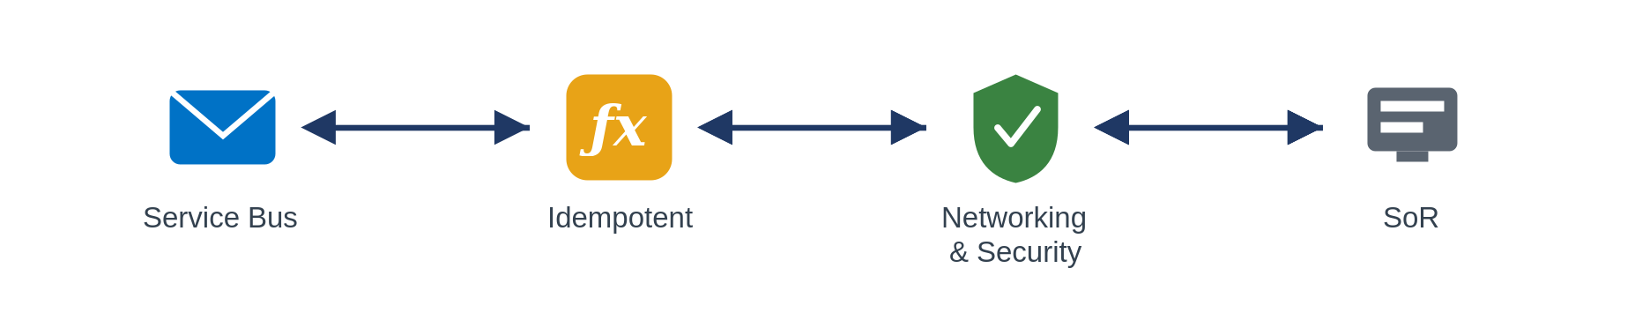
Use it when message loss or double-processing has real financial or data-integrity impact.
Avoid it when the notification is best-effort and replaceable, use Event Grid.
Risks & considerations. Duplicate-detection windows are finite, so design the idempotency key to outlive them. Premium throughput costs money, size it to the criticality tier, not to the peak of peaks.
Security boundary. Landing zone: Service Bus and consumer in spokes, internal. Within Azure: Private Endpoint, managed identity, TLS, idempotency keys carry no secrets. Outside Azure: none.
Anti-pattern. Assuming exactly-once delivery, non-idempotent consumers that double-apply effects.
In practice. A finance-posting message carries an idempotency key, so a redelivery is recognised and ignored.

5.2.6 Scheduled / timed trigger
Kick off integration work on a clock when there is no event to react to.
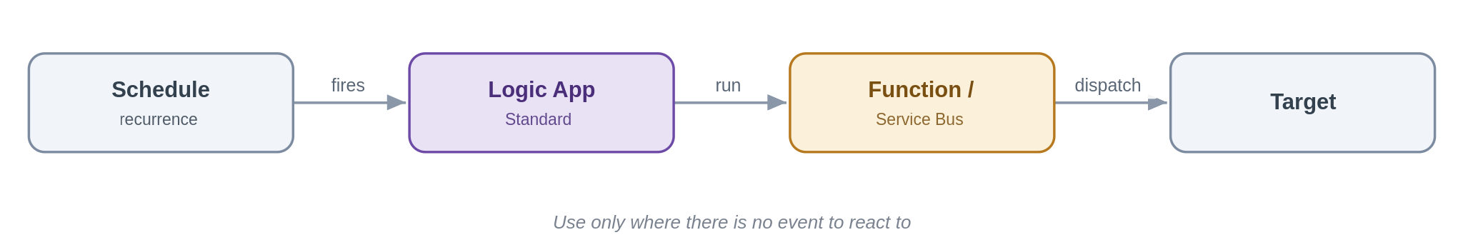
Problem. Some work is inherently periodic, an end-of-day reconciliation, a scheduled extract for a partner, a nightly sweep of a source that cannot emit events. Event-driven is the default in this framework, but forcing an event where none exists is its own contortion.
Solution. A Logic App (Standard) Recurrence trigger fires on a schedule and runs the work, calling a Function or dropping messages on Service Bus for downstream processing. It is the considered, bounded exception to asynchronous-first: a clock, not a poll of a data source pretending to be real-time.
Azure components
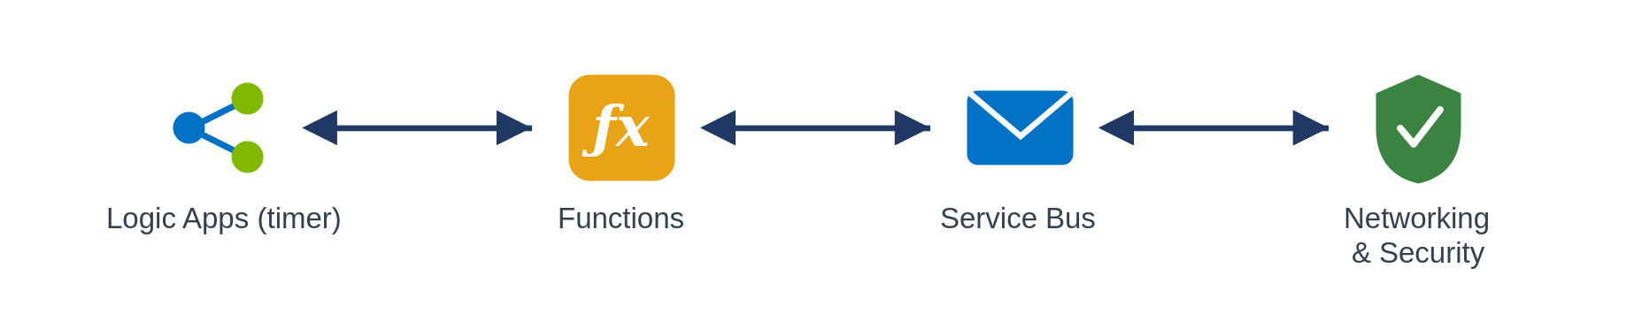
Use it when the cadence is time-based (end-of-day, regulatory windows) or the source cannot notify and there is no event to subscribe to.
Avoid it when an event exists to react to, use it (5.3.x), or you are timer-polling a folder or table to fake real-time, which is an anti-pattern, not this pattern.
Risks & considerations. Schedules drift into hidden coupling and surprise load spikes, document the cadence, stagger jobs, and make each run idempotent and safe to re-run after a missed or overlapping execution. Alert on missed runs; a silent scheduler is worse than a failed call.
Security boundary. Landing zone: the Logic App runs in a workload spoke; the schedule is internal and crosses no boundary. Within Azure: managed identity to any Function/Service Bus it calls, Private Endpoints, TLS. Outside Azure: none, if a scheduled run reaches a partner (an extract), that egress follows the file-egress edge controls (5.5.2).
Anti-pattern. Timer-polling a data source or folder to simulate real-time; overlapping runs with no idempotency; schedules scattered across teams with no visibility.
In practice. An end-of-day reconciliation between the policy system and finance runs on a Logic App recurrence and dispatches the day's deltas onto Service Bus.

5.3 Event-driven, events, webhooks and streaming
Event-driven integration is the strongest lever for removing point-to-point coupling: a producer announces that something happened and interested parties react, without the producer knowing who they are. The three services behind this style are not interchangeable, Section 3.2 is the reference for choosing between them.

5.3.1 Publish / subscribe fan-out
Publish a business event once; let interested consumers subscribe independently.
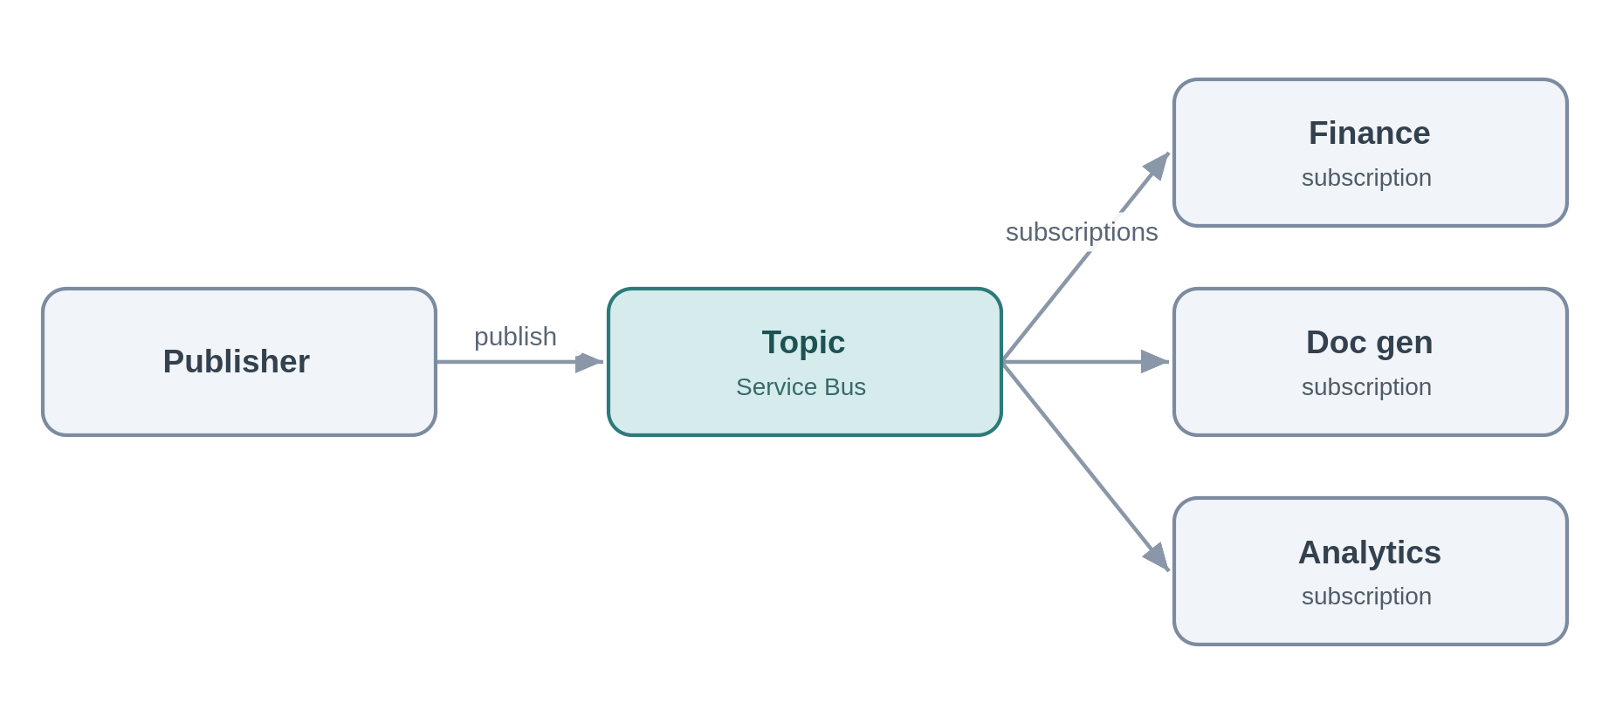
Problem. When a policy is bound, finance, document generation and the analytics offload all need to know. Wiring the publisher to each recreates point-to-point coupling and means changing the publisher every time a consumer is added.
Solution. The publisher emits a “PolicyBound” event to a Service Bus topic, each consumer owns a subscription with its own filter and dead-letter queue. Consumers come and go without the publisher knowing. This is the primary tool for eliminating point-to-point integration.
Azure components
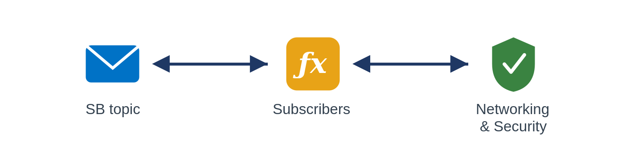
Use it when several consumers must react to the same business event and you want durable, filterable, independently-consumed delivery.
Avoid it when it is a lightweight reactive trigger with no durability need (Event Grid), or a high-volume stream (Event Hubs).
Risks & considerations. Subscriptions proliferate, so govern them and monitor each one's dead-letter queue, a broken filter silently drops messages. A slow subscriber builds its own backlog without affecting the others, which is the point, but it needs its own alerting.
Security boundary. Landing zone: the Service Bus topic and its subscribers in spokes, internal. Within Azure: Private Endpoint, per-subscription managed-identity RBAC, TLS. Outside Azure: none.
Anti-pattern. Hardwiring point-to-point instead of publishing; a publisher that knows its subscribers; using Event Grid where you need durable, ordered, competing-consumer delivery.
In practice. “PolicyBound” is consumed independently by finance, document generation and the analytics offload.

5.3.2 Discrete event notification
A thin "it happened" signal for near-real-time reactions.
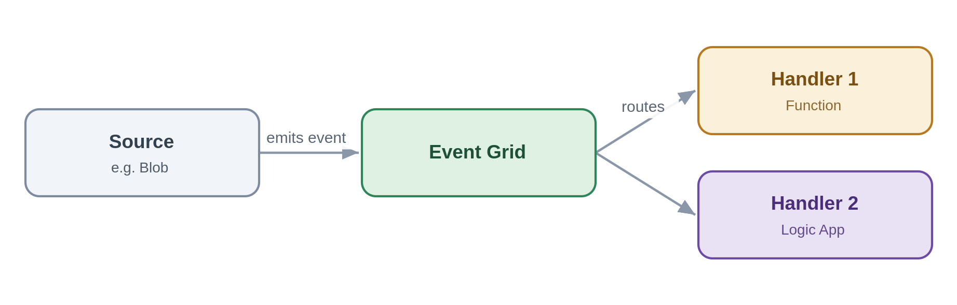
Problem. Something occurred, a file landed, a record changed, and one or two handlers should react quickly. A durable business-messaging topic is heavier than the job needs.
Solution. Emit a thin event to Event Grid, handlers (Functions, Logic Apps, webhooks) subscribe and react. The event is a pointer, not a state carrier, a handler fetches authoritative state if it needs it.
Azure components
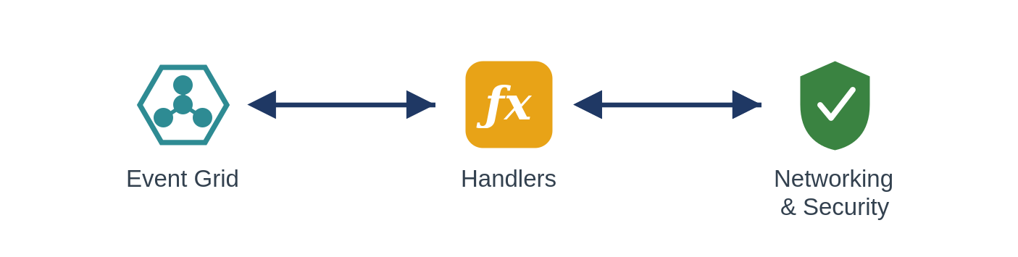
Use it when you want lightweight, low-latency reactive fan-out to Azure-native handlers.
Avoid it when consumers need durable ordered delivery or competing consumers (Service Bus topics), or the volume is a stream (Event Hubs).
Risks & considerations. Delivery is at-least-once and unordered, so handlers must be idempotent and order-independent, and a dead-letter destination must be configured so undeliverable events are not simply lost. Resist fattening the event into a pseudo source-of-truth, it hides coupling and goes stale.
Security boundary. Landing zone: Event Grid and its handlers in spokes, reached privately. Within Azure: managed-identity delivery, Private Endpoint where supported, handler-side validation, TLS. Outside Azure: none, a handler that must be internet-reachable is the inbound-webhook pattern, not this one.
Anti-pattern. Fat events that carry full state consumers come to trust; using Event Grid for streaming or durable business messaging.
In practice. A blob-created event triggers a document-ingestion workflow.

5.3.3 Inbound webhook ingestion
Take partner callbacks safely through the front door, then process them asynchronously.
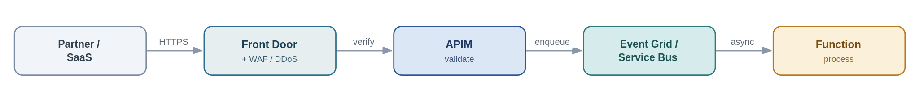
Problem. A partner or SaaS pushes events to Chaucer over HTTPS. Exposing an internal trigger to the internet is exactly the risk the security standards forbid.
Solution. This is the sanctioned public-ingress exception. Traffic enters through Front Door with a WAF and DDoS, terminates at APIM as the single ingress point, is authenticated (mTLS, OAuth, or a signed-payload check) and validated, then dropped onto Service Bus or Event Grid for asynchronous processing. No Function or Logic App HTTP trigger is ever exposed directly.
Azure components
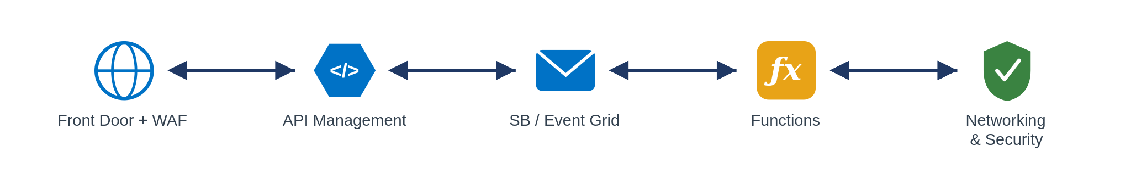
Use it when an external party must push events to us and private networking is not possible.
Avoid it when the integration can use private networking, prefer that every time.
Risks & considerations. You are internet-facing now, so assume replay and forgery: validate signatures, enforce rate limits, and deduplicate, because providers retry. Acknowledge fast and process asynchronously so a slow backend cannot be used to hold connections open. Record the exception with an owner and an expiry.
Security boundary. Landing zone: this is the one pattern that crosses the internet boundary, and it does so only in the online subscription. Front Door + WAF + DDoS terminate the public endpoint, APIM (shared subscription) is the single ingress, and processing happens back in the private spokes. Within Azure: past the edge everything is private, Service Bus/Event Grid and Functions over Private Endpoints with managed identity and TLS. Outside Azure: mTLS, OAuth or signed-payload validation, IP allow-listing and rate-limiting at the edge, no Function or Logic App trigger is ever exposed; the exposure is a registered, time-boxed exception.
Anti-pattern. Exposing a Logic App or Function HTTP trigger straight to the internet, bypassing APIM and the WAF; processing synchronously in the handler.
In practice. A payment provider posts settlement webhooks; APIM validates the signature and drops the event on Service Bus.

5.3.4 Outbound webhook / notification
Push events out to subscribers instead of making them poll.
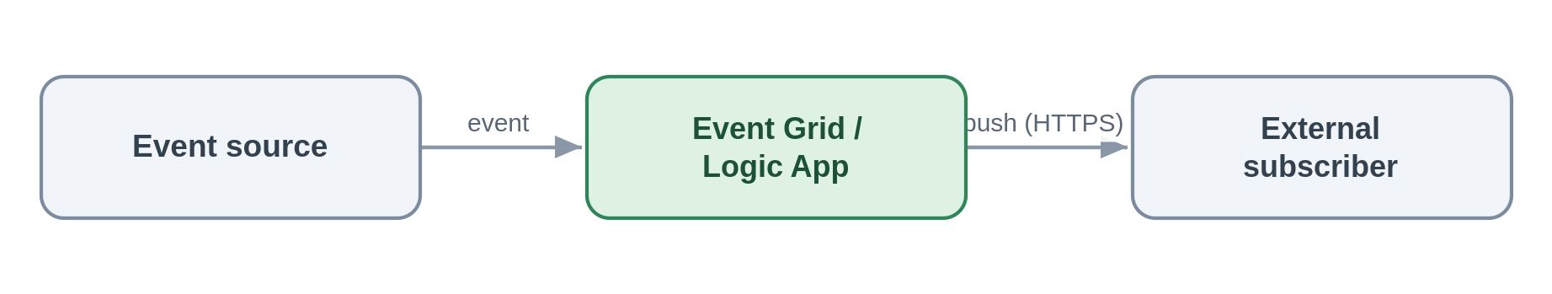
Problem. An external or internal party wants to be told when something changes, rather than polling us for it.
Solution. On the event, dispatch via Event Grid subscriptions or a Logic App connector, webhook, email or Teams. Subscribers are configured, not coded into the publisher.
Azure components
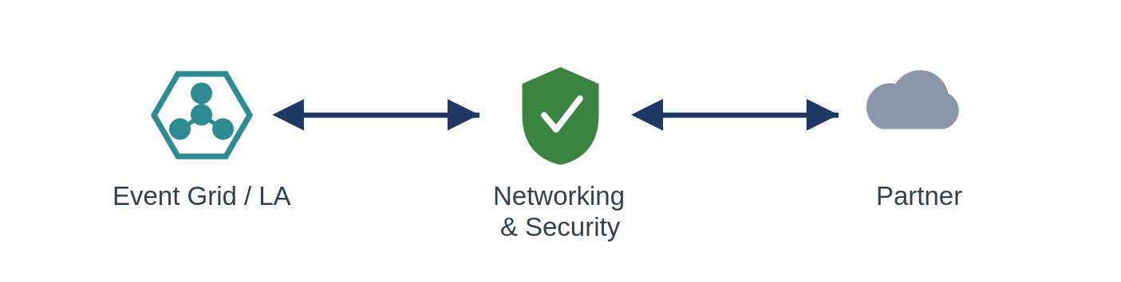
Use it when subscribers expect to be pushed to on an event.
Avoid it when subscribers should really pull current state through an API.
Risks & considerations. A subscriber endpoint being down creates retries and back-pressure, so retry with backoff and dead-letter the undeliverable. Hold partner secrets in Key Vault, sign payloads where supported, and put a circuit breaker around flaky endpoints.
Security boundary. Landing zone: Event Grid or the Logic App in spokes; the egress to an external subscriber leaves through the controlled path, not default internet routing (routing intent enforced). Within Azure: managed identity, partner secrets held in Key Vault and referenced, TLS. Outside Azure: TLS to the subscriber, payload signing where supported, partner endpoints allow-listed, and secrets rotated/revoked through Key Vault.
Anti-pattern. Polling to simulate push; bespoke per-subscriber dispatch code instead of subscriptions.
In practice. The broker's system is notified automatically when a claim status changes.

5.3.5 Stream / telemetry ingestion
Ingest high-volume continuous data and hand it to processors or the data platform.
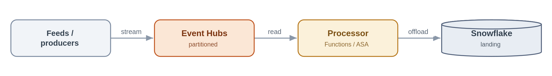
Problem. A high-frequency feed produces far more events than a business-messaging queue is designed for, and it needs partitioned, ordered processing.
Solution. Ingest into Event Hubs, partitioned for throughput; process with Functions or Stream Analytics and typically capture or offload to Snowflake for analytics. Event Hubs is the firehose, Service Bus is not.
Azure components
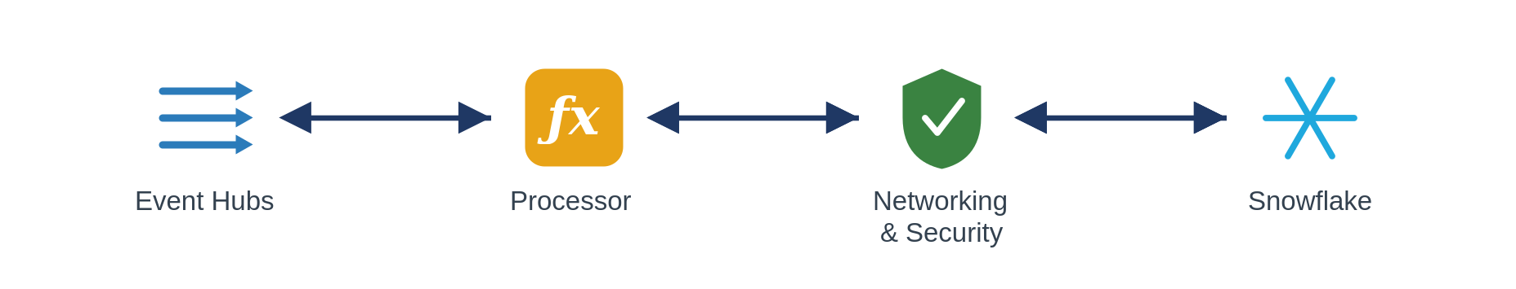
Use it when sustained high event rates need partitioned stream processing.
Avoid it when these are transactional business commands needing per-message dead-lettering and sessions (Service Bus), or low-volume discrete notifications (Event Grid).
Risks & considerations. Partition count is a capacity decision you largely live with, so plan it against throughput and consumer parallelism. Manage checkpoints, monitor consumer lag, and remember ordering holds only within a partition. Premium or Dedicated capacity is a real cost line.
Security boundary. Landing zone: Event Hubs and its processors in spokes; capture to a firewalled storage account. Within Azure: Private Endpoint, managed identity, TLS, with capture storage under RBAC. Outside Azure: an external feed enters through the edge; internal streams cross no boundary.
Anti-pattern. Service Bus for firehose volumes, Event Hubs for transactional commands; synchronous consumers on a stream.
In practice. A high-frequency exposure feed is ingested, processed near-real-time and offloaded to Snowflake.

5.4 Orchestration, stateful process coordination
When a business process spans several systems and needs state, retries and visibility, it is orchestrated centrally in Logic Apps (Standard). One rule governs this whole style and is worth stating on its own before the patterns: the workflow owns control flow, and nothing else. Business logic, computation and transformation live in Functions that the workflow calls. Keeping the two apart is what stops orchestrations turning into unmaintainable monoliths.
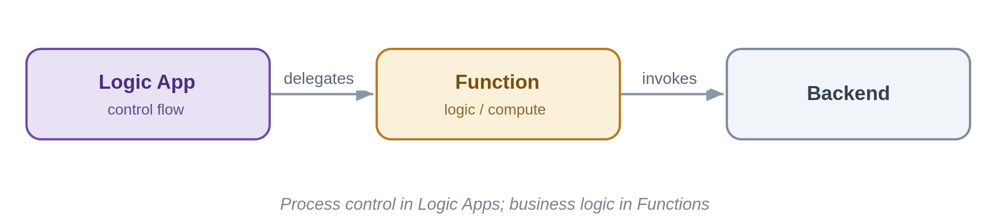

5.4.1 Stateful process orchestration
Coordinate a multi-step, multi-system business process with state, retries and visibility.
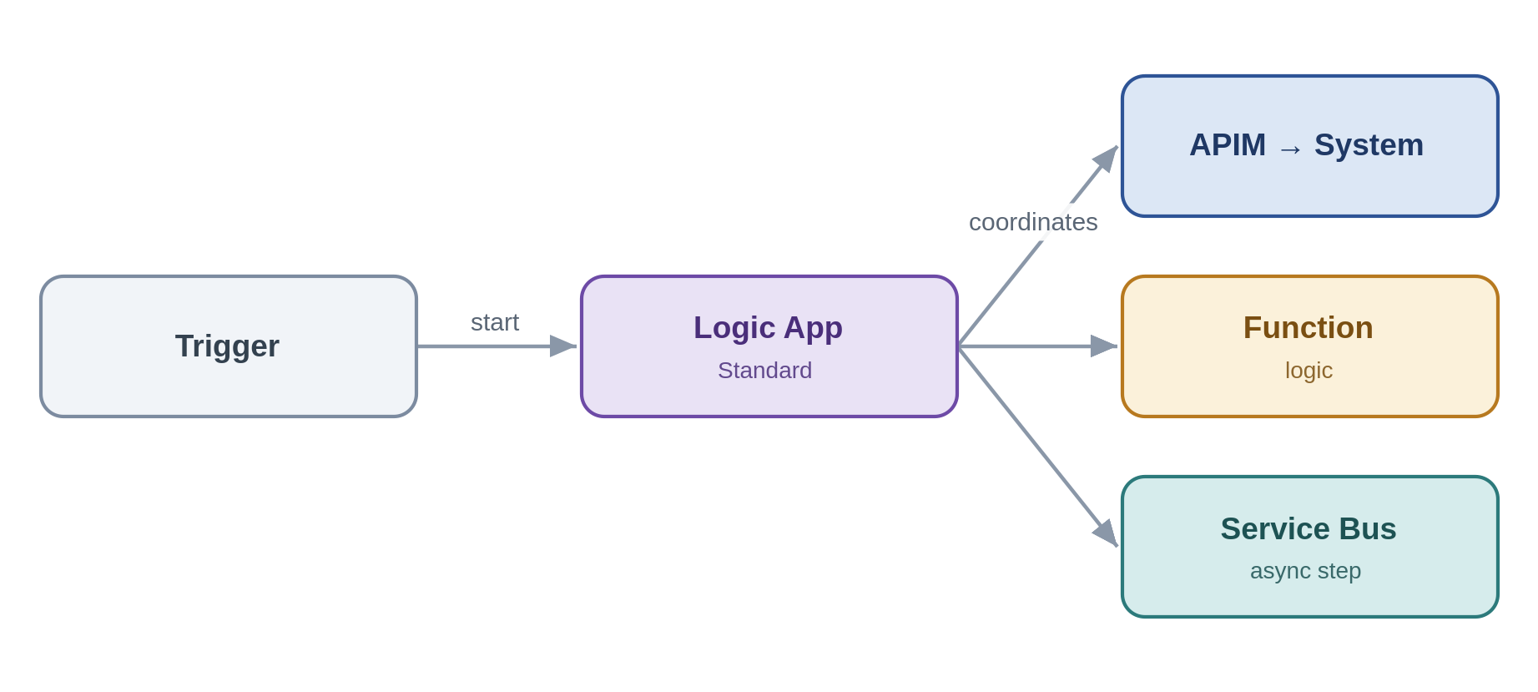
Problem. New-business onboarding spans validation, pricing, document generation, notification and system updates. No single system owns the process, and stitching it together point-to-point makes it invisible and brittle.
Solution. A Logic App (Standard) owns the process: it sequences the steps, calls capabilities through APIM, delegates computation to Functions, and hands asynchronous work to Service Bus. It keeps run state and history, so the process is observable and recoverable, and, per the rule above, it holds control flow only.
Azure components
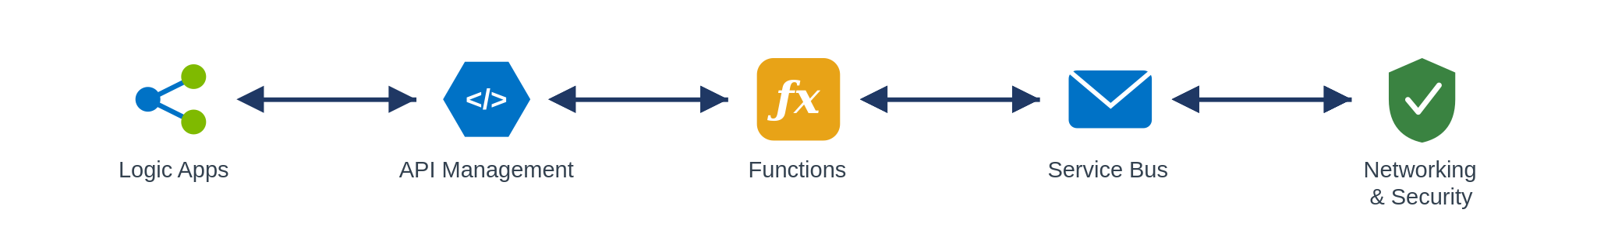
Use it when a business process crosses several systems and steps and needs state, retries and auditability over minutes, hours or days.
Avoid it when a single synchronous call suffices, or it is really just message buffering.
Risks & considerations. Without discipline the workflow accretes business logic and becomes a monolith, keep logic in Functions and the workflow readable. Standard run history is region-bound, so DR is active-passive and in-flight runs do not migrate; design steps to be idempotent and restartable. Connectors have throttling limits, long-running state has a cost, and you need a versioning strategy for changing a workflow while runs are in flight.
Security boundary. Landing zone: the Logic App (Standard) is VNet-integrated in a workload spoke and calls APIM (shared), Functions and Service Bus (spokes), all internal. Within Azure: every connector authenticates with a managed identity (no keys), Key Vault references for any unavoidable secret, Private Endpoints, TLS. Outside Azure: none directly, external calls leave through APIM and the edge, not from the workflow.
Anti-pattern. Business, compute or transformation logic inside the workflow, orchestration smeared across many uncoordinated workflows; microservices-style choreography with no owning process.
In practice. New-business onboarding is coordinated end-to-end by one Logic App calling Functions and systems in turn.

5.4.2 Process with compensation
When a later step fails, undo the earlier ones, orchestrated centrally, not choreographed.
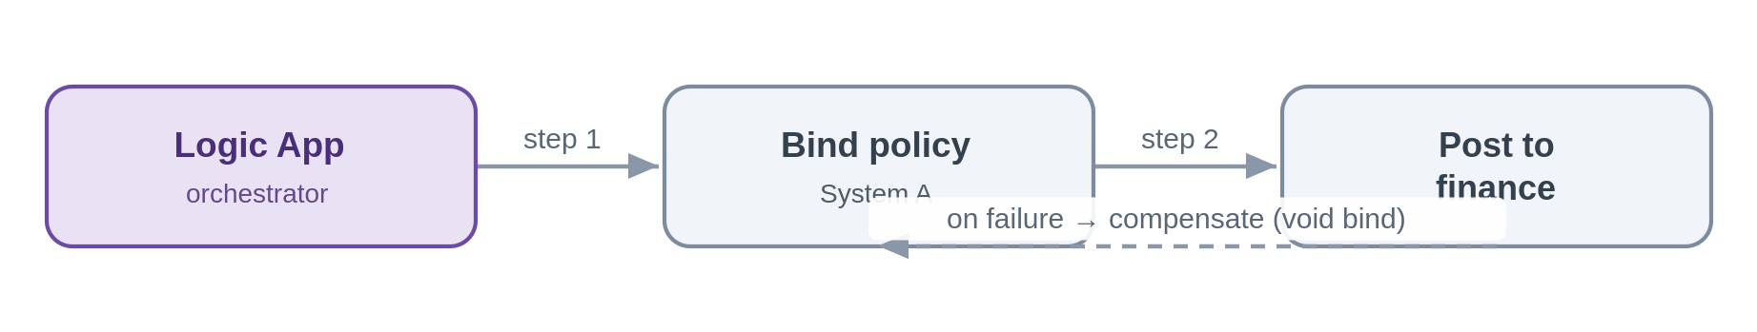
Problem. A policy is bound in one system and then the finance posting fails. There is no distributed transaction across these systems, but the bind must not be left dangling.
Solution. The orchestrator drives compensating actions on failure, here, voiding the bind. Because Chaucer's model is SOA, the process is centrally owned and its compensation logic lives with it, not scattered across services reacting to each other.
Azure components
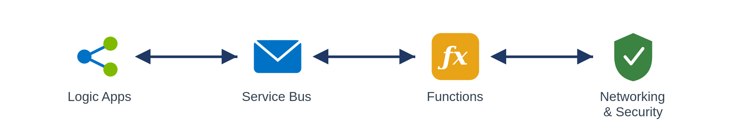
Use it when you need cross-system consistency without distributed transactions and a single process can own the compensation.
Avoid it when an ACID transaction within one system suffices, or someone proposes a microservices-style distributed saga (out of scope here).
Risks & considerations. Compensation is best-effort, not atomic, a compensation can itself fail, so make compensations idempotent and retryable, and use the run history as the saga log. Watch ordering and the possibility of duplicate compensation.
Security boundary. Landing zone: Logic App, Service Bus and Functions in spokes, internal. Within Azure: managed identity, Private Endpoints, TLS, with each step and each compensation audited in run history. Outside Azure: none, cross-system calls are to internal systems over private connectivity.
Anti-pattern. Choreographed sagas with no central owner; relying on two-phase or distributed transactions.
In practice. If the bind succeeds but the finance posting fails, the orchestration compensates by voiding the bind.

5.4.3 Human-in-the-loop / approval
Insert a human decision into an automated process, with audit and escalation.
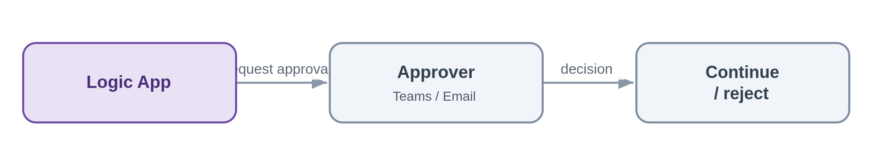
Problem. A referral needs underwriter sign-off before the process continues, and the decision must be captured.
Solution. The Logic App pauses for an approval over Teams or email, captures the decision with the approver's identity, and resumes. Timeouts and escalation keep the process from stalling.
Azure components
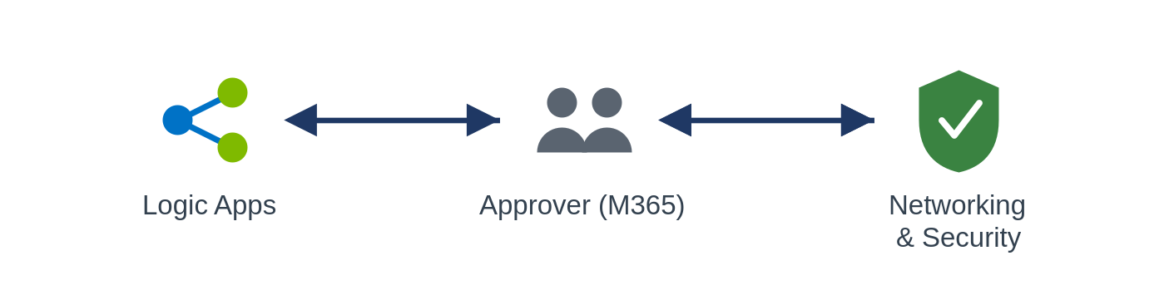
Use it when a process needs human sign-off and an audit trail.
Avoid it when the decision can be made by rules, keep it straight-through.
Risks & considerations. Un-answered approvals stall processes, so always set timeouts, reminders and an escalation path. Authenticate approvers through Entra and record the decision for audit.
Security boundary. Landing zone: the Logic App in a spoke; approvals run over Teams or Outlook, which are Entra-authenticated Microsoft 365 services, not arbitrary internet endpoints. Within Azure: managed identity, TLS, and an audit of the decision and the approver's identity. Outside Azure: approver interaction is over Entra-authenticated Microsoft 365; there is no bespoke internet exposure.
Anti-pattern. Approvals handled over untracked email outside the platform; no timeout or escalation.
In practice. A referral waits for underwriter sign-off before the workflow proceeds to bind.

5.5 File-based exchange
Files are the oldest integration mechanism and, for partners and legacy systems, still unavoidable. The framework's position is that a file is a transport, not an integration contract: prefer an API or an event, and where a file is the only option, handle it event-driven, react when it lands, never poll a folder on a timer, and decompose its contents into records the rest of the platform can process like any other message. Operational, per-record files belong here large bulk or analytical files cross to the data platform (see 5.6.3).

5.5.1 Event-driven file ingestion
A partner or system drops a file; pick it up on arrival, validate and parse it, and turn its contents into messages the platform can process.
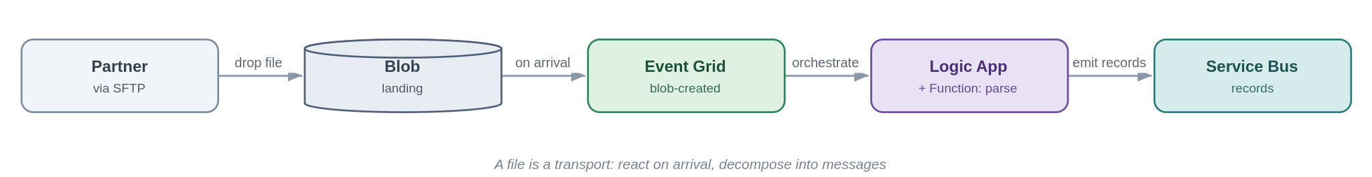
Problem. Two systems must exchange data but one can only produce files, a broker's daily SFTP drop, a legacy nightly extract. The tactical habit is to poll a folder on a timer and process the whole file in one lump, which trades latency for load, hammers storage, and leaves the file layout as a brittle point-to-point contract.
Solution. Land the file in Blob (an SFTP endpoint can be backed by Blob) and react to its arrival with an Event Grid blob-created event, event-driven, not polled. A Logic App orchestrates the handling: a Function validates and parses the file, and each record is emitted onto Service Bus so downstream processing uses the platform's ordinary messaging patterns. The file becomes a transport; the records become the integration.
Azure components
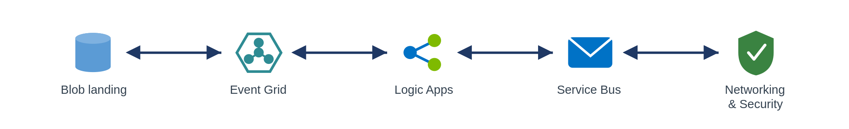
Use it when a source can only deliver operational data as files (partner SFTP, legacy extract, scheduled drop) and the contents are records to process.
Avoid it when the systems can expose an API or emit events directly, prefer that; or the file is a large bulk/analytical dataset, which is a data-platform concern (5.6.3).
Risks & considerations: Do not timer-poll, react to arrival events, or you reintroduce latency and load. Handle partial files with a completion marker or a write-then-rename so you never read a half-written file. Validate up front and move bad files to an error/quarantine container rather than half-processing them, the file equivalent of a dead-letter queue. Make ingestion idempotent and dedupe on filename plus content hash, because partners resend. Large files follow claim-check semantics (5.2.4), pass the reference, don't shuttle the bytes. Secure the transport: SFTP over a Private Endpoint with no anonymous access, a managed identity to Blob, encryption in transit and at rest, and PII handling for the contents.
Security boundary: Landing zone: the Blob landing (firewalled, public access disabled), Event Grid, the Logic App/Function and Service Bus all sit in spokes; a partner SFTP drop is the external boundary. Within Azure: Blob over a Private Endpoint with managed-identity RBAC (no account keys, no public SAS); Event Grid and the Function private; TLS. Outside Azure: the SFTP endpoint is fronted through the online-subscription edge or reached over private connectivity, requires SFTP-over-SSH with key or certificate auth and no anonymous access, is IP allow-listed, and files are encrypted in transit and at rest, a registered exception where it is internet-facing.
Anti-pattern: Timer-polling a folder to fake real-time processing the whole file as one monolithic blob with no per-record error handling; treating the file layout as a permanent contract instead of decomposing to messages.
In practice: A broker SFTPs a daily submissions file; arrival triggers a Logic App that validates and parses it, emitting each submission as a Service Bus message into the policy admin flow.

5.5.2 File generation and delivery
The platform produces a file from records or events and delivers it to a partner or system that can only consume files.
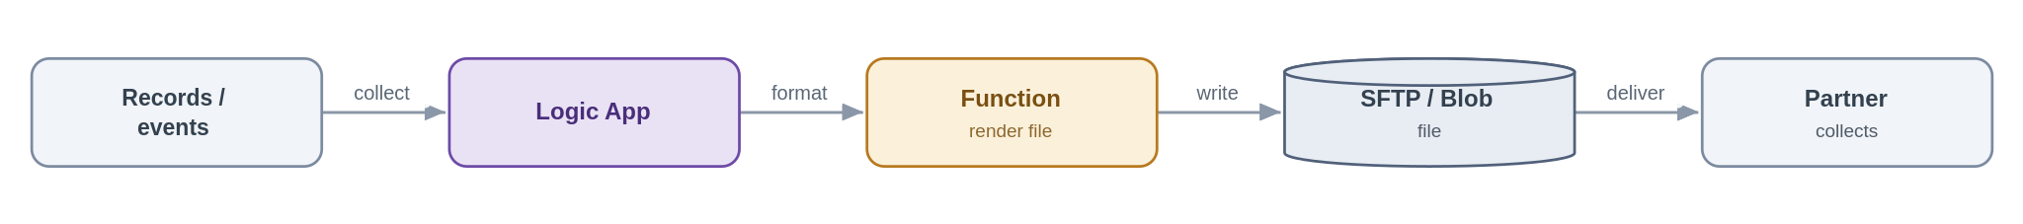
Problem. A downstream party, a partner, a legacy system, a regulator, needs data as a file, on a schedule or on an event, but we hold it as records and events.
Solution. A Logic App collects the data (from events, a query, or accumulated messages), a Function renders it into the required file format, and the file is written to Blob and delivered, pushed to the partner's SFTP or staged for collection, with a completion event so downstream teams know it went. Delivery status is tracked and retried.
Azure components
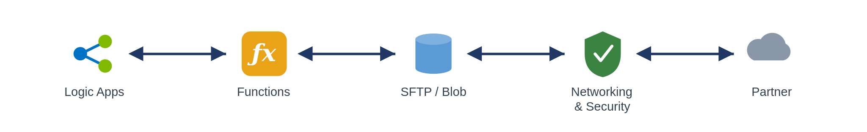
Use it when a consumer can only ingest files, or a scheduled or regulatory extract is required.
Avoid it when the consumer could call an API or subscribe to events, offer that instead.
Risks & considerations. Delivery guarantees to third parties are weak, so retry with backoff, track delivery status and alert on failure; use idempotent naming so a retry does not duplicate. Hold partner SFTP credentials in Key Vault, and sign or encrypt sensitive files (PGP where required). Write-then-rename so a partner never collects a half-written file, and manage retention so generated files do not accumulate cost.
Security boundary. Landing zone: the Logic App, Function and Blob/SFTP staging sit in spokes; delivery to the partner is the external boundary. Within Azure: managed identity to Blob (no keys), partner SFTP credentials held in Key Vault and referenced, TLS. Outside Azure: SFTP-over-SSH with key auth to an allow-listed partner host, sensitive files signed or encrypted (for example PGP), and egress over the controlled path rather than default routing.
Anti-pattern. Hand-rolled scheduled scripts running outside the platform with credentials in config and no delivery confirmation or retry.
In practice. A nightly settlement extract is generated and pushed to the partner's SFTP, with a completion event notifying the finance team.
For large, bulk or analytical files, a full bordereaux dataset for reporting, say, this is a data-platform concern, not a SIF one: see the boundary pattern in 5.6.3. The SIF handles operational, per-record file exchange; the data platform handles bulk file loads.

5.6 Data-platform exchange Integration Patterns
TBA

5.7 Transformation and routing Integration Patterns
These two patterns are cross-cutting, they apply within several of the styles above rather than being a style of their own, but they are important enough, and in this domain common enough, to stand as first-class patterns. Both are classic enterprise-integration patterns, both are heavily used wherever the estate meets external parties.

5.7.1 Canonical data model and message translator
Map every external format to one internal canonical model, so internal systems never bind to a partner's format.
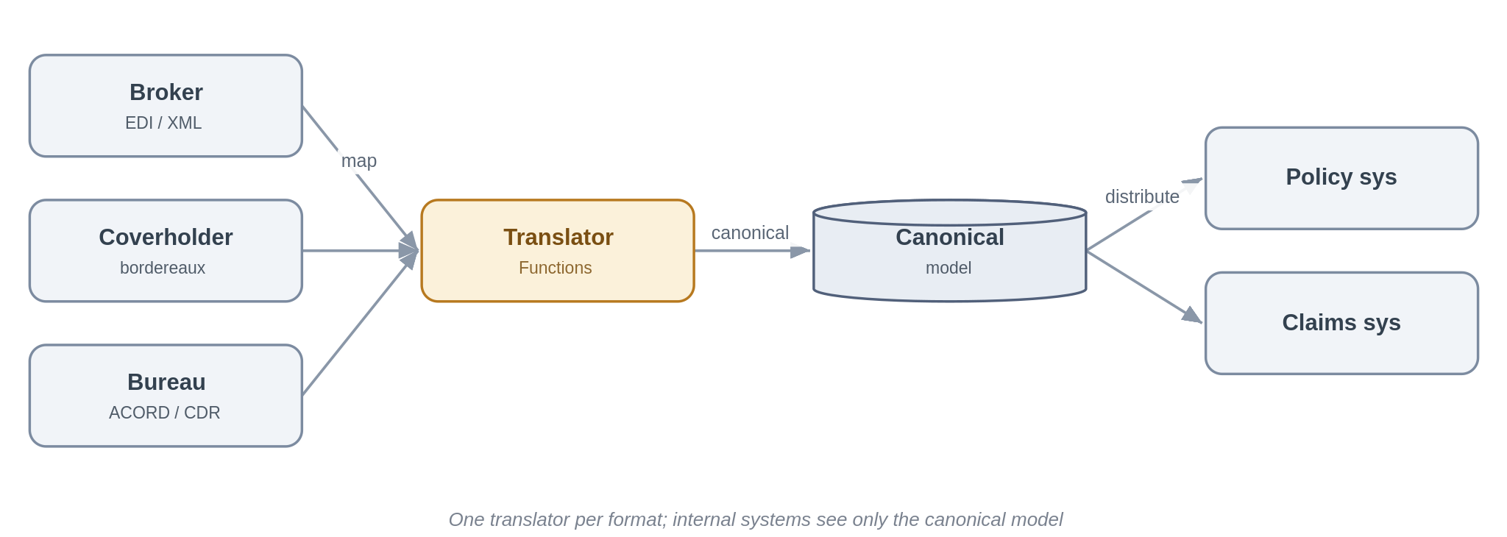
Problem. Insurance means integrating with many parties, brokers, coverholders, delegated claims administrators, reinsurers, the bureau, each with its own format and its own version of the truth: EDI, ACORD XML, bordereaux spreadsheets, the Core Data Record. If each internal system integrates directly with each external format, every new partner multiplies the interfaces and every format change ripples across the estate.
Solution. Define one internal canonical model per business concept, risk, premium, claim, and translate at the edge. A Function maps each inbound external format into the canonical model, and the reverse on the way out. Internal systems and the downstream patterns only ever see the canonical form, so adding a partner means writing one translator rather than touching every consumer. The same canonical model is the contract used when publishing to the data platform (Section 5.6), so a single semantics serves both operational and analytical consumers.
Azure components
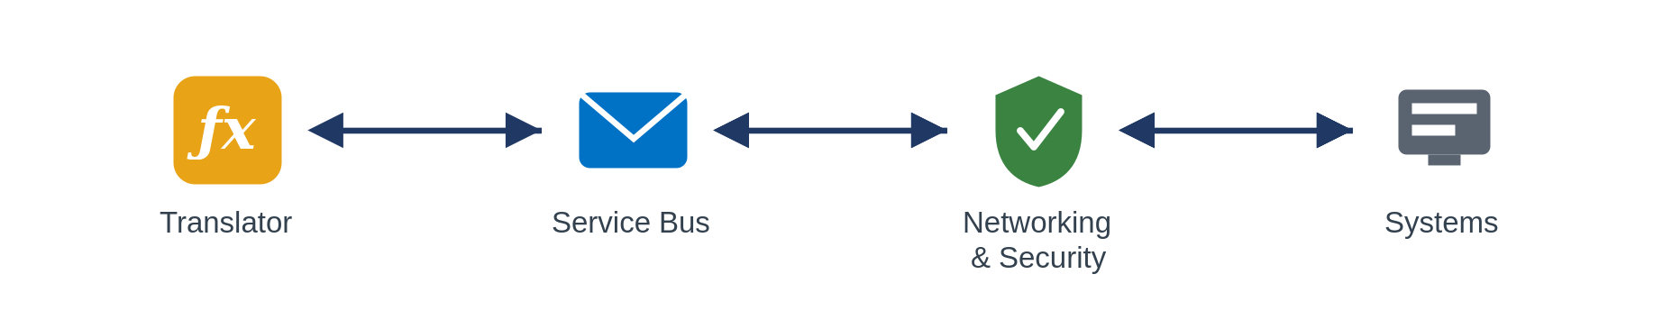
Use it when you integrate with several external parties or standards for the same business concept, which, in this domain, is almost always.
Avoid it when there really is a single, stable format on both sides (rare here), a straight protocol mediation (5.1.3) is enough.
Risks & considerations. The canonical model is a shared asset and a governance responsibility, it needs an owner, versioning and a change process, or it rots. Keep mappings declarative and tested, and treat a field that has no canonical home as a design conversation, not a silent drop. This is a message translator doubling as an anti-corruption layer, so resist the gravitational pull of letting a dominant partner's or the bureau's schema quietly become the internal model.
Security boundary. Landing zone: the translator Function runs in a workload spoke, sitting at the seam between external formats and the internal canonical model. Within Azure: internal distribution over Private Endpoints with managed identity and TLS. Outside Azure: inbound external formats arrive via the relevant boundary pattern, the edge for internet partners, private connectivity for peered ones, and the translator itself is never internet-exposed.
Anti-pattern. Point-to-point mapping between every internal system and every partner format letting one broker's or the bureau's schema become the de facto internal model.
In practice. Broker EDI, coverholder bordereaux and bureau messages are each translated into Chaucer's canonical risk, premium and claim model the policy and claims systems consume only the canonical form.

5.7.2 Content-based routing
Route a message or event to the right destination based on what is in it.
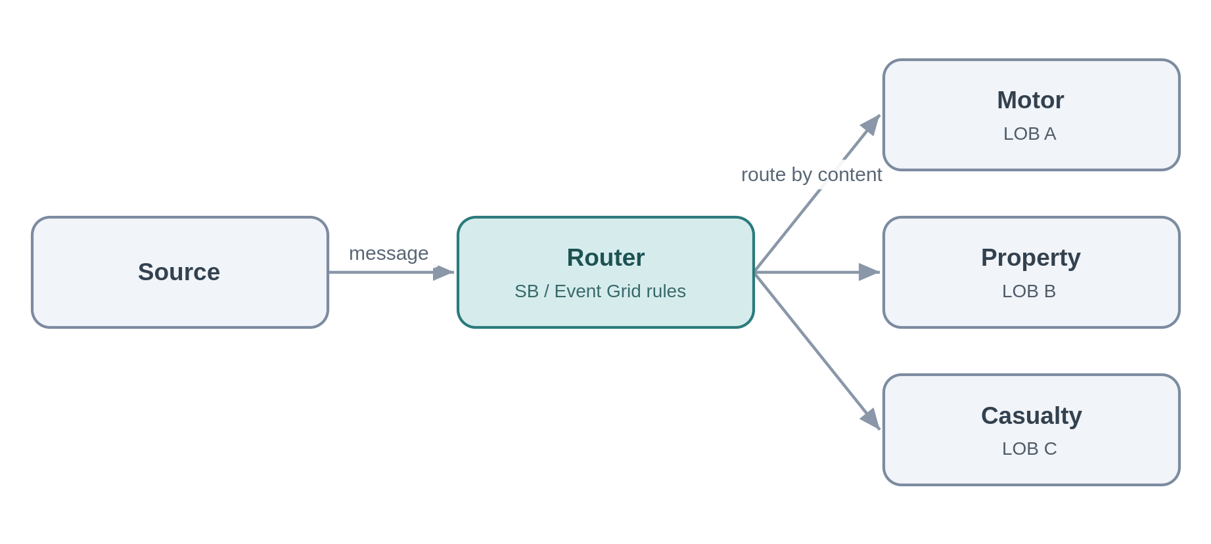
Problem. Submissions, bordereaux and claims arrive on a common channel but need to go to different places, by line of business, territory, coverholder or claim type.
Solution. Route on content using Service Bus subscription filters or Event Grid routing, or a Function for richer rules, so each message reaches the right handler without the producer knowing the routing map.
Azure components
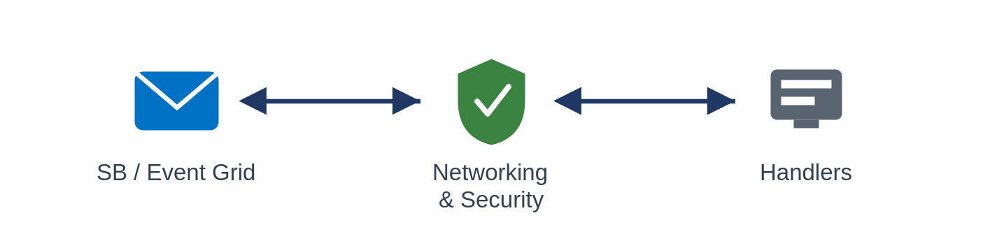
Use it when items on a shared channel need to diverge to different handlers according to their content. Avoid it when there is only one destination, or the routing depends on external lookups better handled by a short orchestration.
Risks & considerations. Routing rules are logic and they drift, so keep them declarative and versioned, and always provide a default or dead-letter route, anything that matches no rule must be caught, not silently lost.
Security boundary. Landing zone: the Service Bus/Event Grid routing rules, or a routing Function, in spokes, internal. Within Azure: Private Endpoint, managed identity, TLS, with a default/dead-letter route captured. Outside Azure: none.
Anti-pattern. A monolithic if/else router hard-coded in one place; no default route for unmatched content.
In practice. Inbound submissions are routed to the motor, property or casualty underwriting queues by line of business.

5.8 Applying the integration pattern scenarios
This section maps the integrations actually runs onto the catalogue, so a team recognises their problem and knows where to start. It also serves as a completeness check: every characteristic insurance integration below resolves to patterns already in the framework.
Scenario | Patterns it composes | Primary components | Domain notes
Delegated authority & bordereaux (coverholder / DCA risk, premium, claims reporting) | File-based ingestion (5.5.1), canonical model (5.7.1), content routing (5.7.2), push to platform (5.6.1) | Logic Apps, Functions, Blob, Service Bus, Snowflake | Validate for Coverholder Reporting Standards, strategic target is API capture-at-source (the DDM direction), retiring manual bordereaux re-key.
London market bureau & settlement | Canonical model (5.7.1), messaging (5.2), orchestration (5.4), push to platform (5.6.1) | APIM, Logic Apps, Service Bus, Functions | Integrate with core processing (accounting, settlement, claims),align to Core Data Record / ACORD, design for incremental modernisation.
Broker submission & placement intake | Inbound API/webhook (5.1.1, 5.3.3), file-based (5.5.1), content routing (5.7.2),composition (5.1.2) | APIM, Front Door/WAF, Logic Apps, Functions | Accept submissions by API, file or portal, triage and route to the right underwriting team and system.
Sanctions & financial-crime screening | Synchronous request-reply (5.1.4), async with hold (5.2.3), human-in-the-loop (5.4.3) | APIM, Functions, Logic Apps | Real-time screening at onboarding and bind block or refer on a hit and full audit trail.
Claims lifecycle (FNOL to settlement) | Inbound webhook/API (5.3.3), orchestration + compensation (5.4.1–2), outbound webhook (5.3.4), push to platform (5.6.1) | APIM, Logic Apps, Service Bus, Functions | FNOL intake from portals and TPAs, orchestrate across DCA and loss adjuster, electronic claims to the bureau, status notifications to brokers.
Reinsurance (ceded) | Canonical model (5.7.1), file/messaging (5.5, 5.2),orchestration (5.4.1) | Logic Apps, Functions, Service Bus, Snowflake | Cede risk, premium and claims to treaty and facultative systems and reinsurers, outbound bordereaux; manage recoveries.
Regulatory & tax reporting | Event offload (5.6.1), consume & serve (5.6.2), orchestration (5.4.1),file egress (5.5.2) | Snowflake, Logic Apps, Functions, APIM | Solvency II and tax assembled on the data platform and submitted via orchestrated feeds or files.
Rating & pricing | Synchronous request-reply (5.1.4), facade (5.1.1) | APIM, Functions | Real-time rating-engine calls during quote and bind.
Document generation & delivery | Orchestration (5.4.1),file egress (5.5.2), outbound webhook (5.3.4) | Logic Apps, Functions, Blob | Policy schedules and certificates generated and delivered to brokers and insureds.

9. Data Platform Position and Exchange Patterns

Core Position
The data platform should not be treated as the default enterprise integration mechanism. It should be used where the purpose is governed analytical data, reporting, BI, machine learning enablement, data products, data history, or controlled bulk data exchange. It should not be used for transient operational handoffs, real-time command processing, service-to-service transactions, or business process orchestration.

Typical Use Cases for Snowflake / Data Platform
Use Case | Appropriate? | Rationale
Analytical reporting | ✅ | Snowflake is the strategic platform for curated reporting and analytics use cases.
Historical data consolidation | ✅ | Supports governed, reproducible analytical data.
Data extracts for business functions | ✅ | Data warehouse scope includes extracts, reporting, and BI analysis.
Batch ingestion from systems | ✅ | ADF, Blob/ADLS, Snowpipe, and COPY INTO are well known patterns for Snowflake.
Operational API response path | ❌ | Operational APIs should not rely on analytical stores for transient request/response integration.
Real-time system command | ❌ | Use APIs or messaging depending on latency and reliability need.
Workflow state management | ❌ | Use Logic Apps/workflow state, Service Bus, or operational store patterns.
Temporary handoff between systems | ❌ | Use messaging or controlled integration storage, not Snowflake by default.

SIF to Snowflake Data Exchange Patterns
Pattern | Description | Recommended Use
Operational event to analytical feed | Integration platform emits governed event/data extract into landing zone for Snowflake ingestion | When operational events need downstream analytics
API/source extraction to landing zone | Logic App/Function/ADF extracts from API and lands data into Blob/ADLS for Snowflake ingestion | Data ingestion from SaaS platform or REST data
Batch file handoff | Source file lands in controlled storage and is ingested into Snowflake via Snowpipe/COPY INTO | Scheduled or event-driven data loads
Curated result consumption | Applications consume curated output only through approved service/API layer where operational use is required | Avoid direct coupling to Snowflake for operational workflows

10. Guardrails, Exceptions and TDA Governance

10.1 Mandatory Guardrails and Evidence

Mandatory Guardrails
Guardrail | Rule | Governance Evidence
APIM ingress | All published APIs must be exposed through APIM unless exception approved. | API design section in HLD.
REST/JSON standard | REST and JSON are default for synchronous APIs. | API contract / OpenAPI spec.
No direct database coupling | Direct database-to-database operational integration is not permitted by default. | Design decision in HLD.
Managed identity first | Azure service-to-service authentication should use managed identity where supported. | IAM/RBAC section in HLD / LLD.
Key Vault for secrets | Secrets, keys, and certificates must be stored in Key Vault. | HLD / LLD.
Private endpoint where possible | Supported PaaS services should use private endpoints where appropriate. | Network design.
CI/CD required | Integration assets must be source-controlled and deployed through CI/CD. | Pipeline evidence in LLD.
Observability required | Logging, correlation, alerts, and runbooks must be included. | HLD / Operational readiness checklist.
Exception handling required | Retries, error handling, dead-lettering, or compensating actions must be defined. | Exception handling design.
Data platform not default | Snowflake/ADF must not be used for transient operational integration without rationale. | Design decision in HLD.

Exception Process
Step | Activity | Owner | Output
1 | Identify deviation from SIF pattern or guardrail | Delivery team / supplier | Exception request
2 | Document rationale, risk, alternatives, and mitigation | Portfolio architect | Architecture Decision Record
3 | Review against security, operations, data, and cloud standards | Architecture / Security / Platform / Data | Review comments
4 | Approve, reject, or time-bound the exception | TDA or delegated architecture governance / risk register | TDA Decision outcome
5 | Track exception through lifecycle | Platform owner / risk register | Exception register
6 | Review expiry or remediation path | Service / Product owner | Closure or renewal

10.2 Detailed Non-Negotiable Guardrails and TDA Gates

6.1 Non-negotiable guardrails
These are the things a TDA reviewer will look for on every integration, regardless of pattern. They are inherited directly from the security principles and engineering standards, so they are not up for per-project renegotiation, but the exception process below exists for the genuine edge cases.
Area | The rule
Identity | Entra ID with managed identities for every service-to-service call, least privilege. No account keys, shared keys or secret-bearing connection strings.
Secrets | Only where unavoidable, held in Key Vault (Cyber subscription) and referenced, never copied into configuration.
Network | Private Endpoints to dependencies; APIM shared and internal, public ingress only through Front Door with WAF and DDoS.
Encryption | TLS on every hop, private network or not.
Observability | Correlation IDs end-to-end, logs, metrics and traces centralised, the SOC has the access it needs.
Resilience | Zone-redundant by default, cross-region posture set by criticality tier, DR runs at the same security posture as production.
Contracts & versioning | APIs and event schemas are versioned and evolve without silently breaking consumers.
Reuse & publication | Check the catalogue first, publish new services and patterns so the next team can find them.
Delivery & build | All assets in source control; repeatable IaC deployment, automation authenticates as managed identities or SPNs.
Business traceability | Every integration ties to a business outcome and is assigned a criticality tier.

6.2 When you need to deviate
The framework is opinionated, but it is not a straitjacket. A genuine need to depart from a mandated component, a guardrail or the data-platform boundary is handled openly: document the deviation and why the standard pattern does not fit, complete a security and risk assessment and identify compensating controls; take it to the TDA for approval and record it in the exception register with a named owner and an expiry, with remediation back to the standard pattern scheduled. The public-ingress path in Section 5.3.3 is the worked example of a controlled, time-boxed exception.

6.3 TDA gates
Governance is light but real. At design, the chosen pattern and interaction style are confirmed against the decision tree and the scope boundary. At build, guardrail conformance is evidenced, identity, network, secrets, observability and resilience. And any exception is logged and approved before build proceeds. The intent is not to slow teams down but to make sure the easy path and the approved path are the same path.

6.4 Per-pattern security conformance
Rather than repeat an identical verdict twenty times, the patterns are grouped below by their security profile. The internal group shares one posture the boundary-crossing group is where TDA attention is warranted.
Pattern group | Internet boundary | Controlling security posture | TDA verdict
Internal patterns, 5.1.2-5.1.4, 5.2.x, 5.3.1-5.3.2, 5.3.5 (internal feeds), 5.4.x, 5.6.1, 5.6.3, 5.7.x | Not crossed | Components in shared subscription / private workload spokes, Private Endpoints, Entra managed identity, no keys, Key Vault references, TLS every hop,NSG-segmented, default-deny. | Conforms
Managed API facade, 5.1.1 (internal use) | Not crossed | APIM shared and non-public, Private Endpoint to backend, managed identity, TLS. | Conforms
Consume-and-serve, 5.6.2 (internal consumer) | Not crossed | APIM (Entra auth) over a serving layer, Snowflake via Private Link, least-privilege data access, caching. | Conforms
Inbound webhook, 5.3.3 | Crossed (ingress) | Online subscription only Front Door + WAF + DDoS,APIM single ingress, mTLS/OAuth/signature; IP allow-list, async processing in private spokes, no direct triggers. | Conforms with registered exception
Public API / external consumer, 5.1.1, 5.2.3, 5.6.2 when exposed externally | Crossed (ingress) | Same edge as 5.3.3: Front Door + WAF + DDoS + APIM, OAuth/mTLS, online subscription, APIM never exposed directly. | Conforms with registered exception
Outbound webhook / notification, 5.3.4 | Crossed (egress) | Controlled egress path (routing intent), not default internet; TLS, signed payloads, partner allow-list, Key Vault-held secrets. | Conforms
File-based with partner SFTP, 5.5.1, 5.5.2 | Crossed | Edge or private connectivity, SFTP-over-SSH with key/cert auth, no anonymous access, IP allow-list, encryption in transit and at rest, Key Vault credentials. | Conforms with registered exception

11. Anti-Pattern Quick Reference
A consolidated list of what the framework is trying to prevent, and where to go instead. If a design review turns up any of these, it is a signal to stop and re-choose.
Anti-pattern | Instead
Direct, unmediated point-to-point integration | Mediate through the platform, an API, a queue or an event (5).
Bypassing APIM to expose a backend | APIM as the single front door, Front Door + WAF for public (5.1.1).
Microservices choreography / distributed saga | Centrally-owned orchestration with compensation (5.4.2).
Business logic in gateway policies or Logic Apps | Logic in Functions, control flow in Logic Apps (5.4).
Long-running work behind a synchronous call | Asynchronous request-reply or orchestration (5.2.3, 5.4).
Snowflake as a real-time integration hub | Event offload and data-as-a-product across the boundary (5.6).
Batch ETL built inside the integration platform | The data platform owns bulk movement (5.6.3).
Account keys or connection strings for auth | Managed Identity and Key Vault references (6.1).
Public Function/Logic App HTTP triggers | Front Door + WAF + APIM ingress (5.3.3).
Fat events treated as source of truth | Thin events plus an authoritative read (5.3.2).
Assuming exactly-once delivery | At-least-once plus idempotent consumers (5.2.5).
Timer-polling a folder for files | React to blob-created arrival events; decompose to messages (5.5.1).
Manually re-keying bordereaux; mapping every partner format point-to-point | Canonical model + translator; capture at source via API (5.7.1, 5.8).
Using the data platform as a hop between two operational systems | The platform is a destination/source only; integrate operationally through the SIF (5.6).
Two different data models for operational vs analytical use | One canonical model as the shared contract across the boundary (5.6, 5.7.1).
PII in logs or URLs, or unmasked in analytics | Classify, minimise and tokenise; log metadata not payloads (3.6).

12. Glossary
Term | Meaning
SIF | This framework, the Systems Integration Framework.
AIS | Azure Integration Services: APIM, Logic Apps, Service Bus, Event Grid, Event Hubs, Functions.
SOA | Service-Oriented Architecture, coarse-grained, capability-aligned services with clear ownership. Chaucer's chosen model.
Idempotent | Safe to apply more than once with the same effect as applying it once, the antidote to at-least-once delivery.
Claim-check | Passing a reference to a large payload rather than the payload itself.
Data platform | Snowflake, the analytical platform, reached only across a defined boundary.
TDA | Technical Design Authority, approves the framework and any exceptions to it.

13. Pattern Cross-Reference and Reconciliation
This framework was cross-checked against the organisation's earlier "Integration Patterns in Azure" reference deck. Almost every pattern in that deck maps onto a pattern here; the table records the mapping, the one pattern this framework adds, and the one divergence.
Reference pattern (deck) | Where it lives in this SIF
Simple Service (Functions) | A building block, the implementation layer (Functions) and the orchestration/implementation rule (5.4), not a standalone integration pattern.
Composite Service | API composition (5.1.2) and process orchestration (5.4.1).
Service Proxy / mediation | Managed API facade (5.1.1) and protocol/format mediation (5.1.3).
Reliable Acquisition | Queue-based load levelling (5.2.1), inbound webhook (5.3.3), or file ingestion (5.5.1), depending on the inbound transport.
Timed Event / Timed Data Sync | Added as Scheduled / timed trigger (5.2.6), the gap this reconciliation surfaced.
Queuing Proxy | Reliable messaging (5.2.5) and load levelling (5.2.1).
Extract, Transform, Load (ADF) | Deliberate divergence: ETL is not a SIF pattern. It is a data-platform responsibility across the boundary (5.6.3), the SIF only triggers it.
Reliable Dispatch | Asynchronous messaging (5.2.x) and orchestration (5.4.1).
Message Bridge / Async Mediation | Asynchronous messaging (5.2.x) and publish/subscribe (5.3.1).
Event-Driven Data Sync | Event-driven patterns (5.3.x) and push to the data platform (5.6.1).
Async Orchestration | Process orchestration (5.4.1), asynchronous.

End of draft v1.1

