**The Big Three Cloud Wars:**

**The Rise of Microsoft Azure, the Mystery of Google Cloud Platform, and the Rise, and Rise of Amazon Web Services**

Xu Ren

INSEAD DSMS P4

Dr. Dubois

2020-April-19

It seems like from the dawn of the cloud computing era, there was only space for one major winner, maybe two. When I first started working on cloud, even I was hesitant to believe that there could be two major players (at least in the United States). Which is all the more shocking to me when I was told in 2017, while working for a global insurance company, that we would be switching all of our AWS workloads to Microsoft Azure in just a few months. How did Microsoft Azure become such a successful challenger to AWS?

To this end, I wanted to explore more deeply the changes in the cloud landscape over the last five years and whether this space can become more than just a bi-polar world. I used the terms “AWS+Amazon Web Services”, “Azure+Microsoft Azure”, and “GCP+Google Cloud” as my list of keywords and set the geography to United States and the timeframe to last 5 years. As a quick side note, I find the Google Trends web application interface extremely cumbersome to use, the manual downloading of individual CSV files for each category was a pain, and there were real limits to numerically seeing more details in the related queries section. Alas, not to fear, we live in an open source world where I can stand on the shoulders of those before me—someone who has graciously contributed a Python Google Trends API for me.

In Figure 1, we immediately notice the steady rise of Microsoft Azure, while Google Cloud has not enjoyed a similar ride. I explored further the major spikes in AWS back in February of 2017, particularly in the *News* type of search interest and discovered that there was a major outage of Amazon’s S3 service that brought down a high number of services, such as Slack, Trello, and Quora. What this teaches me is both the customer loyalty of AWS as well as the type of customers that AWS attracts – early startups and internet companies.

In Figure 3, I wanted to explore whether there were geographical differences between these three services, and the only thing that shocked me was the strength of Azure in North Dakota. Further digging revealed that Microsoft had donated $1.5 Million to establish a tech-farm there and that the current Governor of North Dakota was a former Microsoft executive. However, no major insights or further explorations revealed any evidence for me as to the struggles of GCP across the US.

However, upon digging more deeply into the related search queries (Figure 4), I began to surface evidence of the problem—one that is more than the usual first-movers’ advantage hypothesis. Notice how AWS’s top terms were IOT, Glue, Athena, Fargate, Lightsail, Sagemaker, etc. These are all proprietary Amazon services that they have built to solve very specific and modular challenges that their customers face. Take a look at Azure’s related terms—they include SQL, AD, DevOps, Windows; all terms related to existing enterprise workloads and continuity. Lastly, that leaves us with GCP—the related queries are Console, Cloud, Account; these are generic terms that are probably reflective of people’s intent to simply navigate to their existing accounts. They do not represent specialized services nor expertise in existing workloads that can be “upsell-ed” to the cloud. Nonetheless, there may be hope as Gsuite remains a beacon in this cloudy picture for GCP, and we see signs of Google’s competitive advantages entering “servicization,” such as Vision and ML. Furthermore, Google recently announced GCP Anthos as a way to tackle hybrid-cloud trends and complexities. These are key learnings for Google to bear in mind and if their current bets pay off in the near future, the landscape may become far from AWS and Azure’s zero-sum game.

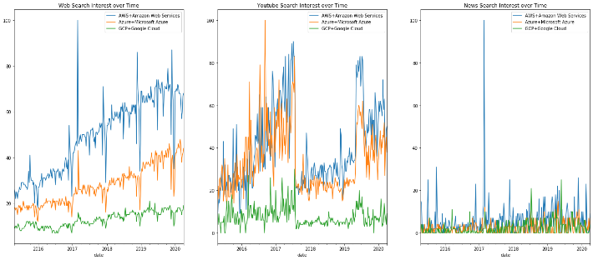

Figure 1: Web, Youtube, and News Relative Search Interest

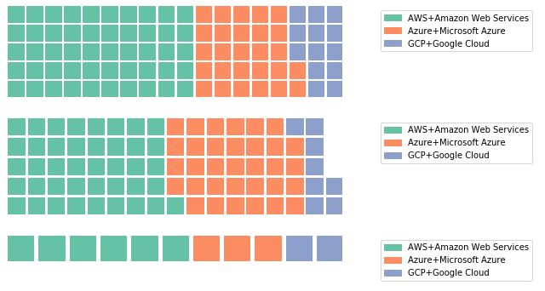

Figure 2: Average Web, Youtube, News Search Interest

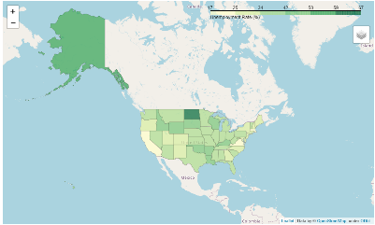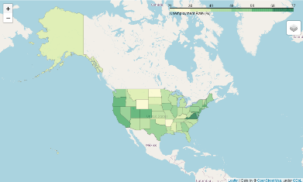

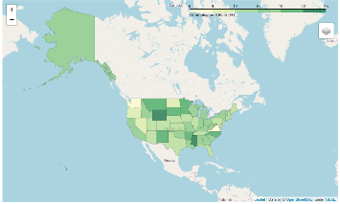

Figure 3: Geographical Web Search Interest of AWS, Azure, and GCP Respectively

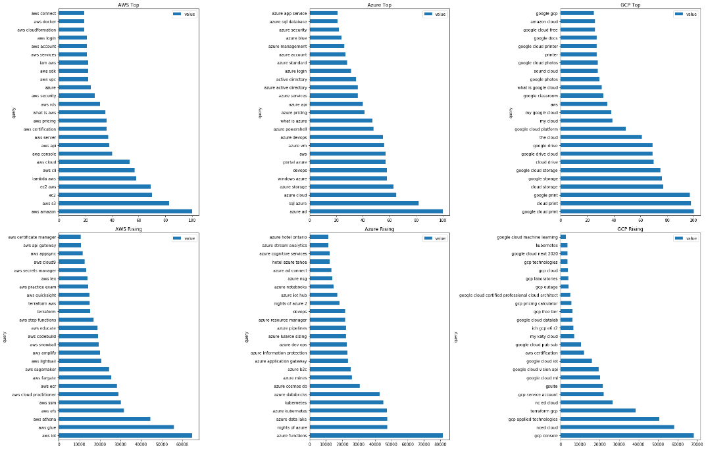

Figure 4: Related Top and Rising Search Queries