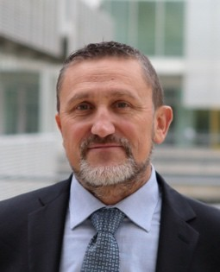

Dr. Marco Sacco, Research Director, Head of the CNR-STIIMA branch office in Lecco ("Human-Centered Living Environment").
Vice President of EuroXR (European Association for XR Technologies) with responsibility for European Union issues and collaborations. EuroXR is the oldest European association on XR technologies (funded in 2010) and the annual conference is at its 23rd edition.
Member of the Board of the VWA (Virtual World Association) representing the National Council of Italy. The association has entered into a partnership with the European Commission to improve and promote immersive technologies, extended reality, digital twins, virtual collaborative spaces, interoperability, and digital skills.
His experience (since 1994) concerns XR technologies (VR/MR/AR) and AI applied to both the manufacturinge and the health and well-being sectors.
Cluster Manager for the TechforLife Foundation (Lombardy Region Technology Cluster for Living Environment Technologies).
He has coordinated European (two of the largest EU projects under the 6th and 7th Framework Programmes) and national/regional projects. He has served as an expert on several R&D project evaluation committees, both at the European and national/regional levels.
He has authored over 180 publications, including articles in academic journals and conference proceedings.

