Task 1
Project Title: Library Management System (using SQL)
Project Description:
Design and develop a Library Management System using SQL. The project should
involve three tables: Books, Members, BorrowingRecords. The system will manage book
inventories, member details, and borrowing transactions.
Database created
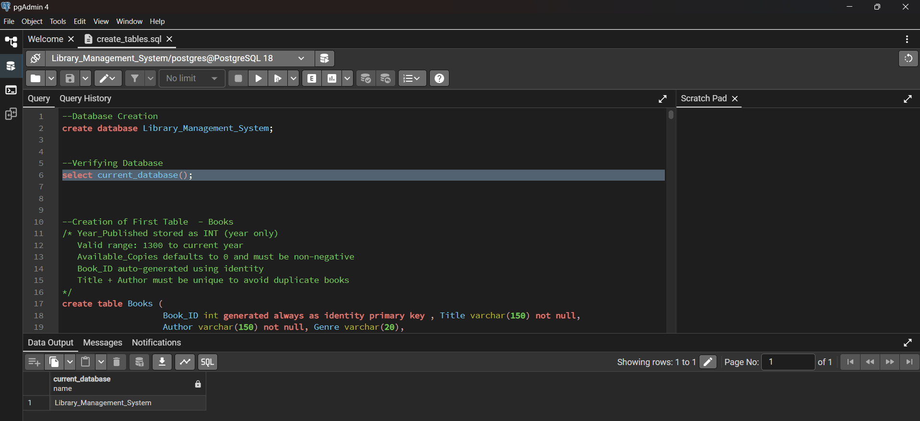
Tables created
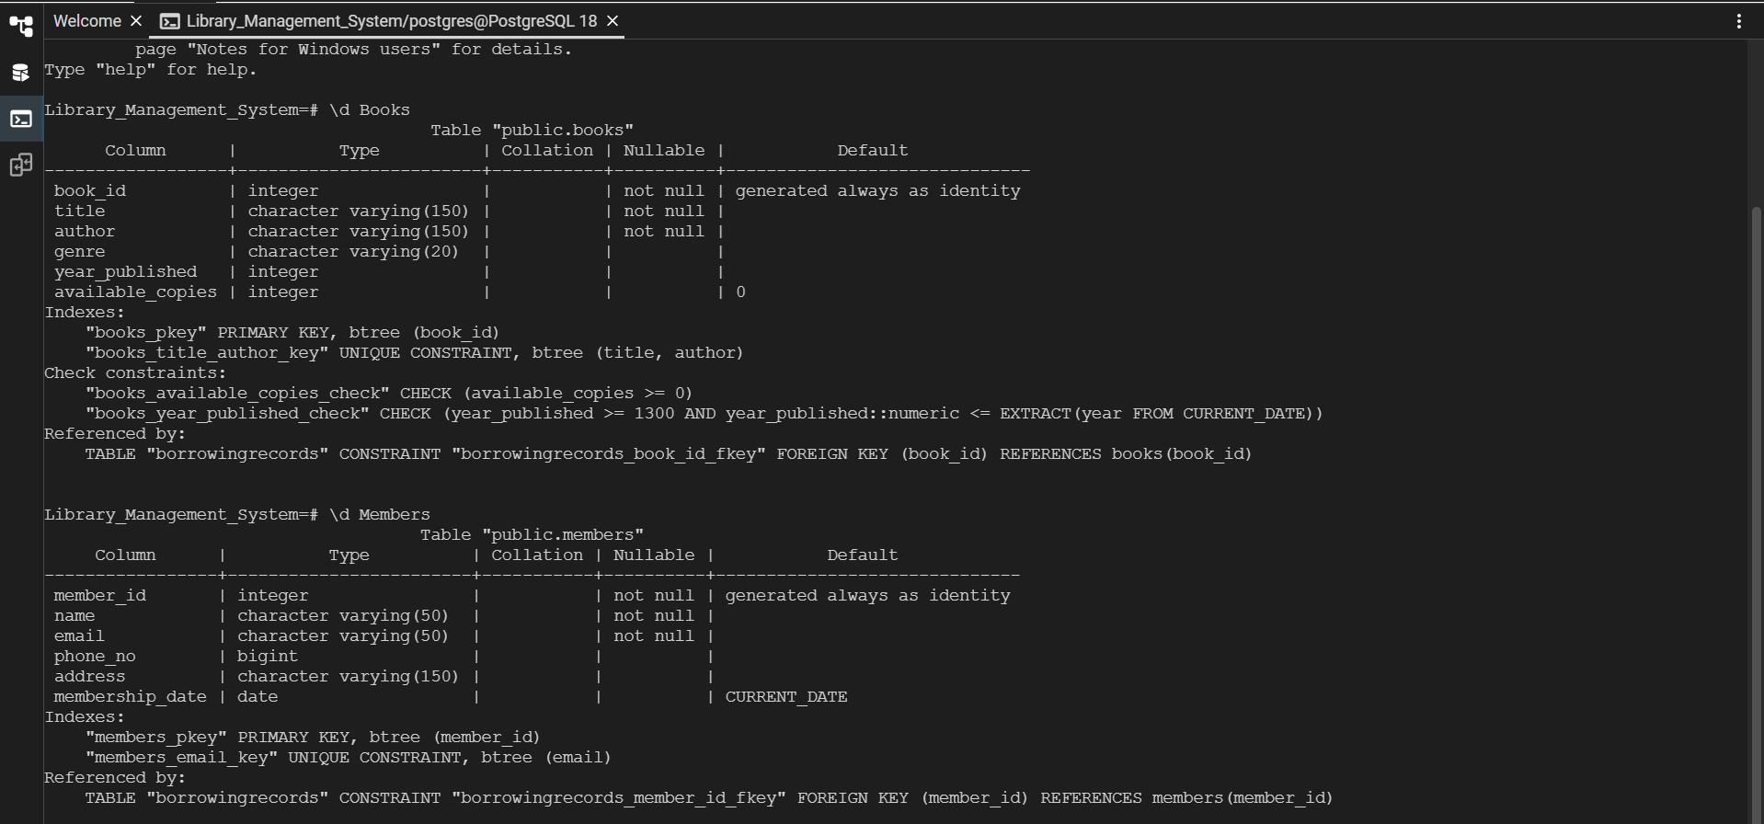
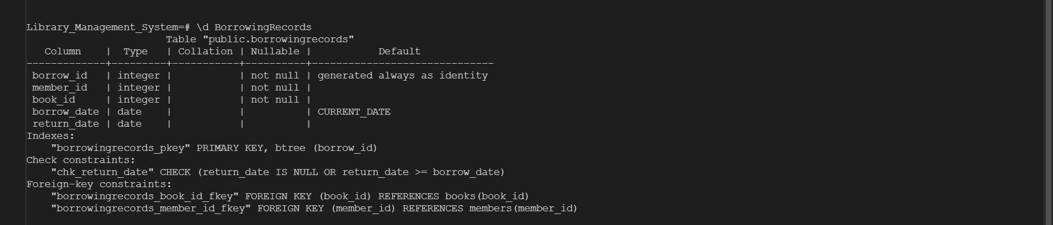

Information Retrieval:
- Retrieve a list of books currently borrowed by a specific member.
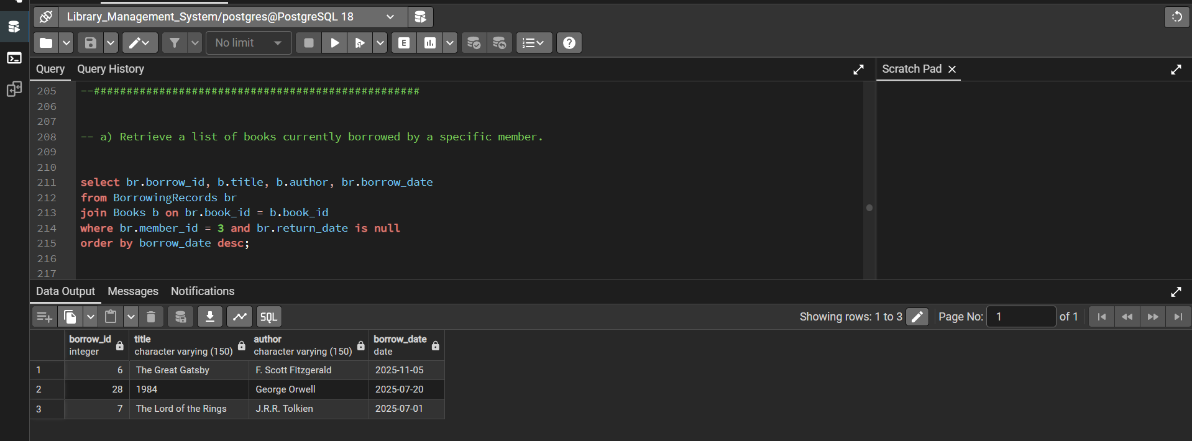
- Find members who have overdue books (borrowed more than 30 days ago, not returned).
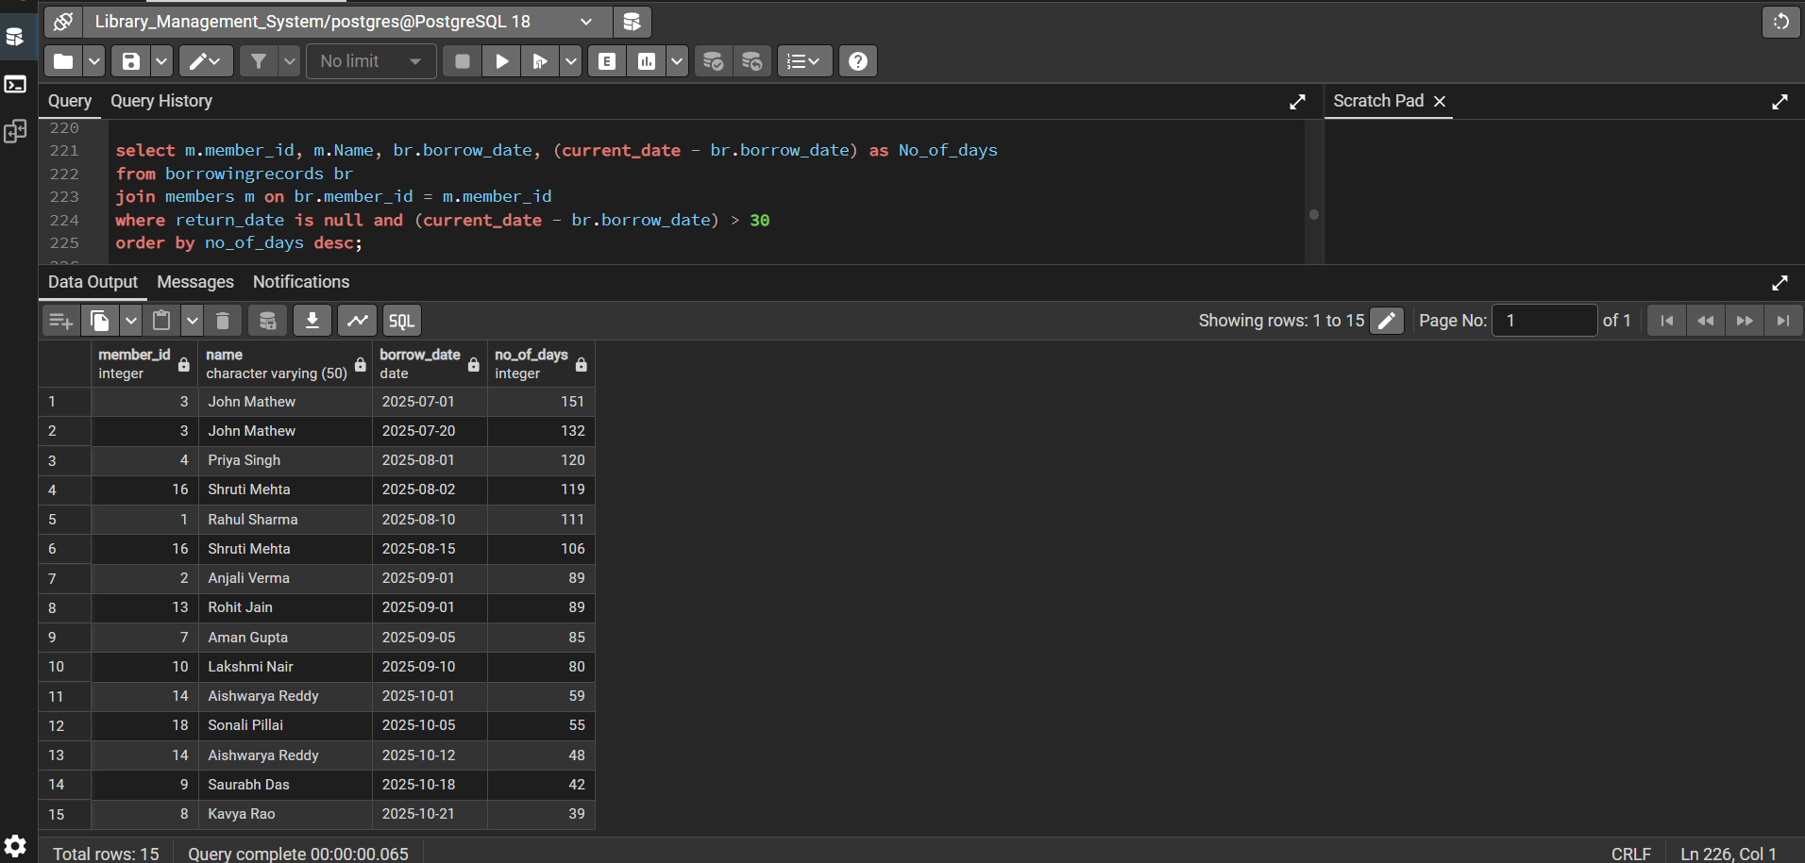

- Retrieve books by genre along with the count of available copies.
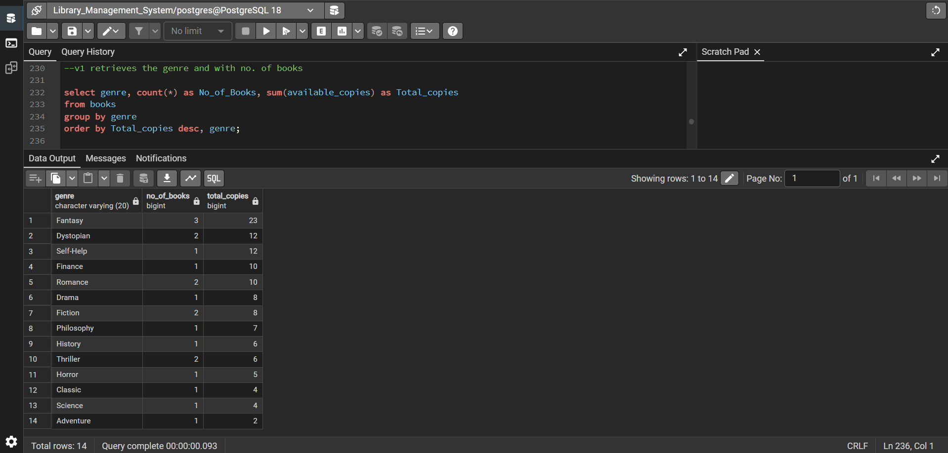
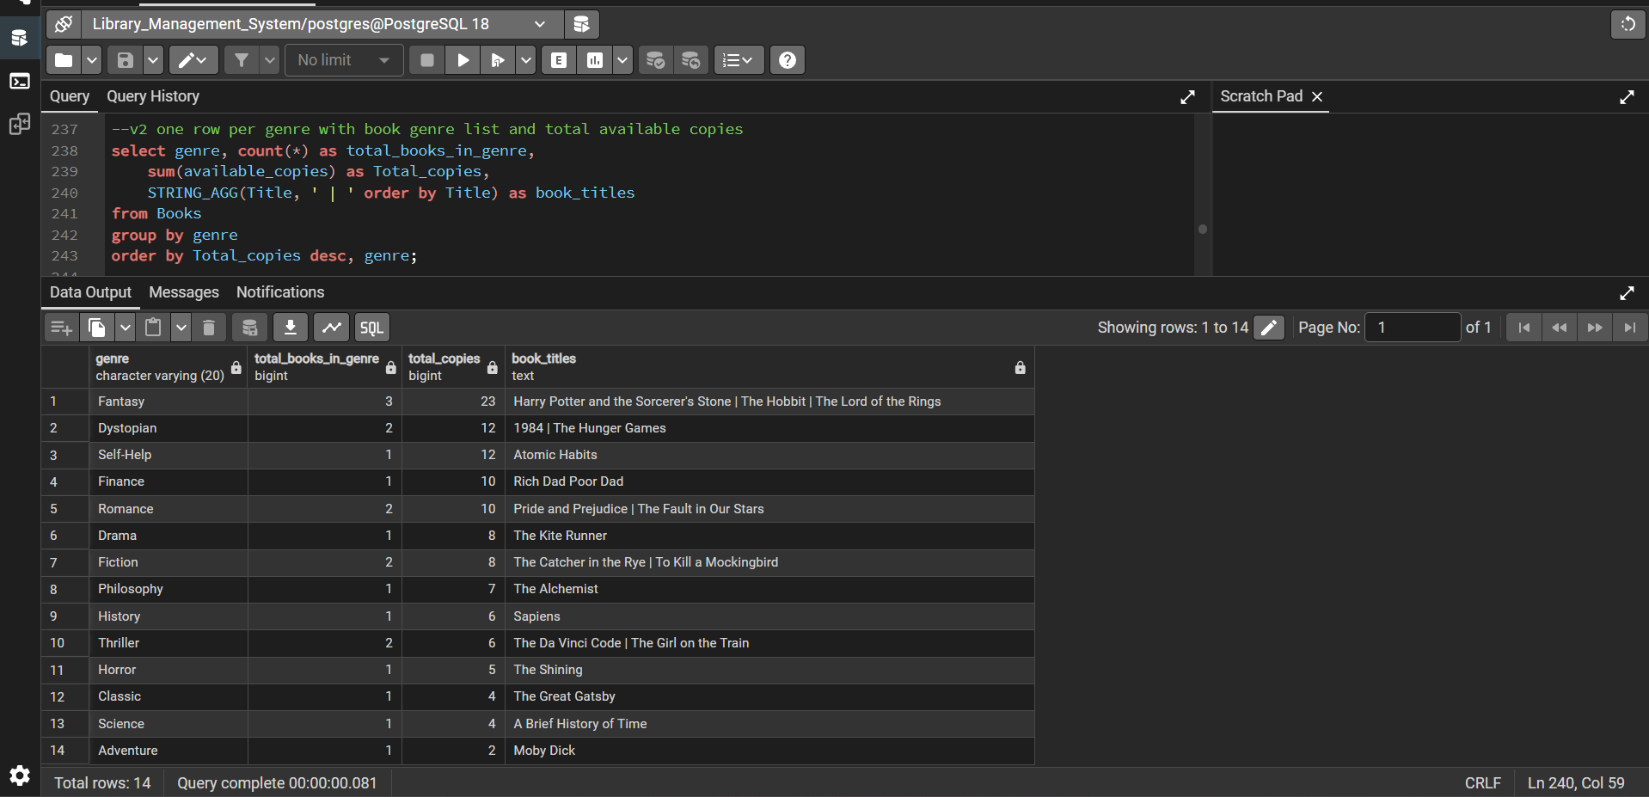
- Find the most borrowed book(s) overall.
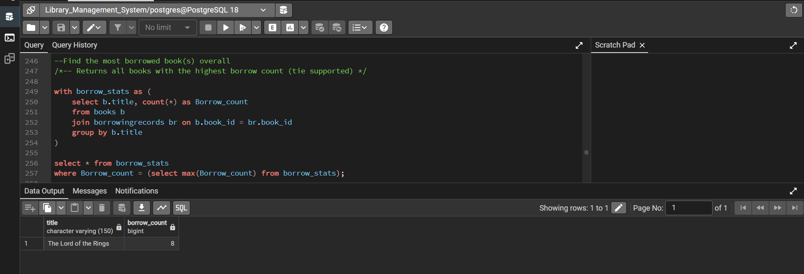

- Retrieve members who have borrowed books from at least three different genres.
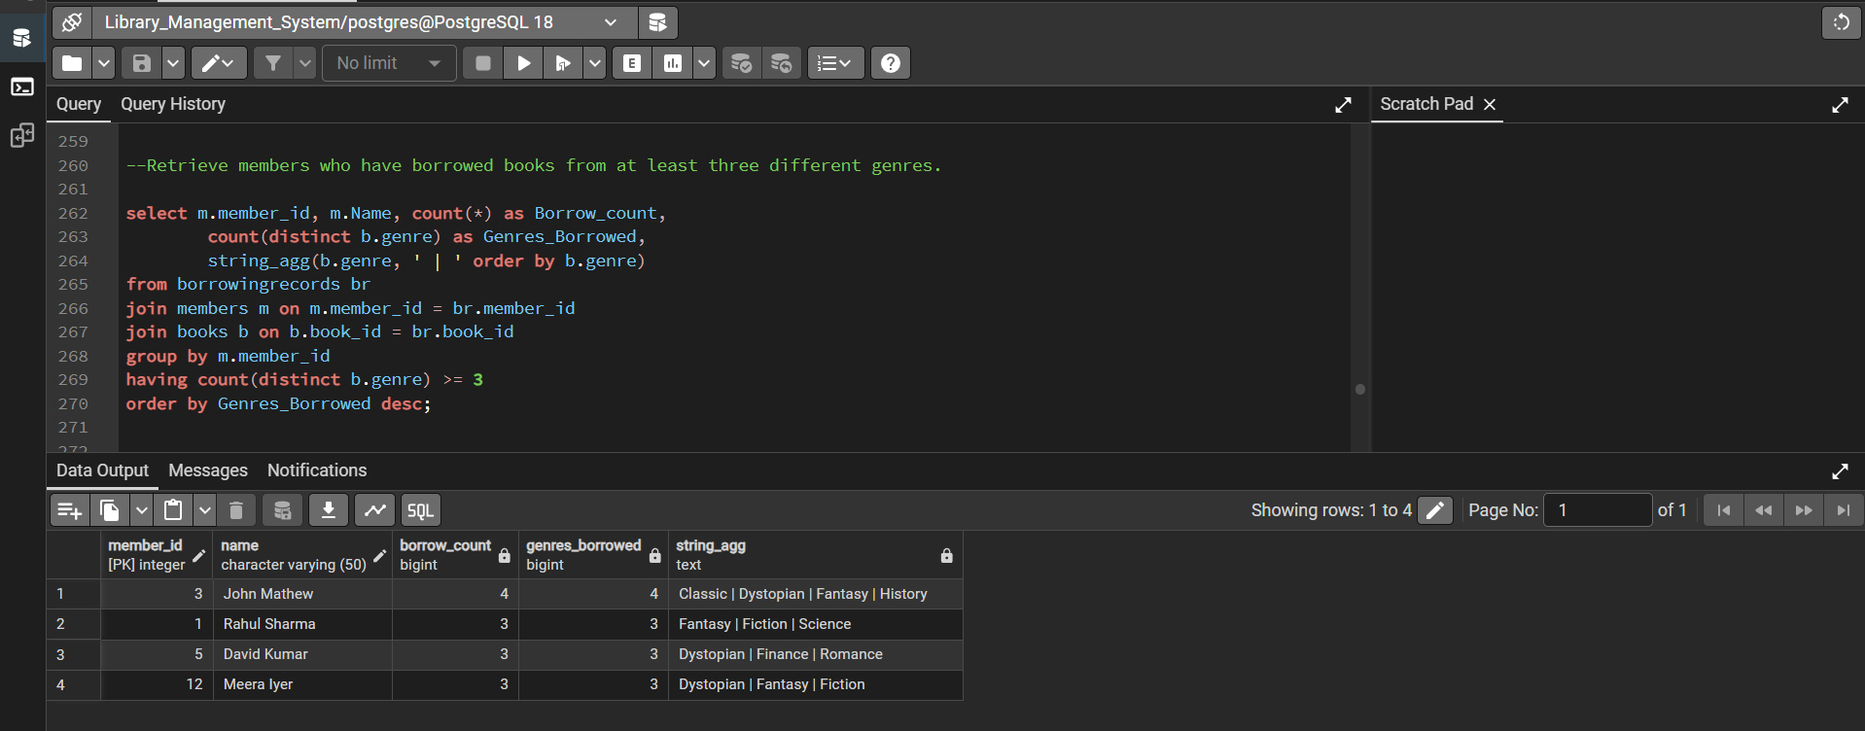

Reporting and Analytics:
- Calculate the total number of books borrowed per month.
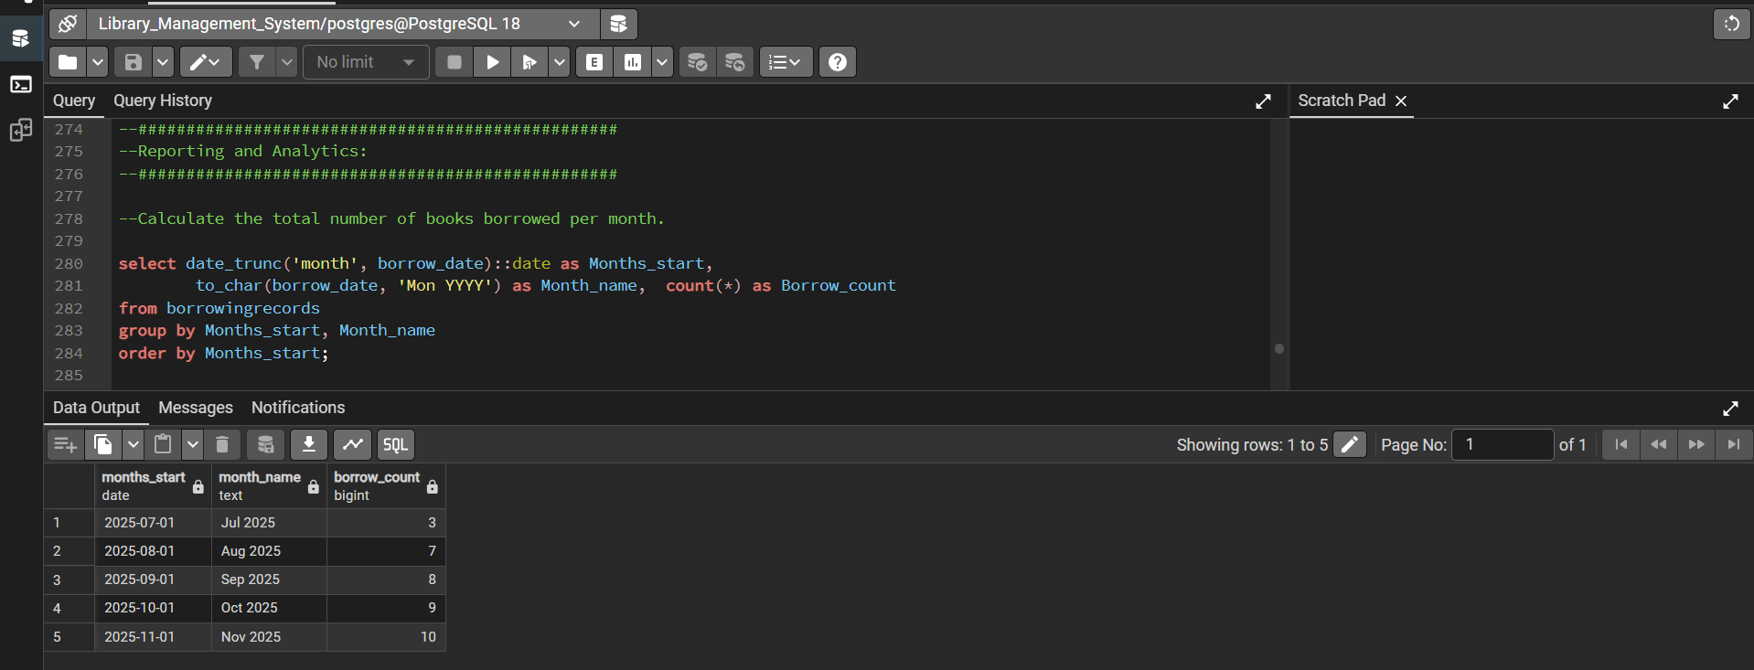
- Find the top three most active members based on the number of books borrowed.
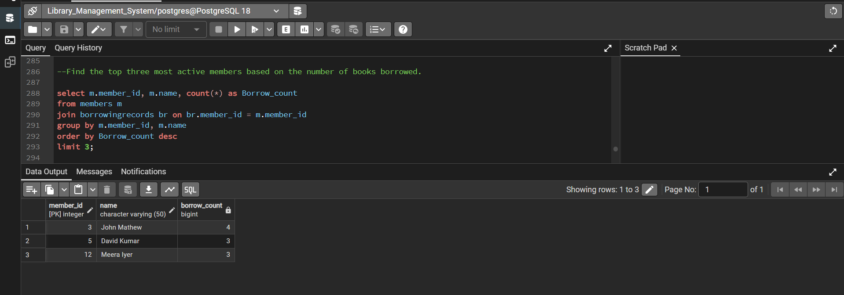

- Retrieve authors whose books have been borrowed at least 10 times.
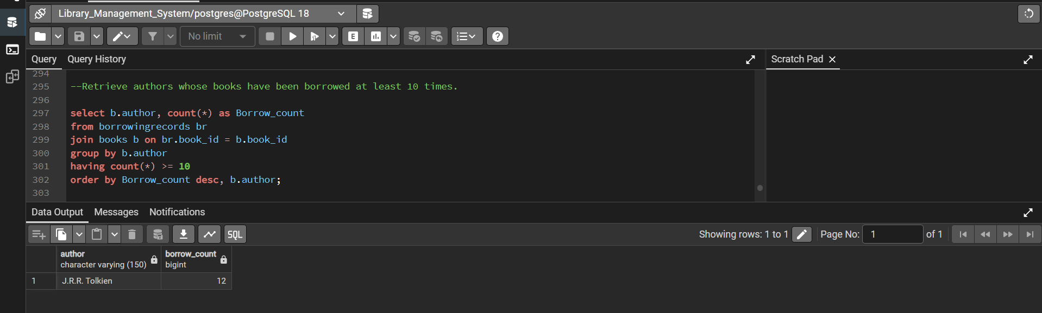

- Identify members who have never borrowed a book.
