Metagenomic analysis characterizes stage-specific gut microbiota in Alzheimer's disease
Longhao Jia^{1,12}, Yize Ke^{2,12}, Shuo Zhao³, Jinxin Liu¹, Xiaohui Luo¹, Jixin Cao¹, Yujia Liu³, Qihao Guo⁴, Wei-Hua Chen^{5,6}, Feng Chen⁷, the ZIB Consortium*, Jiao Wang^{3#}, Hao Wu^{2#}, Jing Ding^{1#} and Xing-Ming Zhao^{1,8,9,10,11#}
- Department of Neurology, Zhongshan Hospital and Institute of Science and Technology for Brain-Inspired Intelligence, Fudan University, Shanghai 200433, China
- Fudan Microbiome Center, State Key Laboratory of Genetic Engineering, School of Life Sciences, Human Phenome Institute, and Center for Obesity and Hernia Surgery, Department of General Surgery, Huashan Hospital, Fudan University, Shanghai 200040, China
- Laboratory of Molecular Neural Biology, School of Life Sciences, Shanghai University, Shanghai 200444, China
- Department of Gerontology, Shanghai Jiao Tong University Affiliated Sixth People’s Hospital, Shanghai 200233, China
- Key Laboratory of Molecular Biophysics of the Ministry of Education, Hubei Key Laboratory of Bioinformatics and Molecular Imaging, Center for Artificial Intelligence Biology, Department of Bioinformatics and Systems Biology, College of Life Science and Technology, Huazhong University of Science and Technology, Wuhan 430074, China
- Institution of Medical Artificial Intelligence, Binzhou Medical University, Yantai 264003, China
- Department of Radiology, Hainan General Hospital (Hainan Affiliated Hospital of Hainan Medical University), Haikou, Hainan 570311, China
- Lingang Laboratory, Shanghai 200031, China
- State Key Laboratory of Medical Neurobiology, Institutes of Brain Science, Fudan University, Shanghai 200032, China
- MOE Key Laboratory of Computational Neuroscience and Brain-Inspired Intelligence, and MOE Frontiers Center for Brain Science, Fudan University, Shanghai 200433, China
- Huzhou Central Hospital, Affiliated Central Hospital Huzhou University, Huzhou, Zhejiang 313000, China
- These authors contributed equally: Longhao Jia and Yize Ke.
* A list of authors and their affiliations appears at the end of the paper.
# Correspondence: xmzhao@fudan.edu.cn; ding.jing@zs-hospital.sh.cn; hao_w@fudan.edu.cn;jo717@shu.edu.cn

Supplementary Methods

Zhangjiang International Brain Bank
Zhangjiang International Brain Bank (https://zib.fudan.edu.cn/index) of Fudan University is the database platform of Fudan Zhangjiang International Innovation Center for Brain and Brain-like Intelligence. The brain bank includes three important parts: dry bank, wet bank and algorithm bank. It fully draws on the platform construction model of the International Brain Research Center to form the construction idea of "three banks integration, multi-source sharing" and "full-dimensional, multi-modal, multi-source sharing". Across "time and space" data acquisition mode. The dry library and algorithm library are built by the institute integrating several domestic and foreign medical and scientific research institutions. It has more than 520,000 international shared databases such as UK Biobank, ABCD, and HCP.
By 2023, the Zhangjiang International Brain Bank has established a comprehensive research infrastructure, encompassing six distinct cohorts: schizophrenia, depression, autism, stroke, neurodegenerative diseases, and a control group of individuals without these conditions. It has amassed a collection of 15,000 cases from these cohorts, each documented with extensive multi-dimensional data that includes environmental, behavioral, genetic, brain imaging, and neurological information at the 'O' scale.

Neuropsychological assessment
All participants underwent a battery of neuropsychological assessments including a subjective cognitive decline interview [1], six neuropsychological tests in three cognitive domains (i.e., Rey Auditory Verbal Learning Test-HuaShan version (AVLT-H) 30-minute delayed free recall auditory verbal learning test (AVLT-N5) and AVLT recognition (AVLT- N7) [2] in memory domain; Boston Naming Test (BNT) [3] and Animal Fluency Test (AFT) [4] in language domain; and Shape Trail-Making Test parts A and B (STT-A, STT-B) [5] in attention/executive domain), global cognition tests (e.g., the Mini-Mental State Examination (MMSE) [6]; Montreal cognitive assessment-basic (MoCA_B) [7]; Addenbrooke's Cognitive Examination – III (ACEIII) [8]), Daily functional activities (FAQ), and Everyday cognition (Ecog) [9].

Diagnostic criteria
Diagnosis of Alzheimer’s disease. The AD patients were diagnosed following the guidelines of the National Institute on Aging-Alzheimer's Association (NIA-AA) [10], which were: (1) Interfere with the ability to function at work or usual activities; (2) Represent a decline from previous levels of functioning and performing; (3) Are not explained by delirium or major psychiatric disorder; (4) Cognitive impairment is detected and diagnosed through a combination of history taking, physical exam and cognitive evaluation, such as MMSE≤24; (5) Meets criteria for dementia described above, and in addition, has the following characteristics: (a) insidious onset, (b) clear-cut history of worsening of cognition, (c) history and examination in amnestic or non-amnestic presentations, (d) no important features of other dementia types.
Diagnosis of mild cognitive impairment. The MCI participants were determined with Jak/Bondi criteria if the participant met one of the following criteria [11]: 1. Impaired scores ( defined as >1 standard deviation (SD) below the age-corrected normative mean) on two of the six neuropsychological indexes mentioned above in the same cognitive domain (memory, language or executive function); 2. Impaired scores (>1 SD) in each of the three cognitive domains.
Diagnosis of subjective cognitive decline. The diagnosis of SCD was given if the subject had impaired scores (>1 SD) on two measures in different cognitive domains [12].
Diagnosis of slight cognitive symptom. The individuals with SCS were diagnosed according to the criteria proposed by Huang et al [13], which are: (1) one impaired score (>1 SD) alone; (2) the level of objective impairment that did not meet the requirement of SCD or MCI based on neuropsychological tests.

DNA extraction, library construction, and metagenomic sequencing
These 476 samples were sequenced in two batches. In April 2020, we sequenced 234 fecal samples, including 34 NC, 41 SCS, 40 SCD, 61 MCI, and 58 AD samples. In November 2022, we sequenced 242 additional samples, including 29 NC, 41 SCS, 50 SCD, 58 MCI, and 64 AD samples. Total genomic DNA was extracted using the E.Z.N.A.® Soil DNA Kit (Omega Bio-tek, Norcross, GA, U.S.) following the manufacturer’s instructions. The concentration and purity of extracted DNA were assessed using TBS-380 and NanoDrop2000, respectively. The quality of extracted DNA was evaluated using 1% agarose gel electrophoresis.
To prepare the DNA for sequencing, extracted DNA was fragmented to an average size of approximately 400 bp using Covaris M220 (Gene Company Limited, China). The paired-end library was constructed using NEXTFLEX Rapid DNA-Seq (Bioo Scientific, Austin, TX, USA). Adapters containing the necessary sequencing primer hybridization sites were ligated to the blunt ends of the DNA fragments. The paired-end sequencing was performed on an Illumina NovaSeq platform (Illumina Inc., San Diego, CA, USA) at Majorbio Bio-Pharm Technology Co., Ltd. (Shanghai, China), following the manufacturer's instructions (www.illumina.com). All samples were subjected to paired-end sequencing with a read length of 150 bp, aiming to achieve a targeted data size of 10.0 Gb.

Metagenomic taxonomic profiling
Preprocessed reads were assigned taxonomic classifications for bacteria, archaea, fungi, and viruses using Kraken2 v.2.1.2, which is an advanced metagenomic taxonomy classifier that utilizes k-mer-based algorithms [14]. To build a custom database for classification, 268,184 bacterial, 1,344 archaeal, 11,742 viral, and 478 fungal reference genomes were obtained from the NCBI RefSeq database (accessed in December 2022). Jellyfish v.2.3.0 was employed to count distinct 31-mers in the reference libraries and map each k-mer in a read to the lowest common ancestor of all reference genomes with exact k-mer matches. Subsequently, each query was classified to a specific taxon based on the highest total k-mer hits by pruning the general taxonomic trees affiliated with the mapped genomes. Bracken v.2.5.0 [15] was utilized to accurately estimate taxonomic abundance, especially at the species and genus level based on Kraken2. The taxonomic abundance of the four kingdoms (bacteria, archaea, fungi, and viruses) was normalized separately. For further analysis, species with a relative abundance of over 10^-4 in at least 10% of the samples were selected, including 86 archaea, 343 bacteria, 50 fungi, and 54 viruses.

Metagenomic functional profiling
Preprocessed reads were assembled into contigs with Megahit v.1.2.9 [16] using ‘meta-sensitive’ parameters. Contigs less than 500 bp in length were excluded from further analysis. Gene prediction was performed using Prodigal v.2.6.3 [17] in the metagenome mode (-p meta). To construct a non-redundant microbial gene reference, CD-HIT v. 4.8.1 [18] was employed with a sequence identity cut-off of 0.95 and a minimum coverage cut-off of 0.9 for shorter sequences. The reference was annotated with EggNOG mapper v.2.1.0 [19] based on EggNOG orthology data.
Furthermore, the abundance of microbial genes was estimated by mapping the high-quality reads to the reference sequences using CoverM v.0.4.0 (https://github.com/wwood/CoverM). Clean reads were then mapped to the non-redundant microbial gene reference using BWA MEM, and SAM files were converted into BAM files using SAMtools. CoverM was utilized to calculate the coverage of genes in the original contigs (coverm contig). The relative abundances of KEGG KOs (ortholog groups) or pathways were estimated by summing the relative abundances of genes belonging to the same KOs or pathways. In total, 14,105 KOs and 437 KEGG pathways were identified. Furthermore, 6,493 KOs and 407 KEGG pathways with an abundance over 10^-6 in at least 10% of the samples were selected for further analysis.

The simulated human intestinal redox model (SHIRM)
The simulated human intestinal redox model (SHIRM) is a one-chamber fermenter with an anaerobic luminal chamber that is continuously purged with mixed gas (5%H₂, 10% CO₂, and 85% N₂). The feed for the luminal chamber consisted of (in g/l) arabinogalactan (1.0), pectin (2.0), xylan (1.0), starch (3.0), glucose (0.4), yeast extract (3.0), peptone (3.0), mucin-type II (1.0), NaCl (0.9), KH₂PO₄ (0.45), K₂HPO₄ (0.45), CaCl₂.2H2O (0.45), MgSO₄.7H₂O (0.09), hemin (0.01) and cysteine (0.5). A vitamin mix [consisting of (in μg/l) biotin (10), cobalamin (10), p-aminobenzoic acid (30), folic acid (50), pyridoxamine (150), riboflavin (50) and thiamine-HCl (50)] was added. To simulate digestion processes, the feed was acidified to a pH of around 2 with 6 M HCl followed by the addition of pepsin (10 mg/l) and neutralized with simulated pancreatic juice [(in g/l) NaHCO₃ (12.5), Ox gall bile salts (6.0) and pancreatin (0.9)] to pH 6.9. The luminal chamber was continuously fed with SHIRM feed (70:30 mix of the feed and pancreatic juice described above) at a rate giving a retention time of around 24 h and pH was maintained at 6.6-6.9 using a pH controller and dosing pump.

Y-maze test
The Y-maze test was used to assess cognitive abilities, particularly spatial working memory. The maze was made of grey plexiglass and had three arms (30×8×15 cm, 63006, Shenzhen Ruiwode Lift Technology Co., Ltd.), which were symmetrically disposed at 120° angles from each other. The test involves two main phases: the habituation phase and the testing phase, each with distinct procedures. In the habitation phase, one arm was blocked with a baffle, which was recorded as the Novel arm. Then, the mouse was put into the starting arm, the movement track was recorded for 10 minutes, and the mouse was taken out. In the testing stage, after 24 hours, the baffle was removed and the mice were allowed to move freely for 10 min. The behavioral analysis system records the number of times the mouse enters the new arm, the time it stays and the distance it moves in the novel arm.

Novel object recognition

The novel object recognition (NOR) test was used to assess recognition memory and performed as previously described[20]. The mice were allowed to acclimate in the experimental room for 30 minutes, then tested within a non-transparent open arena (40×40×40 cm, 63008, Shenzhen Ruiwode Lift Technology Co., Ltd.). In the familiarization phase, the mouse was introduced into the center of the arena to explore for five minutes before returning to the home cage. One hour later, one object was kept (Old Object), and the other object was replaced by one novel object (Novel Object).In the test phase, the mouse was once again introduced to the center of the arena to explore for five minutes. After each trial, the chamber and objects were cleaned with 75% alcohol. The videos were recorded using the SMART3.0 camera system and subsequently analyzed through manual timing in a blinded fashion. The time mice spent exploring the novel object and the frequency of their exploration of the novel object were recorded when the mice sniffed or touched the object within 2 cm. Mice that sat near the object, climbed on the object or chewed the object were excluded.

Supplementary Figure Guide
Figure S1. Flow chart of Cognitive Impairment-No Dementia (CIND) diagnosis and classification system
Figure S2. Heatmap showing the 10 most abundant genera in the NC, SCS, SCD, MCI and AD groups.
Figure S3. The Firmicutes/Bacteroidetes ratio in the NC, SCS, SCD, MCI and AD groups.
Figure S4. The alpha diversities of archaea, bacteria, fungi and viruses in the NC, SCS, SCD, MCI and AD groups.
Figure S5. The alpha diversities of microbial KOs in the NC, SCS, SCD, MCI and AD groups.
Figure S6. Principal coordinate analysis of samples based on Bray–Curtis distance of species.
Figure S7. Principal coordinate analysis of samples based on Bray–Curtis distance of microbial KOs.
Figure S8. Heatmap showing differential species in our AD cohort.
Figure S9. Heatmaps showing differential signatures that maintained consistent alterations in the Japanese dataset.
Figure S10. The number of features in classification models with 20 randomized five-fold cross-validations.
Figure S11. The ROC curves showing the performance of transferring to metagenomic datasets of other brain disorders.
Figure S12. Heatmap showing the 10 most abundant genera in an in vitro gut simulator.
Figure S13. The scatter plot showing the PCoA analysis of microbial species in an in vitro gut simulator.
Figure S14. Fig S14. Stage-specific gene families validated by an in vitro gut simulator.

Supplementary Figures
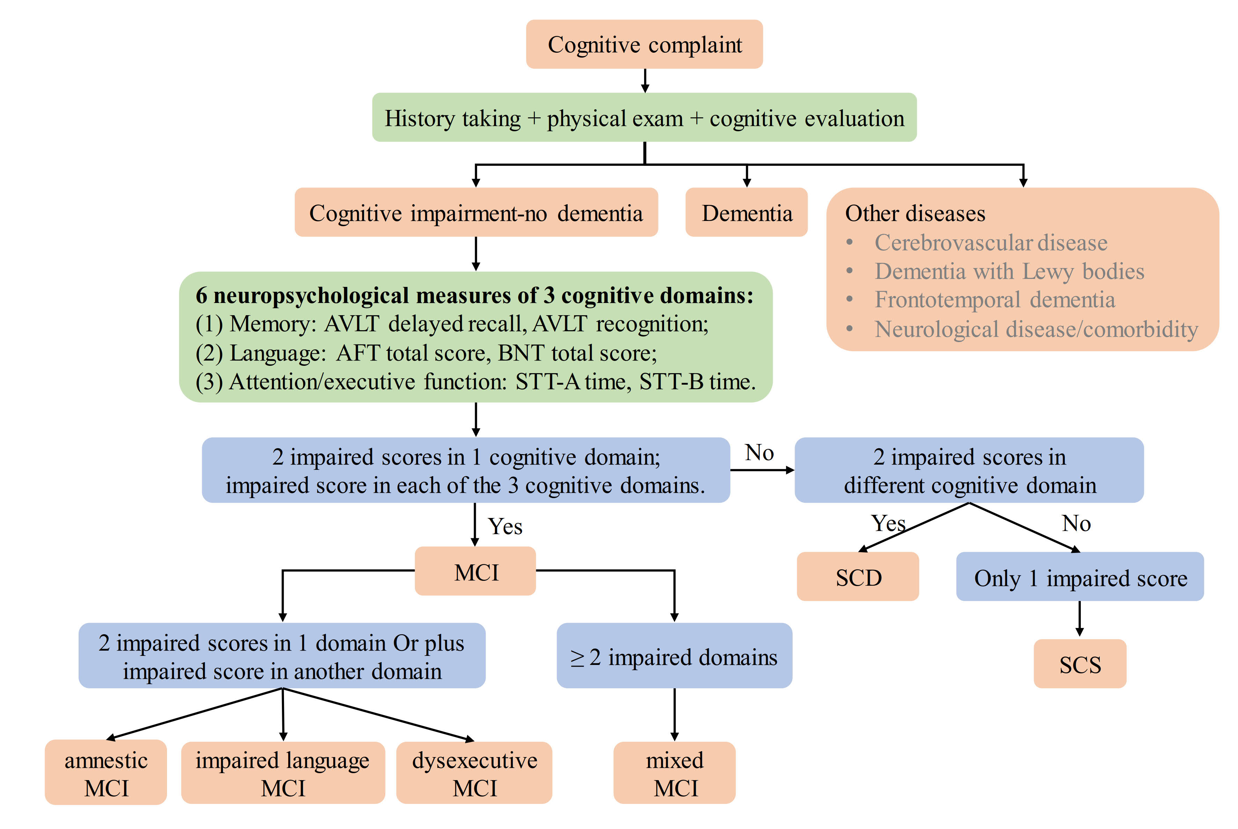
Figure S1. Flowchart of Cognitive Impairment-No Dementia (CIND) diagnosis and classification system. Abbreviations: NC, Cognitively Normal; SCS, Slight Cognitive Symptom; SCD, Subtle Cognitive Decline; MCI, Mild Cognitive Impairment; CIND, Cognitive Impairment With No Dementia; AVLT, Auditory Verbal Learning Test; STT, Shape Trail Test; AFT, Animal Fluency Test; BNT, Boston Naming Test.
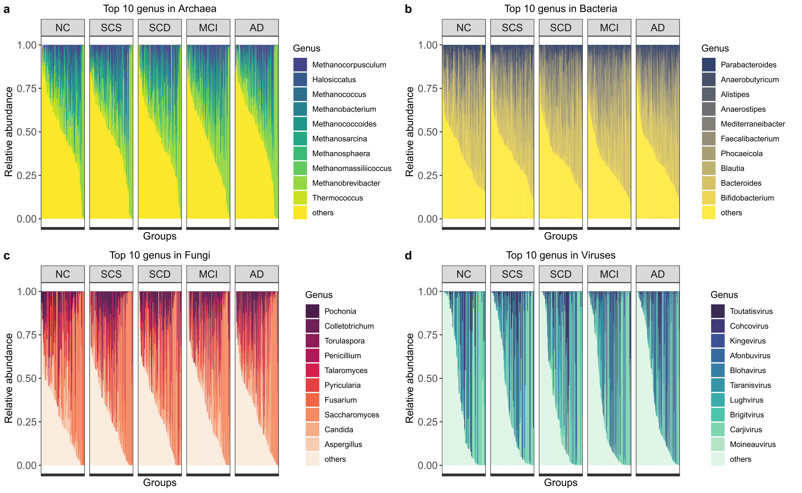
Figure S2. Heatmap showing the 10 most abundant genera in the NC, SCS, SCD, MCI and AD groups. The 10 most abundant genera in the (a) Archaea, (b)Bacteria, (c)Fungi and (d)Viruses kingdoms. At the genus level, the 10 most abundant genera in bacteria and fungi accounted for more than 40% of the abundance in almost all samples, and archaea and viruses showed higher variability between samples and thus showed lower proportions.

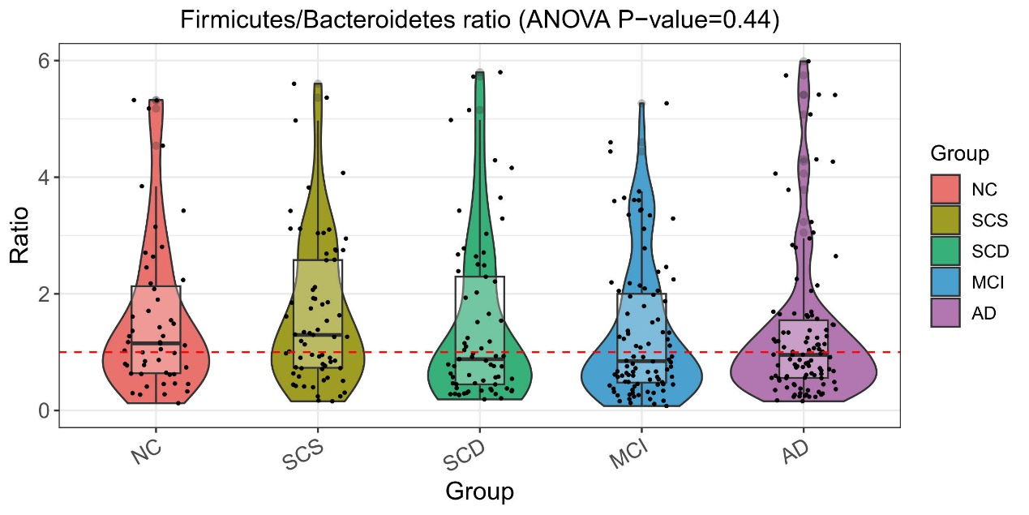
Figure S3. The Firmicutes/Bacteroidetes ratio in the NC, SCS, SCD, MCI and AD groups. The Firmicutes/Bacteroidetes ratio in the NC and SCS groups is higher than in the other three groups, and Firmicutes plays an important role in regulating host digestive and absorptive adaptive response to dietary lipids.

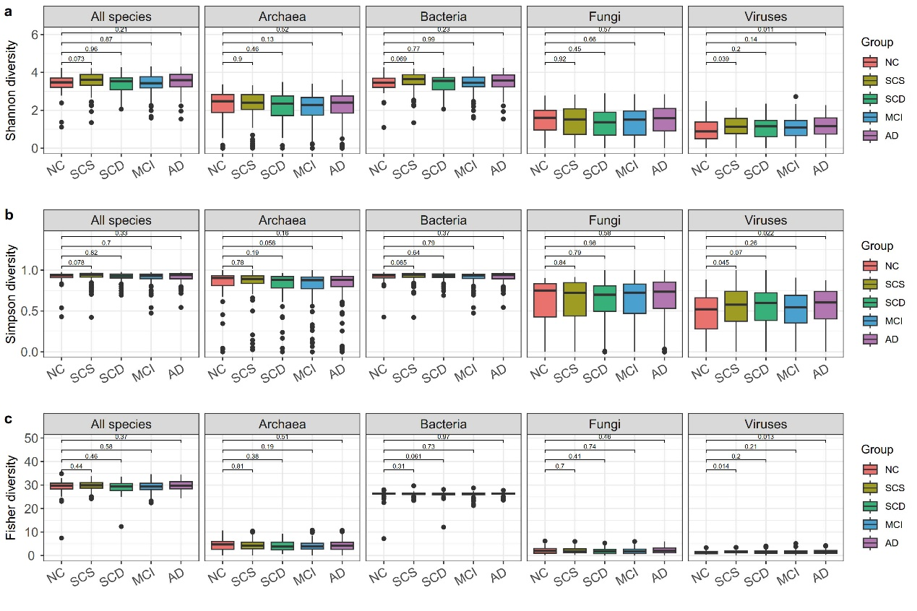
Figure S4. The alpha diversities of archaea, bacteria, fungi and viruses in the NC, SCS, SCD, MCI and AD groups. The (a) Shannon, (b) Simpson, (c) Fisher diversity. At the species level, the alpha diversity of archaea, bacteria, and fungi does not show significant differences among the five groups, whereas the alpha diversity of viruses is elevated in all four disease stages compared to NC, especially in the SCS and AD groups (Wilcoxon test, P-value<0.05).

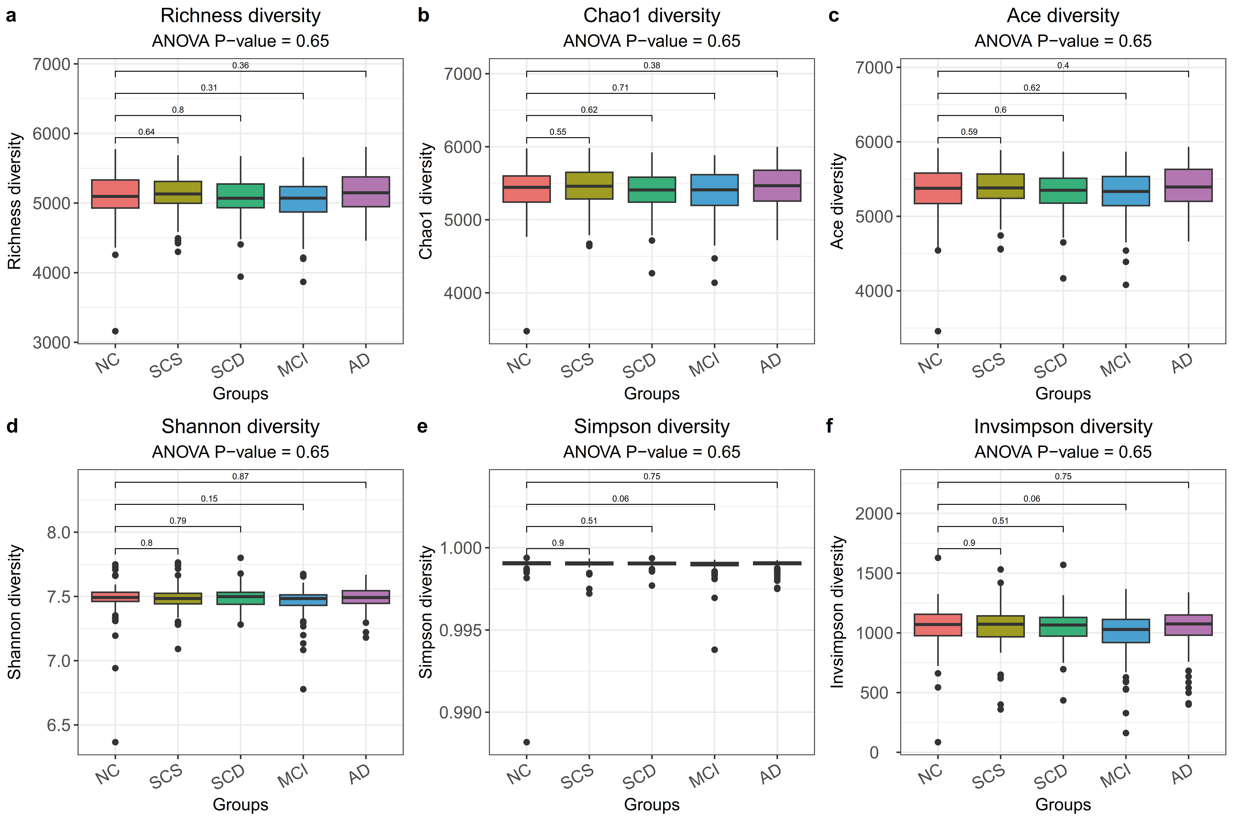
Figure S5. The alpha diversities of microbial KOs in the NC, SCS, SCD, MCI and AD groups. The (a) Richness, (b) Chao1 (c) Ace, (d) Shannon, (e) Simpson and (f) Invsimpson diversities of microbial KOs showed no difference between groups.
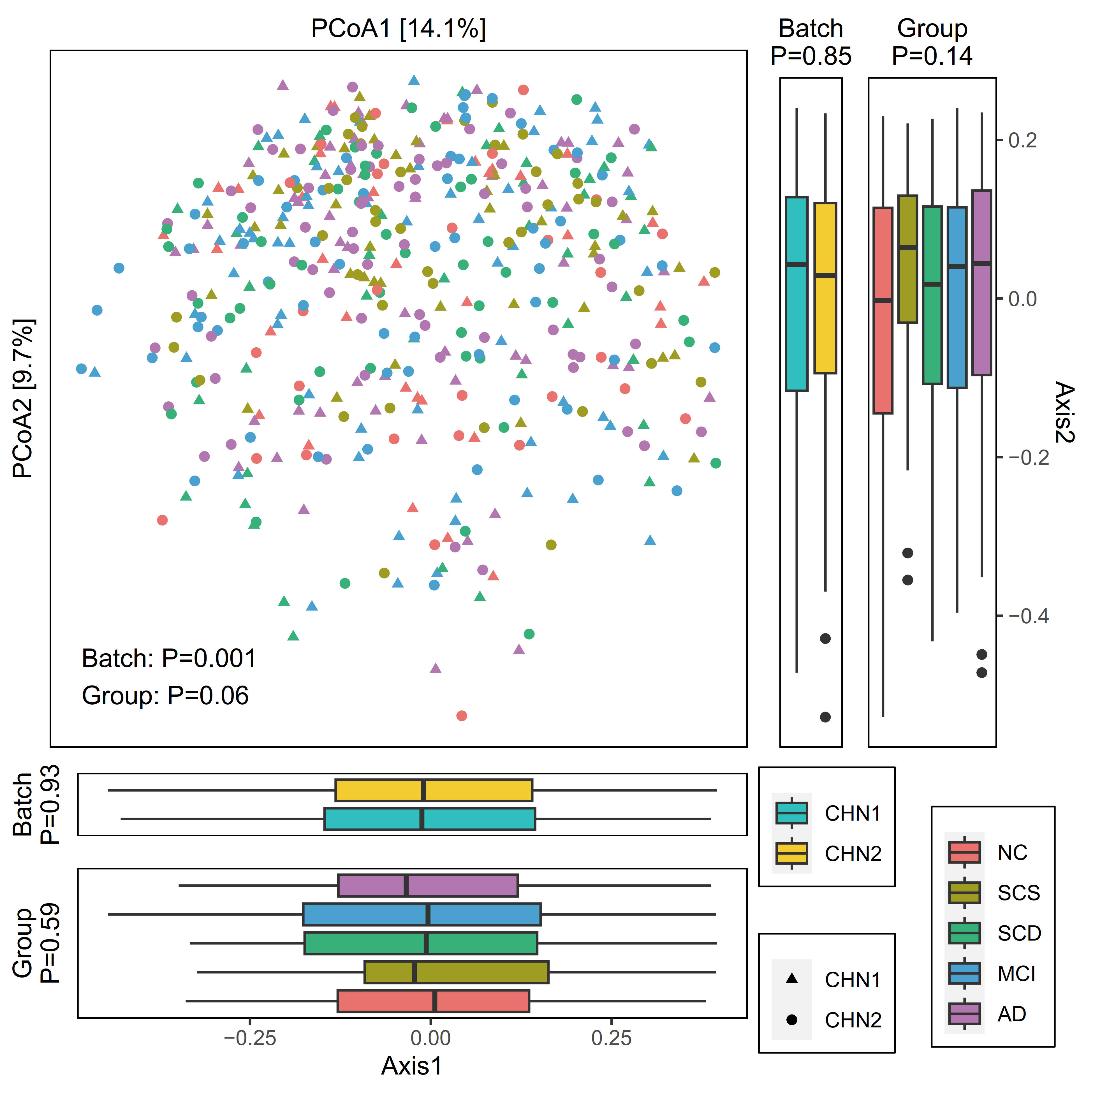
Figure S6. Principal coordinate analysis of samples based on Bray–Curtis distance of species. P values of beta diversity based on Bray–Curtis distance were calculated with PERMANOVA. The group (NC, n = 63; SCS, n = 82; SCD, n = 90; MCI, n = 119, AD, n = 122) is color-coded and the batch is indicated by different shapes. The upper-right and the bottom-left boxplots illustrate that samples projected onto the first two principal coordinates broken down by batch and disease status, respectively. P values of the first and second principal components were calculated with a two-sided Kruskal–Wallis test for batch and group. All boxplots represent the 25th–75th percentile of the distribution; the median is shown in a thick line at the middle of the box; the whiskers extend up to values within 1.5 times of IQR, and outliers are represented as dots.

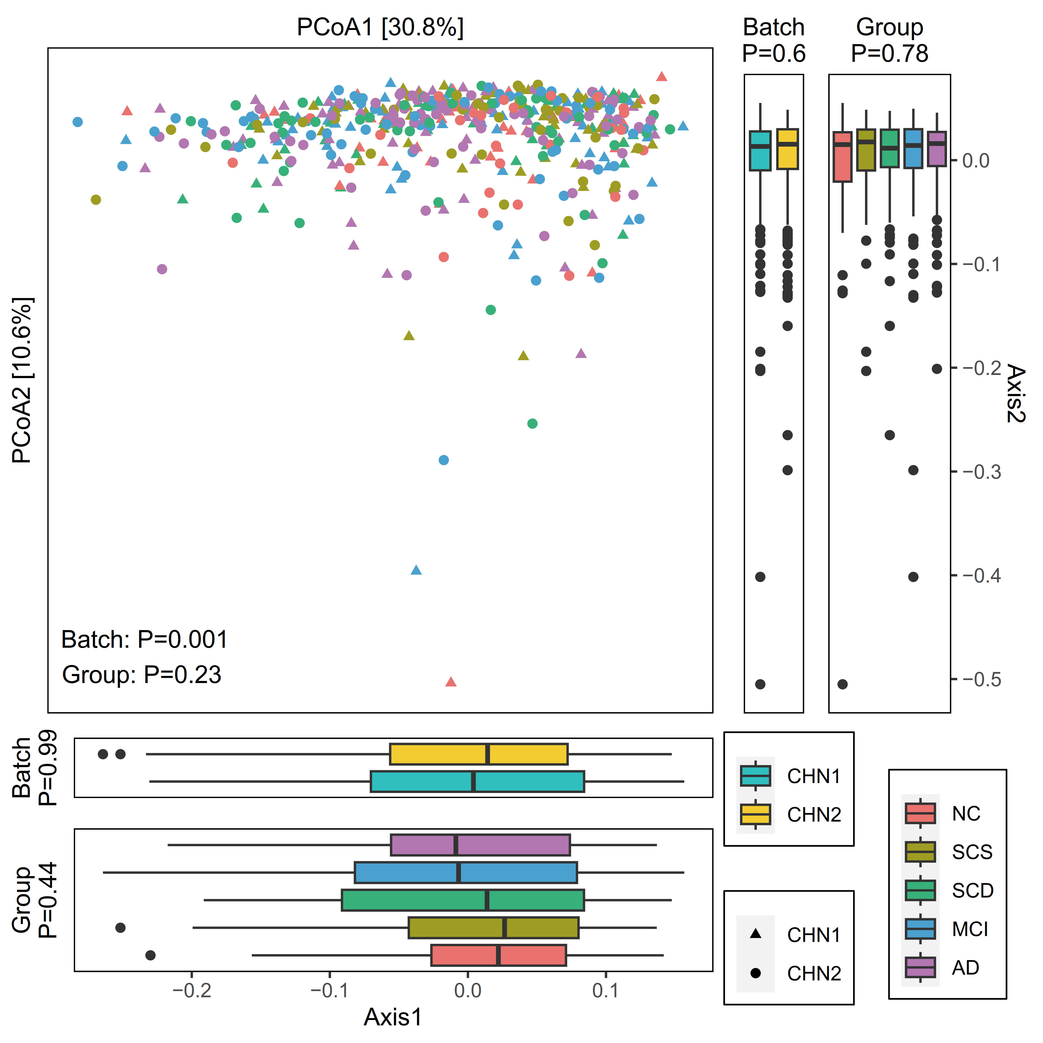
Figure S7. Principal coordinate analysis of samples based on Bray–Curtis distance of microbial KOs. P values of beta diversity based on Bray–Curtis distance were calculated with PERMANOVA. The group (NC, n = 63; SCS, n = 82; SCD, n = 90; MCI, n = 119, AD, n = 122) is color-coded and the batch is indicated by different shapes. The upper-right and the bottom-left boxplots illustrate that samples projected onto the first two principal coordinates broken down by batch and disease status, respectively. P values of the first and second principal components were calculated with a two-sided Kruskal–Wallis test for batch and group. All boxplots represent the 25th–75th percentile of the distribution; the median is shown in a thick line at the middle of the box; the whiskers extend up to values within 1.5 times of IQR, and outliers are represented as dots.

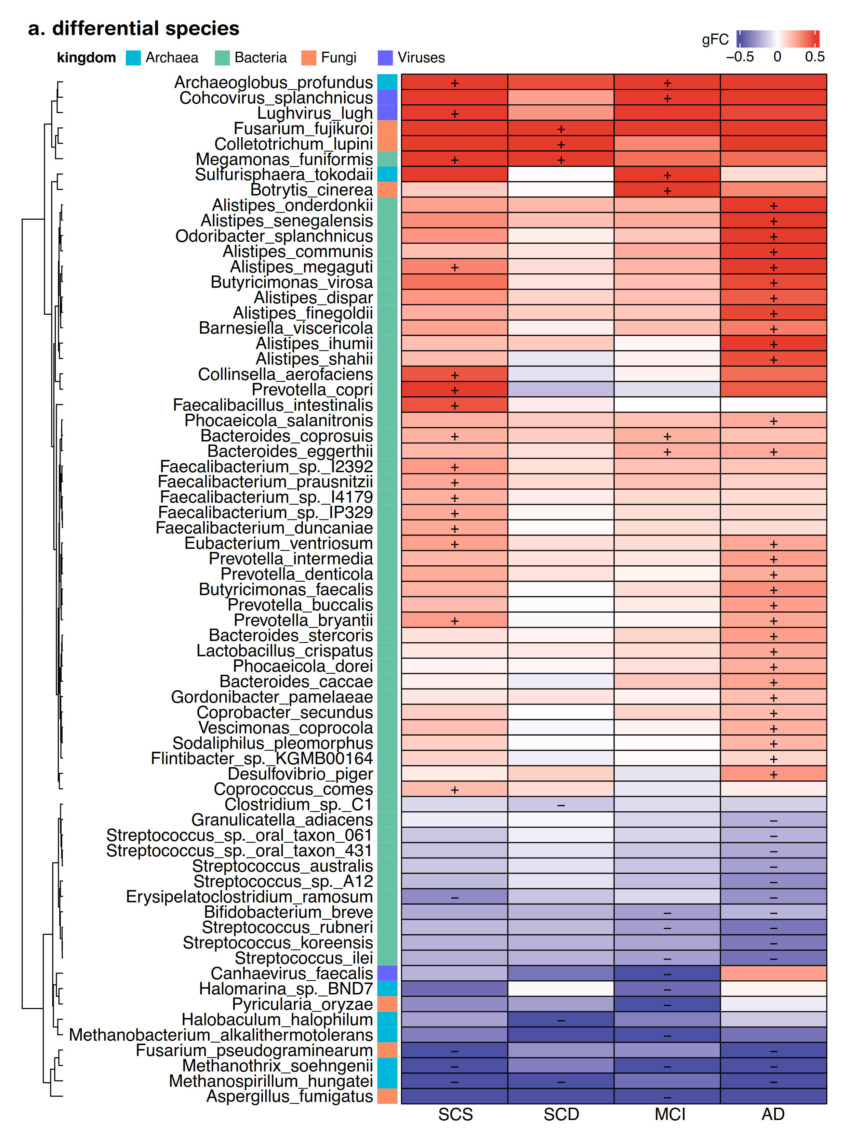
Figure S8. Heatmaps showing differential species in our AD cohort. The cell color and intensity represent the generalized fold change (gFC). Significant alterations are identified by MaAsLin2 and denoted as follows: +, elevation, q-value < 0.25; -, depletion, q-value < 0.25.

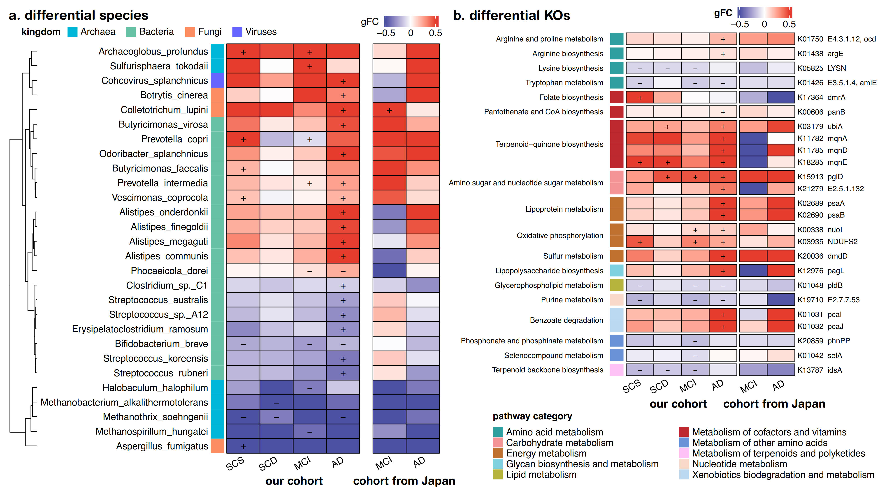
Figure S9. Differential microbial taxonomic and functional features in our cohort and the Japanese cohort. (a-b) Heatmap showing the differential microbial (a) species and (b) KOs. The cell color and intensity represent the generalized abundance fold change of differential species and KOs. Significant changes in our cohort are identified by MaAsLin2 and expressed as follows: +, elevation, q-value < 0.25; -, depletion, q-value < 0.25.

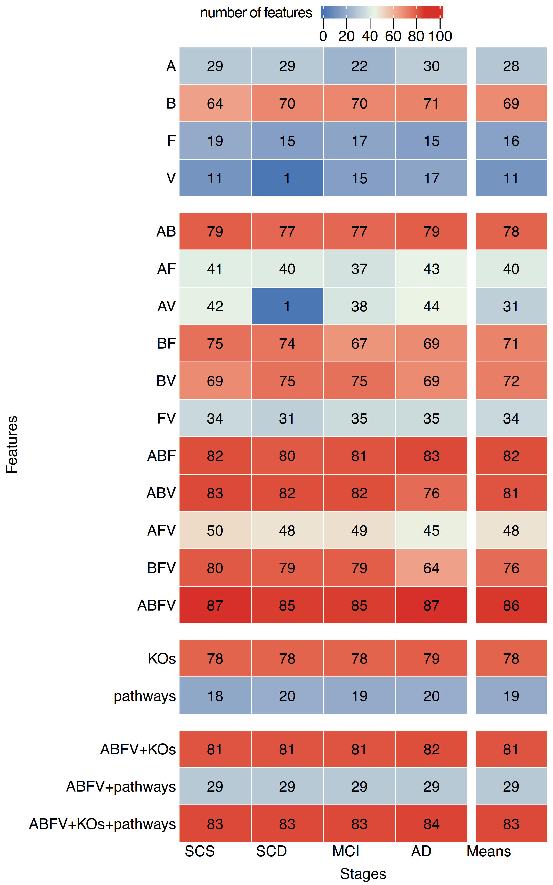
Figure S10. The number of features in classification models with 20 randomized five-fold cross-validations. First, the taxonomic and functional microbial features are selected through an iterative feature elimination method. The selected features were then used to construct a random forest classifier to distinguish various stages of Alzheimer's disease from healthy controls. To reduce the impact of random factors, we performed 20 randomized five-fold cross-validations and reported the average AUC and number of features.

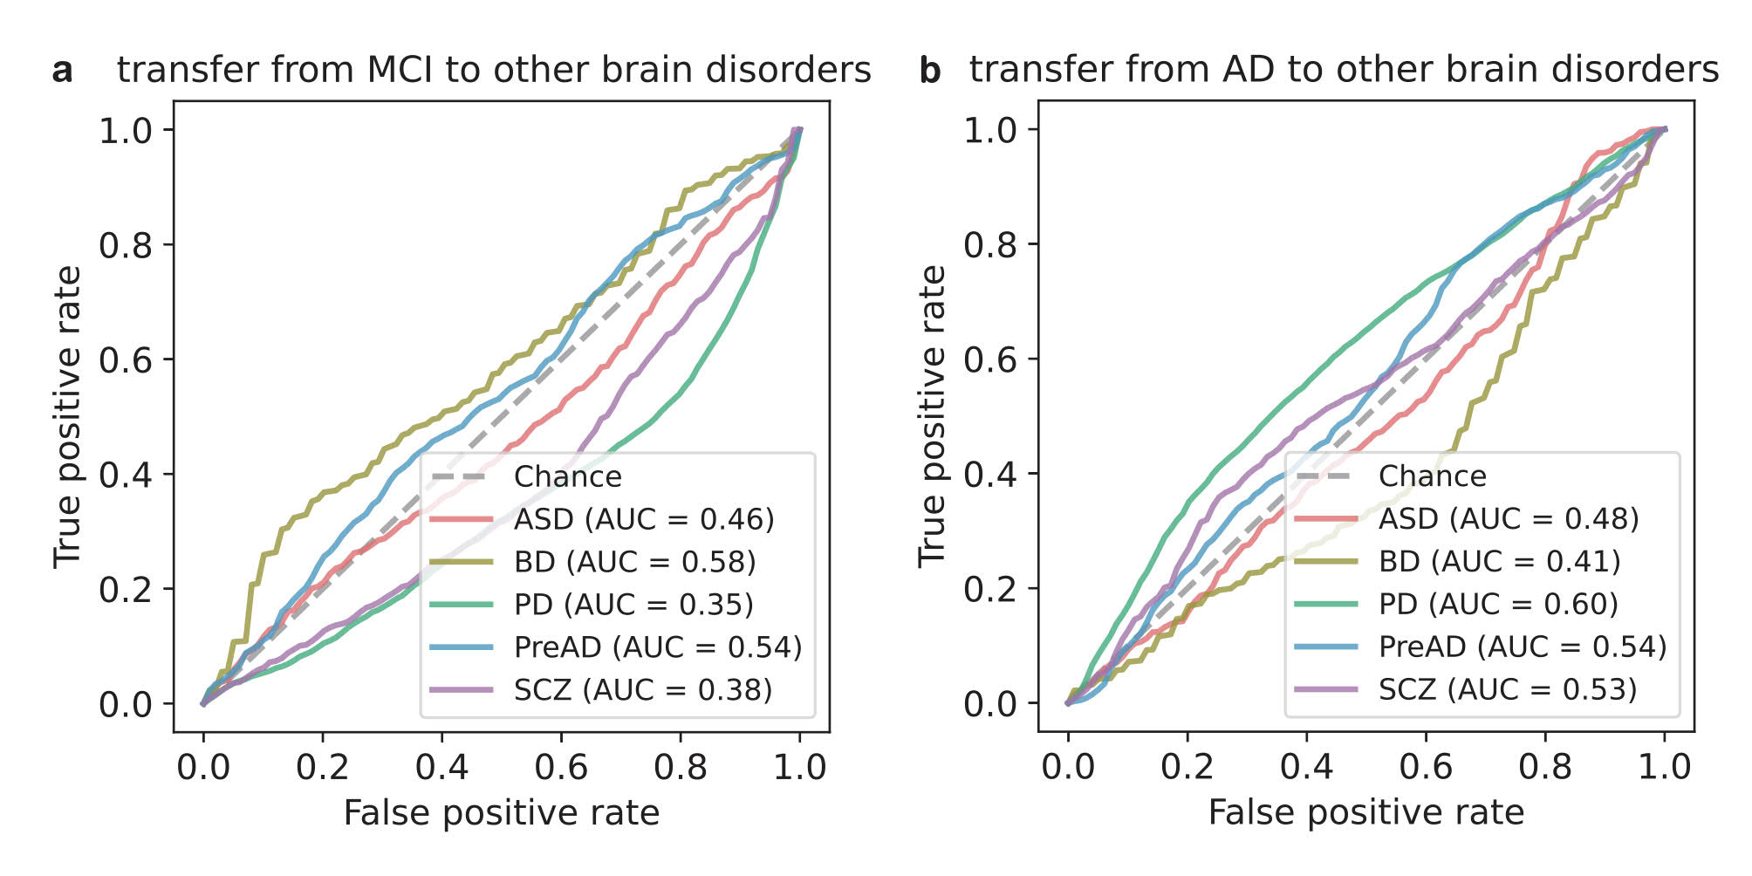
Figure S11. The ROC curves showing the performance of transferring to metagenomic datasets of other brain disorders. The (a) MCI and (b) AD classifiers were transferred to metagenomic datasets of other brain disorders, such as such as preclinical AD, Parkinson's disease (PD), schizophrenia (SCZ), bipolar disorder (BD) and autism spectrum disorder (ASD).

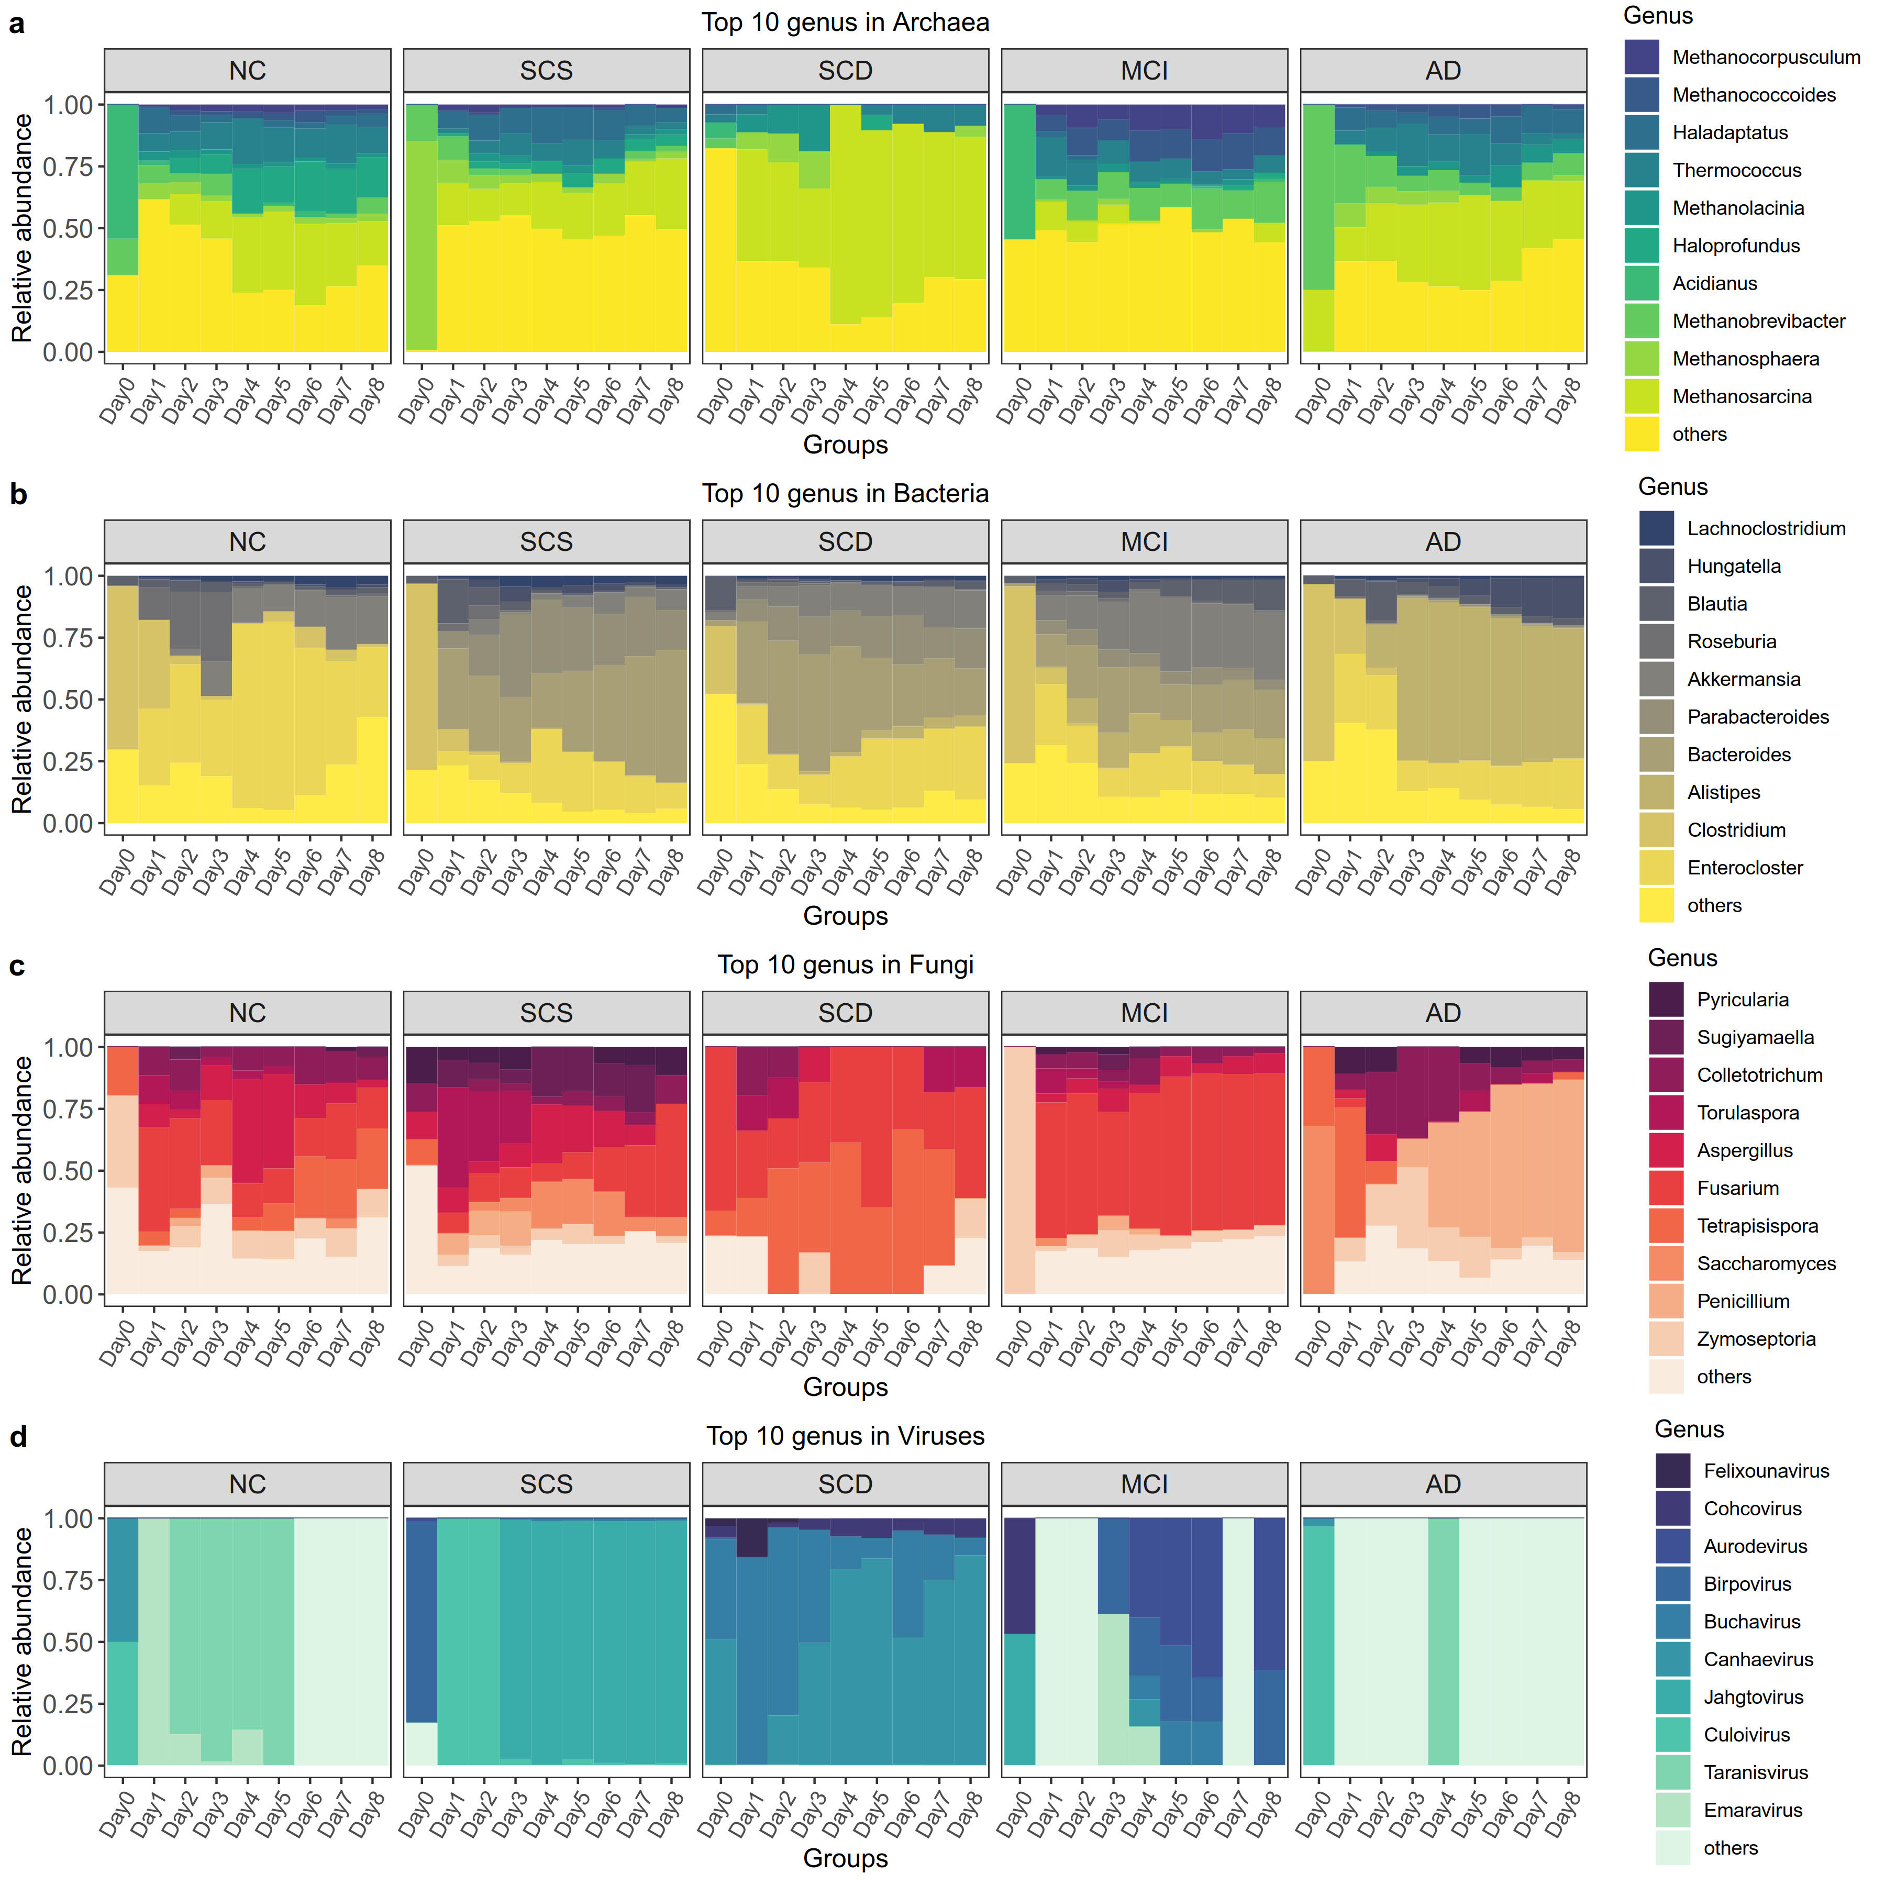
Figure S12. The heatmap showing the 10 most abundant genera in the in vitro gut simulator. The 10 most abundant genera in the (a) Archaea, (b)Bacteria, (c)Fungi and (d)Viruses kingdoms. The abundance of archaea, bacteria, and fungi exhibited significant fluctuations during the initial three days of cultivation. By the fourth day, these populations had stabilized, with the abundance of each genus remaining relatively constant thereafter.

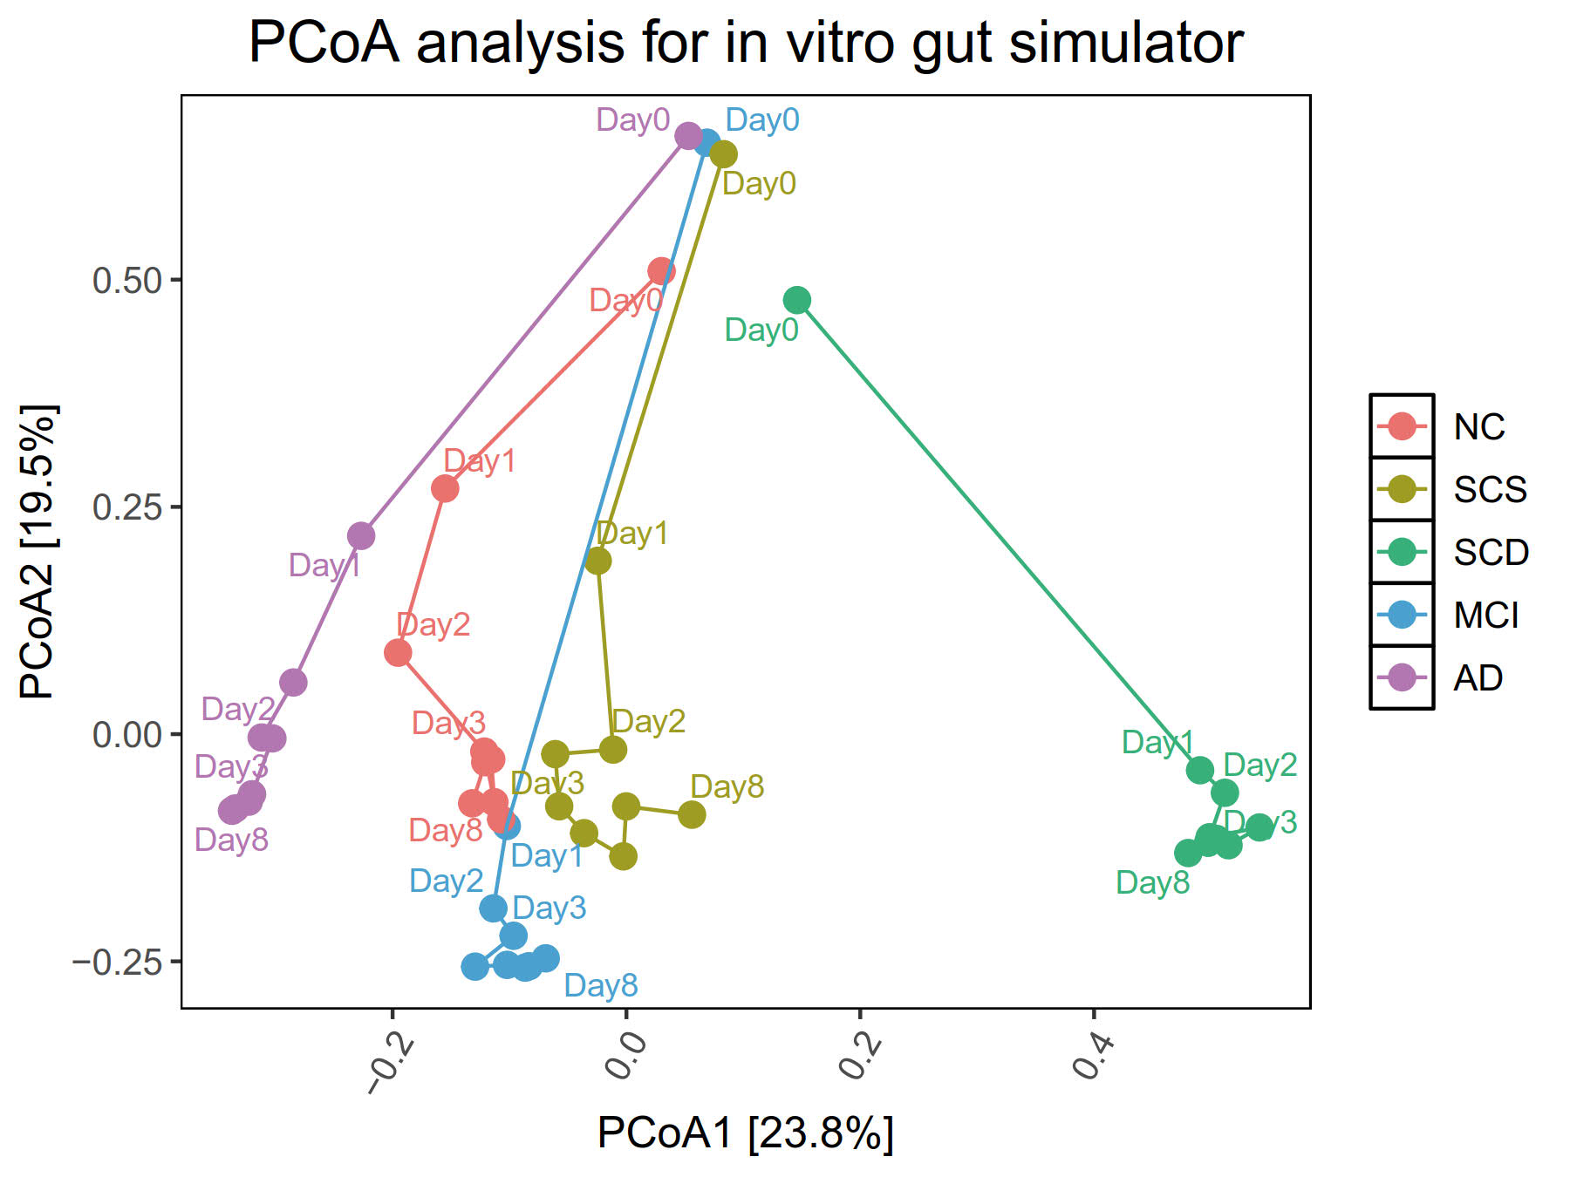
Figure S13. The scatter plot showing the Principal coordinate analysis (PCoA) analysis of microbial species in the in vitro gut simulator. The PCoA revealed drastic changes in microbial abundance during the first 3 days of culture, followed by stabilization in the gut simulator.

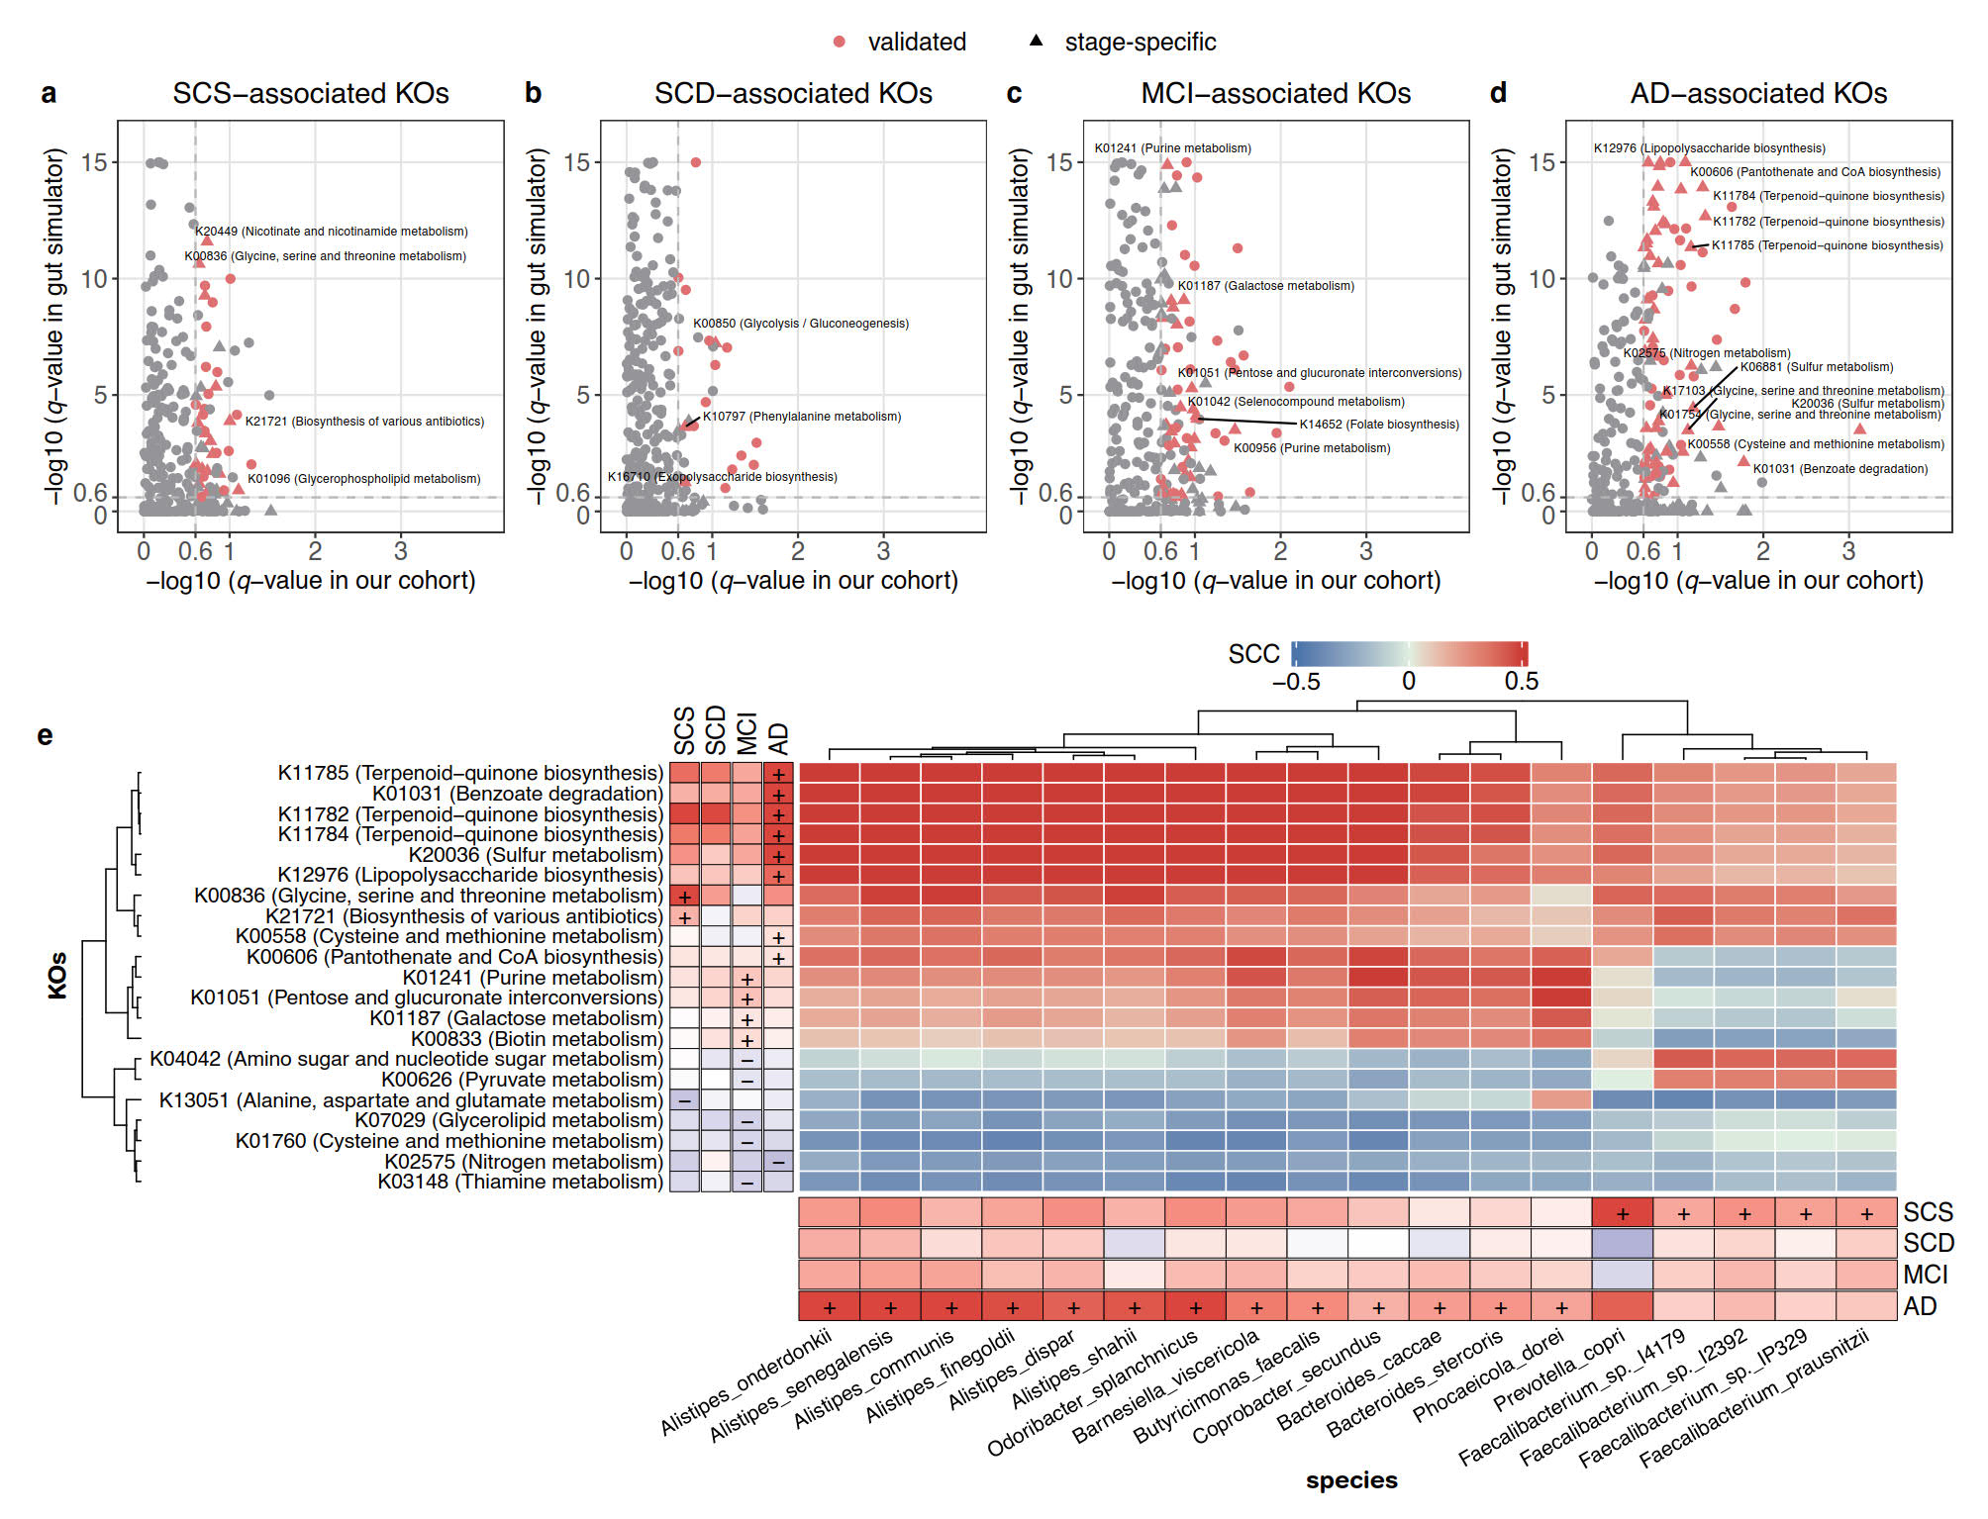
Fig S14. Stage-specific gene families validated by an in vitro gut simulator. (a-d) Scatter plots showing differential KOs validated by the gut simulator at the (a) SCS, (b) SCD, (c) MCI, and (d) AD stages. Red indicates KOs validated by the gut simulator. Triangles indicate stage-specific KOs. (e) Heatmap showing the Spearman correlation coefficients (SCCs) between the stage-specific KOs and species based on their abundance. Annotations on the left and below indicate stage-specific KOs and species.

References
1. Miebach L, Wolfsgruber S, Polcher A, Peters O, Menne F, Luther K et al. Which features of subjective cognitive decline are related to amyloid pathology? Findings from the DELCODE study. Alzheimers Res Ther 2019; 11(1): 66.
2. Zhao Q, Lv Y, Zhou Y, Hong Z, Guo Q. Short-term delayed recall of auditory verbal learning test is equivalent to long-term delayed recall for identifying amnestic mild cognitive impairment. PloS one 2012; 7(12): e51157.
3. Guo Q-H, Hong Z, W.X S, Sun Y-M, C.Z L. Boston naming test using by Chinese elderly, patient with mild cognitive impairment and Alzheimer's dementia. Chin Ment Health J 2006; 20: 81-85.
4. Shi Y-b, Guo Q-H, Yu H, Zhao Q-h, Hong Z. Validity study of Animal-City Alternating Form Fluency Test in the identification of mild cognitive impairment and Alzheimer's disease. Chinese Journal of Contemporary Neurology and Neurosurgery 2015; 15: 560-564.
5. Zhao Q, Guo Q, Li F, Zhou Y, Wang B, Hong Z. The Shape Trail Test: application of a new variant of the Trail making test. PLoS One 2013; 8(2): e57333.
6. Katzman R, Zhang MY, Ouang Ya Q, Wang ZY, Liu WT, Yu E et al. A Chinese version of the Mini-Mental State Examination; impact of illiteracy in a Shanghai dementia survey. J Clin Epidemiol 1988; 41(10): 971-978.
7. Chen KL, Xu Y, Chu AQ, Ding D, Liang XN, Nasreddine ZS et al. Validation of the Chinese Version of Montreal Cognitive Assessment Basic for Screening Mild Cognitive Impairment. J Am Geriatr Soc 2016; 64(12): e285-e290.
8. Pan FF, Wang Y, Huang L, Huang Y, Guo QH. Validation of the Chinese version of Addenbrooke's cognitive examination III for detecting mild cognitive impairment. Aging Ment Health 2021: 1-8.
9. Farias ST, Mungas D, Reed BR, Cahn-Weiner D, Jagust W, Baynes K et al. The measurement of everyday cognition (ECog): scale development and psychometric properties. Neuropsychology 2008; 22(4): 531-544.
10. McKhann GM, Knopman DS, Chertkow H, Hyman BT, Jack CR, Jr., Kawas CH et al. The diagnosis of dementia due to Alzheimer's disease: recommendations from the National Institute on Aging-Alzheimer's Association workgroups on diagnostic guidelines for Alzheimer's disease. Alzheimers Dement 2011; 7(3): 263-269.
11. Bondi MW, Edmonds EC, Jak AJ, Clark LR, Delano-Wood L, McDonald CR et al. Neuropsychological criteria for mild cognitive impairment improves diagnostic precision, biomarker associations, and progression rates. J Alzheimers Dis 2014; 42(1): 275-289.
12. Edmonds EC, Delano-Wood L, Galasko DR, Salmon DP, Bondi MW, Alzheimer's Disease Neuroimaging I. Subtle Cognitive Decline and Biomarker Staging in Preclinical Alzheimer's Disease. J Alzheimers Dis 2015; 47(1): 231-242.
13. Huang L, Chen K, Liu Z, Guo Q. A conceptual framework for research on cognitive impairment with no dementia in memory clinic. Current Alzheimer Research 2020; 17(6): 517-525.
14. Wood DE, Lu J, Langmead B. Improved metagenomic analysis with Kraken 2. Genome biology 2019; 20: 1-13.
15. Lu J, Rincon N, Wood DE, Breitwieser FP, Pockrandt C, Langmead B et al. Metagenome analysis using the Kraken software suite. Nature protocols 2022; 17(12): 2815-2839.
16. Li D, Liu CM, Luo R, Sadakane K, Lam TW. MEGAHIT: an ultra-fast single-node solution for large and complex metagenomics assembly via succinct de Bruijn graph. Bioinformatics 2015; 31(10): 1674-1676.
17. Hyatt D, Chen G-L, LoCascio PF, Land ML, Larimer FW, Hauser LJ. Prodigal: prokaryotic gene recognition and translation initiation site identification. BMC bioinformatics 2010; 11: 1-11.
18. Fu L, Niu B, Zhu Z, Wu S, Li W. CD-HIT: accelerated for clustering the next-generation sequencing data. Bioinformatics 2012; 28(23): 3150-3152.
19. Cantalapiedra CP, Hernández-Plaza A, Letunic I, Bork P, Huerta-Cepas J, Tamura K. eggNOG-mapper v2: Functional Annotation, Orthology Assignments, and Domain Prediction at the Metagenomic Scale. Molecular Biology and Evolution 2021; 38(12): 5825-5829.
20. Bevins RA, Besheer J. Object recognition in rats and mice: a one-trial non-matching-to-sample learning task to study'recognition memory'. Nature protocols 2006; 1(3): 1306-1311.

