**Marketing Analysis**

1. **Introduction**
   1. Project Overview
   2. Data Source
   3. Acknowledgments
   4. Data Overview
      1. Structure
      2. Data Cleaning Needs
   5. Research Questions
   6. Goals
2. **Research**
   1. Purchasing Behavior by Education and Income
   2. Different product types purchasing behavior by Income
   3. Purchasing Behavior by Age
   4. Purchasing Behavior by Country
   5. Purchasing Behavior by Visit website
   6. Purchasing Behavior by Martial Status
   7. Purchasing Behavior by child at home
3. **Conclusions**

## **Introduction**

**1.1** **Project Overview**

This notebook presents a comprehensive analysis of marketing data to uncover relationships between customer demographics, purchasing behaviors, and product preferences. The insights derived from this analysis can inform targeted marketing strategies and enhance customer engagement.

**1.2** **Data Source**

The dataset was retrieved from Kaggle: <https://www.kaggle.com/jackdaoud/marketing-data> .

Detailed information about the features can be found in the "Column" section on the website.

**1.3** **Acknowledgments**

This analysis builds upon code inspiration from the following notebook: 

**1.4** **Data Overview**

1.4.1 Structure

* Rows: 2240
* Columns: 28
* Data types: Predominantly integers

1.4.2 Data Cleaning Needs

* Missing values: 24 in the "income" column
* Inconsistent data types in "income"
* Extra space in the "income" column name
* Potential for enhancing column name consistency

**1.5** **Research Questions**

This analysis aims to explore the associations between the following independent variables and dependent variables:

* income
* education
* age
* country
* maritalStatus

The goal will be to see how these independent variables associate with the following dependent variables:

* mnt_wines : amount of wines purchased
* mnt_fruits : amount of fruit purchased
* mnt_meat_products : amount of meat purchased
* mnt_fish_products : amount of fish purchased
* mnt_sweet_products : amount of sweet purchased
* mnt_gold_products : amount of gold products purchased
* num_deals_purchases: Count of deals purchased
* num_web_purchases: Count of web purchased
* num_catalog_purchases: Count of catalog purchased
* num_store_purchases: Count of store purchased

## **1.6 Goals**

The goal for this project was to do the following:

1. Does a shopper's education level relate to their purchasing behavior?
2. Does a shopper's income relate to their purchasing behavior?
3. Does a shopper's age relate to their purchasing behavior?
4. Does a shopper's country relate to their purchasing behavior?
5. Does a shopper's number of web visits relate to their overall purchasing?
6. Does a shopper's marital Status relate to their purchasing behavior?
7. Having kids or teens at home affect and relate to purchasing behavior?

Analyze variables within the data to gain patterns and insights on these questions

## **Analysis**

### **Purchasing Behavior by Education and Income**

There is a fairly strong, positive linear relationship between income and Catalog, Store and Web purchases

Between income and Deals purchase, however, there is no obvious relationship. It appears there might be a weak, negative linear relationship so deals purchases appears in lower income.

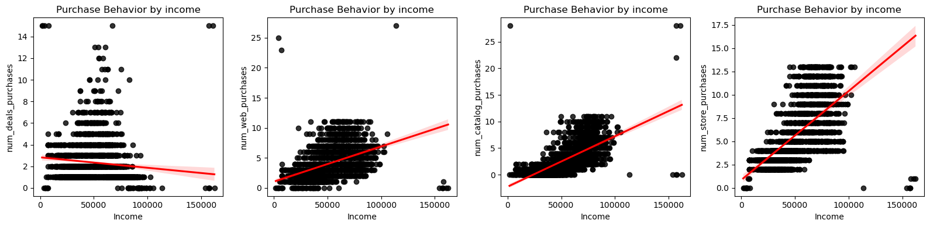

The overall relationship between income and total purchases is strong and linear. Unfortunately, it is still hard to decipher any relationship with the education and total purchases as the points are scattered randomly across the plot.

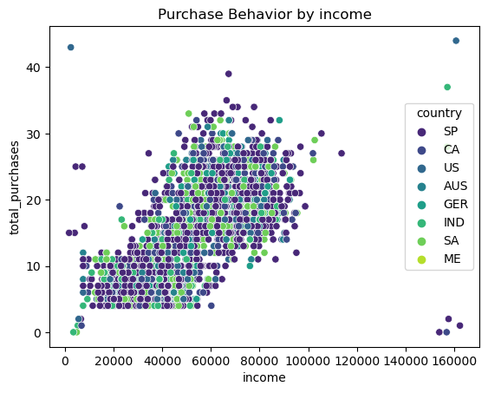

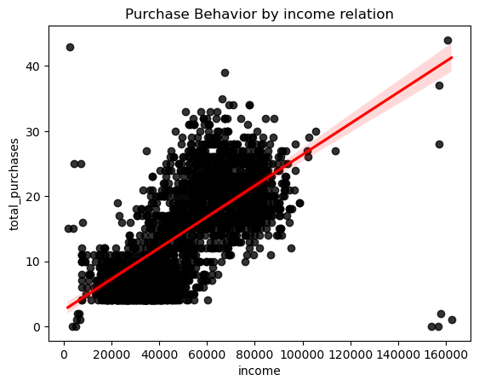

### **Different product types purchasing behavior by Income**

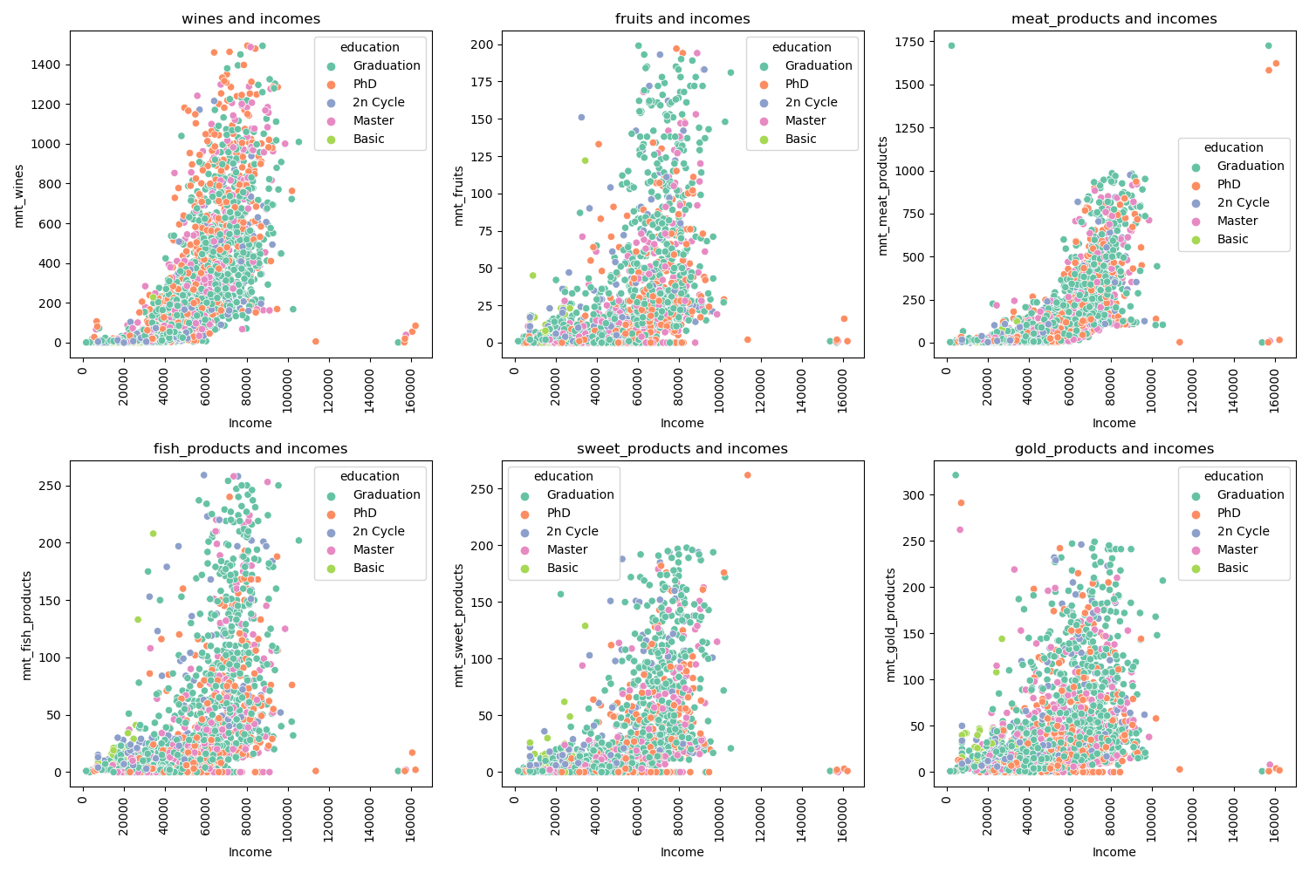

There is a fairly strong linear, positive relationship between the variables across the board. It is still hard to see how education plays a role, however.

### **Purchasing Behavior by Age**

Bar chart showed that 36 to 50 and 51 to 70 year-old age groups dominated shopping at the store.

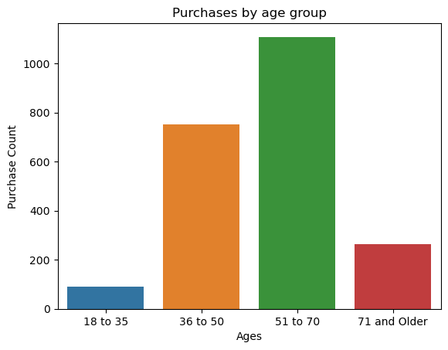

Across the board, age group does not seem to effect purchasing habits. Wine is the most popular bought item for each age group followed by meat products. The least popular bought item is fruits for each age group.

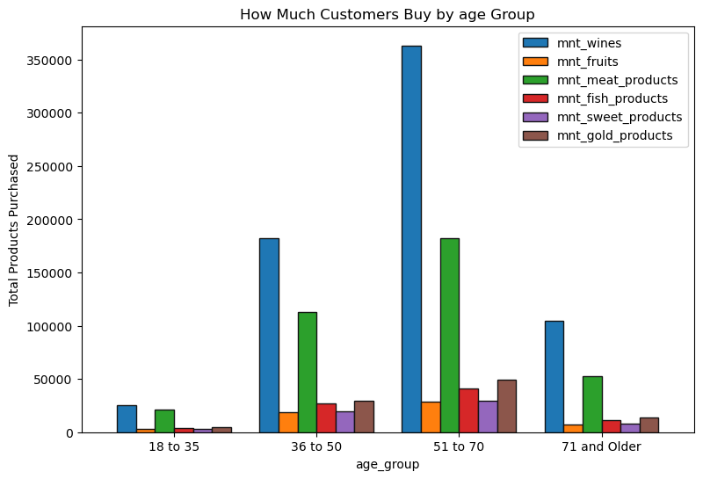

The charts yield below some very interesting insights. Here are some notable ones:

* 18 to 35 and 71 and older age groups tend to be the least interested in deals.
* On average, 71 and older age group customers tend to shop the most online, in store, and through the catalog.
* 36 to 50 and 51 to 70 age groups are interested in deals. Most likely this is because they receive more deals since they have more loyal customers.
* 71 and older age groups tend to be the interested in store purchases.

This information could be super helpful for a marketing department as strategies could be used to increase 36 to 50 and 71 and older customers for the store.

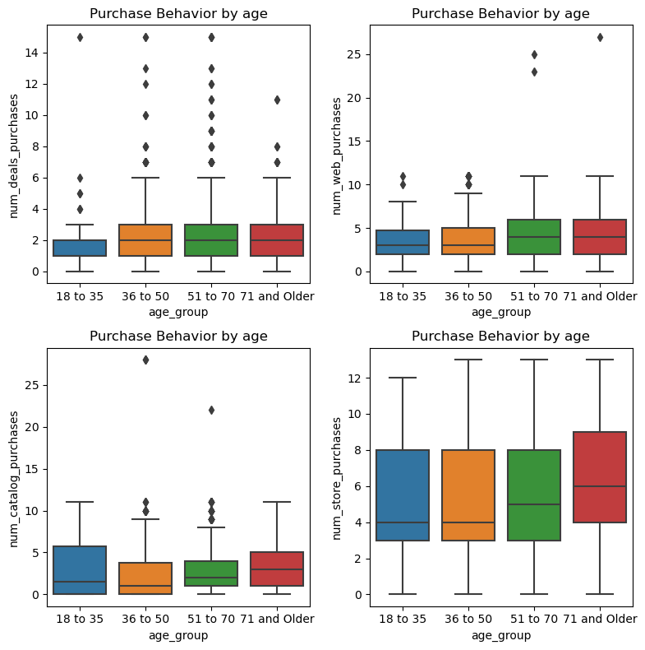

### **Purchasing Behavior by Country**

Countries' spending is similar, with the US slightly ahead and Montenegro at the bottom.

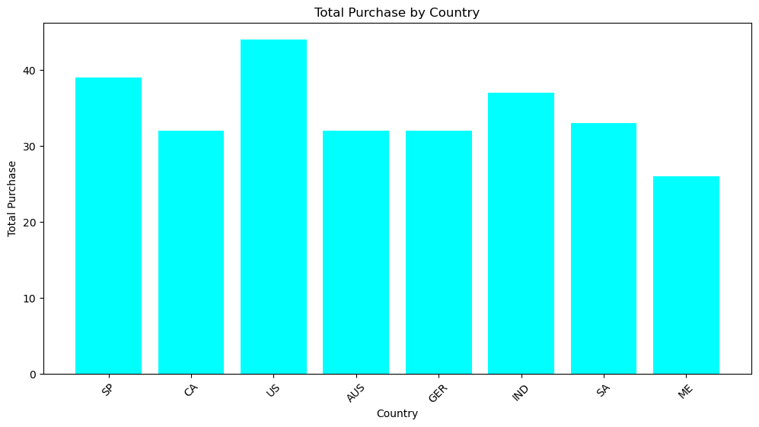

Web and catalog shopping are Montenegro's preferred channels, but their exceptional love for wine steals the show, even though they spend the least overall.

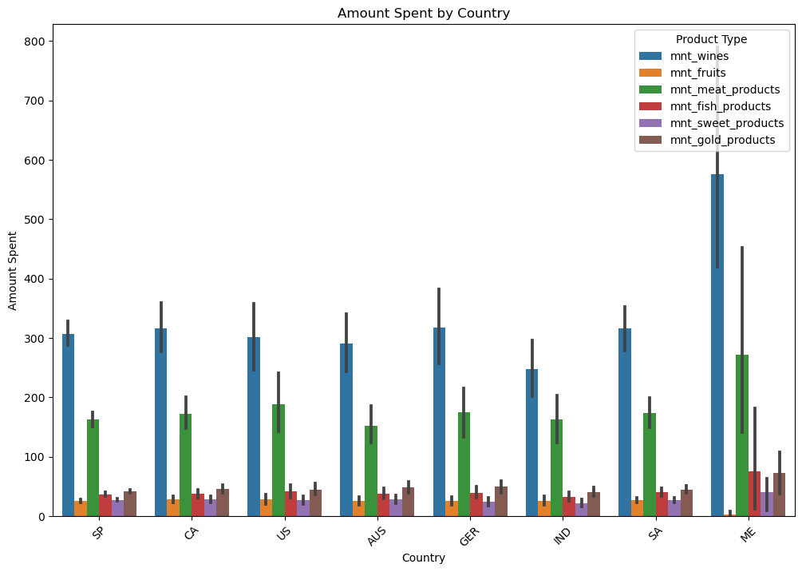

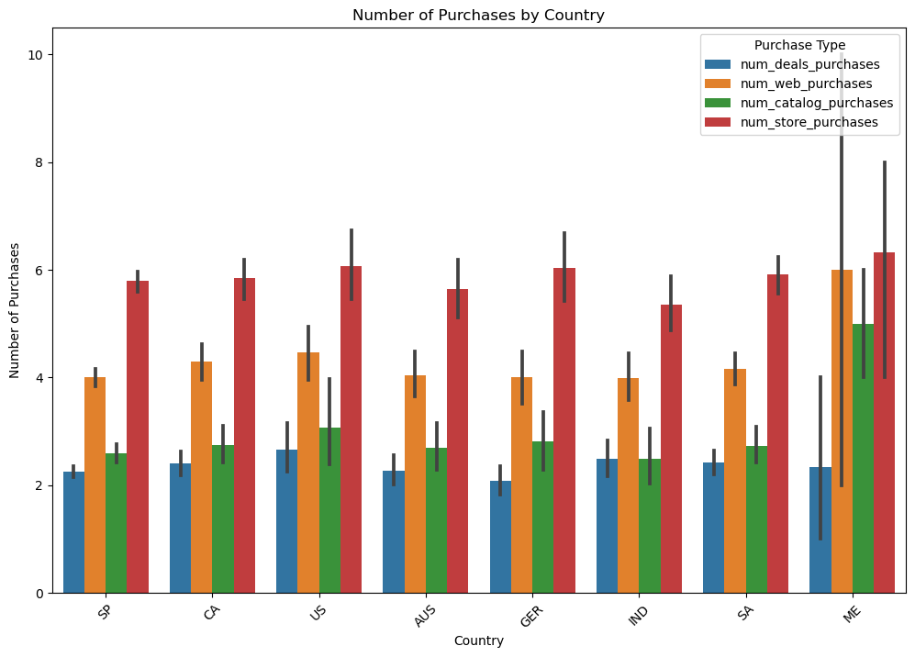

### **Purchasing Behavior by Visit website**

We're facing a challenge in keeping our website content always fresh and easily accessible. This translates to a pattern in purchase behavior: while regular and highly active users (visiting 8+ times) are the main source of online and in-store purchases, less frequent visitors (checking in less than 7 times) primarily browse products and might convert through physical stores. Interestingly, users with a mid-range engagement (9-17 visits) seem to be deal-focused, potentially waiting for specific offers before completing a purchase.

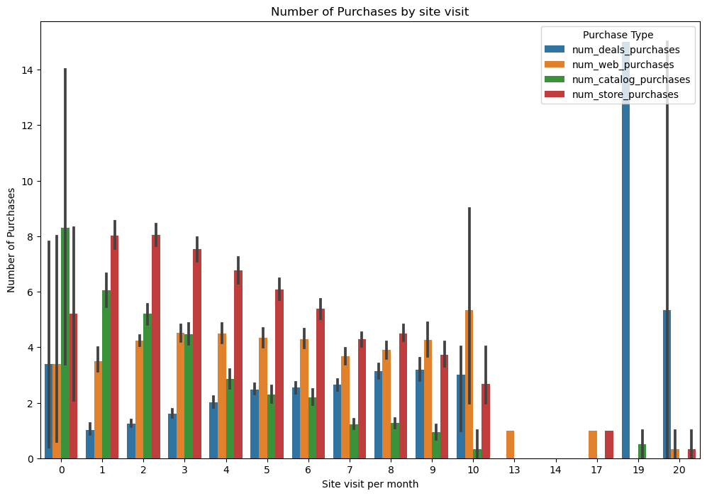

### **2.6** **Purchasing Behavior by Martial Status**

Although marital status doesn't significantly impact overall purchases, a fascinating trend emerges when looking at specific products: widows and divorced individuals consistently buy more wine compared to married and partnered customers.

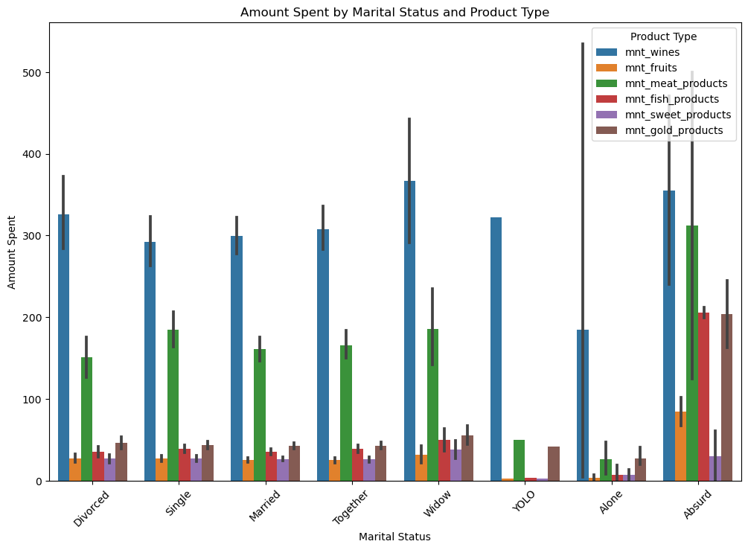

### **2.7** **Purchasing Behavior by child at home**

As the number of children increases, the frequency of both store and catalog purchases appears to decrease. For instance, families with three children might opt for online grocery delivery instead of a long trip to the supermarket with kids in tow. This could be due to various factors like time constraints, the need for convenience, or a shift in household priorities.

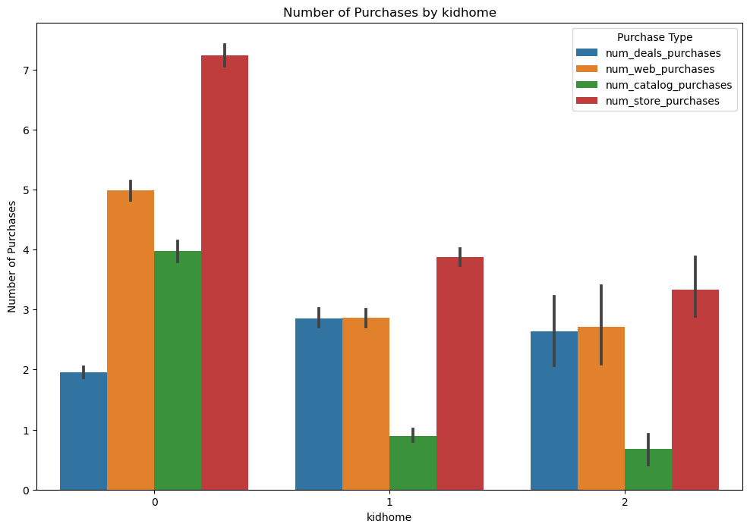

Families with teens seem to be going lighter on the steaks! Data shows they buy less meat compared to households without teenagers. Maybe it's all those veggie burgers those teens love popping on the grill. On the other hand, gold things are flying off the shelves.

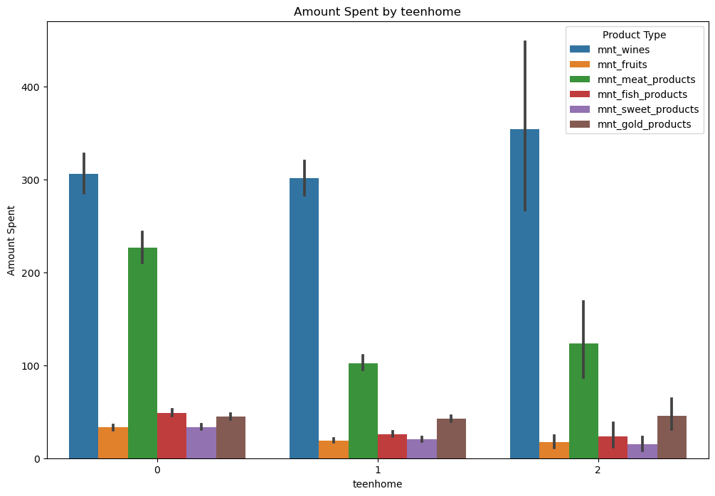

## **Conclusions**

* **Purchasing Power and Preferences:**
  + Income: Strong positive correlation with total purchases except Deals (neutral or weak negative). Education's role unclear.
  + Product Types: All product categories positively correlated with income. Education's impact unclear.
  + Wine: Most popular across all income and age groups.
* **Age and Shopping Habits:**
  + Store Preferences: Dominated by 36-50 and 51-70 age groups.
  + Overall Trends: No significant overall impact on purchasing habits. Wine most popular, fruits least popular across all ages.
  + Subgroups:
    - 18-35 and 71+ least interested in deals.
    - 71+ shop online, in-store, and through catalog the most.
    - 36-50 and 51-70 likely attracted to deals due to higher loyalty program engagement.
* **Geographic Variations:**
  + Overall Spending: Similar across countries, with US slightly ahead and Montenegro at the bottom.
  + Montenegro:
    - Lowest spender but highest wine purchases.
    - Prefers web and catalog shopping.
* Website Engagement and Conversion:
  + Visitor Frequency:
    - Regular visitors (8+) drive online and in-store purchases.
    - Occasional visitors (1-7) browse but convert in physical stores.
    - Mid-range visitors (9-17) focus on deals, waiting for specific offers.
  + Website Freshness: Keeping content fresh and accessible is crucial for conversion.
* **Family Dynamics and Shopping Patterns:**
  + Marital Status: No significant impact on overall purchases, but widows/divorced buy more wine.
  + Children/Teens: Lower physical store purchases with increased family size, likely due to convenience or preference.
* **Recommendations:**
  + Tailor campaigns to specific customer segments based on these insights.
  + Enhance website content and accessibility to drive frequent visits and conversions.
  + Leverage targeted deals and product offerings based on demographics and behavior.
  + Further research product preferences associated with marital status and family dynamics.
* **Overall:** 
  + This data-driven analysis reveals valuable customer insights to inform targeted marketing strategies and optimize the shopping experience for different customer segments.