2. Analysis

2.1 - conversion status

There is 5633 species that are not protected and other conversion status is

Conservation status size

Endangered 16

In Recovery 4

No Intervention 5633

Species of Concern 161

Threatened 10

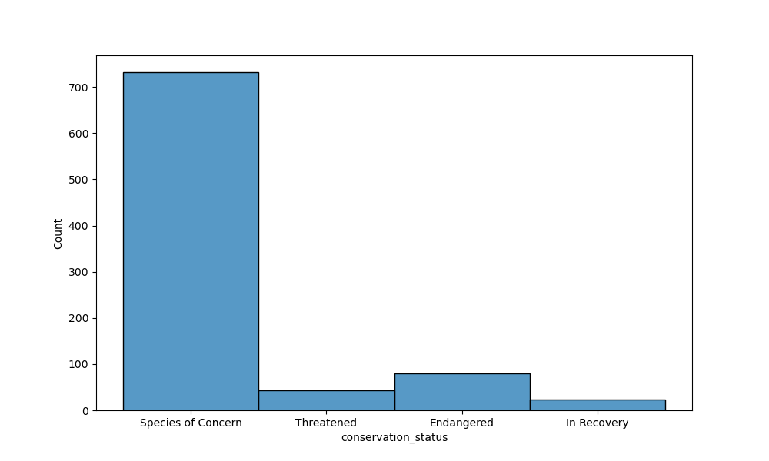

2.2- protection status of species

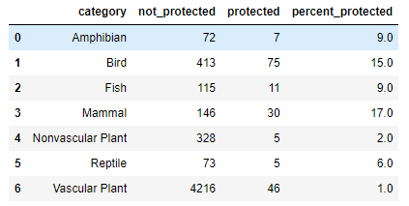

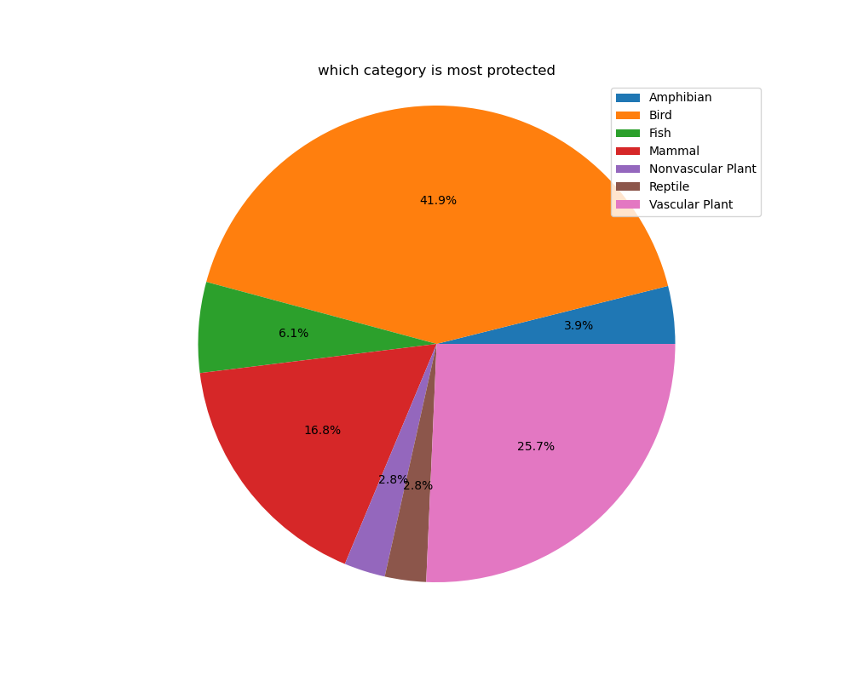

2.3- endangered species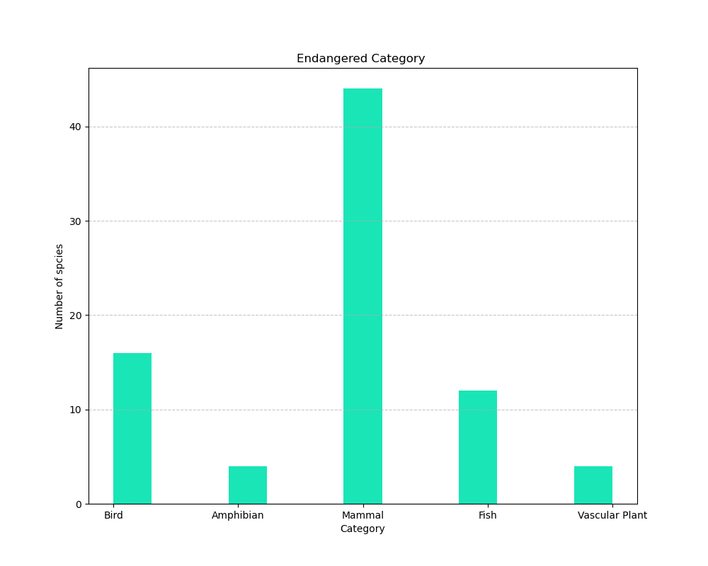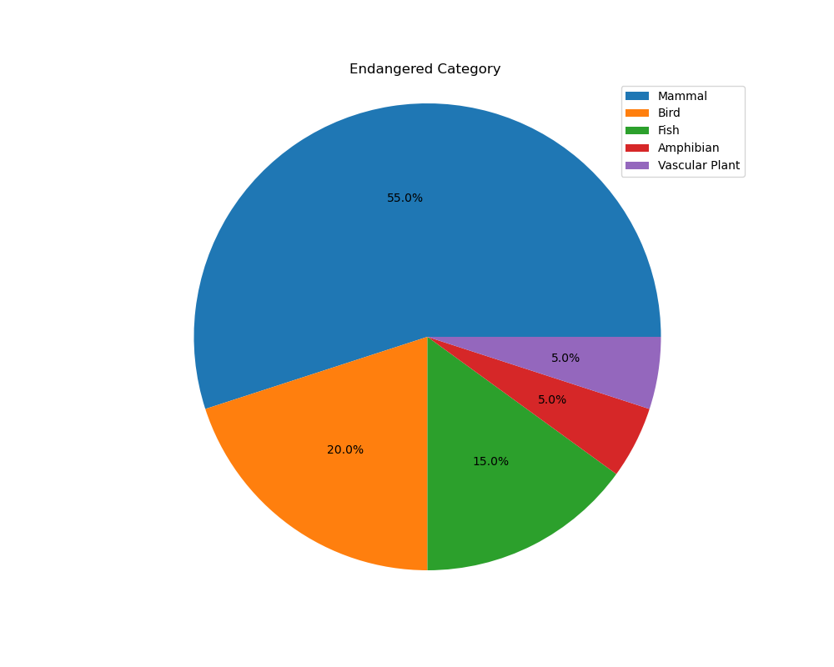

2.4 - threatened species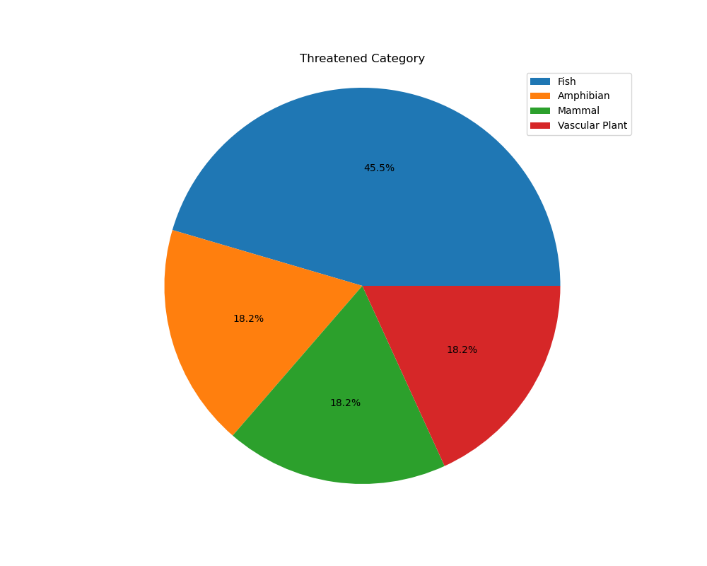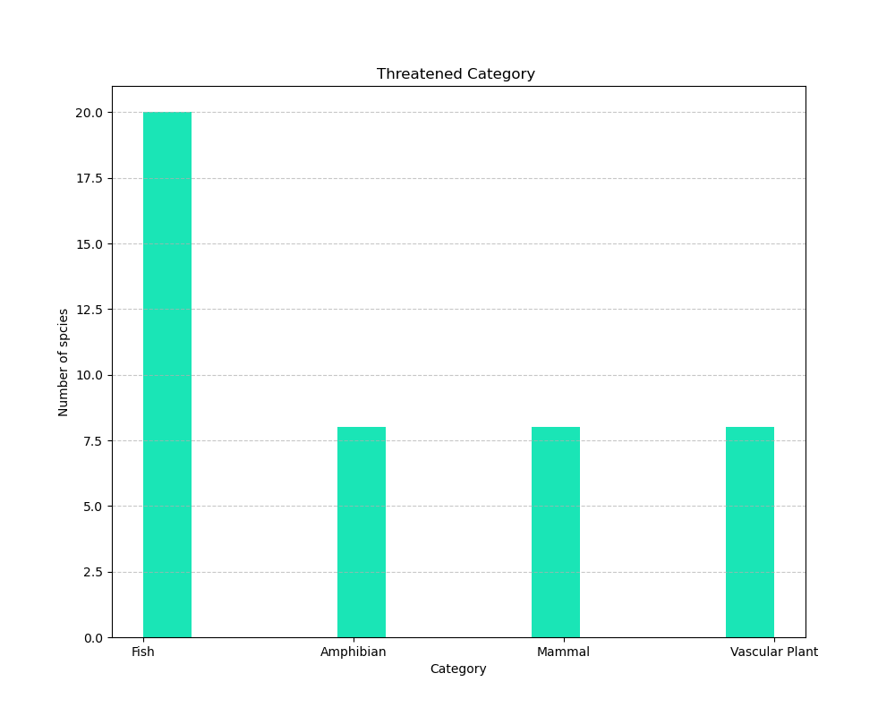

2.5 - Species of Concern

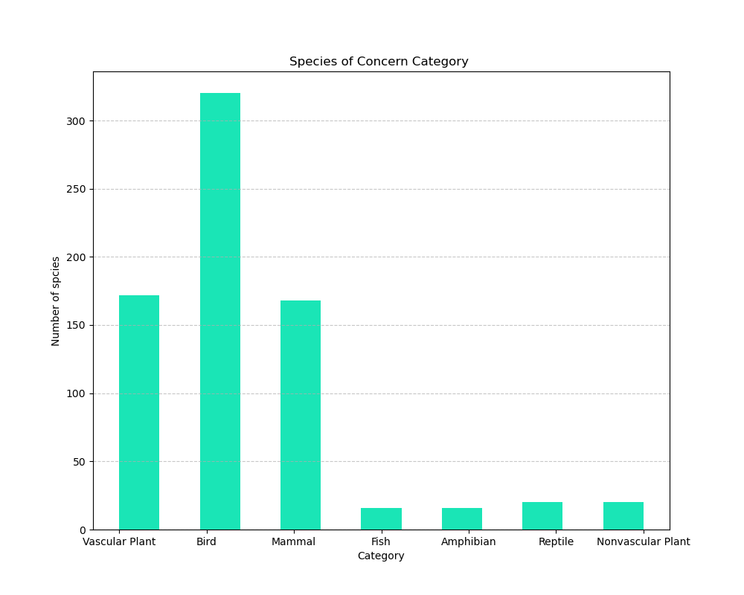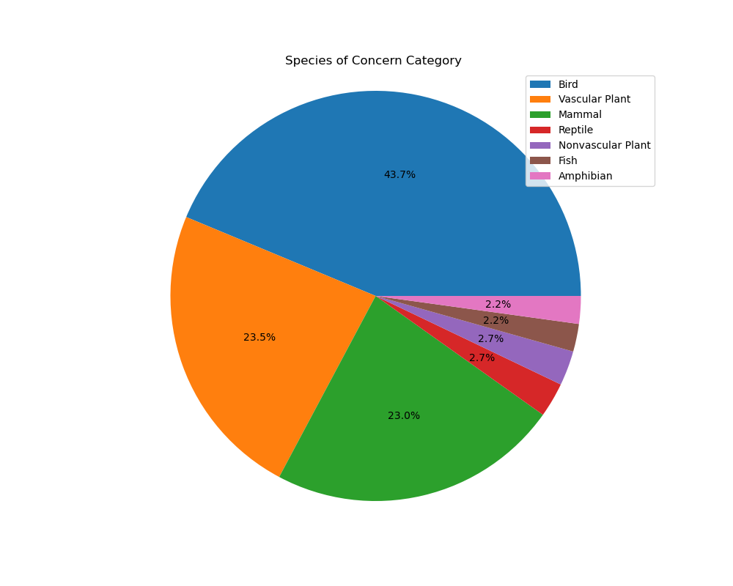

Most Endangered Species Are: ['Vermivora bachmanii']

Park That Have The Most Endangered Species Is: ['Yosemite National Park']

Animal Category That is the most Endangered Is: ['Vascular Plant']

Most In Recovery Species Are: ['Pelecanus occidentalis']

Park That Have The Most In Recovery Species Is: ['Yosemite National Park']

Animal Category That is the most In Recovery Is: ['Mammal']

Most Species of Concern Species Are: ['Zizia trifoliata']

Park That Have The Most Species of Concern Species Is: ['Yosemite National Park']

Animal Category That is the most Species of Concern Is: ['Vascular Plant']

Most Threatened Species Are: ['Ursus arctos horribilis']

Park That Have The Most Threatened Species Is: ['Yosemite National Park']

Animal Category That is the most Threatened Is: ['Vascular Plant']

2.6 - Parks that Vermivora Bachmanii is endangered

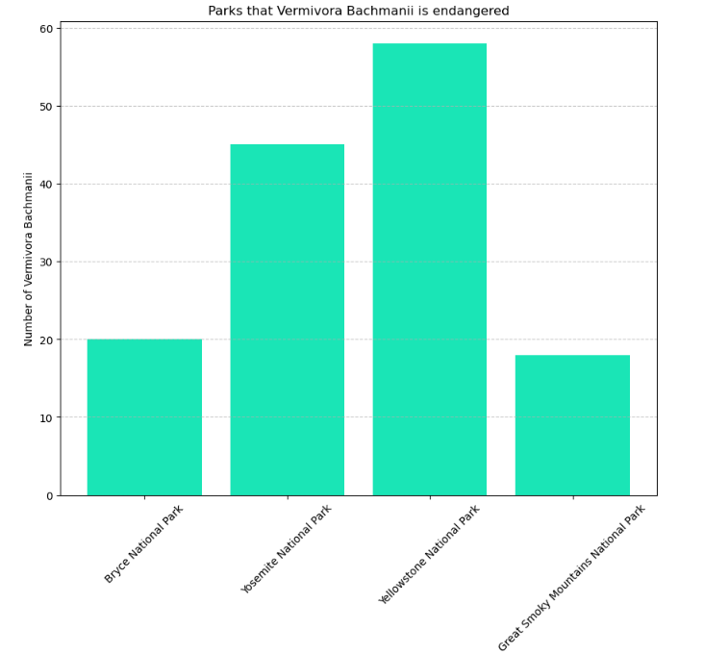

2.7 – most species are concerned

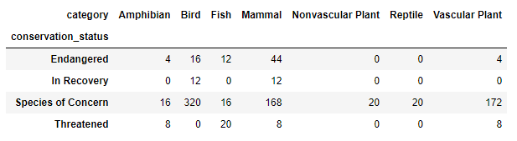

2.8 – Covertion status in Yosemite National Park

